Hugh’s Lament

This tune survives in a single manuscript setting,
--Colin Mór Campbell’s Nether Lorn Canntaireachd, i, 97-100, with the title “Hugh’s Lament”, as follows:
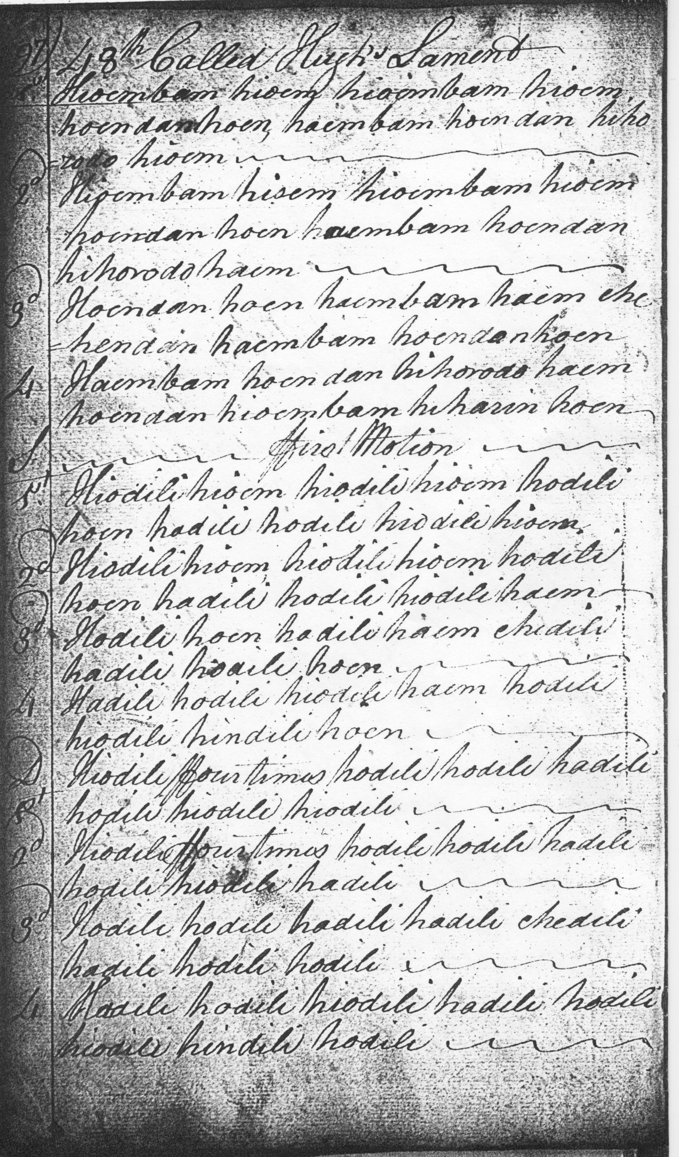
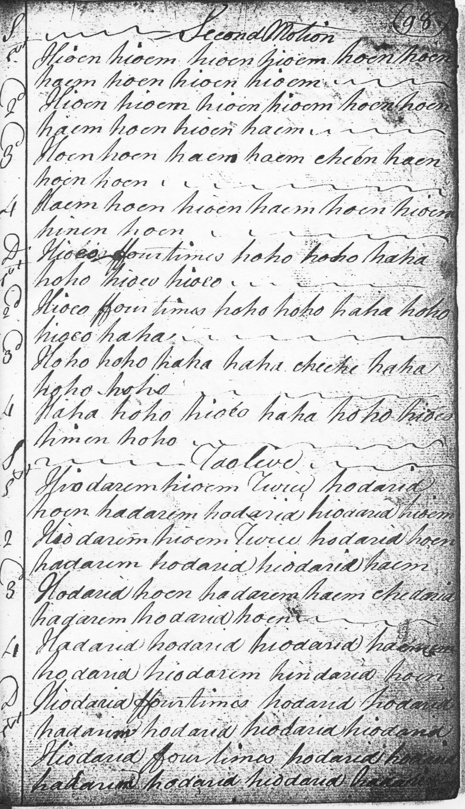
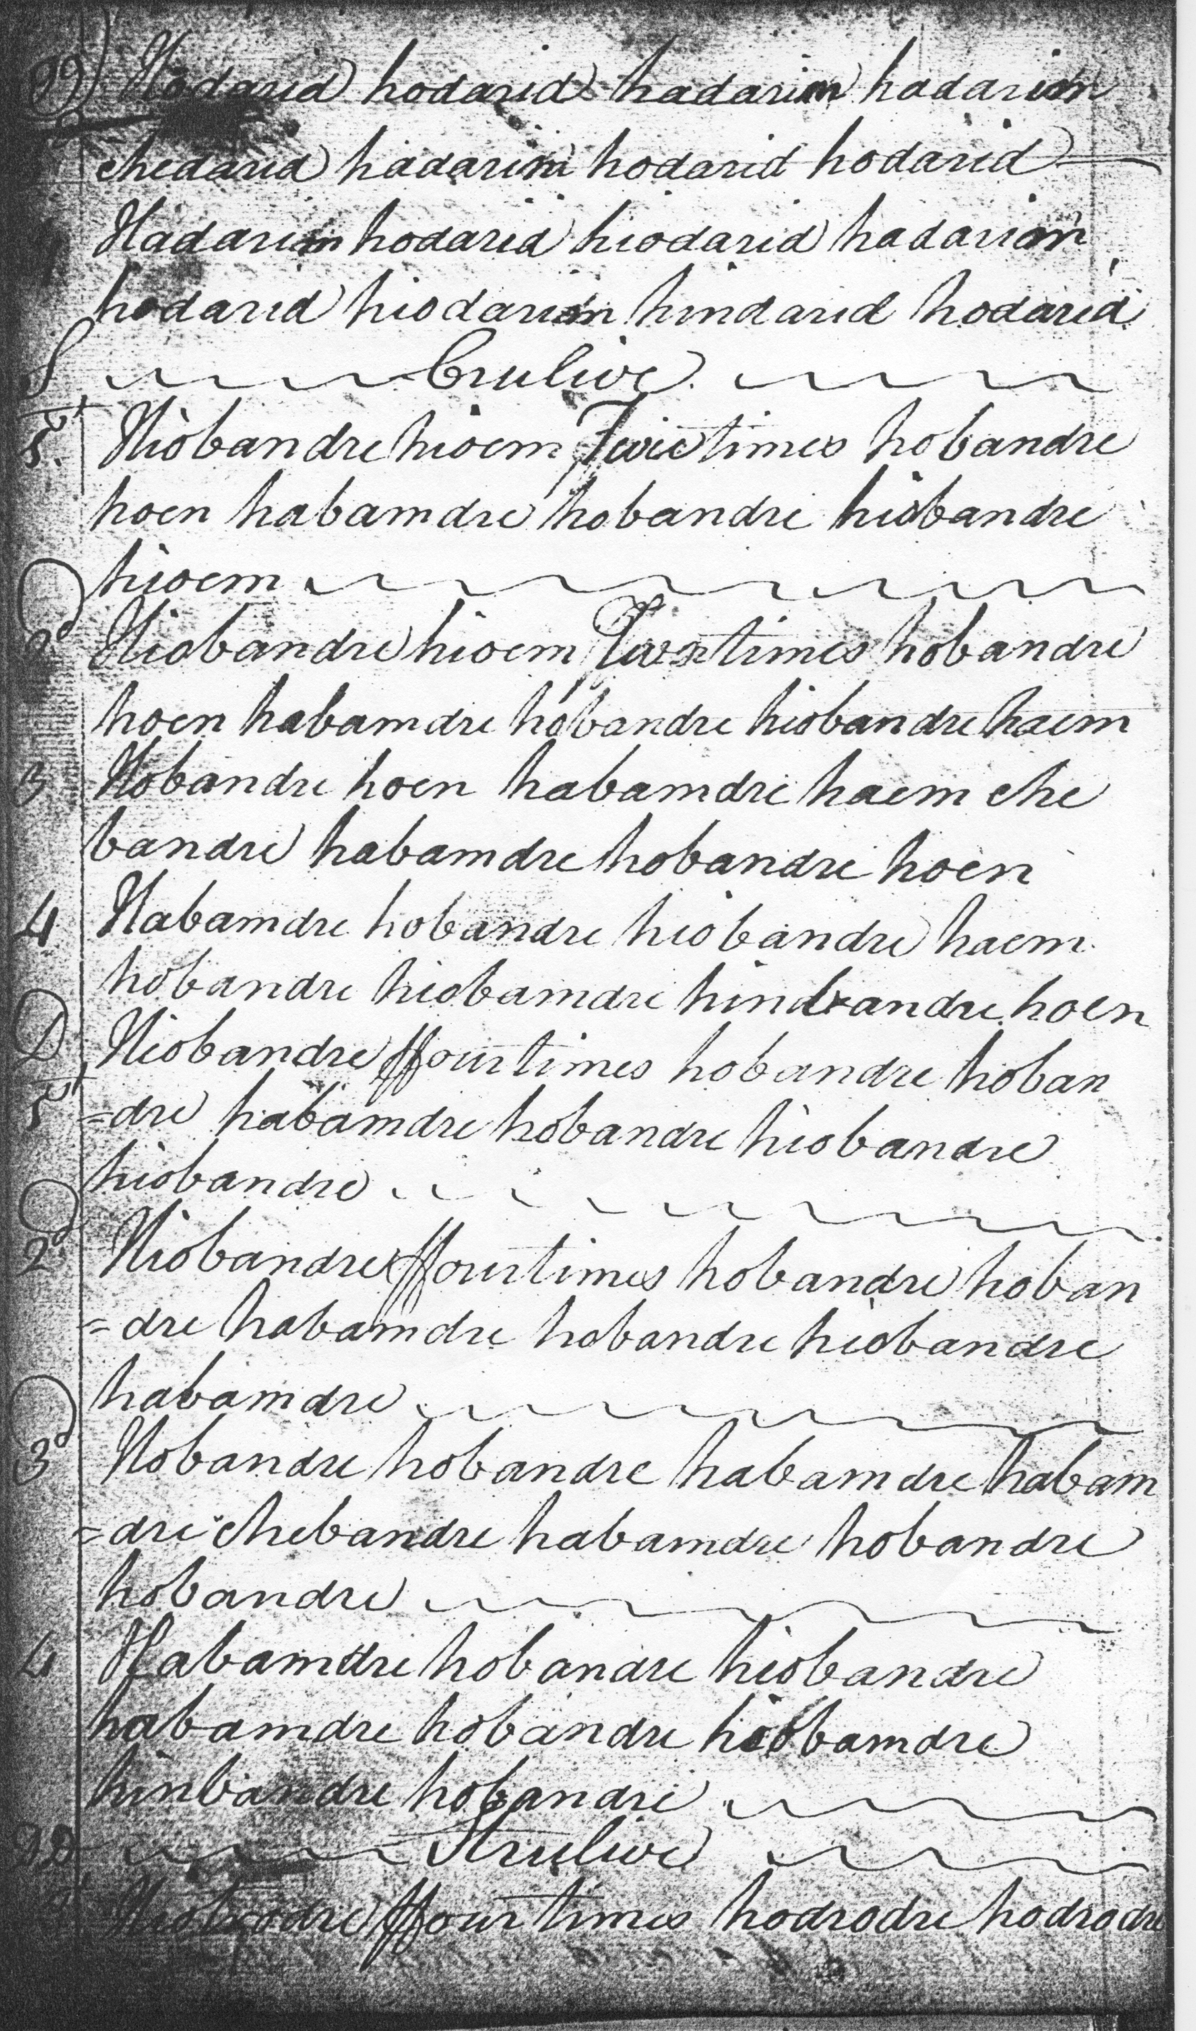
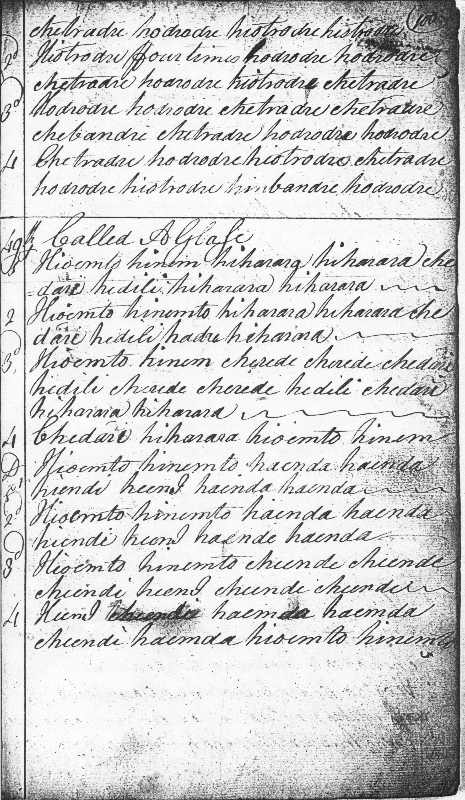

There seem to be a clear structural issue here, and this is not resolved in the single published version of the tune (Piobaireachd Society Collection, vol.13, pp.412-4). There are no alternative scores preserved in other manuscripts or early published collections to offer a guideline to what we should do.

The pattern is essentially a three line one (line one repeated) in the pattern 5:4 4 bars throughout.
The first line seems obviously short by a bar. The presence of subsequent emendations in the MS suggest some uncertainty about the tune. This could indicate the collector struggling with a previously unfamiliar piece; or perhaps simply giving literatim what he initially found in an earlier, and imperfectly notated, source. The intention could perhaps even be satirical: “Hugh thinks this is a lament?” Certainly that missing bar jars both eye and ear.

In his Compleat Theory of the Scots Highland Bagpipe (c.1763) the earliest developed account of piobaireachd as a form, Joseph MacDonald, says

it was by the four Fingers of the Left hand that all their Time was measurd & regulated. E.G. An Adagio in Common Time of Such a Style must not exceed or fall short [of] Such a number of Fingers, otherwise it was not regular. […] They were sure to have no odd Number in any piece they designd to be regular. (Joseph MacDonald’s Compleat Treatise of the Scots Highland Bagpipe, Roderick D Cannon, ed., Glasgow 1994, p.64).

The Piobaireachd Society version does not attempt to amend the structure of this tune, suggesting that its lack of symmetry is part of its appeal. It presents a transliteration of the original canntaireachd score with a version in staff notation. There are discrepancies between the two versions, most noticeably in the crunluath a mach movement on D. In the Nether Lorn score this is rendered “chetradre” which plainly indicates the MacArthur style with the movement being played off an initial E rather than B. (see MacArthur-MacGregor Manuscript of Piobaireachd 1820, Frans Buisman, ed., Glasg. 2001, p.liii). This fact is obscured by the Society’s simple direction to play “Crunluath a Mach in usual form”, the “usual form”, of course, being the style of Angus MacKay whose D movement is played off an initial B and not an E as in the actual score.

In playing, the tune as written feels uncomfortably “out”, disturbing our sense of structure and where the lines ought to end. Something seems necessary to balance that first line. There are a number of possibilities. One could simply double up the second phrase--hoendan hoen—throughout, or, perhaps, making the line up to six bars by adding the echoing gesture haembam hoen in the fourth bar position, and re-phrasing to fit that pattern in the remaining variations. Those variations themselves are framed in a perfectly symmetrical manner. Attention to symmetry is also evident in the construction of the melody elsewhere in the ground—in the parallelism between the arched descending phrases D-C-B-D/C-B-A-C in the final lines, for example.

The missing bar is only one of the odd things about the tune. The style seems unusual for a lament, its flavour being rather that of a gathering tune or battle piece, an impression supported by the presence of an a mach movement which laments in the older tradition tended not to have, but gathering and battle tunes frequently did—it was one of their distinguishing markers. Then there is the question of the title. In the original source the tune is called “Hugh’s Lament”, the title it bears above the score, and also in the index. This could be either “Lament for Hugh”, or “Lament by Hugh” which alters the emotional implications of the tune.

The notation in the original is not entirely consistent. After all this was a traditional art form with a rich palette of expressive possibilities, and a range of different ways of doing things. As Joseph MacDonald makes clear, traditionally trained pipers could realise a piece in any number of individual—but still idiomatic and authentic ways. In the ground for example a number of minor difficulties of expression arise. If timed as written, then the double echo movement on B seems to have a superfluous syllable: if hihorodo is interpreted as beginning with a cadence note on E, as the notation implies, then it leaves one syllable too many to be easily incorporated within the basic rhythmical pattern of the line. In a swinging, surgingly rhythmical tune like this, this is an important matter. Either one could drop the “hi” altogether, interpret it as meaning simply a high G gracenote on the initial B of the horodo movement; or, as I have done here and in the accompanying audio file, elide the final syllable “dan” in the preceding vocable, so that it reads “hoen (as opposed to hoendan) hihorodo hioem”. In a recital context, this would present little difficulty. For the competitive performer, however, adopting it would be an insurmountable obstacle to success, departure deliberate or otherwise from the set score being likely adjudged an irrecoverable error, benches being virtually guaranteed to react adversely to things they do not expect to hear. Of course we have been anything but consistent in this respect down the years, it being perfectly permissible in competitive performance of Nether Lorn tunes to play the unhistorical Piobaireachd Society gairm/eallach with its five pulses, rather than the compiler Colin Mór Campbell’s version which contains not five but three, and which fits snugly into the rhythmic context of the musical gestures surrounding it.

The emended reading is as follows:

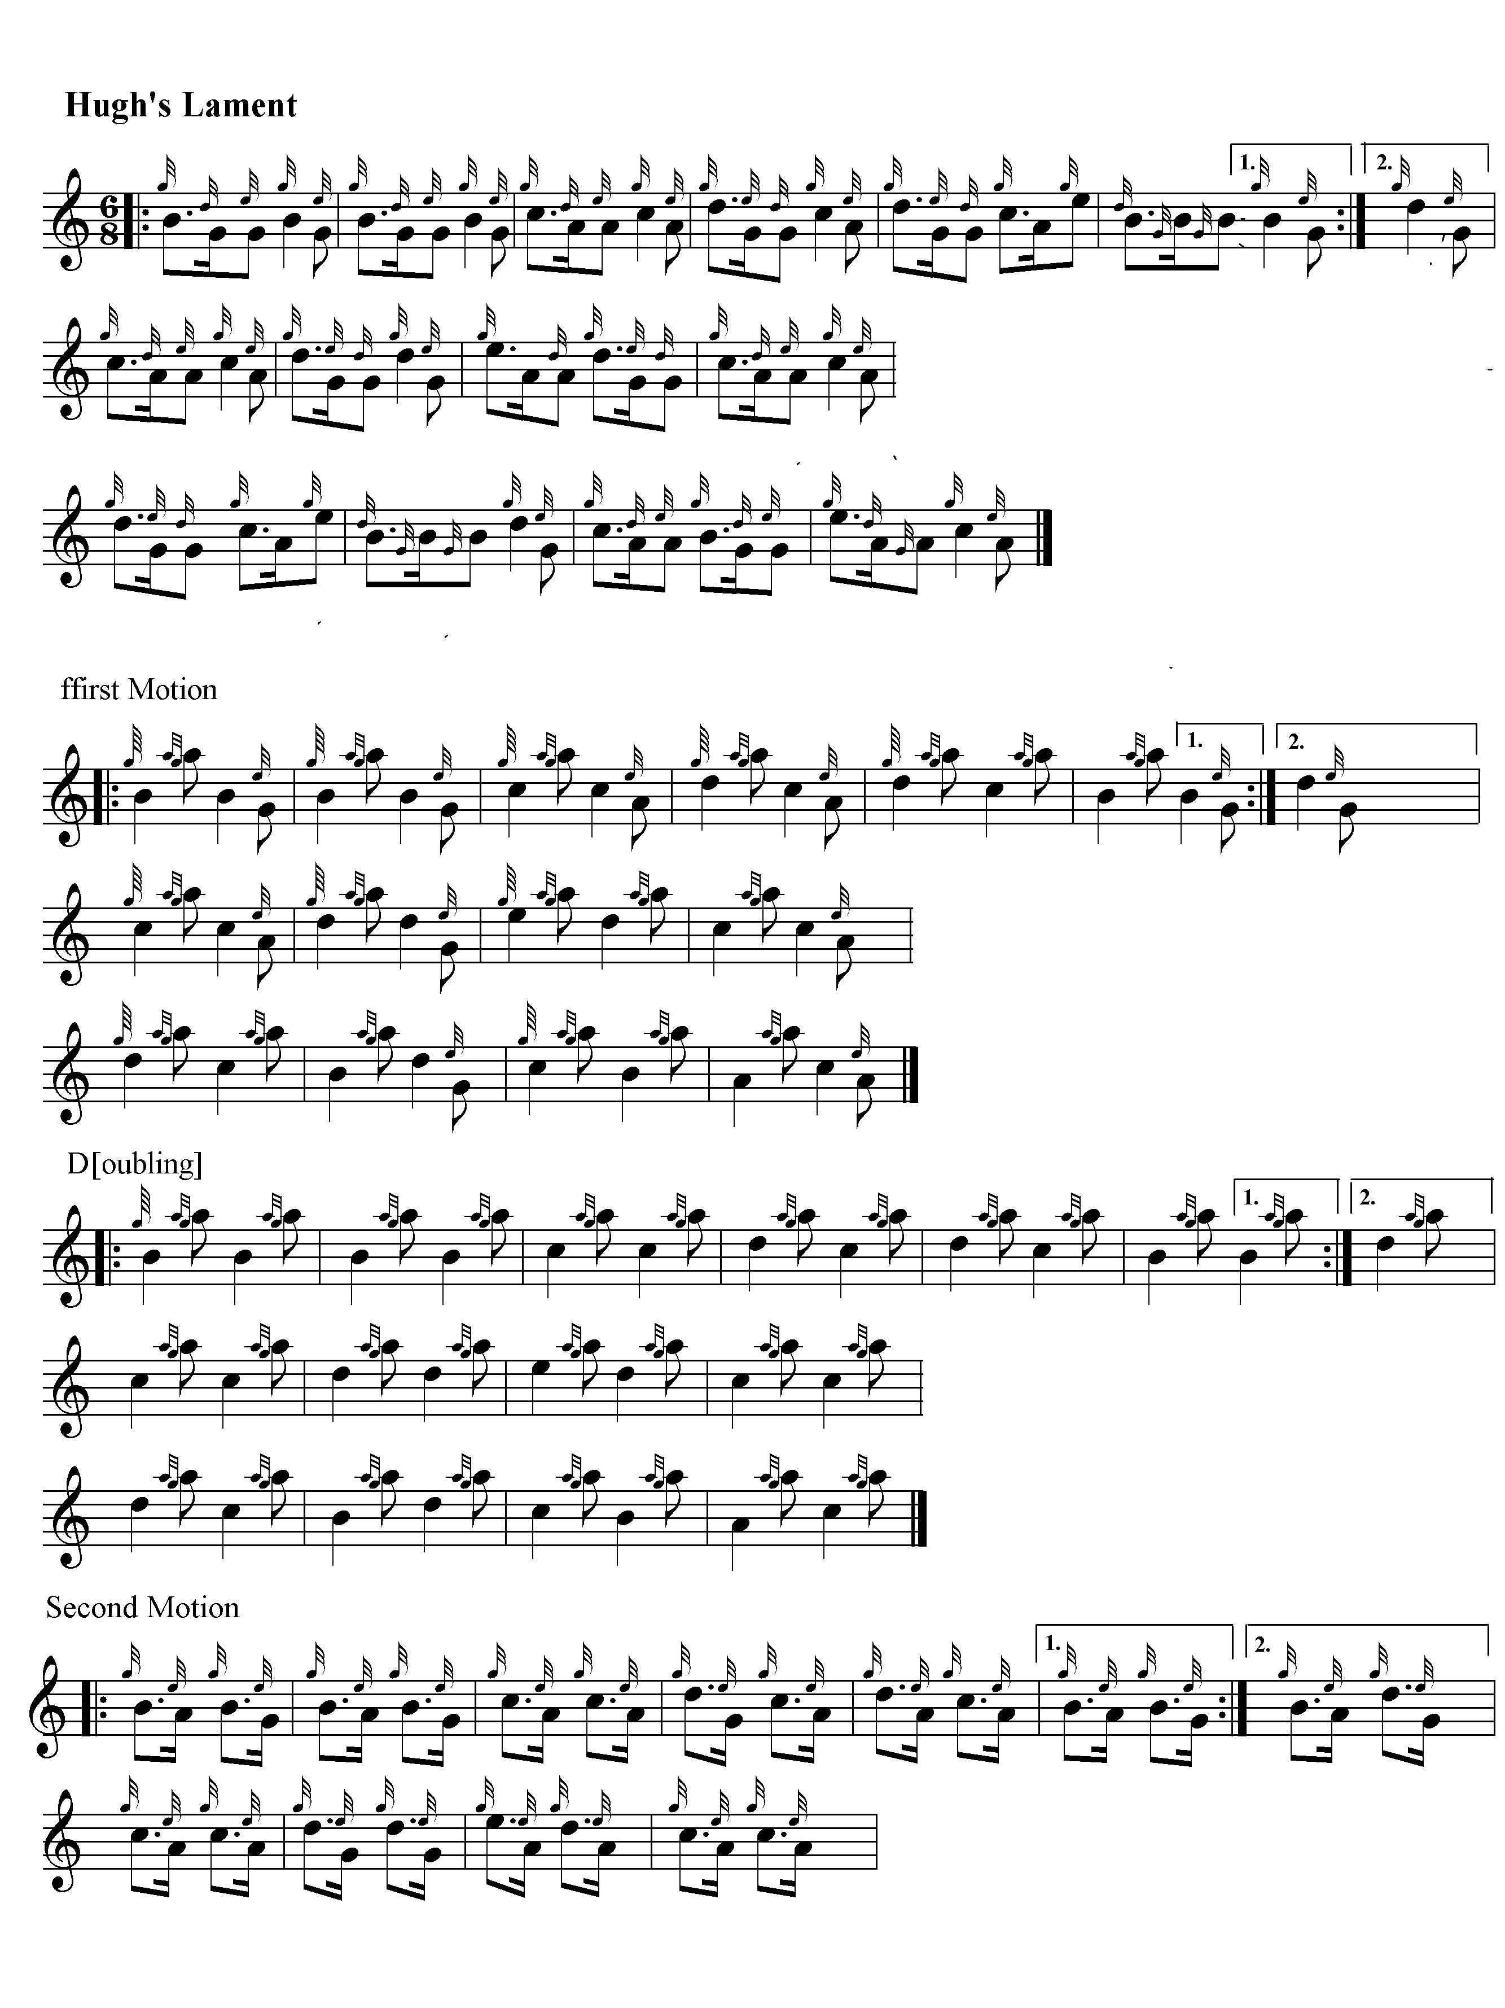
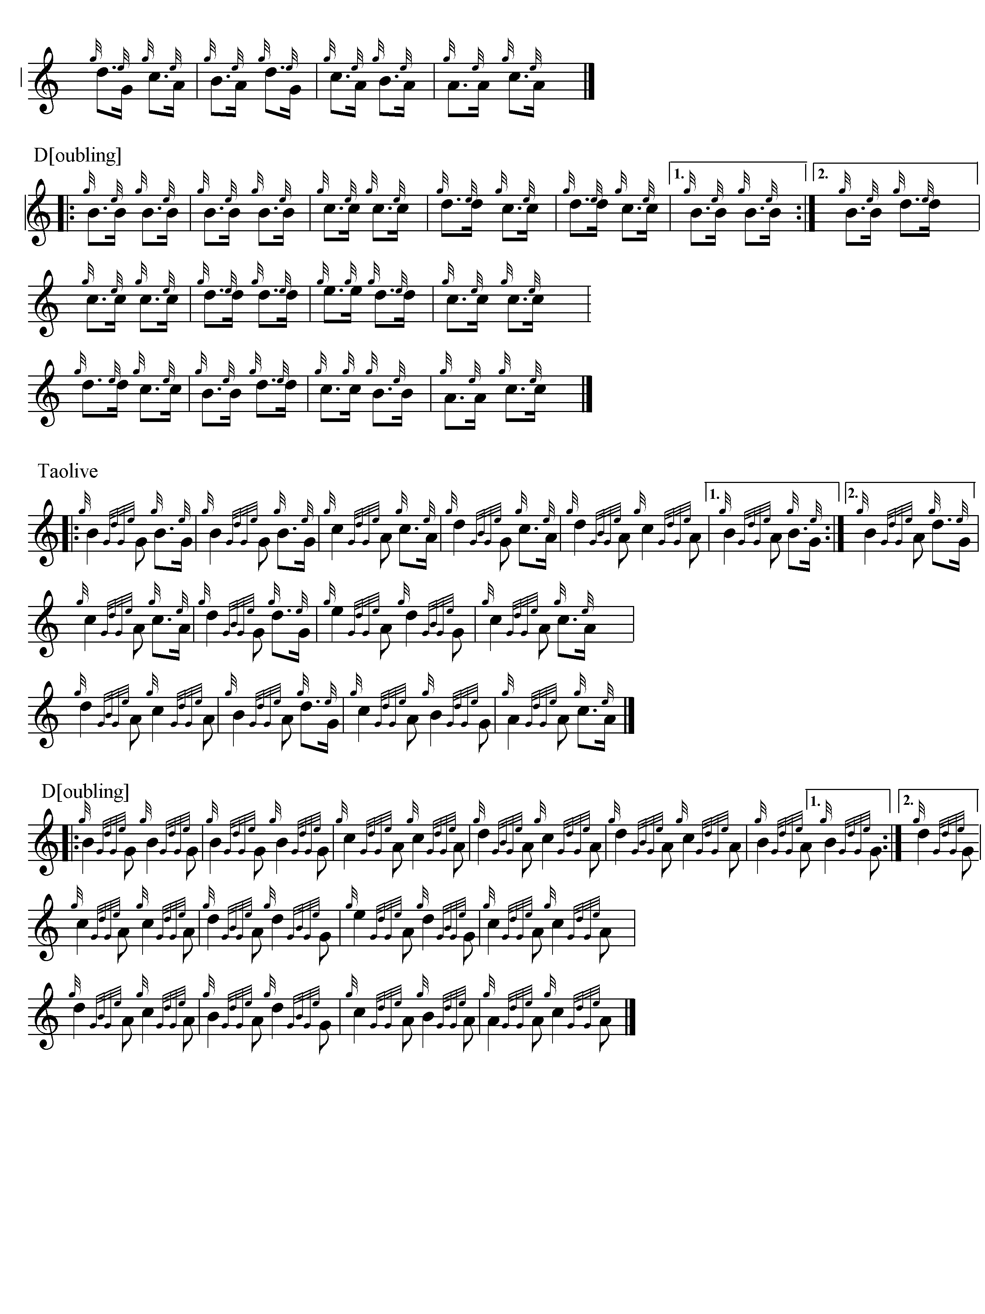
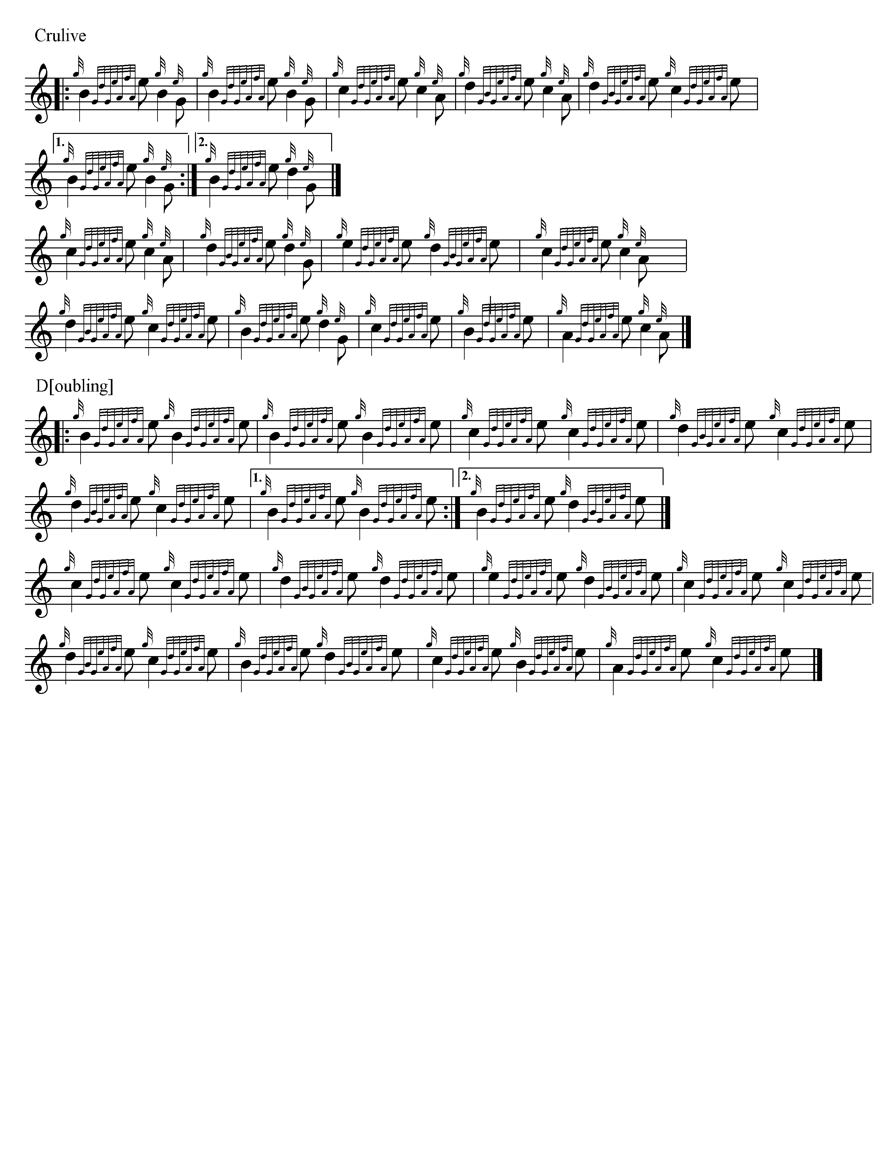
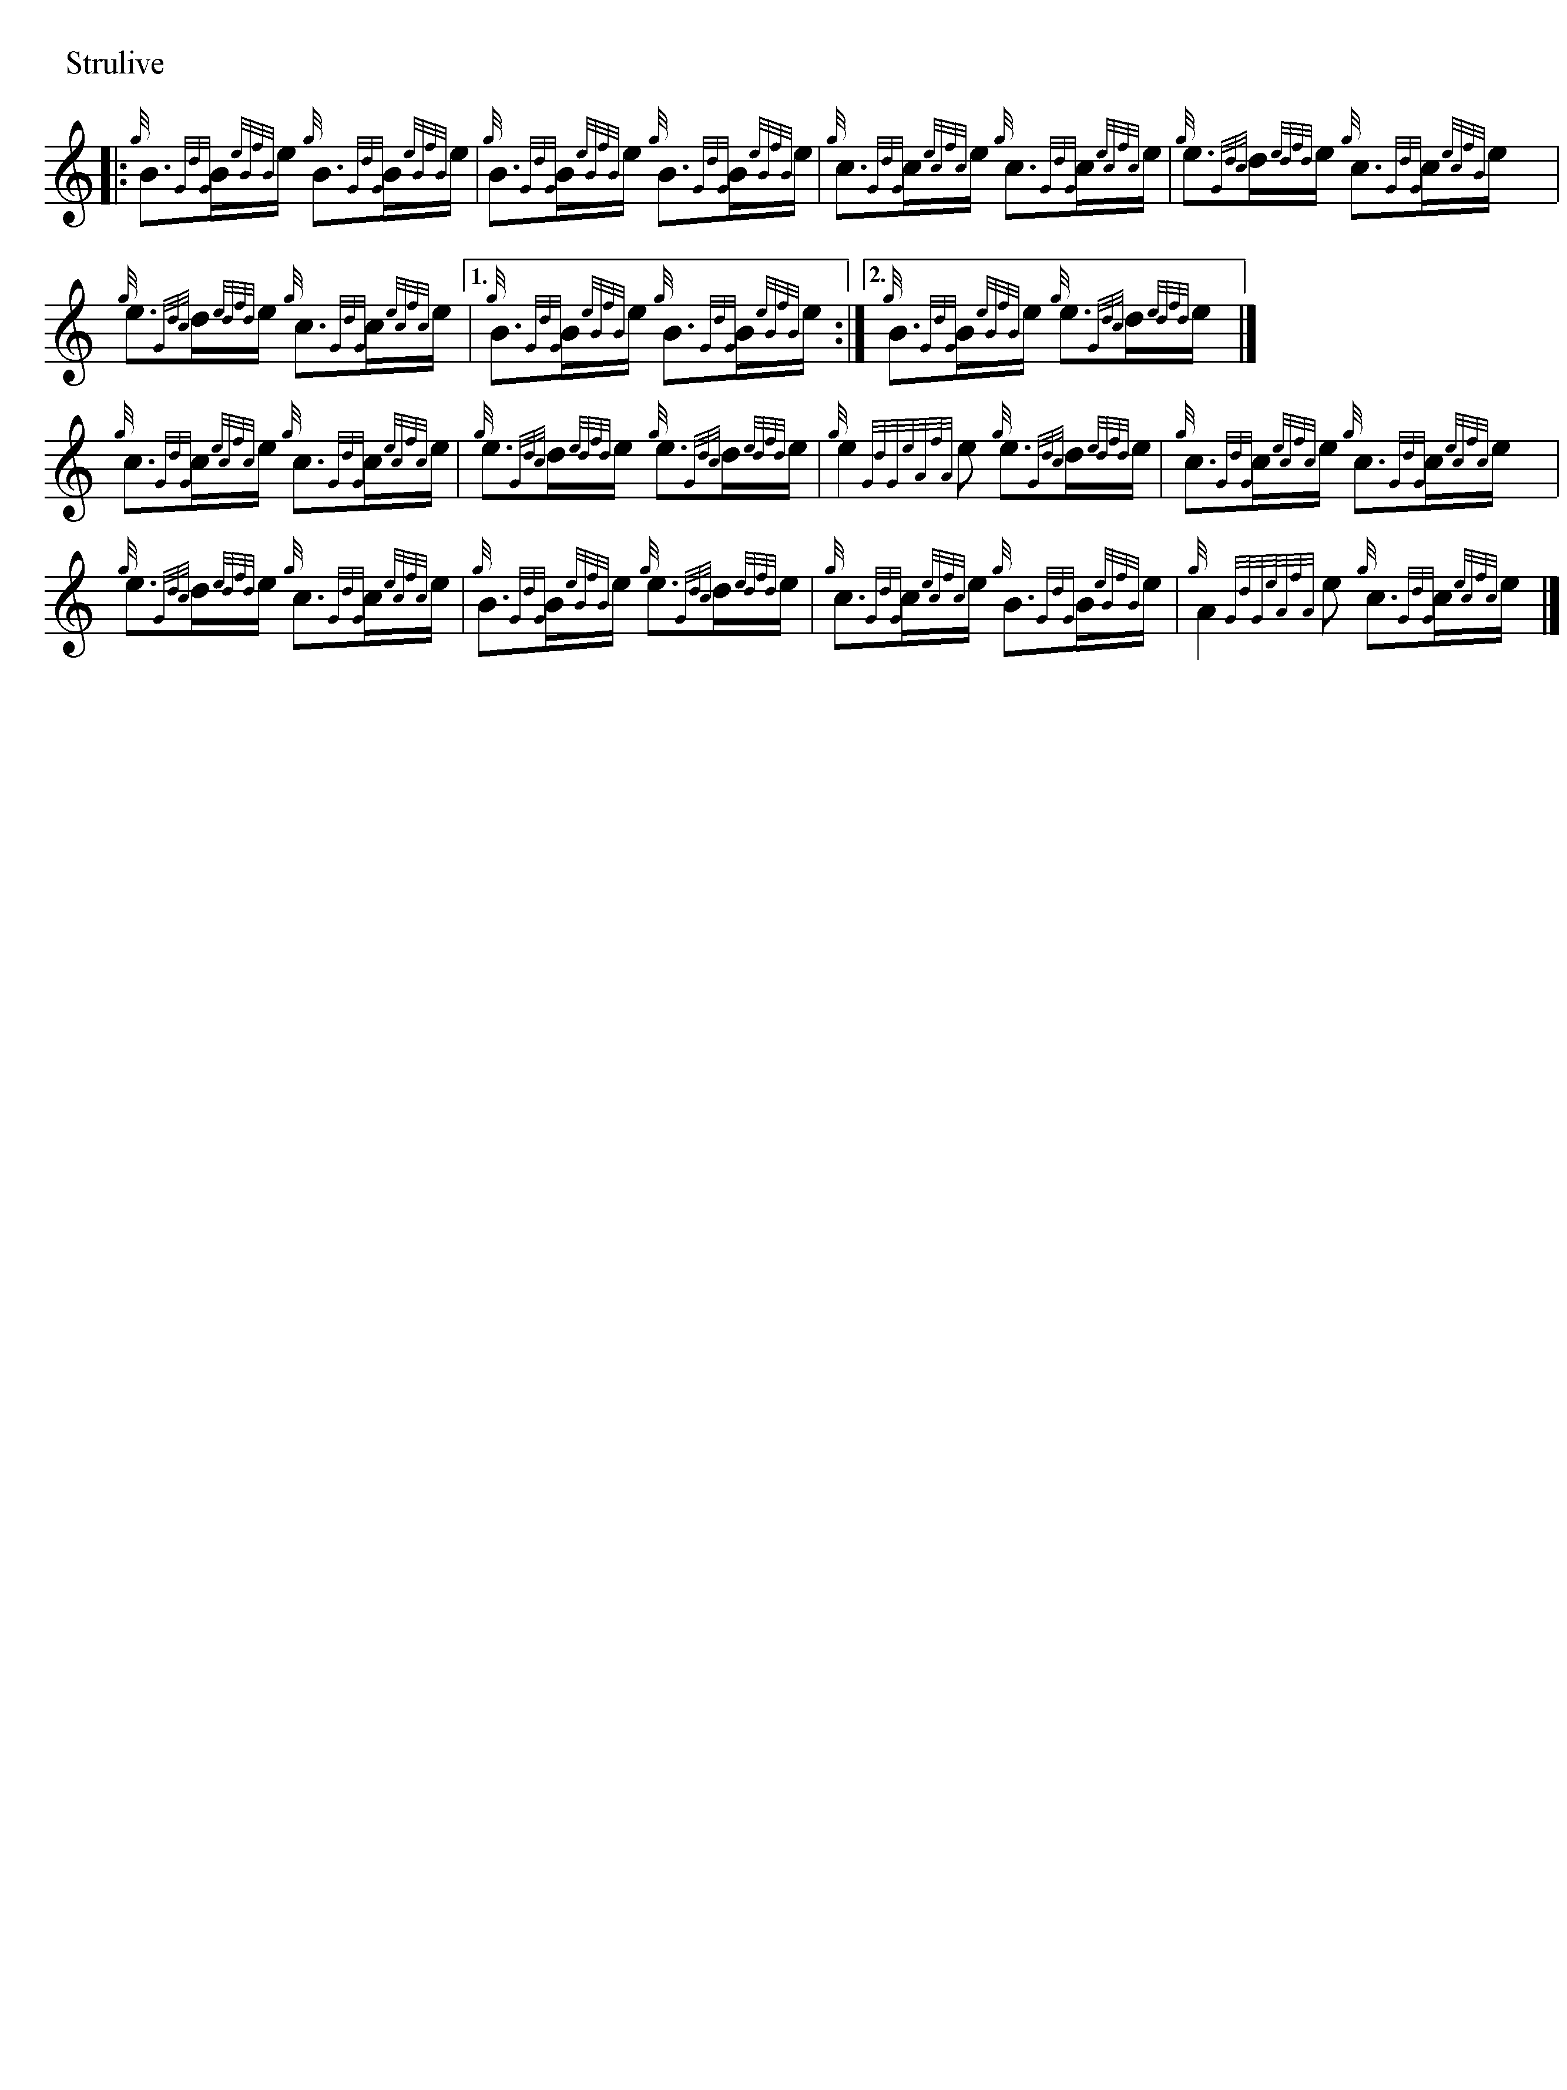
*

Electronic text © Dr. William Donaldson, Cambridge, Massachusetts, 25 May 2022

