The Half-Finished Piobaireachd
There are settings of this tune in the following manuscript sources:
--Colin Mór Campbell’s “Nether Lorn Canntaireachd”, ii, 36-8 (with the title “Leacran”);
--David Glen’s MS, ff.370-371;

and in the following published sources:

--Angus MacKay, Ancient Piobaireachd, pp.144-5;
--C. S. Thomason, Ceol Mor, pp.175-6.

Colin Campbell sets the tune like this:

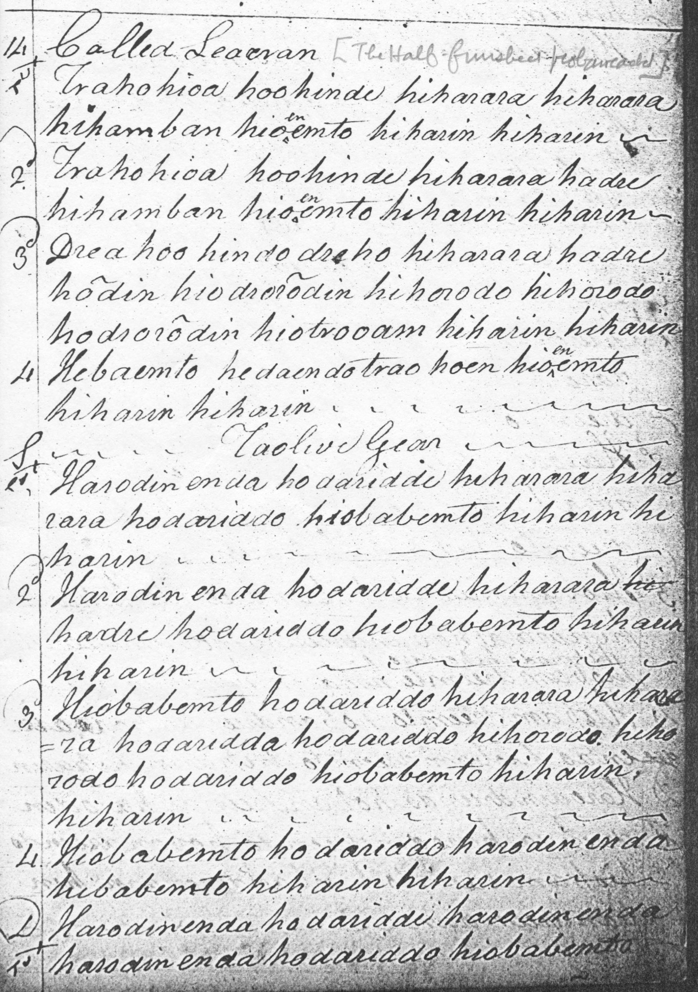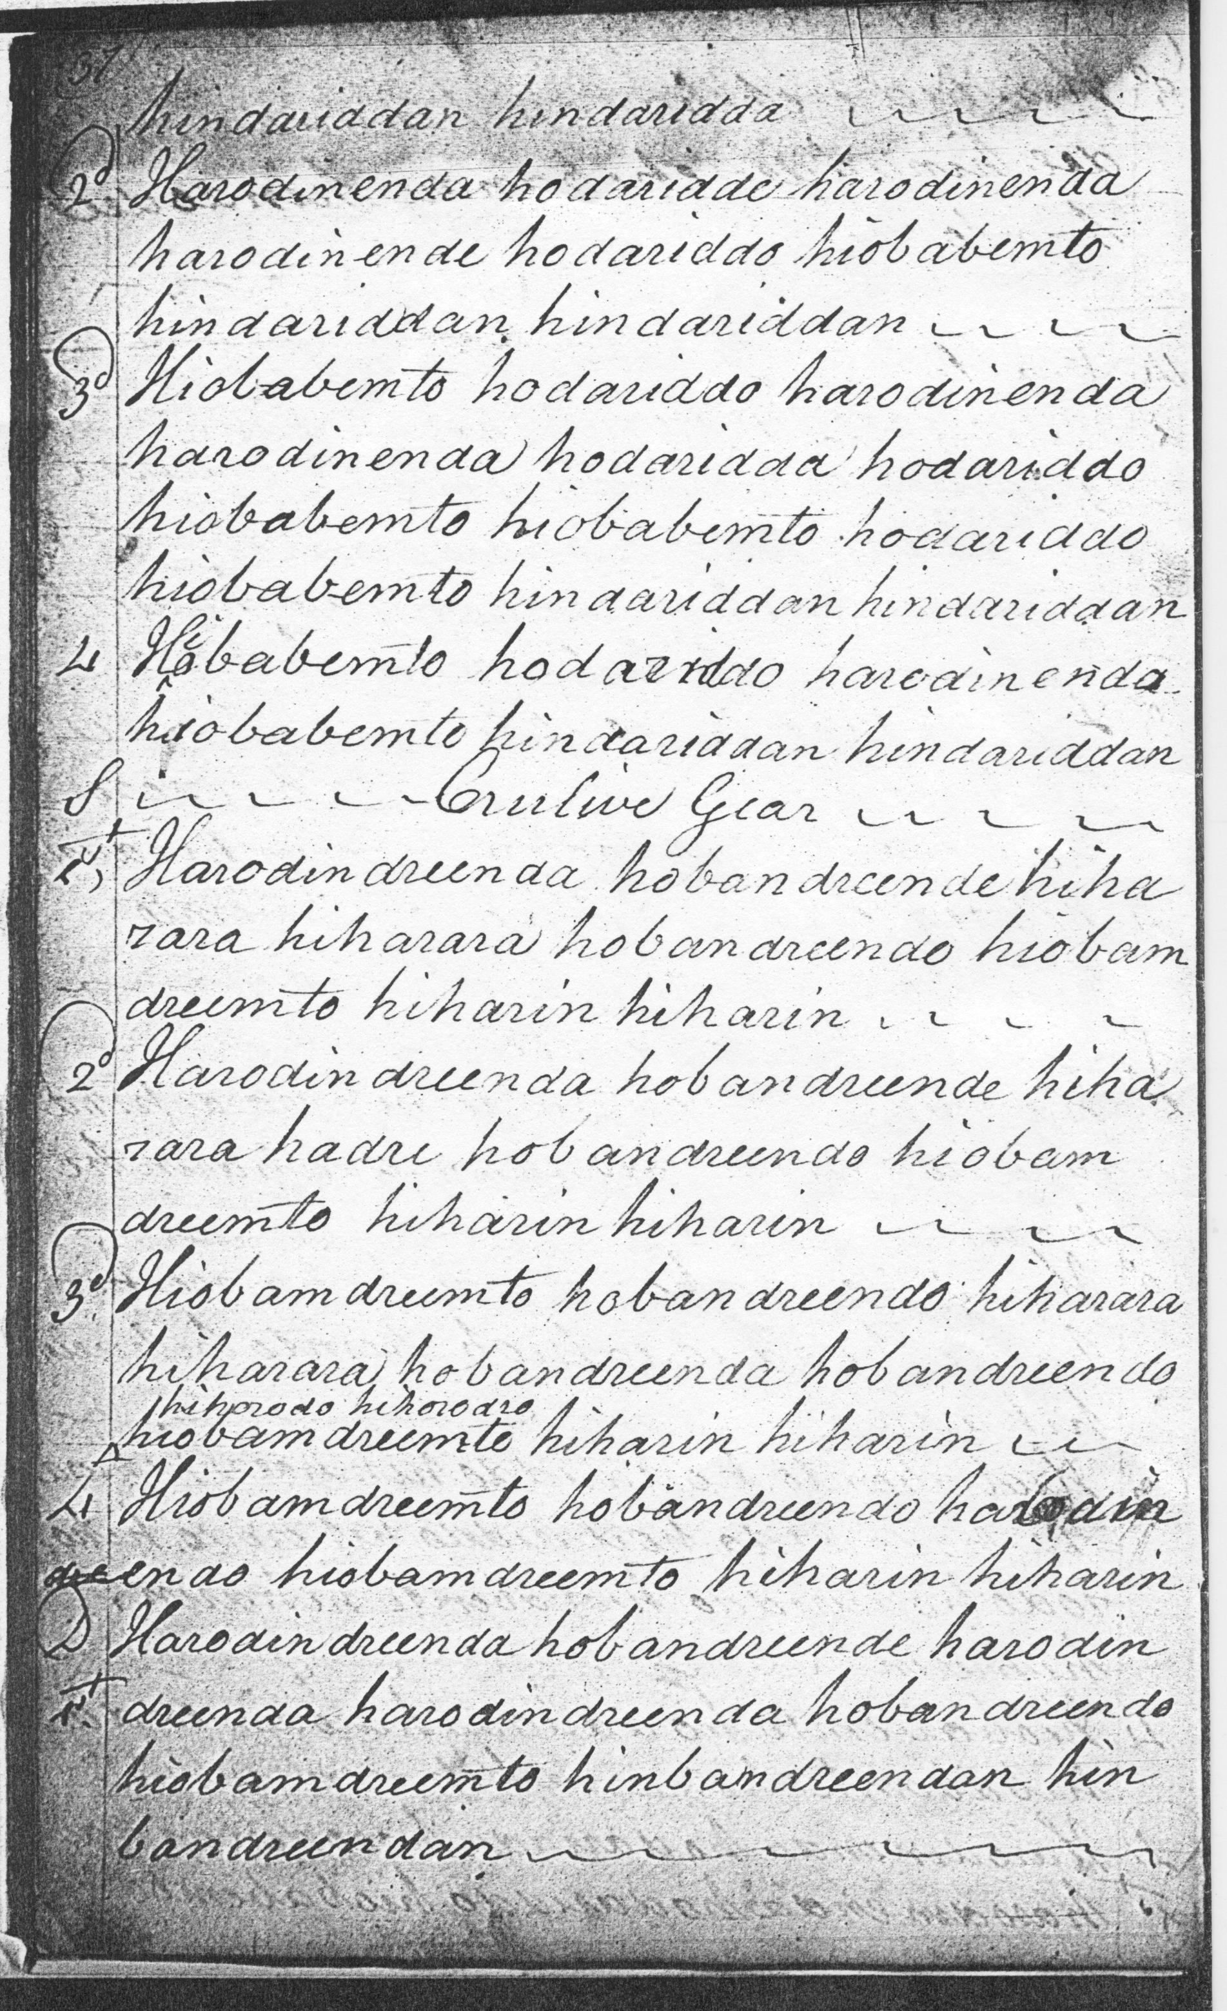
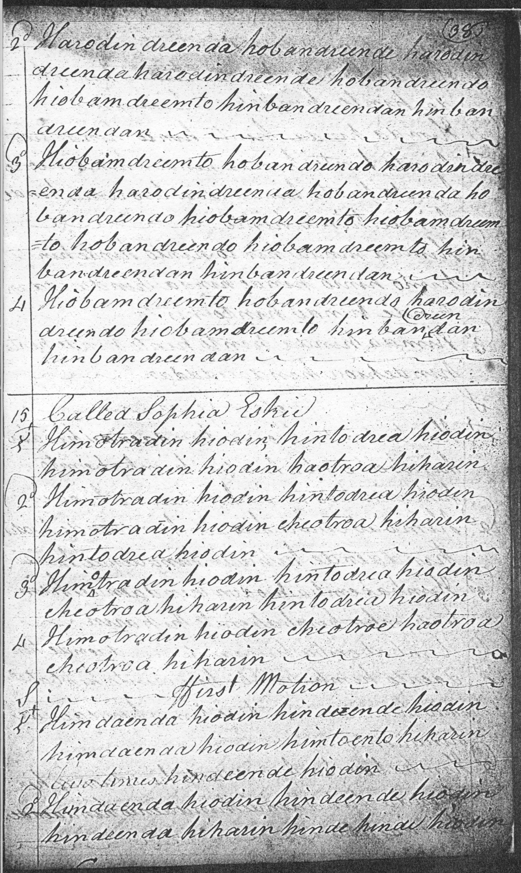

Colin Campbell proceeds directly from the ground to the taorluath and crunluath breabach singlings and doublings. There seems an obvious omission of a double-echo beat in line three of the ground and of the figure hobandreendo in the line three of the crunluath breabach singling (supplied in the staff notated version below), and I have read hiotrooem as hiotroenem in line three of the ground. There are a number of second thoughts in the score above which suggests that the piece did not flow with complete confidence from the compiler’s pen, but as nearly always with Colin Campbell the score shows a number of subtle little touches of expressive detail which always make his work interesting:

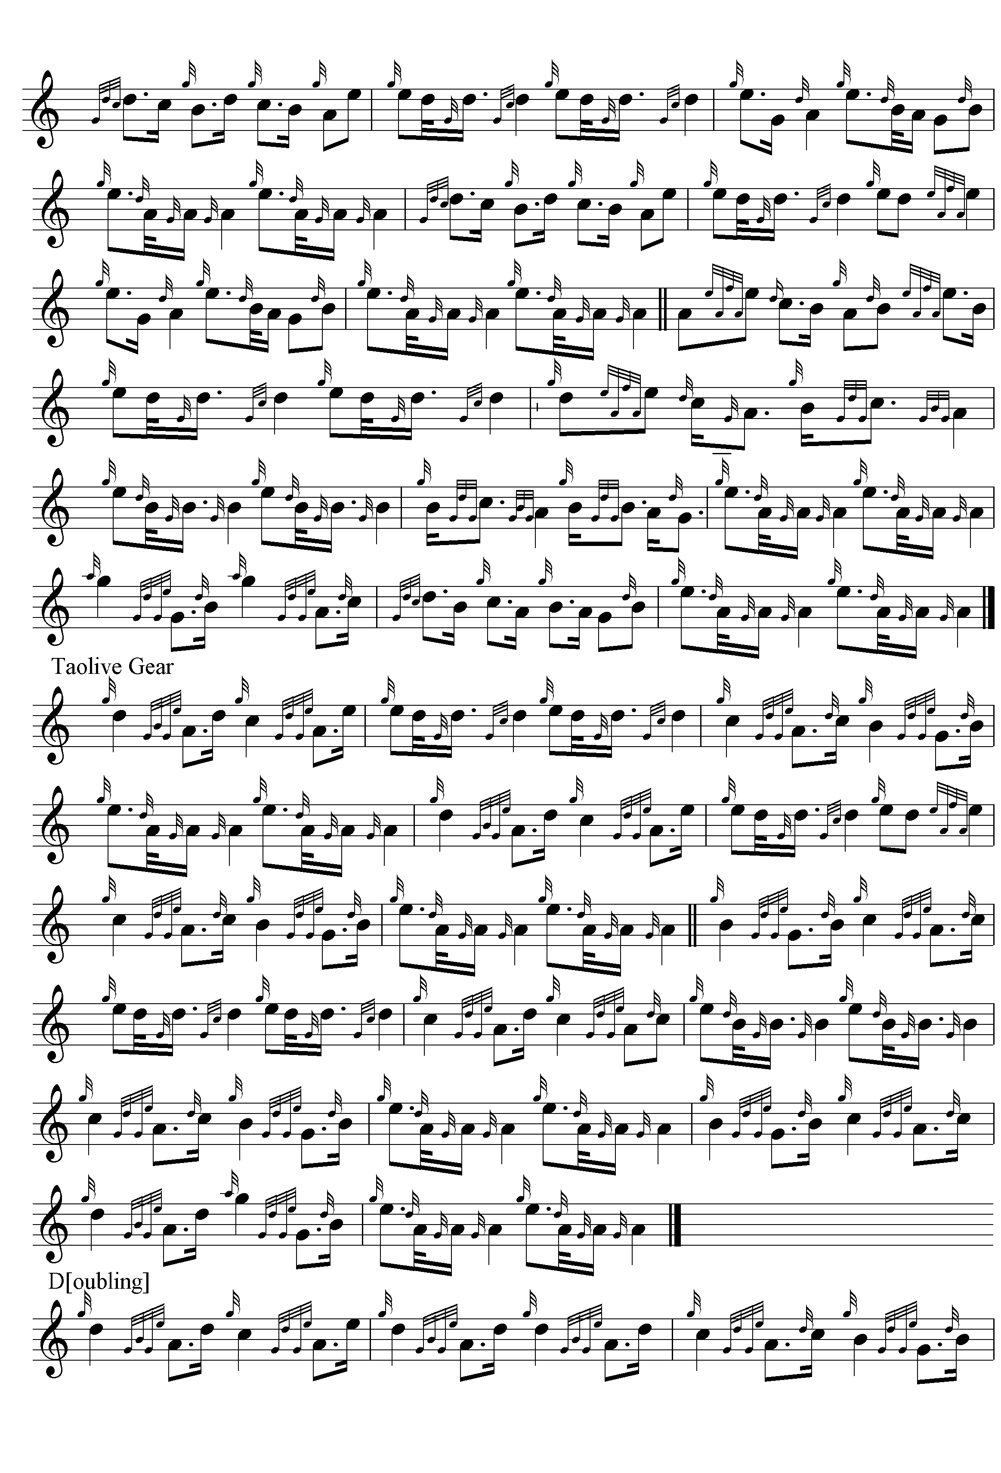
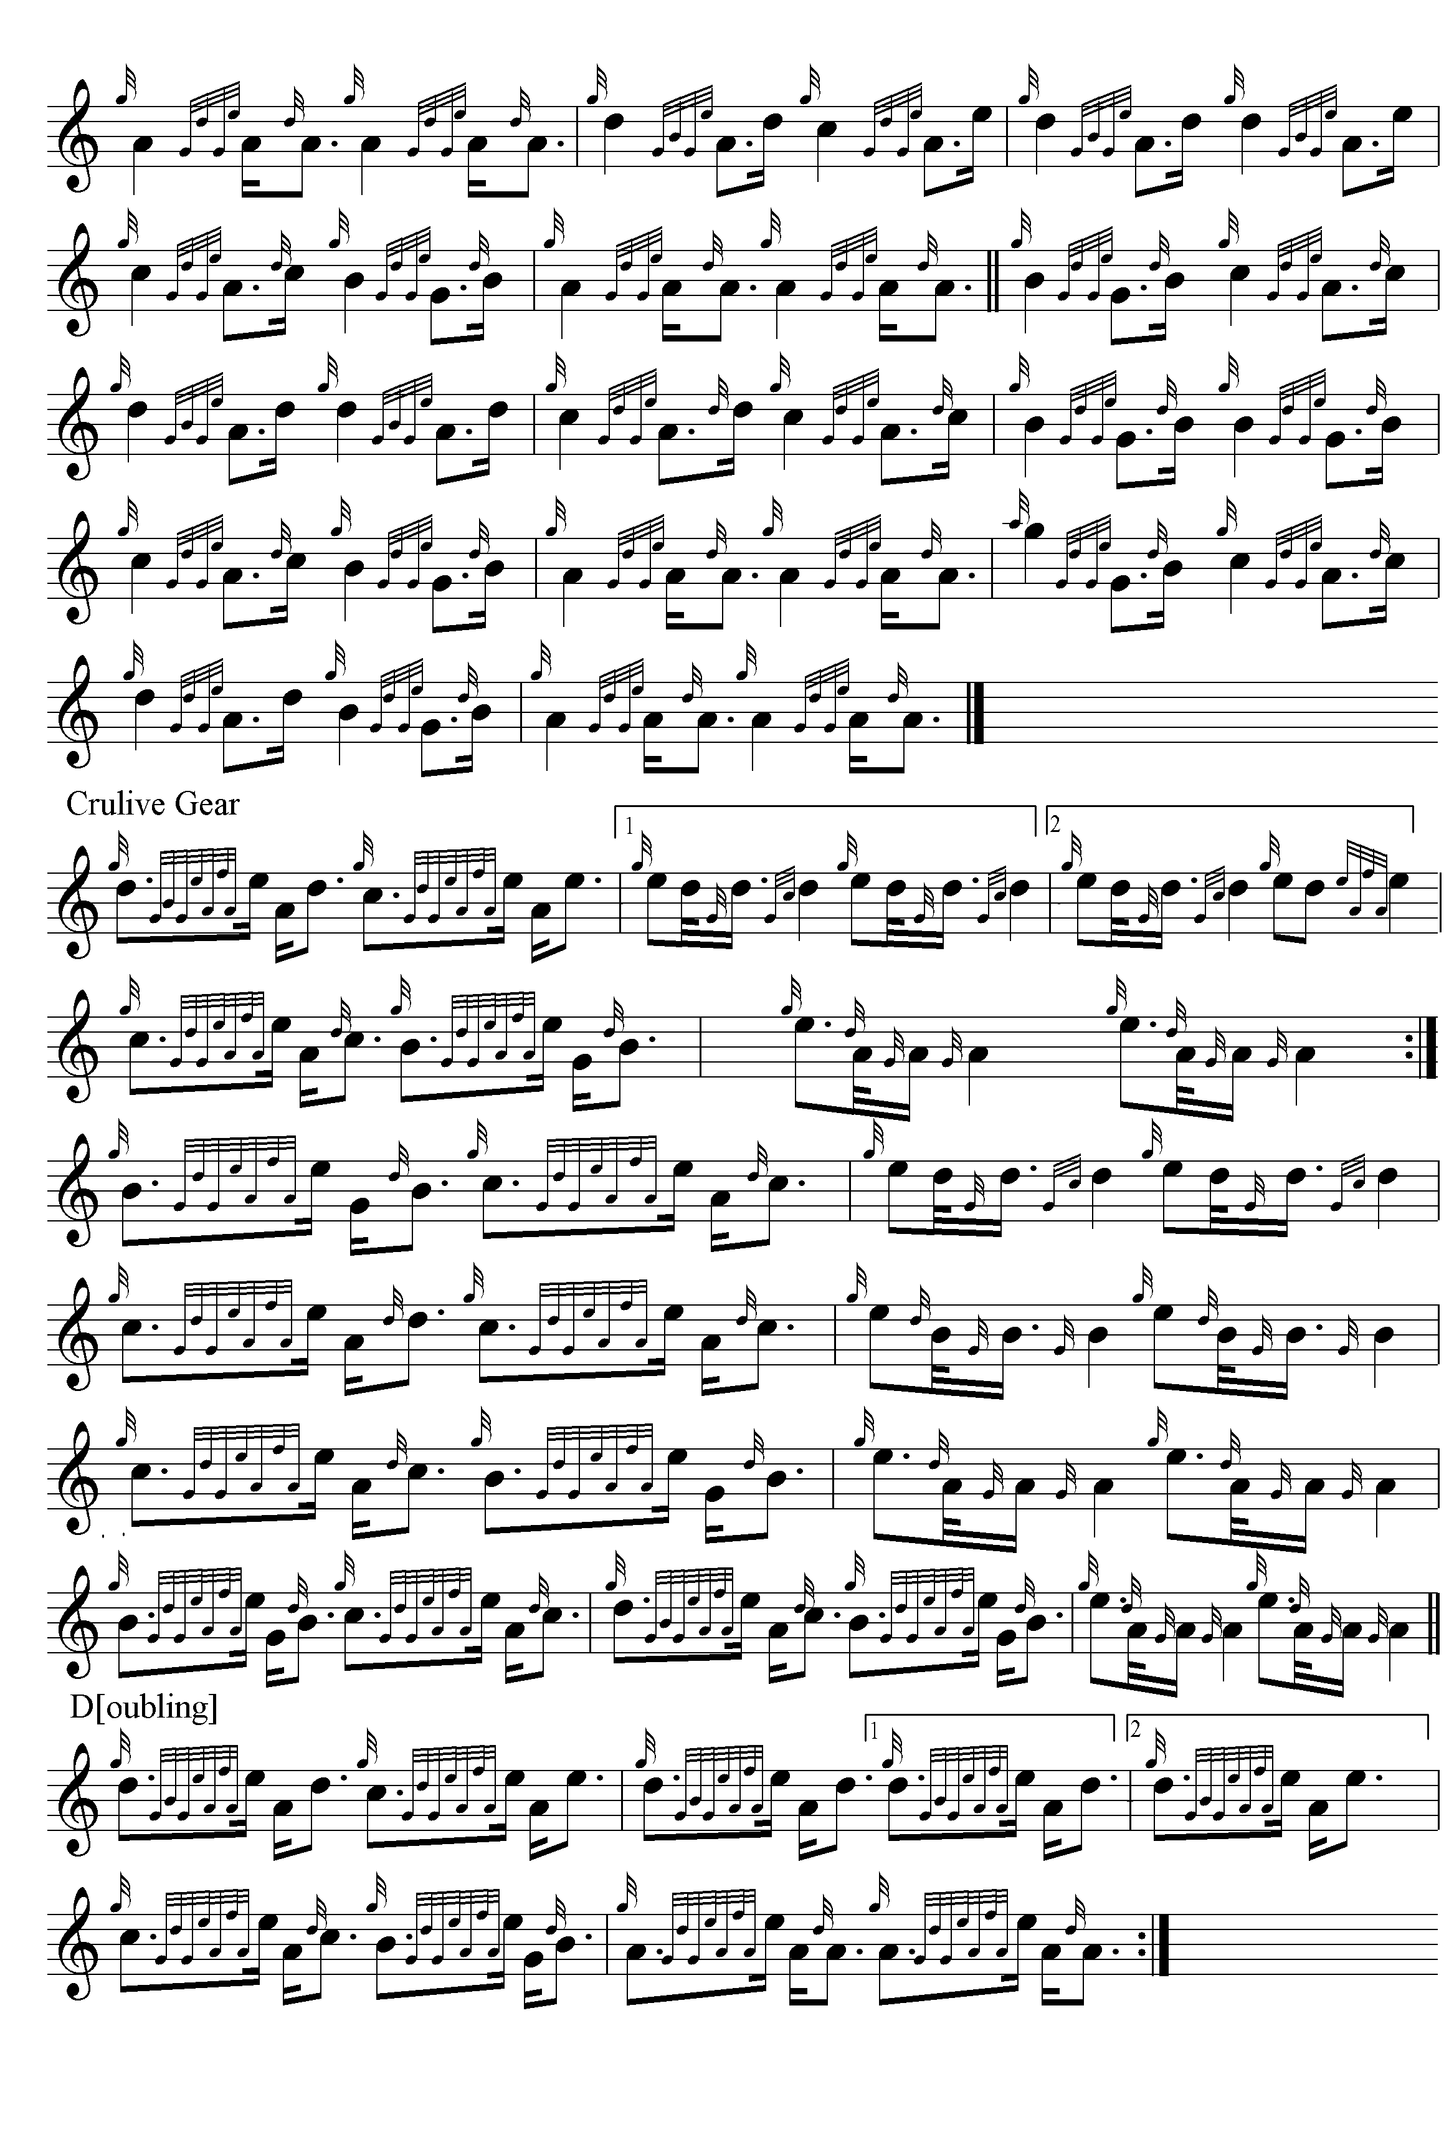

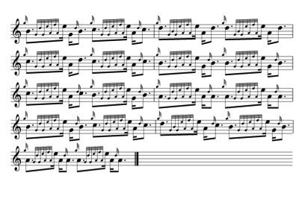
The structure is unusual: three lines arranged asymmetrically, the first of four bars (repeated), the second of six, and the third of three, sustained through both ground and variations.

Angus MacKay sets the tune like this:

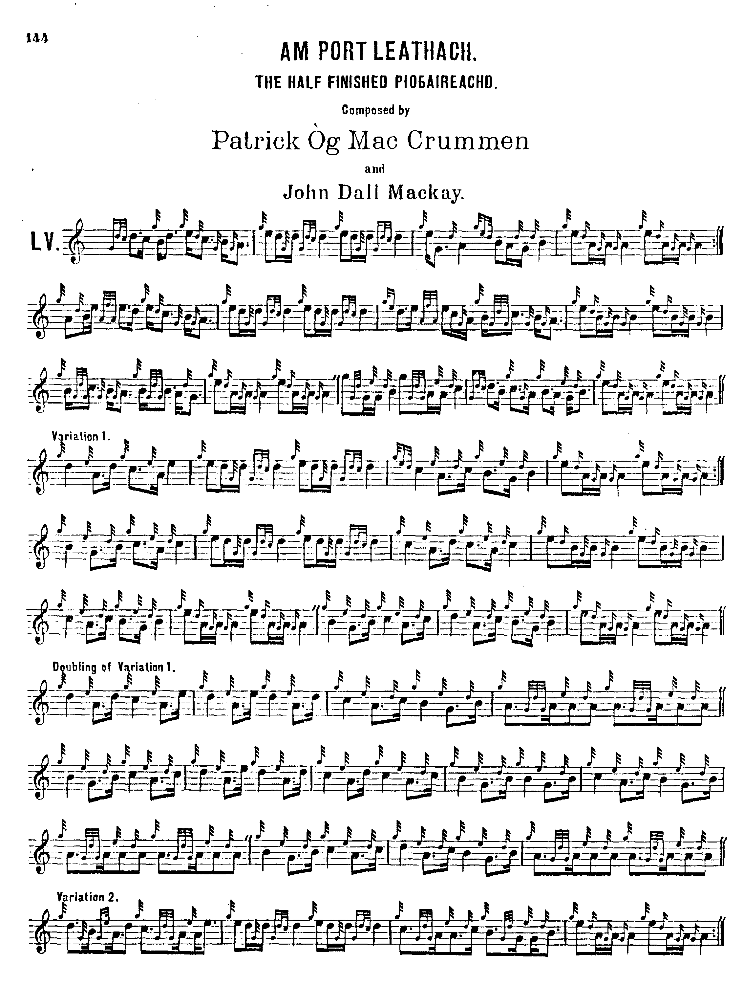

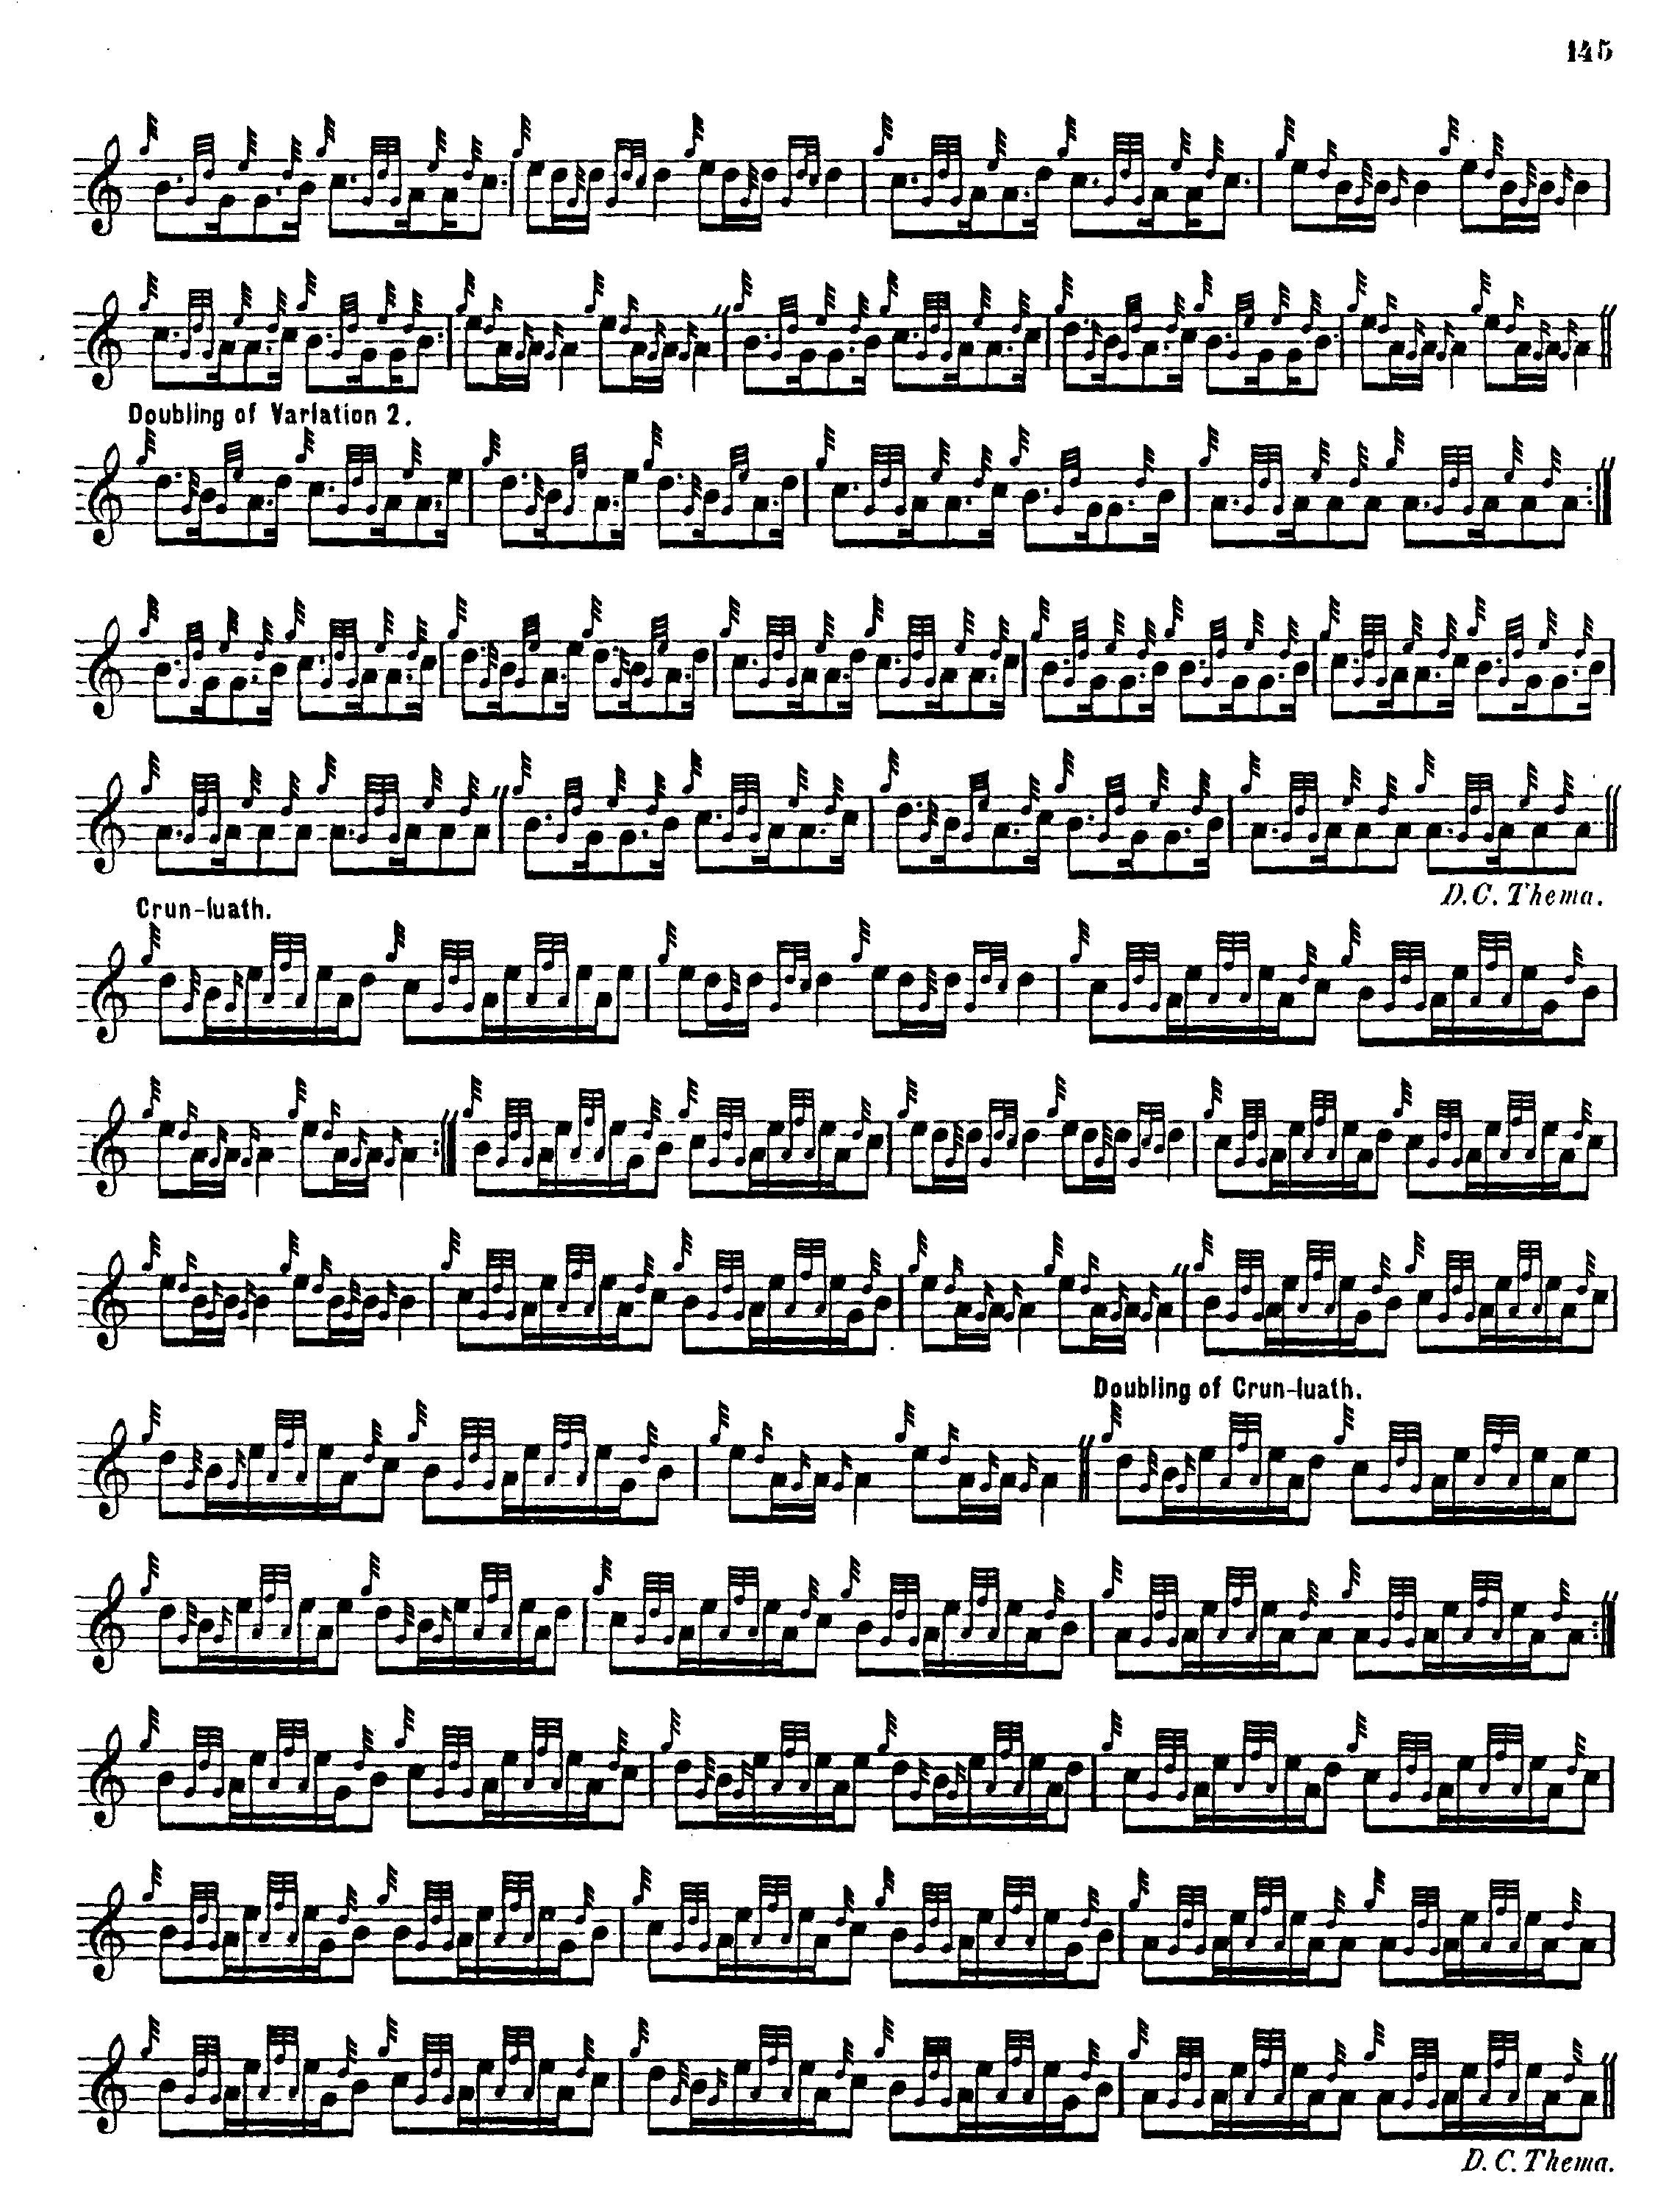

MacKay shows the same structure as Colin Campbell, three lines to the part, comprising an initial line of four bars (repeated); followed by a second line of six bars, and then a final line of three bars. The ground is repeated after the taorluath and crunluath doublings in MacKay’s usual manner. The taorluath is played “down”, and the crunluath “up”. MacKay’s is a pleasing setting. The performer would need strong reasons to play anything else.

The seeming irregularity of this beautiful tune was a strong temptation to later editors, and C. S. Thomason offered an emendation which incorporated a double echo beat on D into the final line, to bring the length up to more plausible-seeming eighteen-bar dimensions. He gives no indication that he had intervened editorially; in the index to Ceol Mor the sources are given as Angus MacKay’s manuscript and the teaching of Angus’s nephew, Donald MacKay, who was a pupil of the Camerons and acted as the General’s adviser and amanuensis. The “fix” could have originated either in the MacKay or Cameron families, and as things stand there seems no clear way of settling the point. Thomason sets the tune as follows:

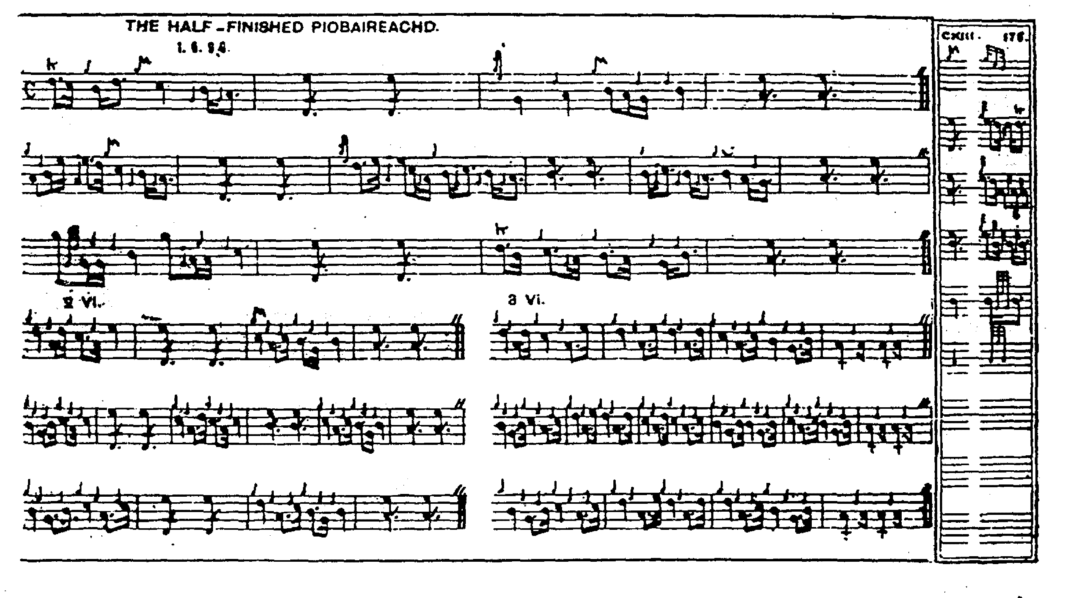
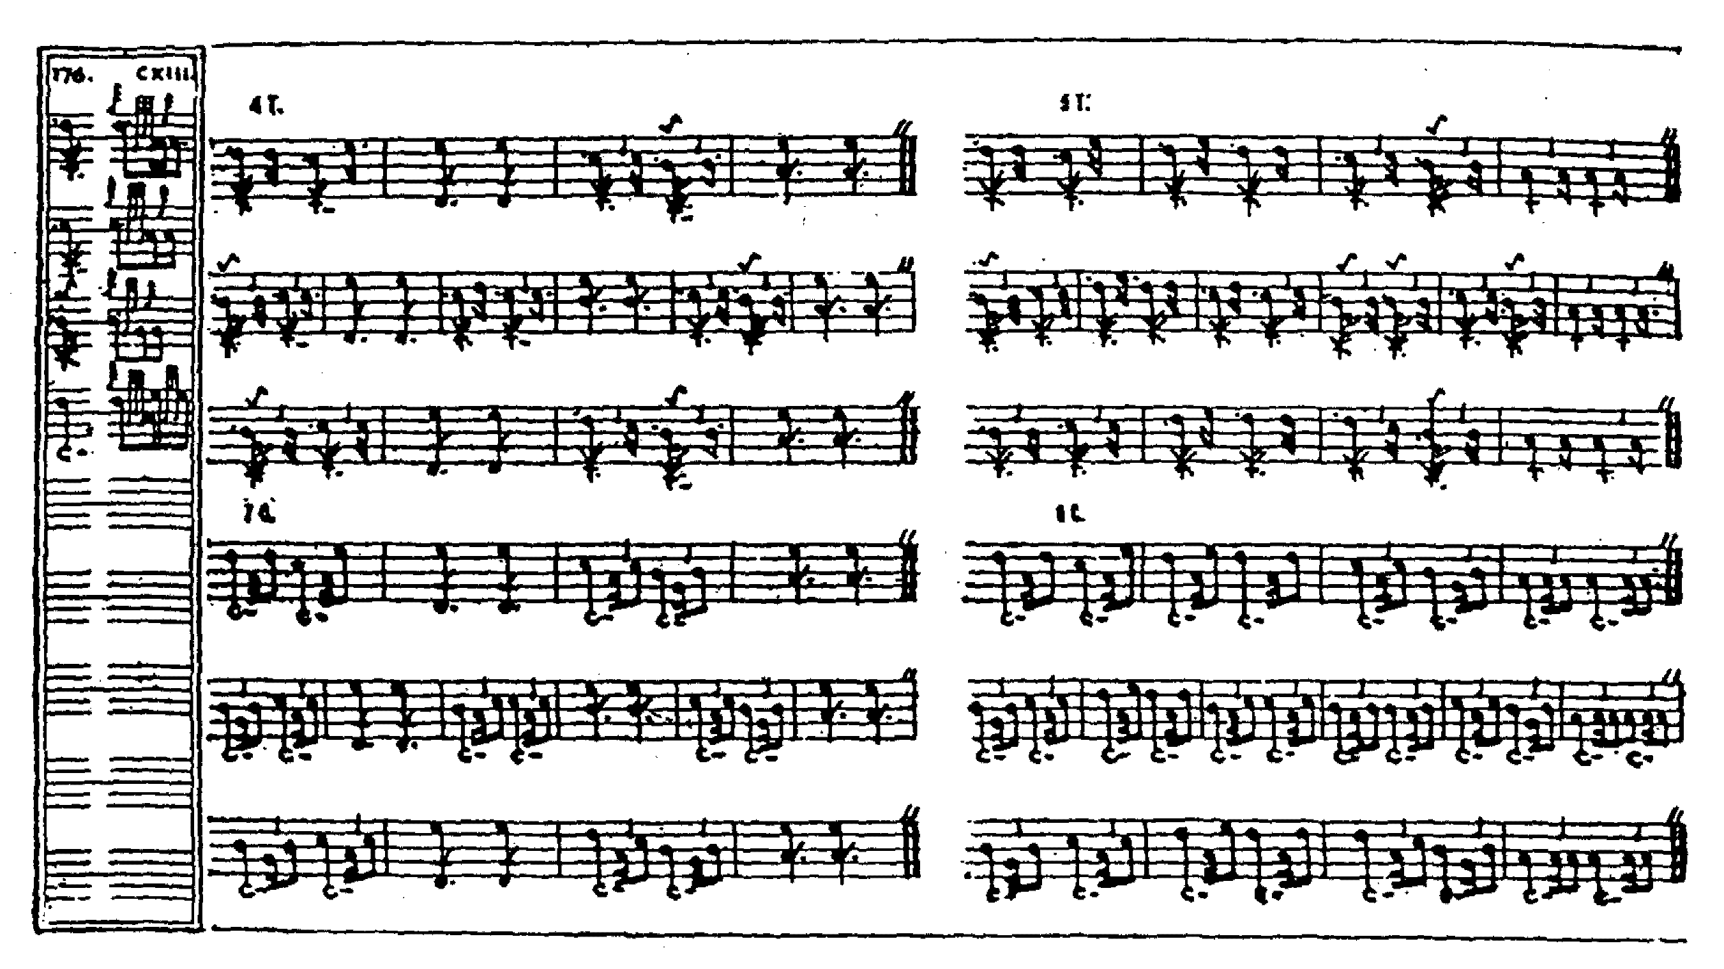

There are likely to be mixed views on Thomason’s solution to this apparent difficulty. His editorial amendments are often plausible and musically pleasing, but it is difficult to see what the added bar in line three contributes to the tune here. It sits rather awkwardly in its new surroundings, especially with the D melody note leading off the succeeding bar. If the circumstances of the tune’s composition—given below-- have been reported accurately, there may be an element of satire involved, the mocking high Gs which accord with the tune’s tonality up to that point like a poke in the eye, and the abrupt enforcement of closure, a bar short of where it should be, may be deliberately ironic. And yet the tune still works beautifully as a piece of music, and is a very satisfying piece to play.
David Glen adopts Thomason’s amendment in his manuscript, simply noting that the score in Ceol Mor does not repeat line one in the ground or variations sand that this should happen throughout. With the exception that he omits Thomason’s instruction to repeat the ground after the taorluath and crunluath doublings, David Glen’s score was obviously made with full knowledge of Thomason’s and follows the essentials of the Ceol Mor score rather closely. It is not reproduced here.

Commentary:

James Logan’s note in MacKay’s Ancient Piobaireachd remarks of “The Half Finished Piobaireachd” that--

This piobaireachd is so called from its having been the joint composition of Patrick òg
MacCrummen, and his pupil John Dall MacKay. Patrick intending to visit MacDonald of Clanranald, then in the island of Uist, was desirous of preparing a piobaireachd suitable to the occasion, and complimentary to the Lady MacDonald, for which purpose he retired to his private apartment. He there commenced the urlar or ground-work, two parts of which he repeated many times without being able to please himself exactly with another; when MacKay, who had placed himself to listen, unobserved at the door, struck up a measure so well adapted to those which his master had been playing, that opening the door with delight, he exclaimed, “Ah! you have done it; but it shall not bear the name I designed for it, but shall be called ‘the half-finished tune,’ as I made two parts, and you have made the other.”
The door which opened to MacCrummen’s room is now closed, but the positions of the
two parties are still pointed out. (“Historical and Traditional Notes”, p.27).

*

Electronic text © Dr. William Donaldson, Cambridge, Massachusetts, 1st October 2016

