Hail to my Country

“Hail to my Country” was composed by Charles Simeon Thomason (1833-1911) whose edition, Ceol Mor, is one of the landmarks of piping history. Thomason was a pupil of Angus MacKay’s nephew, Donald MacKay, and also of Sandy MacLennan and Sandy Cameron the elder, representatives in their time of two of the greatest 19th century piping dynasties. Thomason was a grandson of J. W. Grant of Elchies on Speyside to whom Donald MacDonald (1767-1840) sent his unpublished pìobaireachd manuscript, after the financial failure of his Ancient Martial Music of Caledonia (?1818/1819), “in the hopes that he, who of all his patrons had evinced the greatest interest in his work, would some day find himself in a position to perpetuate it” (“Ceol Mor Legends”, National Library of Scotland MS 3749, ff.83-4). Thomason inherited this manuscript following the death of his grandfather, and it was to form the basis of his monumental Ceol Mor published in 1900, the largest single collection of pìobaireachd ever to issue from the press.

Thomason was invited to became the first President of the Piobaireachd Society, formed in 1903, with the initial aim of broadening the repertoire usually heard in competition, using his dramatically abbreviated system of notation to achieve this—since its compression enabled the set tunes for a given year to be issued to intending competitors free of change. He was deposed as President in September 1904 following the takeover of the Society by a powerful group of wealthy and aristocratic landowners more intent on developing the military side of piping, and restoring the traditional notation. (For a detailed account of these events see The Highland Pipe and Scottish Society 1750-1950, pp.287-8, 440). The Society went on, in April 1905, to ban the playing in competitions under their control of any settings except those created by their own editors and published by the Society. This produced the present-day situation in which the laborious and inaccurate settings of Archibald Campbell, main editor of the Piobaireachd Society Collection (second series) and the Kilberry Book of Ceol Mor, are played, note for note, precisely as written--moving us from a situation in which a narrow range of tunes was played, but in a musically individual style, to one in which a wider range of tunes was played, but in exactly the same way.

“Hail to my Country” is a famous piece and was a favourite of R. B. Nicol of Balmoral, as it was of his teacher John MacDonald (1865-1953), who was probably the source of Bob Nicol’s laconic verdict on Thomason: “they put him out of the Piobaireachd Society; for knowing too much.” Bob grieved that his personal copy of Ceol Mor had been stolen from the pipers’ room at Balmoral Castle and was quick to propose it as a possible title to the English publishing firm, EP of Wakefield, who re-printed the complete text and music of both the 1900 and 1905 editions in 1975. In the summer of 1972, Bob Nicol had taught in Brittany, under the auspices of the Ministère de la Jeunesse et des Sports, the first time a Scottish piper had taught pìobaireachd in Brittany. Bob held classes in Rennes and Saint-Nazaire, and there was talk of his becoming official instructor to a new Breton school of pìobaireachd. He broadcast on French radio (ORTF), gave newspaper interviews, and created a considerable stir. The pupils were impressed by his light music, but even more by “his fantastic knowledge of pìobaireachd”.

The highlight of his farewell concert at Saint-Nazaire, was “Hail to my Country”, “beautifully played” according to one who heard it (P. Mollard, “Robert B. Nicol in Brittany”, Piping Times, 25/1, Oct. 1972, 29-30).

Bob Nicol’s setting was more cadenced in the ground, and slightly differently graced from Thomason’s and the gist of it is given below. The General’s score leaves room for a fairly wide range of individual timings and the performer is at liberty to interpret it accordingly—as with any piece of music in a normal musical world.

Here is the original setting as first published in Thomason’s Ceol Mor (1900, p.369):

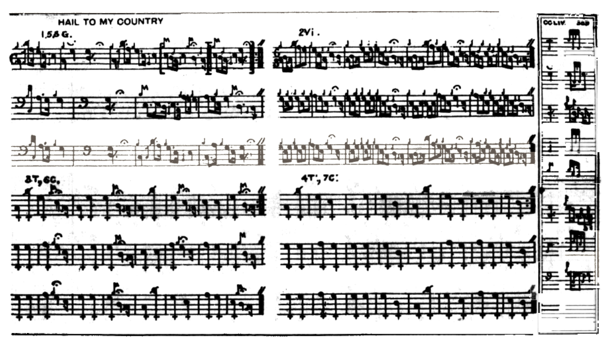

Thomason develops the tune through to taorluath and crunluath duinte variations singling and doubling with the ground re-stated at the end of the taorluath and crunluath doublings. The even quavers in Variation 1 seem to rest on similar assumptions to those which governed G S McLennan’s published light music—i.e. they are intended to offer performer choice rather than dictate precise time values. Bob Nicol timed the tune as follows:
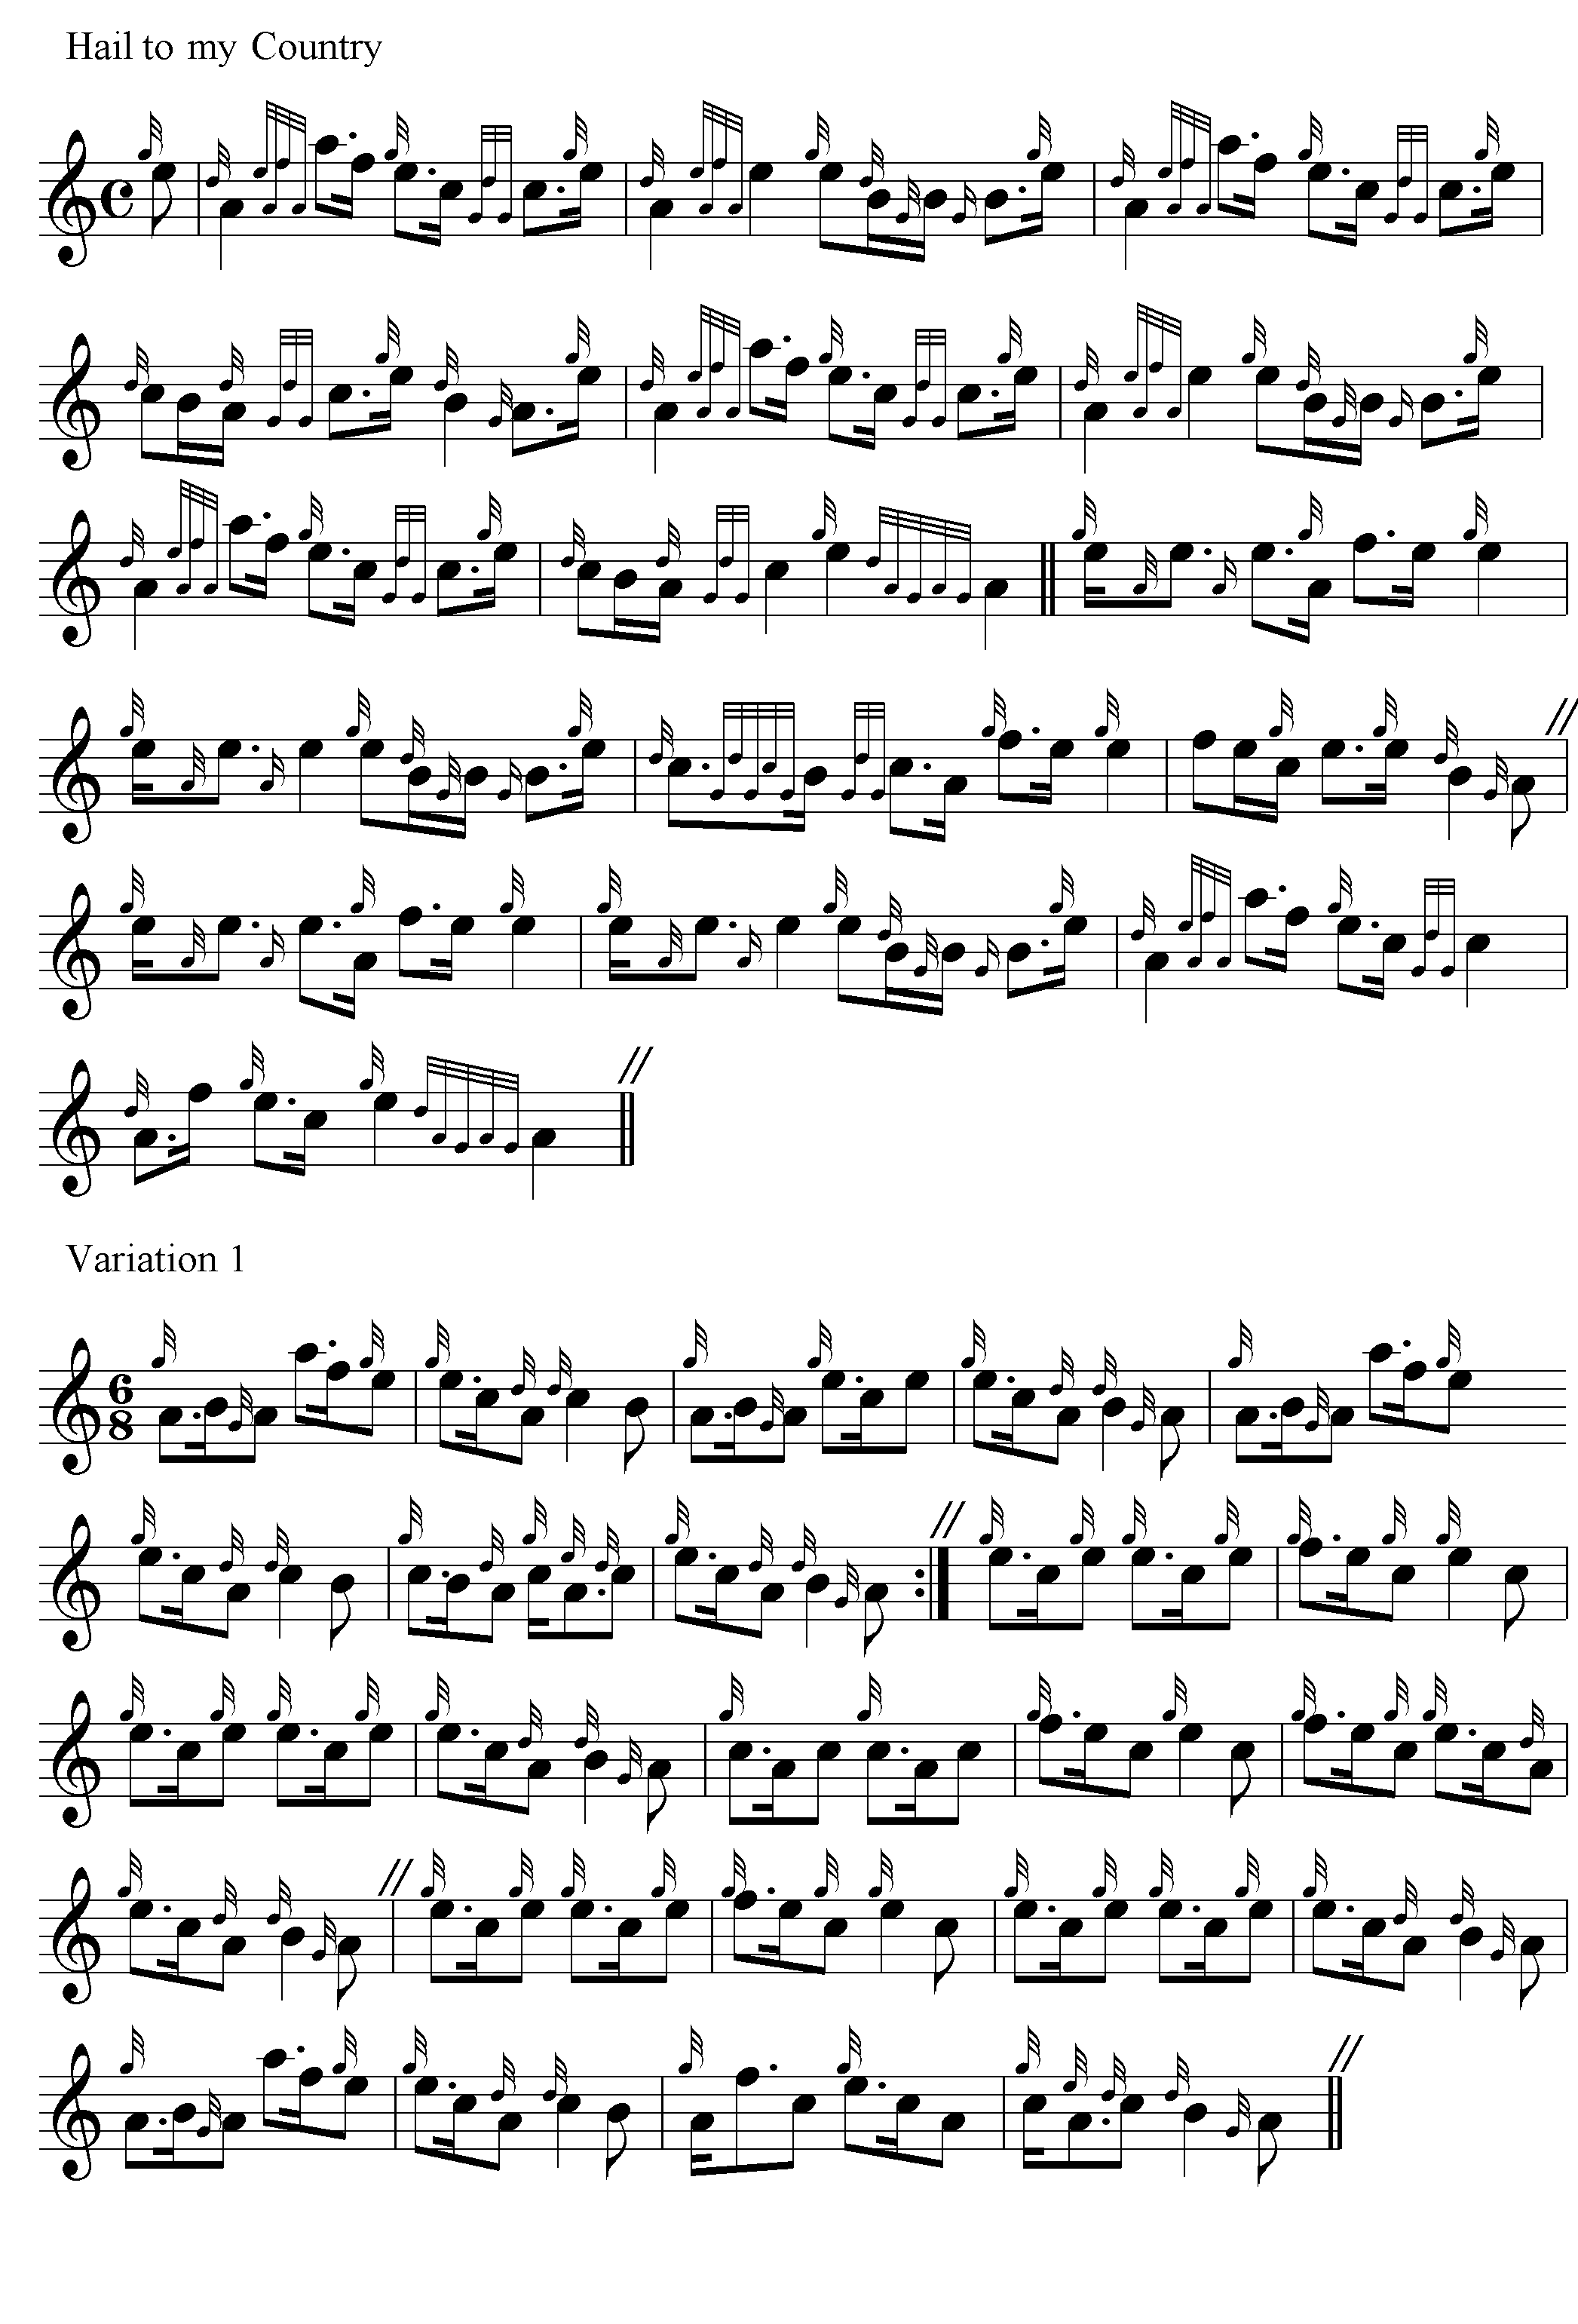
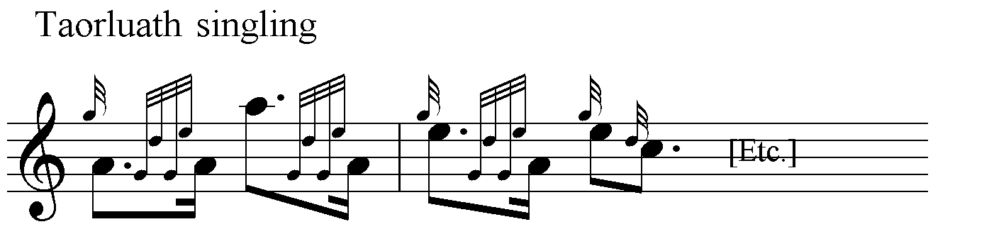

‘…and the rest is plain sailing’, as he would say.

Both Bob Nicol and Bob Brown timed the tune the same way, which is presumably how they got it from John MacDonald of Inverness. It is less austere than Thomason’s setting, but even so, some might prefer a few additional passing notes to soften the contour a bit further, perhaps as follows:

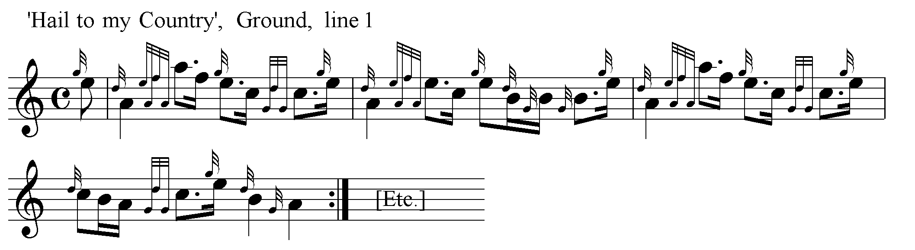

Commentary

Archibald Campbell, Kilberry, had a particular dislike of this tune. Campbell’s “Introduction” to his Kilberry Book of Ceol Mor asserted that “the art of composing piobaireachd is dead” and that “no good player since John Ban MacKenzie [1796-1864] is known to have attempted anything serious in that line” (p.16). The popularity of “Hail to my Country” with leading contemporary players was somewhat inconvenient for Campbell’s theory, therefore, and he often belittled the tune and its composer. Writing to the naturalist and piping judge Seton Gordon he stated:

Both [Willie] Ross and John MacDonald (I gather) consider Donald MacLeod to be the outstanding piper of the day… I rather wonder at a man like that bothering, or being permitted by John MacDonald to bother, with a thing like “Hail to my Country”. I know a lot about that tune…It is not Ceol Mor at all, but very inferior third rate Ceol Beag…
He [General Thomason]…told me about “Hail to my Country”. After many years absence in India he came on leave and woke up in the train on a fine summer morning at Dalwhinnie to see the beginnings of the Spey as he got towards Kingussie. He was so uplifted that the first line of the ground came into his head… Then for the second line, see (if you have it) the note in the Kilberry Book of Ceol Meadhonach about Ossian’s Lament for his Father. The second line was taken from the General’s interpretation of the second part of that tune, and he was very stubborn in condemning my version because he had put his own version into this piobaireachd.
It was very unfortunate that the General included tunes of his own composition in Ceol Mor. … The General’s own explanation to me was that he had put in his own compositions, not because he was proud of them, but in the hope that he would [?incite] others to compose piobd. – which showed a lack of appreciation of the situation.
I fear neither this tune nor any more of the General’s compositions is worth anything. … (Seton Gordon Papers, National Library of Scotland, General Correspondence 1940-45, 19/9/1942).

Campbell was not a very trustworthy witness, however, and thoughtful readers may place a question mark over some of his remarks unless they can be confirmed by another source. Take, for example, the allegation that Thomason’s tune was “lifted” from the rather obscure air “Ossian’s Lament for his Father”. The tune was actually the opening item in The Kilberry Book of Ceol Meadhonach (privately printed, 1909, 2nd edn., 1931), a collection of Highland airs and similar easy tunes edited by Archibald Campbell and his elder brother John. It goes like this:

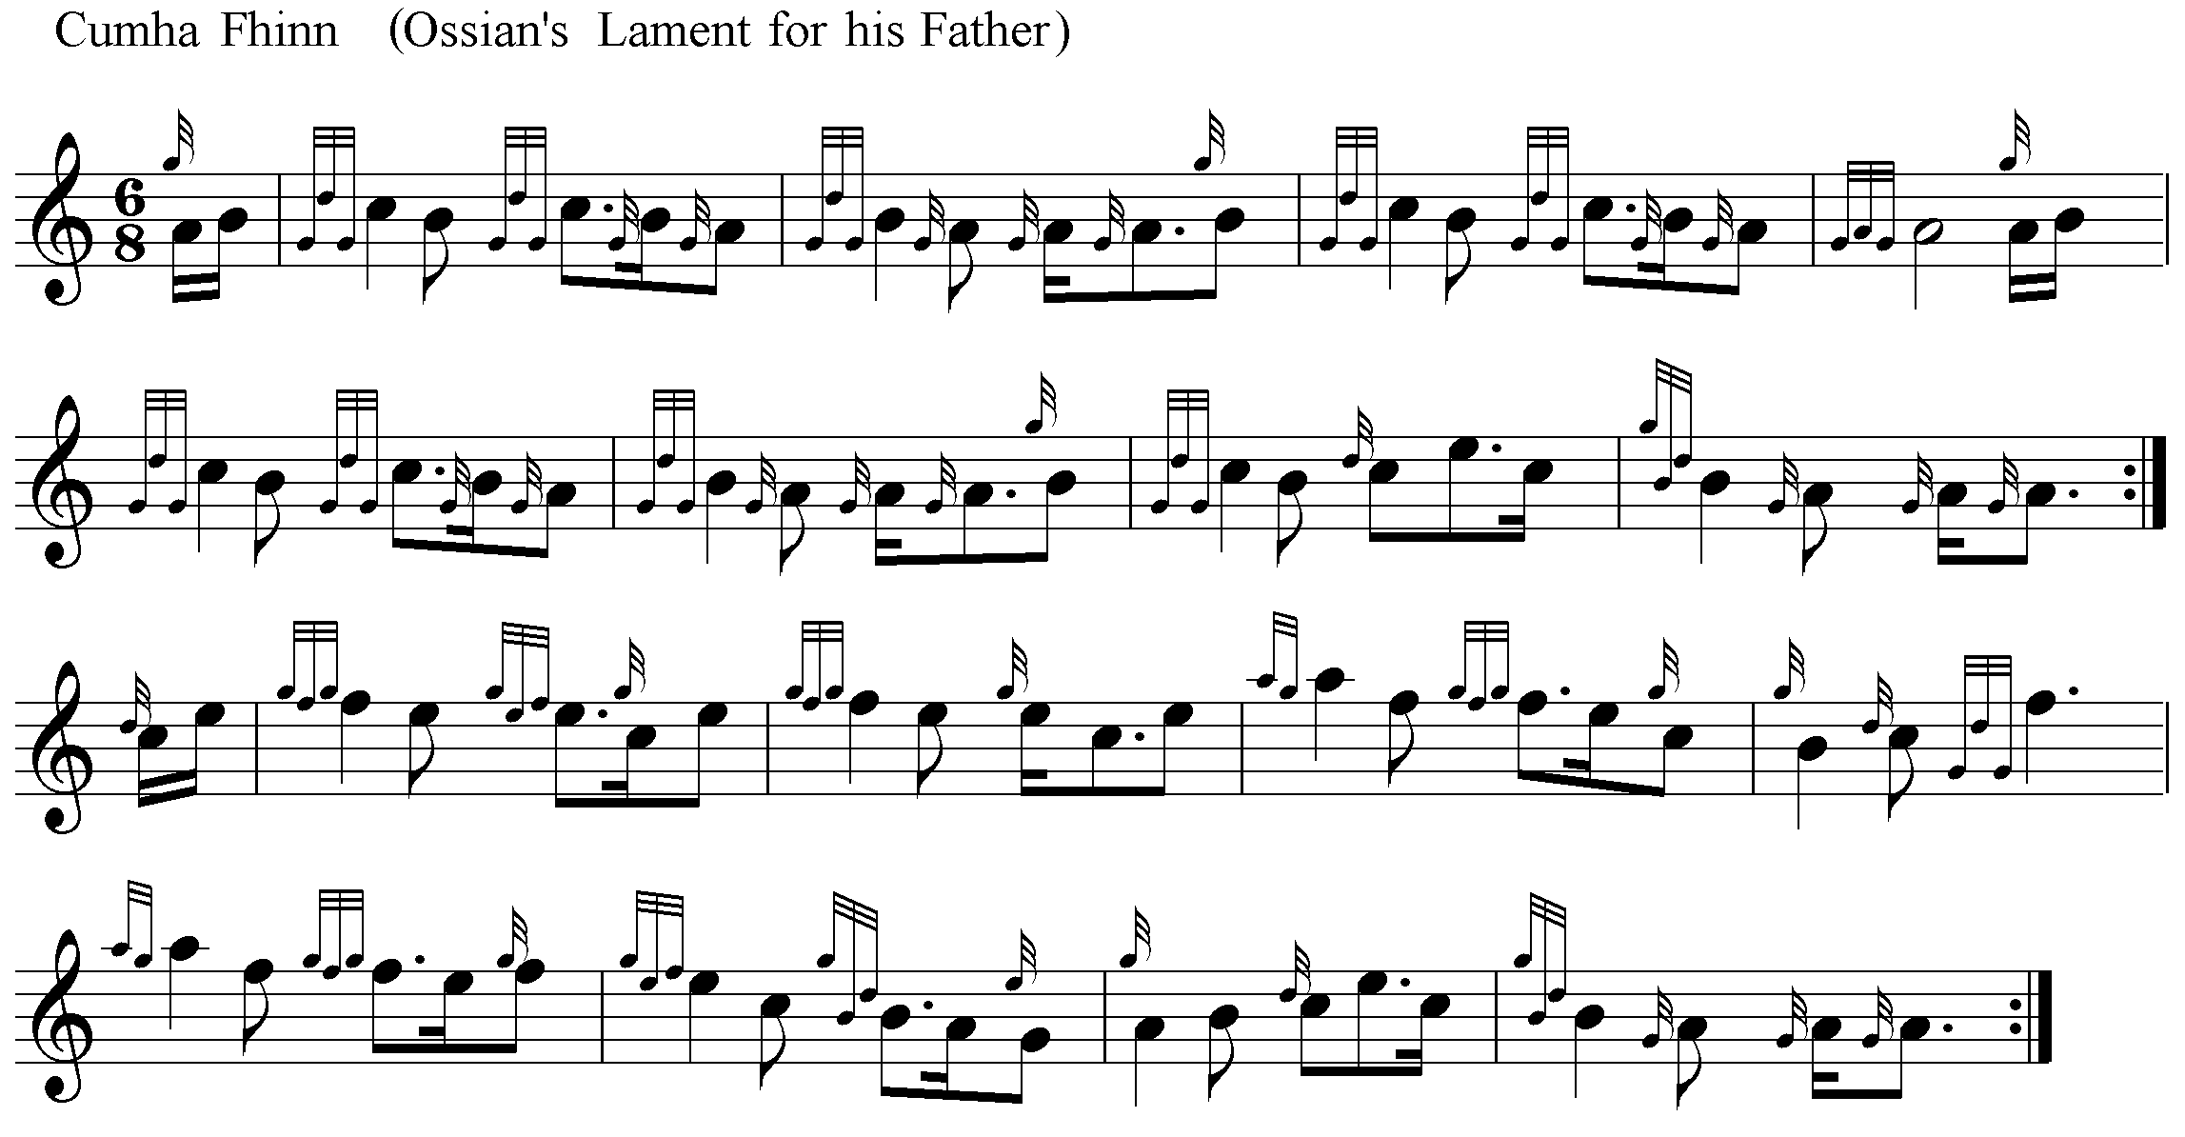

The accompanying note states that:

This tune was first obtained from Major General Thomason, the author of “Ceol Mor”, who became acquainted with it in rather a curious way. The late Donald Mackay, piper to His Majesty the King, then Prince of Wales, once sent General Thomason some reeds wrapped up in a piece of music paper, on which a number of notes were marked without time value or bar strokes. From these General Thomason elicited the present tune, which he afterwards found published in Logan’s Scottish Gael under the name now given. Logan’s setting is in 3-4 time, which is not nearly so effective as General Thomason’s arrangement in 6-8. The present setting, however, differs from that of General Thomason in the second part. General Thomason has E for the crotchet at the beginning of the first and second bars, while the editors prefer to make that E a start note and accent the following F. In this view they seem to be borne out by Logan.

In Logan’s Scottish Gael (2nd edn., ed., Alexander Stewart, 2 vols., Inverness 1876, ii, 8) the tune appears as follows:

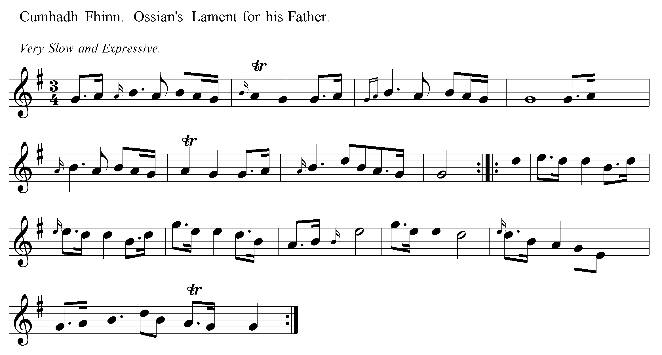

If there are obvious formative links between this and “Hail to my Country”, they are not evident to the present writer, but the above examples may enable readers to assess for themselves the charge that Thomason’s tune was second-hand as well as second-rate.

Later Campbell claimed that the dramatic throw from low to high A in bar one of the Ground was evidence of Thomason’s ignorance of pìobaireachd idiom, saying that it was hitherto unknown in ceòl mór and was the General’s own invention. But this was likewise incorrect. The movement was used by Donald MacDonald, as Thomason, who had edited MacDonald’s papers, will have been aware. And Campbell ought to have known this too. A photographic copy of MacDonald’s manuscript was presented to the Piobaireachd Society in 1911, and Archibald Campbell had access to this throughout his editorial work for the Society.

Although often inaccurate and founded in mere assertion, Campbell’s views came to be accorded an almost Scriptural authority within the Piobaireachd Society. Towards the end of the 20th century the following discussion took place between leading members of the Society at the Ardvasar Seminar in Skye, sponsored by the Clan Donald Trust. The subject was “new compositions”:

S. MacNeill: It’s a funny thing. Donald [MacLeod] was without doubt the greatest composer of light music in his time, and John MacLellan to my mind is not a good composer of light music. Yet John composes better piobaireachd than Donald did. Donald’s piobaireachds are really just slow airs with variations to them. They are not real piobaireachds.
A. Wright: Although some of them, take the Salute to the Bobs of Balmoral that’s a good one, a well constructed tune.
R. Morrison: They are kind of Hail to my Country tunes.
S. MacNeill: Hail to my Country is not a piobaireachd.
A. MacNeill: No, it’s not.
S. MacNeill: Although Bob Brown used to play it in competition...
(Piping Times, 41/6, March 1988, p.39-47).

“Hail to my Country” was a favourite of some of the leading players and teachers of the 20th century, John MacDonald of Inverness, R. U. Brown and R. B. Nicol of Balmoral, and Donald MacLeod. Yet the hostility of Archibald Campbell was sufficient to place it almost beyond the pale. While Campbell offered no adequate explanation of why this appealing tune should not be considered a pìobaireachd, his views were casually accepted as axiomatic by senior members of the Piobaireachd Society, revealing a good deal about the arbitrary way in which notions of “authority” and “authenticity” were constructed during his lifetime and the generation that followed.

* * *

Electronic text © Dr. William Donaldson, Aberdeen. Scotland, December 2002; revised Cambridge, Massachusetts, January 2025.

