Gu ma Slaint dhuit Donail (Good health to you Donald)

This tune is found in a single manuscript source:
--Nether Lorn canntaireachd, ii, 11-14

Colin Mór Campbell treats the tune as follows:

1^{st.} Cherede cheodroo hiharin cheendo hihorodo hinodro hindreho hiodin
2^{d}. Cherede cheodroo hiharin cheendo hihorodo hinodro hiodin hiodro hiodrorodin chehodroe hinodrodin hioedro hihorodo hihorodo hinodro hindreho hiodin
3^{d}. Cherede cheodro hiharin cheendo hidhrodo hinodro hindreho hiodin

D1^{st.} Cherede diliodroo hiharin cheendo hihorodro hinodro Iendreo hiodin
2^{d.} Cherede diliodroo hiharin cheendo hihorodo hinodro hiodin hiodro hiodrorodin Iedreve hinodrodin hioedro hihorodo hihorodo hinodro Iendreho hiodin
3^{d.} Cherede diliodroo hiharin cheendo hihorodo hinodro Iendreho hiodin

S ffirst Motion
1st. Hinde hinde hinI hindo hiharin hinto hindo hinI hinde hiodin
2^{d.} Hinde hinde hinI hindo hiharin hinto hindo hihorodo hindo hindo hihorodo hihorodo hindhe hindhe hinde hinI hindhe hinde hiodin
3^{d.} Hinde hinde hinI hindo hiharin hinto hindo hinI hinde hiodin

D 1st. Hinde hinde hinI hindo hindarendan hinto hindo hinI hinde hiodaridto
2^{d.} Hinde hinde hinI hindo hindariddan hinto hindo hiotroeoao hindo hindo hiotroeoao hiotroeoao hindhe hindhe hinde hinI hindhe hinde hiodaridto
3^{d.} Hinde hinde hinI hindo hindariddan hinto hindo hinI hinde hiodaridto

S. Taolive
1st. Chedarid chedarid Idarid hodarid hiharin hiodarid hodarid Idarid chedarid hiodin
2^{d.} Chedarid chedarid Idarid hodarid hiharin hiodarid hodarid Idarid hihorodo hodarid hodarid hihorodo hihorodo hedarid hedarid chedarid Idarid hedarid chedarid hiodin
3^{d.} Chedarid chedarid Idarid hodarid hiharin hiodarid hodarid Idarid chedarid hiodin

D 1st. Chedarid chedarid Idarid hodarid hindarid hiodarid hodarid Idarid chedarid hiodarid
2^{d.} Chedarid chedarid Idarid hodarid hindarid hiodarid hodarid hiodarid hiodarid hodrid hodarid hiodarid ffour times, hedarid hedarid chedarid Idarid hedarid chedarid hiodarid
3^{d.} Chedarid chedarid Idarid hodarid hindarid hiodarid hodarid Idarid chedarid hiodarid

S. Crulive
1st. Chebandre chebandre Ibandre hobandre hiharin hiobandre hobandre Ibandre chebandre hiodin
2^{d.} Chebandre chebandre Ibandre hobandre hiharin hiobandre hobandre hihorodo hobandre hobandre hihorodo hihorodo hebandre hebandre chebandre Ibandre hebandre chebandre hiodin
3^{d.} Chebandre chebandre Ibandre hobandre hiharin hiobandre hobandre Ibandre chebandre hiodin

D 1st. Chebandre chebandre Ibandre hobandre hinbandre hiobandre hobandre Ibandre chebandre hiobandre
2^{d.} Chebandre chebandre Ibandre hobandre hinbandre hiobandre hobandre hiobandre hiobandre hobandre hobandre hiobandre ffour times, hebandre hebandre chebandre Ibandre hebandre chebandre hiobandre
3^{d.} Che bandre chebandre Ibandre hobandre hinbandre hiobandre hobandre Ibandre chebandre hobandre

The structure is unusual, moving from a 4 8 4 bar pattern in the ground and thumb variation to a 3 6 3 pattern in the later variations. A progressive concentration of metre in this way is not uncommon and thoughtful players may wish to consider some of the alternatives before committing to James Campbell and Archibald Kenneth’s score contained in the Piobaireachd Society Collection (second series, vol. 13, pp.395-7). While Campbell and Kenneth’s score is very symmetrical (a symmetry achieved by swapping material between parts) it is difficult not to feel that this may have been achieved at the cost of musical urgency and dynamism. The following tentative reading in staff notation may give some idea of the possibilities here:

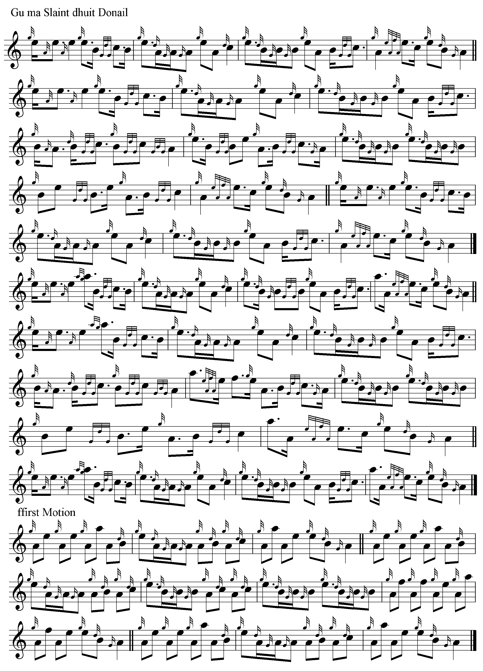
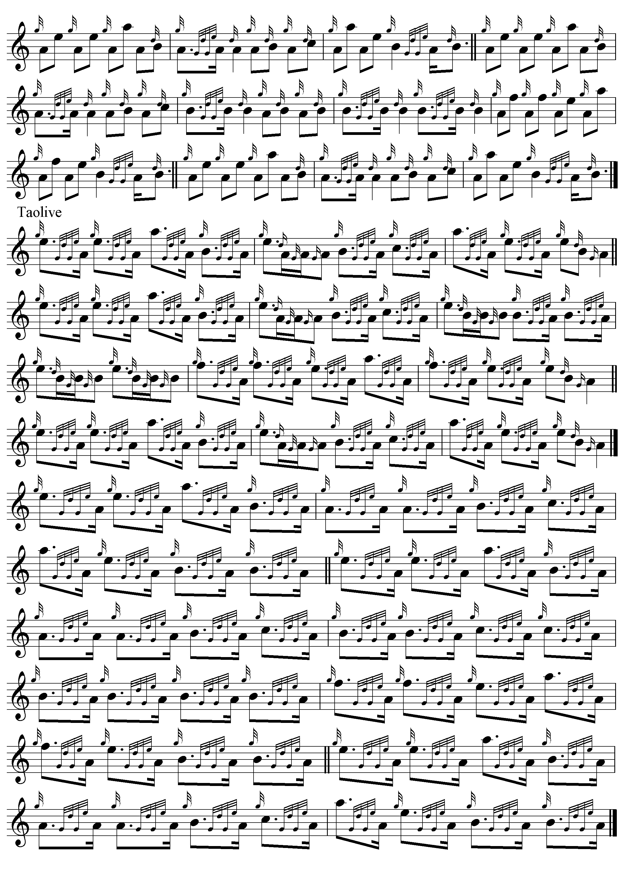

and so on. The crunluath can be taken off the taorluath singling and doubling above.

Since the bulk of the tune is metrically regular it seems reasonable to suppose that the sections which are not so are the result of scribal error rather than deliberate artistic intention, and the interpretation above has been guided by this. At the same time, I have tried to stay as close to the original score as possible.

* * *

Electronic text © Dr. William Donaldson, Aberdeen, Scotland, July 2006

