The Gathering of the MacNabs

There are settings of this tune in the following manuscript sources:
--Colin Campbell’s “Nether Lorn Canntaireachd”, i, 17-19;
--Peter Reid’s MS, f.54;
--John MacDougall Gillies’s MS, f.112;
--Robert Meldrum’s MS, ff.187-189.

The tune appears to have been unpublished before its appearance in the Piobaireachd Society Collection (second series), v, 149-50, which cites the Nether Lorn Canntaireachd as its main source.

Colin Campbell treats the tune as follows:

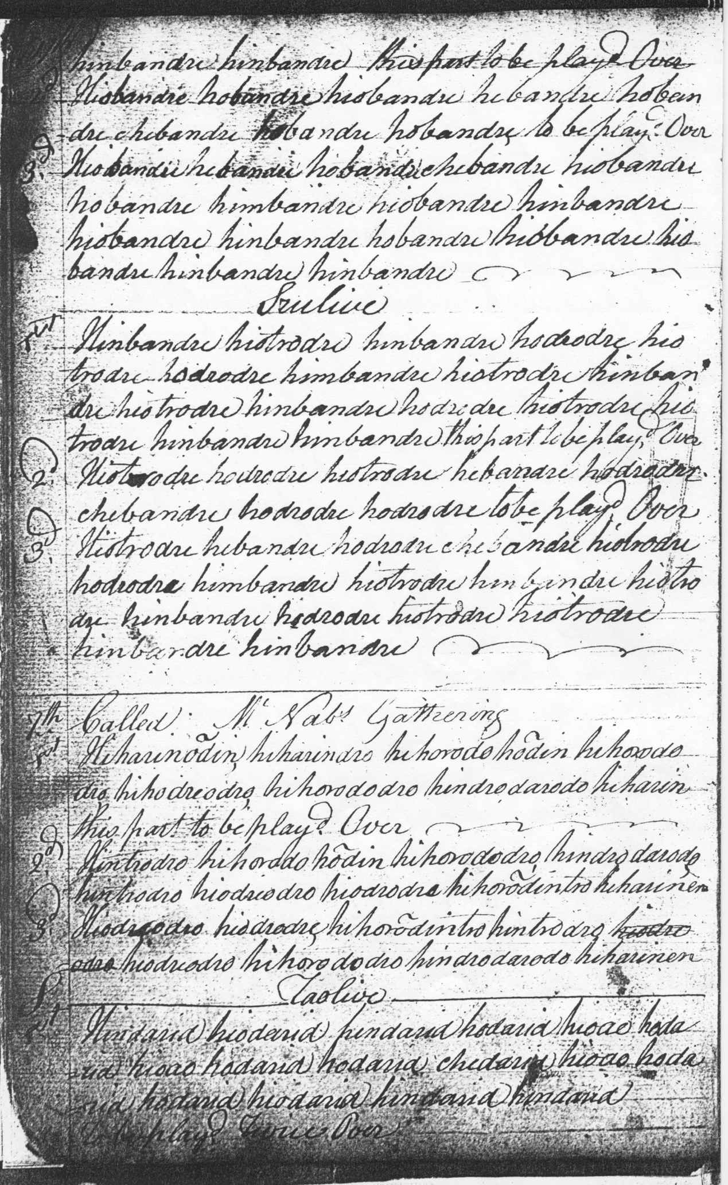

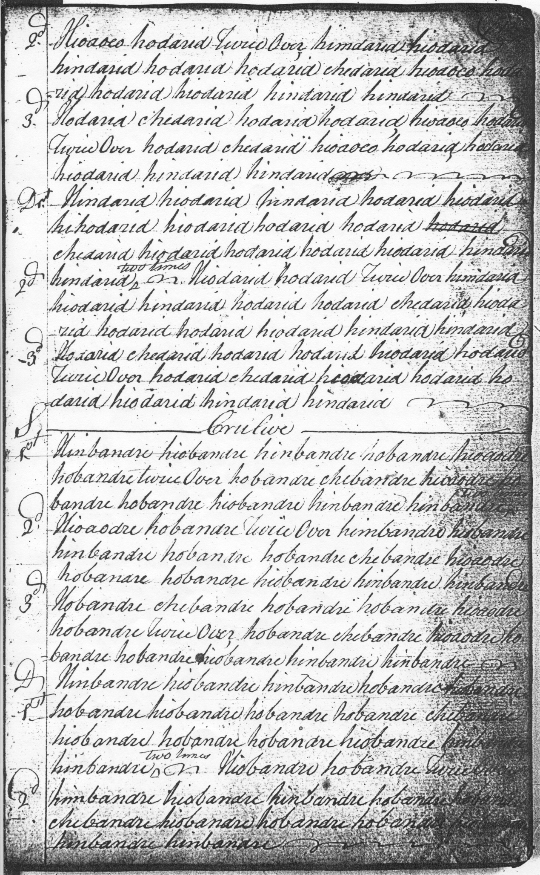

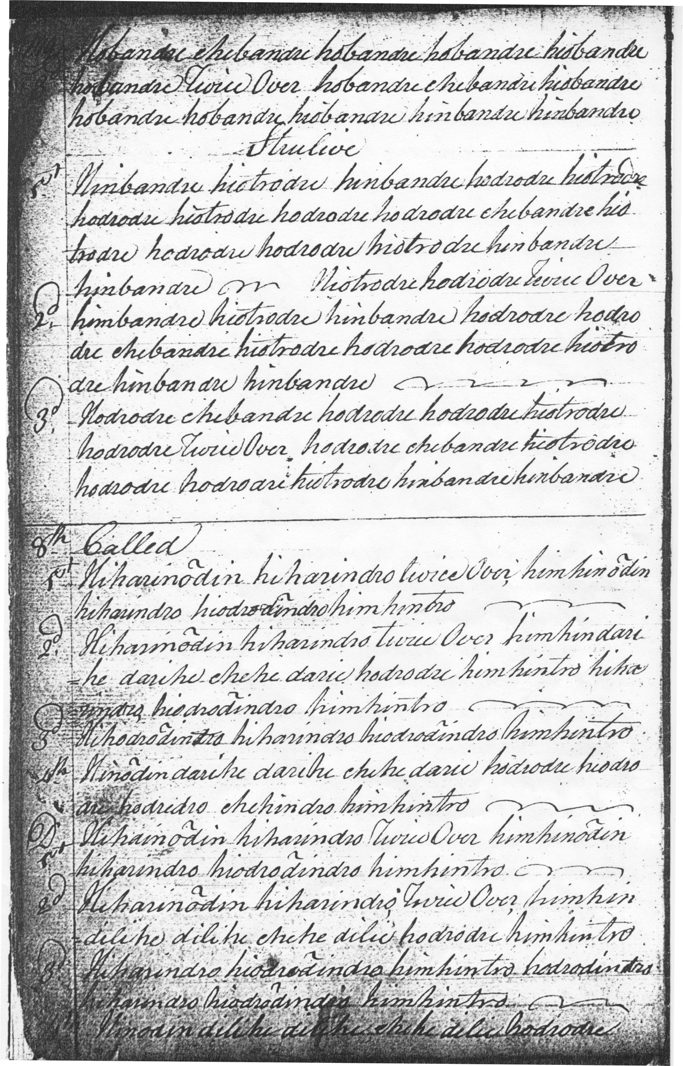

7th Called McNabs Gathering

1st Hiharinodin hiharindro hihorodo hodin hihorododro hihodreodro hihorododro hindrodarodo hiharin[?en] this part to be playd [?twice] Over
2^{d} Hintrodro hihorodo hodin hihorododro hindro darodo hintrodro hiodreodro hiodrodre hihorodintro hiharinen
3rd Hiodreodro hiodrodre hihorodintro hintrodro hiodreodro hihorododro hindrodarodo hiharinen

Taolive

1st Hindarid hiodarid hindarid hodarid hioao hodarid hioao hodarid hodarid chedarid hioao hodarid hodarid hiodarid hindarid hindarid To be playd Twice Over
2^{d} Hioaoeo hodarid Twice Over himdarid hiodarid hindarid hodarid hodarid chedarid hioaoeo hodarid hodarid hiodarid hindarid hindarid
3^{d} Hodarid chedarid hodarid hodarid hioaoeo hodarid Twice Over hodarid chedarid hioaoeo hodarid hodarid hiodarid hindarid hindarid
D 1st Hindarid hiodarid hindarid hodarid hiodarid hihodarid hiodarid hodarid hodarid chedarid hiodarid hodarid hodarid hiodarid hindarid hindarid Two Times
2^{d} Hiodarid hodarid Twice Over himdarid hiodarid hindarid hodarid hodarid chedarid hiodarid hodarid hodarid hiodarid hindarid hindarid
3^{d} Hodarid chedarid hodarid hodarid hiodarid hodarid Twice Over hodarid chedarid hiodarid hodarid hodarid hiodarid hindarid hindarid

Crulive

1st Hinbandre hiobandre hinbandre hobandre hioaodre hobandre twice Over hobandre chebandre hioaodre hobandre hobandre hiobandre hinbandre hinbandre Two times
2^{d} Hioaodre hobandre Twice Over himbandre hiobandre hinbandre hobandre hobandre chebandre hioaodre hobandre hobandre hiobandre hinbandre hinbandre
3^{d} Hobandre chebandre hobandre hobandre hioaodre hobandre Twice Over hobandre chebandre hioaodre hobandre hobandre hiobandre hinbandre hinbandre

D 1st Hinbandre hiobandre hinbandre hobandre hiobandre hobandre hiobandre hobandre hobandre chebandre hiobandre hobandre hobandre hiobandre hinbandre hinbandre Two Times
2^{d} Hiobandre hobandre Twice Over himbandre hiobandre hinbandre hobandre hobandre chebandre hiobandre hobandre hobandre hiobandre hinbandre hinbandre
3^{d} Hobandre chebandre hobandre hobandre hiobandre hobandre Twice Over hobandre chebandre hiobandre hobandre hobandre hiobandre hinbandre hinbandre

Strulive

1st Hinbandre hiotrodre hinbandre hodrodre hiotrodre hodrodre hiotrodre hodrodre hodrodre chebandre hiotrodre hodrodre hodrodre hiotrodre hinbandre hinbandre
2^{d} Hiotrodre hodrodre Twice Over himbandre hiotrodre hinbandre hodrodre hodrodre chebandre hiotrodre hodrodre hodrodre hiotrodre hinbandre hinbandre
3^{d} Hodrodre chebandre hodrodre hodrodre hiotrodre hodrodre Twice Over hodrodre chebandre hiotrodre hodrodre hodrodre hiotrodre hinbandre hinbandre

In the Taolive above, hioao and hioaoeo seem clearly equivalent. Colin Campbell develops the tune as follows: ground; taorluath singling, doubling; crunluath singling, doubling; crunluath a=mach.

This is a surging, tuneful piece, whose ground, as Peter Reid would also seem to indicate below, should be timed somewhat thus:

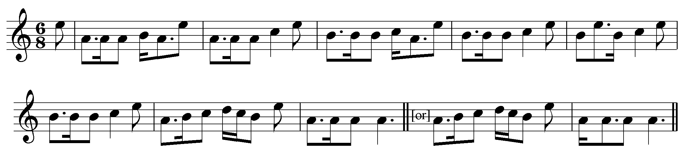

Peter Reid develops the tune as follows: ground, followed by a taorluath singling. There is no indication of further variations:

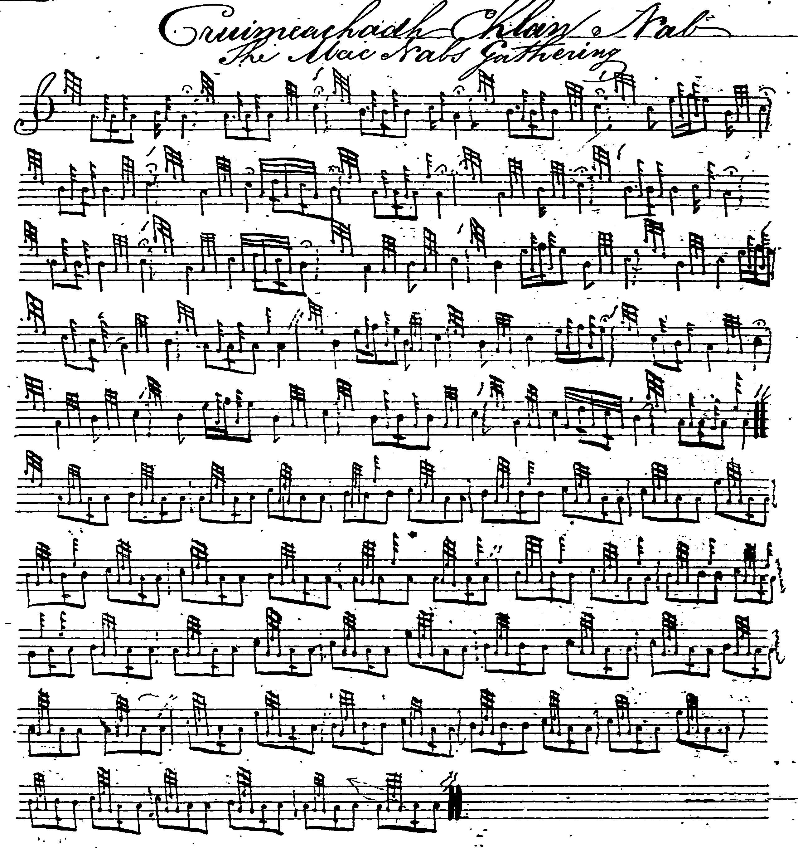

--John MacDougall Gillies’s score is a mere outline sketch and is not reproduced here.

--Robert Meldrum’s score does not add to existing interpretations and is not reproduced here.

Commentary:

“MacNabs’ Gathering “is one of a family of tunes which share very similar opening gestures:

Nether Lorn, Vol.1, “1st Called Kepper Eaggarich [The Unjust Incarceration]
Hiharin hioen, hodrooen, himen hoen, hiotroenem...”
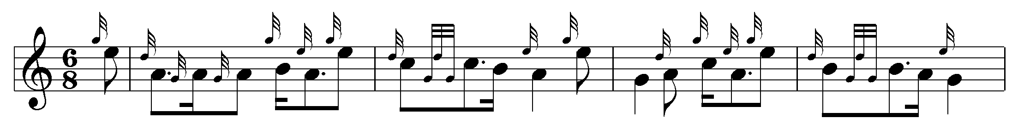

Nether Lorn, Vol.1, “6th Called Spaddarich Bharoch [The Pride of Barra]
Hiharinodin hiharindo, hiodrorodin hiham bantro...”

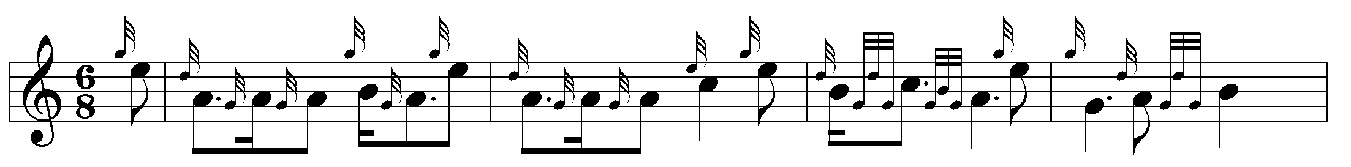

Nether Lorn, Vol.1, “9th Called Bhratich Bhan’ [MacKay’s White Banner]
Hiharinodin hihodaro, do, hiharinodin hihodaro, do, himhinhodin hiodrodin tro...”

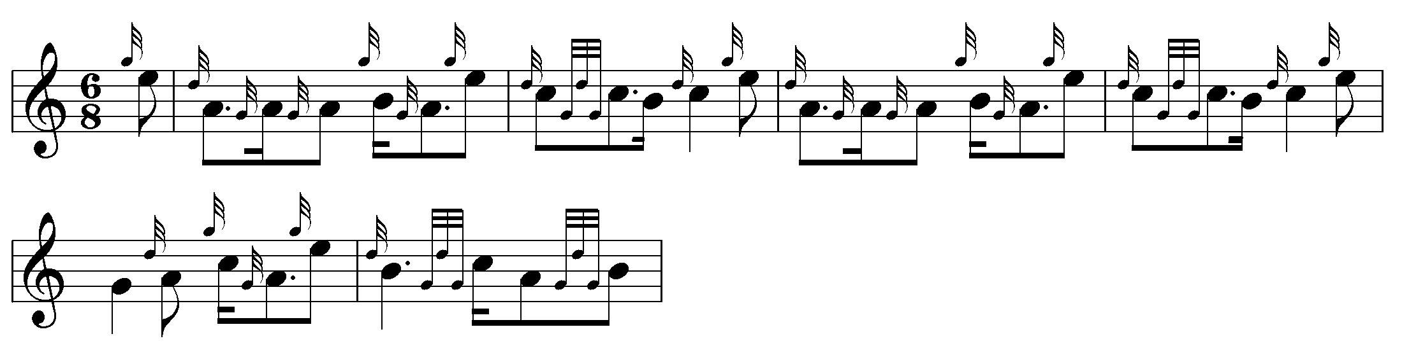

Nameless (based on Angus Mackay’s MSS)
“Hiharinodin hiharindro, hiharinodin hiharindro, hiemdanodin hiharindro...”

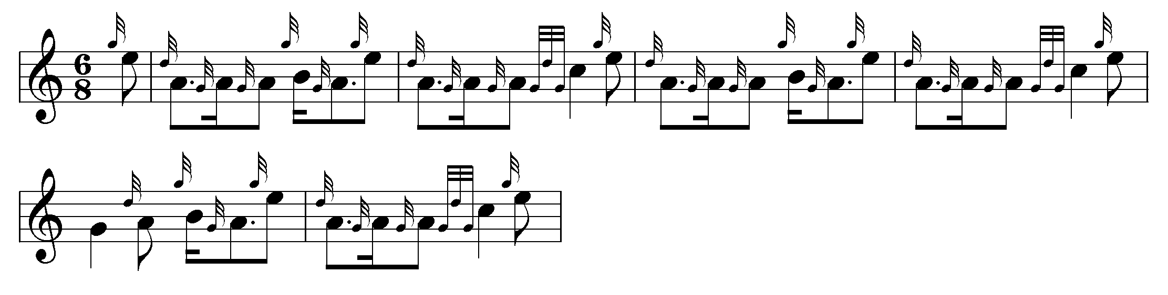

For more detailed analysis see the chapter “Canntaireachd and the Oral Mode” in The Highland Pipe and Scottish Society 1750-1950, pp.448-460.

The tune may well be a compliment to Francis MacNab of MacNab, the last of the MacNab lairds, who was a prominent judge at the early piping contests of the Highland Societies of London and Scotland. He was a most eccentric character by all accounts and there are many stories told of him. “The last Laird of Macnab, before the clan finally broke up and emigrated to Canada, was a well-known character in the country, and being poor, used to ride about on a most wretched horse, which gave occasion to many jibes at his expense. The laird was in the constant habit of riding up from the country to attend the Musselburgh Races. A young wit, by way of playing him off on the racecouse, asked him, in a contemptuous tone, ‘Is that the same horse you had last year, laird?’ ‘Na,’ said the laird, brandishing his whip in the interrogator’s face in so emphatic a manner as to preclude further questioning—‘na; but it’s the same whup.’” (Dean Ramsay, Reminiscences of Scottish Life and Character, 1912, p.226). The diarist, Henry Cockburn, touring in the Killin district remarked “The burial-place of the Macnabs is more singular, and liker the final resting-place of a race of savage chiefs. It looks as if they had expected to be obliged to stand a siege even in the grave.” (Circuit Journeys, 1888, p.302). The novelist, Sir Walter Scott, who was fond of a good story, was one morning at breakfast regaling his wife with anecdotes about The MacNab: “‘who, poor fellow’, he remarked, ‘is dead and gone.’ ‘Why, Mr. Scott’, she interrupted him, ‘Macnab’s not dead, is he?’ ‘Faith, my dear,’ Scott responded gravely, ‘if he’s not dead they’ve done him a great injustice—for they’ve buried him.’” (Edgar Johnson, Sir Walter Scott The Great Unknown, 1970, i, 581).

* * *

Electronic text © Dr. William Donaldson, Aberdeen, Scotland, October 2004; revised Cambridge, Massachusetts, February 2025.

