Gathering of the MacDonalds of Clanranald (Cnocan Ailean mhic Ailean ‘ic Iain)

There are settings of this tune in the following manuscript sources:
Colin Mór Campbell, Nether Lorn Canntaireachd, ii, 173-5 (with the title “MacDonalds Gathering”);
Donald MacDonald’s MS, ff.73-5 (with the title “Gathering of the MacDonalds of Clanranald”);
Angus MacKay’s MS, i, 156-157 (with the title “The MacDonalds Gathering. Cnocan Aillean Mhic Aillean 'ic Iain”);
D. S. MacDonald’s MS, i, 130-31;
David Glen’s MS, f.143;

and in the following published sources:
C. S. Thomason, Ceol Mor, p.46;
Roderick D. Cannon and Keith Sanger, eds., Donald MacDonald’s Collection of Piobaireachd Volume 2, Manuscript (1826) (n.p., 2011), pp.62-3.

Colin Campbell sets the tune like this:

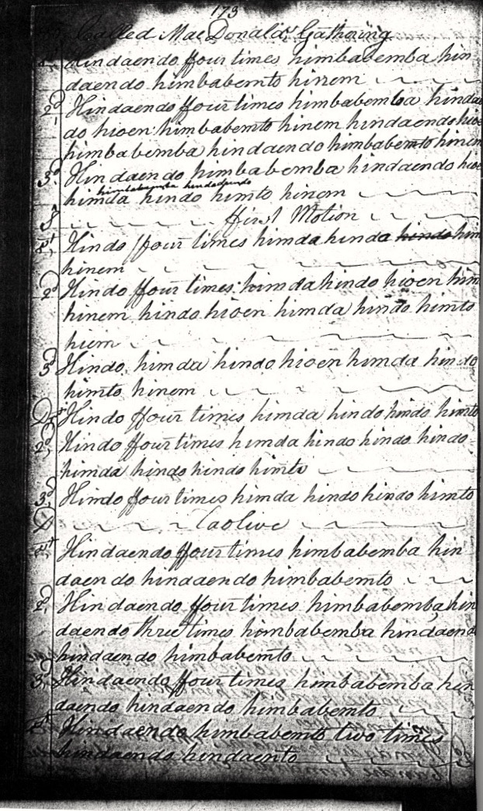
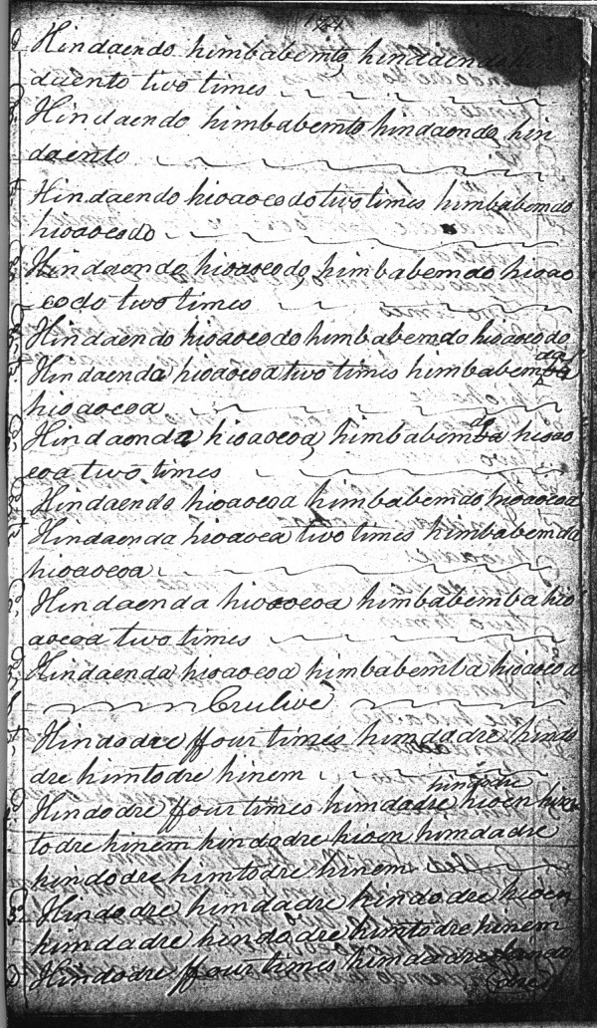
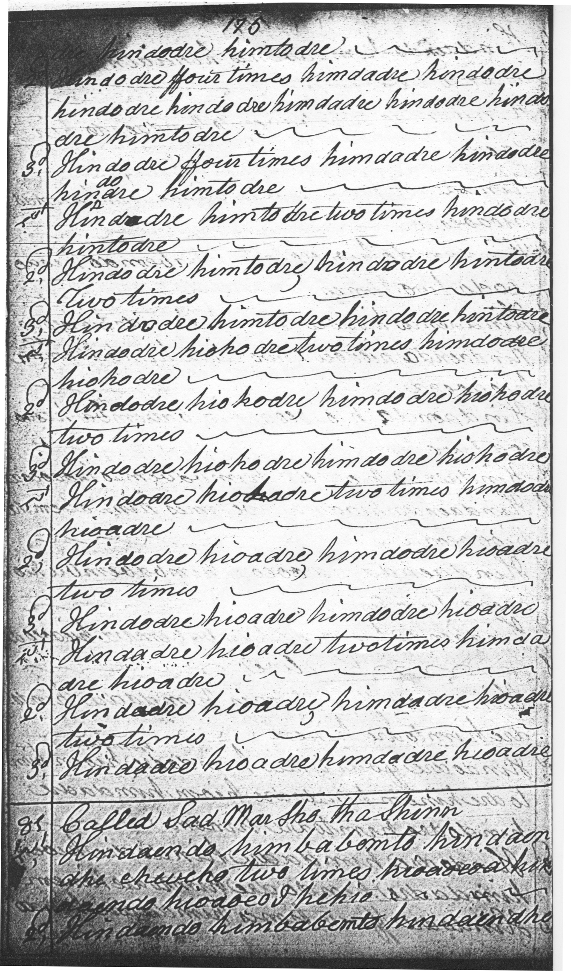

Colin Campbell’s setting is carelessly notated: there is a missing syllable “hindaento” in line two of the ground, and two vocables have been missed and subsequently added in line three. The development is along the following lines, and presents an excellent example of Colin Mór’s highly distinctive style:

Ground: with four bars in the first line, eight in the second and four again in line three.
ffirst Motion singing: a siubhal, played strongly “down”.
ffirst Motion doubling.
Taolive singling: which moves the tune to a four-six-four bar pattern.
Taolive later variations: move the tune to its final three-three-two bar pattern, a dramatic foreshortening of the metre which we see in other gathering and battle tunes, a highly-charged device, which drives the tune to its climax through a series of scurrying ostinato figures.
Crulive: likewise developed through multiple variations in similar style to the taolive.
In staff-notated form, the tune would look something like this:

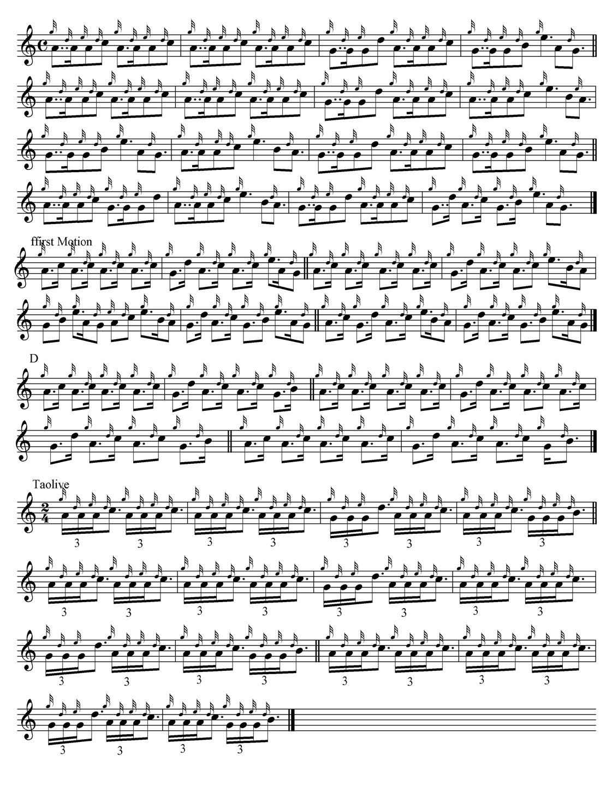
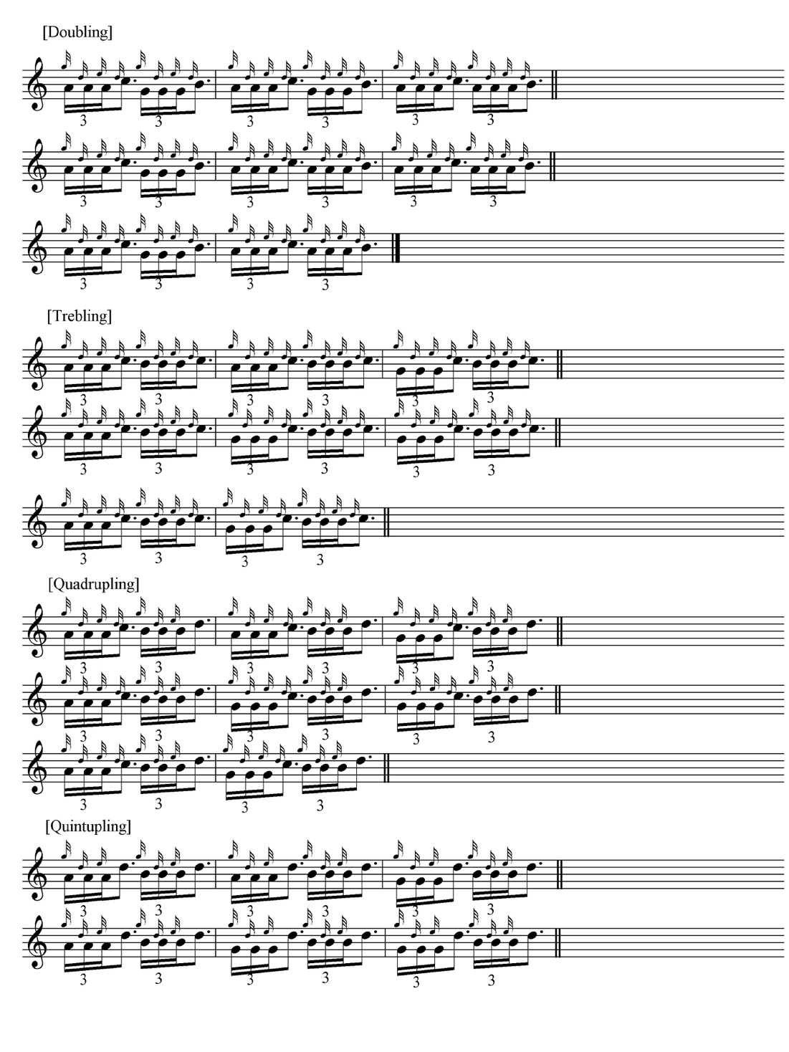

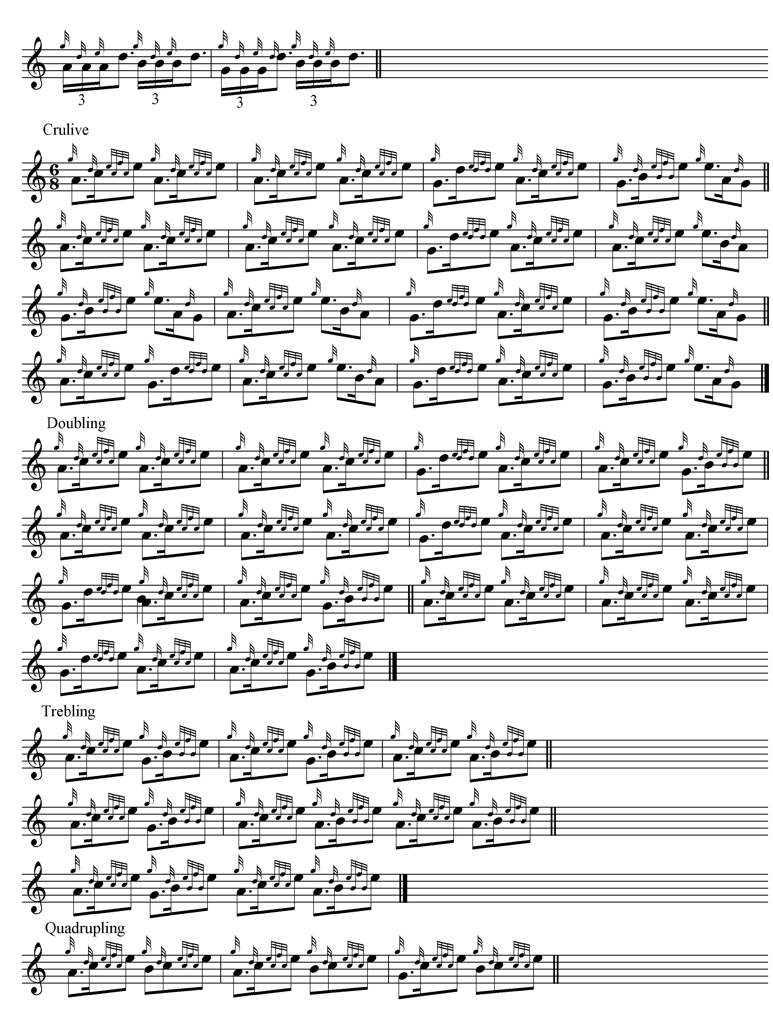
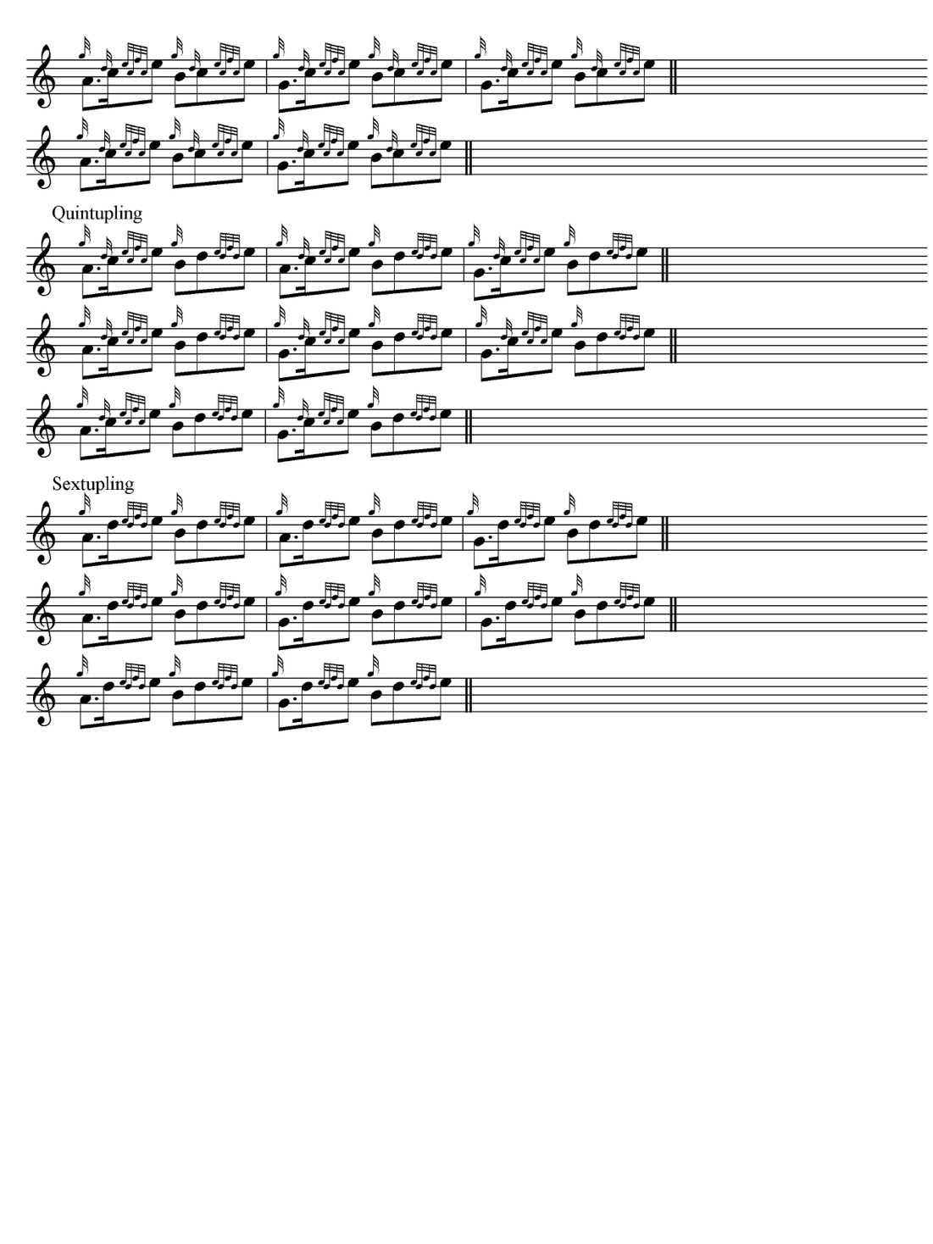

This long, technically demanding, and strikingly asymmetrical tune is full of interest and variety. We note how Colin Campbell moves to the shorter line immediately after the taorluath singling to pack maximum energy into the following sequence; while in the crunluath, the doubling follows the themal pattern of the singling in the normal fashion, and the shorter line is delayed until the trebling. This illustrates the variety of approach possible in the days of the older tradition before the Highland Societies and their successors got to work to standardize the music and strip the master players of their creative autonomy. Taken altogether, Colin Campbell approaches the tune with a freedom and inventiveness that sometimes makes other later editors look pedestrian.

Donald MacDonald sets the tune like this:

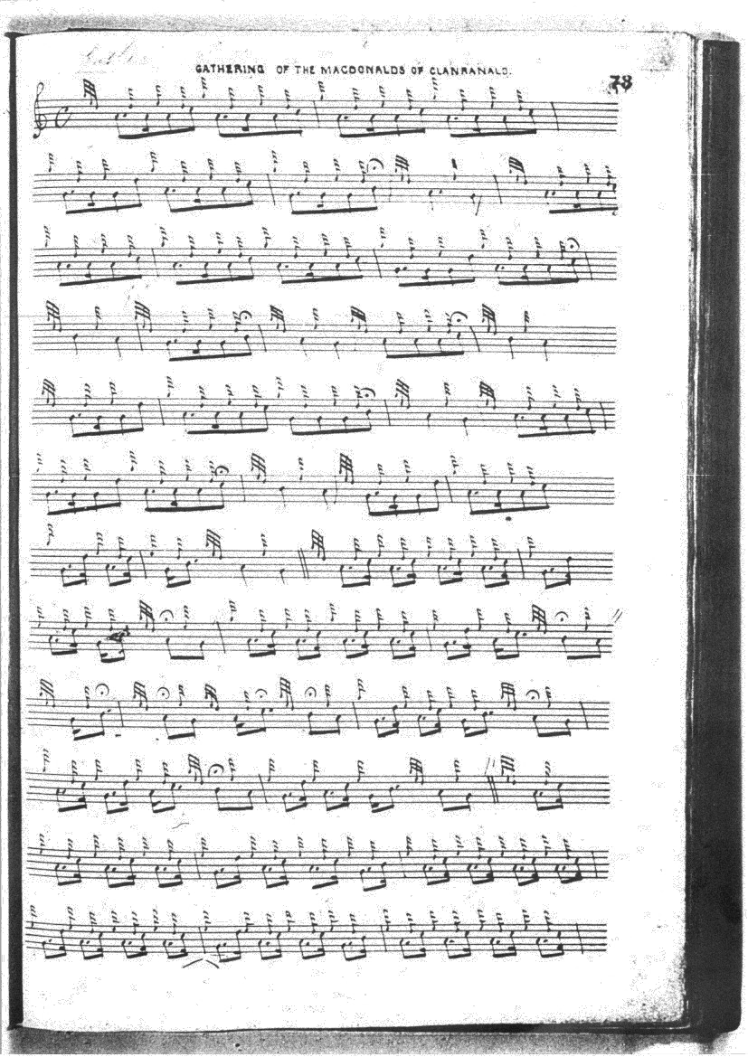
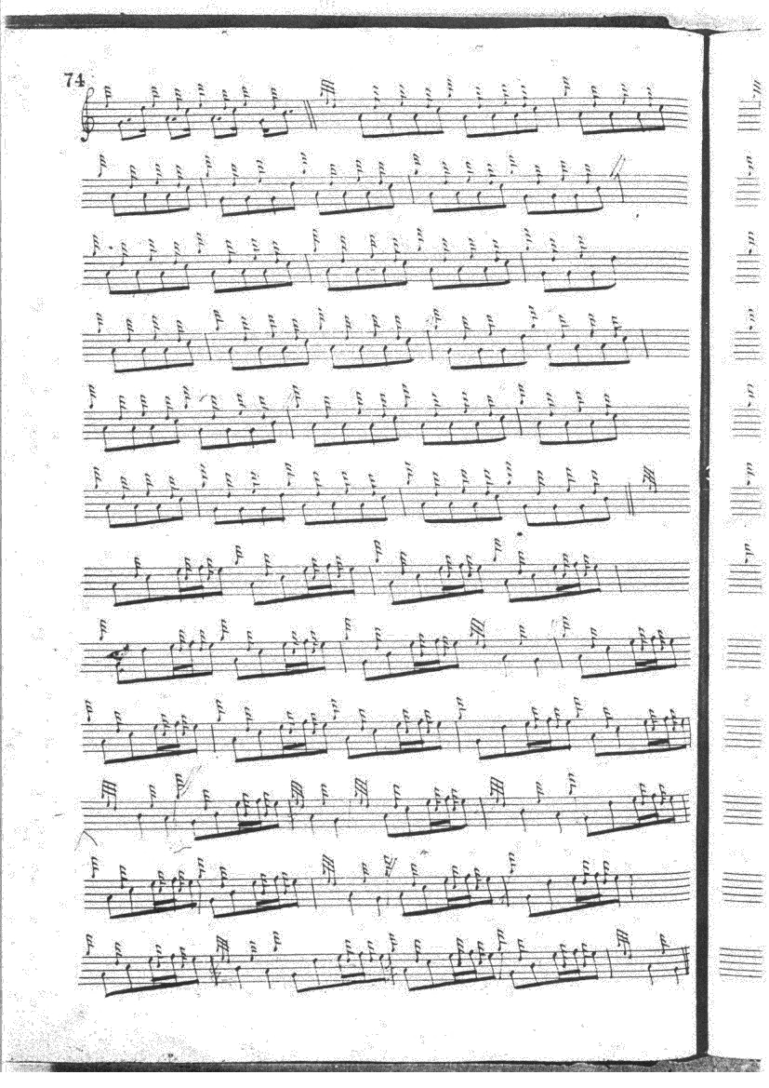
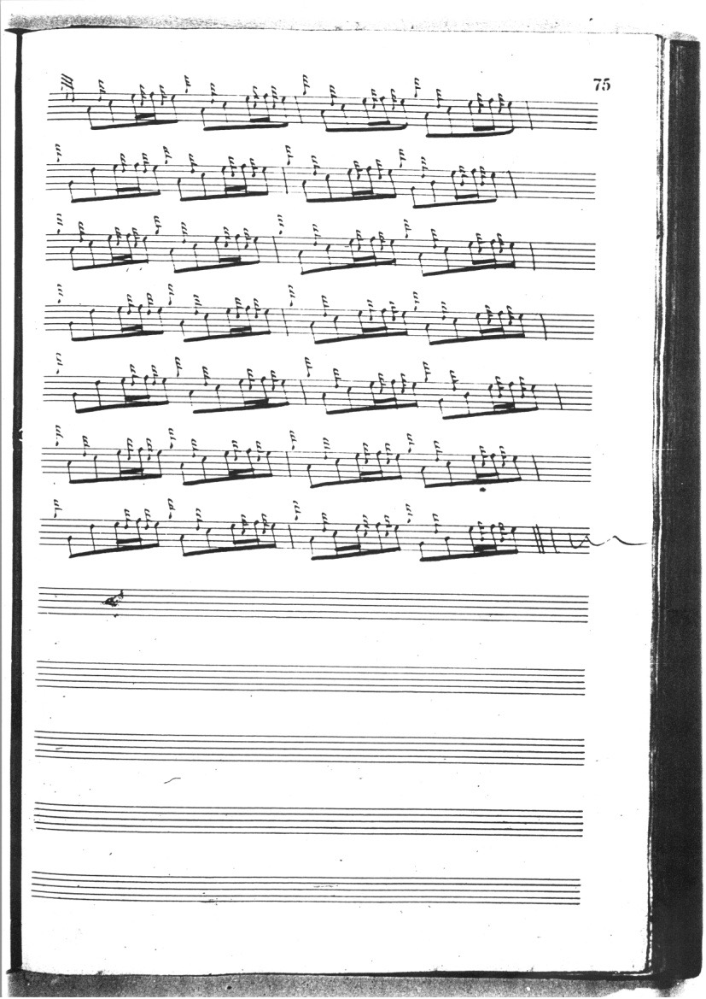

MacDonald’s eccentric barring in the ground may suggests that he, too, encountered notational difficulties here. The wedges below several lines represent suspected lacunae, either inserted by MacDonald or possibly later editors through whose hands his papers passed, including most notably Charles Simeon Thomason, compiler of the great Ceol Mor edition. MacDonald’s structure seems to achieve regularity finally in the taorluath fosgailte variation. MacDonald’s development of the tune is on conventional lines--ground; siubhal singling and doubling; taorluath fosgailte singling and doubling; and crunluath fosgailte singling and doubling. Interestingly he shows the same missing portions that we see in Colin Campbell’s canntaireachd score, although MacDonald reflects little of Campbell’s quasi-improvisational elaboration in the later variations.

Angus MacKay sets the tune like this:

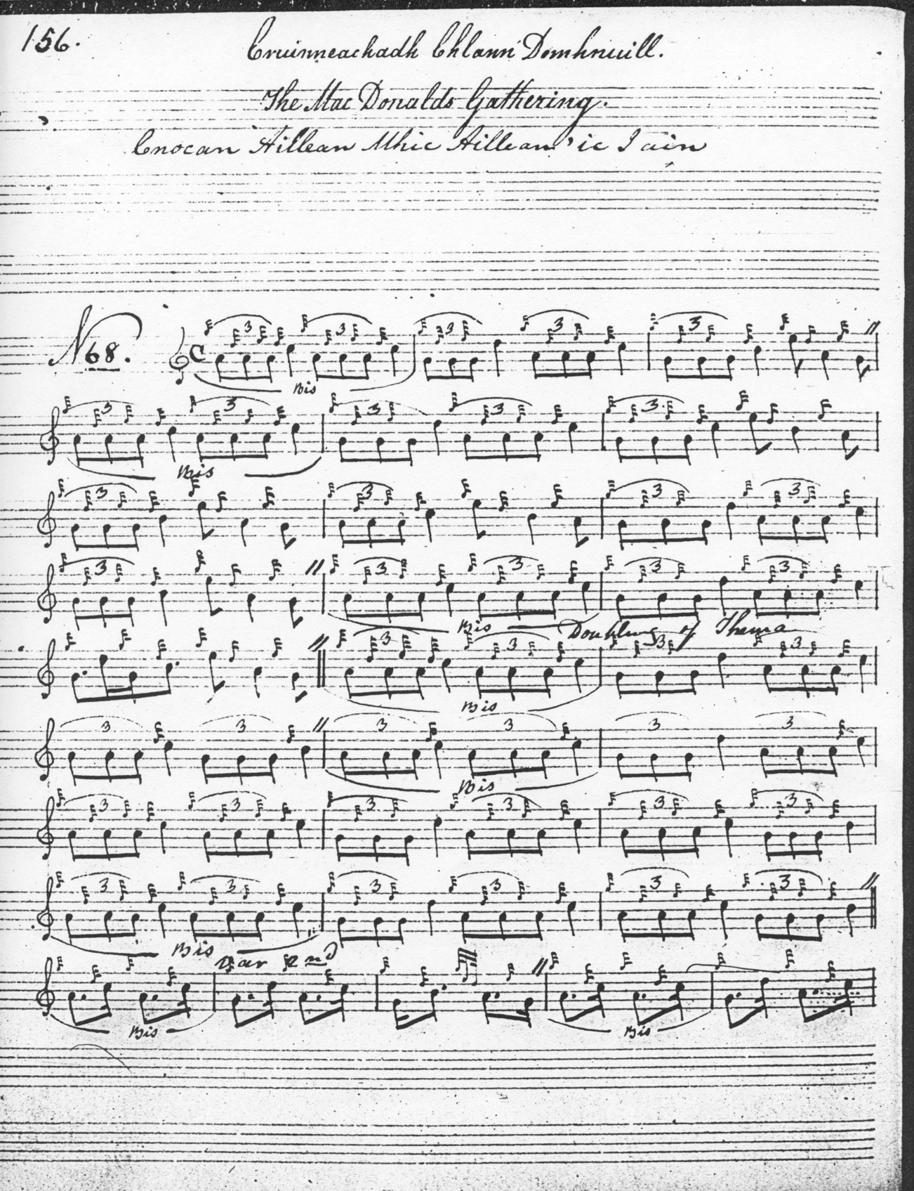

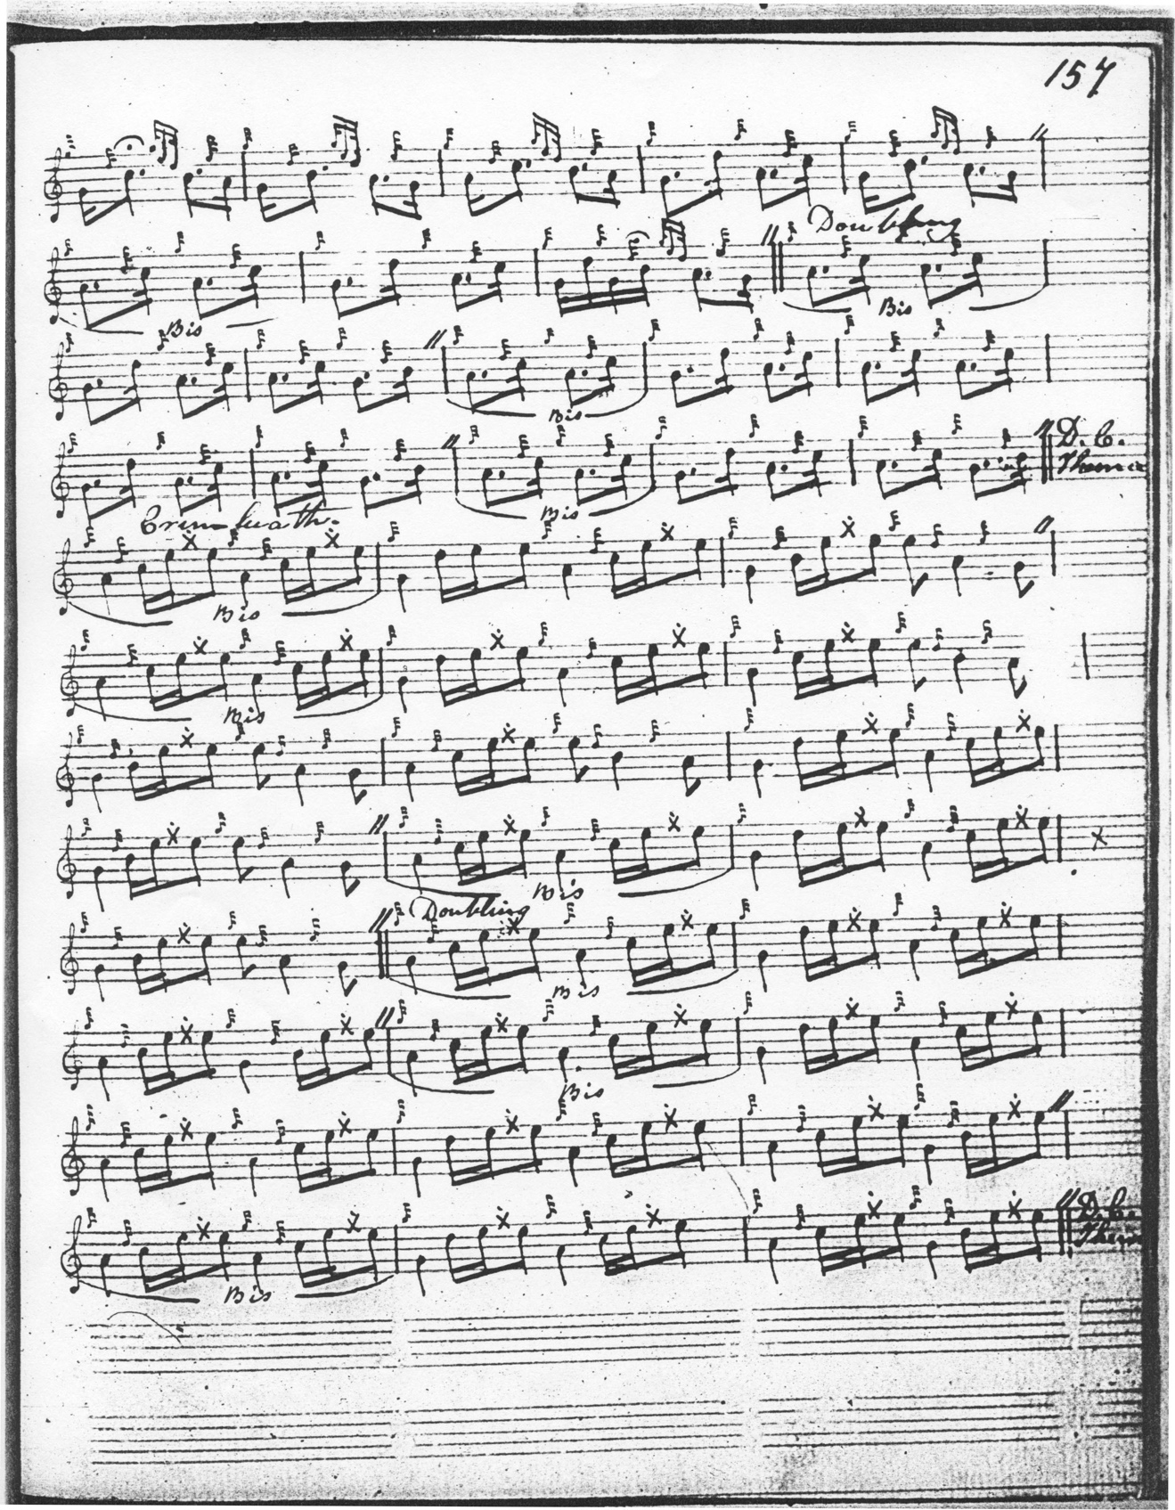

MacKay is the earliest source to play the treblings in the ground on to an expressed C, B or D crotchet, with a different, more staccato timing from MacDonald’s more flowing quaver figures. MacKay’s timing here is followed by Thomason and Glen. MacKay doubles the ground and repeats it between the end of the second variation doubling and the crunluath singling as well as once again at the end of the tune. (note: that awkward step in the last bar of the first line from low G to C, seems to be negated later in the tune at this point, where the interval is low G-B as one would expect). He has no taorluath fosgailte unlike MacDonald and Campbell, but proceeds directly from the siubhal doubling to the repeat of the ground, and then on to crunluath fosgailte singling and doubling. Overall, MacKay’s development of the tune shows a similar conventionality and restraint to Donald MacDonald’s.

D. S. MacDonald (who, it will be remembered, was preparing an edition of Angus MacKay’s piobaireachd manuscript for publication), follows MacKay closely in the ground singling and doubling as one would expect, but has an interestingly varied pointing in his first variation:

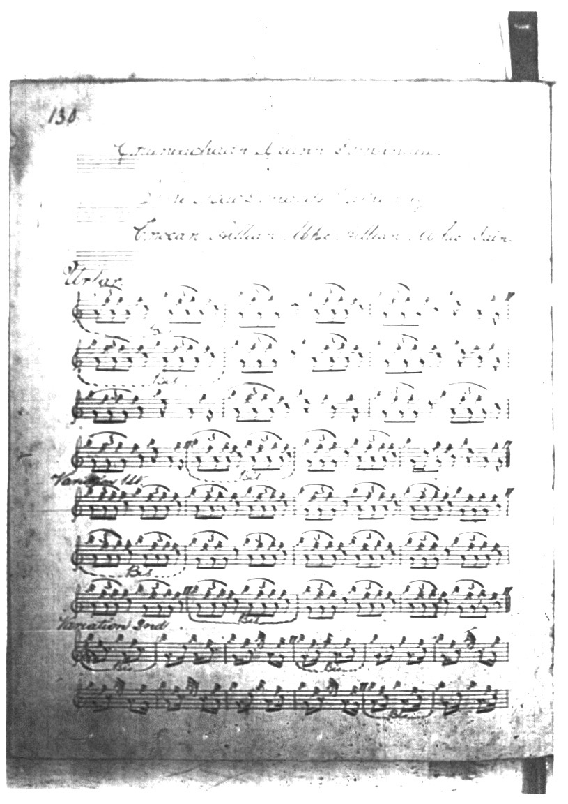

We note that D. S. MacDonald cuts “up” in line one where MacKay cuts “down” and has an interesting Low A/G alternation at the start of his second line.

C. S. Thomason sets the tune like this:
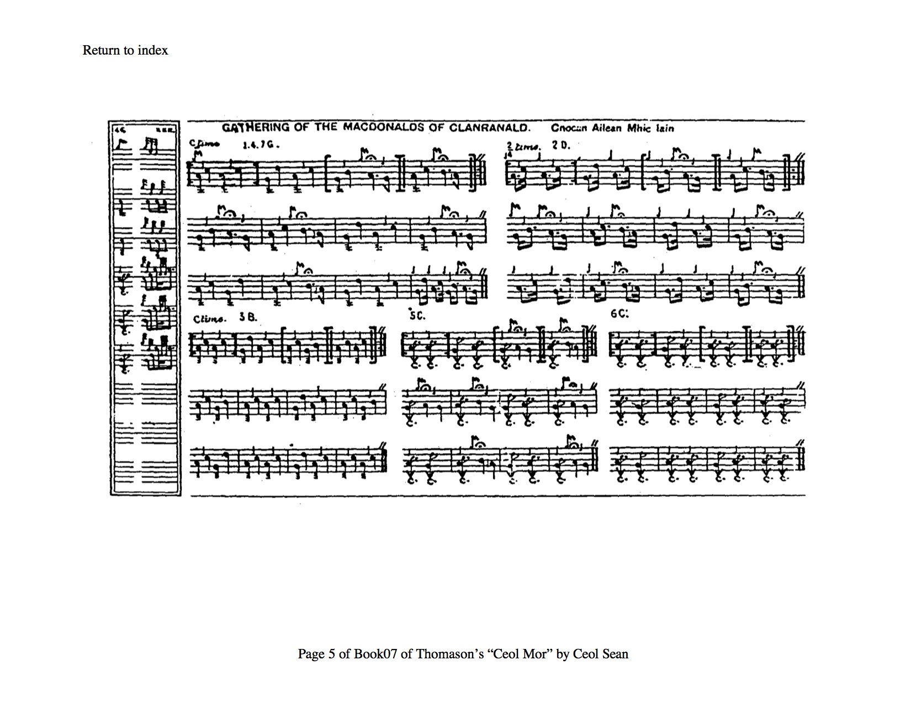
C. S. Thomason gives Donald MacDonald as his single source and marks the score “Ed”, meaning that he accepts ultimate responsibility for it. He follows MacDonald in introducing what looks like a taorluath fosgailte following the siubhal doubling but then indicates, as MacDonald does not, that this should be followed by a repeat of the ground, which seems here distinctly cluttered.

David Glen’s score bears a headnote saying “Edited from McDo[nald] MS & Ceol Mor”. Glen has a ground, siubhal singling and doubling (Thomason’s siubhal is a singling merely); then a modern 2/4-style taorluath fosgailte singling and doubling, then straight into his crunluath fosgailte singling and doubling with no indication that the ground should be repeated at any point. Glen sets the tune like this:

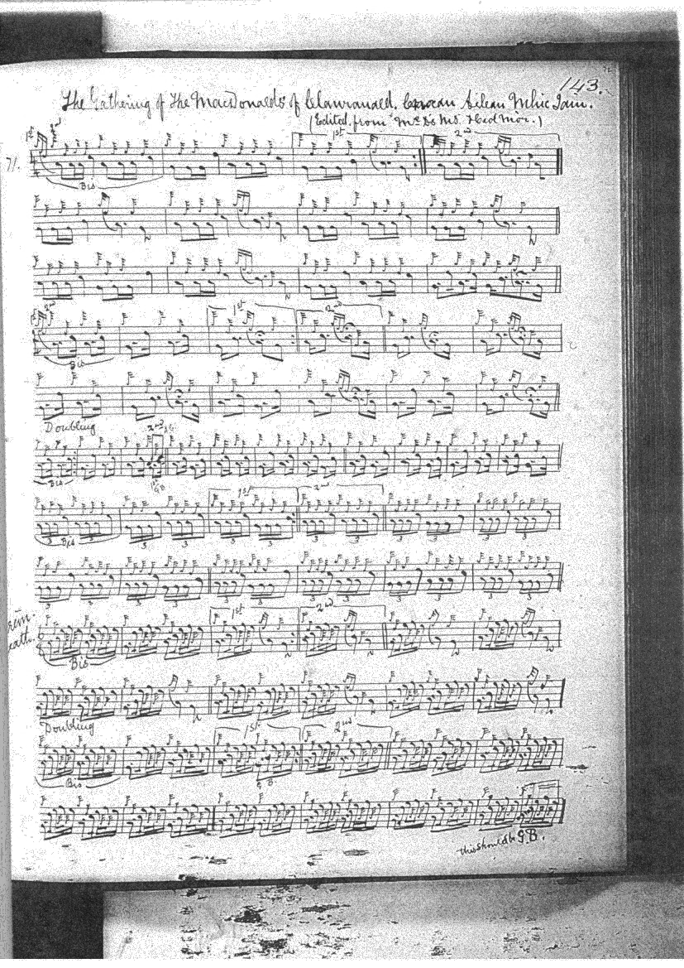

Commentary:

“The Gathering of the MacDonalds of Clanranald” is a member of an interesting group of cognate tunes, similar in structure and tonality which includes “MacDonalds of Clanranald’s Gathering to the Battle of Sheriffmuir”, “The Camerons’ Gathering” and “The End of the Little Bridge” all similar in motif and basic development but pitched in different keys. The gathering to the battle of Sheriffmuir follows a similar pattern to the abbreviated versions by MacDonald and MacKay of Cnocan Ailean mhic Ailean ‘ic Iain quoted above, namely ground and doubling, siubhal singling and doubling, crunluath fosgailte singling and doubling—but transposed down a tone, so that the main themal note is low G rather than low A. Versions are recorded in Angus MacKay’s MS, i, 171-172; and D. S. MacDonald, ii, 15-16; also in David Glen’s MS, ff.170-171. Among the published sources there are copies in Donald MacDonald’s Ancient Martial Music, pp.68-70, Donald MacPhee’s Ancient Piobaireachd, i 40-41 and in Thomason’s Ceol Mor, p.16.

Angus MacKay’s setting of “The MacDonalds of Clanranald’s Gathering to the Battle of Sheriffmuir” begins as follows:
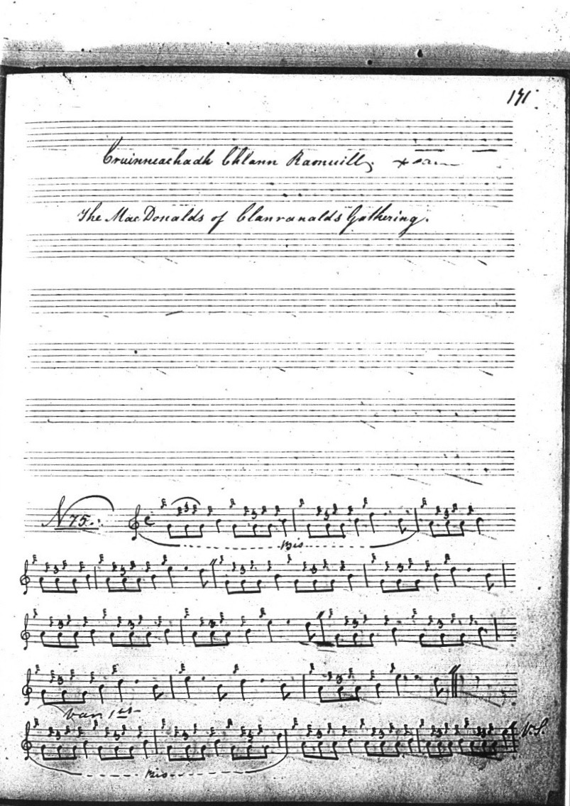

and so on.

Clan Donald was a large confederation, one of the great kindreds of the old Highlands, who claimed as their patrimony “half of Scotland and a house” and who claimed (of themselves) “there is no happiness without Clan Donald”. All descended by various routes from the half-legendary Somerled, Lord of the short-lived Kingdom of the Isles, at the dawn of the high Middle Ages. A formidable crew, Clan Donald. Though a spat with a smallish branch like the MacIans of Glencoe might be survivable, collision with a big outfit like Glengarry or Clanranald was likely to be terminal. “Clanranald Country” lay in the southern stretches of the Rough Bounds--Moidart, Arisaig, Morar, Knoydart and Ardnamurchan, with the isles of Eigg, Rum and South Uist. Cnocan Ailean mhic Ailean ‘ic Iain was evidently a traditional rallying point, similar to the Grants’ Craigellachie.

* * *

Electronic text © Dr William Donaldson, Cambridge, Massachusetts, 31st May 2020

