The Finger Lock (2)

There are settings of this tune in the following manuscript sources:
--Colin Campbell’s “Nether Lorn Canntaireachd”, ii, 108-9;
--Hannay MacAuslan MS, ff.20-22 (with the title “Ghlas Mheur or lock on fingers”);
--Angus MacKay’s MS, i, 61, 63 (the MS is mispaginated at this point, there is no f.62);
--John MacDougall Gillies’s MS, ff.48-9;
--Robert Meldrum’s MS, ff.89-91;

and in the following published sources:
--Donald MacDonald, Ancient Martial Music, pp.7-12 (with a note: “Composed by Raonuill Mac Ailein Oig, one of the MacDonalds of Morar”.);
--Donald MacPhee, Collection of Piobaireachd, ii, 15-16;
--C. S. Thomason, Ceol Mor, p.6;
--David Glen, Ancient Piobaireachd, pp. 60-2.

Colin Campbell sets the tune like this:
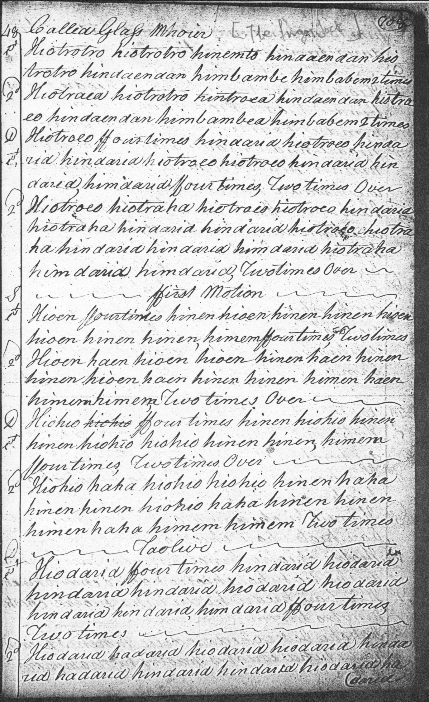
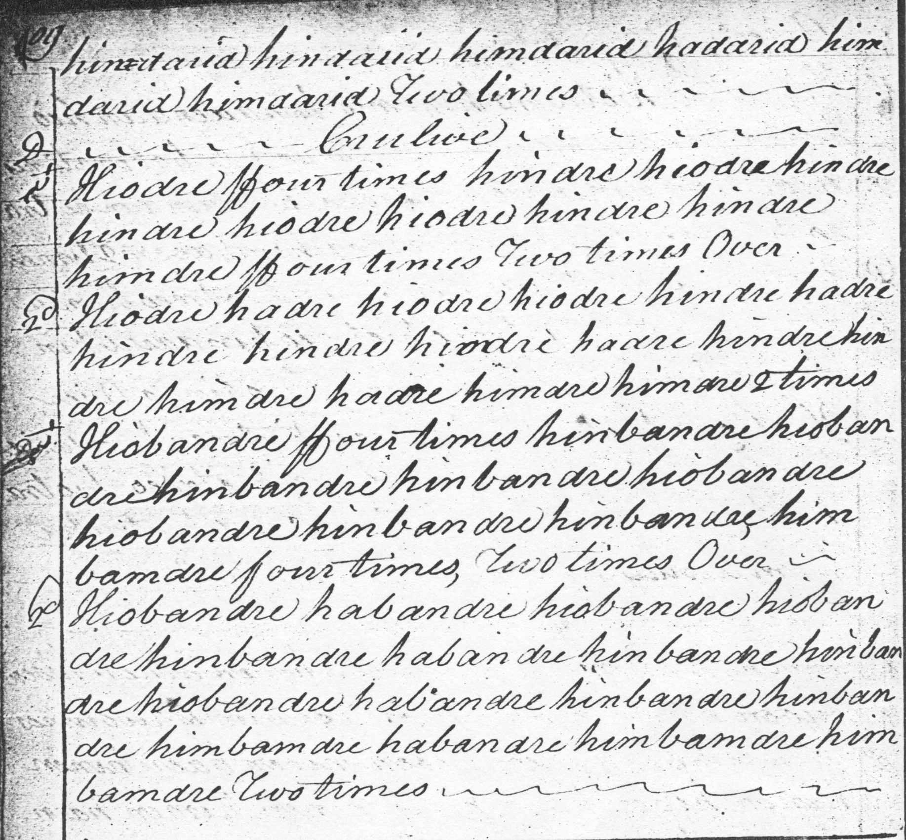

As it stands Colin Campbell’s score is not entirely symmetrical: there is a ground, singling and doubling; a siubhal singling and doubling; a crunluath singling and doubling, but a taorluath singling only. We notice too the relatively rare open crunluath movement played as a singling, a feature shared with several other of the scores featured here. The Nether Lorn score differs from the canntaireachd version published in the Piobaireachd Society Collection (second series, i, 9) which is simply a rendering of the staff notated score on the facing page.

In the Hannay-McAuslan MS the tune appears as follows:

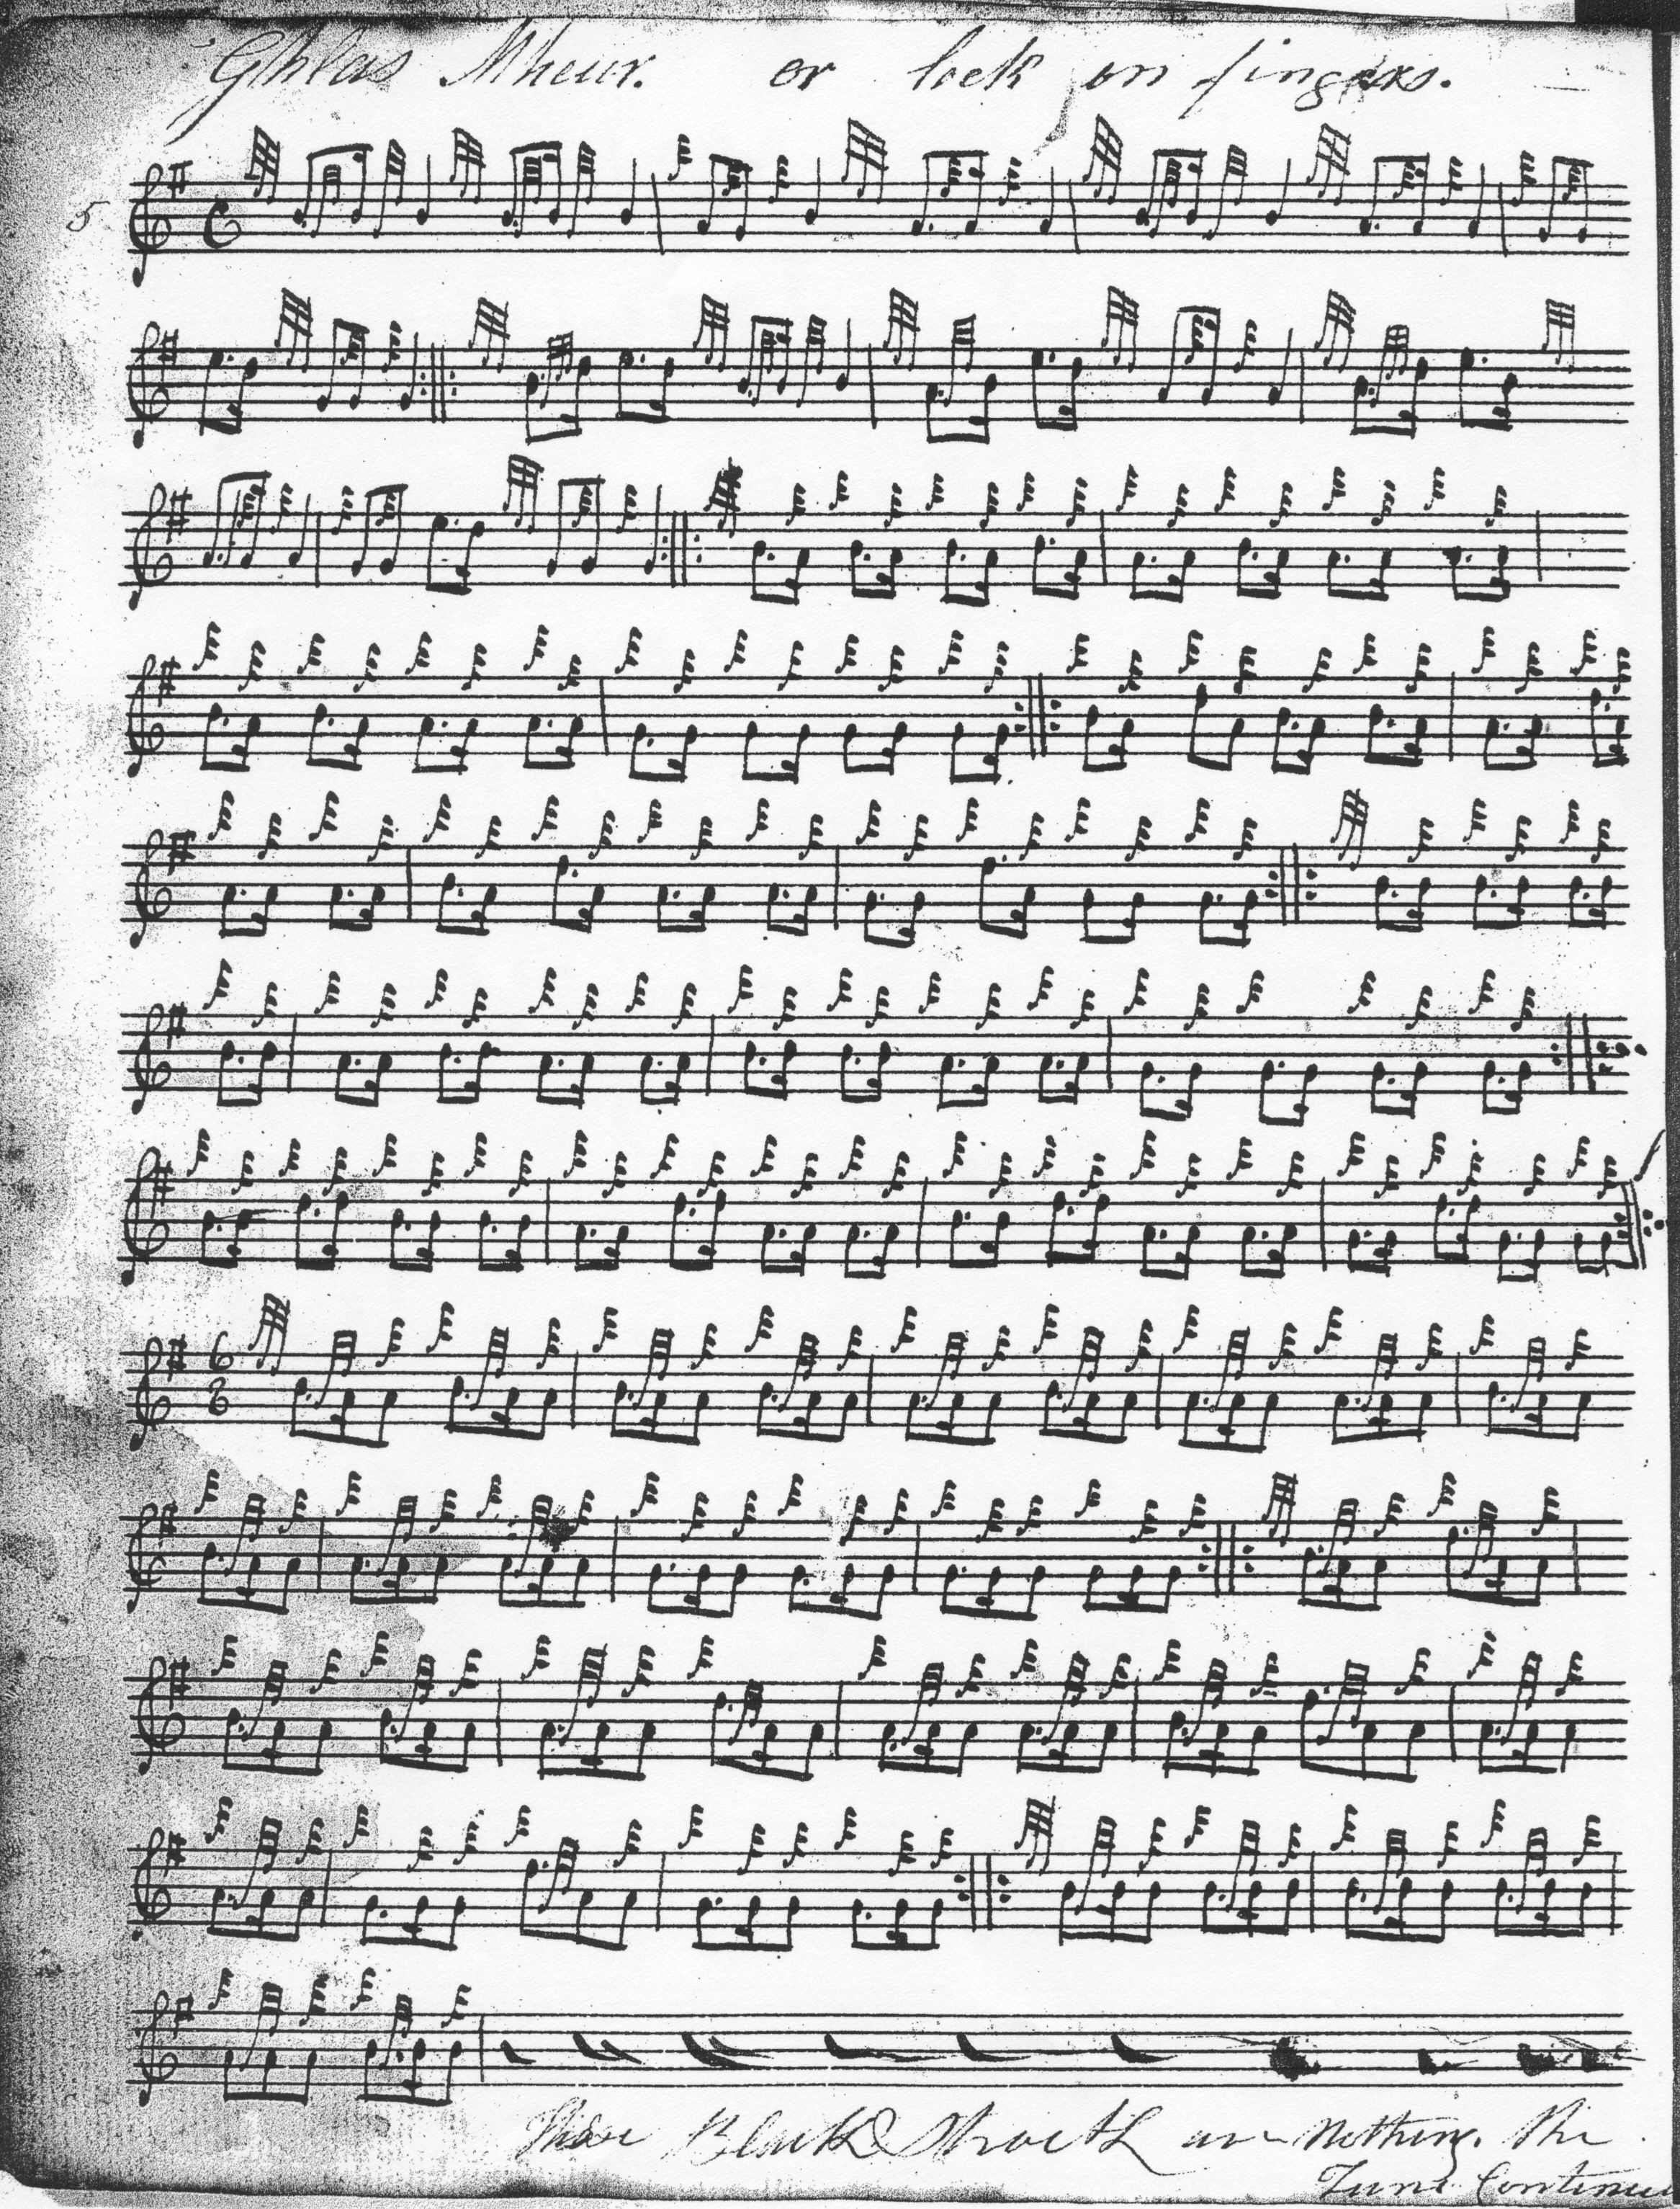
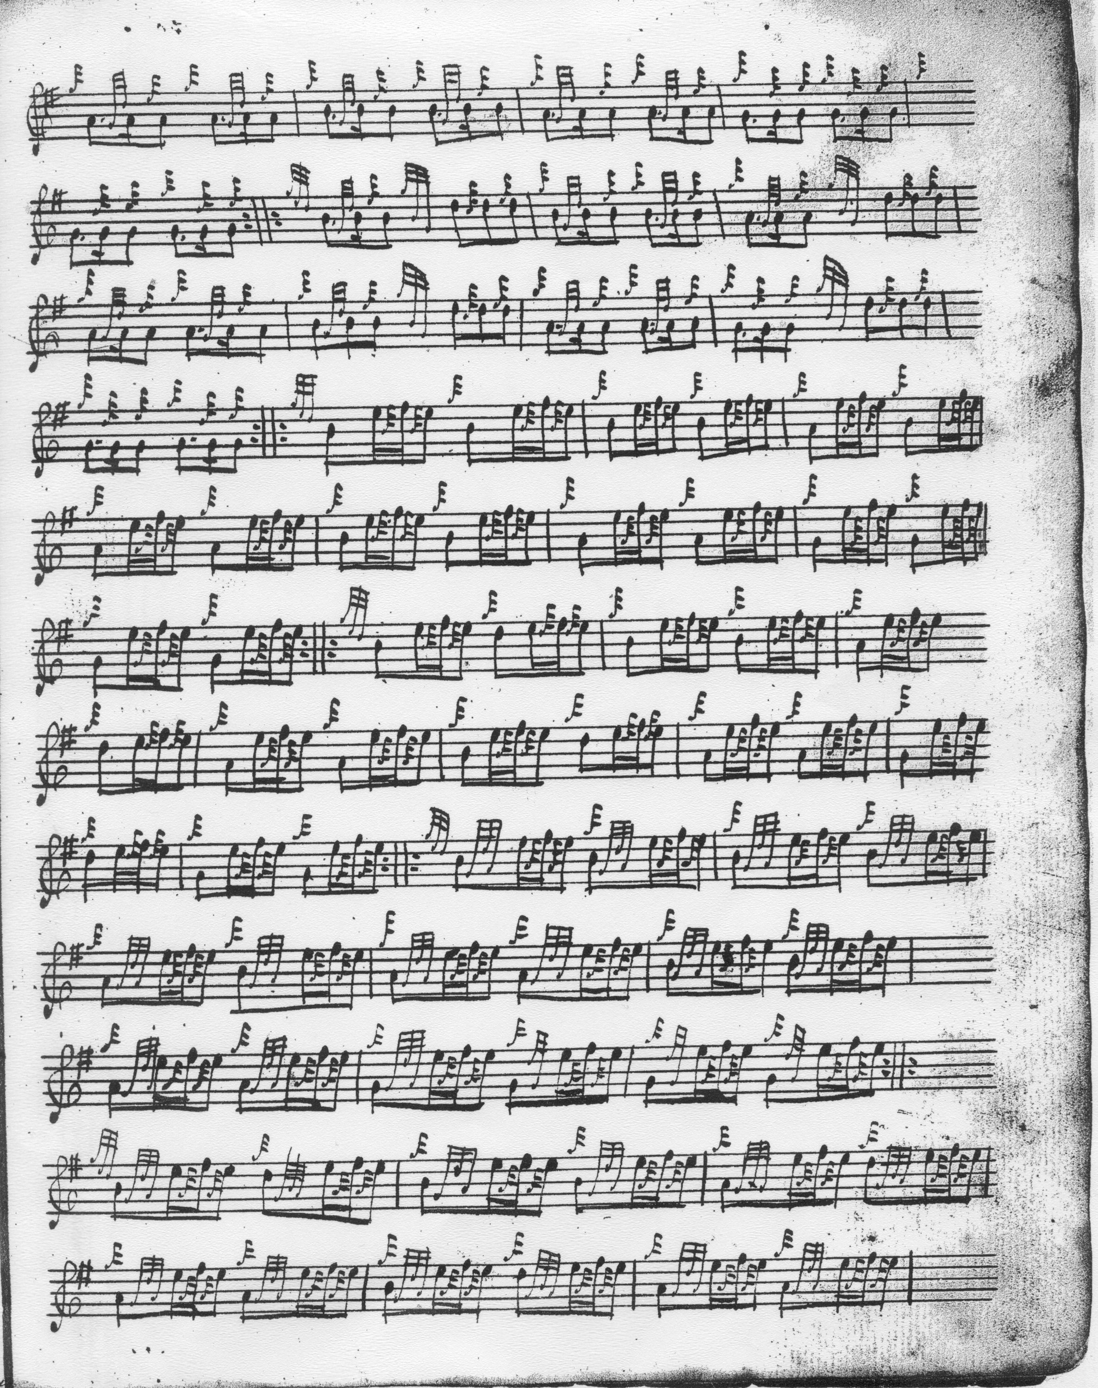

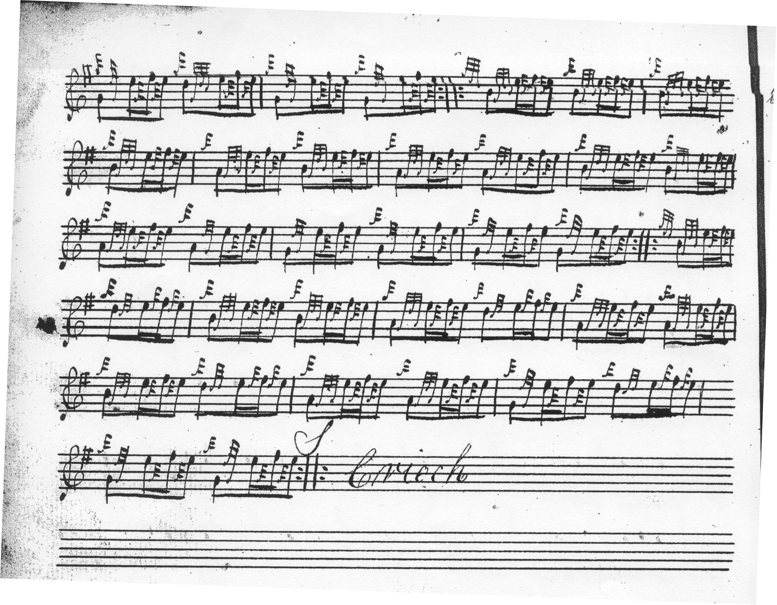

The Hannay-MacAuslan provides a taorluath doubling in the form of a MacDonald-style taorluath a mach, and balances this in turn with a concluding a mach movement in the crunluath section (also in the style now associated with Donald MacDonald—note the movement on D for example).

With the exception of one or two trivial differences in gracenoting, and repeats of the ground, Donald MacDonald’s setting is identical to the Hannay-McAuslan. The latter indicates that the ground should be repeated at the end of the tune, MacDonald brings it back in after the taorluath variations but not at the end:
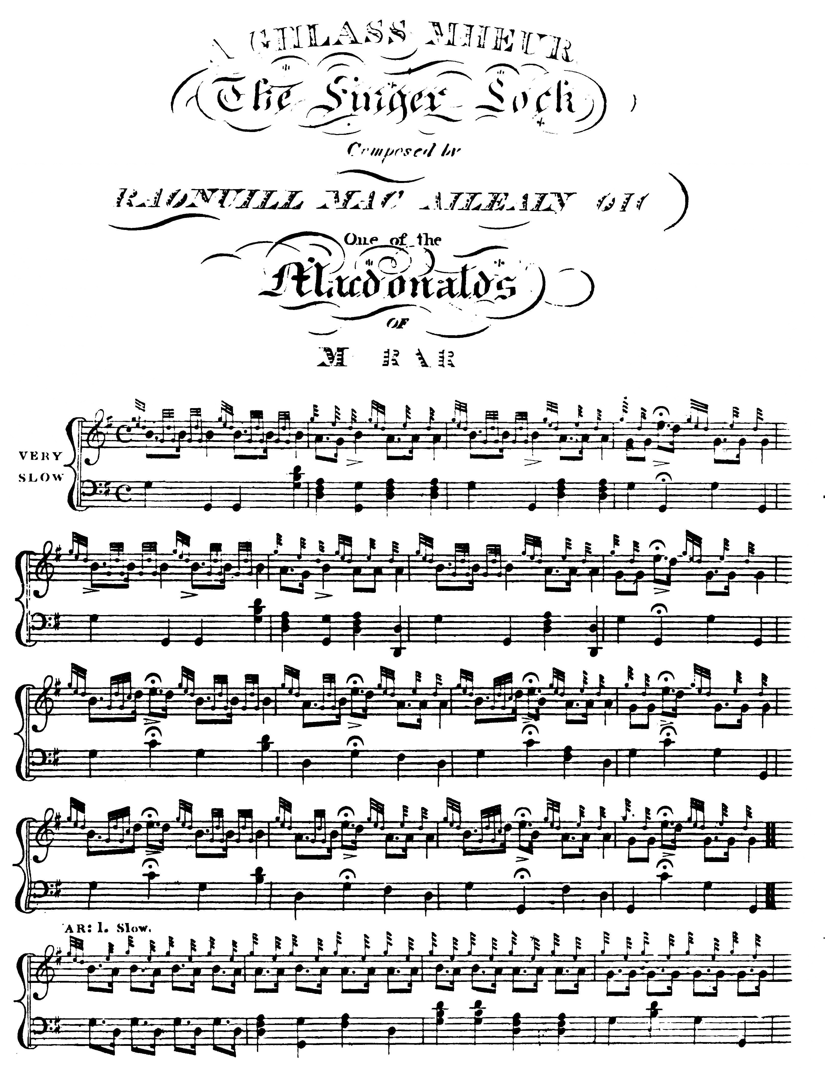

And so on.

Angus MacKay sets the tune like this:
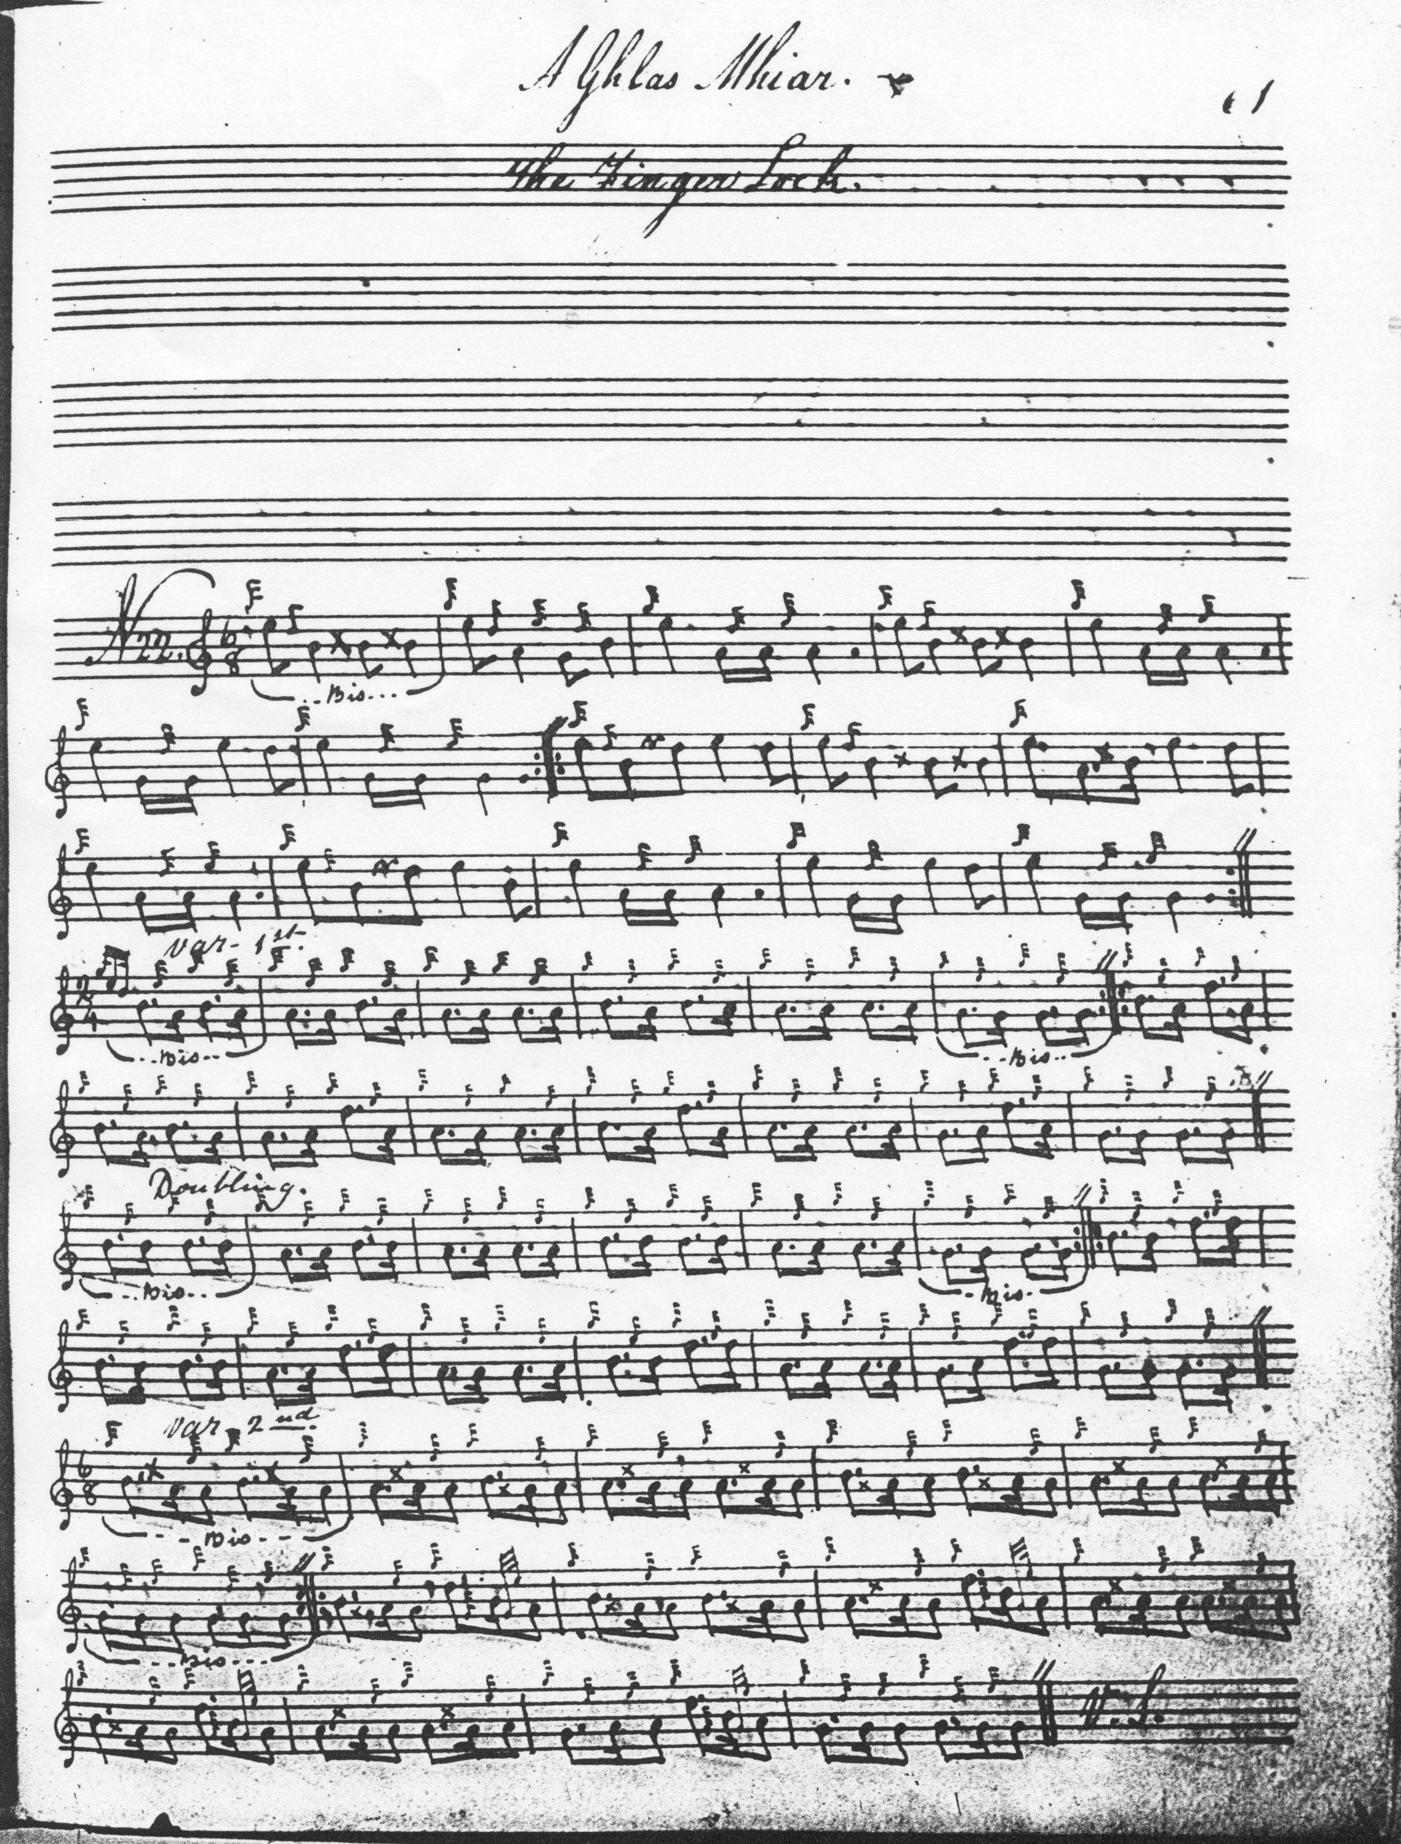
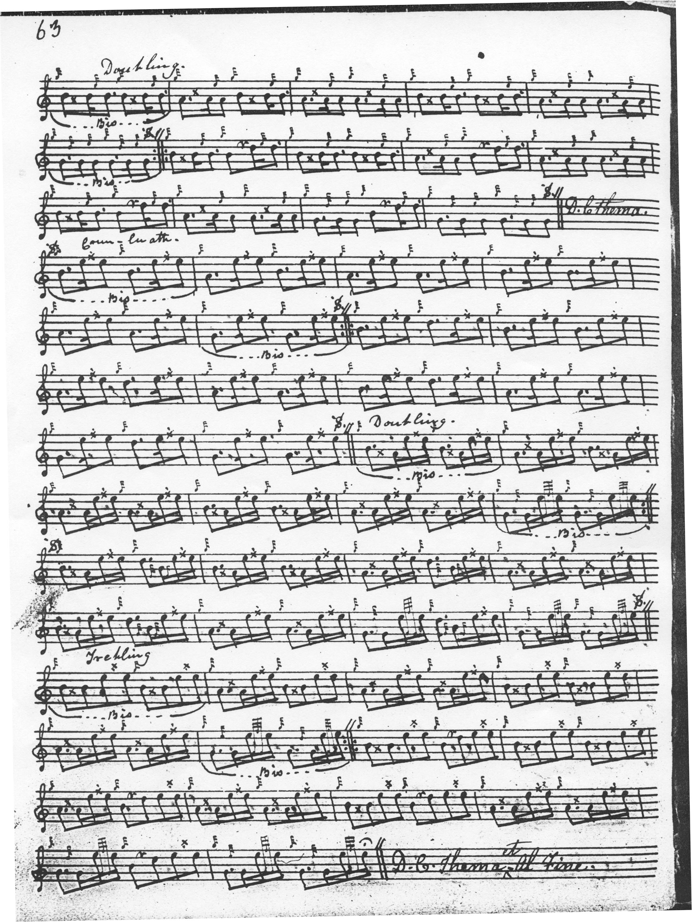

Except for the occasional missing dal segno mark, and his characteristic timing of the taorluath and crunluath a mach movements on D, Angus MacKay takes a very similar route through the tune, which is remarkably stable in all the 19th century settings.

Donald MacPhee has one or two little individual touches which might interest the thoughtful player; he sets the tune like this:
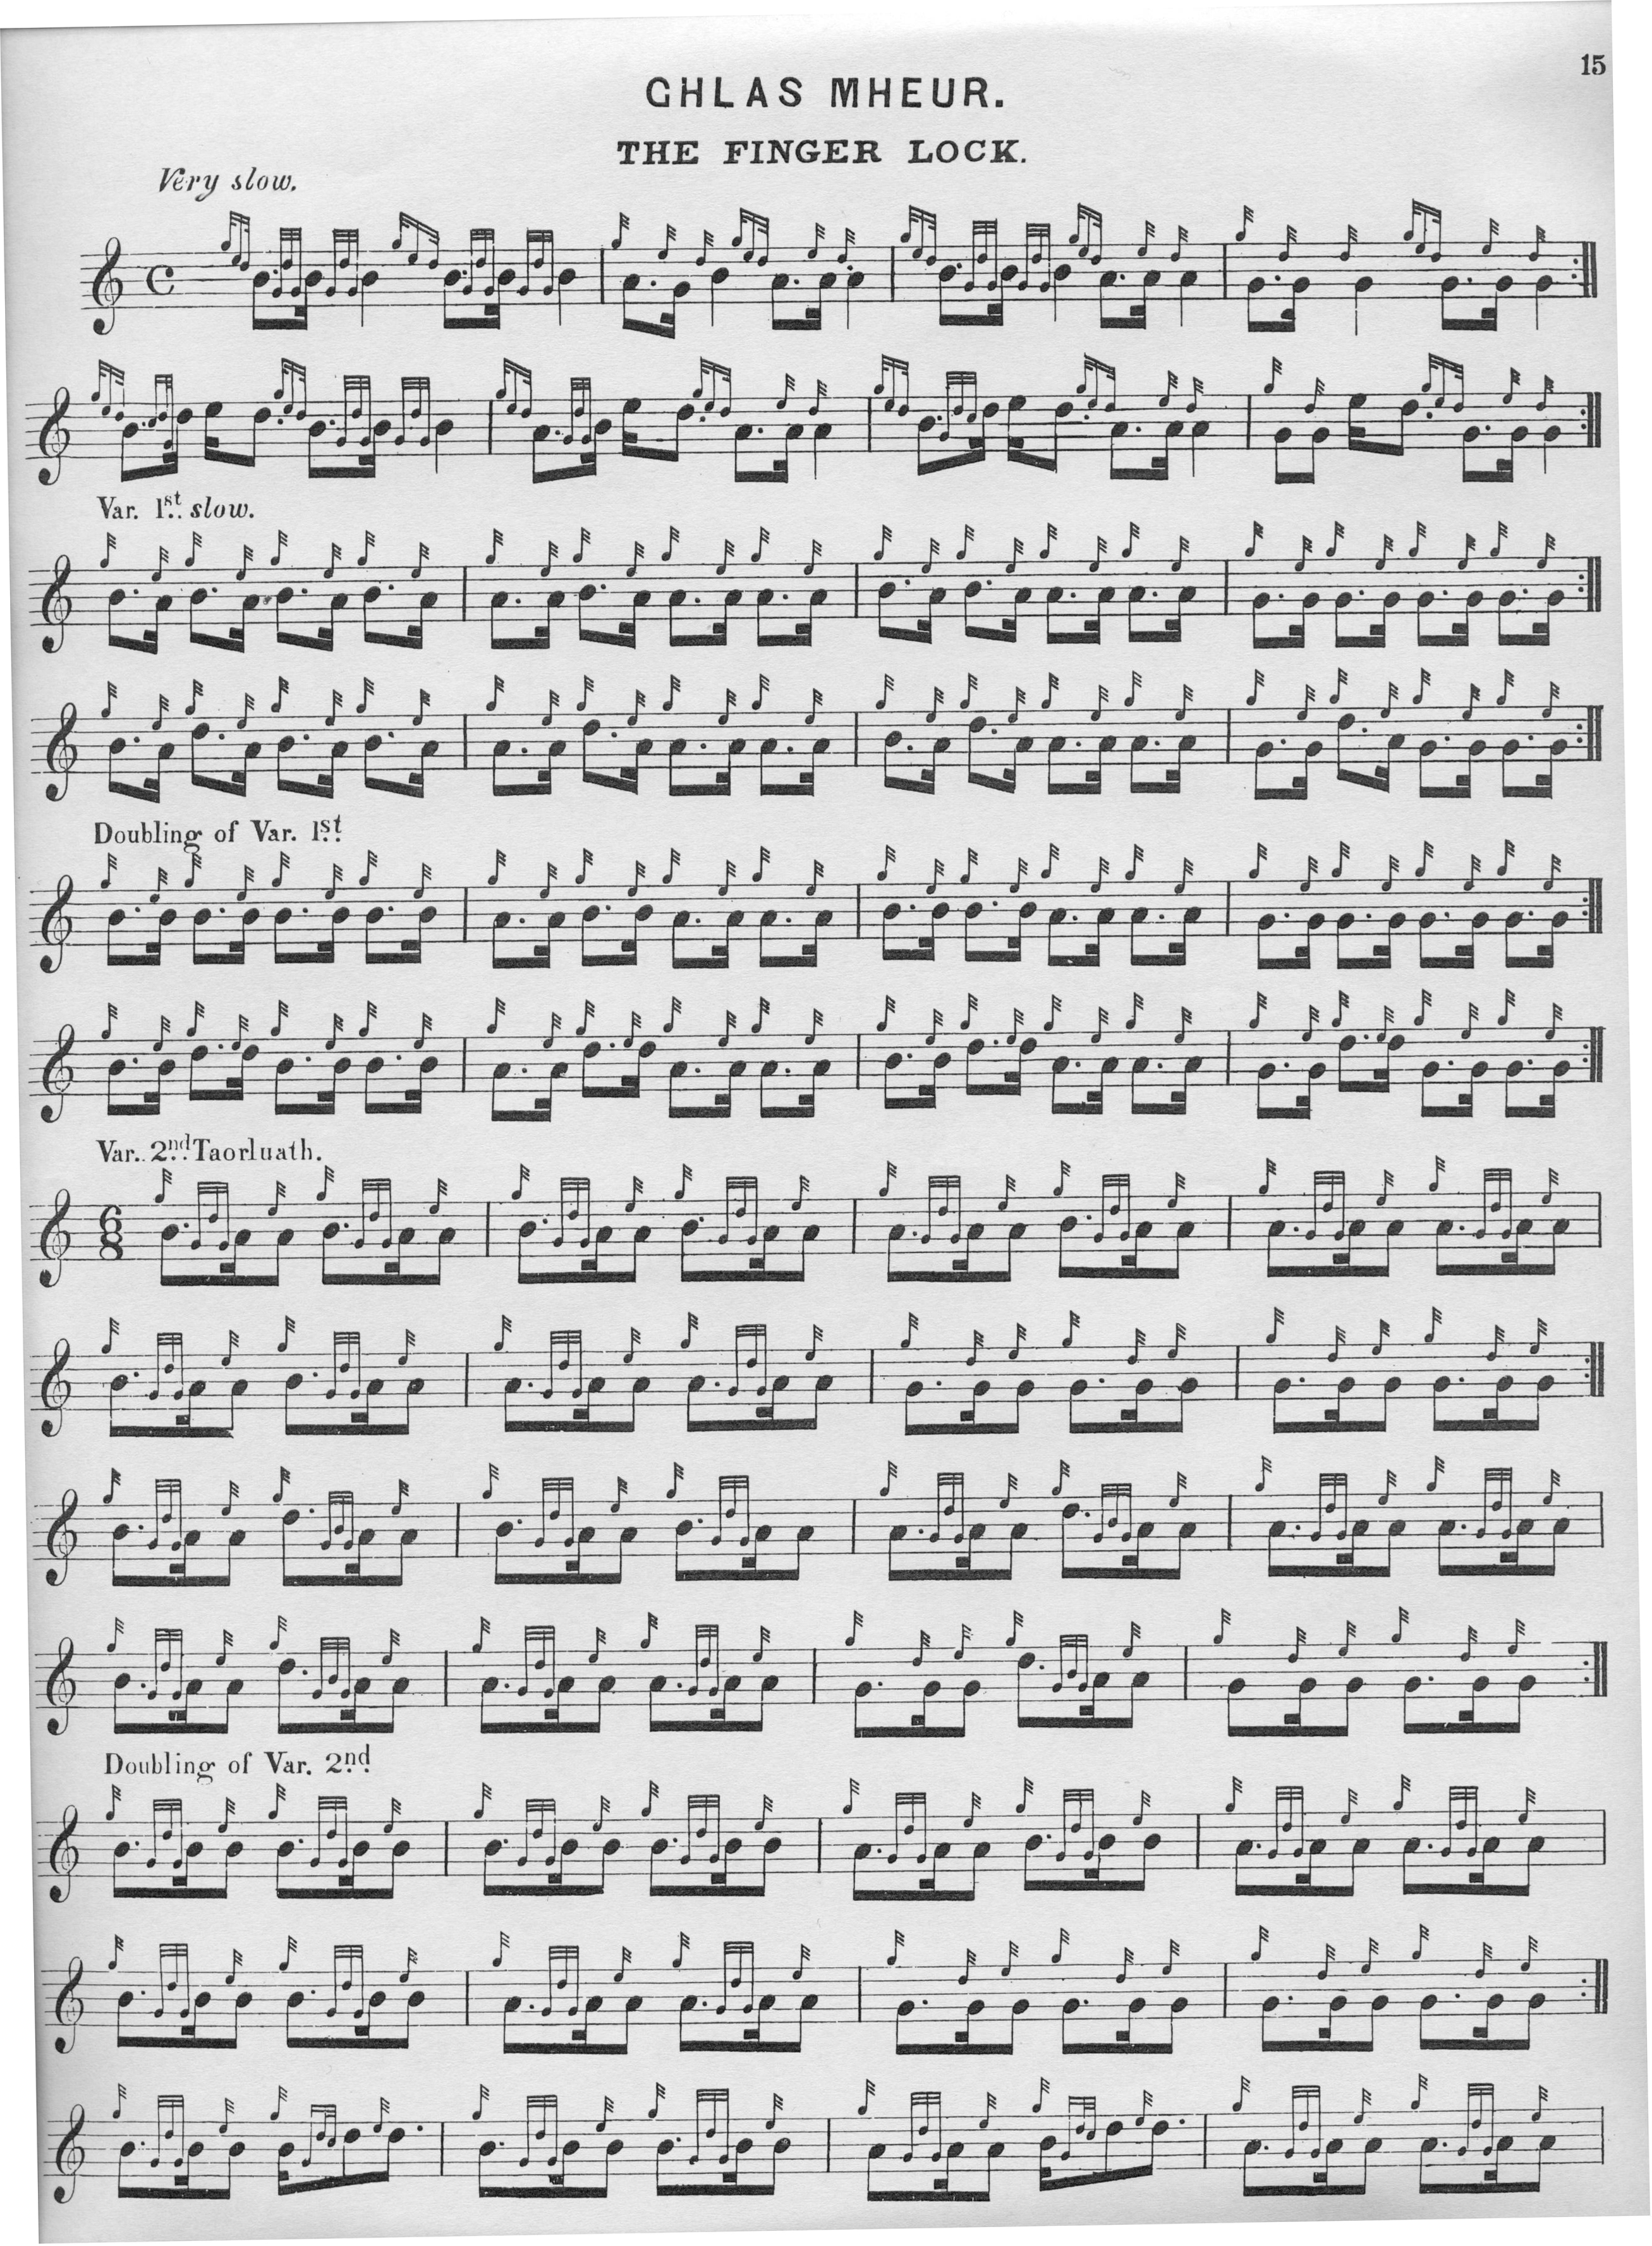

And so on.

John MacDougall Gillies set it like this:
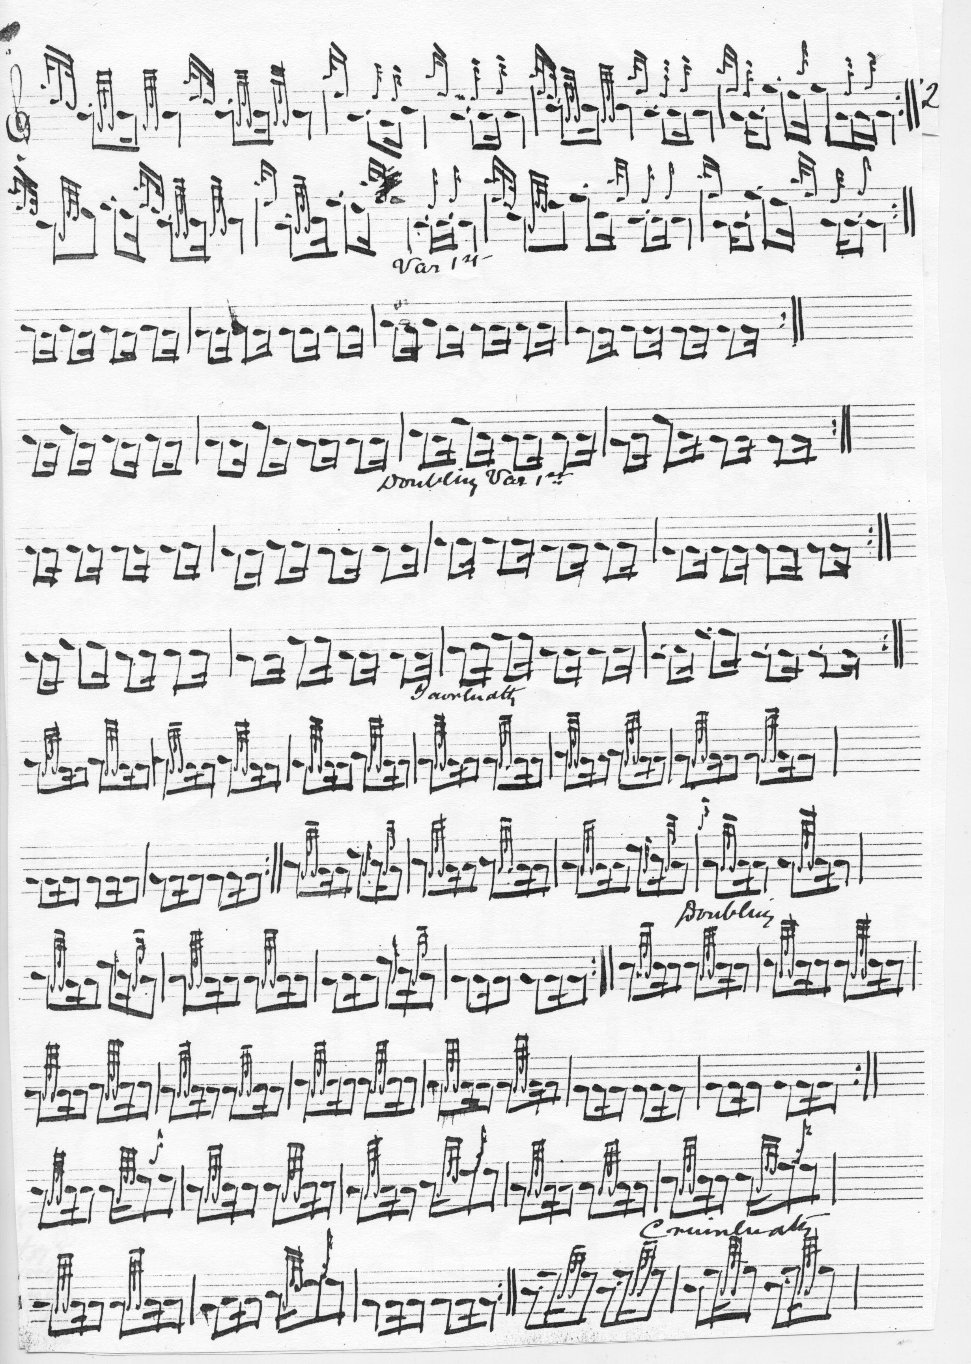
And so on.

C. S. Thomason, who cites the manuscripts of MacDonald and MacKay and who also studied the tune with Donald MacKay and Keith Cameron shows an interesting timing of the grips on B in the ground:

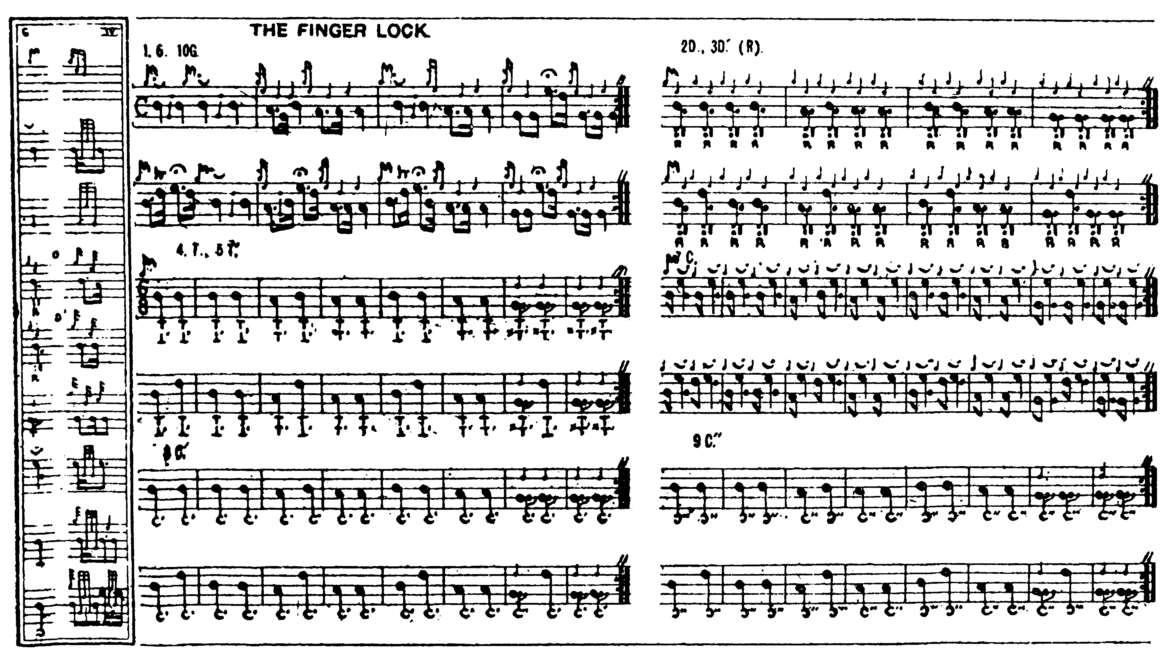

The settings of David Glen and Robert Meldrum do not add to the expressive possibilities of the tune on this occasion, and are not reproduced here.

Commentary

“The Finger Lock” is a classic example of the power and eloquence that can be released by skilful use of a gapped pentatonic scale.

In his “Historic, Biographic, and Legendary Notes to the Tunes” in Glen’s Collection of Ancient Piobaireachd, “Fionn” says that

This tune is the composition of Raonull, mhic Ailein òig, Ronald, son of Allan Og of Morar, a man of wonderful strength of arm and body, and the composer of several well-known pipe tunes. It is said that when MacDonald, Boisdale, renounced the Catholic faith, he resolved to coerce his clansmen to follow his example. He fixed on a certain Sunday to carry out his purpose. When this came to the ears of Ronald, son of Allan Og, he resolved to frustrate the scheme. Taking with him a dozen of chosen clansmen and a piper, he sailed for Uist early on the Sunday morning. He and a trusty henchman went ashore and called on the minister, who treated them hospitably—the “shell” [i.e. drinking vessel] circulating freely. When Ronald saw the parson getting hearty, he suggested that he should accompany him to the birlinn, where he said he had a fine keg of brandy. The parson, nothing loath, accompanied Ronald. After sampling the brandy, the Laird of Morar, to gain time, suggested that they would sail a short distance from the shore, and that he would play his reverence his latest composition, “An tarbh breac dearg,” the brindled red bull. To this the parson was agreeable, and, while engaged in this performance, the minister forgot all about his duties to his congregation. They noticed Boisdale with a large congregation at the church. They immediately landed the parson, but the brandy had taken effect, and he walked with difficulty, and was in no mood for preaching. There was nothing for Boisdale but to return home. On Monday, Ronald of Morar went to Boisdale, and told him, if ever he heard of him trying the same trick again, he would double him up like an old pair of pipes. Boisdale desisted, and allowed his followers to follow their own convictions.

The Gaelic words associated with this tune, and in conformity with the incident recorded, will be found in The Gael, vol.III., page 74. (pp.9-10).

A quite different tale is given by Donald MacFarlane of Oban, who wrote under the pseudonym of “Loch Sloy” and was a frequent correspondent on piping subjects to the Oban Times. MacFarlane says it “was copied from a very old and valuable M.S. and given to me by one passionately fond of Piobaireachd and pipe playing in general.

Story of the Glas Mheur or Fingerlock

Two men named David and Robert were brought from Ireland by the Earl of Cawdor when he was proprietor of Muckairn [located 8 miles north east of Oban on the southern shores of Loch Etive], and they had from him the farm of Scuil in return for their services. David was a superior harper, and Robert was armourer. Malcolm, the son of Robert, had a splendid musical ear, and he was sent by the Earl to Mull to learn the music of the pipes from MacDuillidh. Malcolm, or Calum Mac Raibeart as he was called, was rather young and careless and was not attending to his master’s instructions, and he was rather stiff-fingered. He and his master were at a wedding he went wrong (had too much) and his master lashed him out of the wedding house in the dead of night, and he went with his pipes in his oxter.

The night was dark, but he saw a light at a distance and made for it. There was an old man in the house where the light was and a good fire on: and when the old man opened the door he told Calum to come in, and sit at the fire. After a while the old man asked him if he had the pipes. He said he had. The old man then told him that his master MacDuillidh was studying a tune and that he had it all finished but one part. The old man then taught Calum MacRaibeart the whole tune that his master was studying with the last part complete. Calum stopped in the house till daybreak, when the old man then sent him away and told him to play the tune when he would be near the wedding house. He accordingly did as the old man desired him.

His master on hearing the music knew Calum’s fingering and said that that was Calum coming back playing the very tune that he was studying himself. After that time Calum paid more attention to the pipes than he did before, and there was not a tune that he would hear but what he would pick up at once. His master declared that the lock or “glas” had come off Calum’s fingers, and from that he called the tune the “glas mheur”, or fingerlock. (“The Playing of Piobaireachd”, Oban Times, 01/11/1919, p.3)

* * *

Electronic text © Dr. William Donaldson, Aberdeen, Scotland, November 2002; revised Aberdeen, Scotland, 21 June 2012.; and Cambridge, Massachusetts, 26 December 2024.

