Farewell to the Laird of Islay (2)

There are settings of this tune in the following MS sources:
--Angus MacKay, in the so-called “Kintarbert MS”, ff.105-107;
--Duncan Campbell of Foss’s MS, ff.127-131;
--Donald MacKay’s “Ballindalloch MS”, f.22;
--David Glen’s MS, ff.78-80;

and in the following published source:
--C. S. Thomason, Ceol Mor, p.254.

Angus MacKay sets the tune as follows:
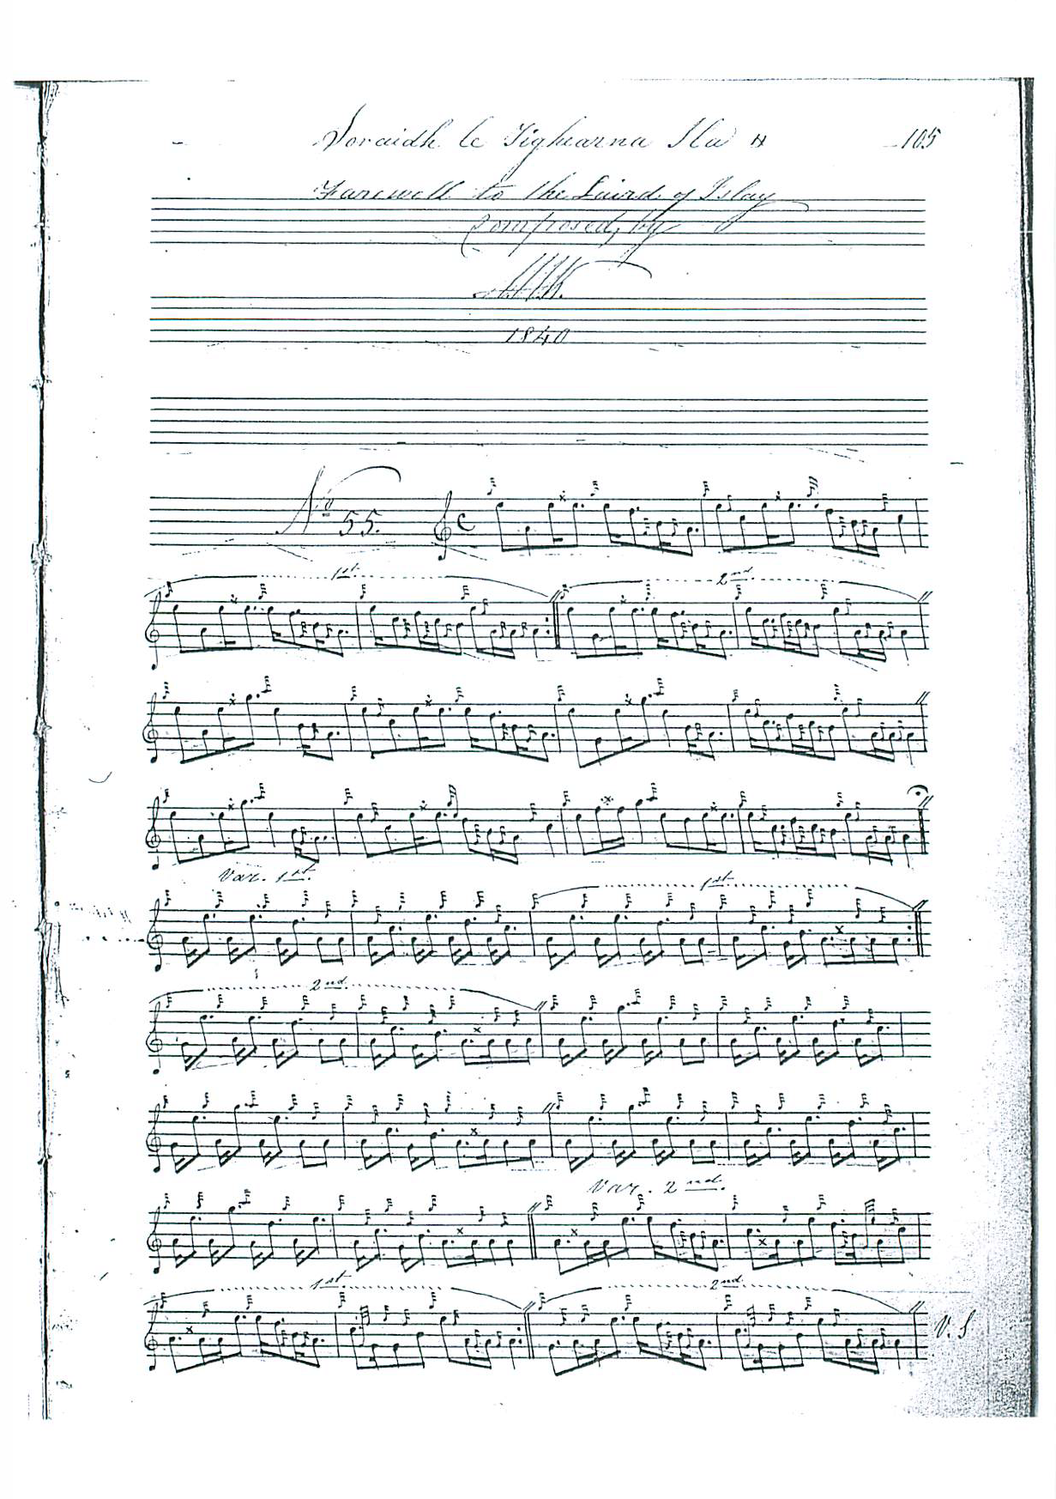

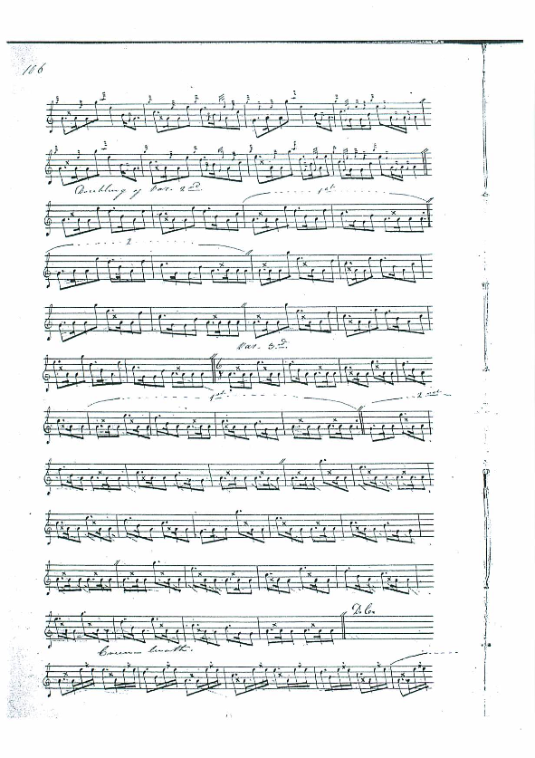

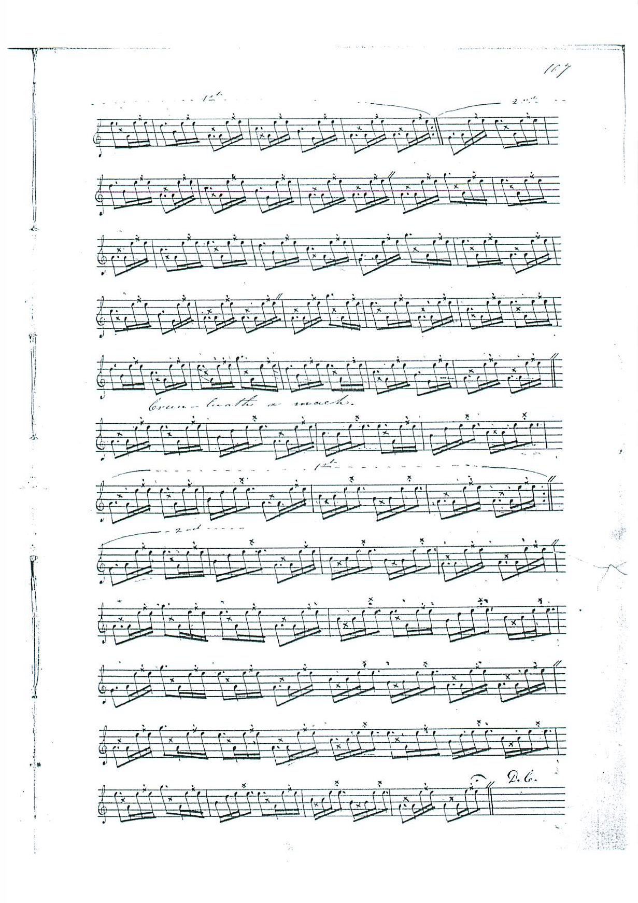

There should probably be a C crotchet at the end of the second bar of the second line of the ground to echo the C in corresponding places throughout the variations and square the phrasal symmetry of the tune, but none of the sources with a direct connection to the composer, Angus MacKay, has got it, including Duncan Campbell of Foss. It is interesting that Archibald Campbell, who edited the tune for the Piobaireachd Society, should give as his source the MS of Duncan Campbell of Foss, since the Society version does have the C (as well as numerous silent changes to note values. See Piobaireachd Society’s Collection, second series, ix 267). In some ways the setting is rather unusual. Particularly striking is the decision to end with a crunluath a-mach, following a regular duinte crunluath, rather disrupting the singling/doubling pattern established earlier in the piece.

Duncan Campbell set the tune as follows:

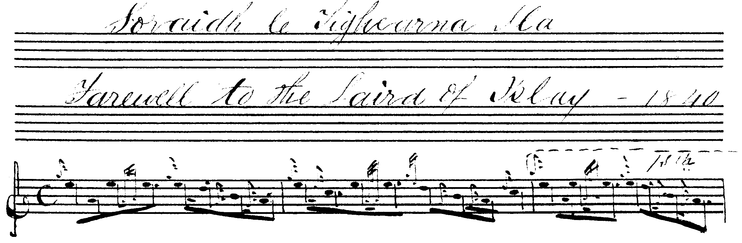
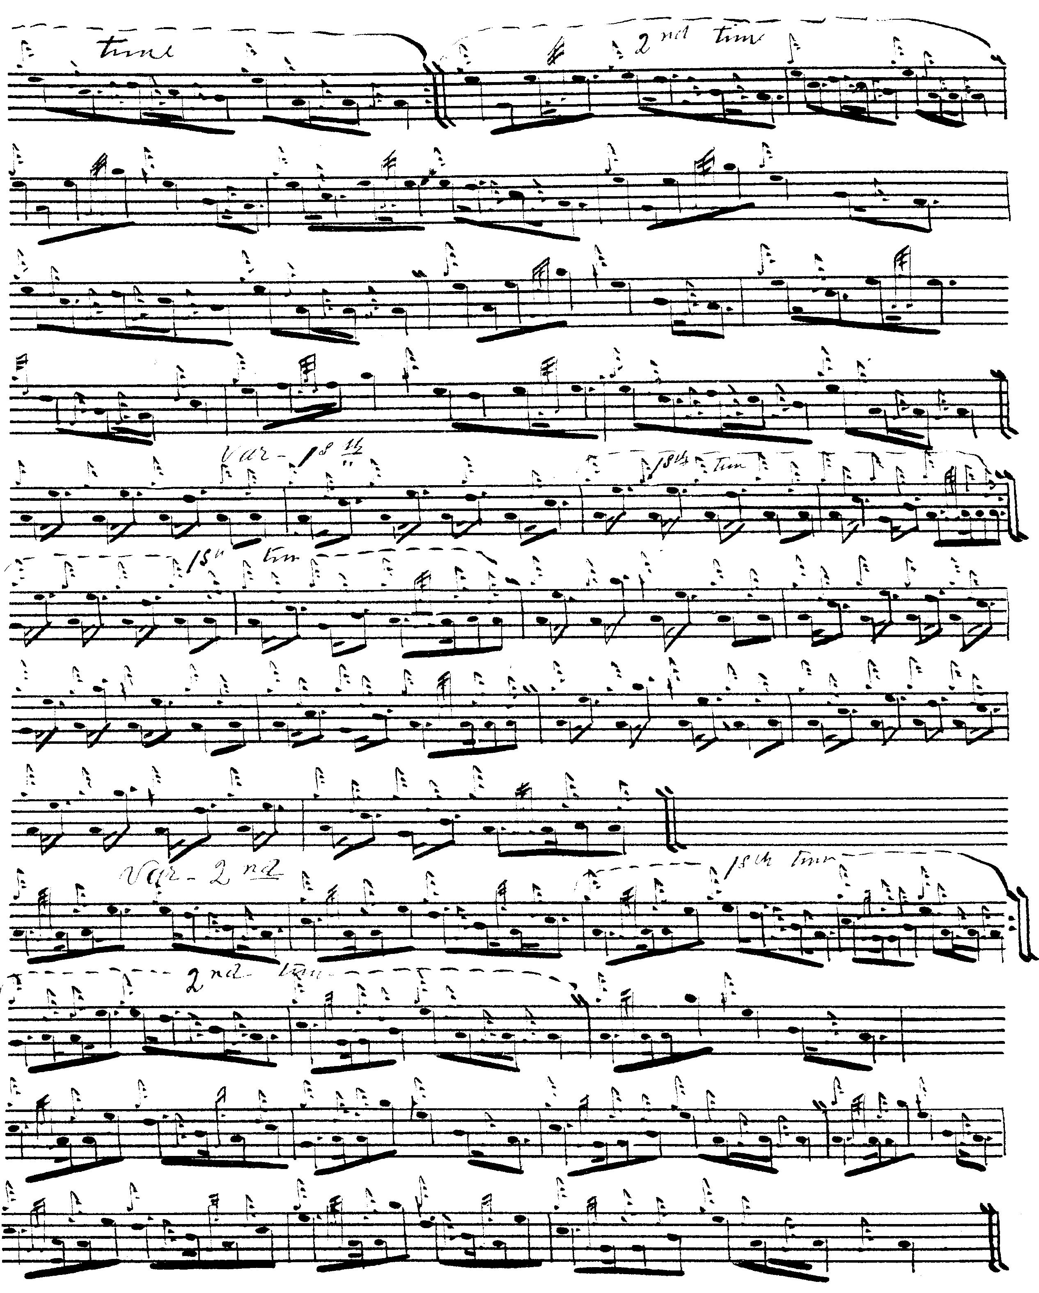

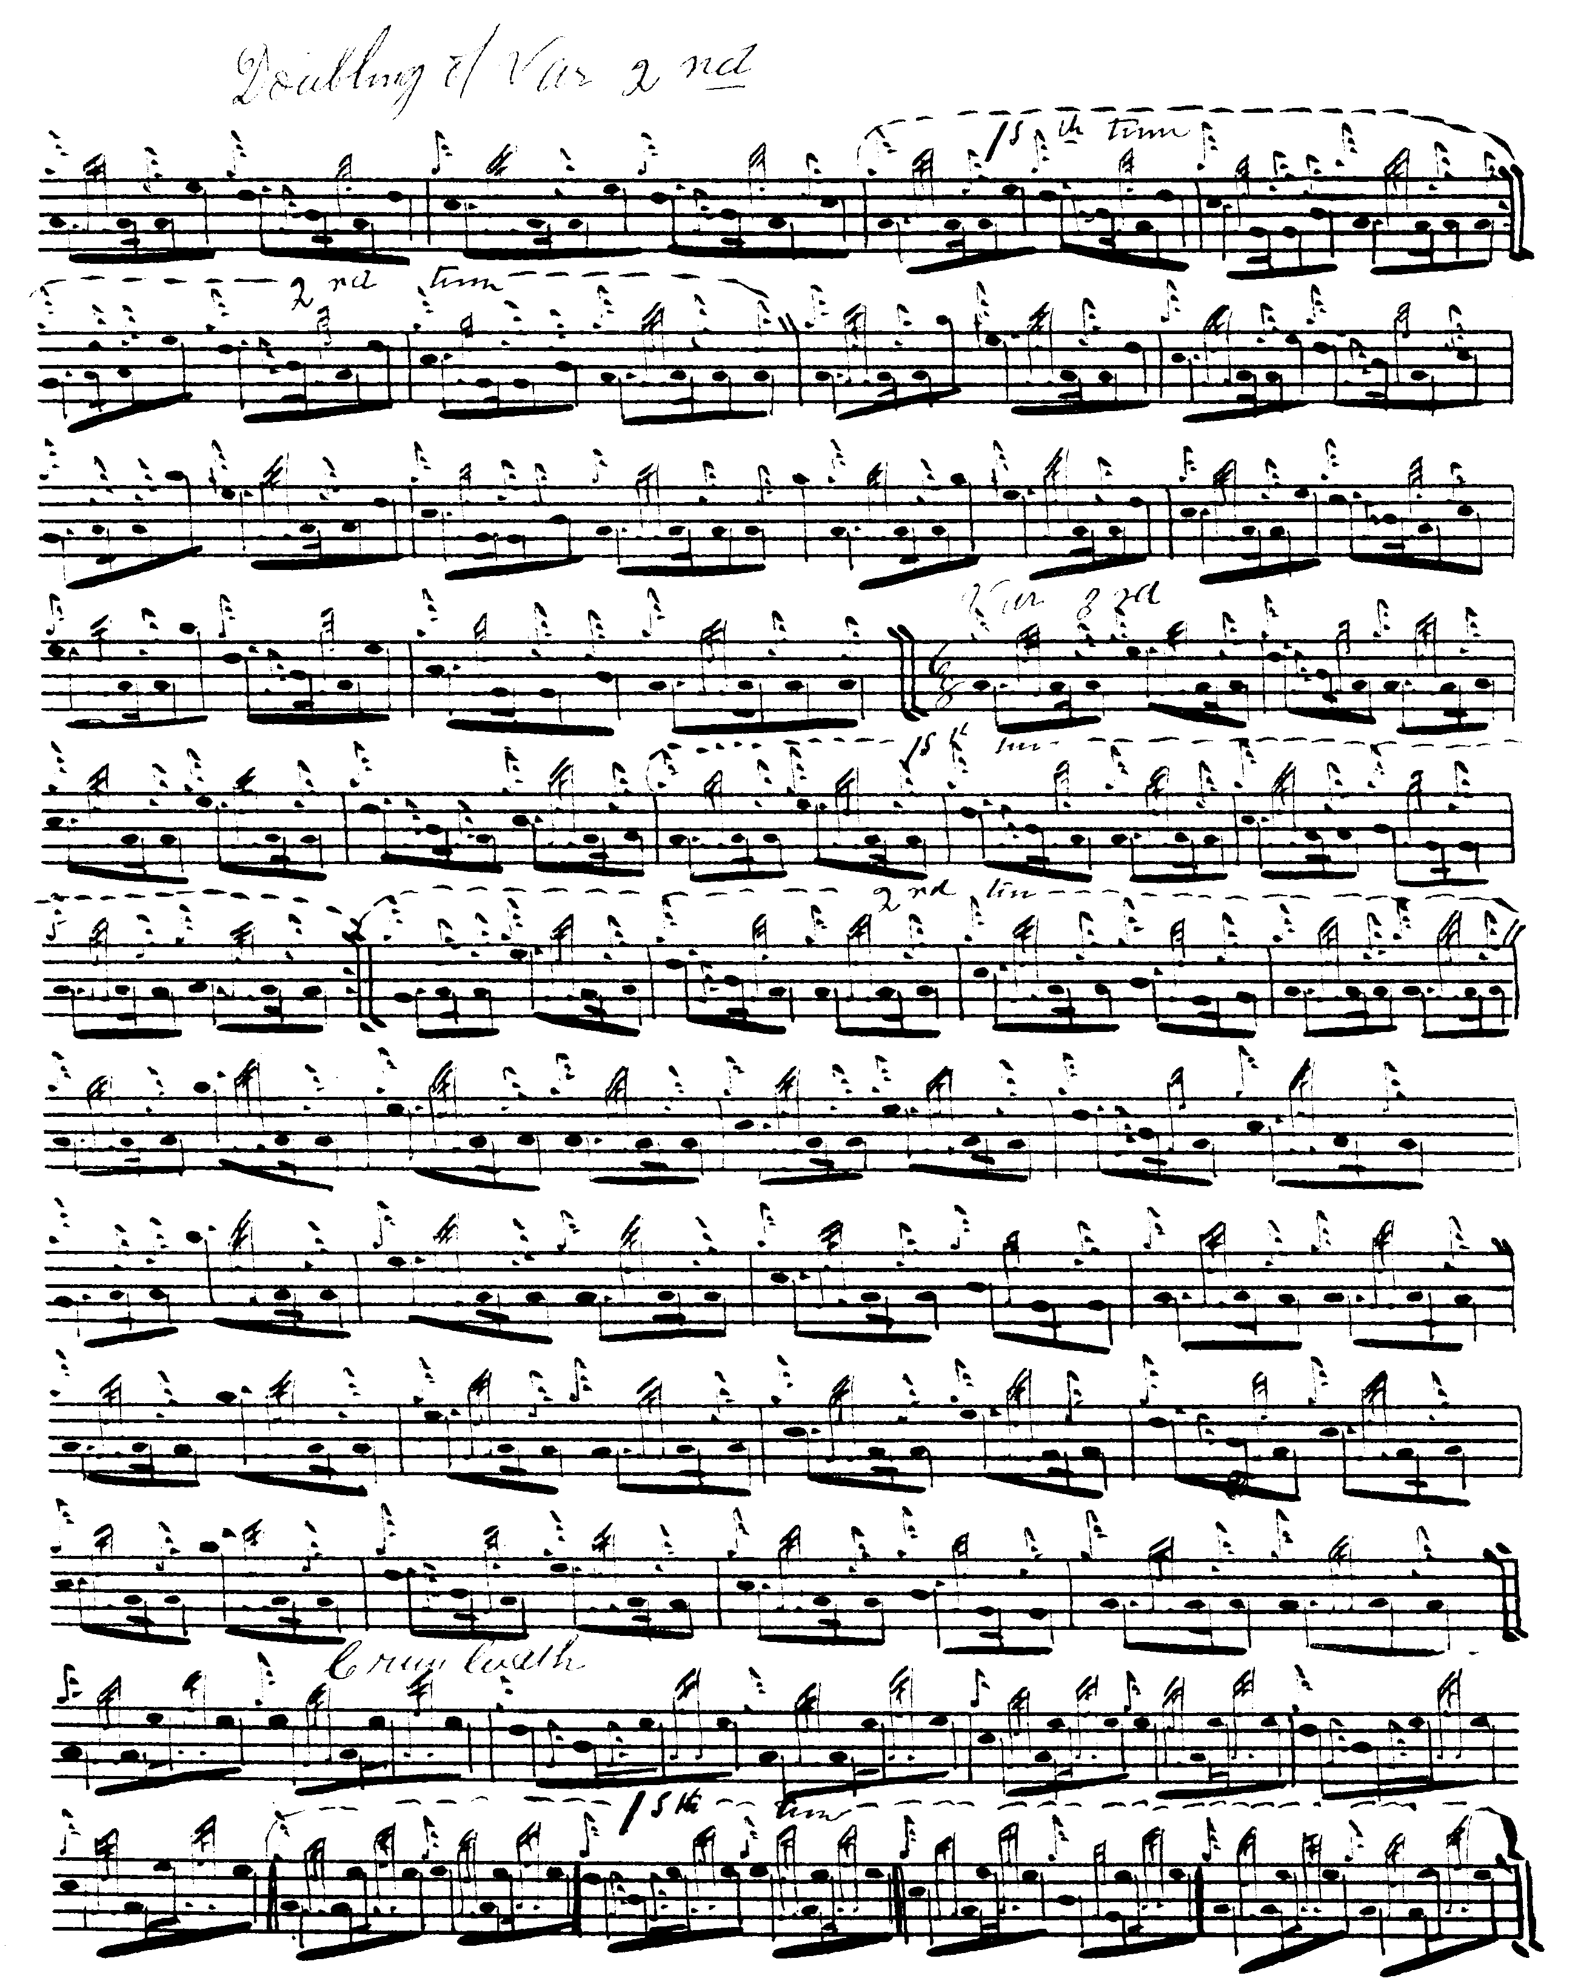

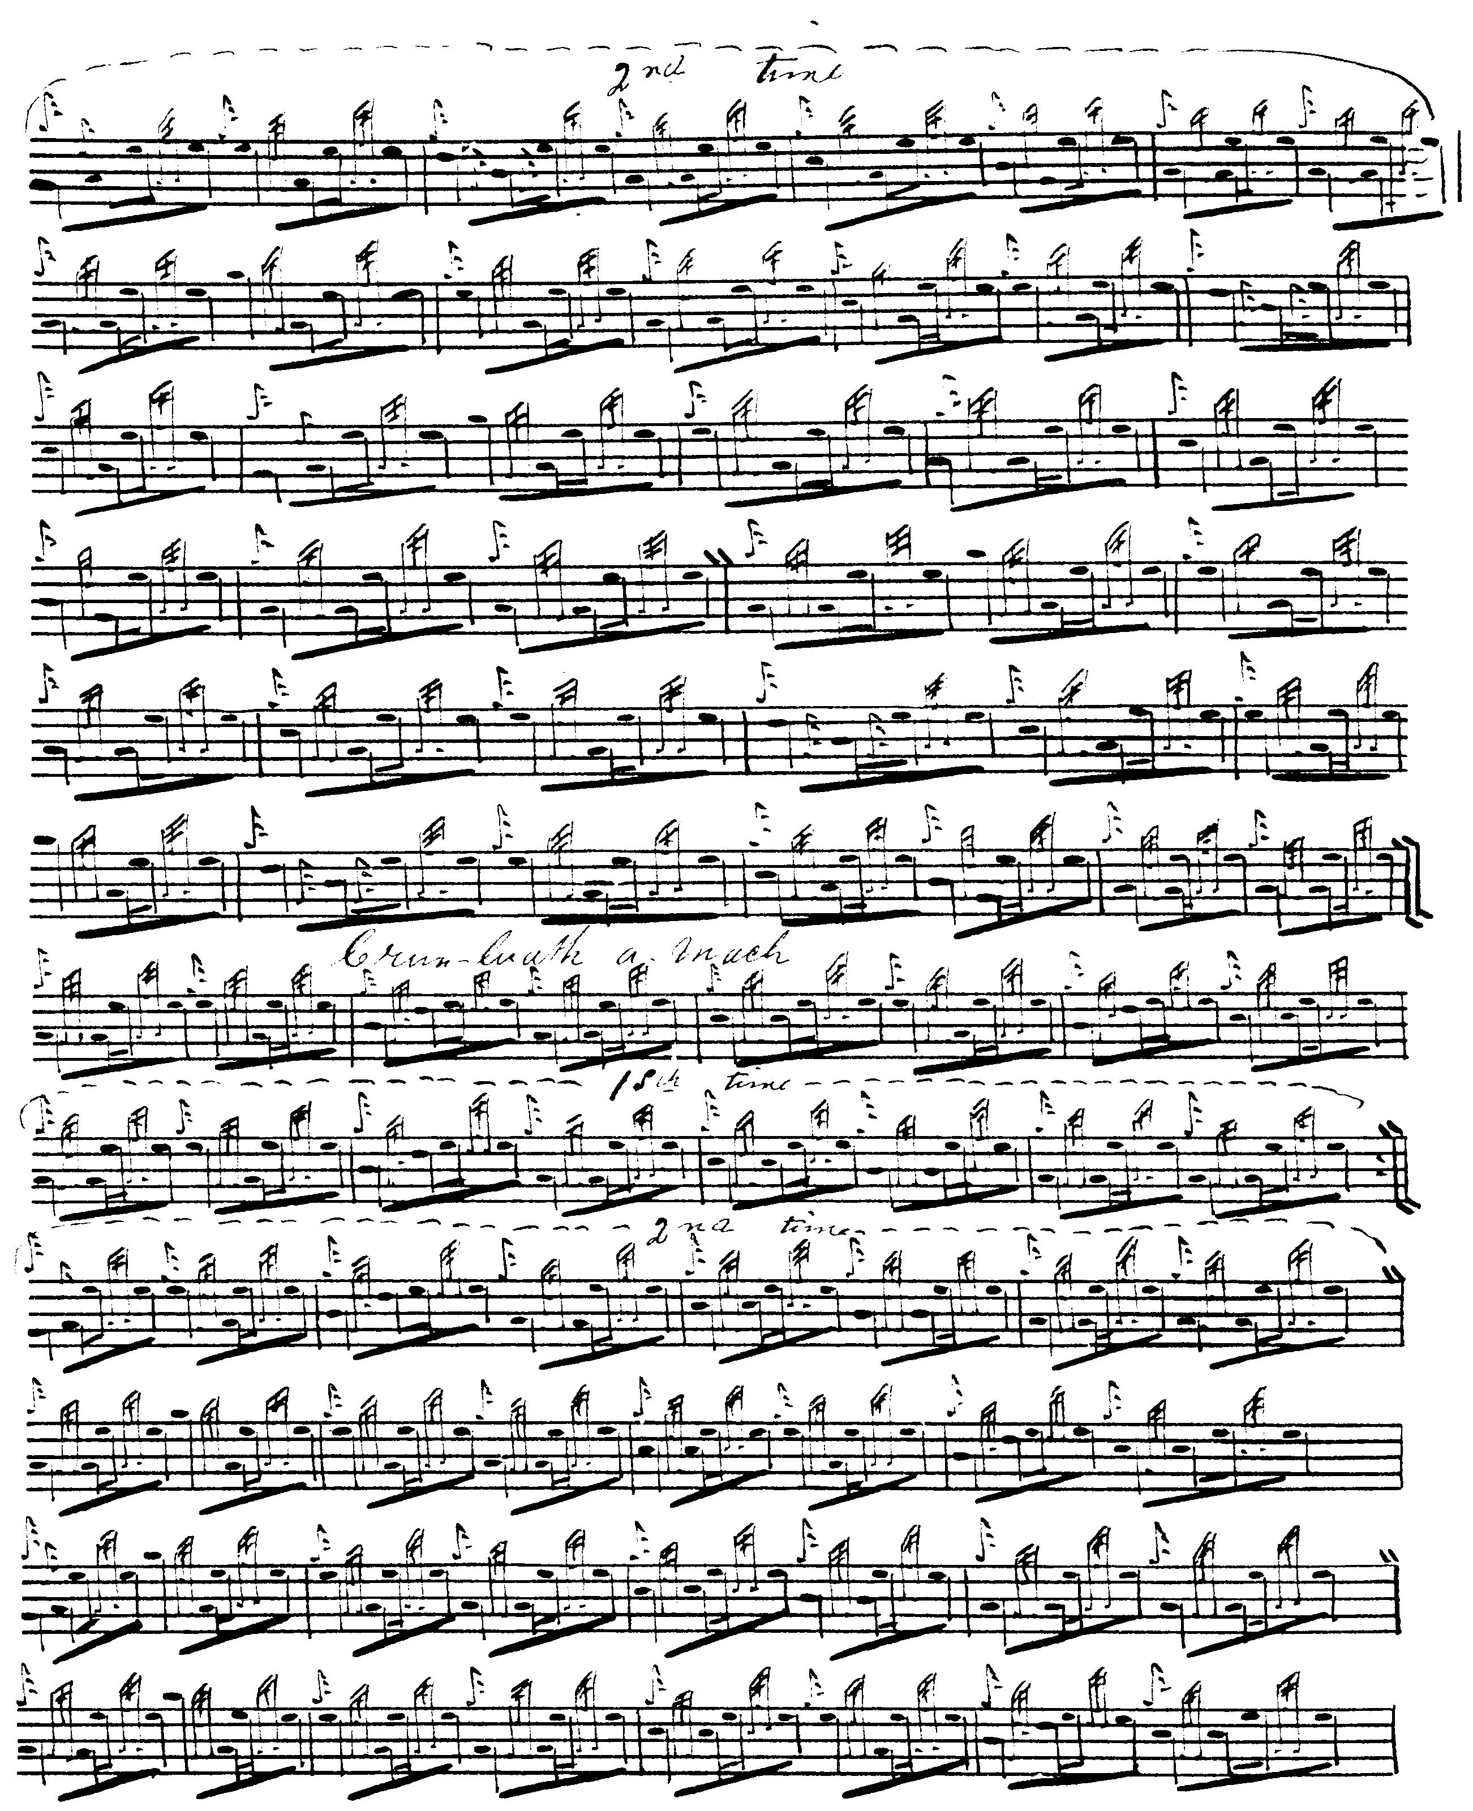
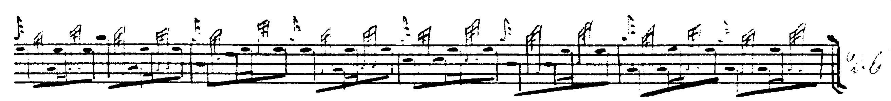

Donald MacKay’s MS is transcribed from his uncle Angus MacKay’s MS, but notated using a number of clever contractions he did not find in his original, but which he and General Thomason were later to develop into the abbreviated notation used in Ceol Mor. Donald MacKay interestingly points the taorluath “down” (as opposed to Angus MacKay and Duncan Campbell’s even quavers with their implied “up” timing):
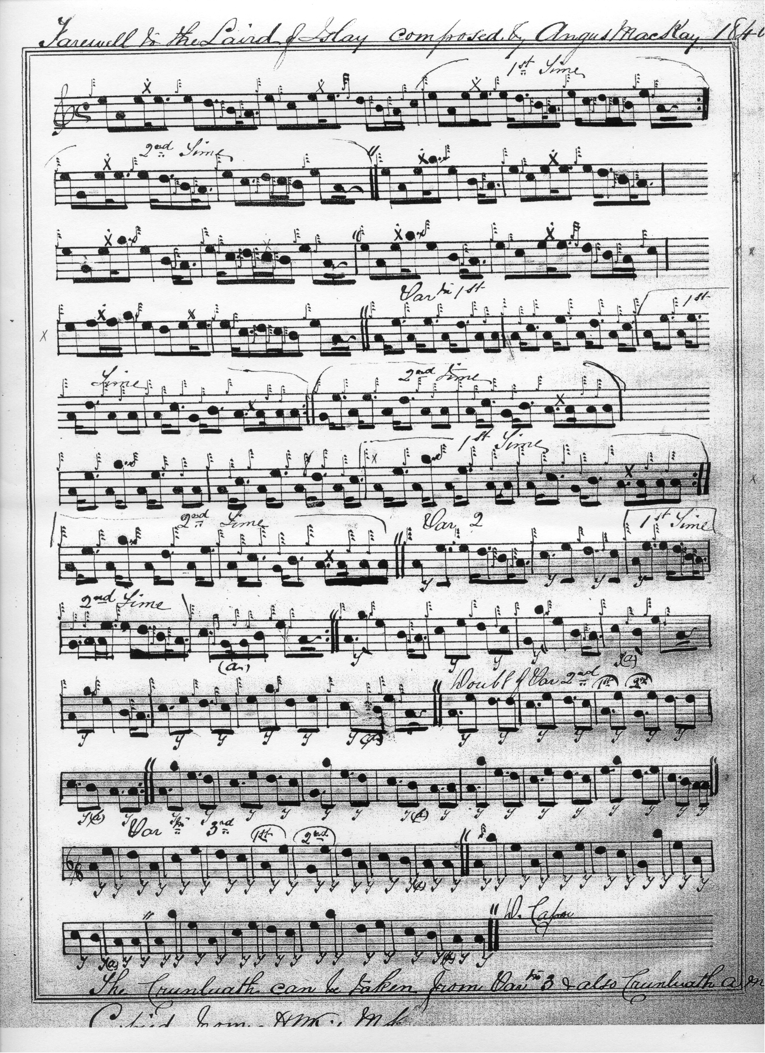
David Glen sets the tune in his characteristic style:
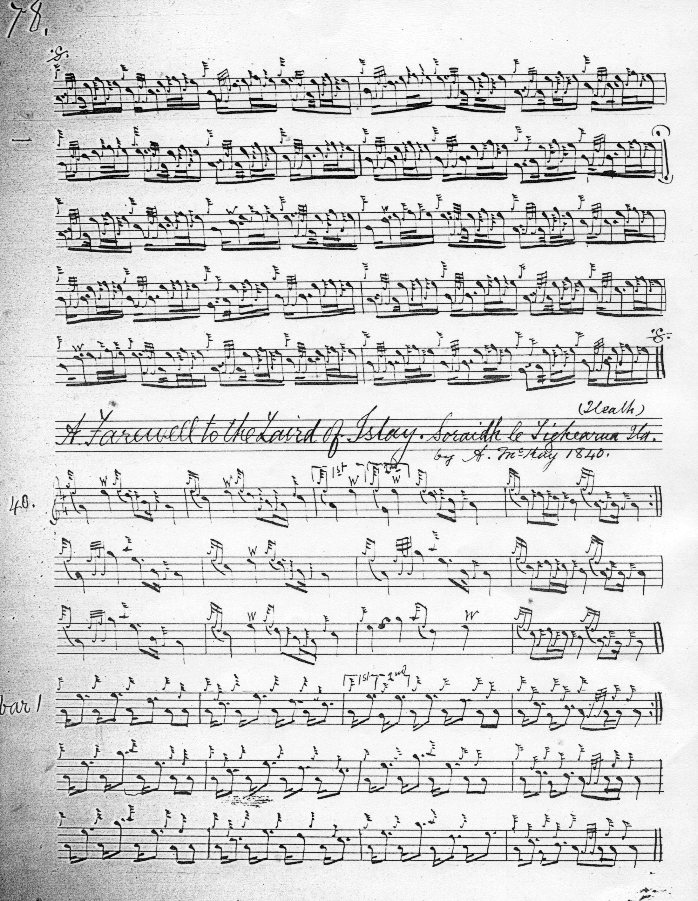

And so on.

The missing C crotchet in the second line of the ground was first identified by C. S. Thomason and reinstated by him in Ceol Mor. Some may feel that this otherwise most attractive tune eventually rather outstays its welcome, being developed somewhat beyond its potential, a thing which sometimes happens with the MacKays. In addition, the MacKay-derived settings seem rather unbalanced, with a taorluath breabach (singling and doubling) plus a taorluath duinte, followed by a crunluath duinte plus a mach. If the development were more symmetrical, one would expect the pattern to be crunluath breabach (singling and doubling) followed by a crunluath duinte. At any rate, C. S. Thomason came to something like this conclusion, citing Angus MacKay, Donald MacKay and Colin Cameron as his sources for the tune, with ground, siubhal, taorluath breabach singling and doubling, taorluath duinte (acting as a kind of taorluath trebling), repeat of the ground, crunluath breabach singling and doubling, followed by a duinte crunluath concluding movement. There is no a-mach:

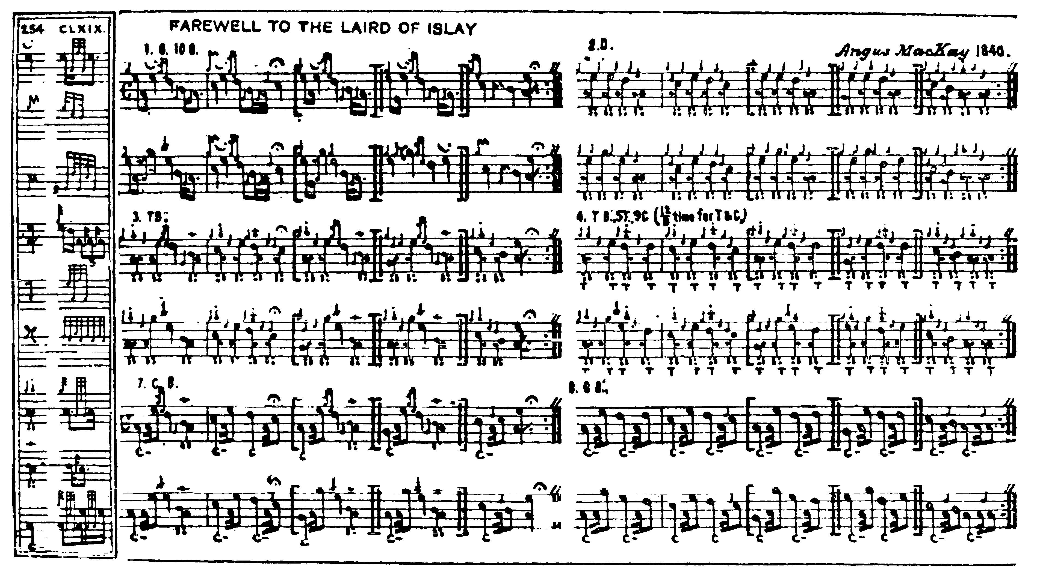

Since we have settings from both the Mackays and neither seems to include the crunluath breabach this may be a Cameron family styling, the General being strongly influenced by that particular strand of tradition.

Commentary

Perhaps the simplest thing to do would be to develop the tune either to a duinte or a breabach conclusion, but not both. One could perhaps drop the duinte taorluath and crunluath variations—so that the tune would end taorluath breabach singling and doubling/crunluath breabach singling and doubling. But this option is not available to the modern player in competitive piping. Indeed, it is recorded that one year at Oban, Sheriff J. P. Grant of Rothiemurchus relegated his own teacher John MacDonald of Inverness (although the Sheriff himself was little more than a beginner as a player) to fourth place in a competition MacDonald had otherwise clearly won, for weeding out what he considered a redundant variation in “The MacKay’s Banner”, rather than playing the official score as written.

The tune is said to have been written by Angus MacKay for his employer Walter Campbell of Shawfield and Islay, one of a number of piper-employing arriviste lairds who were converting business fortunes into Highland estates. The Shawfield family is a very interesting one: it was from it that the great folklorist J. F. Campbell of Islay sprang. Indeed, the piper “nurse” by whom J. F. had been reared was another distinguished player, John Campbell of the Nether Lorn family who figured prominently in the Edinburgh competitions in the second decade of the nineteenth century. We get an intriguing little sketch of him in Lady Eleanor Campbell’s diary recording an incident in January 1830 in which the family had been beguiling a rainy afternoon looking for the missing Shawfield pearls, and found an old deed box which it was thought might contain them: “…on his heels beside the box was John Campbell the piper in his Kilt, his good natured pock marked face lighted up with curiosity and eagerness. At last with a wrench and cheer the lid rose and there were only layers of yellow papers. Still hoping for the pearls or for a snuff box at least, layer after layer was unpacked and tossed on the floor. No one heeded the dusty old papers. At last his voice cracked with keenness the piper shouted and a rough tin with a parchment dangling to it was handed to the light of day…‘Huch’ said the Piper ‘its only a seal. But it’s a very queer one.’ The box contained nothing but papers and we were all grievously disappointed.” (Freda Ramsay, The Day Book of Daniel Campbell of Shawfield, 1767 with relevant papers concerning the Estate of Islay, Aberdeen: AUP, 1991, pp.101-2)

* * *

Electronic text © Dr. William Donaldson, Cambridge, Massachusetts, 10th December 2011; revised 24 December 2024.

