Fair Honey:

There are settings of this tune in the following manuscript sources:
--Nether Lorn, ii, 124-7 (with the title “Vuile Vrionich”);
--Angus MacKay, ii, 113 (with the title “A’ Mheil Bhraonach Far an [title smudged] Charly Stewart”);
--Duncan Campbell of Foss, ff.169-70;
--Uilleam Ross, ff.189-90;
--C. S. Thomason, f.49;
--D. S. MacDonald, ii, 57 (with the title “A Bheel Bhraonach. Charlie Stuart.”);
--John MacDougall Gillies f.47 (with the words “are you sad” jotted casually at the foot);
--David Glen, ff.97-8;
--Robert Meldrum, ff.235-6;

and in the following published source:
--Ceol Mor, p.238.

Colin Mór Campbell sets the tune like this:

1st Hinde hodroo hinde hoo hinde hodroo hinde hodin hioe hae hioe haem
2^{d} Hinde hodroo hinde hodin hioe hae hioe hae [hioe hae] hioe haem
3^{d} Hinde hodroo hinde hodin hioe hae hioe haem

S ffirst Motion
1st Hindili hodroo hindili hoo hindili hodroo hindili hodin hiodili hadili hiodili haem
2^{d} Hindili hodroo hindili hodin hiodili hadili hiodili hadili [hiodili hadili] hiodili haem
3^{d} Hindili hodroo hindili hodin hiodili hadili hiodili haem

D 1st Hindili hodili ffour times hiodili hadili hiodili hadili
2^{d} Hindili hodili hindili hodili hiodili hadili ffour times
3^{d} Hindili hodili hindili hodili hiodili hadili hiodili hadili

S Second Motion
1st Hinde hoe hinde hoo hinde hoe hinde hodin hioe hae hioe haem
2^{d} Hinde hoe hinde hodin hioe hae hio[e] hae [hioe hae] hioe haem
3^{d} Hinde hoe hinde hodin hioe hae hioe haem

D 1st Hinde hoe ffour times hioe hae hioe hae
2^{d} Hinde hoe hinde hoe, hioe hae ffour times
3^{d} Hinde hoe hinde hoe hioe hae hioe hae

S Taolive
1st Hindarid hodarid hindarid hodroo hindarid hodarid hindarid hodin hiodarid hadarid hiodarid haem
2^{d} Hindarid hodarid hindarid hodin hiodarid hadarid hiodarid hadarid [hiodarid hadarid] hiodarid haem
3^{d} Hindarid hodarid hindarid hodin hiodarid hadarid hiodarid haem

D 1st Hindarid hodarid ffour times hiodarid hadarid hiodarid hadarid
2d Hindarid hodarid hindarid hodarid, hiodarid hadarid ffour times
3d Hindarid hodarid hindarid hodarid hiodarid hadarid hiodarid hadarid

S Crulive
1st Hinbandre hobandre hinbandre hodroo hinbandre hobandre hinbandre hodin hiobandre habandre hiobandre haem
2^{d} Hinbandre hobandre hinbandre hodin hiobandre habandre hiobandre habandre [hiobandre habandre] hiobandre haem
3^{d} Hinbandre hobandre hinbandre hodin hiobandre habandre hiobandre haem

D 1st Hinbandre hobandre ffour times hiobandre habandre hiobandre habandre
2d Hinbandre hobandre hinbandre hobandre, hiobandre habandre ffour times
3d Hinbandre hobandre hinbandre hobandre hiobandre habandre hiobandre habandre

In his notes to this tune in the Piobaireachd Society Collection, ix, 263, Archibald Campbell stated that “The Canntaireachd setting is printed here”. He did not point out that the Nether Lorn setting was irregular, and that he had silently supplied an additional bar in line two of the ground, and in variation singlings throughout, indicated in square brackets above, to make the tune up to the expected dimensions.

Angus MacKay sets the tune as follows:
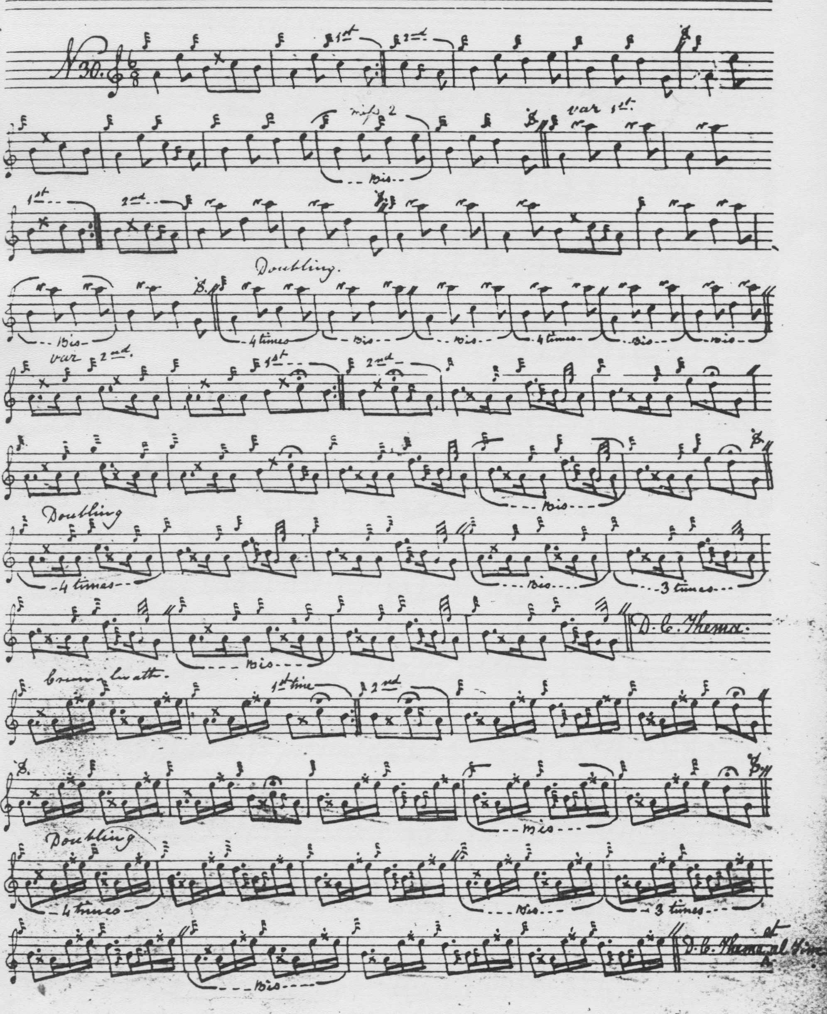

MacKay does not have the siubhal variation singling and doubling we see in Colin Campbell; he also directs that the ground be repeated at the end of the taorluath and crunluath doublings, a point on which Colin Mór is silent.

Duncan Campbell of Foss’s setting is very similar to MacKay’s but shows signs of not being finished, with ‘bis’ signs scattered about loosely, and missing bars in the inner variations. It is not reproduced here.

Uilleam Ross’s setting is also very similar to MacKay’s except that he does not indicate that the ground be repeated after the taorluath doubling. It is not reproduced here.

D. S. MacDonald’s setting reflects his source, Angus MacKay, very closely and is not reproduced here.

John MacDougall Gillies’s setting also reflects MacKay’s treatment of the tune and is developed down to the end of the taorluath doubling. It directs that the ground be repeated at this point and continues “Crunluath off Taorluath”. It is not reproduced here.

David Glen takes MacKay’s route through the tune, except that he does not indicate that the ground should be repeated at any point.. This score is not reproduced here.

Robert Meldrum records the tune as “Are You Sad Fair Honey A Mhil Bhraonach”. His score also follows MacKay and is not reproduced here.

C. S. Thomason’s published setting adds nothing stylistically to Angus MacKay. Thomason indicates, as MacKay does, that the ground be repeated at the end of the taorluath and crunluath doublings. This score is not reproduced here.

Commentary:

This is a tightly organised tune offering little obvious opportunity for stylistic variation and most of the later manuscript scores are very close to the way MacKay treats it. It is an unassuming little piece of no enormous technical difficulty, and posing few challenges with regard to interpretation. It has tonal affinities with “Mary’s Praise” and the “Rout of Glenfruin”, and is widely diffused in the sources. Yet Bob Nicol told the writer that he had never heard it or heard of anybody playing it, perhaps an acknowledgement of its relatively derivative status.

This tune offers interesting insight into the transmission of the tradition during the 20th century. It appears in the list of one hundred or so “Tunes which require a crunluath a mach” first issued in 1989, and reproduced in the magazine of the Eastern United States Pipe Band Association The Voice (vol.32 no.1, Spring 2003, p.66). It would be interesting to trace how this “requirement” came to be specified, and by whom, because not one of the sources, either published or in manuscript (including those of the Piobaireachd Society), stipulates that a crunluath a mach should be played.

* * *

Electronic text © Dr. William Donaldson, Aberdeen, Scotland, July 2005; rev. Cambridge, Massachusetts, December 2024

