The End of the Little Bridge

There are settings of this tune in the following manuscript sources:
--Colin Mór Campbell’s Nether Lorn Canntaireachd, ii, 183-6;
--Angus MacKay’s MS, i, 165-166;
--Donald MacKay’s Ballendalloch MS, ff.13-15;
--David Glen’s MS, ff.173-175 and again at ff.397-403;

and in the following published collections:
--Donald MacDonald, Ancient Martial Music of Caledonia, pp. 38-47 (with the title “Ceann na Drochaid big or the Clans' Gathering composed on the last battle fought at Inverlochy in 1645”);
--Niel MacLeod of Gesto, Pibereach or pipe tunes (1828), pp.28-30;
--C. S. Thomason, Ceol Mor, pp.19-21.

Colin Mór Campbell sets the tune as follows:

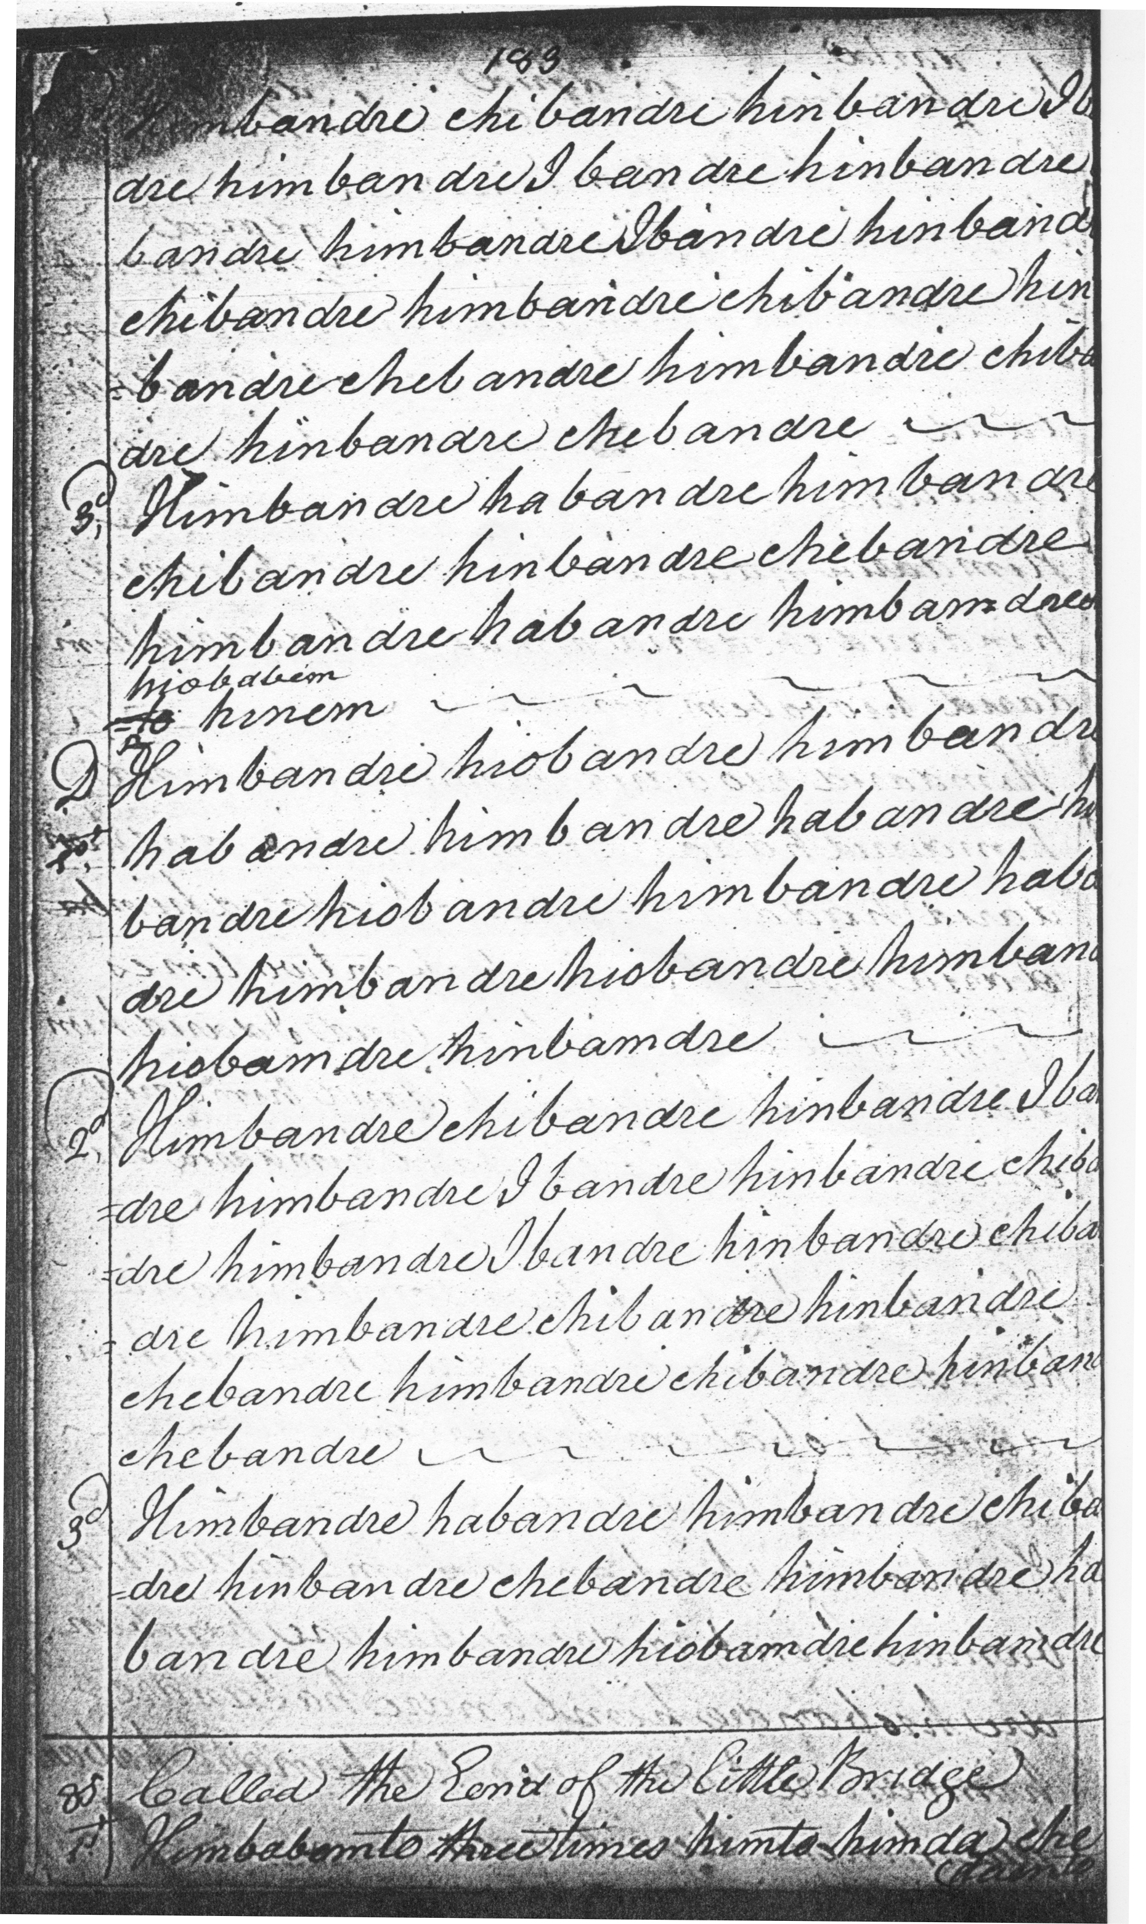
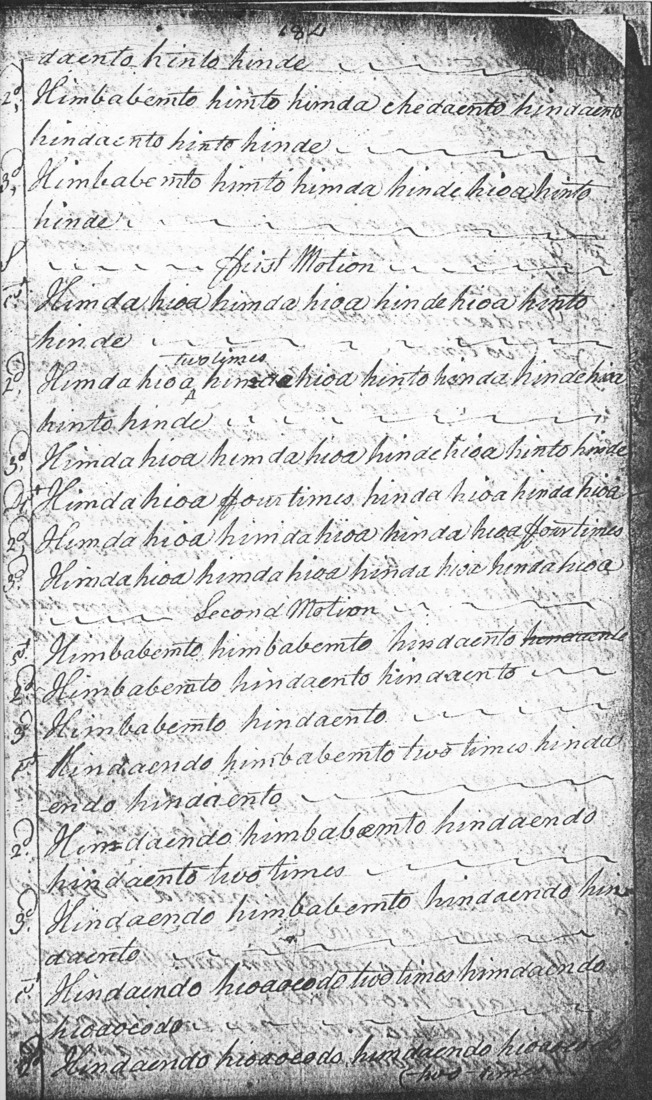
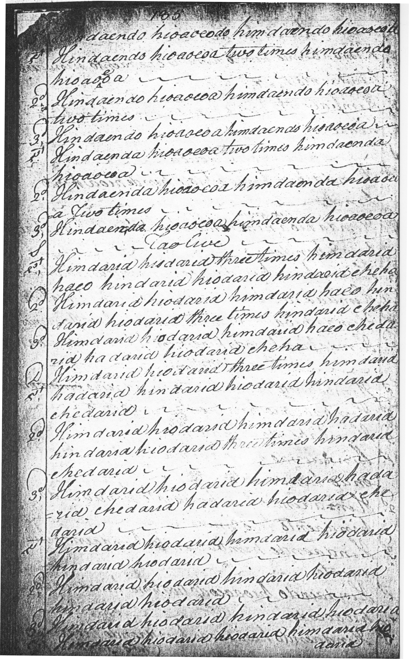
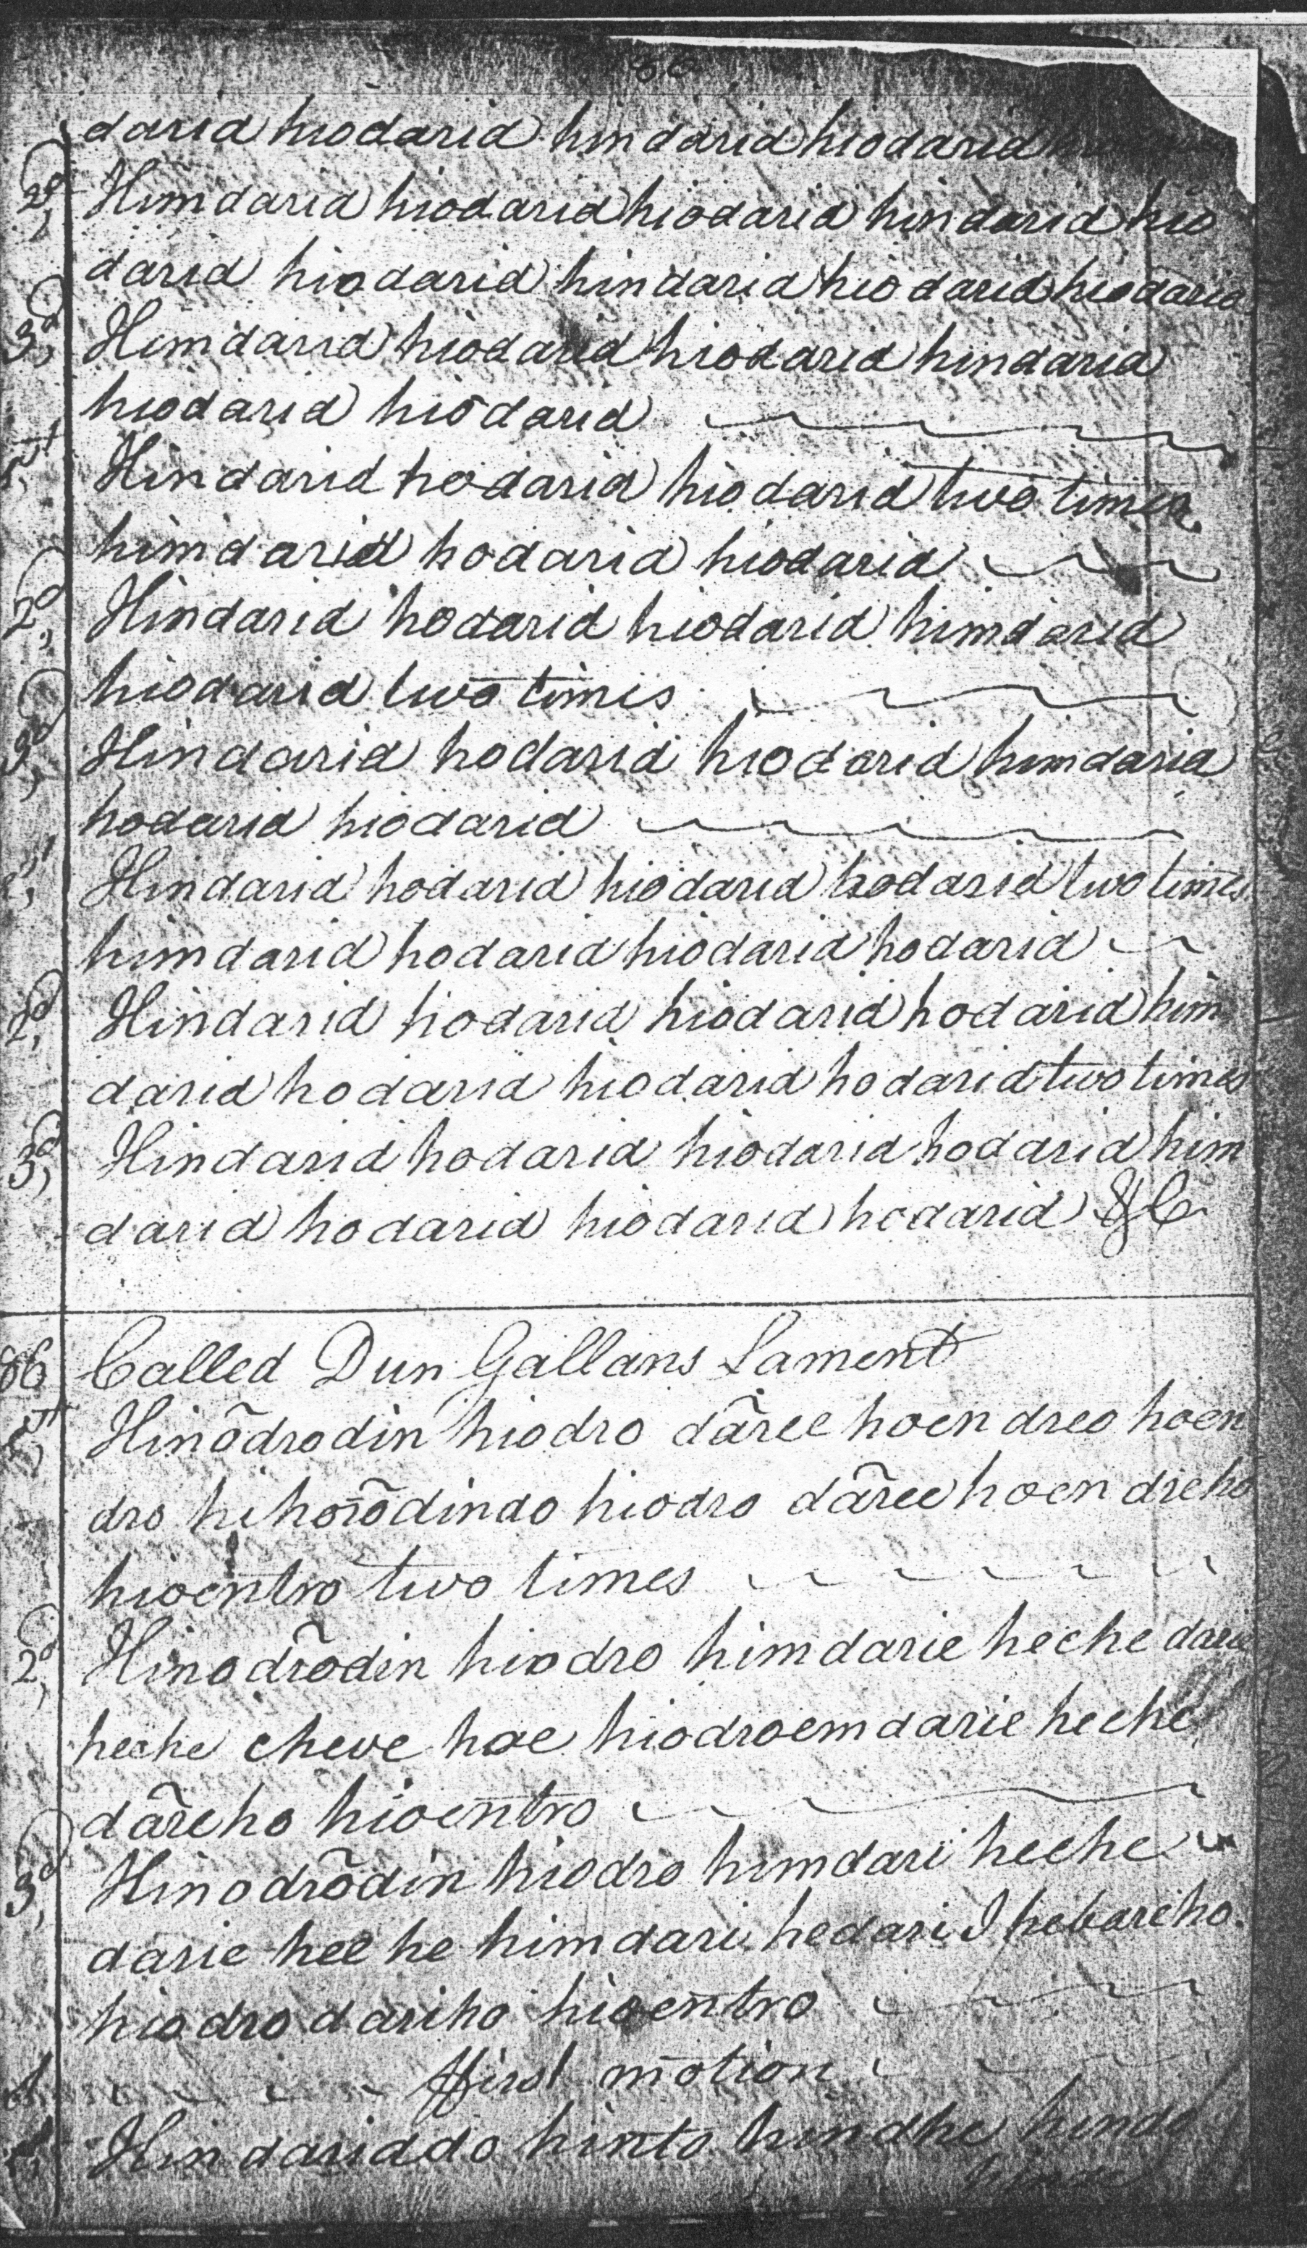
There are numerous fascinating technical points about this grand and elaborate setting, for example, in the Ground: the B phrase is played off E rather than A as in other scores, with pleasing effect. In the ffirst Motion first line, the A phrase is short of a vocable group: himdahioa in the original score. This is made good in the staff notated version below.
The Second Motion shows a dramatic shortening of metre and scale, with a similar passage later in the Crunluath variations. It presents an abbreviated summary of the succession of tonics hitherto utilised, before launching into a new pattern where A rather than low G predominates. The initial gapped pentatonic scale (GABDE) is contracted into three dramatically reiterated notes—low G, low A, and B, before expanding into a tetrachordal sequence G-A-B-C which then forms the basis for the rest of the tune. The alternation of tonics is also dramatically reversed. It’s like a musical earthquake right in the middle of the tune. The normal succession, G then A, is reinstated in the Taolive, then flips back again to A>G in the Quintupling. While all this is going on, the themal notes gradually work their way back up the chanter, progressively raising the emotional charge, so there are constant flickering changes in the tone row, with the time signature swinging between duple and triple time, all to achieve maximum variety within a tightly focused tonal frame. The physical score ends with an “&c” mark at the end of the taorluath variations, indicating that the remainder may be read off them, a common enough practice during the eighteenth and earlier nineteenth centuries when paper would be more expensive than it would become later on. These later variations are realised in the transcript in staff notation below:

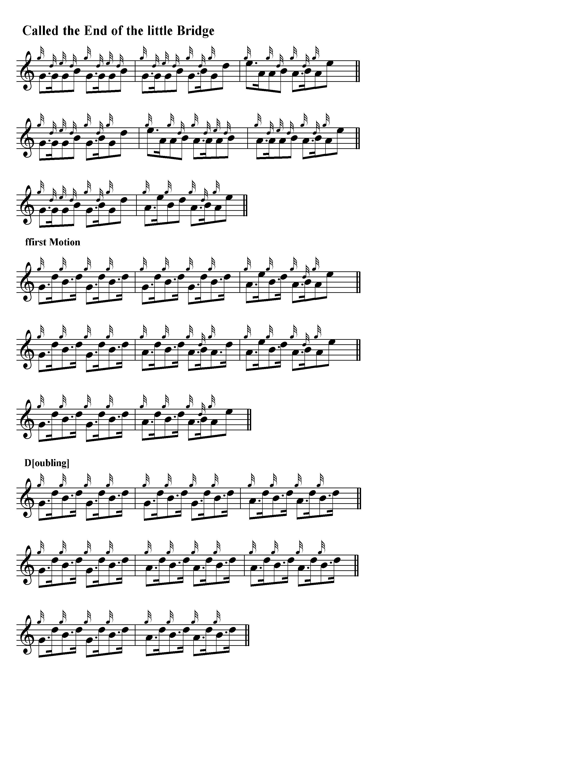
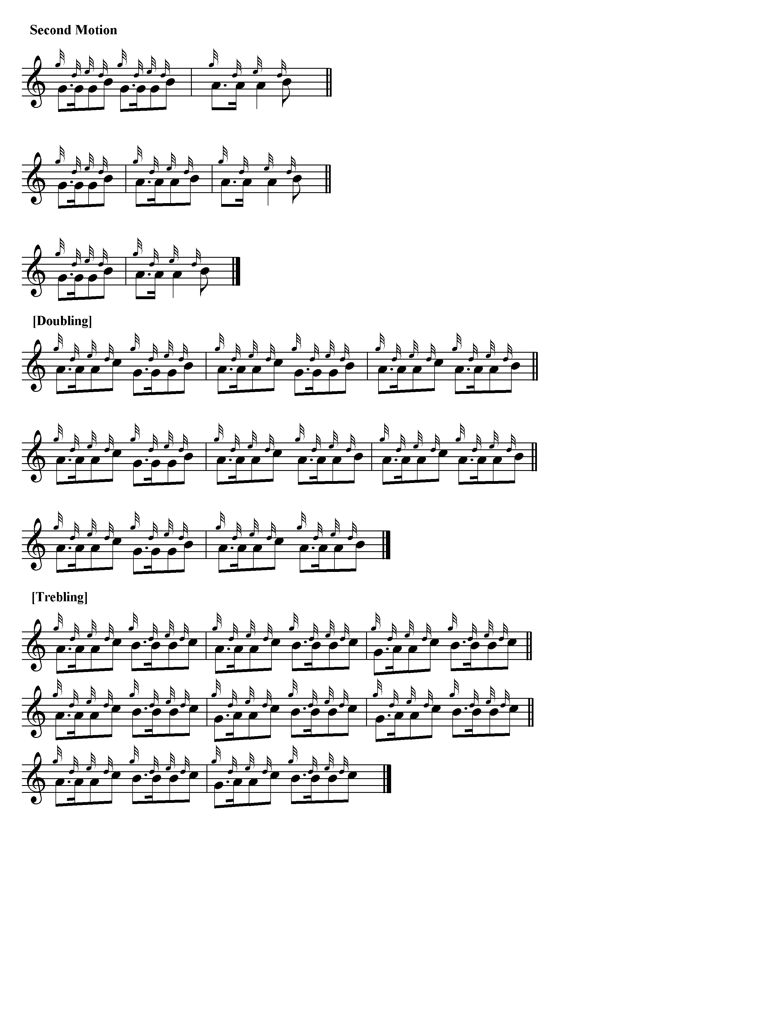
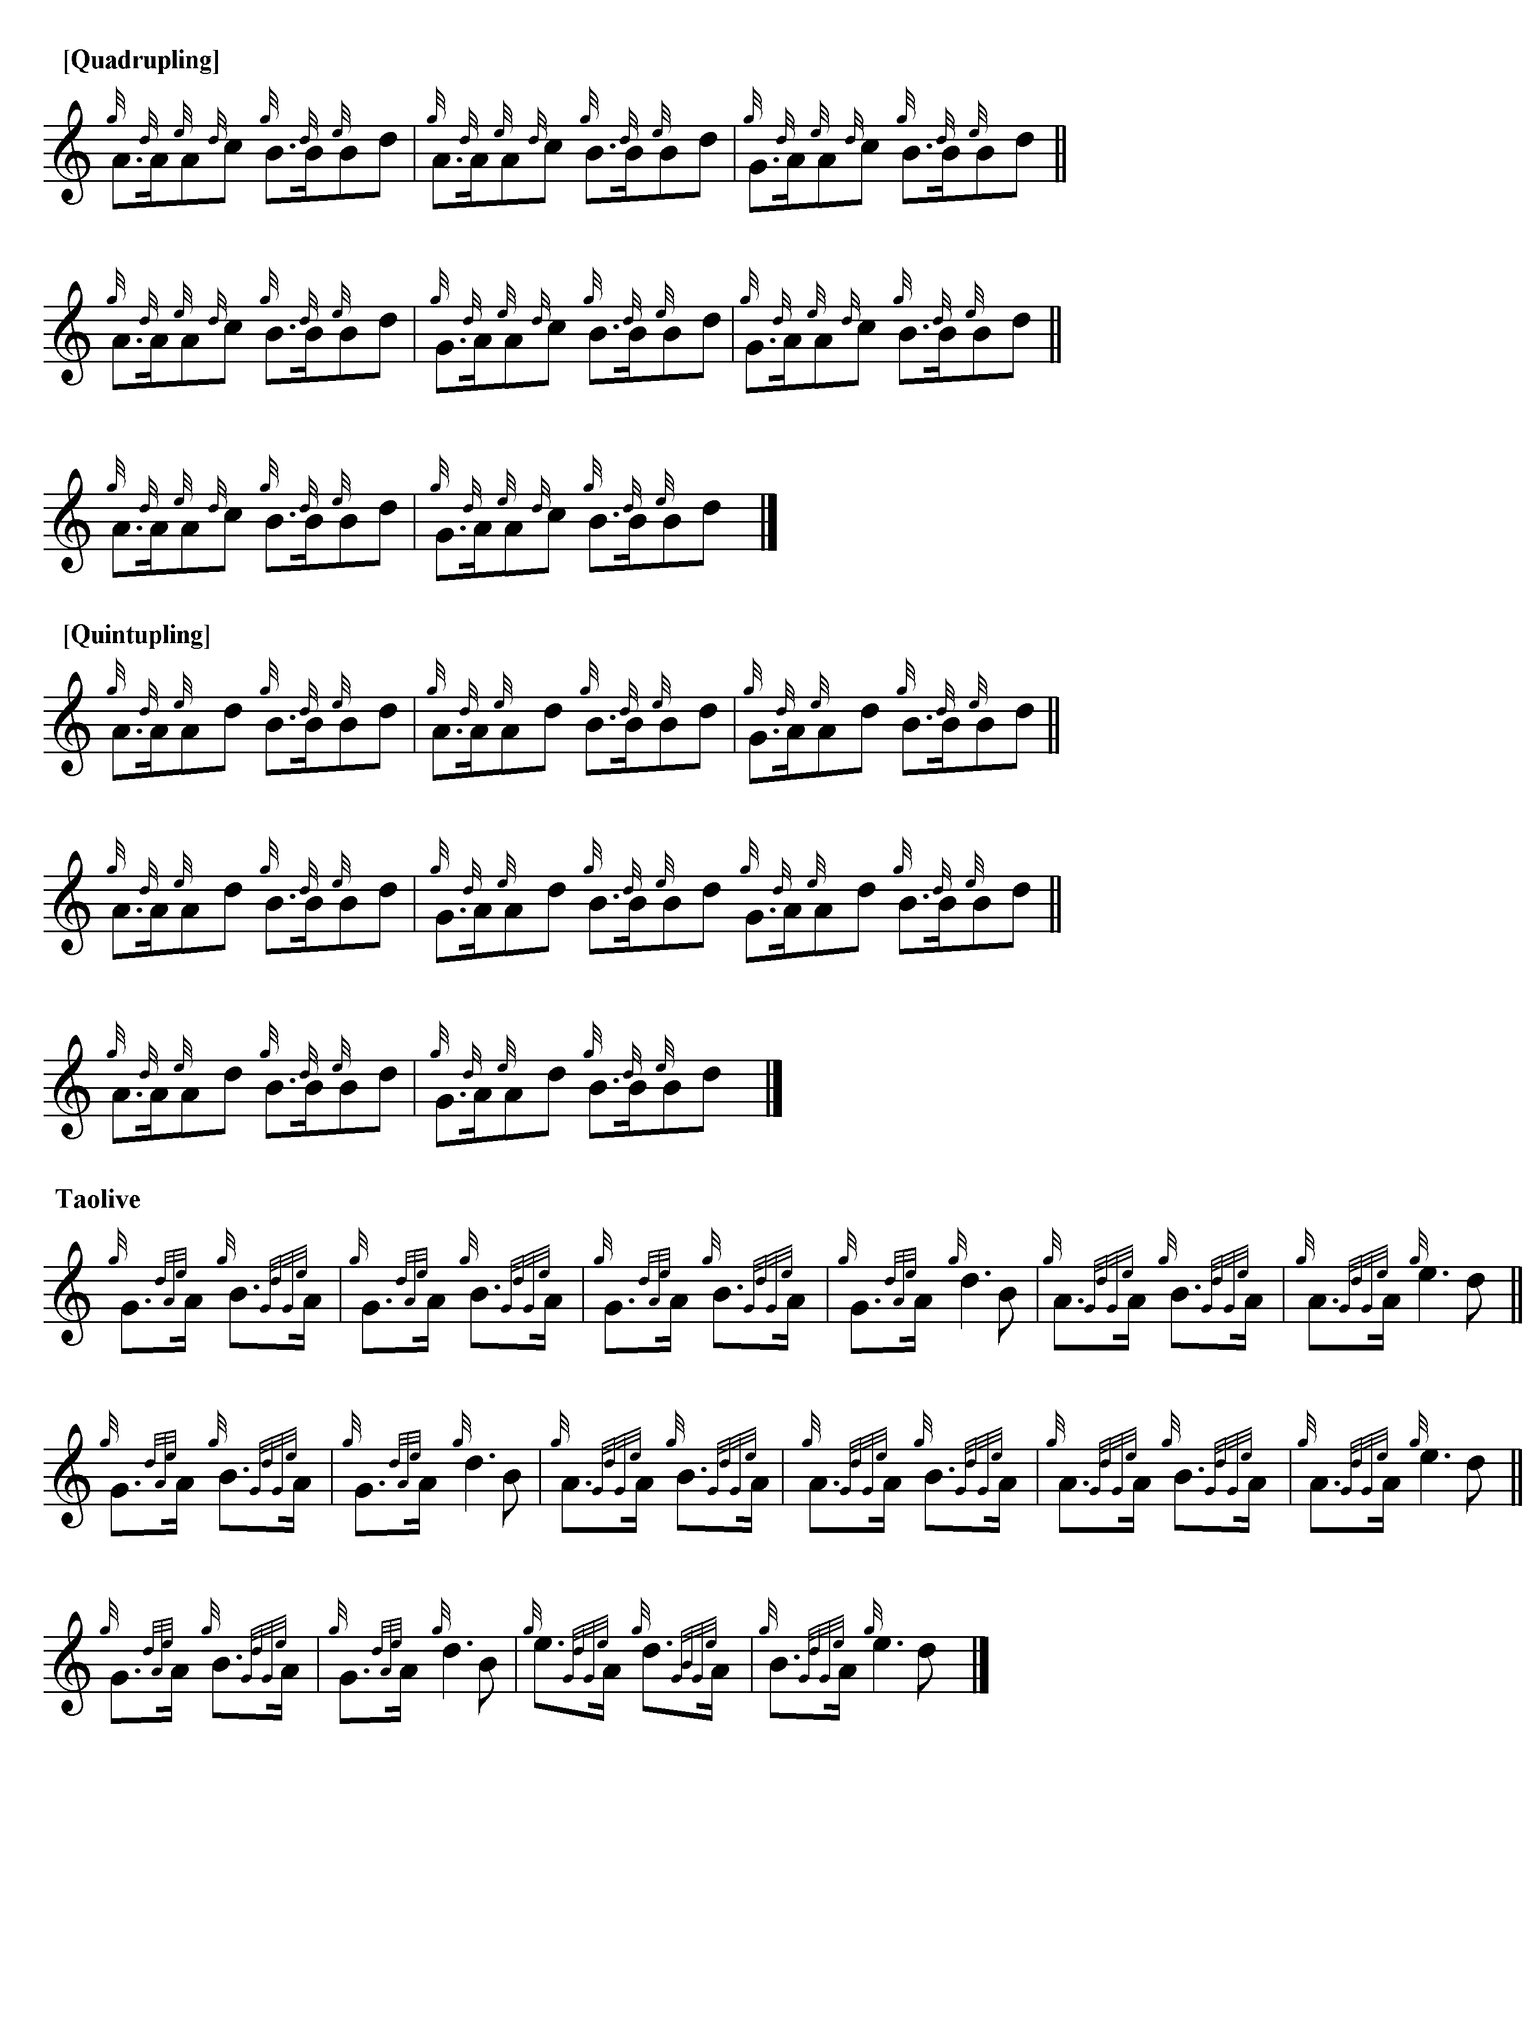
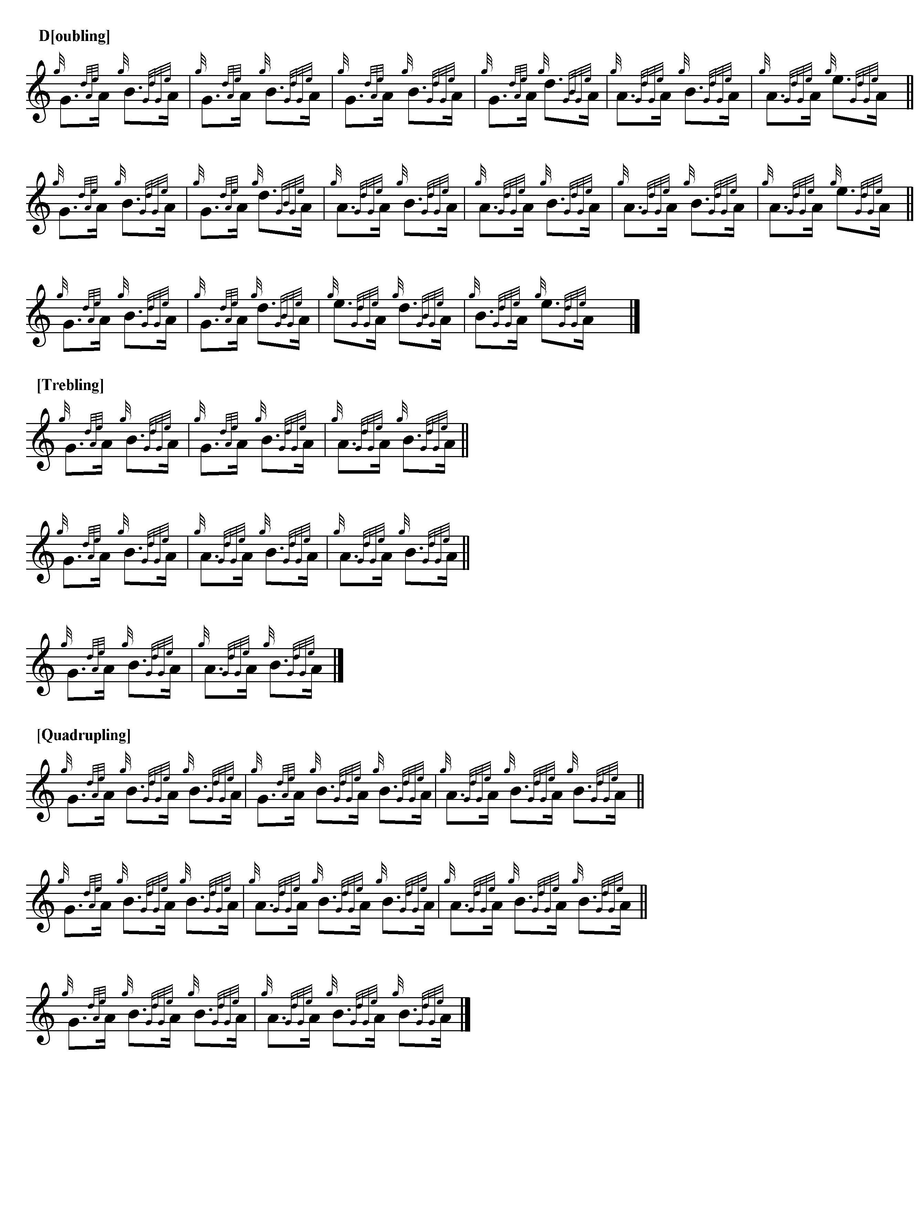

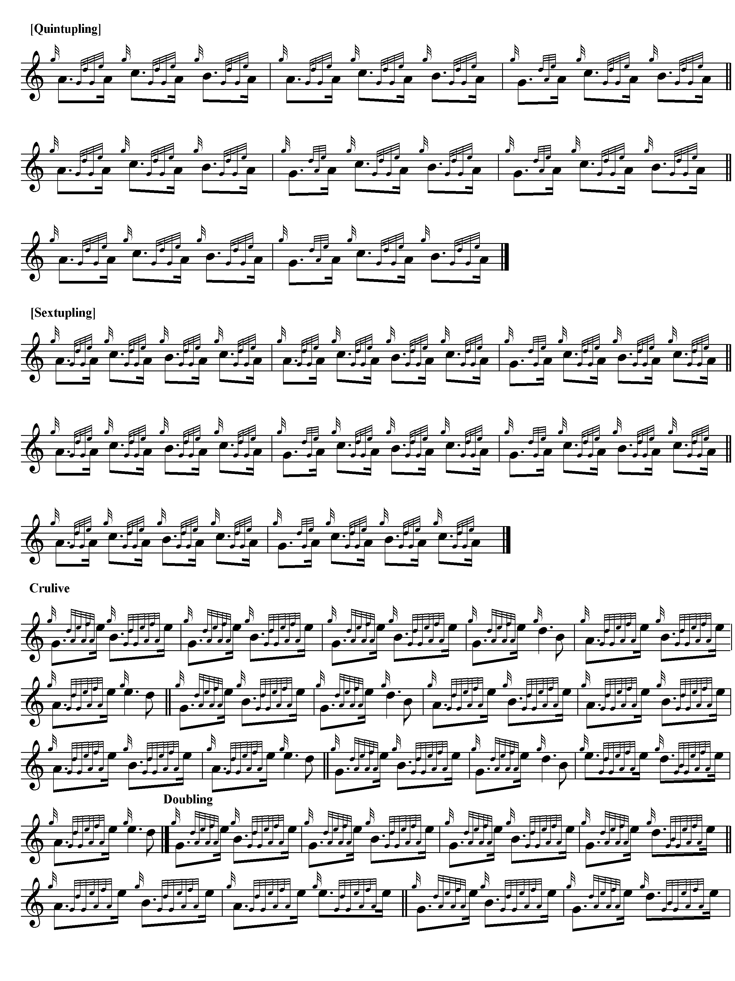

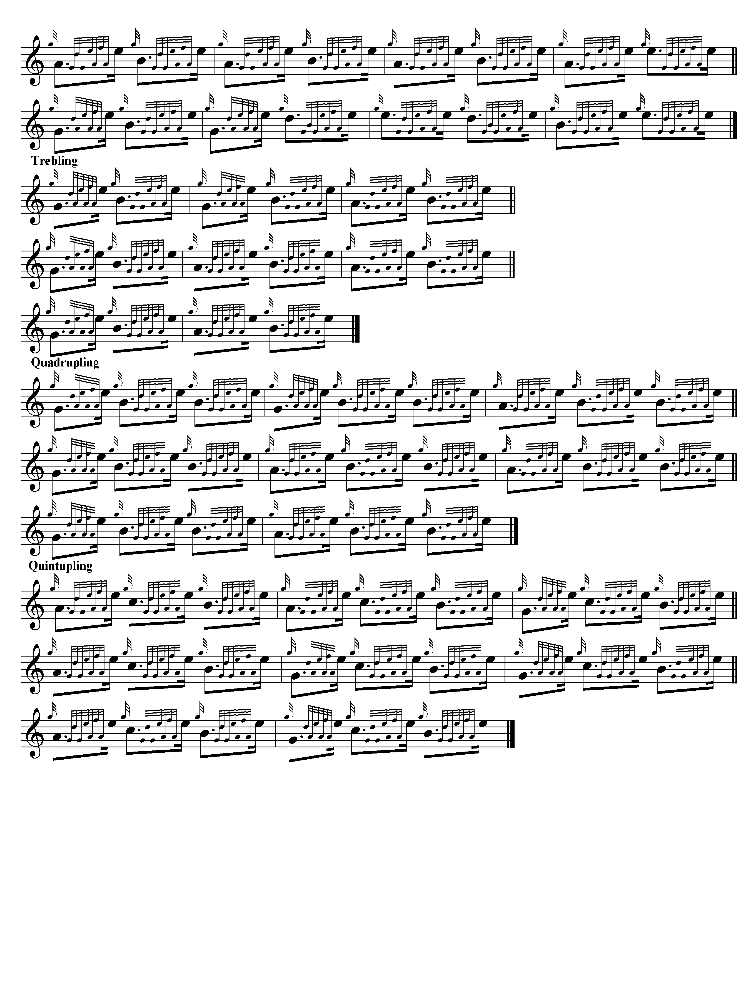

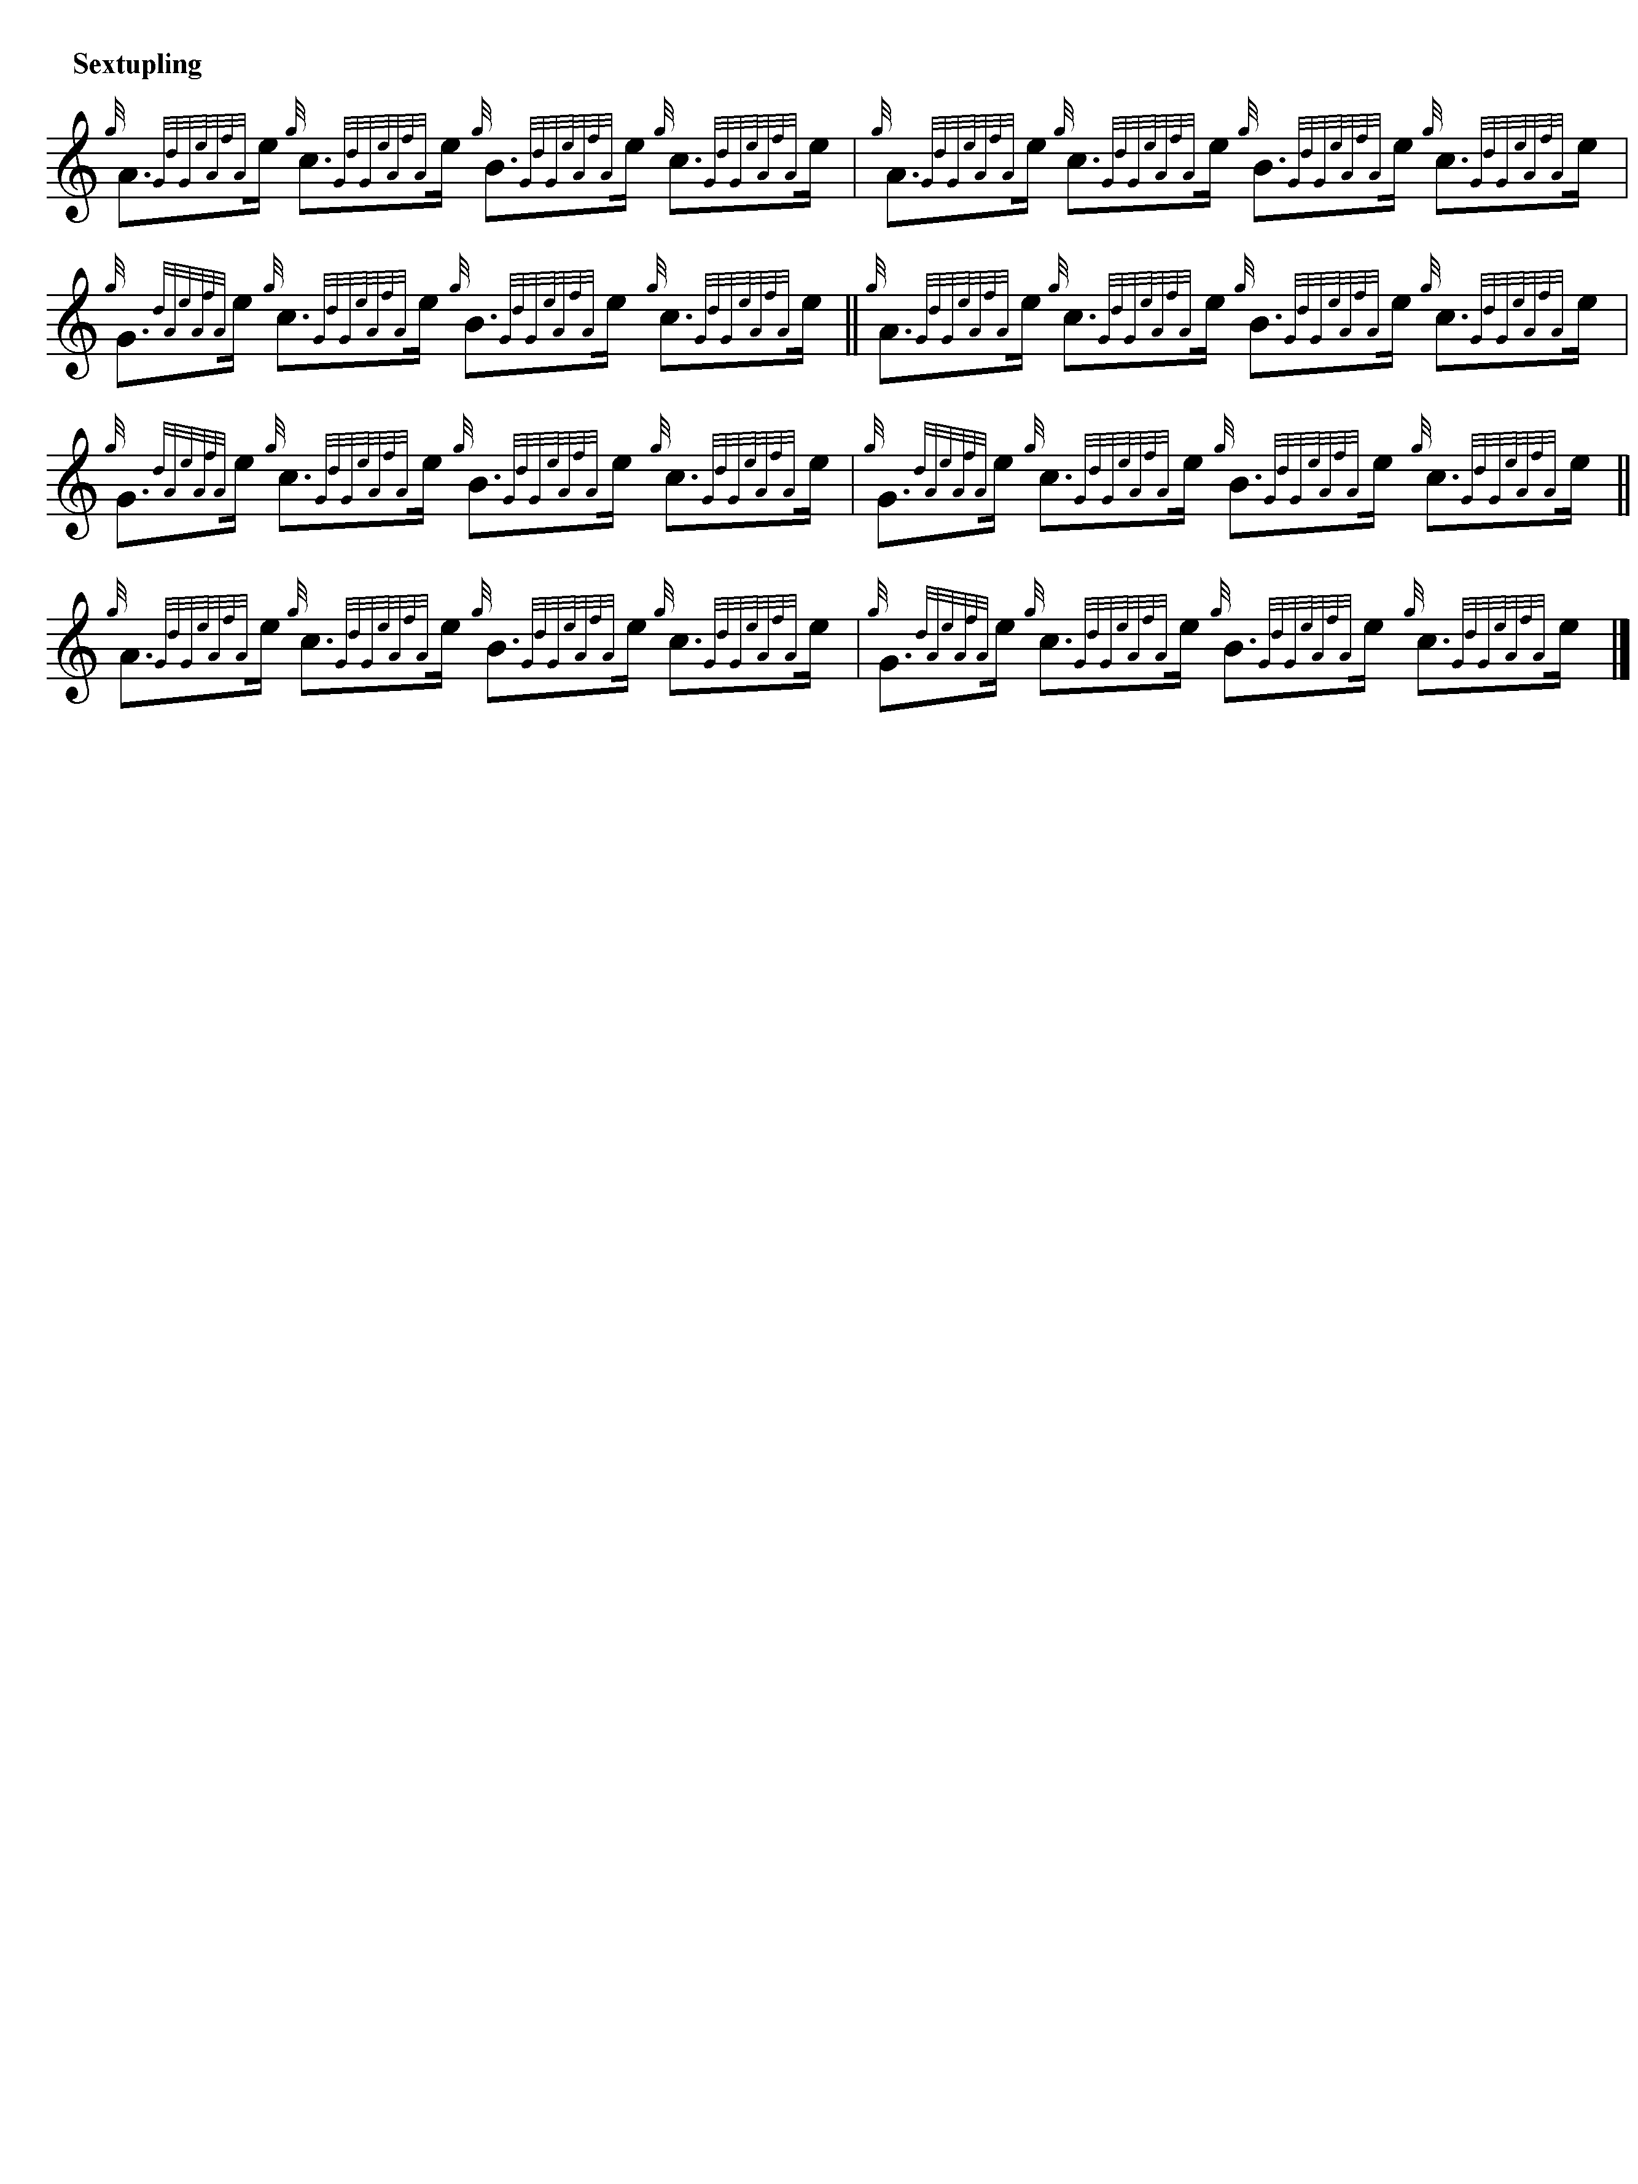

Stylistically Colin Mór Campbell’s “Nether Lorn” version seems the best of the available settings of “The End of the Little Bridge”, a magnificent incitement-tune, full of life and fire, which, if played up to time, builds explosive rhythmical, tonal and metrical tensions. This is a seriously heavyweight tune: Colin Mór must have had a formidable technique.

The setting in Niel MacLeod of Gesto’s collection of 1828 bears the title “Kiaunma Drochid a
Beig, alias the Head of the little Bridge, played by McLeod’s piper, during Skirmishes in Ireland, inviting the clan Cameron to follow him and his party across the Bridge to the Enemy, which they did.” This appears to be on similar lines to the Nether Lorn setting in its general development but it is shorter overall and ends with a crunluath fosgailte rather than the duinte resolution favoured by Colin Mór. The ambiguity of Gesto’s vocables and his failure to distinguish clearly between notes at certain important pitches make the score difficult to interpret with certainty. It is not reproduced here.

Angus MacKay’s setting likewise shows the themal notes rise progressively up the chanter in a series of hammer-blow repetitions:

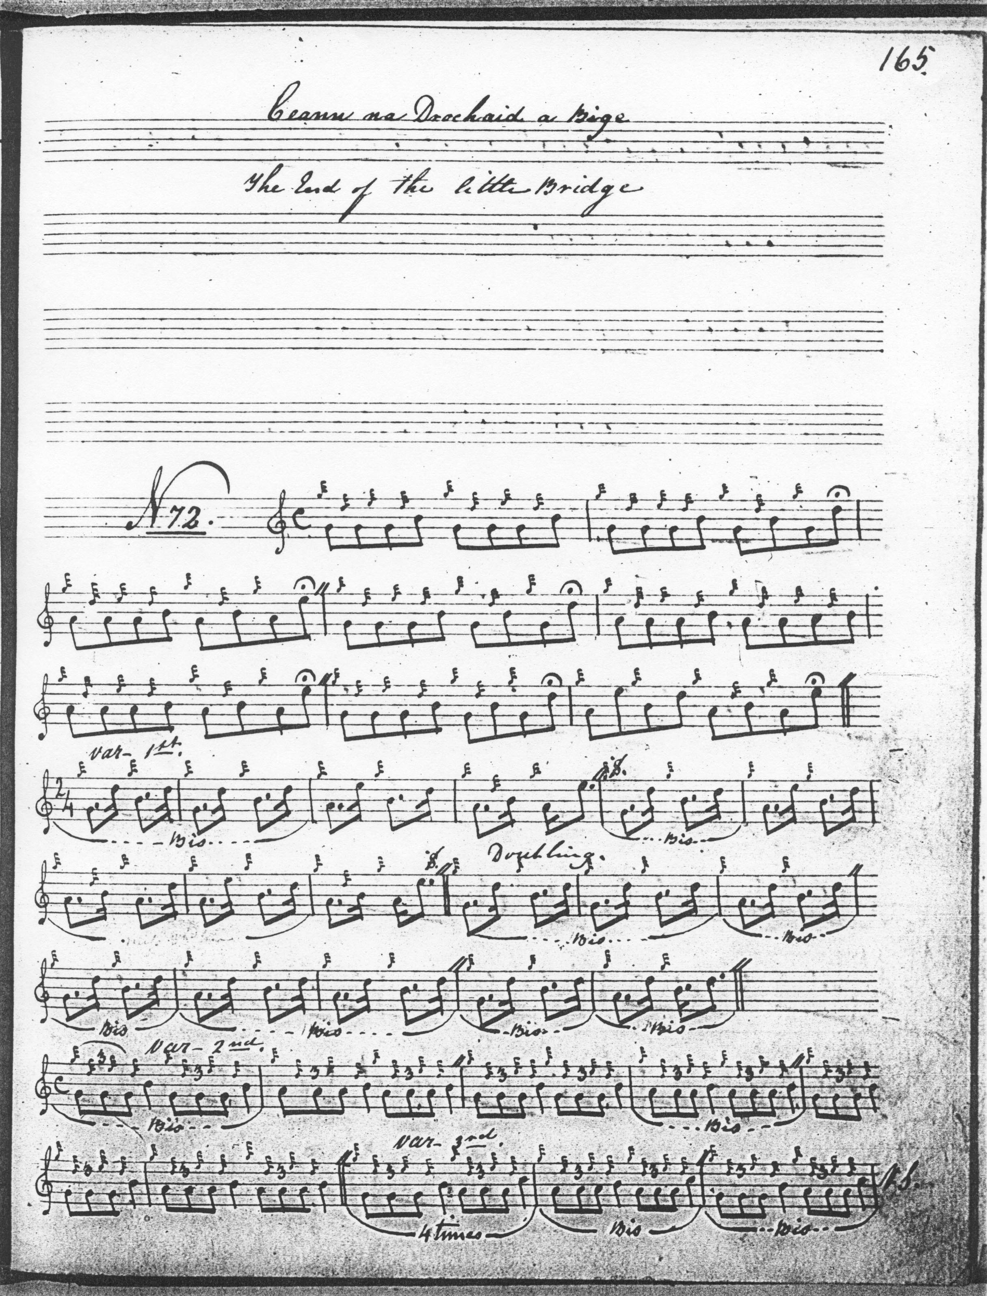

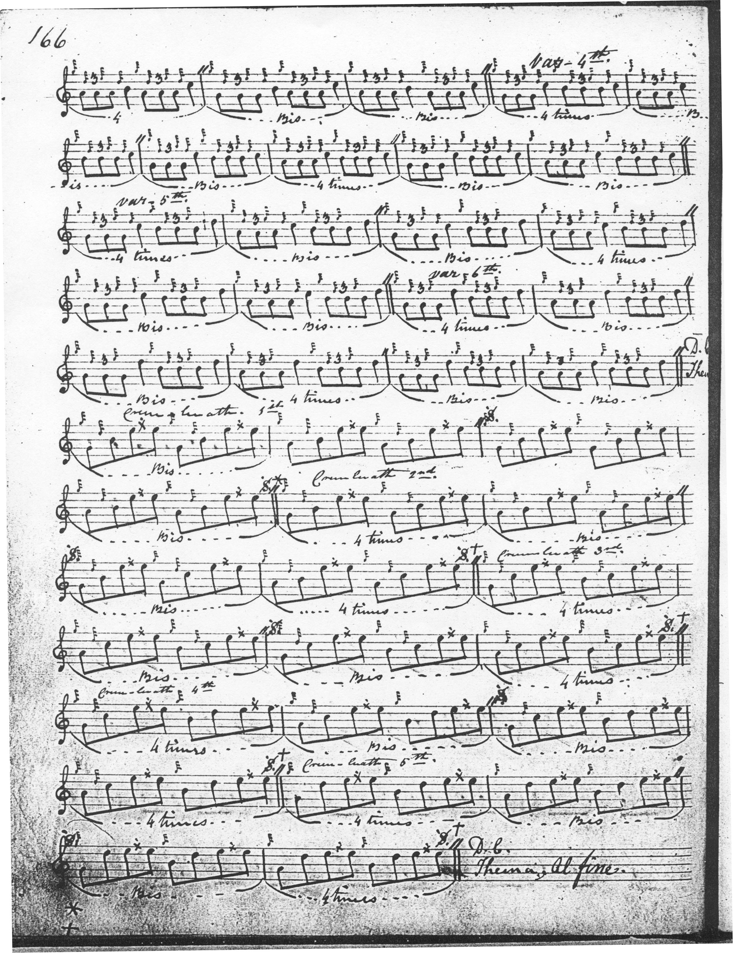

MacKay’s ground is similar to Colin Mór’s, but his development of the tune is shorter and simpler. He goes straight from the Ground to a Tripling (singling and doubling) followed by a Crunluath movement singling and doubling, with returns of the Ground between the Tripling doubling and Crunluath singling and again at the end of the tune. Interestingly he also develops the melody to a fosgailte rather than a duinte Crunluath conclusion. This sometimes happens in the larger tradition, with certain tunes capable of development in either manner, as readers lucky enough to possess a copy of Ceol Mor will have noted. If one wished an easier route through a potentially long and demanding piece, MacKay would be the way to do it. MacKay’s nephew, Donald MacKay’s score in the Ballendalloch MS is an abbreviated transcript of Donald MacDonald’s published setting and is not reproduced here.

Donald MacDonald’s bold setting interestingly develops the tune to a duinte conclusion like Colin Mór’s and equals his in scale of development. MacDonald’s version is more heavily cadenced, with a series of short appoggiaturas punctuating the line. MacDonald retains his original gapped pentatonic scale, (G-A-B-D-E) not interjecting the “foreign” C note at in the manner of Colin Mór and Angus MacKay. The version published by the Piobaireachd Society does not reproduce MacDonald’s score accurately. For example, the reader will note MacDonald’s 4/4 timing of Var. 2:

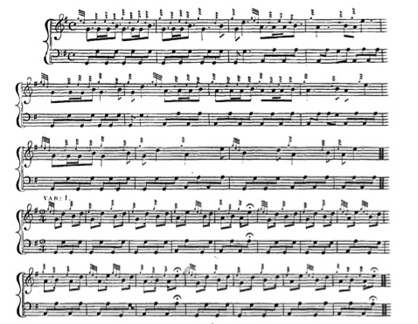
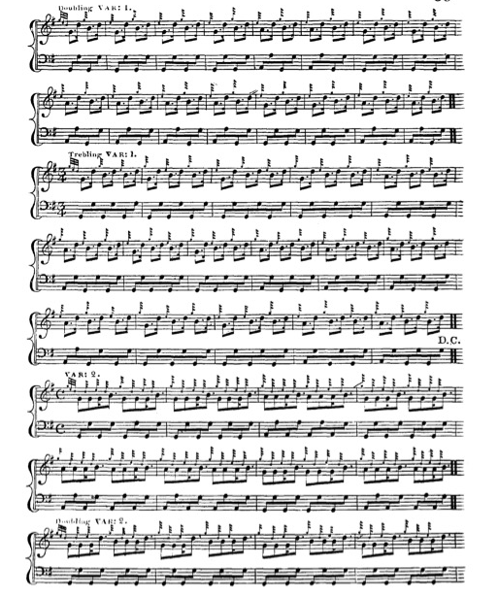a
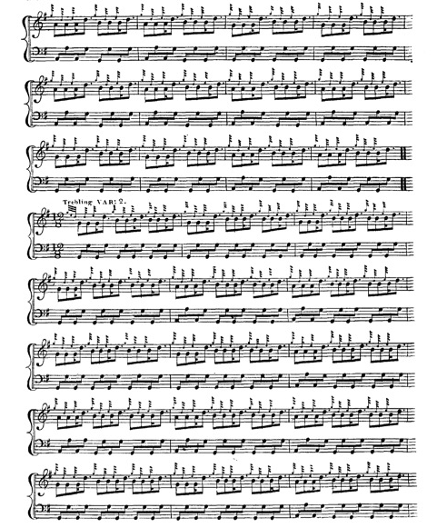
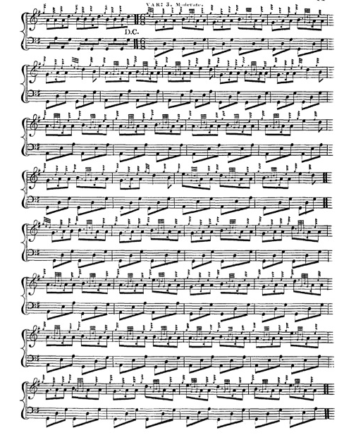
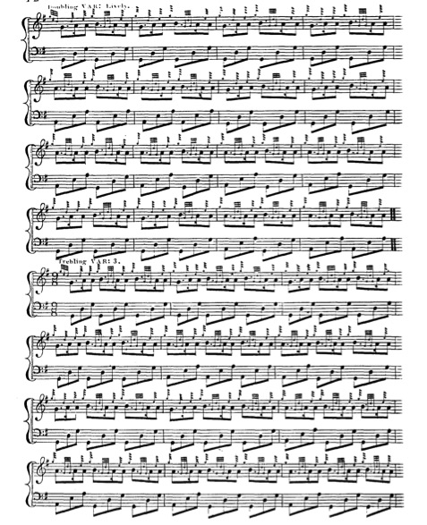
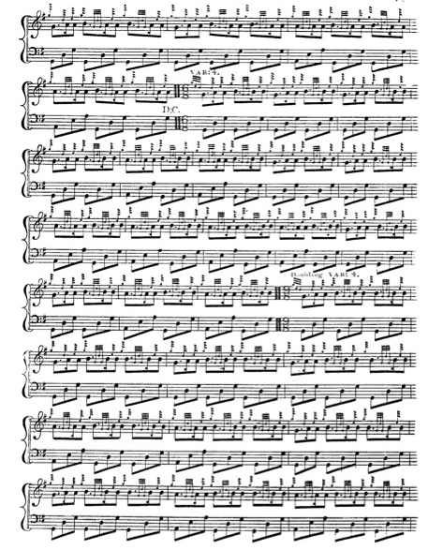
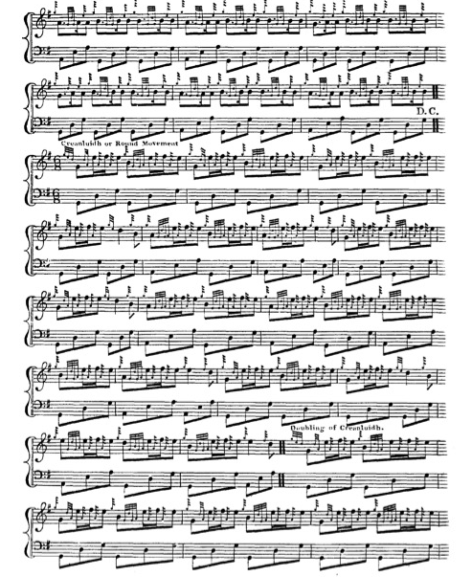

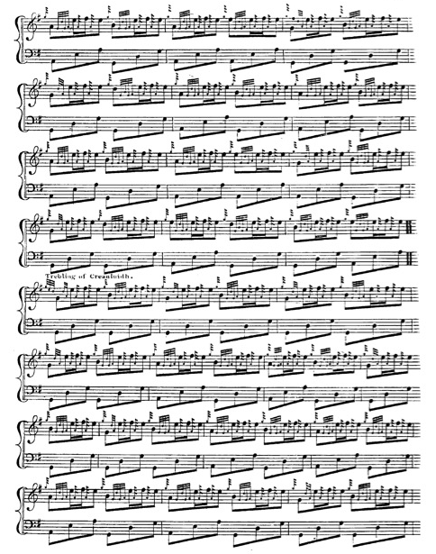
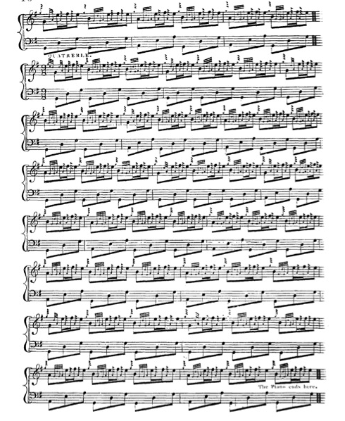

The Ground is repeated four times within the tune: at the end of the siubhal variations, at the end of the repeat of the pendulum movement; at the end of the taorluath and before the taorluath a mach variations, and between the taorluath a mach and the crunluath variations. The tune also ends curiously abruptly with a note above the text “The Piece ends here.” Just where an informed player would expect the crunluath a mach variations to come in. One can think of no obvious reason why they should not be played, but so the text directs.

David Glen has two settings in his manuscript, the first a version of Donald MacDonald with a revised timing similar to that published by the Piobaireachd Society, and the second, marked “Cameron N.Z”, an outline sketch merely. Neither is reproduced here.

C. S. Thomason’s setting is in line with his tendency to give every recorded variation for his tunes. He cites MacDonald and MacKay as his sources, and indicates editorial intervention. The setting has little to offer the performer not contained in earlier scores, and is not reproduced here.

Commentary:

“The End of the Little Bridge” is a classic gathering/incitement tune, and as such shares several stylistic features with pieces like “The Camerons’ Gathering” , “The Gathering of the MacDonalds of Clanranald”, and “Clanranald’s Gathering to Sheriffmuir”. It is widely distributed in the early sources, and clearly regarded as a standard piece, As often happens, the tune has more than one story attached to it as we see in the details in the Gesto Canntaireachd noted above, and Donald MacDonald who relates the tune to the great Civil War in the mid-seventeenth century, and the second battle of Inverlochy when the Marquis of Montrose routed a government force in lower Lochaber.

General C. S. Thomason had an ambitious project to record all the stories associated with the tunes, left uncompleted at his death. Here are the General’s notes on “The End of the Little Bridge” as they stand:

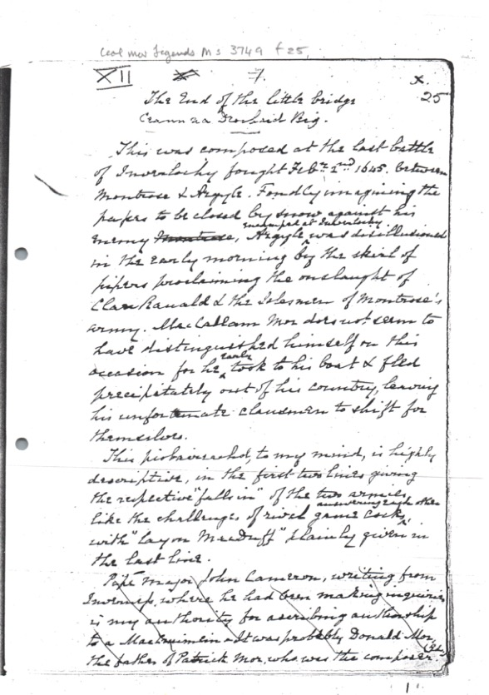

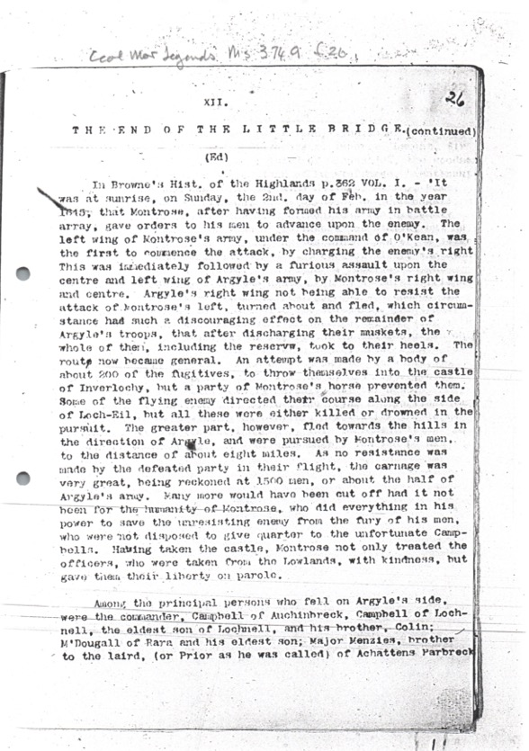

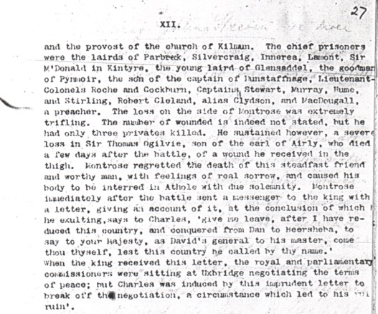

*

Electronic text © Dr William Donaldson, Cambridge, Massachusetts, 1 January 2023

