The Earl of Seaforth’s Salute

This tune appears in the following manuscript sources:
--Ronald MacKenzie’s setting in a volume inscribed “Pipe Major Alexander Mackenzie 78th Highlanders (Ross Shire Buffs) October 8th 1891”, National Library of Scotland MS 22125;
--Robert Meldrum’s Manuscript, ff.3-5.

and in the following published sources:
--Angus MacKay’s Ancient Piobaireachd, pp.116-8;
--Donald MacPhee’s Collection of Piobaireachd i, 25-27;
--C. S. Thomason’s Ceol Mor, pp.172-3;
--David Glen’s Ancient Piobaireachd, pp.80-1;
--John McLennan’s Piobaireachd as Performed in the Highlands for Ages, till about the year 1808, pp.8-9

The tune is interpreted variously in the sources, there being differences in pointing the ground and in timing the taorluath and crunluath variations: Ronald MacKenzie has mainly even quavers in the taorluath (with a strongly implied “up” timing) and plays his crunluath “up” also; Meldrum plays “up” in both (although at the top of the taorluath doubling, the score bears a note “Play down” which suggests that he had left open the possibility that the pointing might be reversed here, giving an “up”/“down” alternation between the taorluath singling and doubling; MacKay plays “down” in the taorluath and “up” in the crunluath; MacPhee plays “down” in the taorluath and “up” in the crunluath; Thomason, “down” in the taorluath and “up” in the crunluath; Glen, “down” in the taorluath and “up” in the crunluath; McLennan, “up” in both taorluath and crunluath.

 | Taorluath timings | Crunluath timings | Ground repeated at end of taorluath doubling
Ronald MacKenzie | mainly even quavers | “up” | yes
Robert Meldrum | “up” | “up” | no
Angus MacKay | “down” | “up” | yes
Donald MacPhee | “down” | “up” | yes
C. S. Thomason | “down” | “up” | yes
David Glen | “down” | “up” | no
John McLennan | “up” | “up” | no

In the ground, the main differences lie in the timing of the A phrase, and the treatment of the closing gesture at the line endings. In modern playing, the initial low G and low A quavers are often very much prolonged, perhaps as a result of too-zealous interpretation of the fermatas inserted by Archibald Campbell in the Piobaireachd Society Collection (Second Series, v, 135-6) a timing receiving little support in the earlier written and published sources. We get interesting suggestions that the proper timing might once have been very different at these points in Ronald MacKenzie’s score which is one of the earliest surviving manuscript sources. In addition, MacKenzie’s timing of the concluding figures at the end of each line of the ground would give something rather more idiomatic-sounding than the exaggerated movement commonly heard today (following Campbell again: most of the earlier scores had one crotchet in this sequence; he has three in a row); Robert Meldrum, who was taught by Calum Piobaire, times these line endings similarly to MacKenzie (with whom he also studied).

Ronald was a nephew and pupil of the famous John Bàn MacKenzie, and went on to become one of the leading players and teachers in Victorian Scotland in his own right. His extensive collection of manuscripts forms a fine example of the fascinating musical variety that was lost when we allowed ourselves to be persuaded that there was little of value in the earlier written tradition and that Campbell’s Piobaireachd Society scores should be the starting point for any serious enquiry into the genre.

The essential stylistic points of Ronald MacKenzie’s setting are as follows. The full score is given below:

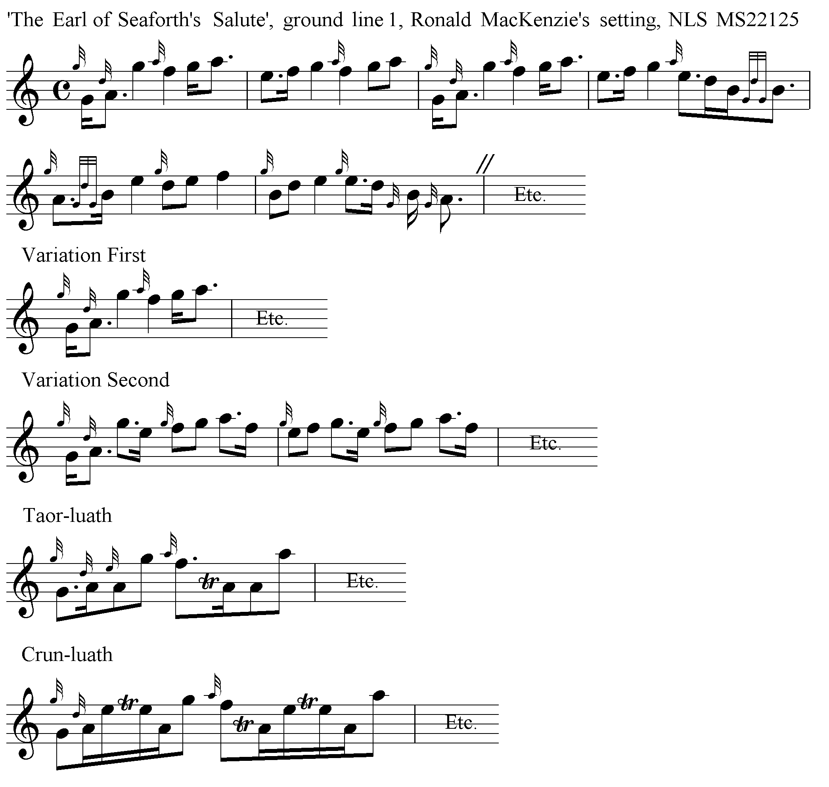
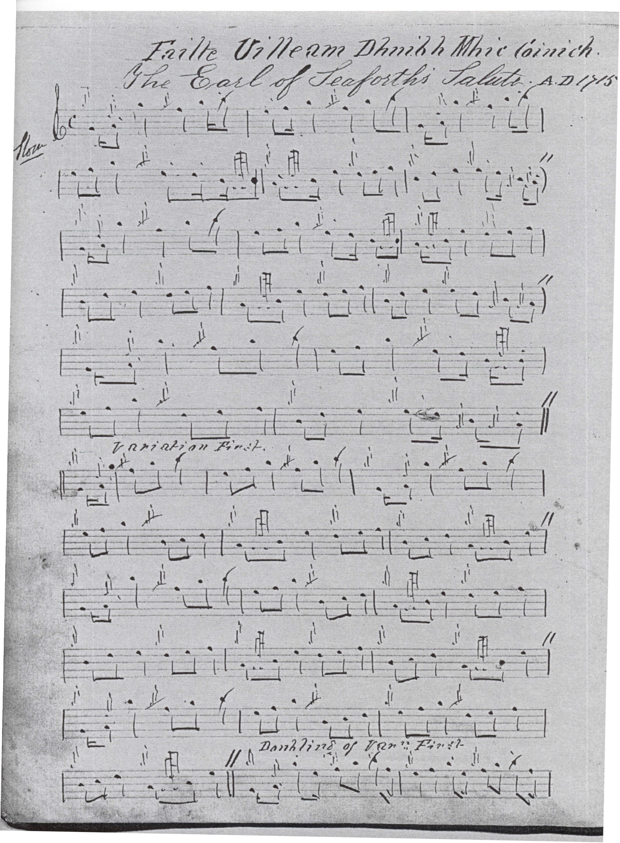
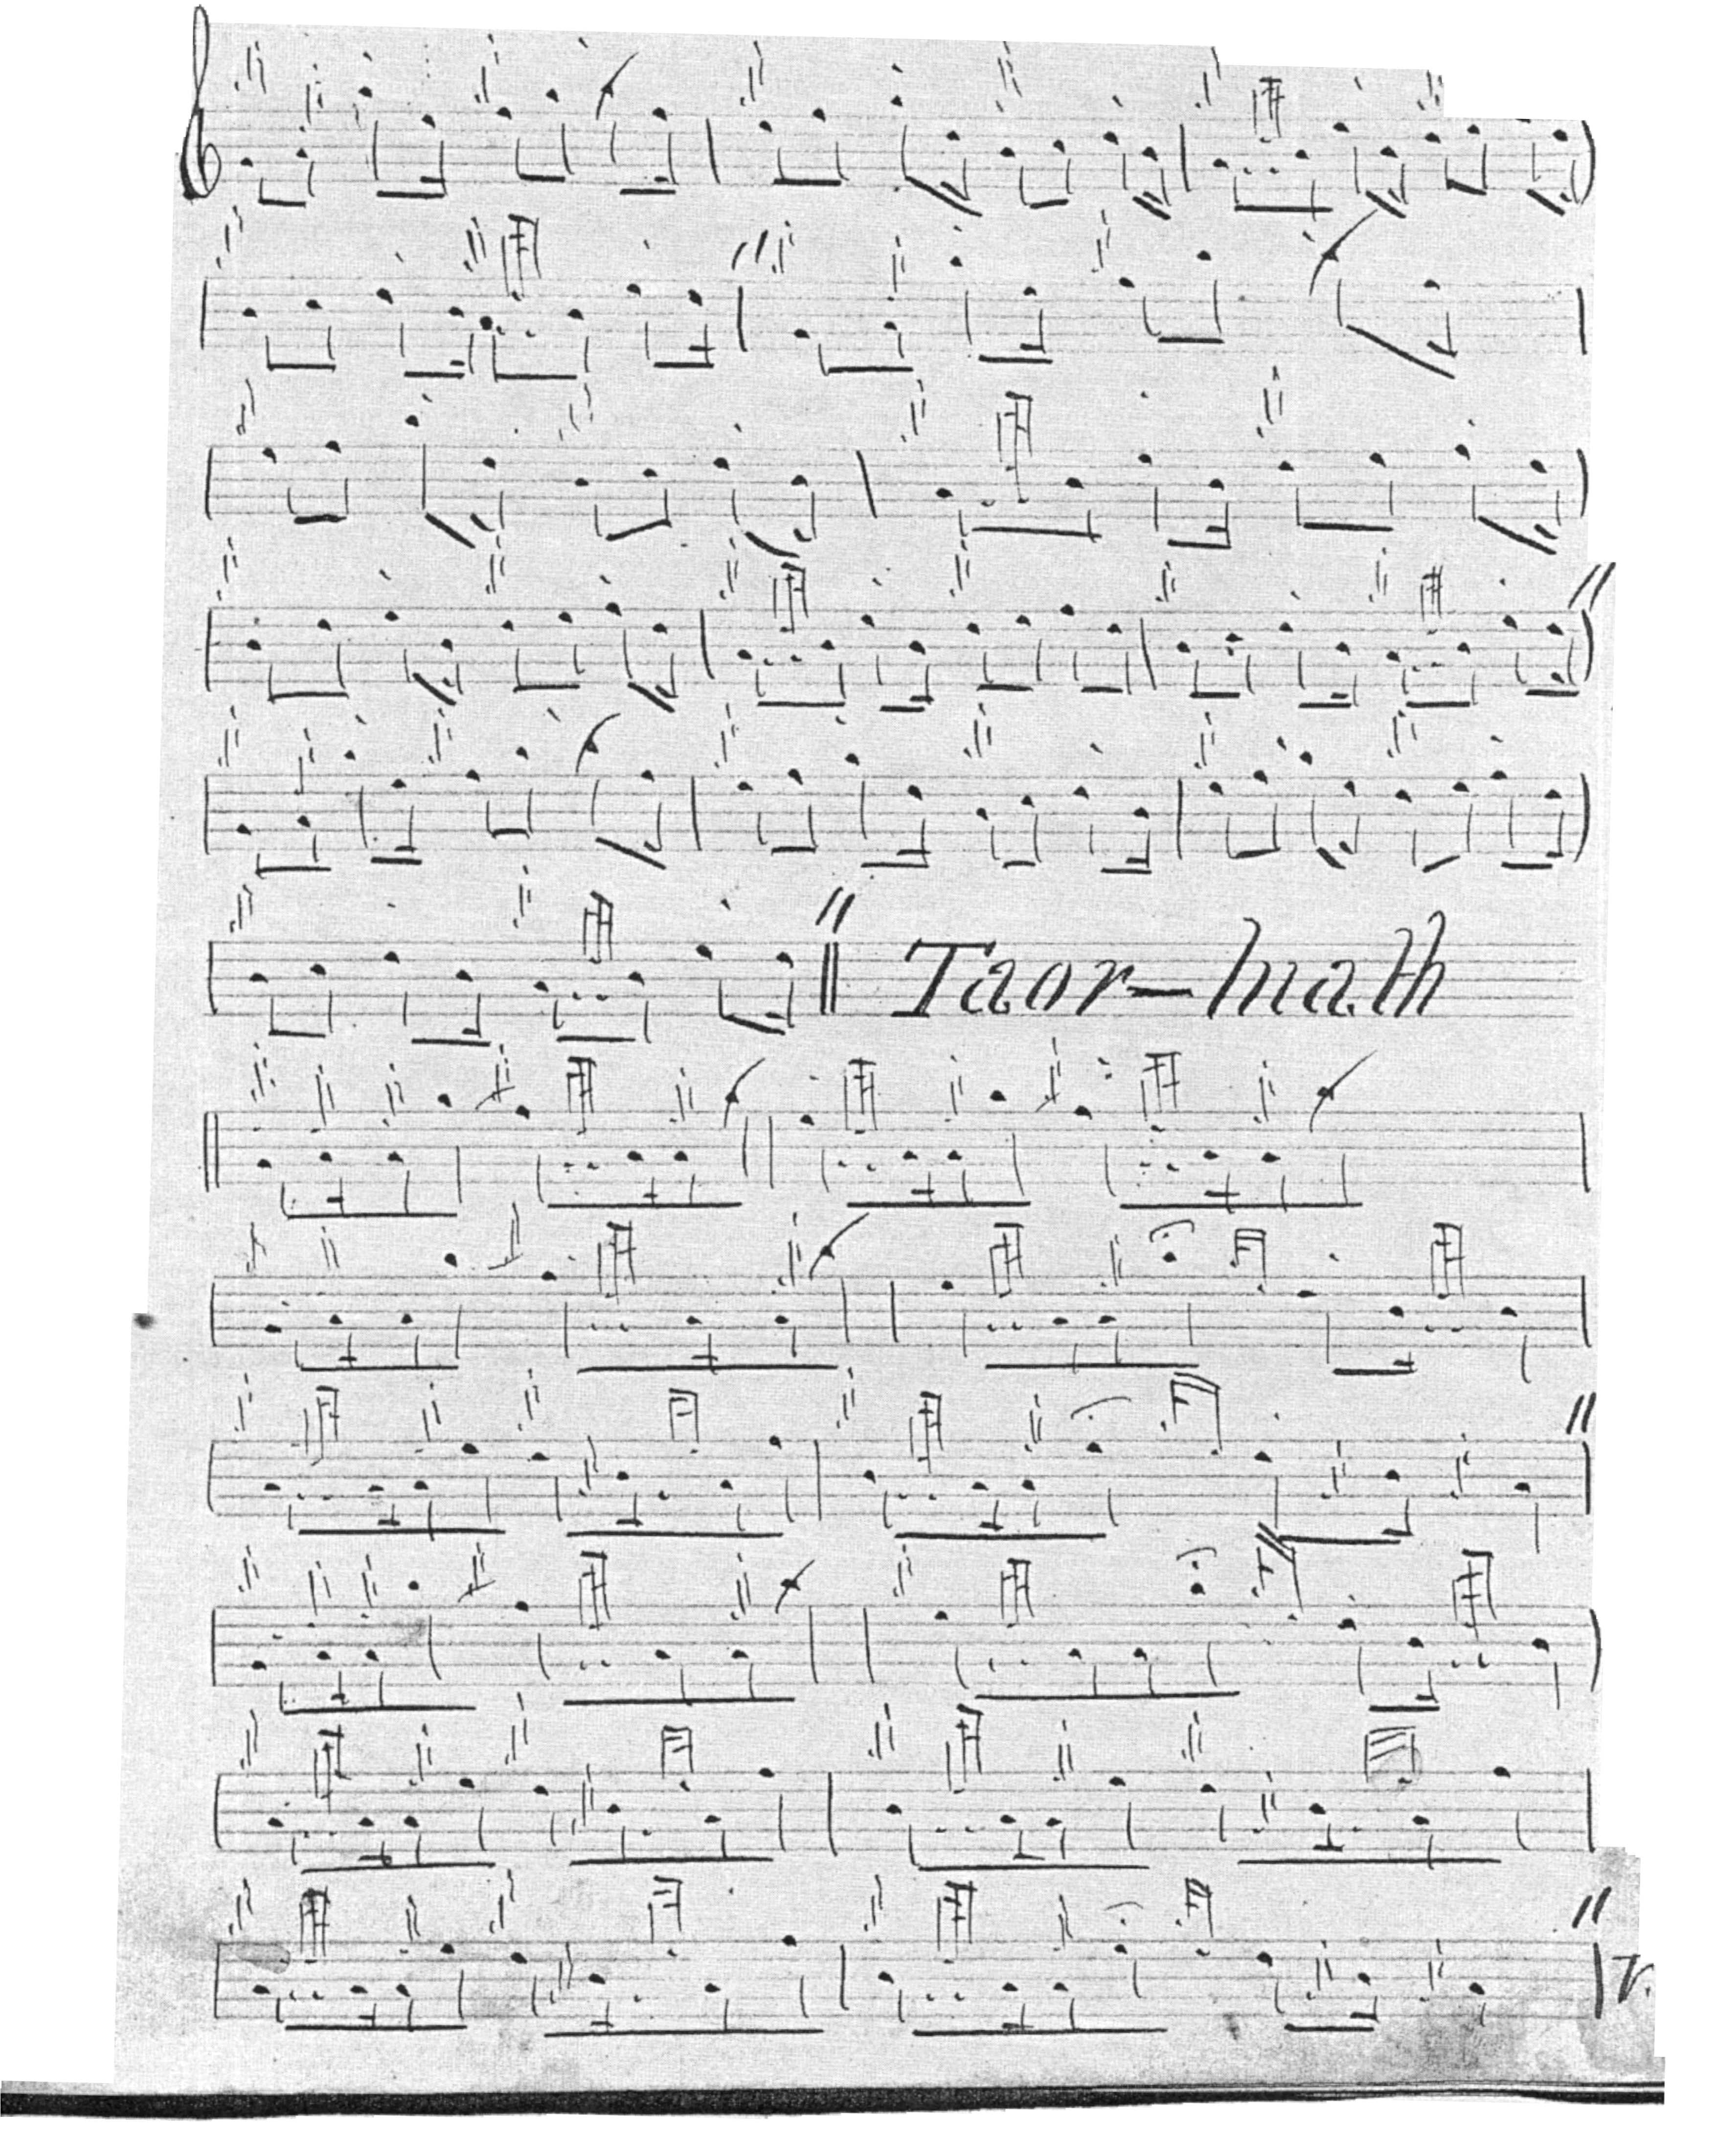

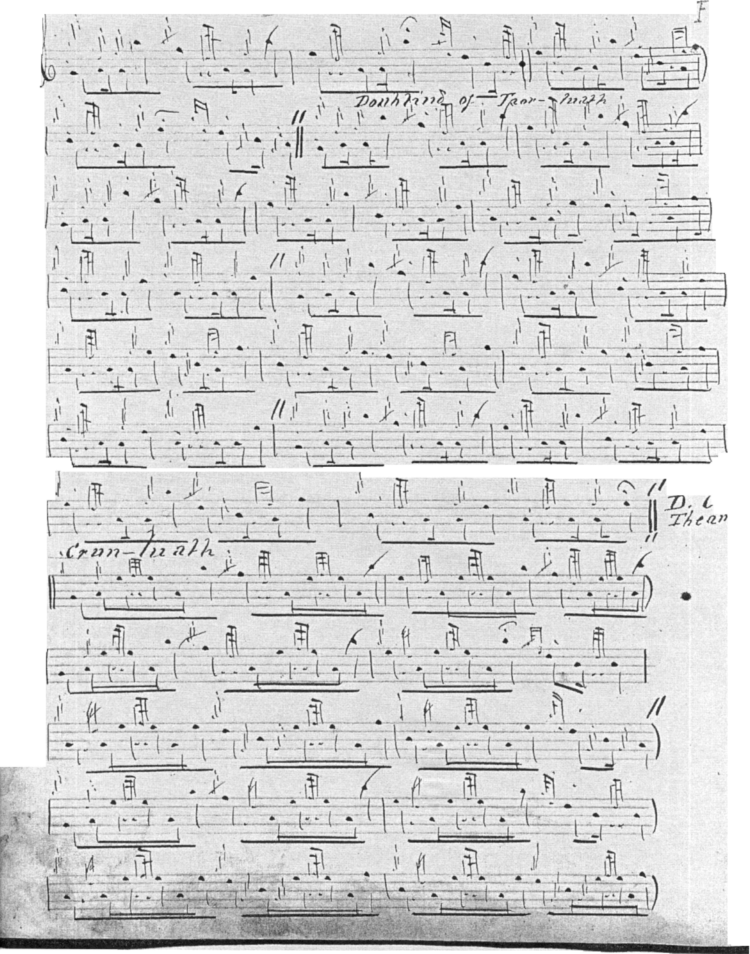

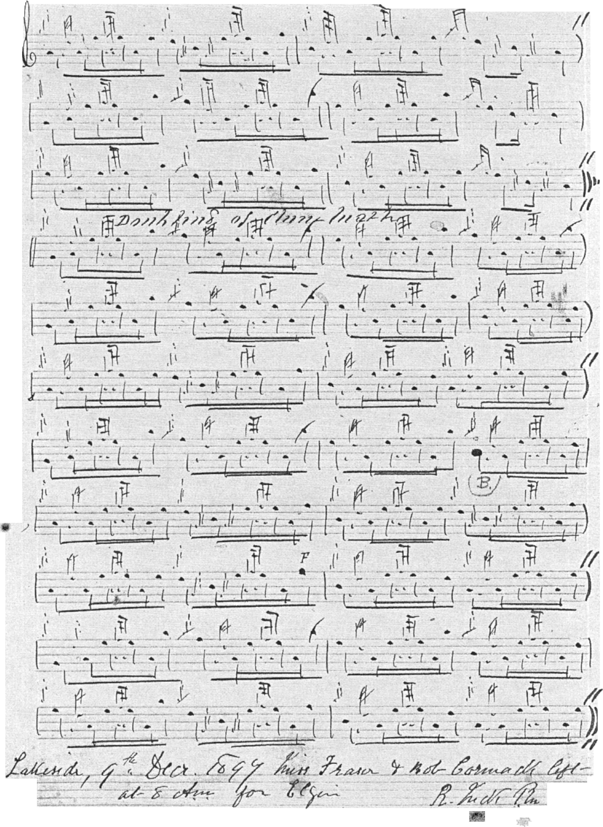

Since the original document is a little muddy, I have prepared a transcript as follows:

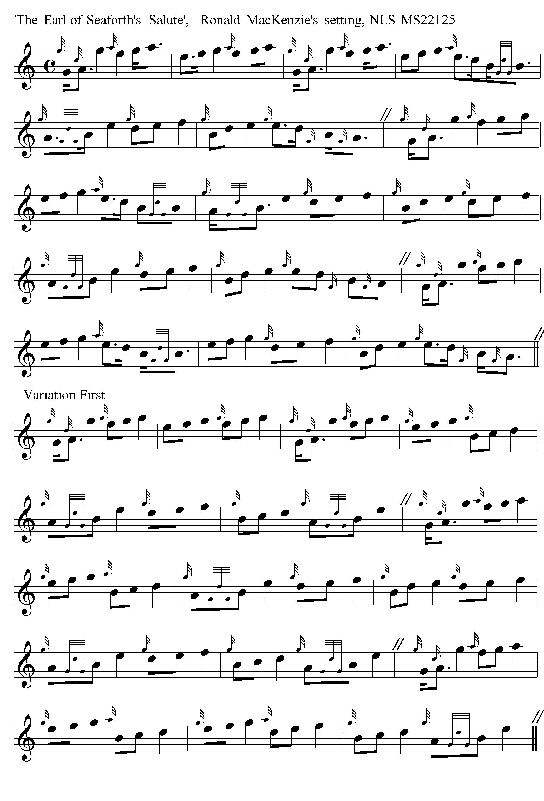
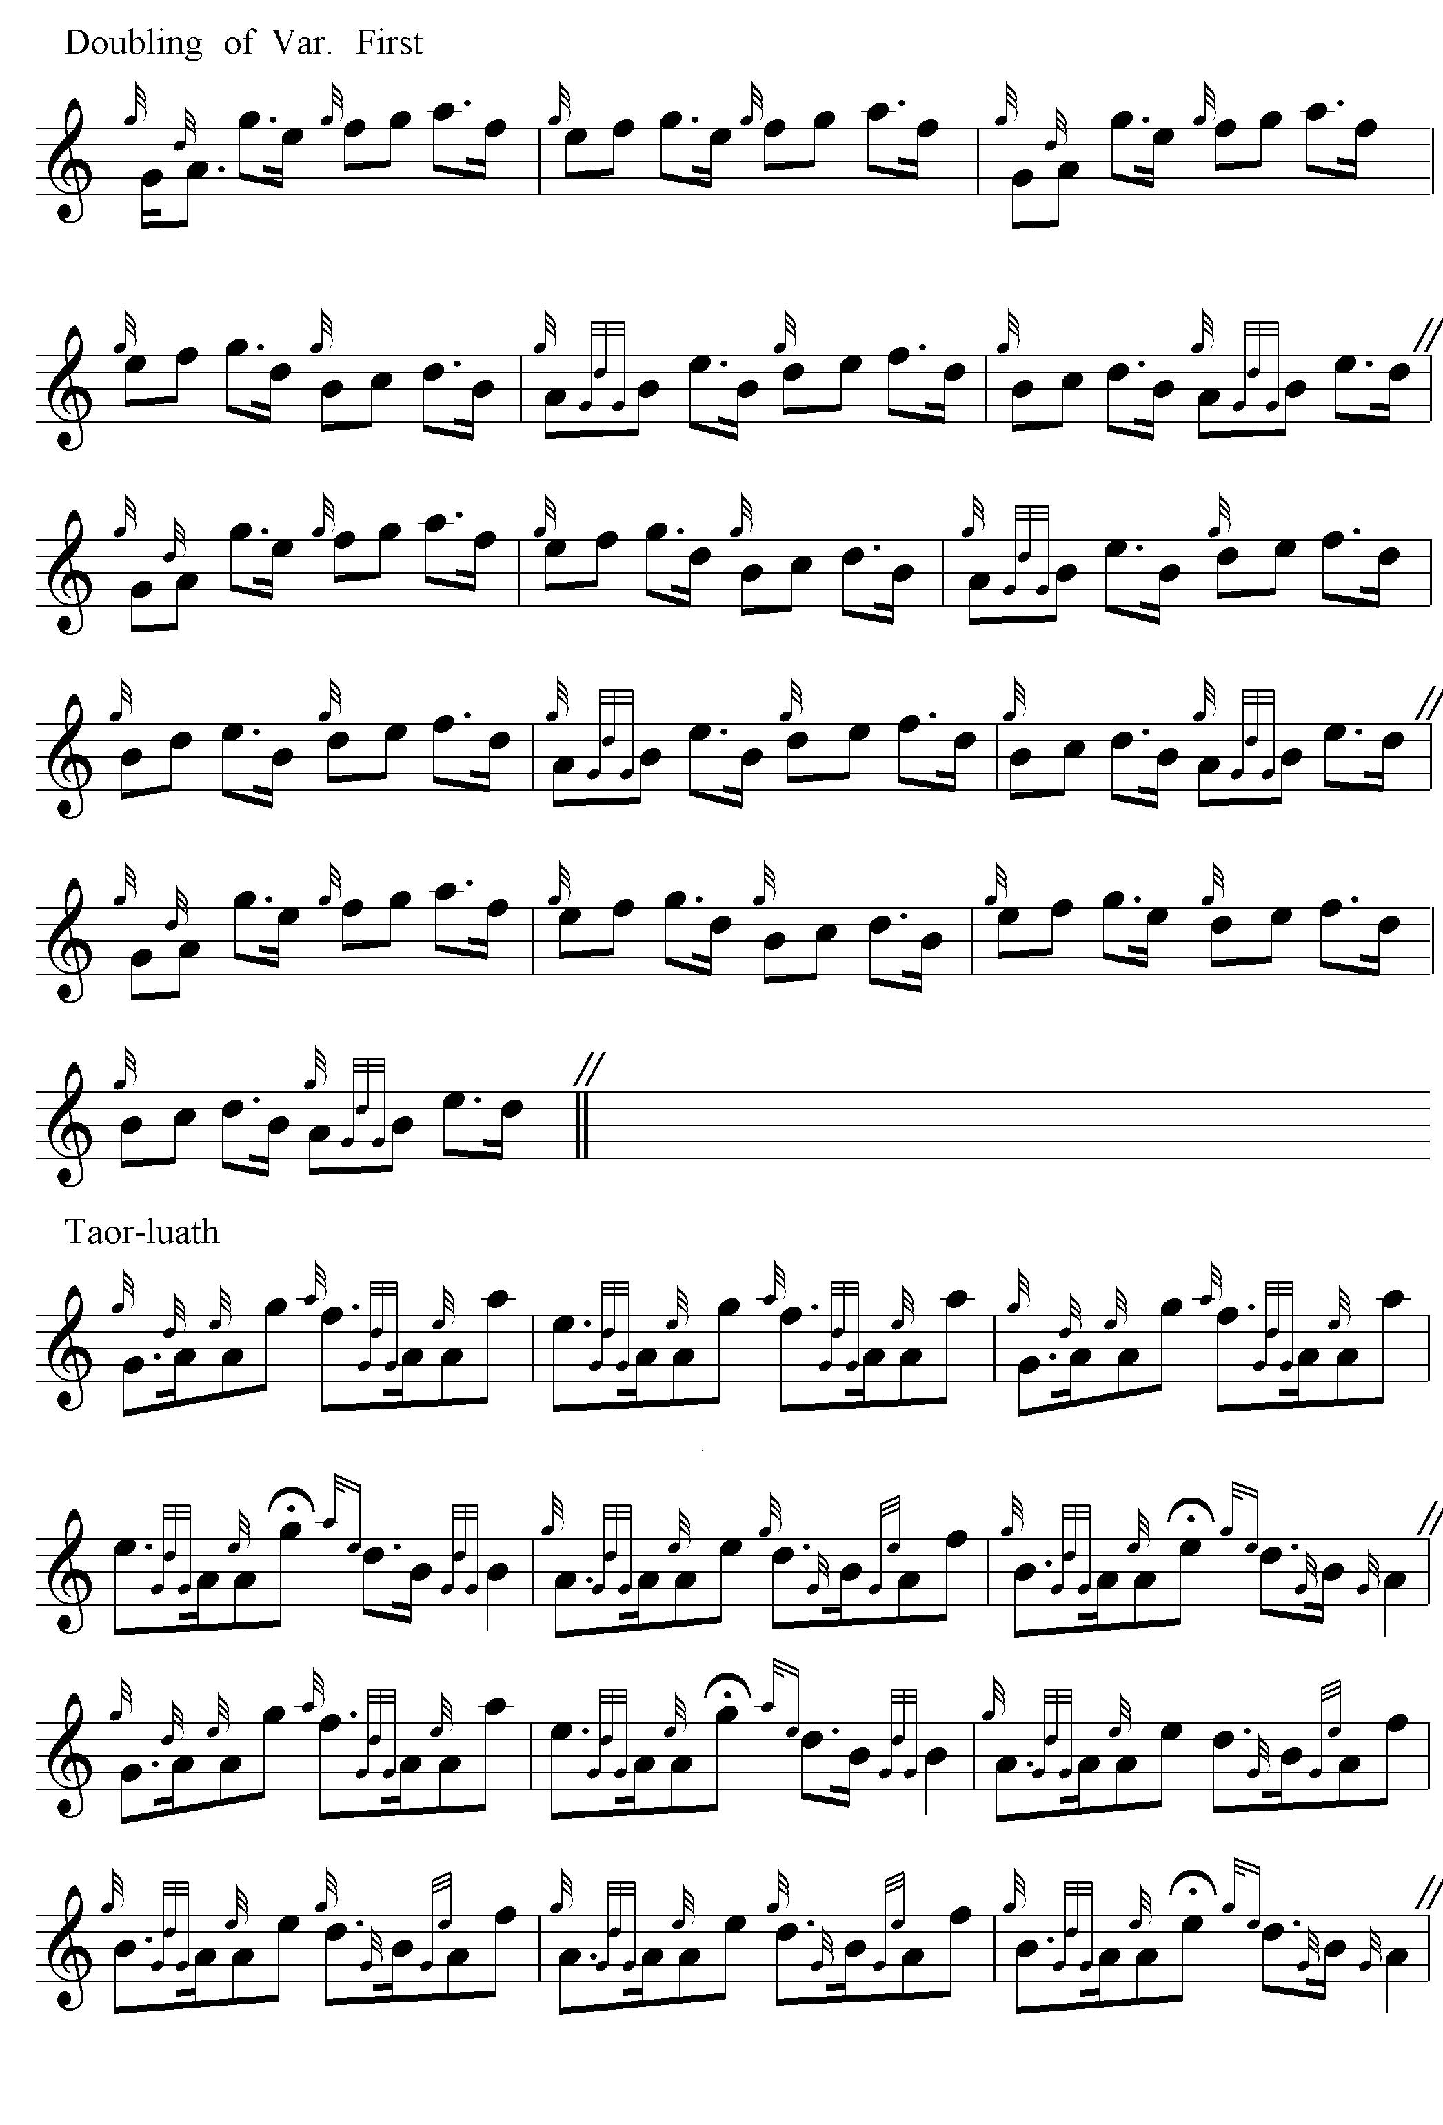
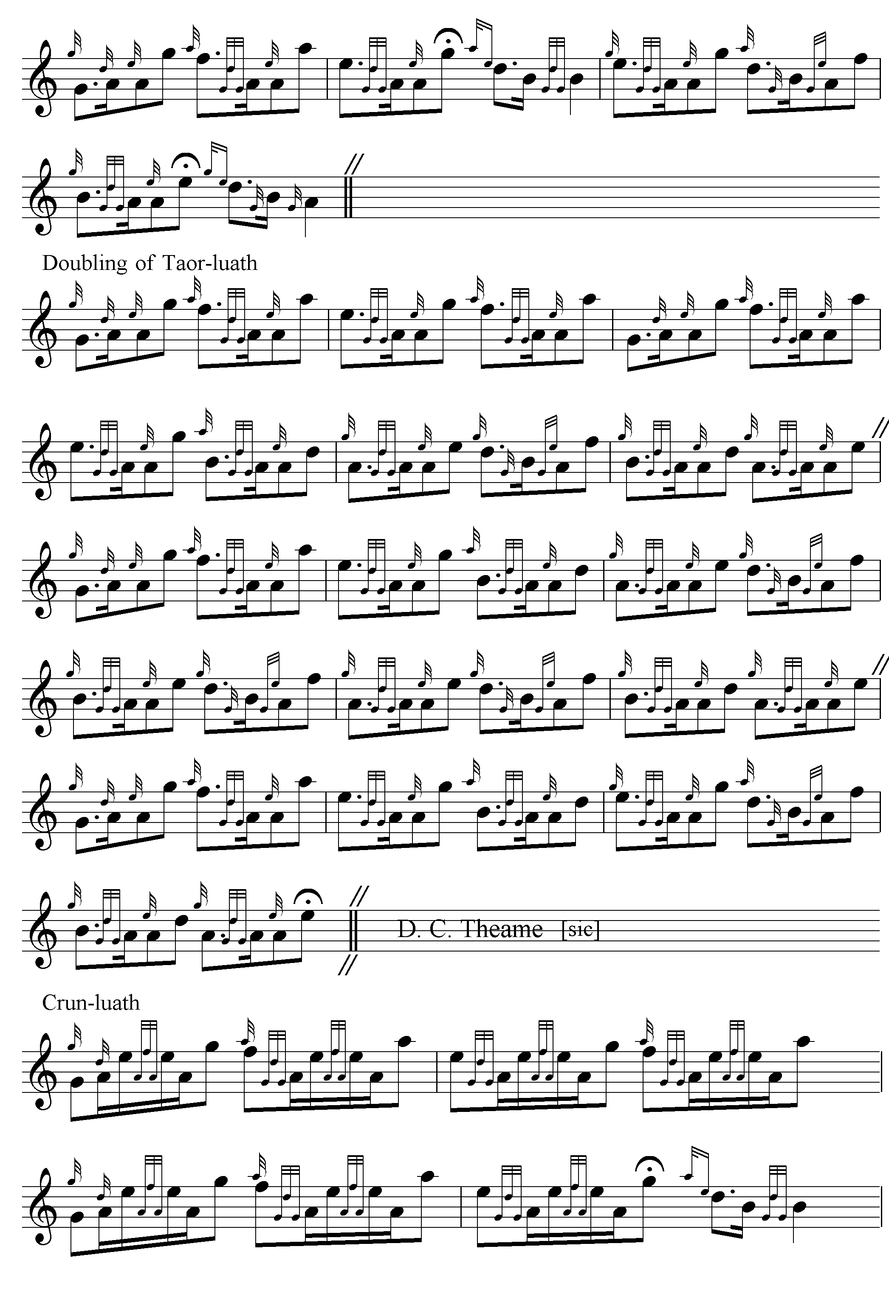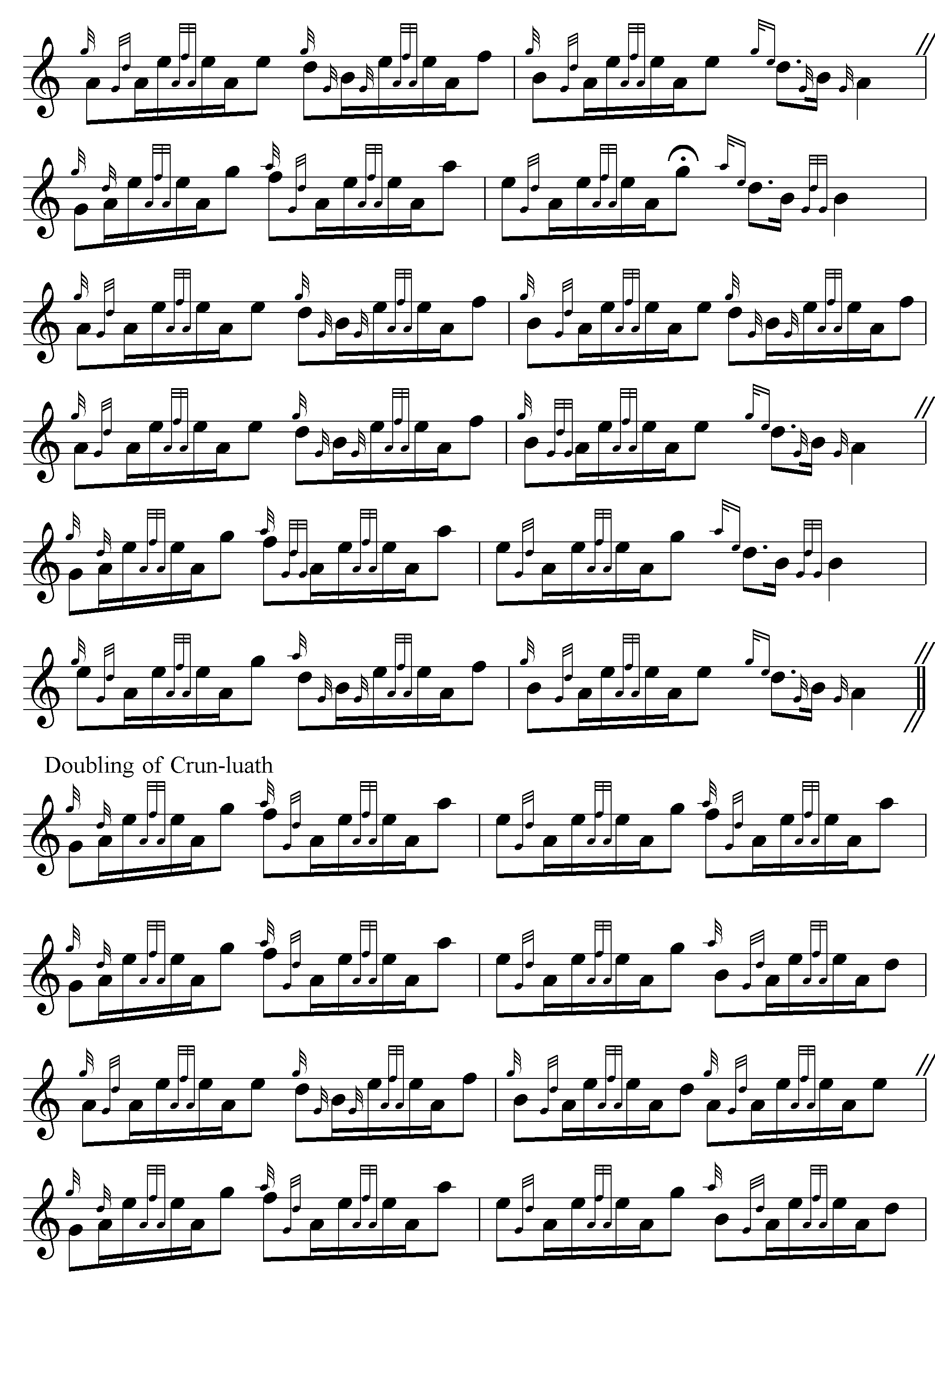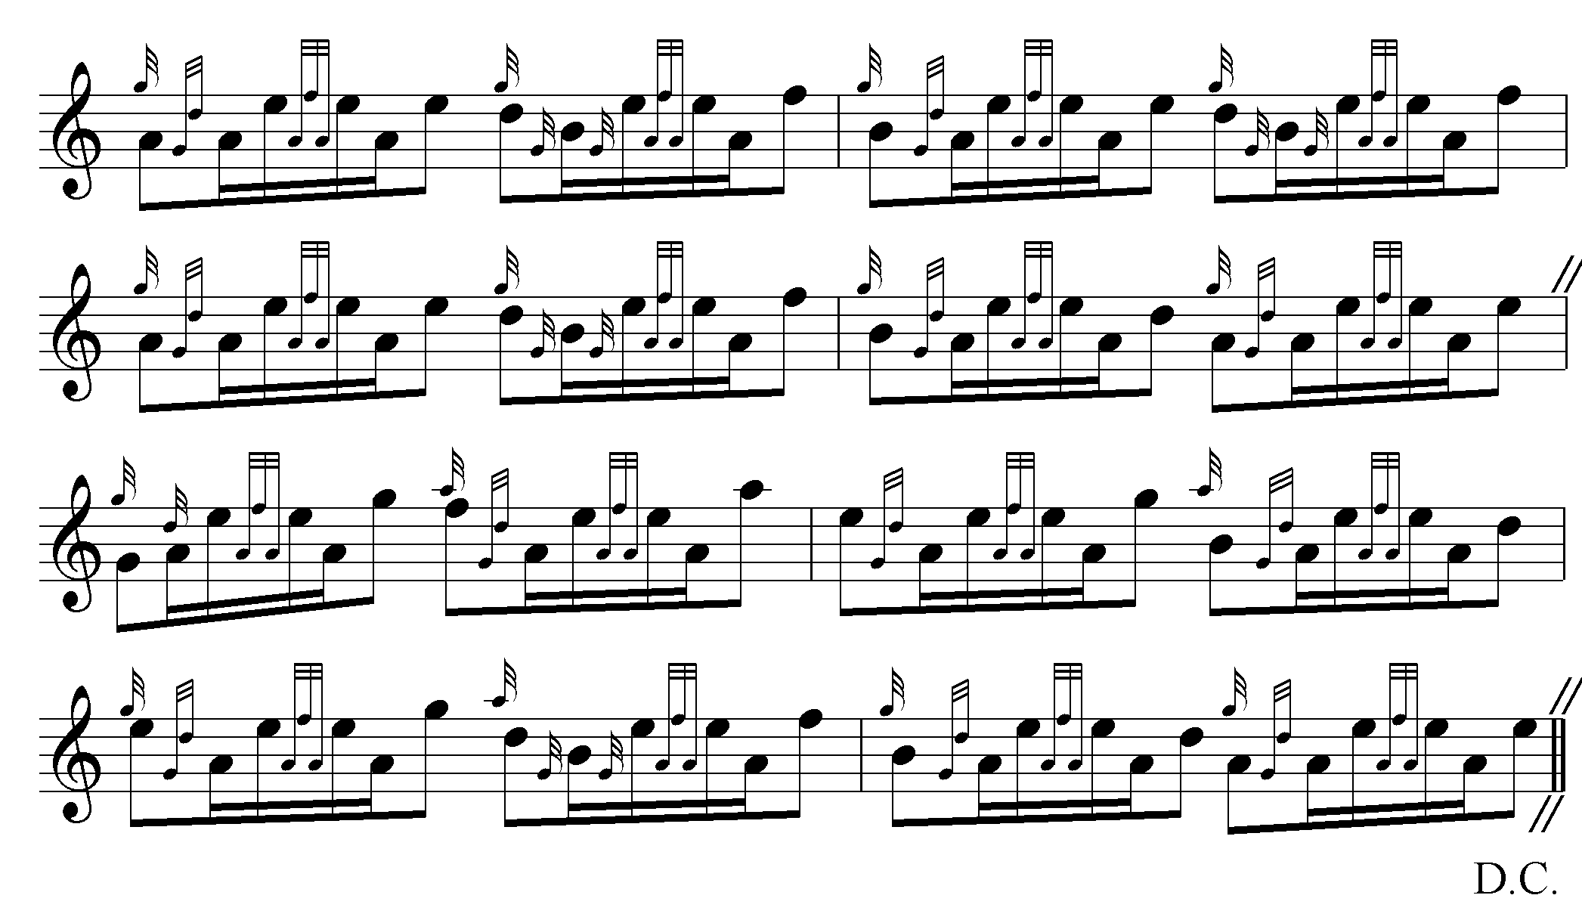

Angus MacKay times the tune as follows:

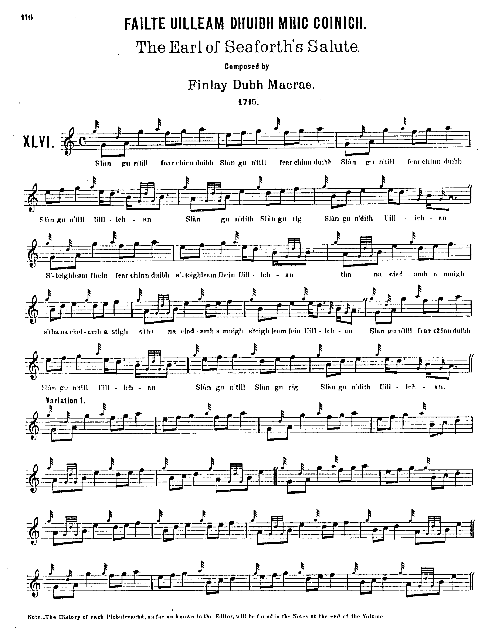

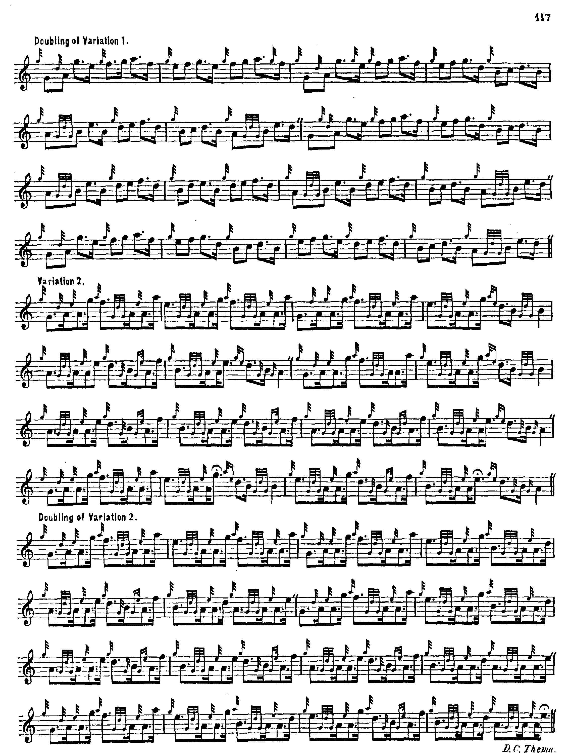

and so on.

John McLennan’s setting goes some degree towards the actual timings nowadays heard with characteristic over-lengthening of low As and Gs in the ground and early variations more clearly than any of the early sources, perhaps reflecting a recently-developing tendency. Glen and Thomason both begin the ground with even quavers, as Angus MacKay does. McLennan’s ground and early variations are as follows:

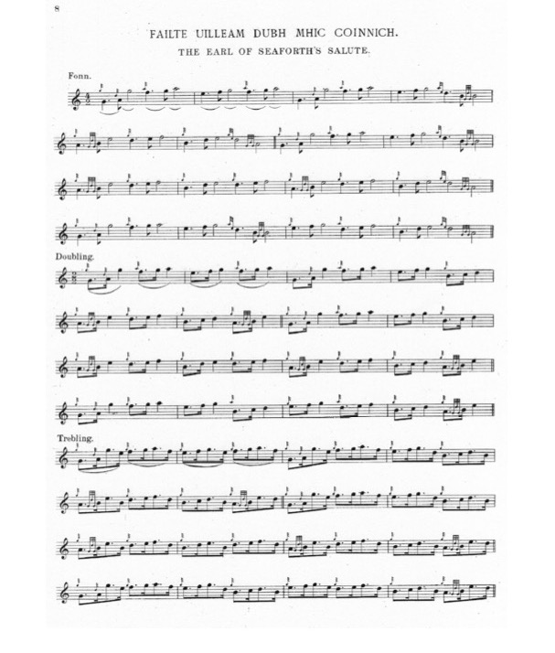
and so on.

Commentary:

John MacDonald wrote in 1938 with reference to the taorluath breabach “[…]I haven’t the slightest doubt as to how Sandy Cameron played and taught it […i.e.] with a dotted low A. I never learnt either Colin or Sandy play a breabach but in this way […] The most consistent player of all was Calum McPherson, who in my opinion played some tunes much more pleasing than either of the Camerons […] He told me he got most of his learning from Sandy Cameron, Greenock [Donald Cameron’s brother, Sandy Cameron, a leading Victorian player, teacher and authority in his own right]. He played all breabachs with accent on low A”. The wording is a little vague here, perhaps. MacDonald starts talking specifically about the taorluath, but by the end he could be construed as speaking about all breabachs, both taorluath and crunluath varieties. This is interesting, in view of the fact that this was not the method he imparted to his pupils Bob Brown and Bob Nicol, who in the crunluath at least, played neither “up” nor “down”, but in sequences of even-quaver figures playing straight through on to the following melody note, giving a smooth and flowing effect, somewhat thus:

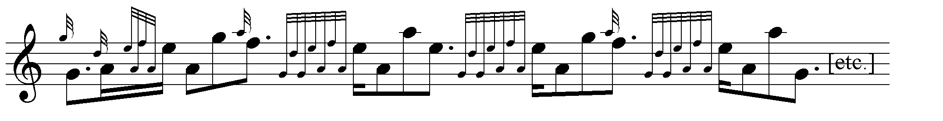

Archie MacNeill (born Govan, 1879), who had heard John MacDougall Gillies playing at his peak wrote that “Piping seems to me to have changed within the last sixty years […] The greatest change I hear is in piobaireachd playing, the Breabach seeming to be the wrong way round. In the “Lament for Sir James MacDonald’ Kilberry follows the theme of the tune, pausing on the tonic A. About 30 years ago Peter Henderson published a book on behalf of the Piobaireachd Society of that time. [Piobaireachd Society Collection, first series, vols. 2-5] I think the tunes were more musical than those of the present […] When the late MacDougall Gillies played the “Seaforth Salute’ he timed the Taorluath variations in compound time, playing the last note on each bar as a dotted crotchet and the same in the Crunluath.” “Solo Piping Past and Present”, Piping Times, Vol.10, no.8, May 1958, pp.13-14.

Elsewhere Archie MacNeill stated that “Piobaireachd playing seems to me to have changed greatly from what it was sixty years ago. When the late MacDougall Gillies played ‘Seaforth’s Salute’ he followed the rhythm of the urlar all through with the high G and A as dotted crotchets. The same with the Taorluath and Crunluath movements. When playing the Breabach he did not pause on the low A before high G and A, which is the reverse of the present day method.”

There are a number of stories associated with this famous tune.

James Logan says in his notes to MacKay’s Ancient Piobaireachd: “The rising for King James under the Earl of Mar, was promoted in the North, chiefly by the MacKenzies, who distinguished themselves at Sherriffmoor. They were the first clan who were called by General Wade to deliver up their arms, which they did at Brahan Castle, 1725.
This was composed by Finlay dubh MacRae, Seaforth’s Piper, when his master was in exile, and expressed the wish of himself and the clan, that he might soon return, and in good health. During his absence, the rents of the estate, although forfeited, were regularly remitted to France, and 800 men escorted the money to Edinburgh.” (“Historical and Traditional Notes on the Piobaireachds”, p.11).

“Fionn” gives a rather more plausible-sounding account in his notes to David Glen’s Collection of Ancient Piobaireachd: “‘The Earl of Seaforth’s Salute (1715)
Fàilte Uilleim Dhuibh Mhic Coinnich’. This ‘Uilleam Dubh’, or Black William, was the fifth Earl of Seaforth. He lived in a most critical time in the history of the Highlands. He was present with his Clan at Sheriffmuir, and after that battle he followed James III. (The Pretender) into exile. His estates were forfeited, although it was found extremely difficult to carry the forfeiture into effect. For several years after the estates were forfeited the rents were collected by the Earl’s faithful henchman at Sheriffmuir, Donald Murchison, and conveyed to his exiled master in Spain. There is a story told of a faithful Kintail man, who, when he found the Earl of Seaforth casting peats in Spain, expressed his astonishment in what has since become a proverb, by exclaiming, ‘Bha latha eile aig muinntir na mòna’, the peat-cutters have seen better days. The Earl was equal to the occasion, and promptly replied, ‘Cha’n’eil neach gun dà latha ach fear gun lath’ idir’, there is none without a change of days but he who has no day. Here are some of the words associated with this Salute : -

Slàn gu’m pill fear a’ chinn-duibh,
Slàn gu’n till fear a’ chinn-duibh,
Slàn gu’m pill fear a’ chinn-duibh,
Slàn gu’n till Uilleachan.
Slàn gu’n tig, slàn gu’n ruig,
Slàn gu’n tig Uilleachan,
’S toigh leam fhéin fear a’ chinn-duibh,
’S toigh leam fhéin Uilleachan’”.

(“Historic, Biographic, and Legendary Notes to the Tunes”, by “Fionn”, p.12).

* * *

Electronic text © Dr. William Donaldson, Aberdeen, Scotland, October 2003; revised Cambridge, Massachusetts, March 2025

