The Earl of Ross’s March

There are settings of this tune in the following MS sources:

--Colin Mór Campbell’s Nether Lorn Canntaireachd, ii, 82-5 (with the title “Chean na Daise”);
--Donald MacDonald’s MS, ff.6-9;
--Peter Reid’s MS, ff.17-18;
--David Glen’s MS, ff.130-135;

and in the following published sources:
--Niel MacLeod of Gesto, Pibereach or pipe tunes (1828), pp. 16-19 (with the title “Kiaunidize”);
--Angus MacKay, Ancient Piobaireachd, pp.122-4 (“Composed by Donald Mor MacCrummen. About the Year 1600” according to MacKay/Logan);
--C. S. Thomason, Ceol Mor, pp. 201-2.

Colin Campbell’s setting begins like this:

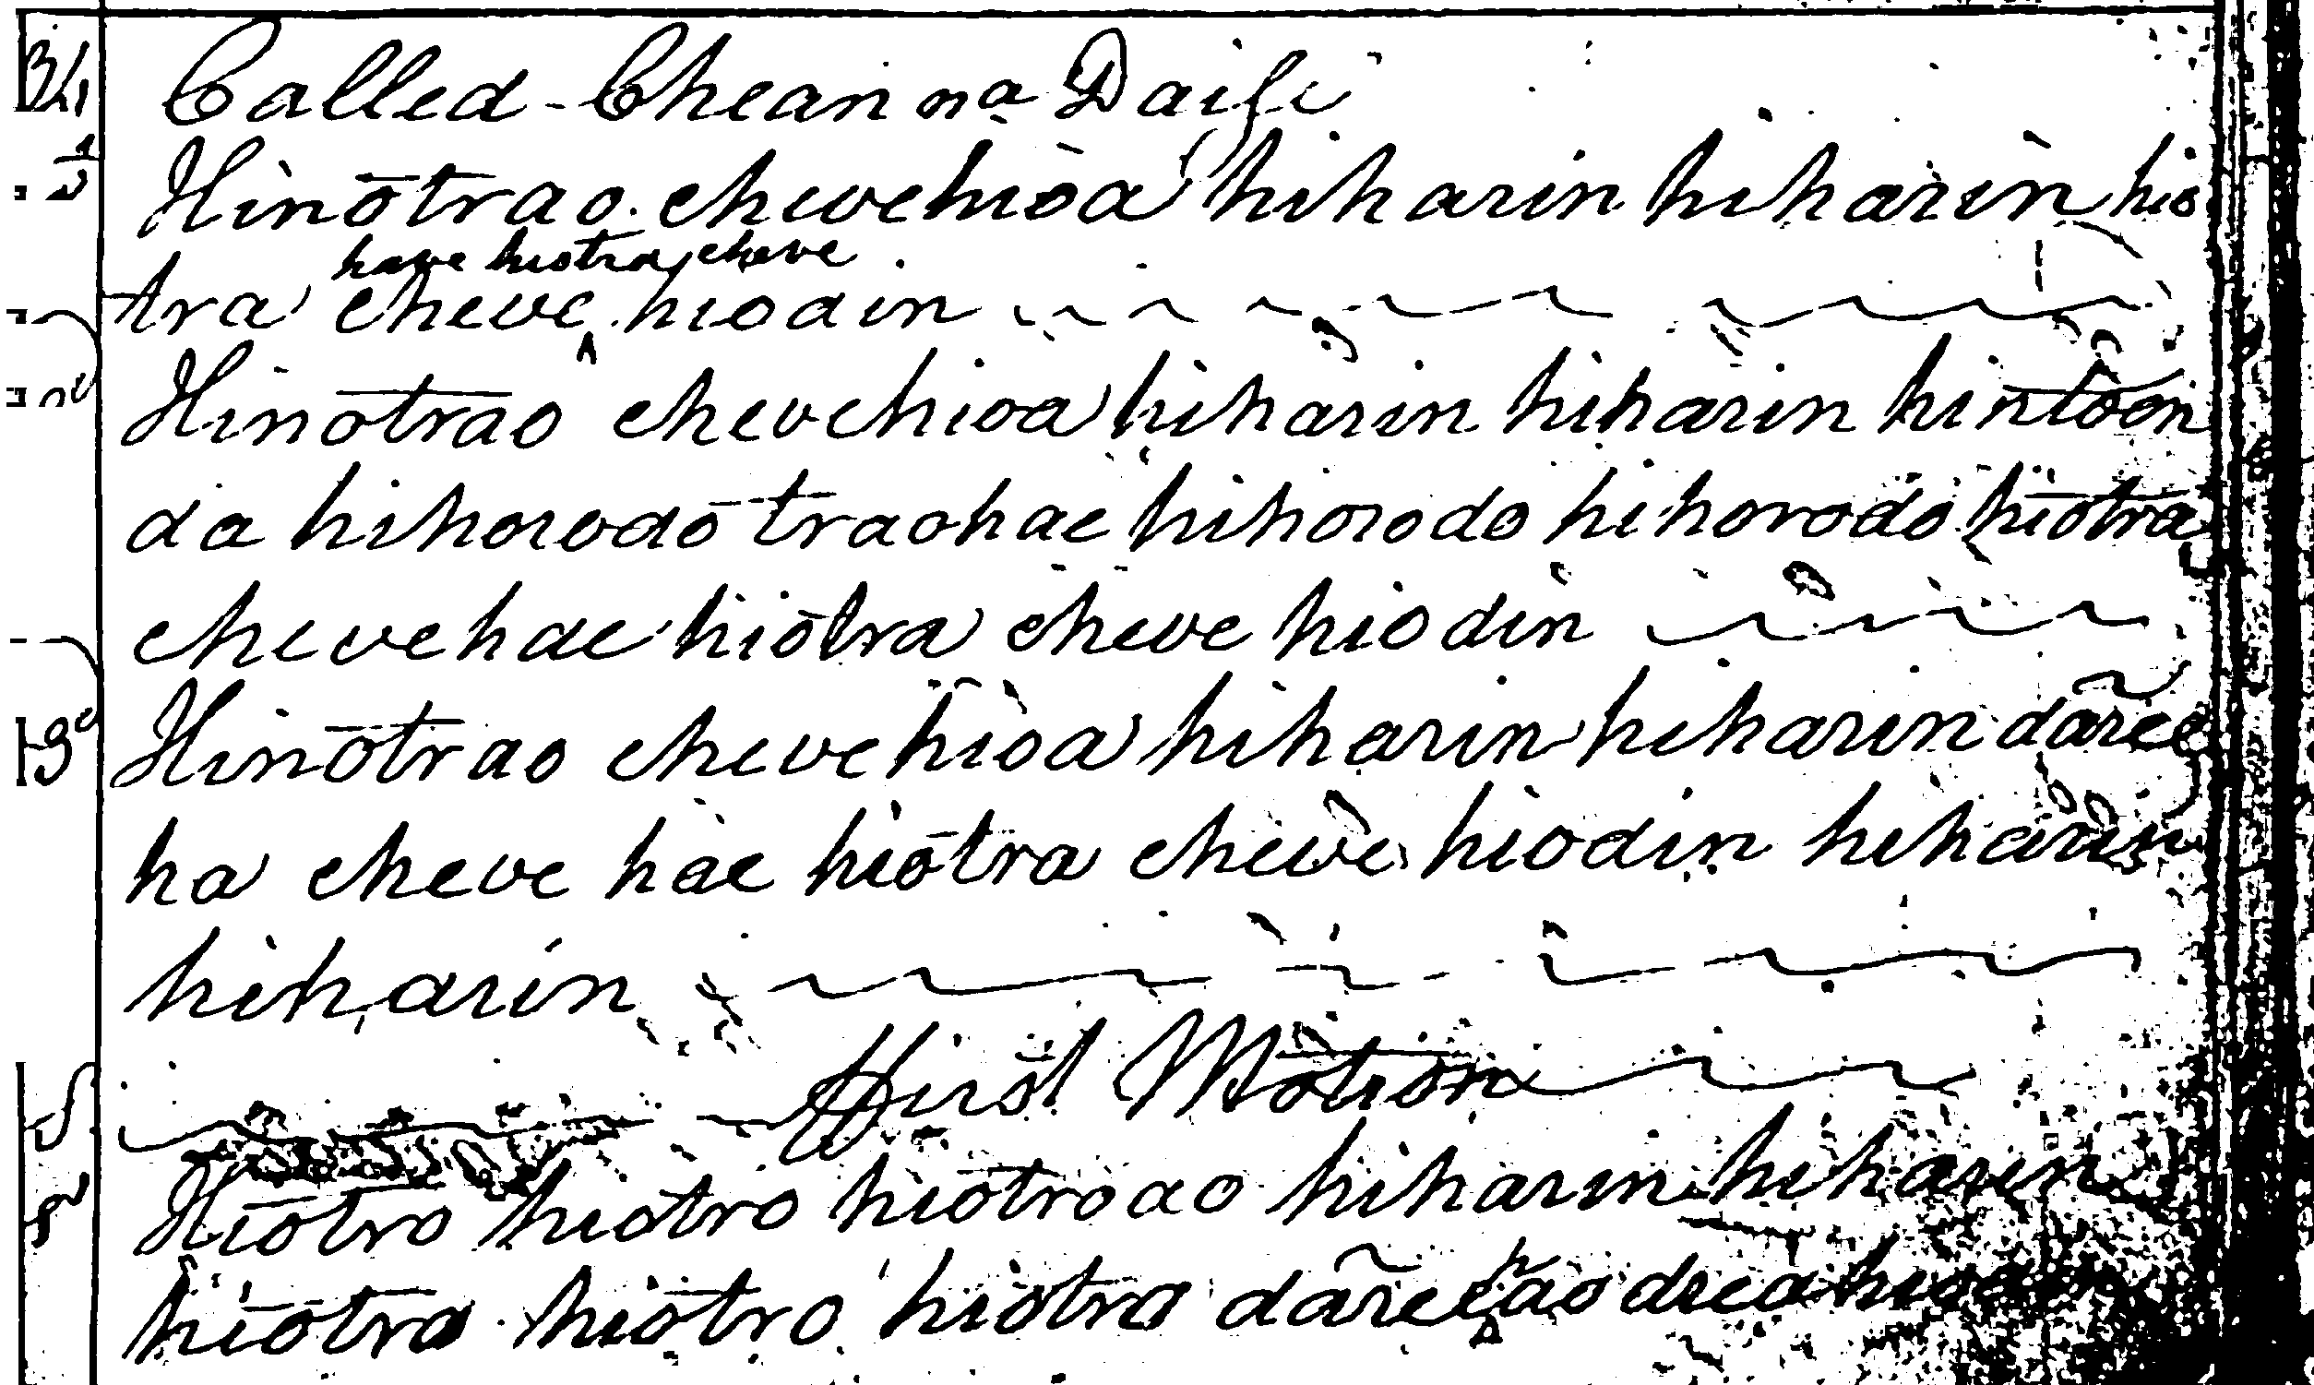

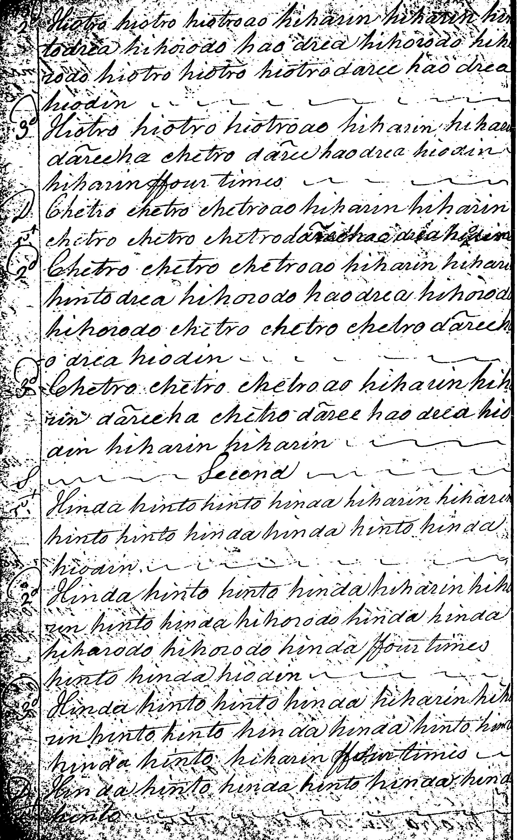

And so on.

None of the settings of this tune seem “regular” in the modern acceptance of the term. There are differences in line lengths, apparently “redundant” beats, and a tone row which, in Colin Campbell’s case at any rate, changes between the various movements:

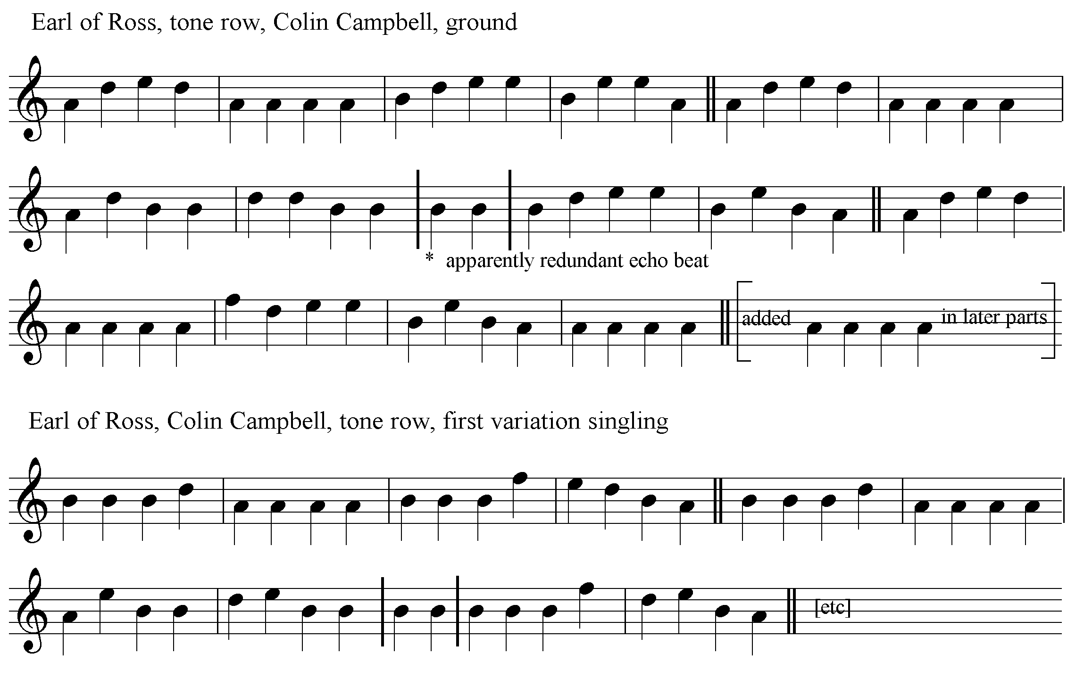

One problem for the interpreter in many of the “Earl of Ross” scores lies in the timing of variation one. Colin Mór’s version could imply something along the following lines:

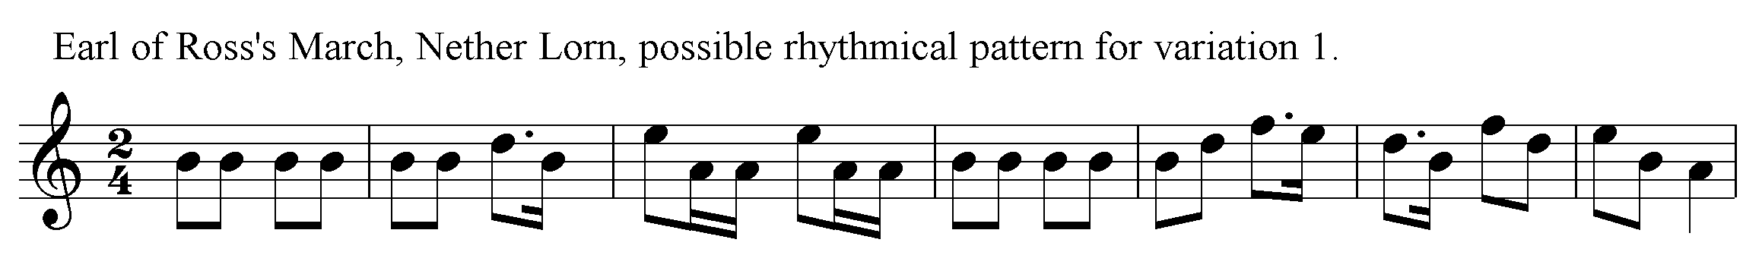

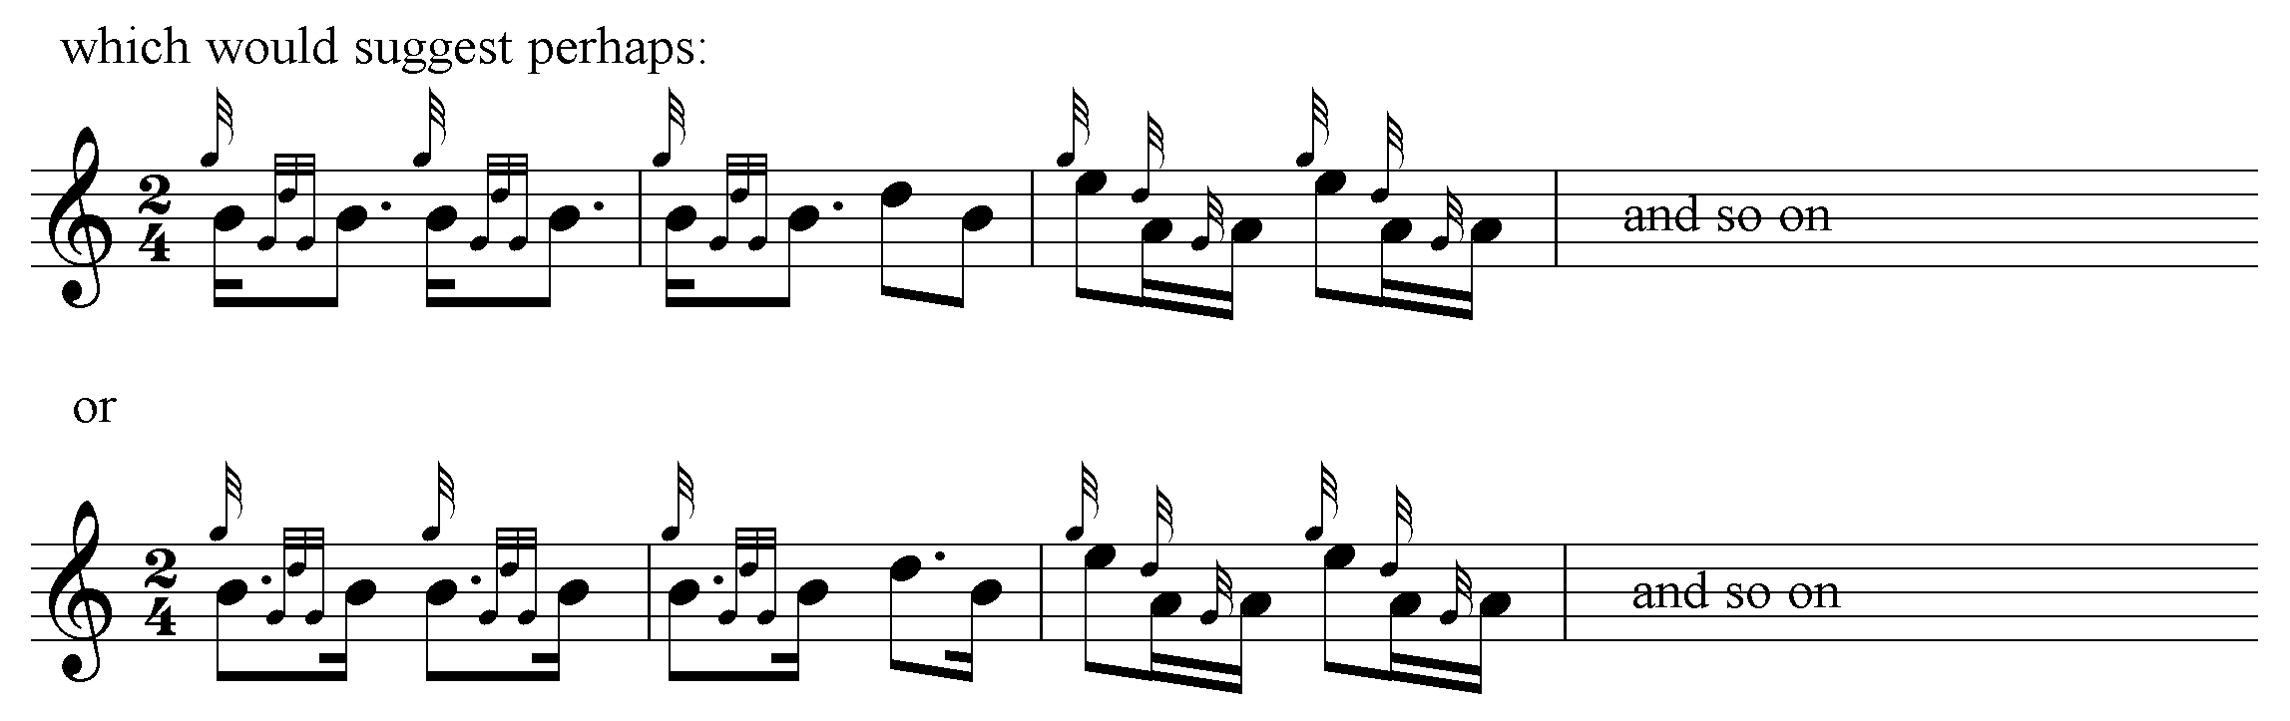

It is difficult at some points to get the Nether Lorn score to scan rhythmically. Also there seems to be an “extra” double echo on B in line 2; nor is Colin Mór consistent in the number of eallachs at the end of each part. He begins at 4, 6, 6 in the ground (if you add the extra hiharin); the later variations seem to settle into a basic 4, 6, 4 pattern but the score is irregular in this respect.

Donald MacDonald plays his eallachs “down”. His ground, like Colin Mór’s, is a little erratic. He points his siubhal predominantly “down”, while Angus MacKay plays his “up”. MacDonald’s doublings seem strangely truncated throughout:

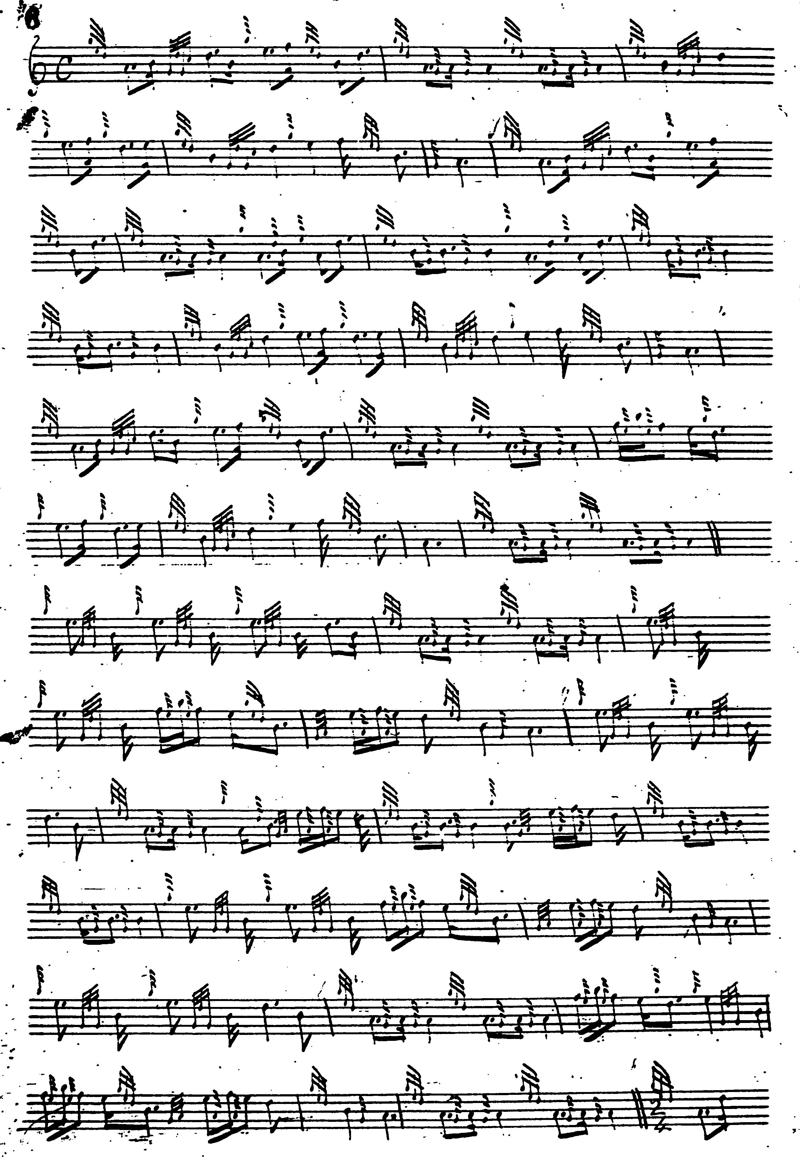
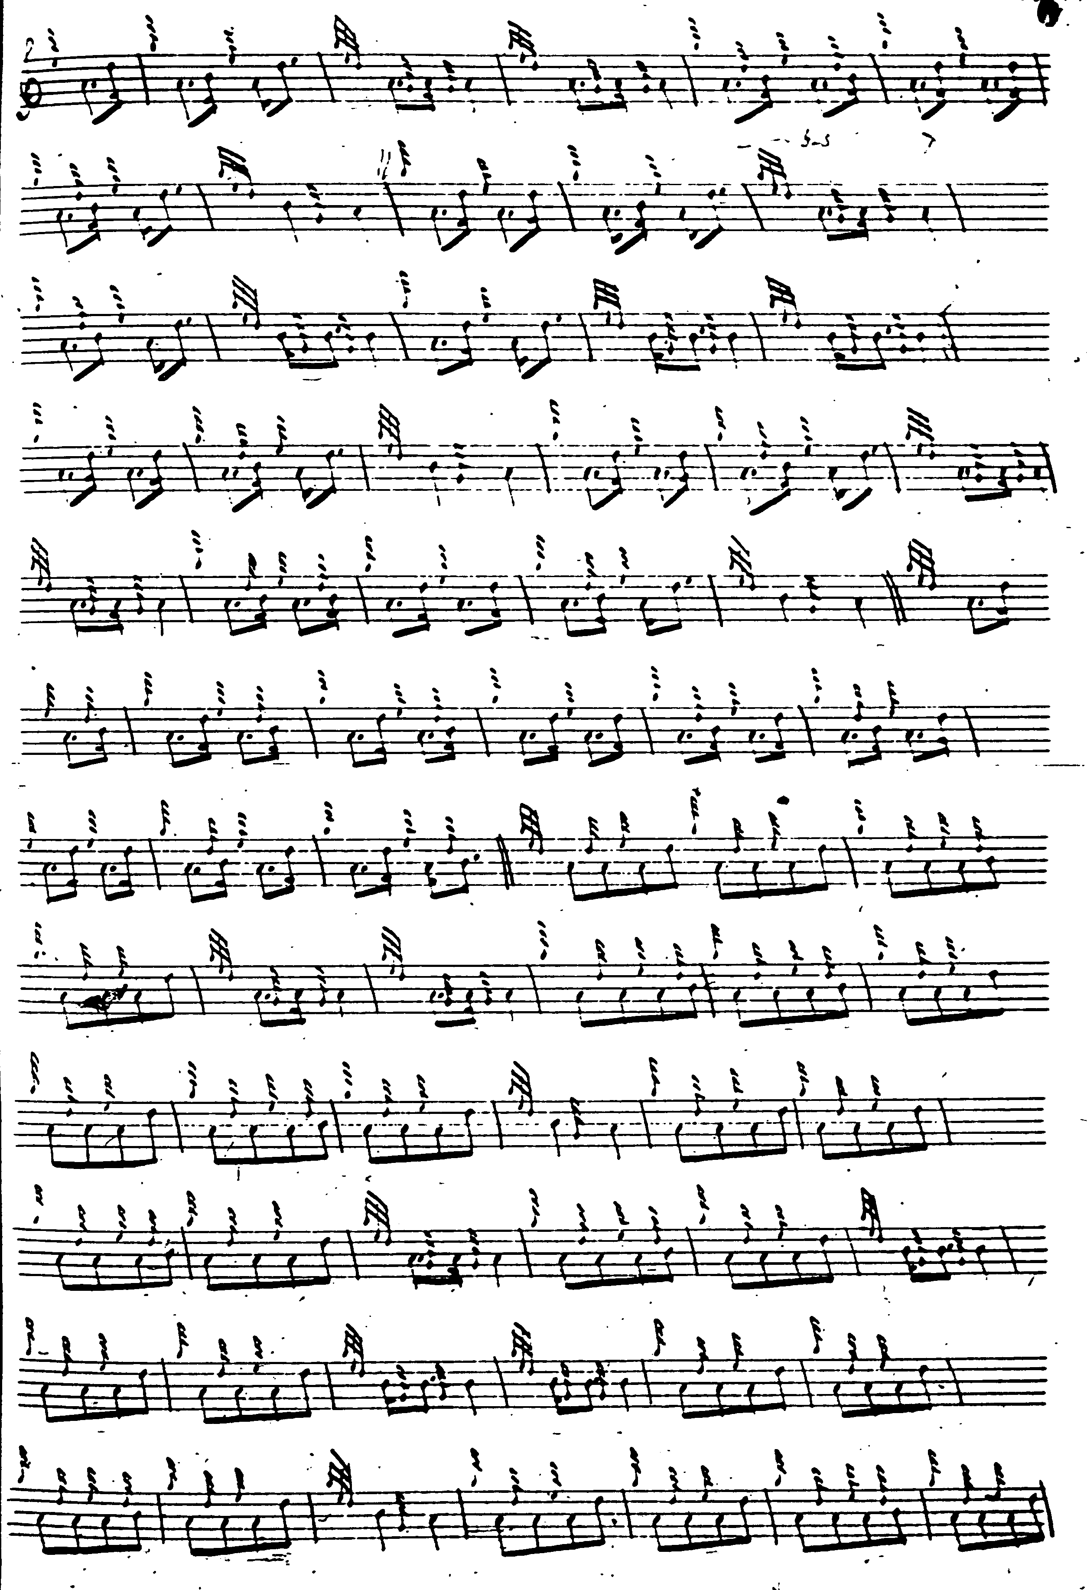
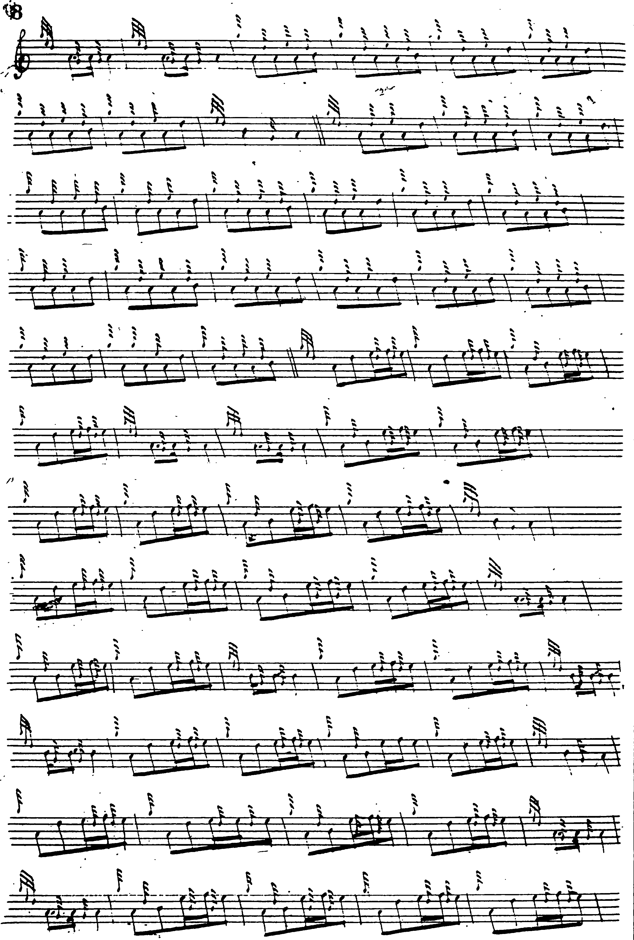
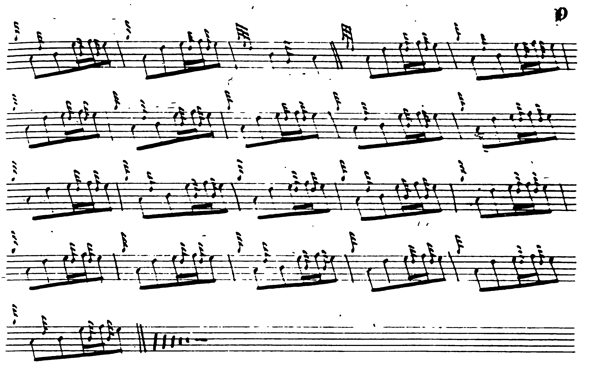

Peter Reid has his usual nice little reflexive gracenotes. He is different from MacDonald and turns the ground rather more nicely; plus he has a thumb variation which nobody else has got and it works well with this tune, but he still seems “out” in his variations:

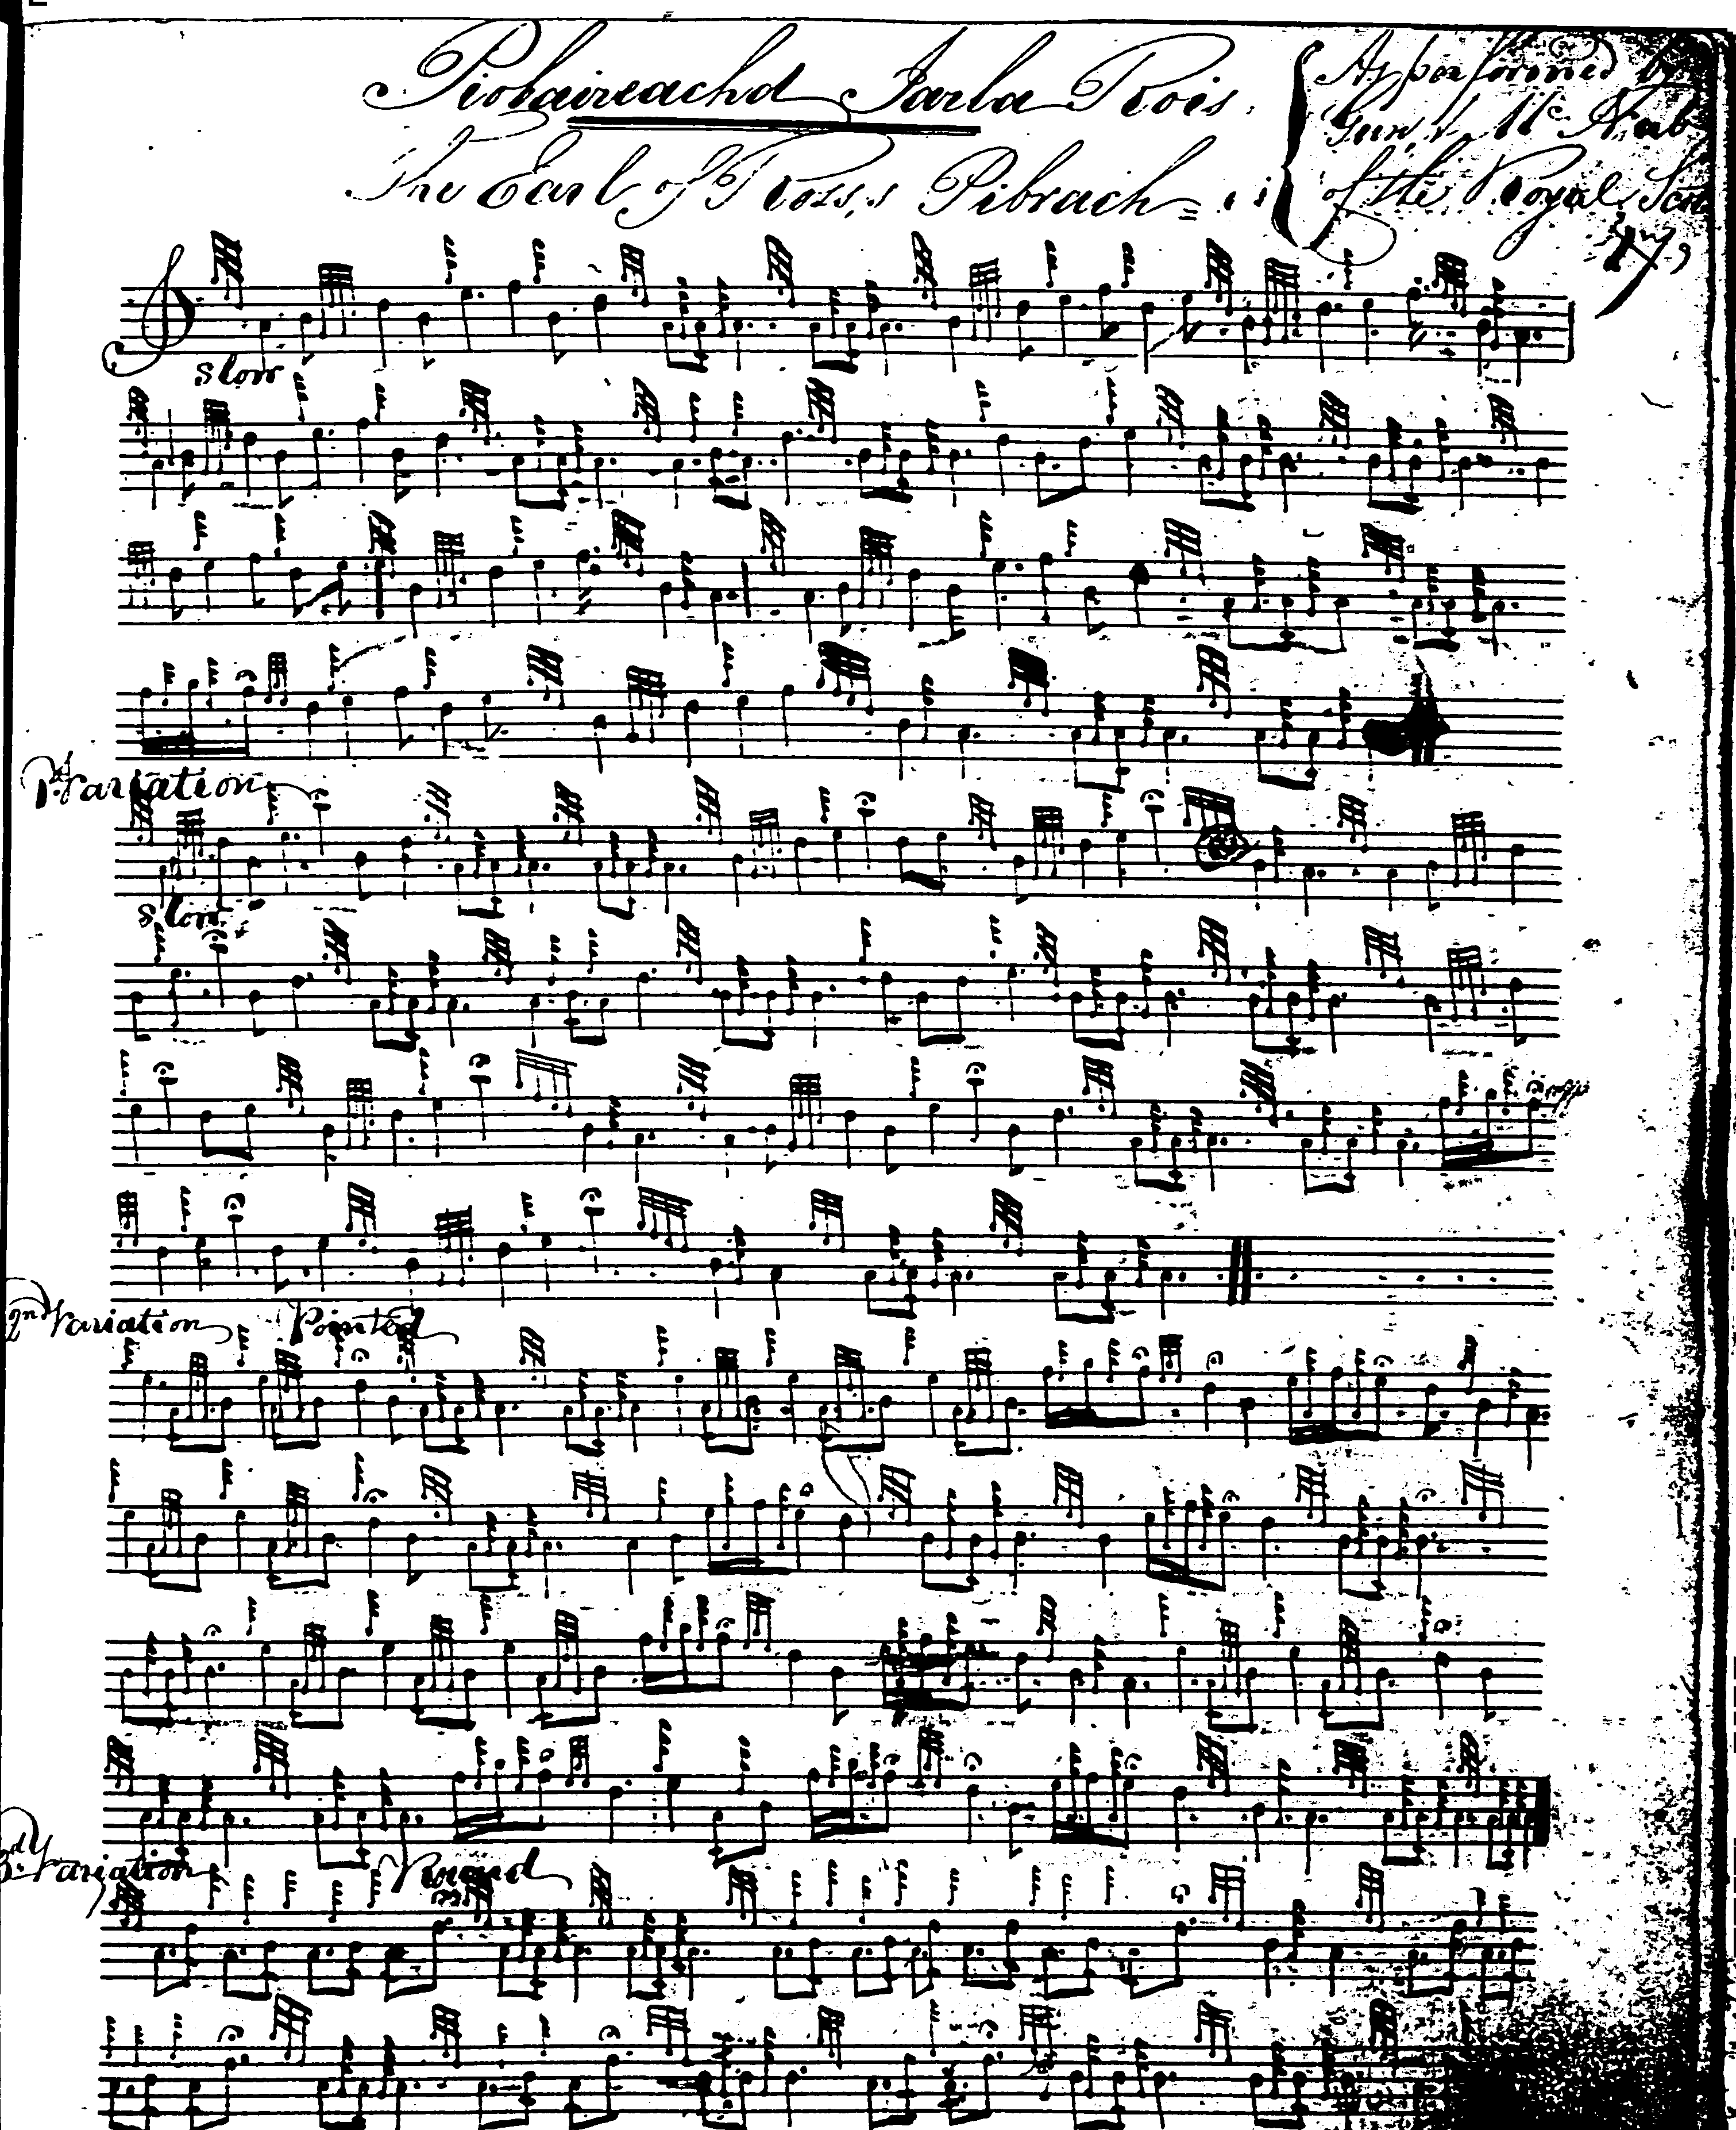
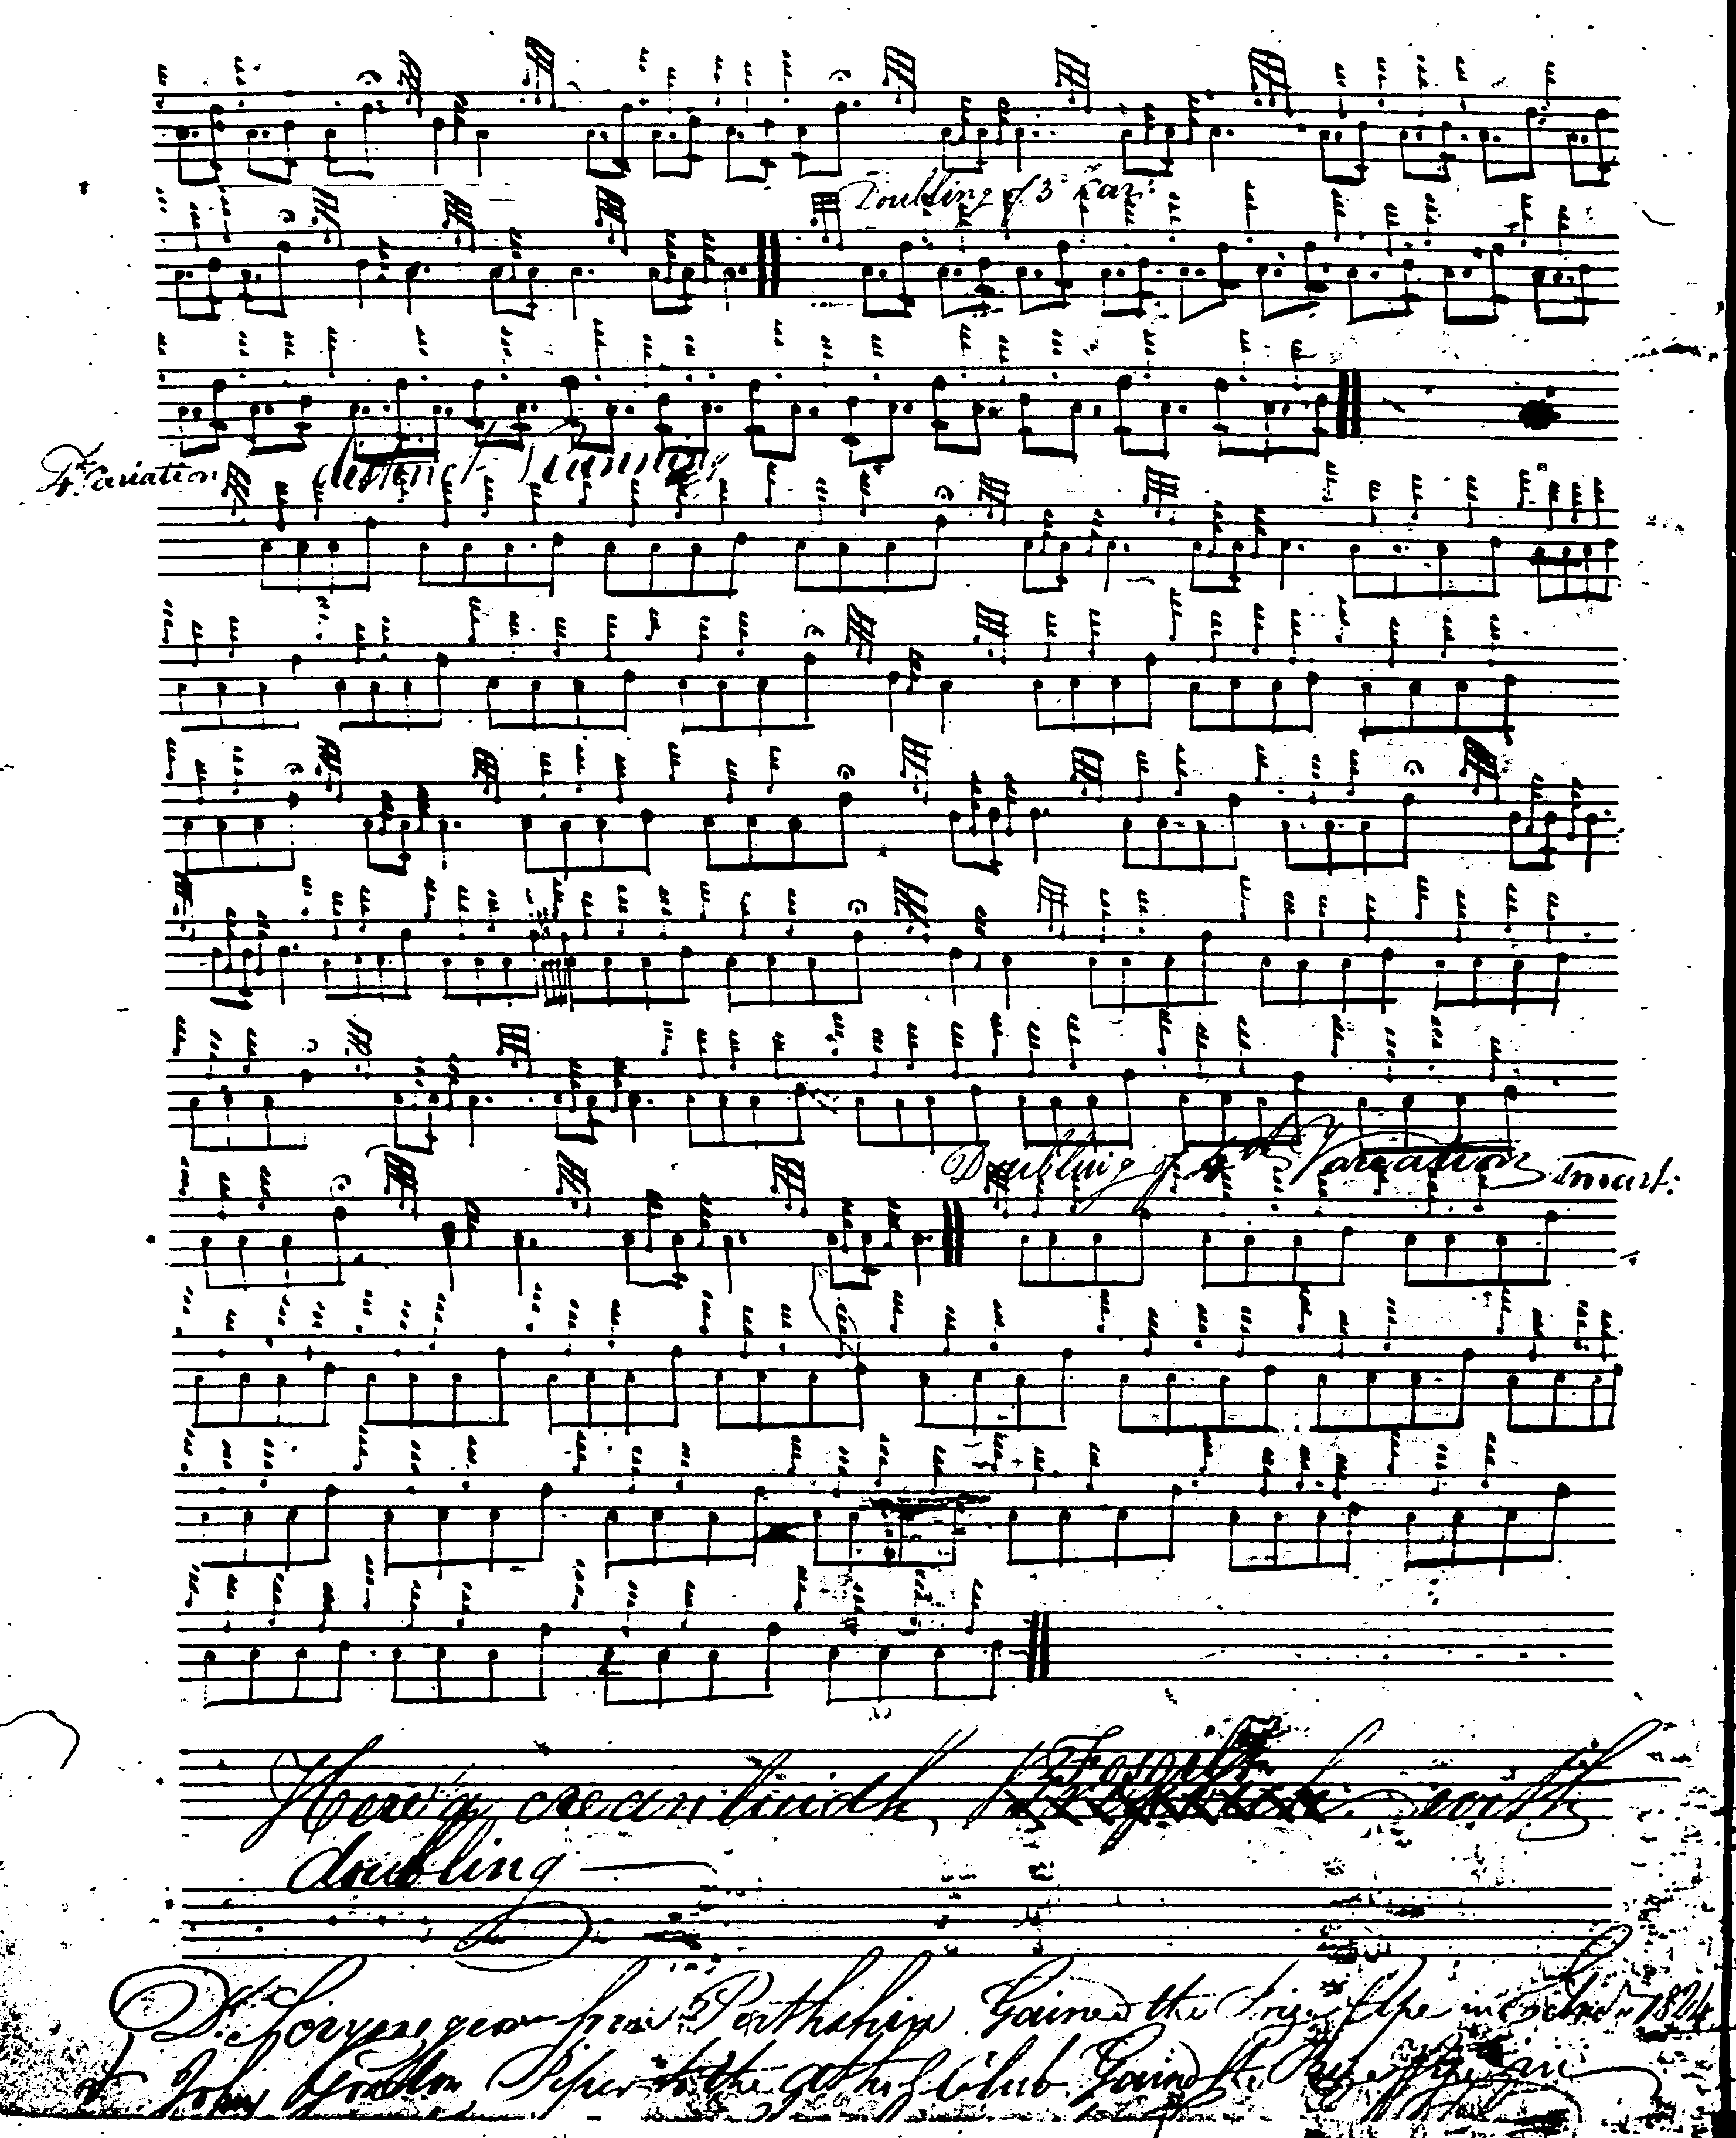

David Glen gives both MacKay’s and MacDonald’s grounds, following MacKay from var.1 onwards, commenting “McD being far wrong”. Both are marked as “edited”. Gives as an alternative title, “Heads of Corn. Ears of Corn”, presumably following Gesto. Glen corrects the missing bar in MacKay’s crunluath doubling as well. Both settings are given below as offering an interesting insight into the editorial process:

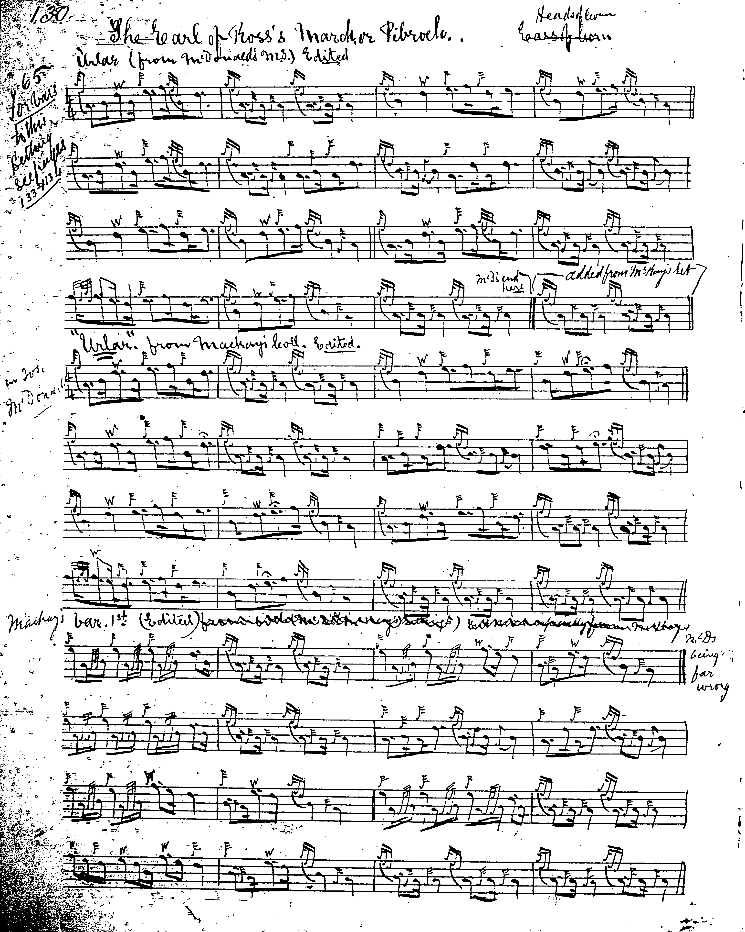
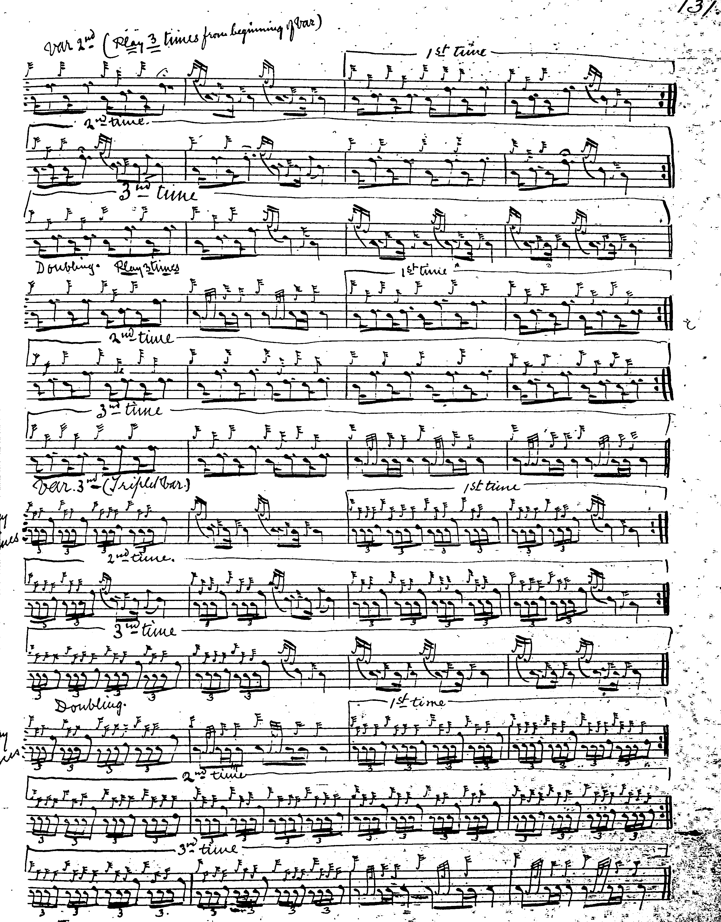
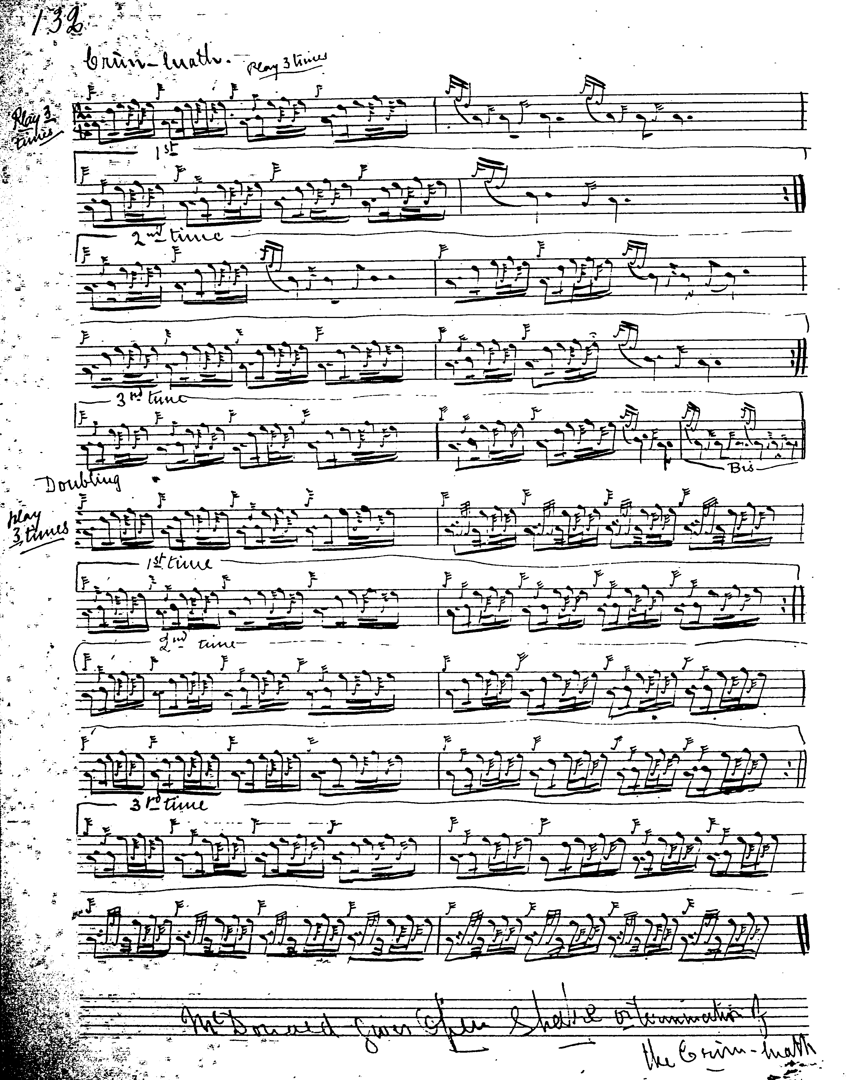
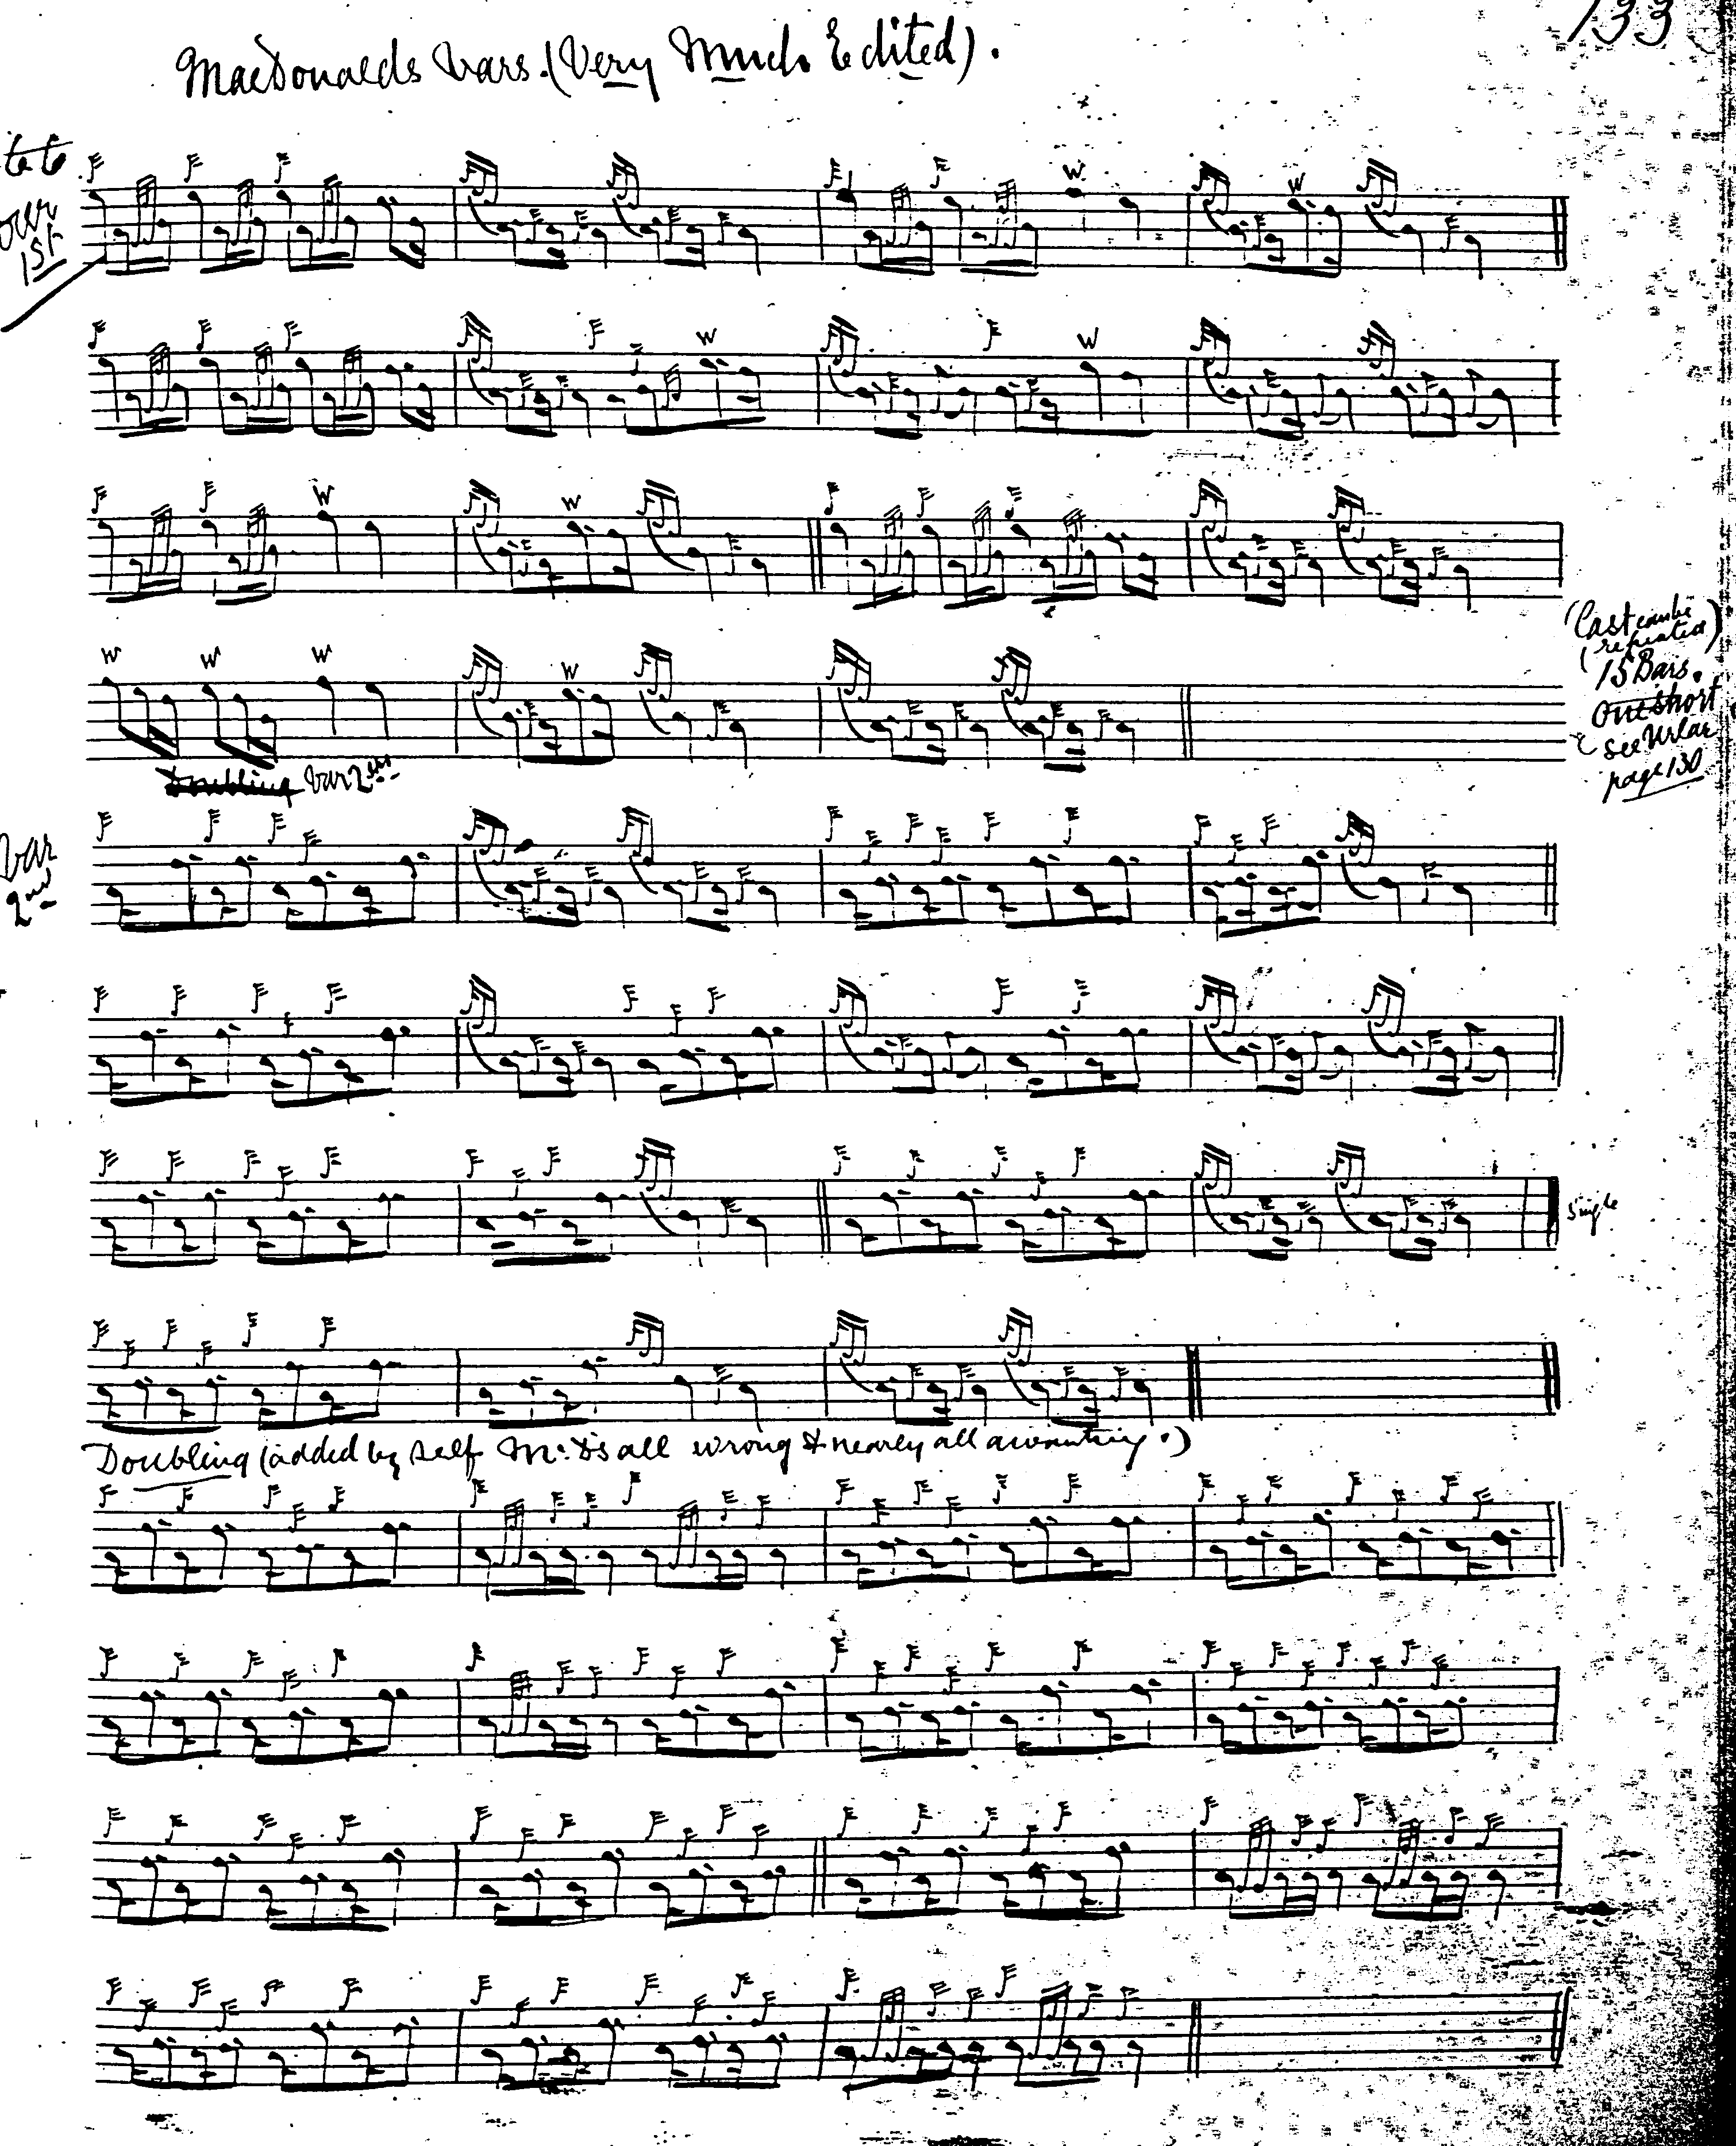
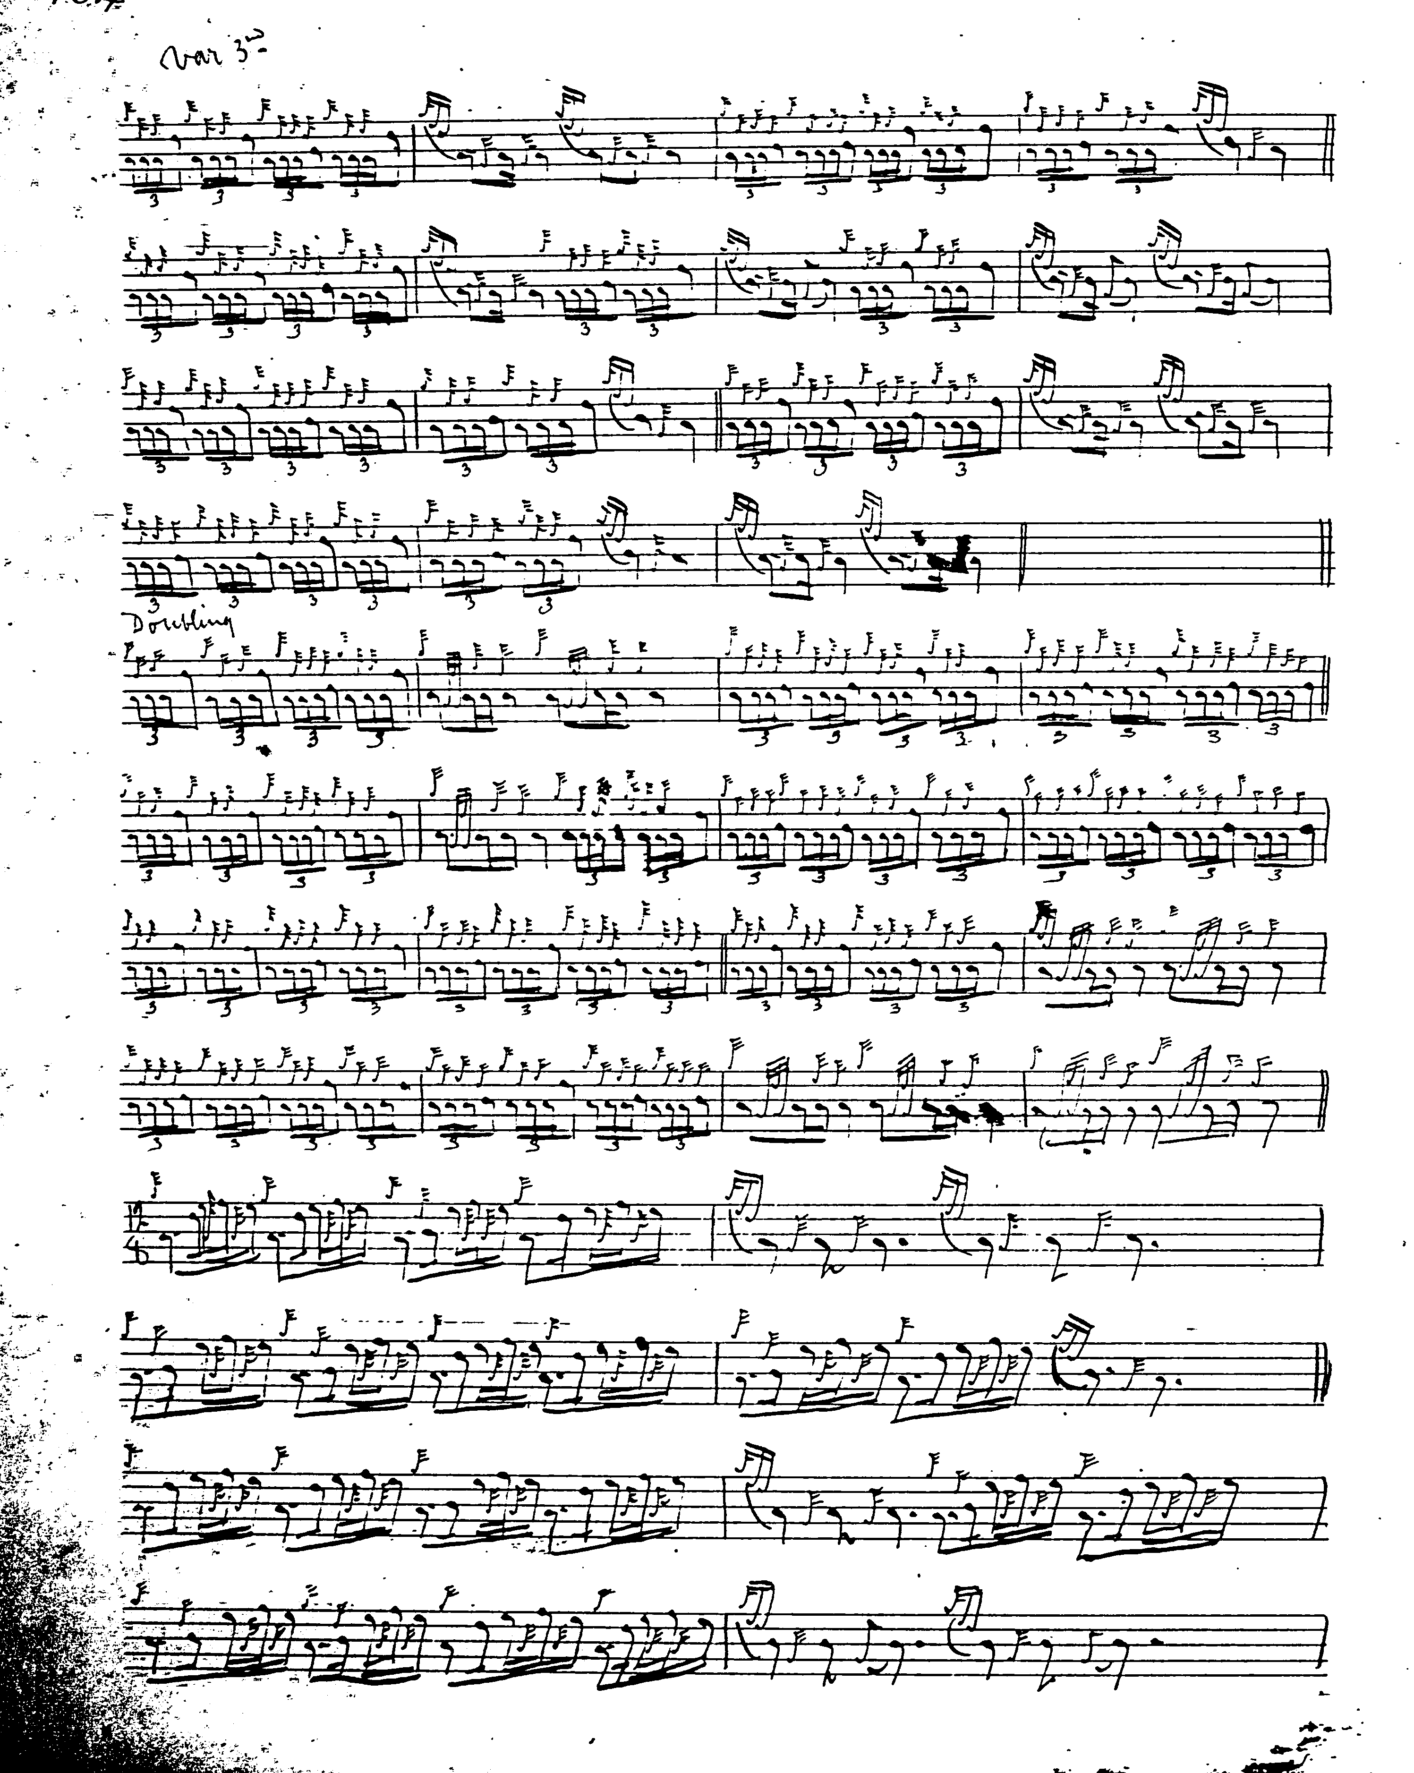

Angus MacKay’s published setting is if anything even more irregular than MacDonald’s. His ground is 4, 6, 6; Var 1=6, 8, 8; Var 2 singling 4, 7, [misplaced ‘bis’ sign] 6; doubling is 4, 6, 6; taorluath fosgailte singling is 7, 11, 9; doubling is 7, and then a long line of 20 bars. Angus then repeats the ground. Crunluath singling is 7, 11, 8; doubling 7, long line of 20 bars, probably dividing 11, 9. MacKay is followed by the Piobaireachd Society editors with minor changes to time signatures and the silent omission of his instructions to repeat the ground after the taorluath and crunluath doublings:
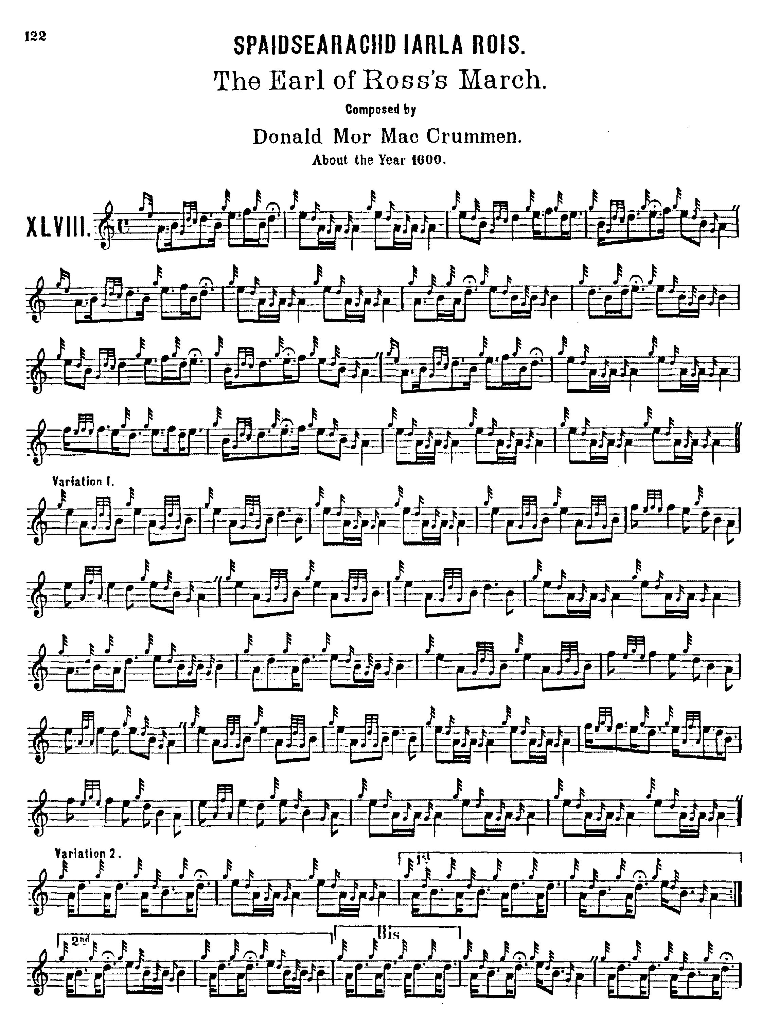
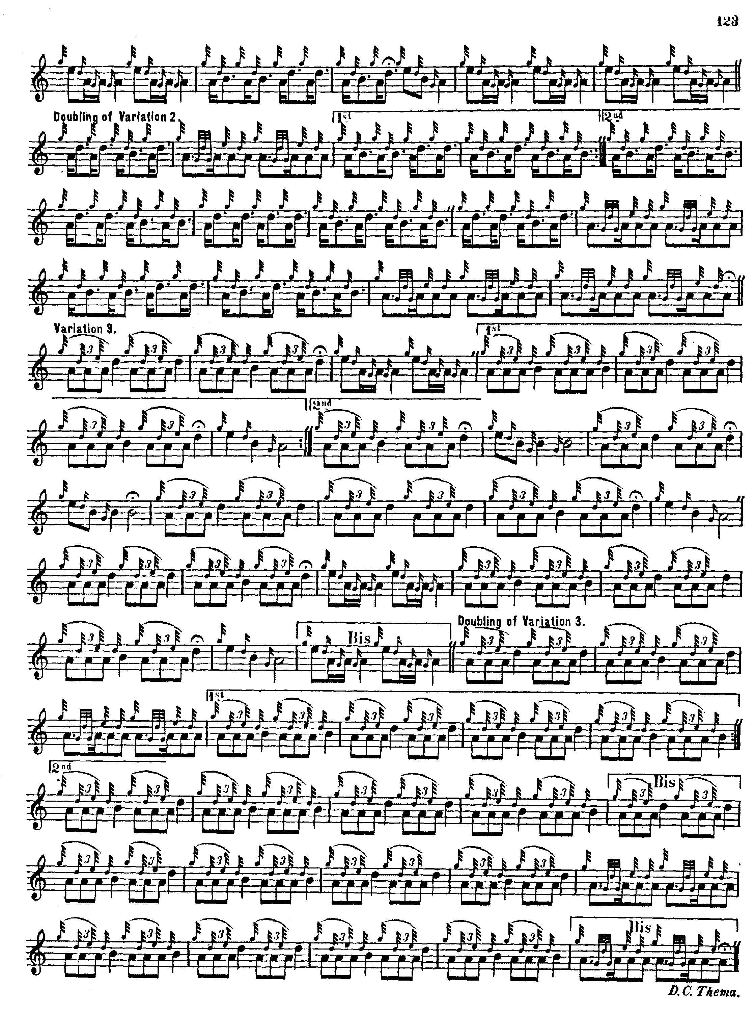

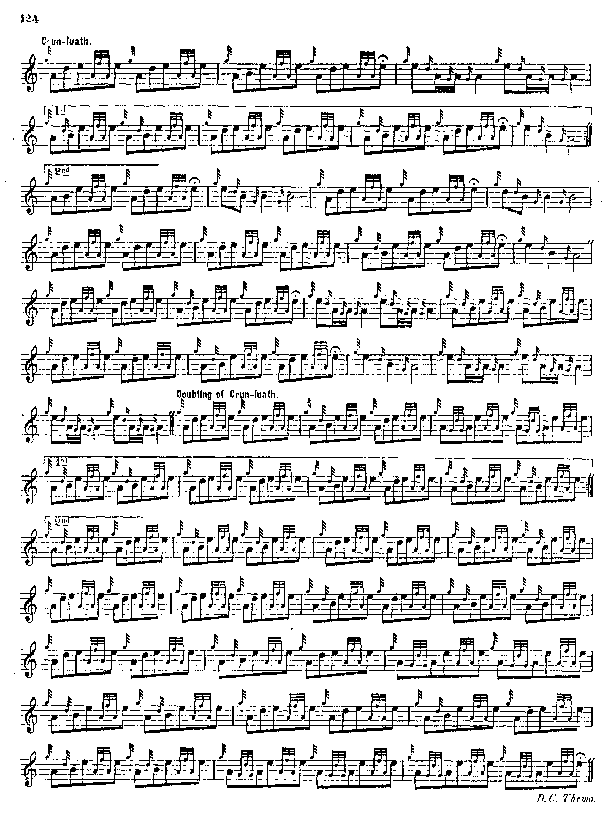

Niel MacLeod of Gesto begins as follows:

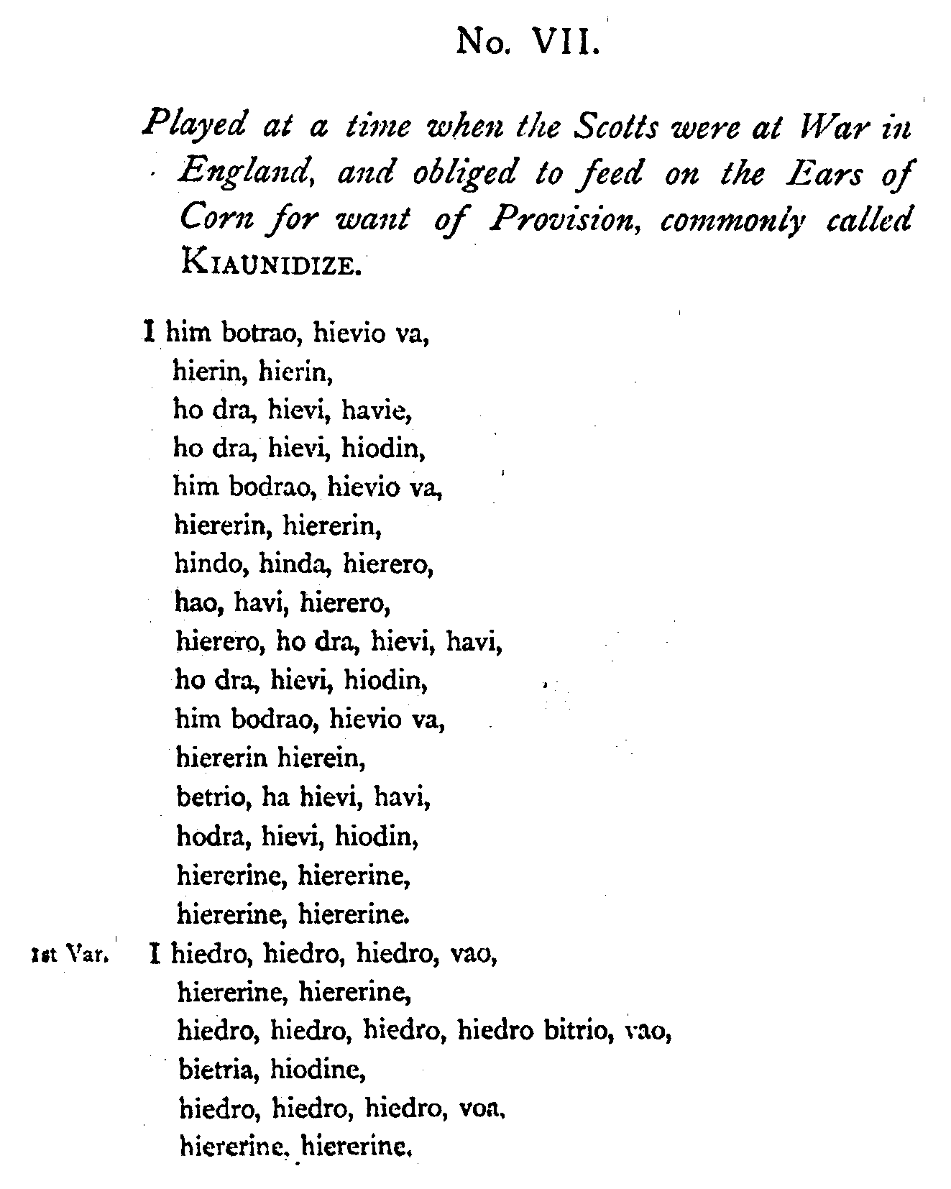
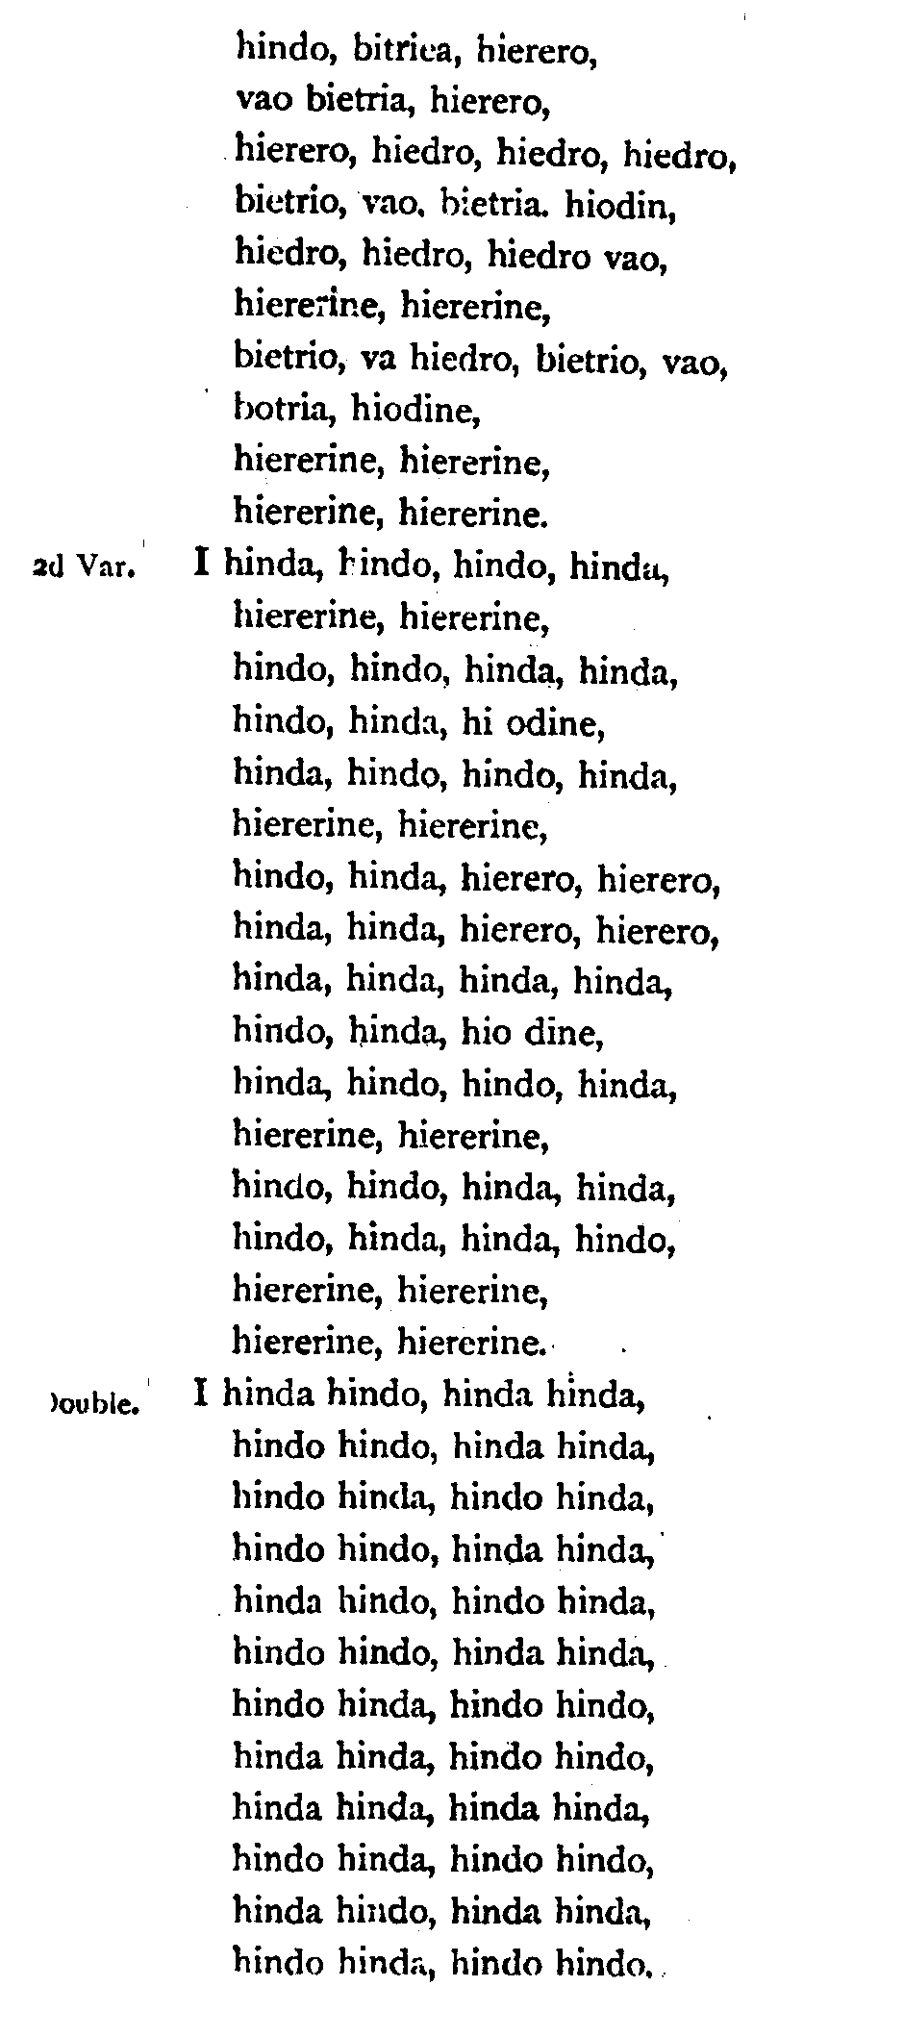
and so on.

C. S. Thomason bases his score on MacKay and is unable therefore to resolve the timing difficulties which attach to MacKay’s first variation. It is difficult to see how to time this section as written in any way pleasingly. Thomason’s score is not reproduced here.

Commentary:

The disputed succession to the fertile and strategically important Earldom of Ross long kept the north in ferment. Donald, Lord of the Isles, having been deprived of the Earldom through various kinds of feudal skulduggery, marched upon Aberdeen, and was defeated on 24th July 1411 at a place called Harlaw in the uplands of the Garioch by a force of North-East gentry and the citizens of Aberdeen. It was a brutal, drawn encounter, known locally as “the reid Harlaw”, and is celebrated in a ballad sung to this day, “The Battle of Harlaw”, notable alike for the energy of its language and an historical inaccuracy more or less complete. The tune goes somewhat thus:

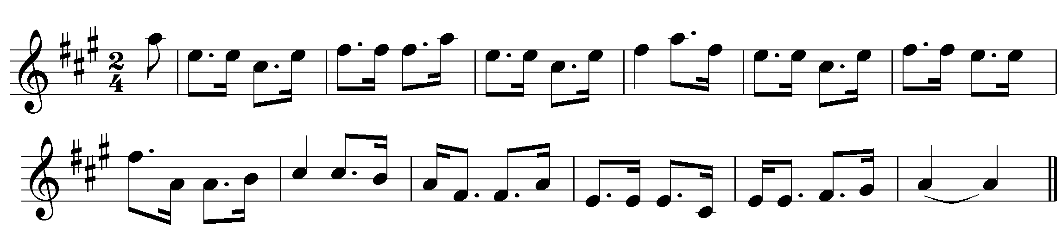

The words begin:

As I cam’ in by Dunideer,
An’ doon by Netherha’,
There was fifty thoosan’ Hielandmen A’ marchin’ tae Harlaw.
Wi’ my dirrum doo,
My fal de dal,
My diddie and a day.

[…]The first straik that Lord Forbes strack [“Forbes” pron. as an evenly stressed
He gar’t MacDonald reel; disyllable: “For-biss”]
The neist straik that Lord Forbes strack
The great MacDonald fell.
Wi’ my dirrum doo, [etc.]

An’ siccan a pileerichie
The like ye never saw;
As was amang the Hielandmen
When they saw MacDonald fa’.
Wi’ my dirrum doo, [etc]
(Greig-Duncan Folk Song Collection, song 112)

And so on. (The curious will find it sung in stirring style by Andy Hunter in his album, King Fareweel, Lismor Folk, LIFL 7002).

This was more than a raid. If MacDonald had taken Aberdeen he would have cut the country in two, effectively controlling most of the north and poised, not just to defy the King of Scots but to replace him.

After a good many further contretemps, the Earldom of Ross was detached from the Lordship of the Isles and annexed to the crown in 1476.

* * *

Electronic text © Dr. William Donaldson, Aberdeen, Scotland, September 2004

