The Lament for the Earl of Antrim

This is a widely diffused tune. There are settings in the following MS sources:

--Angus MacKay’s MS, i, 247;
--Duncan Campbell of Foss’s MS, ff.153-156;
--Uilleam Ross’s MS, ff.121-122;
--C. S. Thomason’s MS, f.36;
--D. S. MacDonald’s MS, ii, 158-64;
--John MacDougall Gillies’s MS, f.106;
--David Glen’s MS, ff.86-89
--Robert Meldrum’s MS, ff.38-41;

and in the following published sources:

--C. S. Thomason’s Ceol Mor, pp.233-4;
--David Glen’s Collection of Ancient Piobaireachd, pp.175-7;
--John McLennan’s The Piobaireachd as MacCrimmon Played it, p. 4;
--G. F. Ross, Some Piobaireachd Studies, p.46; and A Collection of MacCrimmon and Other Piobaireachd, pp.28-9.

The traditional scores show two routes through this tune, one coming down from Angus MacKay reflected in Uilleam Ross and D. S. MacDonald; and another, a rather fuller development of the piece by Duncan Campbell of Foss.

Angus MacKay ends the tune after the second variation, i.e., there are no taorluath or crunluath movements. He may have intended such (his note at the foot of the score has been largely removed by subsequent cropping of the page) but his normal practice is to write out such movements in full if he meant them to be played:

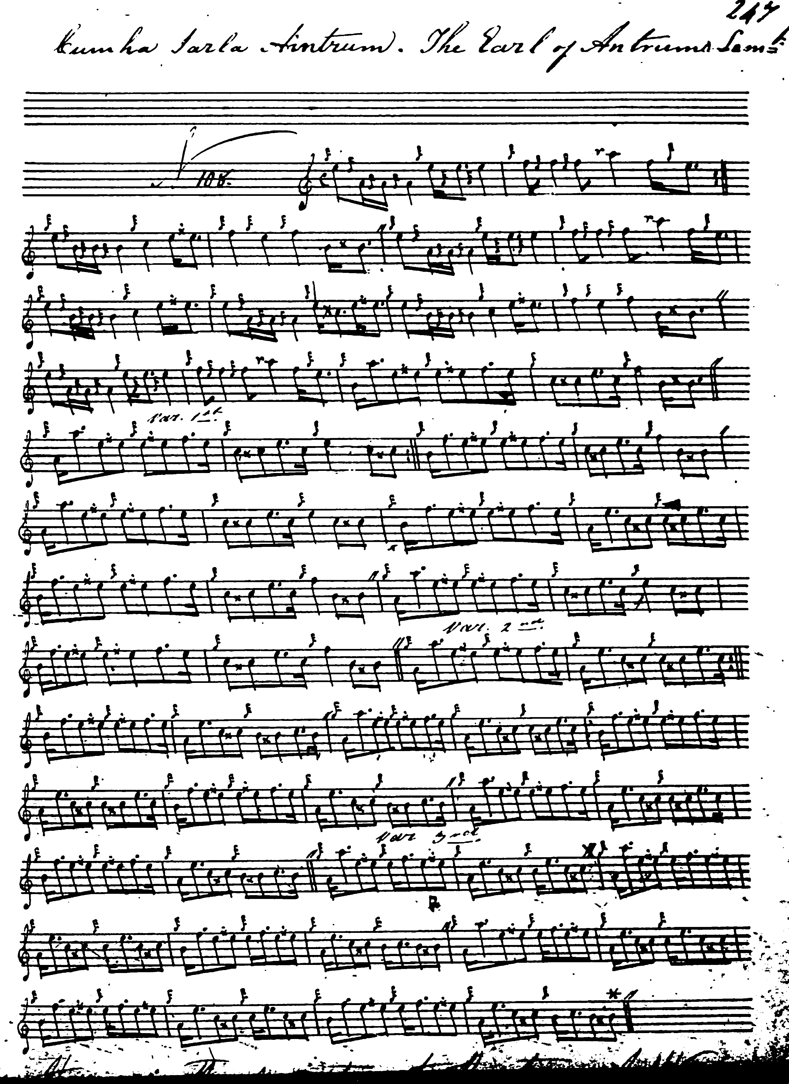

Duncan Campbell of Foss: treats the tune like this:

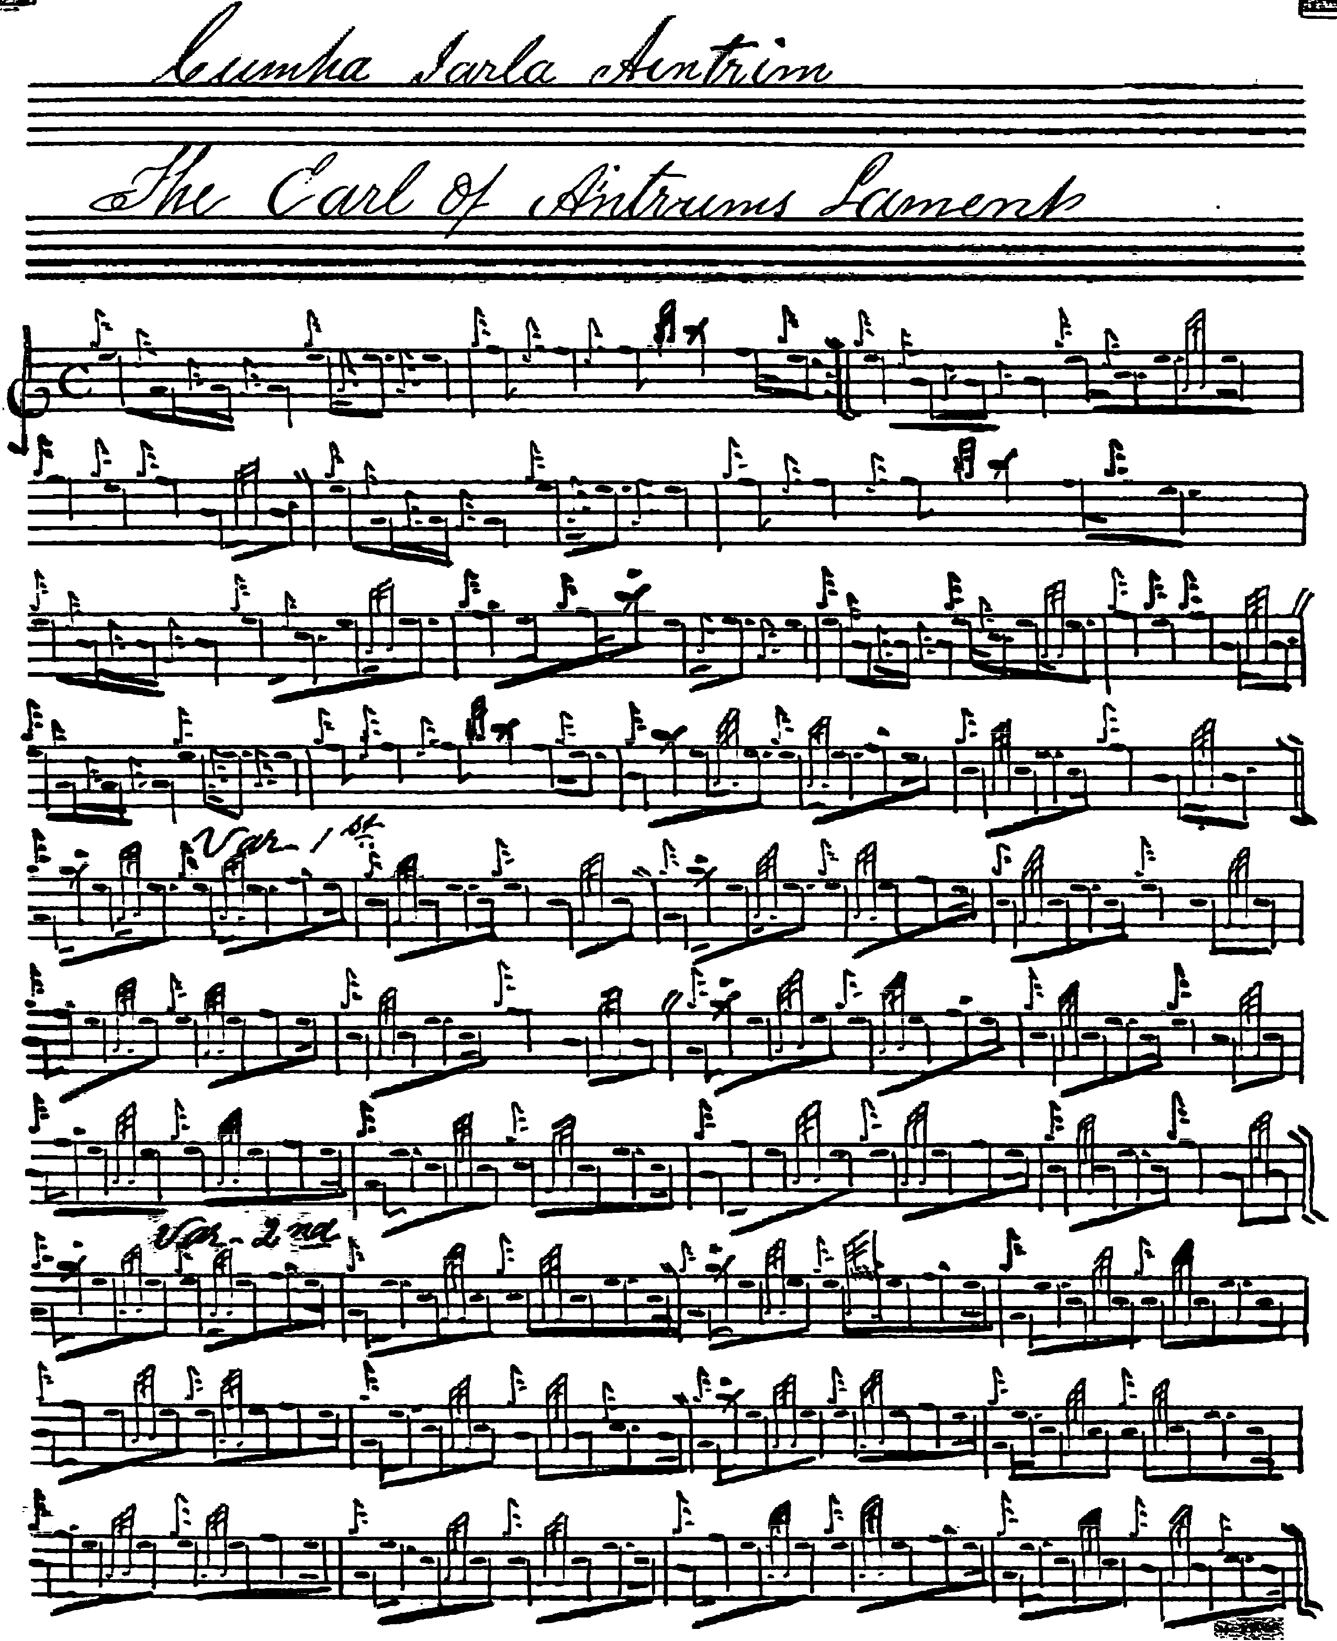
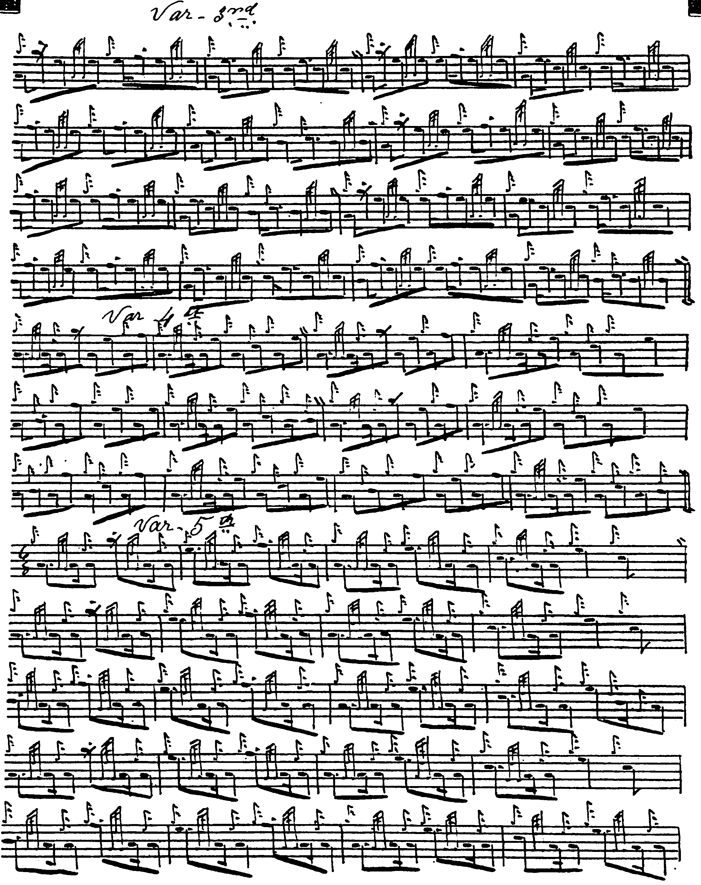
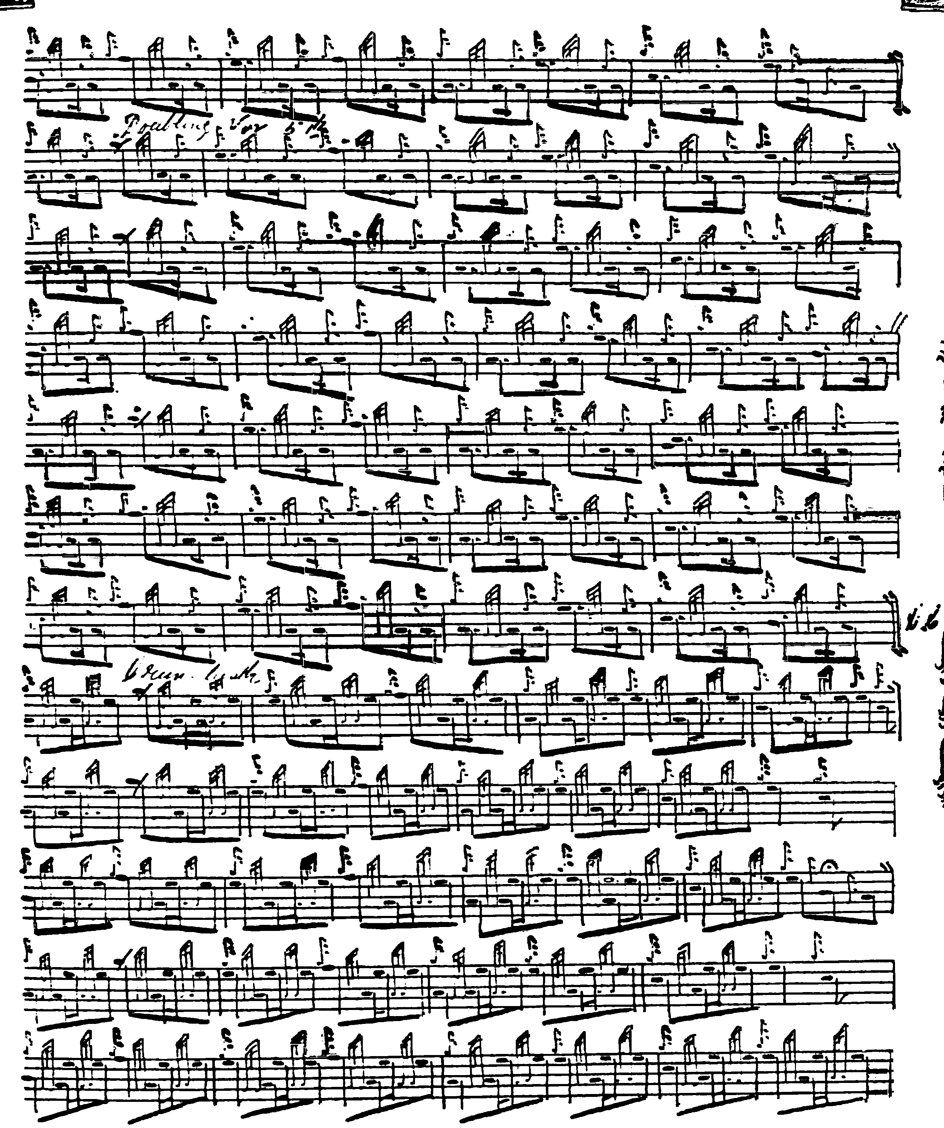
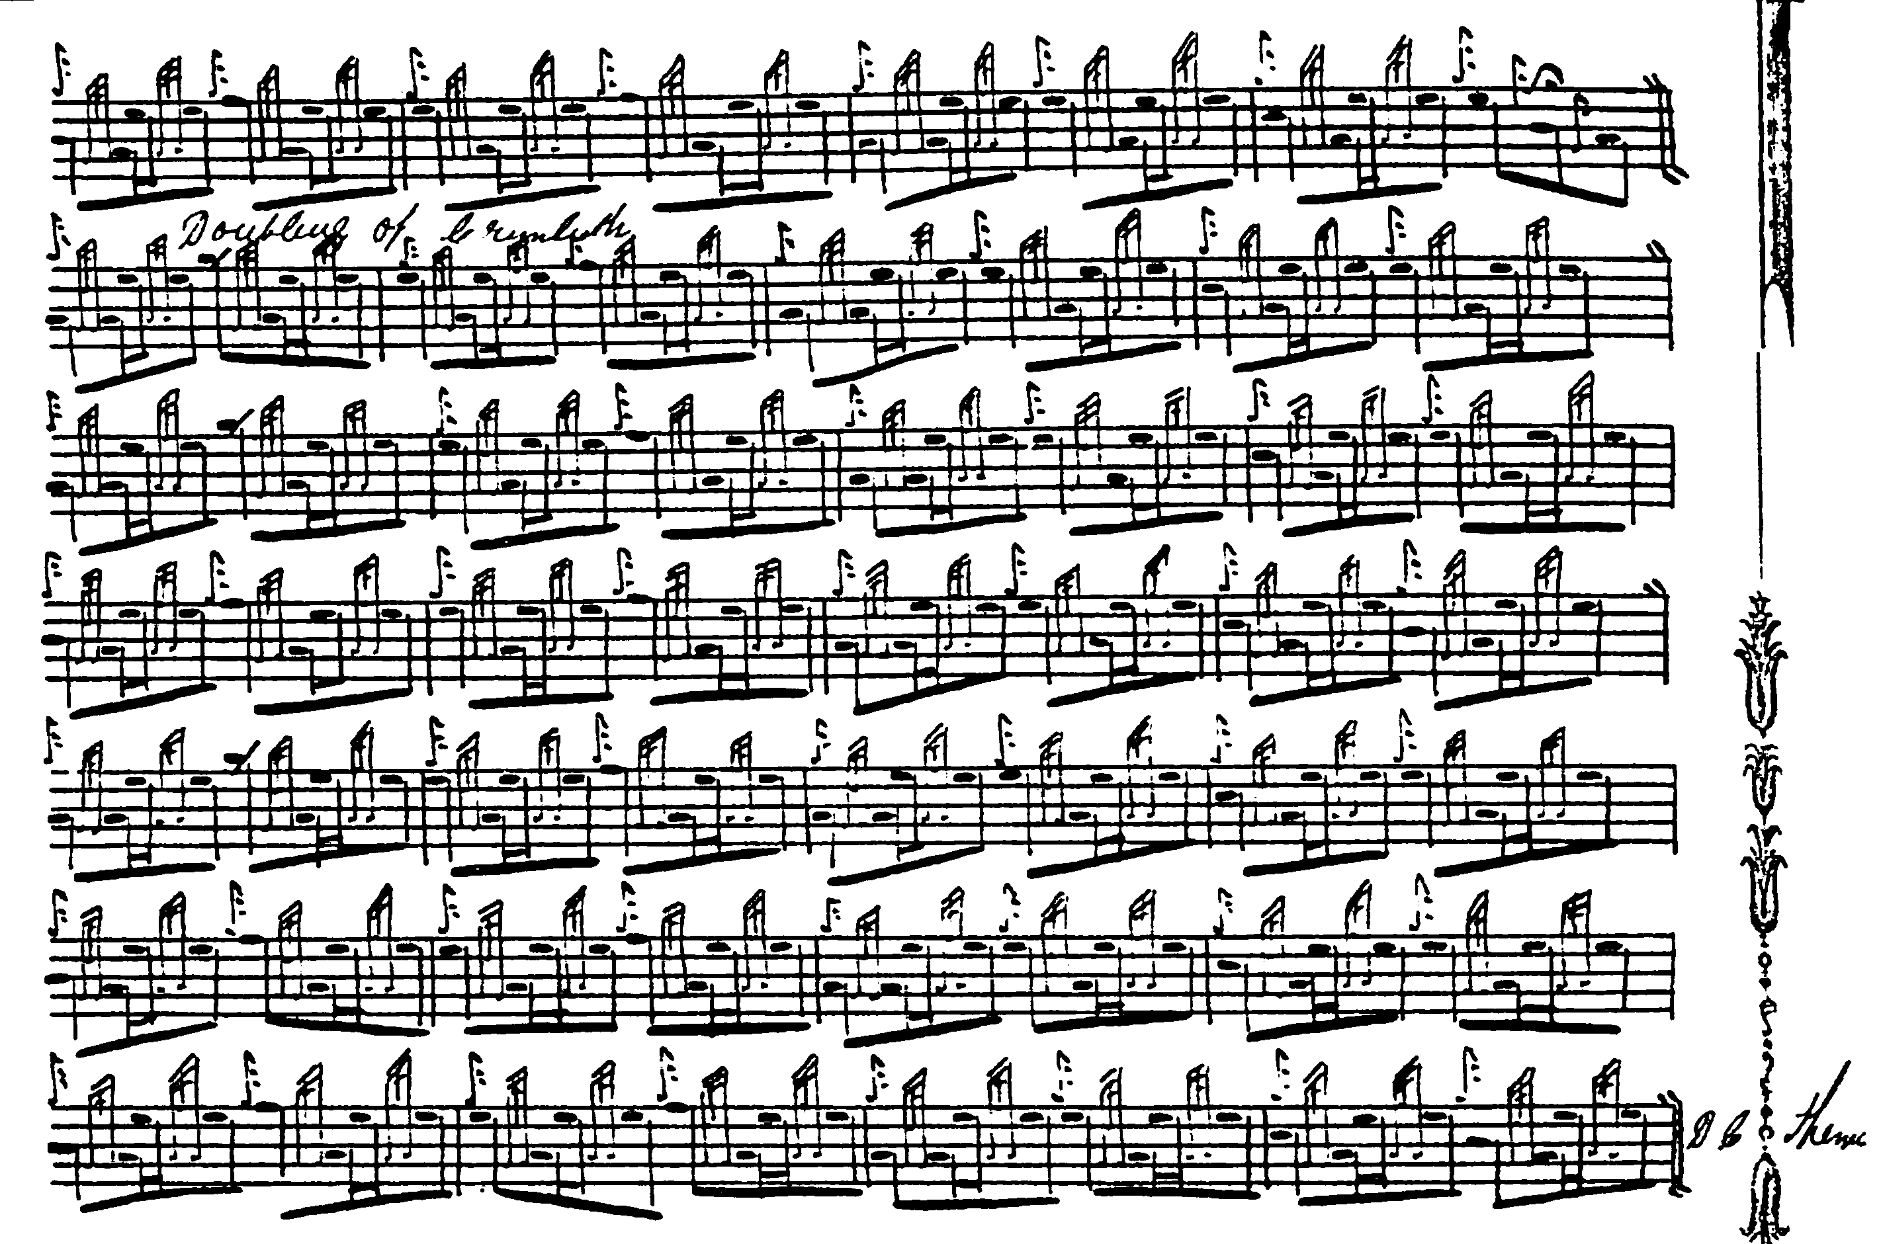

Duncan Campbell’s is the earliest source in which the tune is developed to its full extent continuing beyond the third variation to a taorluath and crunluath singling and doubling. He directs that the ground be repeated after the taorluath doubling and at the end of the tune. One notes the interesting timing of cadences in the taorluath and crunluath singlings. See the note on length below.

Uilleam Ross: adds little to MacKay and Campbell, except that his variations are written out in full. Like MacKay, he, too, does not develop the tune to a taorluath/crunluath conclusion, ending with the second variation and directing that the ground be repeated thereafter. There is no indication that he considered the tune might be of greater extent. This score is not reproduced here.

D. S. MacDonald: this setting is in outline only, but follows MacKay. MacDonald, too, ends the tune with the second variation and returns to the ground. This score is not reproduced here.

John MacDougall Gillies: this setting is an outline sketch of the tune merely, although taking the piece as far as the taorluath singling and concluding ‘etc’. It is similar to Duncan Campbell’s way of the tune and is not reproduced here.

David Glen: likewise follows Duncan Campbell, and this score is not reproduced here.

Robert Meldrum also follows Duncan Campbell’s route through the tune and his score is not reproduced here.

Published Sources:

C. S. Thomason’s Ceol Mor: gives Donald MacKay’s Ballindalloch MS as the source, but follows Duncan Campbell’s development of the tune, including repeating the ground at the end of the taorluath and crunluath doublings. This score is not reproduced here.

David Glen’s Collection of Ancient Piobaireachd, pp.175-177. Glen plays his eallachs ‘down’ and holds the initial note of his B echo beat in the ground. He cuts the pendulum movement “up”. Glen sensibly omits the repeat of the ground following the taorluath doubling, although this might be considered if one were to drop one of the first three variations as discussed below:

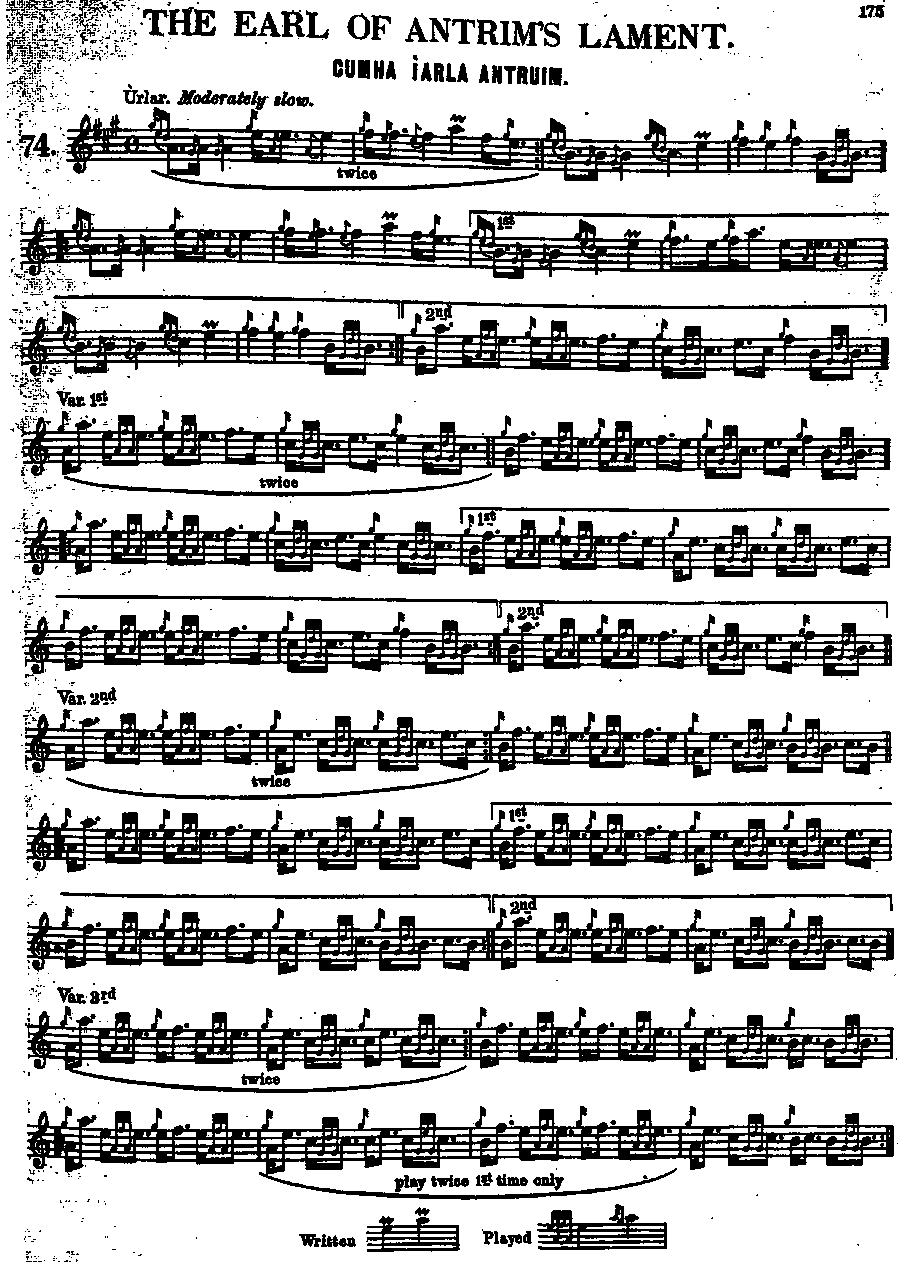

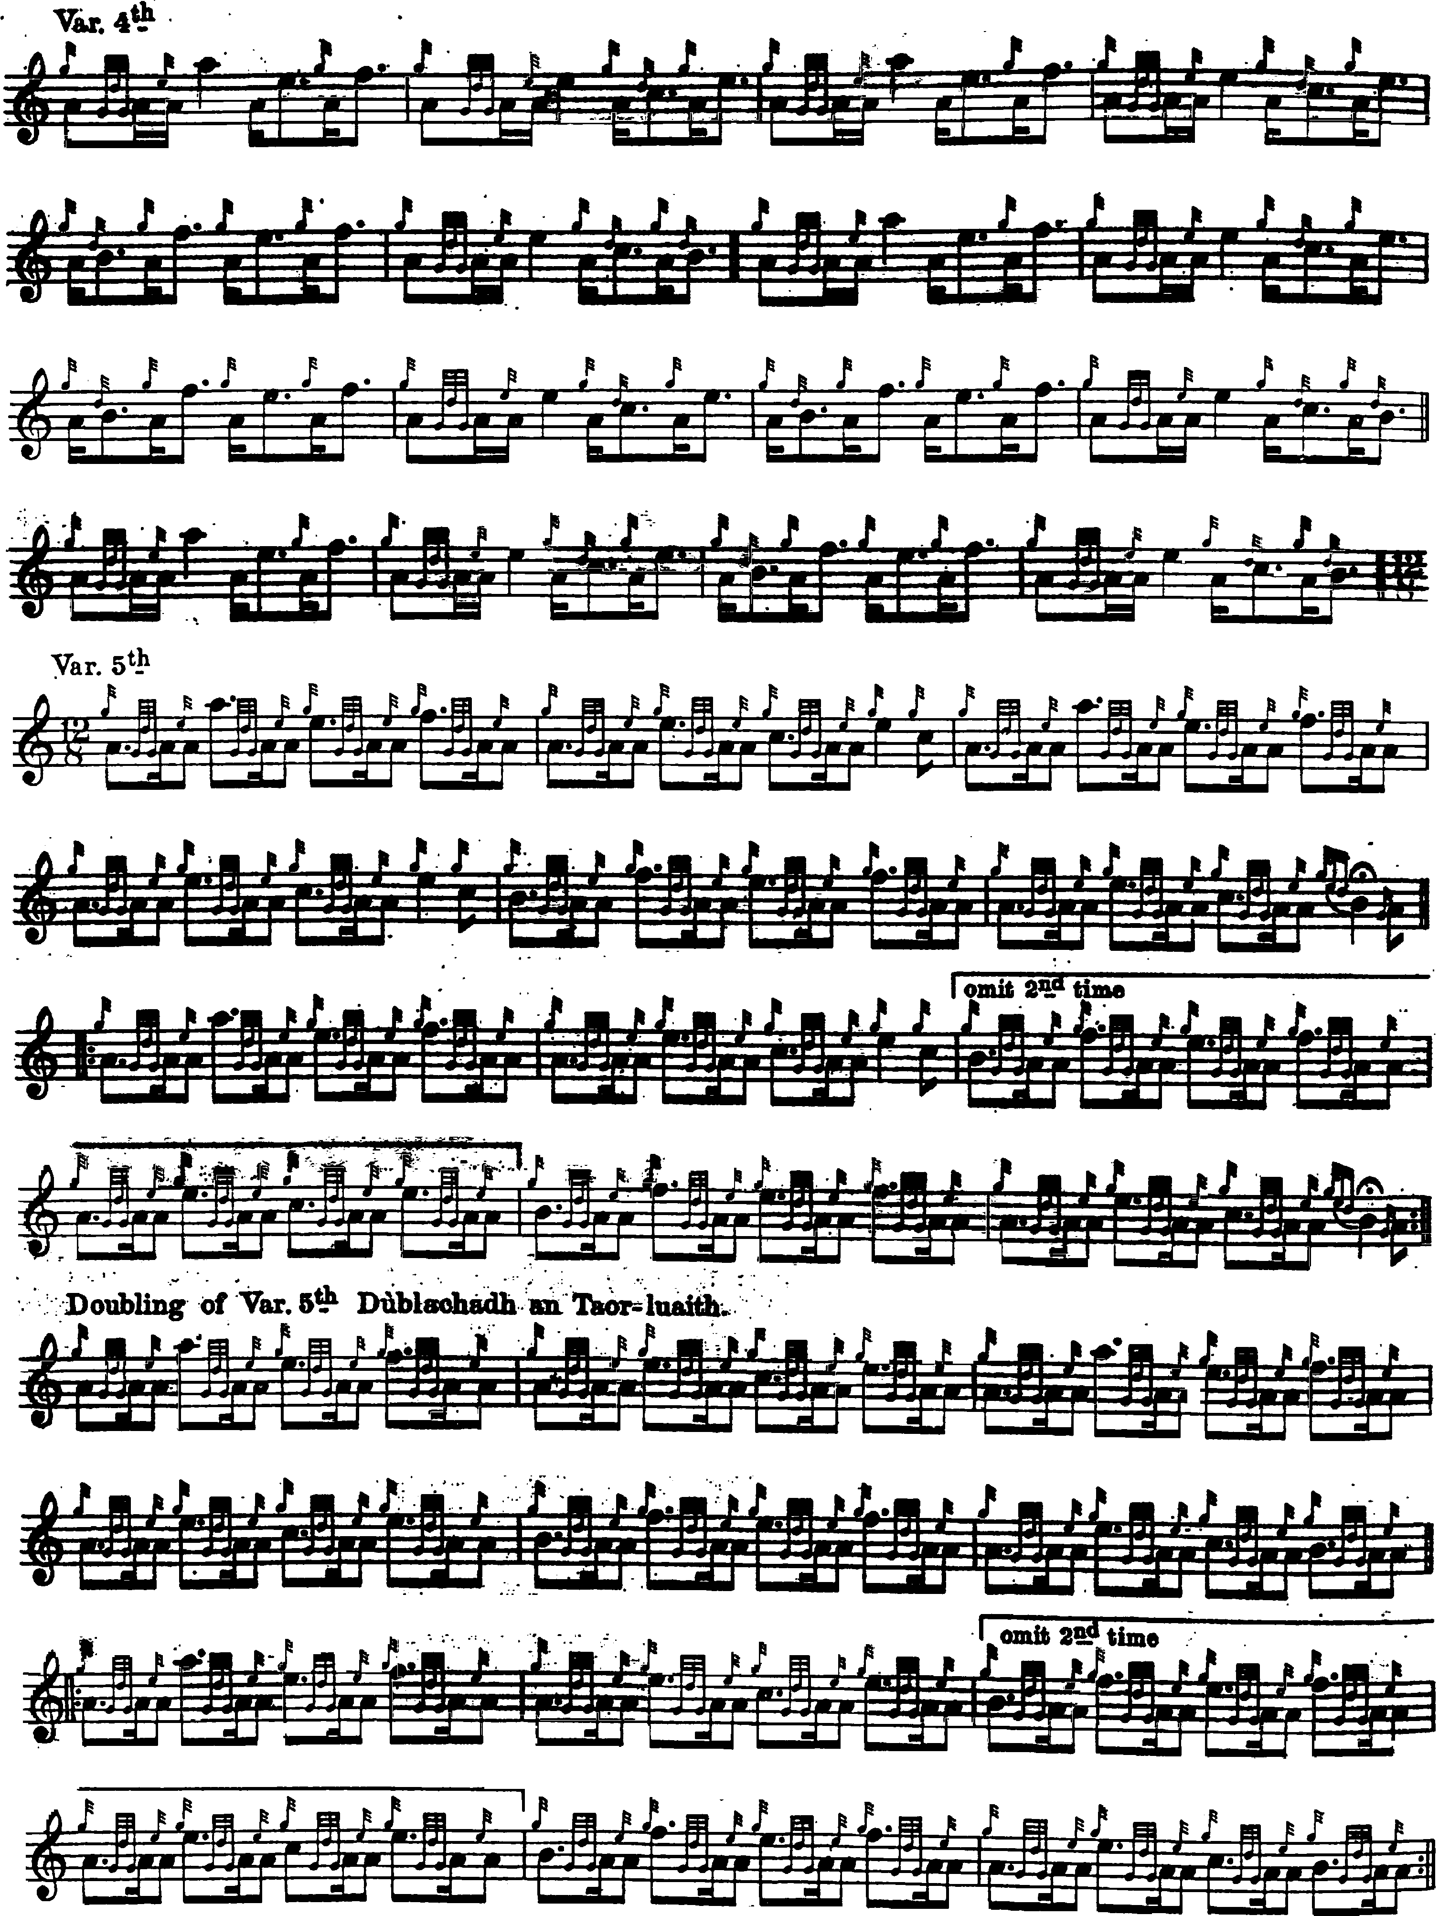

And so on.

John McLennan treats the tune as follows:

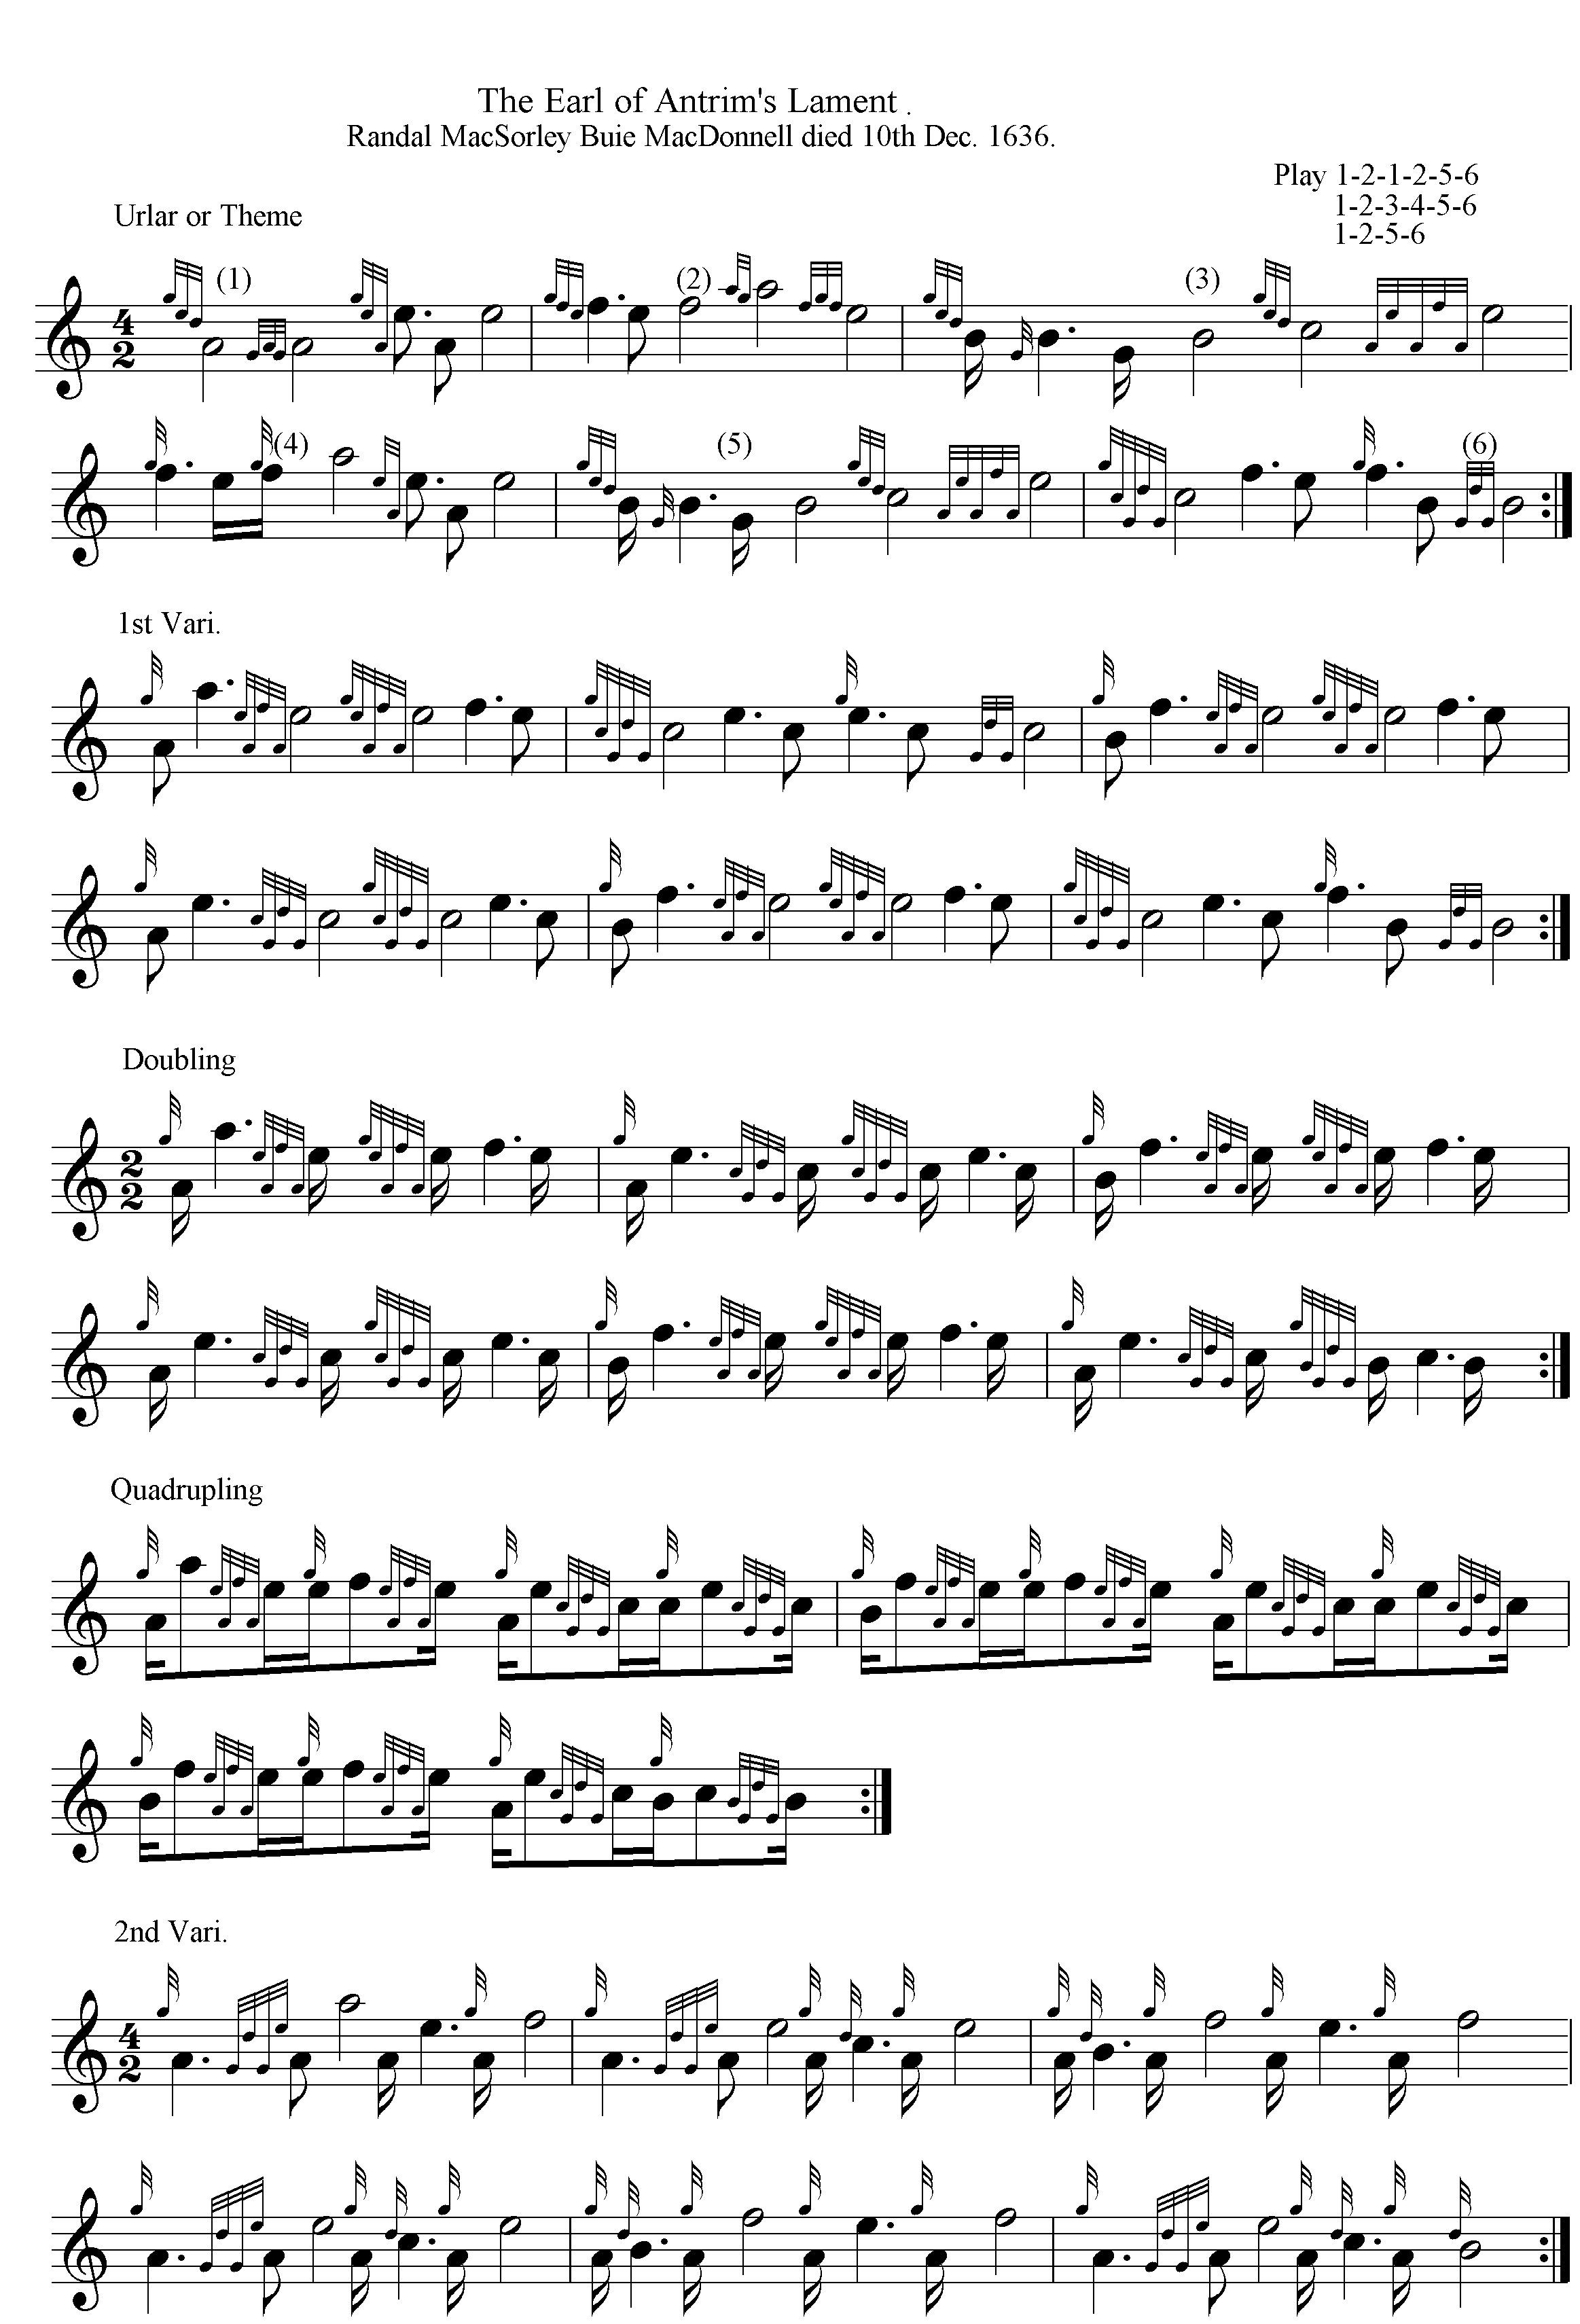

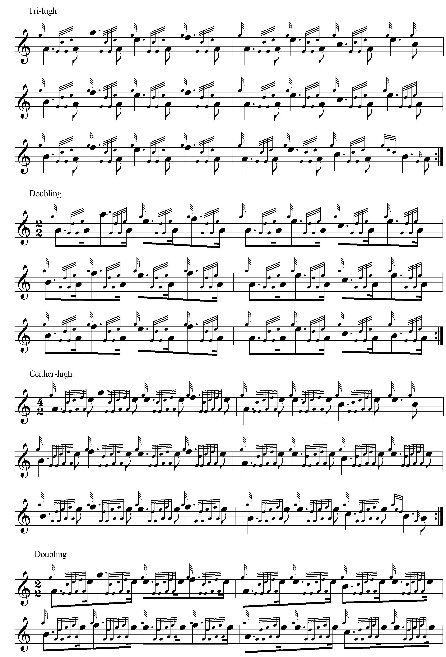
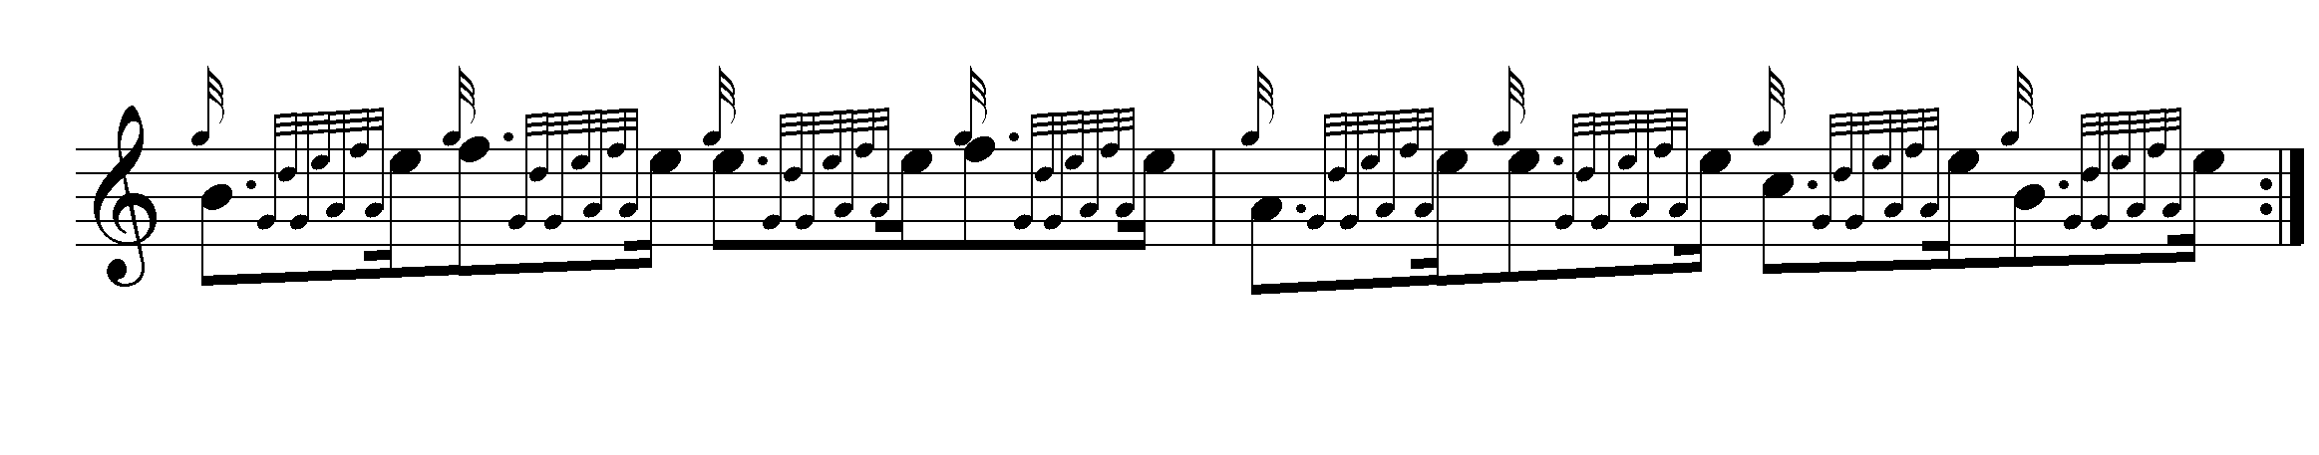
John McLennan plays his eallach “down”, and turns the last bar of each line of the ground in a distinctive way which some might feel had rather more musical interest than the other scores. The reader will note too his lovely little reflexive cutting through F to E in the second bar of the ground, and the boldly “cut” nature of the timing. It is sometimes claimed that the Camerons expressed their tunes characteristically smoothly in contrast with other “schools”; on the basis of this it seems clear that it was not just the MacPhersons who (allegedly) cut things. A reader of the Oban Times replying to another correspondent in 1929, said: “Did Mr Cameron ever hear Lieut. MacLennan’s son, the late G. S. MacLennan, play? At the Skye Highland Gathering of 1923 that gallant little man played ‘The Lament for the Earl of Antrim.’ It was played as written in his father’s book, and although he was not in the prize-list it was the most brilliant piping I have ever heard.” (“Piobaireachd Playing”, from “Kintail”, 02/11/1929, p.3):

G. F. Ross has a note on the tune in Some Piobaireachd Studies, claiming the authority of Simon Fraser for emending the final bar in all three lines of the ground and stating that Glen and Thomason were “wrong”. But Ross’s “correction” merely reproduces the bar concerned as in John McLennan’s score above, published in 1907.
In A Collection of MacCrimmon and other Piobaireachd, Ross prints the score entire. He plays his eallachs “down” and reproduces the McLennan line endings, and accents the opening note of his B echo beats:

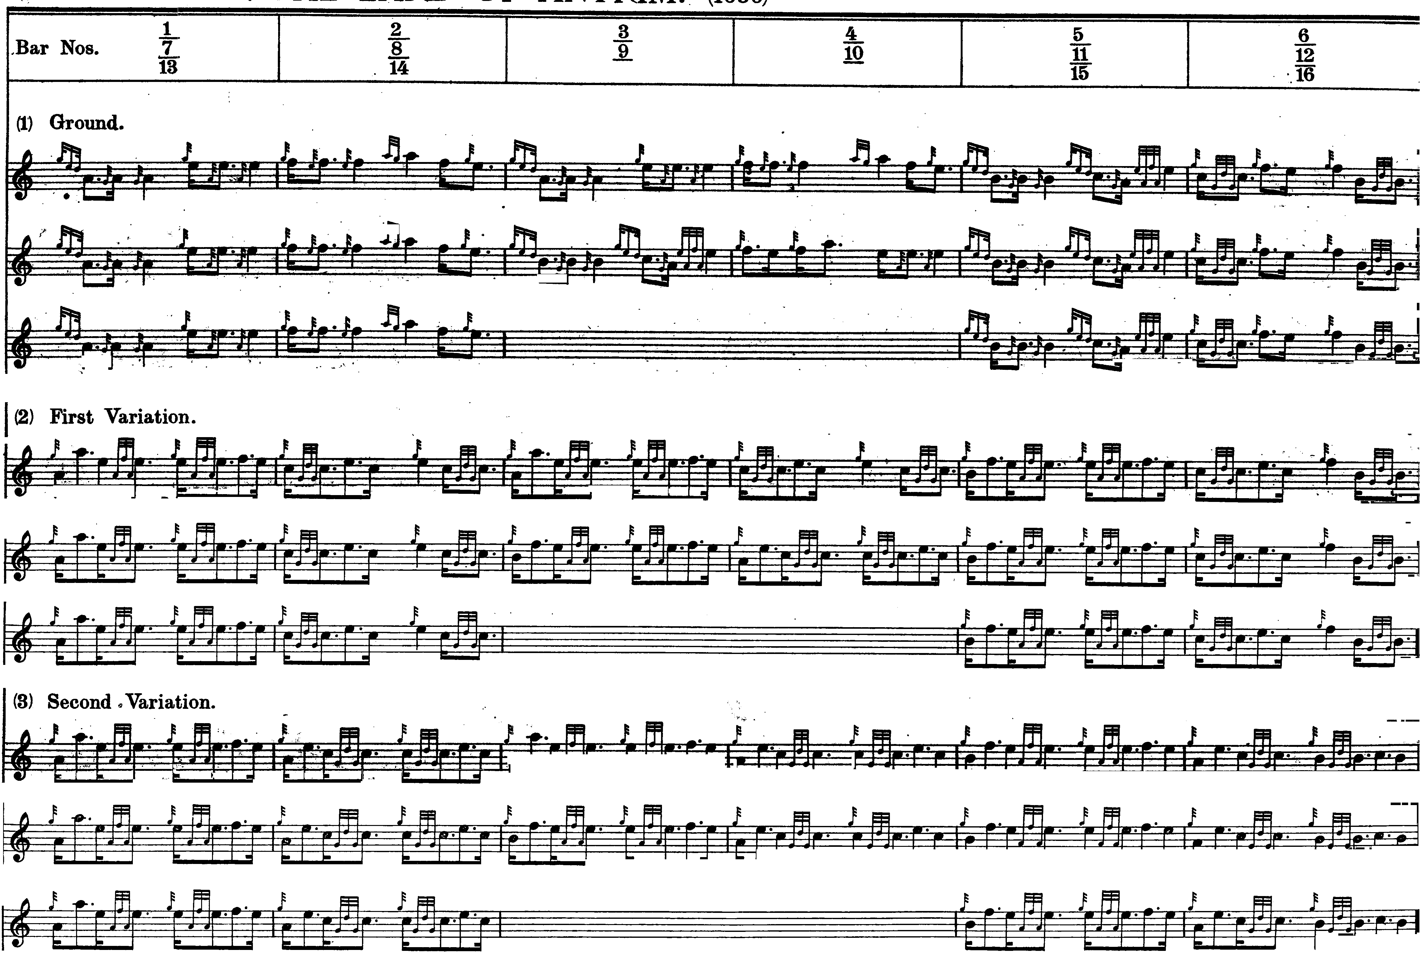

Commentary:

A reader of this series has asked whether it would be possible to drop one of the first three variations on the grounds that they are rather repetitive within the overall architecture of the tune as nowadays played. I think it makes sense to play them if the tune ends at that point, as in MacKay and Uilleam Ross. But if you choose to go down Duncan Campbell’s route then the tripartite development of these ideas may be thought a little excessive if the tune is played through to a taorluath/crunluath conclusion. For myself, I might drop the second variation, proceeding directly from Var.1 to Var 3.

None of the above manuscript and printed scores—thirteen in all--stipulates a crunluath a mach.

There’s a brief note by “Fionn”, in his “Historic, Biographic, and Legendary Notes to the Tunes”, in Glen:

The Earl of Antrim, Ranald MacDonald, was made Marquis by Charles 1. in 1643 in anticipation of his raising an army for service in England. He was to raise 10,000 men, but failed to do so. In 1644 he sent 1600 men to assist Montrose. His father died in 1636, and some hold that this Lament was for him.” (p.18). In his “Ceol Mor Legends”, General C. S. Thomason preserves some further comments on this tune by “Fionn” from the Oban Times in 1904: “As there was more than one Earl of Antrim, it is difficult to determine to which of them this lament was composed, but the probabilities are that the person referred to is Sir James MacDonald, son of Sorley Buie. Sir James came to Scotland & made good some claims to the Islay estate in 1597.
He was well received by James VI, by whom he was knighted, & received a grant of twenty-two merks of land in the south-west of Kintyre. These lands had formed part of the Islay possessions. In an old chronicle it is said of Sir James, he was ‘ane bra man of person & behaviour, but had not the Scots tongue, nor nae language but Erse.’ Sir James died in 1601 not without suspicion of being poisoned.” The chronicle adds that he was accounted “the most distinguished of the Clan Donnell, either in peace or war.” (ff.374-5).

“The Earl of Antrim” has led to competition success for a good many notable players. Here we have an account from the Argyllshire Gathering in September 1904. The Piobaireachd Society had been formed the previous year. This was the earliest competition it oversaw and was still actively promoting its president, General Thomason’s, work. Later it deposed Thomason from the presidency as part of a bid to return to more traditional notational styles. In this early competition, offprints of Thomason’s Ceol Mor were provided free of charge to intending competitors:

The first part of the programme was occupied with the piobaireachd competitions. For the principal event nineteen competitors entered, but the whole of the contestants did not put in an appearance. The Society is, however, gratified by the response made to its initial efforts, and also with the piping results. The competitive tunes, the history of each was recently described in the "Oban Times", were [The Desperate Battle; The King’s Taxes; Lament for MacLeod of MacLeod; The Earl of Seaforth's Salute; The Groat; and Lament for the Earl of Antrim] the setting being that of “Ceol Mor,” the distinguished author of which, (Major-General Thomason) was present during the day. The first prize--a gold medal and £20--fell to Mr. John MacDonald, Inverness, for “The King's Taxes”. This is rather a hard tune, the proper getting up of which presents some difficulties, but MacDonald gave an excellent rendering of it. Pipe-Corporal Geo. Stewart MacLennan, 1st Gordon Highlanders, a young piper, carried off the second prize with the “Lament for the Earl of Antrim,” which he played carefully and well. The third prize winner was Corporal Piper W. Ross, 1st Scots Guards, who played “The Desperate Battle” with good effect. The fourth prize fell to James A. Center, Edinburgh, who made a very promising appearance. (“The County Gathering”, Oban Times, 17/09/1904, pp.4, 5).

At the Northern Meeting in 1947, Bob Brown won the clasp playing this tune. The Oban Times noted: “The first part of his tune was rather slow and dull, certainly the second and third variations, but his finish was strong and musical.” (“Northern Meeting. Grand Display of Pipers’ Powers”, 04/10/1947, p.3).

* * *

Electronic text © Dr. William Donaldson, Aberdeen, Scotland, September 2004

