Lament for the Duke of Hamilton

There are settings of this tune in the following manuscript sources:
--Colin Mór Campbell’s Nether Lorn Canntaireachd, ii, 1-3 (with the title “Duke Hamilton’s March”);
--Angus MacKay’s MS, i, 20-22;
--Colin Cameron’s MS, ff.112-114;
--David Glen’s MS, ff.165-167;
--McLennan papers, ff.16, 27;
--Robert Meldrum’s MS, ff. 82-4;

and in the following published sources:
--Donald MacDonald’s Ancient Martial Music, pp.23-29 (with the title “Lamentation for the Duke of Hamilton”);
--C. S. Thomason’s Ceol Mor, pp.10-12;
--David Glen’s Ancient Piobaireachd, pp.200-202.

In the oldest of the settings, that in the Nether Lorn Canntaireachd, Colin Mór Campbell treats the tune as follows:

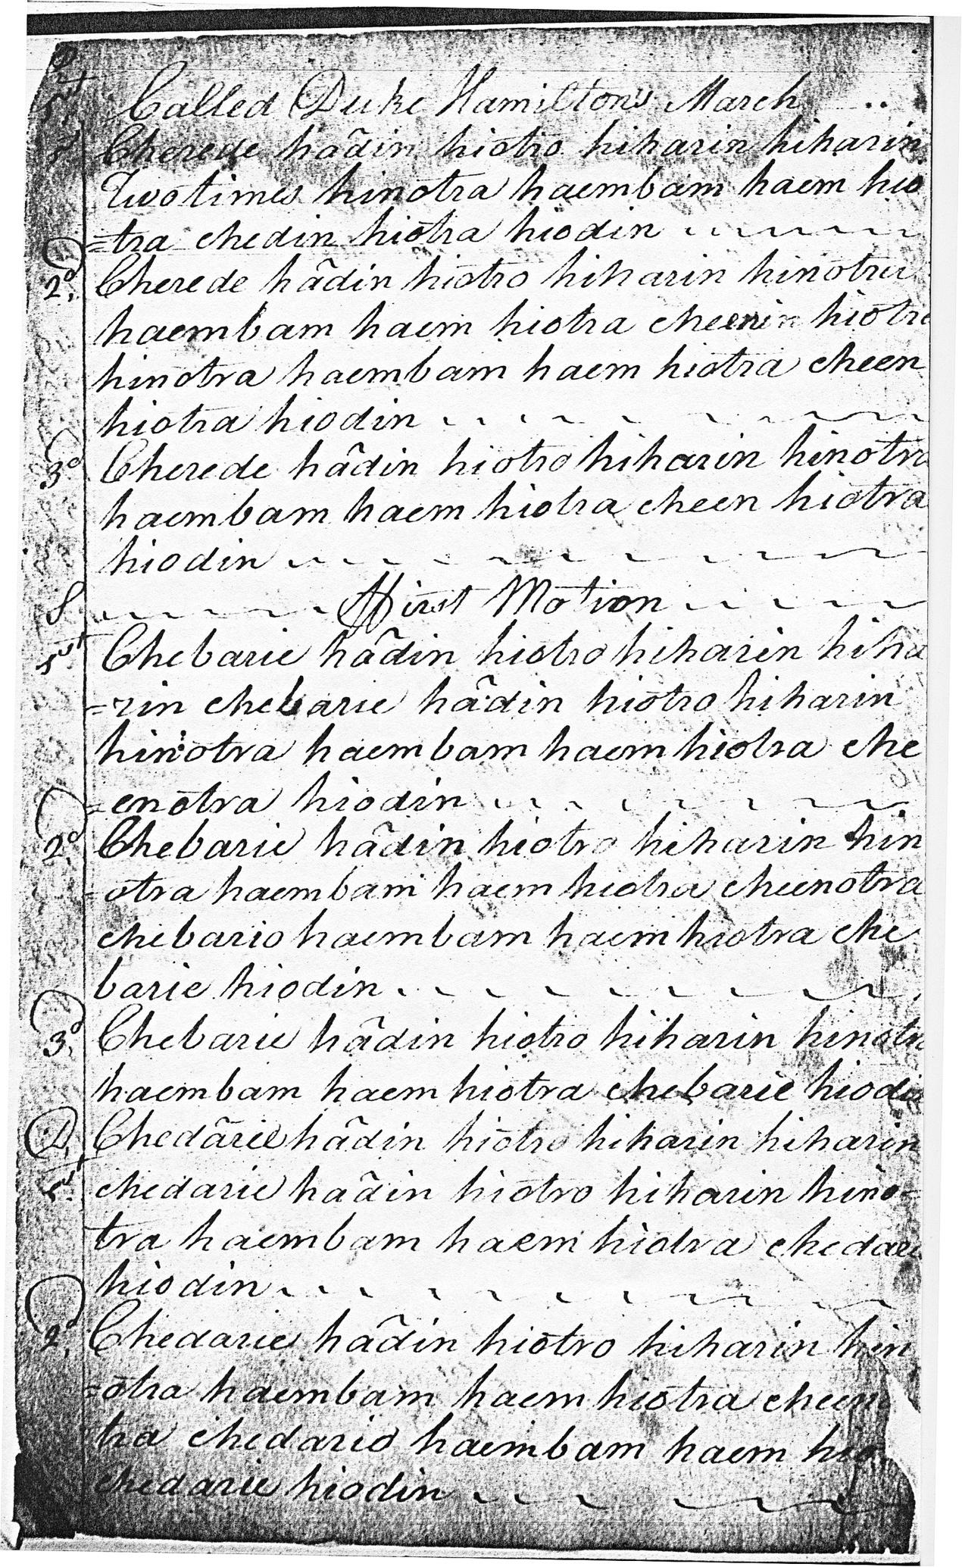

and so on. A partial transcript is included below:

“Called Duke Hamilton’s March”
1st Cherede hadin hiotro hiharin hiharin Two times hinotra haembam haem hiotra chedin hiotra hiodin
2^{d.} Cherede hadin hiotro hiharin hinotra haembam haem hiotra cheenin hiotro hinotra haembam haem hiotra cheen hiotra hiodin
3^{d.} Cherede hadin hiotro hiharin hinotra haembam haem hiotra cheen hiotra hiodin

Colin Mór then proceeds to a “ffirst Motion” singling:

1st. Chebarie hadin hiotro hiharin hiharin chebarie hadin hiotro hiharin hinotra haembam haem hiotra cheenotra hiodin

and so on; then to a doubling of the “ffirst Motion”:

1st. Chedarie hadin hiotro hiharin hiharin chedarie hadin hiotro hiharin hinotra haembam haem hiotra chedarie hiodin

and so on; then to a rather unusual “Second Motion” singling:

1st. Hindehinde hindaento hiharin hiharin hintoen hintoen hinde hinde hindaento hiharin hindaenda haembam himbaemba hinde hinda hiodin

and so on

there follows the doubling:

1st. Hinde hinde hinda hinde hindaridan hindaridan hinto hinto hinde hinde hinda hinto hindariddan hinda hinda himbaembam himbahimba hinde hinda hinto hinto

then a “Taolive Gear” singling, doubling, and tripling, and “Crulive Fosgail” singling, doubling and tripling. The intended structural pattern seems clearly to be three lines of twelve, twelve, and eight bars and the first line of the ground is garbled but could easily be reconstructed from the subsequent variations.

Donald MacDonald treats the tune as follows:

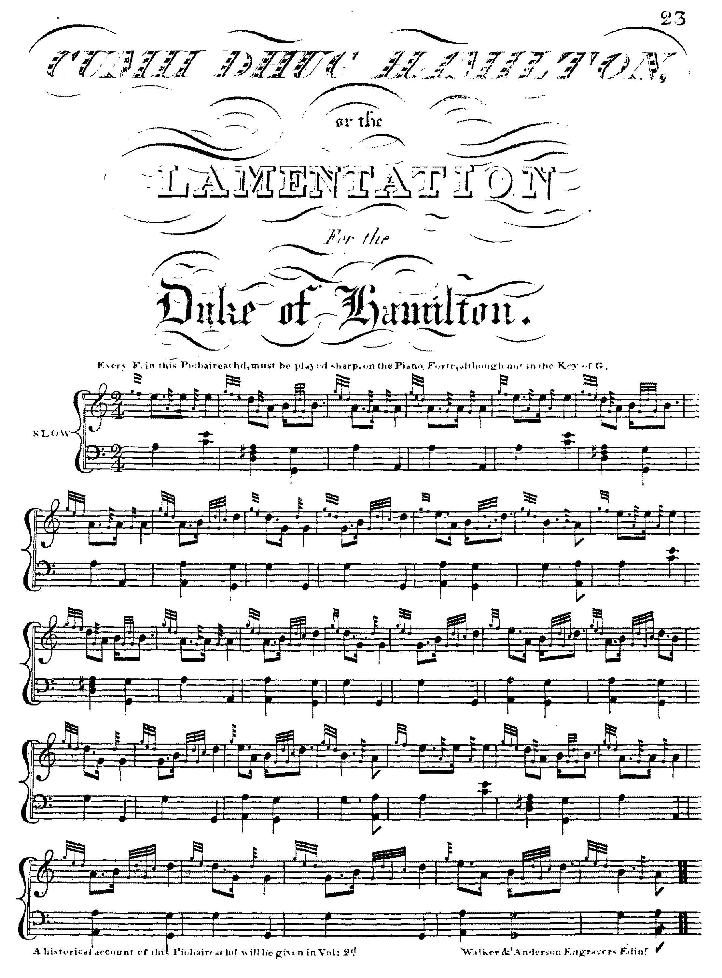
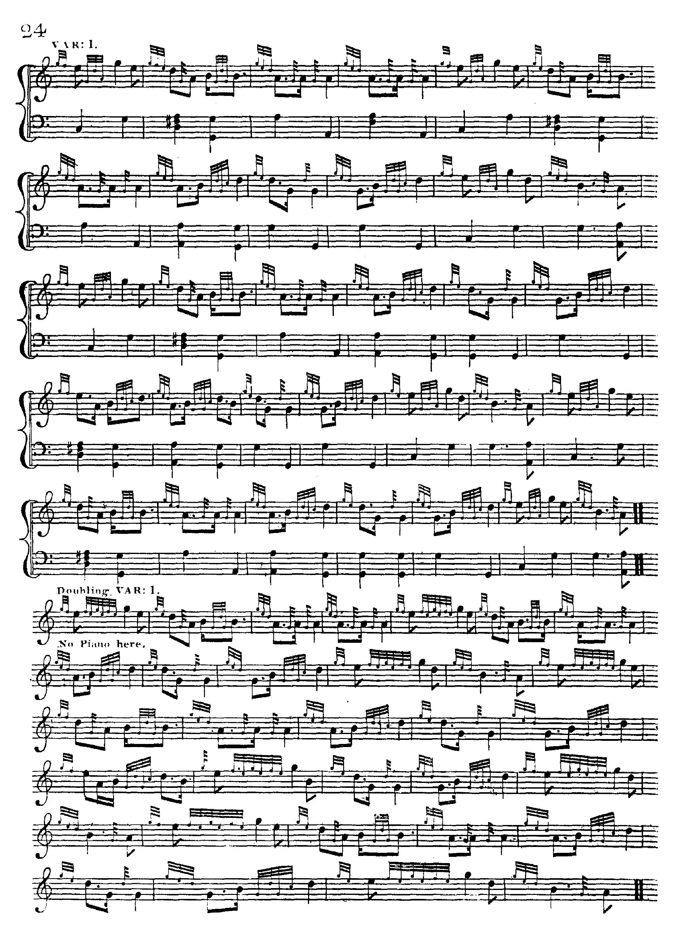
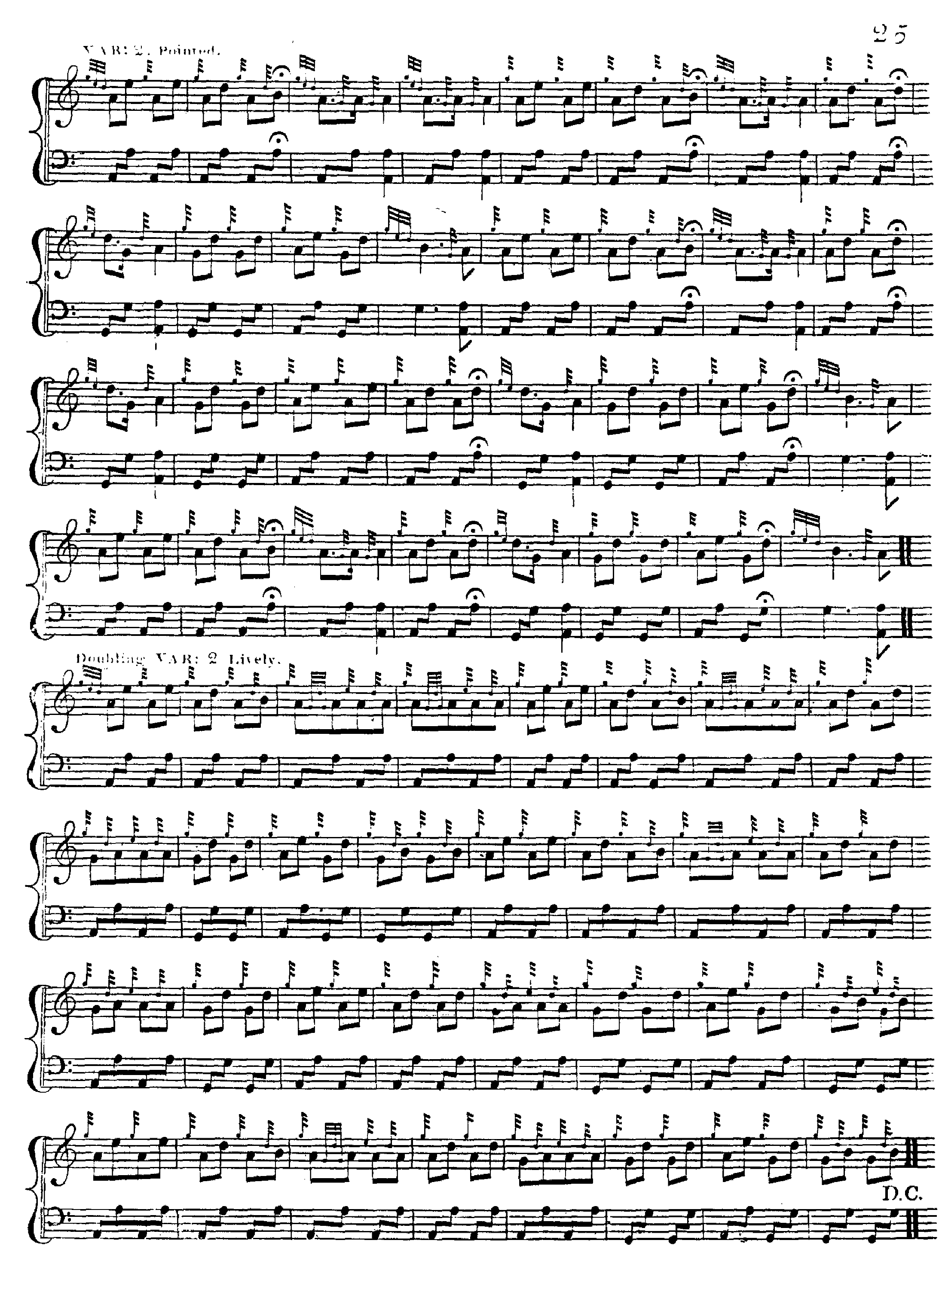
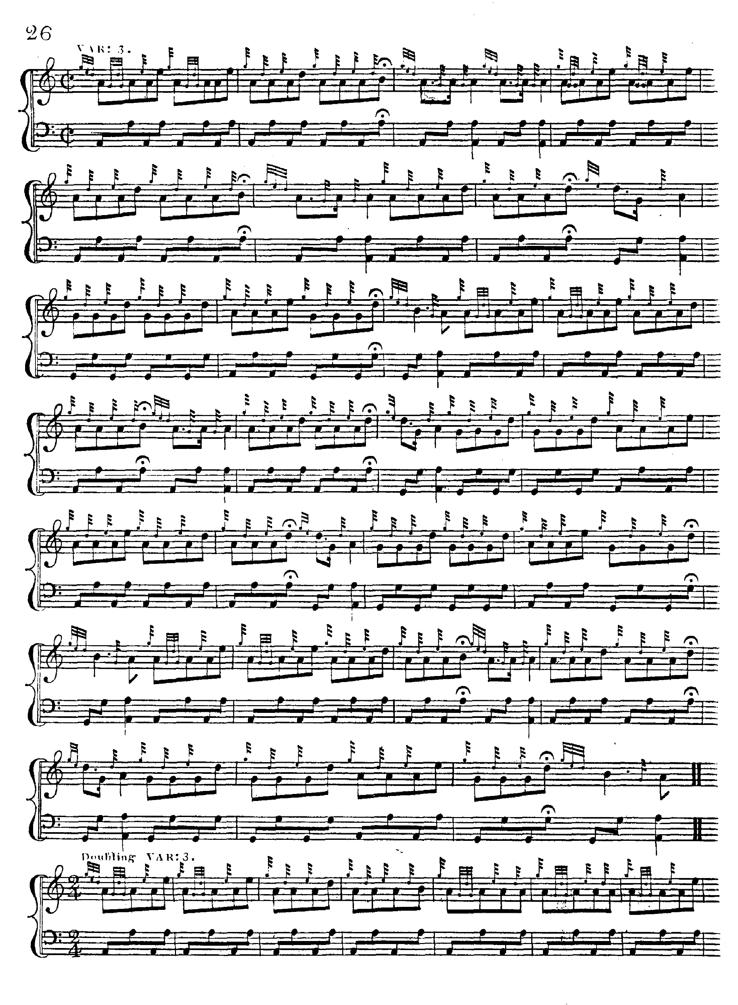
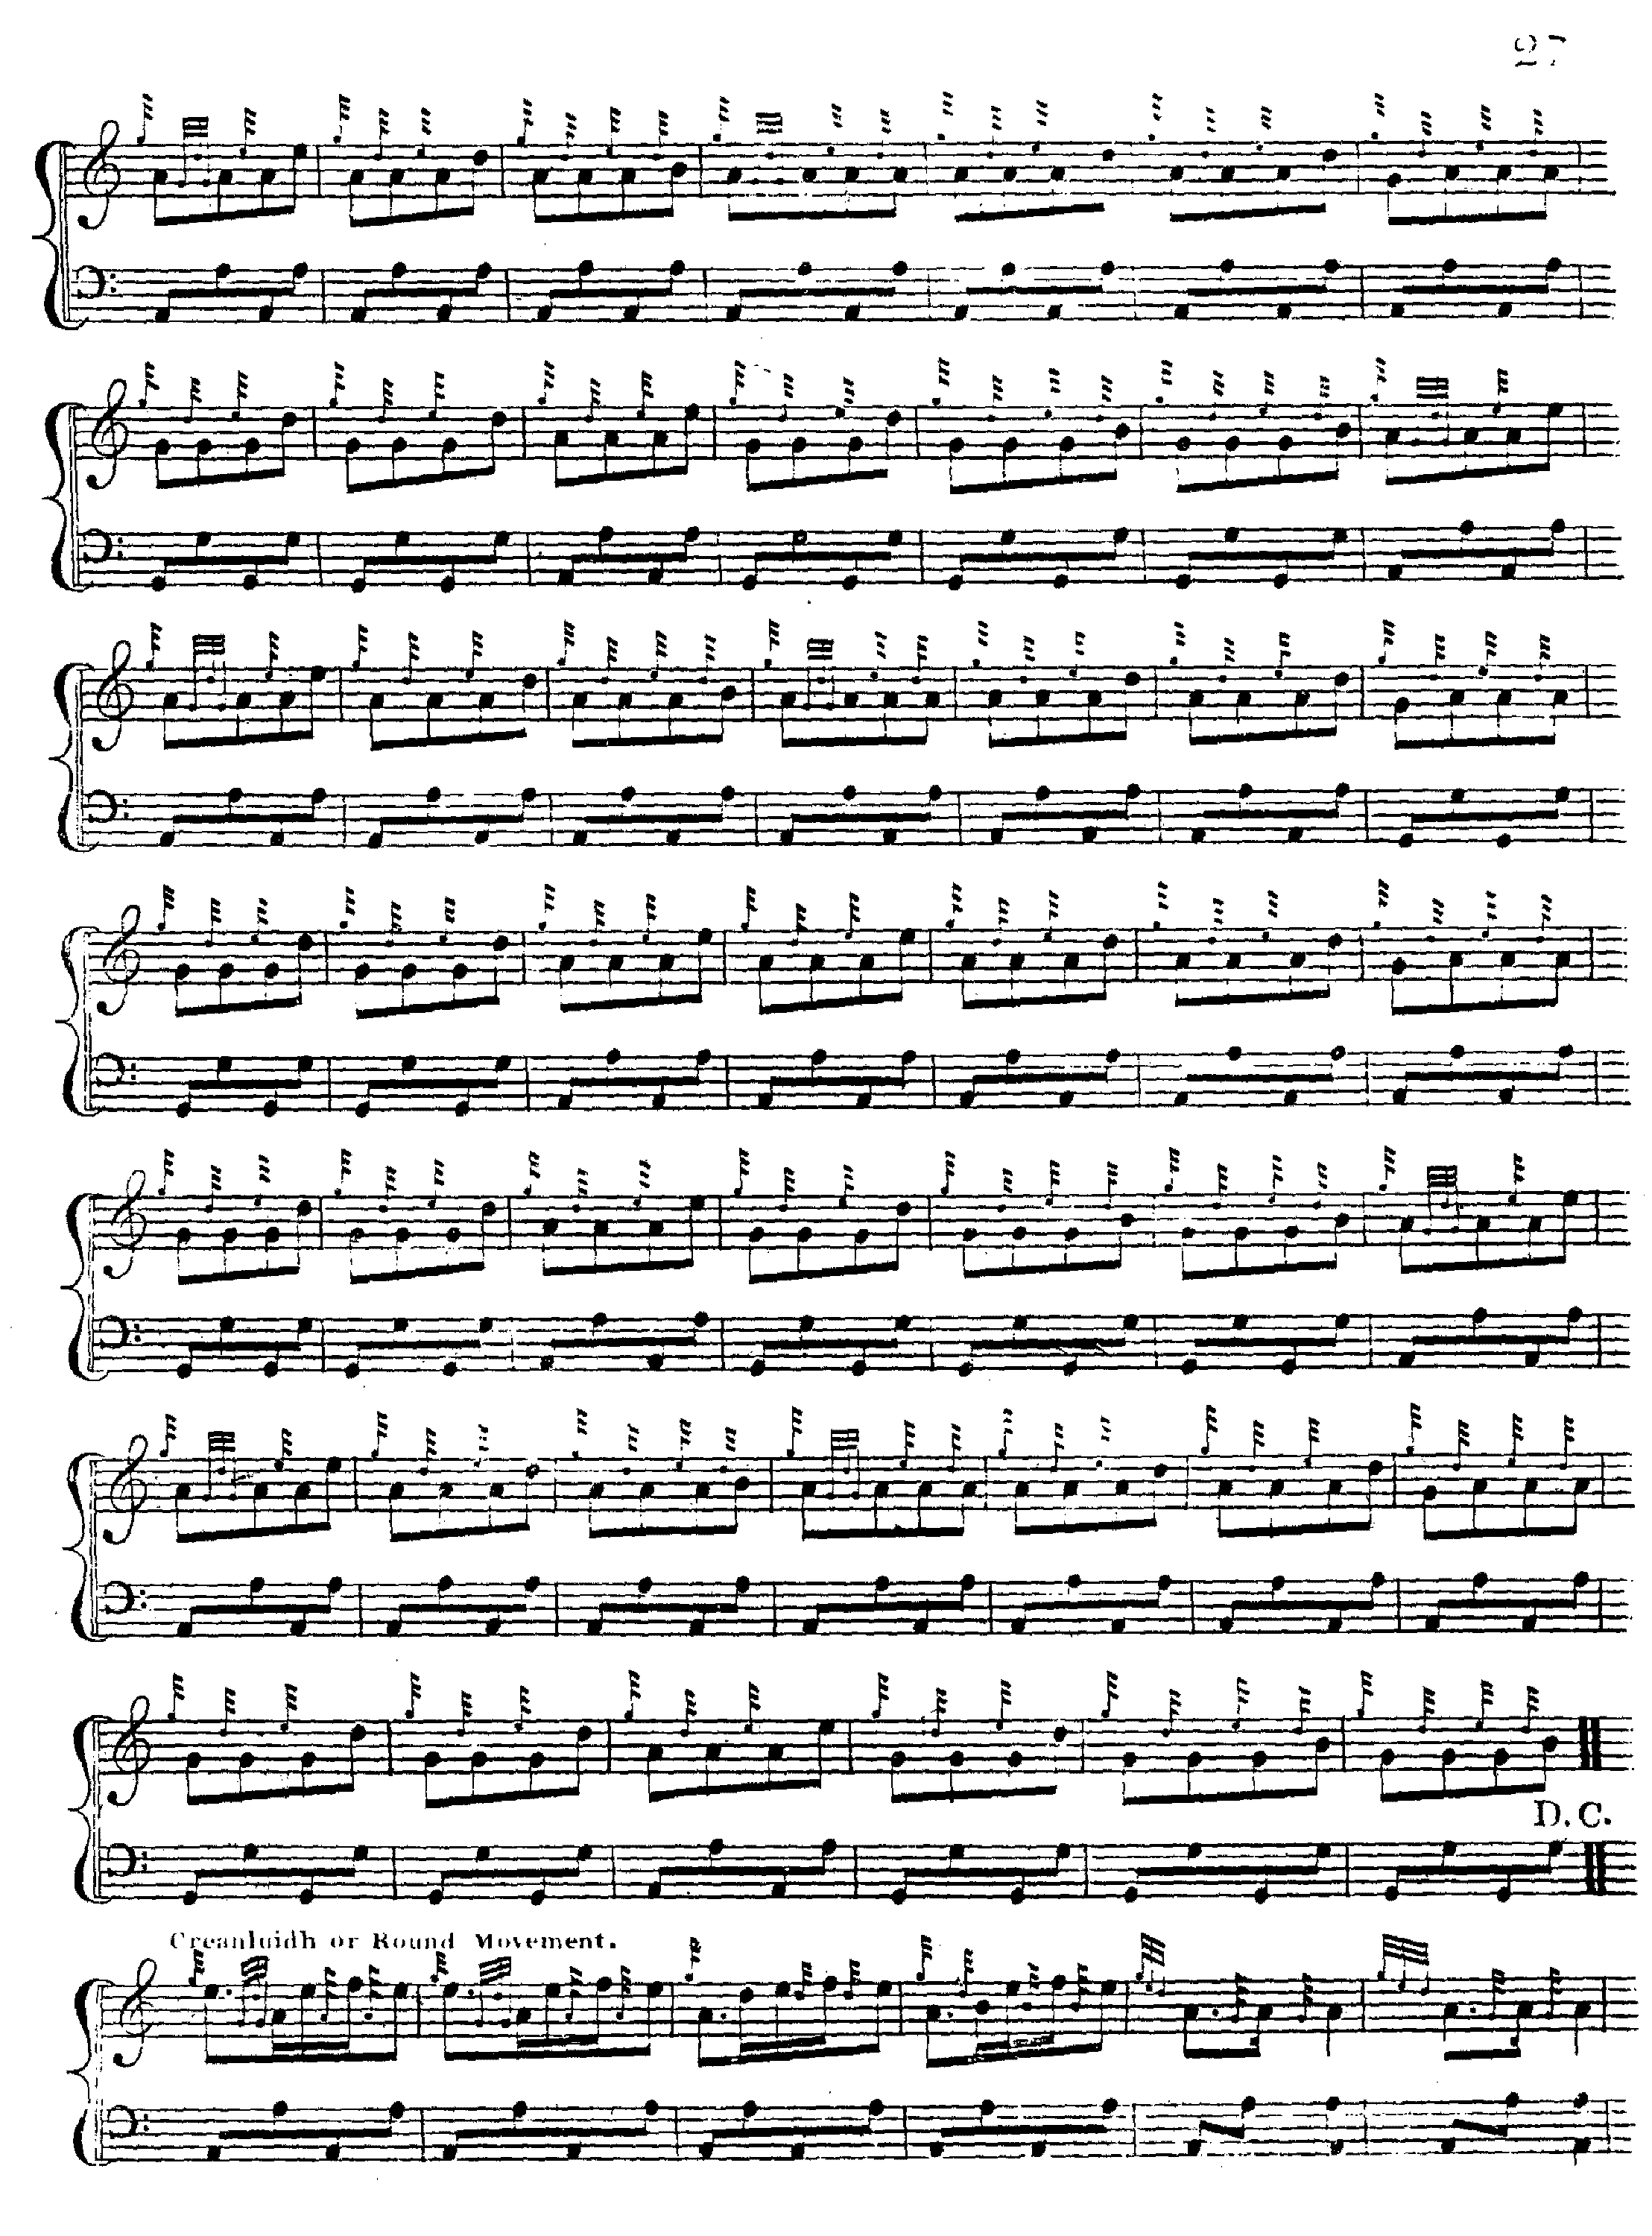
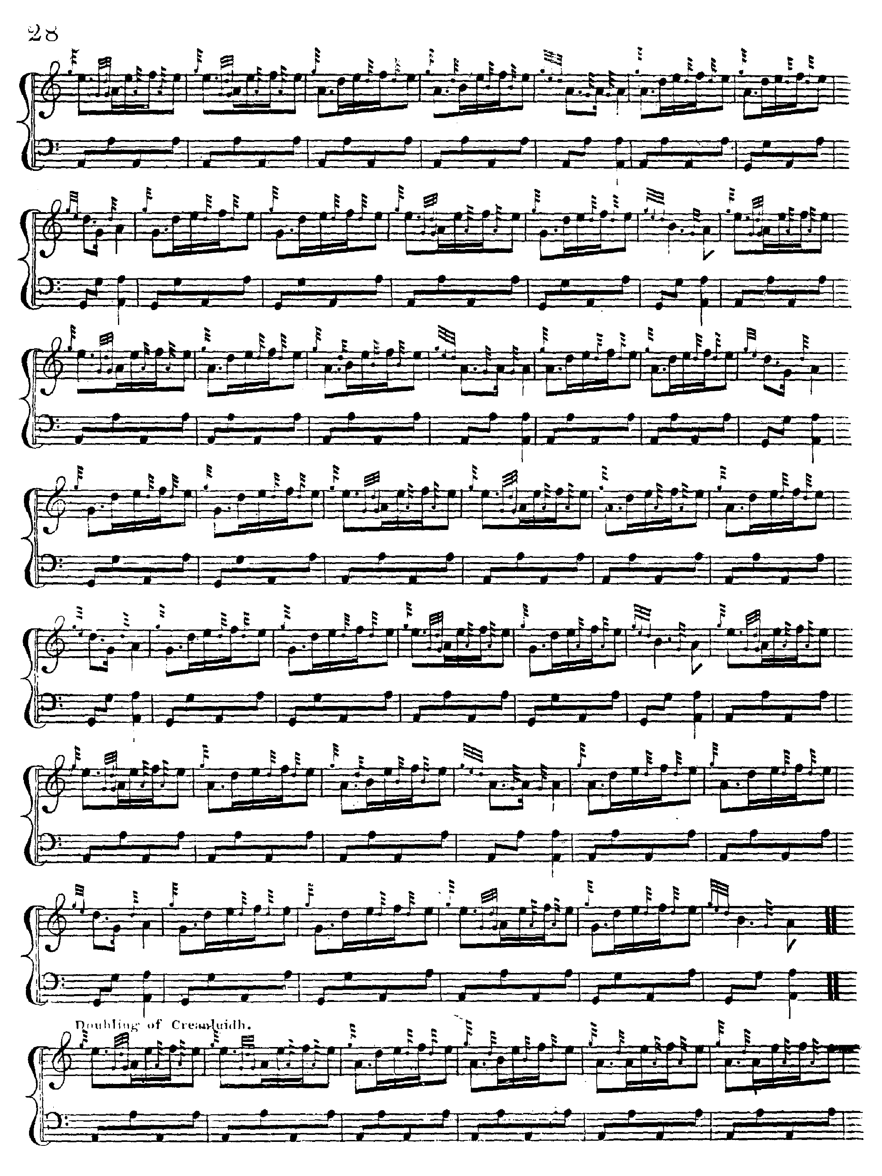
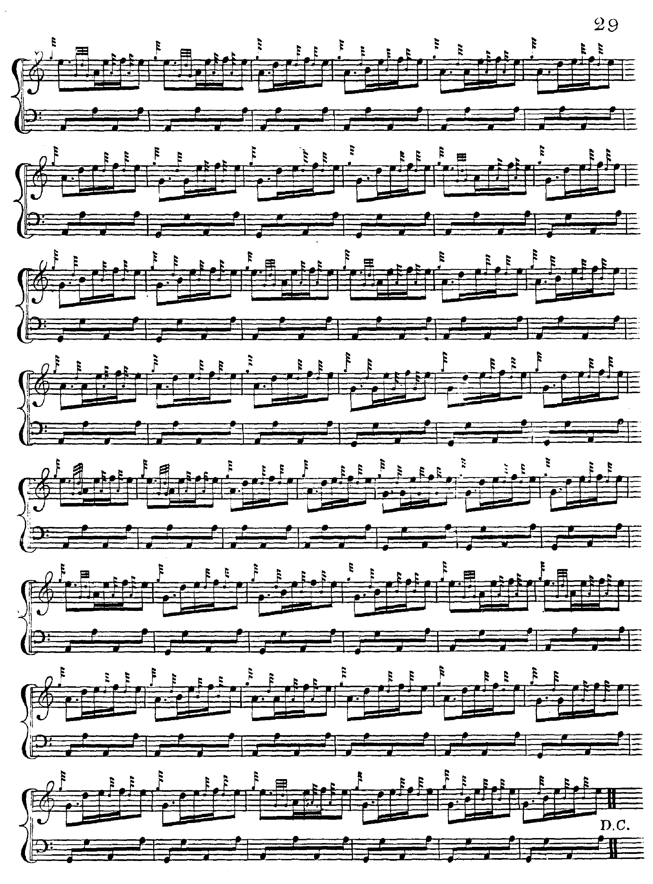

Donald MacDonald gives his double echoes with an initial dotted quaver, prefixing the one on E with an attractive F cadence and he times his siubhal as even quavers but the implied pointing is “down”; he repeats the ground at the end of the siubhal doubling and also following the taorluath and crunluath doublings.

Angus MacKay’s title is “Cumha Dhuichd Thamilton The Duke of Hamilton’s Lament Composed by Patrick Mor MacCrummen James 4th Duke of Hamilton Killed in a duel in Hyde Park by Lord Macartney 1712”. He treats the ground as follows:

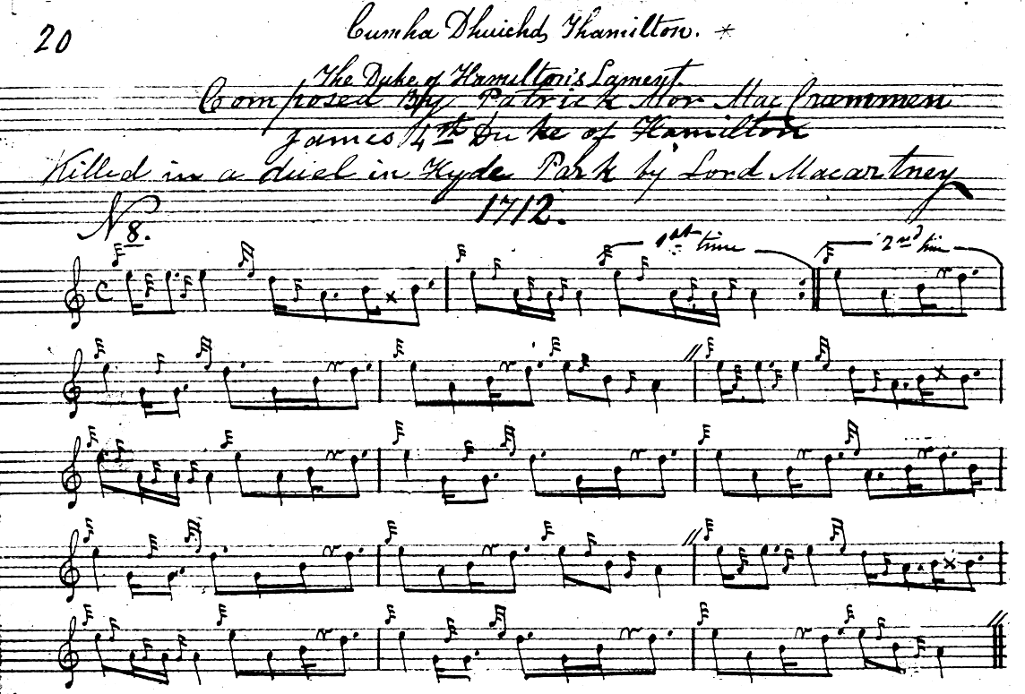

and so on. His development of the tune is the same as MacDonald’s, namely ground, first variation singling and doubling; siubhal singling and doubling; taorluath fosgailte singling and doubling; crunluath fosgailte singling and doubling. He repeats his ground after the taorluath fosgailte doubling and again at the end of the tune.

Colin Cameron’s setting has MacKay’s elaborate title word for word and adds “from the original MSS by AMK vol 1st p.20”. Cameron corrects a notational mistake by MacKay in the first variation singling and doubling but otherwise does not add significantly to the stylistic possibilities of the tune. This score is not reproduced here.

The partial score in the MacLennan Papers aims to “correct” MacDonald’s line one in the crunluath singling, but it is not clear that it adds anything at all substantial to the tune; it is not reproduced here.

David Glen develops the tune in a manner similar to all the later editors from Donald MacDonald onwards: ground, first variation singling and doubling, siubhal singling and doubling; taorluath fosgailte singling and doubling; crunluath fosgailte singling and doubling. He repeats the ground at end of tune, but not within it. He sets the tune as follows:
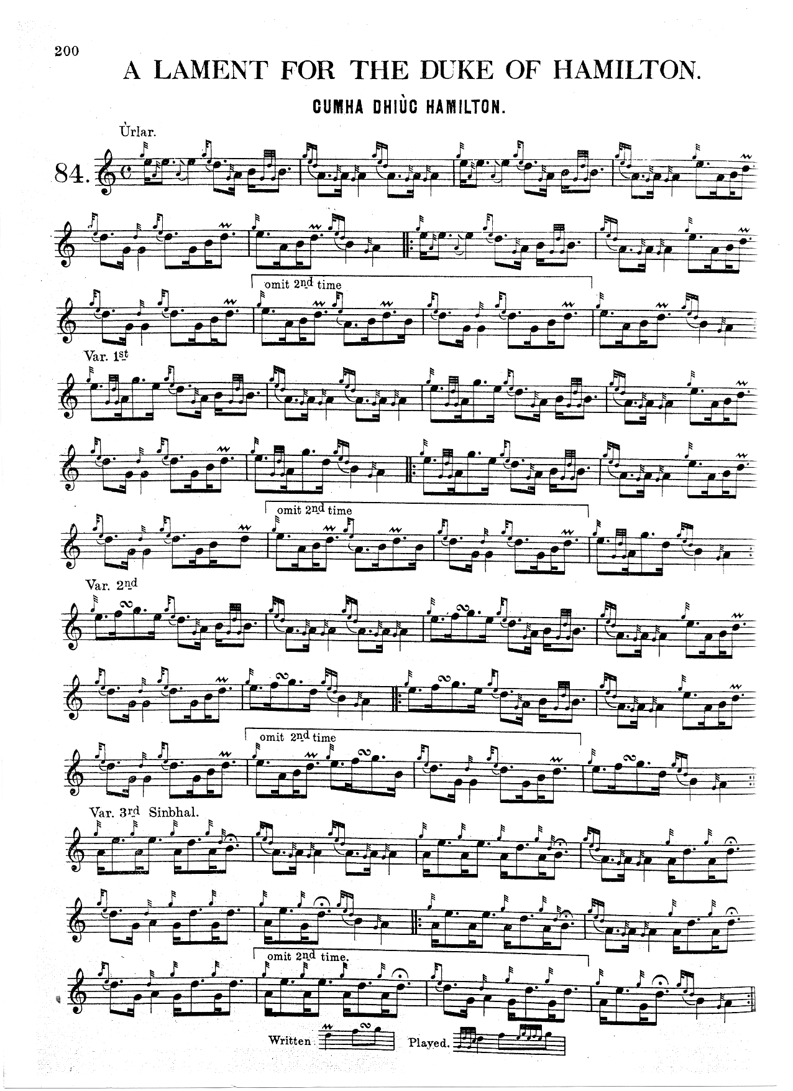
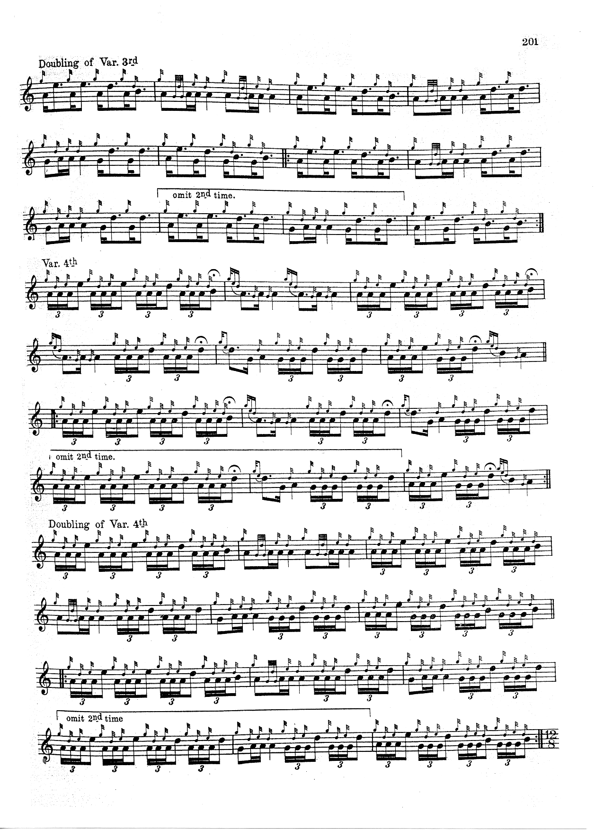

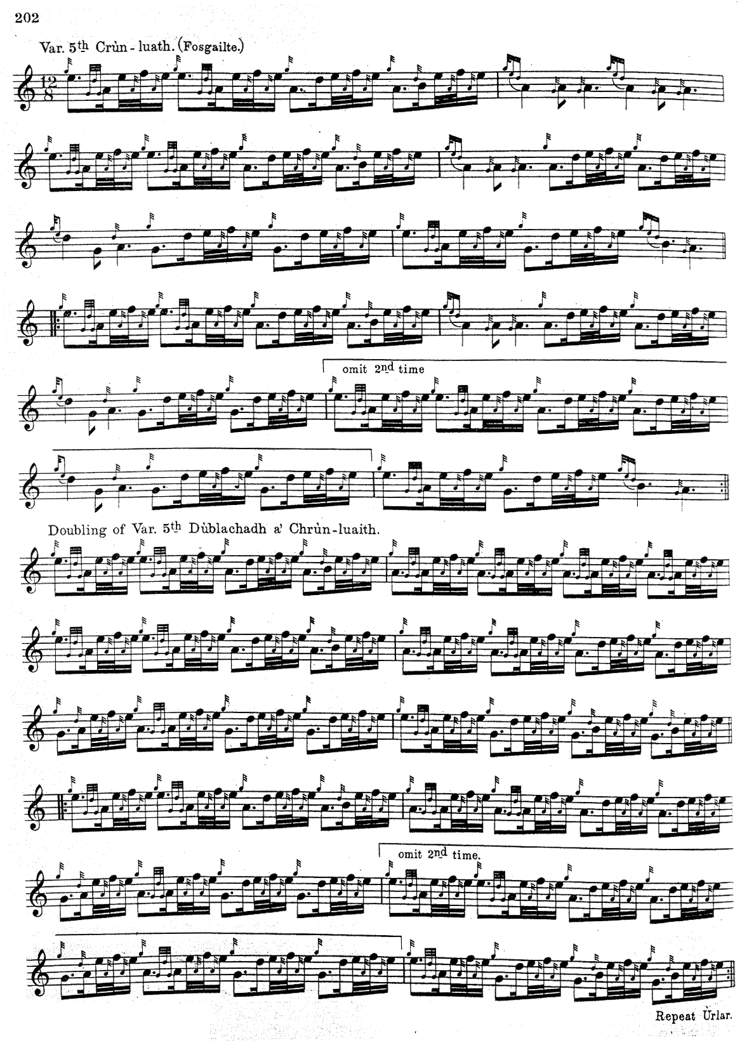

Glen plays his eallachs “down” and his siubhal “up”. His timing of the EDA movement in the ground is interesting. While MacDonald and everybody else cuts down, or at the very least moves in even quavers from D to A, Glen holds the D; it produces quite an attractive effect. From a playing point of view this is probably the best of the scores.

Thomason’s score is marked “a”, “d”, “Ed”, indicating that his sources were Donald MacDonald’s published book and the manuscript of Angus MacKay; also that he had intervened in the tune editorially. He follows MacDonald in having a grip instead of a trebling movement in the taorluath fosgailte. He repeats the ground at the end of the taorluath doubling and at the end of the tune. These features excepted, he adds little to the stylistic possibilities not evident in MacDonald and Glen. His score is not reproduced here.

Robert Meldrum’s score adds nothing of significance to the stylistic interpretation of “Lament for the Duke of Hamilton” and is not reproduced here.

Commentary:

There are really only two ways of doing this tune, David Glen’s and Donald MacDonald’s and both offer attractions to the thoughtful player.

The inclusion of the tune in MacDonald’s published book may have increased the popularity of this tune which was in the lists of several players at the Edinburgh Competition in 1824, including William Gunn of Glasgow.

Some players might consider the first variation singling and doubling, which is basically a repeat of the ground twice over with small changes, as excessive. It might be possible however, to integrate them into the tune in a more satisfactory way by playing the ground at the beginning and proceeding straight from there to the siubhal singling. At the end of the siubhal doubling the ground is restated but in the slightly altered form of what Colin Mór Campbell calls the “ffirst Motion” singling to emphasise the essentially rondo nature of the tune and give a pleasing variety; when the ground returns a third time, at the end of the taorluath fosgailte doubling, then the remaining third version of the ground should be played there. So that treating ground and first variation singling as grounds 1, 2 and 3, the sequence would be:
ground 1
siubhal singling
siubhal doubling
ground 2
taorluath fosgailte singling
taorluath fosgailte doubling
ground 3
crunluath singling…
and so on.

There is no evidence in the written tradition indicating that this was actually done, but it seems an attractive possible approach to a number of tunes showing this feature.

Commentary:

The person commemorated by this tune was James 4th Duke of Hamilton (1658-1712), one of the principal leaders of the opposition to the Treaty of Union (1707) in the Scottish parliament. An enigmatic figure, his failure to offer decisive leadership at a number of crisis points has been identified as one of the main reasons why the treaty was carried, despite widespread opposition to it in Scotland. Hamilton was vacillating and dissolute and torn by conflicting personal interests: he had massive debts, vulnerable English estates, and dynastic claims of his own. When he was killed in a duel (not the first he had fought), it is thought that his opponent’s second, General Macartney, treacherously stabbed Hamilton after the Duke had brought down his principal, Lord Mohun. Hamilton had just been appointed ambassador to France by Queen Anne with, some contemporaries thought, a secret programme to negotiate the succession of the Old Chevalier as James VII and III. There were suspicions at the time of political assassination. Robert Chambers gives a gruesome account of the affray:

…they repaired to the Ring in Hyde Park, and, being both greatly exasperated, they fought with peculiar determination and ferocity. This is attested by the number and deadliness of the wounds on both sides. Lord Mohun fell and died on the spot. He had one wound mortal, but not immediately so, entering by the right side, penetrating through the belly, and going out by the iliac bone on the left side. Another dreadful gash, in which the surgeon’s hands met from opposite sides, ran from the groin on the left side down through the great vessels of the thigh. This was the cause of immediate death. There were some slighter incisions, and two or three fingers of the left hand were cut off. The duke’s body suffered an equal havoc, partly inflicted, it was alleged by foul play. A cut in the elbow of the sword-arm severed the small tendons, and occasioned so much loss of blood as to be fatal. A wound in the left breast, between the third and fourth upper ribs, pierced downwards through the midriff and caul, sufficient to produce death, but not immediately. He had also a dangerous slash in the right leg. It is believed that the duke, after his right arm was disabled, being ambidexter, shifted his weapon, and killed Mohun with his left hand. The wound in his own breast was the last that was inflicted, and colonel Hamilton gave his oath that it was the sword of general Macartney, Mohun’s second, which dealt it. So strong was the presumption of the truth of this, that the general absconded and when brought to trial in the ensuing reign, the evidence upon which he was acquitted still left the matter doubtful.
The death of two men of rank in so bloody a rencounter, was in itself enough to produce a strong feeling of horror in the public mind. The unfair play by which it was believed one of them had been sacrificed, filled every honourable bosom with indignation; and the agitation was increased by reports that the duke had fallen a victim to assassination instigated by political hatred. Immediately before the duel took place, he had been named ambassador extraordinary to Paris, with powers to effect an arrangement for the restoration of the exiled family on the death of the queen; and the party who were desirous of such a consummation openly alleged that his death had been conspired by the whigs with a view to prevent it. This does not appear to have been the case, however true it may be that Mohun was a zealot in politics, and disreputable in his private character. The duke’s body was conveyed to Scotland for burial. (Biographical Dictionary of Eminent Scotsmen, 1855, iv, 596-7)

* * *

Electronic text © Dr. William Donaldson, Aberdeen, Scotland, July 2006; revised Cambridge, Massachusetts, December 2024

