The Duke of Atholl’s Salute

There are settings of this tune in the following manuscript sources:

--Nether Lorn Canntaireachd, ii,175-6 (with the title “Fad Mar Sho tha Shinn”, [i.e., “Too long are we thus”]);
--Angus MacKay’s MS, i, 126-7 (with the title “Ceann Drochaid Isiberri The End of Isheberry Bridge”);
--Colin Cameron’s MS, ff.77-8 (with the title “Inchberry Bridge”);
--D. S. MacDonald’s MS, i, 63-4;
--David Glen’s MS, ff.313-4 (with the titles “The Atholl Salute. The End of Isheberry Bridge”);
--Robert Meldrum’s MS, ff.196-7;

and in the following published sources:
--Uilleam Ross, Ross’s Collection, pp.95-6 (with the title “Failte Dhuic Adhol. Inchburny Bridge, or the Duke of Athole’s Salute”);
--C. S. Thomason, Ceol Mor, pp. 264, 303 (with the titles “The Athol Salute” and “The End of Isheberry Bridge”);
--John McLennan 1907, Piobaireachd as MacCrimmon Played It, p.3. (with the title “The Duke of Atholl’s Salute”)

Colin Mór Campbell sets the tune thus:

1st Hindaendo himbabemto hindaendhe che[ve] ho two times hioaoeoa hindaendo hioaoeo I hehio
2^{d} Hindaendo himbabemto hindaendhe cheho hioaoeoa hindaendo hioaoeo Iho hioaoeoa hindaendo hioaoeo I hehio
3^{d} Hindaendo himbabemto hindaendhe cheho hioaoeoa hindaendo hioaoeo I hehio

D 1st Hindaendo himbabemto hindaendhe chehocheo two times hioaoeoa hindaendo hioaoeoI heeheho
2^{d} Hindaendo himbabemto hindaendhe cheho cheo two times hioaoeoa hindaendo hioaoeoI hee[he]ho hioaoeoa hindaendo hioaoeoI heeheo
3^{d} Hindaendo himbabemto hindaendhe cheho cheho hioaoeoa hindaendo hioaoeoI heeheo

S ffirst Motion

1st Hindo himto hindhecheo hindo himto hindhe cheho hioa hindo hioIheo
2^{d} Hindo himto hindhe cheho hioa hindo hioa hindo hioa hindo hioIheo
3^{d} Hindo himto hindhe cheho hioa hindo hioIheo

D 1st Hindo himto hindhe cheho cheo two times hioa hindo hioIheeheo
2^{d} Hinto himto hindhe cheho cheho, hioa hindo three times hioIheeheo
3^{d} Hindo himto hindhe cheho cheho hioa hindo hioIhee heo

DD 1st Hindo himto hindo himto hindo hindo himto
2^{d} Hindo himto hindo hindo himto two times
3^{d} Hindo himto hindo hindo himto

and here, with this obviously corrupt trebling of the First Motion, the Nether Lorn score ends.

Angus MacKay’s score is on very similar lines and, except for its rather boxy phrase endings in the ground may reflect fairly closely what Colin Mór Campbell had in mind:

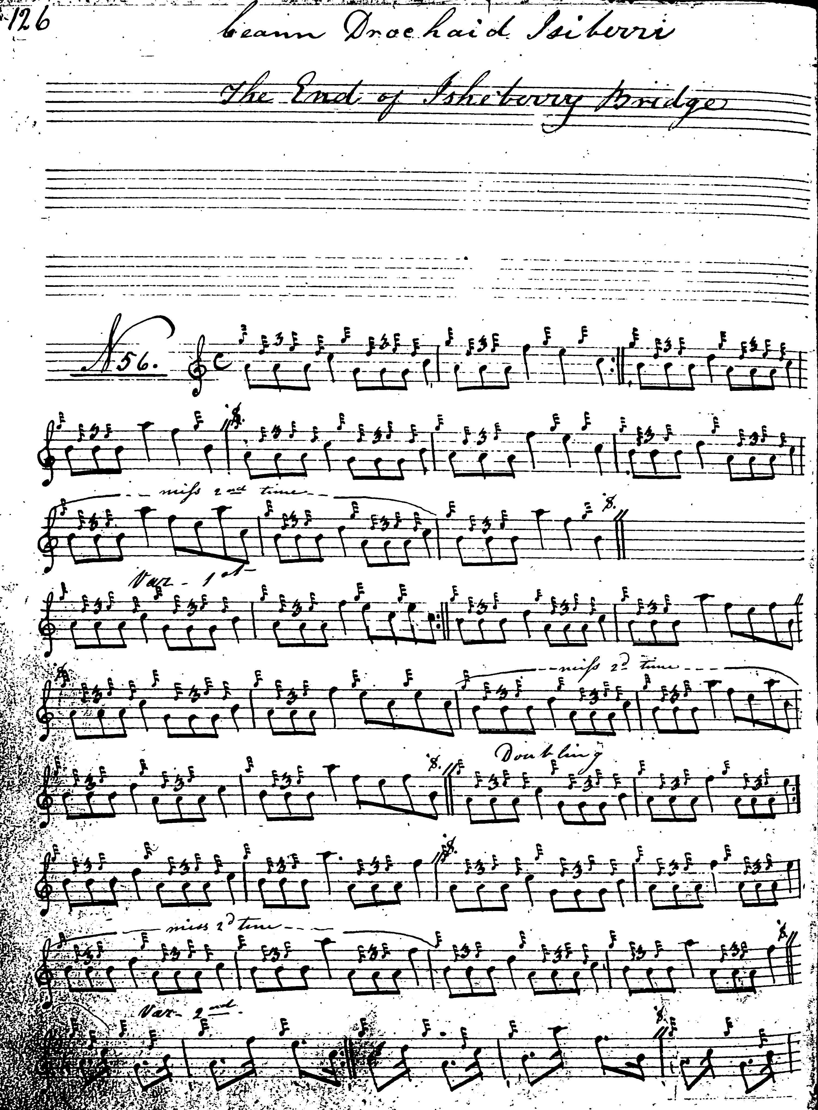

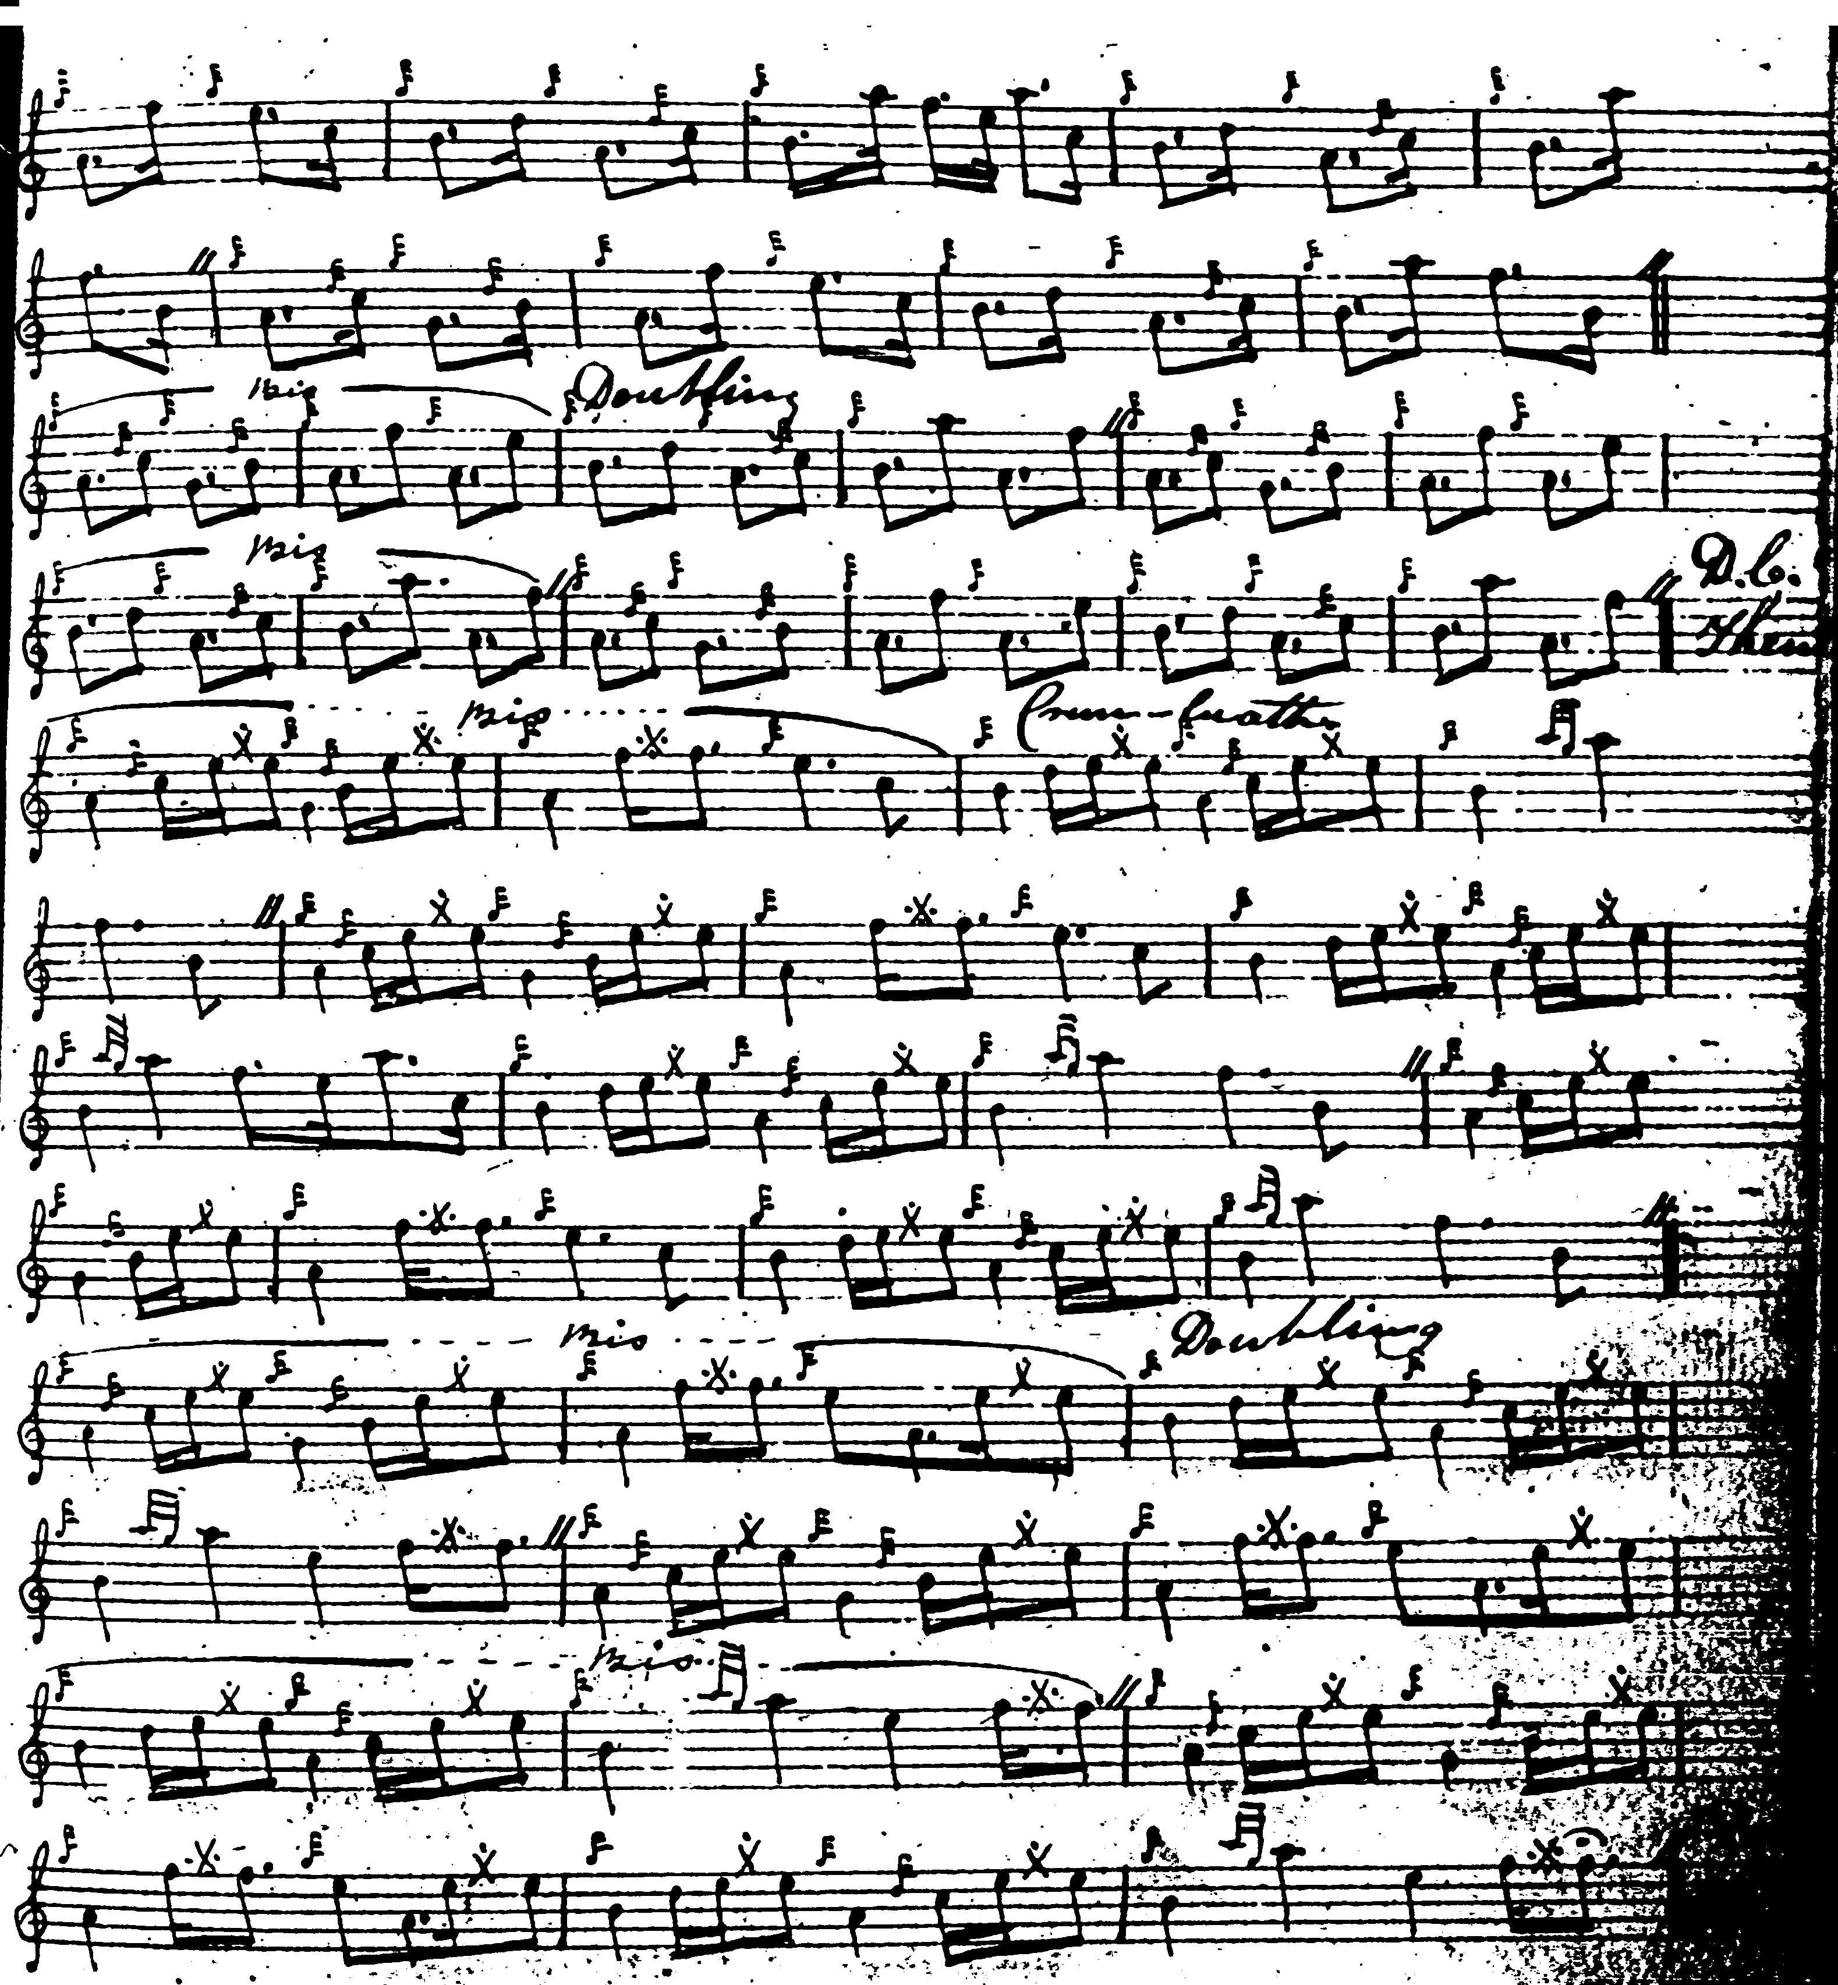

Colin Cameron times the ground as follows:

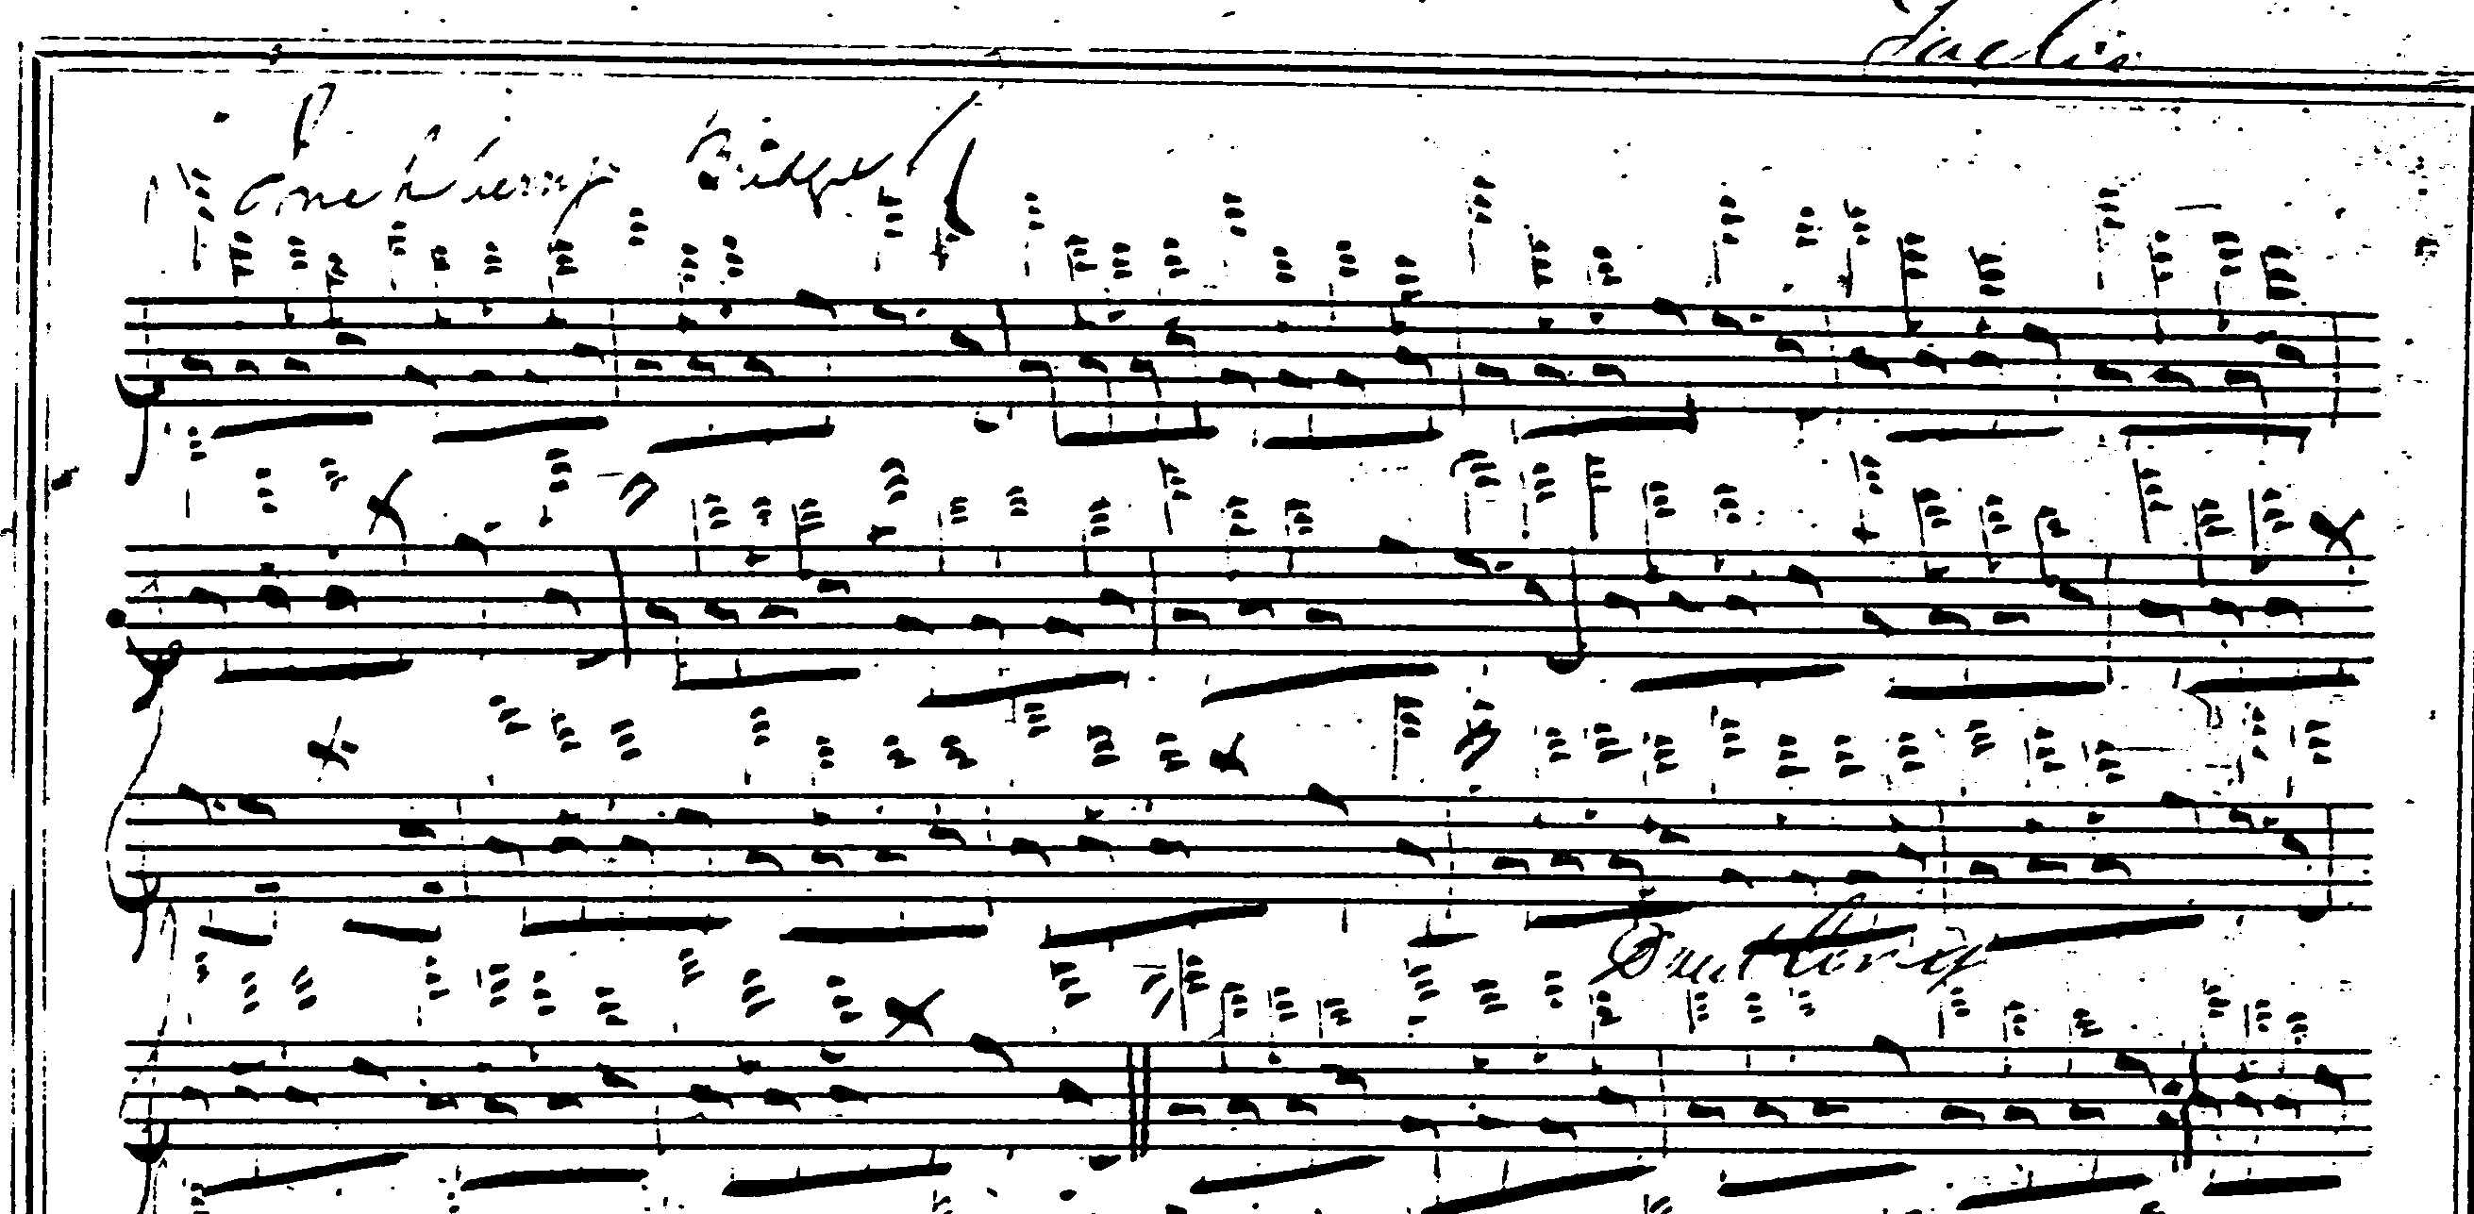

And so on.

D. S. MacDonald’s score adds nothing to that of Angus MacKay and it is not reproduced here.

David Glen’s score shows the style with the 2/4 timing of the taorluath fosgailte movements which was beginning to become common towards the end of the nineteenth century—which of course also gives a rhythmical contrast with the trebling movements which feature in the ground of the tune. Glen times the piece as follows:

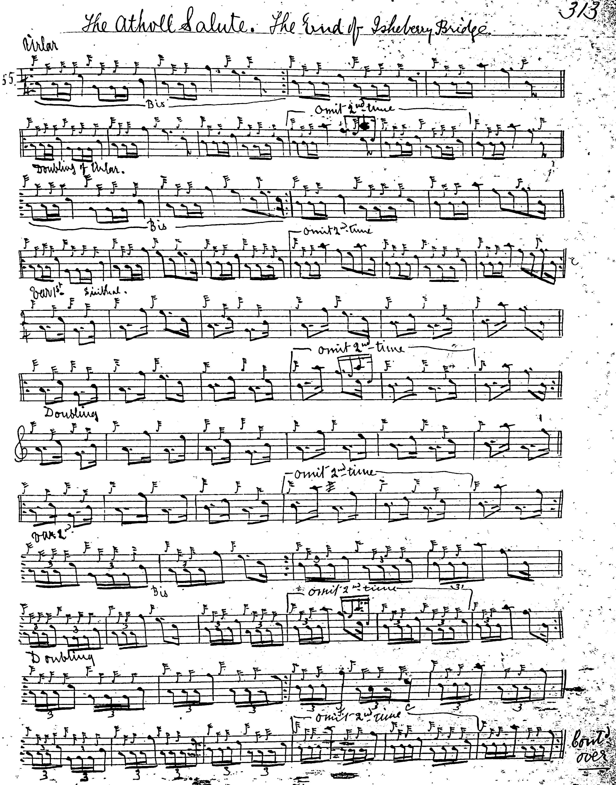
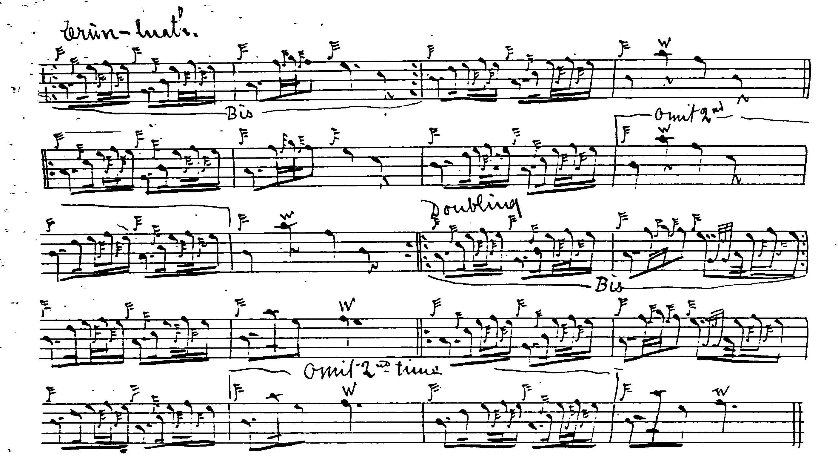

Robert Meldrum’s score is dated 13 October 1931 and appears to be a transcript of the “Athol Salute” from C. S. Thomason’s Ceol Mor. It is not reproduced here.

Uilleam Ross’s published setting does not contain MacKay’s interesting doubling and trebling of the ground but proceeds directly to the siubhal singling. The reader will note that he indicates the “opened” MacDonald style for the crunluath fosgailte, which seems to have been the normal way of executing this movement until the Piobaireachd Society’s Second Series publications adopted the “closed” style of MacKay, and decreed that it be followed with a similar movement in the “opened” form as a kind of crunluath a-mach, ostensibly at the suggestion of Sandy Cameron, but at odds with virtually the whole of the earlier recorded tradition:

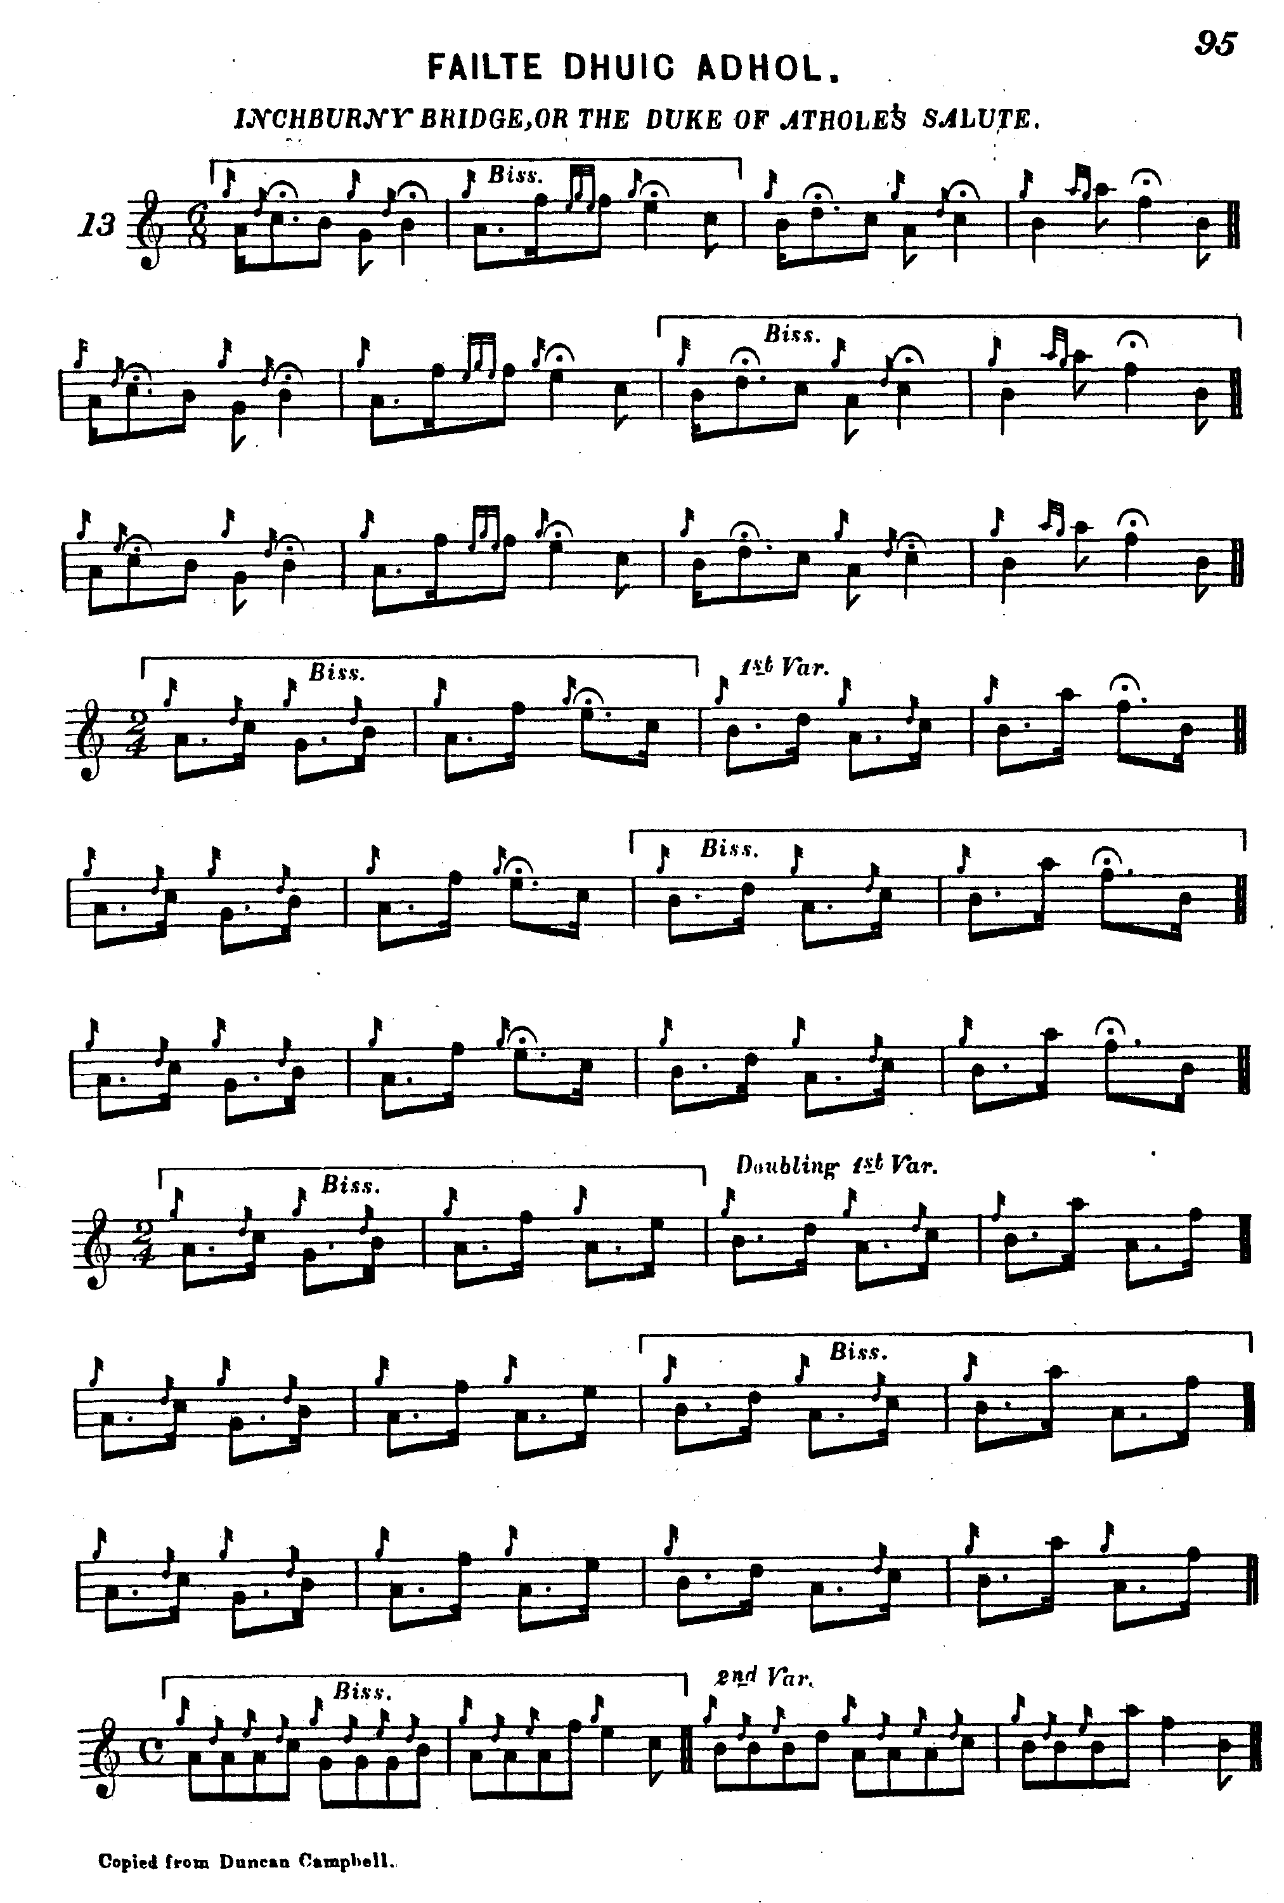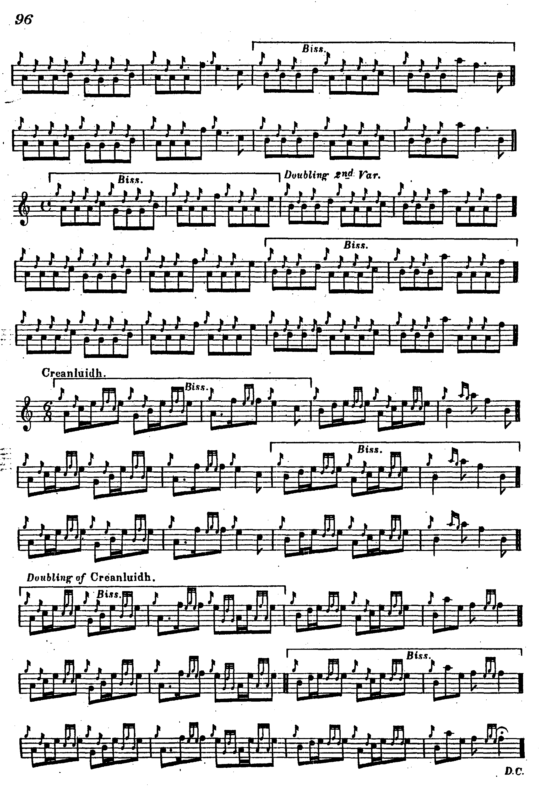
C. S. Thomason gives the tune in two settings, as the “Athol Salute” from Uilleam Ross, and “The End of Isheberry Bridge” from Angus MacKay. Interestingly he omits MacKay’s crunluath singling and doubling, ending with the siubhal doubling. His scores are not reproduced here.

Lt. John McLennan develops the tune somewhat after Uilleam Ross but his score is intriguingly pointed. McLennan also times the crunluath fosgailte in the “open” MacDonald style:

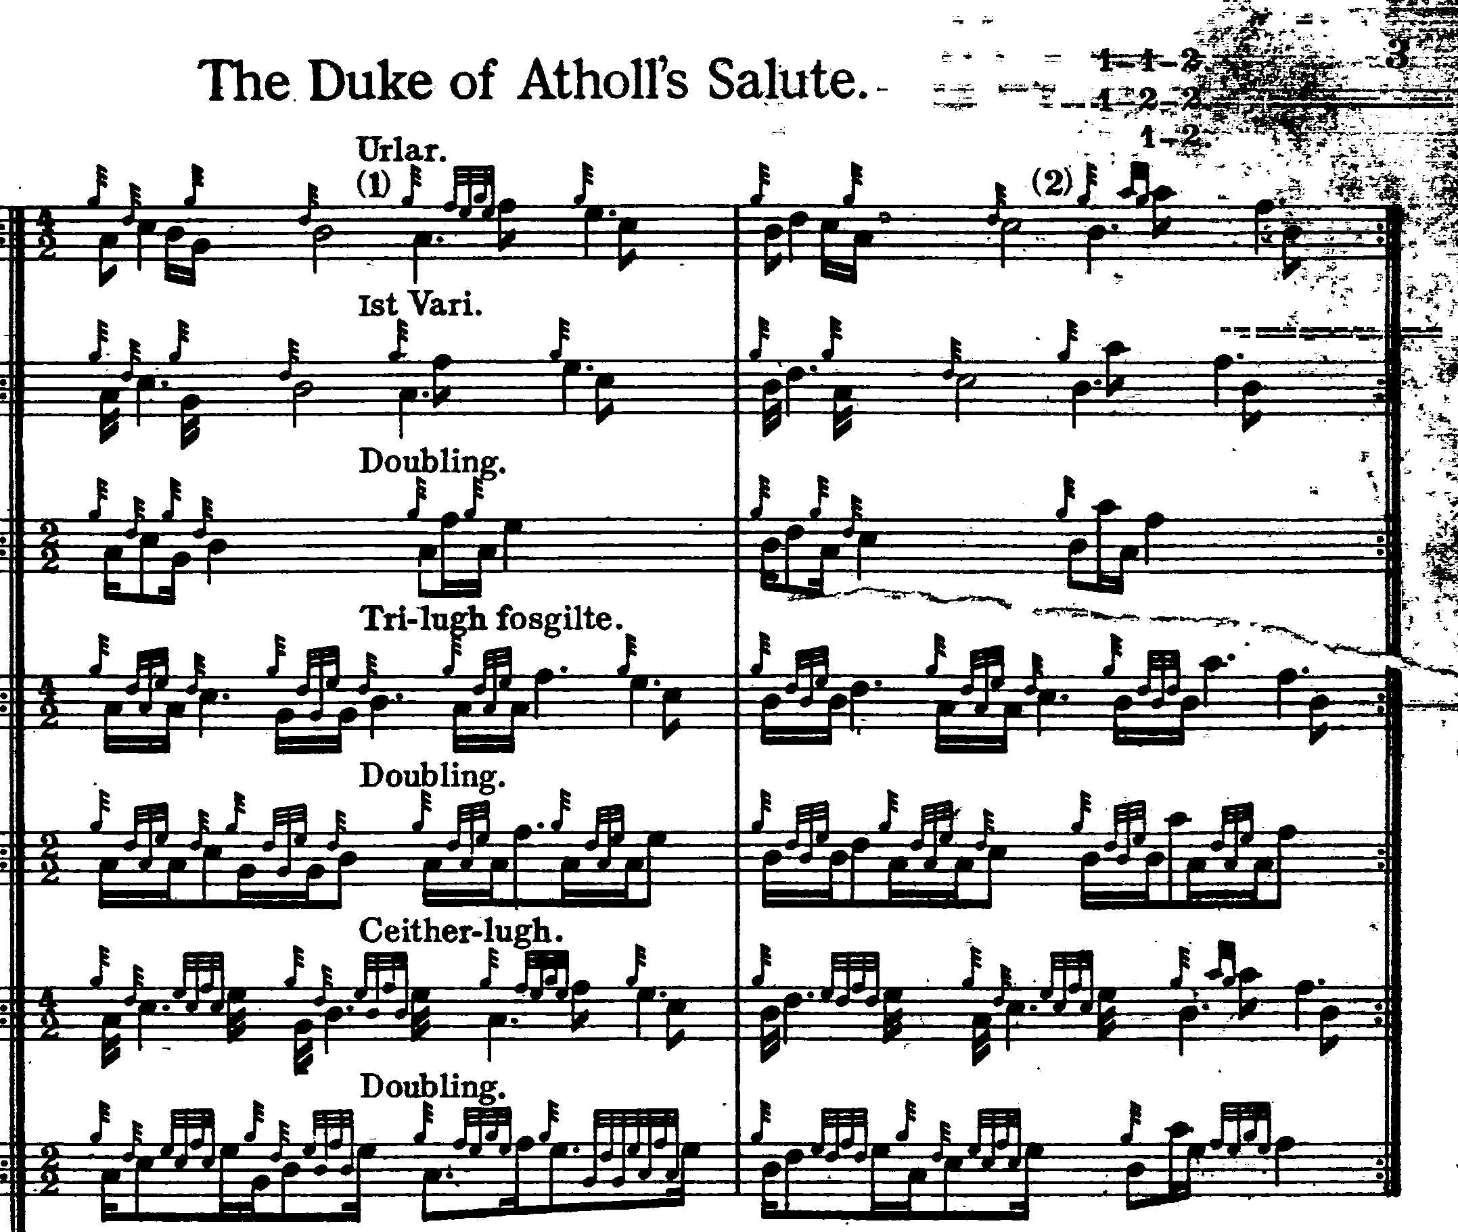

Commentary:

There are two routes through this tune, basically that of Uilleam Ross and that of Colin Campbell and Angus MacKay. Many may feel that Ross’s ground is the more attractive but that MacKay’s more spacious development is the more interesting of the two.

There is a story of the tune preserved in C. S. Thomason’s “Ceol Mor Legends”, as follows:

John Johnston of Coll notes, who calls it “Ceann Drochaid Uisge Birri”. This is a gathering played by Clanranald’s Piper, who was on the expedition to England with the Prince in ’45.—The Highland Army halted at a certain point, well on in England, for the night and the Chiefs, after the Prince retired, held a secret Council of War. When it was resolved to return to Scotland as the English were gathering in the rear, and none of the nobility joined them, as promised and anticipated—the morning had broke when the Council terminated, and “Clanranald” on coming out called for his piper—requested him to play a “Gathering” which the Army immediately obeyed, as they knew it to be a gathering—Orders to march north were immediately given, and the movement began before the Prince became aware of it—He expostulated, even to tears, but it was useless […] At all events the Gathering played by the piper was a new one—never known before—and a splendid one. It cannot be imaginable that he could be able to play such a fine and intricate piece on the spur of the moment, he had very likely prepared it beforehand, for an emergency—but, in any case, it is one of the very finest Gatherings in the “Piping”. (C. S. Thomason, “Ceol Mor Legends”, f.399).

There is a place called Inchberry on the Spey, about three miles south of Fochabers.

* * *

Electronic text © Dr. William Donaldson, Aberdeen, Scotland, June 2005

