Drizzle on the Stone
There are settings of this tune in the following manuscript sources:
--Colin Campbell’s “Nether Lorn Canntaireachd”, ii, 122-4;
--Angus MacKay’s MS, i, 93;
--Duncan Campbell of Foss’s MS, ff.167-168;
--Uilleam Ross’s MS, ff.155-157;
--D. S. MacDonald’s MS, i, 35-6;
--John MacDougall Gillies’s MS, f.82;
--David Glen’s MS., ff.96-97;

and in the following published source:
--C. S. Thomason, Ceol Mor, p. 297.

In the Nether Lorn the title is “Grahams March”. D. S. MacDonald calls this simply “Cruineachadh A Gathering”, setting aside the title the tune bears in MacKay's MS, namely “C** air Cloich.”
Colin Campbell sets the tune as follows:

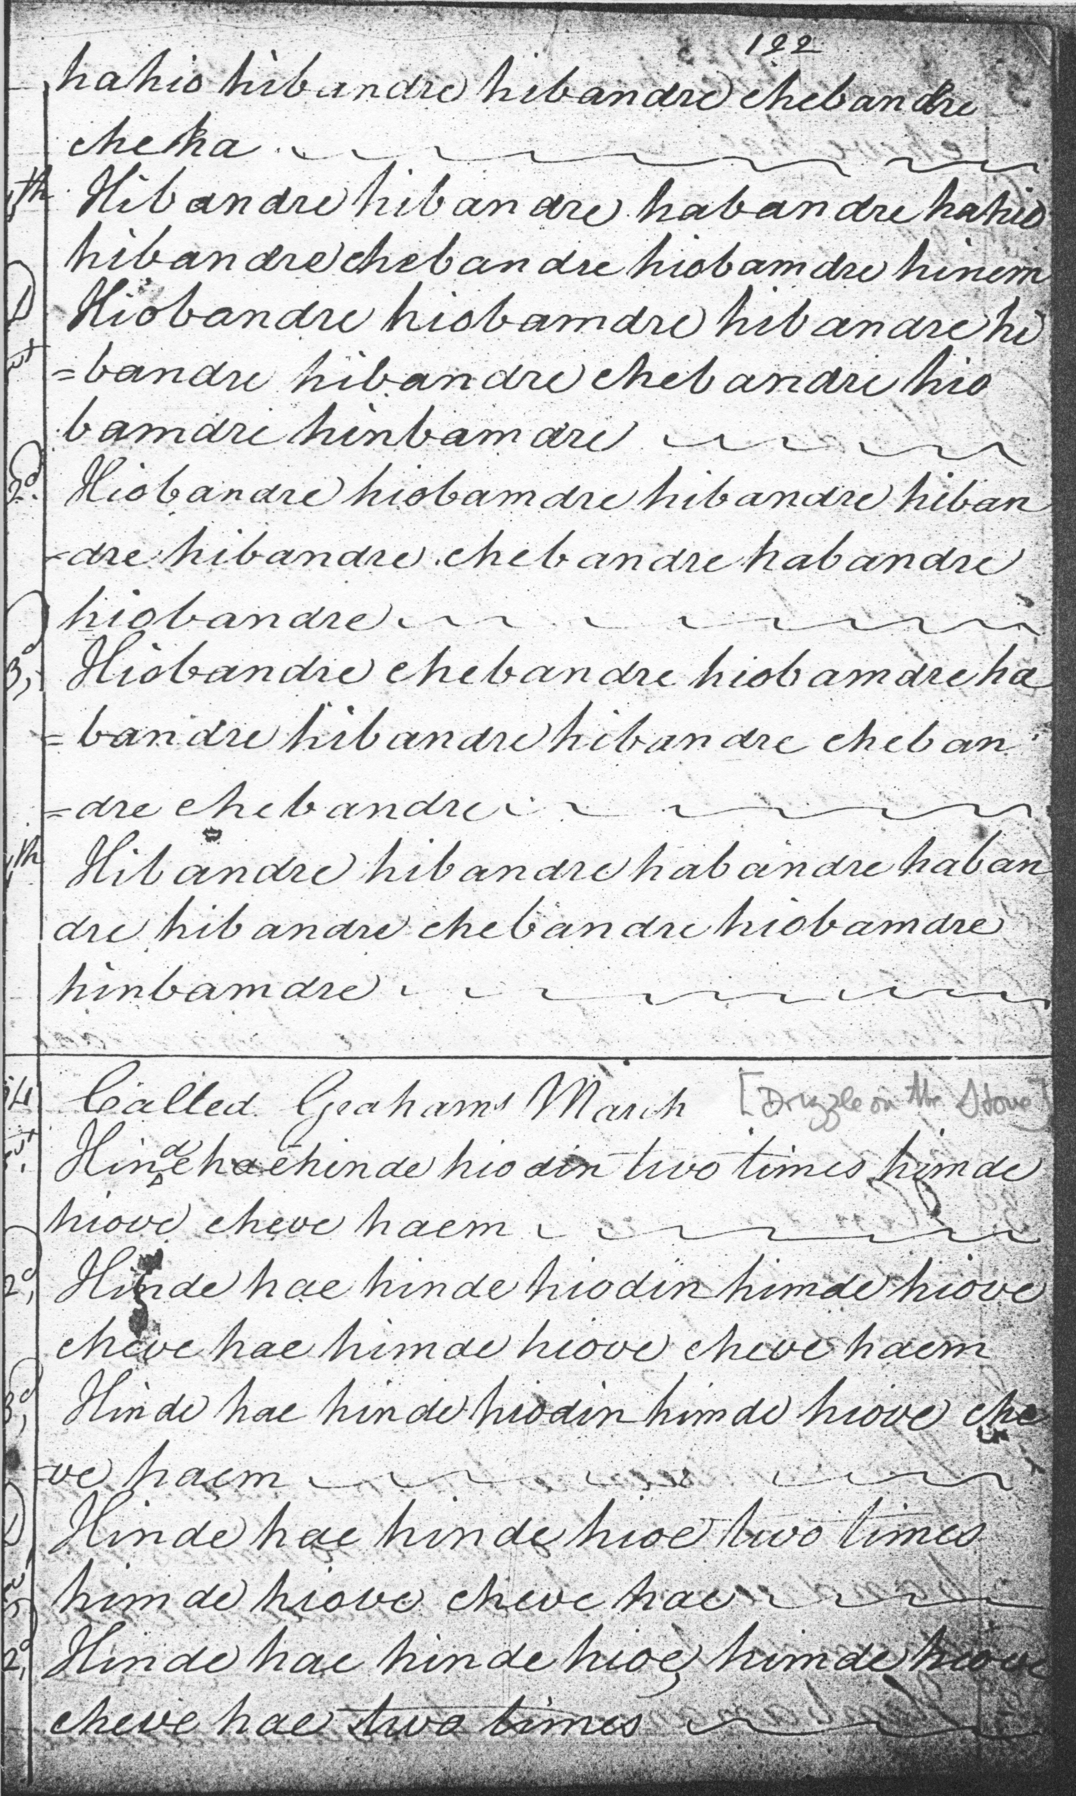
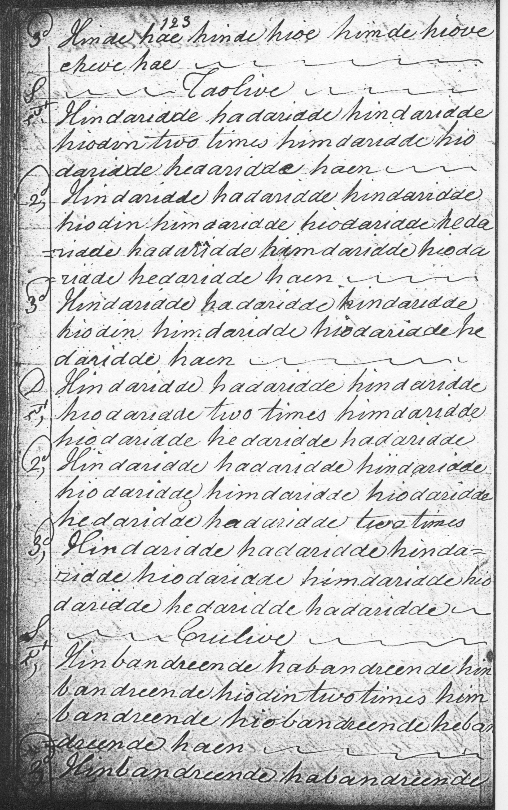
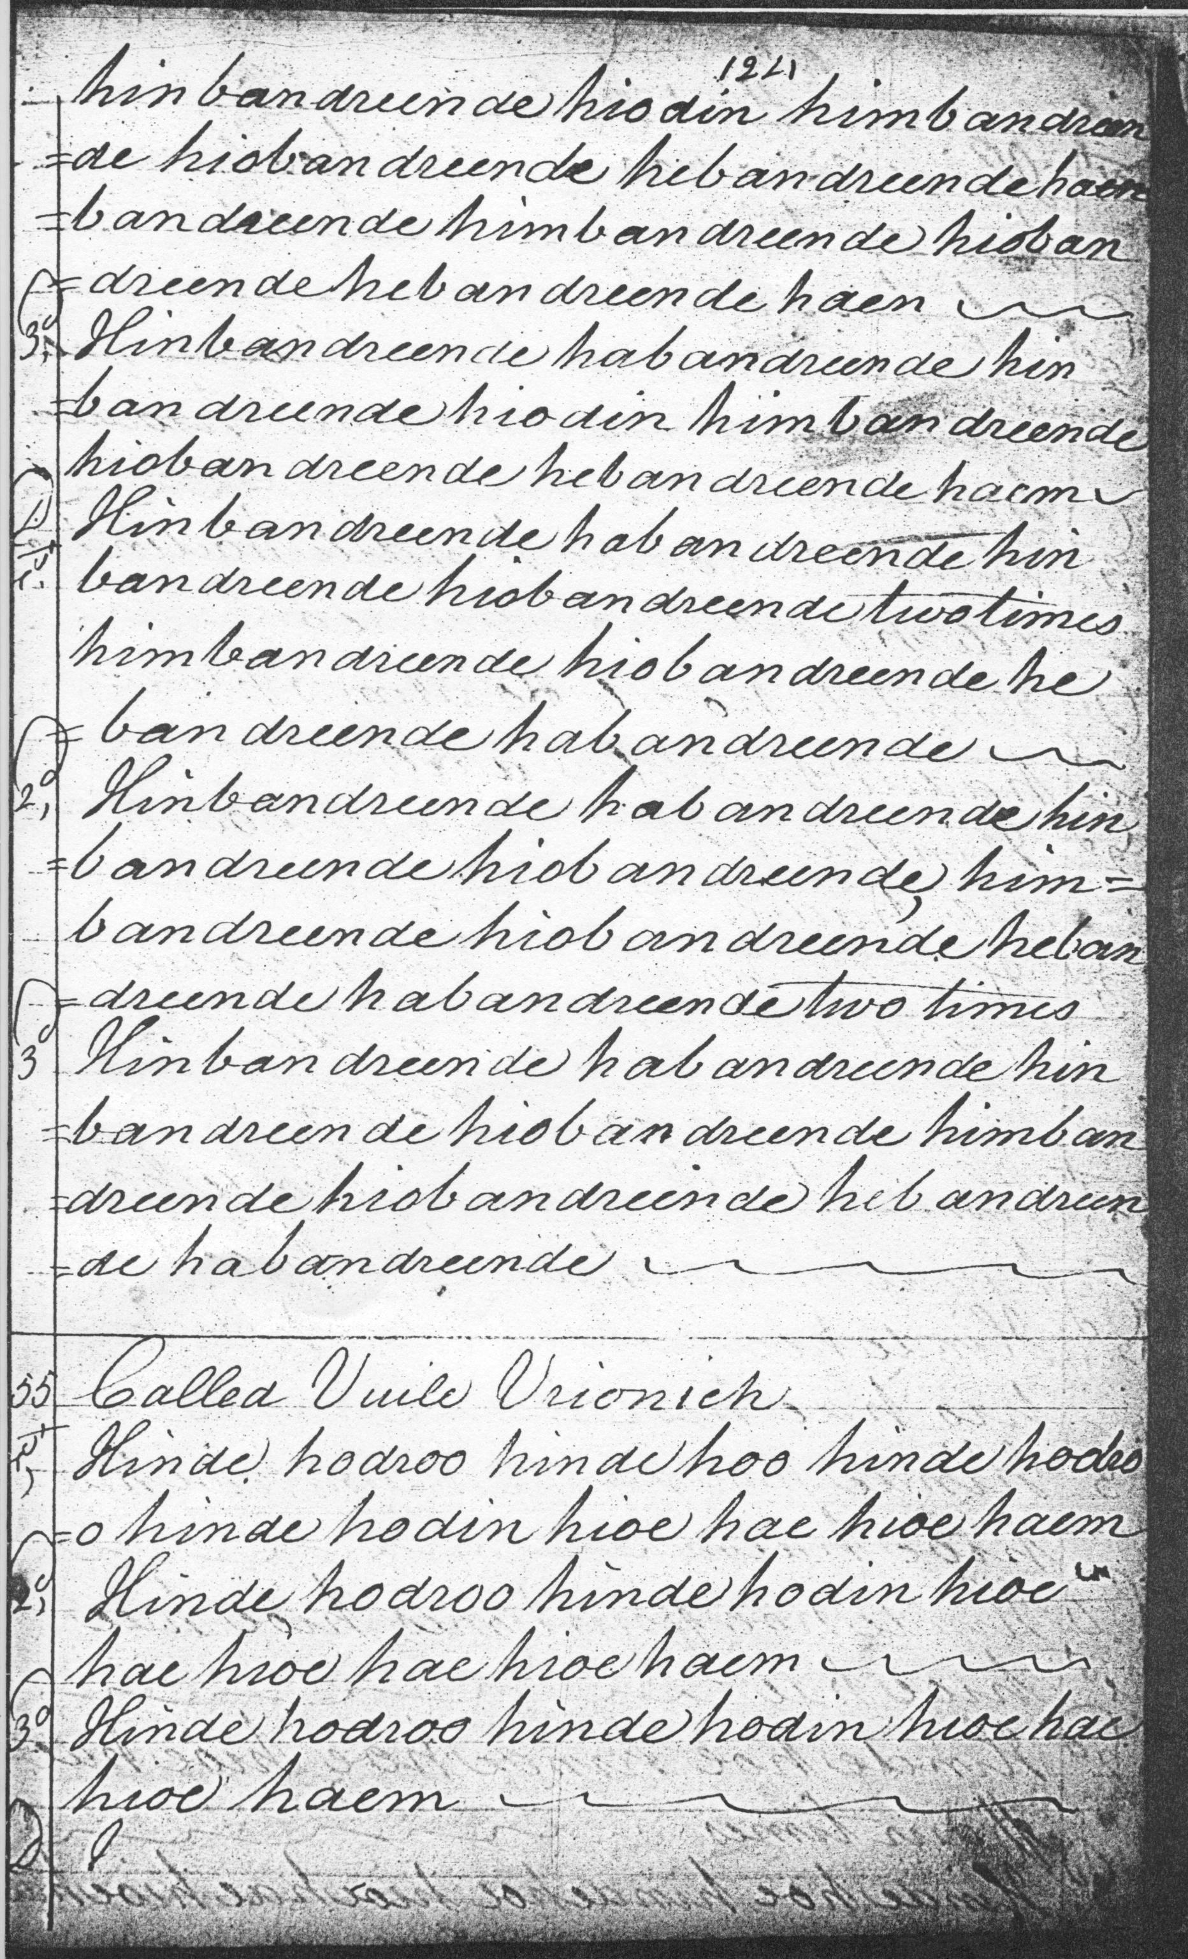

Colin Campbell develops the tune in a straightforward manner: ground and doubling of the ground, taorluath breabach singling and doubling, concluding with a crunluath breabach singling and doubling. Interestingly the tone row contracts in the variations focusing on the interplay between tonic and dominant (low A and E) and eliding the F which is a significant feature of the ground and its doubling, except in the very last bar, where it re-appears with pleasing effect.

The main features of Colin Campbell’s score are as follows:

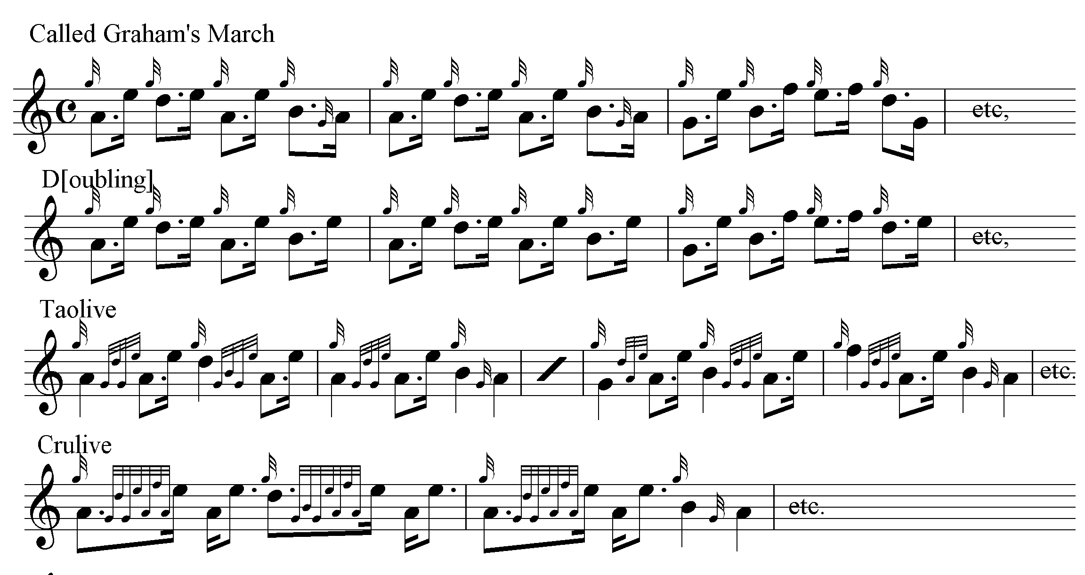

And so on.

Angus MacKay’s title is “C** air Cloich”, (“Ca*”, in the index—MacKay would seem to have been uncertain about the title). Ceob, implying mist, is the generally preferred suggestion: cloich indicating stones. MacKay retains the F as a themal note throughout the variations, and many may feel that the resulting increase in tonal contrast and tension makes his the preferable setting:

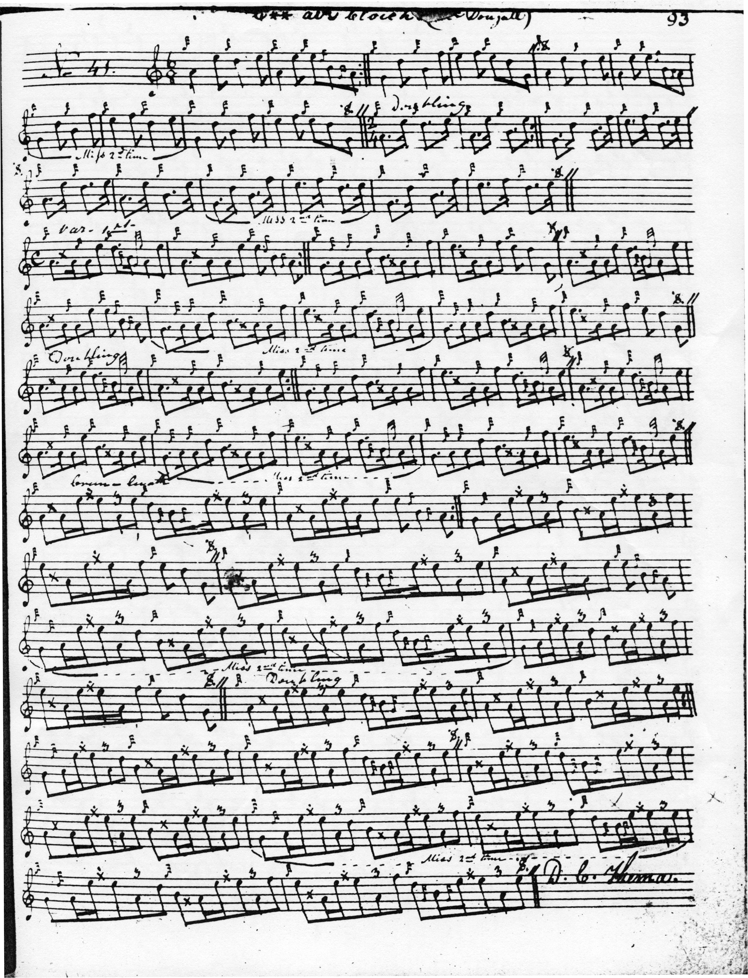

From the headnote to the tune, this appears to be one of a number of pieces he got from “Blind MacDougall”. In structure, MacKay’s development of the tune is similar to Colin Campbell’s: ground and doubling of ground; taorluath breabach singling and doubling; crunluath breabach singling and doubling. The even quaver timing of the taorluath and crunluath variations might imply that these could be cut “up” or “down” , with the balance of probability in favour of an “up” cut timing (if only to balance the “down” pointing of the doubling of the ground).

Duncan Campbell’s setting which clearly has close links with MacKay’s, resolves a number of these ambiguities: for example in the timing of the cadences where the emphasis is clearly indicated, and in the unequivocally “up” cut timing of the crunluath breabach:

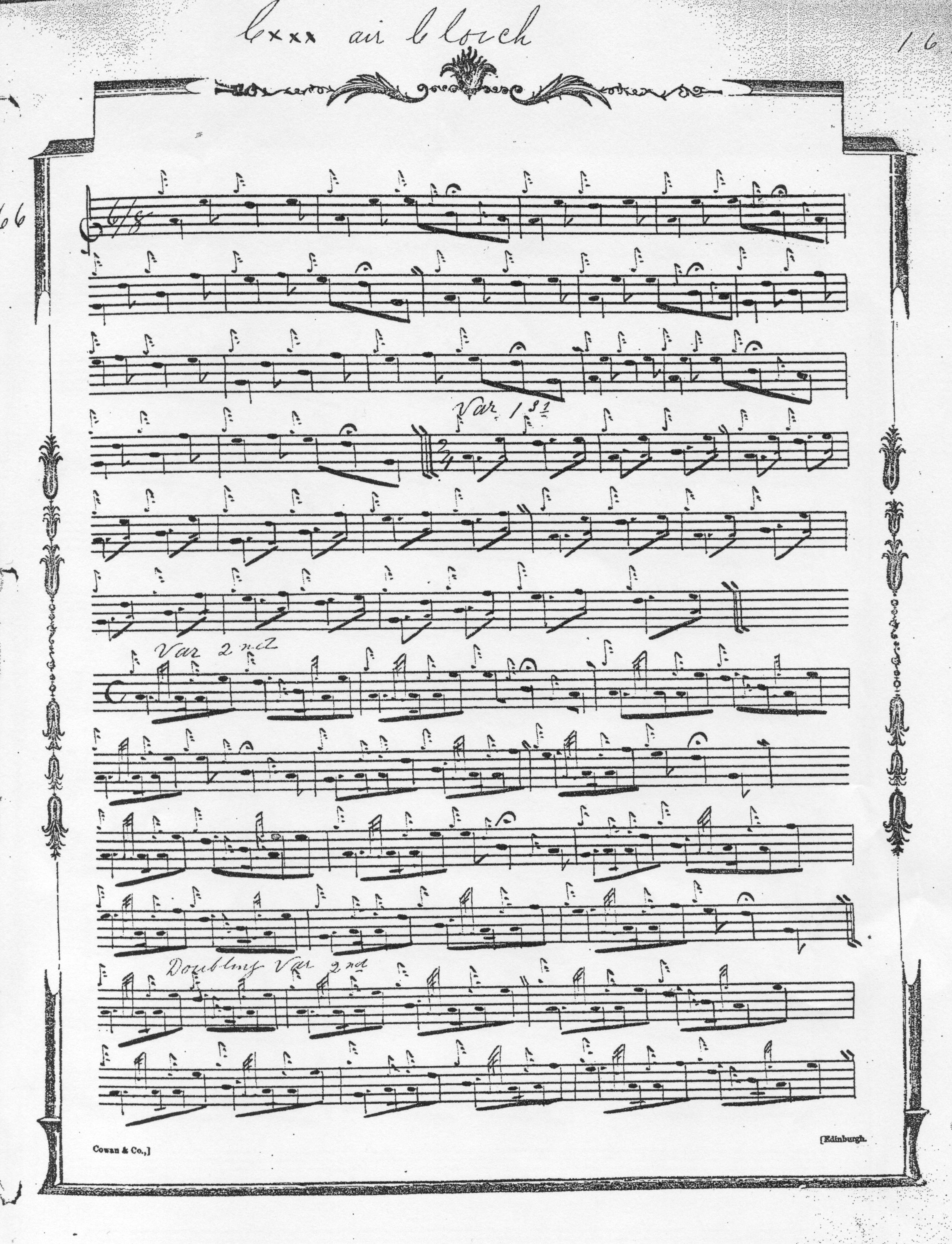

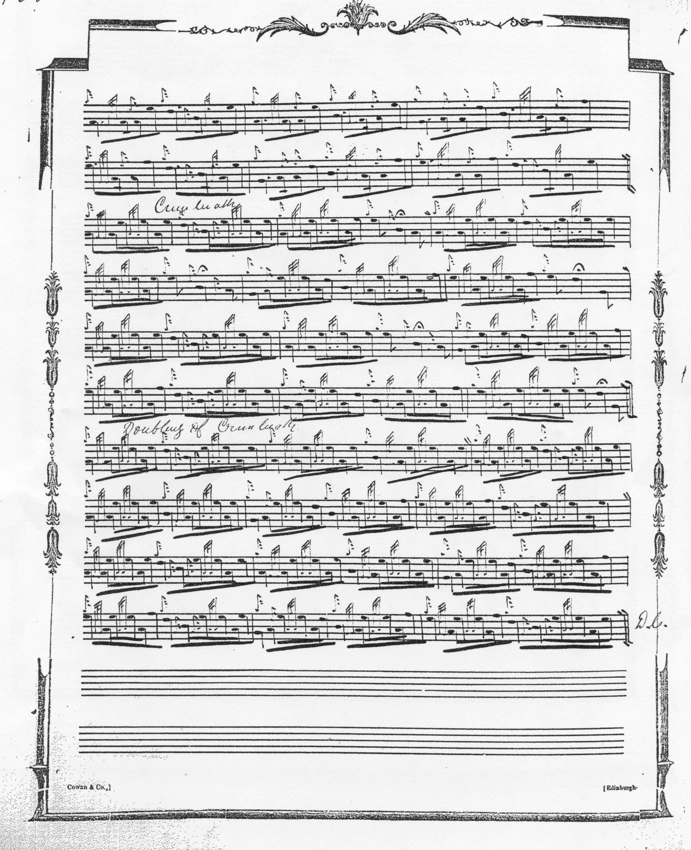

Uilleam Ross’s setting adds nothing from an interpretational point of view to Duncan Campbell’s and is not reproduced here. D. S. MacDonald directs that the ground be repeated after the taorluath doubling (as well as at the end of the tune) but otherwise his score adds little of interest to his source, Angus MacKay, and is not reproduced here. John MacDougall Gillies’s setting is in outline only and does not proceed beyond the taorluath singling; it is not reproduced here. David Glen titles the tune “Ceòl air Cloich. Drizzle on the Stone (or Stones)” with an attribution to “R.[onald] McDougall”. Except that Glen has for some reason left the taorluath variation unbeamed, this might well be the pick of the scores in the style coming down through Angus MacKay:

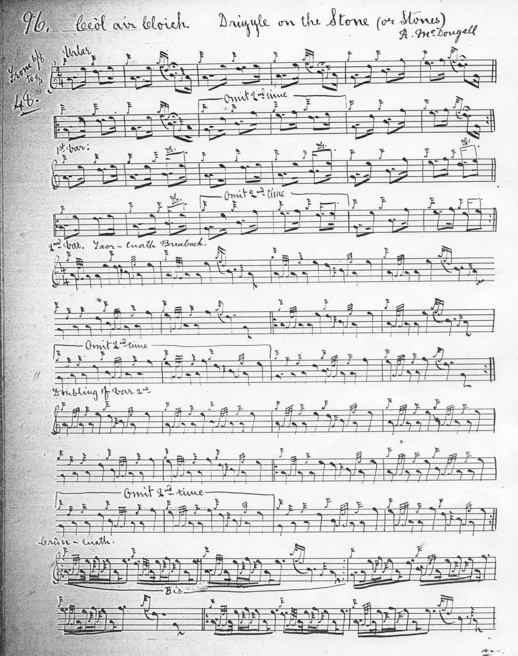

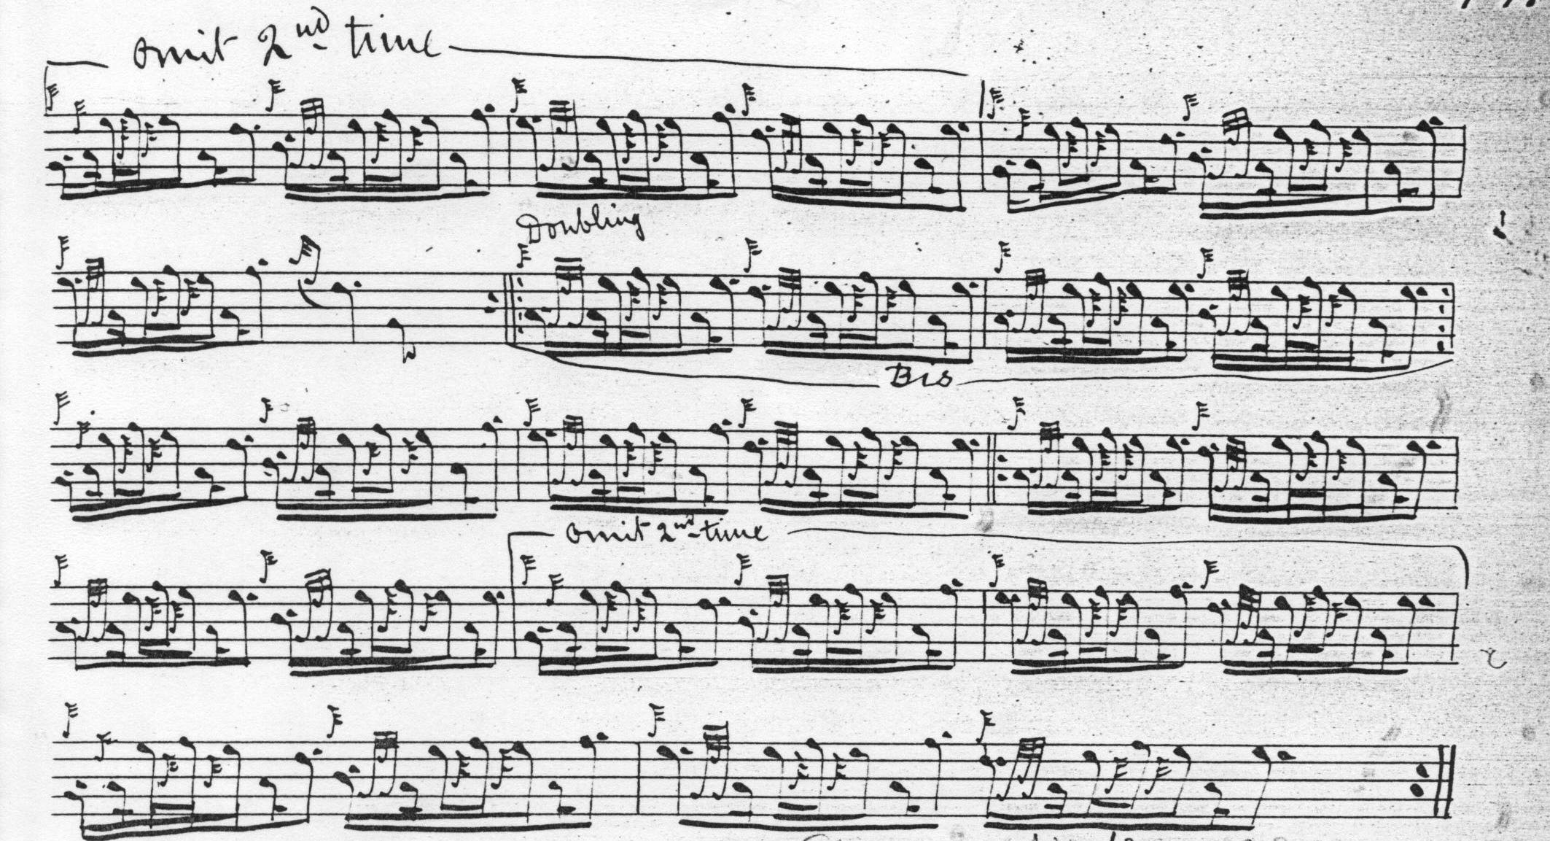

C. S. Thomason’s setting in Ceol Mor adds little of musical significance to his stated source, which is Angus MacKay’s manuscript, and his score is not reproduced here.

Commentary:
Discussing this tune with the writer at his home in Birkhall in January 1977, Bob Nicol spoke about bogus experts, beginning with G. F. Ross and moving on to John Grant: “Bob spoke about G. F. Ross, and said he wasn't to be relied upon. He didn't know where Ross had got his information, but he didn't think anything of the fellow at all. Once in London Ross had come up to Bob (who was personally unknown to him) after he had played Donald Duaghal and won the Blue Banner with his performance, as he was leaving the hall, and told him he should steer clear of that tune, as he had no idea how to play it properly. Bob said ‘I just left him where he stood.’ John Grant was another of the same sort. He was an Edinburgh advocate or something and published a great deal of very thick books about piping and piobaireachd; but he didn't know anything about it. His credentials were sufficient, however, for him to be appointed the first instructor at the army school of piping, after World War 1. He began the course with ‘Drizzle on the Stone’, and his method of teaching it was to go outside the classroom window with a pitcher of water and solemnly pour it on the ground. The pipers on that first course took the unprecedented step of writing to their commanding officers requesting to be taken off the course. The authorities took the hint and Grant was dismissed. Bob said ‘He was just so bloody bad...’”

Although apparently sometimes used as a beginners’ tune, this is an attractive piece dipping in and out of two contrasting and overlapping scales: A-B-D-E and G-B-D-E-F, with an angular step-wise movement, particularly striking in the successive fifths, low G-D and B-F in bar five of the ground and at comparable places in the later variations.

*

Electronic text © Dr. William Donaldson, Cambridge, Massachusetts, 22nd June 2016

