Lament for Donald of Laggan

This tune is to be found in the following manuscript sources:

—**Colin Campbell**’s “Nether Lorn Canntaireachd”, i, 54-6 (marked “One of the Cragich”);

—**Angus MacKay**’s MS, ii, 94 (and also in the so-called “Kintarbert MS”);

—**Colin Cameron**’s MS, f.29 (with the title “Donald MacDonell of Laggan’s Lament”);

—**Duncan Campbell of Foss**’s MS, ff.135-136;

—**Uilleam Ross**’s MS, ff.137-138;

—**Donald MacKay**’s “Ballindalloch” MS, and the related MS of C. S. Thomason, f.27;

—**D. S. MacDonald**’s MS, i, 70-71;

—**John MacDougall Gillies**’s MS, f.107;

—**David Glen**’s MS, f.81;

—**Robert Meldrum**’s MS, ff.155-156;

and also in the following published collections:

--**C. S. Thomason**’s *Ceol Mor*, p. 231;

--**William Stewart** of Ensay, et al., eds., *Piobaireachd Society’s Collection* (first series), v, 1;

--**G. F. Ross**, *Some Piobaireachd Studies*, p.25; and also *A Collection of MacCrimmon and other Piobaireachd*, pp.34-5.

As with all breabach tunes, the possibility arises here of playing the taorluath and crunluath movements “up” or “down”. The major staff notated scores time these as follows:

|  |  |  |  |  |  |  |
| --- | --- | --- | --- | --- | --- | --- |
|  | **MacKay** | **Cameron** | **Campbell of Foss** | **Glen** | **Thomason Ceol Mor** | **G. F.**  **Ross** |
| Taorluath  breabach | even  quavers | “down” | even  quavers | even  quavers | “down” | “down” |
| Crunluath  breabach | “up” | “up” | “up” | “up” | “down” | “down” |

The taorluaths set as even quavers all have an implied “up” timing, but obviously not jerkily so: all these things should be timed fairly “round” and smooth.

**Colin Campbell** sets the tune like this:

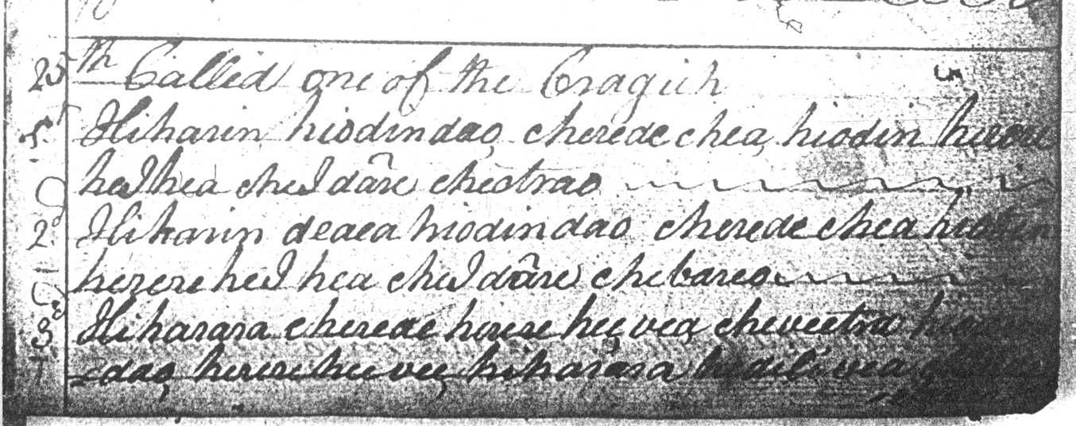

ran

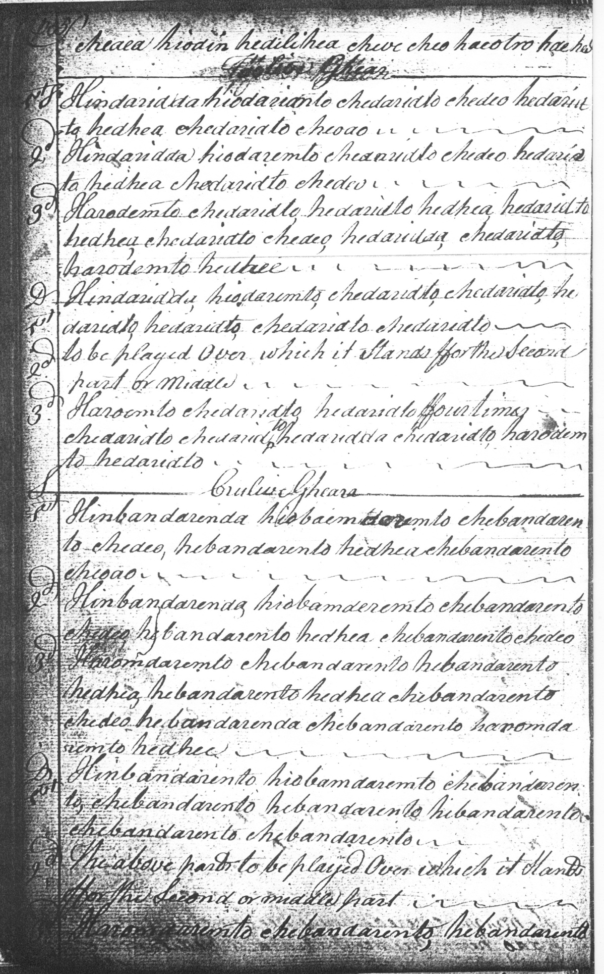

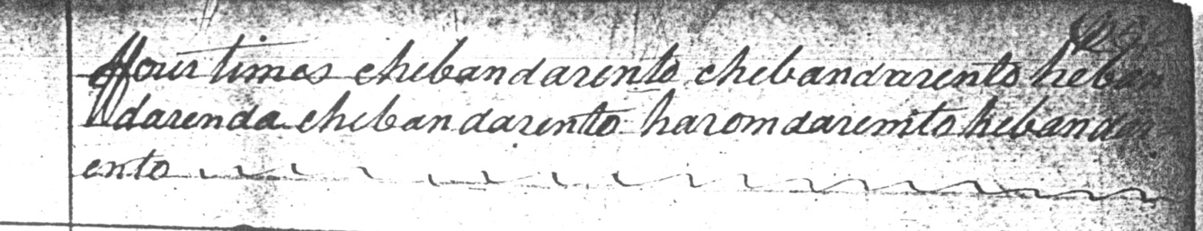

**Colin Mór Campbell’s** setting shows his usual individual touches, but establishes the typical development of this tune in the remainder of the major scores: *ground* followed by *taorluath breabach* singling and doubling and *crunluath breabach* singling and doubling in perfectly orthodox form. It is interesting, though, to see the explanation in English for the repeat of the first line in the taorluath doubling: “to be played Over which it Stands ffor the Second part of Middle” which looks a little quaint on the page, but not so surprising, perhaps, at a period in the Highlands where it was more common to be literate in English than in Gaelic. There is a similar repeat instruction in English appearing in the crunluath doubling. The setting has a number of points of interest: it makes it clear, for one thing that that D in the second figure of bar one in the ground in Angus MacKay’s setting is a simple gracenote and should not be sounded separately; Colin Campbell plays straight down from E to B here.

**Angus MacKay** sets the tune as follows:

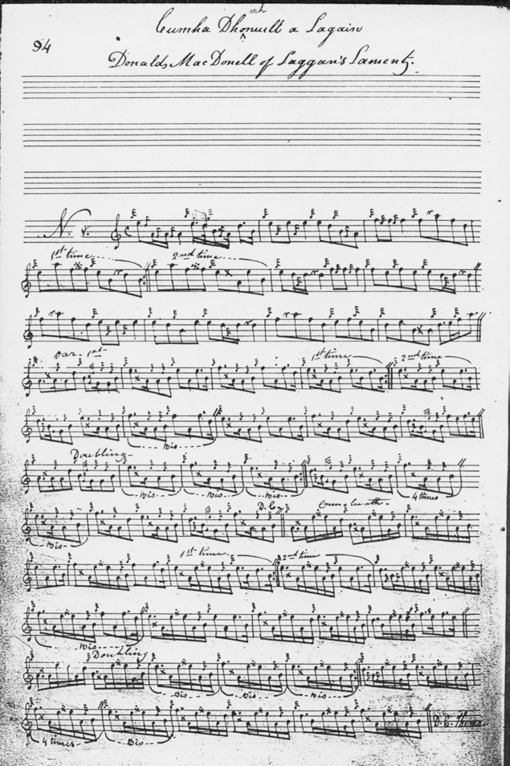

MacKay, as he often does in his manuscript, uses strings of even quavers, which has the effect of leaving final decisions about pointing up to the player. More guidance is given in this respect by other important Victorian sources including **Colin Cameron** who sets the piece like this:

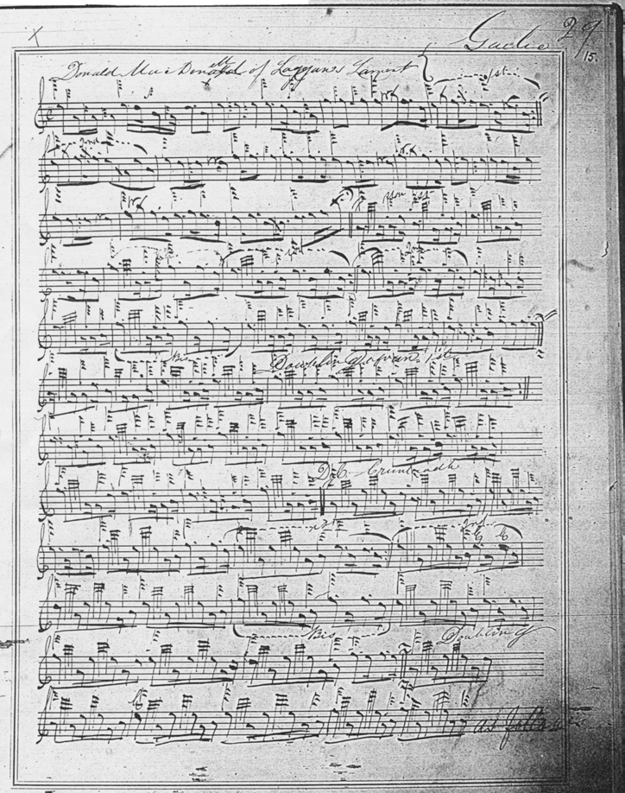

**David Glen**’s marginal notes show a typical attempt to amend a tune which later times sometimes considered “irregular”: he notes “1st strain 4 bars, 2nd 6, 3rd 4—could be rendered perfect by repeating 1st 2 bars in 1st strain.”

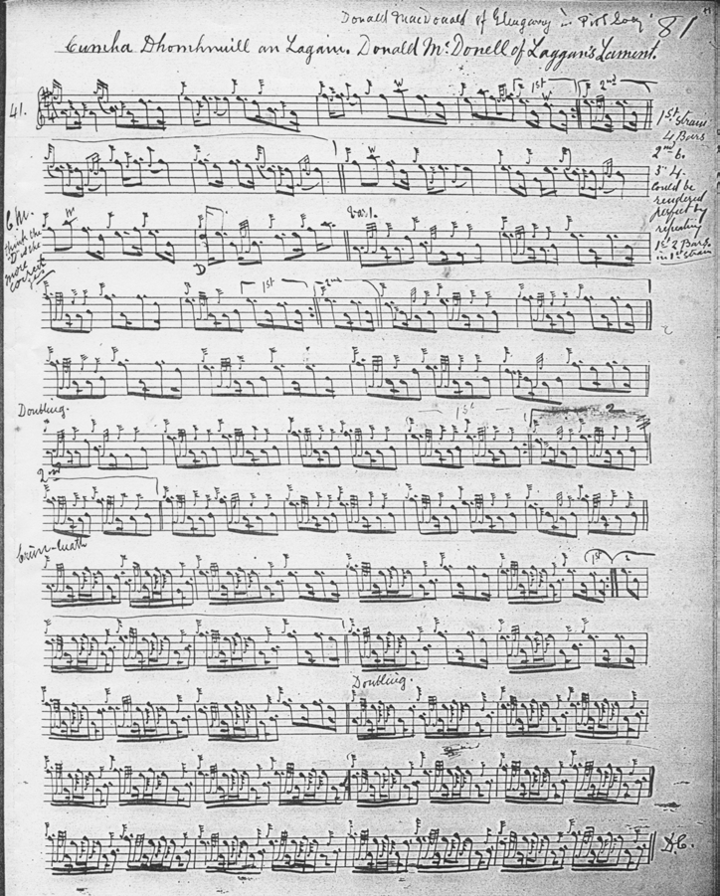

The most dramatic attempt at emendation came from **G. F. Ross**. In his book *Some Piobaireachd Studies* (Glasg., 1926), he brought the ground up to sixteen bars by transposing bars 3and 4 of the first line to the initial position. Ross was influenced by the controversial ideas of Simon Fraser in Australia (for which see *The Highland Pipe and Scottish Society 1750-1950,* pp.188-9, 350-2) , and this emendation probably had Fraser as its ultimate source:

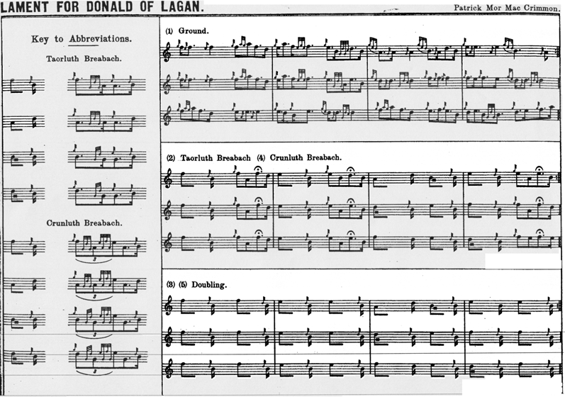

*Commentary:*

Donald of Laggan was *Domhnull MacAonghais mhic Alastair*, 8th laird of Glengarry, who lived in the later 16th and first half of the 17th century. His turbulent father, Angus Og, bequeathed him a series of long-running feuds with the Grants and the MacKenzies. The Glengarry lands in the north marched with MacKenzie territory in Lochalsh and Loch Carron, producing almost constant friction. Hostilities took place by land and sea, culminating in the burning of the church of Cillechriosd and the capture and destruction of Glengarry’s stronghold, Strome castle, at the mouth of Lochcarron. This latter provided the subject of another lovely, and too much neglected, tune, known variously as “Castle Strome” and “The Battle of Lochcarron Point." (*Ceol Mor*, pp.63, 240, 355—and elsewhere on this website). Donald of Laggan died aged more than a hundred, on Sunday 2nd February 1645, the day of the second battle of Inverlochy.

Further information will be found in Alexander MacKenzie’s *The MacDonalds of Glengarry* (Inverness, 1881), and the same writer’s *History of the Clan MacKenzie* (Inverness, 1879).

* * *

Electronic text © Dr. William Donaldson, Aberdeen, Scotland, October 2003; revised Cambridge, Massachusetts, December 2024.