Lament for the Departure of King James
There are settings of this tune in the following manuscript sources:
--Colin Mór Campbell’s “Nether Lorn Canntaireachd”, ii, 102-3;
--Angus MacKay’s MS, ii, 83-4;
--Colin Cameron’s MS, ff.109-10;
--Uilleam Ross’s MS, ff.262-3;
--John MacDougall Gillies’s MS, ff.26-7;
--David Glen’s MS, ff.171-2;
--Lt. John McLennan’s MS (NLS, Acc.11516/8), f.15;

and in the following published sources:
--Donald MacDonald, Collection of Ancient Martial Music, pp.89-91; (with the title “Suihel Shemes Lament for King James’ Departure in 1688”);
--Donald MacPhee, Collection of Piobaireachd, ii, 4;
--C. S. Thomason, Ceol Mor, p.18.

Colin Campbell sets the tune as follows:
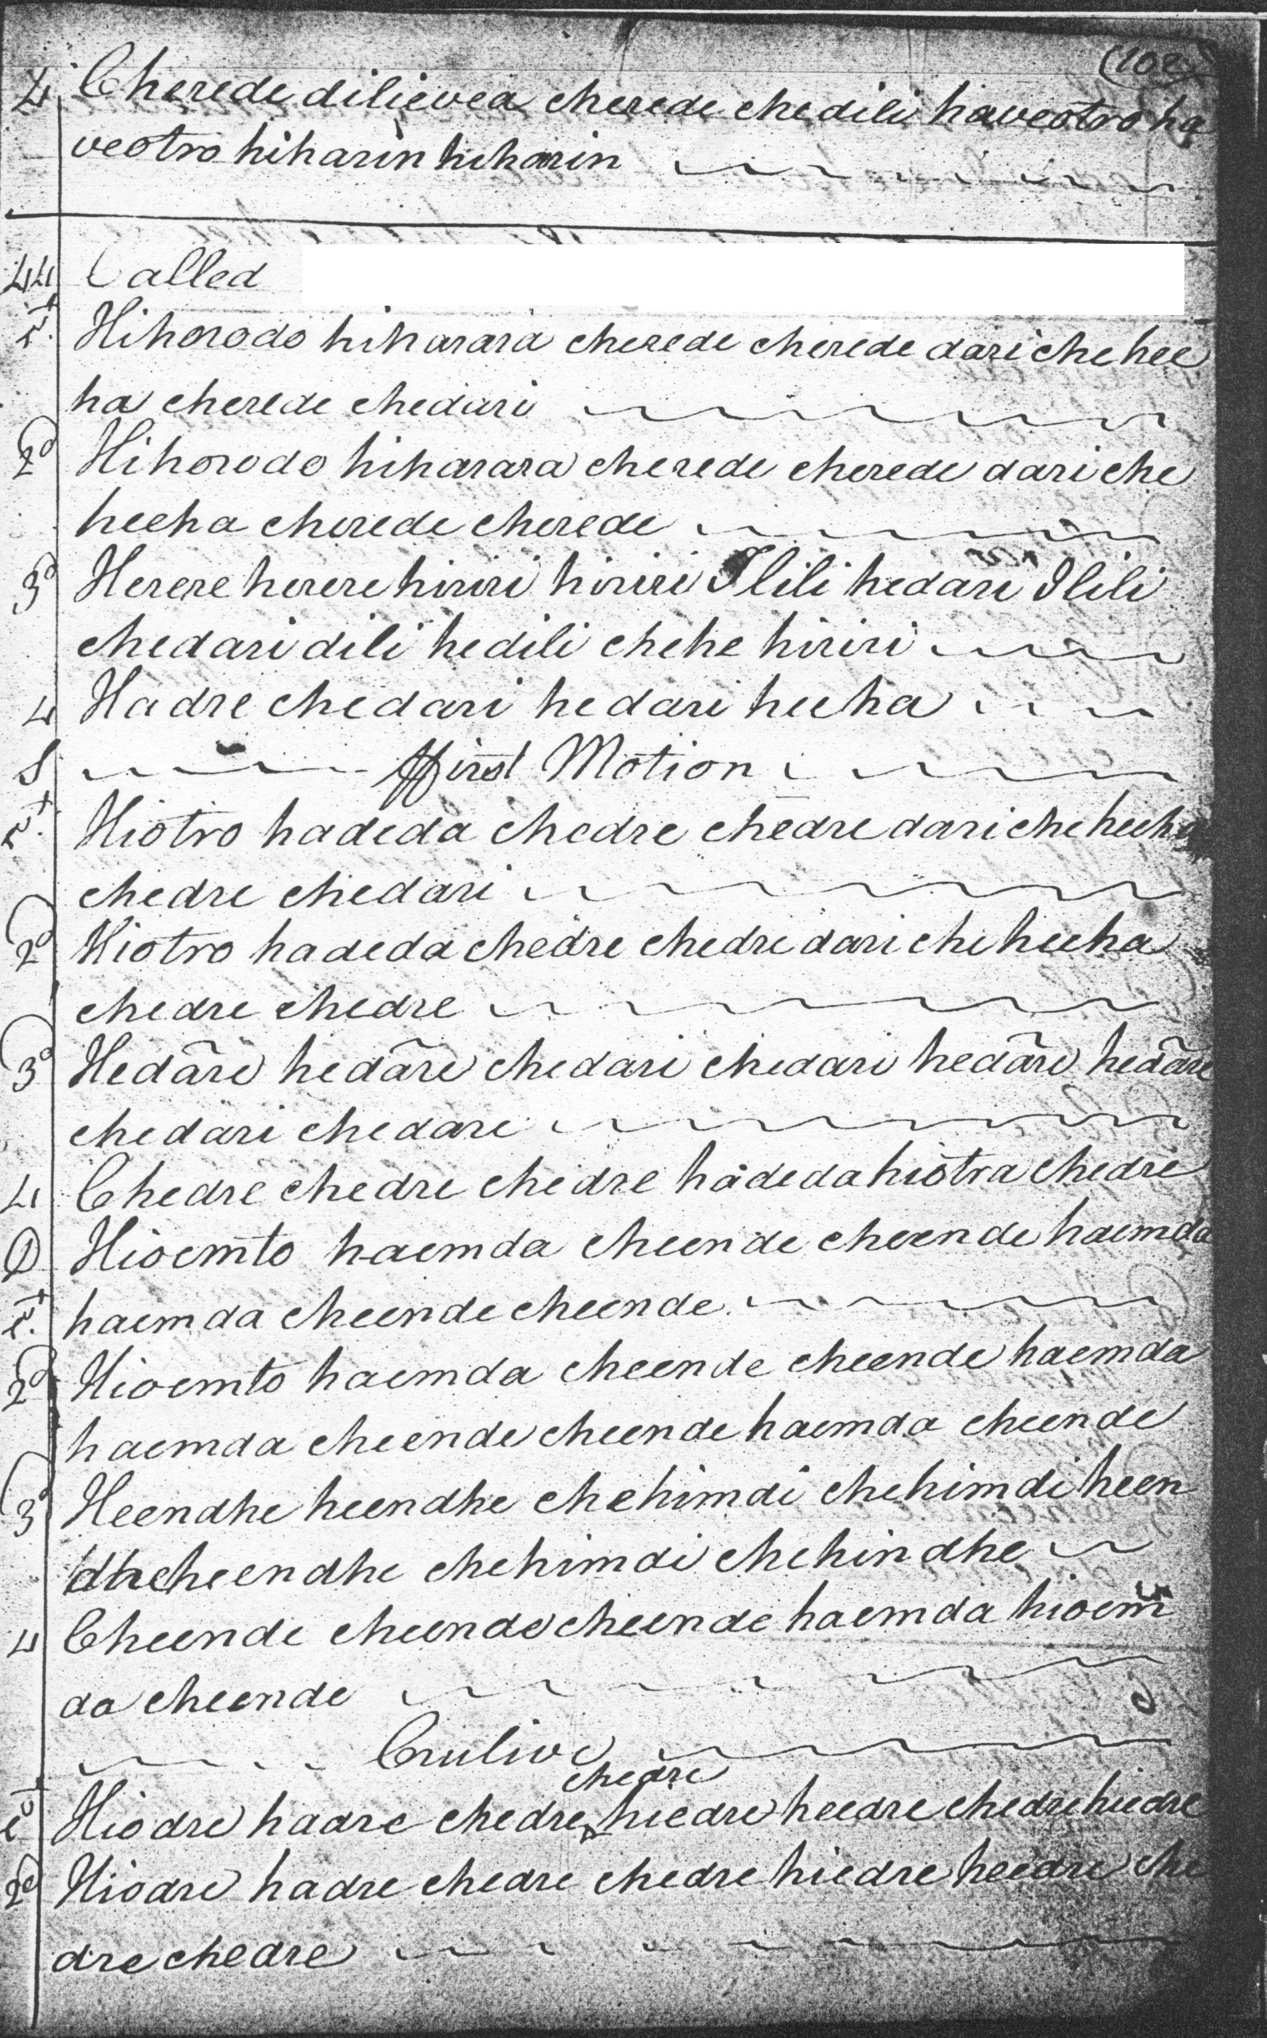
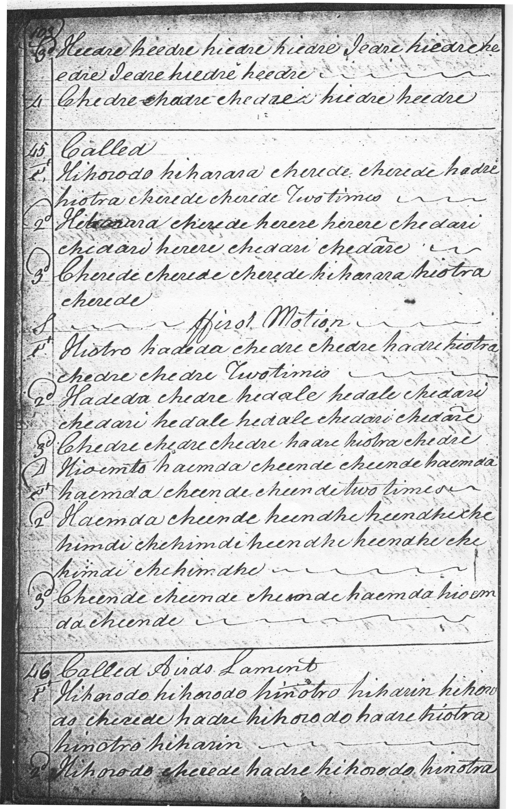

There are two closely related settings adjacent to one another in Colin Campbell’s “Nether Lorn Canntaireachd”, both nameless. These settings have many interesting features, including—in the second--an attractive dip down to D and B where other scores feature a similar descending contour but at a higher pitch.
No.44 proceeds roughly as follows:
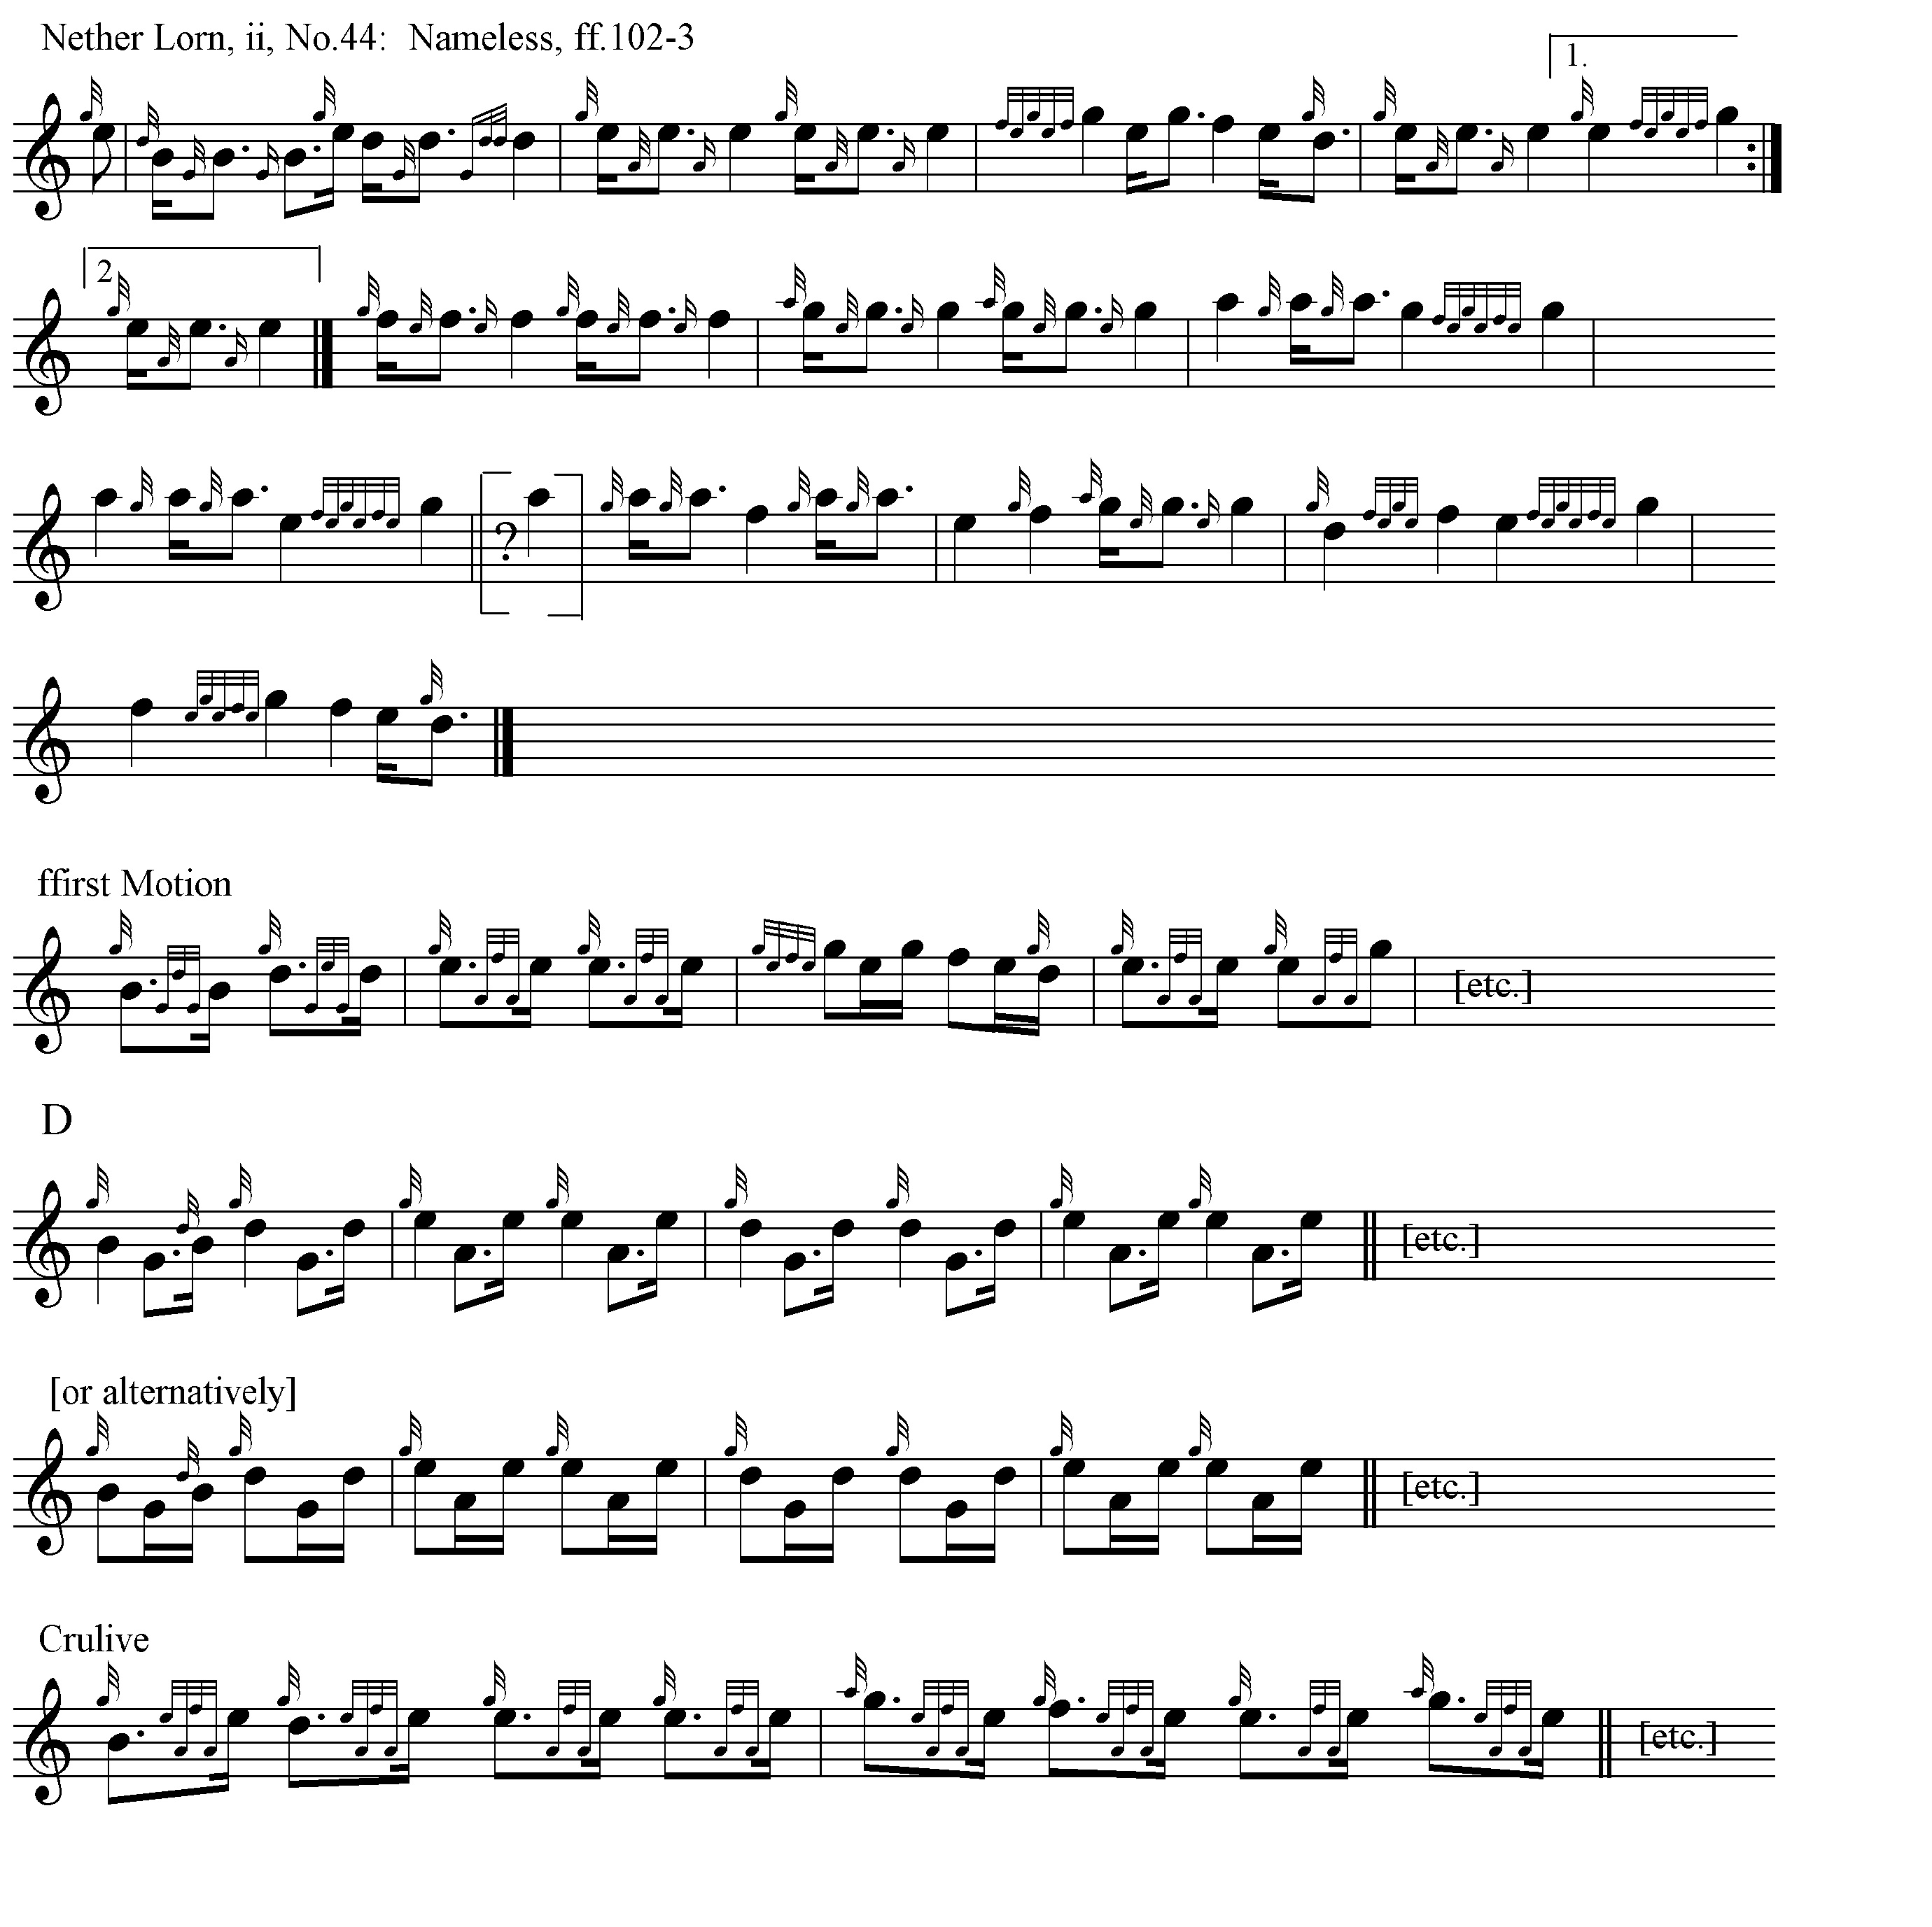
I have set the ffirst Motion above with a dotted quaver as the initial note to vary the beaten track a bit, but this could easily be “cut” the other way to produce the more usual semi-quaver/dotted quaver pattern.
No.45, clearly a variant, begins like this:
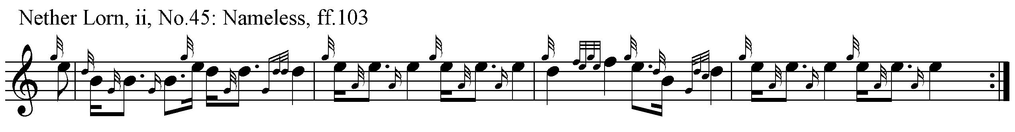
The tune continues into a first variation singling and doubling very much along the lines of the first version above, but there the it ends.

Donald MacDonald sets the tune like this:
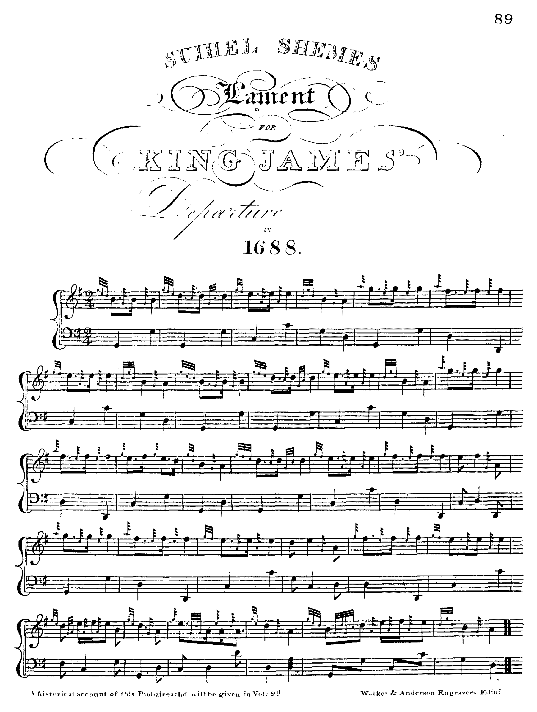

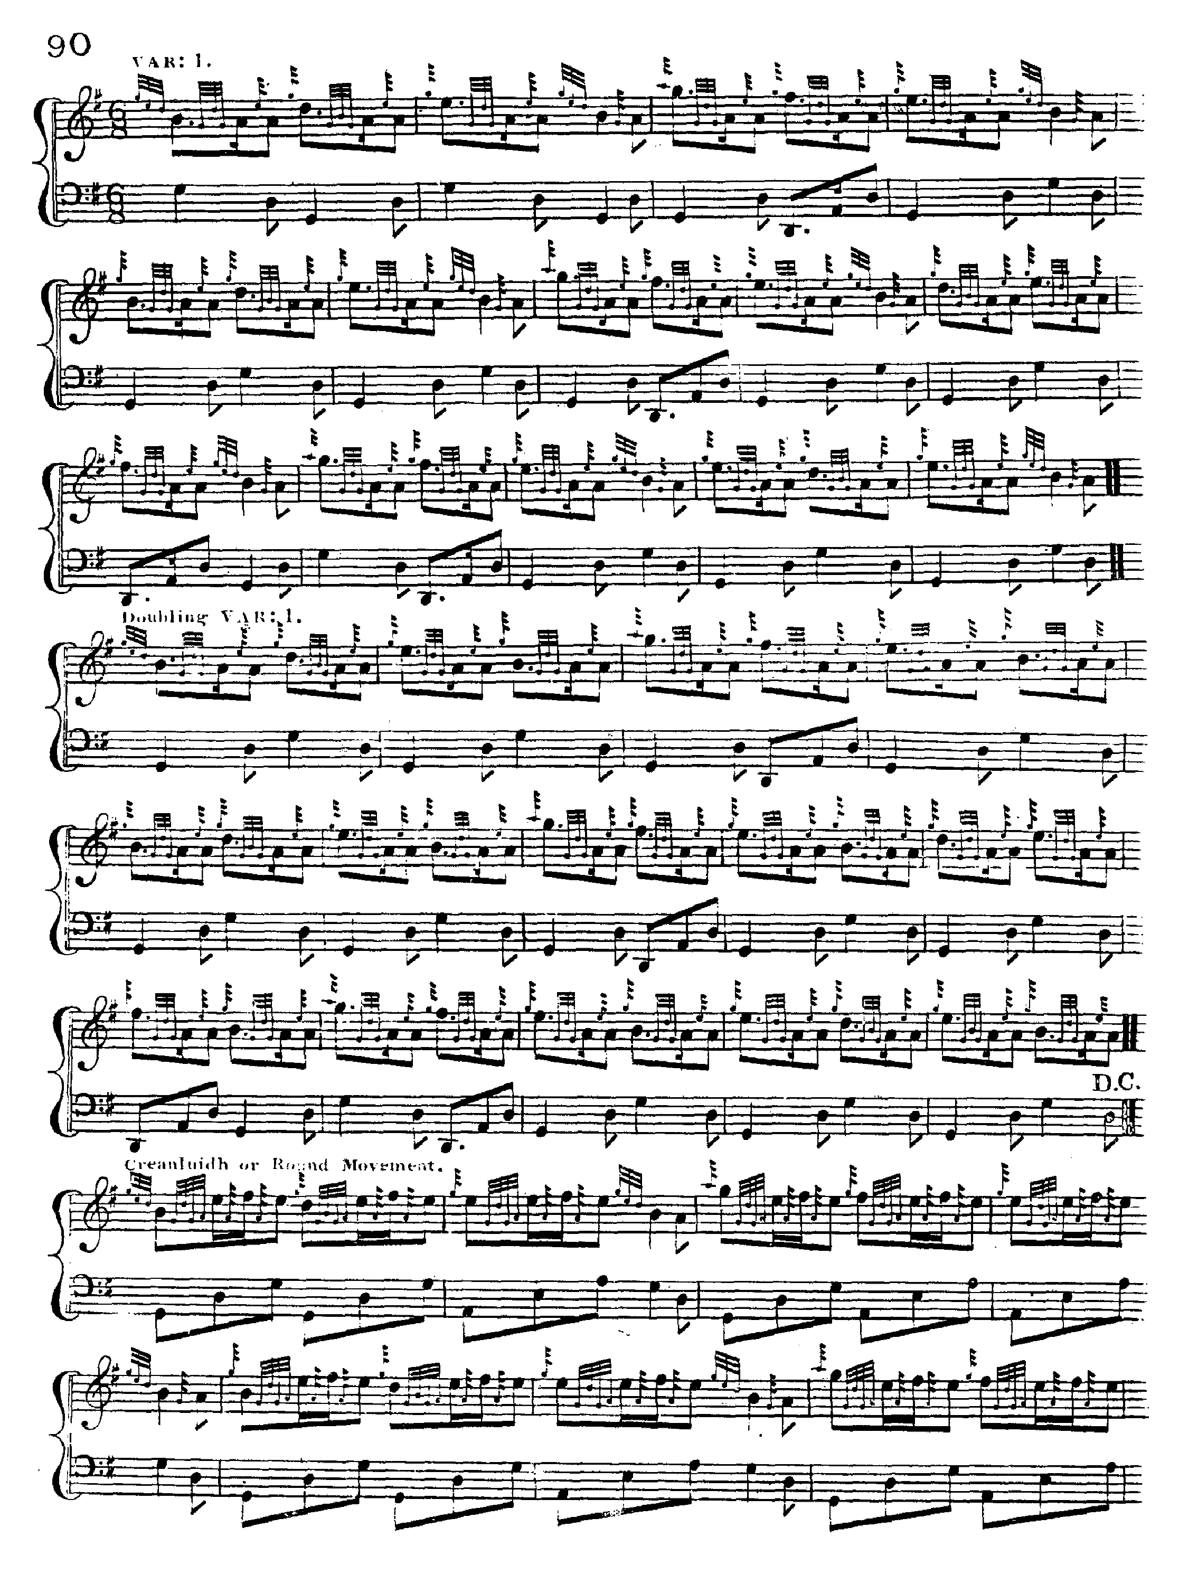

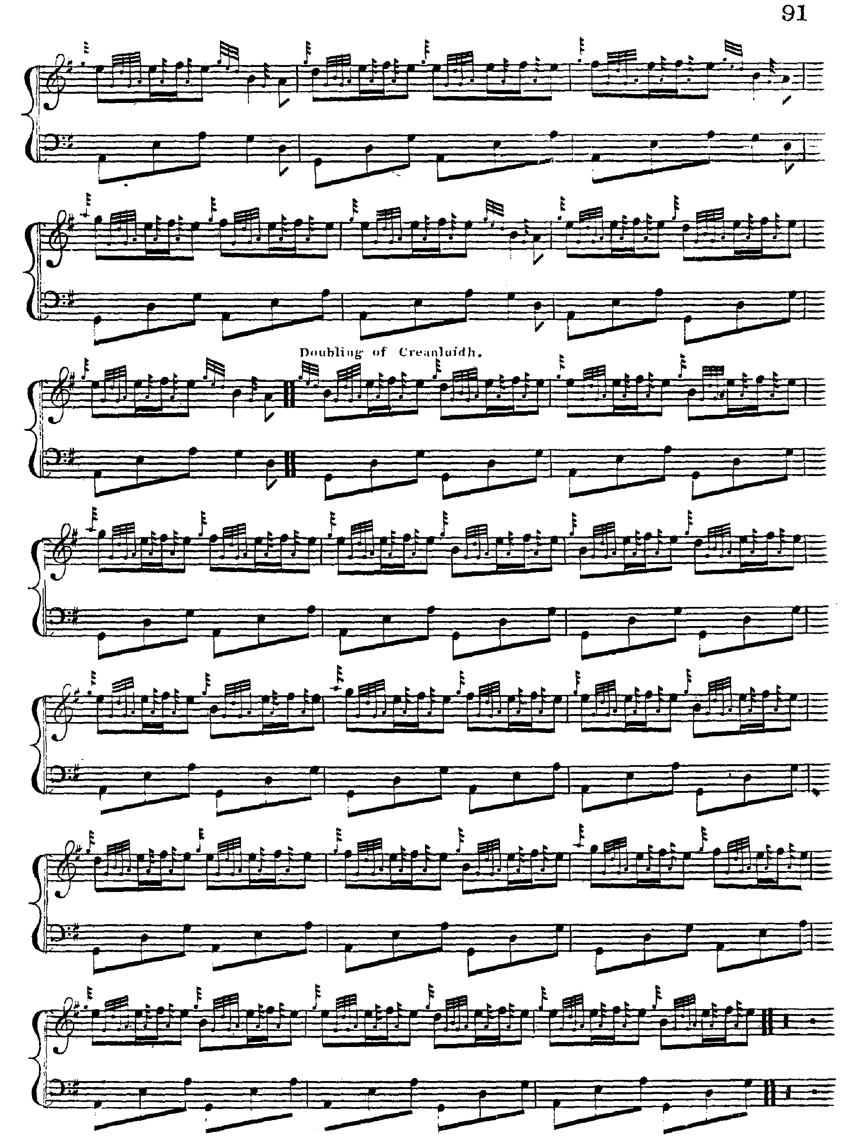
MacDonald’s ground has four lines of eight bars each. He does not have the first variation heavily ornamented by grips and throws that we see elsewhere, but proceeds directly to the taorluath singling. His variations do not exactly follow his ground, however: they are consistently a couple of bars short in the final line, settling into what to a modern ear should be a regular sixteen bar pattern, but missing bars thirteen and fourteen throughout. He repeats the ground after the taorluath but not after the crunluath doubling.
Angus MacKay sets the tune like this:
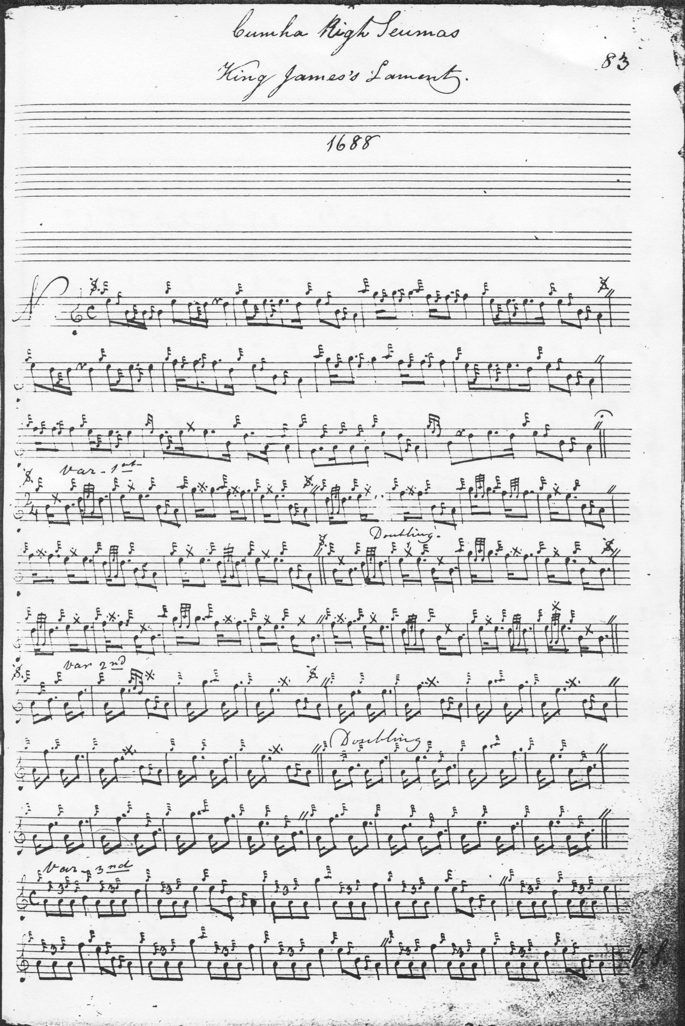
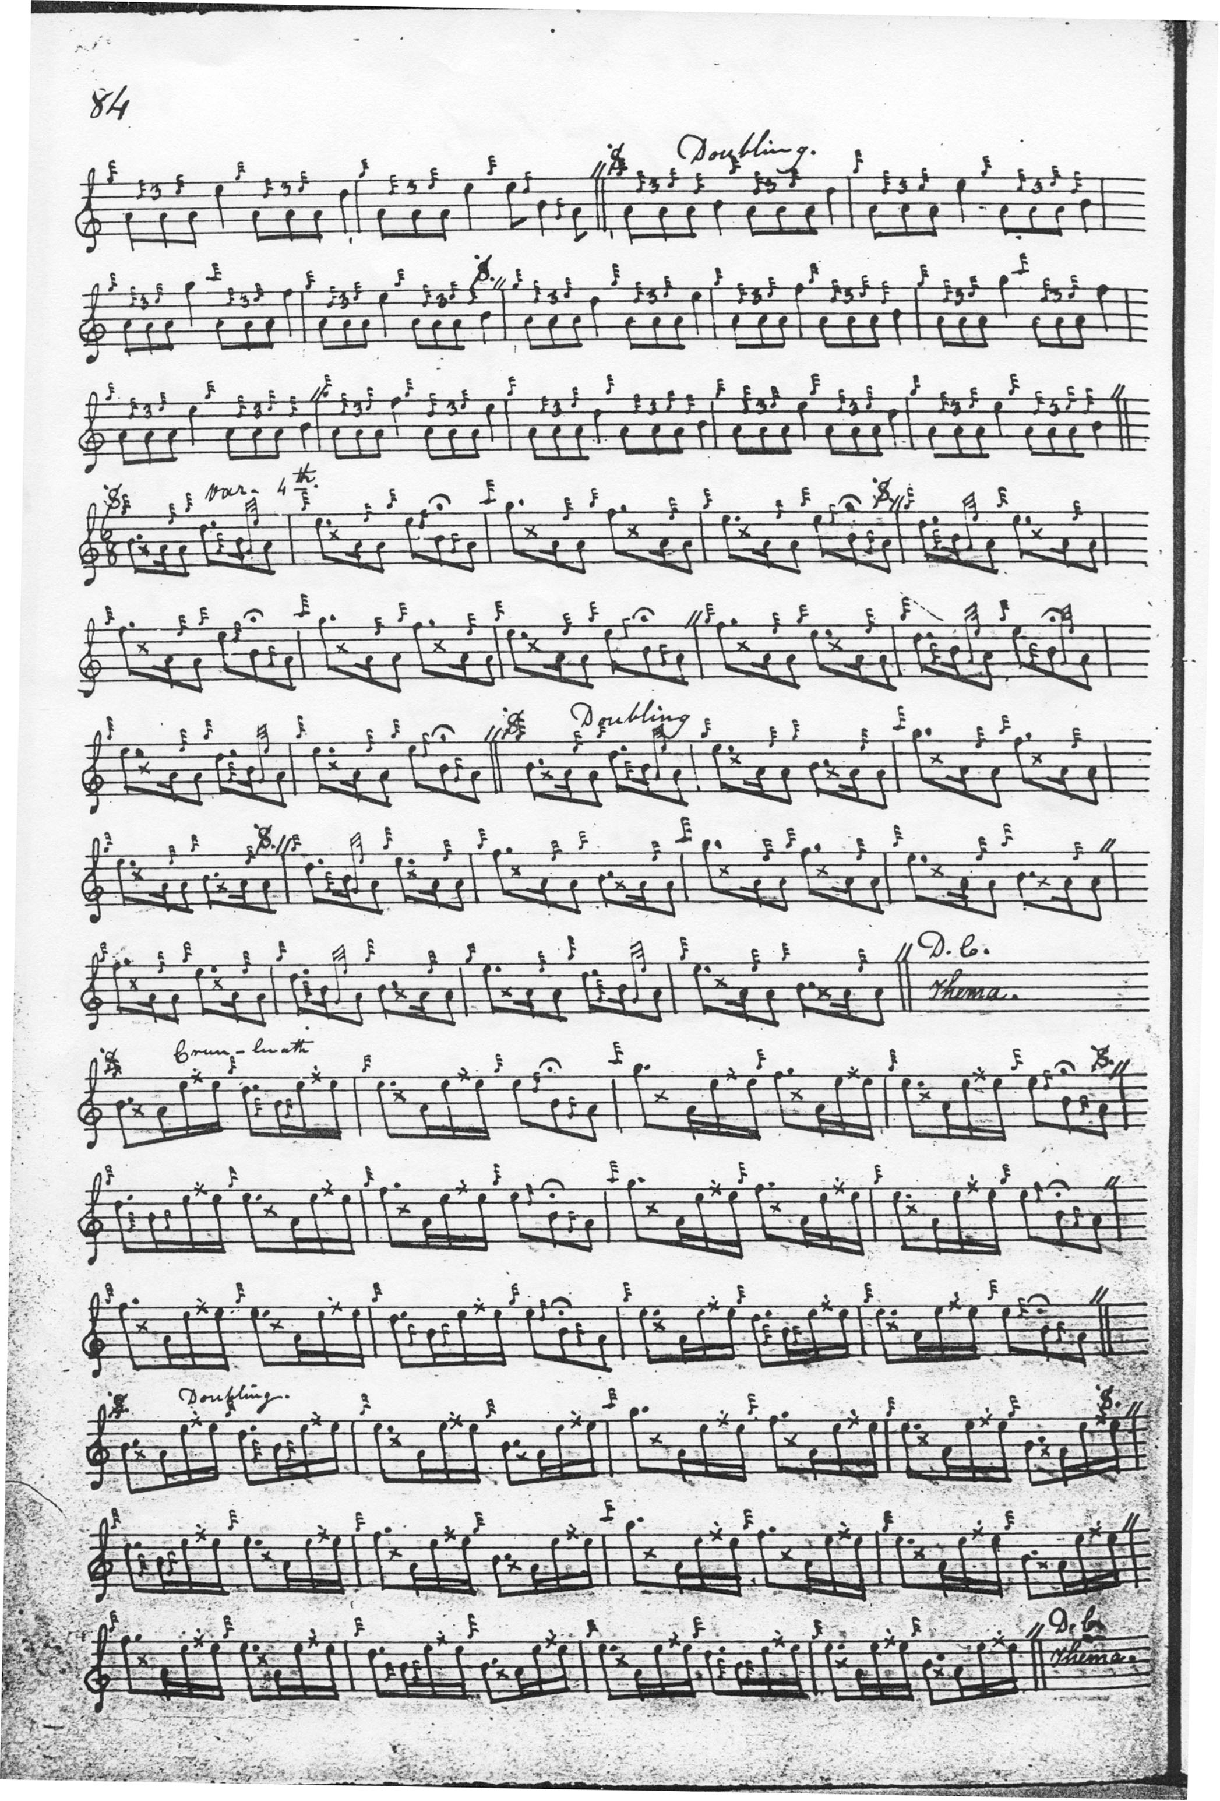
MacKay’s development of the tune is fuller than Donald MacDonald’s, showing the piece very much in its modern form, including the highly characteristic first variation with its dramatic succession of grips and throws, and the inclusion (as frequently happens in MacKay settings) of a taorluath fosgailte singling and doubling. MacKay frames the tune in the now customary four even lines of four bars each, and he indicates that the ground should be repeated after the taorluath and crunluath doublings. The third variation is oddly set, with what at first sight seem like throw symbols puzzlingly placed, but they must be intended, in this context, to represent GED cadences otherwise not indicated although the corresponding sections of the tune would seem to require their presence.
Colin Cameron’s manuscript bears a cross reference to Angus MacKay’s, but his title is different: “Suibhel Shiumais James Departure. A Lament for the departure of King James the Sixth from Scotland 1688”—(an obvious slip; this should be James VII) Other than confirming that the throw signs in the singling of the second variation are indeed cadence notes, Colin Cameron’s setting adds little to MacKay’s and is not reproduced here.
Uilleam Ross’s MS ends with the taorluath doubling and a direction to repeat the ground, noting “Crunluadh to follow: This Piobaireachd is in McDonalds Book, but not such a good set as this.” The setting is that of Angus MacKay, and since Ross adds little of significance to MacKay his score is not reproduced here.
John MacDougall Gillies adds nothing to Colin Cameron, his probable source, and his score is not reproduced here.
David Glen sets the tune like this:

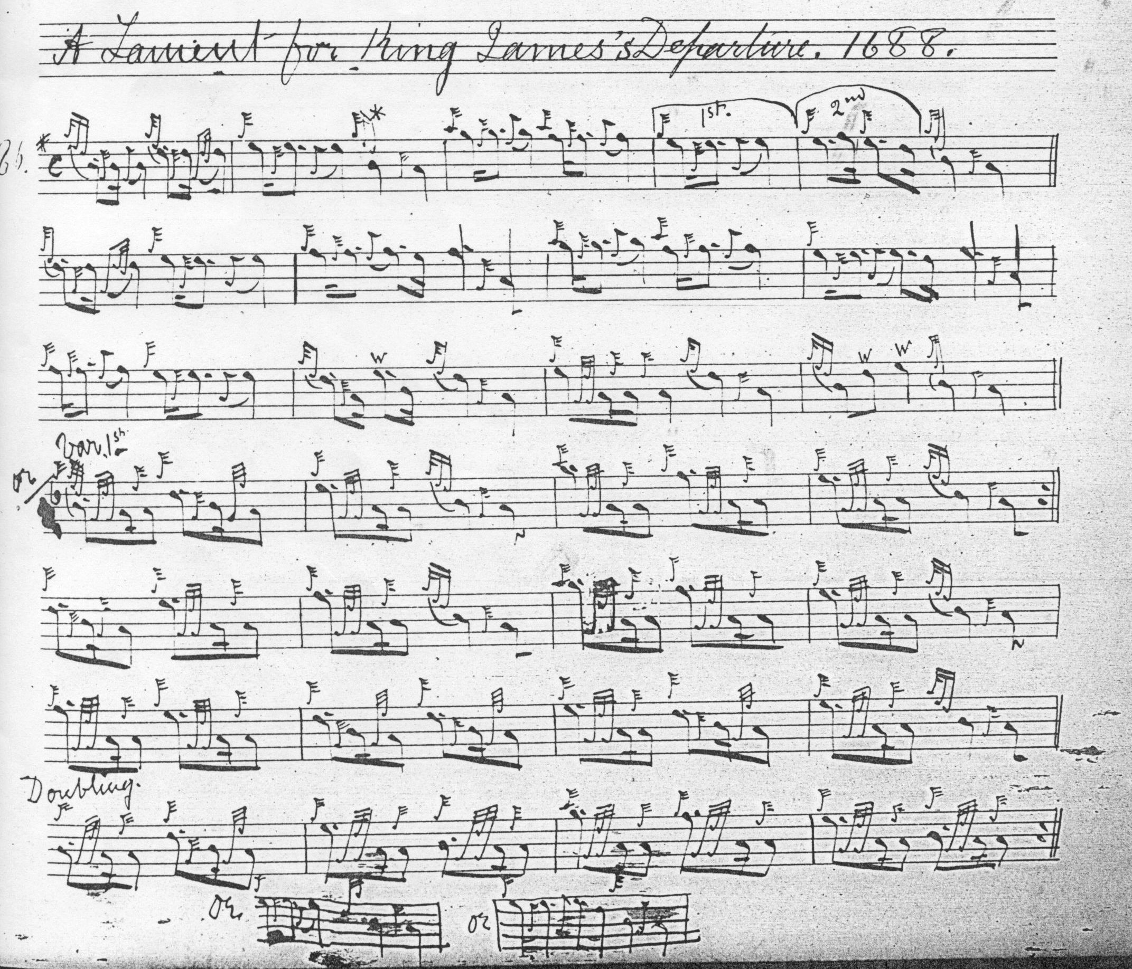
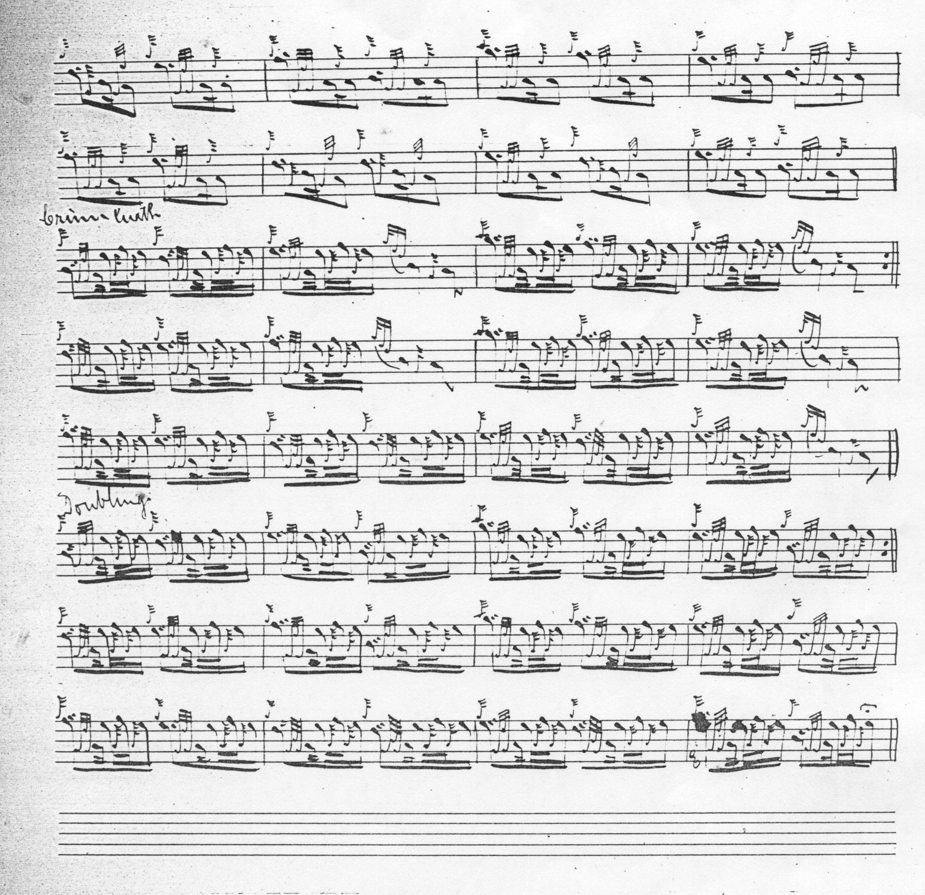

Glen follows Donald MacDonald here, although with numerous little individual touches. We note particularly his suggested alternative timings for the cadence at the end of bar two of the ground, for example. Glen also makes up MacDonald’s final line in the variations supplying the missing two bars throughout. If one wanted to play the short version of “Lament for the Departure of King James”, this unpublished setting by David Glen would have much to offer:
Donald MacPhee likewise follows Donald MacDonald in this tune. Rather interestingly in view of MacPhee’s general practice as an editor, he leaves MacDonald’s truncated fourth line in the variations un-amended. Since he adds little to MacDonald from an interpretational point of view, his score is not reproduced here.

Lt. John McLennan’s MS: has a set of notes indicating differences between MacKay’s setting of the tune and the published settings of MacDonald and MacPhee. The title given here is “King James’s Flight” and there is a headnote reading: “Variations neither in McDonalds or McPhees books”; plus an endnote “Turluath fosgailte &c + Doubling—then the same as McPhee”. This is not reproduced here.
C. S. Thomason’s setting follows Donald MacDonald, but with the missing bars supplied in MacDonald’s fourth line in the variations. Since it adds little to the interpretational possibilities of the tune, Thomason’s score is not reproduced here.

Commentary:
The ground is remarkable: a brilliant exploitation of the tonal possibilities of the chanter using a single movement. The tune is noticeable, too, for its reticence: sometimes in ceol mor what does not happen is as revealing as what does. A conventional siubhal movement singling and doubling would be perfectly possible in the first variation position, but none of the historic sources elects to play it, perhaps because the existing option with its succession of grips and throws is so much bolder and emphatic. In tonal terms what we see here is a basically rising phrase B-D-E-B answered by three falling ones high G-F-E, F-E-D, and the final phrase which hesitates on E before falling back again to the tonic with strikingly melancholy effect.
The tune is based on a single pentatonic scale, B-D-E-F-high G, and there is no dialogue with a contrasting adjacent scale as so often happens in piobaireachd, which similarly contributes to the powerful sense of concentration.
This lovely tune well illustrates Joseph MacDonald’s remarks about the characteristic tonality of laments, namely, that they nearly always avoid the third interval of the scale, how effectively they can do so is particularly apparent here.

As the note in Donald MacDonald indicates “The Lament for the Departure of King James” probably dates from the time of the so-called “Glorious Revolution” in 1688-9, and the Great Power rivalry of the period, in which king James VII was forced to abandon the throne and flee to France. Alternatively, the king James in question may be the latter’s son, “The Old Chevalier”--known to the Jacobite faithful as James VIII--and spring from the latter’s brief presence in Scotland during the Rising of 1715.
* * *

Electronic text © Dr William Donaldson, Aberdeen, Scotland, 27th June 2014

