Lament for the Dead

This tune is found in the following manuscript sources:

**--Peter Reid**’s MS, ff.50-51 (with the title “Ruaig Ben Doeg—The Rout of Bendoeg”);

**--Angus MacKay**’s MS, i, 64 (with the title “Cumha na Mairbh. Lament for the Dead.” MacKay’s MS is mispaginated at this point: he has two page 64s, and this tune occupies both of them);

**--Colin Cameron**’s MS, ff.13-14;

**--Duncan Campbell of Foss**’s MS, ff.8-10;

**--Uilleam Ross**’s MS, ff.79-82;

**--Donald Dow**’s MS, i;

**--David Glen**’s MS, ff.126-127;

and in the following published sources:

**--Uilleam Ross**, *Ross’s Collection of Pipe Music,* pp.8-10;

**--David Glen**, *Collection of Ancient Piobaireachd,* pp.212-3;

**--C. S. Thomason**, *Ceol Mor,* pp.65-6; 267;

**--G. F. Ross**, *Some Piobaireachd Studies,* p.34.

**Peter Reid** sets the tune as follows:

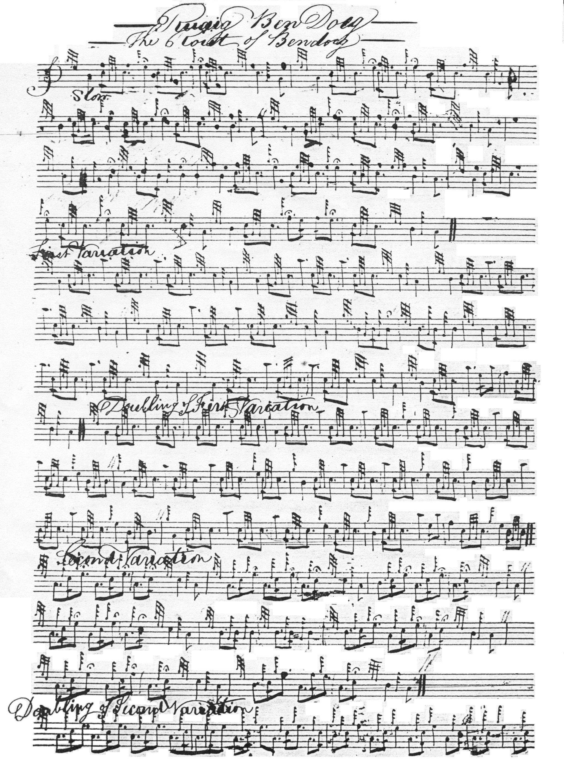

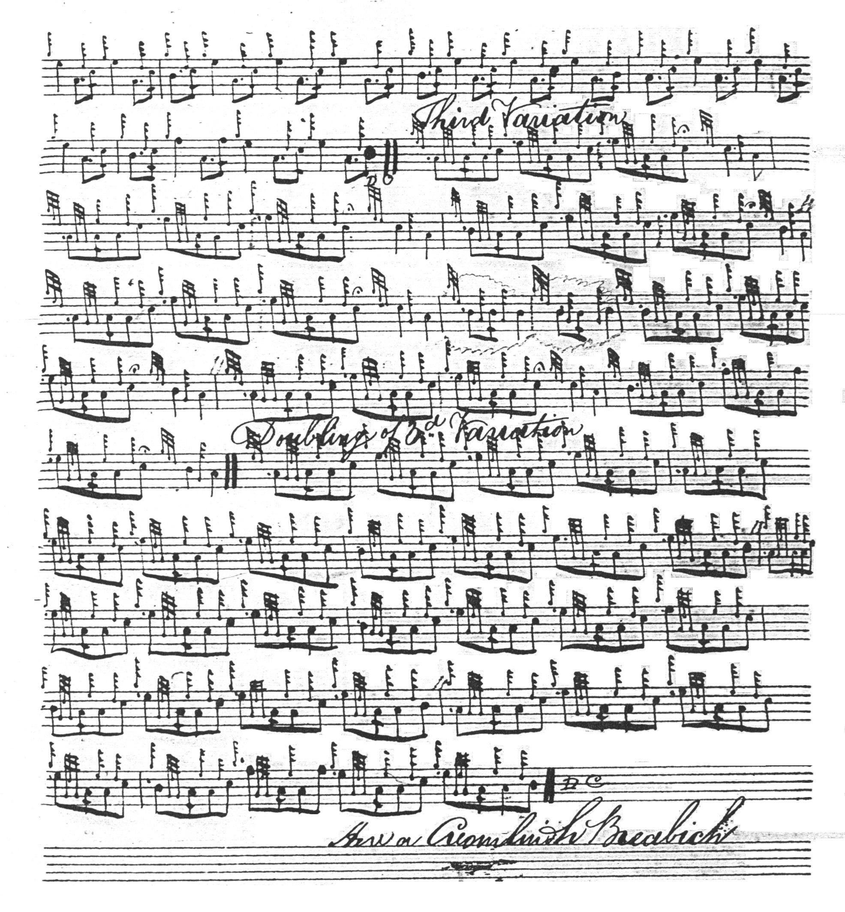

**Angus MacKay**’s setting has an alternative structure to Reid’s straightforward AAB/ABB/AB approach and many of the later manuscripts follow his style:

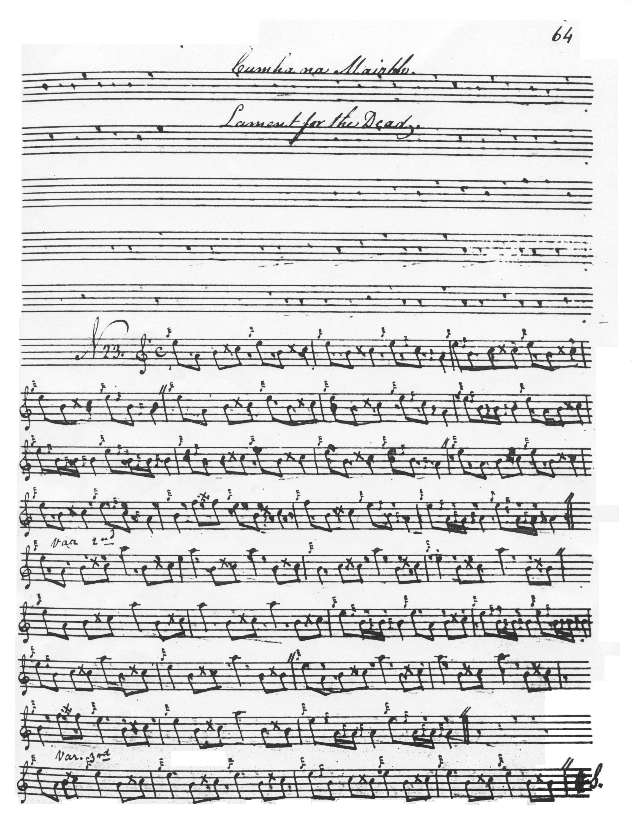

and so on.

**Duncan Campbell of Foss**’s setting also follows this route through the tune. It adds little of significance to MacKay’s score and is not reproduced here.

This is the case also with the setting in **Uilleam Ross**’s MS (although Ross does drop MacKay’s eallachs at the end of the ground and second and third variations, as he does in his published *Collection*). This score is not reproduced here. Nor is that of **Donald Dow**, which has similar features (although Dow retains MacKay’s eallachs).

**Colin Cameron**’s setting would appear to derive from MacKay, but amends the tune to make it conform to the primary form:

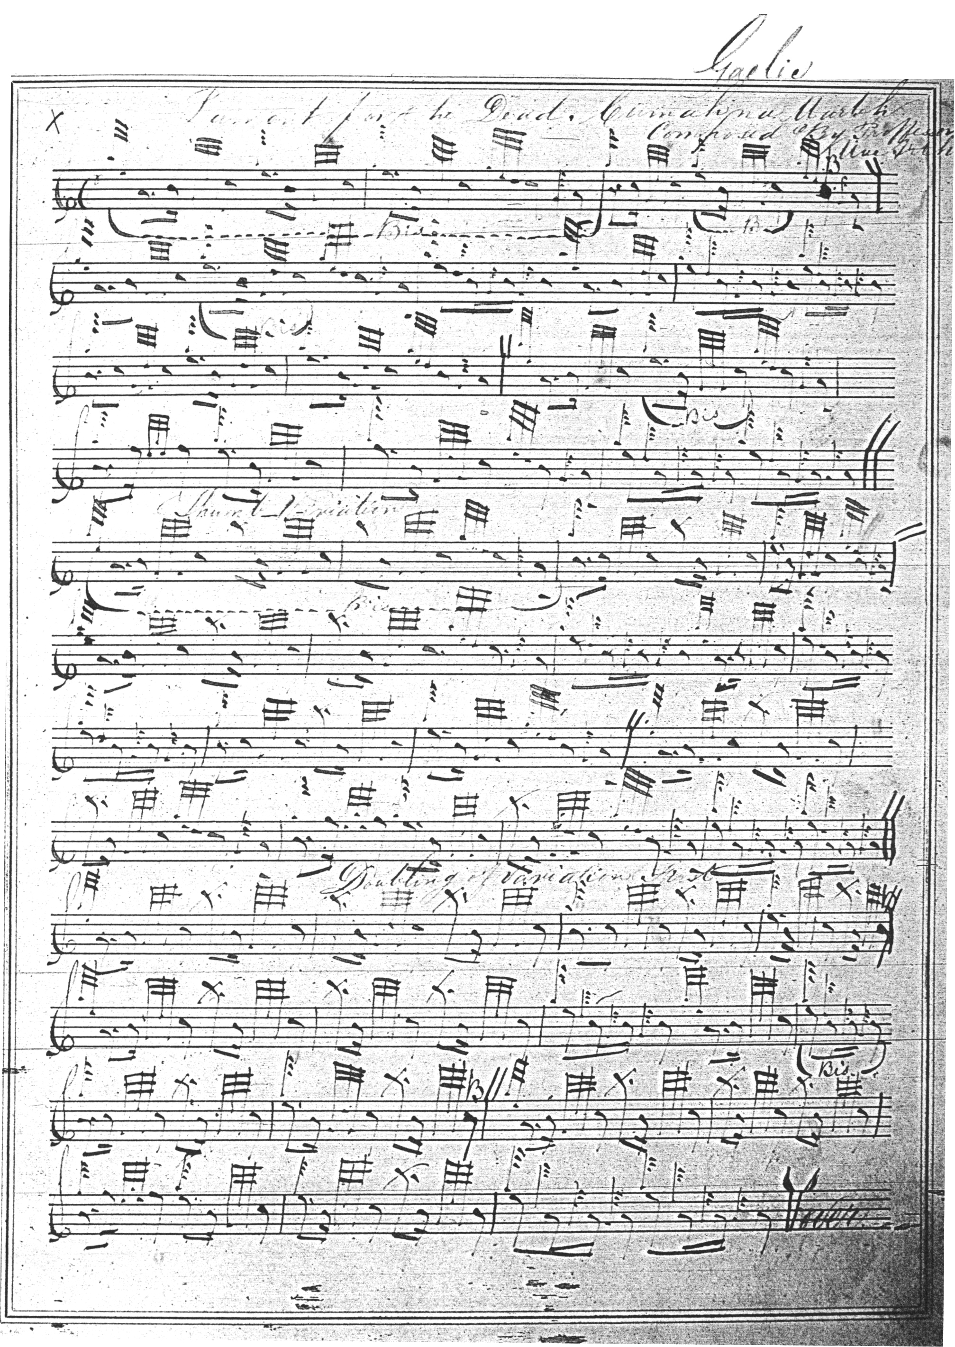

and so on.

Interestingly Cameron notes that the tune is a composition of Professor MacArthur, which would make it a fairly late piece, and perhaps account for its wide distribution in 19th century piping manuscripts, as well as the very limited textual variation visible in most of the written and printed scores.

**Uilleam Ross**'s published setting is as in MacKay's MS, except that Ross drops the eallachs at the end of the ground and first variation, and sensibly emends the B phrase in MacKay’s 3rd variation. He also includes a crunluath a mach not present in MacKay, as follows:

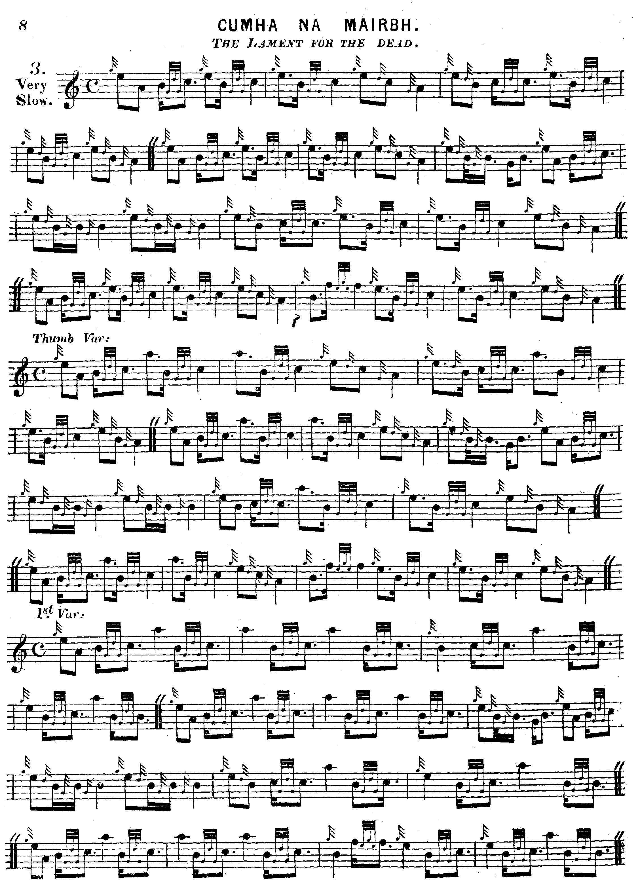

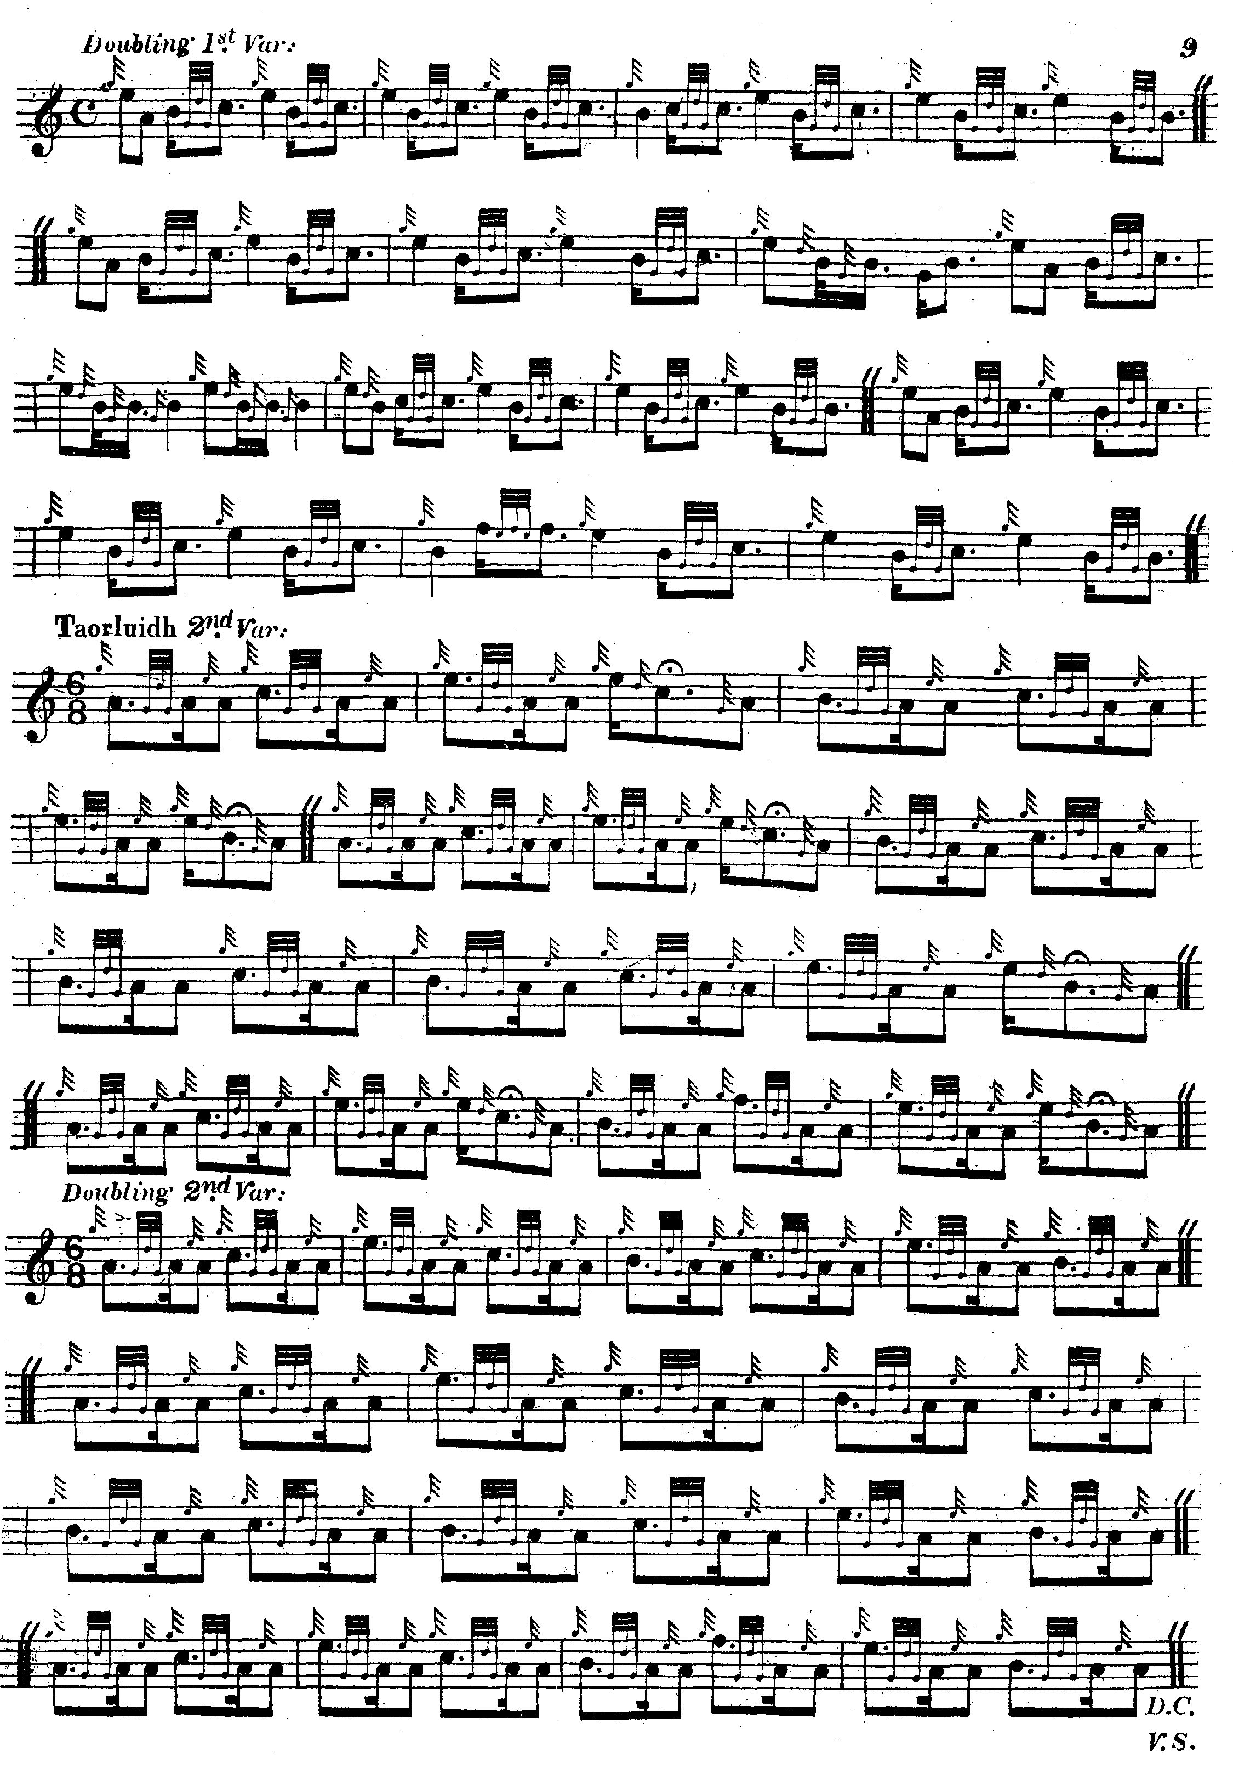

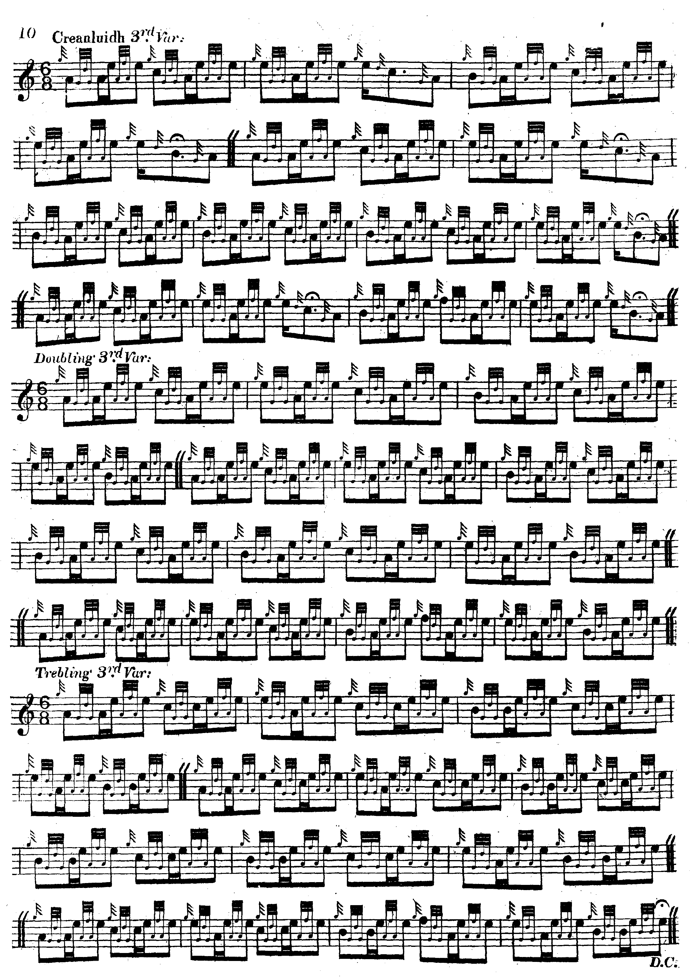

**C. S. Thomason** prints two versions of this tune, once with the title “The Rout of Bendoeg” (pp.65-6) and again with the title ‘Lament for the Dead” (p.267). The first of these settings is marked “Z” in the index, indicating a tune from an unnamed source. Thomason misses the high A’s at the beginning of his variation three, but the setting is otherwise that of Peter Reid to which the General must have had access at least at second hand, or to a source playing a very similar style:

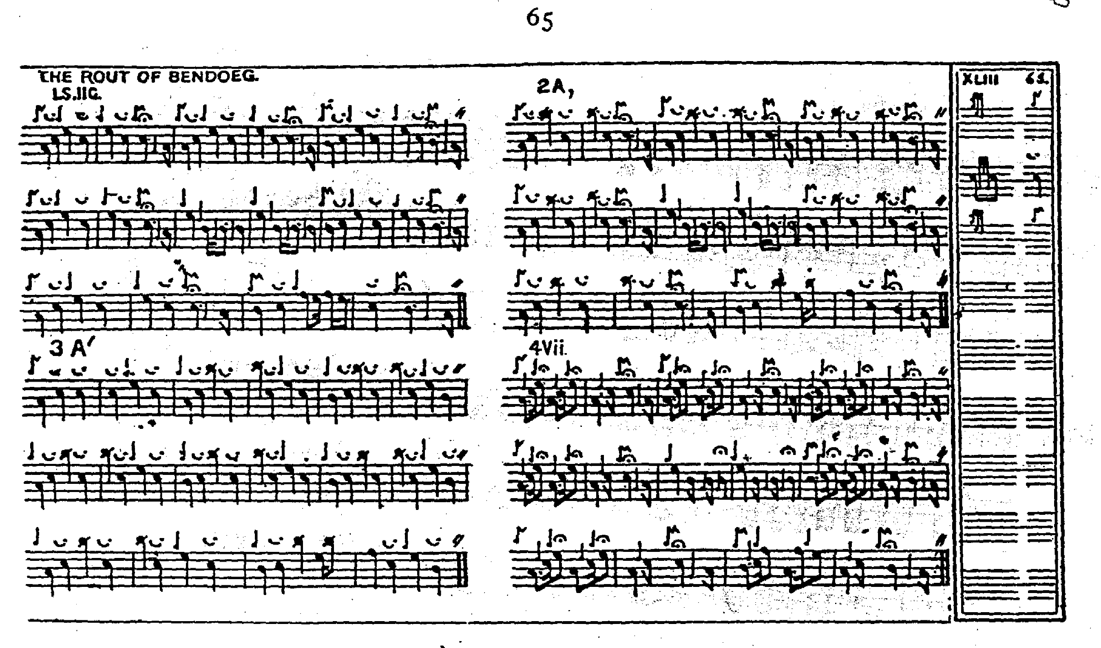

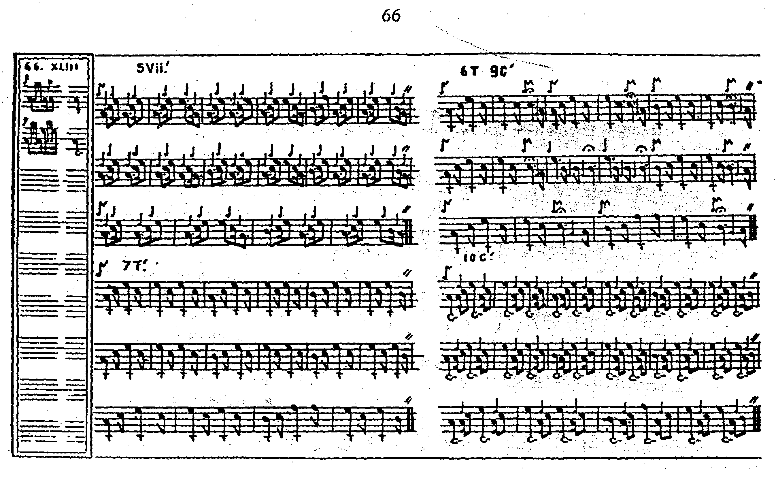

For the second of his settings, Thomason gives Angus MacKay’s MS, Uilleam Ross’s published book, and Donald MacKay, Angus’s nephew, as his sources, indicating that this was one of the tunes that Donald MacKay was directly taught by Donald Cameron. It is also marked “Ed.” indicating that Thomason had intervened editorially in the text and assumed ultimate responsibility for it:

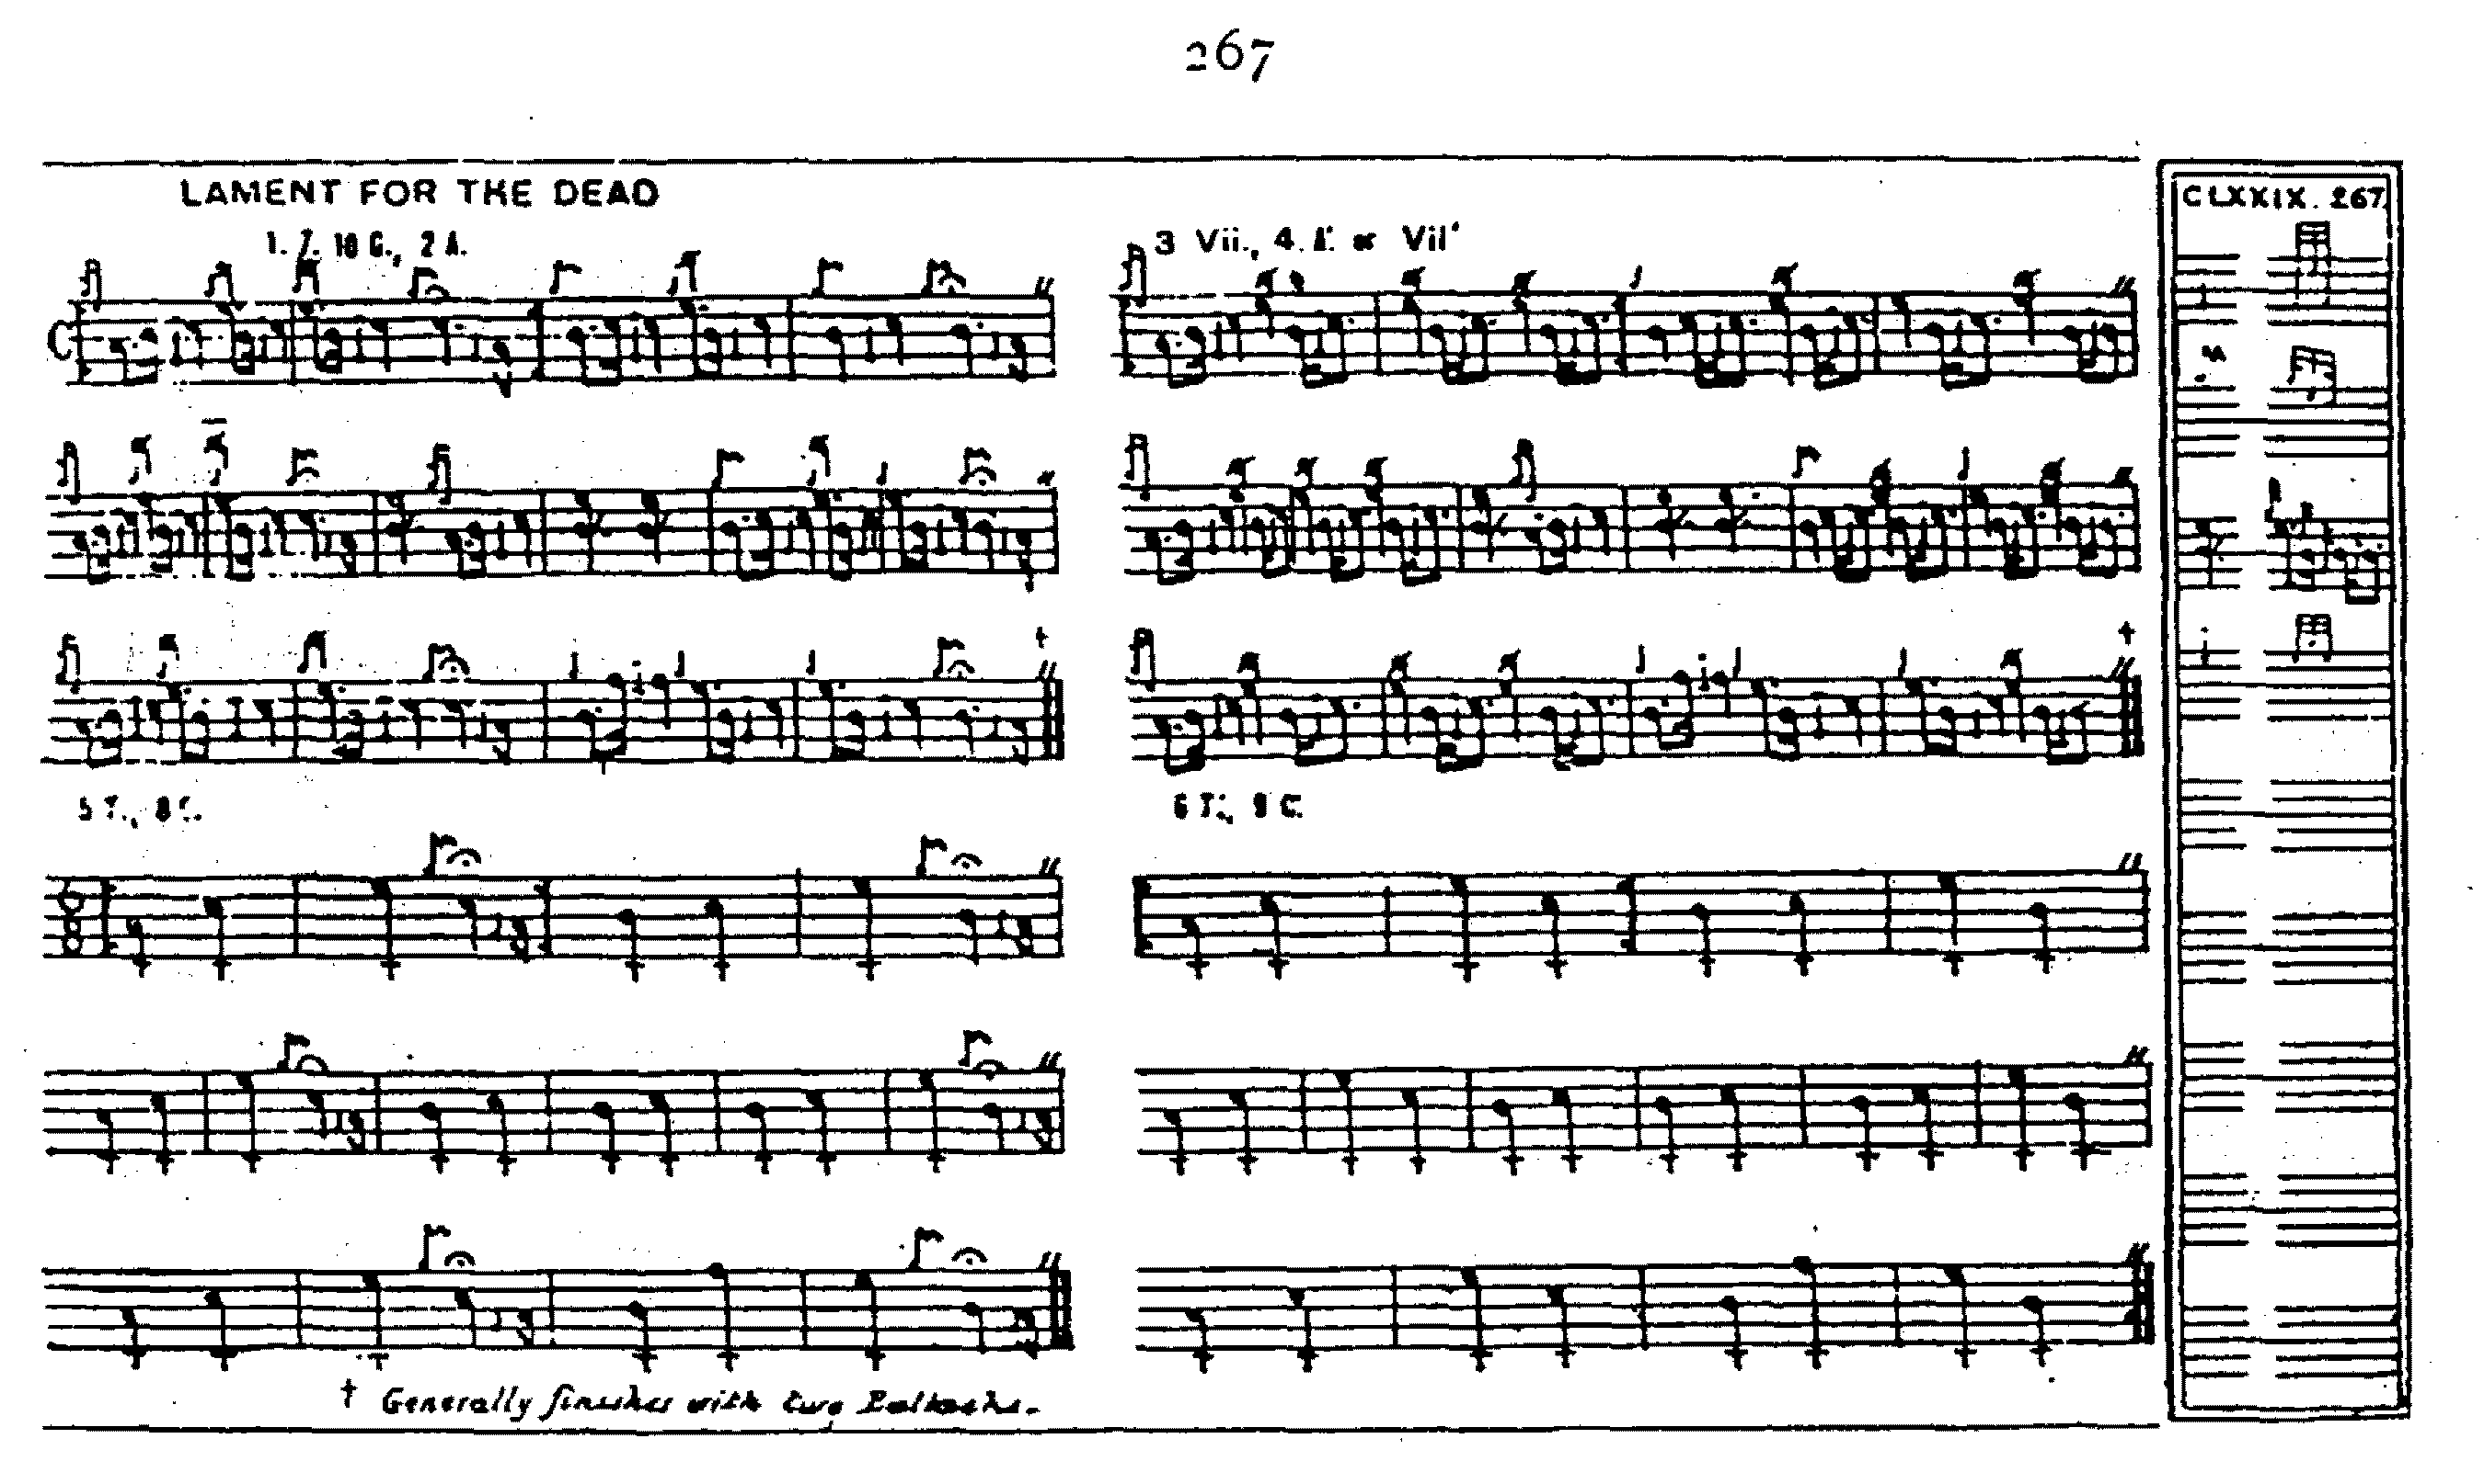

**David Glen**’s MS version is superseded by his printed setting which is reproduced below. Glen was unhappy about the structure of the tune and noted that “This Tune, as handed down, is one bar short in the measure. To render it perfect, repeat the 1st and 2nd bars of each movement and omit the last one; or play the last bar in each movement twice.” Glen set the tune as follows:

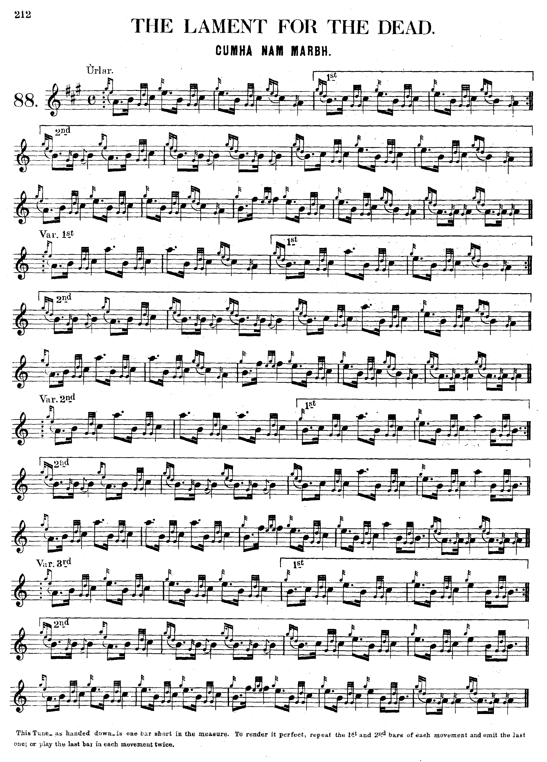

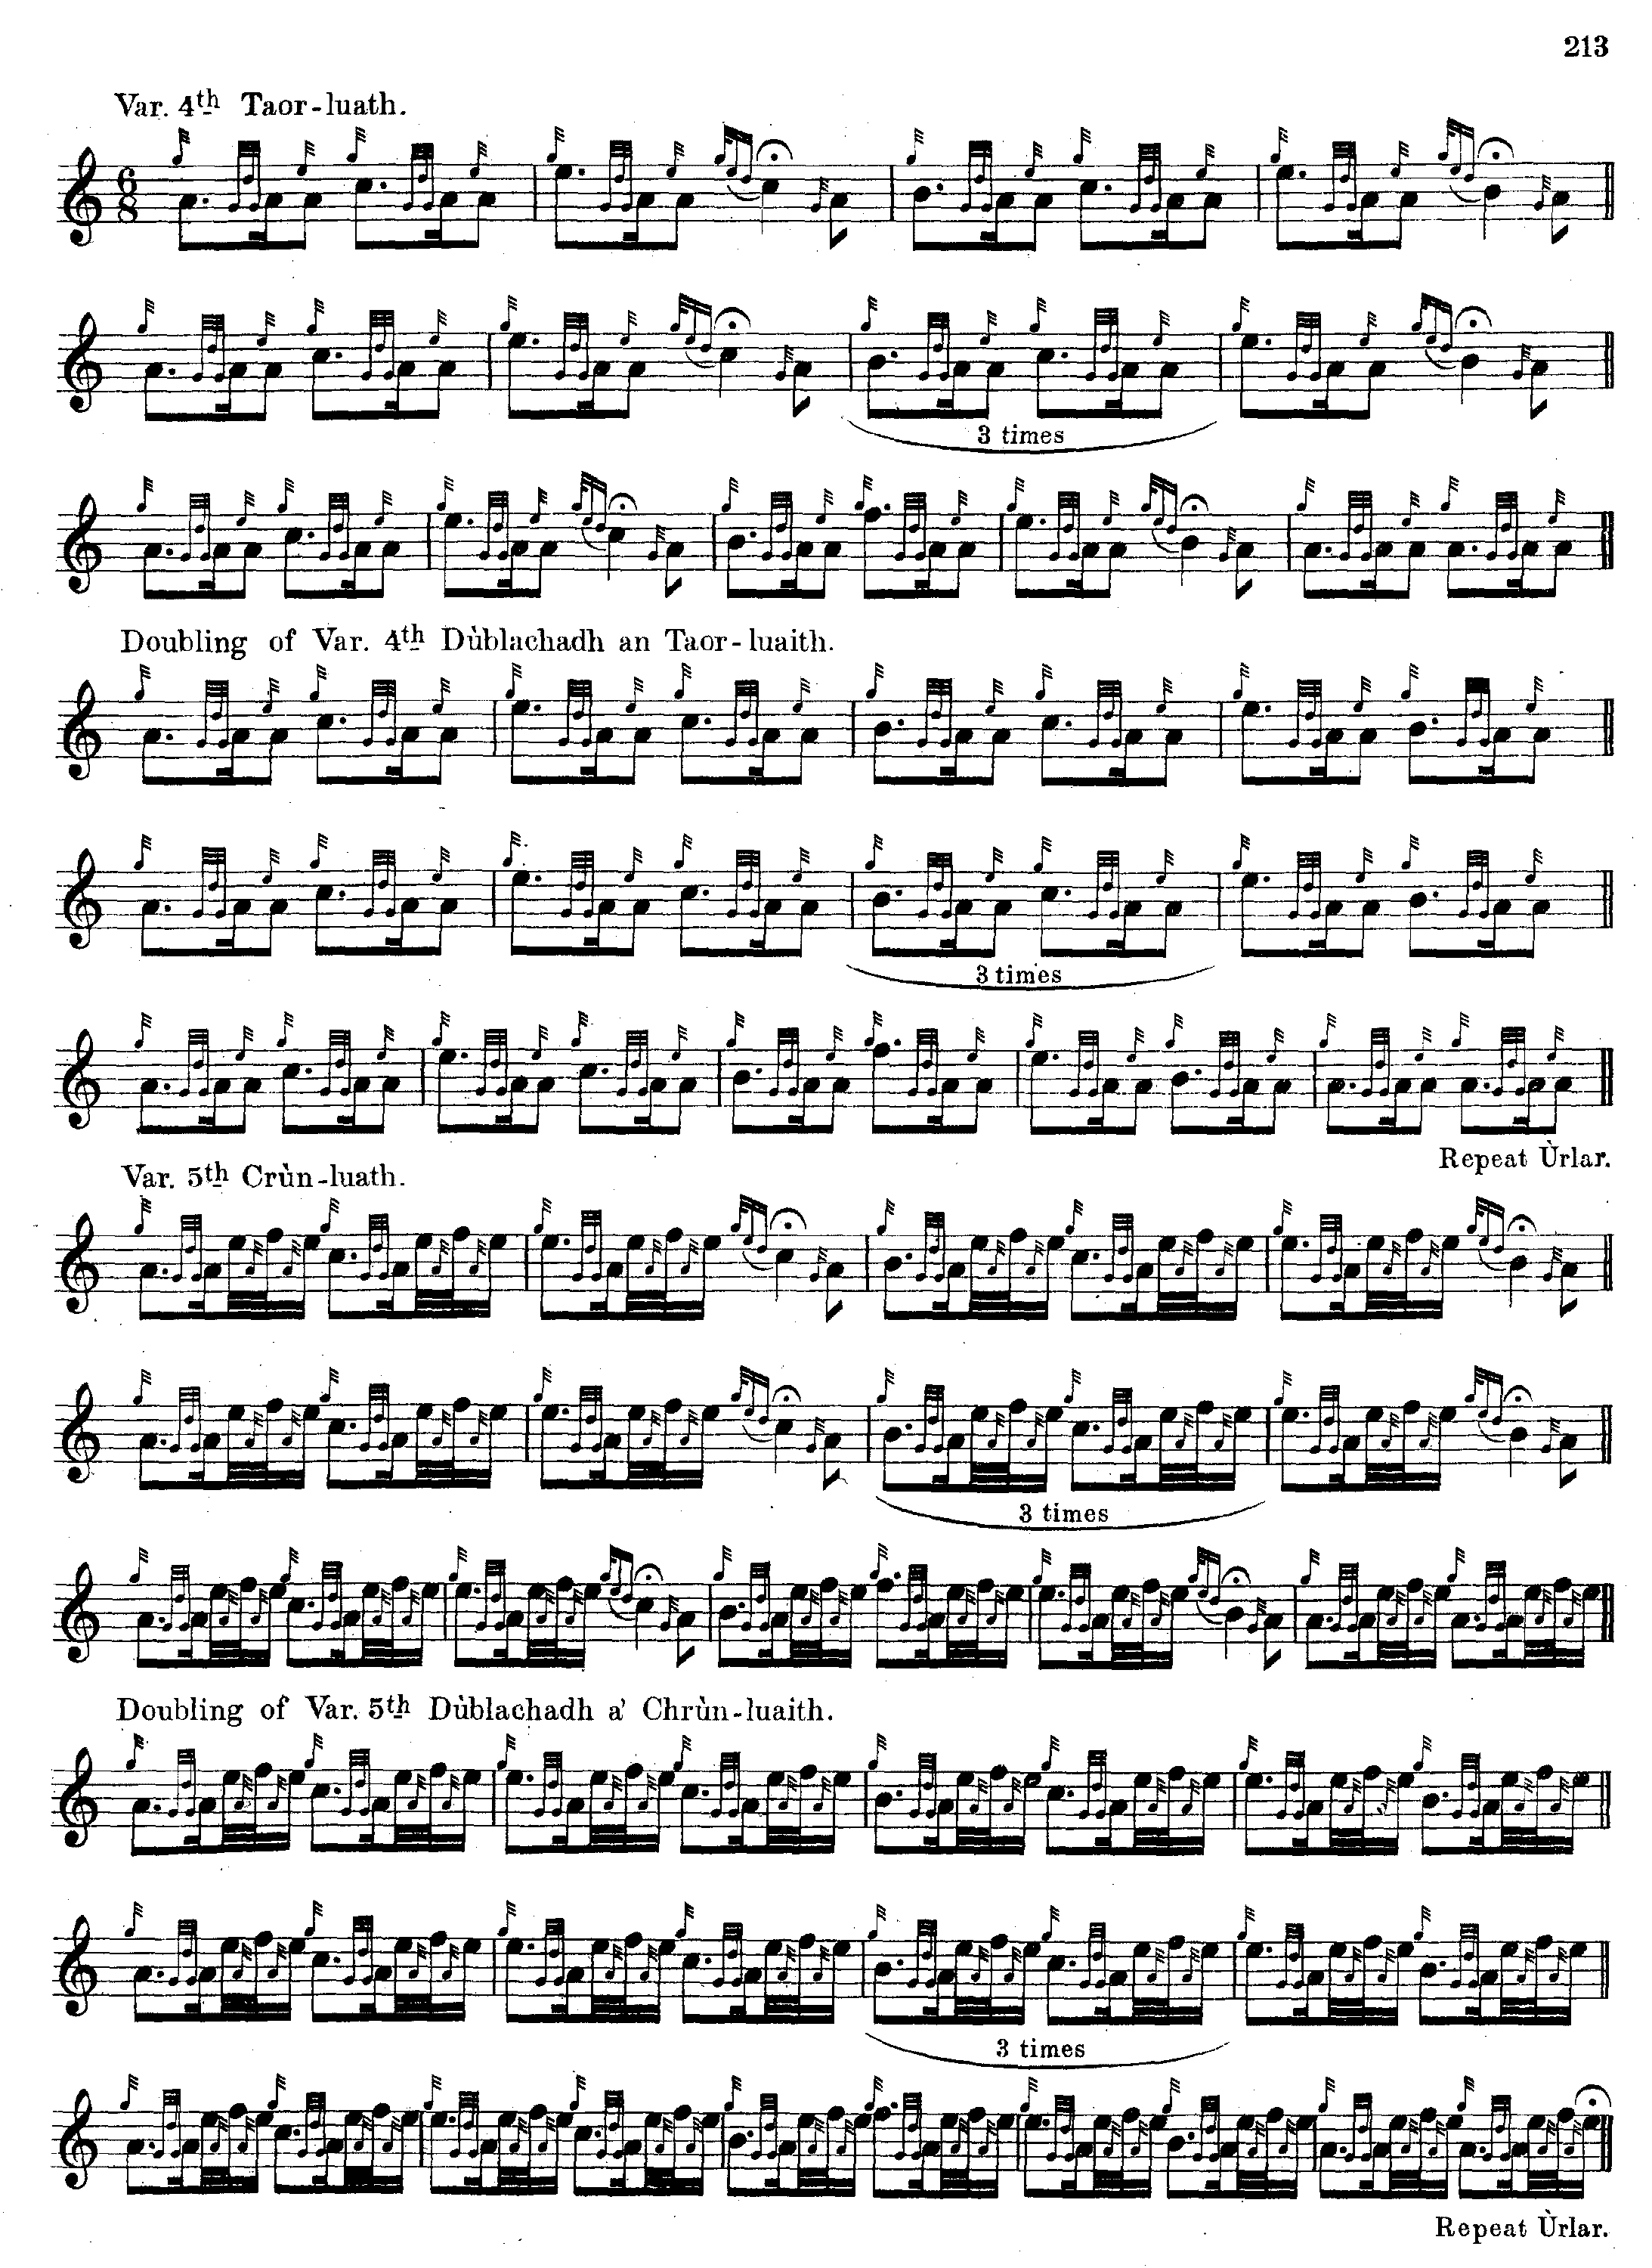

**G. F. Ross** also considered the main inherited text as structurally deficient and emended it as follows:

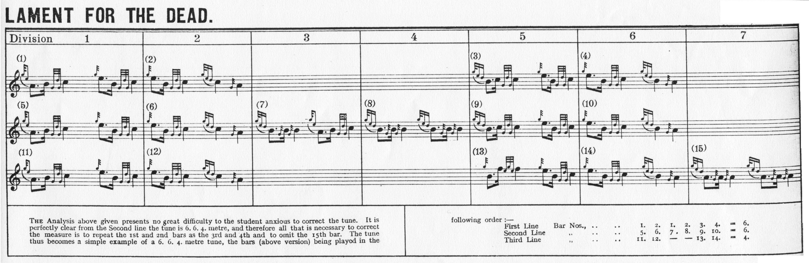

*Commentary:*

This tune was in the list of pipe-maker William Gunn at the Edinburgh competition in 1838 as follows:

**WILLIAM GUNN, Pipe-maker, Glasgow; gained 5th Prize as Piper, and 2nd Prize as Best Dressed**

Campbell of Loch Nell’s Lament Cumha Fear Ceann Loch

n’Eall

Prince’s Salute Failte a Phrionnsa

Maclachlan’s March Moladh Mairi

Battle of Glentarff Blar Ghlentarbh

Retreat of Bendoig Ruaidoig

Otherwise, little is known of the history or context of this piece. In his note in the “Historic, Biographic and Legendary Notes to the Tunes” attached to David Glen’s *Collection of Ancient Piobaireachd,* Fionn says: “There is little or no information extant regarding this tune, or who composed it. It probably is a tune that was played at ordinary funerals when there was no special tune associated with the family to which the deceased belonged.” p.19.

There is a Ben Toaig near Bridge of Orchy.

Set in 4/4 as it commonly is, and played at characteristically languourous modern tempi, “The Lament for the Dead” must be one of the dullest tunes in the repertory. It might be smart move to offer it in competition always. They would give you the medal on the spot just to get you to stop and go away. A time-signature in 6/8 and a brisk aggressive attack would seem one obvious solution.

* * *

Electronic text © Dr William Donaldson, Aberdeen, Scotland, March 2009