Craigellachie

There are settings of this tune in the following manuscript source:

--**Colin Campbell**’s “Nether Lorn Canntaireachd”, i, 102-6; (with the title “Craig Charan”);

and in the following published sources:

--**Donald MacDonald**, *Ancient Martial Music,* pp.61-67 (with a note: “Craigillachy The Grants’ Gathering. Craigillachy, a Mountain in Strathspey, has been Considered from Time Immemorial As a kind of rallying point of the Clan Grant”);

--**Angus MacKay**, *Ancient Piobaireachd,* pp.33-36;

--**C. S. Thomason**, *Ceol Mor,* pp. 3-4;

--**David Glen**, *Ancient Piobaireachd,* pp. 167-9;

--**William Stewart**, et.al., eds., *Piobaireachd Society Collection* (first series), i, 12-15;

**Colin Campbell** sets the tune like this:

1st. Hindorodin chedre hiodin hiodrorodin hedale hioem cherede che

heedrehe hindorodin chedre hiodin, heedrehe cheotrodro hiodrorodin

hedaleoem

2d. Cherede che heedrehe hindorodin chedre hiodin hiodrorodin hedale

hioem daren dorodin chedre hiodin heedreche cheotrodro hiodrorodin

hedale hioem

3d. Cheredeche heedrehe hindorodin chedre hiodin dili he cheotrodro

hiodrorodin hedale hioem

S ffirst Motion

1st. Hindo hindo cheho cheen hiodrohindo emdanhem chedre chedre heeheo

hindo hindo cheho cheen heedreve cheodrodin hiodro hindoemdanhem [etc]

D 1st. Hindo hindo hinde hindo hinto hindo hinde himto, hinde hinde

hindhe hindhe hindo hindo hinde hindo hindhe hindhe hinde hindo hinto

hindo hinde himto [etc.]

Second Motion

1st Hindaendo hindaendo hindaende hindaendo hindaento hindaendo

hindende himdaemto, hindaende hindaende hindaendhe hindaendhe

hindaendo hindaendo hindaende hindaendo hindaendhe hindaendhe

hindaende hindaendo hindaento hindaendo hindaende himdaemto [etc]

S Taolive

1st. Hodarid hodarid chedarid hodin, hiodarid hodarid chedarid hioem,

chedarid chedarid hedarid hedarid hodarid hodarid chedarid hodin,

hedarid hedarid chedarid hodarid hiodarid hodarid chedarid hioem

[etc.]

D 1st. Hodarid hodarid chedarid hodarid, hiodarid hodarid chedarid

hiodarem, Chedarid chedarid hedarid hedarid hodarid hodarid chedarid

hodarid, hedarid hedarid chedarid hodarid hiodarid hodarid chedarid

hiodarem

2d. Chedarid chedarid hedarid hedarid hodarid hodarid chedarid

hodarid, hiodarid hodarid chedarid hiodarem, hodarid hodarid chedarid

hodarid, hedarid hedarid chedarid hodarid hiodarid hodarid chedarid

hiodarem,

3rd. Chedarid chedarid hedarid hedarid hodarid hodarid chedarid

hodarid Idarid hedarid chedarid hodarid hiodarid hodarid chedarid

hiodarem

S Crulive

1st. Hobandre hobandre chebandre hodin, hiobandre hobandre chebandre

hioem, chebandre chebandre hebandre hebandre hobandre hobandre

chebandre hodin, hebandre hebandre chebandre hobandre hiobandre

hobandre chebandre hioem [etc]

D 1st. Hobandre hobandre chebandre hobandre, hiobandre hobandre

chebandre hiobarem [hiobamdre?], chebandre chebandre hebandre hebandre

hobandre hobandre chebandre hobandre hebandre hebandre chebandre

hobandre hiobandre hobandre chebandre hiobamdre [etc.]

DD Strulive

1st. Hodrodre hodrodre chebandre hodrodre, hiotrodre hodrodre

chebandre hiotrodre chebandre chebandre hebandre hebandre hodrodre

hodrodre chebandre hodrodre, hebandre hebandre chebandre hodrodre

hiotrodre hodrodre chebandre hiotrodre, [etc.]

**Donald MacDonald** marks his Ground “Very Slow”. He treats the tune as follows:

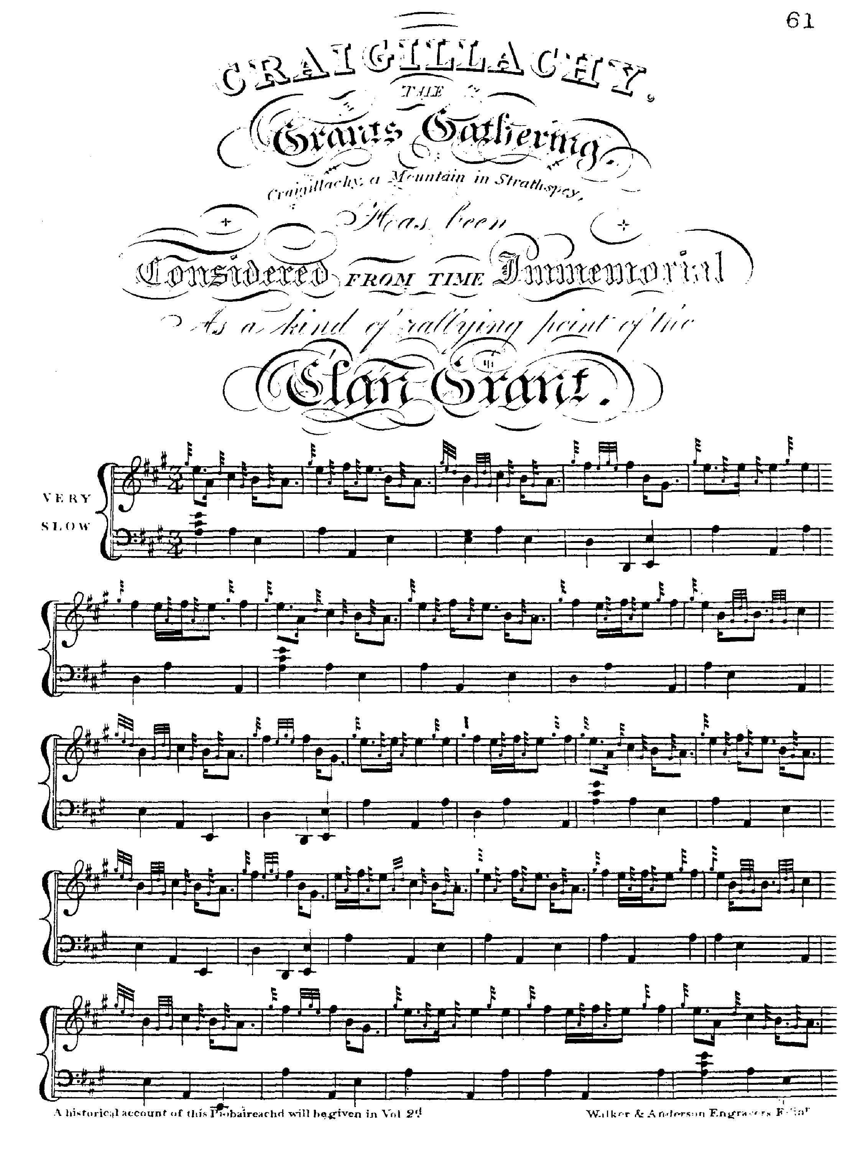

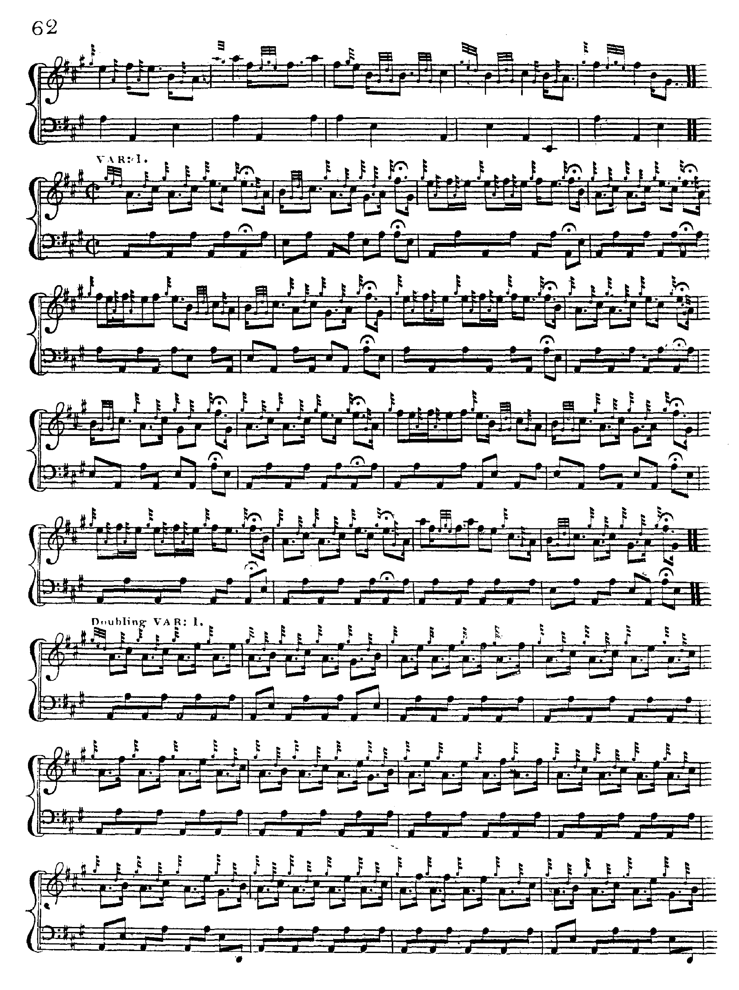

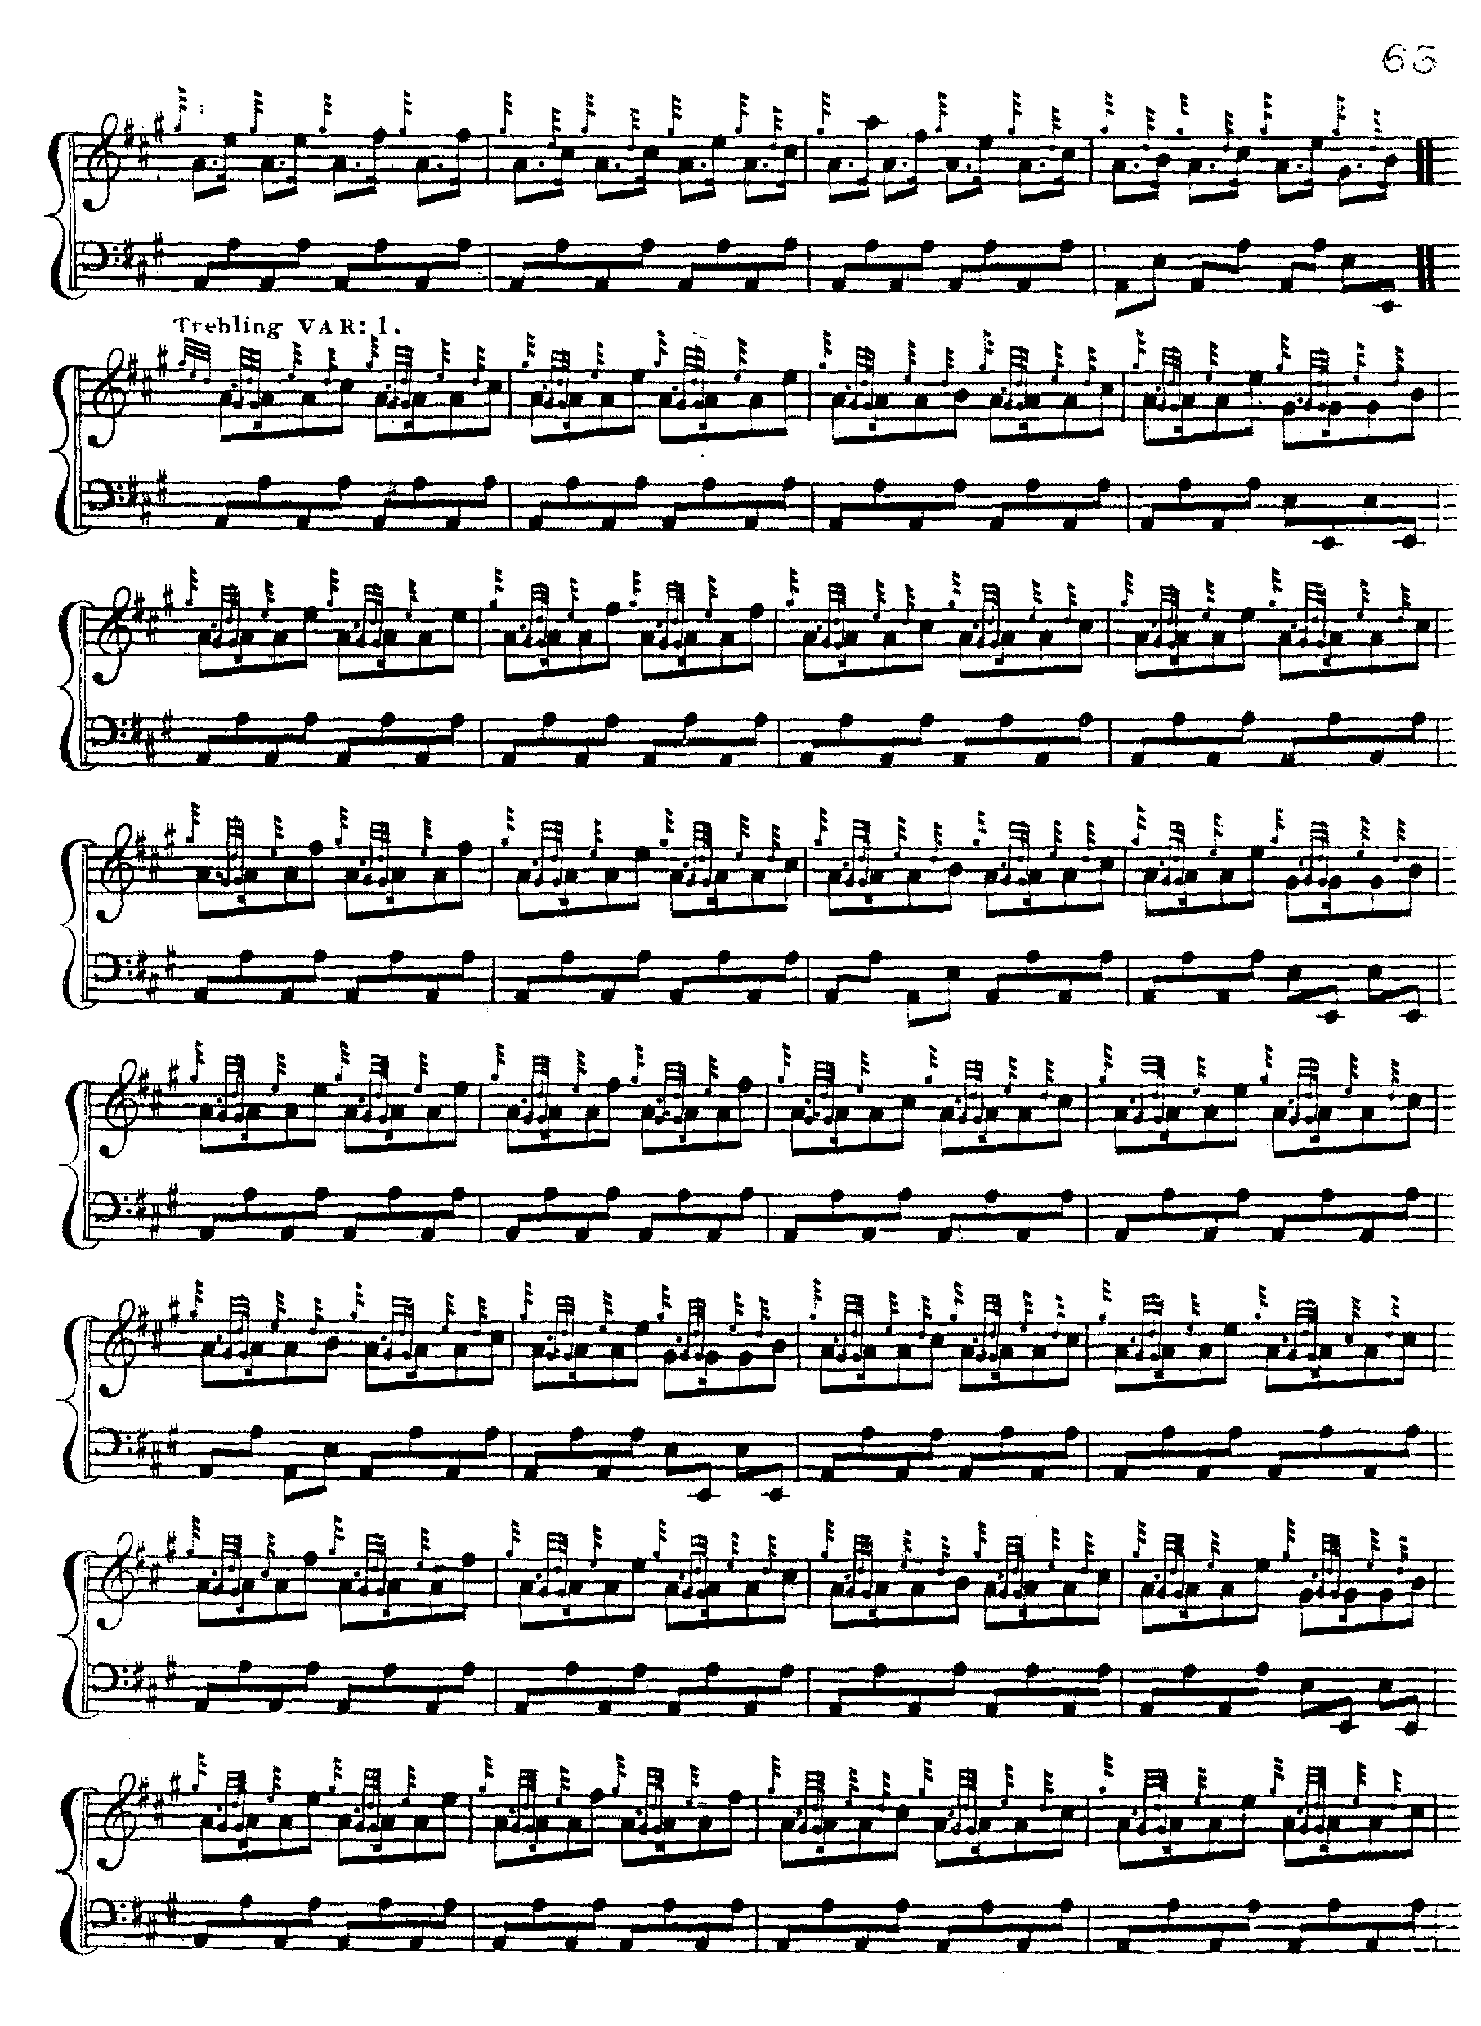

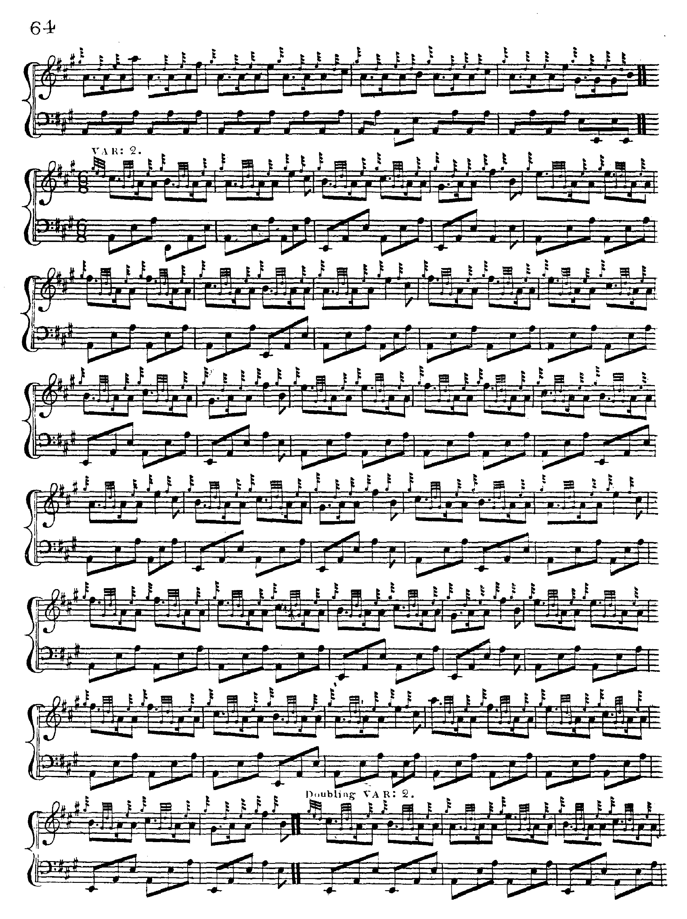

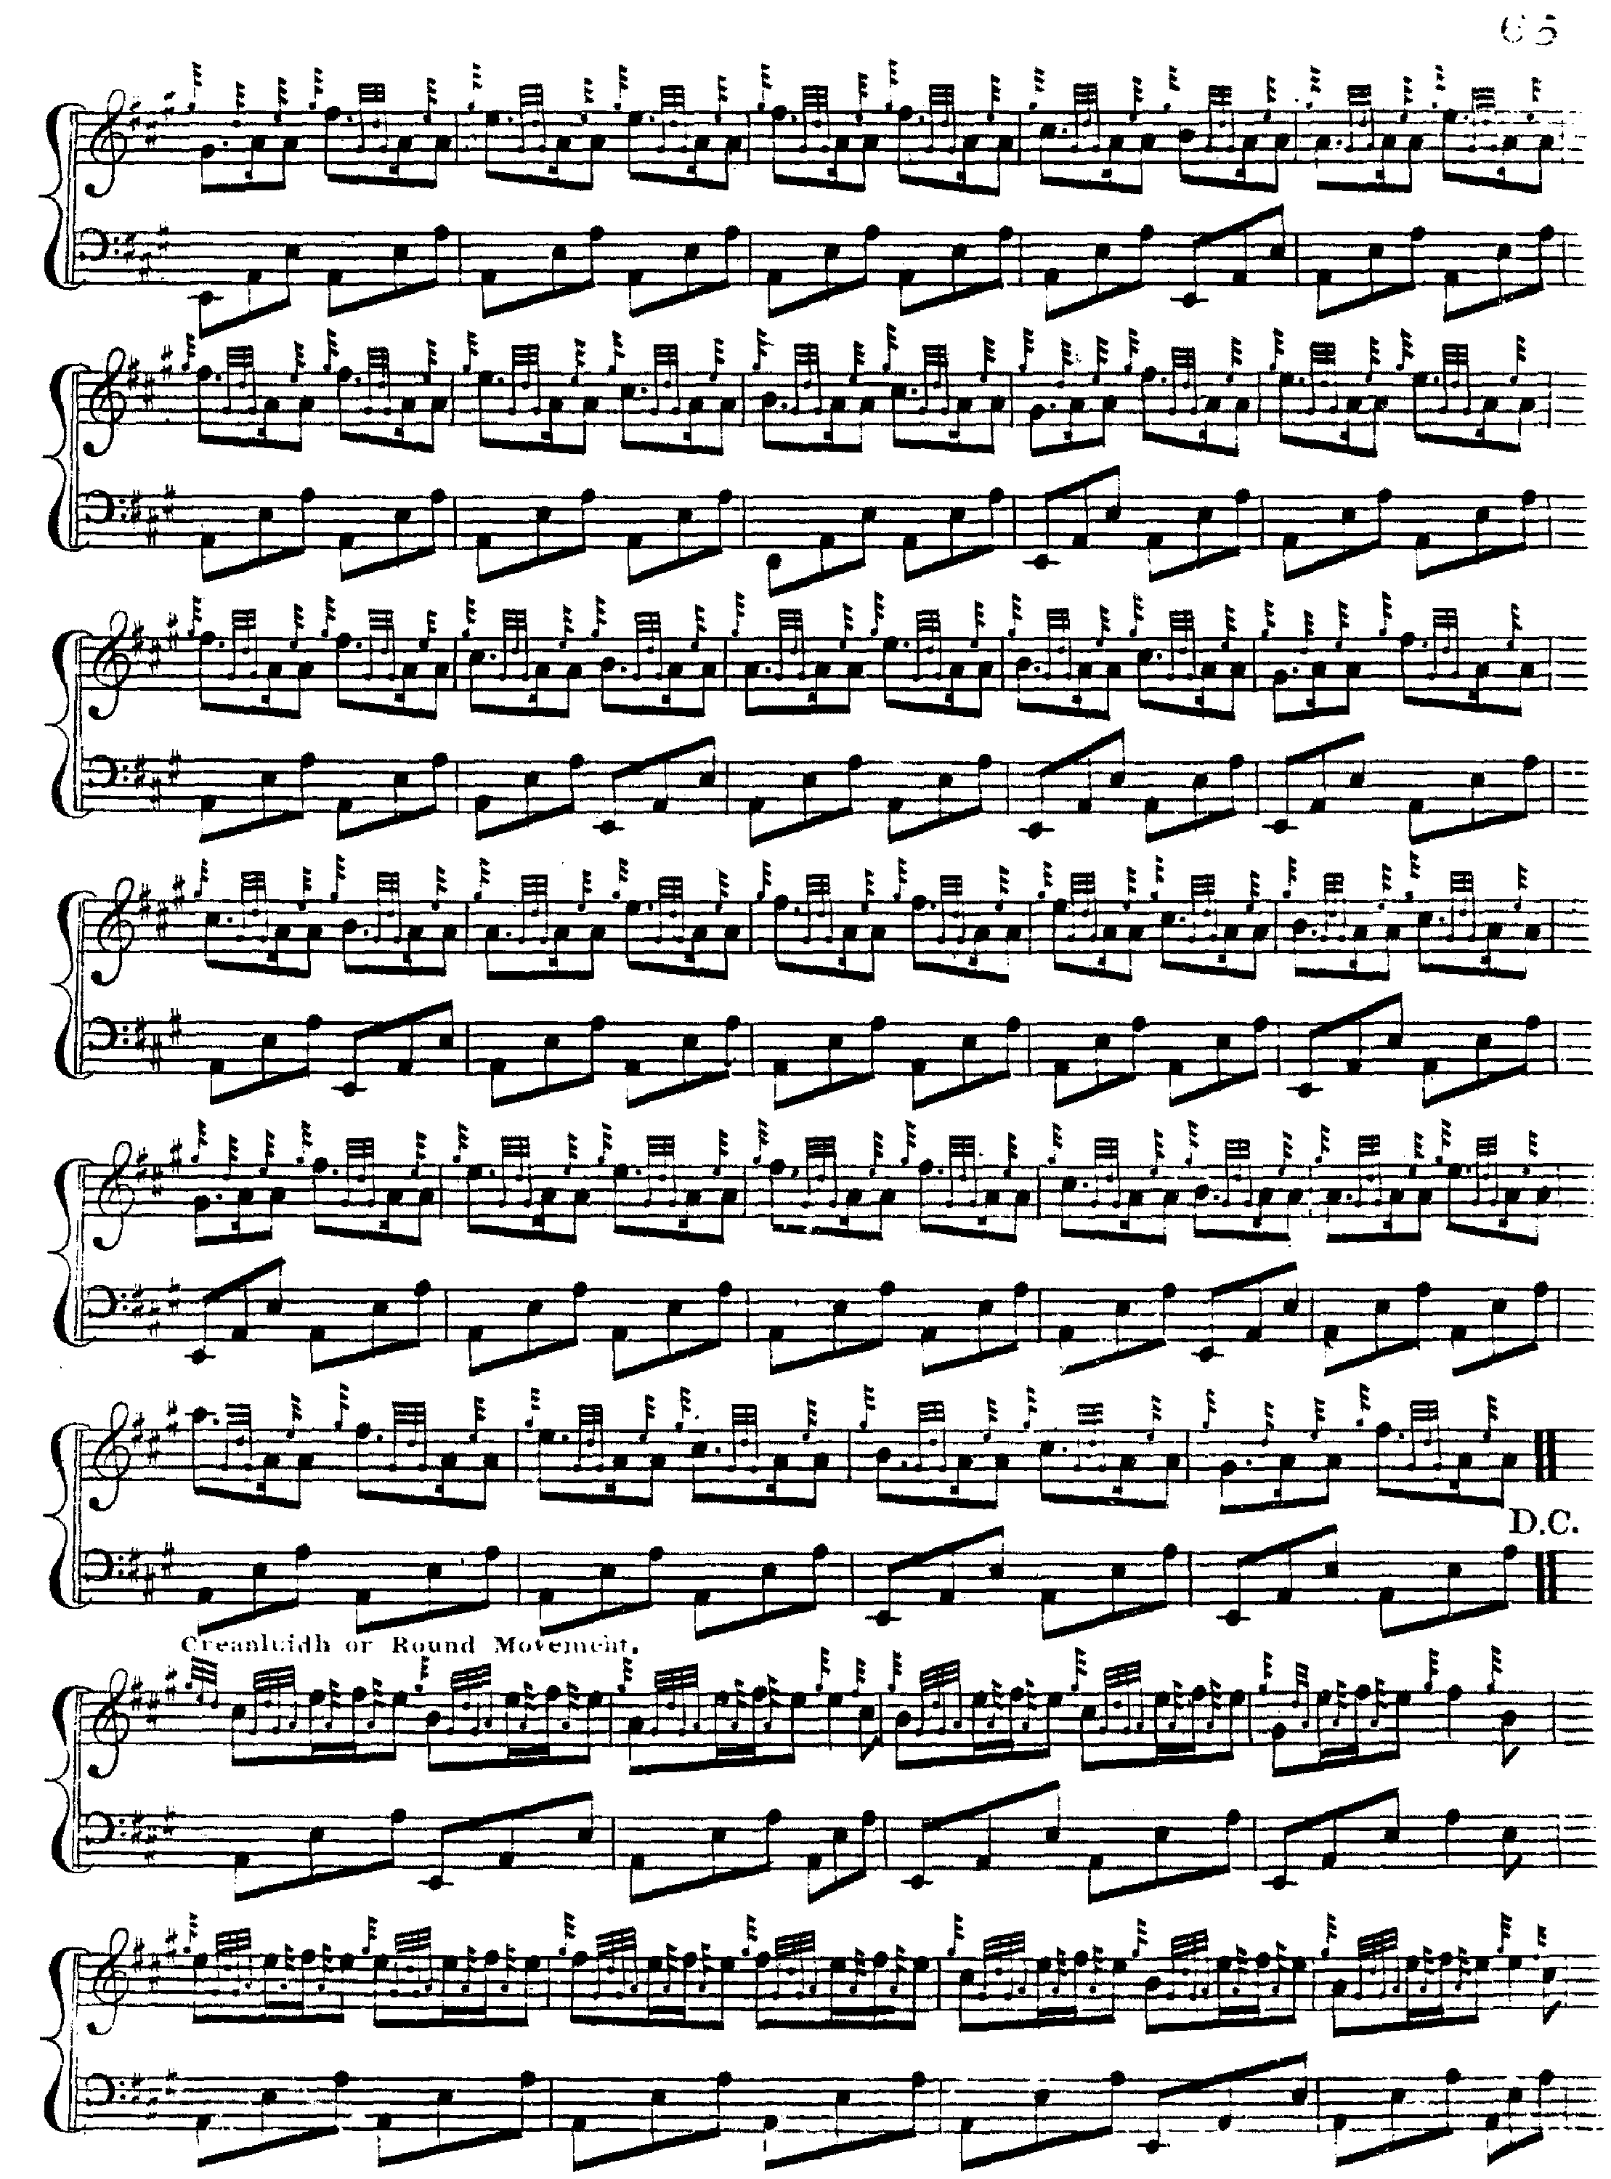

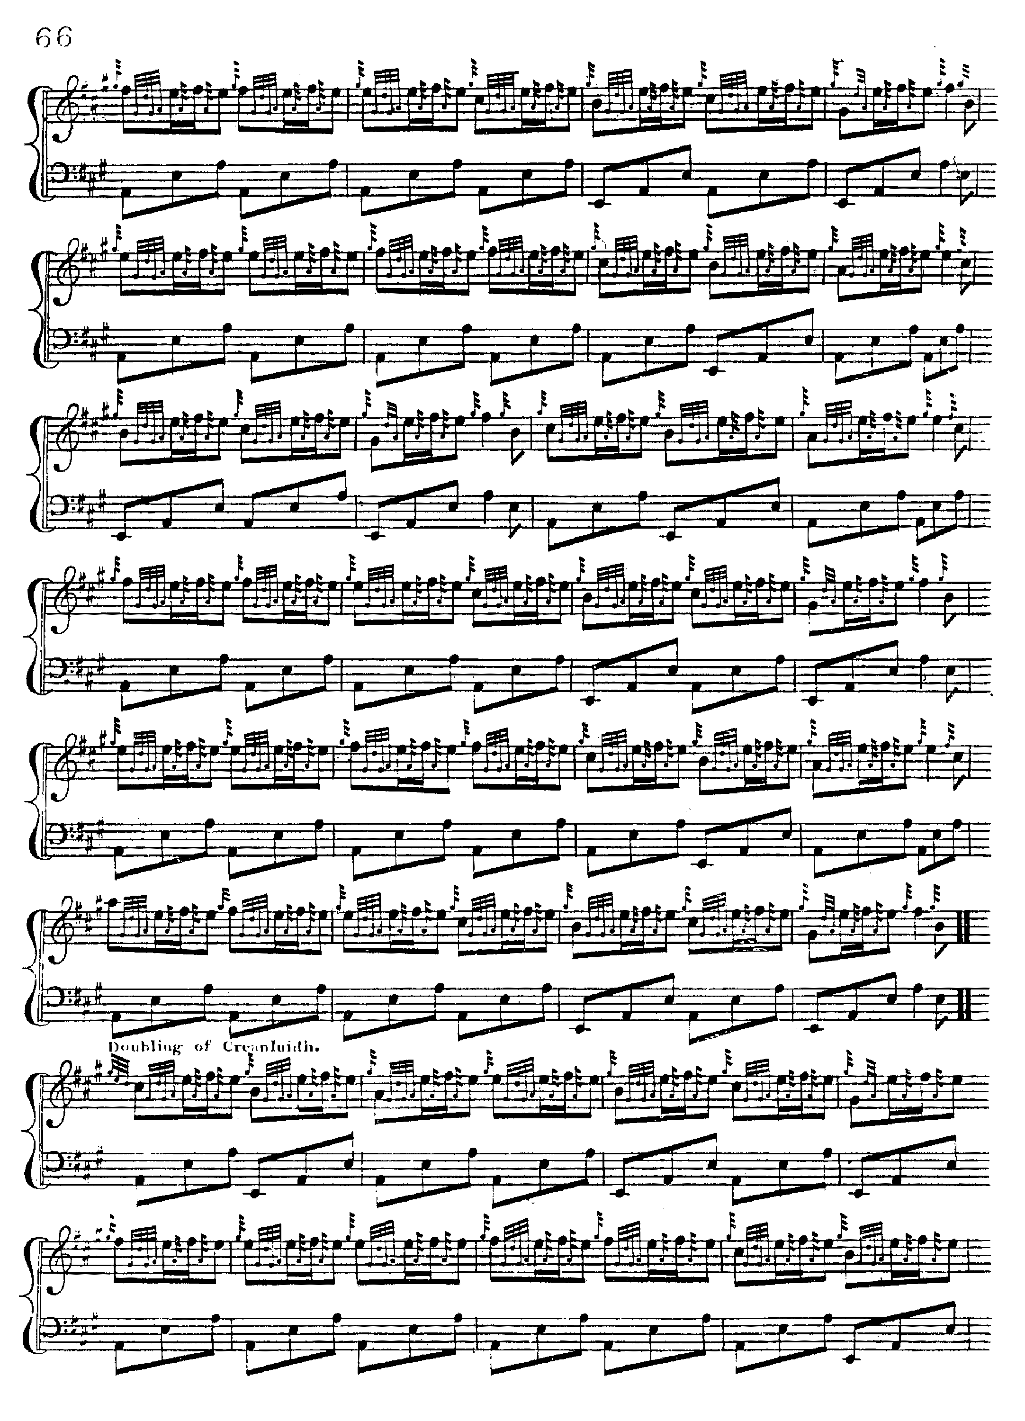

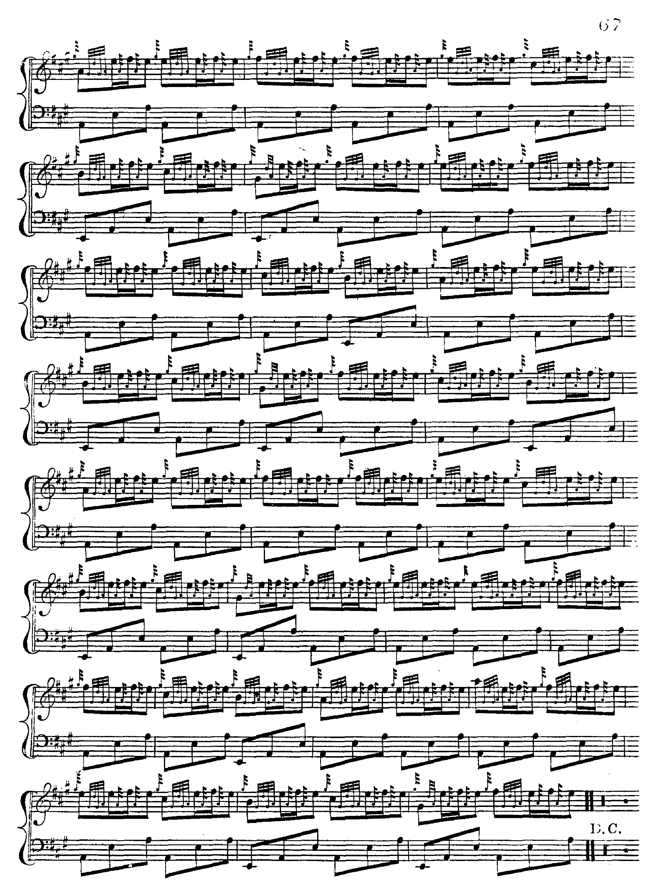

We note the frequent use of edre/dare on E and F in preference to double echo beats, visible also in Colin Campbell’s score. Further points of interest include the pointing of such echo beats as are used, and the timing of the opening phrase of the ground, where the initial A is a semi-quaver, and the E/A gesture acts as a kind of anacrusis leading on to an expressed C, the tonal importance of which is increasingly emphasised in the later variations from the Taorluath duinte singling onwards.

There is a slight problem in what MacDonald describes as the ‘trebling’ of Variation 1:

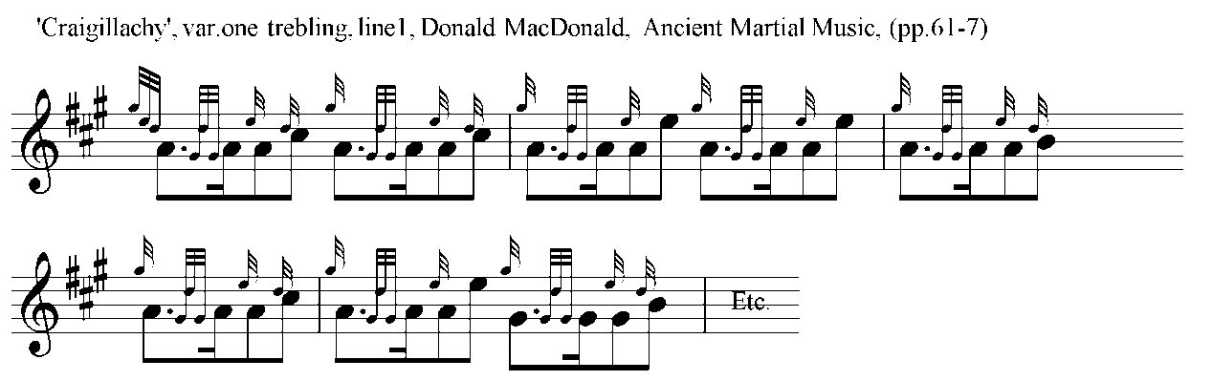

As it stands the grip movement on low G would appear to be unplayable, although the intention is clear enough. Then follow the later variations as above--the Taorluath singling

providing the tone row for all of these. There is no crunluath a mach.

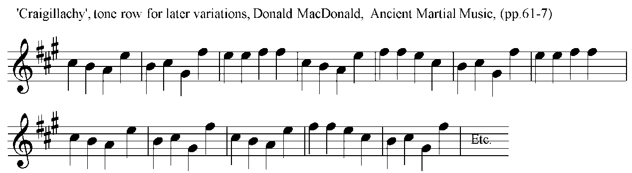

**Angus MacKay** develops the tune along the lines of MacDonald, except

that his Taorluath fosgailte movement takes the form of open triplets

as below, which is his standard way of doing this movement—as follows:

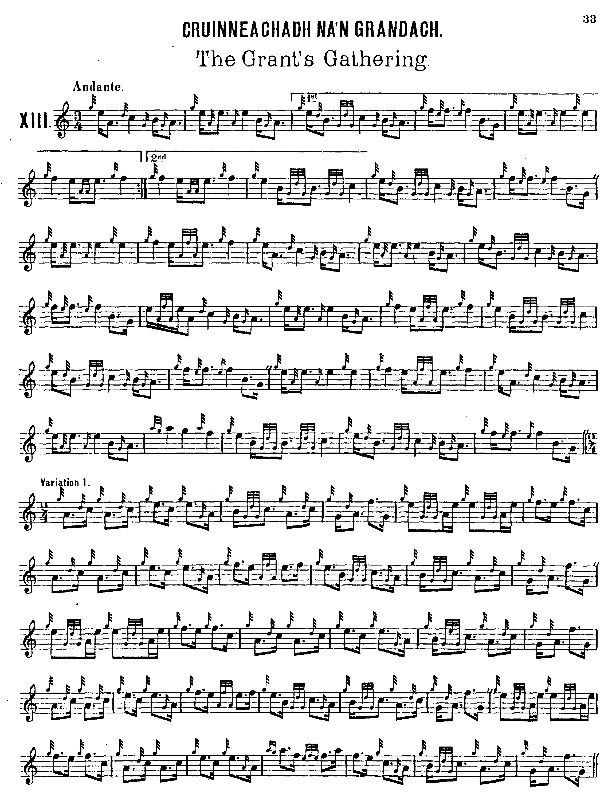

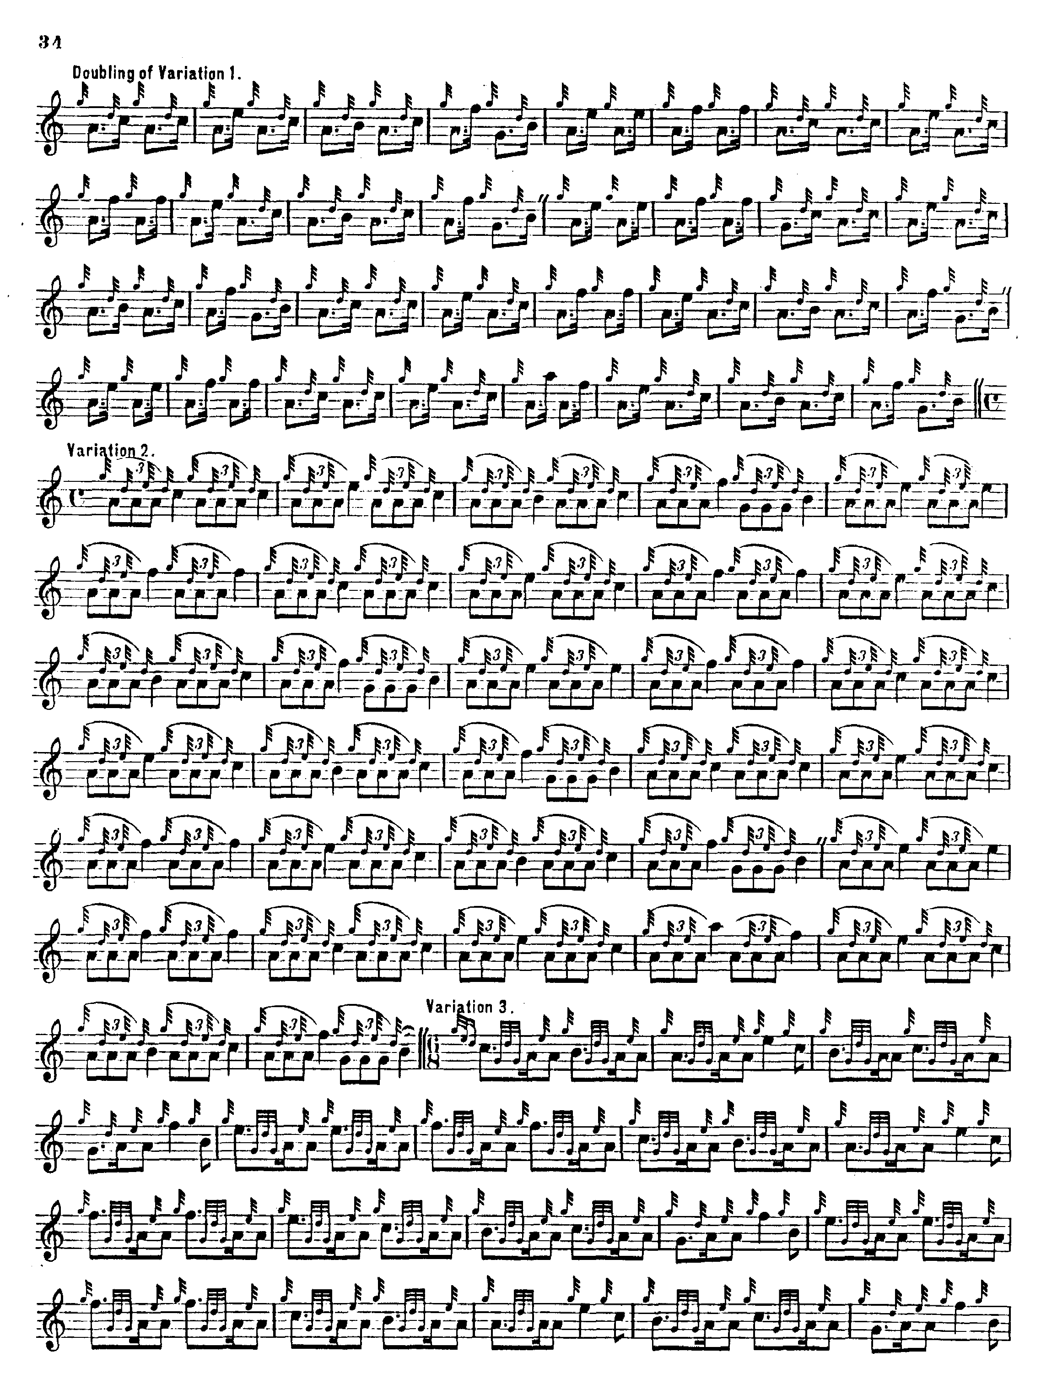

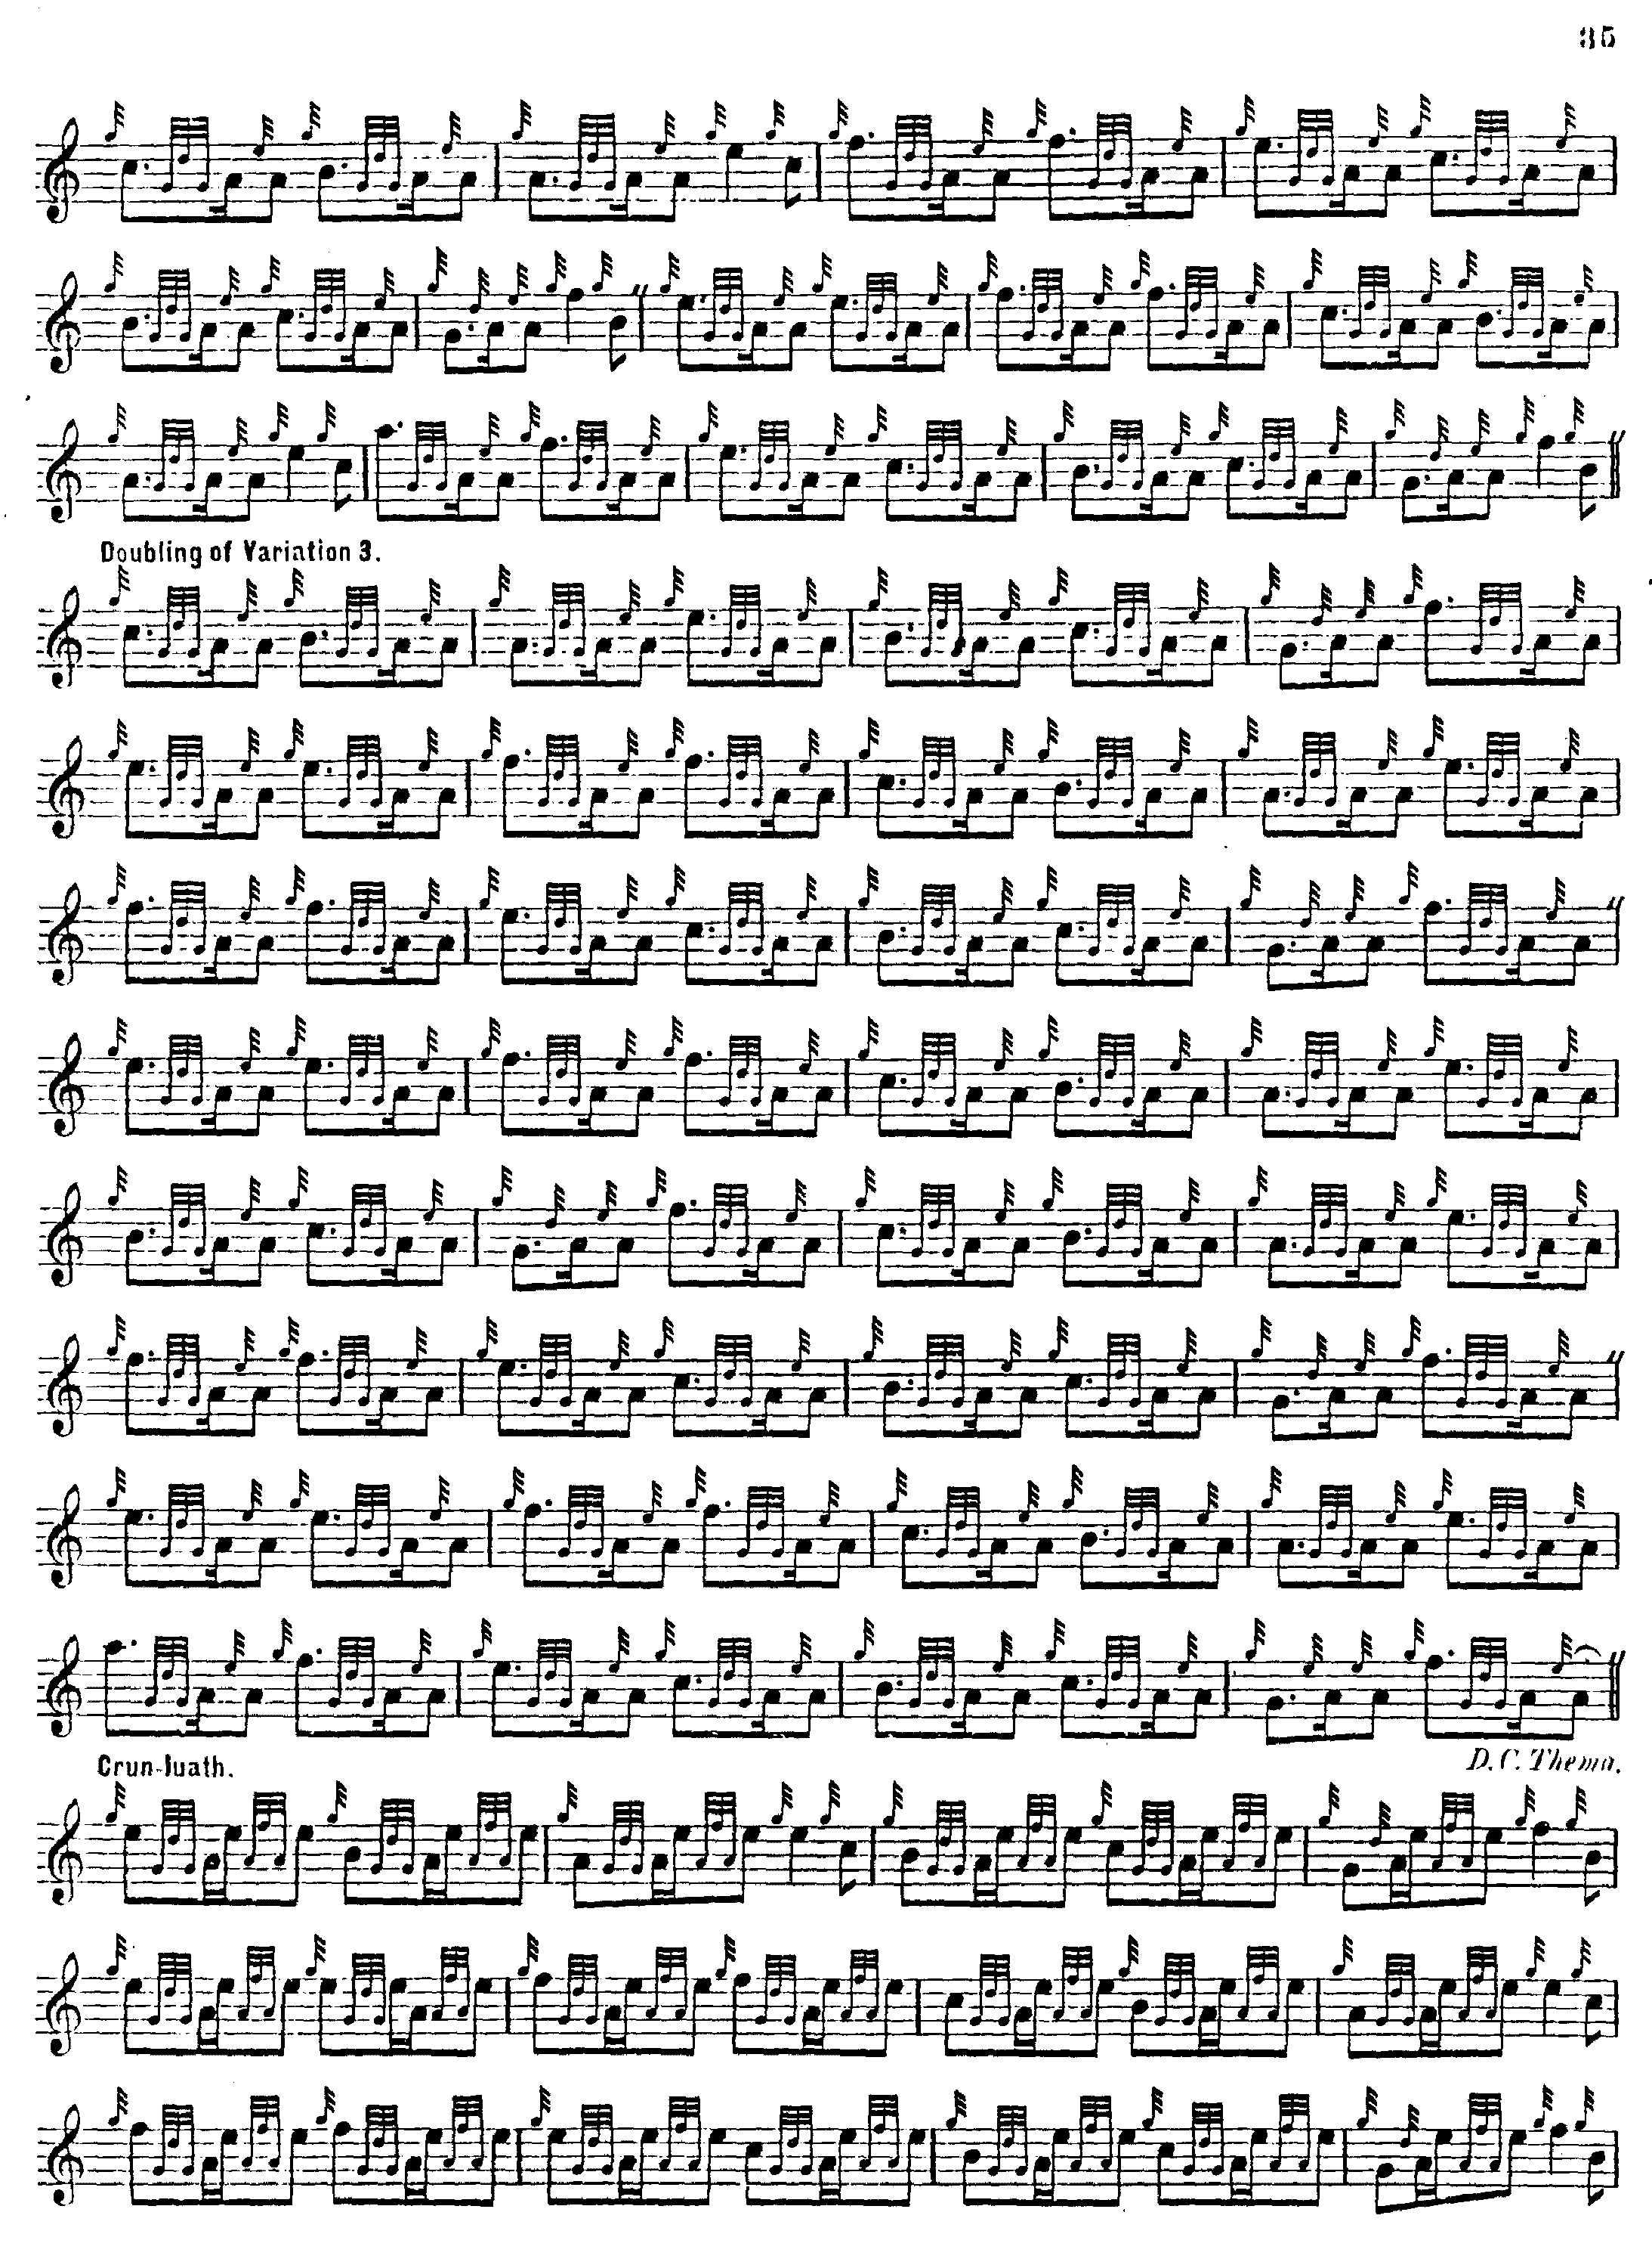

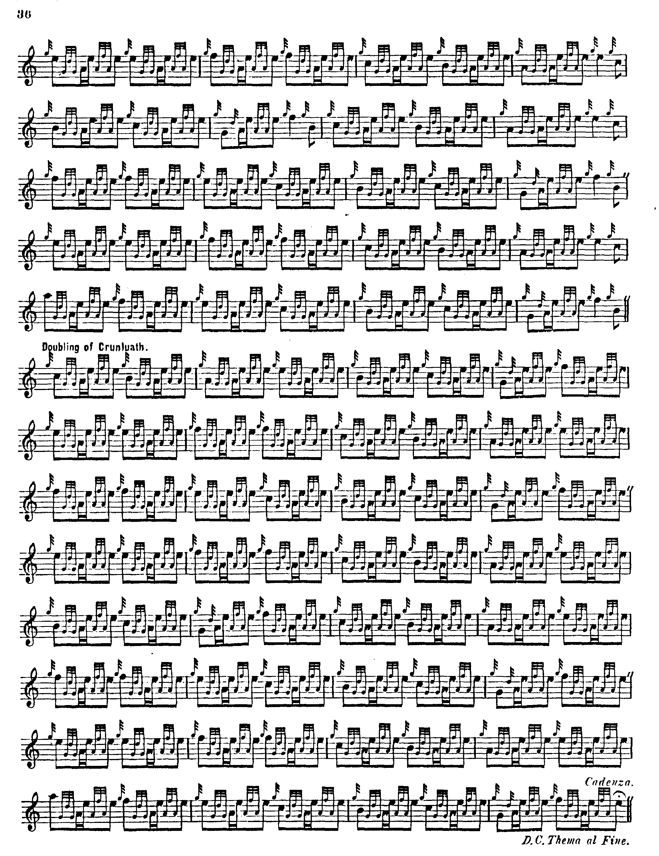

MacKay has no crunluath a mach.

**C. S. Thomason** gives his sources as MacDonald and Angus McKay and also Donald MacKay (the younger) who was taught the piece by Donald Cameron. As frequently occurs, Thomason’s preferred setting is a blend of MacDonald and MacKay, although he times the Taorluath fosgailte triplets as demisemiquavers and translates the movement into 2/4 time. Like MacDonald and MacKay, he directs that the Ground be restated after the Taorluath doubling and at the end of the tune. He sets the tune as follows:

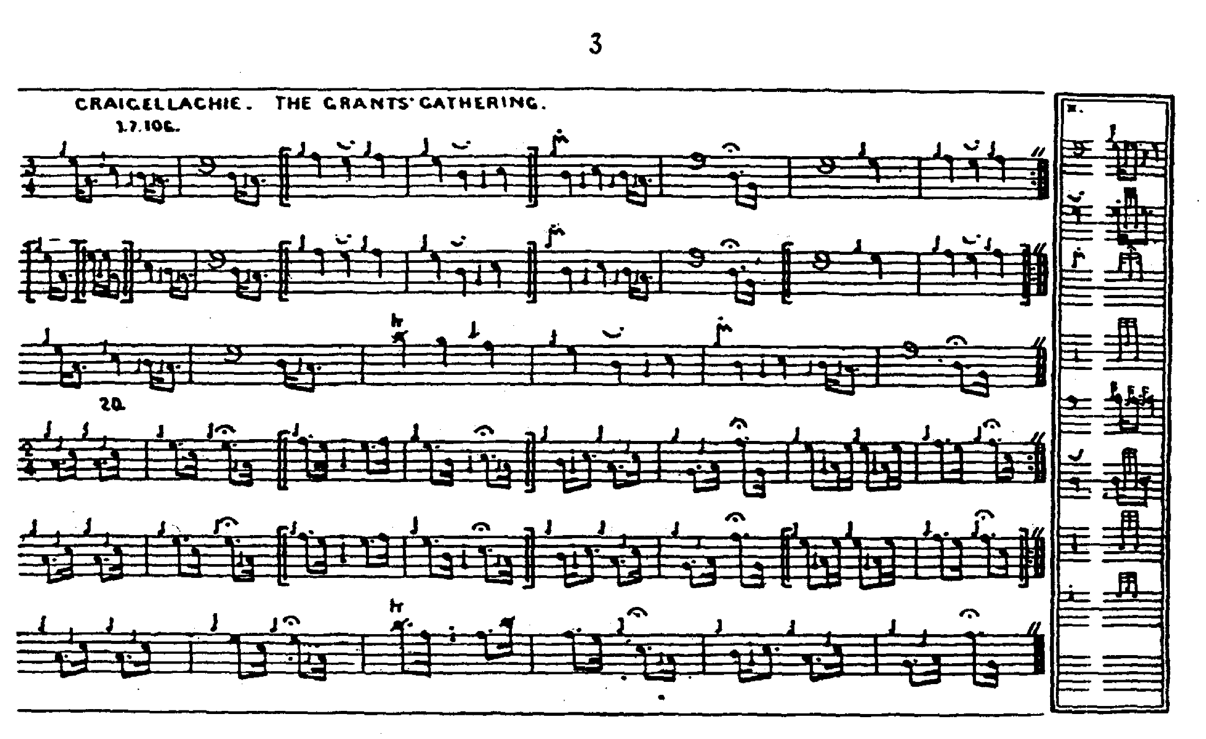

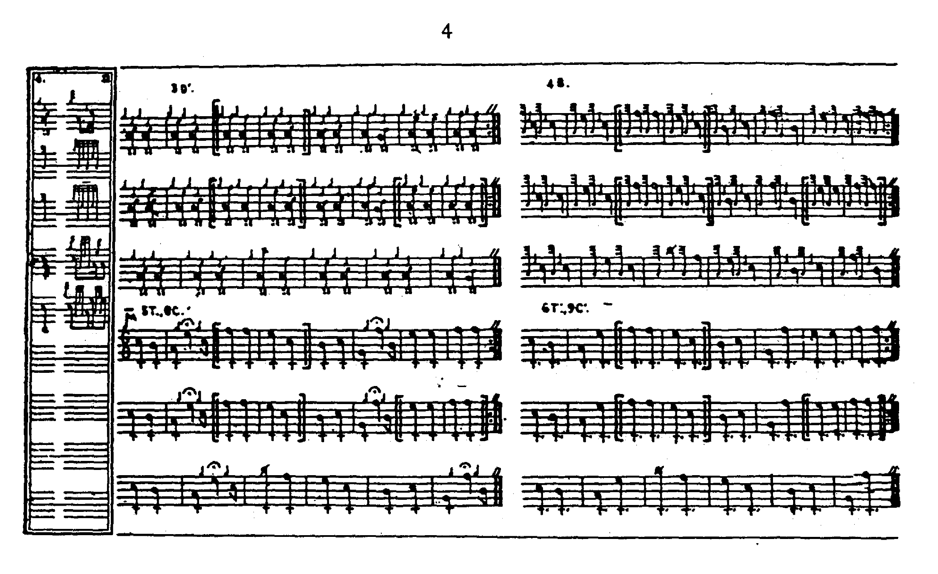

Thomason has no crunluath a mach.

**William Stewart’s** score in *The Piobaireachd Society Collection* (first series, i, 12-15), is a simple transcription of Angus MacKay, correcting a couple of typographical errors in the Ground, but missing the one at the beginning of the Crunluath singling, where the first melody note has been allowed to remain as E but should, on the analogy of surrounding parts, be C.

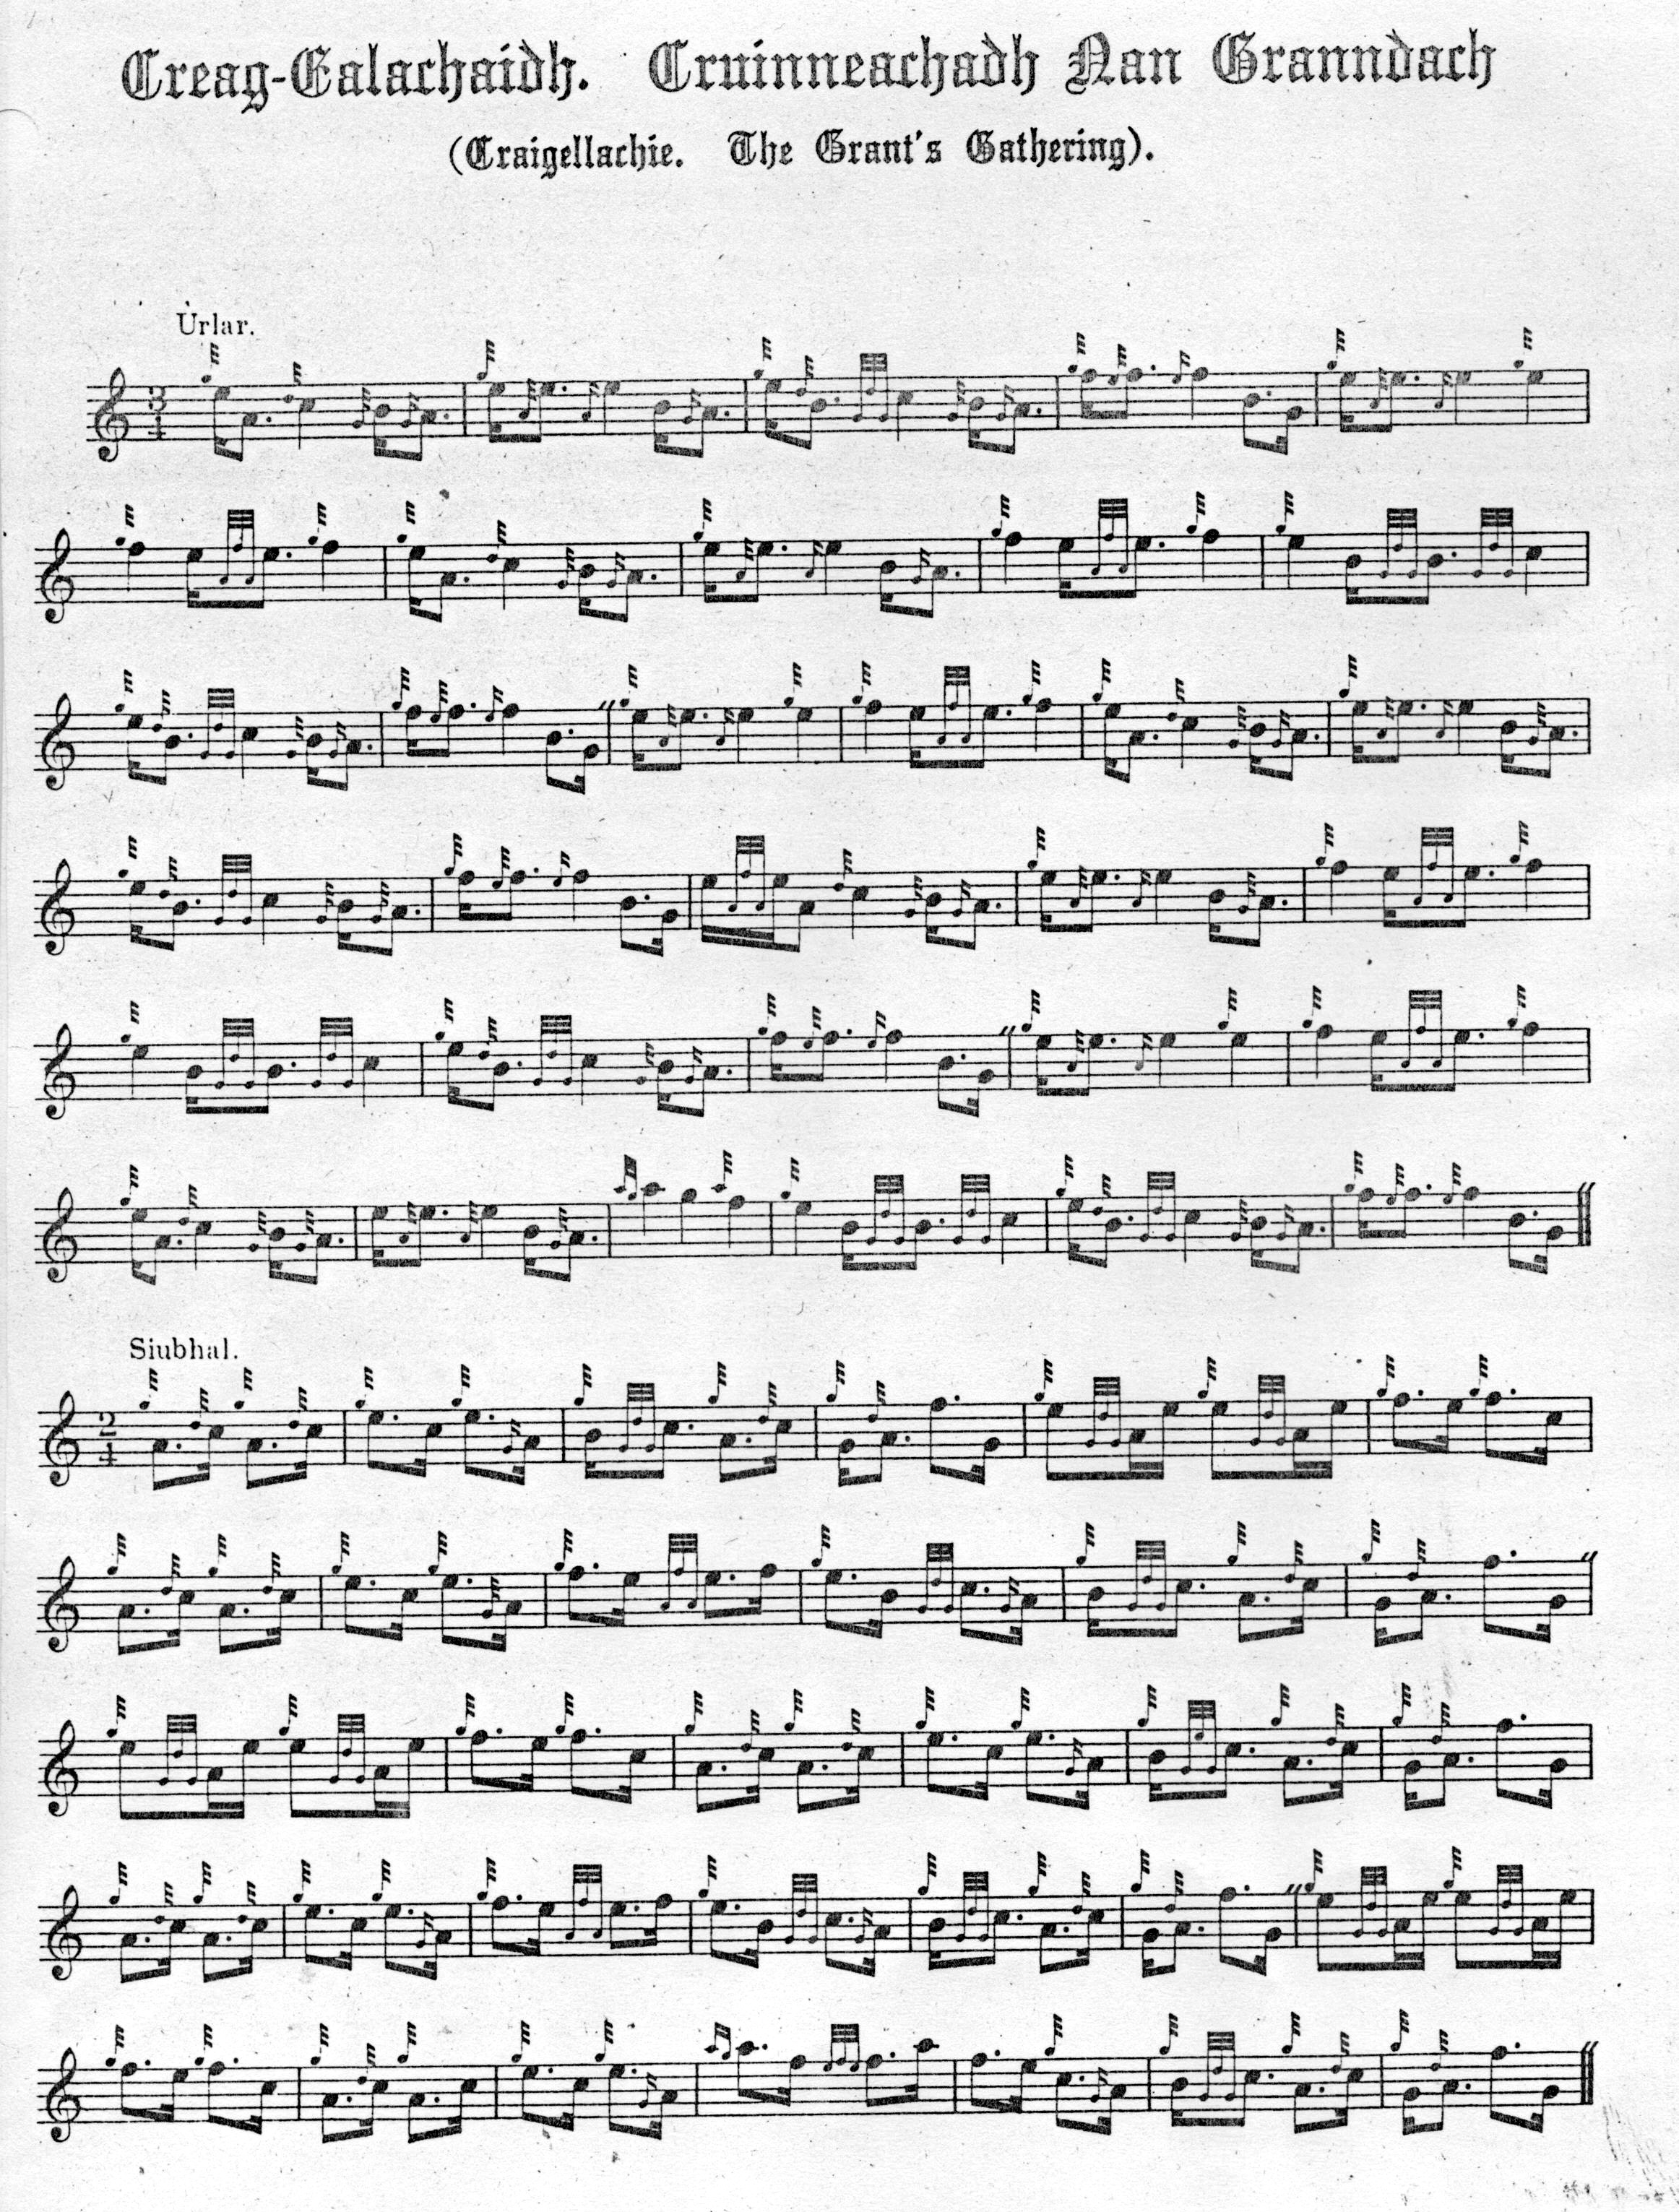

And so on. Stewart has no crunluath a mach.

**David Glen’s** score is very similar to Thomason’s in style while being very much easier to read typographically, lacking Thomason’s extreme compression and sometimes confusing symbols for first and second repeats:

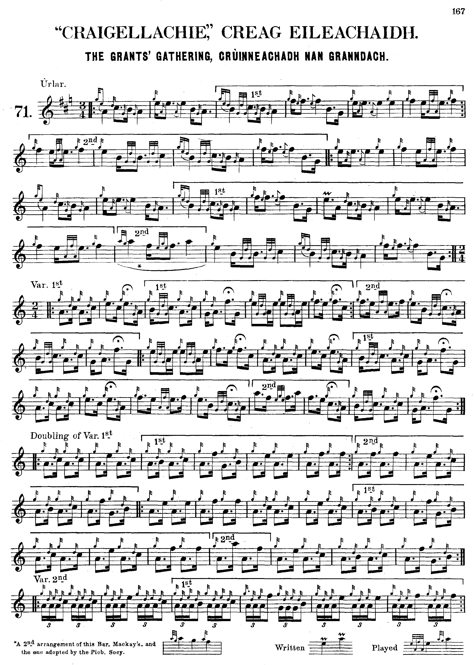

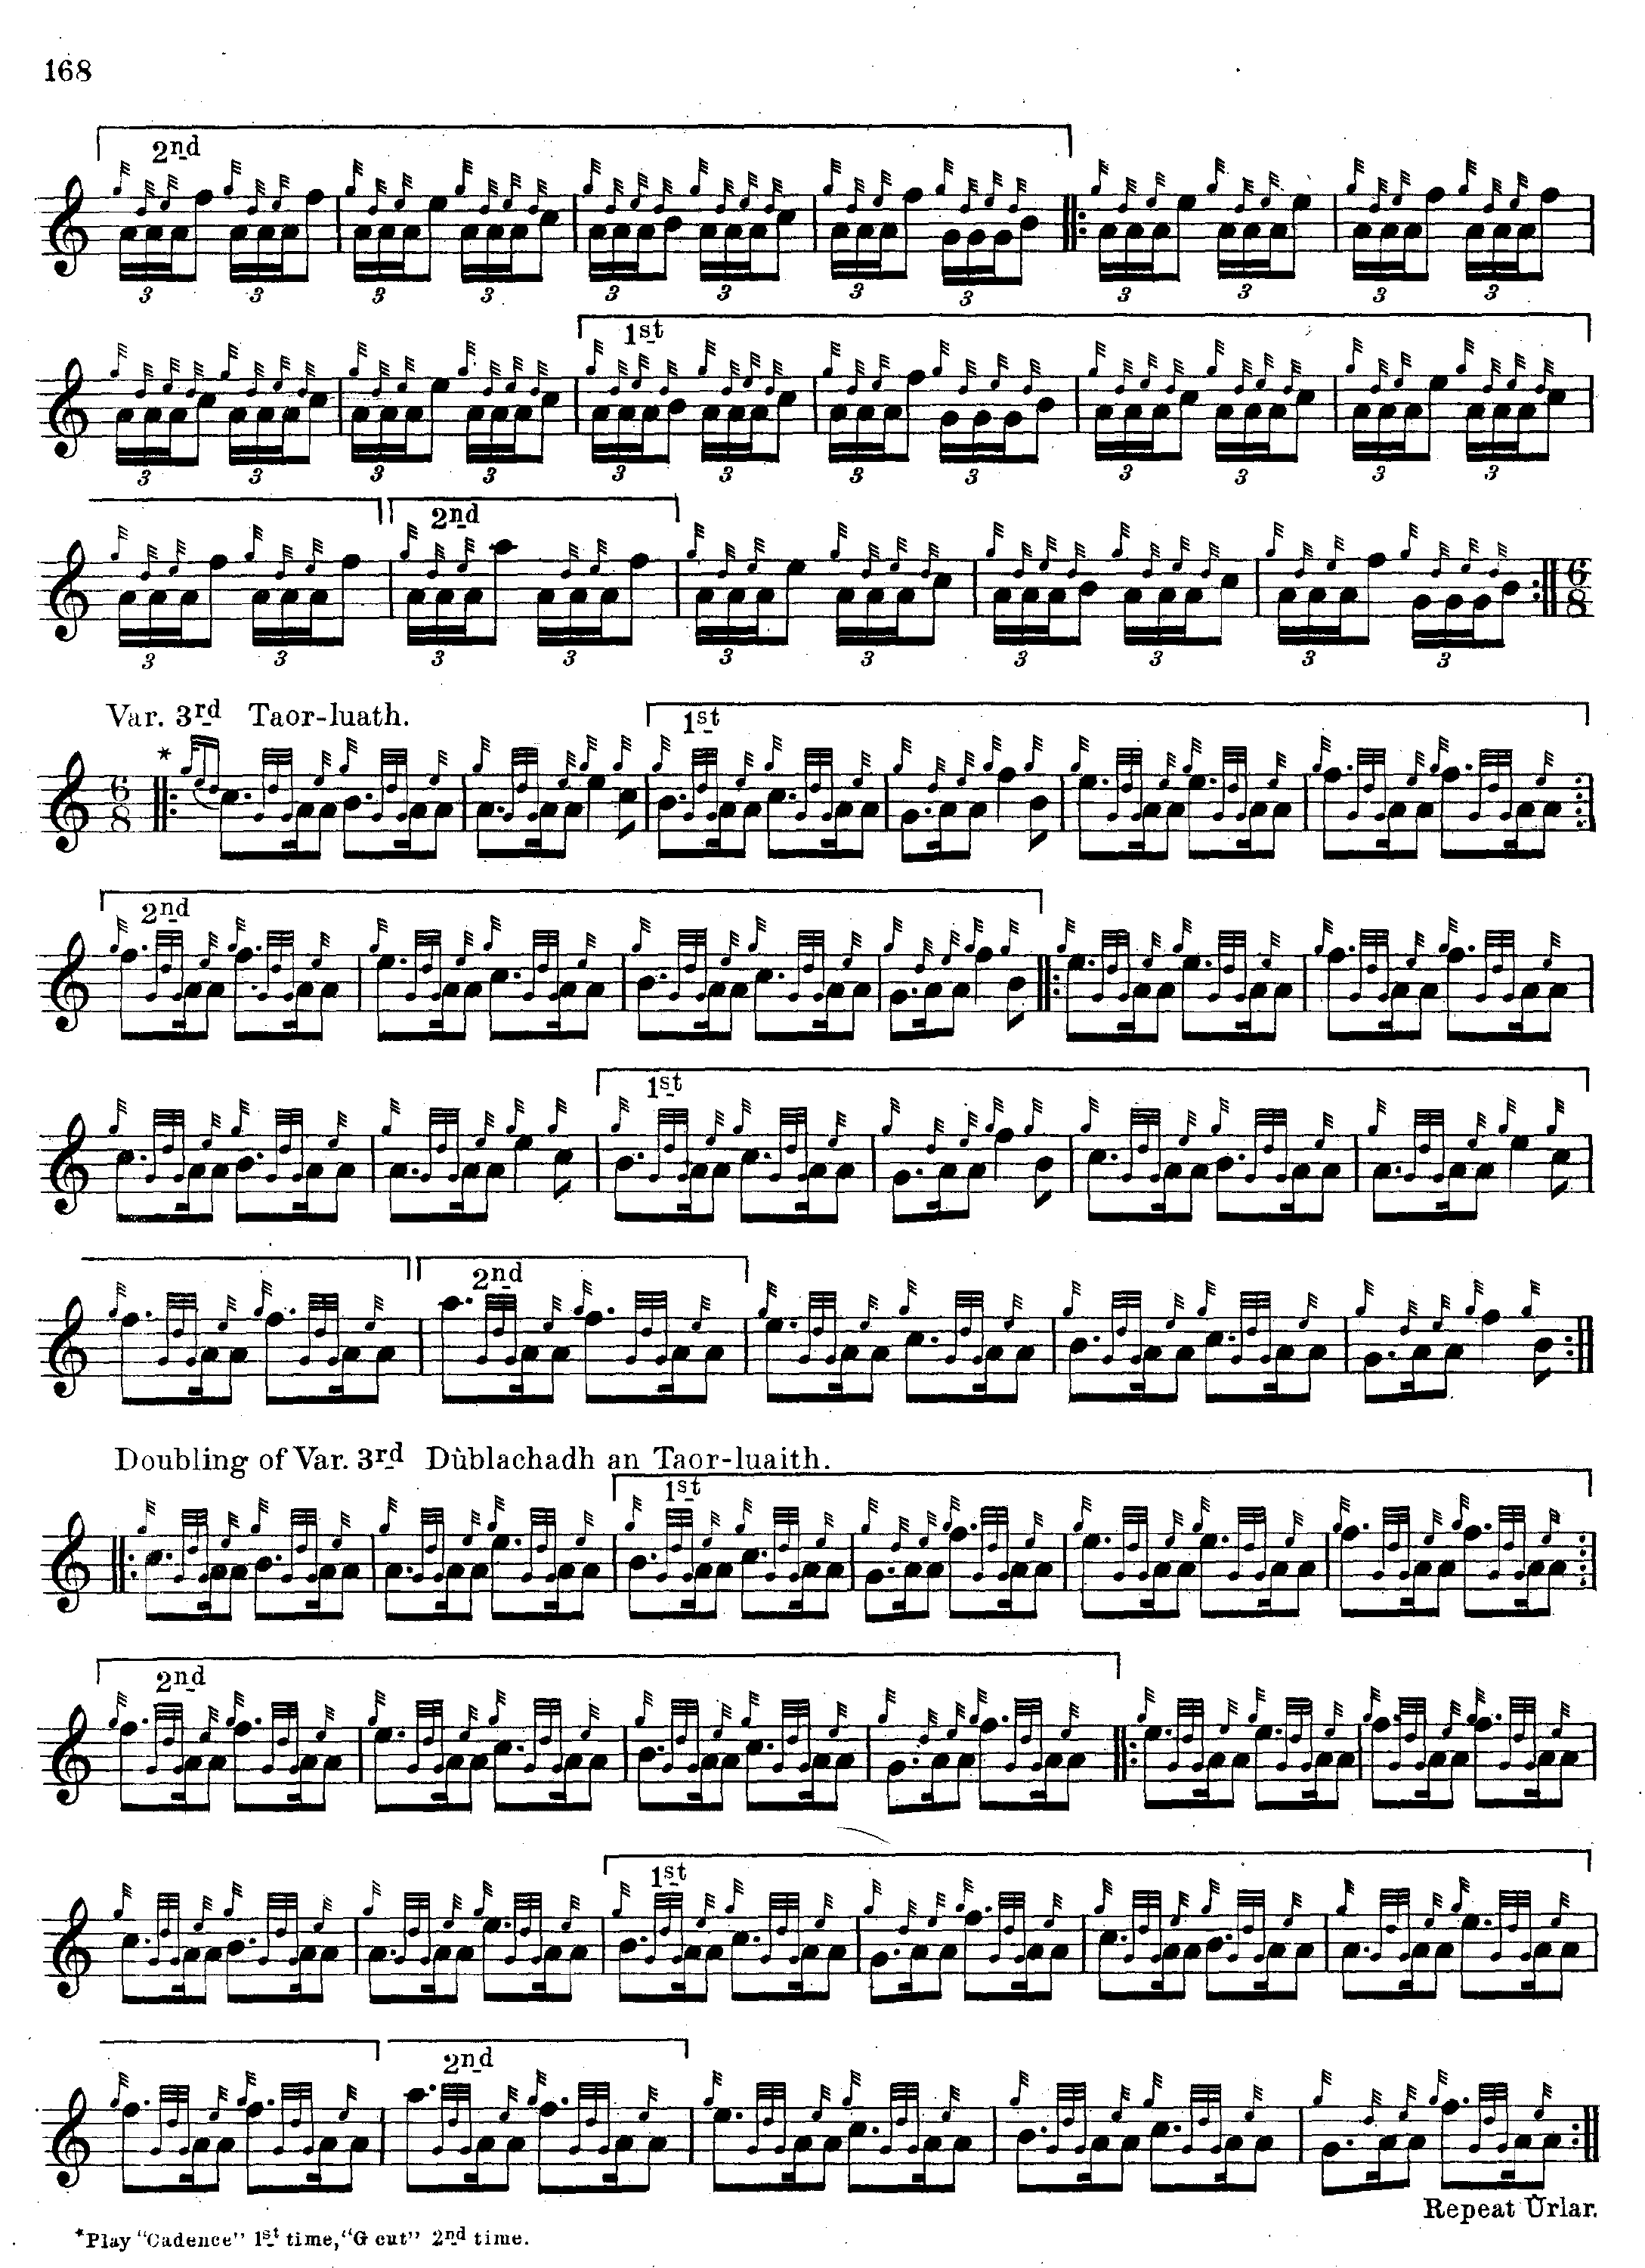

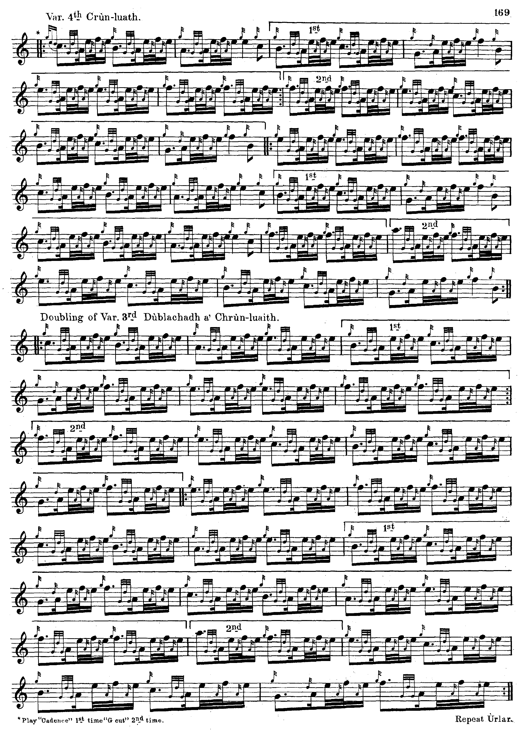

*Commentary:*

General C. S. Thomason was much attached to this tune for family reasons (he had been brought up by the Grants of Elchies on Speyside) and in “Ceol Mor Legends” recorded his attempts to trace its history:

Craigellachie - The Grants gathering

Between the upper Craig Ellachie near Aviemore & the lower Craig Ellachie near Rothes, both in Strathspey, lies the Grant land. “Stad Craig Ellachie” or “Stand fast Craig Ellachie” was the slogan of the clan, and from its structure, I should judge the piobaireachd to be a very old one. Though half a Grant myself, I never yet got a satisfactory answer from any Grant as to the derivation of “Ellachie”. It is not a Gaelic word of today, & the nearest derivation, the accepted one, is “Eagalach” Ang. “Fearful”.

I have made every endeavour when at Aviemore to discover the history of this Pibroch. I cannot quote any absolute authority for saying so, but the general impression there seems to be that it was composed either in commemoration of or at a great battle fought (date unknown to me at present) between the Shaws and the Cummings at Craig Ellachie. It is a matter of history that the Grants subsequently ousted the Cummings from Strathspey, and established themselves […] at Castle Grant. When so establishing themselves the Grants are said to have adapted this as their Gathering Pibroch.

[...]what the clan generally seem to accept as pertaining to them, and derived from the old lairds of Grant is, for a crest, a burning mountain, and for a motto “Stad Craig Ellachie” or “Stand fast Craig Ellachie”....My old friend Mr. Charles Grant, - one of my childhood - formerly schoolmaster of Elchies and afterwards of Aberlour, where he died about seven years ago, relying upon the tradition that the Elchies Grants were descended from Ballendalloch, used to tell me that the motto was derived from “Craig-Achocheaw”. close to Ballendalloch, and which, if it were put into proper Gaelic, was supposed to mean, “Rock of hanging”. I know of no such Gaelic word as this, and from what has lately come to my knowledge the motto has a far older derivation than the lairds of Ballendalloch. I dont think the word has ever been properly written, in any recent documents in Strathspey. The real motto is evidently “Creag a Chrochainn” - (The rock of hanging).

Close to Grantown, and closer still to Inverallen in a field a little to the west of the farm of Gaick, is a solitary overhanging rock. Tradition says that this was used when executing criminals by hanging. My old Gaelic master, Dr. Cameron Gillies, whom I have consulted, and to whom it is a second nature to enquire in to derivations, says there cannot be the slightest doubt as to this being the real origin of the motto [...] (ff. 2-9)

* * *

Electronic text © Dr. William Donaldson, Aberdeen, Scotland, 13th June 2012