One of the Cragich, No 34, Nether Lorn Canntaireachd

There is a single setting of this tune:
--Colin Mór Campbell, Nether Lorn Canntaireachd, No.34, i, ff.68-9. (with the title “One of the Cragich”).

Colin Mór sets the tune as follows:

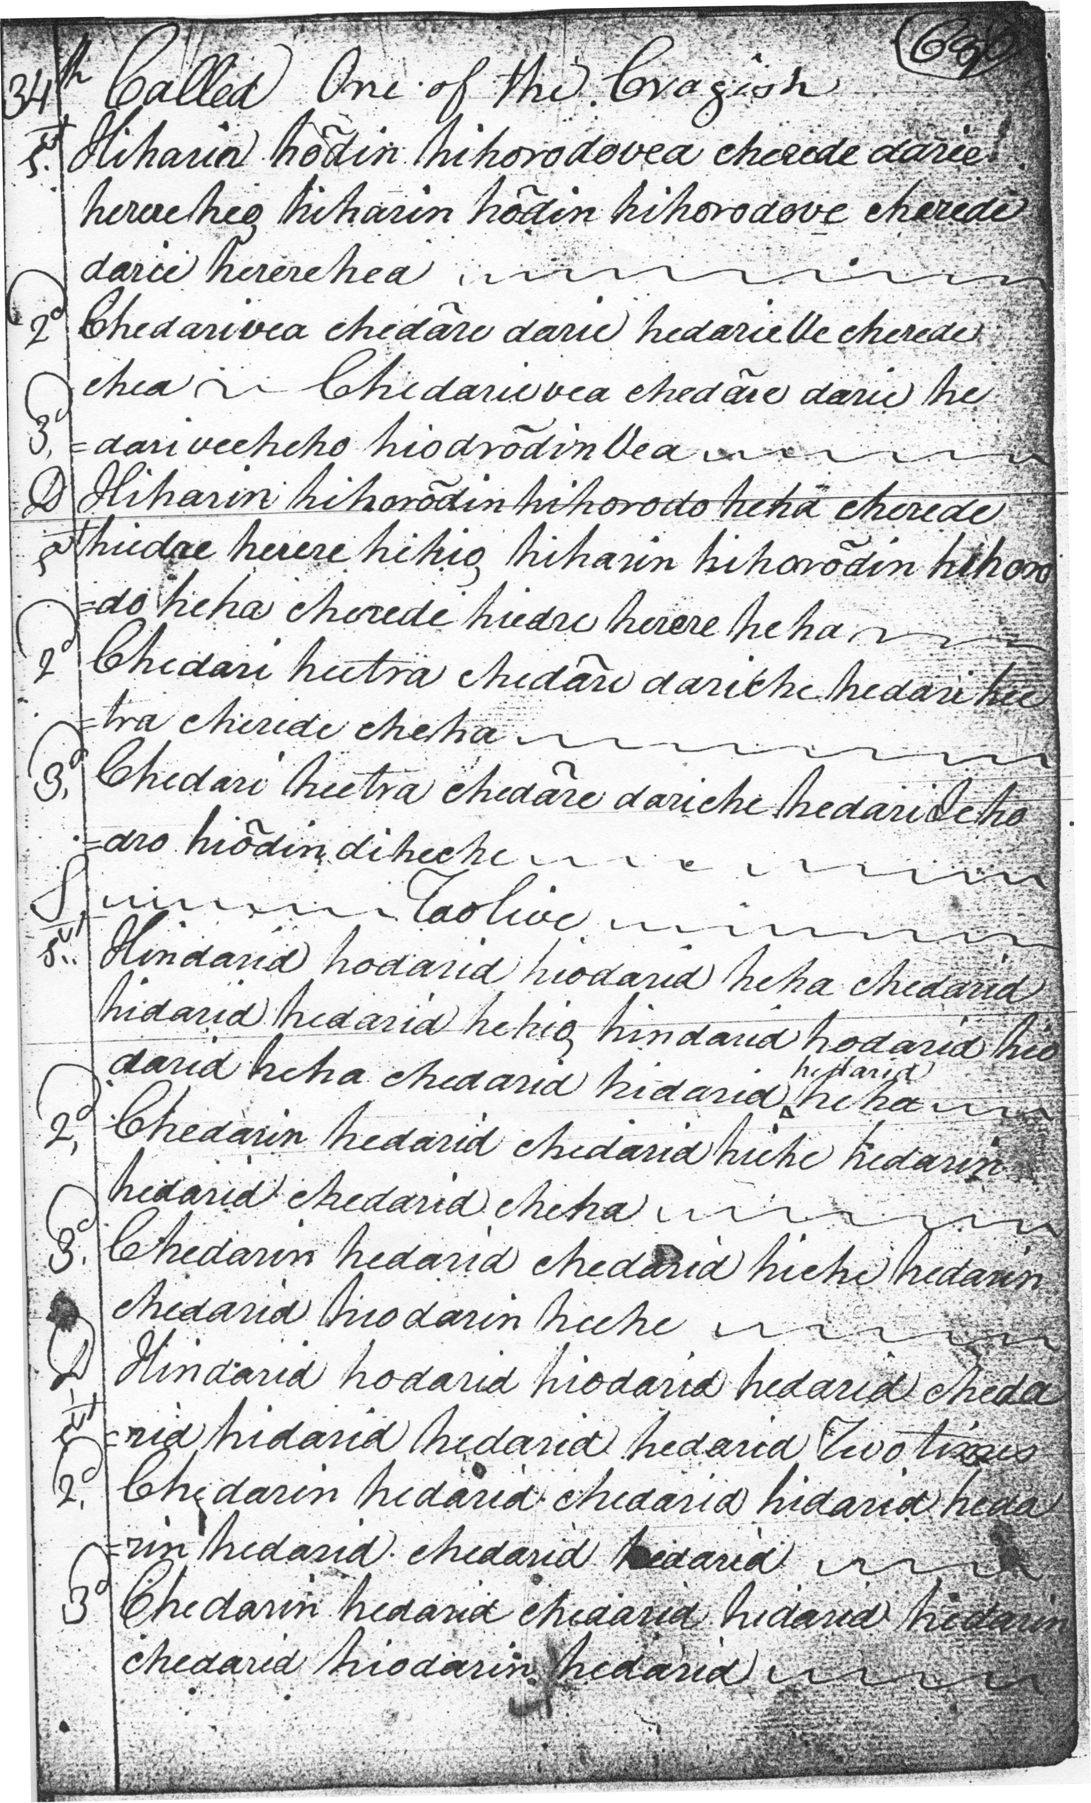
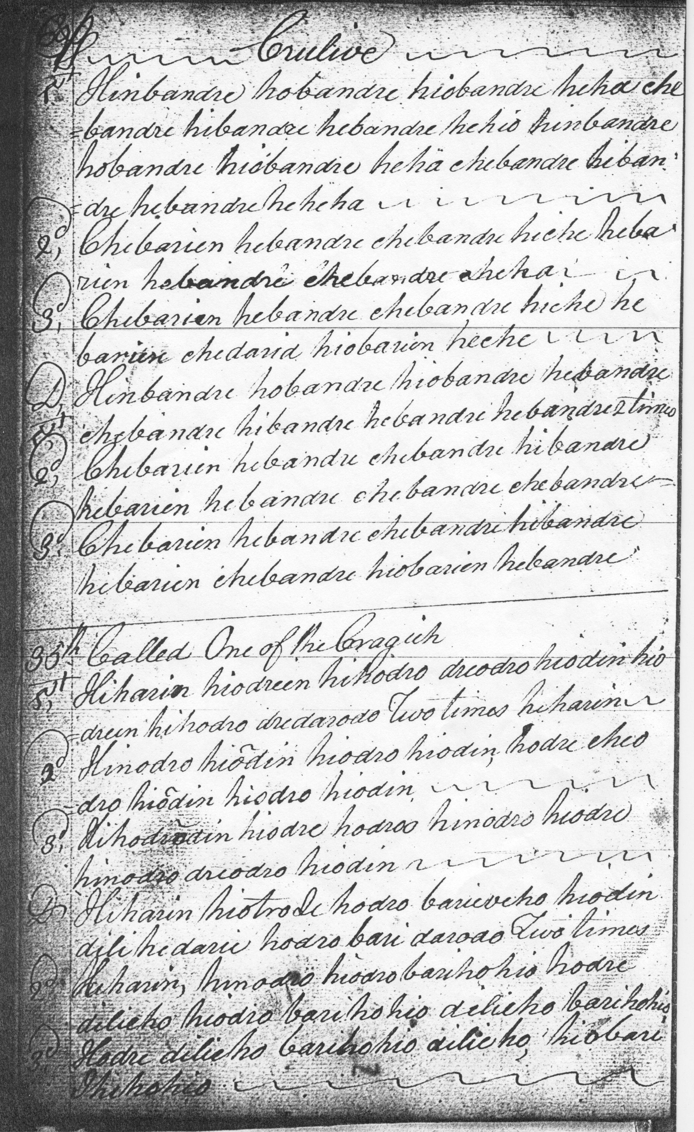

This might be realized along the following lines:

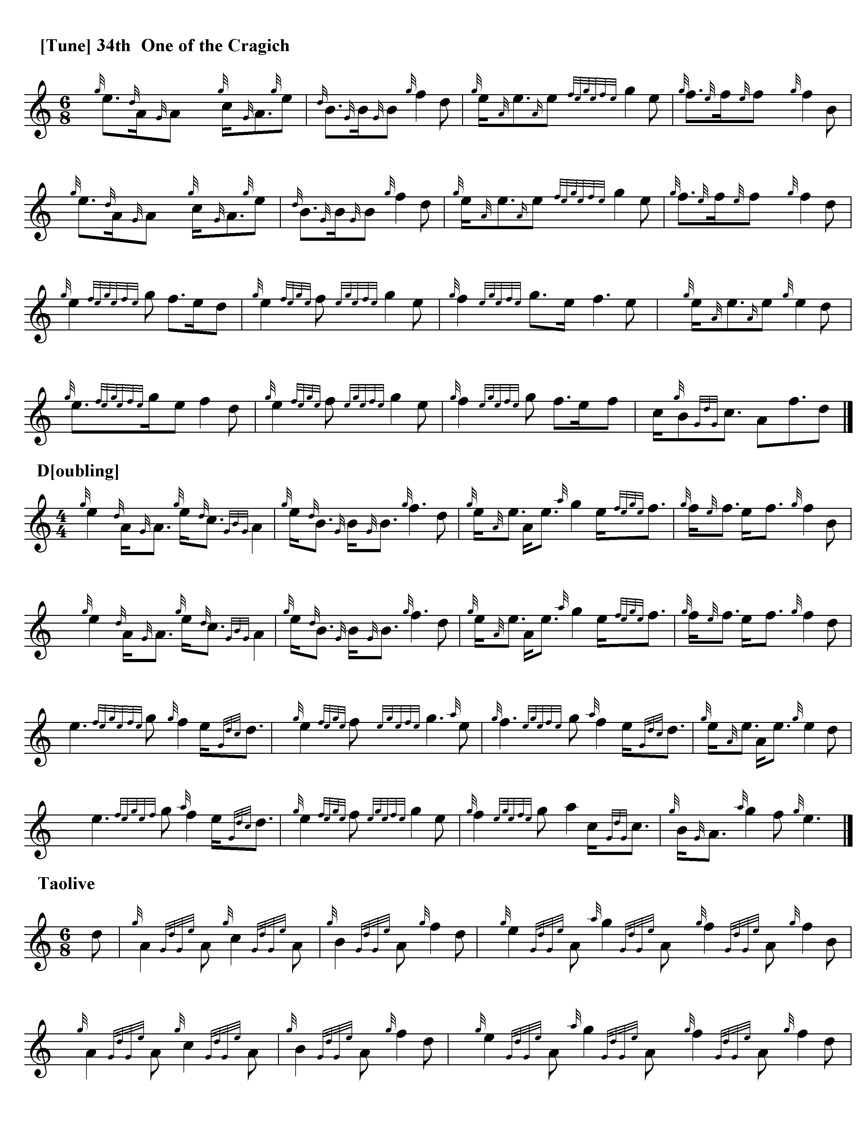

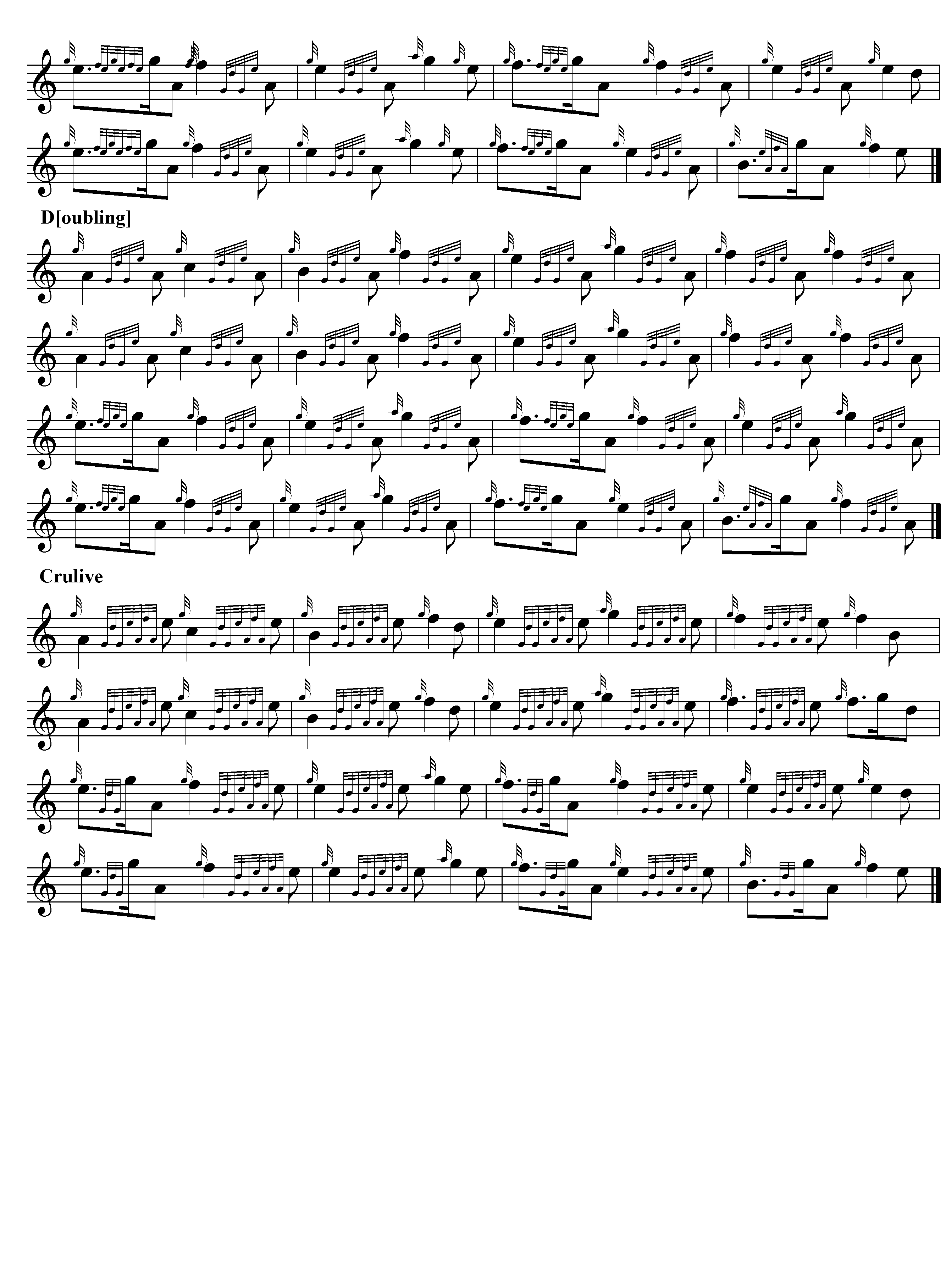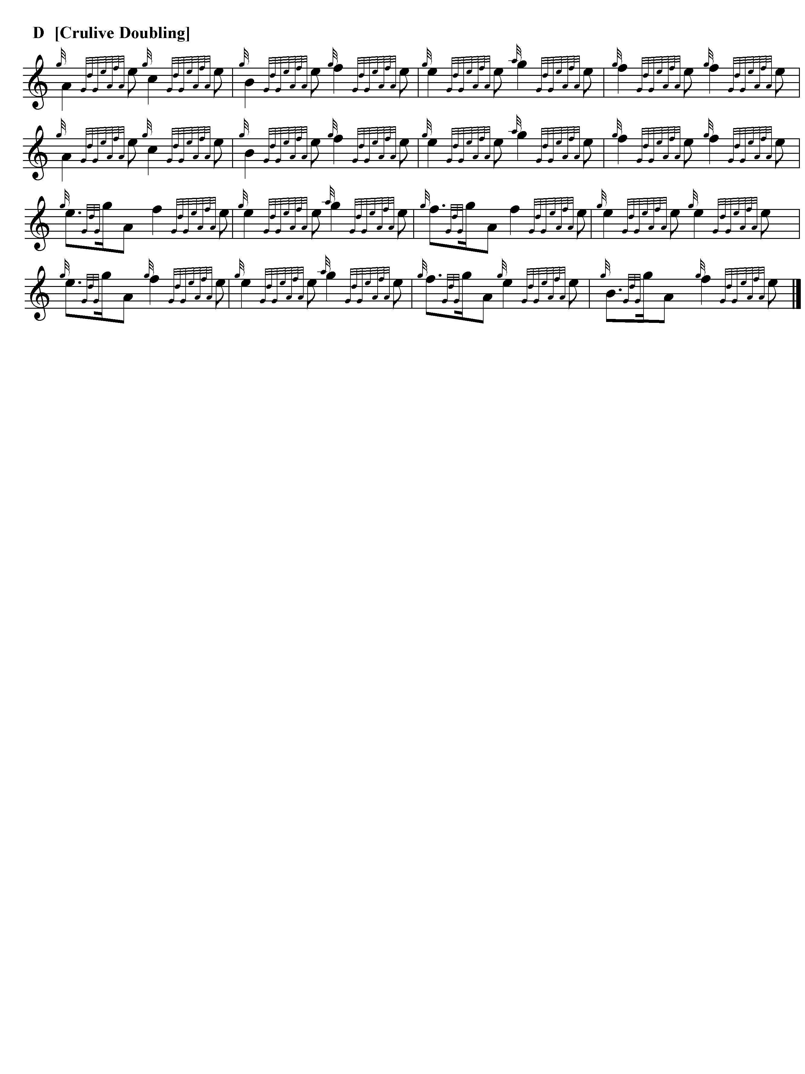
Commentary

There are at least eight tunes designated as “Cragich” in the Nether Lorn Cantaireachd, including this one, No.34, and Nos.25 (which is a version of Donald of Laggan), 35, 52 in volume one of the collection, and 26, 30, 49 and 72 in volume two. The word means “rocky” or “stony”, and the word is usually interpreted to mean that the tunes are irregular in construction. But they share a number of other characteristics as well, including a strong interplay between the tonic and fourth of the scale and abrupt “throws” from the bottom to the top hand on the chanter.

*

Electronic text © Dr. William Donaldson, Cambridge, Massachusetts, 10 October 2022.

