Corrienessan’s Salute

There are a number of different tunes bearing the “Corrienessan” title, and the version currently played has a rather tortuous history. “Corrienessan” tunes appear in the following manuscript source:
--David Glen’s MS, ff.412-414, and again at 433; (Glen calls this “The Lost Pibroch” and has two versions of the ground, one of them his own; the other seemingly Dr. Charles Bannatyne’s);

and in the following published sources:
--David Glen’s Ancient Piobaireachd, pp.180-1, where it bears the title “A Salute to the Corry of the Tiny Fall” and an attribution to Roderick (Dall) MacKay, Glen adding in a note that “The Urlar, Var. 1st and its Doubling is from an old MS. in possession of Dr. Chas. Bannatyne. The Taor-luaths and Crun-luaths have been added by the Compiler.”
--William Stewart, et.al., eds., The Piobaireachd Society Collection (first series), ii, 8-9.
--G. F. Ross’s Collection of MacCrimmon and Other Piobaireachd, pp.44-5, with the title “Lament for the Great Music”.

Glen sets the piece as follows:

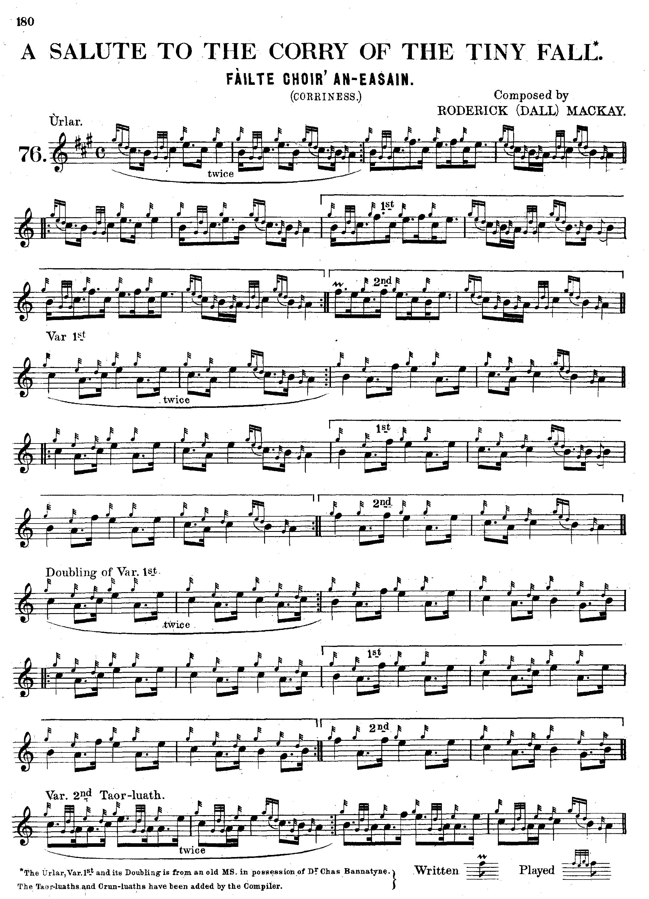
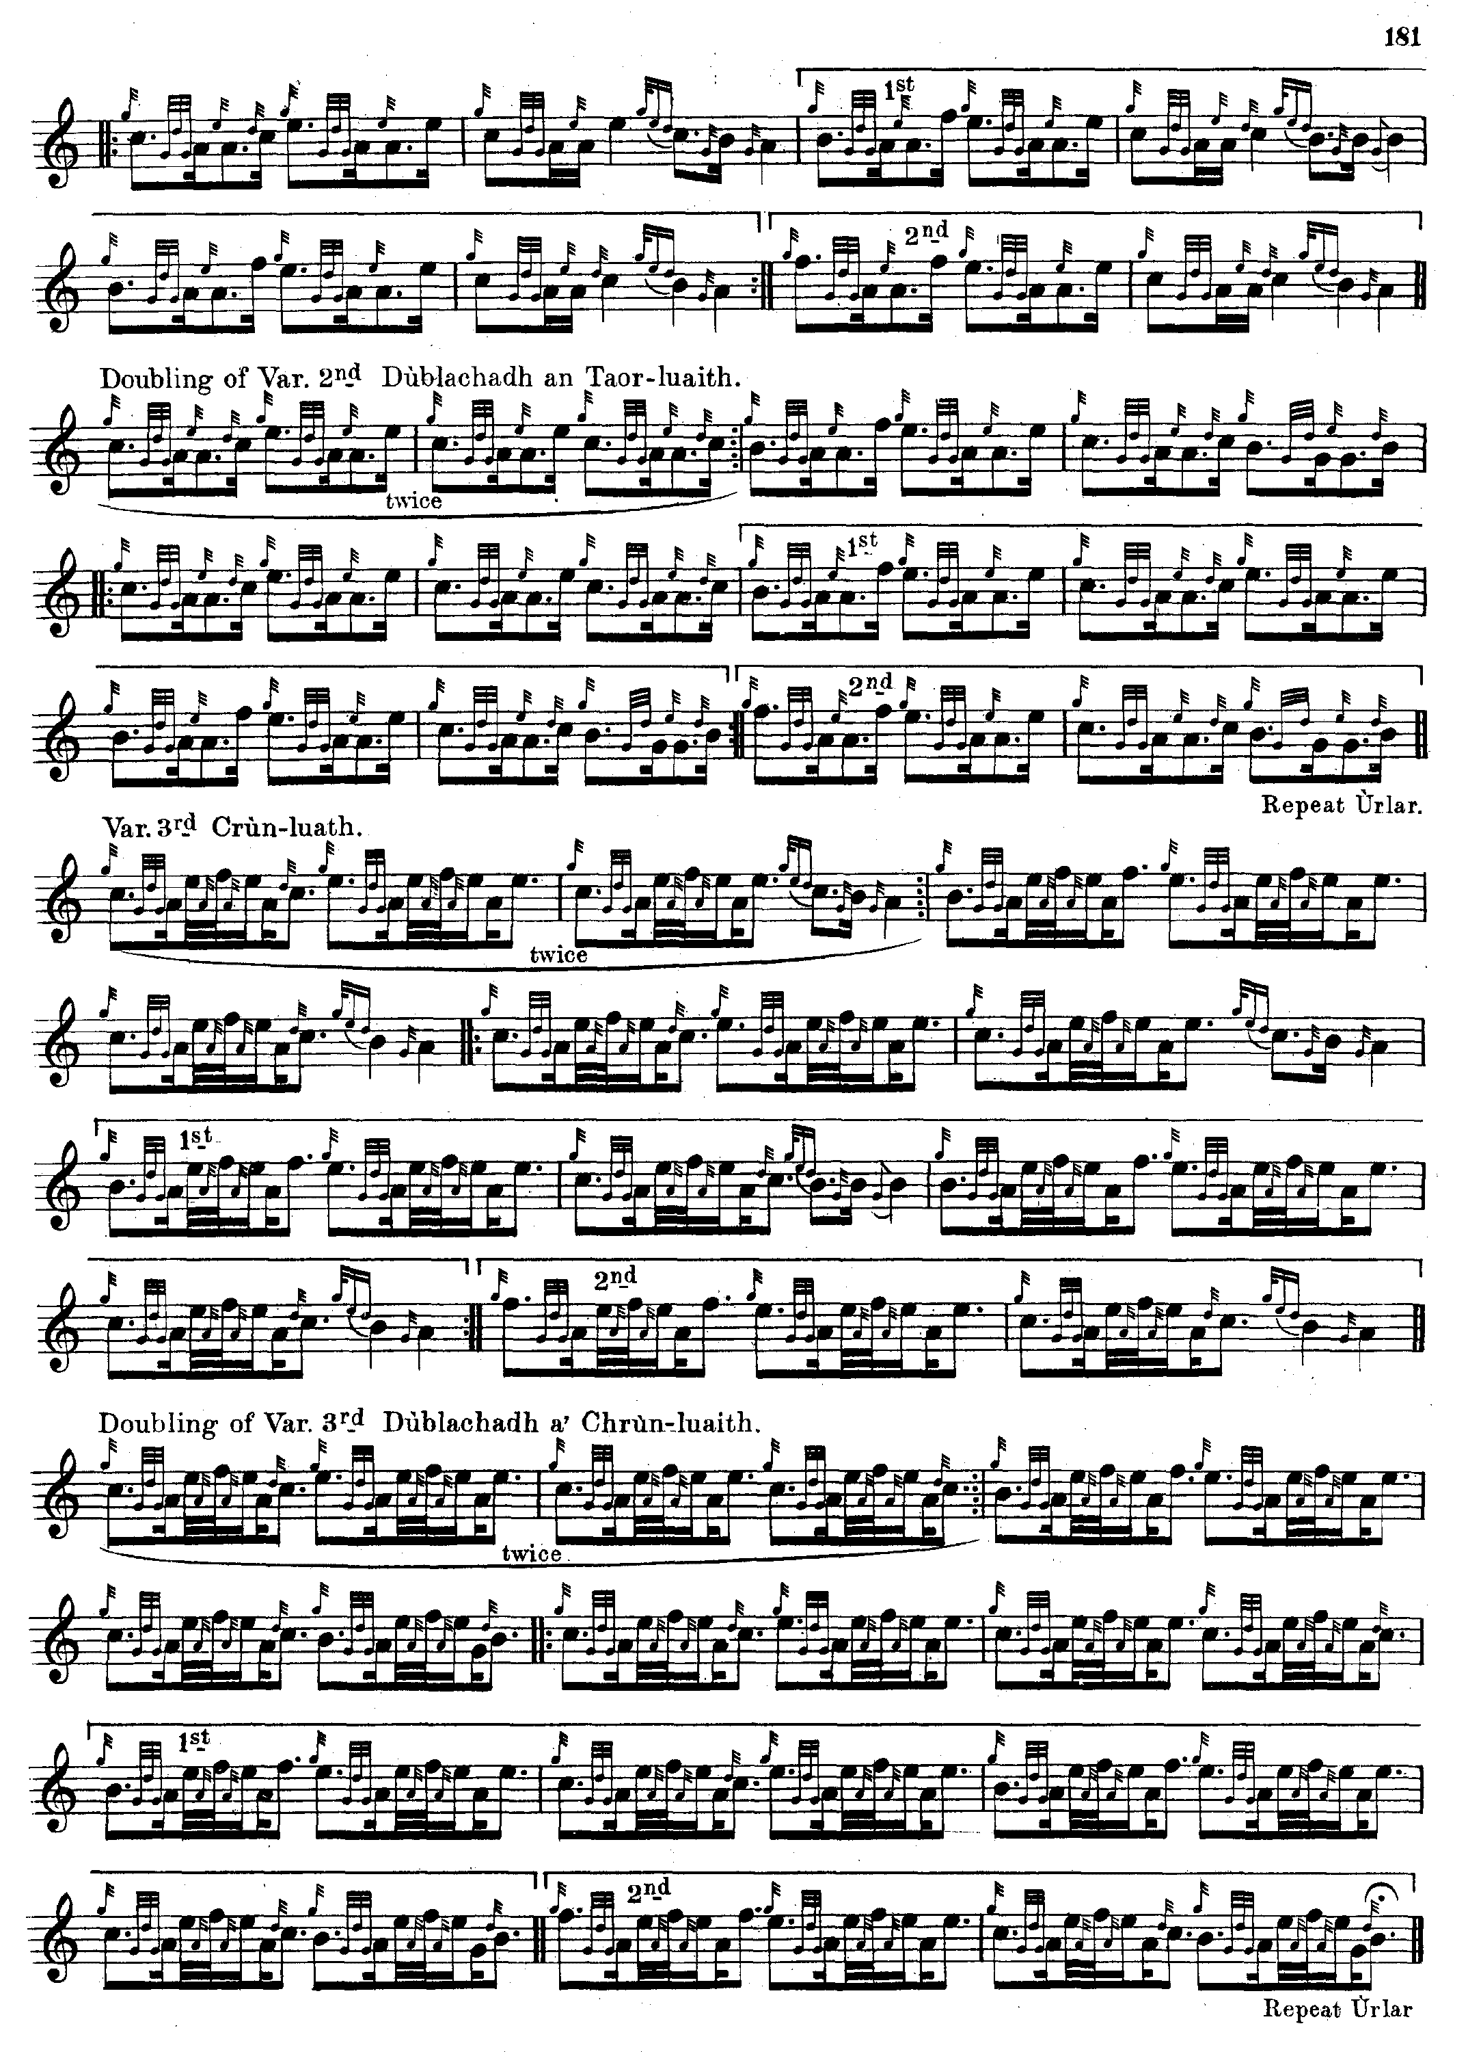

In the second volume of the Piobaireachd Society Collection (first series) the editor, William Stewart claimed that his arrangement (apparently supplied by Dr. Charles Bannatyne) was the first publication of the tune. Stewart’s score is very similar to Glen’s, but cuts the first variation and taorluath “up” in contradistinction to Glen, and there are one or two other minor differences in pointing:

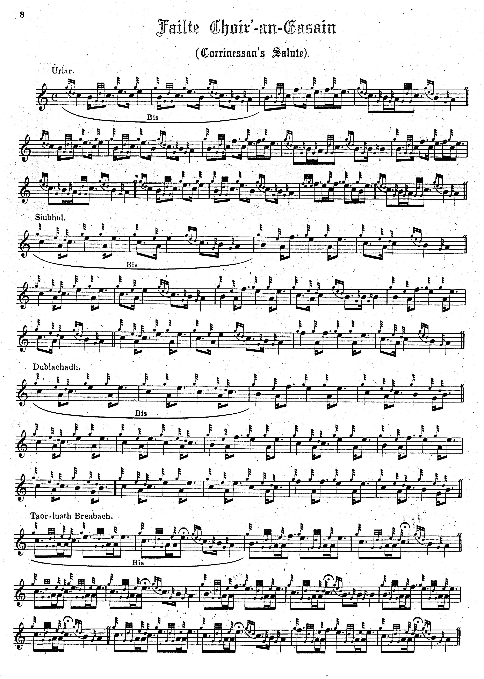
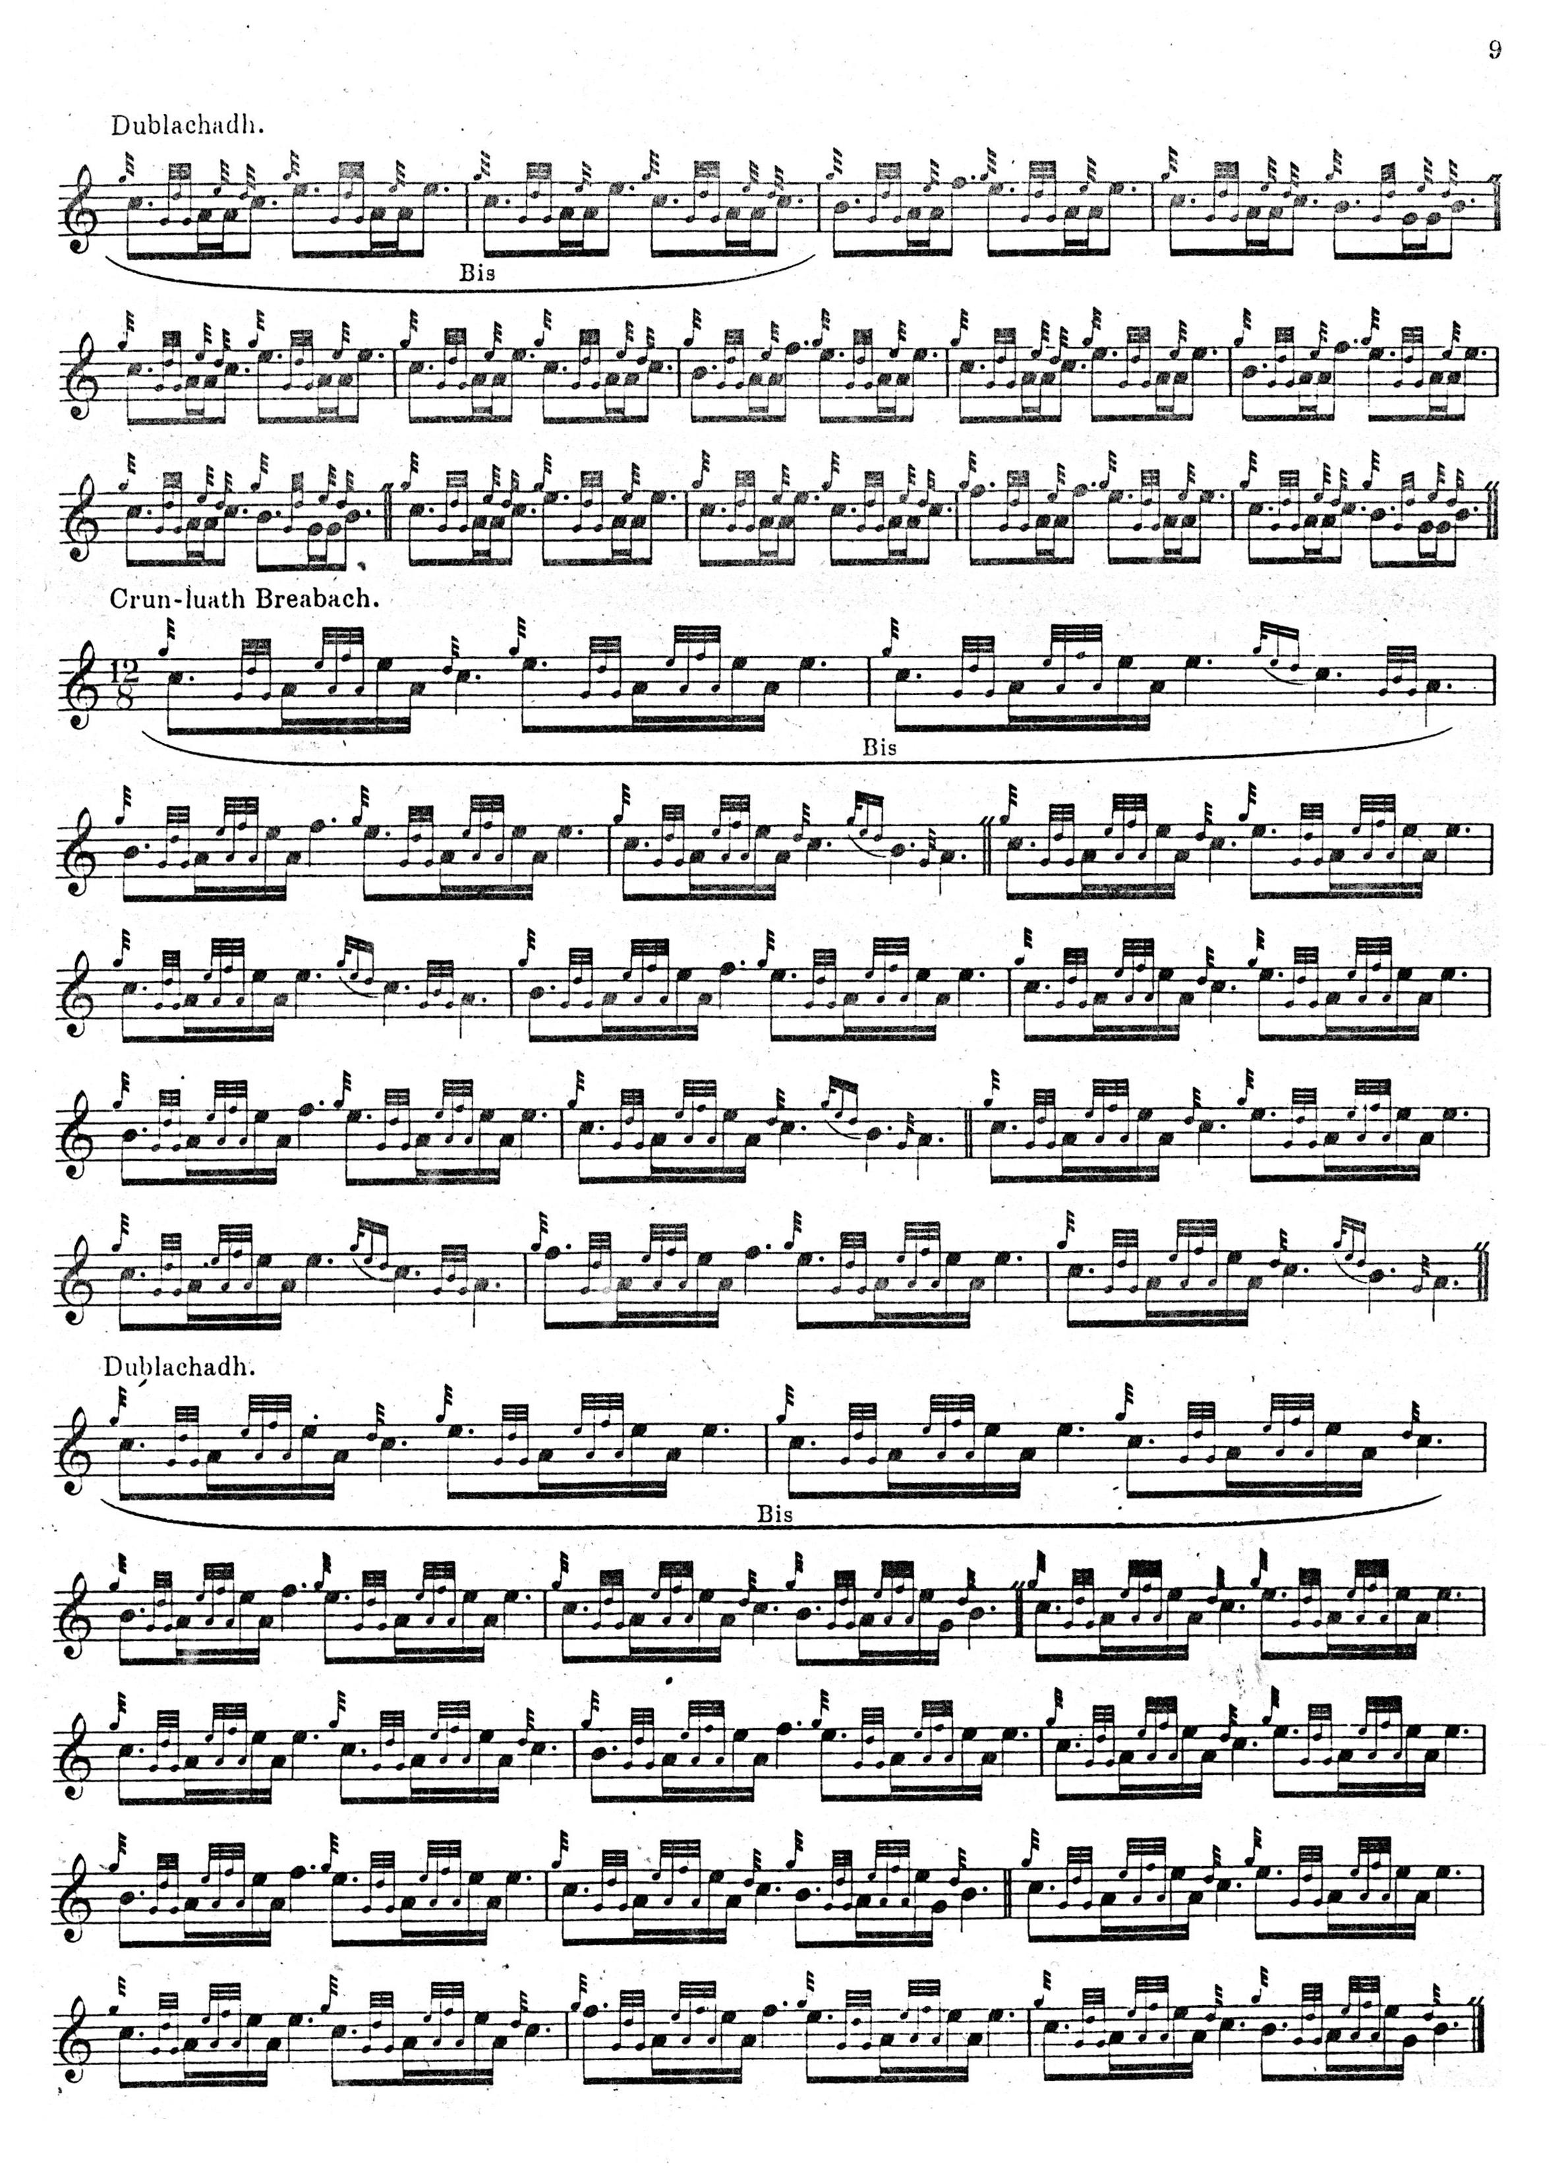

G. F. Ross’s setting is derived from the mysterious Simon Fraser in Australia who was in correspondence with several important figures in piping during the earlier years of the twentieth century. There are few grounds to suppose that this represents an independently surviving tradition (as Fraser claimed), or independent evidence to support Fraser’s title for this tune: “Cumha na Ceol More—Lament for the Great Music—” or his attribution of it to Patrick Òg MacCrimmon. For further details, see The Highland Pipe and Scottish Society 1750-1950 pp. 188-9, 327, 351-2, 408-14. This score is not reproduced here.

Commentary:

There are at least two different tunes which have received the “Corrienessan” title, only one of which concerns us here. There is a tune in David Glen’s manuscript (ff.412-414, f.433) which Glen calls “‘The Lost Pibroch’ Corrinessan (or Corriness.) Corriness Salute” but it is not related musically to the tune now called “Corrienessan’s Salute”. The ground is as follows:

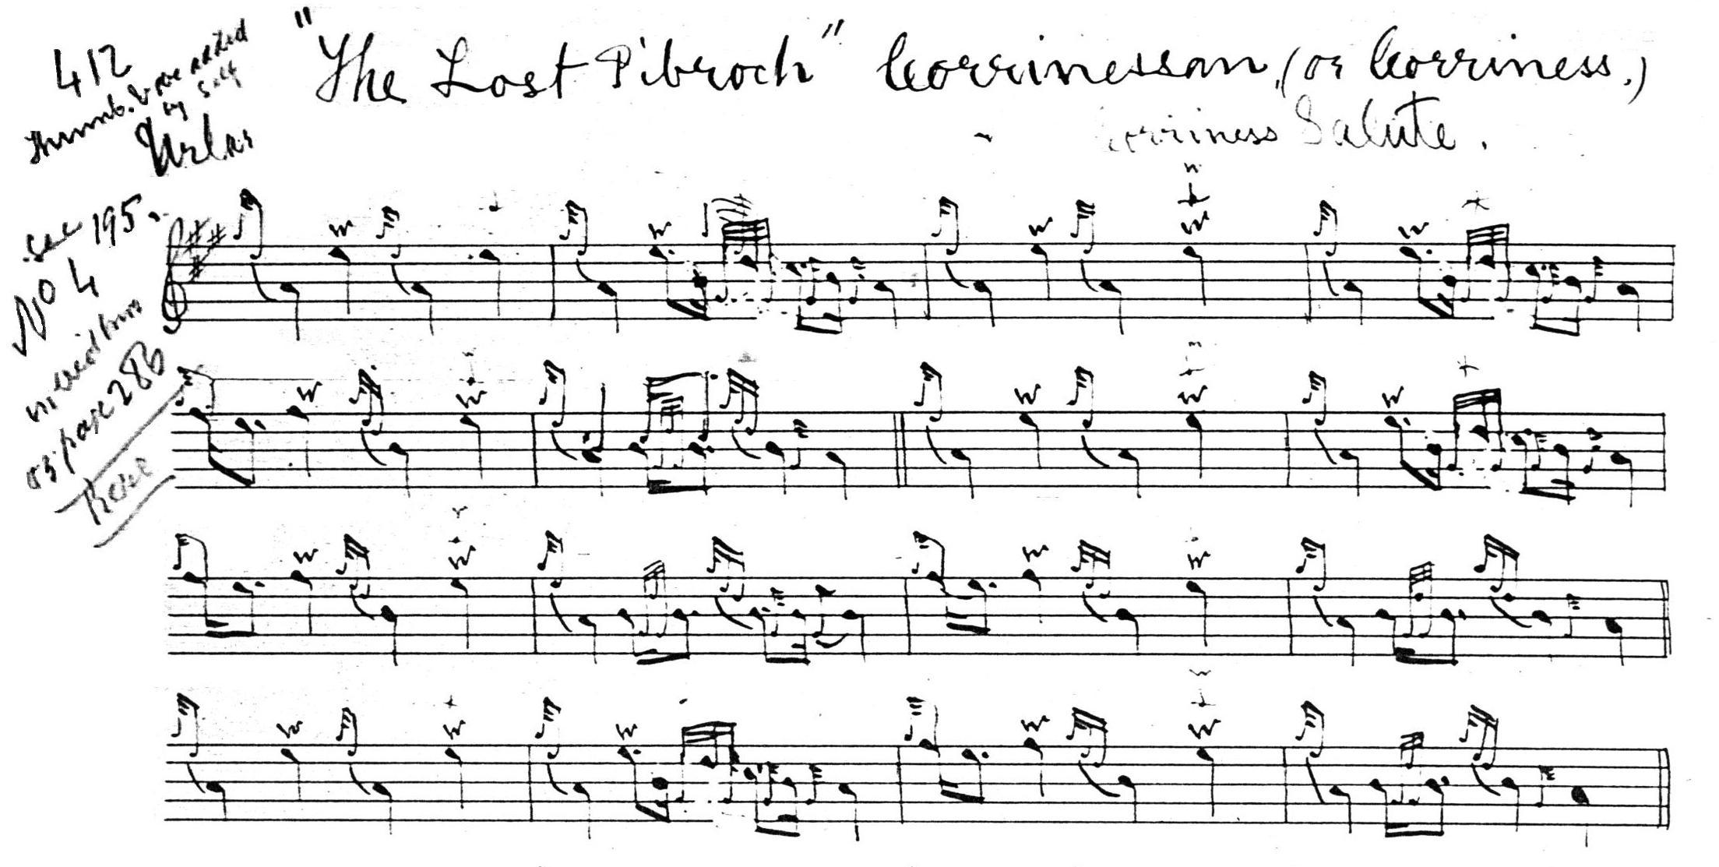

This is a variant of General Thomason’s “Nameless No. 4” (Ceol Mor, p.382), which in turn is related to “Tulloch Ard”. Glen also gives “Corrienessan’s Lament”, ff.392-394, which he says is “arranged by Charles Bannatyne from Air supposed by Rod. Dall MacKay.”

In his “Historic, Biographic, and Legendary notes to the tunes” in David Glen’s Ancient Piobaireachd, Henry Whyte, writing under his pen-name “Fionn”, claimed “Corrienessan’s Salute” as a composition of Ruairidh Dall, father of the famous John Dall MacKay (p.18), but the tune—at least in the form in which it is commonly heard today—seems likely to have been more recent, at least in its fully developed form.

According to Archibald Campbell, it had its origins in a sheet of manuscript in the hand of Angus MacKay which when Campbell wrote (in 1938) was in the possession of the Piobaireachd Society (i.e., himself—since he held its music manuscripts). Campbell says that when Angus MacKay’s papers had been acquired by Dr. Charles Bannatyne (this happened in 1904; the Society bought them in turn following Bannatyne’s death in 1924), the latter had found the ground and first variation sketched out by MacKay and that either he or David Glen had completed the tune with a taorluath and crunluath breabach.

The source of this information was probably the great player John MacDonald of Inverness, with whom Archibald Campbell was regularly in correspondence. MacDonald used the tune to illustrate certain points about the timing of breabach movements in a letter he wrote to Campbell in July 1938:

The most consistent player of all was Calum McPherson, who in my opinion played some tunes much more pleasing than either of the Camerons [Colin or Sandy the younger] […] He played all breabachs with accent on low A. [i.e., he pointed them “down”] […] I remember asking Sandy Cameron about the Taorluath Breabach of “Corrienessan” as altered by the then Piob. Society. He said it was all wrong. I questioned the late Dr Bannatyne about it, as I got a copy of this with accent on the low A as soon as he got the tune into shape. He told me that the Society asked him for a copy and altered it to suit themselves. I still have Bannatyne’s copy of this and other tunes he attempted to put into notation.

When we consider that it was a matter of written record that the variations concerned were put together well within John MacDonald’s lifetime, this forms an interesting commentary on power relations in the piping world during the first half of the 20th century, as indeed does the whole MacDonald/Campbell correspondence, which has been frequently misunderstood.

“Corrienessan’s Salute” was the tune with which pipe maker R. G. Hardie won the Gold Medal at Oban in 1947. Archibald Campbell described the occasion in a letter to Seton Gordon:

The piping at Oban was not very satisfactory, and there was not a single decent performance in either piob. competition.
All the players of any repute had entered, but Archie MacNab, Donald MacLeod, PM. Donald Maclean, Malcolm MacPherson and Roderick MacDonald did not appear and Brown and Nicol could not get leave. A joiner in Glasgow called Hardie was given [the medal] for a not inspiring rendering of Corrienessan. [Robert] Reid was placed first in the open with Craigellachie, a tune which is completely beyond him. D. Maclean was second with an indifferent performance of Antrim. I thought Robertson should have been first with the Children, not that he played it well, but he was about the most local. [NLS. Acc. 7451/2/2. 03/10/1947]

* * *

Electronic text © Dr. William Donaldson, Aberdeen, Scotland, December 2007; revised, Cambridge, Massachusetts, November 2024.

