The Company’s Lament

There are settings of this tune in the following manuscript sources:

**--Angus MacKay**’s MS, i, 115-116; (and in the so-called “Kintarbert MS”, f.101);

**--Colin Cameron**’s MS, f.120;

**--Duncan Campbell of Foss’s** MS, ff.15-16;

**--Uilleam Ross’s MS**, ff.50-151;

**--David Glen’s** MS, ff.315-6;

and in the following published sources:

**--*William Ross’s Collection****,* pp. 40-41;

**--C. S. Thomason**, *Ceol Mor*, p. 259.

**Angus MacKay** sets the tune like this:

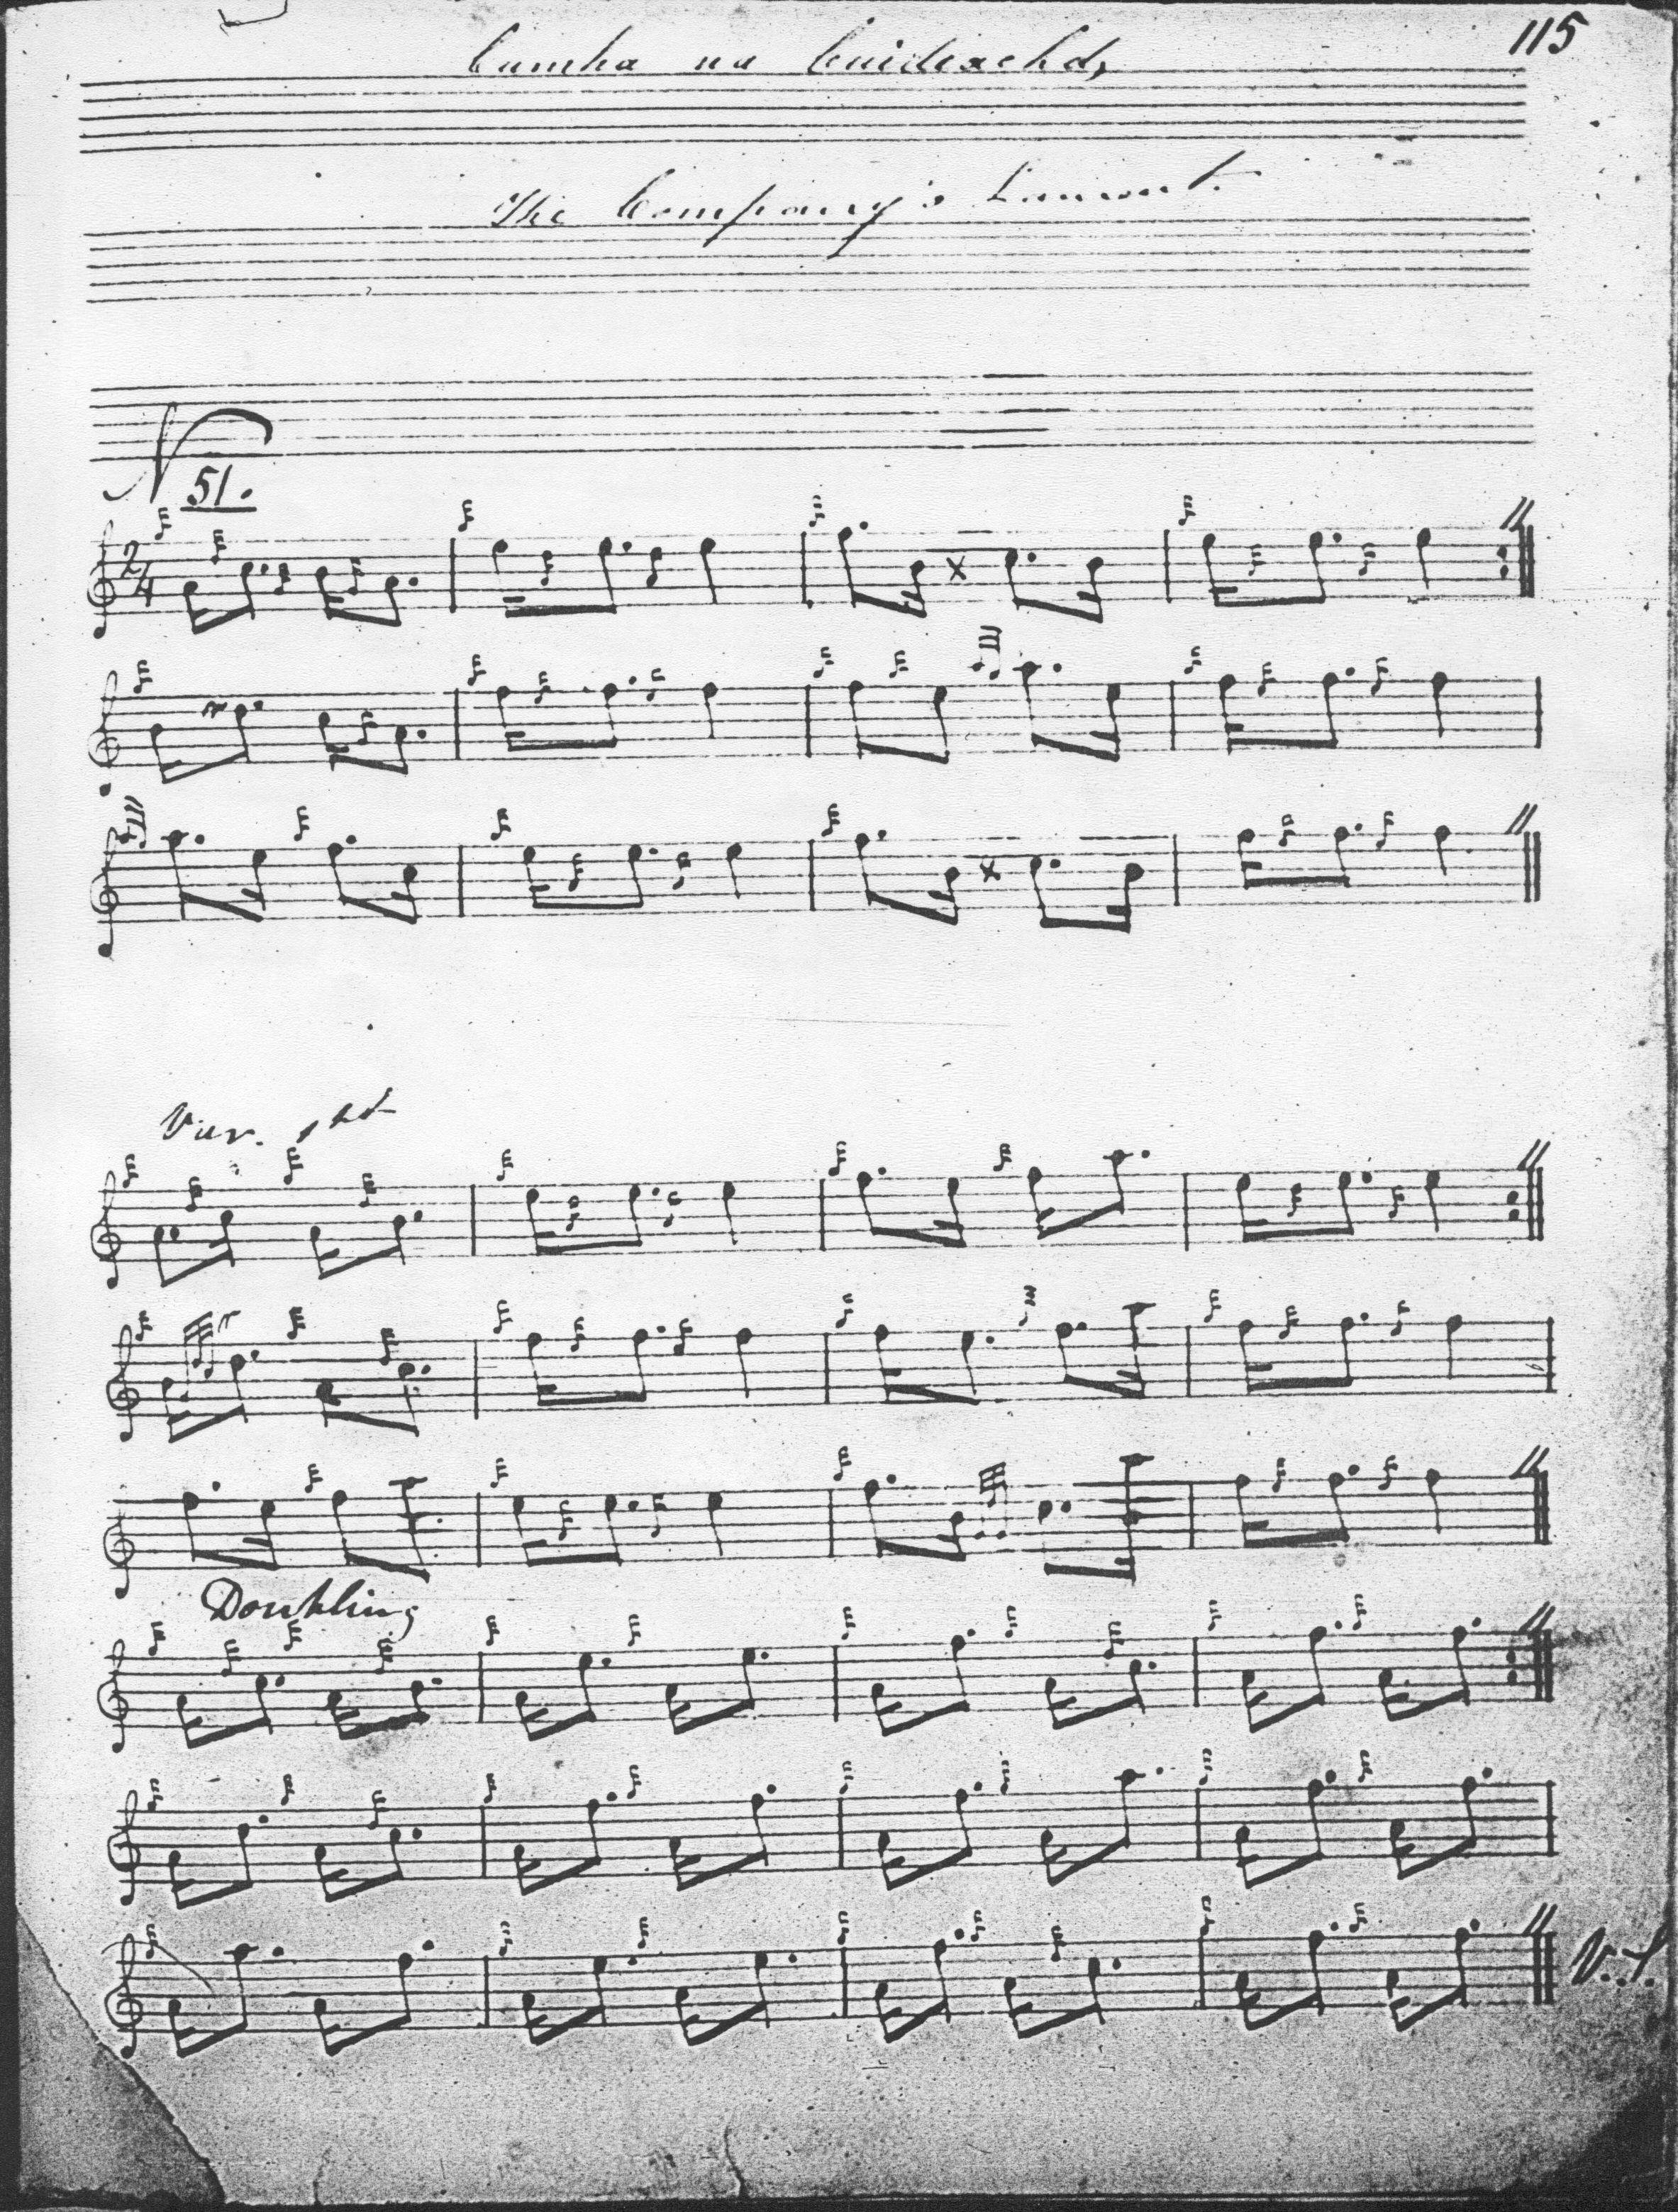

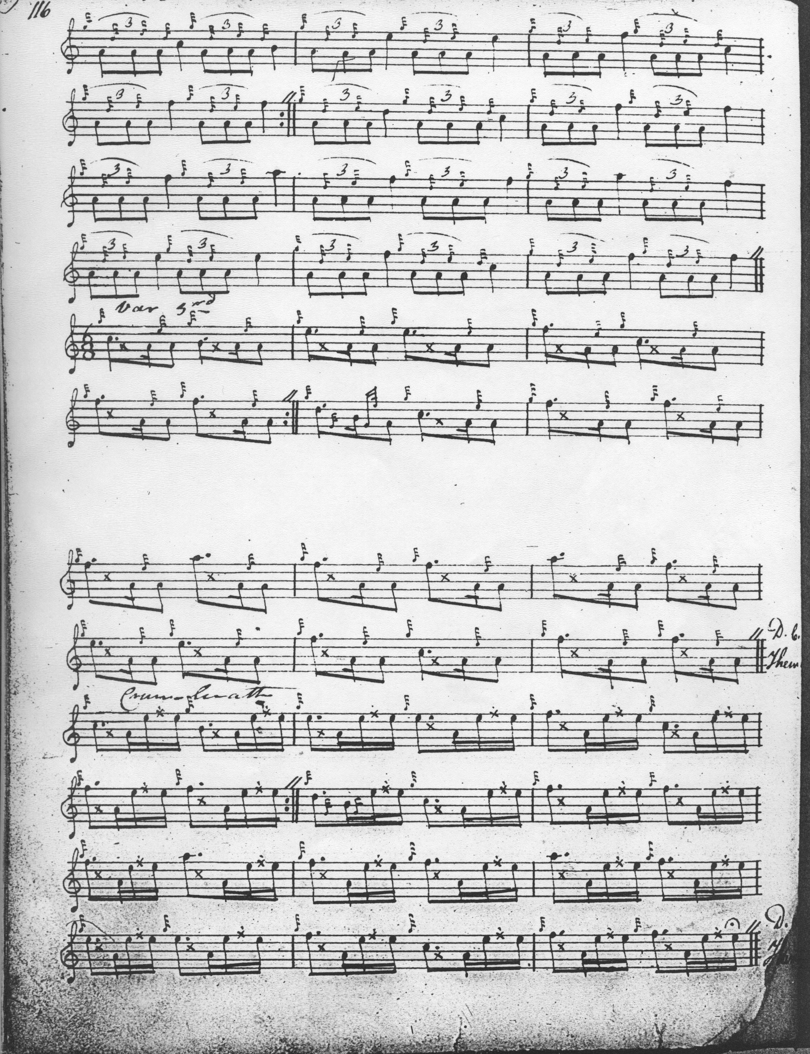

The development of the tune is a little asymmetrical: ground, followed by siubhal singling and doubling, but singlings only of the subsequent taorluath fosgailte, taorluath and crunluath duinte. Despite the brevity of the tune, MacKay indicates that the ground should be repeated after both taorluath and crunluath variations.

None of the other Victorian masters adds significantlyto the expressive possibilities of the tune.  **Colin Cameron**’s score is a partial one with no grace notes after the doubling of the first variation and is therefore not reproduced here. The settings of **Duncan Campbell of Foss, Uilleam Ross, C. S. Thomason** and **David Glen** also add little to Mackay and are not reproduced here. **MacKay**’s is a version with which a number of things could obviously have been done, such as playing taorluath and crunluath doublings but none are explored in the older sources. This suggests that it was the kind of thing that master players had in their repertories, but it was not very widely played, at least until the twentieth century, when the tune established itself quite widely as a beginner’s piece.

*Commentary:*

The surviving scores sound like an imperfectly remembered version of a closely related, and more interesting, tune--“The Black Watch’s Salute”, which has already featured in the Set Tunes series under the title “March for a Beginner”. The tone rows indicate a general similarity of contour:

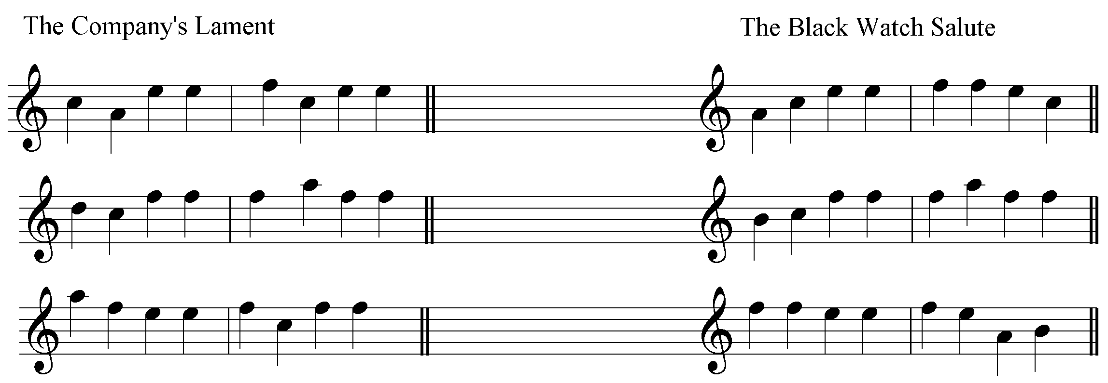

But “The Black Watch’s Salute” is the more cleverly articulated piece.

I did not study this tune with Bob Nicol. It never appealed to me when young, because it was so overworked: it was the kind of thing you could be certain that if somebody had a piobaireachd in their repertoire at all (and not everybody did) it would be Archibald Munro’s “Glengarry's Lament”, or “Struan Robertson's Salute”, or this, all of which I thought very dull as tunes. This piece has sometimes been linked with Joseph MacDonald which means the Company of the title would be the famous East India Company in whose service he died, but the piece flagrantly violates one of Joseph’s keenest strictures on the framing of laments:

“The Key for Laments excludes C. altogether, because it is sharp. Laments dwell much upon the lowest Notes, and take the freedom of all the Notes excepting this.” (*Compleat Theory*—Glasg.,1927, p.3).

***

Electronic text © Dr. William Donaldson, Cambridge, Massachusetts, 20th October 2016.