Colin Roy MacKenzie’s Lament

There are settings of this tune in the following manuscript sources:
--Angus MacKay’s MS, ii, 69-71 (and also in his so-called “Kintarbert” MS, ff.93-6);
--John MacKay’s MS, f.5;
--Colin Cameron’s MS, ff.56-57 and again at, ff.115-117;
--Duncan Campbell of Foss’s MS, ff.85-89;
--Uilleam Ross’s MS, ff.87-90;
--D. S. MacDonald’s MS, i, 126-9;
--David Glen’s MS, ff.60-63;
--John McLennan’s MS, f.18;
--Robert Meldrum’s MS, ff.76-79;

and in the following published sources:
--Niel MacLeod of Gesto’s Pibereach or pipe tunes, pp.37-8;
--C. S. Thomason’s Ceol Mor, p.316;
--William Gray, “Piobaireachd—Ceol Mor” in Piping and Dancing (vol.5, no.1, September 1939), pp.1-2;
--B. J. Maclachlan Orme, ed., The Piobaireachd of Simon Fraser, (Gesto XVII).

Angus MacKay sets the tune as follows:

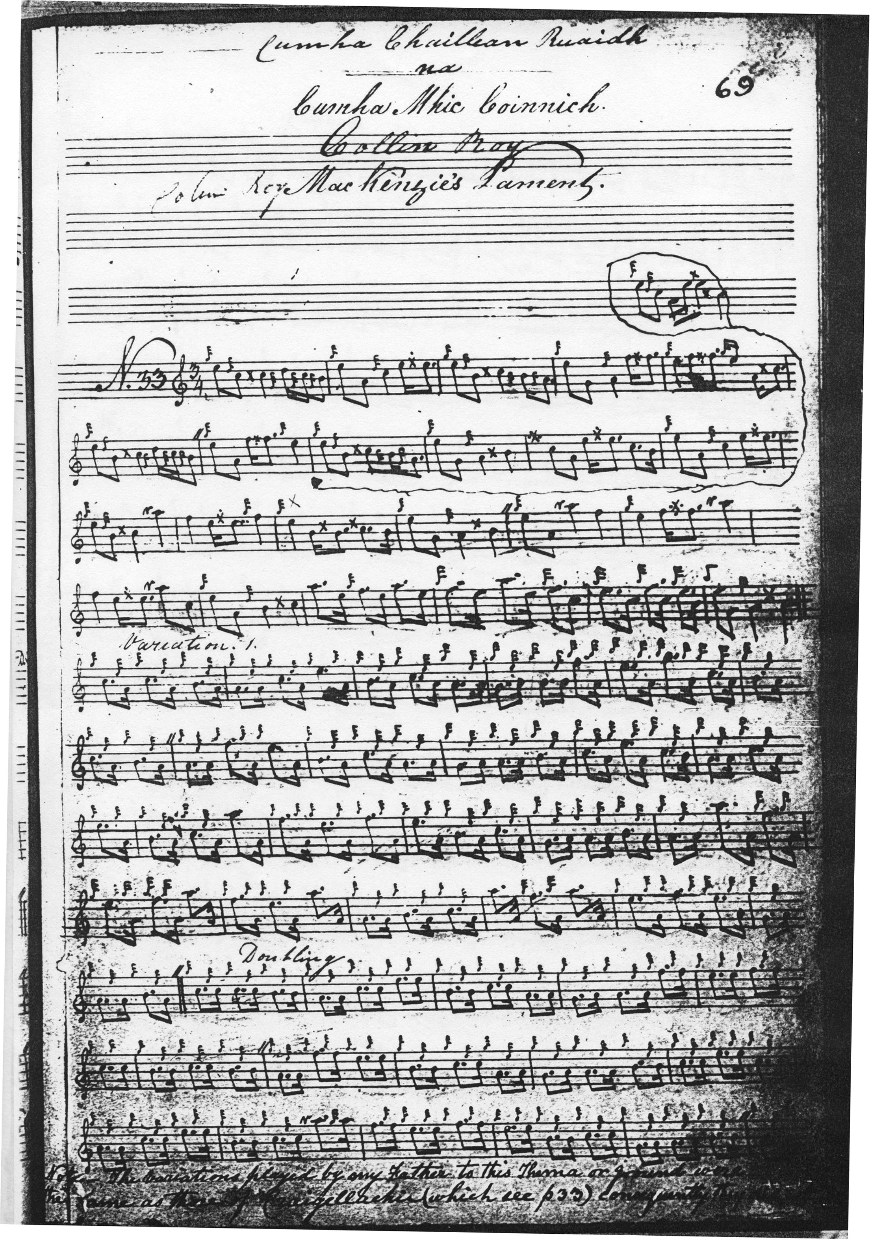
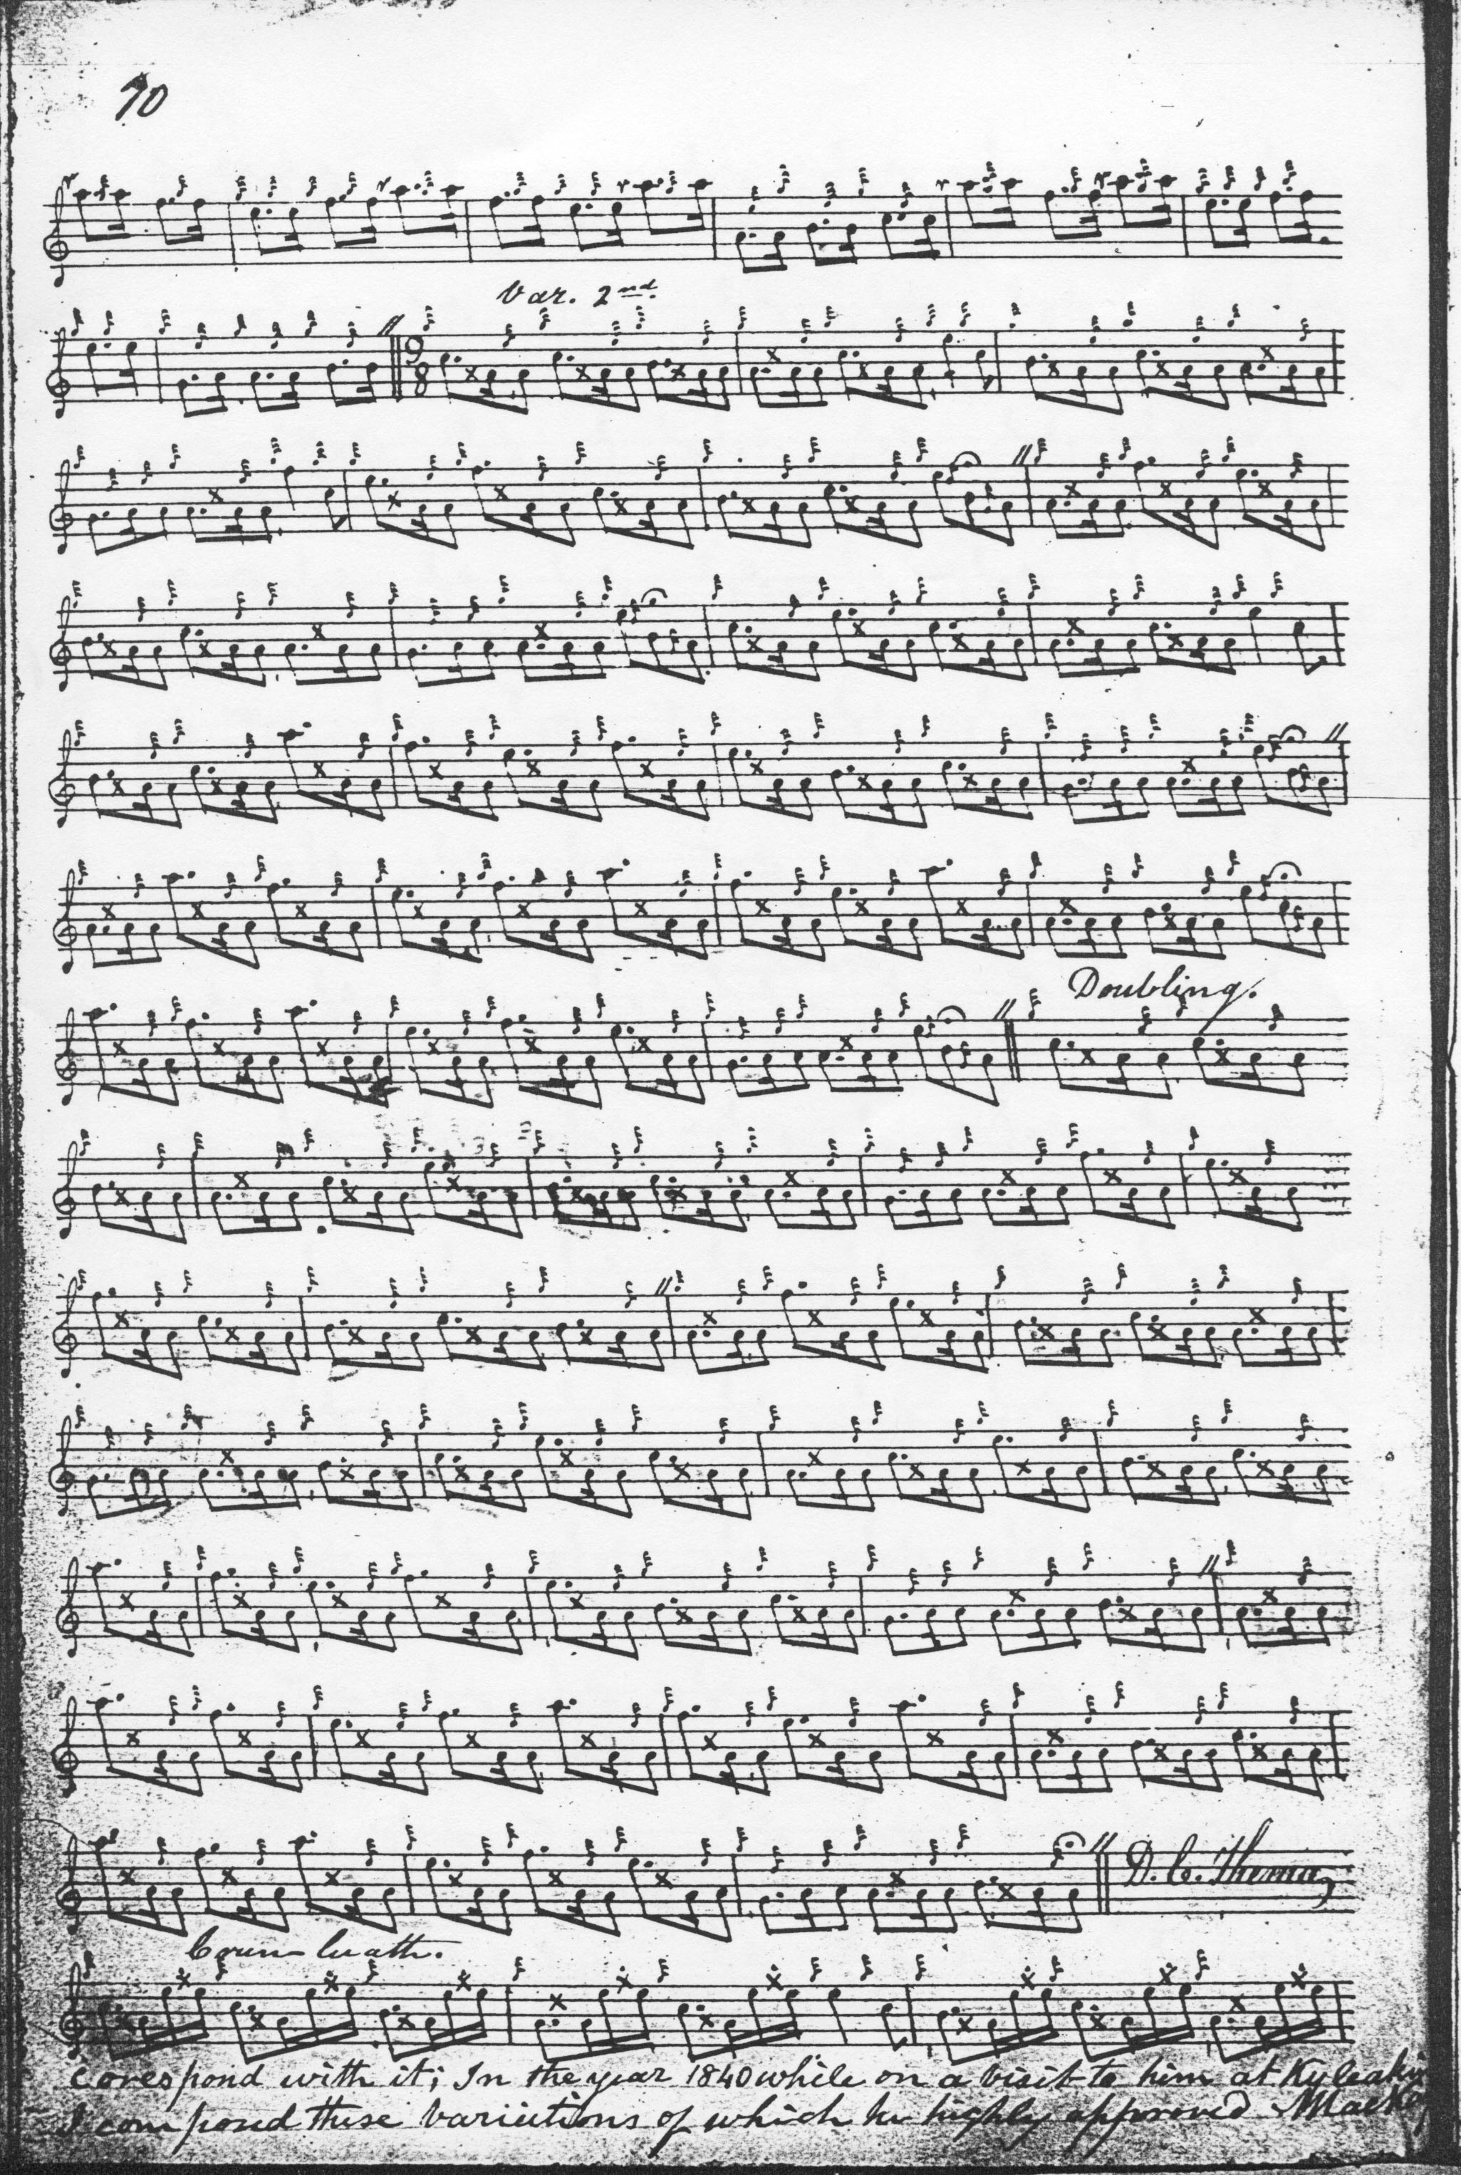
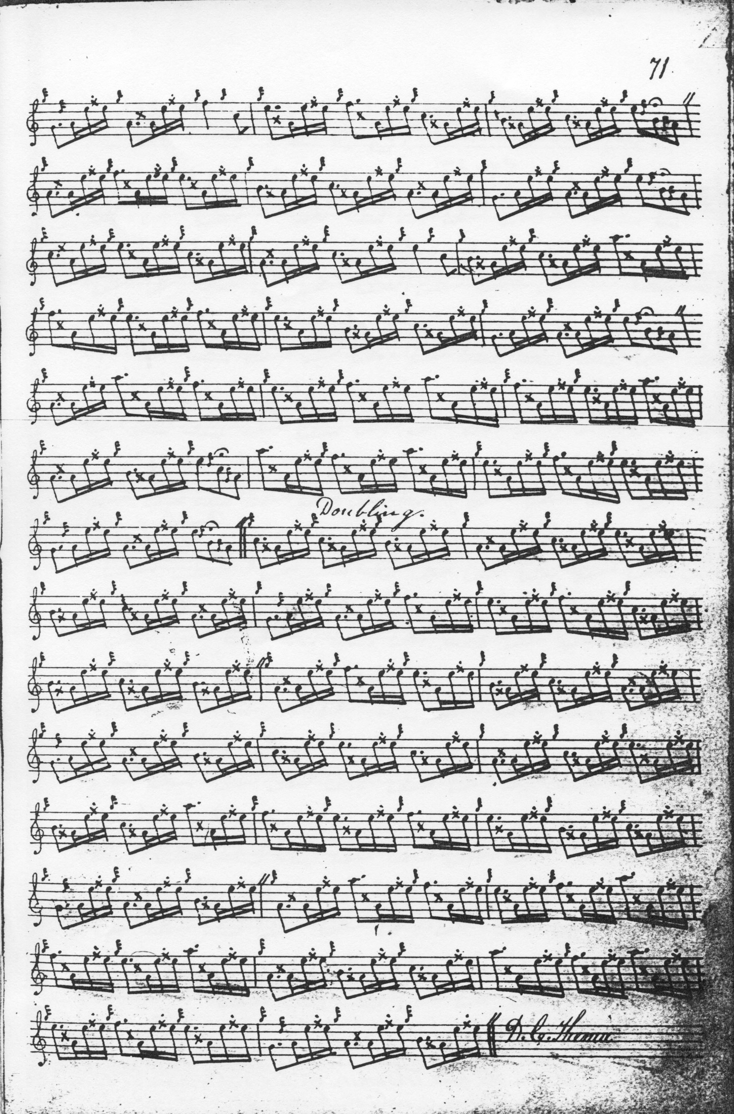
Angus MacKay added a note to the score saying “The variations played by my Father to this Thema or ground were the same as those of Craigellachie […] consequently they did not correspond with it; In the year 1840 while on a visit to him at Kyleakin I composed these variations of which he highly approved. A MacKay”. Scores survive which demonstrate the Craigellachie option (see below). The reader will note above that Angus has supplied the missing bar from the ground in the editorial bars above the tune (although this correction is not made in the so-called “Kintarbert” MS and interestingly the bar is also missing in his brother John MacKay’s MS), but has not regularised the remaining variations. One bar might just have been a slip—but it is curious on structural grounds that the corresponding bars (line 2, bar 2) should be missing in the same position throughout the remainder of the tune, especially as there are claims that MacKay actually composed the piece.

The Craigellachie variations are preserved in Colin Cameron’s manuscript. Colin’s father, Donald Cameron, was, of course, a pupil of Angus MacKay, but also studied with Donald Mór MacLennan of Moy, John Bàn MacKenzie, and Kenneth MacRae, through any of whom the Craigellachie variations may have come. They were plainly current in Skye in the opening years of the 19th century as we shall see in Niel MacLeod of Gesto’s setting below. Colin Cameron sets the tune like this:

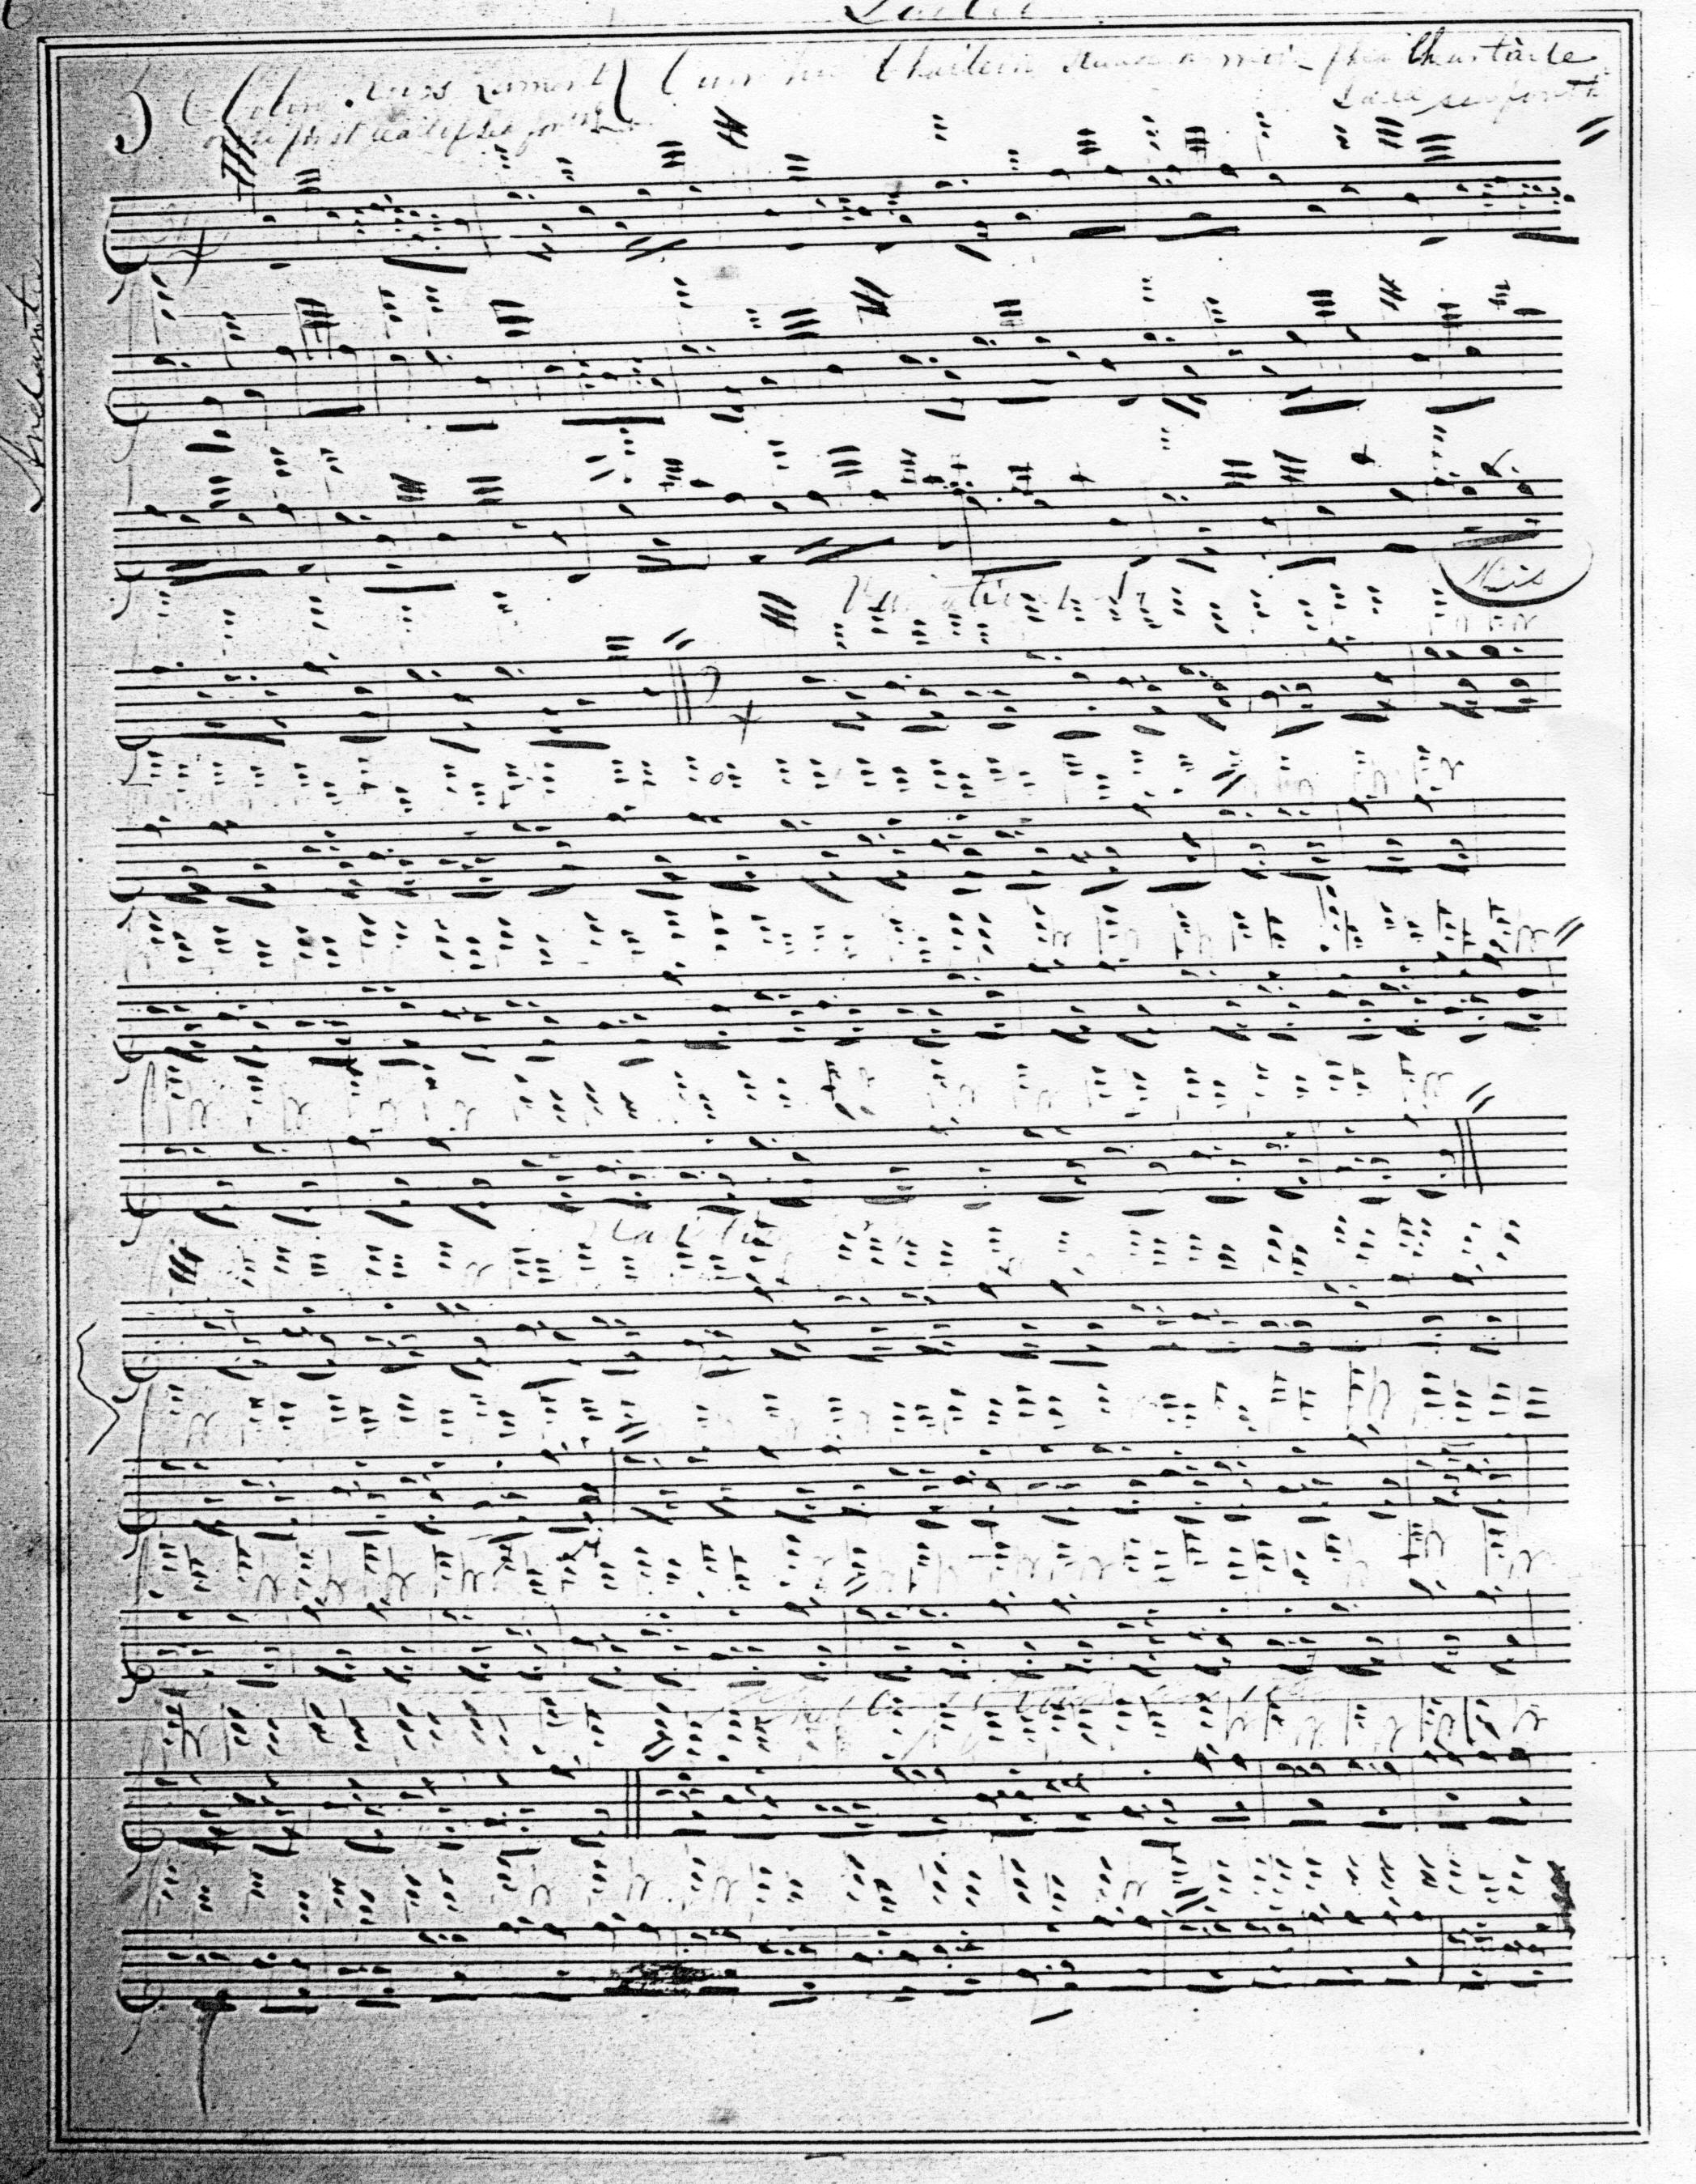

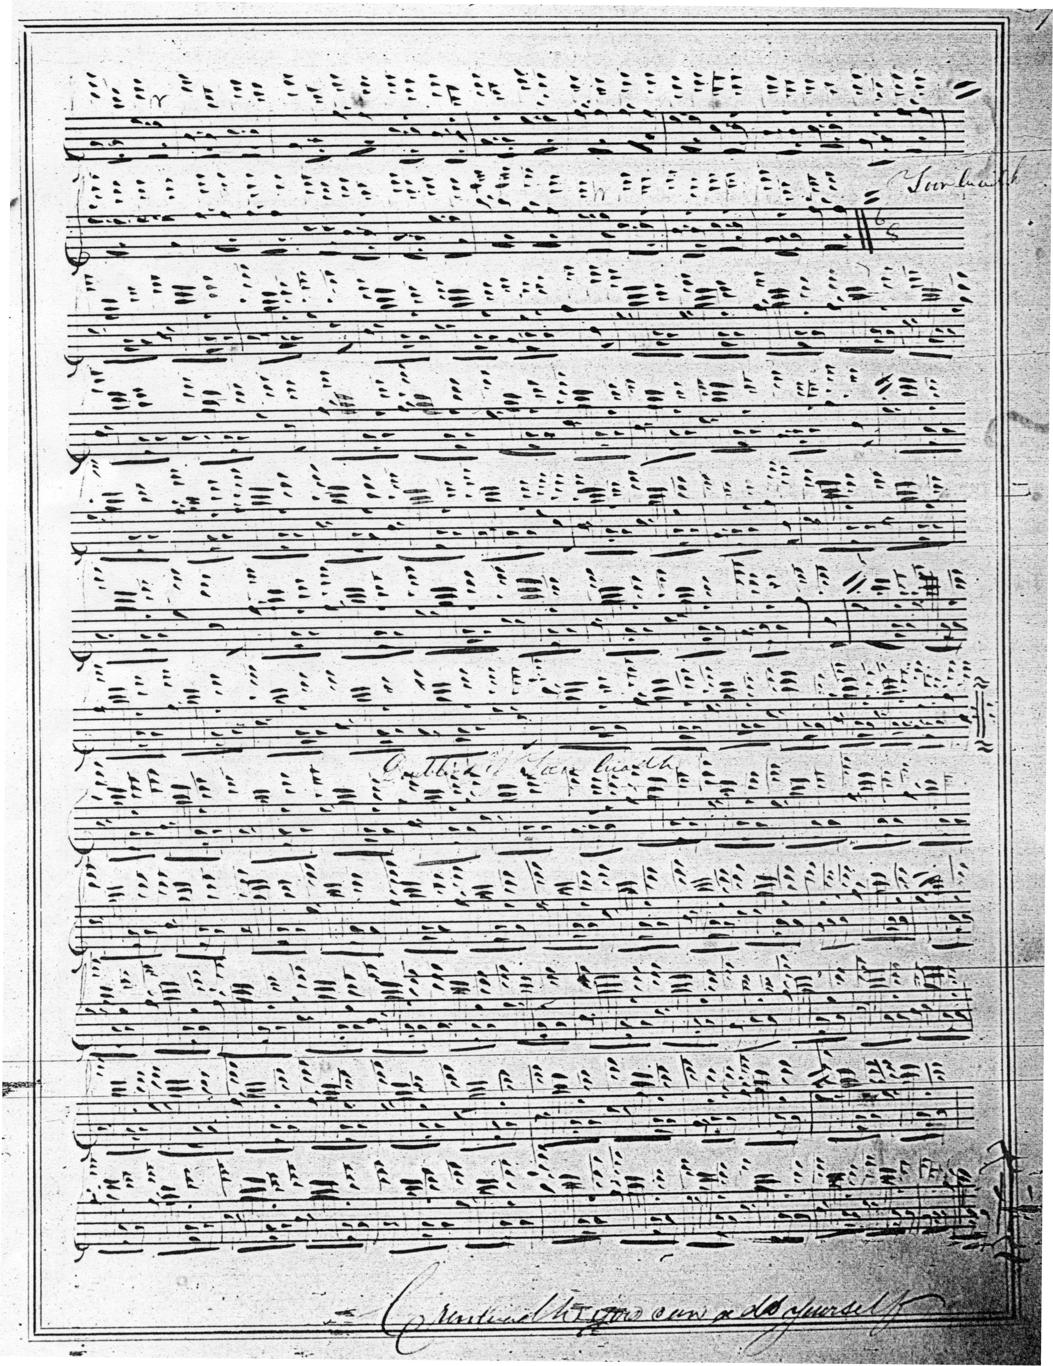

In the ground bar two line two, the section missing from the MacKay scores is missing here as well, and also the final bar of line two and bar six in line three. The tune as it came down through the Camerons suggests a fairly fragmentary affair in general need of editorial attention, and Angus MacKay may well have squared up the ground before going on to add the later variations, hence his father’s appreciation for the otherwise fairly straightforward task of supplying conventional variations to a structurally simple tune, although in the MS version the tune still falls short of what would nowadays be considered regularity.
Uilleam Ross’s, and Duncan Campbell of Foss’s scores both show the missing bar in line two, suggesting that in each case the piece must have been transcribed from MacKay’s MS (or a closely related intermediate source) before the omission was spotted and corrected by MacKay. D. S. MacDonald supplies the missing bar in the ground, but interestingly not in the variations.

The tune was given its modern form by General C. S. Thomason who set it like this:

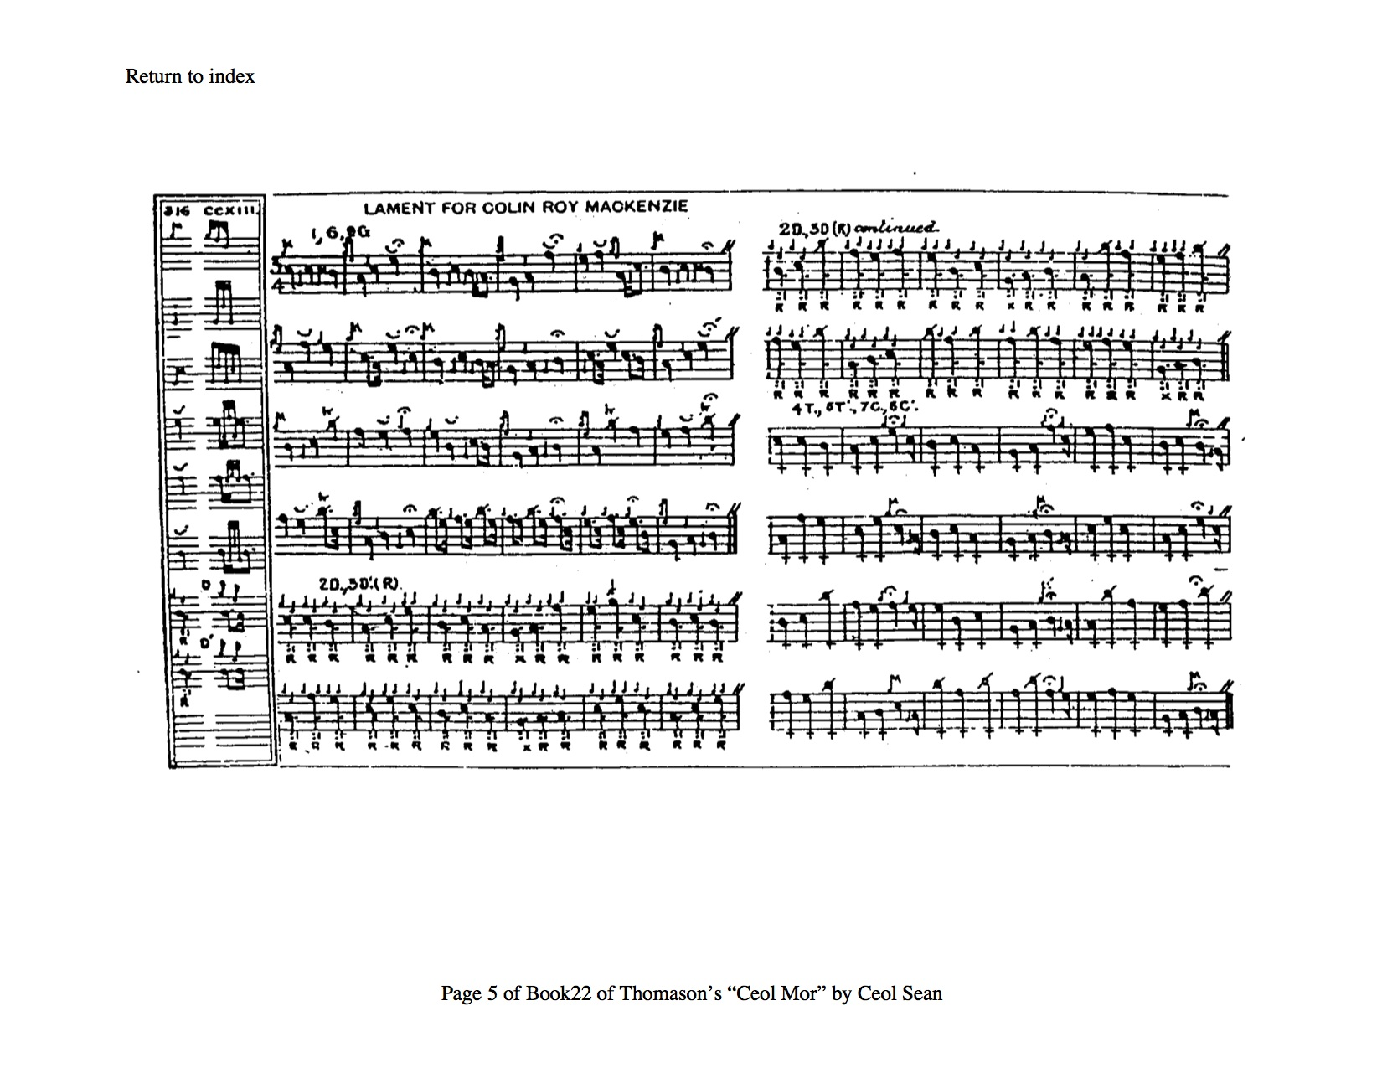

David Glen derived his score from the Ceol Mor setting, preserving Thomason’s emendations in his manuscript which is not, therefore, reproduced here. John McLennan gives the ground in full but his variations are merely sketched in outline: his score is not reproduced here. Robert Meldrum has an interesting little run down from C to low A in his ground which might interest players looking for ways of varying a rather square tune:

A third significantly different route through this tune comes to us through William Gray, one of the leading Glasgow players during the first half of the 20th century, a pupil of John MacDougall Gillies and of Sandy Cameron (the younger) who in a contribution to the magazine Piping and Dancing in 1939, proposed an alternative tone row for the variations as adhering more faithfully to the ground than Angus MacKay’s version, Gray wrote:

[…] the manner in which the bulk of our piobaireachd is printed today makes many pipers say “We pay no heed to that but play it this way.” Perhaps they are justified in saying this as I think there could be an improvement in the setting down of our music. The average piper appears to find it extremely difficult to decipher and understand.’ (vol.5, no.1, September 1939, p.1).
As a young player going over piobaireachd with Alexander (Sandy) Cameron, and while asking some questions whereon Sandy remarked to me “You cannot write piobaireachd” and insisted on my timing from him and referring as little as possible to the book […] the Piobaireachd Society…tunes as printed in their present contracted and abbreviated form, are of little benefit to the piper to whom the services of a qualified pibroch tutor are not available…the tunes as written are almost unintelligible to the ordinary piper—who has first to decipher them and then re-write them in full […] (vol.5 no.11, July 1940, p.4)

Gray’s proposal for emending the variations of “Colin Roy MacKenzie” was as follows:

MacKay had in his possession only a copy of the Urlar of this tune which he obtained on the death of his brother John. This Urlar only of Colin Roy MacKenzie is given in John’s M.S. of which Angus has written of as being a “copy of his father’s tunes.” It would appear rather that Angus has attempted to compose the Shuibhal and other variations from the Urlar and in support of this contention I give the Shuibhal from another M.S. with a similar Urlar, but with variations which retain the characteristics and stress of the melody more emphatically than MacKay’s variations, viz.—

Shuibhal—Colin Roy MacKenzie

1st C B C E C A G F E F E B
2nd C B F E C A G B C E A E
3rd C A F E B C A B A E E F
4th F F B C A F F A E F A B

Metre 6, 6, 6, 6. A denotes top A. The usual small “a” of shuibhal intervening between all foregoing notes.

Gray’s reticence about the source of the manuscript he cites may be partially explained by the supposition that he had not personally seen it, and that the information came from a controversial source, namely Simon Fraser in Australia, with whom Gray is known to have been in correspondence, and whose standing as an authority had been seriously questioned in the Scottish press (for further details of which, see my book The Highland Pipe and Scottish Society 1750-1950, pp. 341, 413-414). A similar interpretation of the siubhal of “Colin Roy MacKenzie” is preserved amongst the Fraser papers, a conjectural reading in staff notation of the canntaireachd version of Niel MacLeod of Gesto.

Niel MacLeod had set the tune like this:

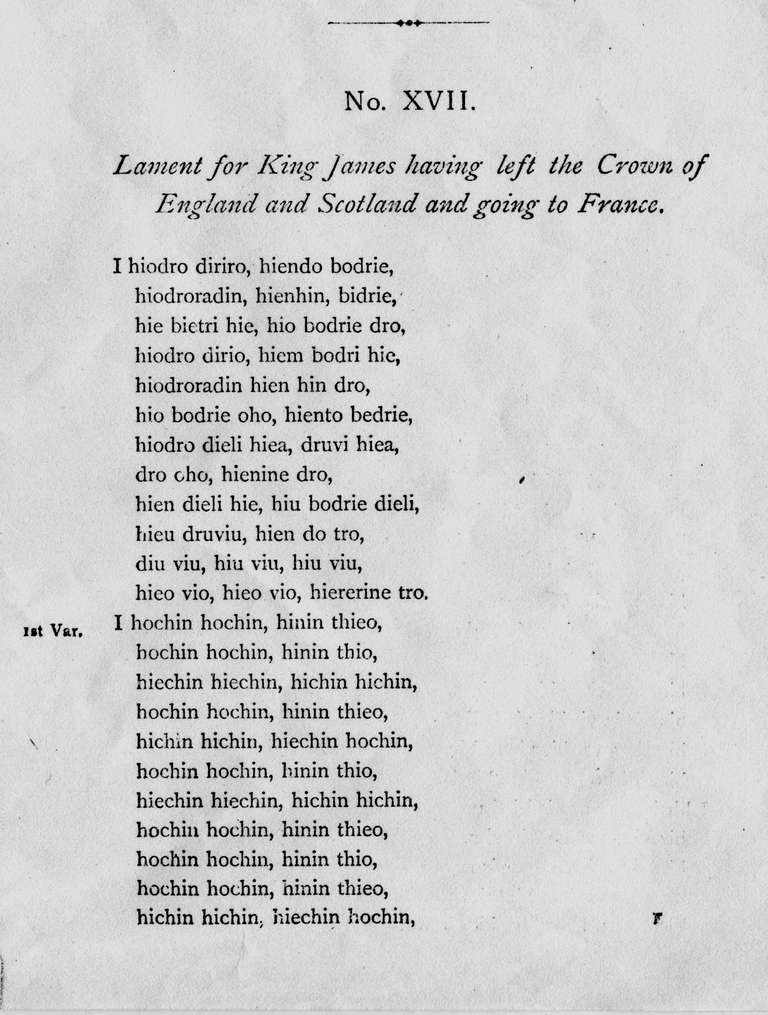

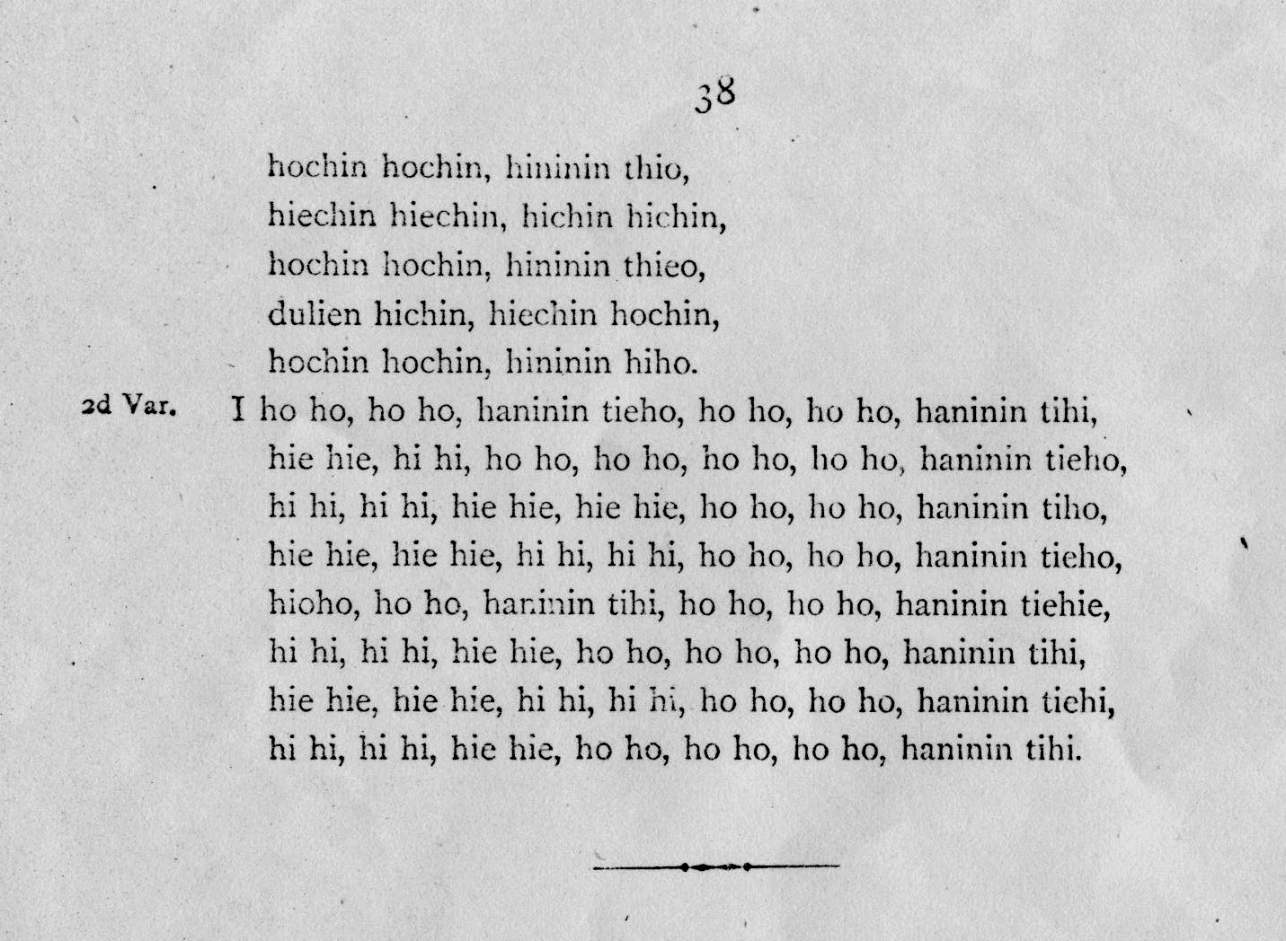

There are the usual interpretational difficulties here with Gesto’s rather imprecise notation, but the first variation seems strongly redolent of the “Craigellachie” siubhal. In any case, Simon Fraser set it like this:
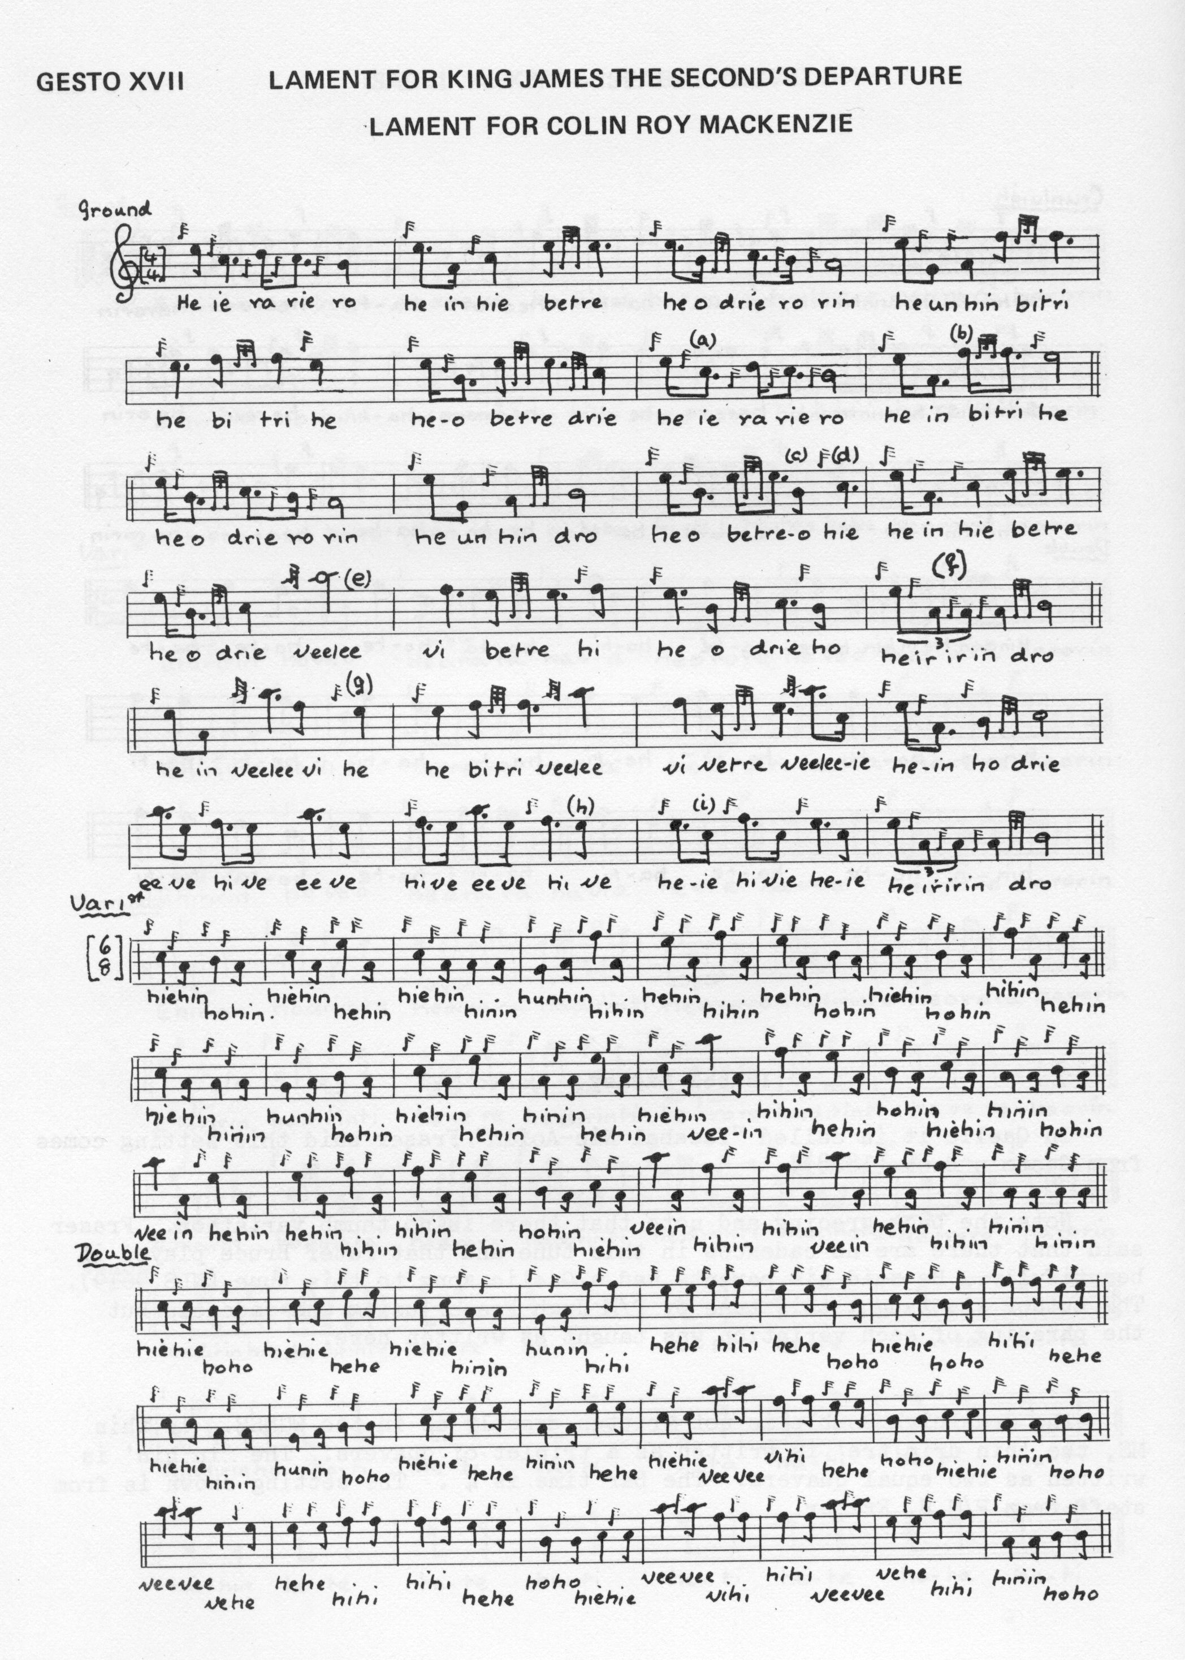

and so on.

Commentary:

Colin Roy MacKenzie was the second Lord Kintail and later first Earl of Seaforth. At the age of fourteen he succeeding his father on the latter’s death in 1611. His inheritance was a typical one for an old-style Highland laird, wide acres and an assortment of feuds more or less virulent, in this case with Glengarry and the MacLeods of Dunvegan and Lewis, the north-west Highlands being then in their normal condition of chronic turbulence and instability. In those days the acquisition of feudal superiorities might mean having considerable clout even in areas one did not physically possess, and so thanks to his capable uncle Rory as Tutor of Kintail, skilled in the art of making interest in the Highlands by all the usual methods– including legal and marital chicanery and when all else failed, brute force energetically applied– Colin MacKenzie's influence was extended deep into the adjacent isles of Skye and Lewis while he was still in his teens. Eventually it encompassed virtually the whole of the Rough Bounds between Ardnamurchan and Strathnaver. Colin Roy was a favourite of King James VI and was frequently at Court, being raised to the peerage as Earl of Seaforth and Viscount Fortrose in 1623. Seaforth was then added the great marcher lordships, Huntly, Athol and Argyll, as a guarantor of what passed for order in the Highlands during the seventeenth-century. Colin Roy’s chief residence was the Chanonry of Ross at Fortrose in the Black Isle, and he kept up considerable style, annually touring his great estates in ships well plenished with beer and wine and hosting great hunting parties for his friends and relatives. He built Brahan Castle and endowed many churches and schools. He was buried in Fortrose Cathedral after dying of a lingering fever at the Chanonry on 15th April 1633.
* * *
Electronic text © Dr. William Donaldson, Aberdeen, Scotland, 16th June 2012

