Cluny MacPherson’s Salute

There are settings of the tune the Piobaireachd Society calls “Cluny MacPherson’s Salute” in the following manuscript sources:
--Angus MacKay’s MS, ii, 39-40;
--Duncan Campbell of Foss’s MS, ff.203-5;
--D. S. MacDonald’s MS, i, 60-2;

and in the following published source:
--C. S. Thomason’s Ceol Mor, p.*394.

Angus MacKay sets the tune as follows:

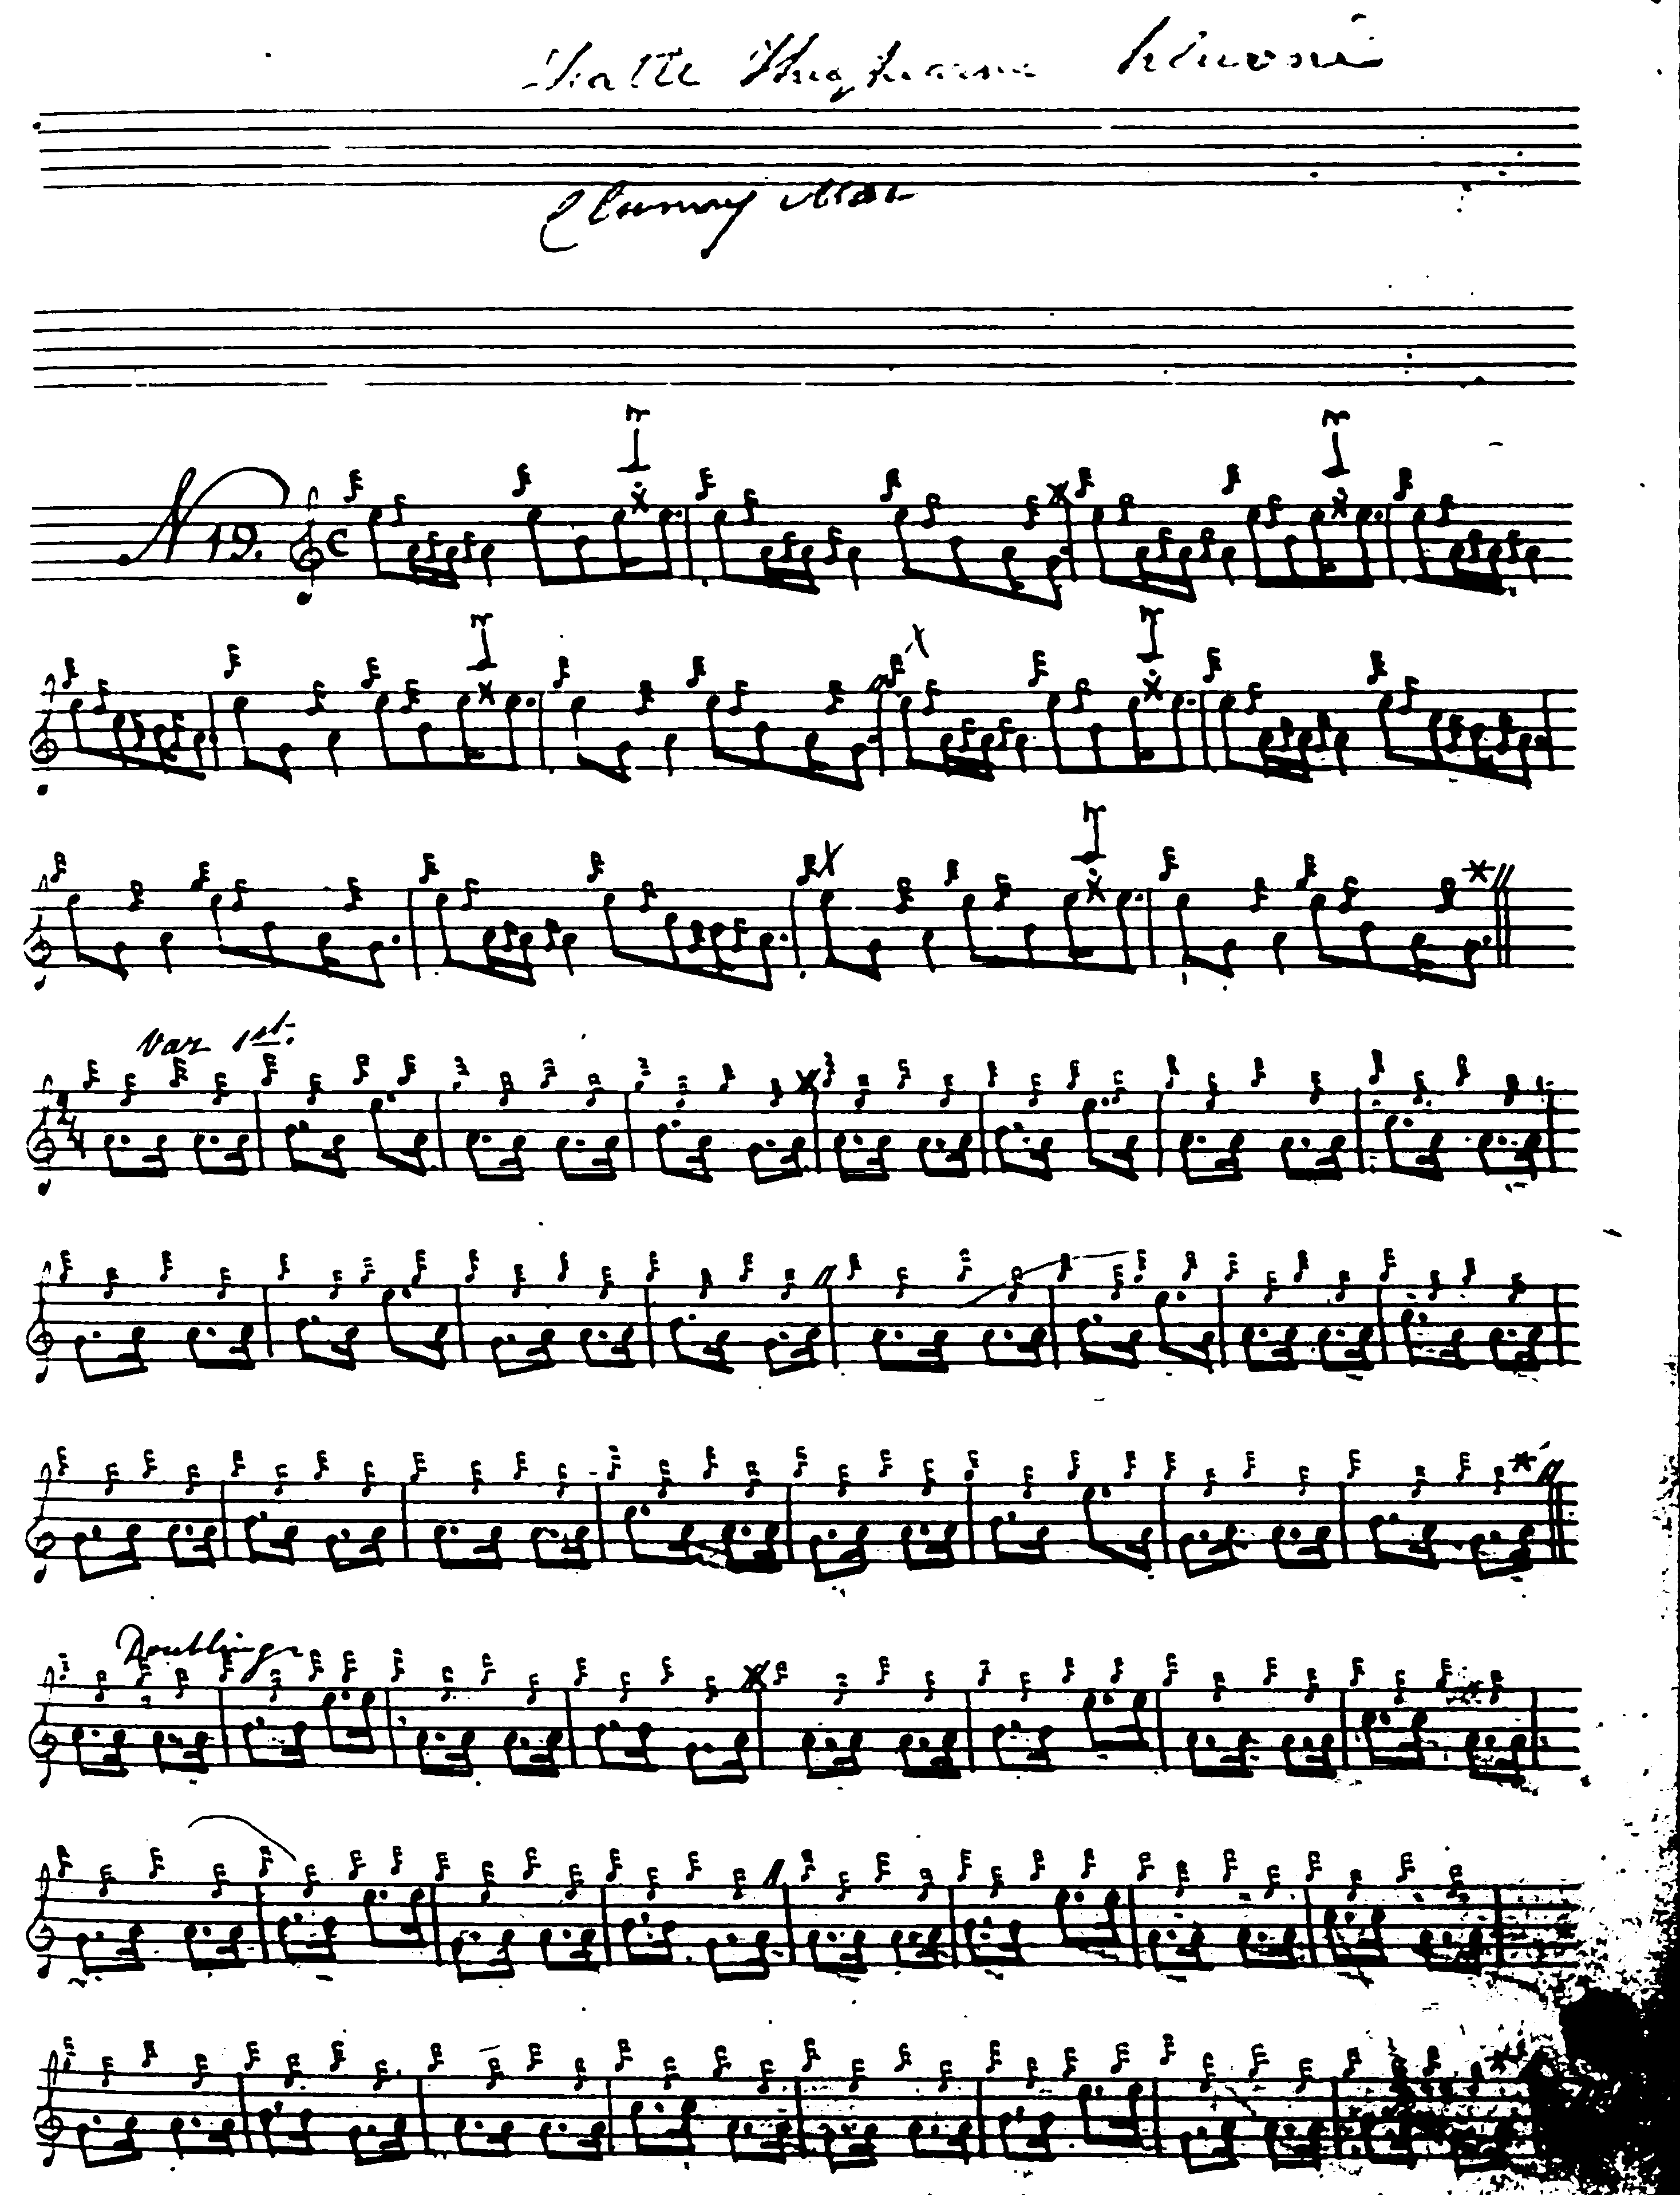
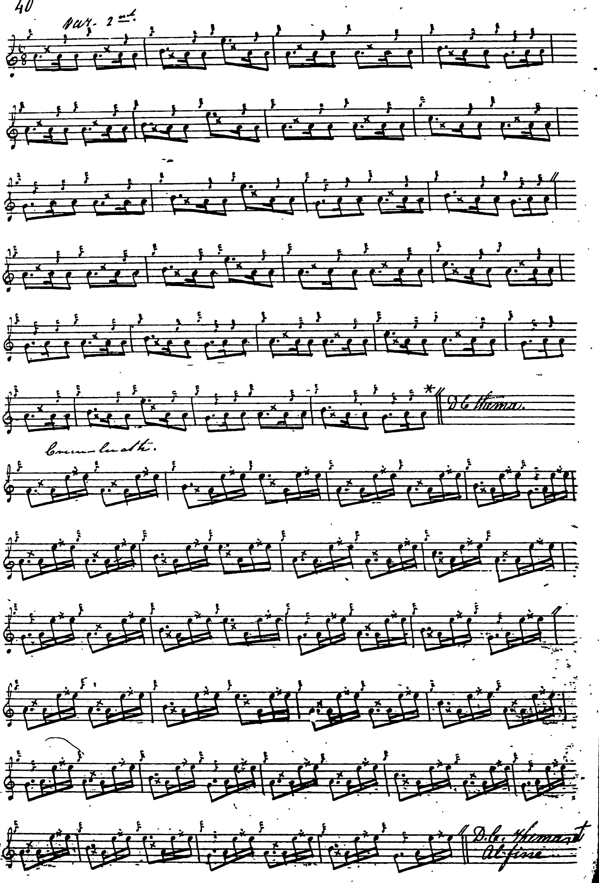

Although claiming his setting as Angus MacKay’s, Archibald Campbell made a number of silent changes to what MacKay had actually written, including removing the instructions to repeat the ground after the taorluath and crunluath variations, and altering MacKay’s changes of time signature within the tune.

Commentary:

There is an awkward confusion of titles here. Following a casually scribbled note in MacKay’s MS, “Failte Tighearna Chluainie Cluny Mac” Archibald Campbell published this tune as “Cluny MacPherson’s Salute” despite the fact that a different tune with this same title had already been published by Uilleam Ross, and C.S. Thomason, a simple but characterful little piece, which goes like this:

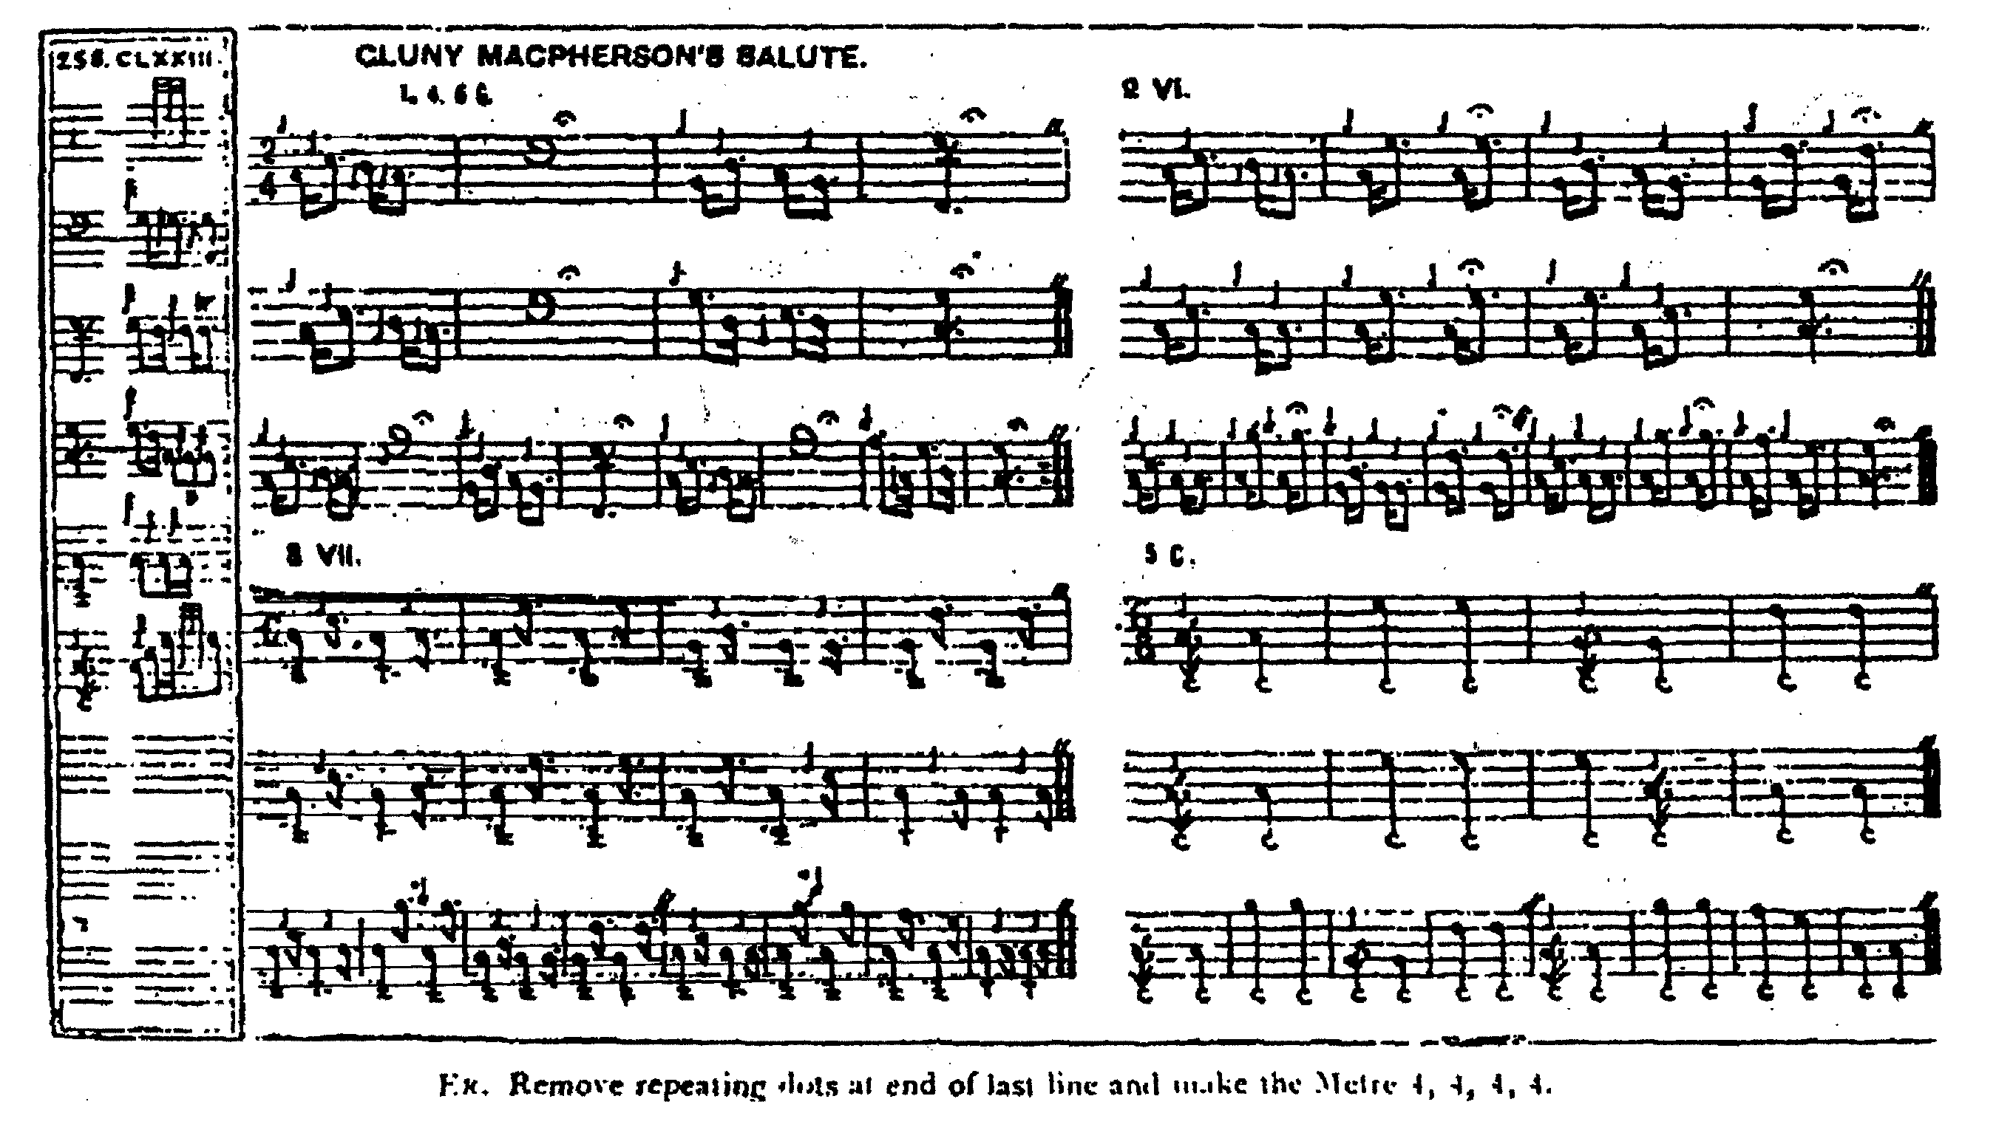

This could have been avoided if the present tune had simply been called “The Laird of Cluny’s Welcome” or some similar phrase.

* * *

Electronic text © Dr. William Donaldson, Aberdeen, Scotland, October 2004; revised Cambridge Massachusetts, November 2024.

