Clanranald’s Salute

There are settings of this tune in the following manuscript sources:
--Peter Reid’s MS, f.19;
--C. S. Thomason’s MS, f.13;

and in the following published sources:
--Angus MacKay’s Ancient Piobaireachd, pp.96-8;
--Donald MacPhee’s Collection of Piobaireachd, ii, 23-6;
--David Glen’s Ancient Piobaireachd, pp.75-6;
--C. S. Thomason’s Ceol Mor, pp.249-50.

The various sources develop the tune as follows:

Peter Reid | Angus MacKay | Donald MacPhee | C. S. Thomason | David Glen
ground | ground | ground | ground | ground
thumb variation | thumb variation | thumb variation | thumb variation | thumb variation
siubhal 1 | siubhal 1 | siubhal 1 | siubhal 1 | siubhal 1
 | siubhal 2 | siubhal 2 | siubhal 2 | siubhal 2
 |  |  | siubhal 3
 | siubhal 4 |  | siubhal 4 | siubhal 4
 |  | taorluath fosgailte singling
 | taorluath fosgailte doubling | taorluath fosgailte doubling | taorluath fosgailte doubling | taorluath fosgailte doubling
leumluath singling | leumluath singling | leumluath singling | leumluath singling | leumluath singling
leumluath doubling | leumluath doubling | leumluath doubling | leumluath doubling | leumluath doubling
taorluath singling | taorluath singling | taorluath singling | taorluath singling | taorluath singling
taorluath doubling | taorluath doubling | taorluath doubling | taorluath doubling | taorluath doubling
 | ground |  | ground | ground
crunluath singling | crunluath singling | crunluath singling | crunluath singling | crunluath singling
crunluath doubling | crunluath doubling | crunluath doubling | crunluath doubling | crunluath doubling

crunluath a mach
?ground | ground | ground | ground | ground

Peter Reid’s setting: one notes his cadence on the B’s at phrase endings in the ground; on its first occurrence it appears as a MacDonald-style GED demi-semi-quaver group, while at the end of the line, the central note of the group, namely E, appears as a full crotchet melody note. Reid is much more heavily cadenced in the ground than Angus MacKay; indeed if these cadences were timed in the modern manner they would intolerably interrupt the flow of the melody; but it seems likely that Reid meant these to be incorporated into the rhythmic pattern of the tune which would require most of them to be timed a good deal more smartly than at present. Reid goes straight from the siubhal singling to the leumluath singling where his staff notation score ends, indicating in a note that: “Here follows the doubling of 3rd part [i.e., a leumluath doubling], then Taorluidh with the doubling & Creanluidh with doubling and Threbling &c”, suggesting that he played a crunluath a mach here. The “&c.” may imply a repeat of the ground:

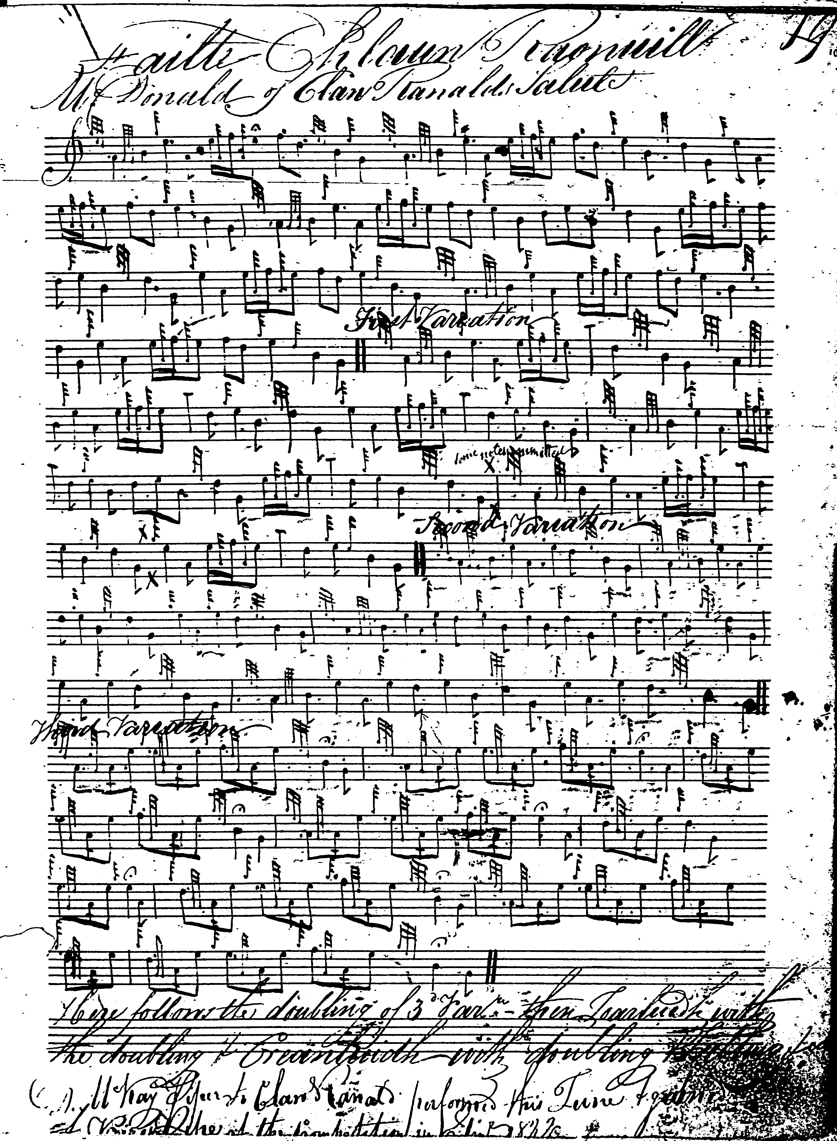

In Angus MacKay’s setting there are a number of note errors in both the 1st and 3rd editions of Ancient Piobaireachd, namely a false accent at the beginning of the thumb variation (where the introductory dotted E quaver should be an E semi-quaver and a false note at the beginning of variation two doubling (which should be a dotted A quaver); also the 3rd edn. contains an error not present in the 1st edition: in the taorluath doubling, the C quaver in bar 7 should be an E. MacKay does not stipulate a crunluath a mach:

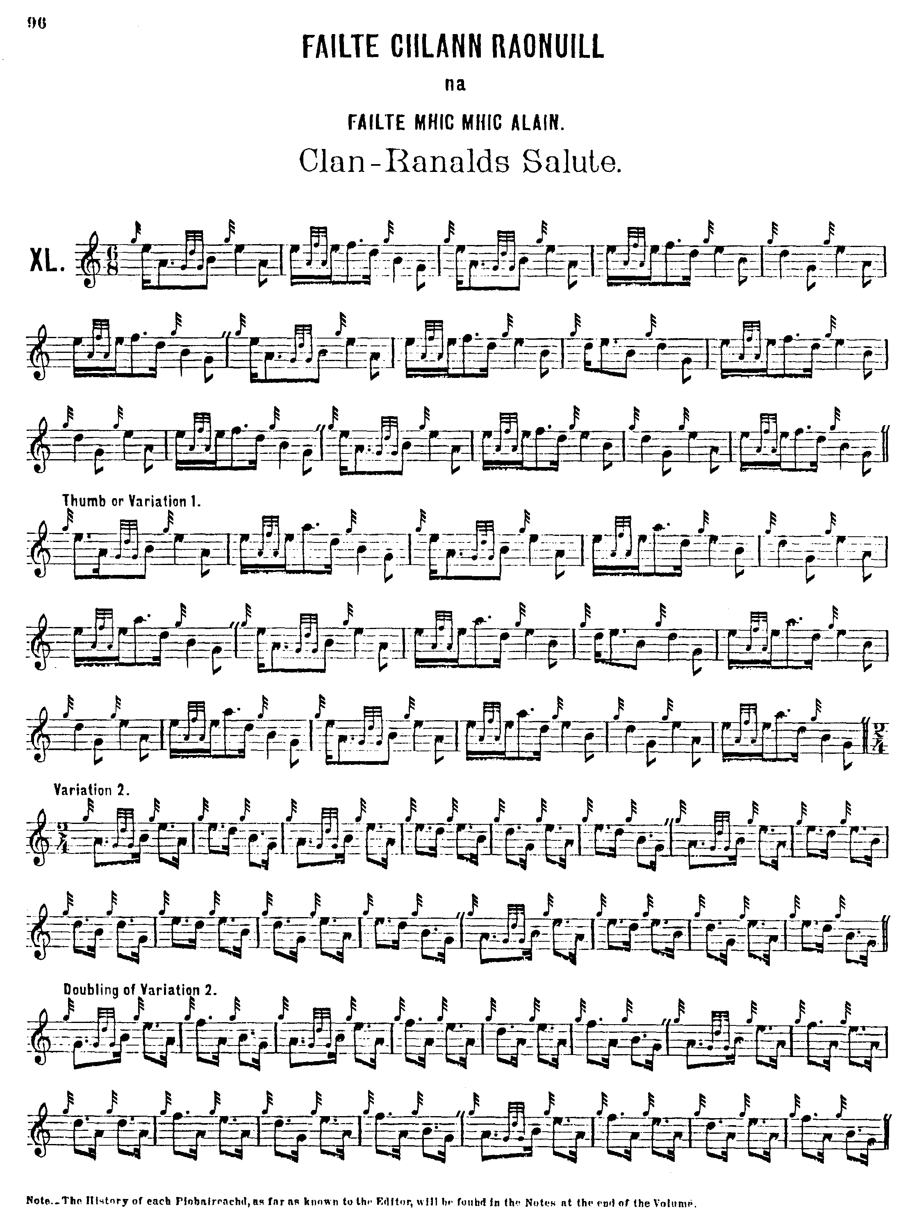
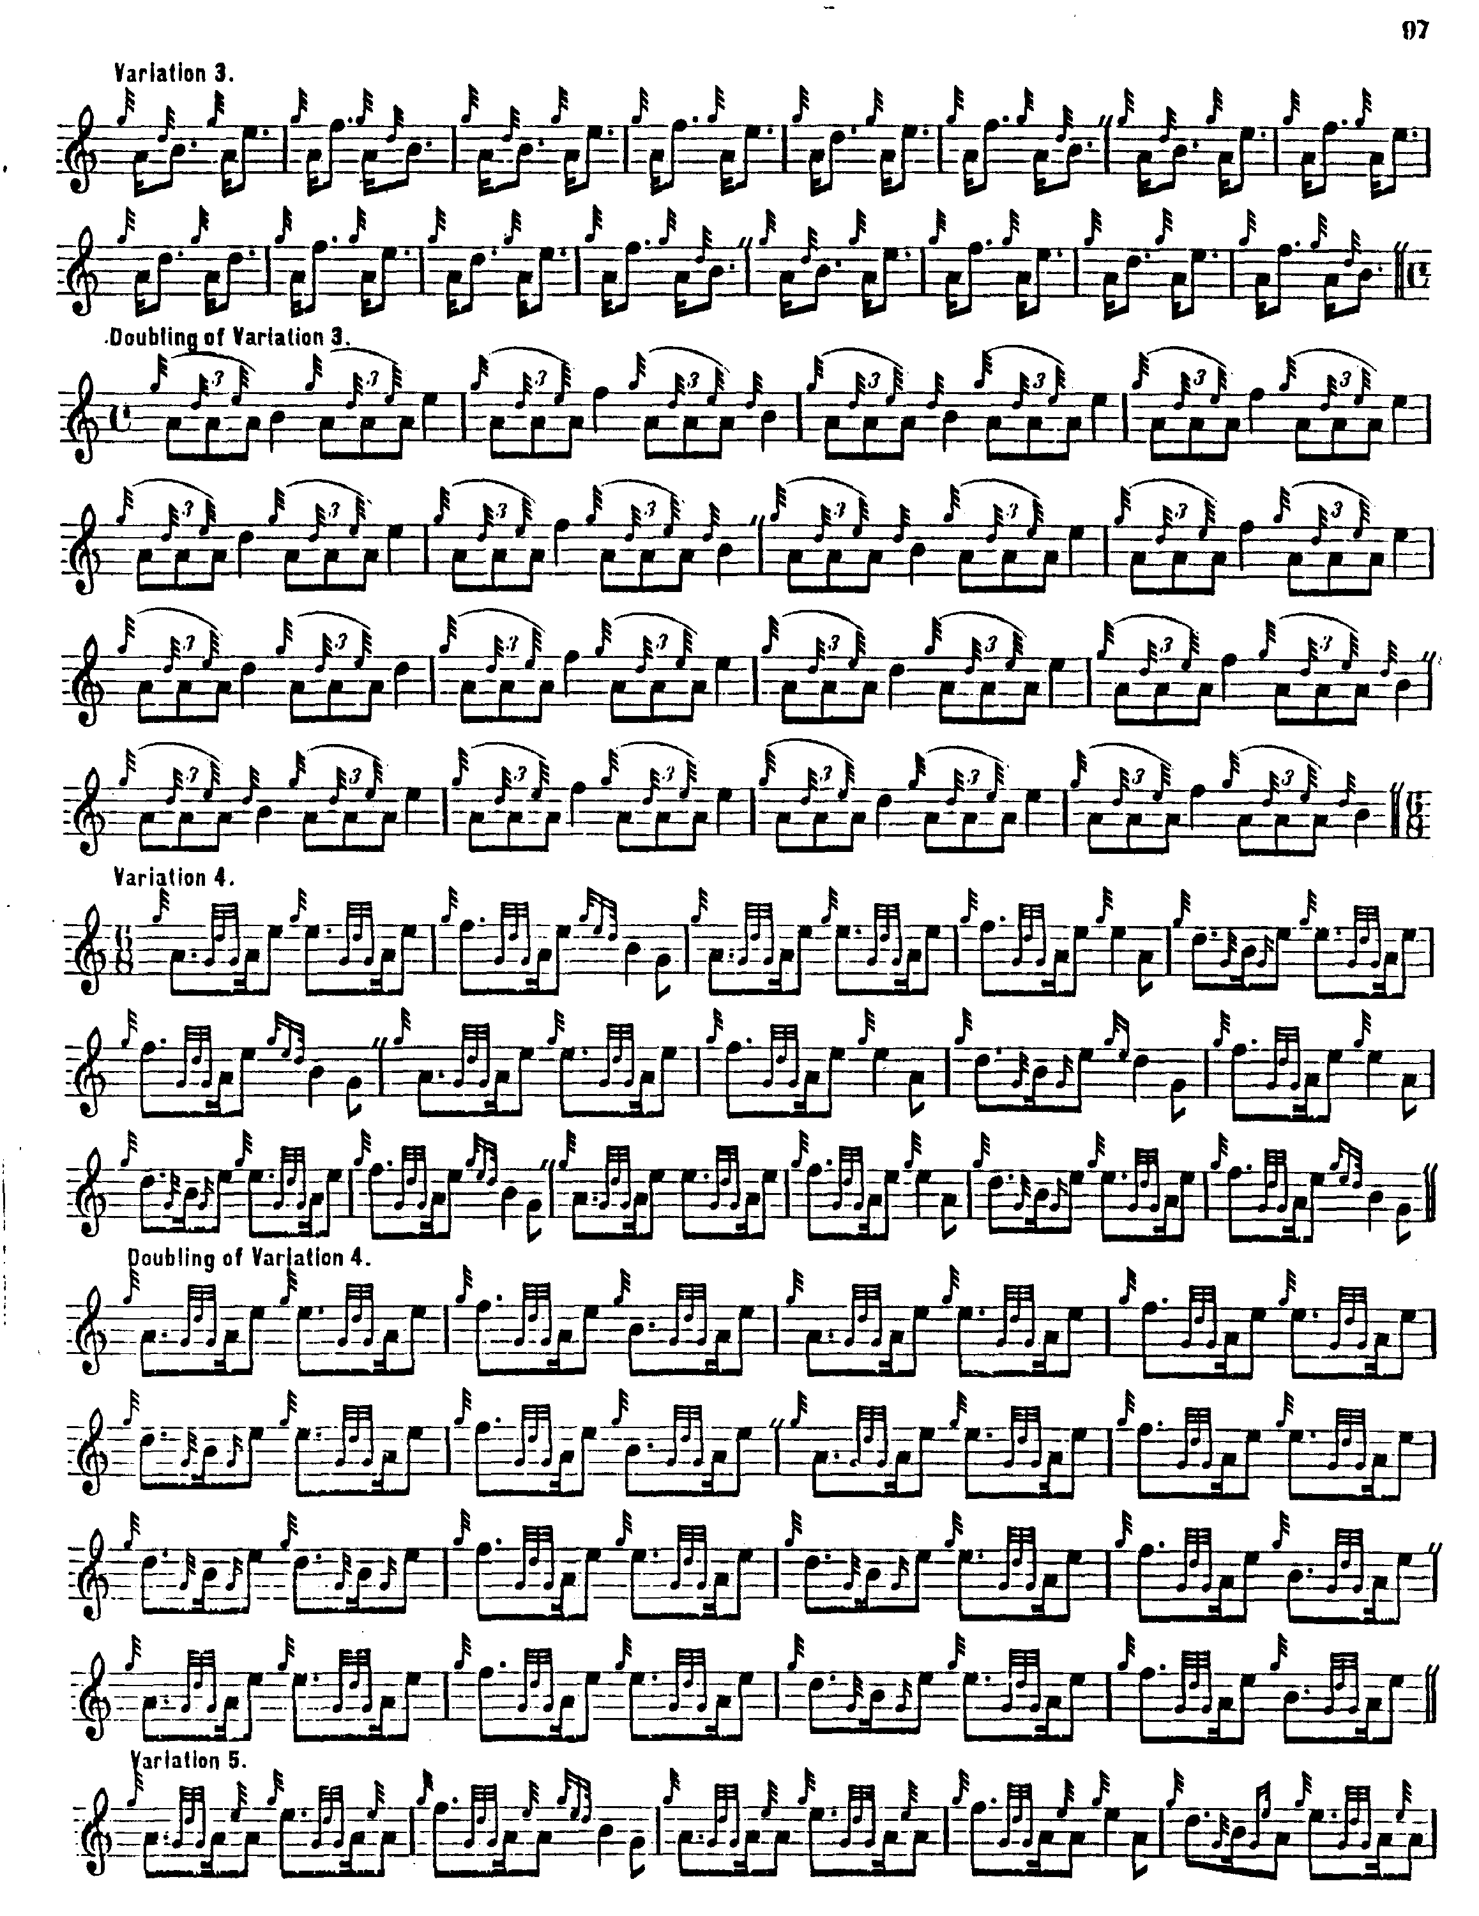
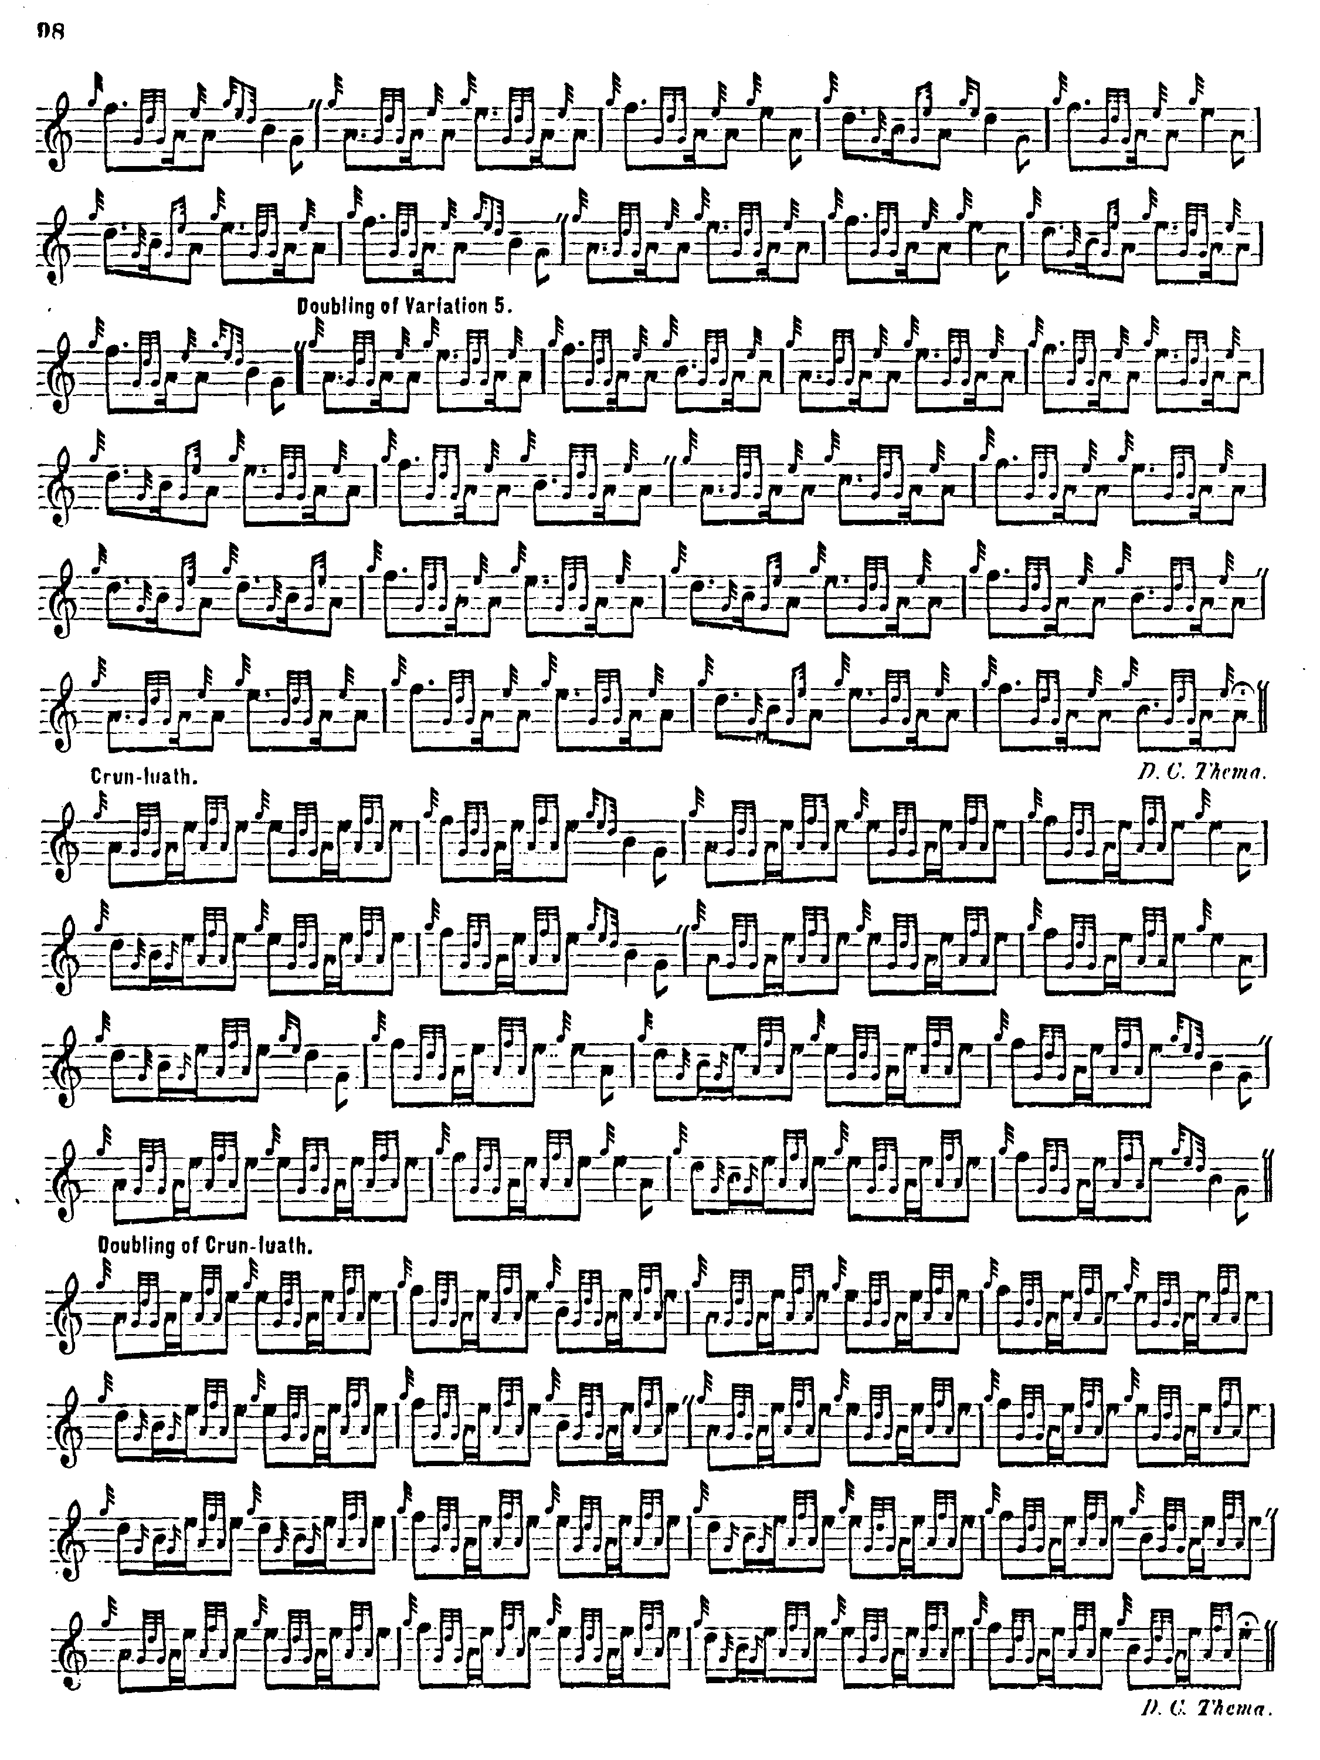

The sudden switch to an up-beat at the start of Variation 3, reverses the accent and makes for an awkward transition with the previous part. If not playing in competition, a thoughtful performer might consider dropping this variation, and if a two-parted taorluath fosgailte section were felt to be necessary to balance up the structure of the tune, then a new singling could easily be contrived by cadencing the following doubling.
Donald MacPhee’s siubhal singling differs a little from the others, incorporating the F, which is such a prominent part of the tone row as it develops through the tune, from the outset. This might suit somebody looking for something a little different. MacPhee is tactfully restrained in his development of the tune and does not flog it to death as Thomason does by including every variation ever recorded as having been played and repeating everything that can be repeated. Thomason may have intended to present a complete menu of possibilities from which he expected the player to make a judicious final selection. Some may find MacPhee’s dropping of the cadences at the phrase endings makes his style a little abrupt, but the general symmetry is pleasing, with variations proceeding in pairs throughout the tune. MacPhee has no crunluath a mach:

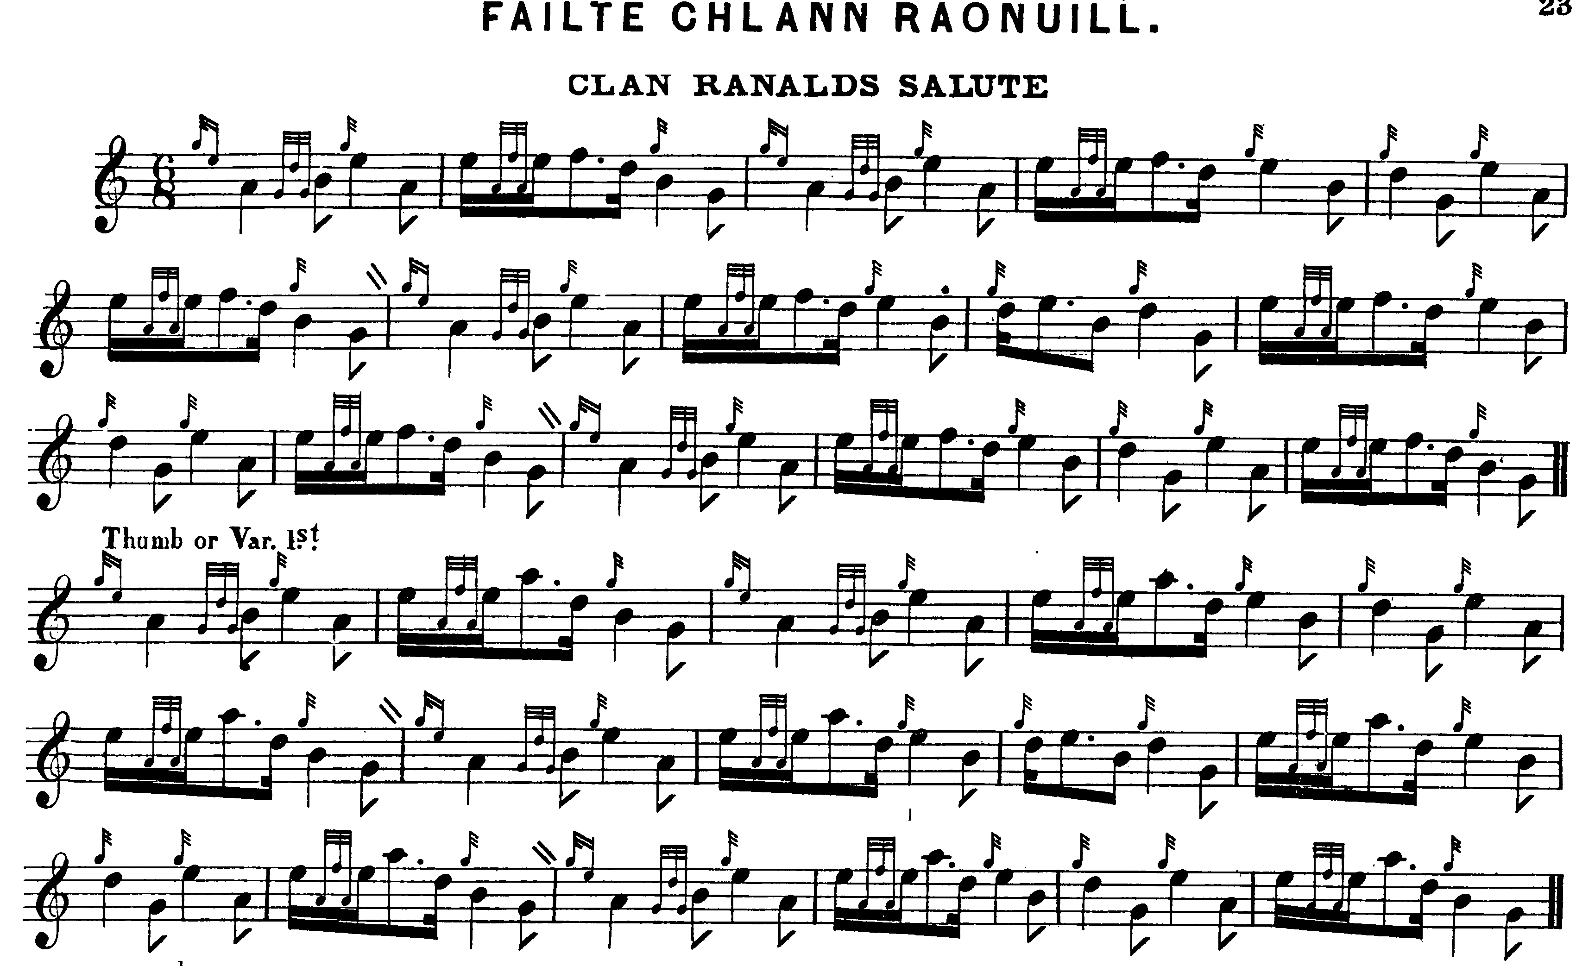
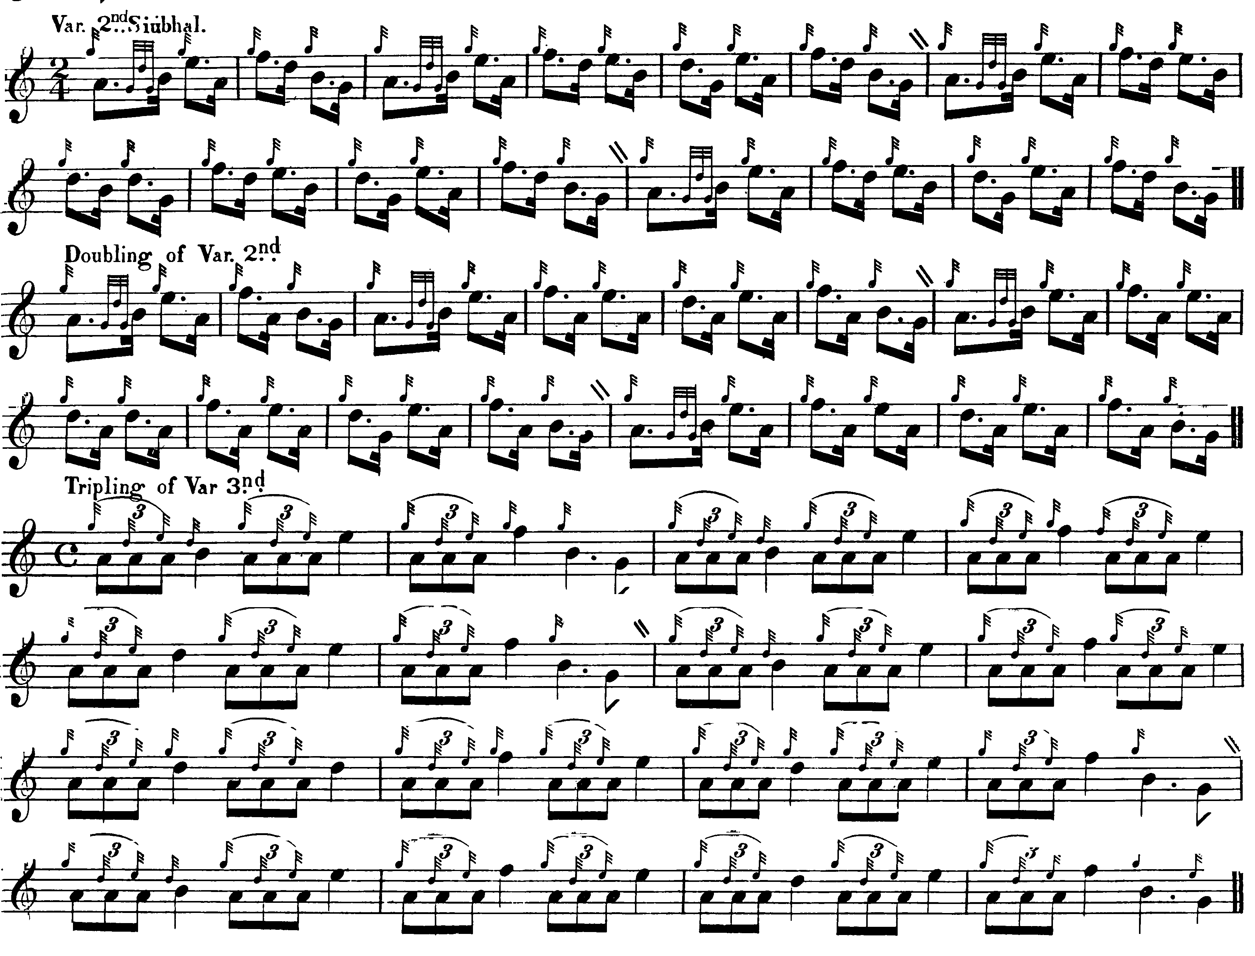
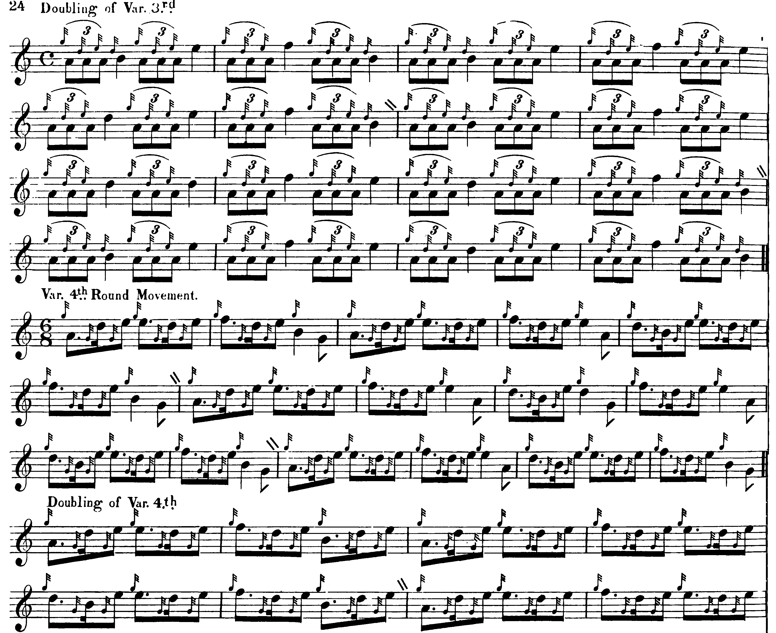
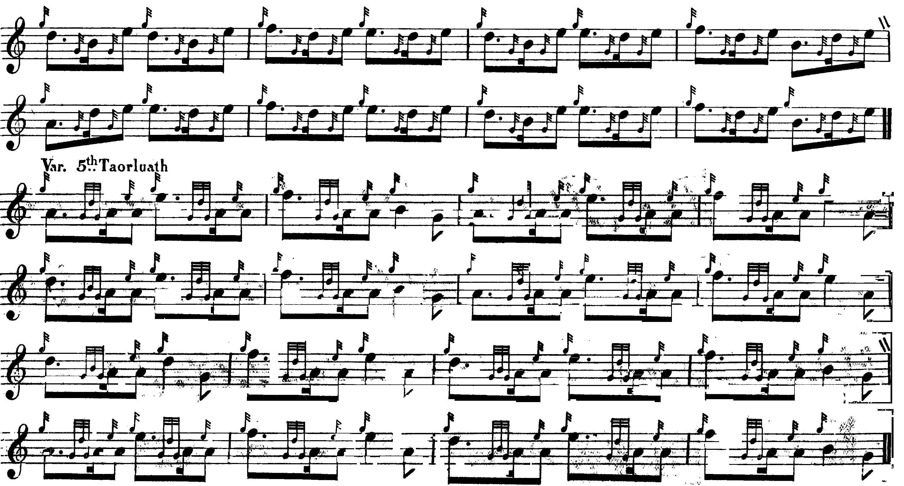
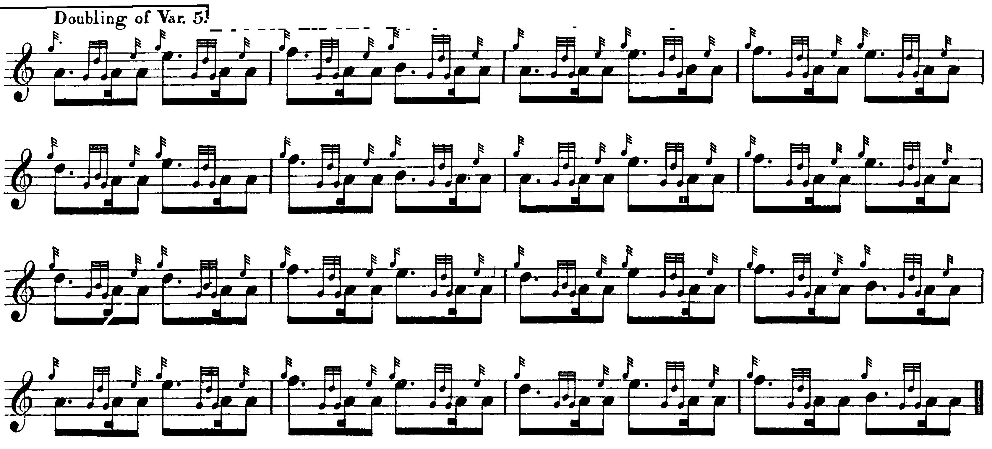
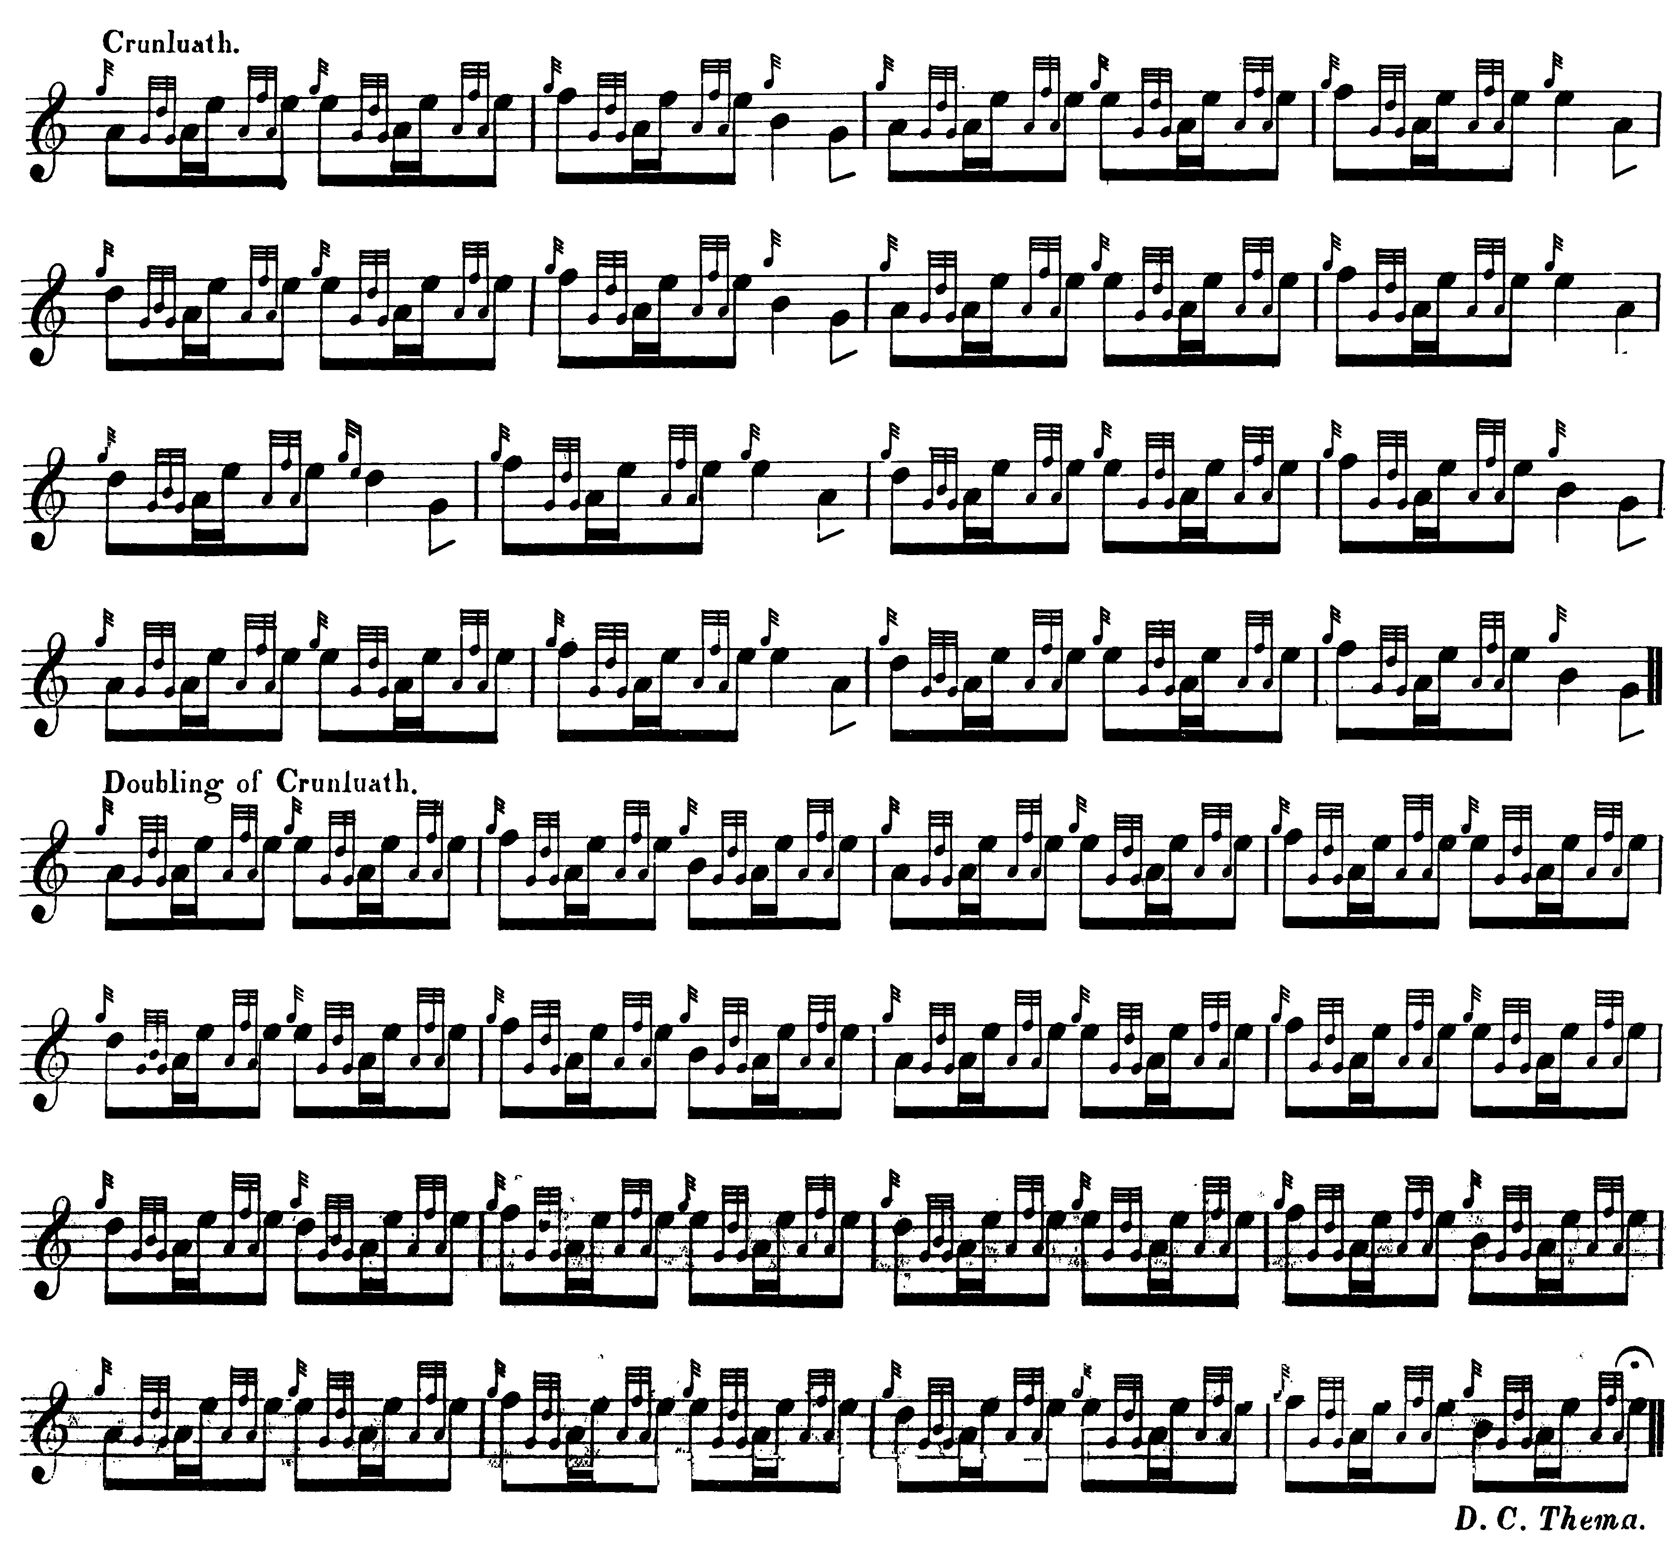

There seems to be a misprint in David Glen’s score: as it stands the instruction to repeat the ground is given at the end of the taorluath singling, it should probably have been placed after the doubling; there is no indication that a ground should be repeated between the taorluath singling and doubling elsewhere in the tradition. Glen’s score in this instance adds little of significance to MacKay and it is not reproduced here.

C. S. Thomason represents the fullest development of the tune; he cites Donald MacKay and Angus MacKay’s published book as his sources:

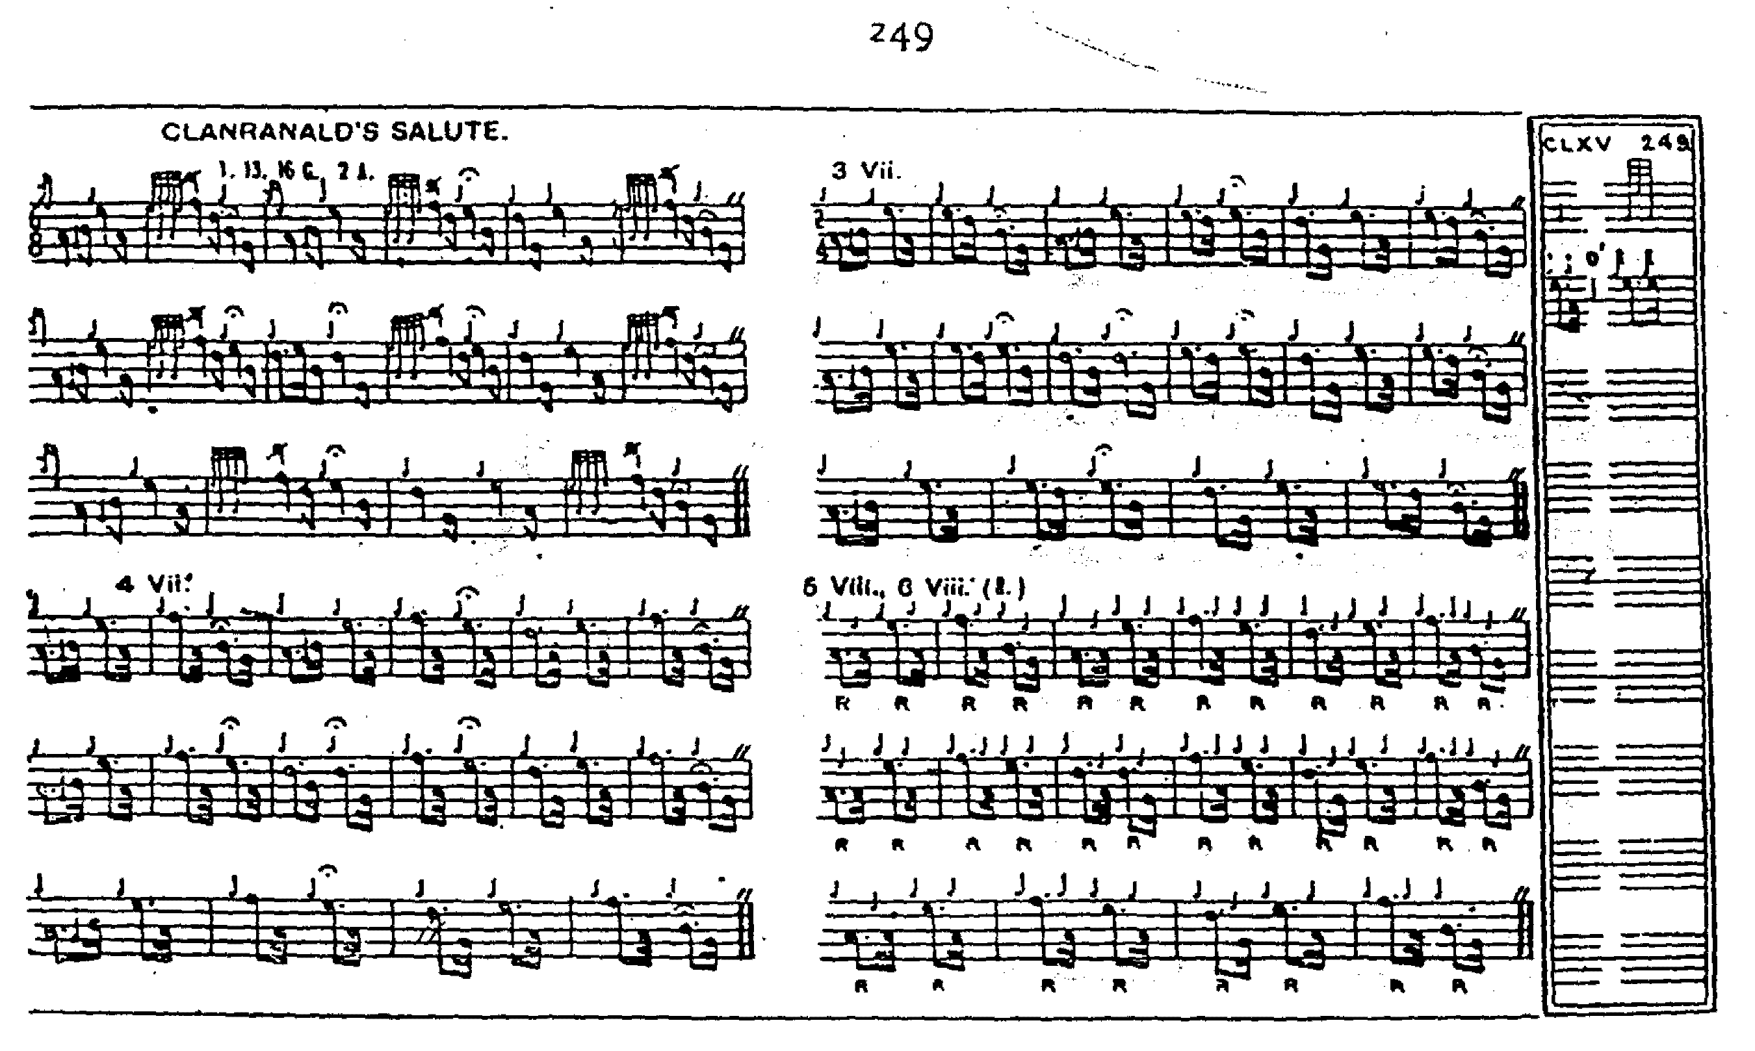
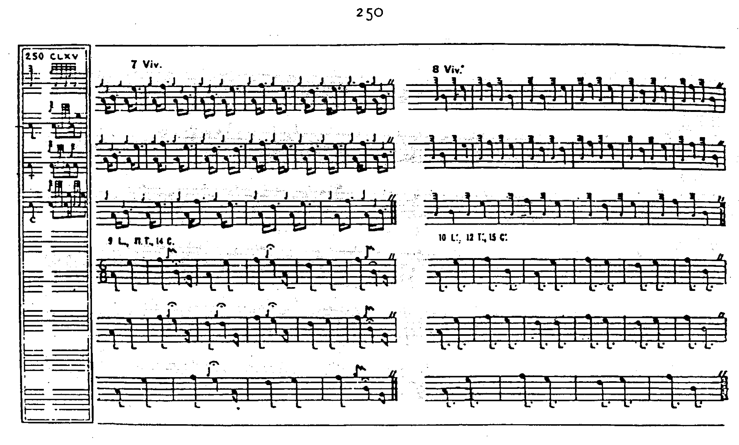

Commentary:

This is part of a cognate group of tunes, including “Clan Ranald’s Tutor” (Nether Lorn, i, 122-4; Angus MacKay’s MS, i, 208-209; and David Glen’s MS, ff.306-307, in which Glen interestingly toys with a fosgailte crunluath variation, singling and doubling). The tune is nameless in MacKay, and published as “Nameless no.16” in Ceol Mor. “Clanranald’s Tutor” is more strongly antiphonal than ““Clanranald’s Salute””, but the underlying idea is very similar, as the tonal frameworks reveal:

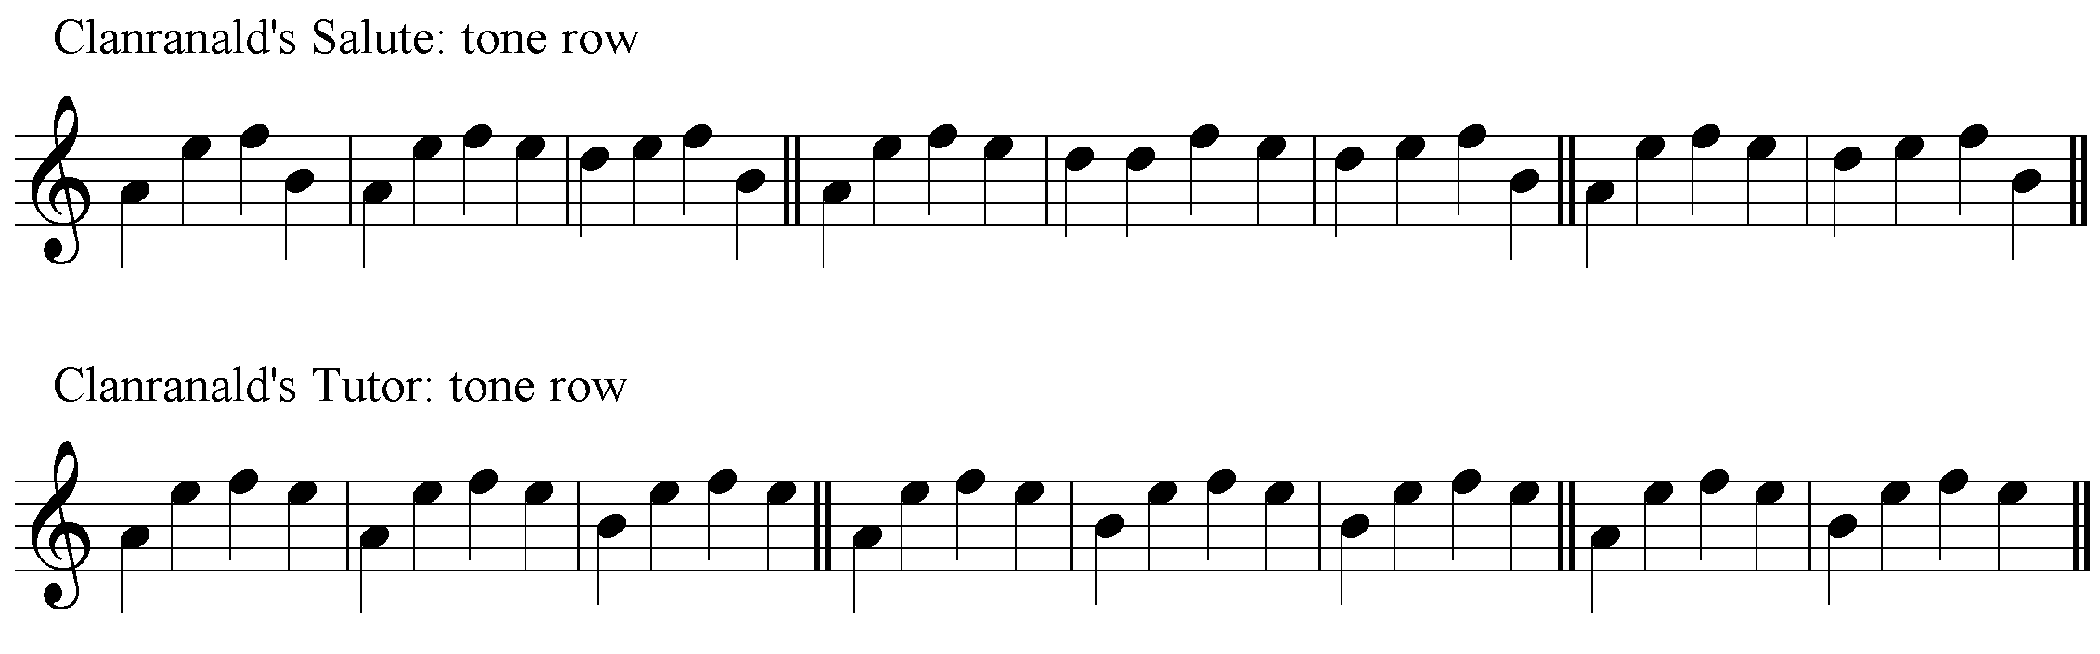

The motif vehaveche provides a further thematic link with “Mrs. MacLeod of Talisker’s Salute”, as discussed in the current Set Tunes series.

The present writer prefers to time the EFD triplets with the accent on the initial E and to thin the cadences out to preserve the onward momentum of the tune, somewhat as follows:

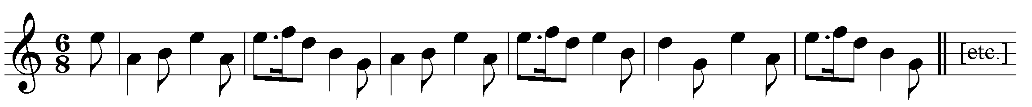

* * *

Electronic text © Dr. William Donaldson, Aberdeen, Scotland, October 2004.

