Clan Chattan’s Gathering

This tune occurs in the following manuscript sources:
--Colin Mór Campbell’s “Nether Lorn Canntaireachd”, i, 164-5;
--Angus MacKay’s MS, ii, 36-38;
--Uilleam Ross’s MS, ff.168-71;
--John MacDougall Gillies’s MS, ff.30-3;

and in the following published sources:
--Uilleam Ross, Collection, pp.92-4;
--C. S. Thomason, Ceol Mor, pp.286; 385;
--David Glen, Collection of Ancient Piobaireachd, pp.66-7;
--John McLennan, Piobaireachd as MacCrimmon Played it, p. 8.

Colin Campbell develops the tune as follows:

1st Hindodro hindodarodo hindodre hindodro himtodre hindodarodo
2^{d} Hindodre hindodro hindodarodo hindodro himtodre hindodarodo
3^{d} Hindodre hindodro cheodrodre hindodarodo

1st Hindodro hindodarodo hindroIe hindodro himtodarie hindodarodo
2^{d} HindroIe hindodro hindodarodo hindodro himtodarie hindodarodo
3^{d} HindroIe hindodro cheodrodarie hindodarodo

DD 1st Hindodro hindodarodo hindotra hindodro himtotra hindodarodo
2^{d} Hindotra hindodro hindodarodo hindodro himtotra hindodarodo
3^{d} Hindotra hindodro cheodrotra hindodarodo

ffirst Motion

S 1st Hinhodindo hinhodinto hinhodinche cheenhodindo himodinche cheen hodinto
2^{d} Hinhodinche cheenhodindo hinhodinto hinhodindo himodinche cheenhodinto
3^{d} Hinhodinche cheen hinhodindo hindheche cheenhodinto

D 1st Hinhodinhodin hinhodinodin hinhodindeen hinhodinhodin himodindeen hinhodinodin
2^{d} Hinhodindein hinhodinhodin hinhodinodin hinhodinhodin himodindeen hinhodinodin
3^{d} Hinhodindeen hinhodinhodin hinaendeen hinhodinodin

And there the score ends. One of its most interesting features is the curious variation following the Thumb singling. A kind of half-way thumb variation which instead of substituting high A or high G for certain figures in the ground, substitutes D, like this:

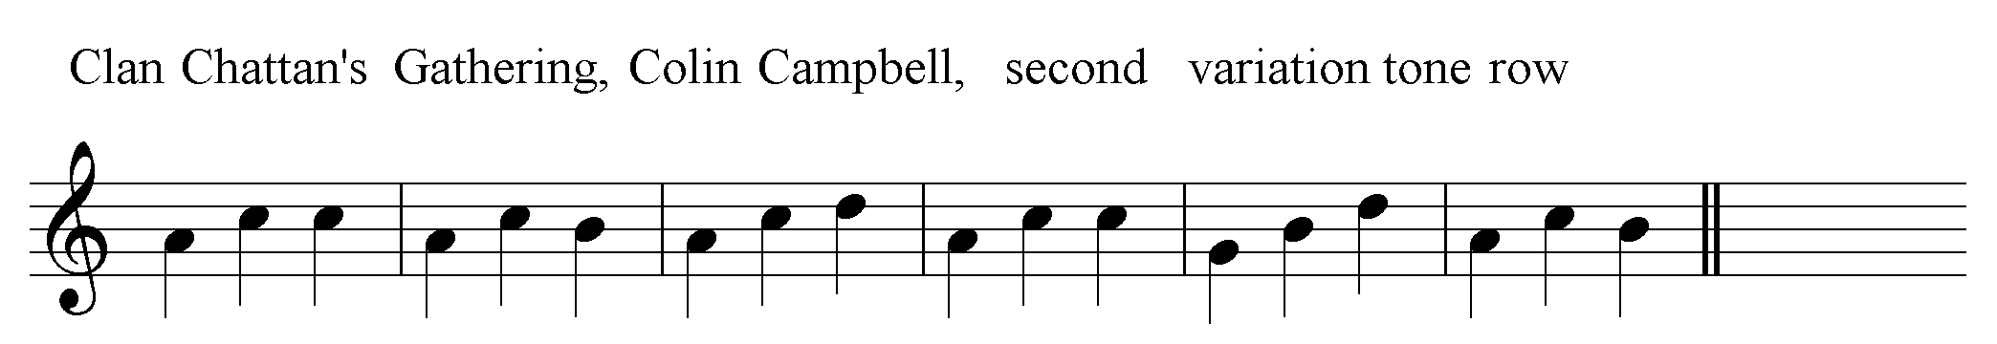

One could read the pulse as two to the bar, in which case the choice would be between playing ‘up’ or ‘down’, thus:

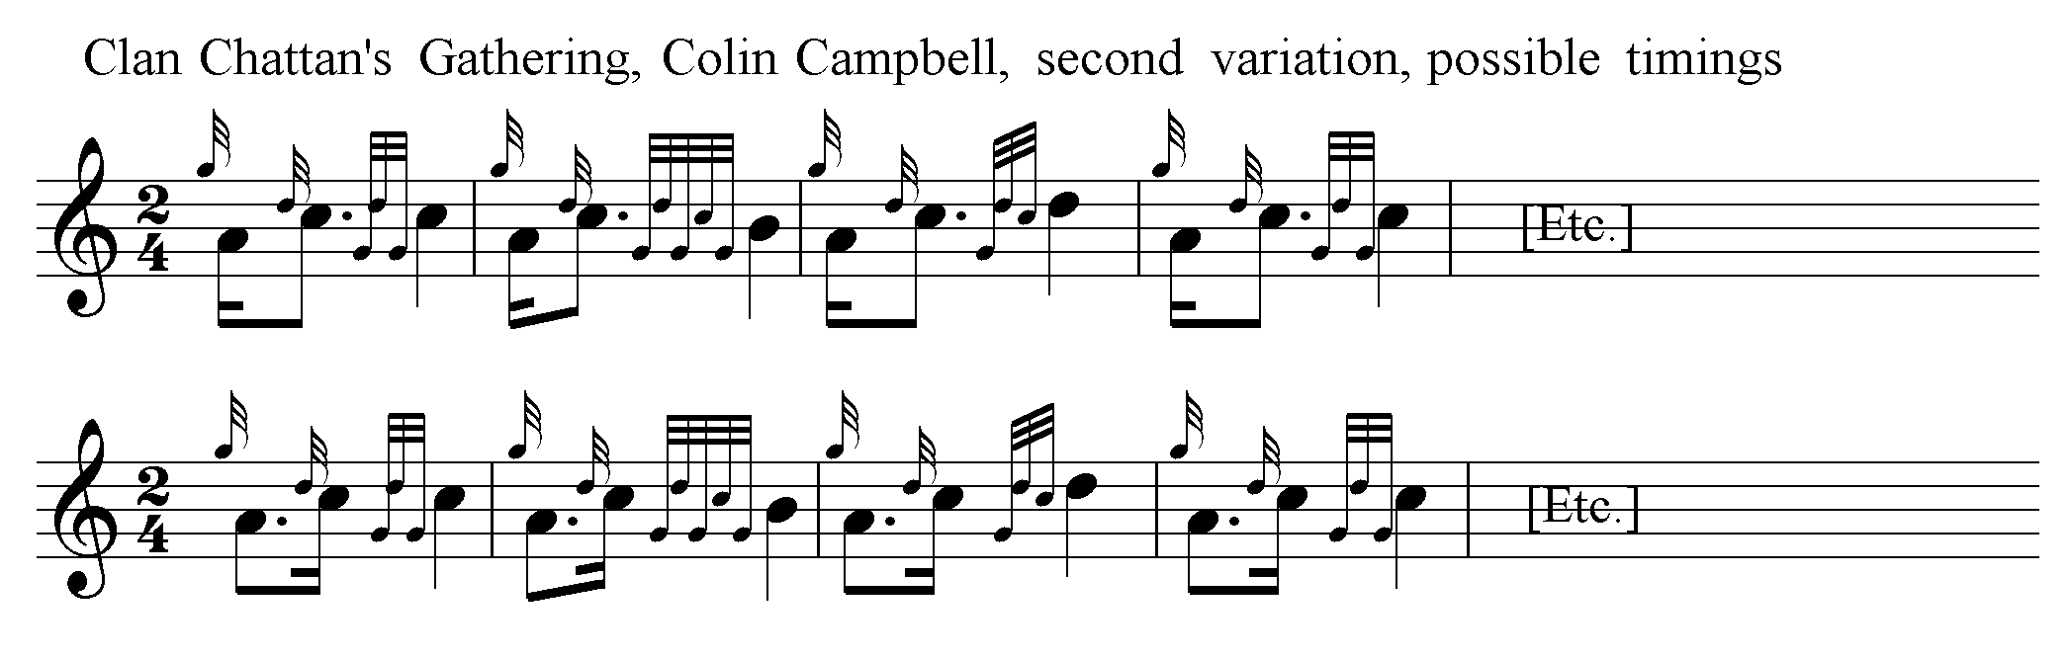

or go for even quavers. One could also opt for the square “three-even-crotchets to the bar” style favoured by some later editors:

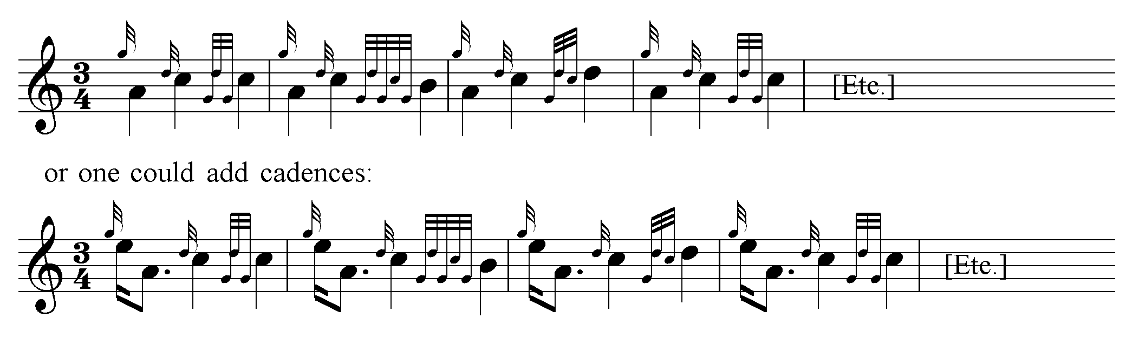

Basically, this variation seems like a re-statement of the ground modified to open up fresh tonal possibilities which could be built on later (although in this particular case they were not, since Colin Campbell’s setting ends shortly afterwards). The earlier parts exploit two overlapping gapped scales, occupying the intervals low G, low A, B, C, and E, the gap occurring at D. This variation “fills in” the D in preparation for…well, nobody now living will ever be quite sure what, although, given Colin Campbell’s ability and the richness of the strand of tradition he represented, it will have been inventive and melodically appealing. Perhaps one shouldn’t regret the loss too much: the Campbell canntaireachd was developed at a time when the responsibility for creative interpretation lay with the performer, and this openness to interpretational possibility (strongly guided by an awareness of convention) is at the heart of the system.

Colin Campbell’s original score is as follows:

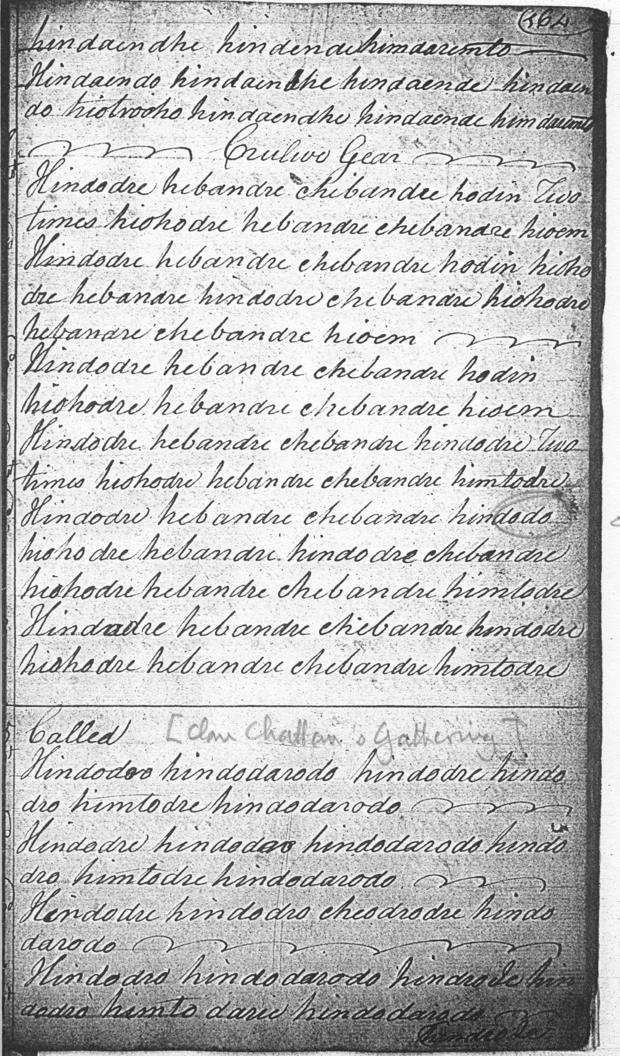
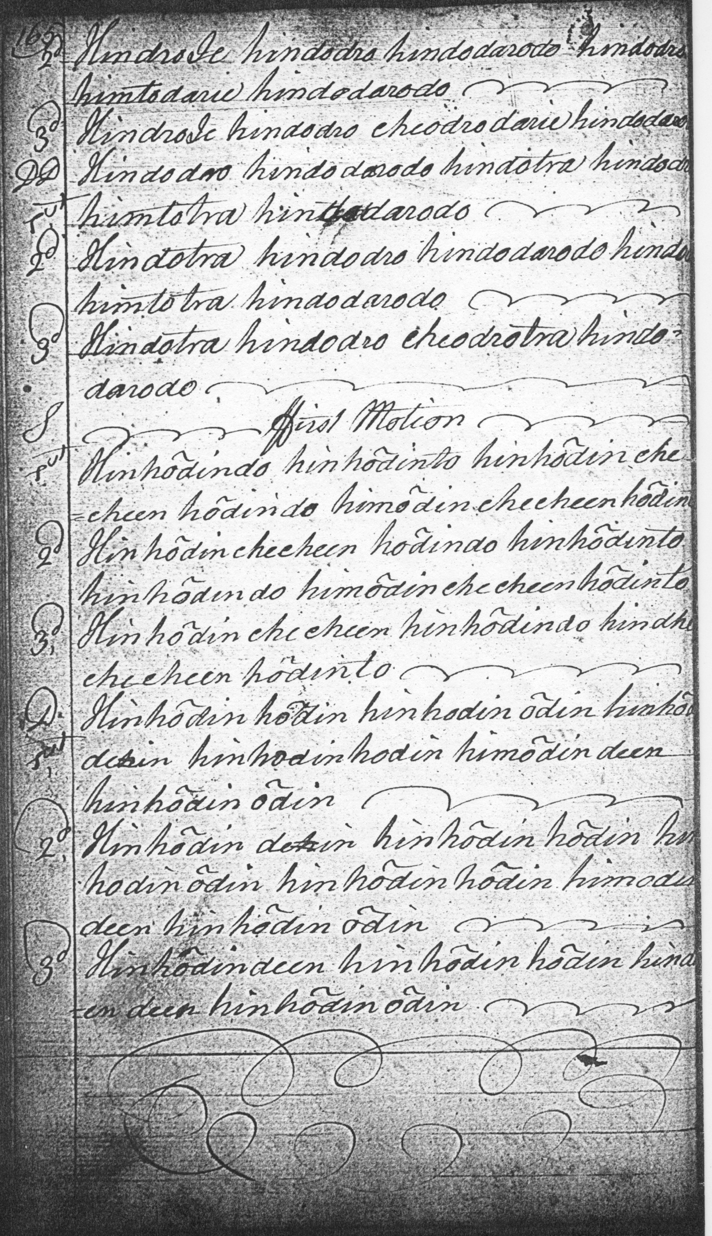

Angus MacKay sets the tune as follows:

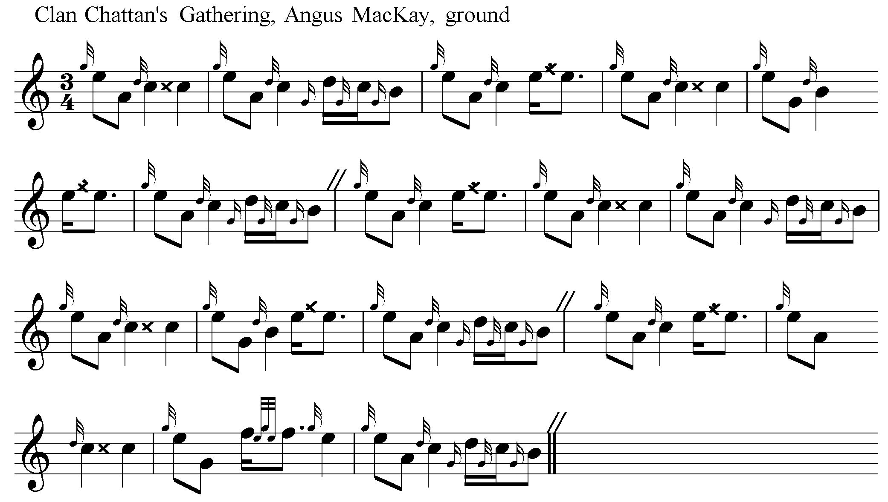
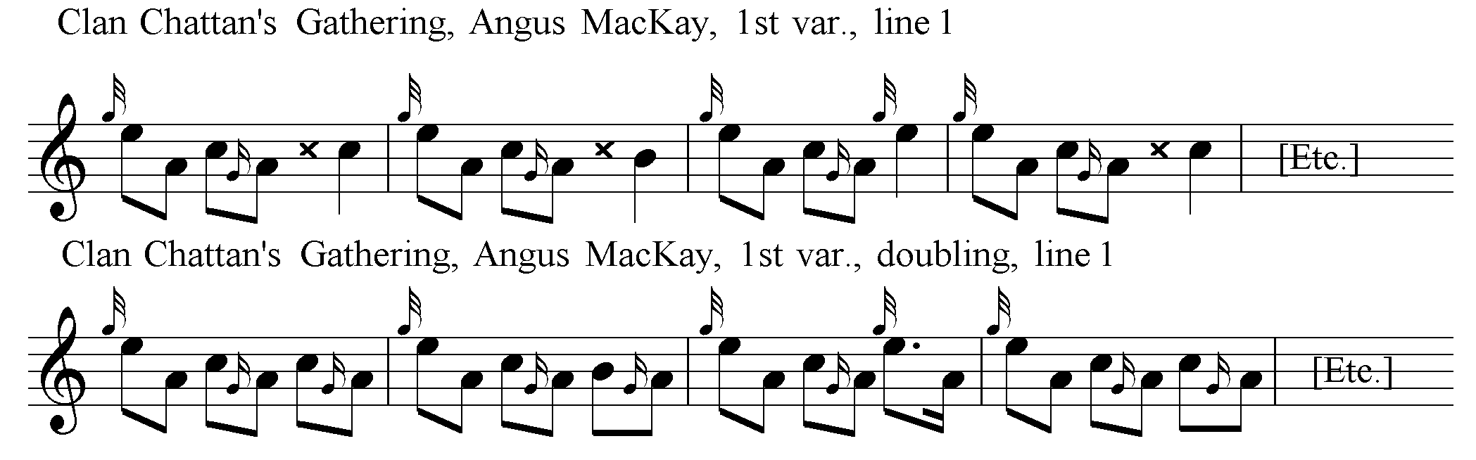

Angus MacKay’s complete score is as follows:
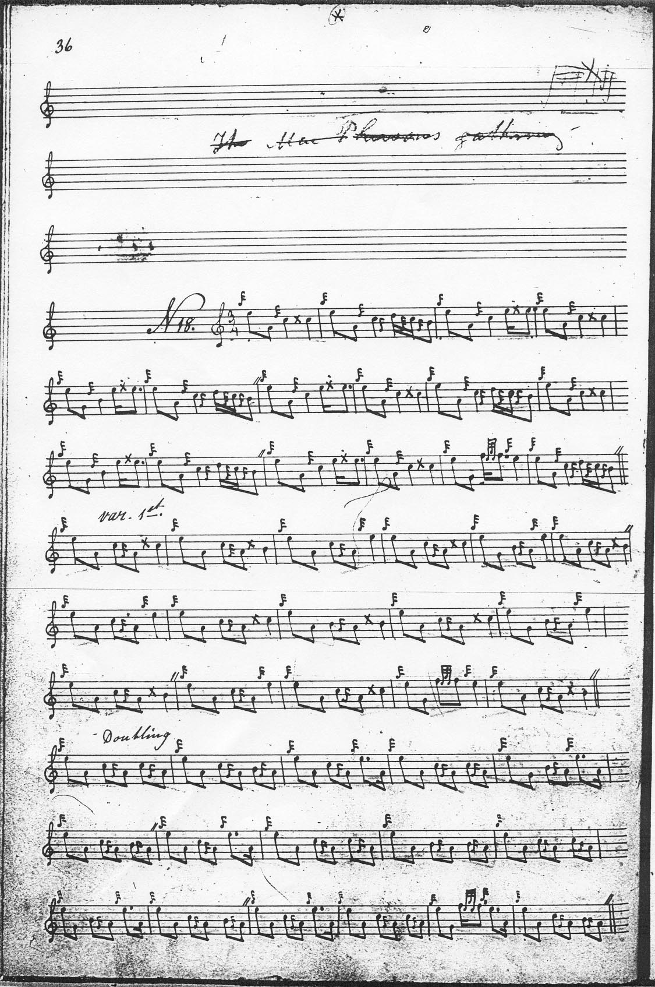

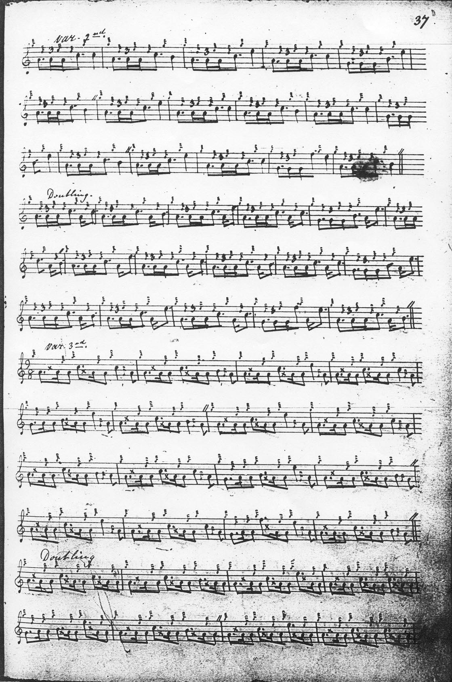

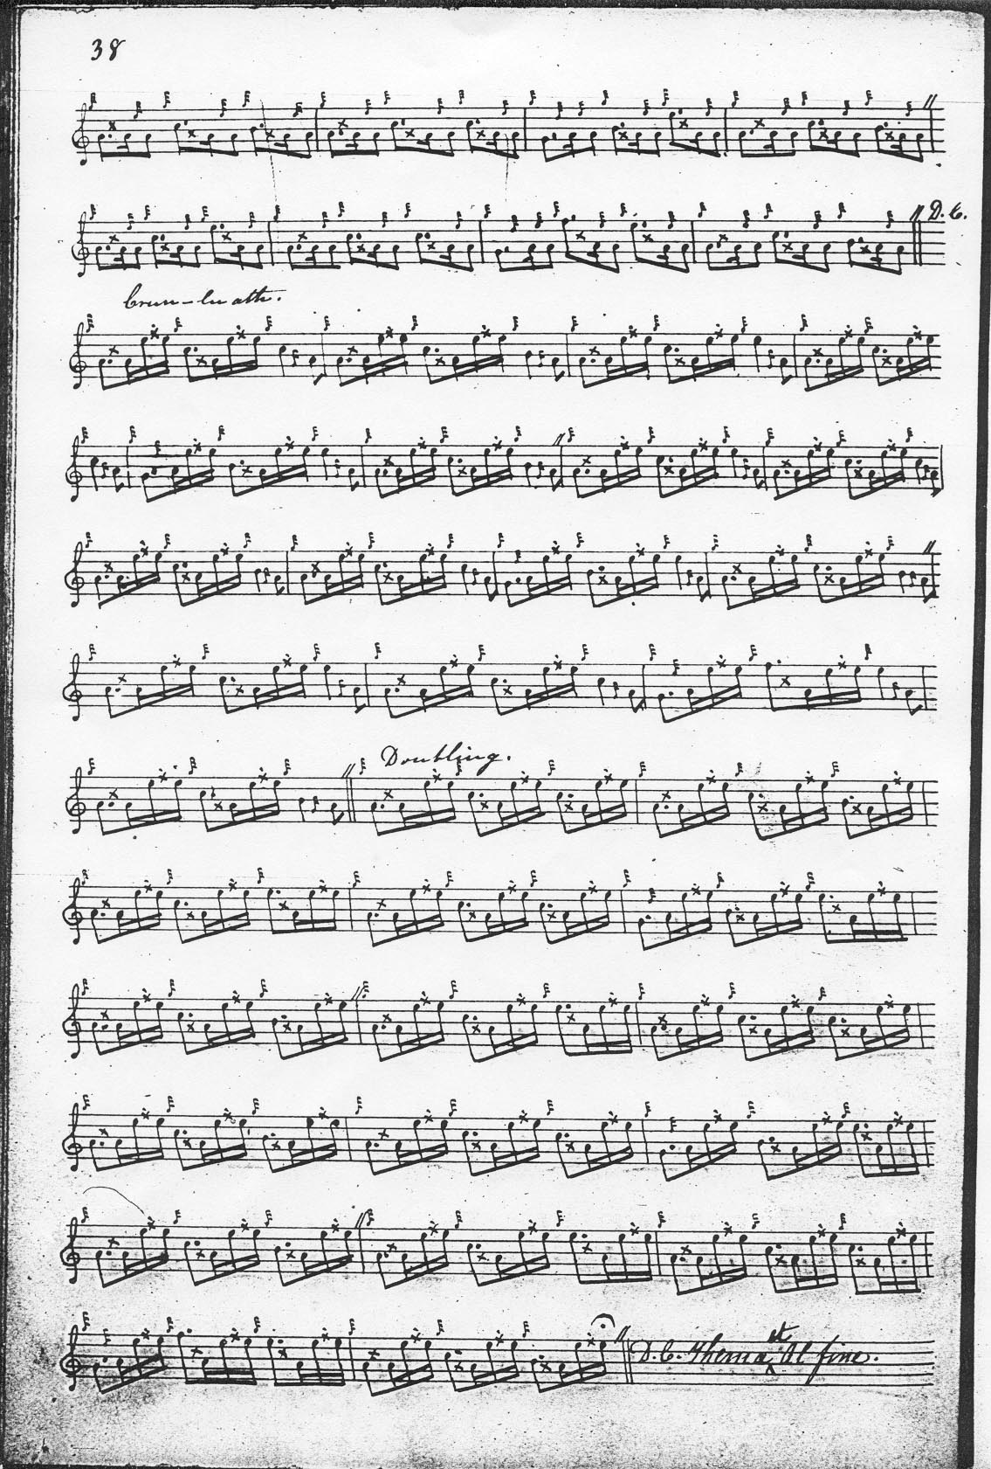

Uilleam Ross’s score was supplied by Alexander MacDonald, father and teacher of John MacDonald of Inverness. It was marked “Copied from Alex. Macdonald Piper to the Late Earl of Fife”, but the setting is basically that of Angus MacKay. Sandy MacDonald has added a number of fermatas to the ground to give an idea of rubato, dotted and cut MacKay’s strings of even quavers to indicate their timing, and expanded MacKay’s musical shorthand with appropriate gracenoting. His timing of the second variation doubling is rather interesting:

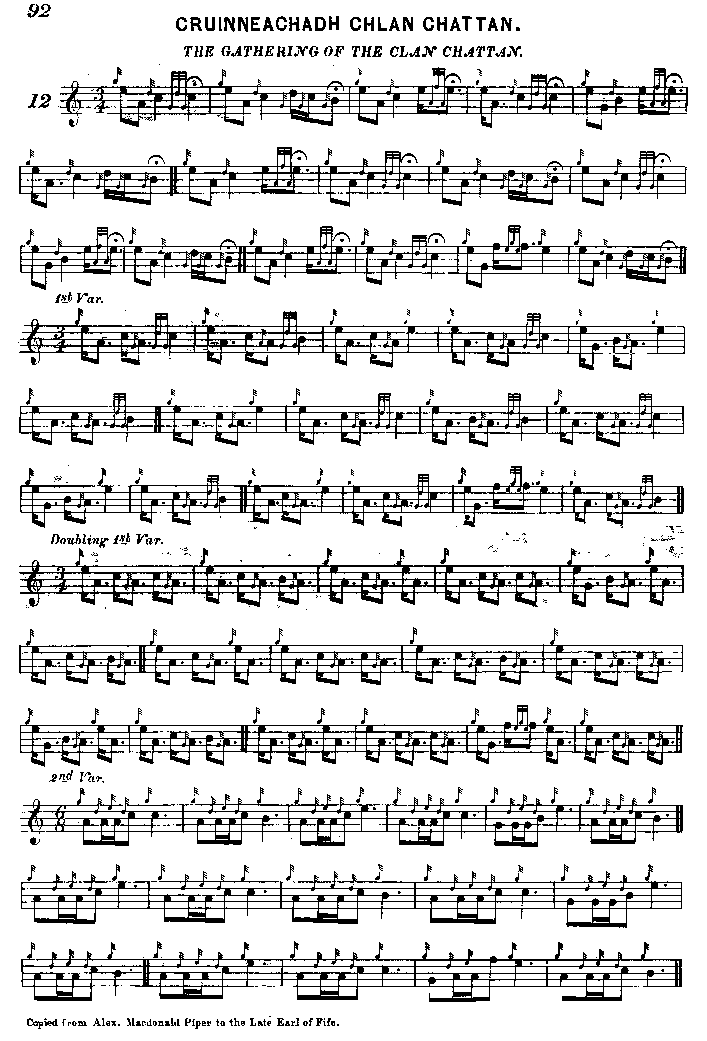
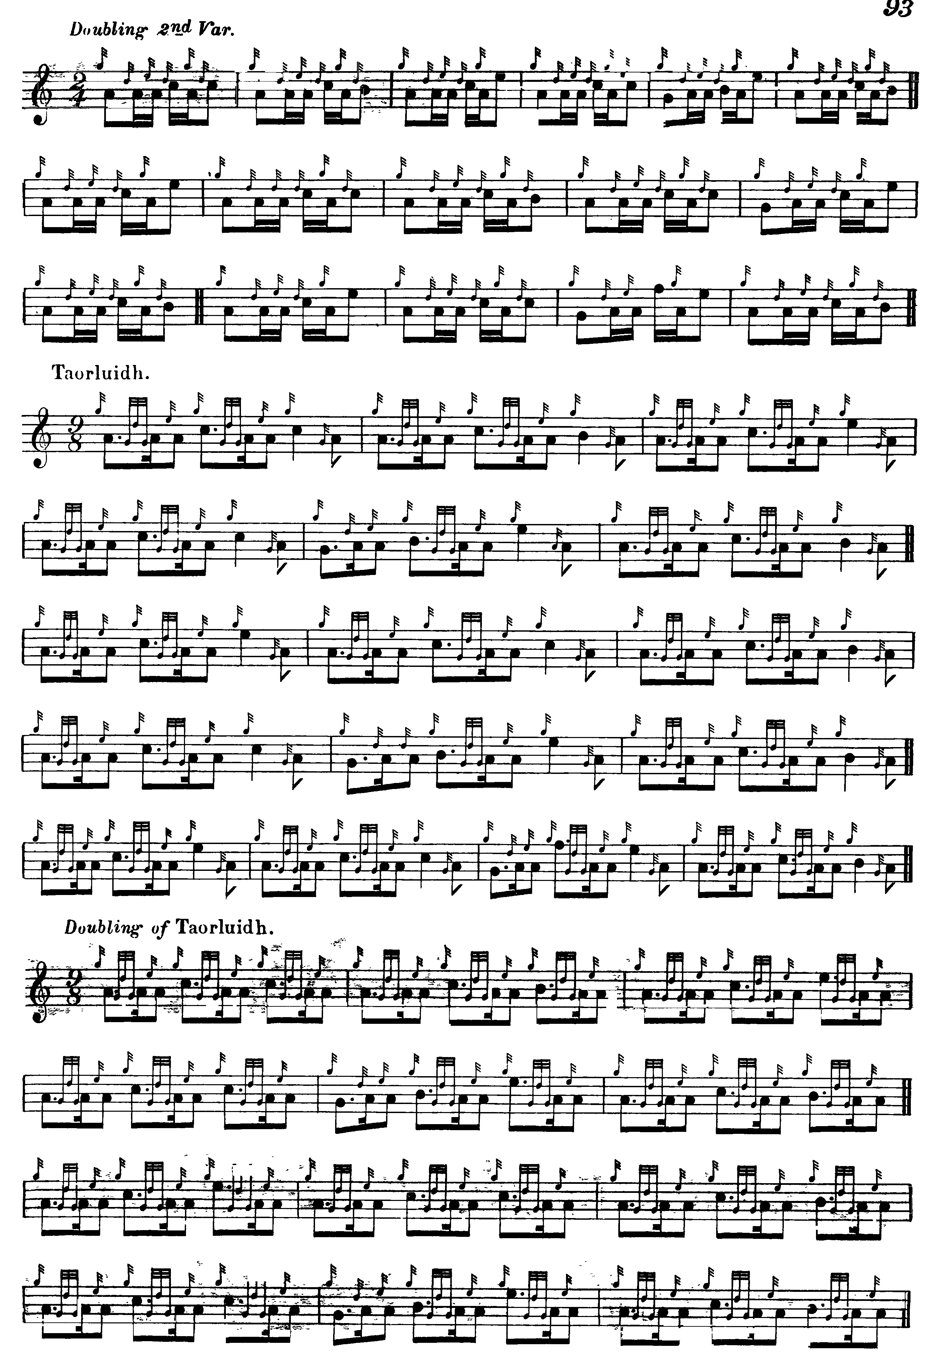
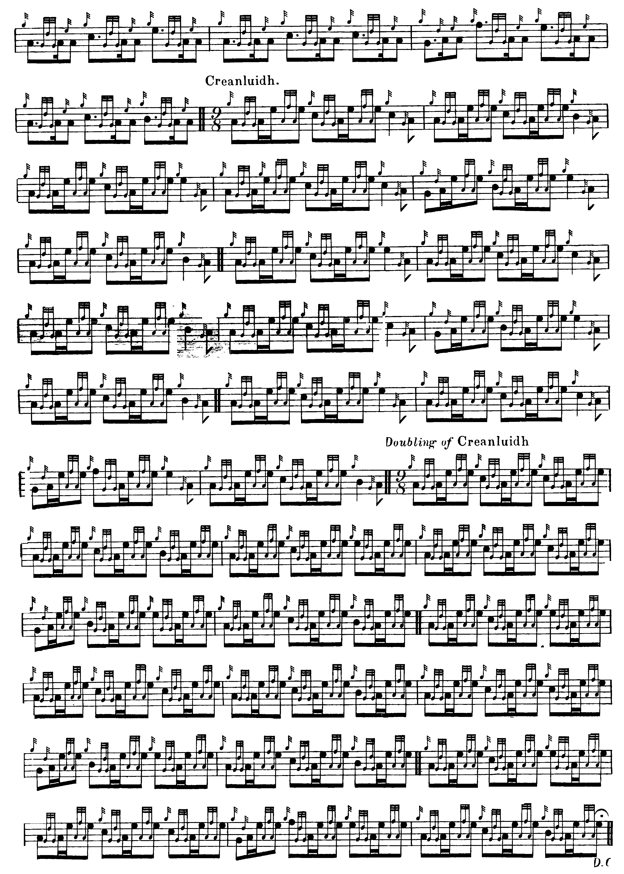

John MacDougall Gillies’s setting also develops the tune in a similar way to MacKay, but there are a number of typical Gillies touches on display. His ground is timed like this:

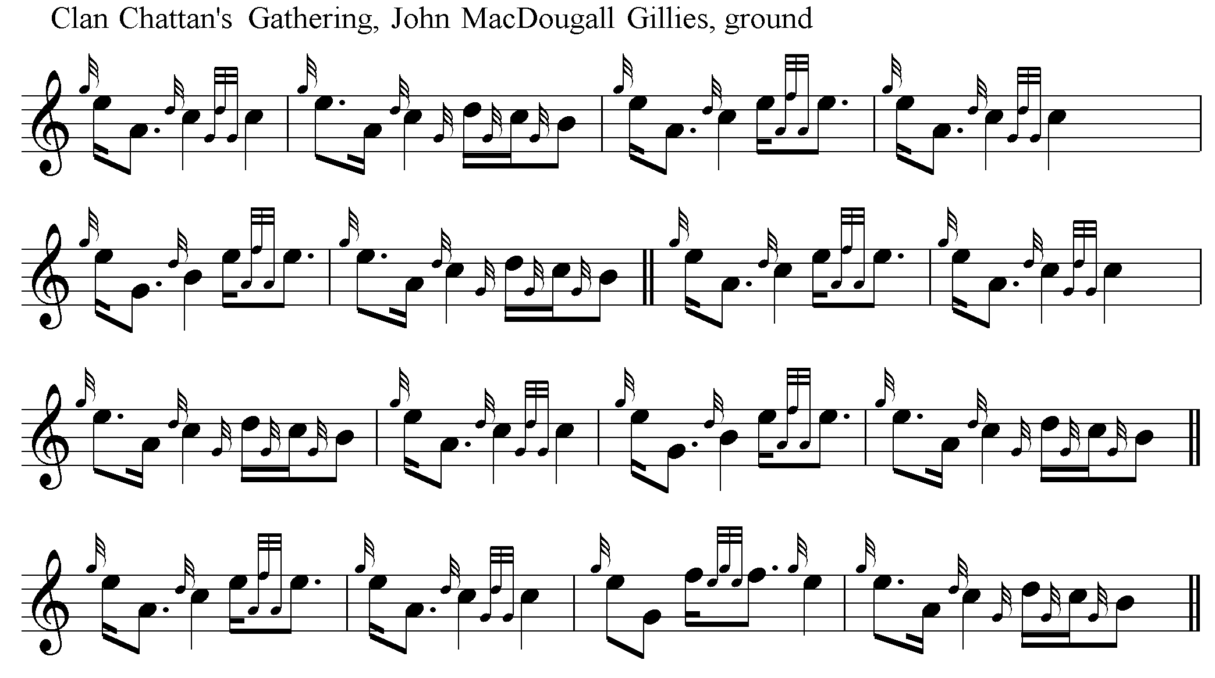

John McLennan’s setting has a number of points of interest, including a different phrase pattern from the other recorded versions and pointing in the first variation which reverses the normal pattern. The score below was scanned from a stained and heavily-used copy:

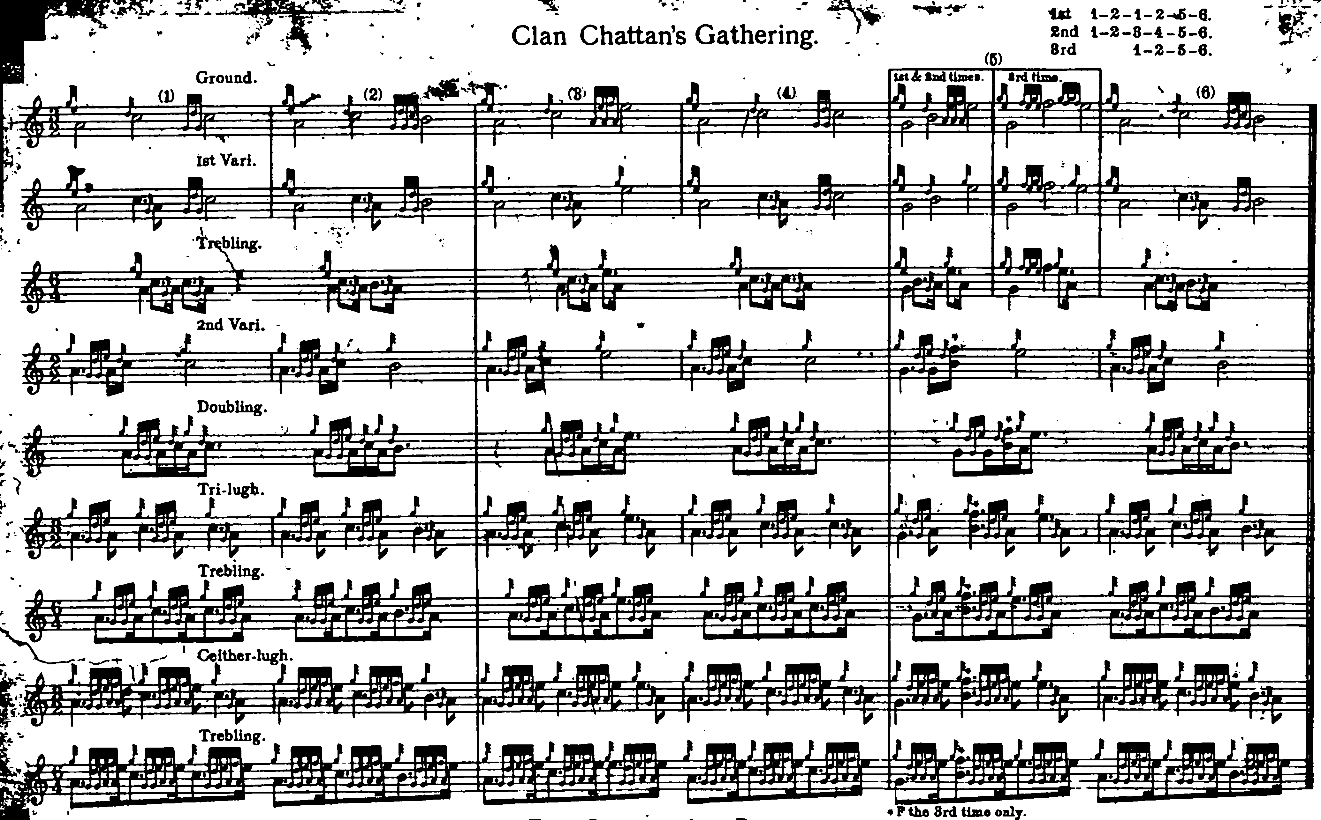

Commentary:

In his notes to this tune (Piobaireachd Society Collection, second series, ii, 65, published in 1928) Archibald Campbell stated that “The setting printed is that of Angus MacKay”, but he made numerous silent changes to MacKay’s score, including frequent alterations to note values making the timing more square and deliberate, added a crunluath a-mach not present in MacKay (none of the pre-Piobaireachd Society scores had a crunluath a-mach) and omitted MacKay’s instruction to repeat the ground at the end of the tune. In the Kilberry Book published in 1948, Campbell re-set the tune in 4/4 time, lengthening various note values to adjust the musical arithmetic, and adding fermatas at various points with similar deadening effect.

Alexander MacDonald (1836-1883) who supplied Uilleam Ross’s setting above, was one of the leading Victorian masters, a pupil of Donald Cameron, piper to the Earl of Fife and the first teacher of his son, John MacDonald of Inverness. The only memorial to Sandy MacDonald and most of his musically gifted family is their tombstone in the old graveyard at Aberlour on Speyside (turn sharp left just inside the gate; you have to pull the heather aside to read the latest entry on the stone). The inscription reads as follows:

In Loving Memory of
Alexander Macdonald who died at Fisherton, Aberlour
December 6th, 1883 aged 48 years
And of his daughter Jean
Who died at
Ferndern, Craigellachie
October 30th, 1908, aged 32 years
Also his wife
Jane Lamont
who died at Ferndern
December 23rd 1931 Aged 90 years
And their son William
Who died at the
Fleming Hospital Aberlour
August 7th 1938 aged 59 years
Also their daughter Mary
Who died 6th July 1946
And their son Andrew
Who died 26th December 1960
Also of their Daughter Helen MacDonald
Viewmount, Craigellachie
Who died 10th April 1975 aged 91 years

Helen (‘Nelly’) MacDonald was organist at the kirk of Craigellachie and hers is the setting of ‘The Caledonian Society of London’ published in G. S. McLennan’s Highland Bagpipe Music of 1929 (p.27). She had strong opinions on the light music of the day; Jack Taylor, who visited her before her death, recorded that she criticised the compositions of John MacColl and William Laurie as having “nae bite.” She always said that brother Andrew MacDonald (an outstanding player who competed little) was the real piper in the family and that her famous brother John was a fiddle player manqué. Sandy MacDonald was a friend of Malcolm Macpherson (Calum Pìobaire), and Robert Meldrum in his “Reminiscences” recollected that:

“on the night before the Northern Meeting at Inverness Malcolm Macpherson and Sandy MacDonald, Glentruim, got so engrossed in their own jollification that they forgot that they had to play at the first night’s ball and did not arrive until the first reel had been danced. Their masters were so angry that they took them down to the station and sent them home, waiting to see the train had started. But the pipers got out at Forres and returned to the Northern Meeting to enjoy themselves in the crowd and laugh at the woes of their friends trying to tune their pipes and whispering and grumbling in secret about the incompetent judges.” (Oban Times, 13 July 1940, p.3)

The full extent of Sandy MacDonald’s contribution to Uilleam Ross’s Collection is not clear, but R. B. Nicol recounted that when he and Bob Brown were studying with John MacDonald, they would quite often hear something unfamiliar but attractive and, on enquiring, John MacDonald would say “oh that is my father’s setting, you’ll get it in Ross’s book.”

* * *

Electronic text © Dr. William Donaldson, Aberdeen Scotland, November 2001; revised Cambridge, Massachusetts, March 2025

