Chisholm’s Salute:

This is a nineteenth century composition and appears in none of the manuscript sources so far cited in the Set Tunes series. There is a tune entitled “Chisholm’s Salute” in Donald MacDonald’s manuscript, but this is a different tune now known as “Chisholm of Strathglass’s Salute”.

There are settings of “Chisholm’s Salute” in the following published sources:

--Angus MacKay’s Ancient Piobaireachd, pp.41-2;
--Donald MacPhee’s Collection of Piobaireachd, i, 28-9;
--C. S. Thomason’s Ceol Mor, p.124;
--David Glen’s, Collection of Ancient Piobaireachd, pp.23-4;
--John McLennan’s, The Piobaireachd as Played in the Highlands (1925), p.10.

With the exception of Thomason (see below), all of the sources follow Angus MacKay in the development and timing of the tune. All the sources indicate that the ground should be repeated after the taorluath doubling and again at the end of the tune. None has a crunluath a mach.

There is a note error in Angus MacKay’s setting in the crunluath doubling, corrected by Donald MacPhee as follows:

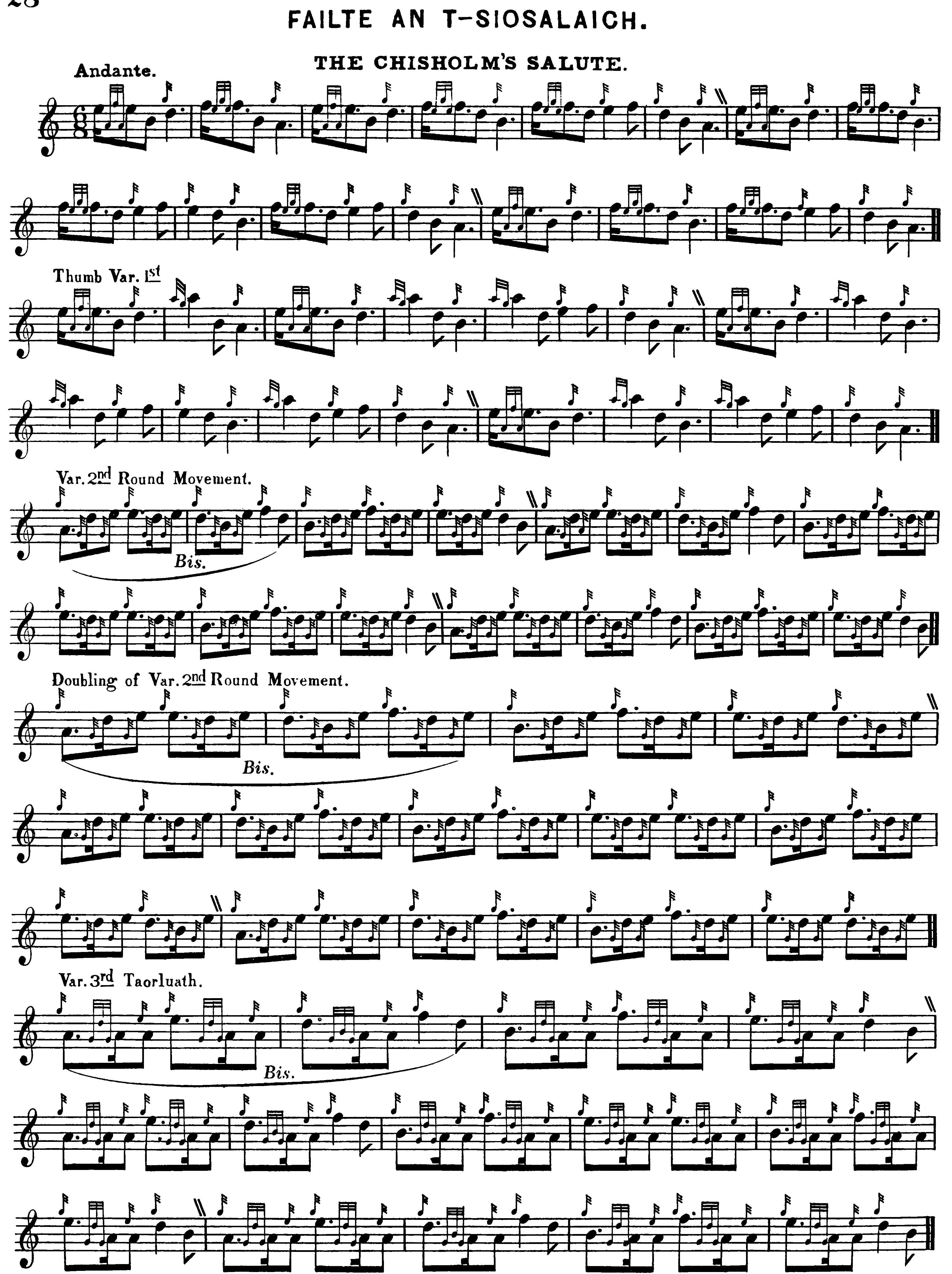
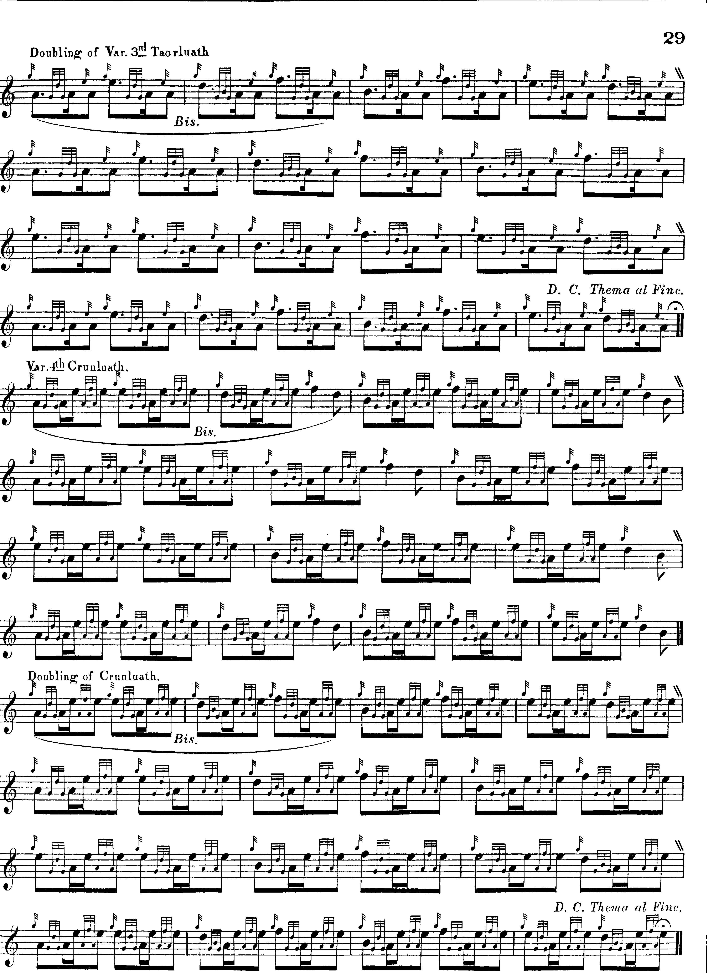

All later editors accept MacPhee’s correction, and follow this route through the tune, except for

C. S. Thomason who, citing Donald MacKay and Colin and Keith Cameron (pointing to Donald Cameron as the ultimate source) includes a second thumb variation. Thomason sets the tune as follows:

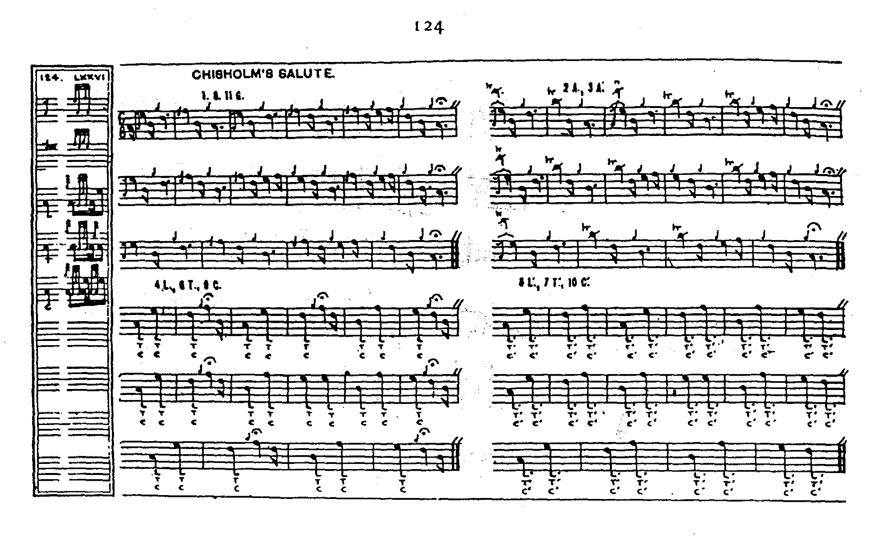

This particular style may have had a wider distribution than the Cameron family in late-Victorian Scotland. Ronald MacKenzie records a similar version with two thumb variations in one of his manuscripts (“Papers of Ronald and Alexander MacKenzie and Charles Scott”, National Library of Scotland, MS22125). It is dated, 14th December 1897.

David Glen adds nothing to the tune stylistically, and his score is not reproduced here.

John McLennan adds nothing to the tune stylistically, and his score is not reproduced here.

Commentary:

In Angus MacKay’s published book, which is the earliest source for this tune, there is a note by the Aberdonian journalist James Logan as follows:

The Chisholm preserves a relic believed to be of great antiquity. It is the chanter of a Bagpipe to which there is attached a degree of importance, from a supposed supernatural faculty which it is alleged to possess. In whatever way it was acquired, this instrument is said to indicate the death of the chief by spontaneously bursting, and after each successive fracture it is carefully repaired by a silver fillet, being an improvement on the primitive mode of firmly binding it with a leathern thong, which, from a fancied resemblance to the lacing of the Cuaran or buskin, procured it the designation of “Maighdean a Chuarain,”—the virgin, or rather, the stick of the Cuaran--to this instrument.
The family Piper, having been from home at a wedding when he heard his chanter crack, and perceived it rent, started up, and observed that he must return, for Chisholm was no more; and it was found to be so.
Kenneth Chisholm, the last family Piper, was taught by John Beag MacRae, Piper to the late Lord Seaforth. He went to America, where he was accidentally killed by the fall of a tree. (“Historical and Traditional Notes on the Piobaireachd”, p.7)

In his “Historic, Biographic, and Legendary Notes” to David Glen’s Collection of Ancient Piobaireachd, Henry Whyte (“Fionn”) adds

[…] In the fourteenth century Sir Robert de Chisholme came to the Highlands of Scotland and married the daughter and heiress of Sir Lauder of Quarrelwood and Constable of Urquhart Castle. He succeeded to the Lauder and other lands in the North […] The Chief of the Chisholms is called in Gaelic “An Siosalach”, and is the only Highland Chief who is entitled to the prefix “The”. (p.6)

This bold, simple, musical tune was offered frequently in competition including by Kenneth Stewart from the Isle of Skye who entered it for the Highland Societies’ competition in 1838. At that time, it was a requirement for pipers to bear a certificate of attestation signed by a gentleman and Kenneth Stewart’s has survived. It read “The Bearer can play several new piobrachs and also the Shiosalach or The Chisholm composed on the occasion of his being elected member of Parliament for the County of Inverness in the Year 1836--by R. McG. Minr. Kilmuir. Skye.” R. McG. was the Rev. Robert MacGregor, a native of Perthshire, who was apparently himself a player. (National Library of Scotland, MS22106, f.8)

It is interesting to reflect that a tune which James Logan presented with the then fashionable pseudo-antique trappings was in reality a brand-new piece when he compiled his notes.

The situation is complicated by there being two “Chisholm’s Salutes”, and it is not clear from the old competition lists which is which. For example, a “Failte an t-Siosalaich The Chisholm (of Chisholm’s) Salute” was offered by William MacKenzie of Breadalbane at the Edinburgh competition in 1824. A “Chisholm’s Salute” was also in Donald Cameron’s list in 1838, when he came second with “The Glen is Mine”. It was also in the list of the eventual winner that year, John MacBeath, piper to the Highland Society of London, and also that of Alexander Stewart of Kinloch Rannoch. Nobody got it to play, which might suggest that the bench did not know it, a further indication, perhaps, that this was a recent composition.

A possible third Chisholm tune, “Spaidseireachd an t-Shiosalaich The Chisholm’s March” was offered by two competitors in 1824. This was glossed as “Spaidearachd an t-Shiosalarach Chisholm of Strathglass’s March” when it appeared in the list of John MacDonald of Fortingall, the following year.

“Chisholm’s Salute” is a member of a closely-linked group which includes “Failt dhuitt Ion Cheir” in Colin Mór Campbell’s Nether Lorn Canntaireachd (i, 135-7, and a very interesting setting it is); “MacDougall of Lorn’s Lament” in Peter Reid’s manuscript (f.45); and two settings in Angus MacKay’s manuscript, namely “Cumha Iain Cheir Lament for John Kear Chief of the MacDougalls” (ii, 11-12) and “Cumha Iain Cheir Gray John’s Lament”(i, 223-4, this latter marked “McD’ll”, presumably Blind MacDougall, who we know was a significant source for MacKay). Indeed, all our current tune adds to “Cumha Iain Cheir Lament for John Kear” in MacKay’s MS is a slight twist to the B phrase and the addition of a thumb variation.

The accompanying m4a sound file offers a detailed talk through the timings for the various sections, including moving idiomatically between phrases and parts aimed at players in the earlier stages of their learning.

* * *

Electronic text © Dr. William Donaldson, Aberdeen, Scotland, June 2005

