The Carles with the Breeks
There are settings of this tune in the following manuscript sources:
--Colin Campbell’s “Nether Lorn Canntaireachd”, i, 44-5 (with the title “Lord Bredalbin’s Gathering”);

and in the following published sources:

--Donald MacDonald’s Ancient Martial Music, pp.102-5 (with the title “Bodaich na ’m Brigis Lord Braidalbane’s March To the Battle fought betwixt him and the Sinclairs of Caithness at Wick”;
--Angus MacKay’s Ancient Piobaireachd, pp.5-6;
--Donald MacPhee’s Collection of Piobaireachd, ii, 17-18;
--C. S. Thomason’s Ceol Mor, p.45;
--David Glen’s Collection of Ancient Piobaireachd, pp.45-6;
--William Stewart, et al., eds., Piobaireachd Society Collection, first series, iv, 12-13;

Colin Campbell sets the tune like this:

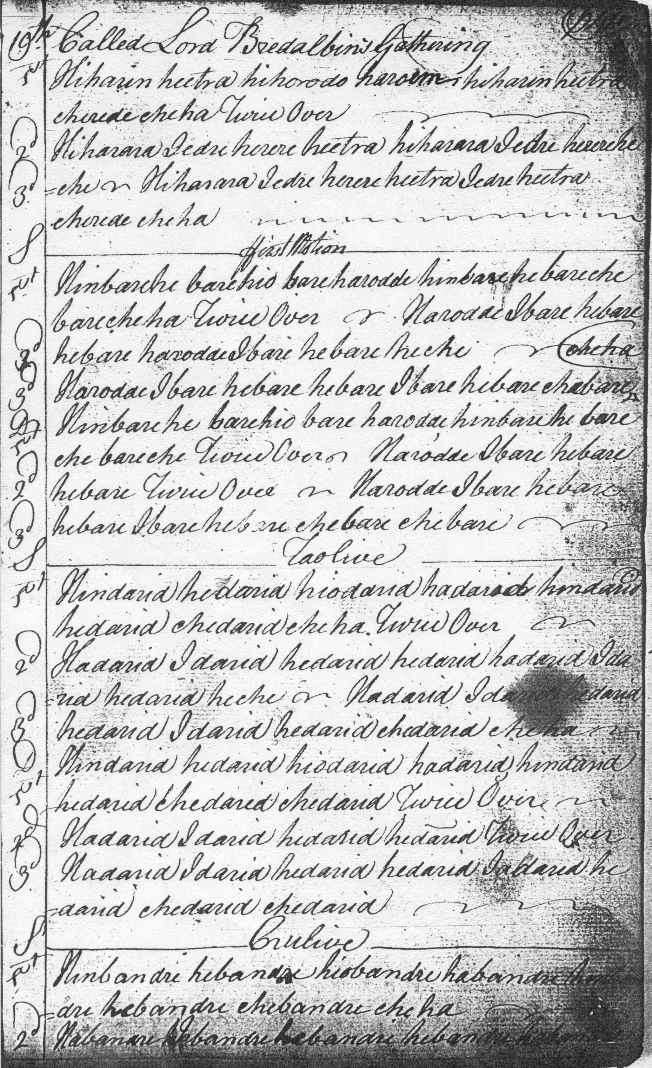

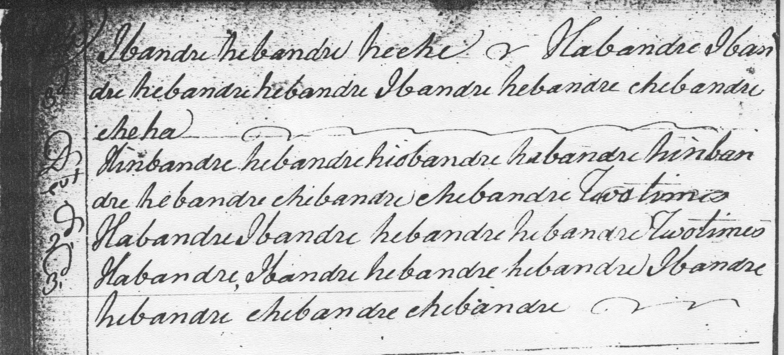

Colin Campbell, who actually worked for the Breadalbanes and may be expected therefore to have known this tune particularly well, develops the piece in a straightforward and logical manner: ground; leumluath singling and doubling; taorluath duinte singling and doubling; and crunluath duinte singling and doubling. The only real interpretational difficulty is what to make of the introductory notes to the movements of the ground, hiharin, hiharara, hihorodo, and whether these were intended as cadence notes or cuttings. A possible interpretation is suggested in the accompanying MP3 file.

Donald MacDonald’s published setting is as follows:

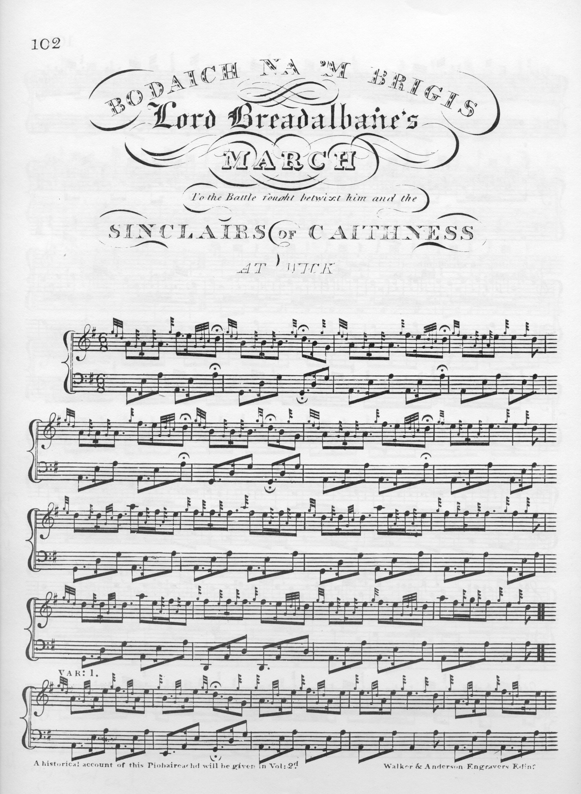

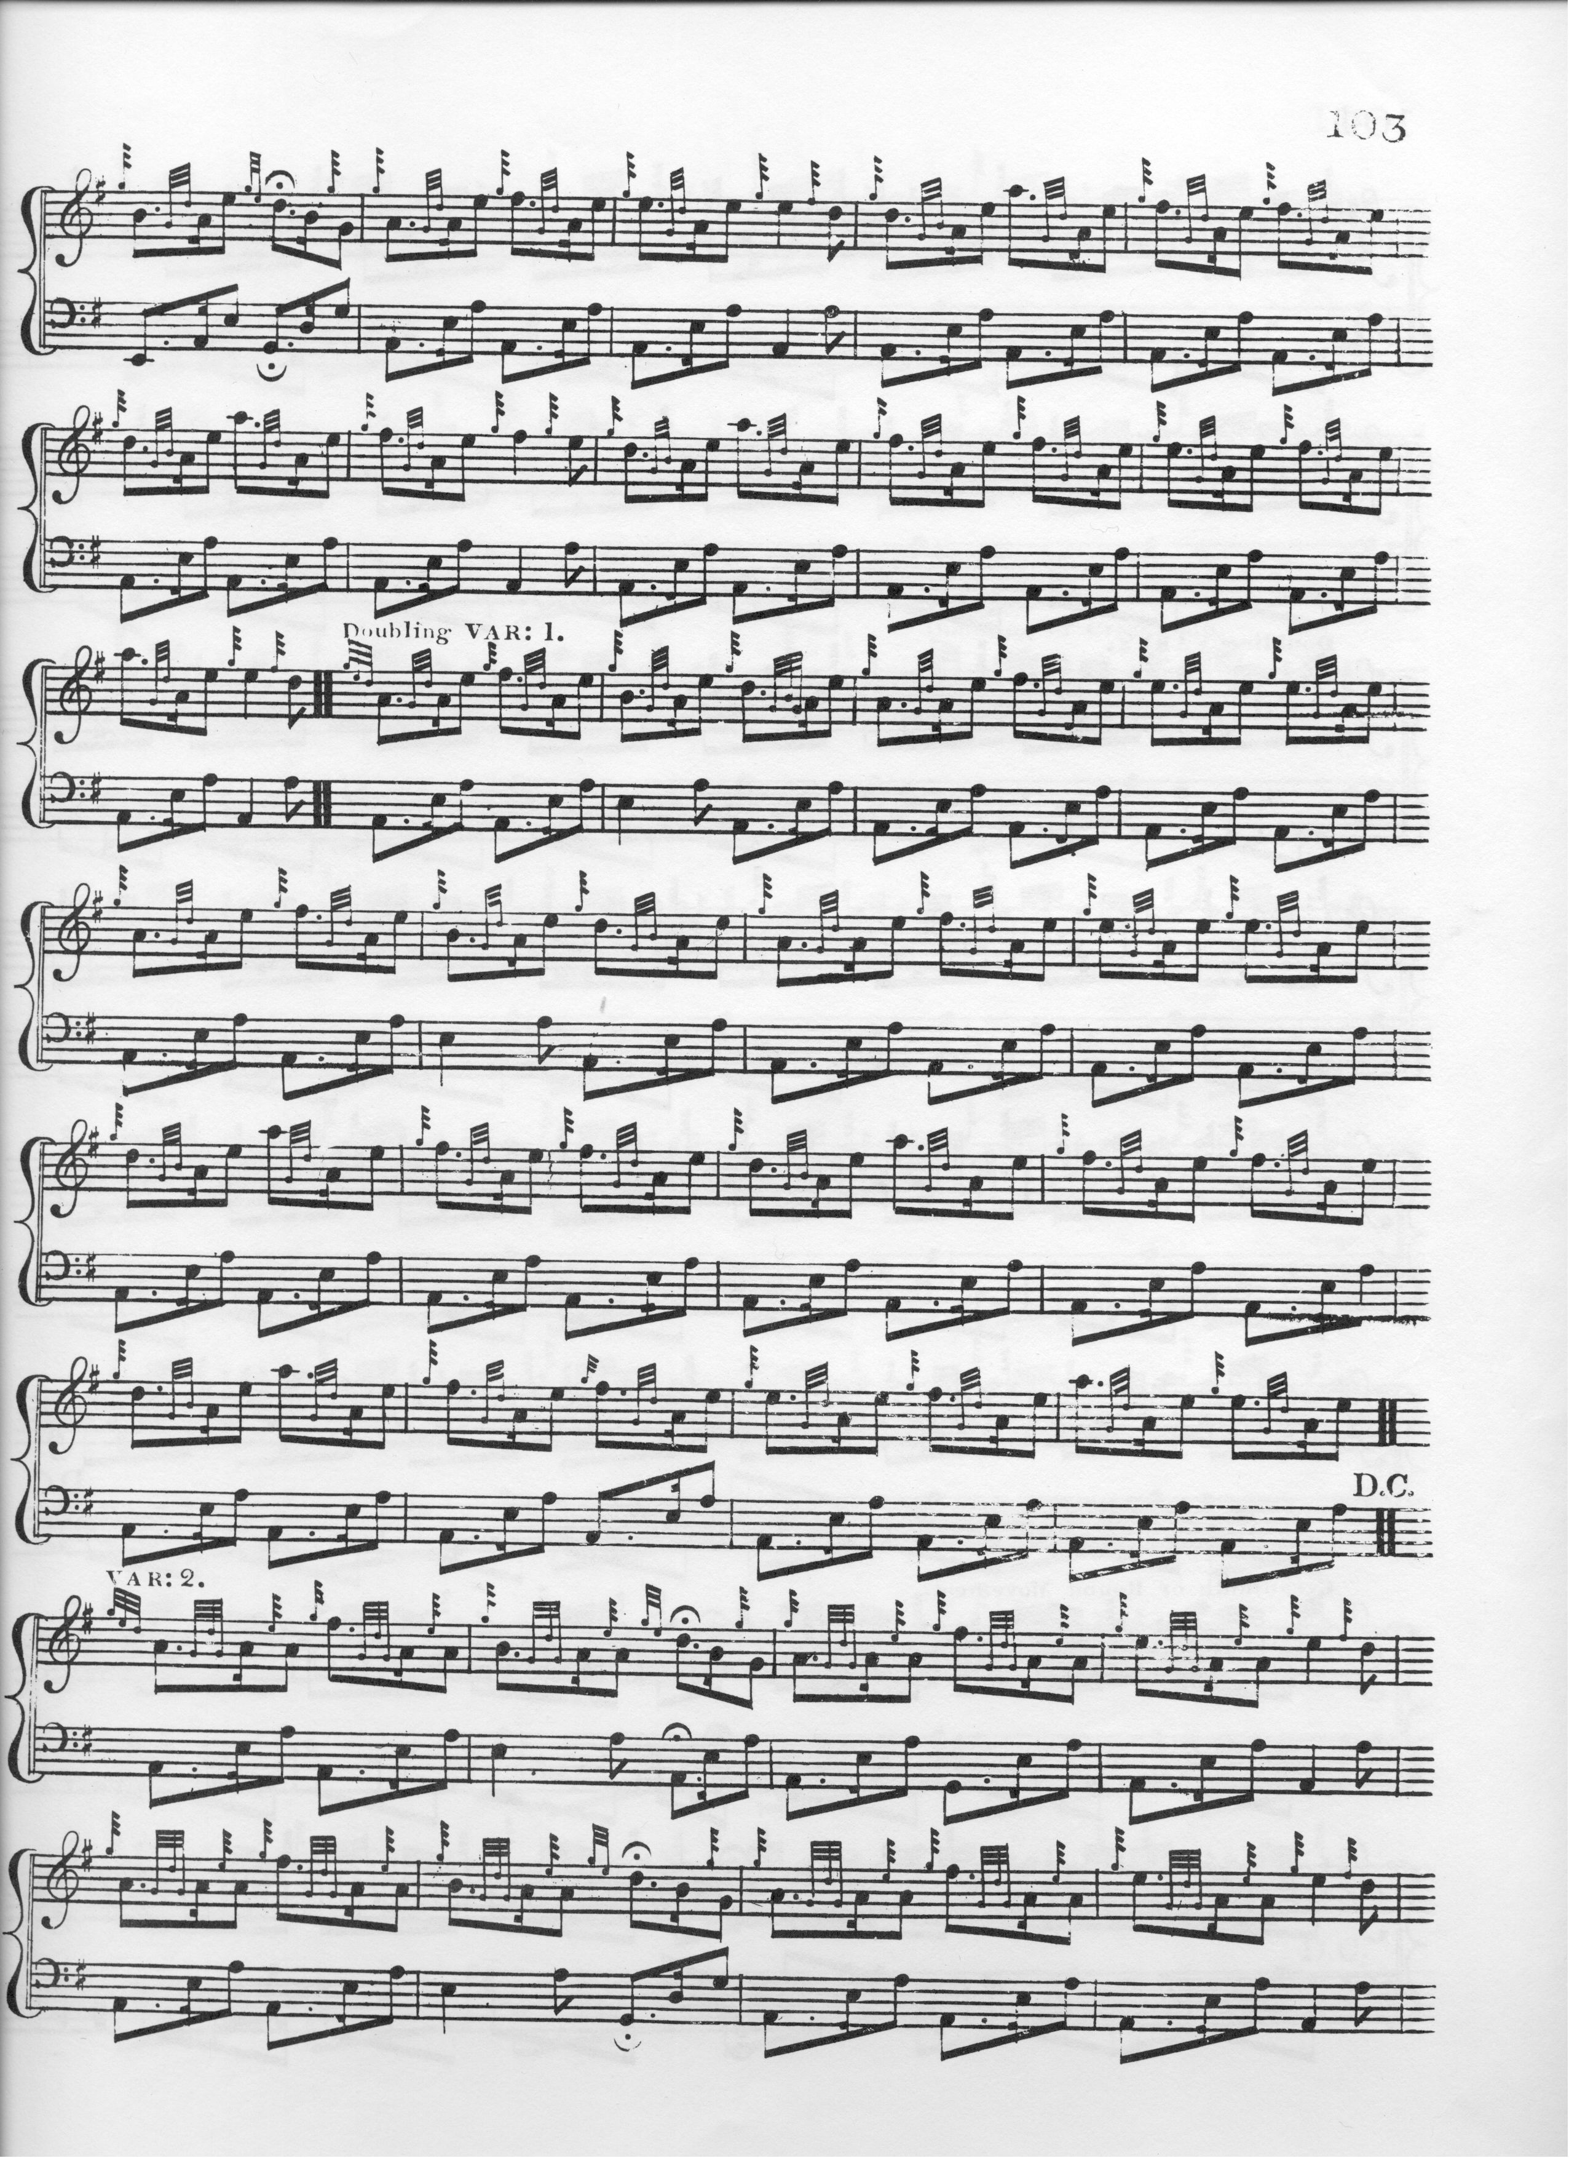

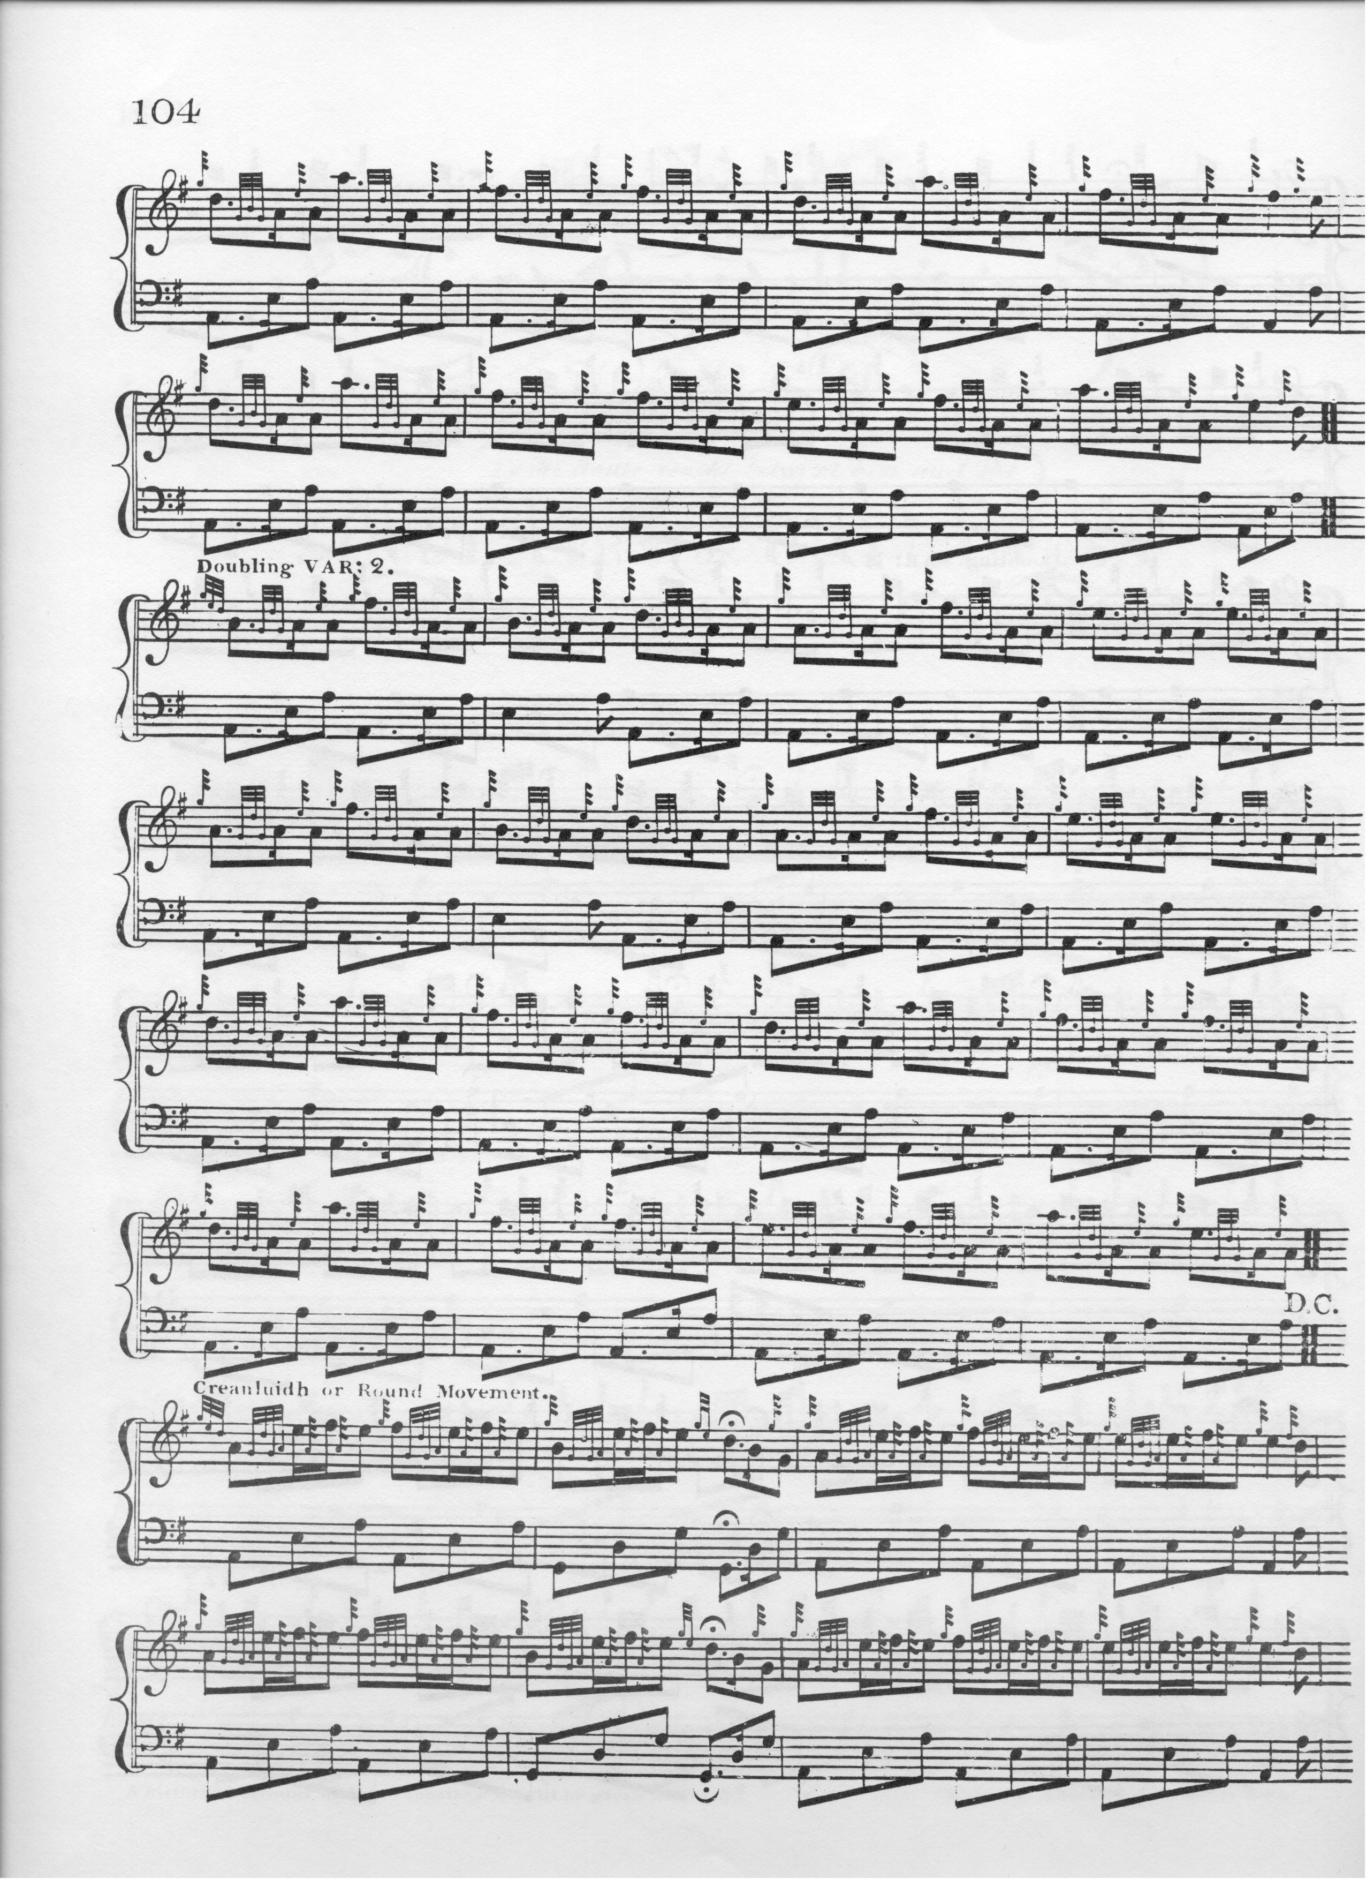

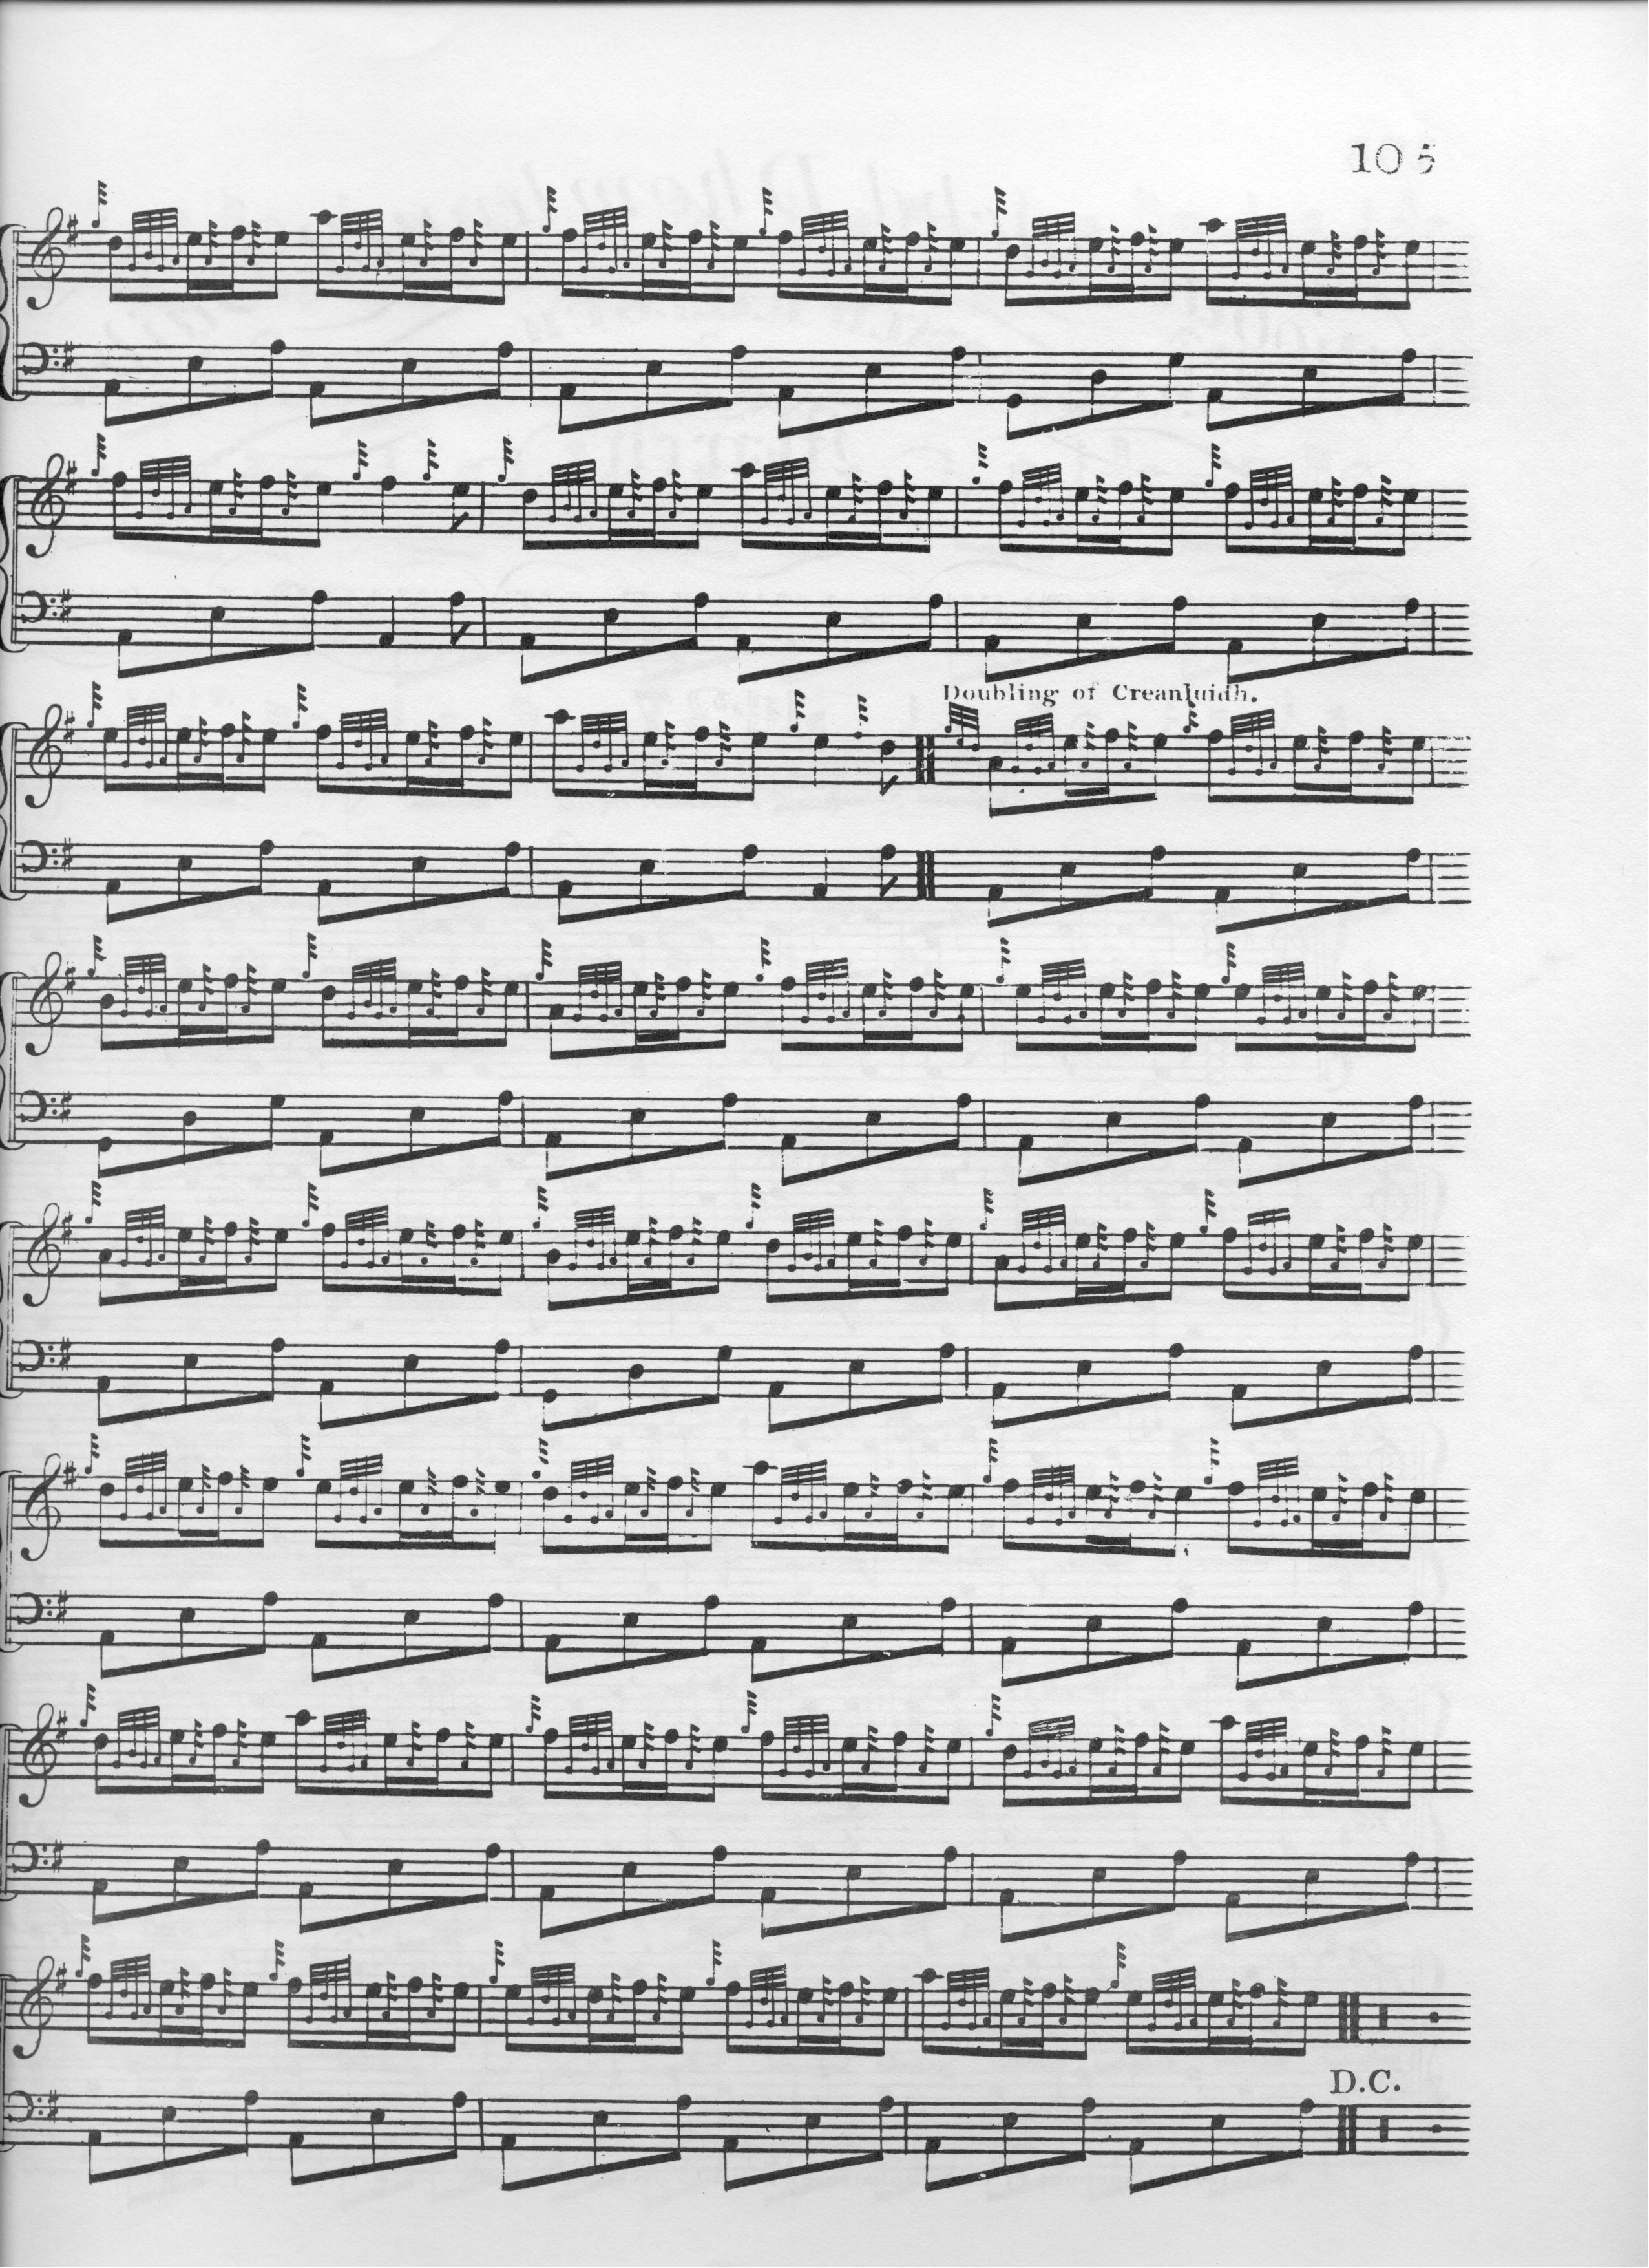
MacDonald’s setting is much more profuse in its use of introductory notes in the ground, so much so, perhaps, as to impede the flow of the tune if given any significant time value. We note the attractive run down D-B-G at the end of the A phrase in the singlings of the later variations where Colin Campbell had used a basic duinte taorluath and crunluath figure in such locations, and the fact that MacDonald repeats the ground after every doubling of the variations, which suggests a pretty brisk approach to the timing of the tune as a whole.

Angus MacKay sets the tune like this:
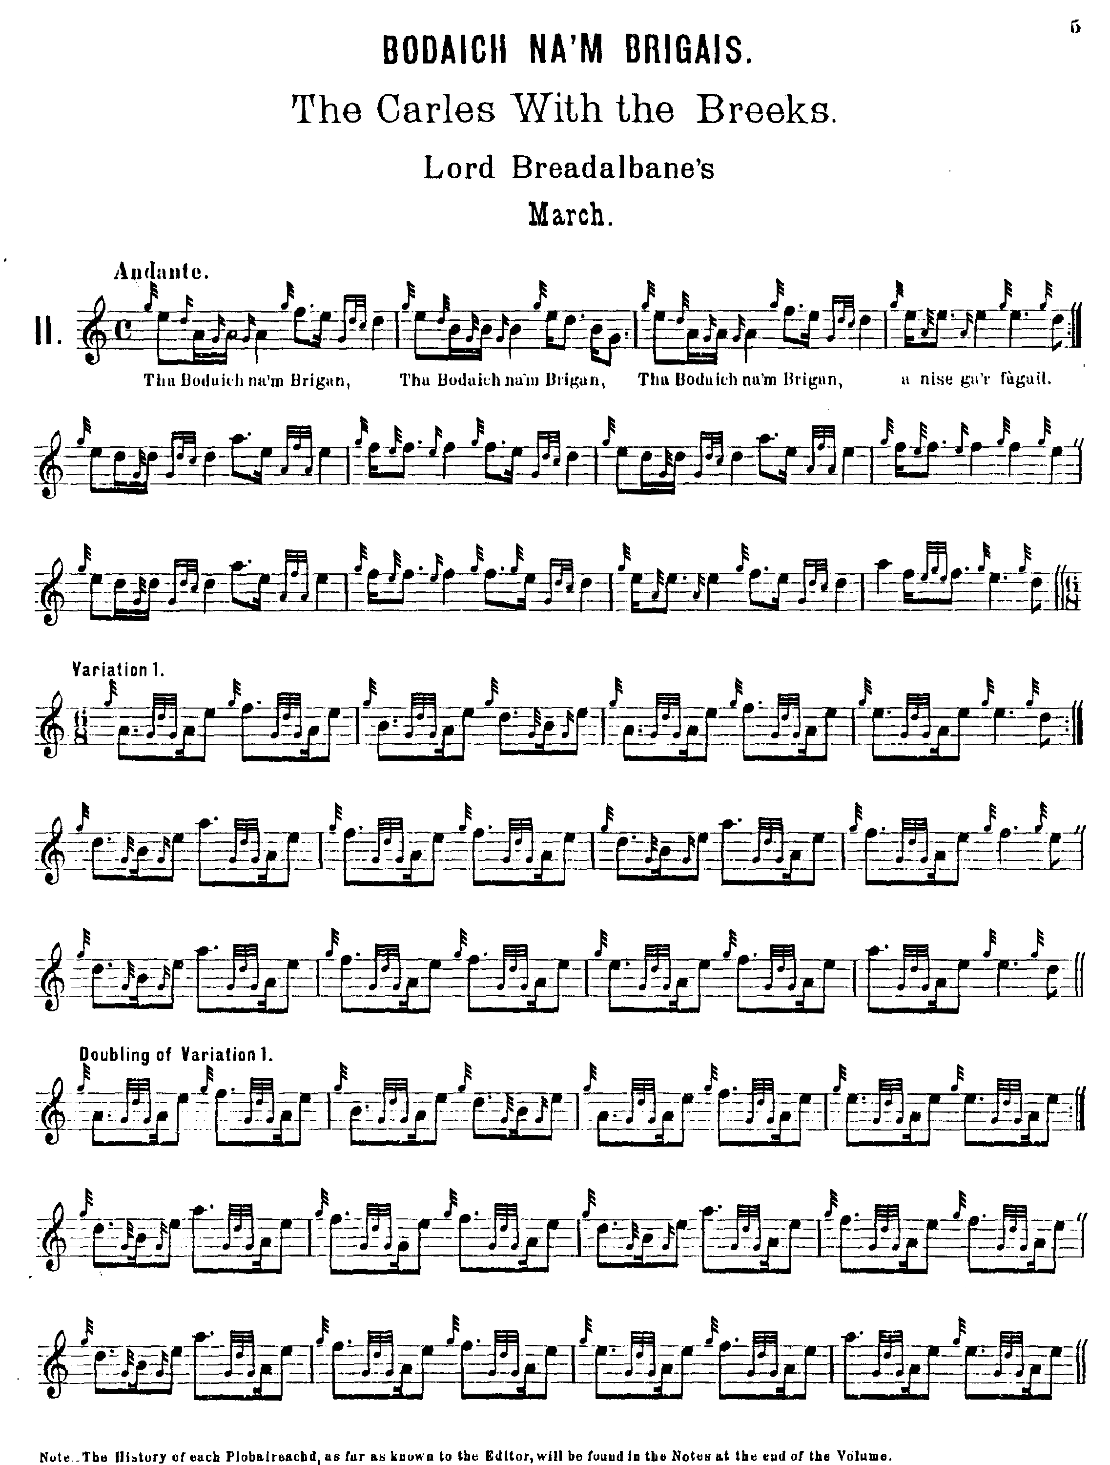

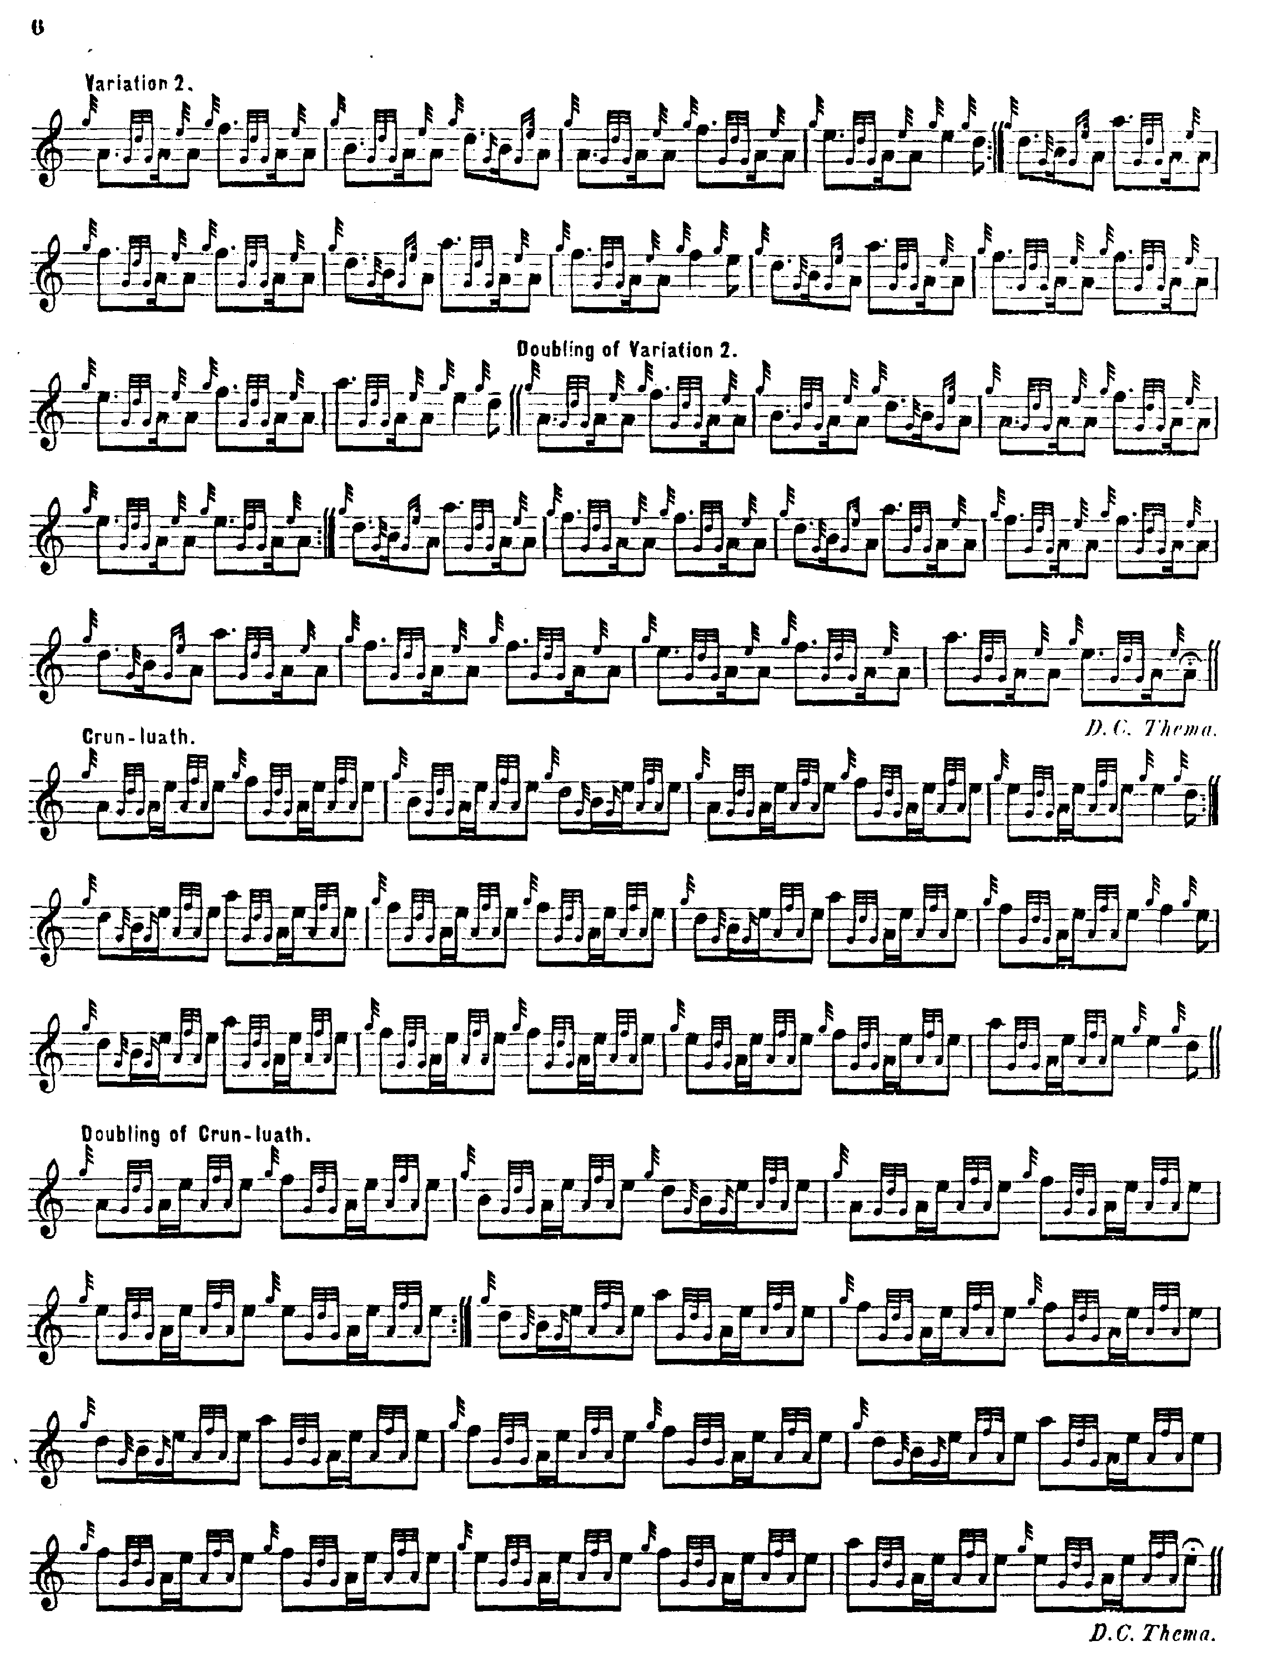

MacKay’s square 4/4 timing stands in contrast to the lilting 6/8 timing (stated or implied) of Campbell and MacDonald. (although the rhythm of the words of the little song quoted beneath line suggest something closer to MacDonald and Colin Campbell). MacKay develops the tune in a similar manner however, with a ground followed by leumluath, taorluath and crunluath variations, singling and doubling. Here, though, the ground is restated only once within the tune, at the end of the taorluath doubling.

Donald MacPhee largely follows MacKay, but has a number of interesting individual touches, thus:

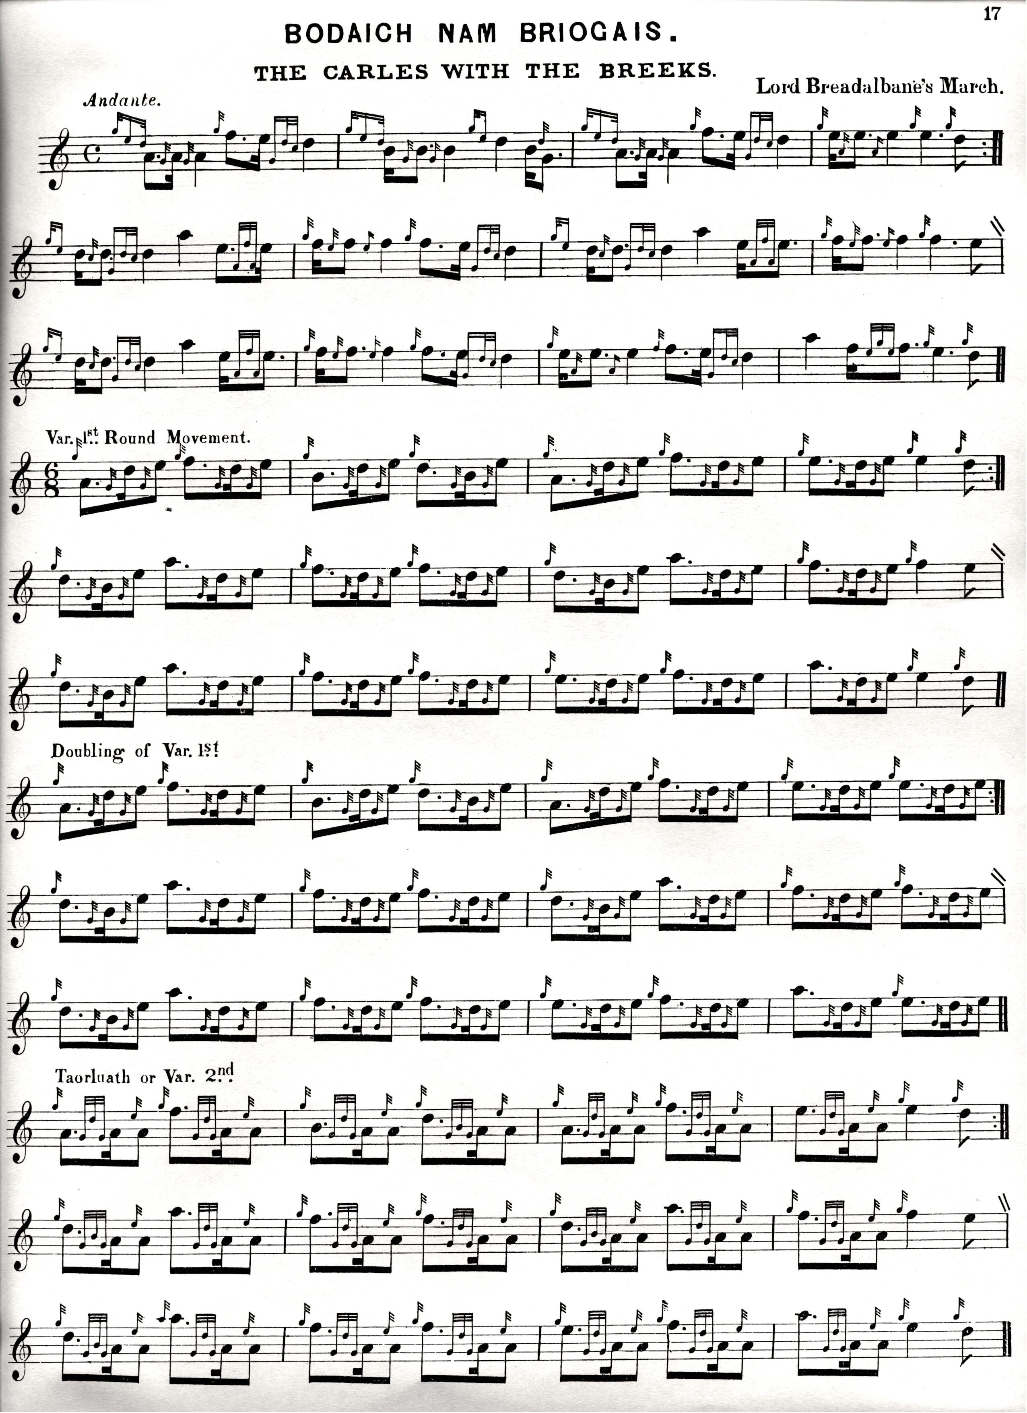

MacPhee emphasises the initial low A in his gairm movement, unlike the cut version in MacKay, he drops the repeat of the ground at the end of the taorluath doubling, and includes a crunluath a mach—so for those who wanted to go down this route MacPhee would represent an attractive, very playable option if one is reconciled to the square 4/4 timing of the ground.

C. S. Thomason follows Donald MacDonald (although adopting MacKay-style double-echo beats throughout). Otherwise his score adds little to the interpretative possibilities of the tune and is not reproduced here.

David Glen also follows the MacDonald style, setting the ground in 6/8 time and playing the gairm on to a low A dotted quaver. Interestingly he returns straight to E from high A in the final bar of the ground, presumably to follow the tone row of the variations more exactly; doubly interesting in view of the fact that Donald MacPhee, of whose editorial approach this was a typical feature, did not elect to do it on this occasion, but came back down to E via a throw on F like most other people did.

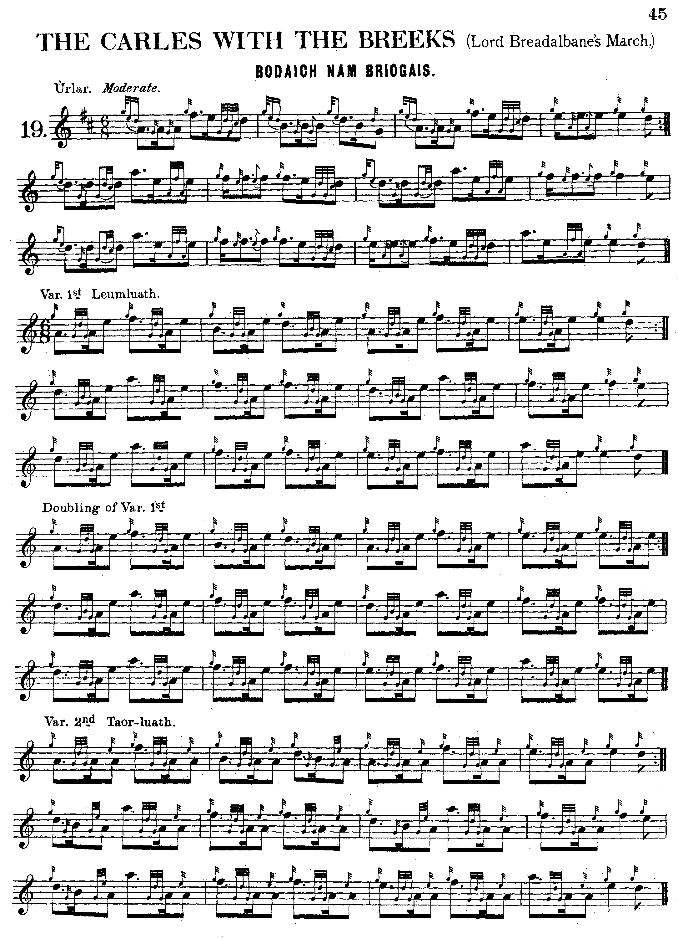

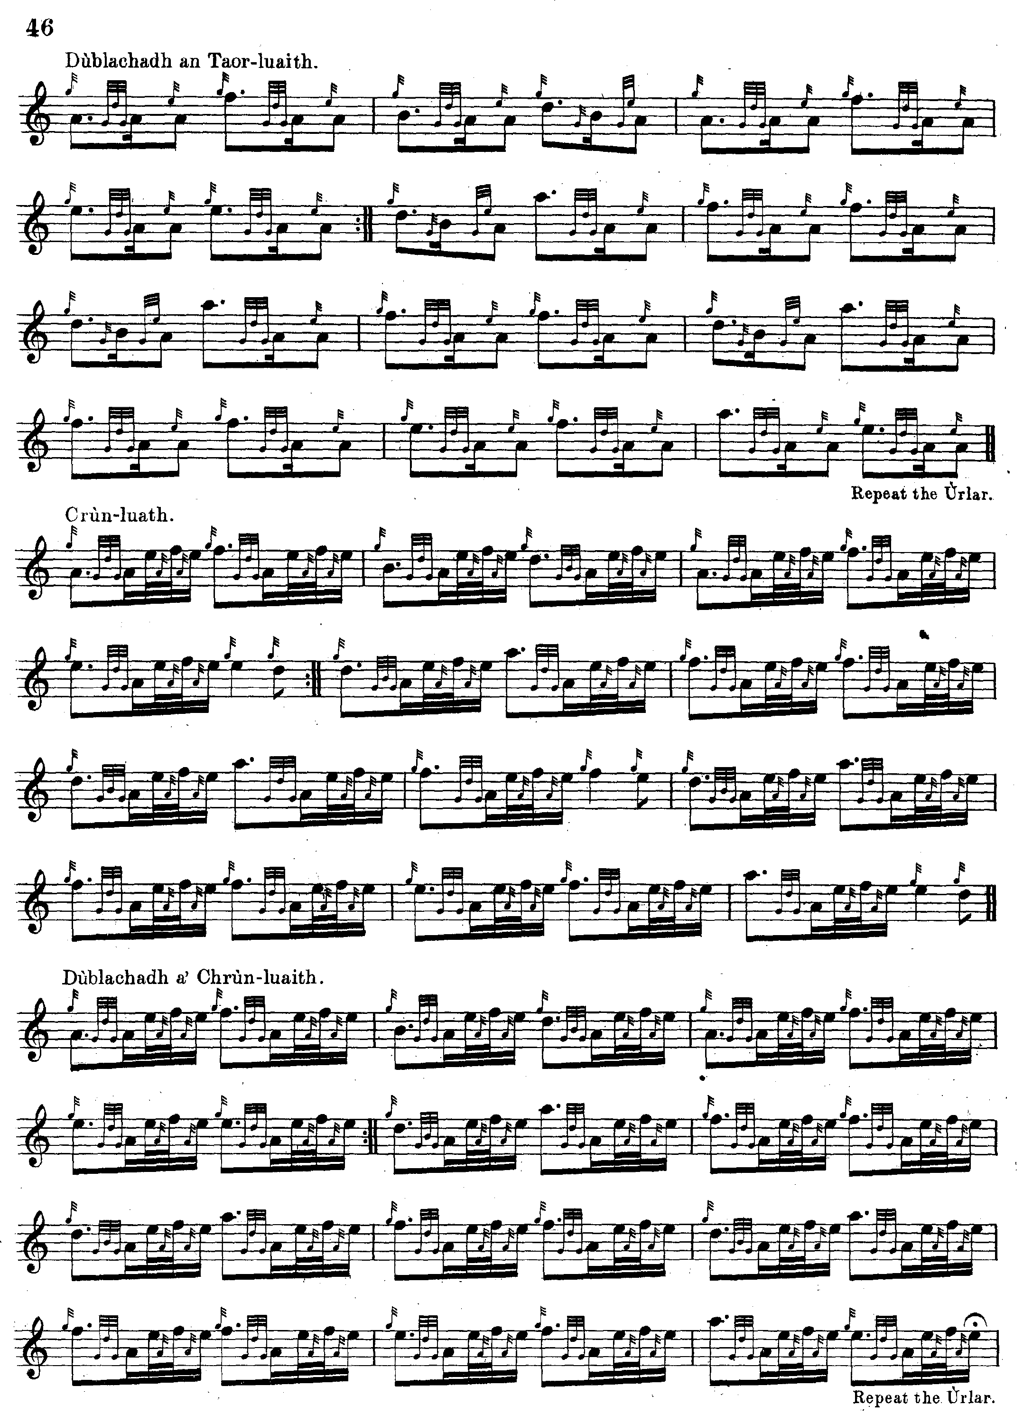It is interesting that neither Thomason nor Glen follows MacPhee in including a crunluath a mach.

The Piobaireachd Society Collection (first series) score does not add to the interpretational possibilities of the tune and is not reproduced here.

Commentary:

This tune is associated with a raid by Breadalbane’s people into the far North East in the year 1680. The most convenient brief summary of the complex of legal claim and counter-claim which lay behind what was effectively an act of territorial aggrandisement is given by James Logan in the notes to Angus MacKay’s Ancient Piobaireachd. One might add that there is a story that the night before the battle, the canny southerners deliberately beached a small vessel crammed with barrels of whisky in the immediate rear of the Caithness forces, and awaited the inevitable:

There had been, for a considerable time, misunderstandings and mutual jealousies
between the Sinclairs and the Mackays, which circumstances, ripened into feud, mutual
aggression, and slaughter. In 1668, Colonel Hugh MacKay of Scourie was subjected to so
severe an imprisonment by Lord Caithness that it cost him his life. Shortly after this event
his brother Hector was waylaid in Aberdeenshire by Sinclair of Dunbeath and Sinclair of
Murkle, and was killed after a stout contention in which MacKay’s servant severely
wounded both the assailants, - Murkle so much so, that a cut in his neck rendered him
ever after incapable of holding up his head. The Earl of Sutherland, Lords Rea and
Strathnaver, Hugh Munro of Eribol, and several others, raised an action before the
justiciary, against George, Earl of Caithness, and several who were concerned with him in those lawless proceedings which harassed the country. This was met by a counter-action, in which various complaints were made against the pursuers, extending downwards from the year 1649 and both parties were summoned to appear on the 10th of December 1668.
A compromise took place, and Caithness withdrew his action: the case as to Dunbeath and Murkle being however excepted. These stubborn gentlemen had not found the caution or security required for their appearance, and had eluded all attempts to apprehend them. A commission of fire and sword was promulgated against them, but the service being declined by those to whom the letters were first addressed, John Campbell younger of Glenurchy undertook it with alacrity, and proceeded to Caithness; but meantime by the influence of their friends, the outlaws obtained a remission of their crimes. Although Glenurchy found this an unprofitable expedition, he resolved to turn his visit with Caithness to some account, and ingratiated himself with the Earl, who had married Argyles’ daughter, and who was consequently his own kinswoman. The Earl, who was advanced in life and in great pecuniary difficulties, was advised by Campbell to execute a bond of entail, 7th October 1672, conveying the earldom and estates to Glenurchy, failing issue male of his own body. He died in 1675 without that issue, leaving his lands encumbered with debt, which Campbell, who was himself a principal creditor, redeemed, and not trusting in the deed of tailzie and disposition, he married in 1678 the dowager Countess, who had enjoyed a handsome life rent. He then led a process of adjudication against the whole property, and ultimately obtained a charter under the great seal and a royal grant of the earldom. George Sinclair of Geiss, son of Francis Sinclair of Northfield, second son of George Earl of Caithness, grandfather to the last Earl, laid claim to the title and was cheerfully acknowledged by a majority of the clan, who would not submit to Glenurchy’s assumption. The lawyers, however, seem to have given the preference to Glenurchy, in whose favour a proclamation from the privy council was issued, 22nd February 1677, forbidding Sinclair to claim, or others to give him the style or title. Sinclair, in support of his claims, alleged a disposition of the lands of Geiss, Northfield, and Tister, from the Earl his grandfather, which he maintained was his sole and inalienable patrimony; but Glenurchy also resisted this claim. Sinclair however defended his right, and with his friends opposed Glenurchy’s collection of the rents, and otherwise annoyed him, who thereupon obtained the protection of letters of lawborow’s against the Sinclairs, who had been previously summoned by the sheriff to compear and resign the lands to the newly created Earl of Caithness; who had moreover obtained an act, charging all his kin, friends, and followers to assist him in the recovery of the disputed lands. In consequence of this, Glenurchy invaded Caithness with an array of about 1000 men from Glenlyon, Glenfallach, Glendochart, Achaladair, with the followers of his brother-in-law, the Laird of MacNab; and finding the Sinclairs prepared to oppose the march, he drew up his army at Allt-na meirlich, about two miles from the town of Wick. His enemies were somewhat more numerous, and unfortunately spent the night preceding the battle in carelessly feasting and drinking, the effect of which was seen in the irregular line of march, when they went forward next morning. The Campbells with becoming prudence, knowing the population so hostile to them and that defeat would be irretrievable ruin, selected the most advantageous ground, and nerved themselves for the onslaught of the advancing host.
Their firmness secured the advantage; for the unsteady ranks of the Sinclairs were broken, and the slaughter was great. Many attempting to cross the river of Wick, escaped the sword, but found a watery grave. The bodies so accumulated in the stream, that it is
traditionally reported the Campbells could step over on the carcasses, dry shod. The
gentlemen being mounted, made good their retreat, but the victory was so complete and
so easily obtained, that on first perceiving the Sinclairs giving way, Glenurchy’s Piper
poured forth a voluntary, the notes of which appeared to re-echo the contemptuous
exclamation, that “the carles with the breeks were flying from the field!”* This
piobaireachd has ever been called, “Lord Breadalbane’s march to the battle,” and does
appear in the ears of lovers of Pipe-music, to articulate very expressively “Bodaich na’m
Briogais,” &c.
* The gentlemen of the Sinclairs being on horseback, wore the Truis; hence the appellation Bodaich na’m Briogais. The late Caithness fencibles, raised and commanded by Sir John Sinclair, Bart. were dressed in this distinguished garb of their ancestors. See Stewart’s Sketches of the Highlanders, p. 399. Douglas’ Peerage, &c.

There is a famous song to this tune, associated with the Massacre of Glencoe, usually called from its opening words, “Mnathan a’ ghlinne seo”, a warning to the women of the glen that there are armed men lying in wait for them. For further details and a sung performance, see

< http://www.tobarandualchais.co.uk/en/fullrecord/101931/ >

*

Electronic text © Dr. William Donaldson, Cambridge, Massachusetts, 6th September 2016

