Lament for Captain MacDougall

There are settings of this tune in the following manuscript sources:
--Angus MacKay’s MS, i, 218-219;
--D. S. MacDonald’s MS, i, 81-2;
--David Glen’s MS, ff.260-261;
--Robert Meldrum’s MS, ff.137-139;

and in the following published sources:
--C. S. Thomason’s Ceol Mor, pp.364-5;
--David Glen’s Ancient Piobaireachd, pp.216-7;
--William Stewart (and others), Piobaireachd Society Collection (first series), iv, 15-17;
--John McLennan, The Piobaireachd as Performed in the Highlands, pp.2-3.

There are basically two routes through this tune, that of Angus MacKay, and the version published by Thomason, Glen and John McLennan.

Angus MacKay: is the earliest source for the tune, stating that it was the composition of Ronald MacDougall the family piper. MacKay’s score is upon the whole precise and complete—leading to the supposition that he intended the “extra pulse” in the penultimate bar of the ground (for more on which, see below). Angus misses the “bis” markings under bars 9 and 10 of the first variation, singling and doubling, but otherwise the score is clear. He repeats the ground at the end of the taorluath section and again at the conclusion of the tune and plays his taorluath and crunluath breabach “up”:

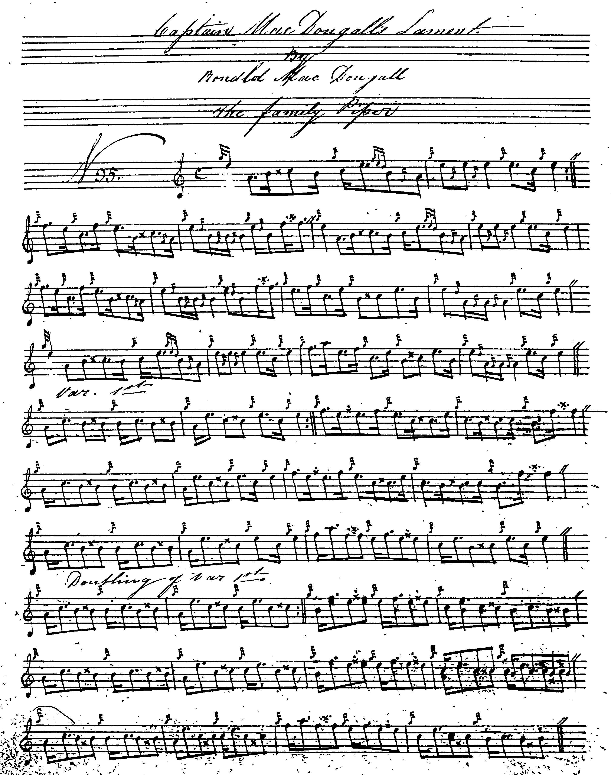
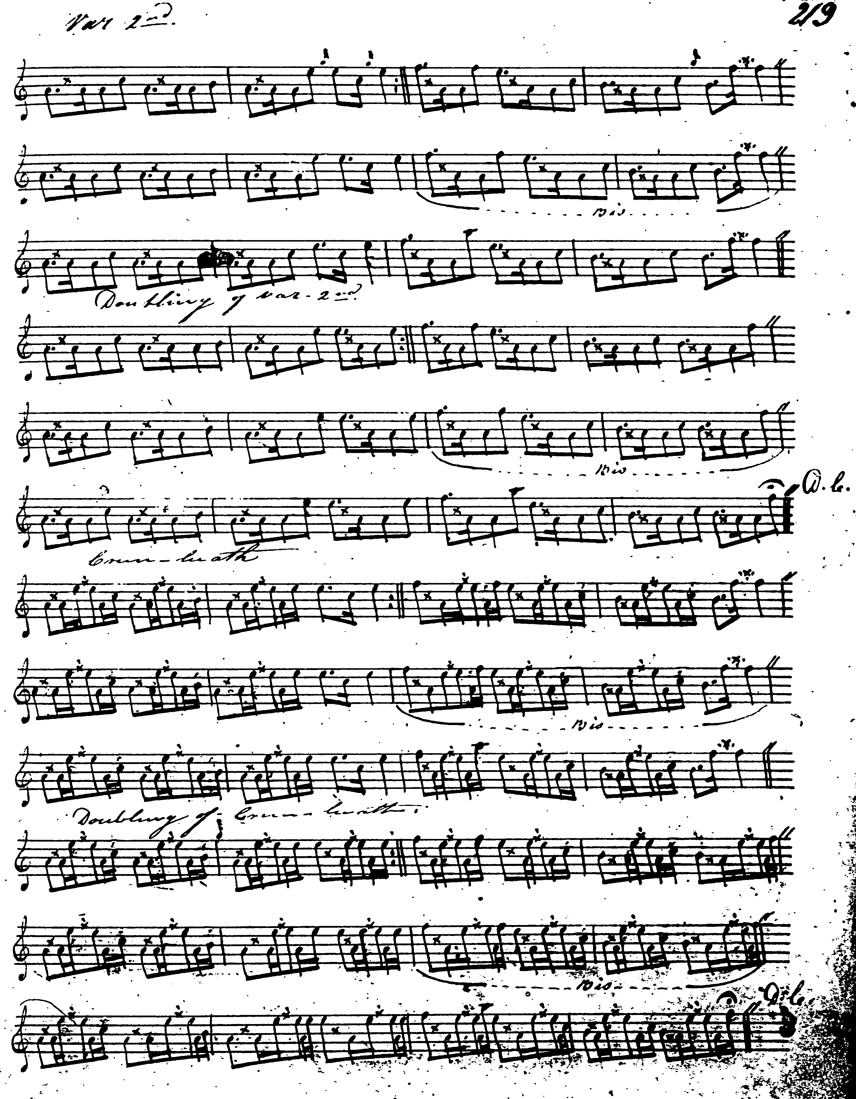

D. S. MacDonald: marks the ground to be played “with feeling”, and interestingly re-times the penultimate bar of the ground in an attempt to get it to scan. That excepted, and the fact that he supplies the missing repeat marks, D. S. MacDonald adds nothing of significance to MacKay’s score; his third line is as follows:

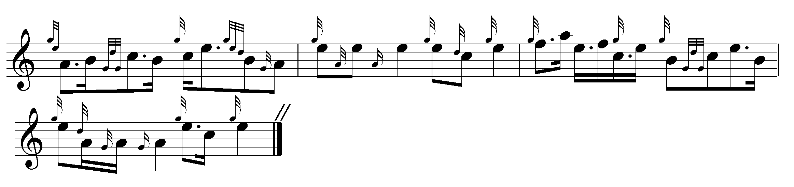

Robert Meldrum: also drops the “additional” pulse in the penultimate bar of the ground and he has a similar treatment of the repeat of the B phrase in line two of the first variation singling and doubling that we see in David Glen below. His score is not reproduced here.

Published scores:

C. S. Thomason: cites MacKay as his single source. Thomason, too, drops a pulse from the offending penultimate bar and takes a similar route to Glen through the repeat of the B phrase at the end of the second line of the first variation singling. He follows a similar contour to Glen in the remainder of the tune. Thomason likewise directs that the ground be repeated after the taorluath doubling and at the end of the tune. His score was published some years before Glen’s appeared but as Thomason was in close contact with David Glen at this time the two settings probably represent joint conclusions. Thomason’s score is not reproduced here.

David Glen: points his eallach “down” and places the accent on the first note of the B echo-beat in his normal fashion. He cuts one of the pulses in the penultimate bar of the ground. In addition, Glen retains the tonal contour of the descending phrases in line 2 when the sequence re-appears in the first line of the doubling. Glen’s score is full of subtle little touches: see, for example, variation one doubling where he artfully varies the repeat of the B phrase in line two (which is sustained through the remaining variations). Glen plays his breabach taorluath and crunluath variations emphatically “up”. We note, too, his different treatment of the final B phrase at the end of the taorluath singling—this is not what MacKay has but shows Glen ceaselessly trying to vary the beaten track:

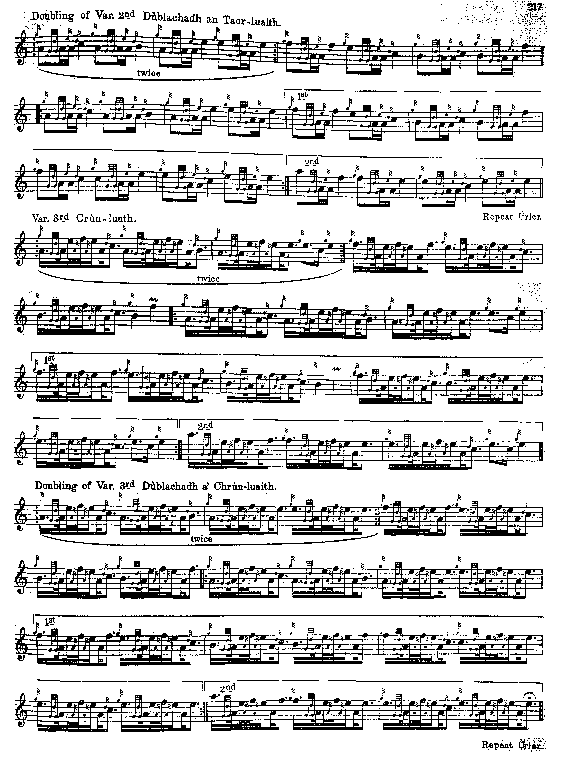

Piobaireachd Society Collection (first series): also drops the “extra” pulse and generally follows Thomason and Glen. One notes the interesting eallach at the end of line 3, the standard MacKay-type staccato one which gives a much more interesting rhythmical effect than the unidiomatic form later promoted by Archibald Campbell. One notes, too, that the Society also cut their taorluath breabachs “up” and time their crunluath breabachs as even quavers. They do not direct that the ground be repeated at the end of the taorluath doubling or at the end of the tune:

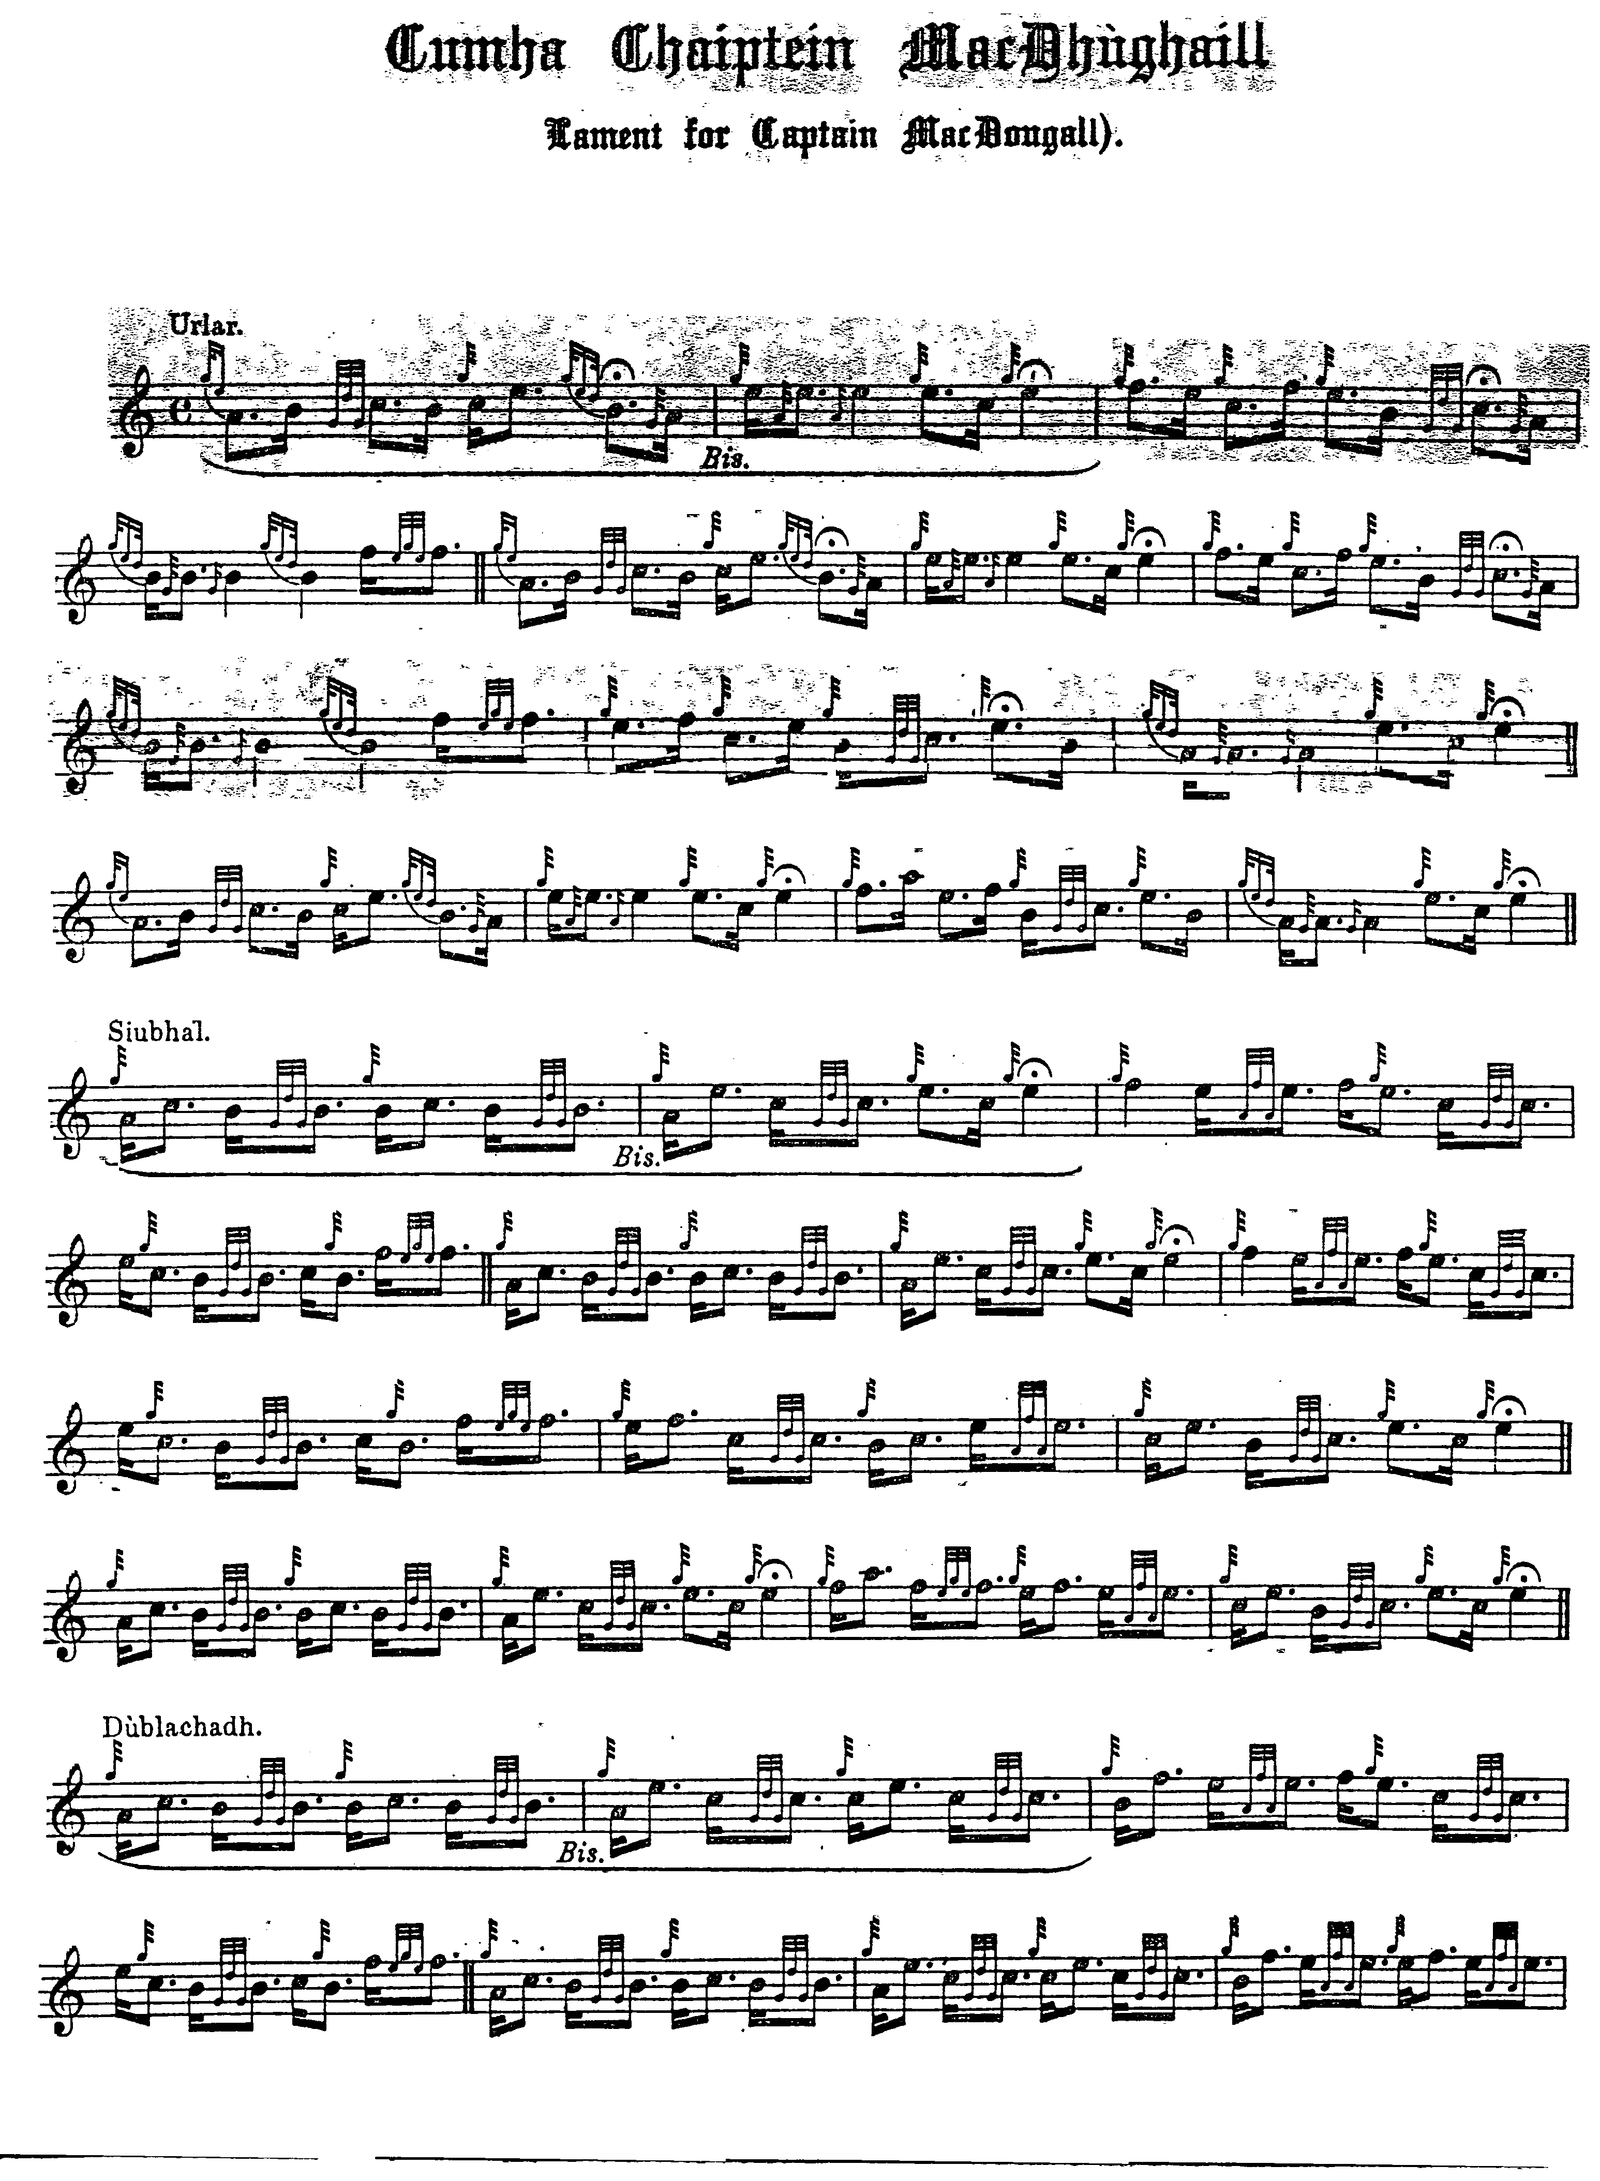
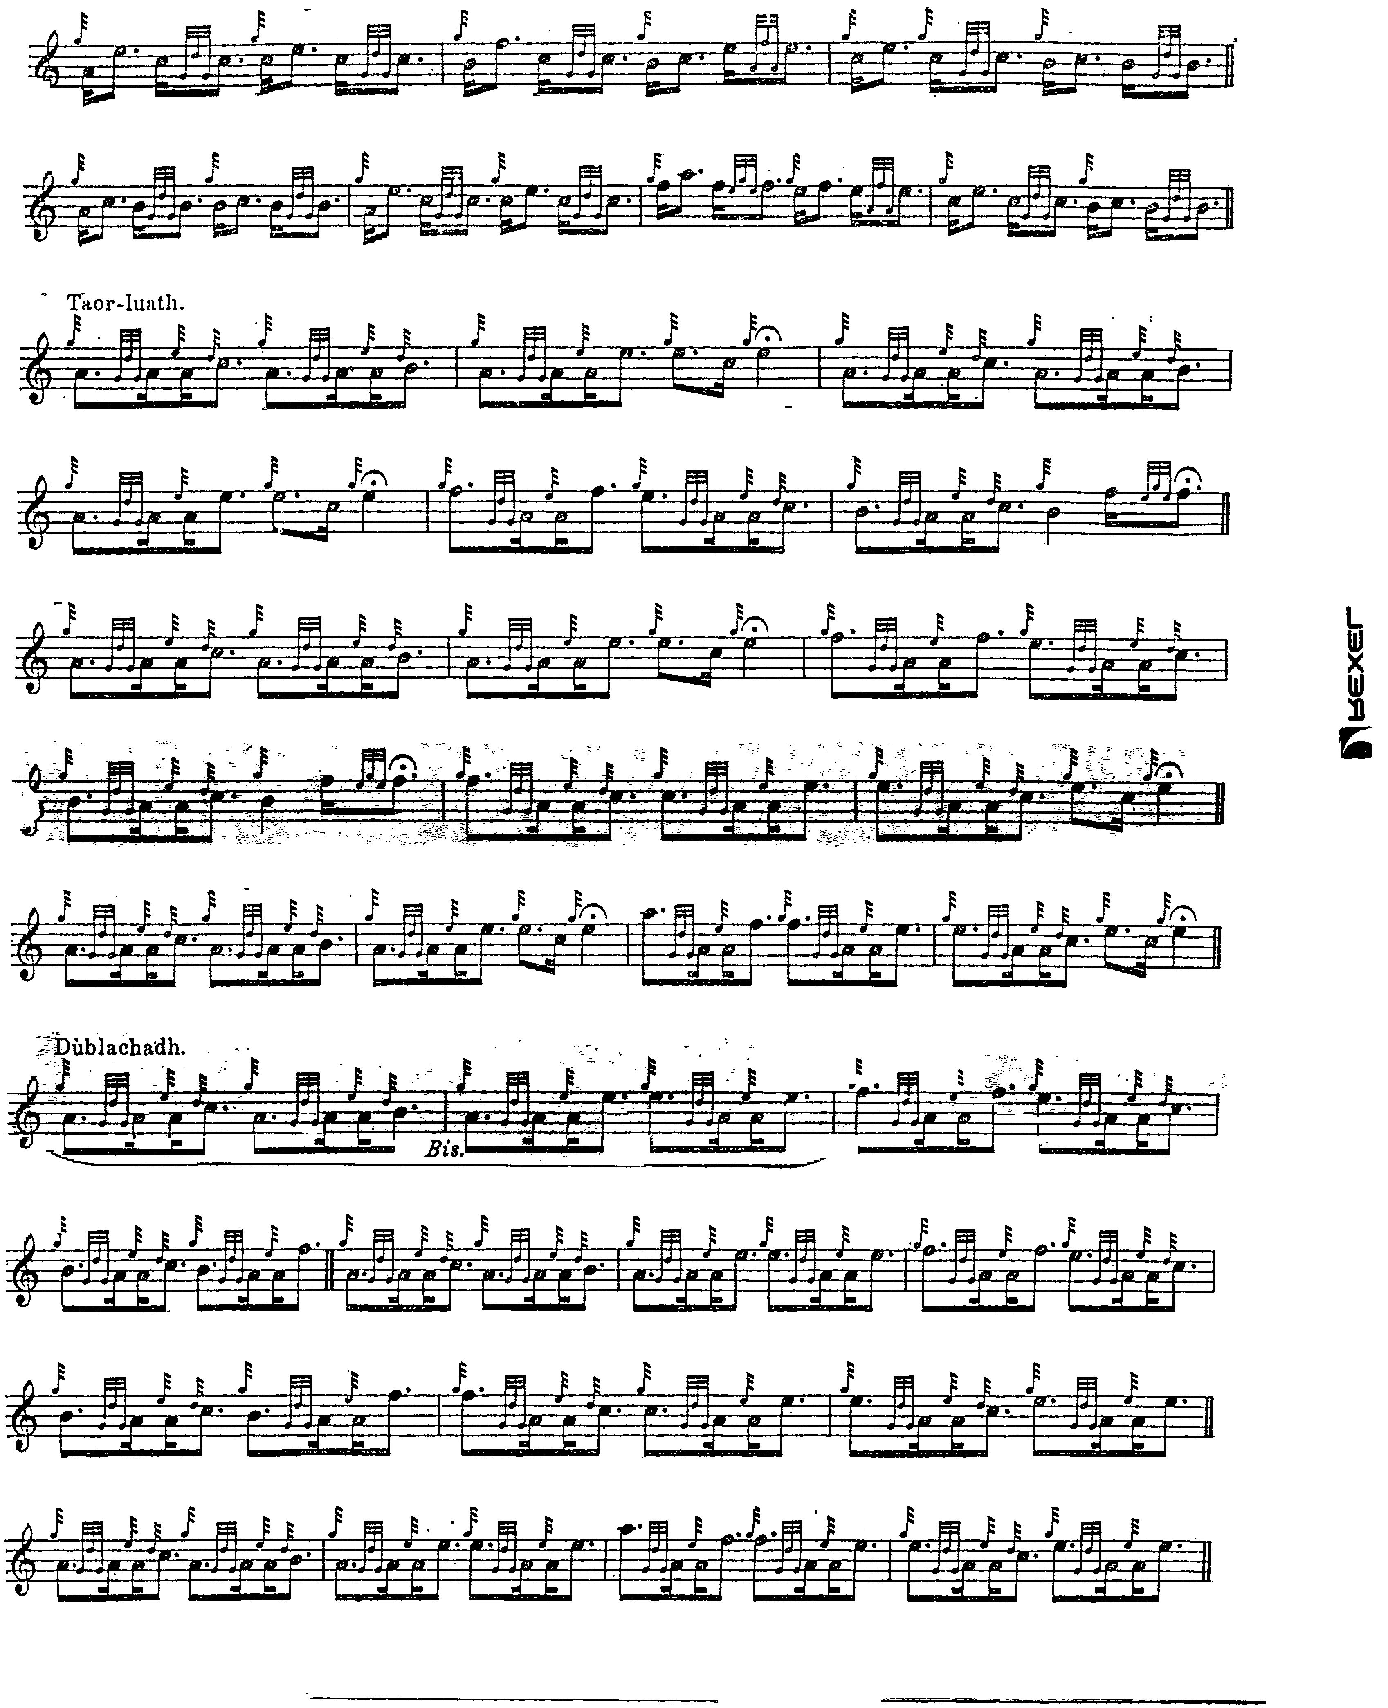
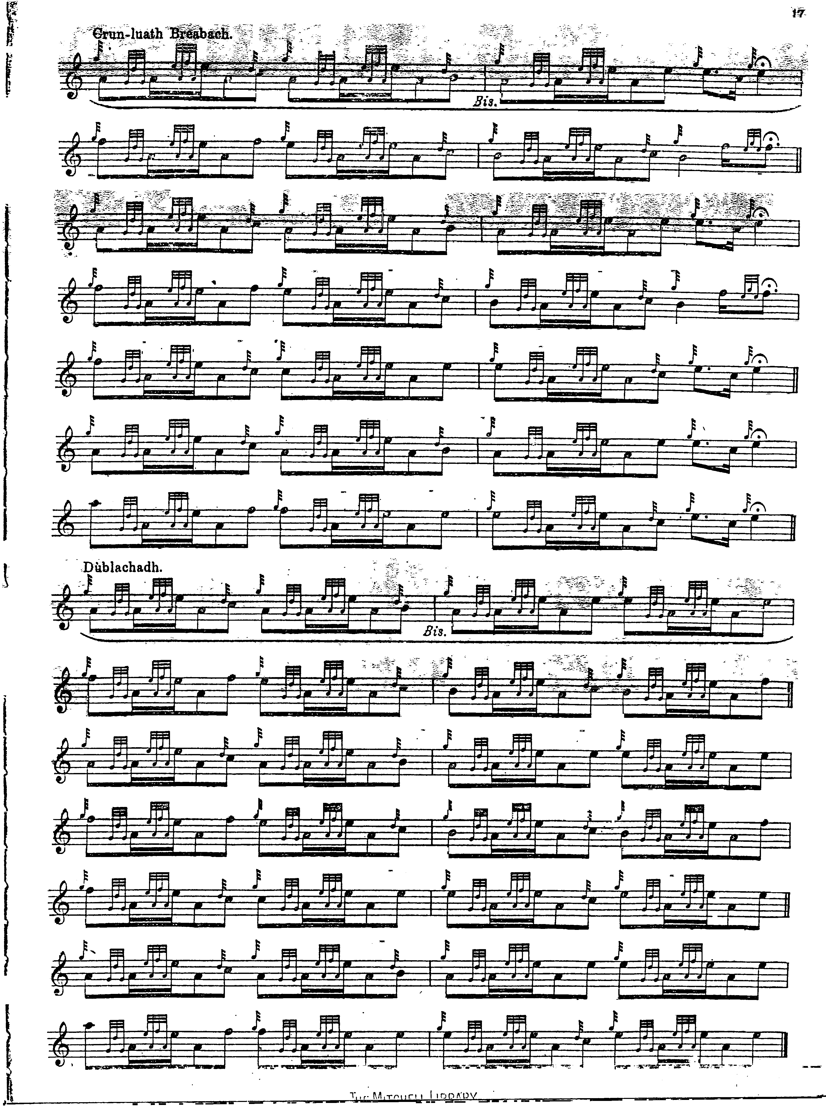

John McLennan plays his eallachs “down” and the tune as a whole is pointed interestingly, not to say arrestingly. He does not hang about on his passing notes and plays his breabachs smartly “up”. I have typeset the score of “The Lament for Captain MacDougall” from John McLennan’s original publication, Piobaireachd as Performed in the Highlands (1924), whose double-spread A3 format makes it awkward to reproduce electronically:

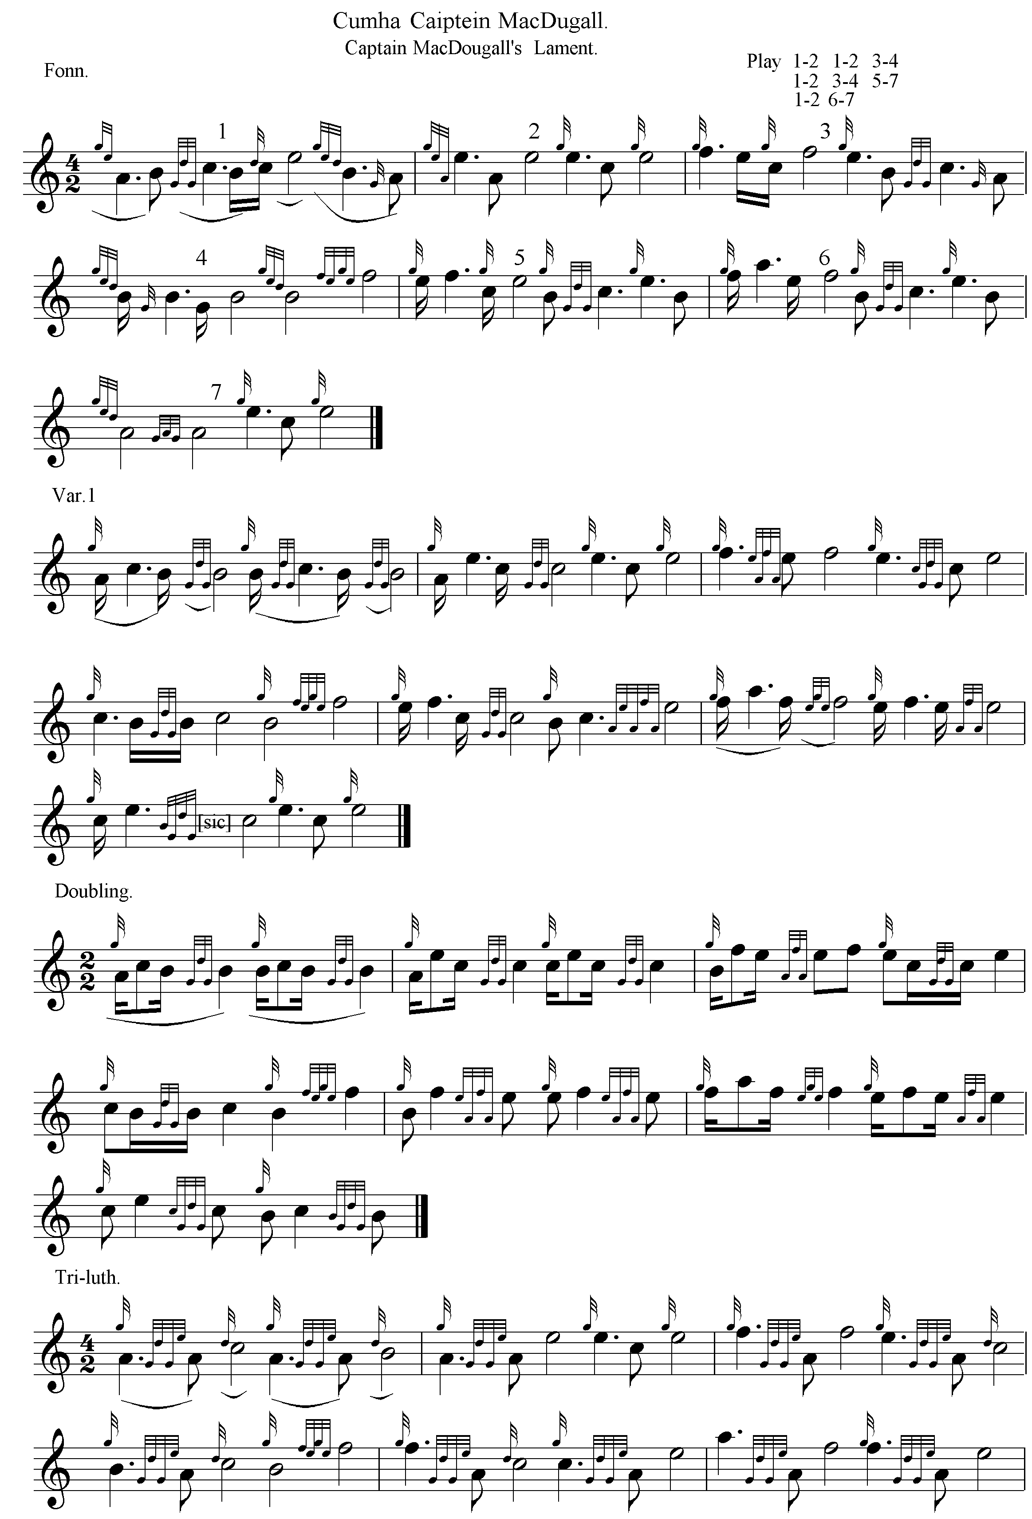
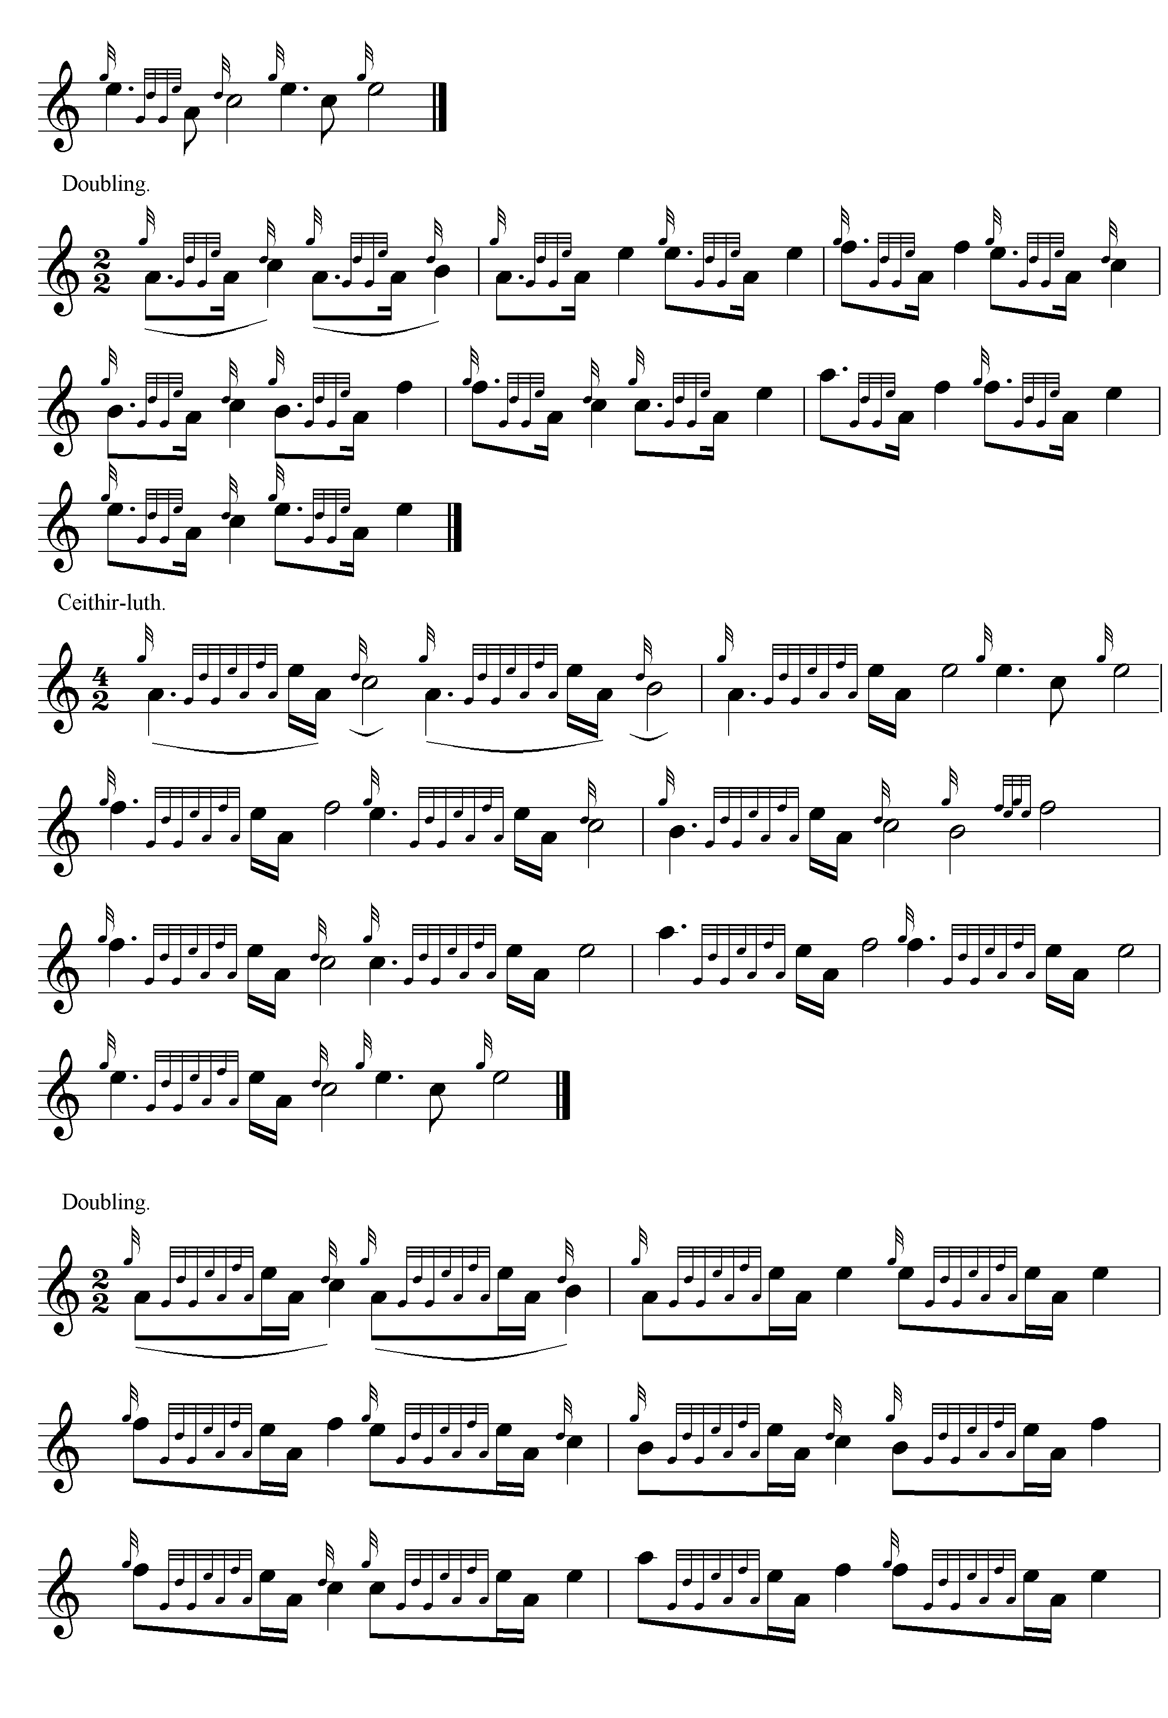
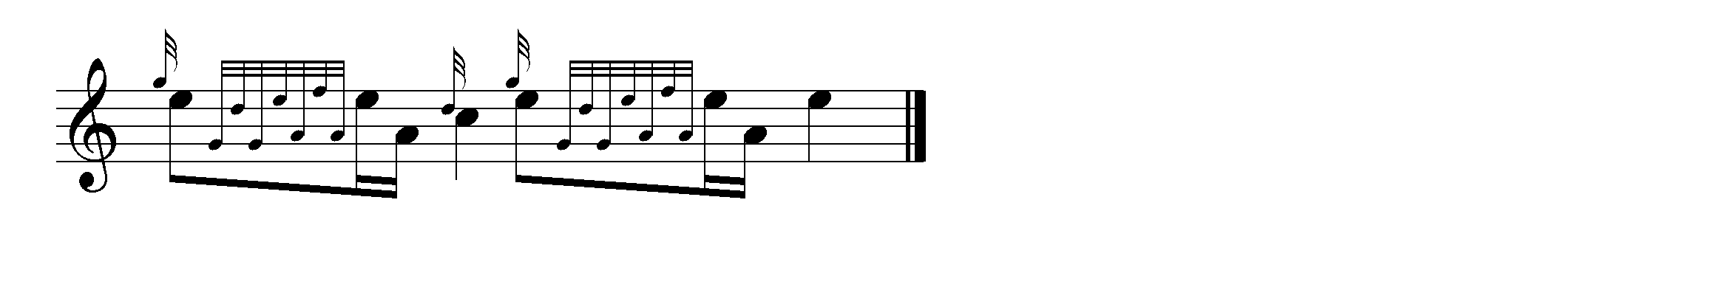

Commentary:

In his “Historic, Biographic, and Legendary Notes to the Tunes” attached to David Glen’s Ancient Piobaireachd, “Fionn” says “This Lament was composed on one of the Chiefs of the MacDougalls of Dunolly by the hereditary piper of the Clan, Ronald MacDougall, who also composed a Salute known as ‘Captain MacDougall’s Salute.’
The MacDougalls had hereditary pipers up to the time of Admiral Sir John MacDougall, K.C.B., who died in 1864, when his piper Ronald—Raonull Mór—left for some reason or other, and was afterwards appointed Pipe-Major to the local Militia. These Clan pipers lived at Moleigh, near Oban, where they had a portion of land called ‘Croit nam pìobairean’ or the Pipers’ Croft. They were all MacDougalls; the last who kept a school of pipers there being Ronald Bàn. Ronald Mór, who was grandson of Ronald Bàn, was the last hereditary piper of the Clan.” p.19.

The folklorist and translator, Katherine Whyte Grant of Oban, author of Myth, Tradition and Story from Western Argyll (Oban, 1925), responding in the Oban Times, 30/01/1926, p.3, to a query from Sheriff J. P. Grant, thought the dedicatee of this piobaireachd was probably Captain Duncan MacDougall (b. 1744), although she did not know the circumstances of his death.

* * *

Electronic text © Dr. William Donaldson, Aberdeen, Scotland, October 2004.

