Lament for Captain Donald MacKenzie (2)

There are settings of this tune in the following manuscript sources:
--Angus MacKay’s MS, i, 30-33 (with the title “Cumha Chaiptean MacCoinnich. Captain Donald MacKenzie’s Lament. Composed by John MacKay”; and also in the so-called “Kintarbert MS”, ff.69-71);
--Duncan Campbell of Foss’s MS, ff.170-173;
--Uilleam Ross’s MS, ff.191-195;
--David Glen’s MS, f.98;

and in the following published collections:
--C. S. Thomason’s Ceol Mor, p.9;
--David Glen’s, Collection of Ancient Piobaireachd, pp.47-9.

Angus MacKay is the original source for this tune, composed by his father, but the doubling of his second variation seems irregular. The following example indicates his typical timings:

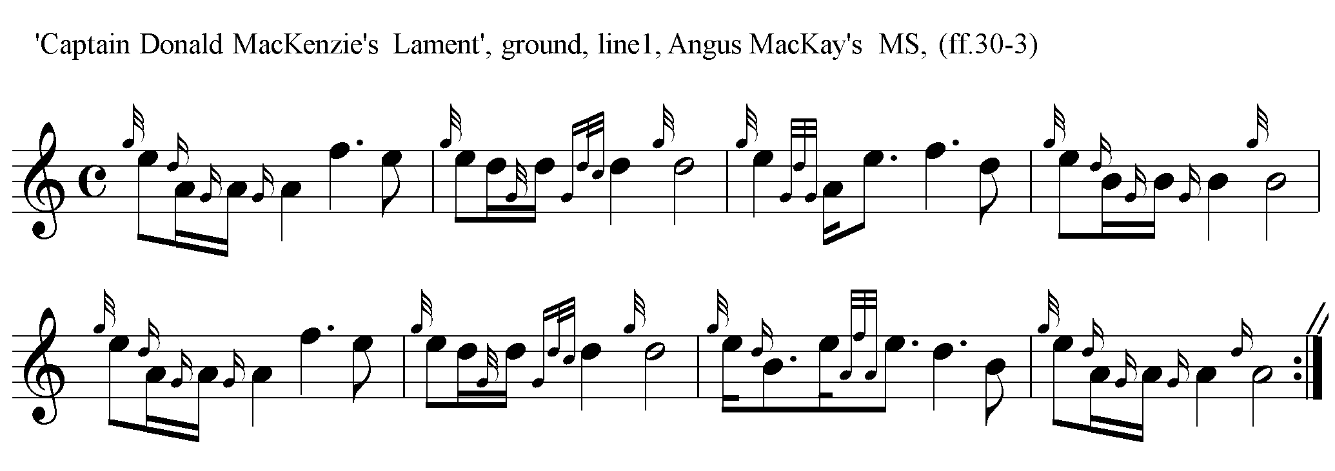
MacKay sets the tune as follows:

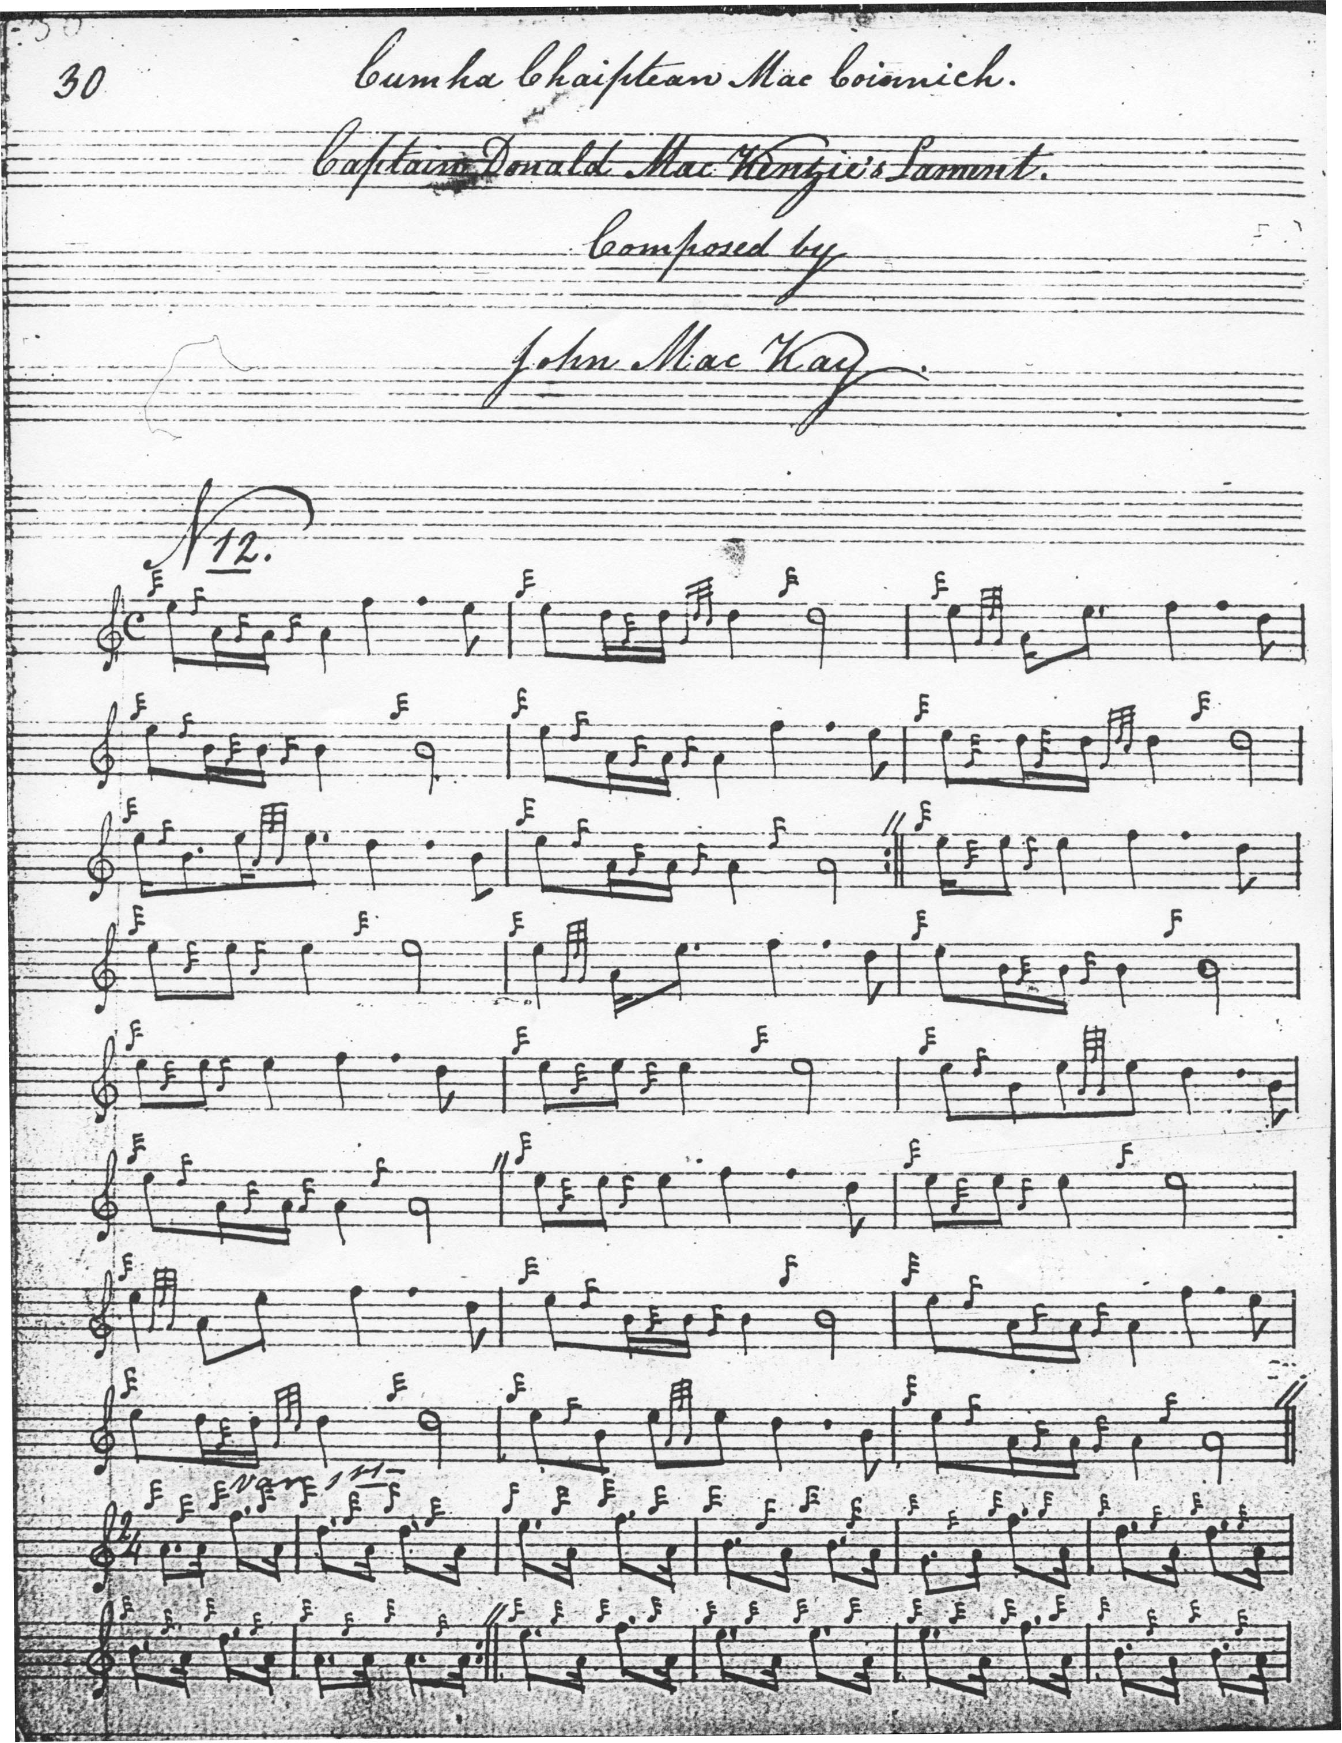
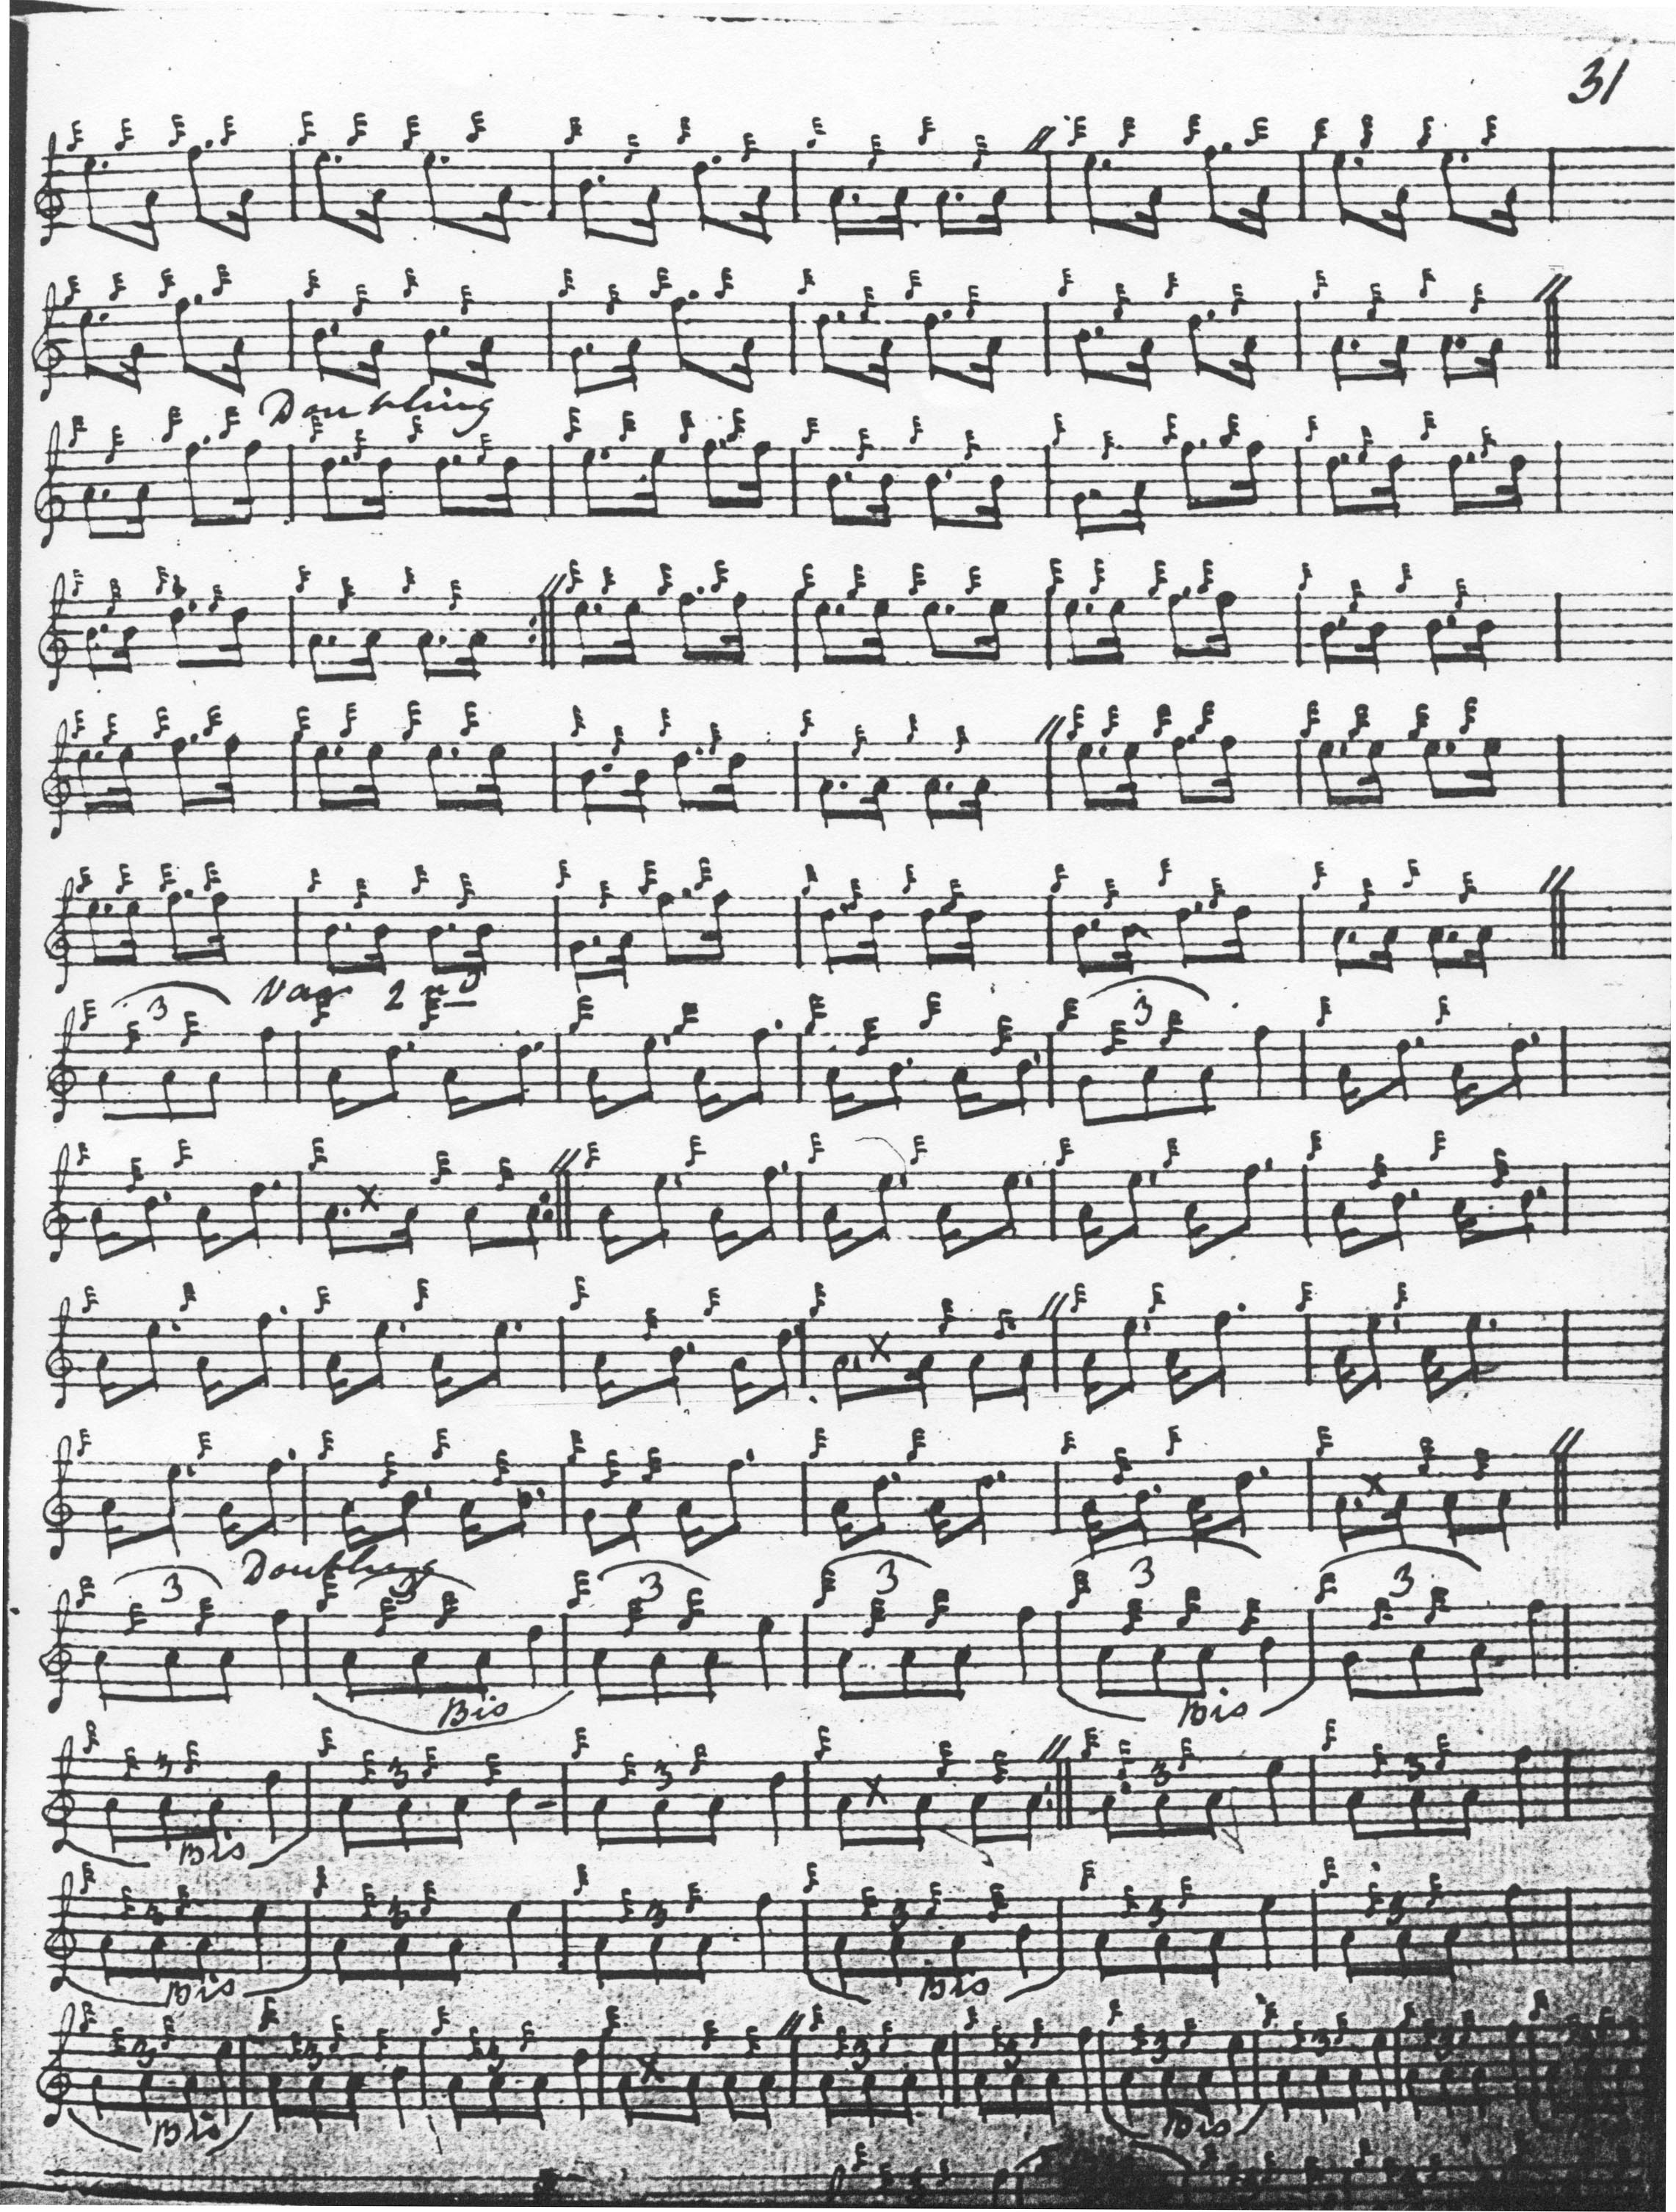
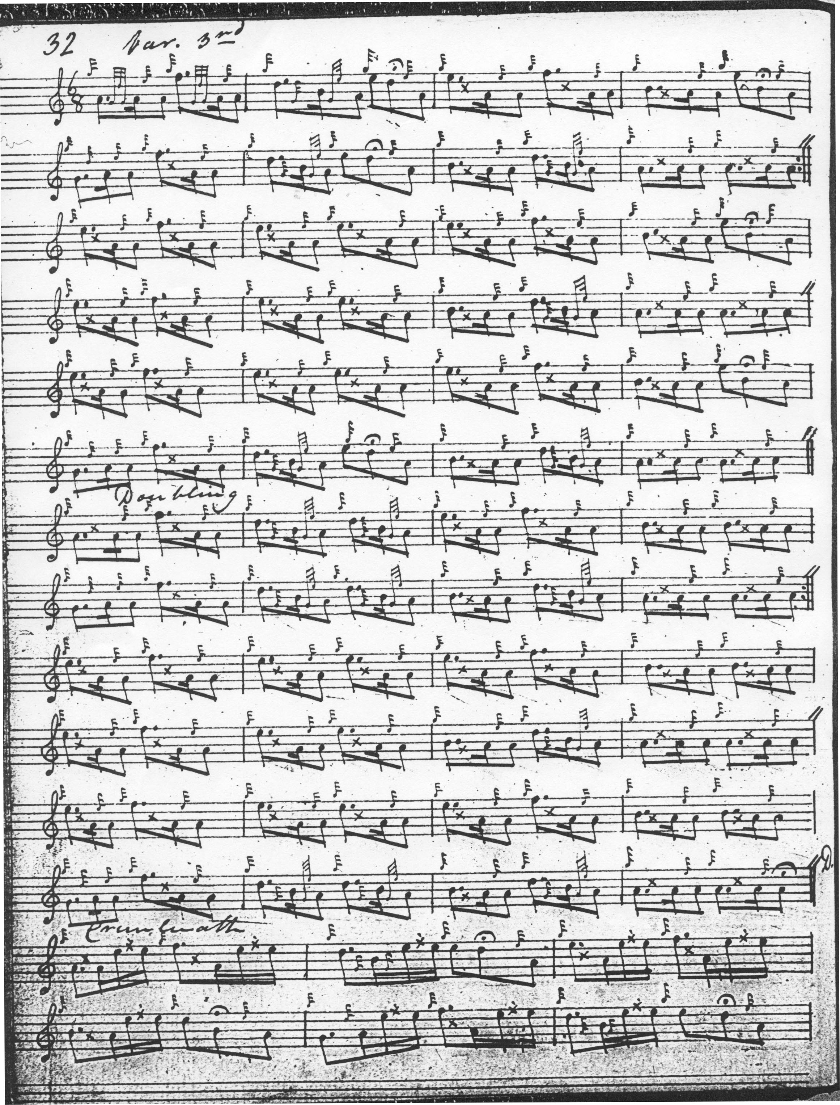
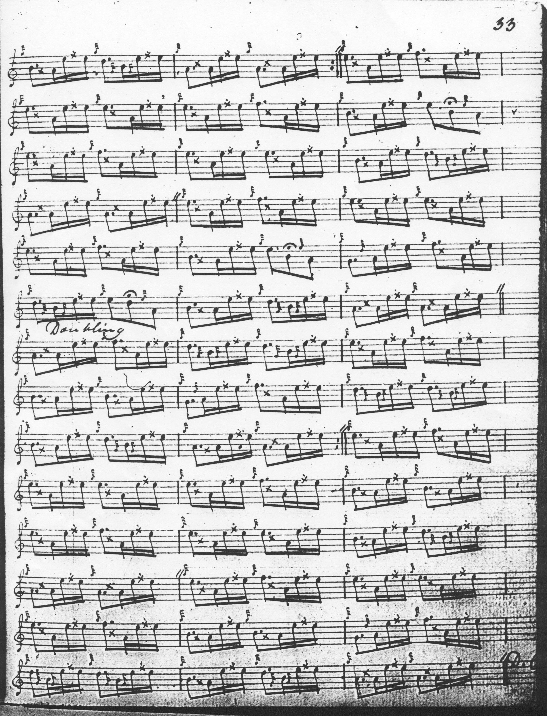

The repeat marks in the first line of the doubling of the pendulum movement should probably be extended to apply to the previous bar in each case. MacKay directs that the ground be repeated after the Taorluath doubling and again at the end of the tune. His pendulum movement is cut “up". The opening sequence in the ground awakes echoes of the “Lament for Donald Ban”, suggesting a not very flattering comparison with the present tune.

Uilleam Ross uses a MacDonald-style taorluath movement in Variation 2, as opposed to MacKay's tripling, but otherwise follows the structure found in MacKay. Duncan Campbell of Foss’s MS adds little to the expressive possibilities of the tune. Neither of these scores is reproduced here.

An amended pendulum movement for this tune is given in David Glen’s MS as follows:

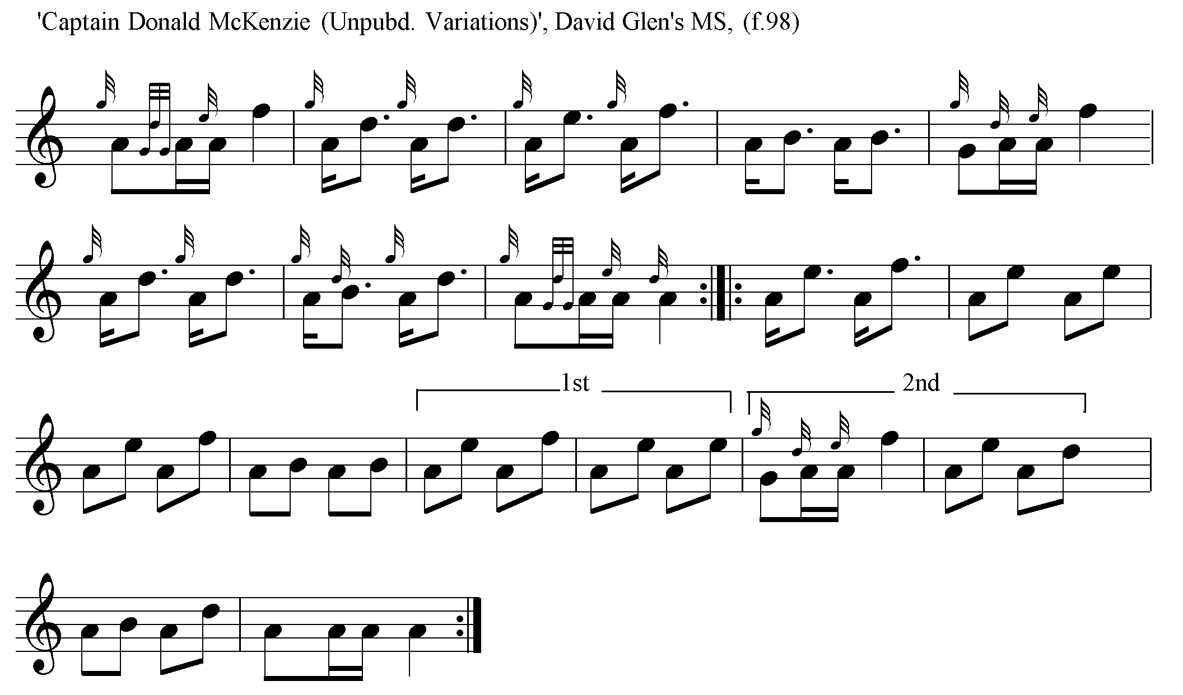
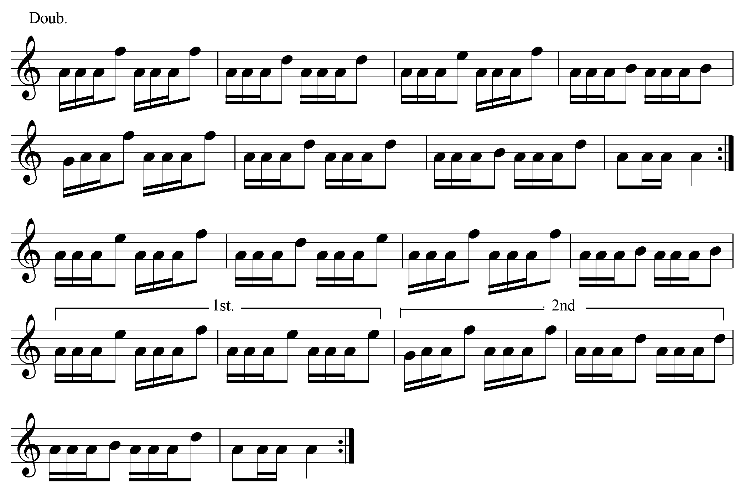
Glen eventually resolved the problem by dropping the pendulum movement altogether in his published score, preserving the general dimensions of the tune by adding a thumb variation, as follows:
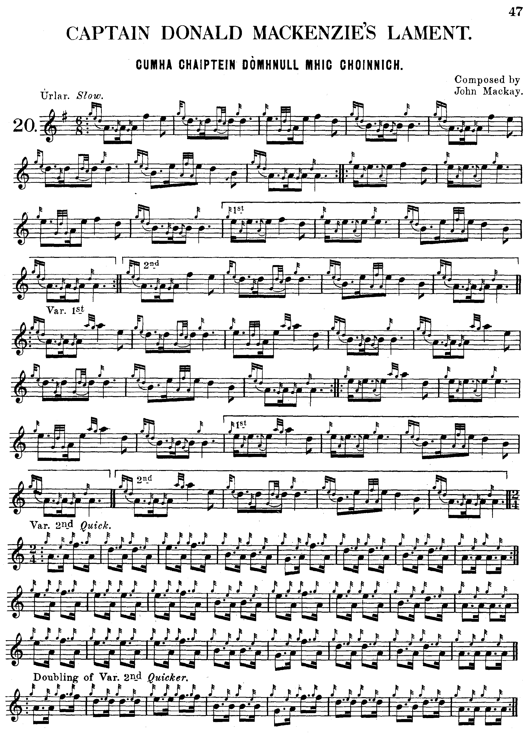
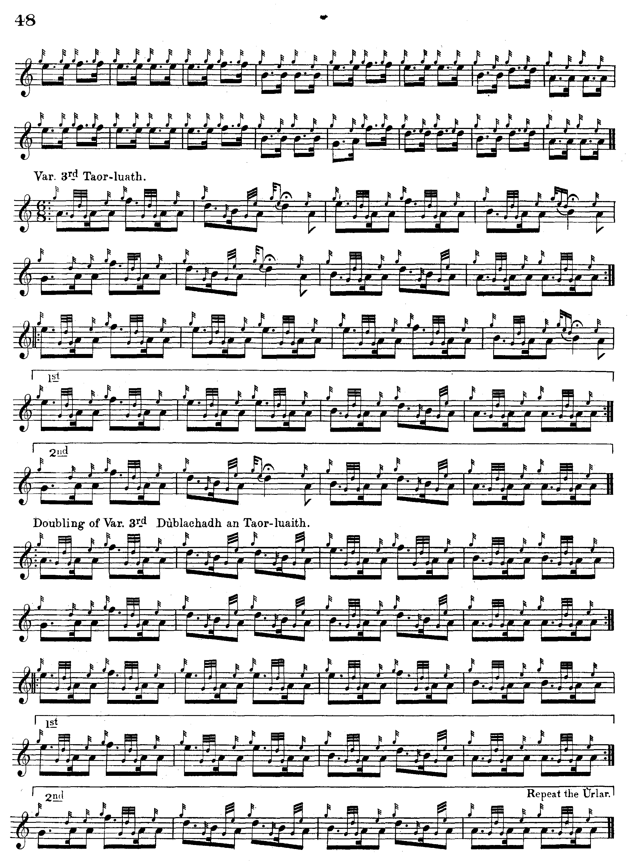
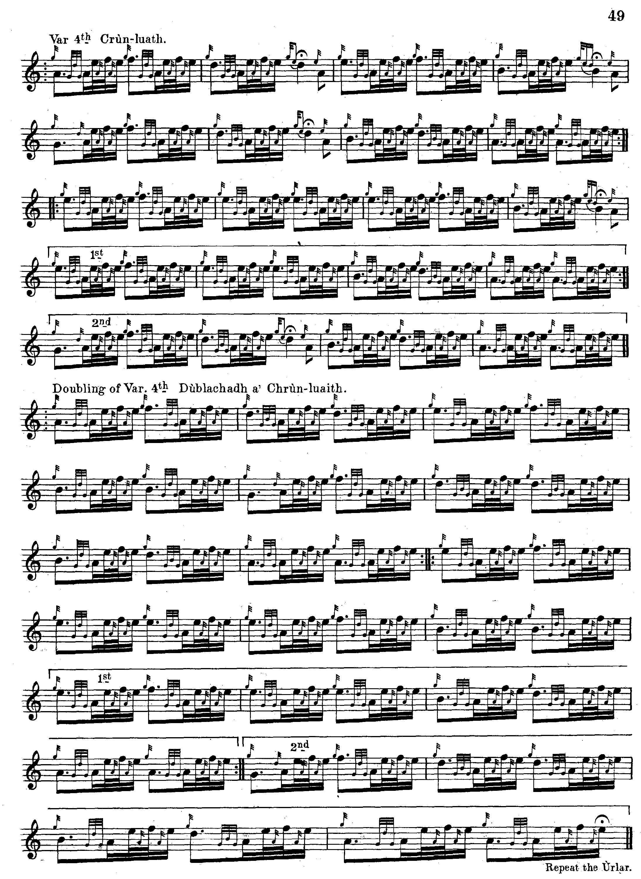

C. S. Thomason treats the tune in a similar manner, citing Glen as a source, and his score is not reproduced here.

Commentary:

In the historical notes to Glen’s collection “Fionn” says

It is difficult to determine who the Captain Mackenzie was to whom this Lament was composed by John Mackay, piper to Macleod of Raasay, as so many members of the Clan have distinguished themselves in the tented field.
The first of the Mackay pipers to come to Raasay was Roderick Mackay. He came from the Reay country, and received his training from his countryman and namesake the Pìobiare Dall of Gairloch. He was celebrated in his day, and composed some famous tunes. He died quite young, leaving a boy called John, who was adopted into the family of Malcolm Macleod, brother to the Laird of Raasay. This Malcolm Macleod was a piper himself, and gave every encouragement to John Mackay to acquire a knowledge of pipe music. He ultimately sent his pupil to the MacCrimmon College to complete his musical education. At the end of his studies he became piper to Macleod of Raasay, where he remained till increasing misfortunes overtook that family. He was afterwards piper to Lord Willoughby de Eresby in Perthshire, and finally settled in the village of Kyleakin. He had four sons - Donald, Roderick, Angus, and John - all of whom were pipers. John had many pupils in Kyleakin, including John Ban Mackenzie. Of the sons, Donald was for some time with MacDonald of Glengarry, and latterly with H.R.H. the Duke of Sussex; Roderick was with Mackay of Arisaig and Moray of Abercairney; John was with Lord Gwydyr; while Angus was piper to Davidson of Tulloch, Campbell of Islay, and ultimately piper to the late Queen Victoria. (p.11)

The Captain Donald MacKenzie who is commemorated in this tune is thought to have met his death on 22 October 1825 when the steamship Comet plying between Inverness and Glasgow collided with another vessel and about seventy of the eighty people on board were lost. It may have been his daughter, Maria, who eloped with the piper John Ban Mackenzie to escape the clutches of Duncan Davidson of Tulloch, in one of the fruitier Society scandals of the age.

* * *

Electronic text © William Donaldson, Aberdeen, Scotland, 2001; revised, Aberdeen, Scotland, 22 June 2012.

