The Boat Tune

there are settings of this tune in the following manuscripts:
--Angus MacKay, i, 235-236;
--Duncan Campbell of Foss, ff.174-176;
--D. S. MacDonald, i, 20-22;
--David Glen, ff.99-100;

and in the following published settings
--C. S. Thomason, *217, 218; *385
This is a tune showing little textual variety.

Angus MacKay sets the piece as follows:

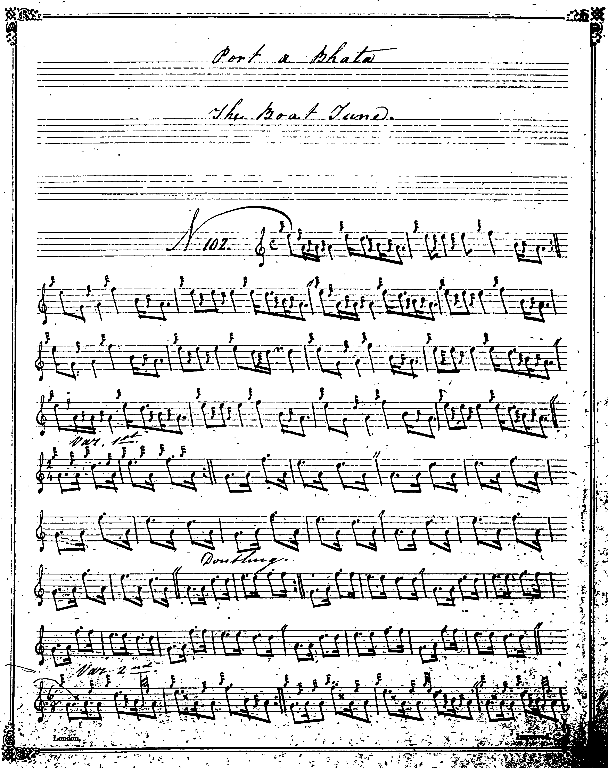
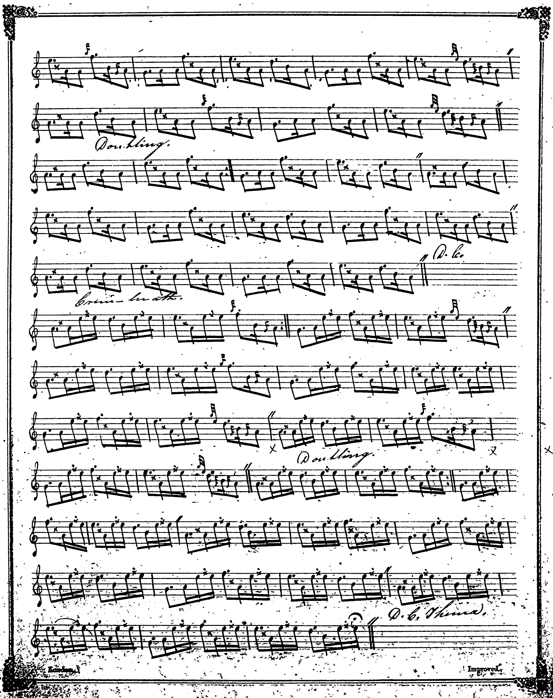

Angus MacKay sets the ground of this otherwise attractive little tune very squarely and the Piobaireachd Society do not improve upon him. In PS 13, p.439, the notes say “printed in the same style as it is recorded by Angus MacKay in his manuscript”, but there are the usual silent changes to time values and substitution for MacKay’s one of the Society’s ugly eallach. MacKay directs that the ground be repeated at the end of the taorluath and crunluath doublings, but these instructions are also silently removed.

Duncan Campbell of Foss’s score adds nothing to MacKay and is not reproduced here.
D. S. MacDonald, likewise.

David Glen, treats the tune as follows:

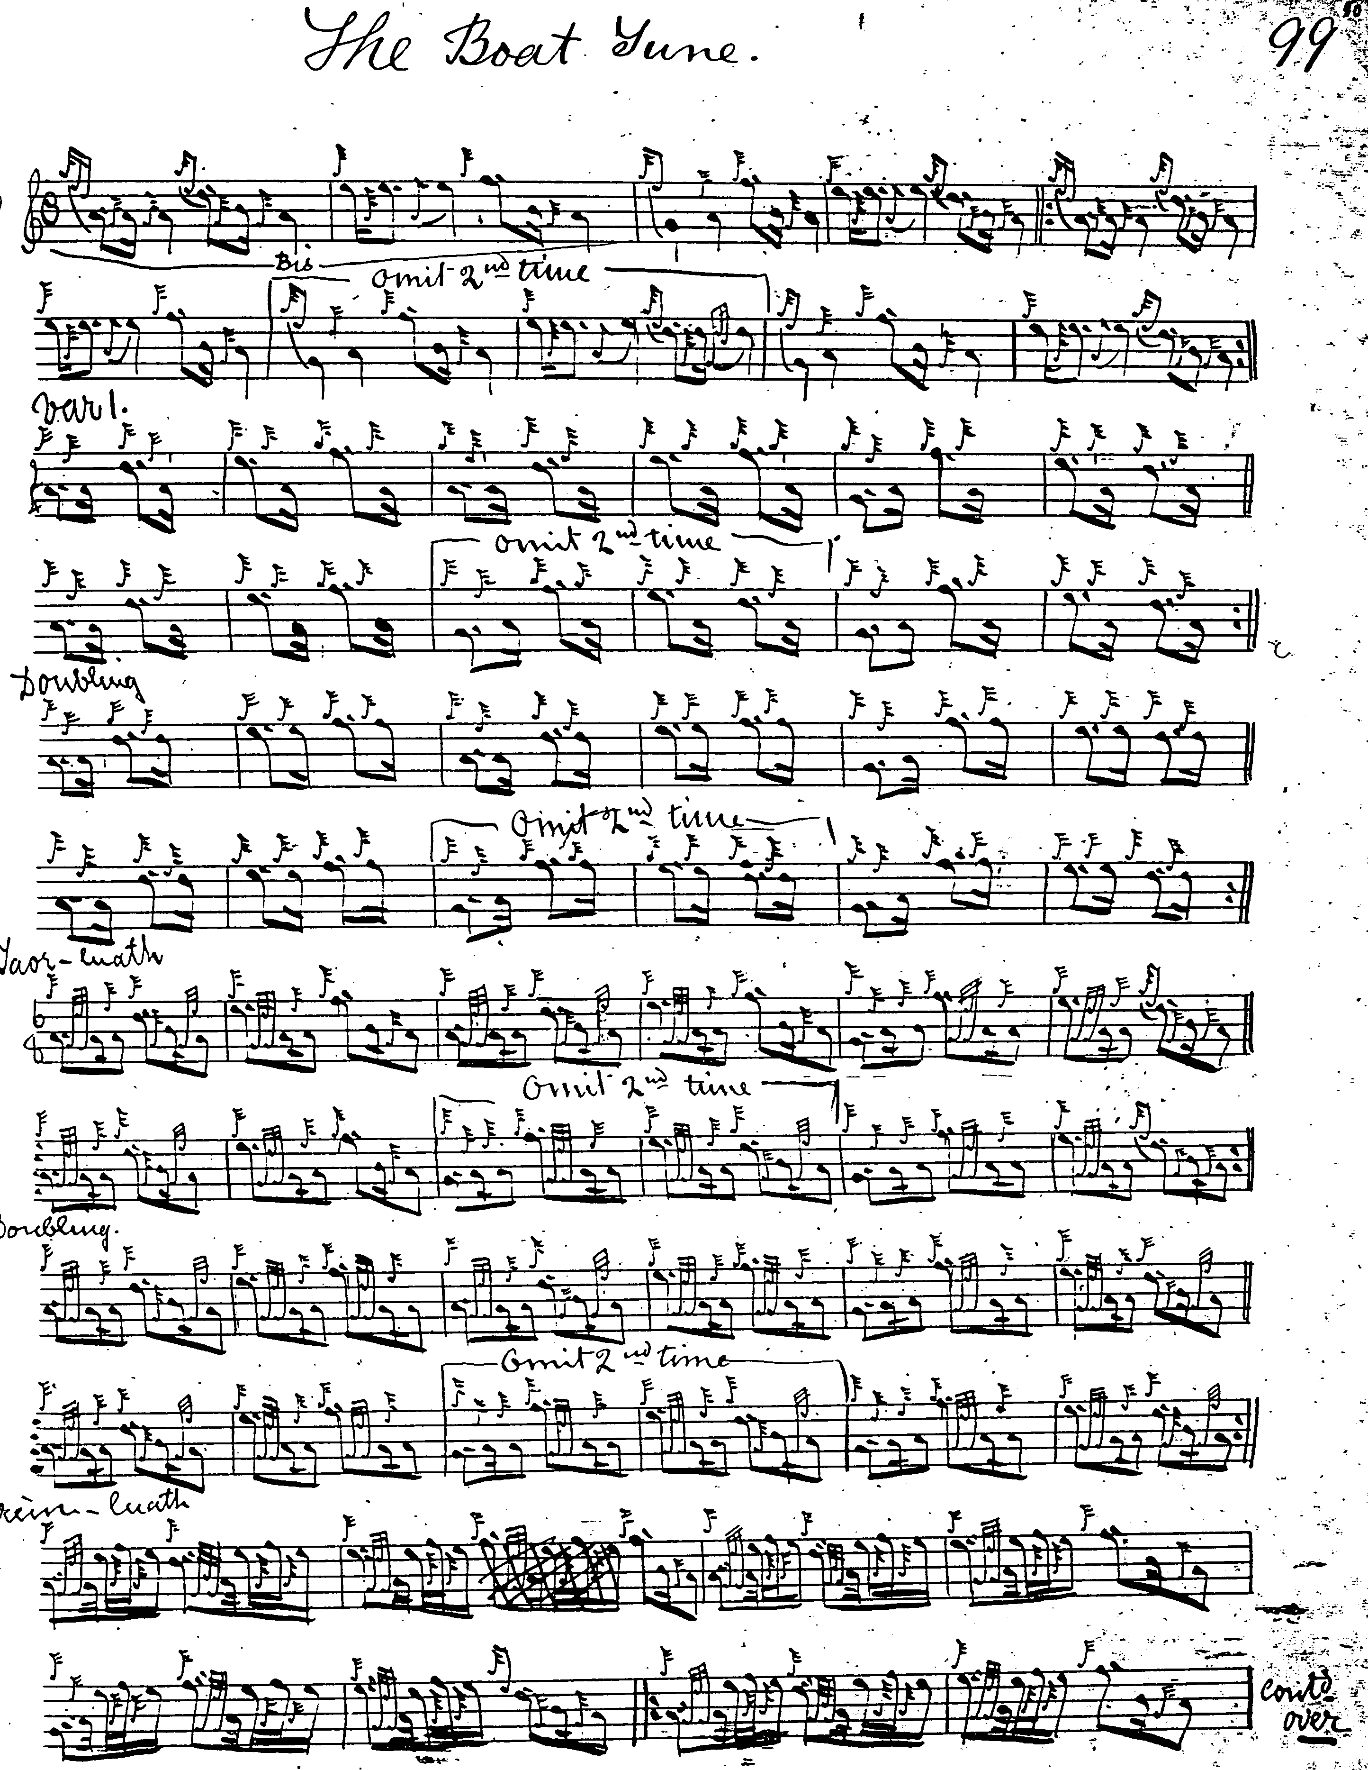
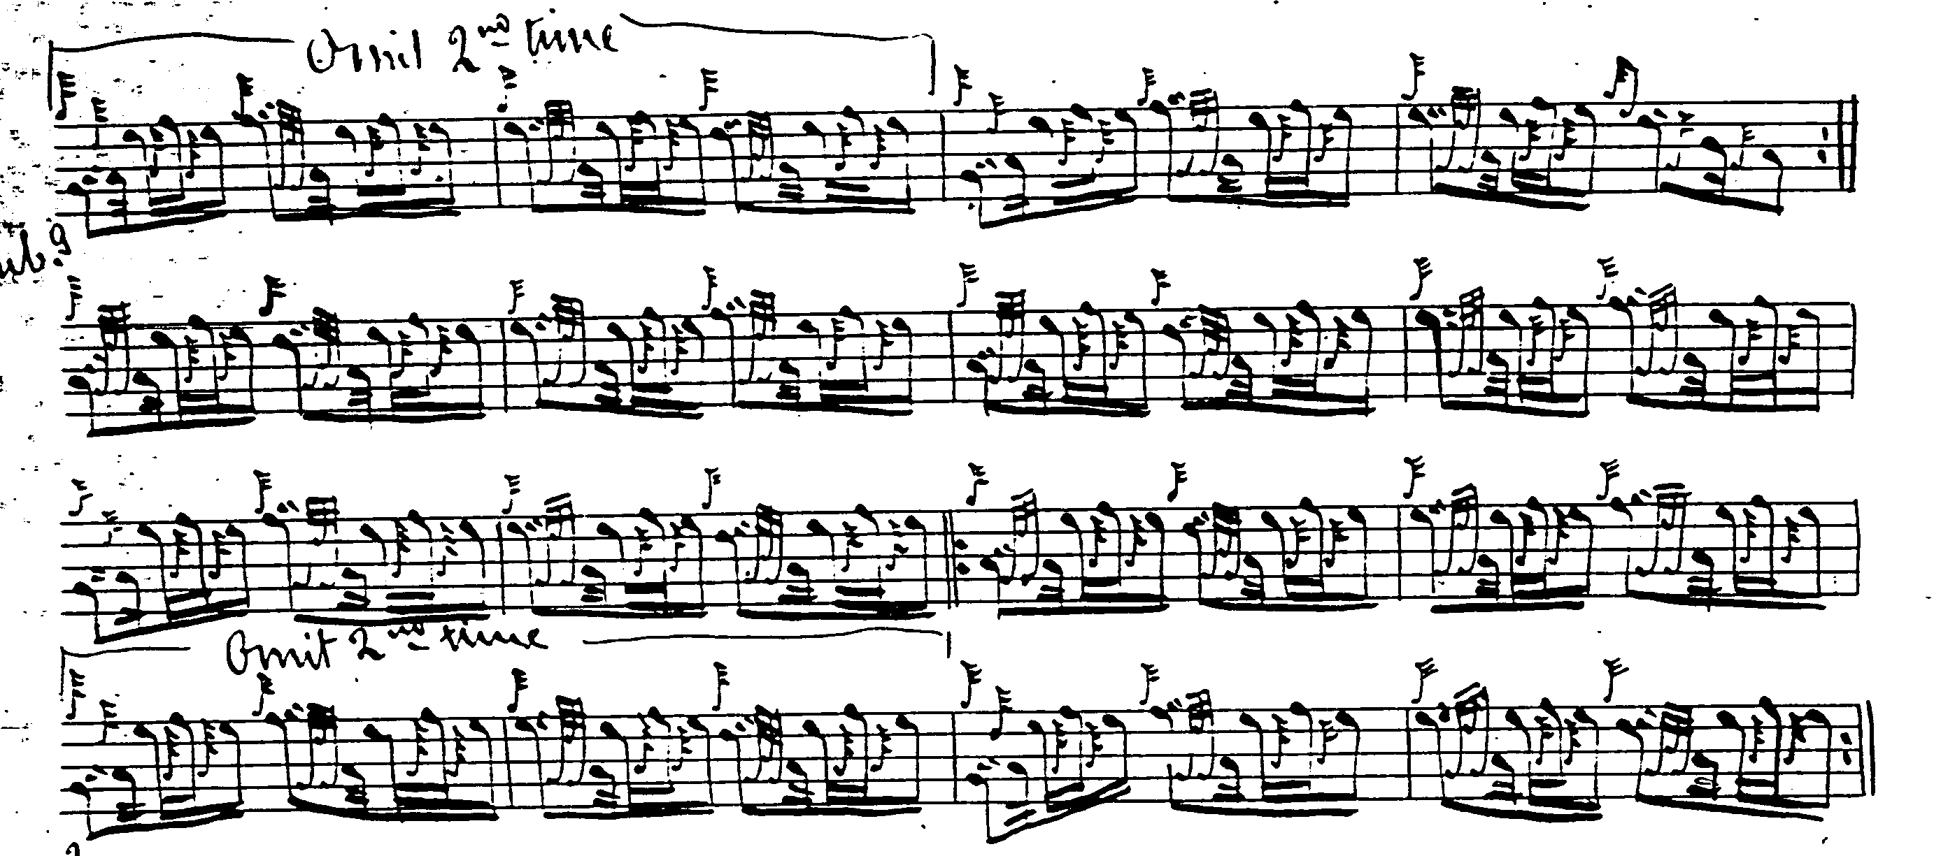

Glen comes as close as anybody to idiomatic fluency in the ground here. He plays his eallachs “down”, and drops the repeat of the ground at the end of the taorluath doubling, once again, sensibly.

C. S. Thomason also plays his eallach “down” in *217, and *385, but not in 218, and directs that the ground be repeated after the taorluath and crunluath doublings. Thomason got into a tangle with titles here, giving the tune in successive editions of Ceol Mor as “Boreraig”, “The Boat Tune”, and “Nameless. No.6”. On the whole, though, he adds nothing of significance to Glen, and is not reproduced here.
Commentary:
One wonders about the wisdom of setting the ground in 4/4 time, and having to pack out the melody line with cadences to achieve this. 6/8 might give a more attractive effect:
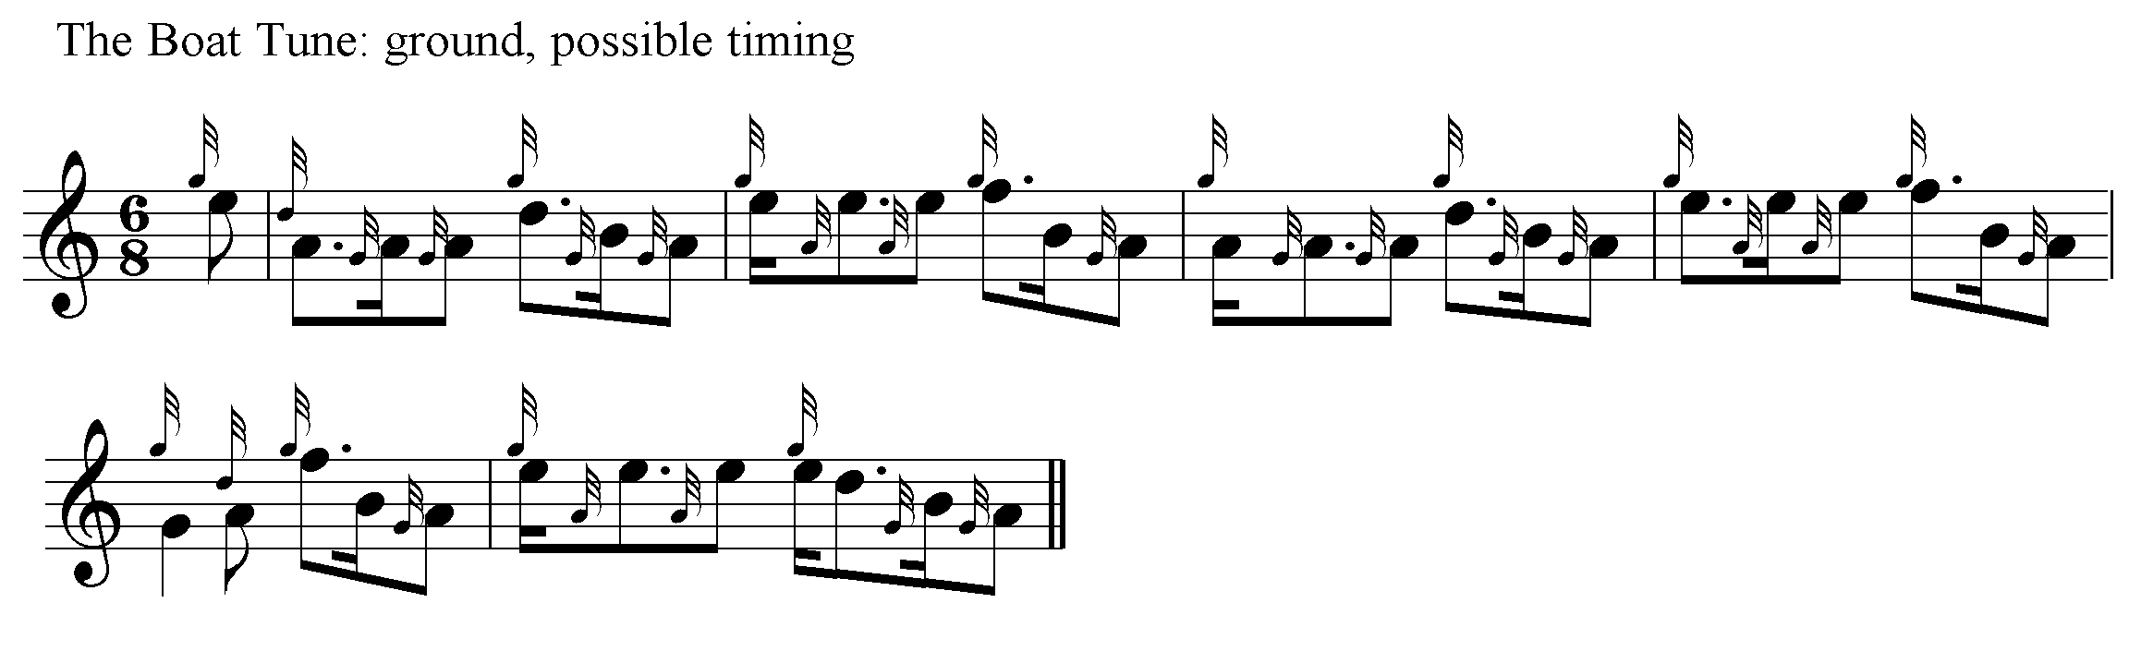

* * *

Electronic text © Dr. William Donaldson, Aberdeen, Scotland, October 2004.

