Black Donald’s March

There are settings of this tune in the following manuscript sources:
--Angus MacKay’s MS, i, 192-194, (with the title “Black Donald Balloch of the Isles’s March to Inverlochy 1427”);
--John MacDougall Gillies’s MS, ff.60-61;

and in the following published sources:
--Donald MacDonald, Ancient Martial Music, pp.106-10 (with the title “Piobaireachd Dhomhnuill Duibh Black Donald Balloch of the Isles March to the First Battle at Inverlochy 1427”);
--Donald MacPhee, Collection of Piobaireachd, i, 22-24;
--C. S. Thomason, Ceol Mor, p.47;
--David Glen, Collection of Ancient Piobaireachd, pp.18-20.

The sources develop the tune as follows:

Donald  MacDonald | Angus MacKay | Donald MacPhee | MacDougall  Gillies | David  Glen | C. S.  Thomason
Ground | Ground | Ground | Ground | Ground | Ground
Thumb var.  singling | Thumb var.  singling  doubling | Thumb var.  singling  doubling  trebling | Thumb var.  singling  doubling | Thumb var.  singling  doubling | Thumb Var.  singling
Leumluath  singling  doubling | Leumluath  singling  doubling | Leumluath  singling  doubling | Leumluath  singling  doubling | Leumluath  singling  doubling | Leumluath  singling  doubling
Ground |  | Ground
Taorluath  singling  doubling  a-mach | Taorluath  singling  doubling | Taorluath  singling  doubling  a-mach | Taorluath  singling  doubling | Taorluath  singling  doubling  a-mach | Taorluath  singling  doubling  a-mach
Ground | Ground | Ground | Ground | Ground | Ground
Crunluath  singling  doubling  a-mach | Crunluath  singling  doubling | Crunluath  singling  doubling  a-mach | Crunluath  singling  doubling | Crunluath  singling  doubling  a-mach | Crunluath  singling  doubling  a-mach
 | Ground |  |  | Ground | Ground

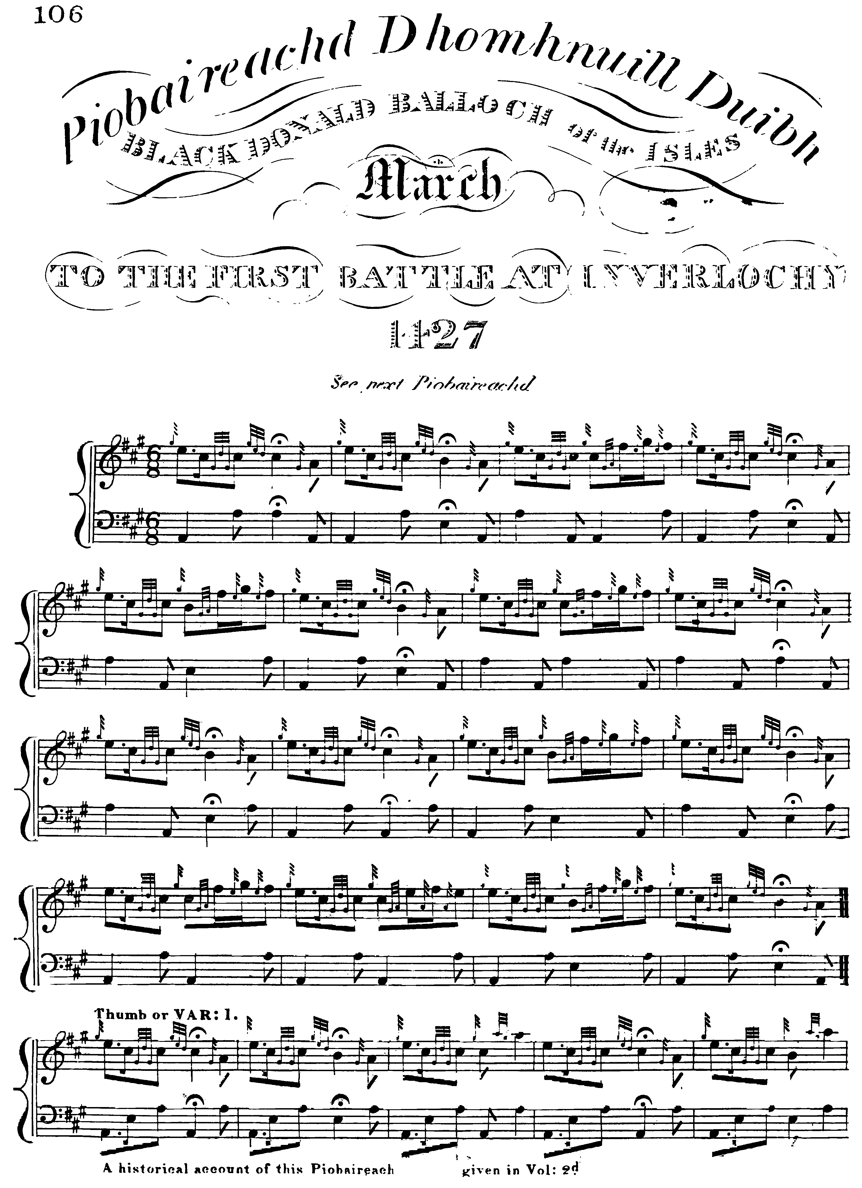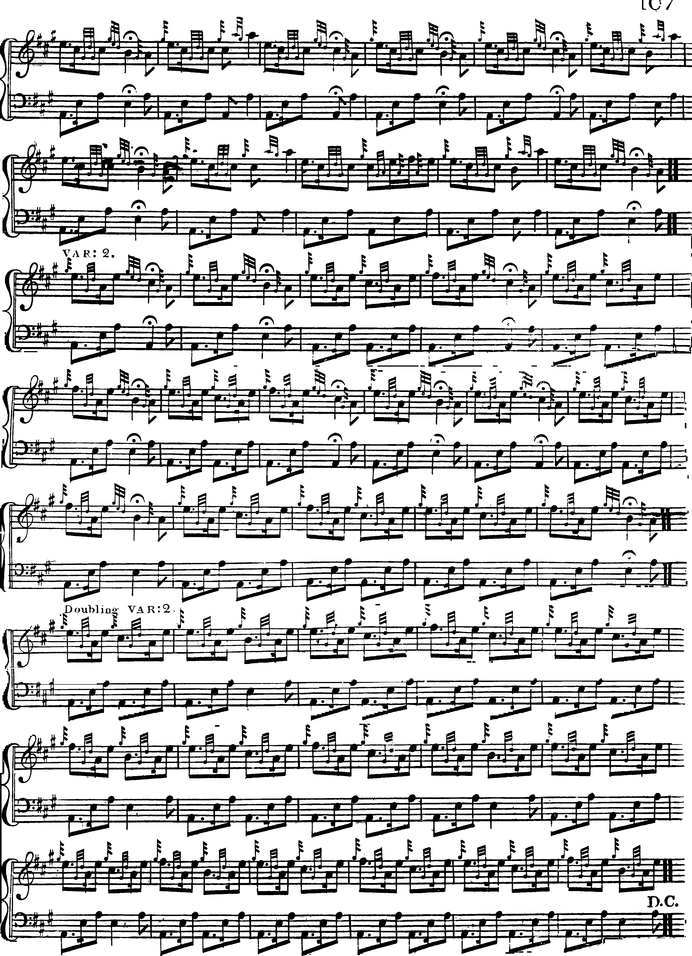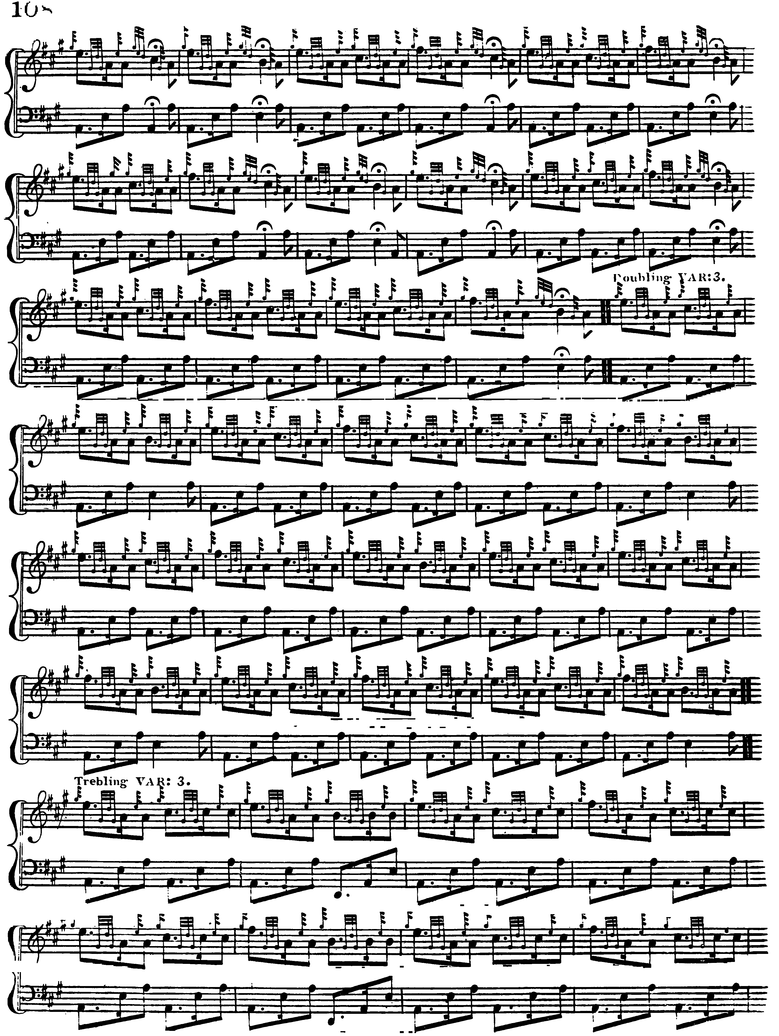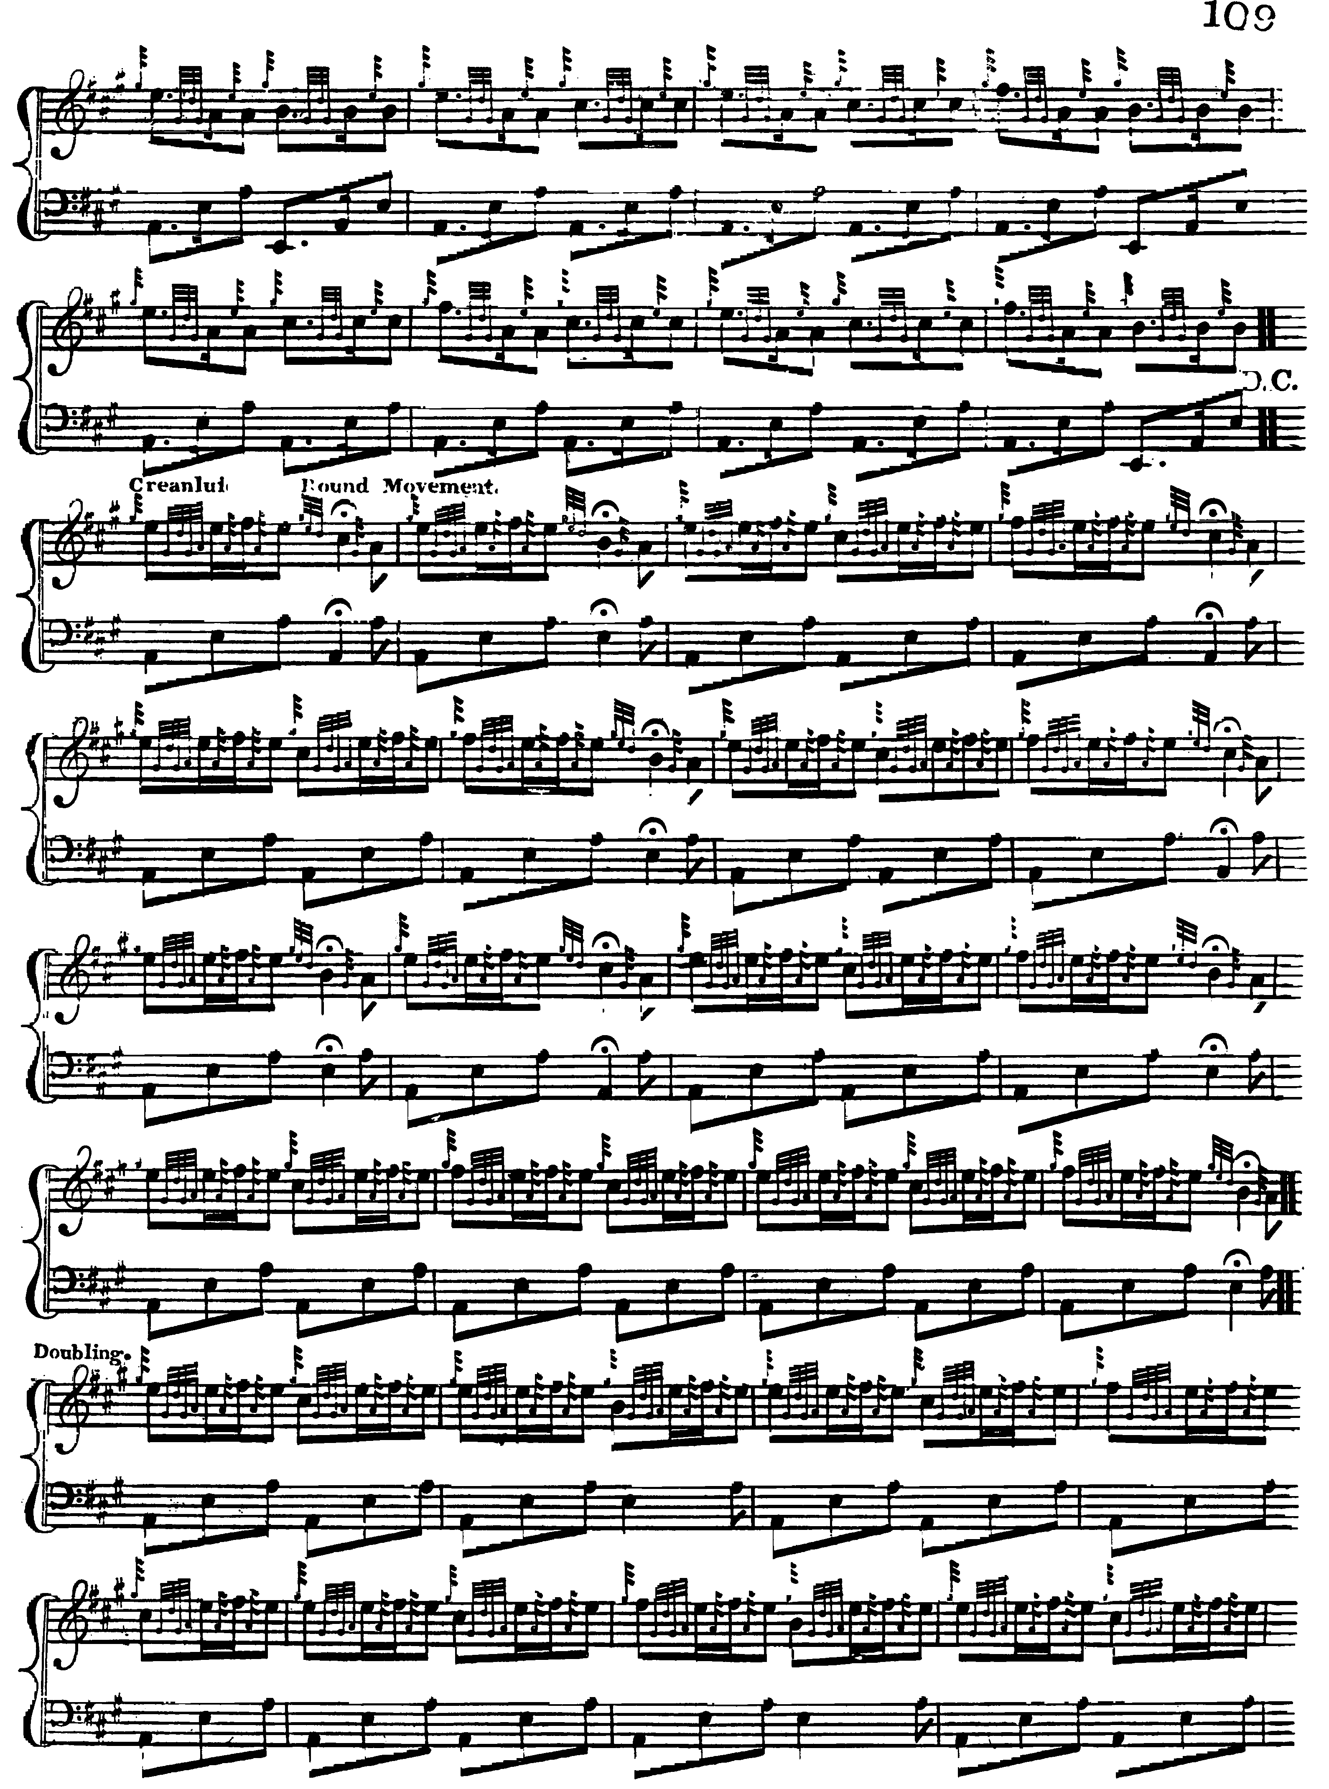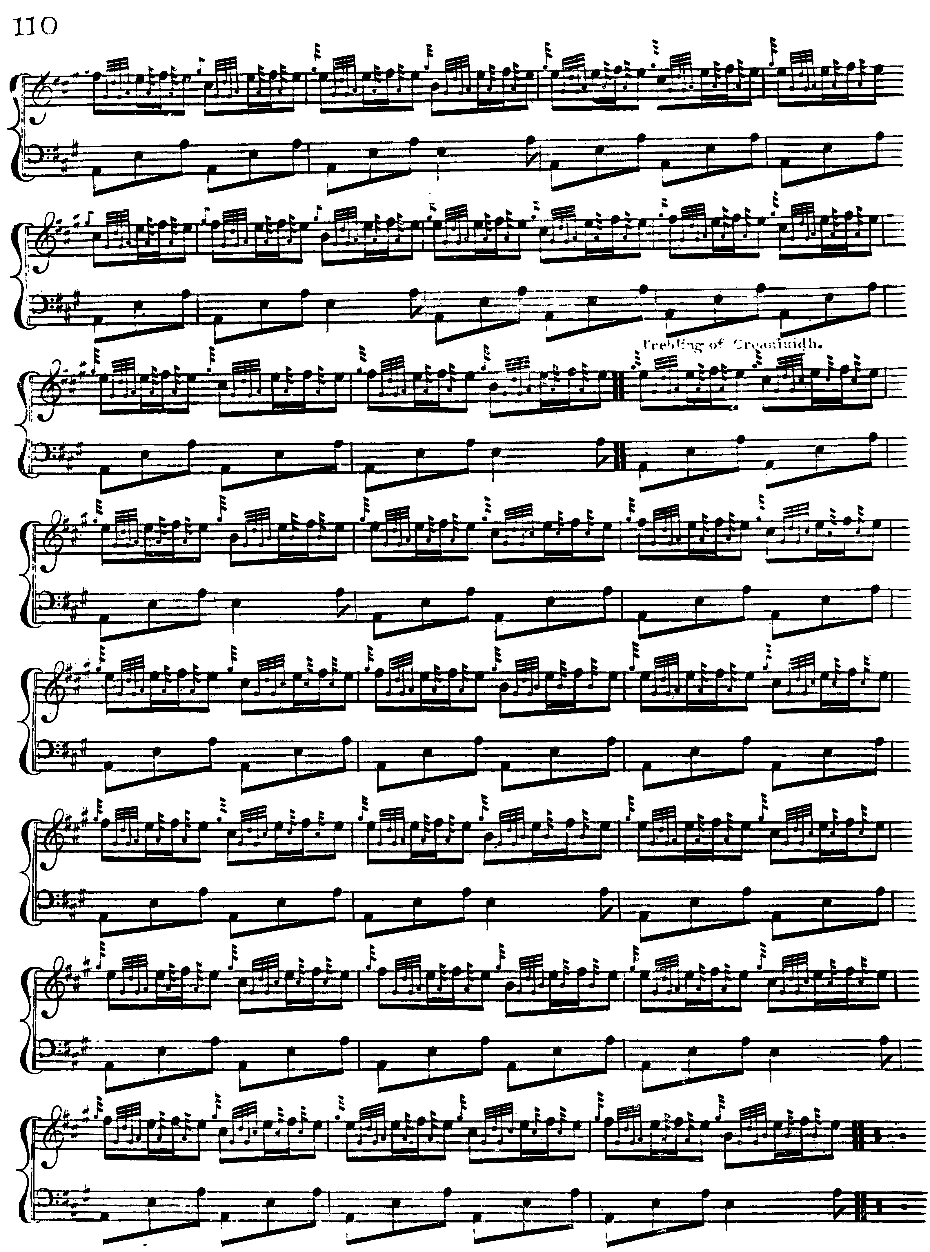

Donald MacDonald’s is by far the most heavily cadenced version of the tune. These cadences, if played in the metrically-intrusive “modern” manner, would seriously impede the onward progress of the melody. If, however, they were incorporated into the rhythmical flow, as seems the intention, one might have something along the following lines:

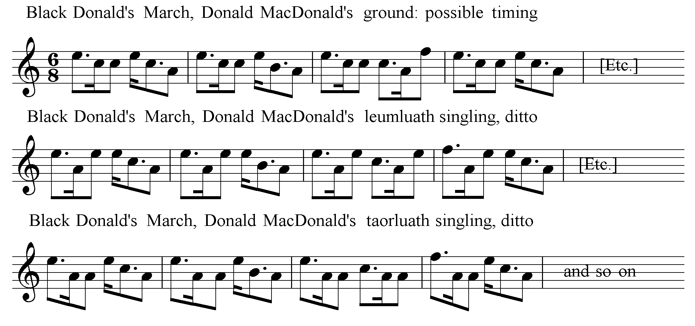

MacDonald’s a-mach movements are set in his usual style, emphasising the first rather than the second note in the group. This contrasts interestingly with the timing in Angus MacKay and David Glen’s settings which are given later.

Angus MacKay times the tune as follows:

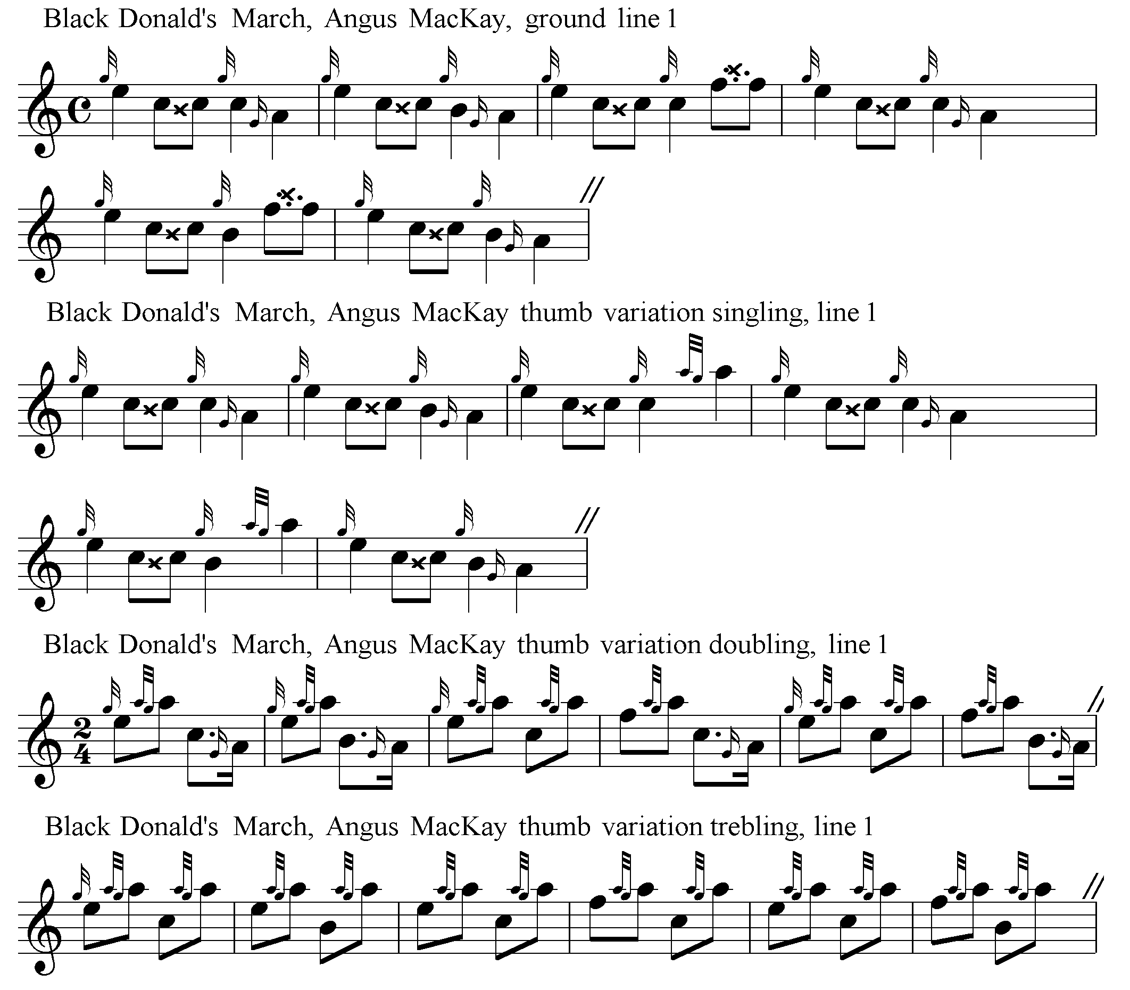
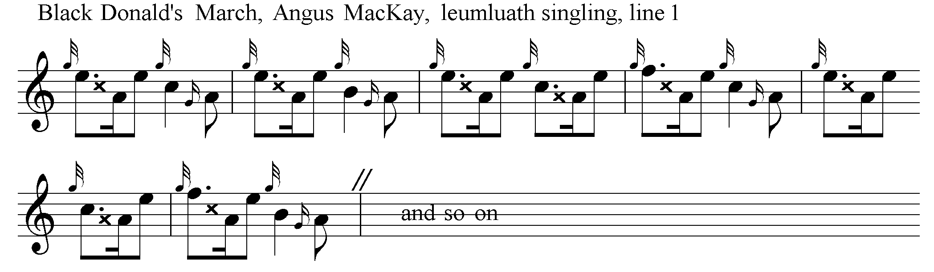

Some may feel that MacKay’s choice of 4/4 for the ground (all the others go for 6/8 here), creates a rather square and pedestrian effect. From the Thumb Variation doubling onwards, MacKay’s tonal contour in line three is as follows:

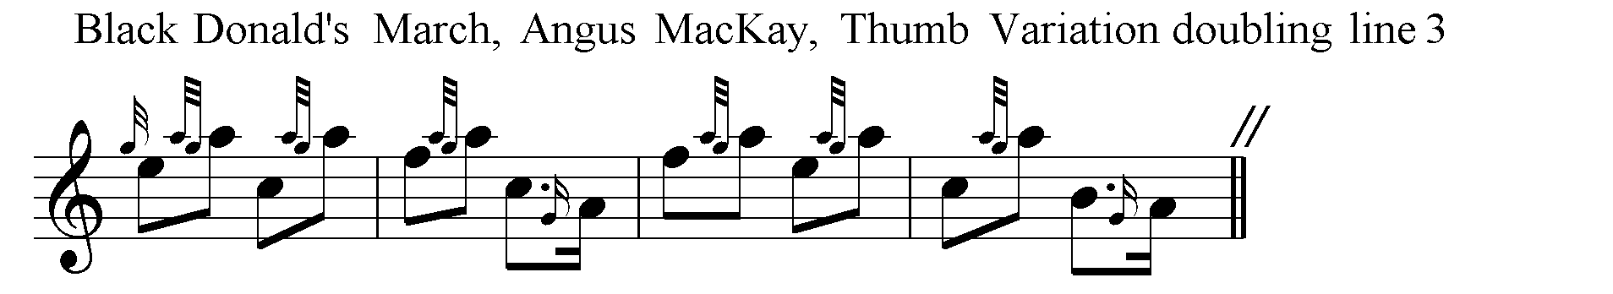

From this point, therefore, there is a difference between the tone rows of MacDonald and MacKay in the third line of each of the variations as follows:

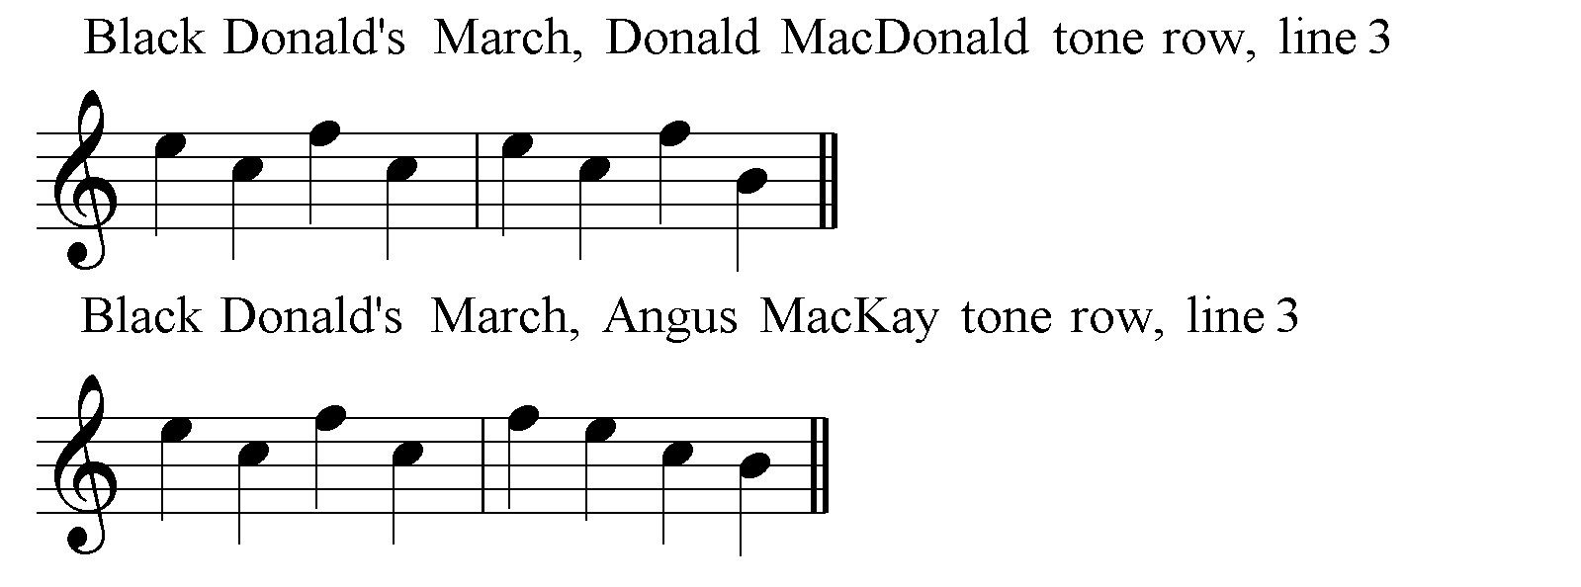

Angus MacKay’s complete score is as follows:
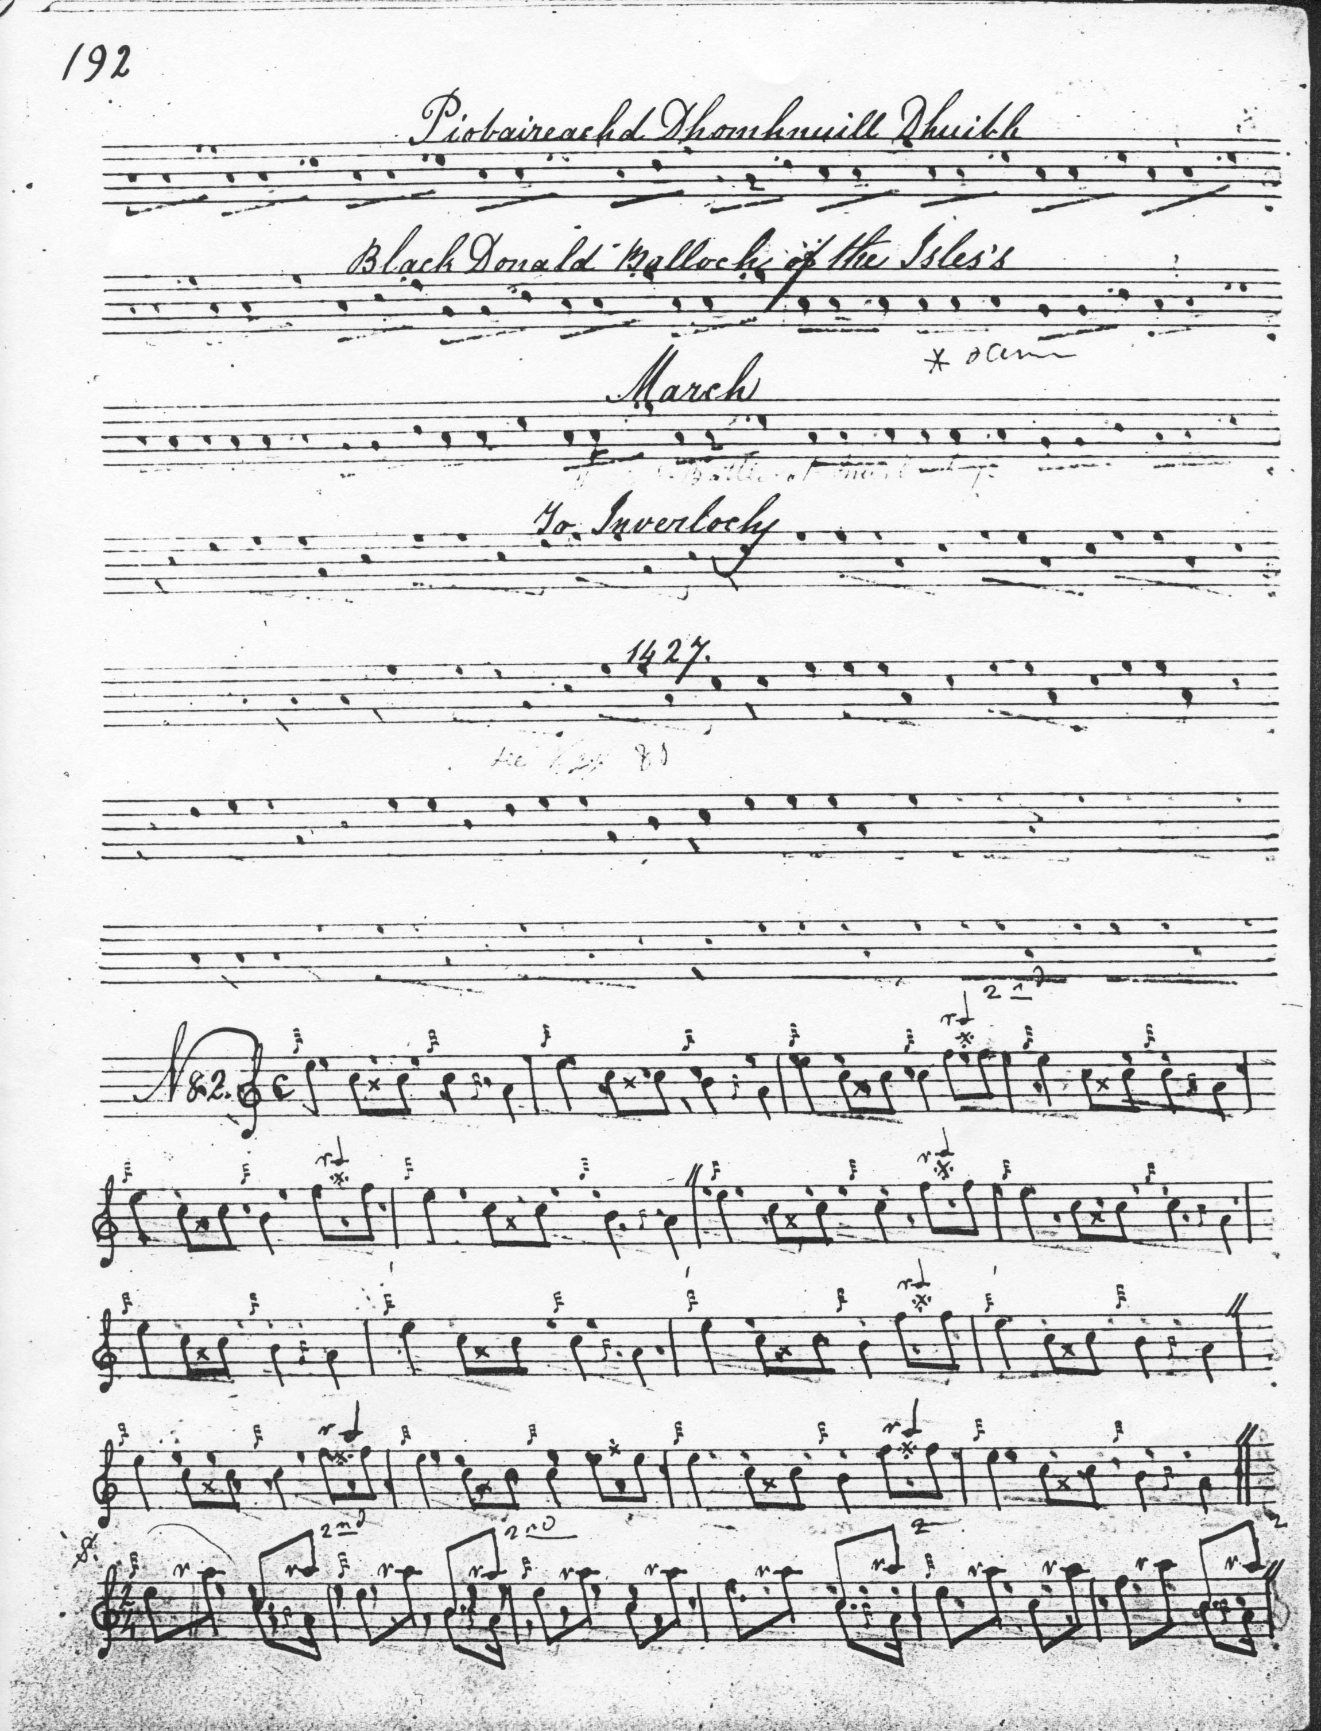

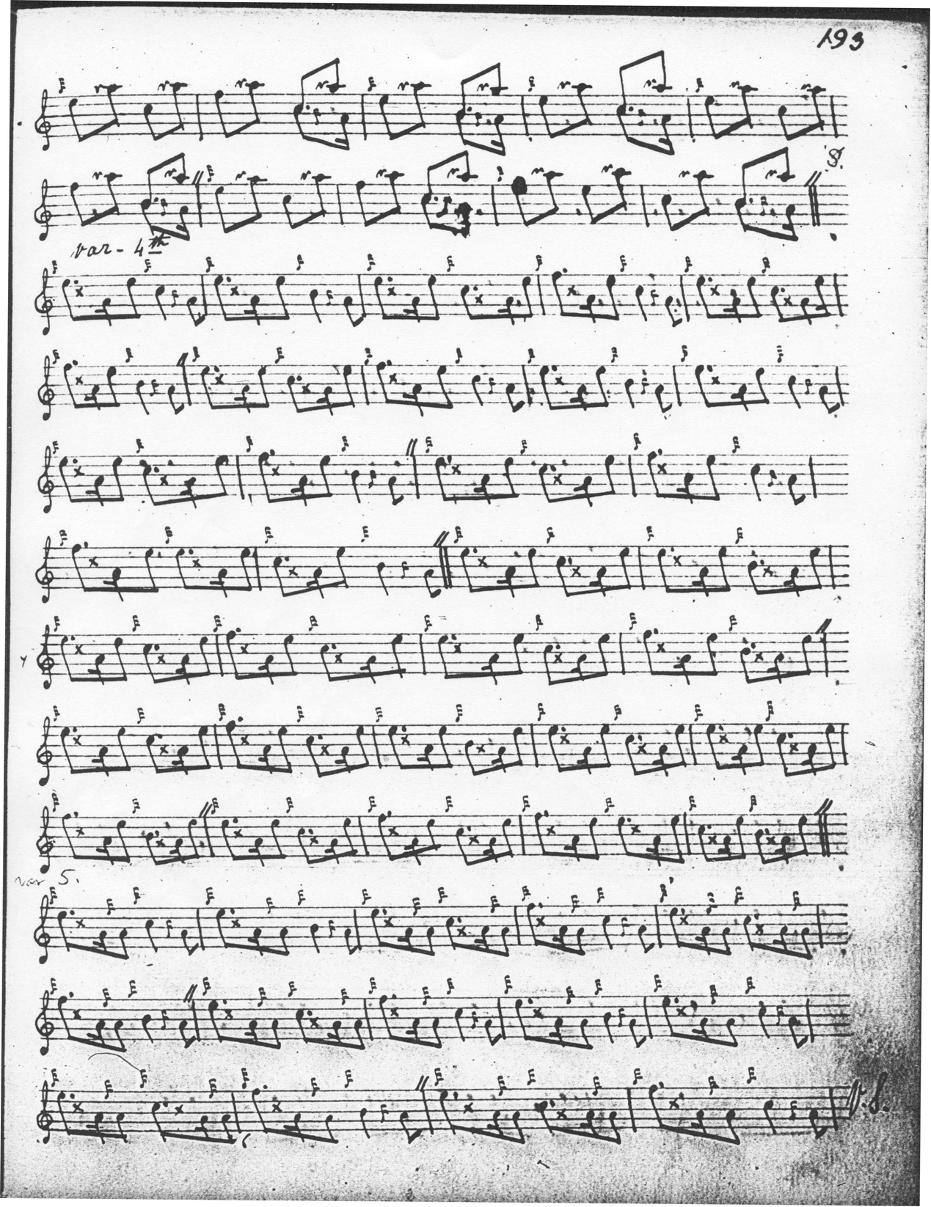
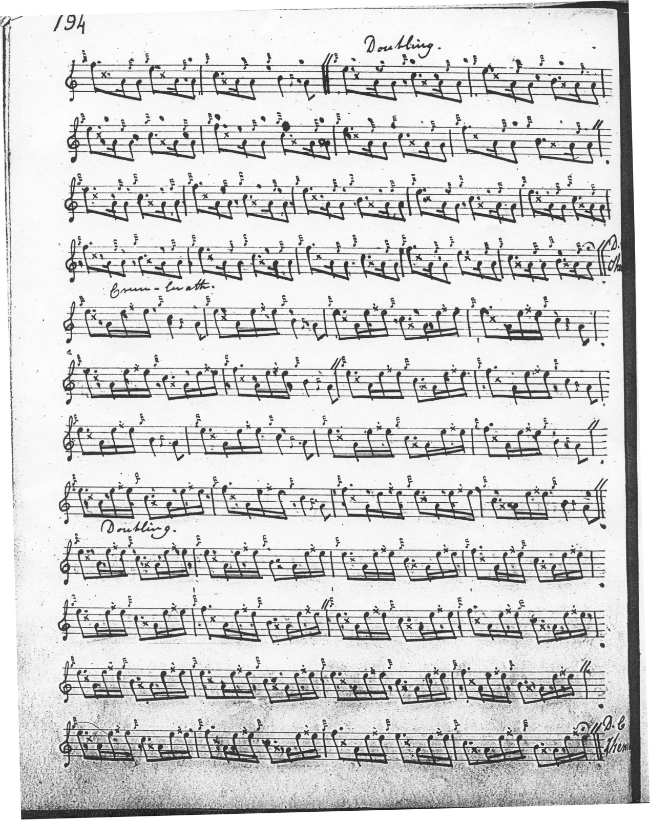

John MacDougall Gillies’s main MS book contains an attractive setting of ‘Black Donald’s March’, which he committed to paper 2 years after he won the Inverness prize pipe in 1882 playing this tune. Gillies was born and brought up in Aberdeen, and it may well have been at his home at 160 Hutcheon Street that he compiled the following account of the tune which is here quoted in his own hand in order to show his characteristically clear and fluent style. As is often the case, Gillies tends to omit ornamentation in the later variations where there is no possibility of ambiguity. It is full of Gillies’s characteristic little subtleties, like his avoidance of the heavy final crotchet at the ends of bars in the ground; the accent being pushed around so that the timing of figures like the throw up from B and C to F in the Ground is varied, and the nice little cut up to high A in the Thumb variation singling balancing the contrasting descending figures from C and B to low A:

‘Black Donald’s March’, John MacDougall Gillies’s setting (in his own hand):

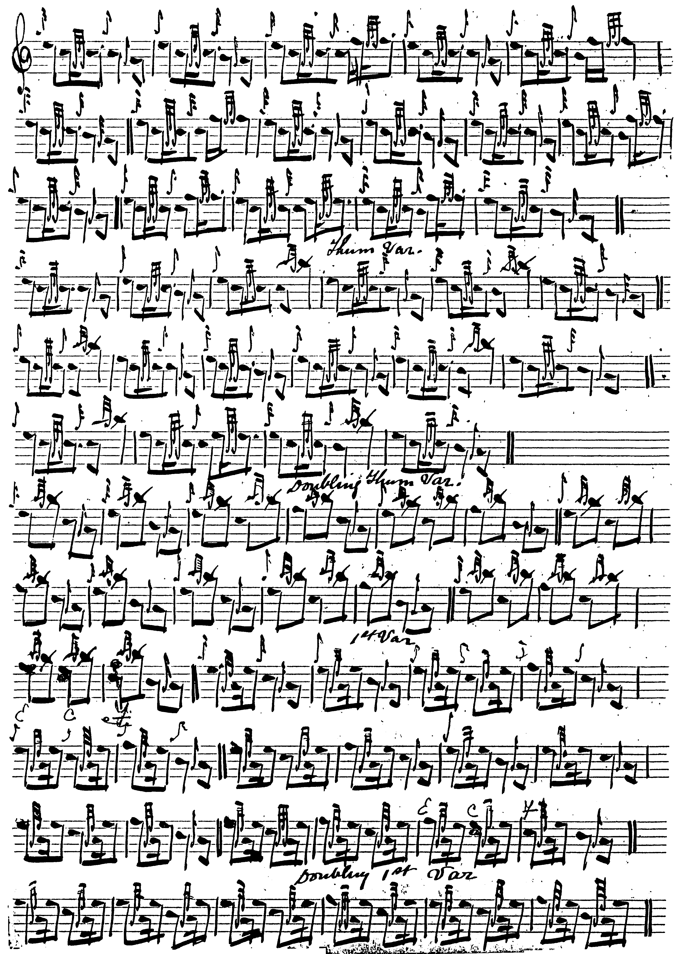

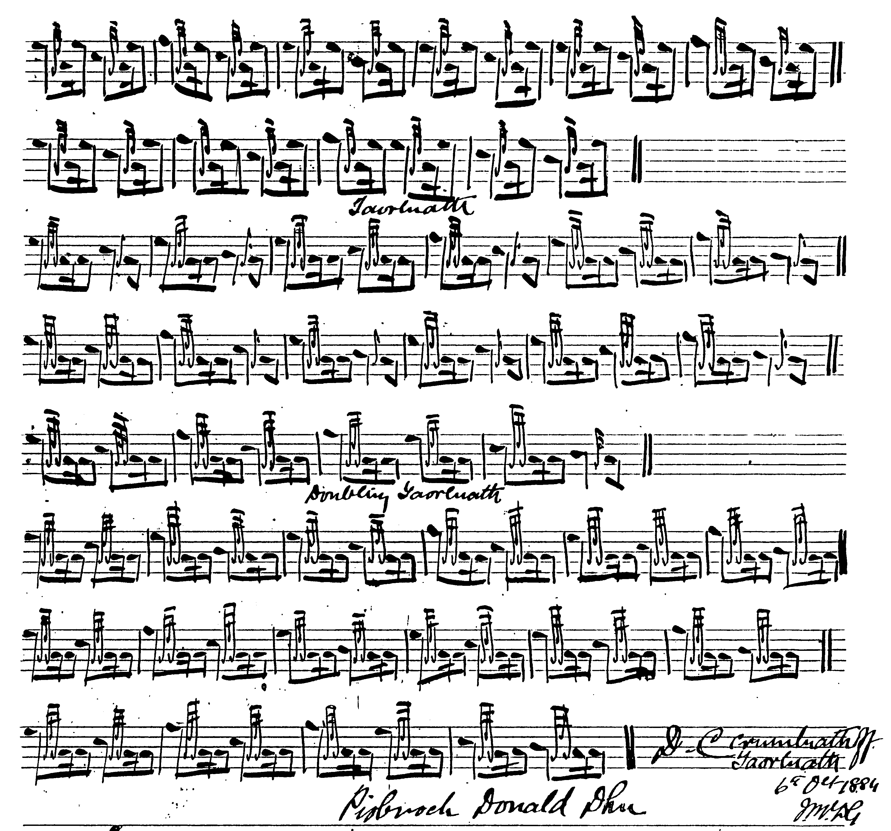

Of the later published settings, David Glen’s is perhaps the most interesting, although his treatment of the Thumb variation doubling, where he elects to follow MacPhee, sits a little uneasily with the succeeding variations:
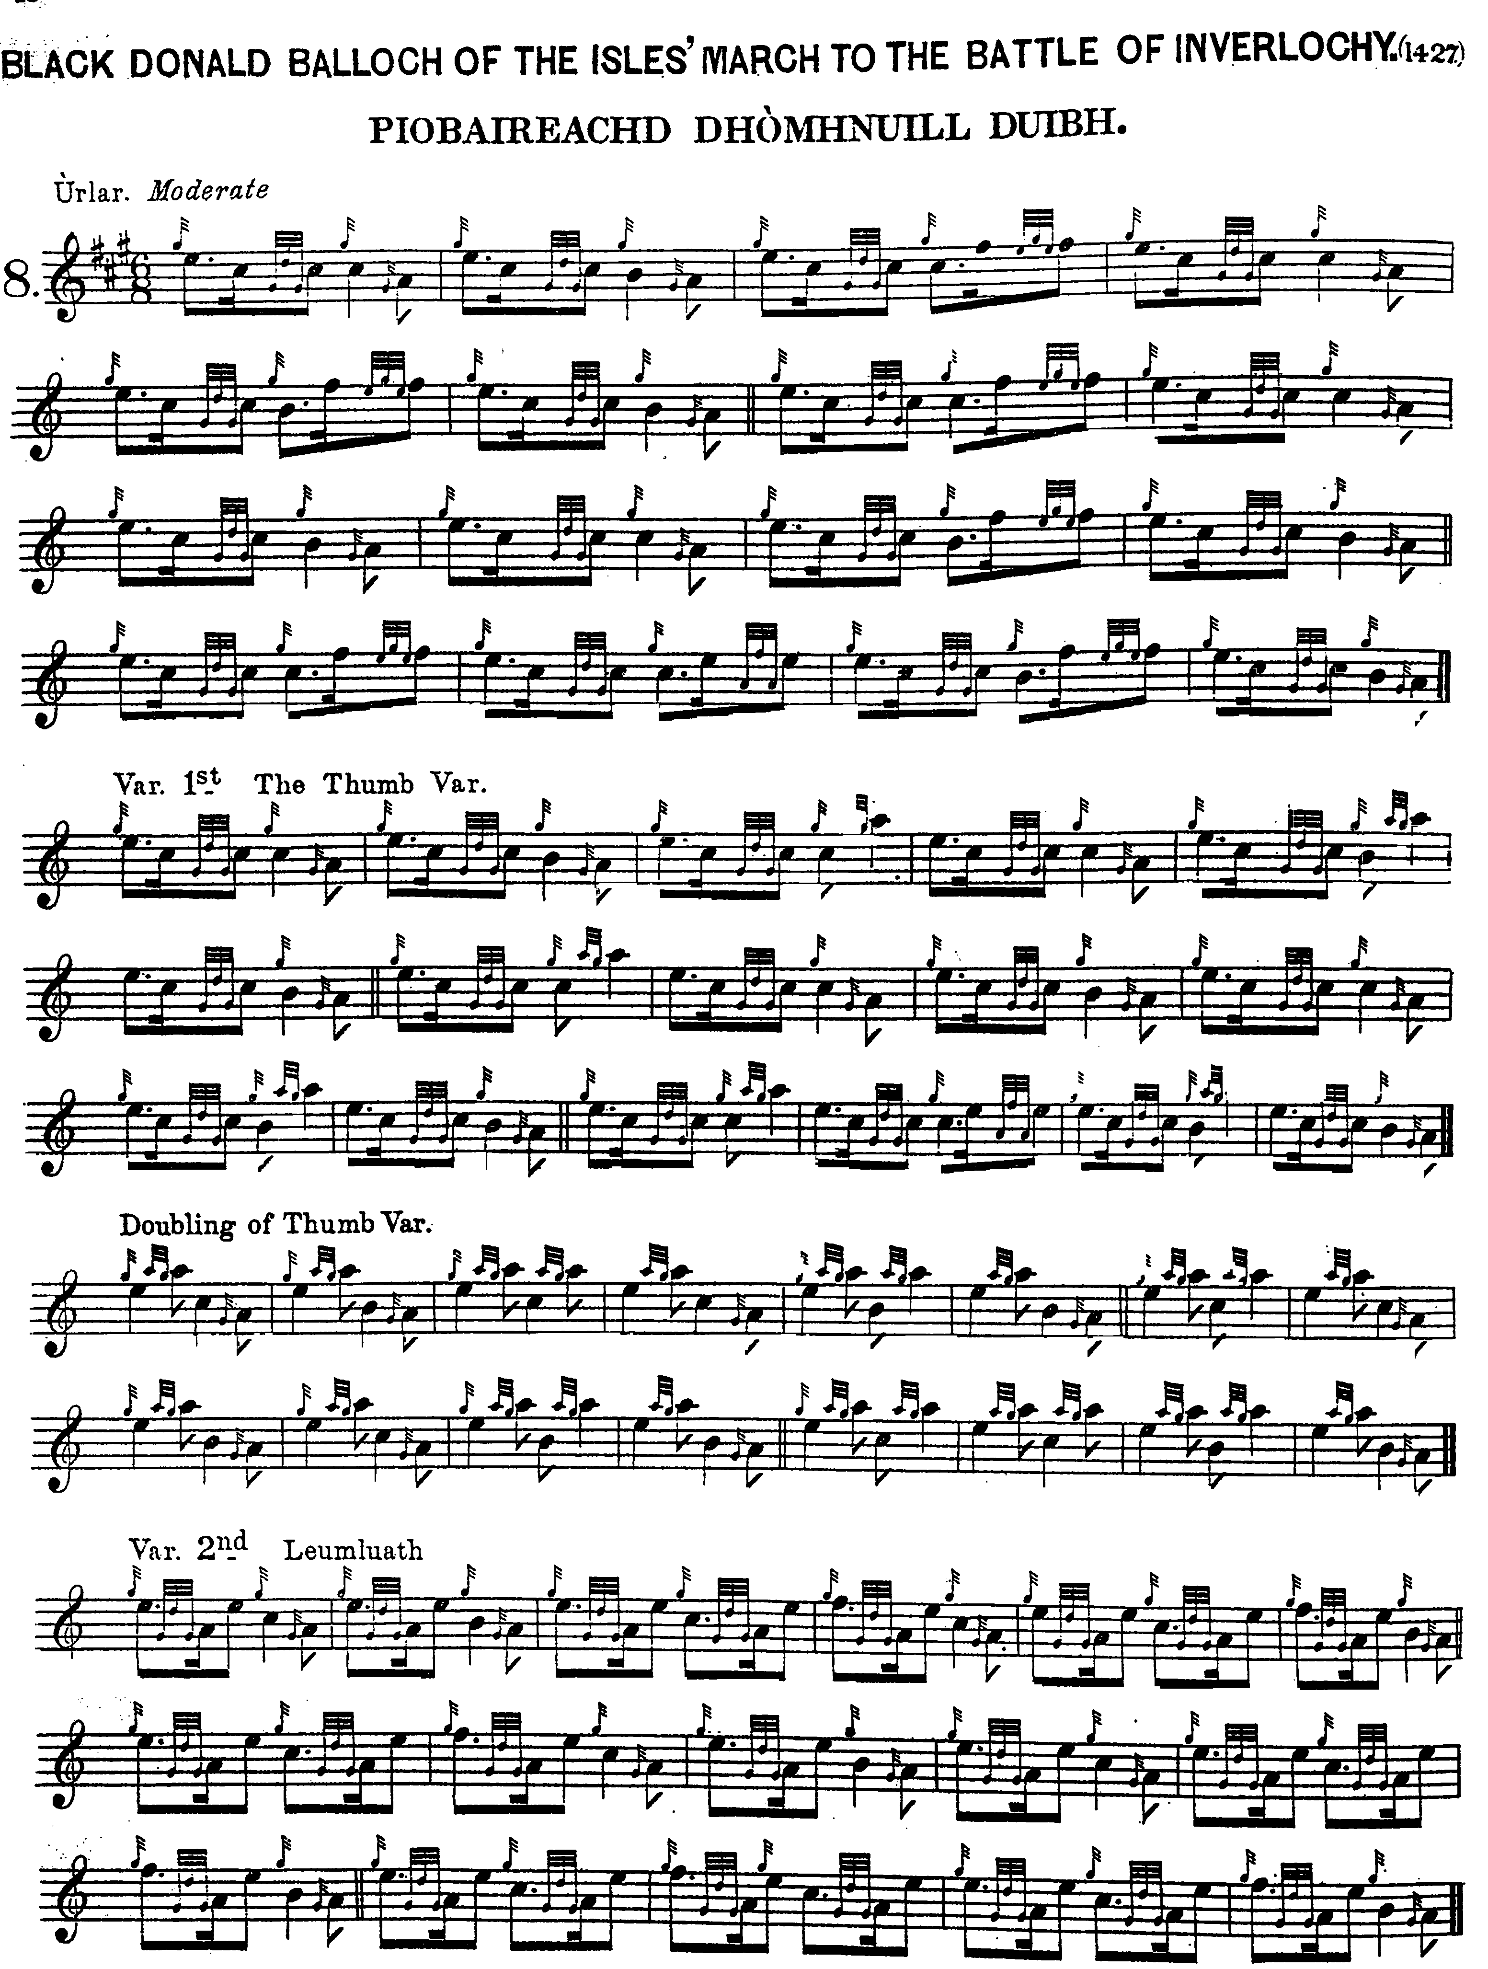
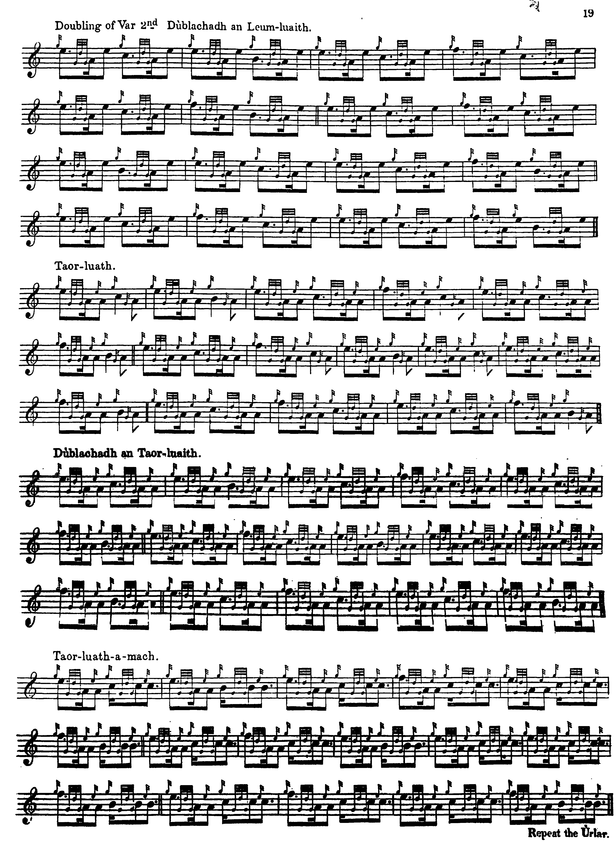

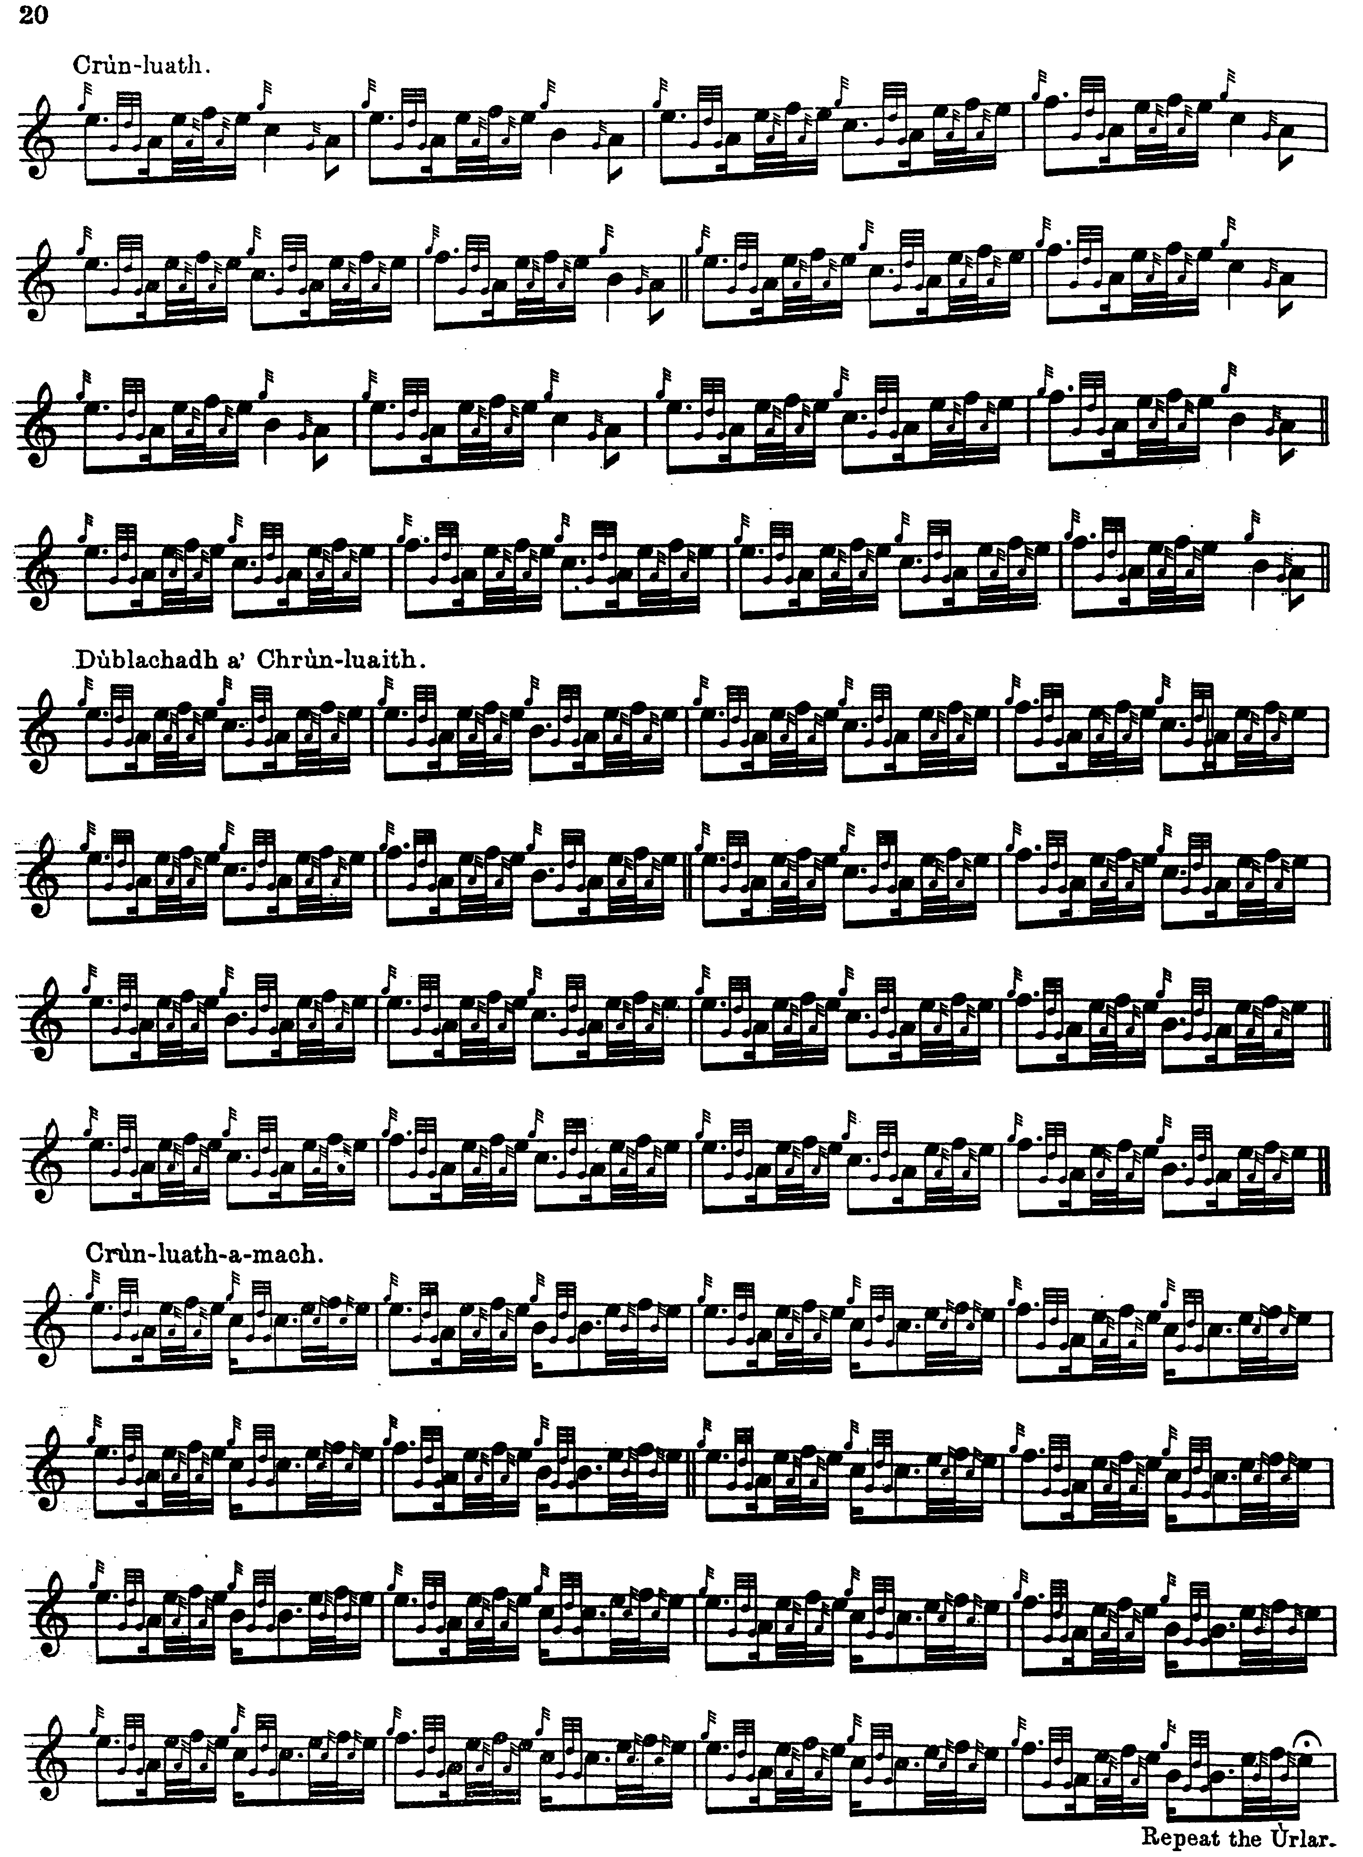

Commentary:

The historical associations of this tune, which link it to the first battle of Inverlochy, may well be arbitrary. It is not yet known who wrote the verbal parts of Donald MacDonald’s Ancient Martial Music of Caledonia (although it is unlikely to have been MacDonald—see The Highland Pipe and Scottish Society 17501950, pp. 116-21), and on the first publication of the tune (in Albyn’s Anthology in 1816, see below), this link with the remote past was not asserted. The early 19th century marked a serious revival of antiquarian interest in the Middle Ages and much was made of the supposed “antiquity” of pìobaireachd, as we see in the titles of a number of contemporary collections of pipe music.

“Black Donald’s March” was one of the first pìobaireachd melodies to become famous outside Scotland, thanks to its being used by Sir Walter Scott (whose hugely-selling books—which would have made him a multi-millionaire today--remain the source of much of the present popular view of “The Highlands”) for his song “Pibroch of Donuil Dubh”:

Pibroch of Donuil Dhu,
Pibroch of Donuil,
Wake they wild voice anew,
Summon Clan-Conuil…
Come from deep glen, and
From mountain so rocky,
The war-pipe and pennon
Are at Inverlochy…

This was first published in composer song-collector and music editor Alexander Campbell’s Albyn’s Anthology, published in 1816. Campbell had visited Skye and Glenelg on a collecting expedition in the previous autumn and met Niel MacLeod of Gesto and Donald Roy MacCrimmon. He may have picked up the tune there, later passing it on to Scott who was on the committee of the Highland Society of Scotland which had sponsored Campbell’s activities. Scott may have had direct access to the tune, however, because when his literary success made him a wealthy man and he set up as a country gentleman at Abbotsford in the Borders, he employed a piper of his own, John Bruce, thought to have been one of the Bruce family of Skye. Scott was little of a musician, however, and it seems that neither was his piper. Scott’s son-in-law and biographer, John Gibson Lockhart, recorded a visit in 1819 by Mrs. Marianne Clephane, formerly Marianne MacLean of Torloisk in Mull, a harper and keyboard player who was rated by contemporaries as one of the foremost experts in Highland music of her generation:

…Mrs. Clephane thought poorly of John of Skye’s piping. “Is he not an elegant man?” Scott tried to wheedle her. “He is a pretty man; but he understands little of his pipe,” Mrs. Clephane said firmly. “ His drones are not in tune with his chanter. He wants the Highland style altogether.” Scott’s uncle, Thomas Scott, agreed with her. “His ear is false,” he said, “ and he will never play well. My nephew, however, is fond of a good-looking man, which Bruce is, and he can make a noise…” (Edgar Johnson, Sir Walter Scott the Great Unknown, i, 683).

* * *

Electronic text © Dr. William Donaldson, Aberdeen, Scotland, November 2001; revised Cambridge, Massachusetts, March 2025

