The Big Spree

There are settings of this tune in the following manuscript sources:
--Donald MacDonald’s MS, ff.144-9;
--MacArthur/MacGregor MS, ff.1-3;
--Donald MacDonald (Junior)’s MS, f.39 (with the title “The Little Drunkard”);
--Angus MacKay’s MS, i, 1-2;
--John MacKay’s MS, f.125;
--Duncan Campbell of Foss’s MS, ff.145-7;
--Colin Cameron’s MS, ff.60-61;
--D. S. MacDonald’s MS, ii, 27-8;
--John MacDougall Gillies’s MS, ff.1-2;
--David Glen’s MS, ff.84-86;
--Robert Meldrum’s MS, ff.47-50;

and in the following published sources:
--Frans Buisman and Andrew Wright, eds., The MacArthur/MacGregor Manuscript of Piobaireachd (1820), p.129;
--C. S. Thomason, Ceol Mor, pp.106-7;
--David Glen, Collection of Ancient Piobaireachd, pp.203-5;
--G. F. Ross, Some Piobaireachd Studies, p.32.

There are two basic routes through this tune: one which ends with the siubhal doubling; and a longer version going on to taorluath and crunluath variations. Amongst the MS sources, Donald MacDonald develops the tune fully, including taorluath and crunluath fosgailte variations (doublings only, he does not include singlings of either of the two final variations). The MacArthur/MacGregor is more truncated, developing the tune through to the end of the siubhal doubling and then indicating a return of the ground: there is no sign that more was intended. Angus MacKay develops the tune to the same limited extent as the MacArthur/MacGregor which appears to be his main source. Colin Cameron also ends with the siubhal doubling.
Amongst the published scores, Thomason gives the tune with similar architecture to MacDonald, but adds a crunluath fosgailte singling. Glen brings up the tune to its full “modern” dimensions, i.e., ground, first variation singling and doubling, siubhal singling and doubling, taorluath fosgailte singling and doubling, and crunluath fosgailte singling and doubling.

Donald MacDonald sets the tune like this:

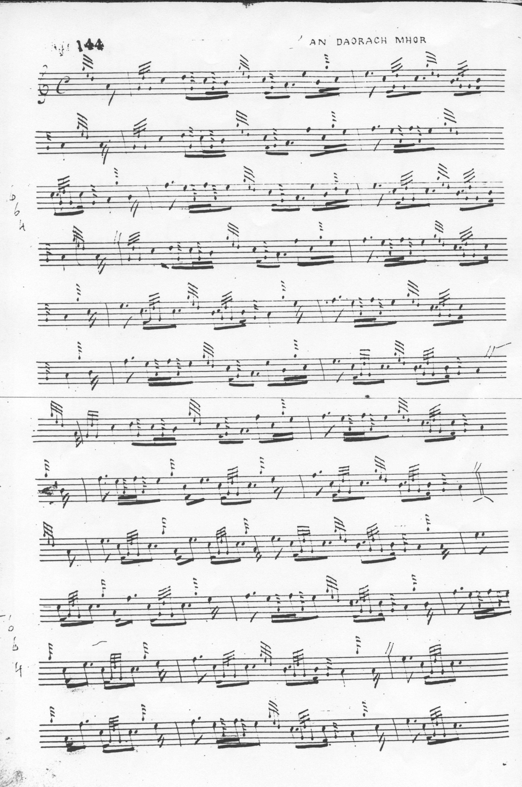
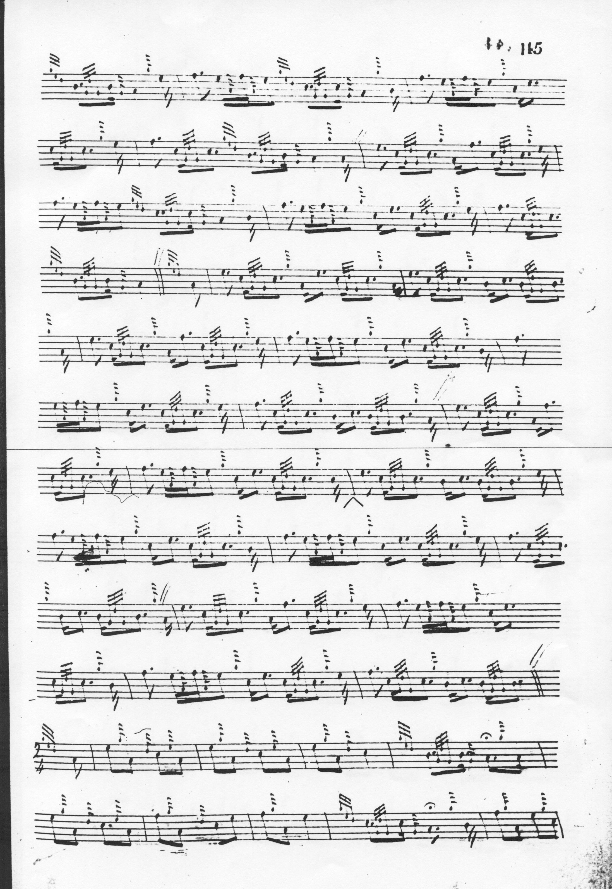

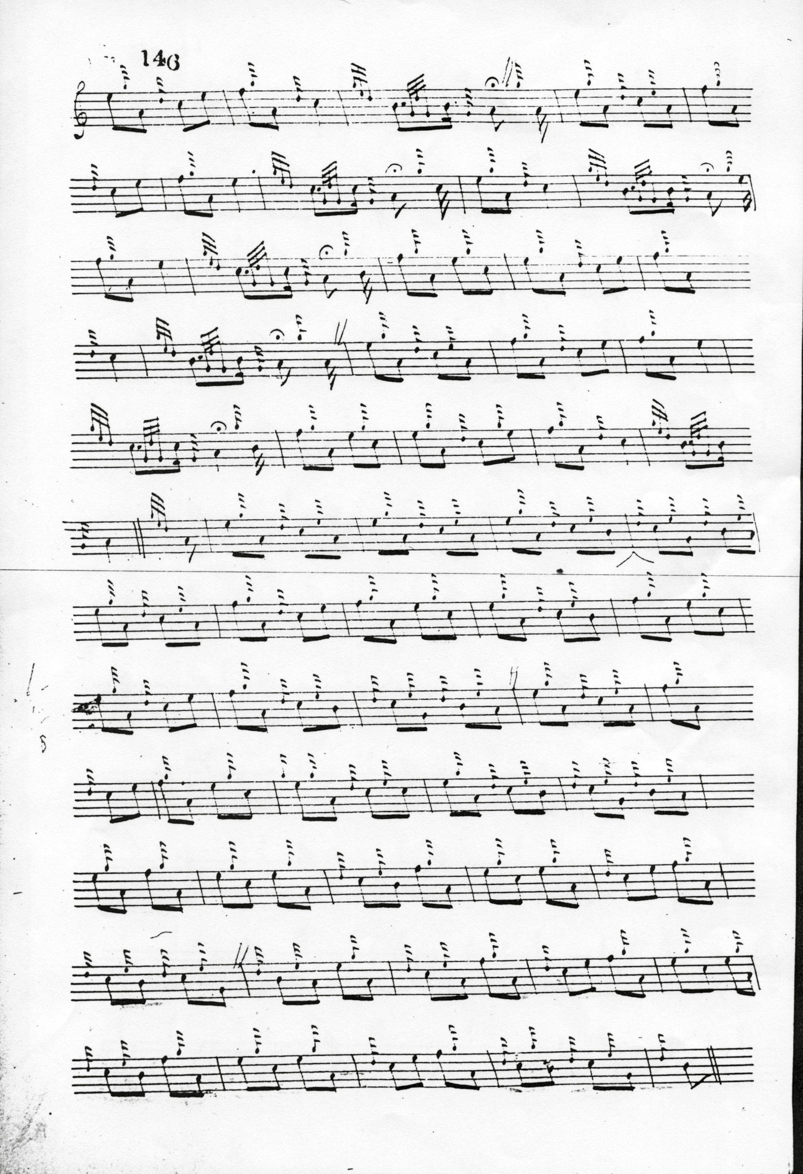

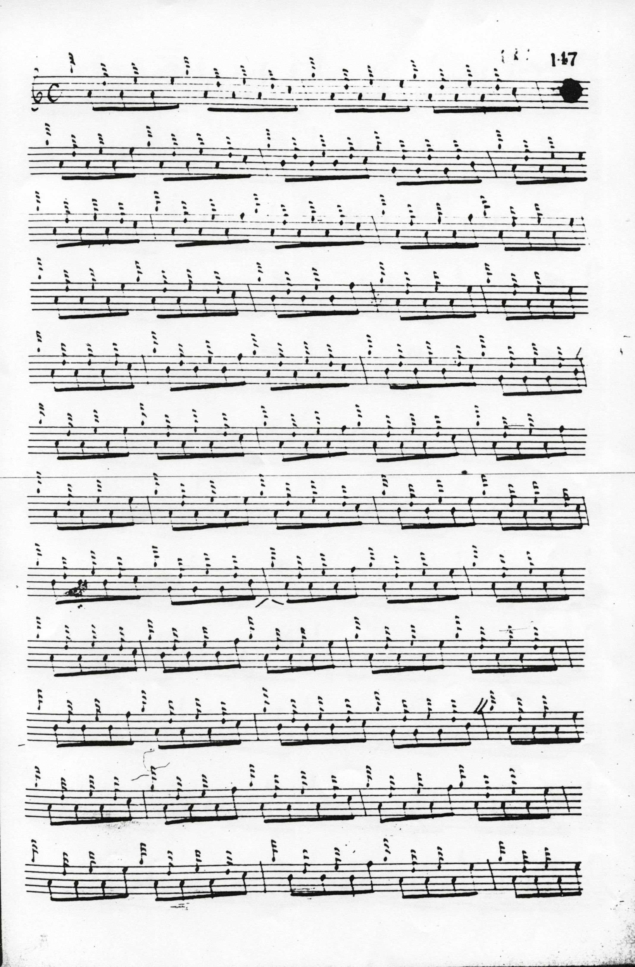
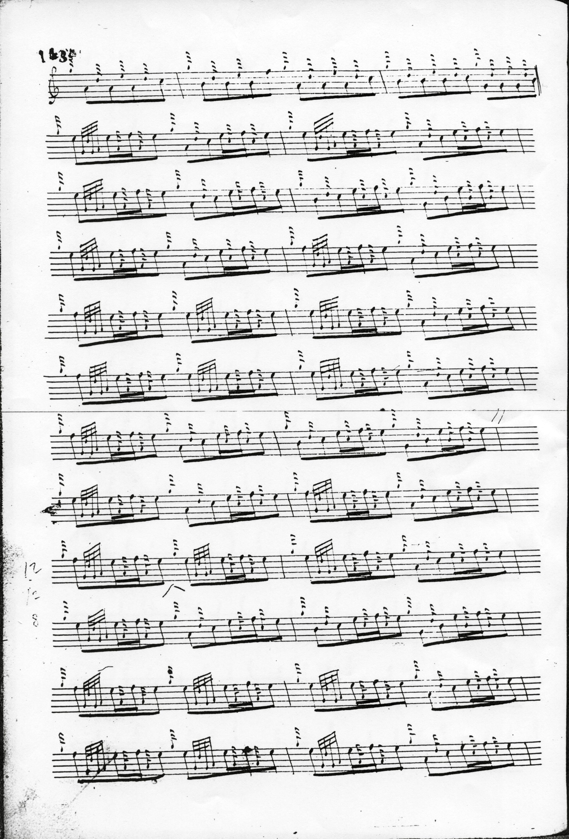

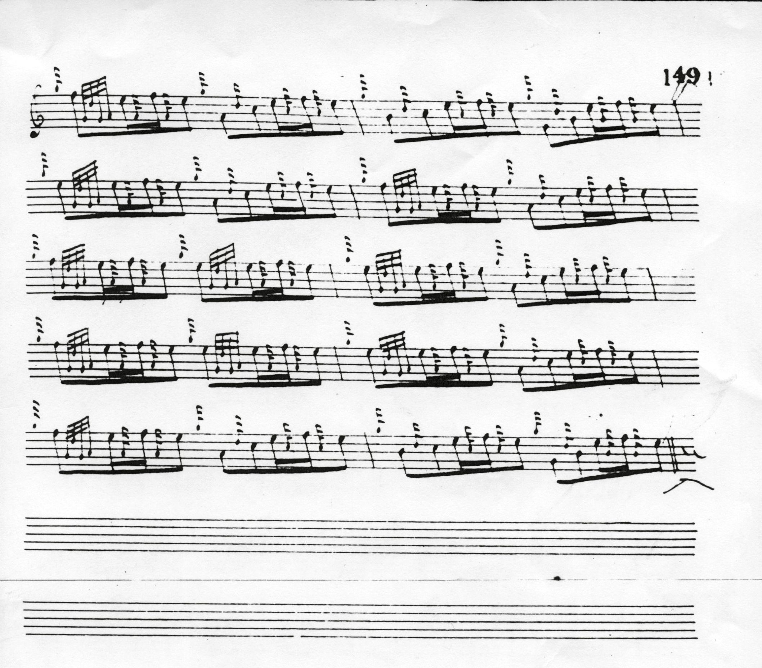

We note the seeming rhythmical awkwardness in the third line of Donald’s ground, a feature also shared by MacKay and MacArthur/MacGregor, although this disappears if one times the ground in 4/4 as actually written. MacDonald’s characteristic use of the crunluath movement in “opened” form also appears to advantage here.

In the MacArthur/MacGregor MS the tune is set as follows:
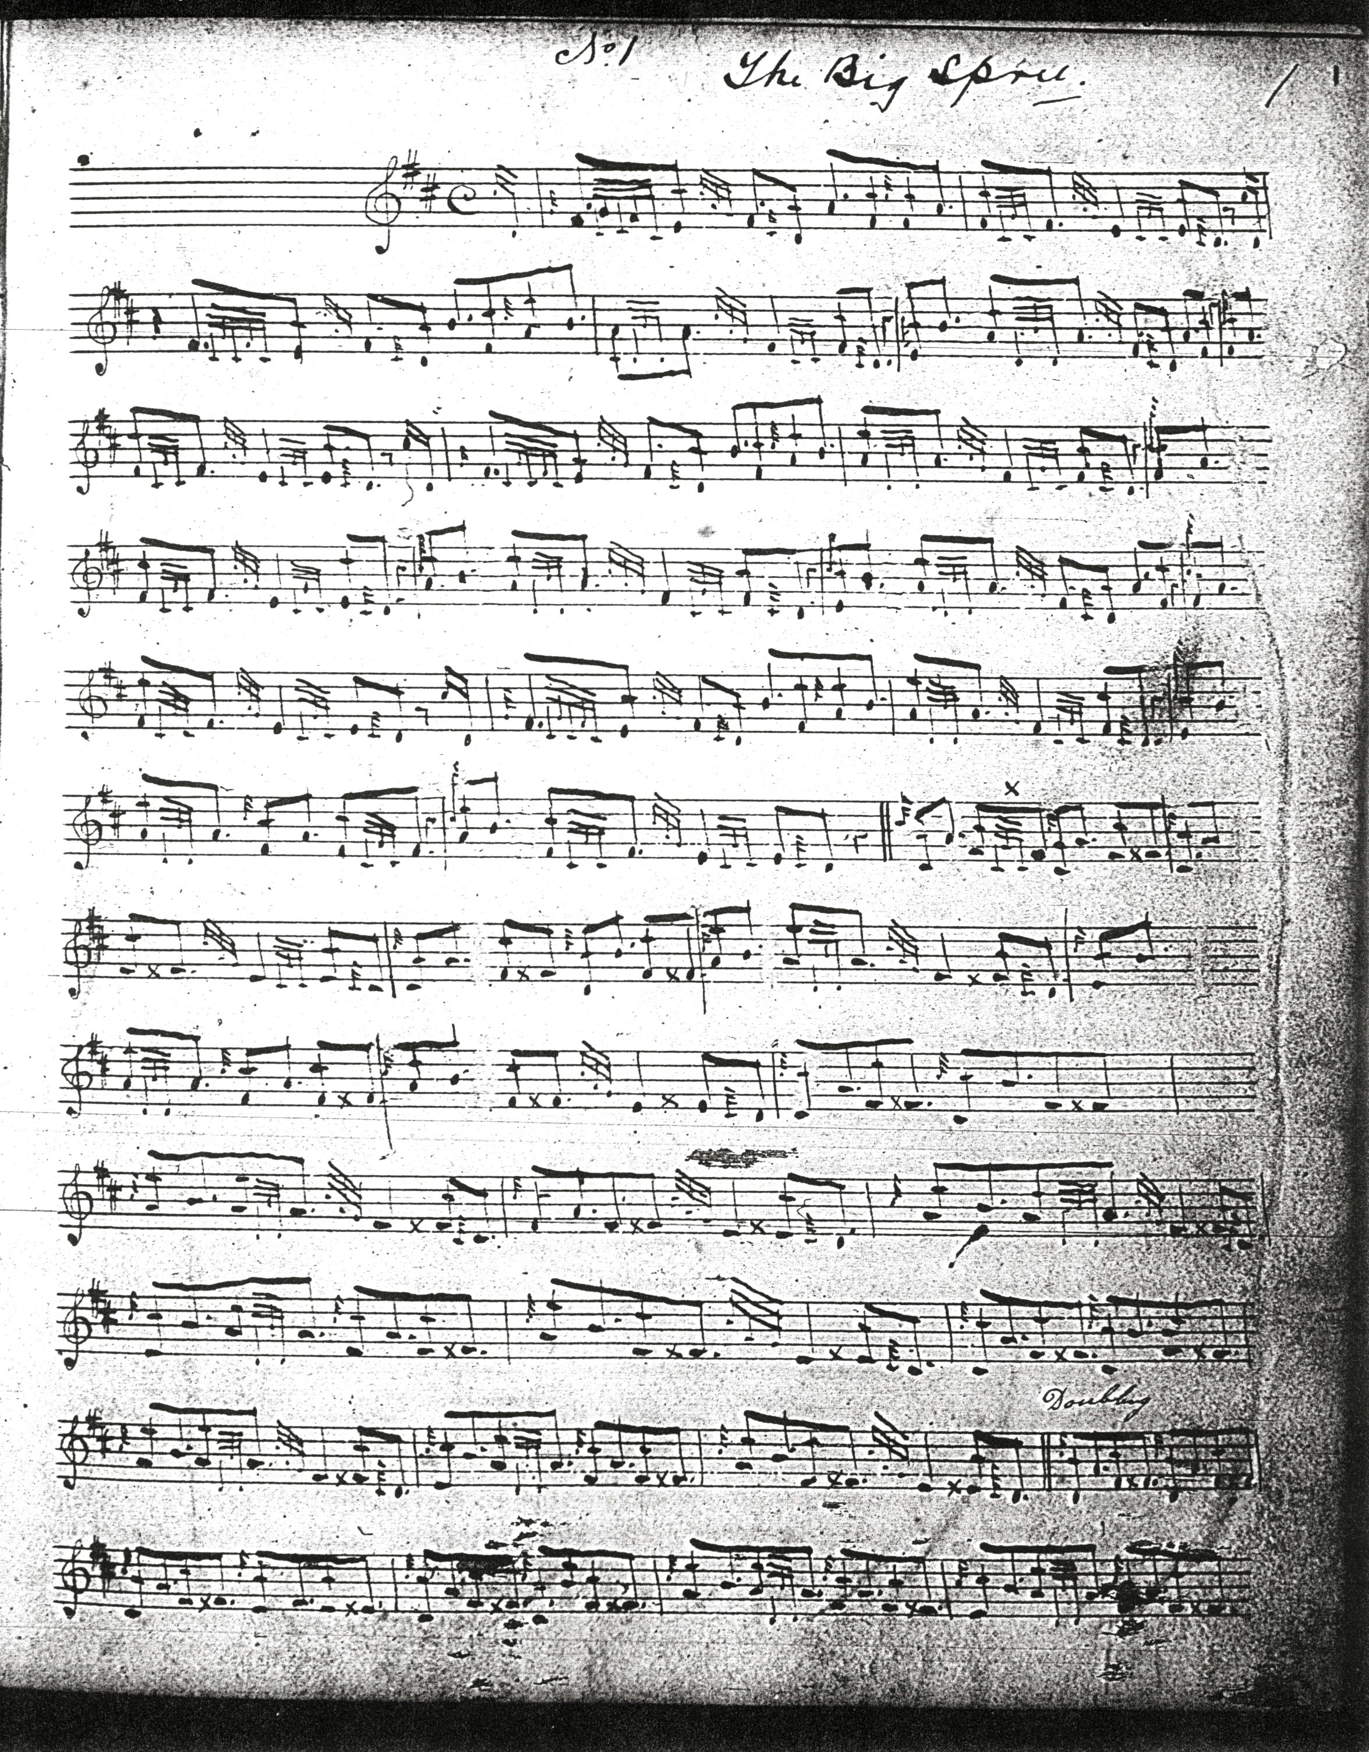

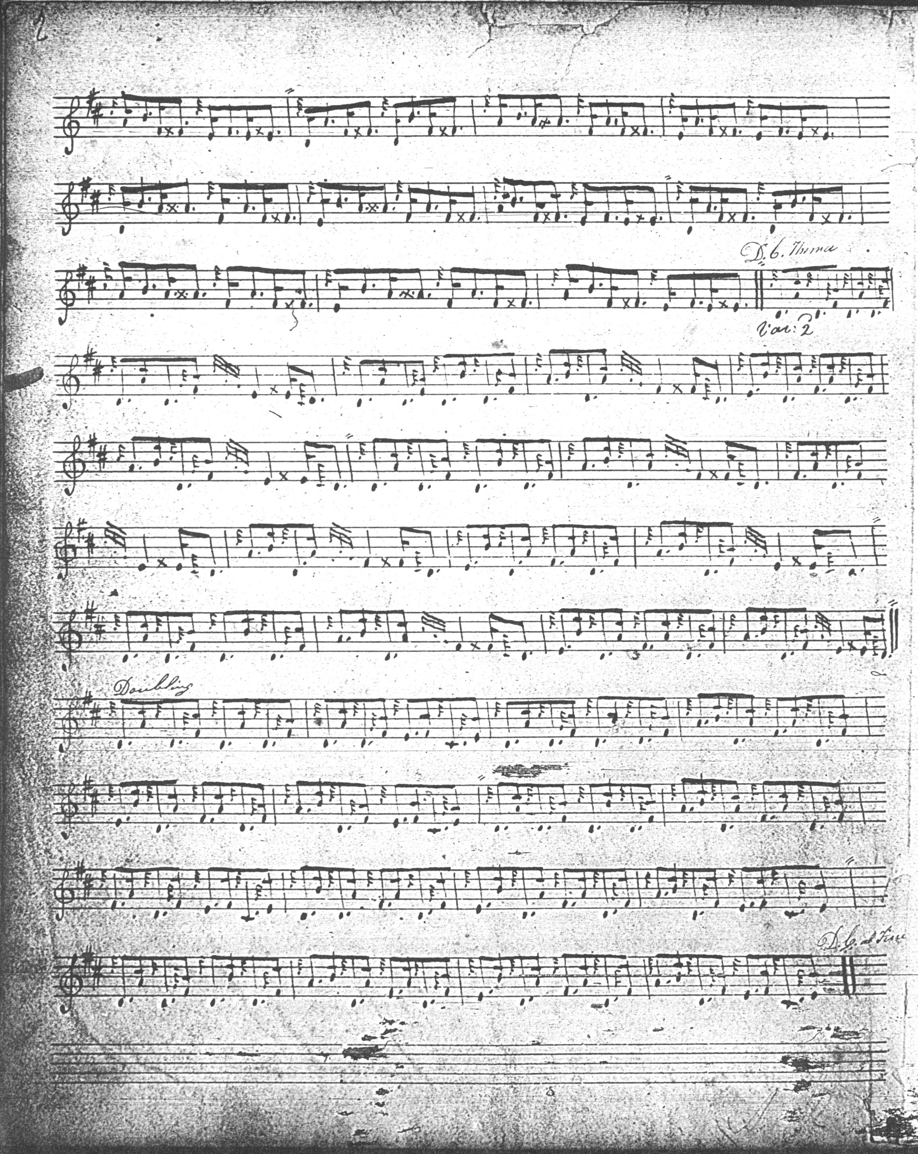

The tune goes no further than the siubhal doubling, and the setting of the ground seems to have caused the compilers notational problems. There were two drafts of the first page of this tune, the earlier bearing the expression mark “Andante con espressione”. It is interesting, too, that the ground is twice restated: at the end of both first and second variation doublings.

Donald MacDonald, jnr.’s score is in outline only and is not reproduced here.

Angus MacKay cites the MacArthur-MacGregor MS as a source, but then overrides its clear instructions about time signature. MacKay sets his ground in 2/4, but his barring is unhelpful: another example, perhaps, of this tune causing editorial difficulties:
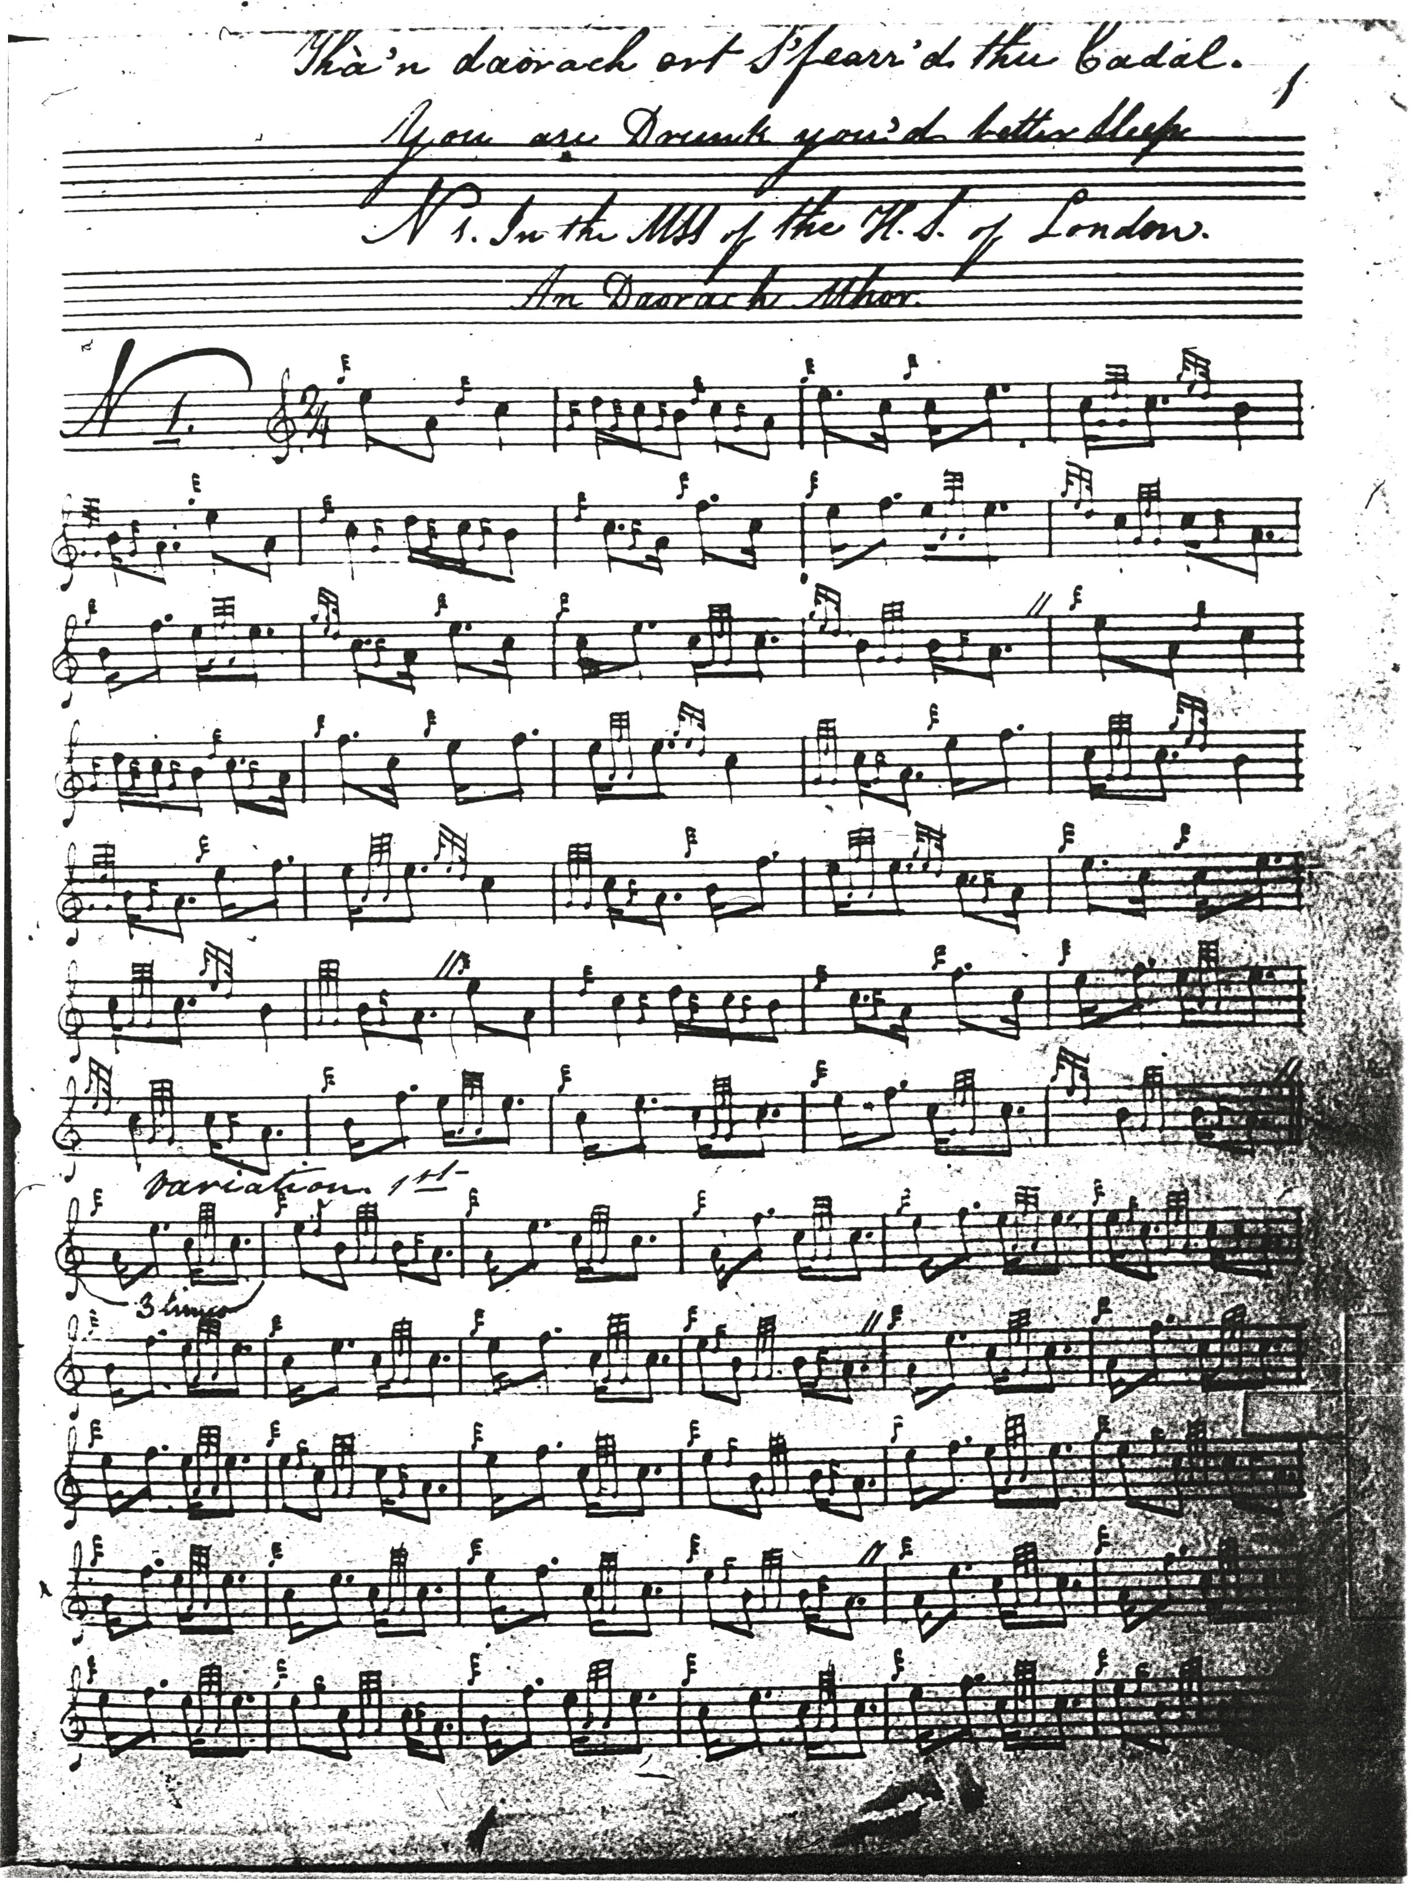

and so on.

John MacKay favours MacDonald-style B>C figures with a grip in variation one, otherwise his score does not differ significantly from Angus MacKay’s and it is not reproduced here. Duncan Campbell of Foss’s setting adds little to Angus MacKay’s likewise, and is not reproduced here.

Colin Cameron’s title is slightly different from MacKay’s, “Tha thu gu mhisg, b’fheard thu cadal”, though the meaning is similar. He sets the tune like this:
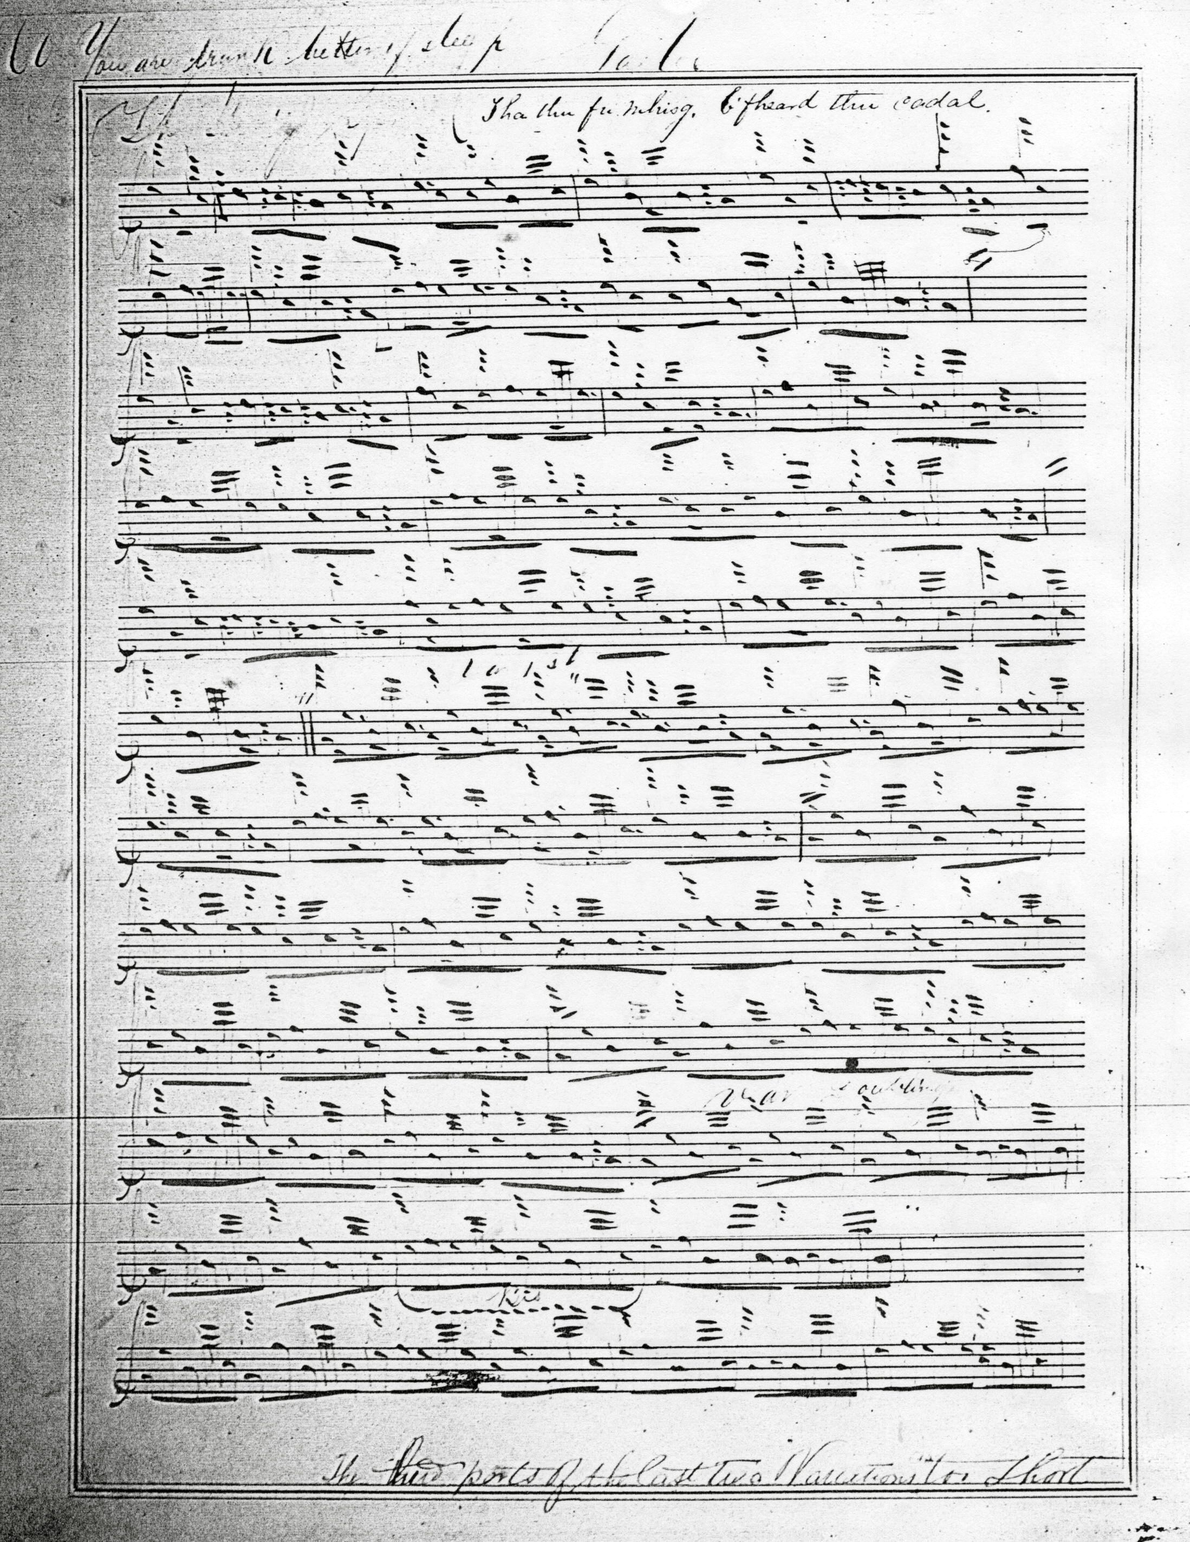

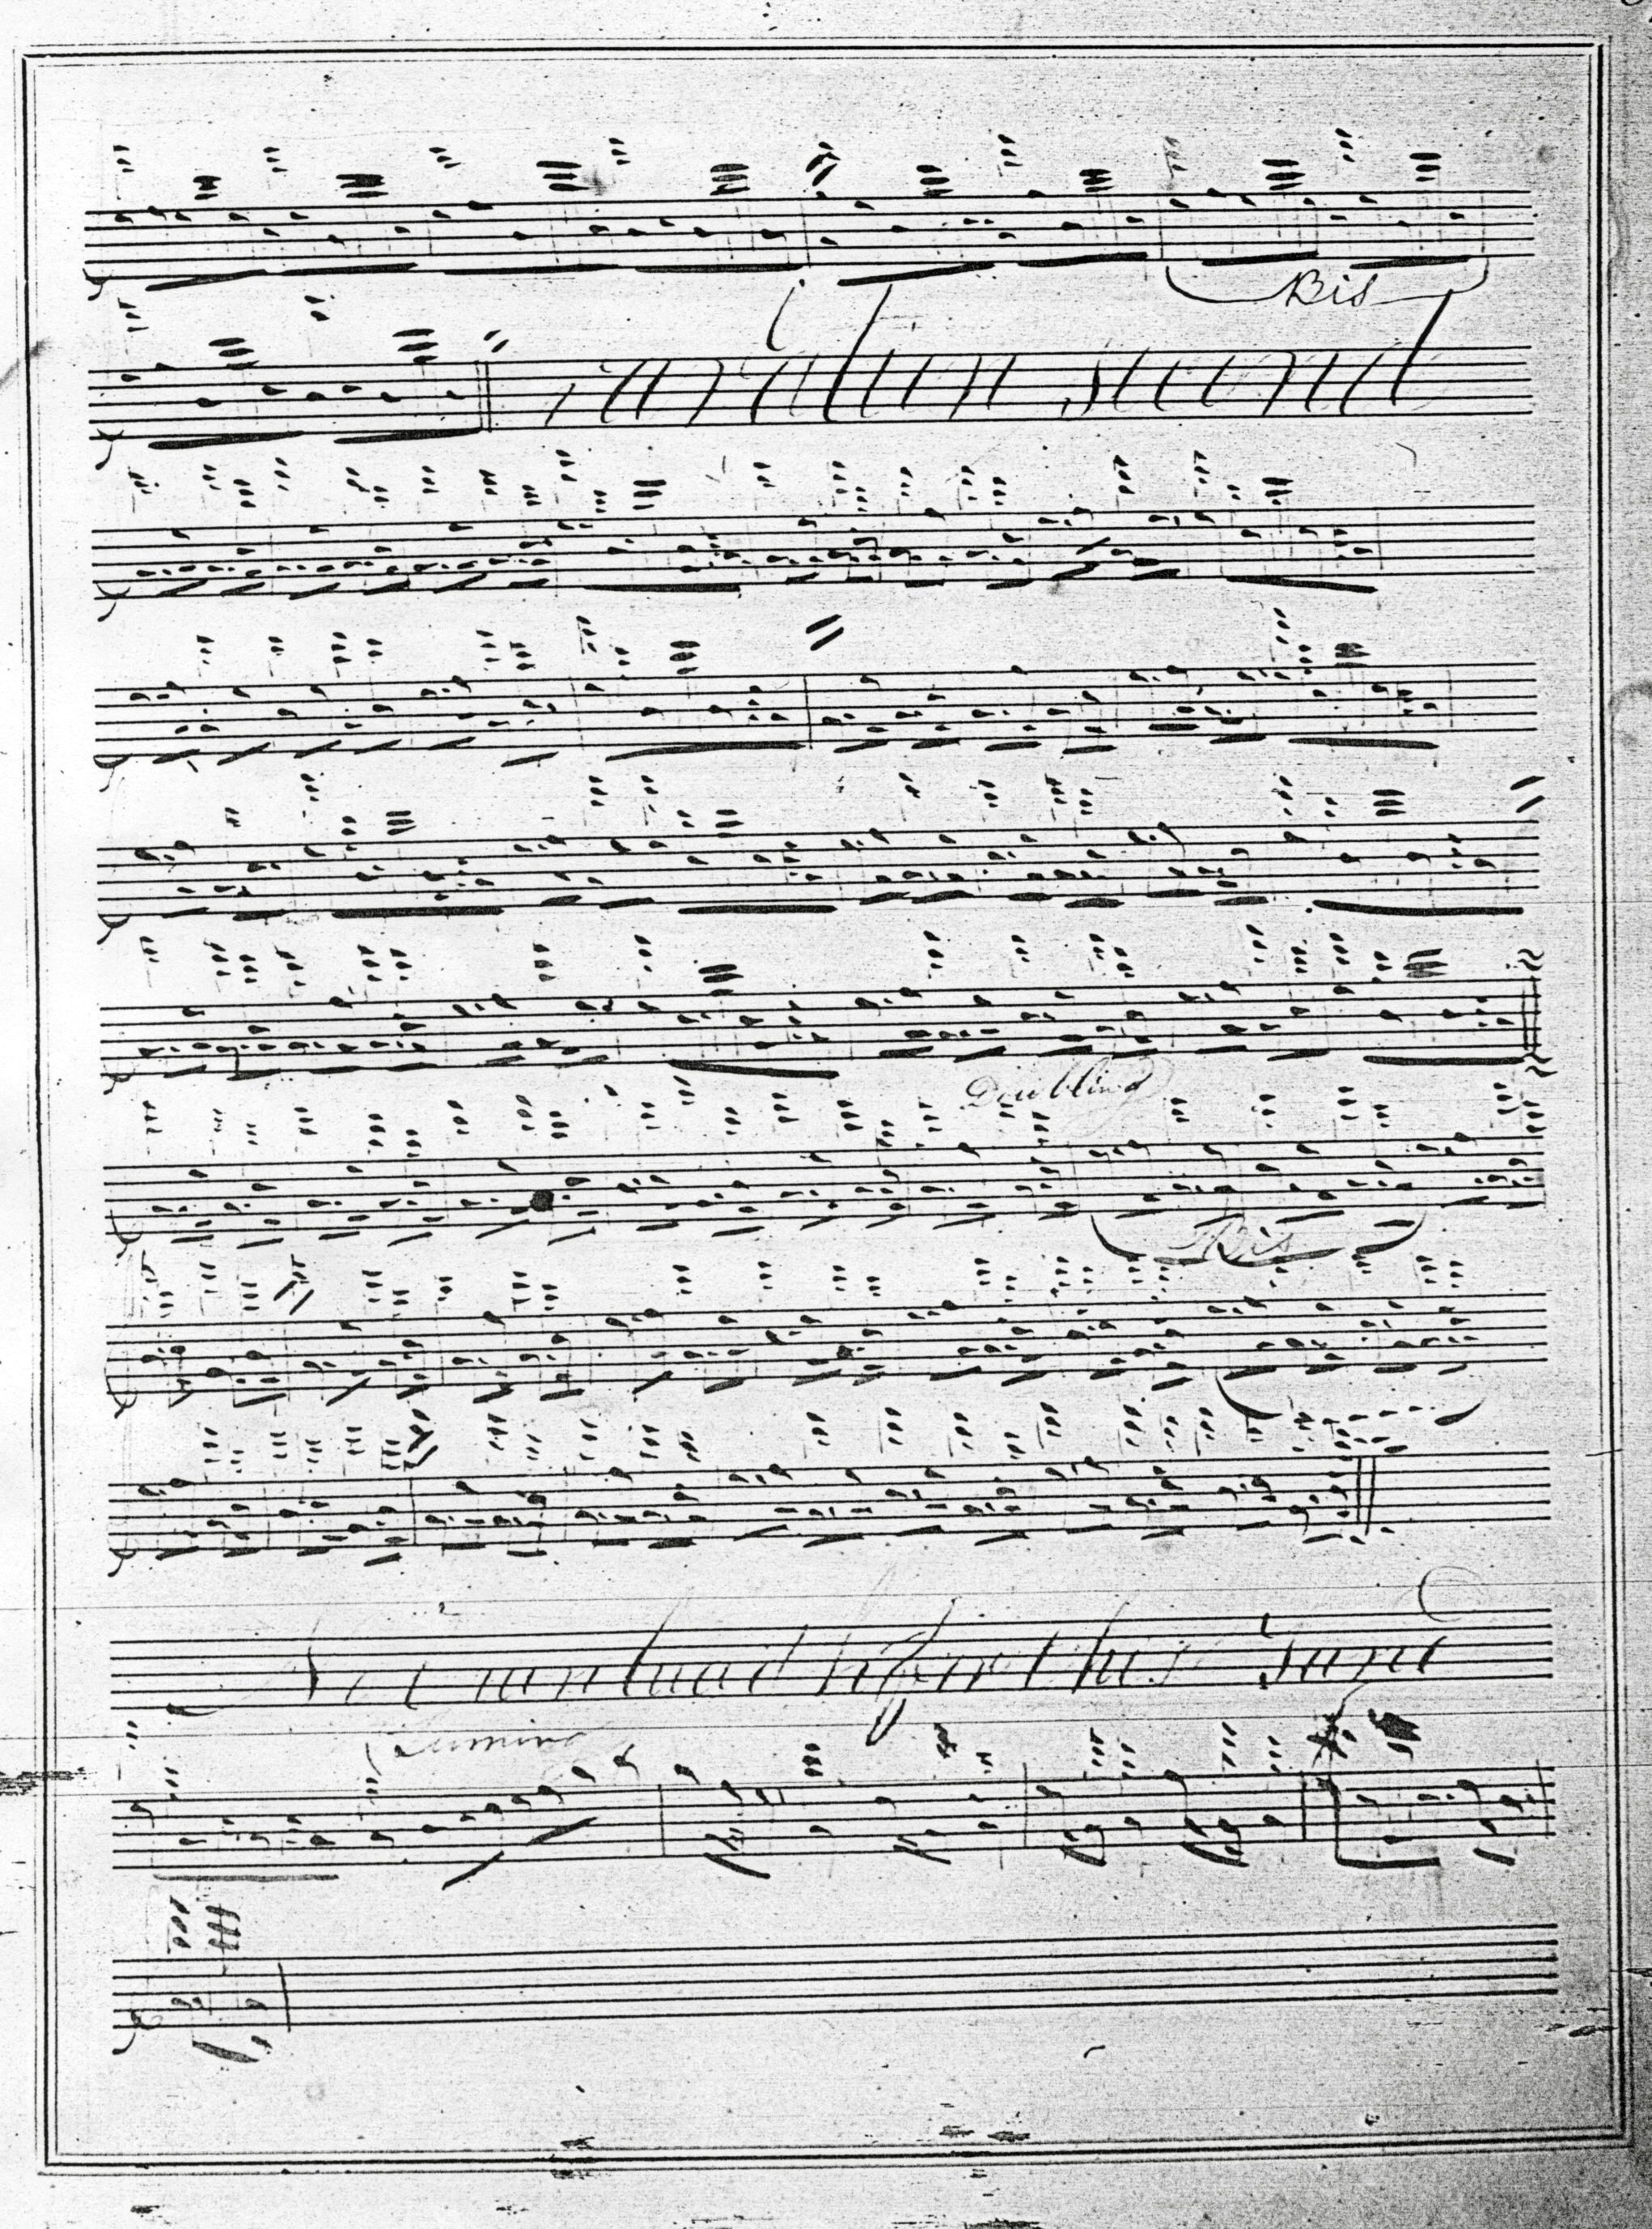

A note at foot of the first folio says “The third parts of the last two Variations too Short.”

The short third line is made good in John MacDougall Gillies’s MS. Gillies was a leading Cameron pupil, being taught by Colin’s brother Sandy. In addition he has one or two delightful touches of his own:

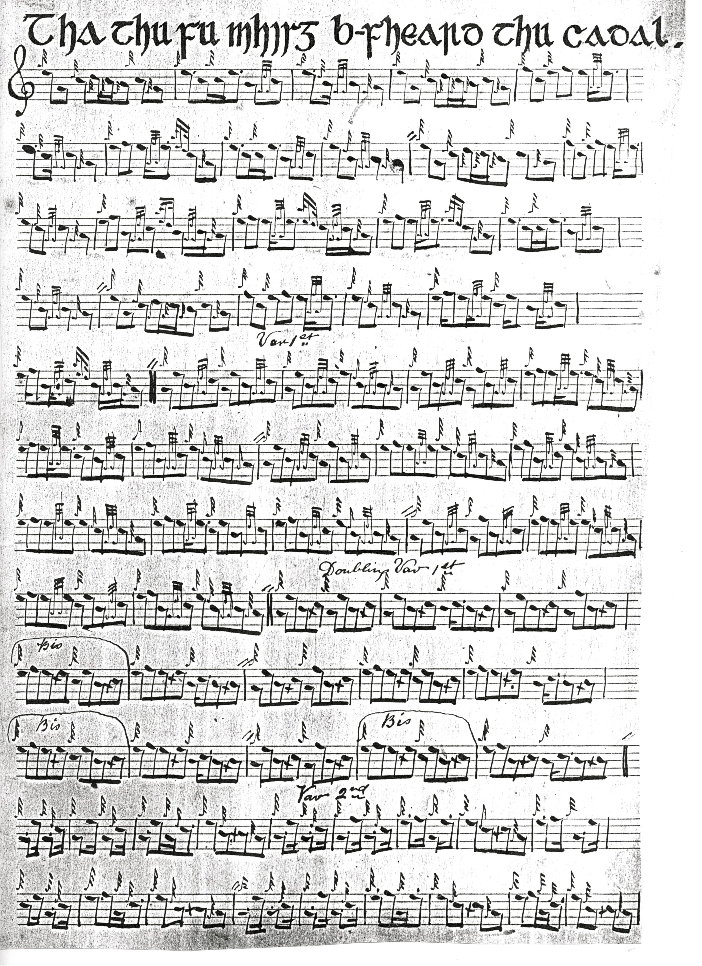
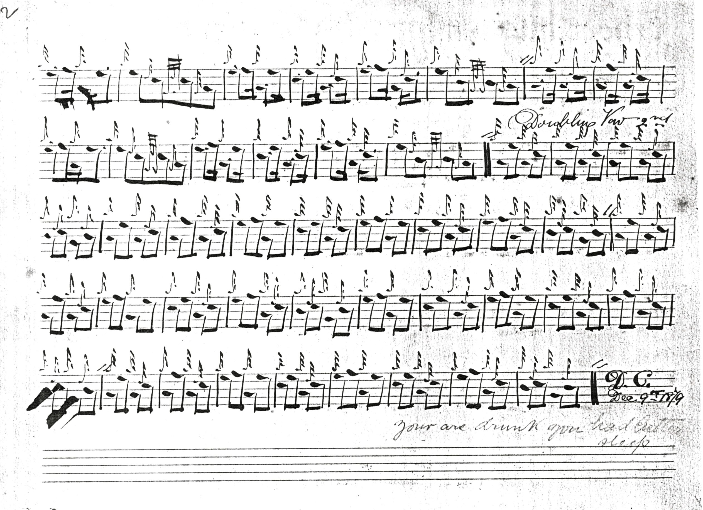

Gillies’s even quavers would allow one to play down on to the initial low A in the ground if one chose—an interesting possibility, seeing as this is the note emphasised in the variations which follow, and we see this realised in the published setting by David Glen below.

D. S. MacDonald adds nothing from an interpretational point of view to his source, Angus MacKay’s MS, and his score is not reproduced here.

David Glen has settings of this tune both in manuscript and in published form. The MS setting is as follows:
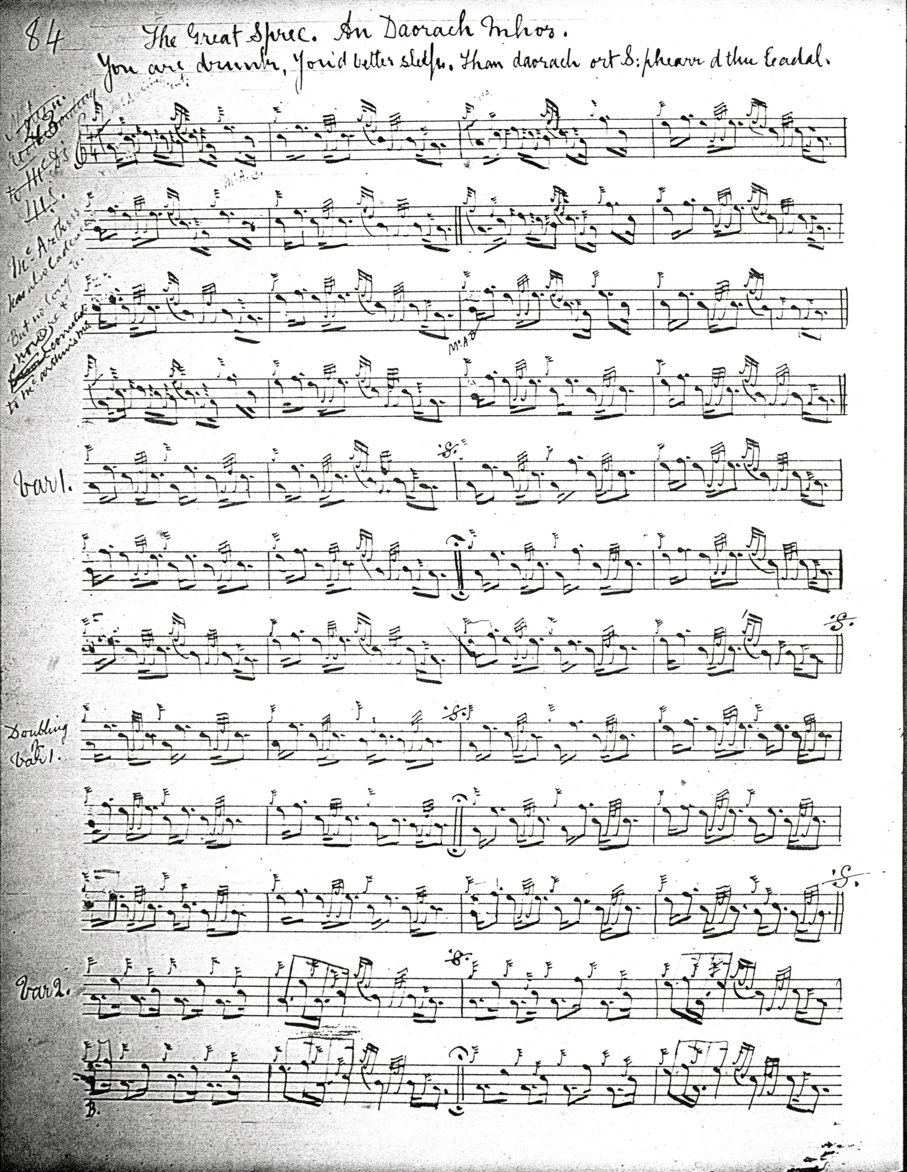
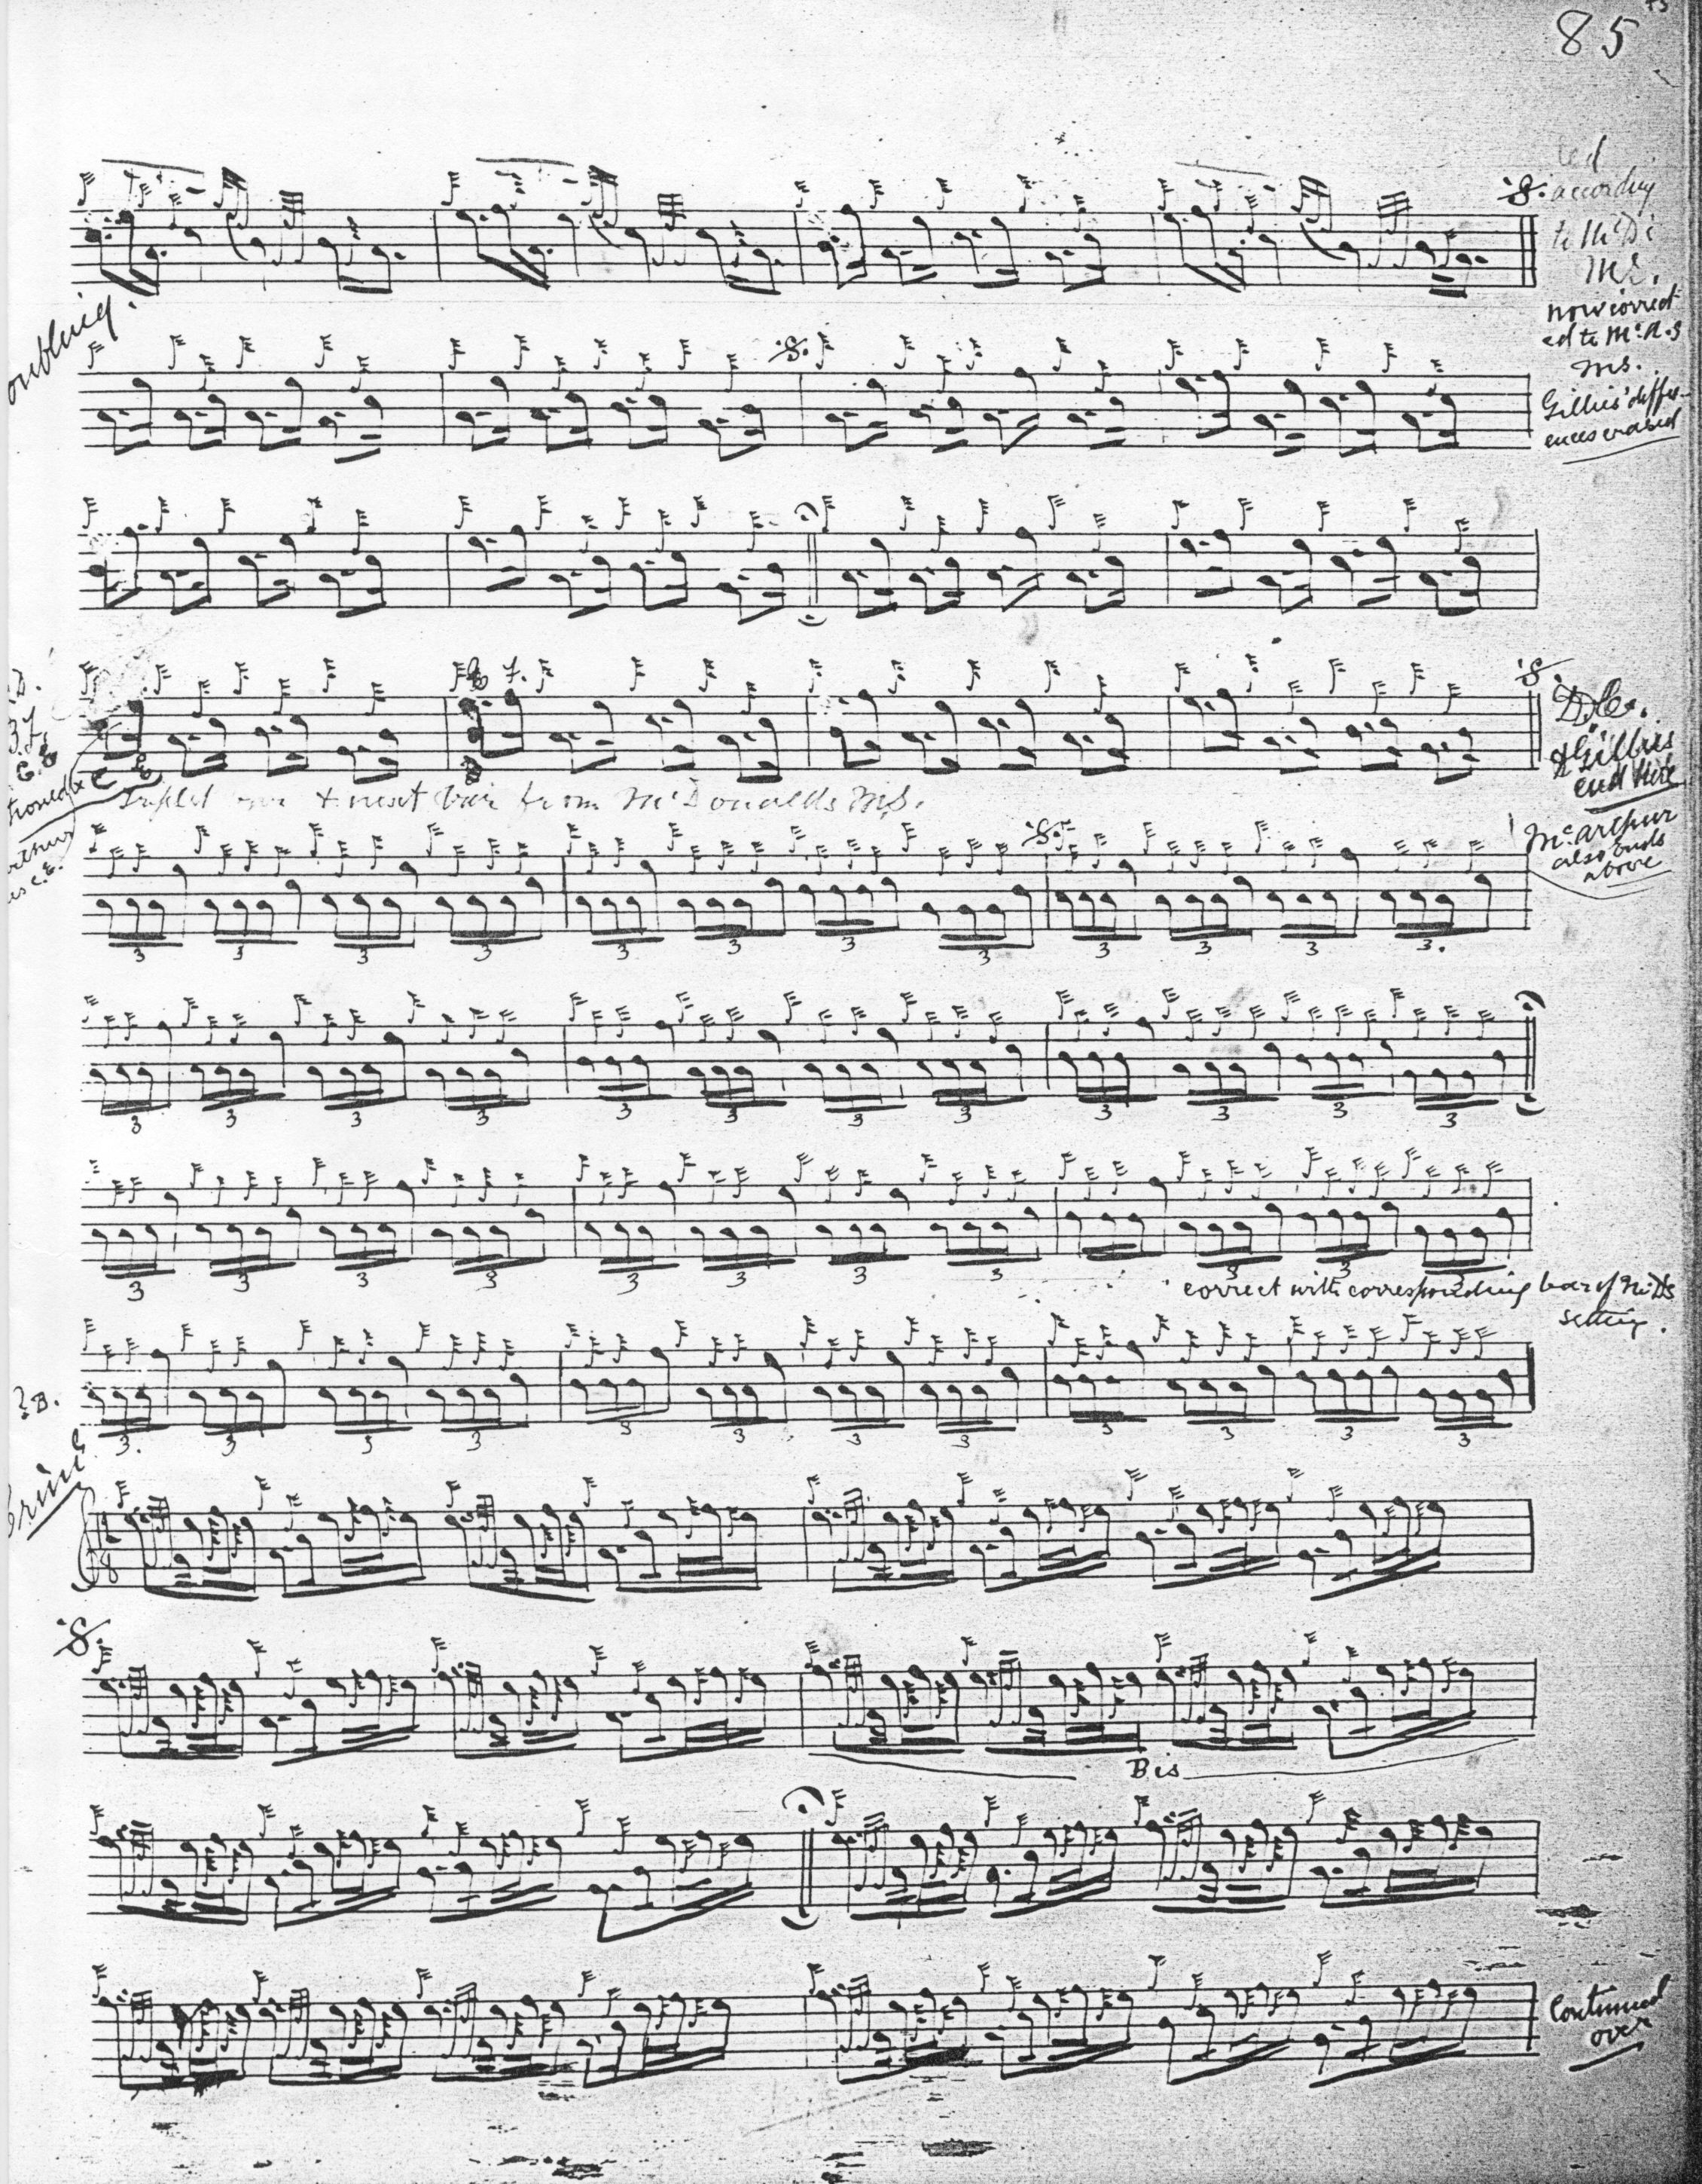

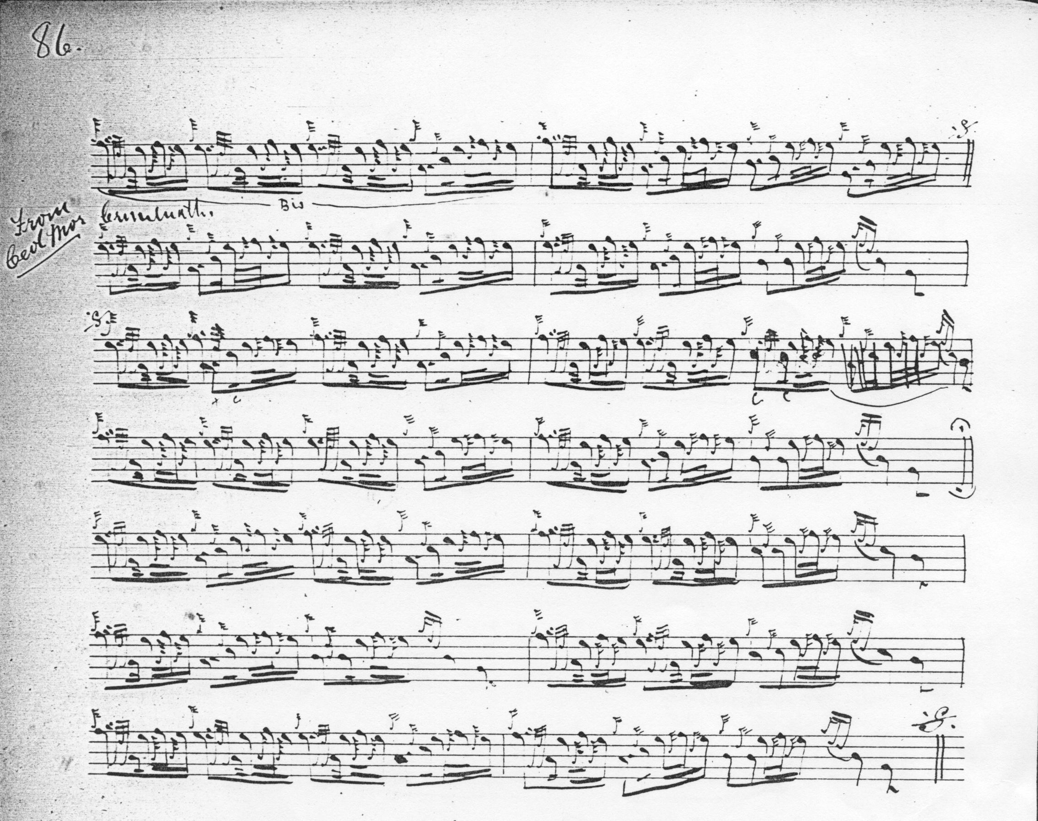

We know that Glen had access to Donald MacDonald’s manuscript and also MacArthur-MacGregor, thanks to his friends Charles Simeon Thomason and Charles Bannatyne in whose possession these papers then were, and we know, too, how closely John MacDougall Gillies was involved in mainstream later nineteenth-century piobaireachd research. We see in Glen’s papers, then, a typical “piper’s workshop”, as the editor worked his way towards a pleasing eclectic setting drawn from a number of identified written sources, making notes on their differences from one another. Glen’s marginalia show the basic method: he has a note alongside the first variation, for example, saying “according to McD’s S. now corrected to McA’s MS. Gillies’ differences erased”; at the end of the siubhal doubling he indicates a Da Capo Thema and notes “Gillies ends here. McArthur also ends above”; between lines three and four of the taorluath fosgailte variation he says “correct with corresponding bars of M’D’s setting”. Here, we see being successfully accomplished what Piobaireachd Society editors Archibald Campbell and J. P. Grant set themselves to do, but could not achieve, being consistently unable to reach acceptable standards of musical accuracy. It seems all the odder when we consider that the task they took upon themselves in the second and third decades of the twentieth century—namely to produce a reliable and affordable modern edition--had already been realised by David Glen. A century later, Glen’s unpublished manuscript score still looks like the pick of the available settings in 4/4 time.

It is curious that in his published Collection of Ancient Piobaireachd, Glen elected to print a version based on Angus MacKay, but developing the tune through to taorluath and crunluath variations, singling and doubling:

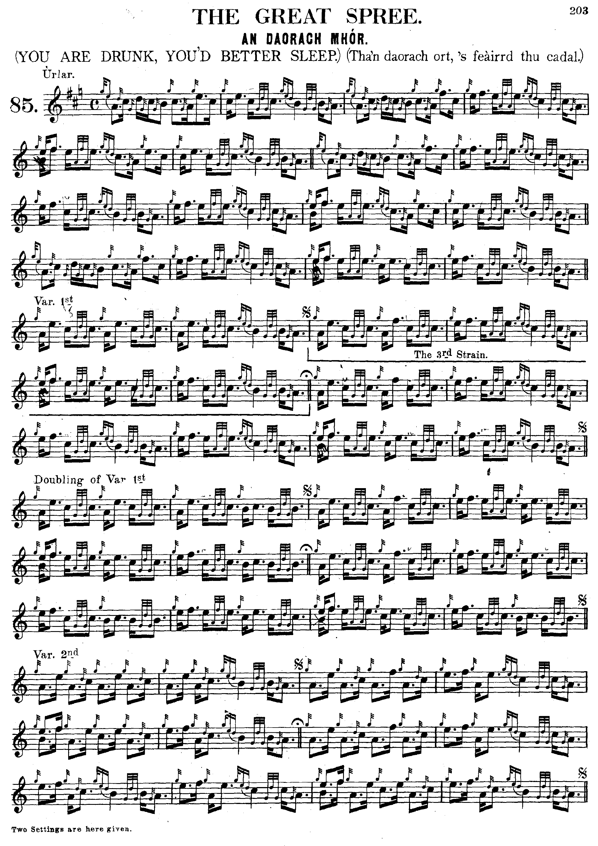
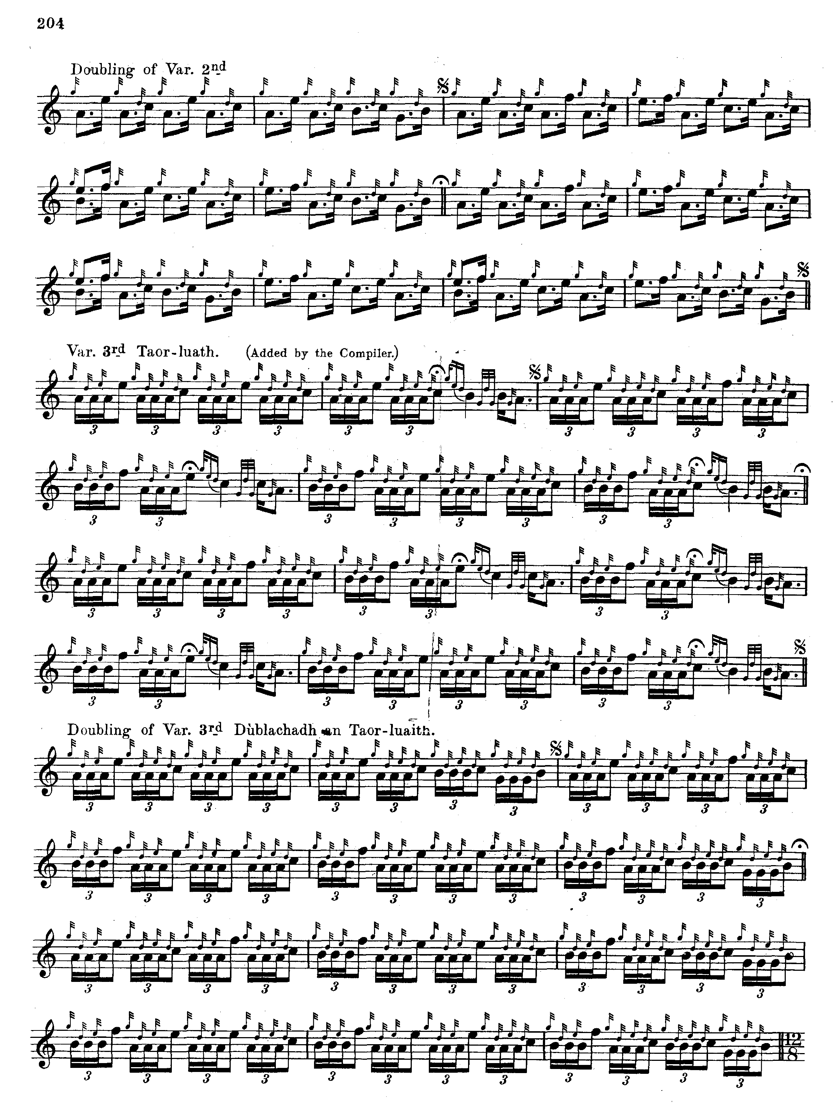
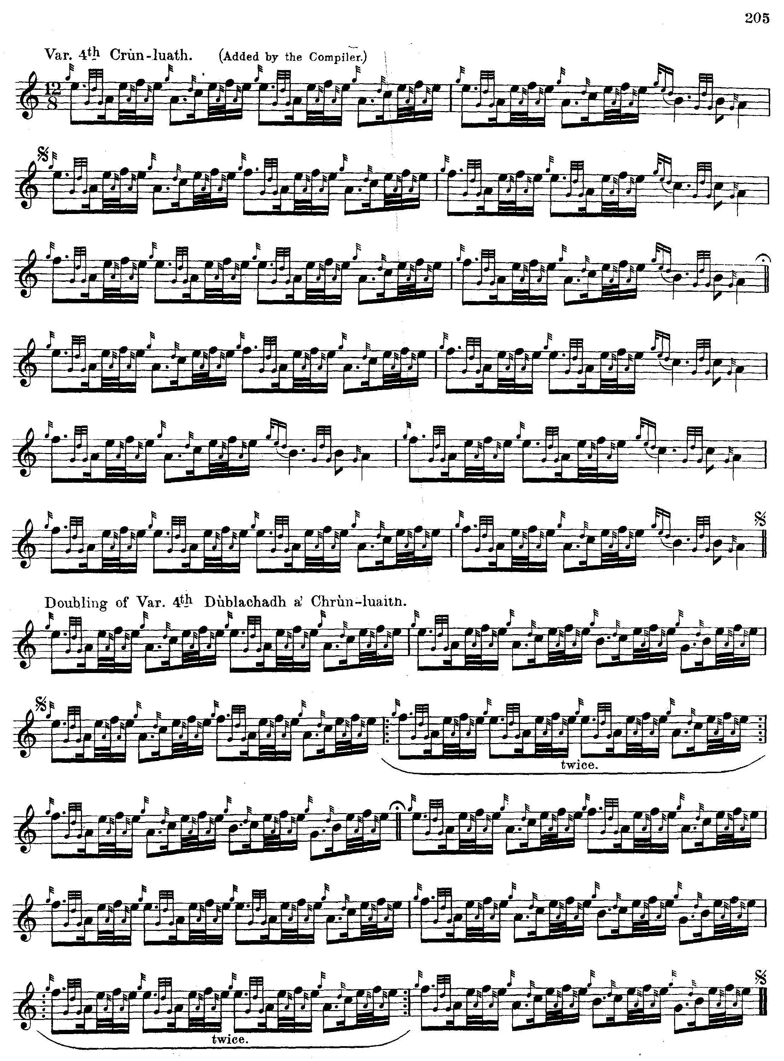

Presumably the new emphasis on the initial low A was to reflect its prominence in the opening gesture of the variations

C. S. Thomason gives an edited version of Donald MacKay the younger’s setting taught to the latter by Donald Cameron:

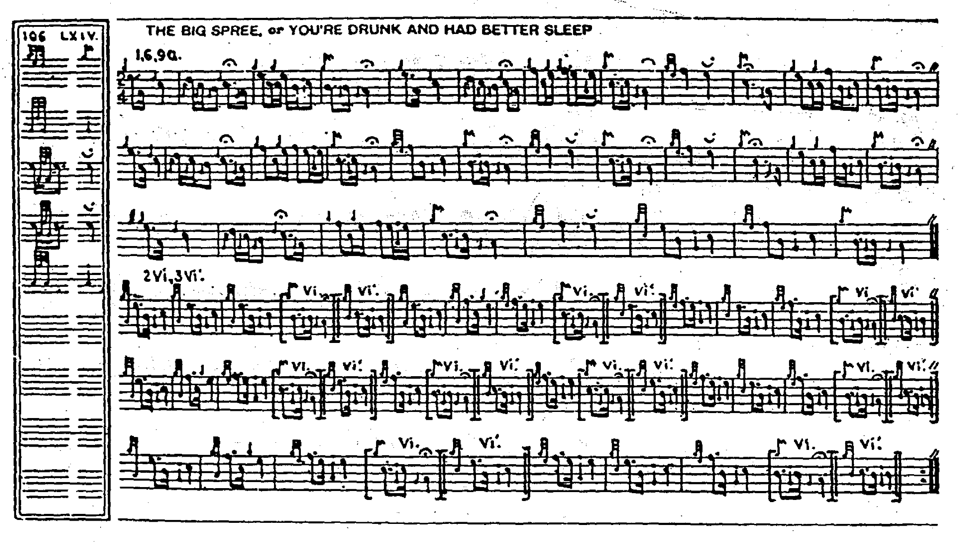

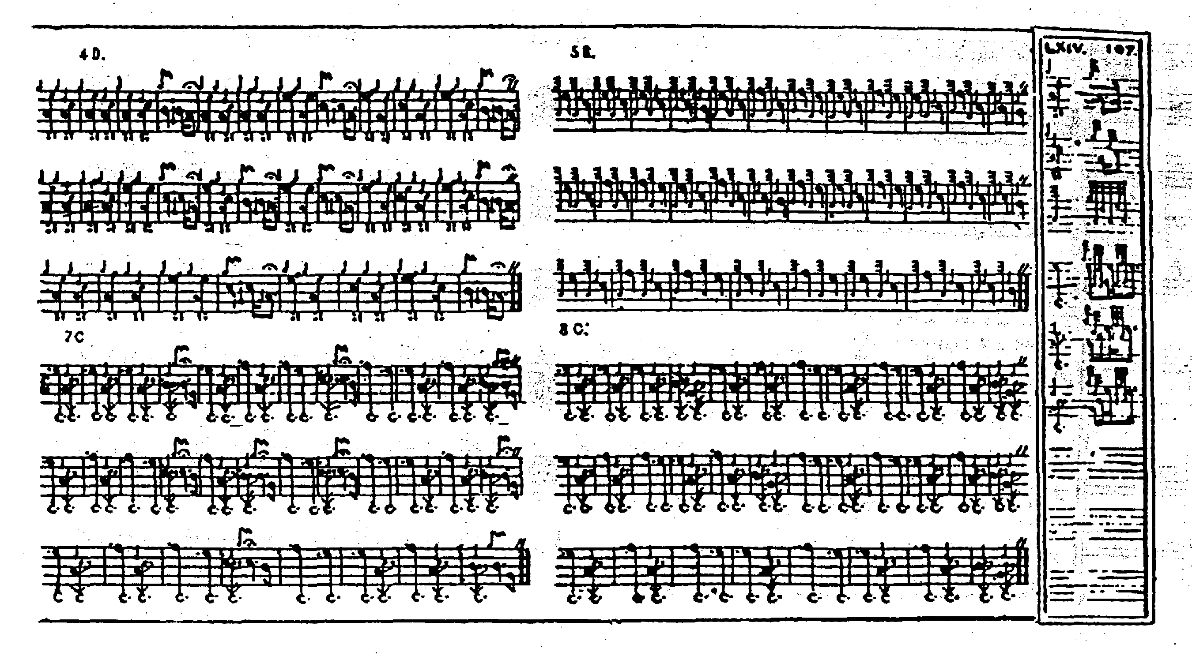

There are clear stylistic links with the settings of Colin Cameron and John MacDougall Gillies above, as one would expect since Thomason too was a Cameron pupil, but Thomason develops the tune to incorporate the later variations: a single taorluath fosgailte and crunluath singling and doubling; so that if one wanted to play a full-length setting of this tune as it came down through the family of Donald Cameron, this would be the obvious choice. Thomason’s setting differs significantly from that published in volume one of the Piobaireachd Society Collection (Second Series) which is claimed to be based on the playing of Colin Cameron’s brother Sandy. Most interestingly, Thomason sets the tune, as Angus MacKay did, in 2/4 time, which gives a very different—and some might think superior—reading of the melody. We shall see something of this in the accompanying MP3 file.

Robert Meldrum’s score seems to be a composite one derived from Thomason and the Piobaireachd Society’s Second Series. It is not reproduced here.

G. F. Ross, with his passion for precision and balance between parts, takes issue with the Piobaireachd Society’s setting, and with Donald MacDonald’s version of the tune:

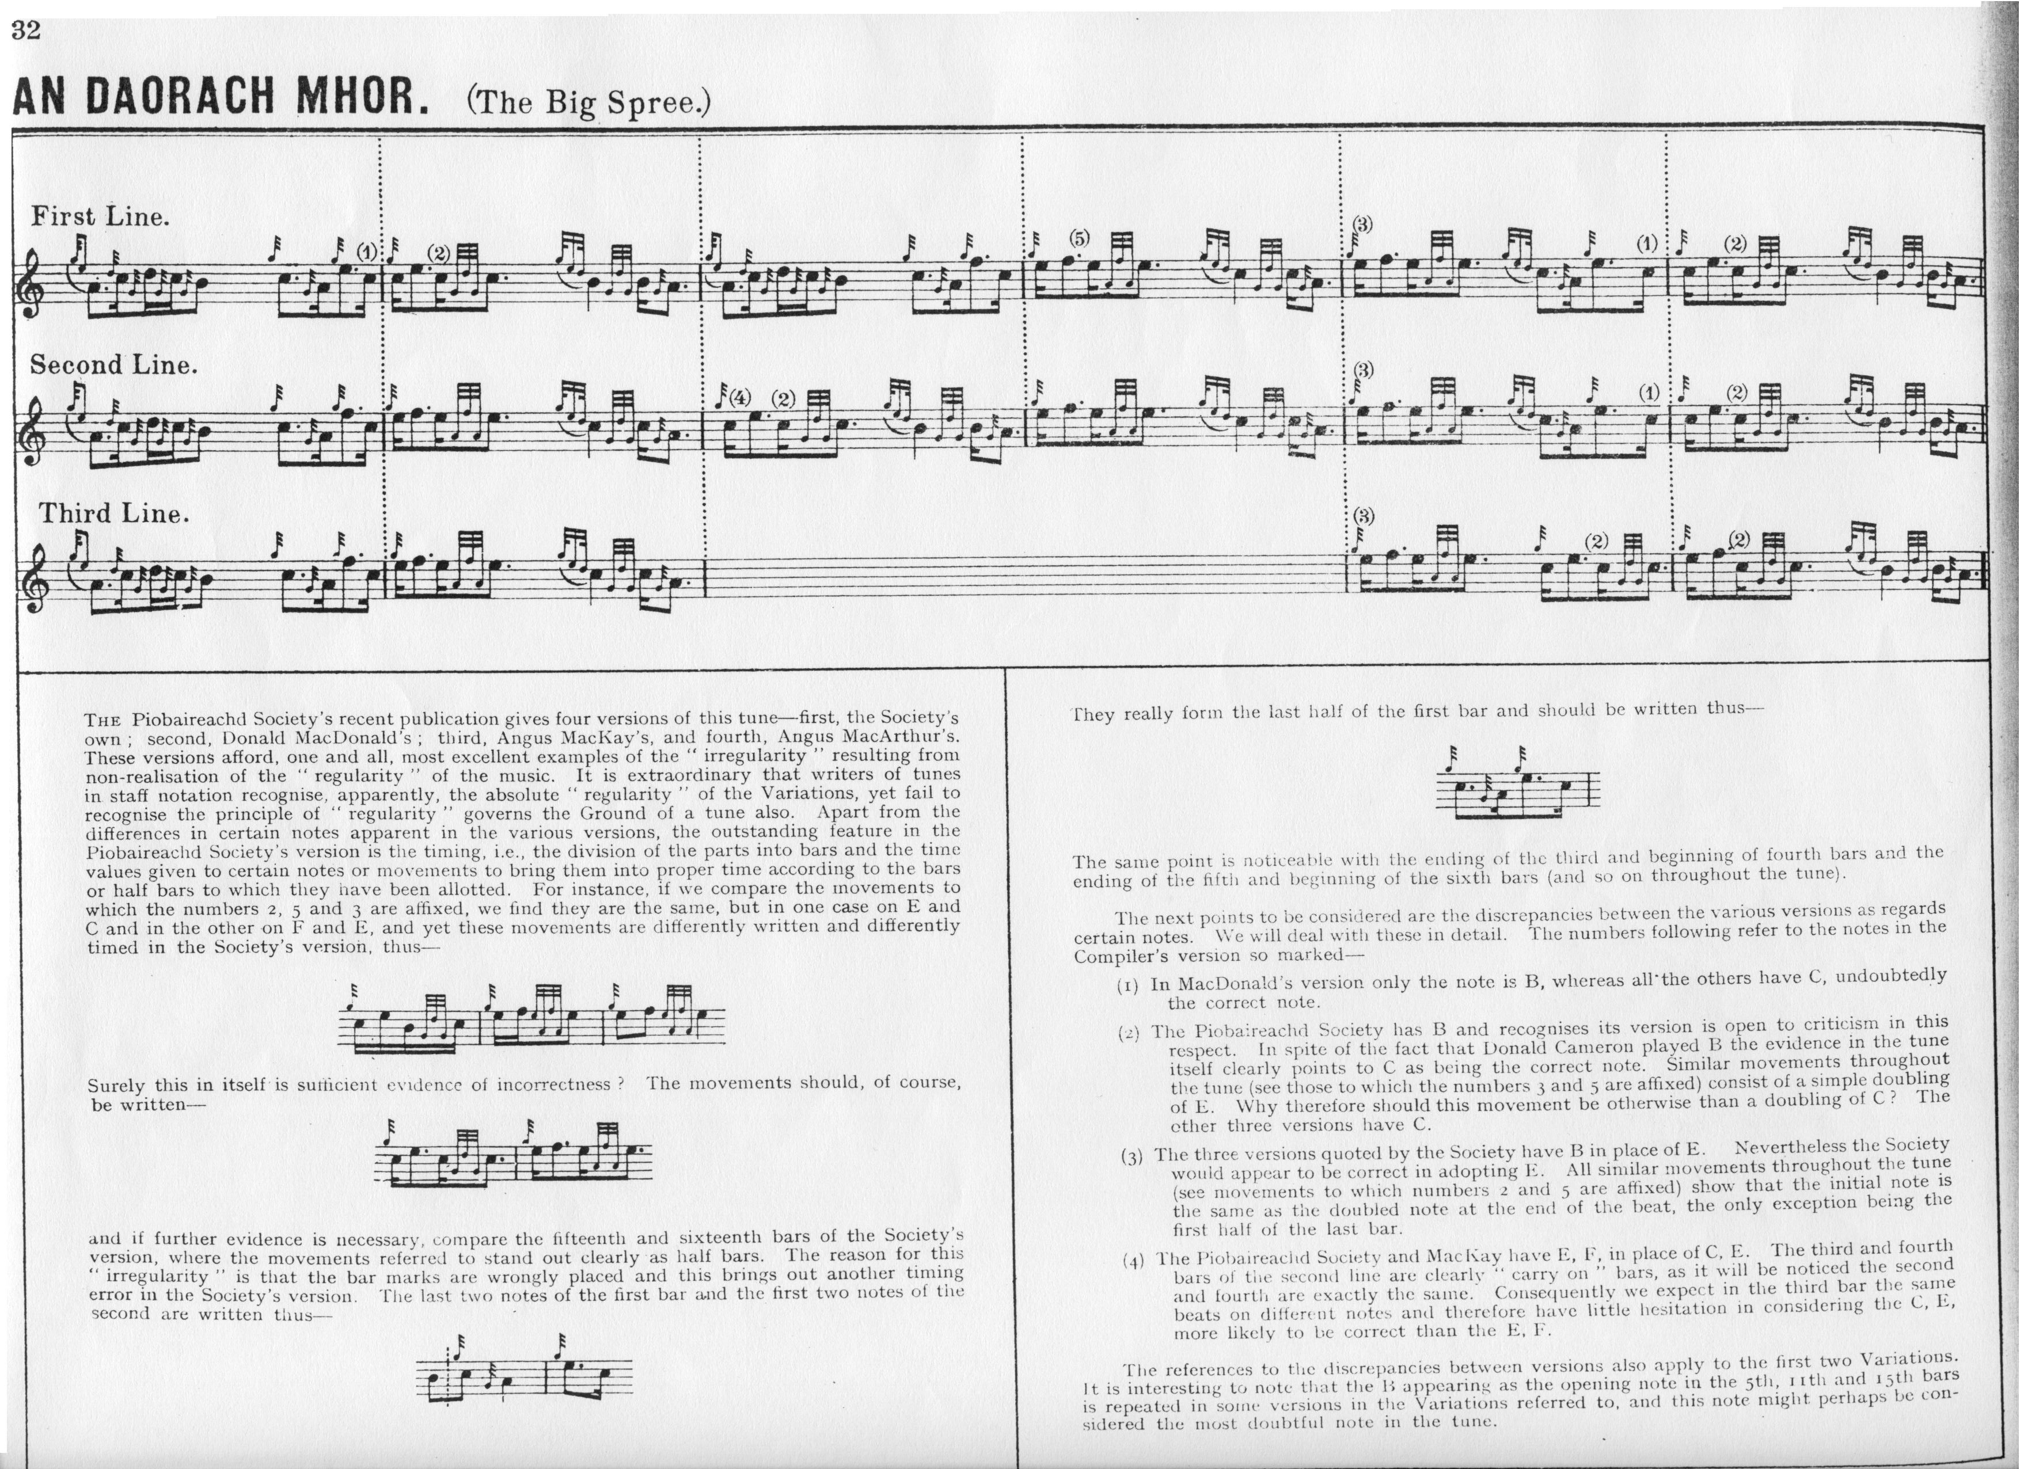

G. F. Ross can sometimes seem doctrinaire, but there does seem to be a good deal of silent straying between time signatures in the Society’s ground. Perhaps it is this that encourages pipers to tiptoe through the piece as through a minefield treating every phrase "on its merits", which further obscures the essentially flowing and expressive character of the melody.

Commentary:

As we have seen, Donald MacDonald continues the tune through to a Crunluath variation; but few of the sources seem to agree on the tune's length. Perhaps this represents artistic choices on the part of the compilers; but it is notable in the earlier authorities’ treatment of a number of tunes, that they are not always developed through to what seems to us their logical conclusion. Which raises, in turn, the vexed problem of scribal practice. A number of the early sources doggedly render a tune through all its variations, but in some the main outlines only are given leaving the remainder merely implicit.

Here is the note to the tune from Donald MacDonald’s MS:

This Piobaireachd was composed by one of the Chiefs of the Macgregors on one of his vassals, who was a very valiant man; he was a blacksmith by trade, and he was often the foremost at all the battles he was engaged in; but there were times when he would get quite deranged, occasioned by his partaking to freely of ardent spirits, which was the cause of the above air being composed. There are three Daorachs, viz. An Daorach Mhor, ’s an Daorach Mheanach, ’s an Daorach Bheg; the whole of which were made upon the same wild hero. “History of the Airs in this Volume” p.4.

This is one of the most widely-distributed tunes in the manuscript tradition, suggesting that despite its editorial difficulties, it was regarded as a centrally important piece

* * *

Electronic text © Dr. William Donaldson, Cambridge, Massachusetts, 13 May 2014

