The Bicker
There are settings of this tune in the following manuscript sources:
--Colin Mór Campbell’s “Nether Lorn Canntaireachd” i, 96 (with the title “Robt Sinclairs Wife Lament”);
--Angus MacKay’s MS, i, 243-4 (with the title “Port a Mheadair”, and also in his “Kintarbert” and Seaforth MSS—see below);
--Duncan Campbell of Foss’s MS, ff.148-9;
--Colin Cameron’s MS, f. 111;
--Uilleam Ross’s MS, ff.144-5;
--John MacDougall Gillies’s MS, f.9;
--Iain McLennan (McLennan Papers, National Library of Scotland, Acc.115. 16/8), f. 16;

and in the following published sources:
--C. S. Thomason, Ceol Mor, p.343 (with the title “The Extirpation of the Tinkers by the King’s Orders”);
--David Glen, Ancient Piobaireachd, pp.144-145.

Colin Campbell sets the tune like this:

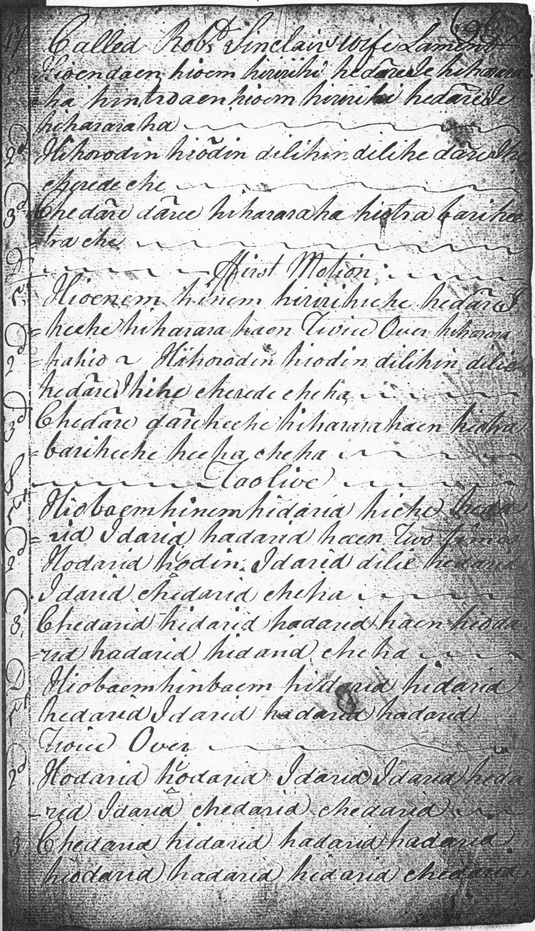
As it stands, the Nether Lorn setting proceeds no further than the taorluath doubling.

Angus MacKay gives two quite different tunes under the “Port a Mheadair The Bicker” title in his main manuscript, i, 65-66 (marked in his English index as “John MacKay’s Sett”), and i, 243-44 (identified in the index as “MacDougall’s Sett”). The second of these is the “Bicker” tune discussed here which also appears in MacKay’s so-called “Kintarbert MS” (ff.175-6—with the title “The Royal Bicker”) and in his “Seaforth” MS (ff.16-17). In his main MS MacKay sets the piece as follows:

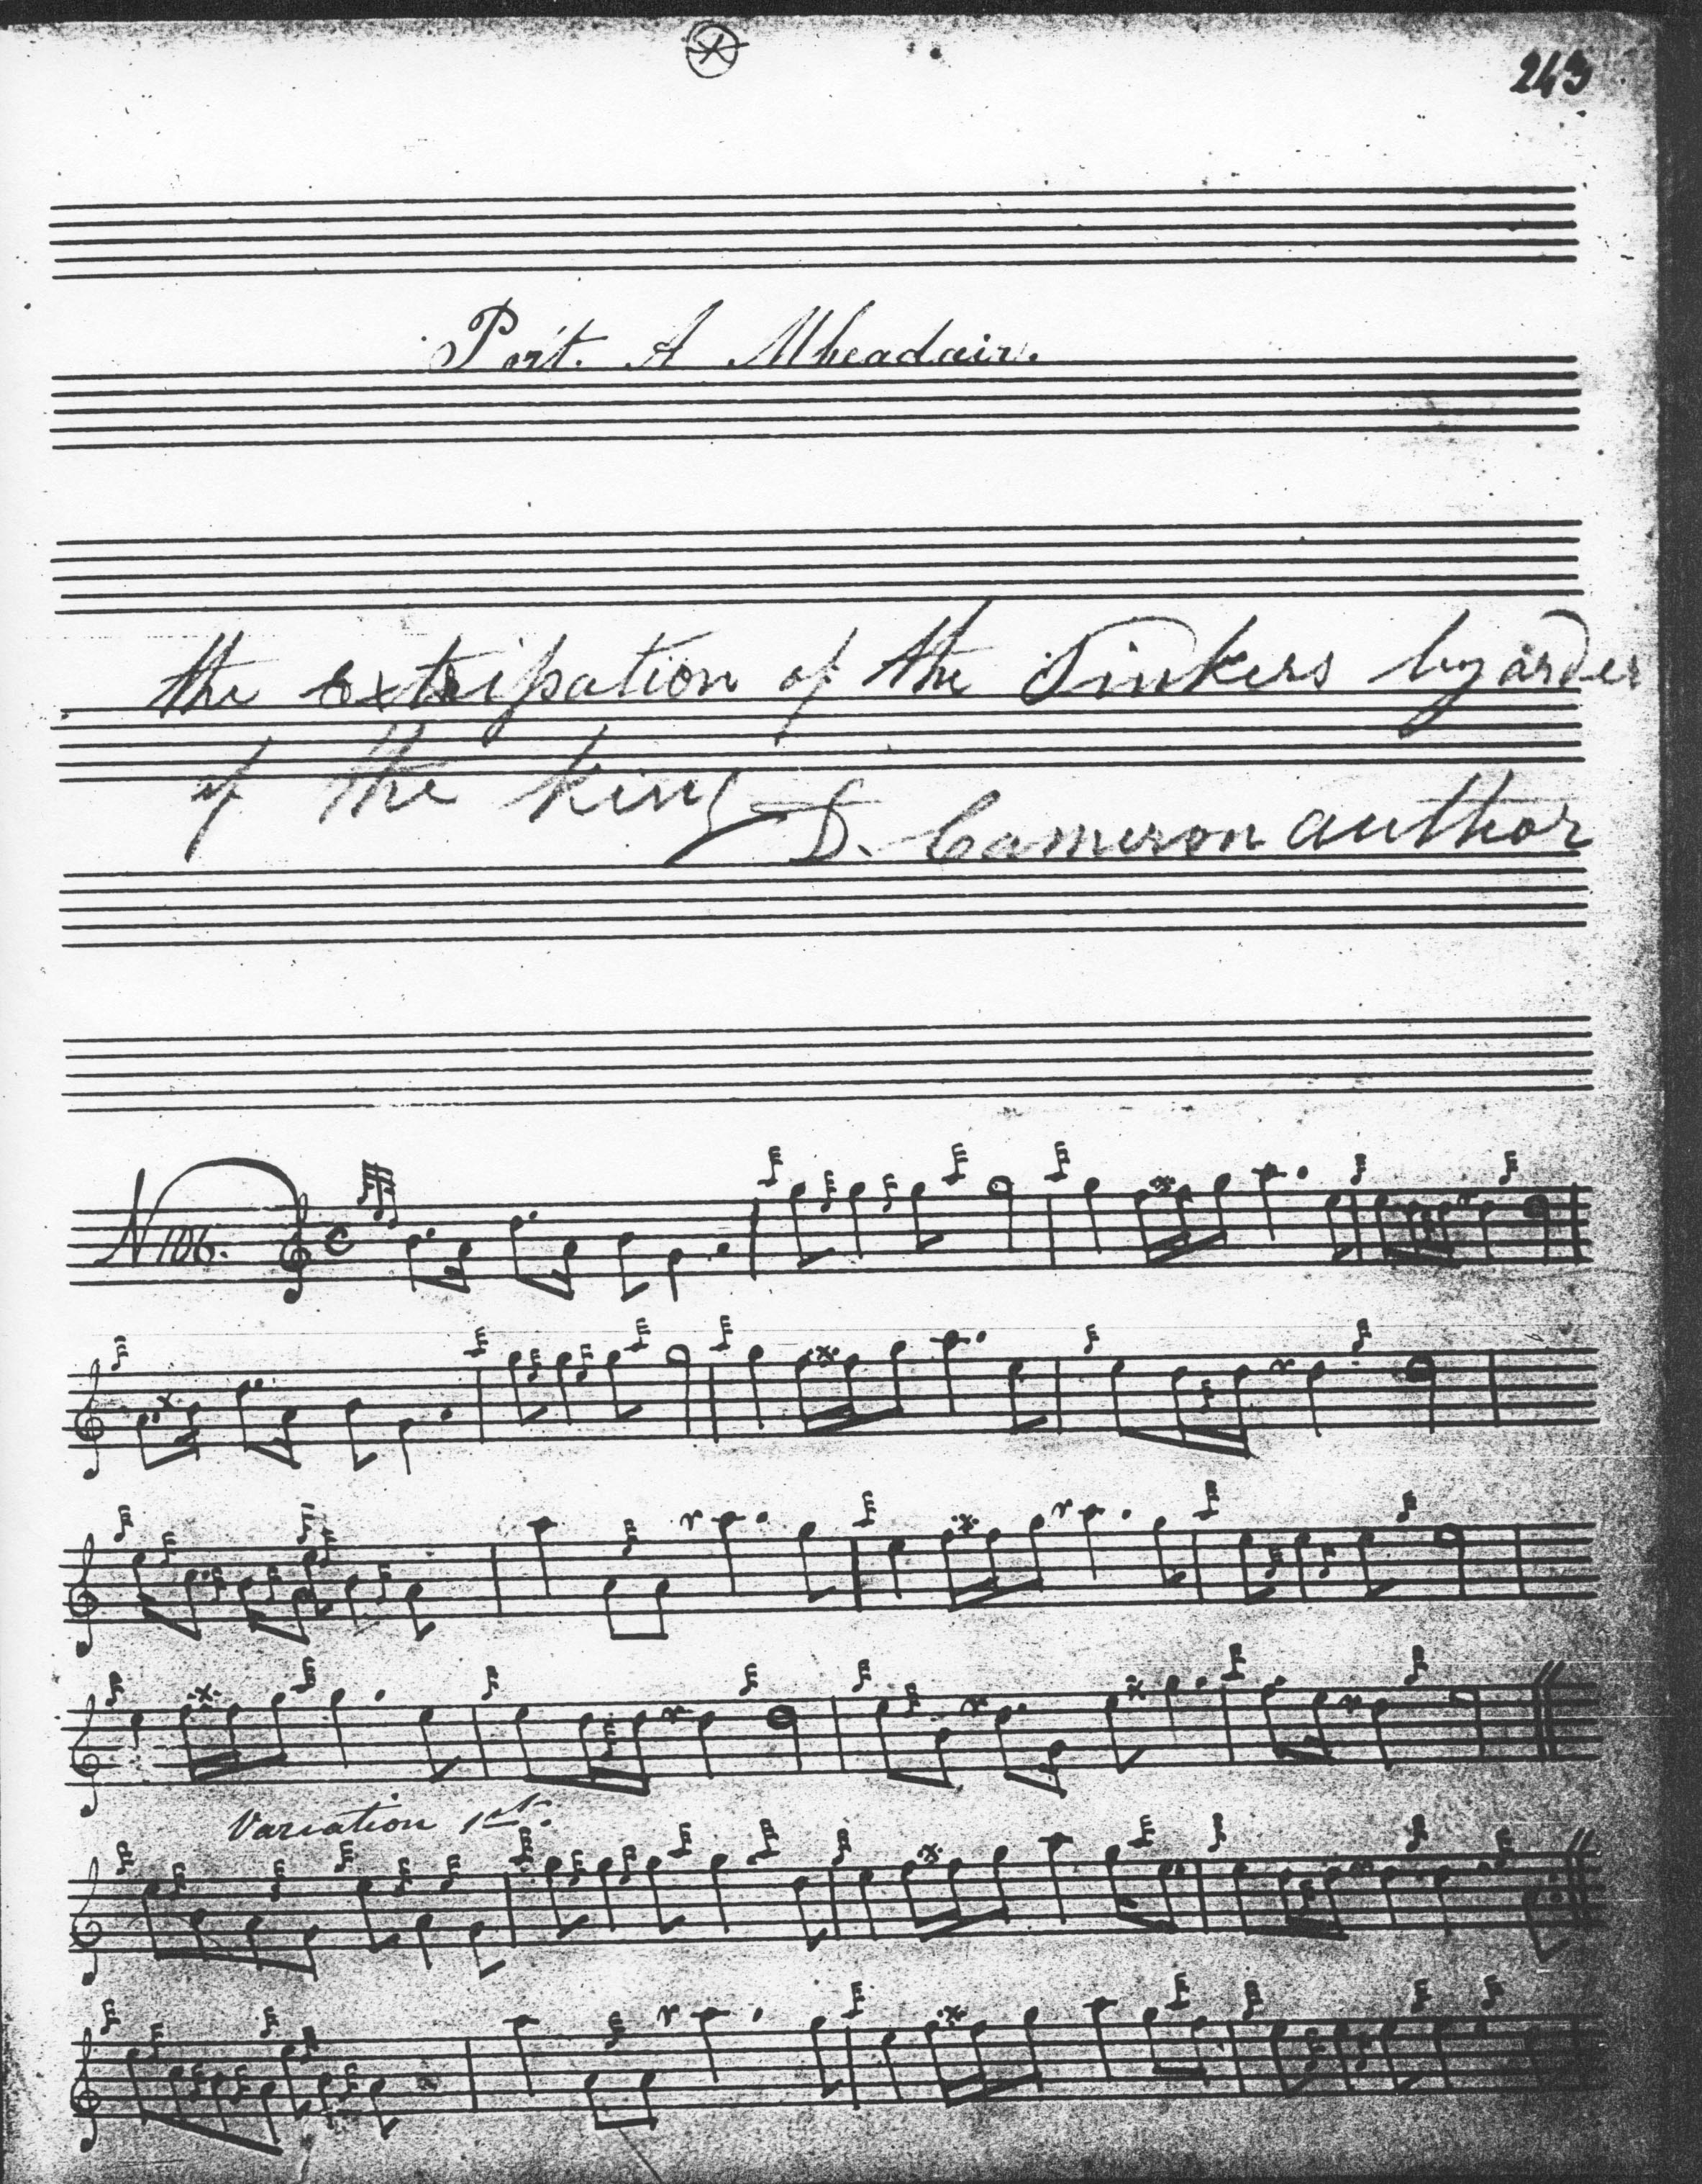

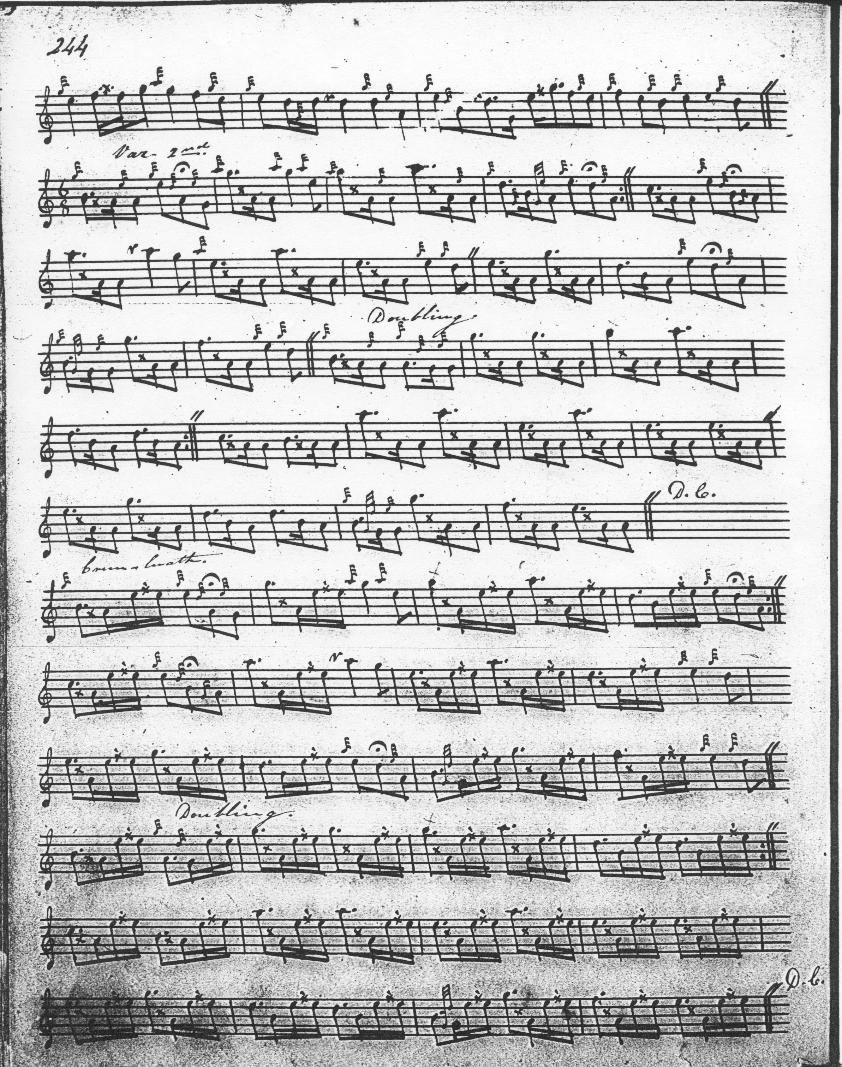

The note below the title, suggesting an alternative name for the tune: “The Extirpation of the Tinkers by order of the King D. Cameron author” has been inserted by a different hand, perhaps that of Donald Cameron. It is believed that Cameron had access to Donald MacDonald’s MSS when he was in Edinburgh for the Highland Societies’ competitions, which might suggest that he had access to Angus MacKay’s as well; he had been a pupil of John MacKay’s sons and counted Angus as a personal friend. The “D. Cameron author” may simply indicates that Cameron was responsible for the note, rather than laying claim as composer to the tune itself. It may have been his solution to the problem of the Bicker title being used by Angus MacKay to identify two quite different tunes.

Duncan Campbell sets the tune as follows: 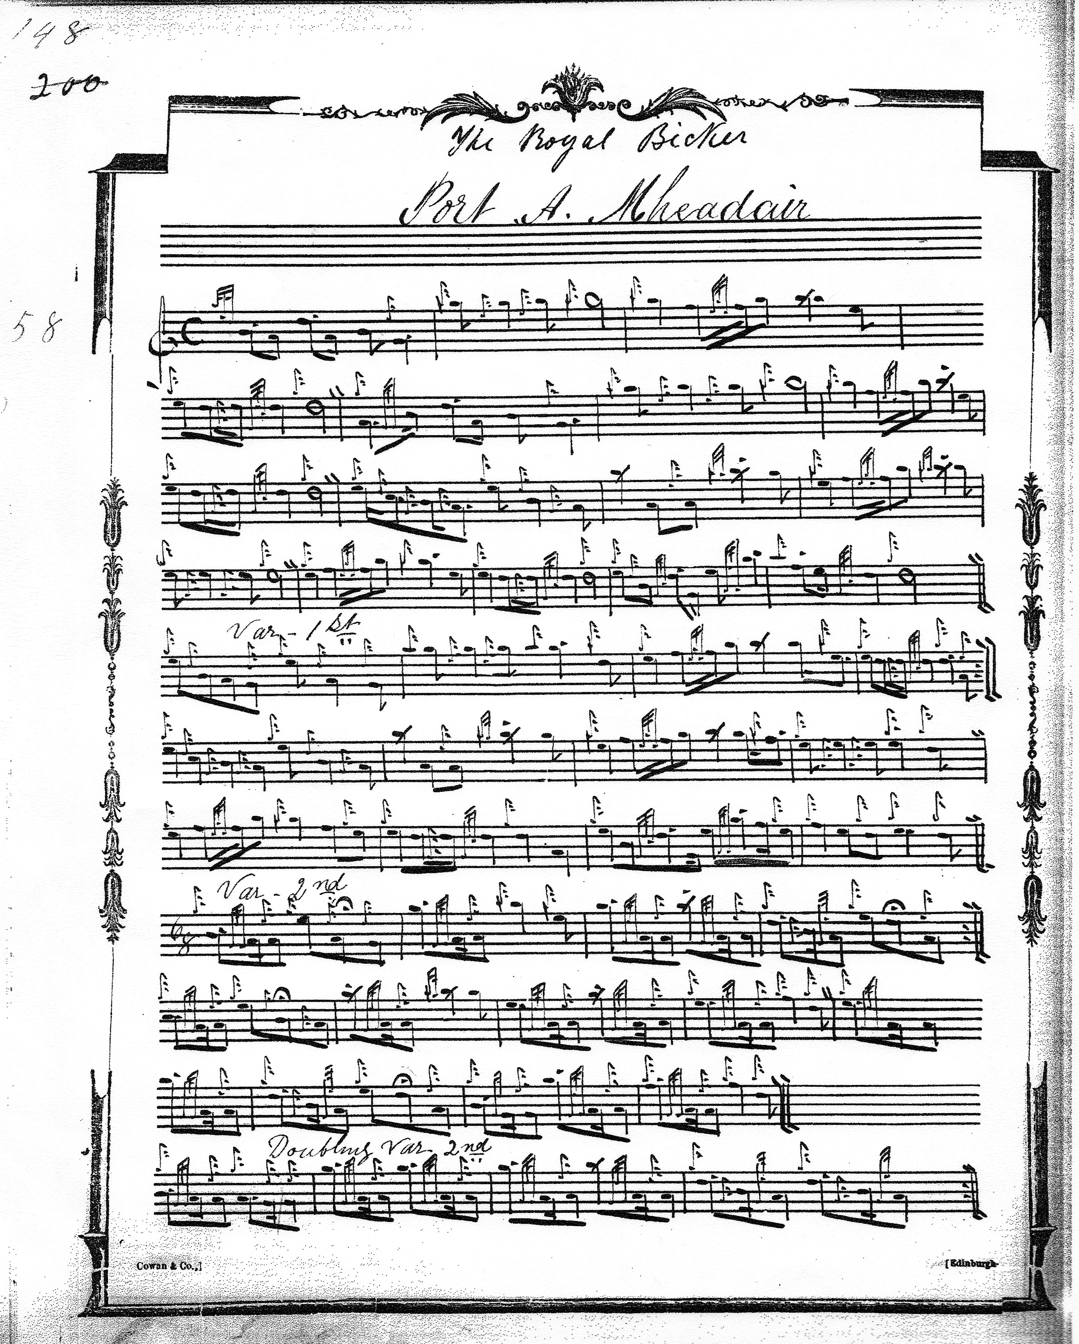

And so on. The score clearly derives from Angus MacKay’s, simply spelling out the ornamentation in detail where MacKay had used abbeviated symbols. At the end of the ground Duncan Campbell gives D rather than E as the main melody note, but this seems to be a transcription error. The only real difference is that Campbell does not indicate that the ground be repeated after the taorluath doubling.

Colin Cameron sets the tune like this:

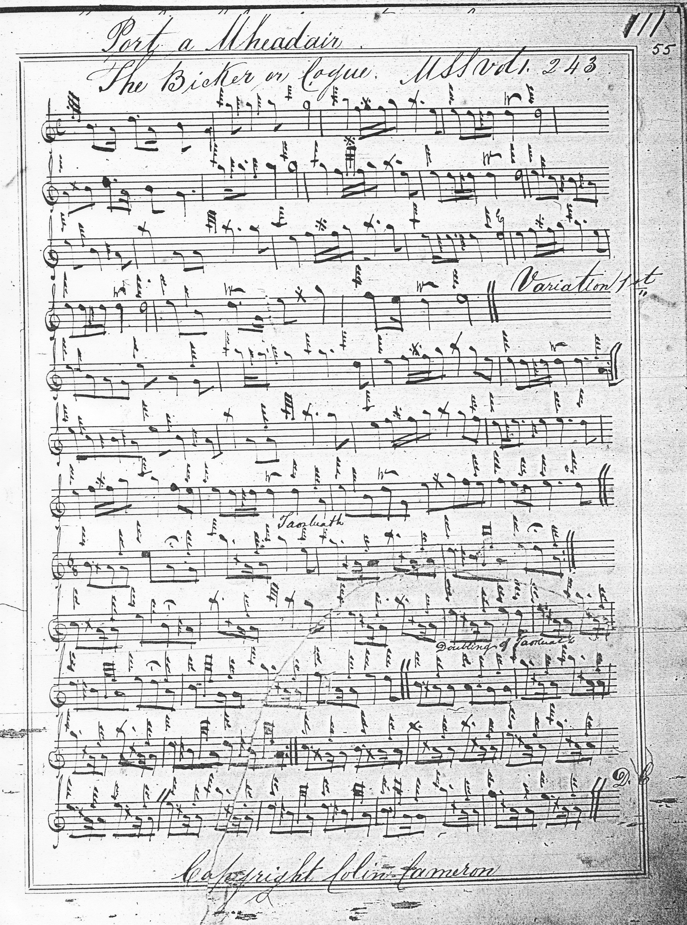

The main influence here seems once again to be Angus MacKay’s setting, although it is interesting that Colin Cameron should end the tune with the taorluath doubling which is where Colin Campbell’s score also terminates. For the treatment of the “run down” movements here, see the Commentary section below.

Uilleam Ross treats the ground like this:
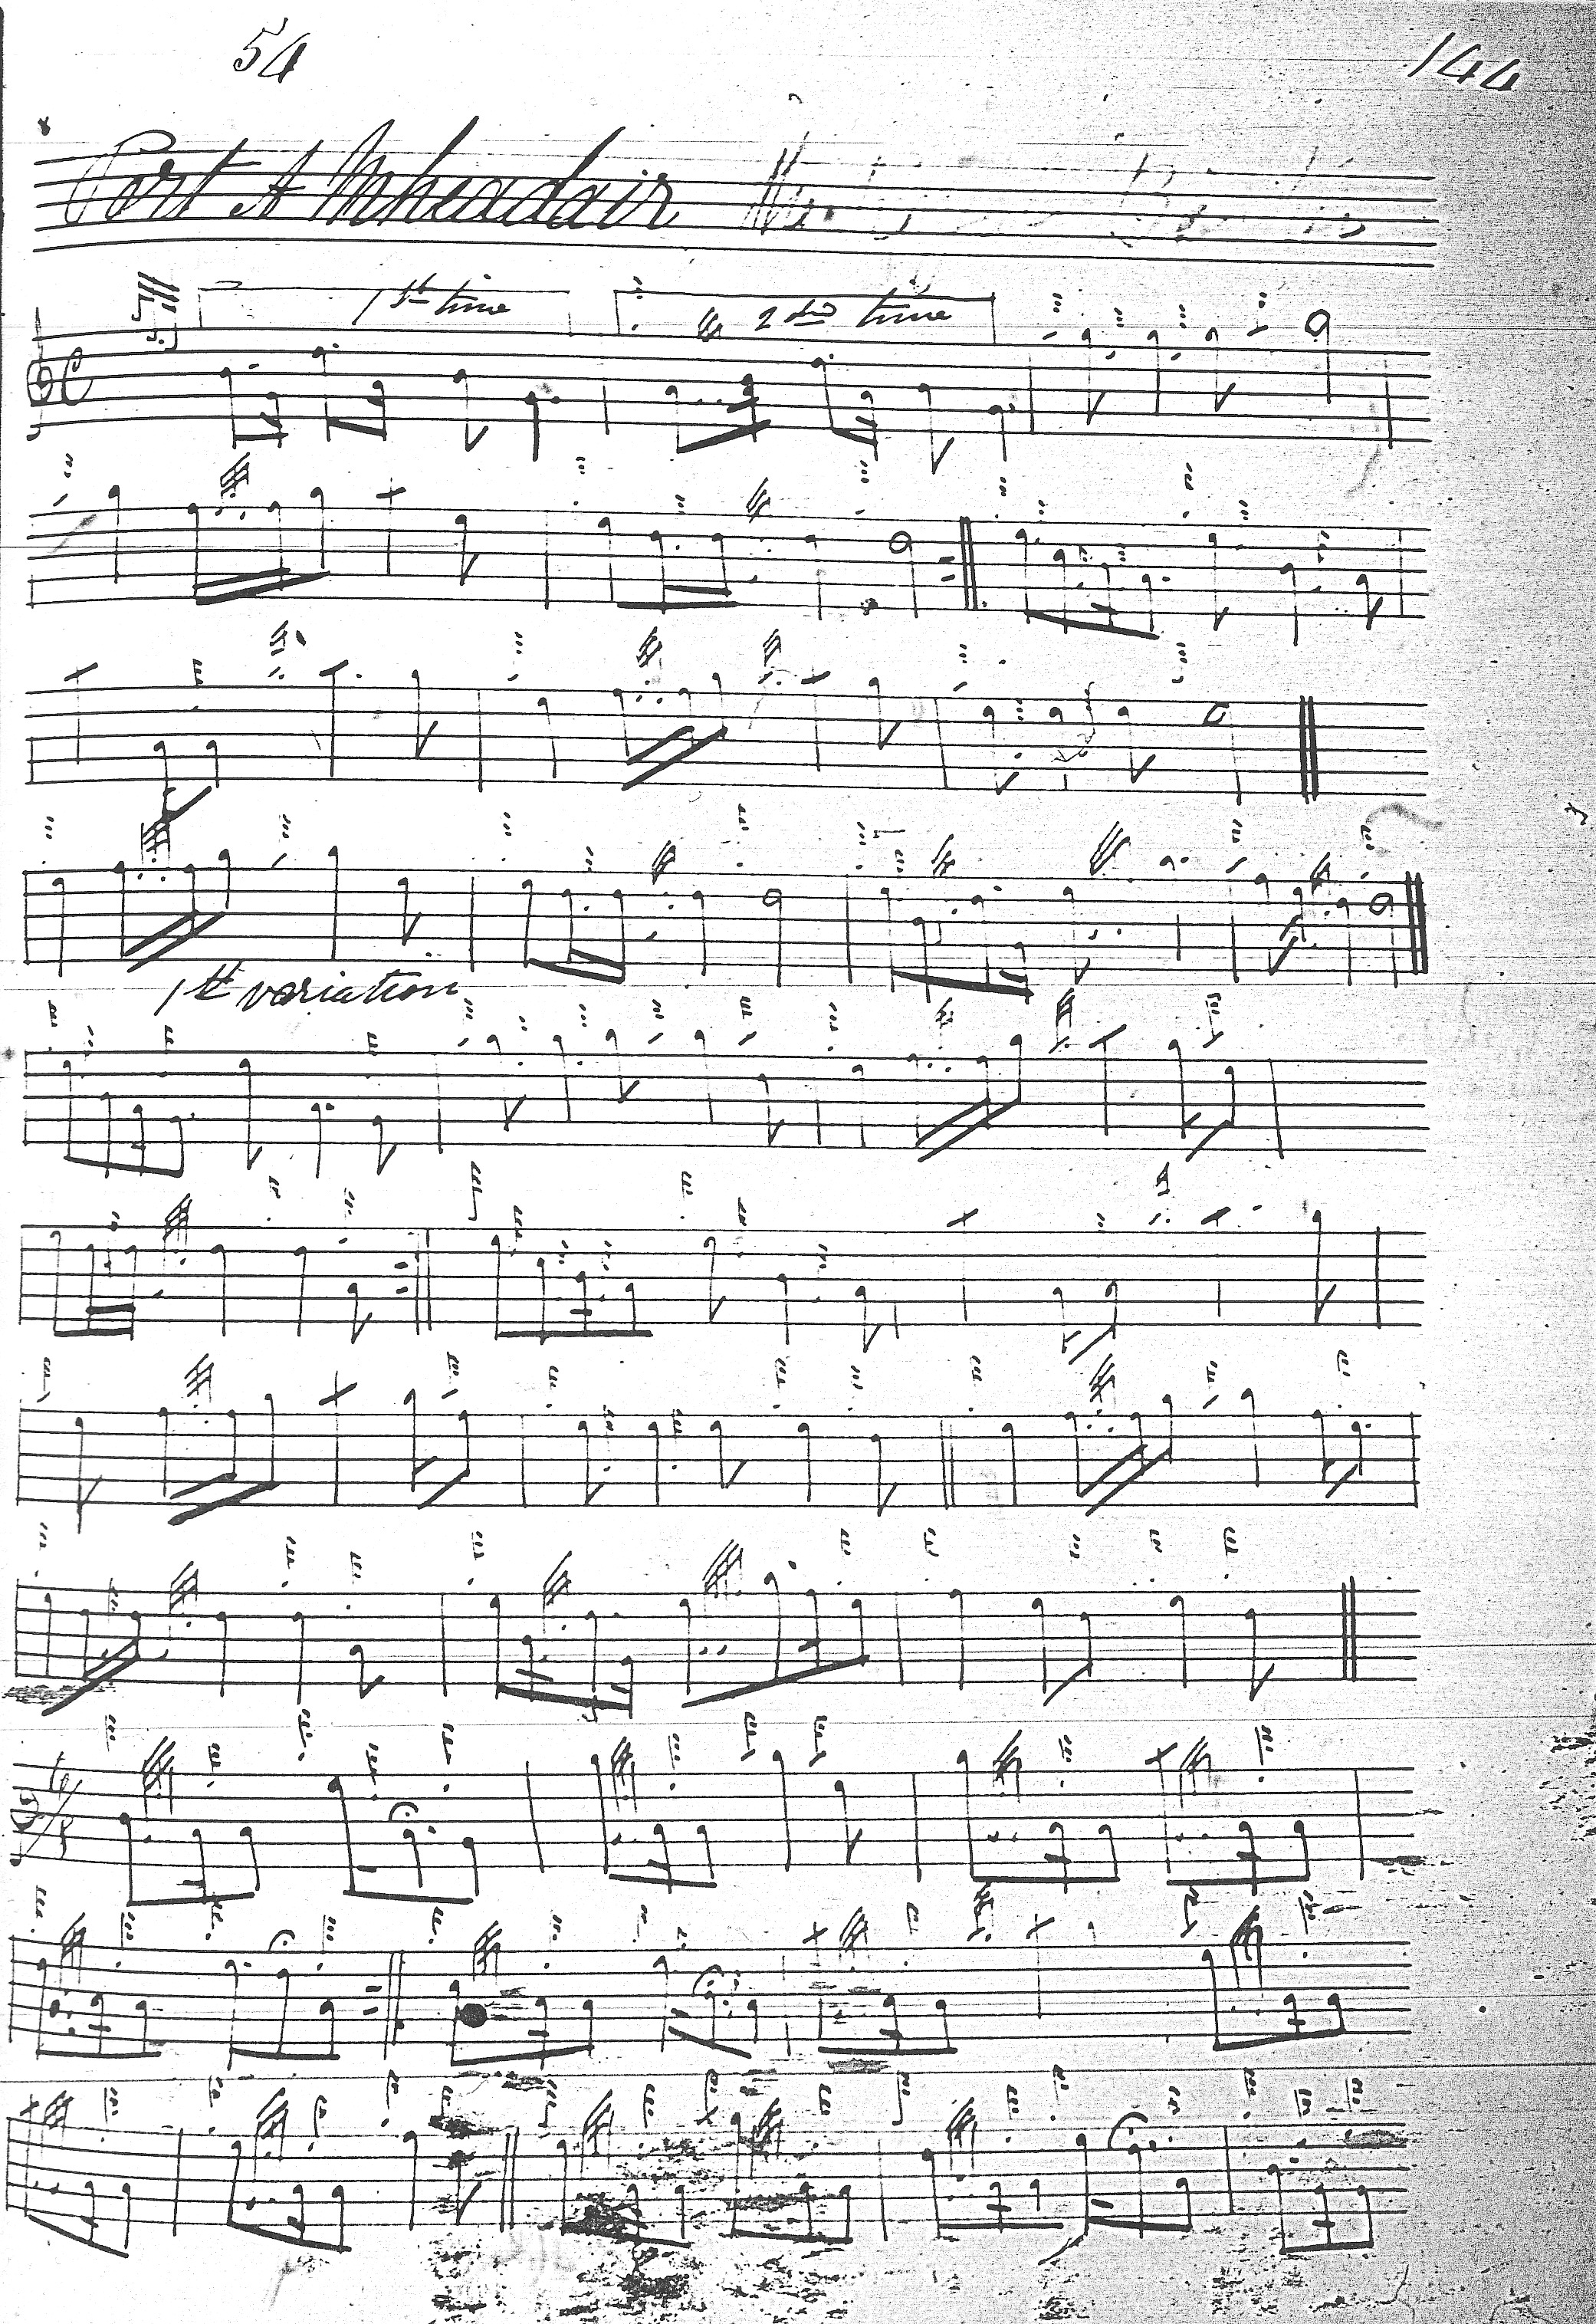

And so on. There are two departures from MacKay’s style in Uilleam Ross’s setting: first the attractive drop down to low G in the opening gesture, and next the held D at the end of the Ground that we see also in Duncan Campbell.

John MacDougal Gillies has interesting little differences from Colin Cameron, but he, too, ends with the taorluath doubling and re-statement of the ground:

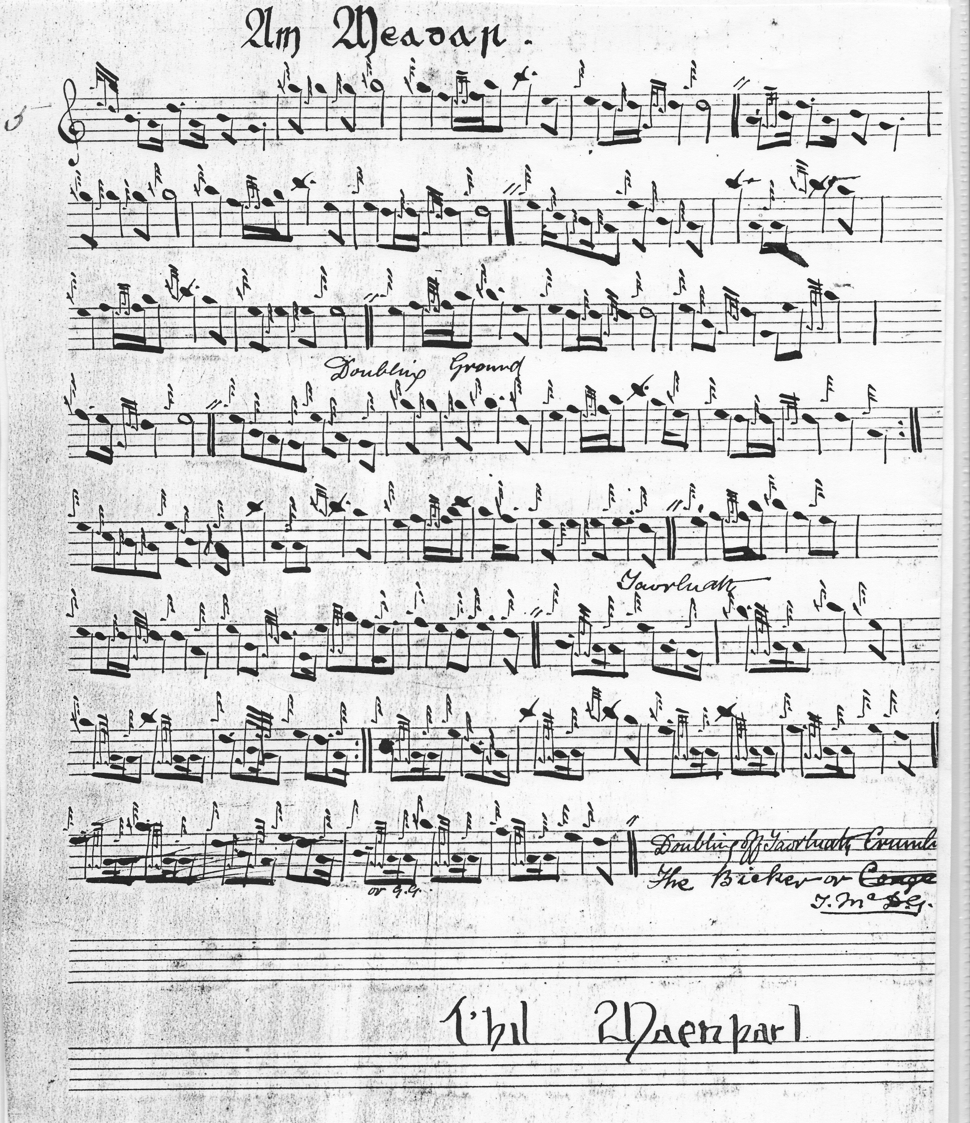

An outline setting of this tune is preserved amongst the papers of Lt. Iain McLennan, father and teacher of G. S. McLennan:
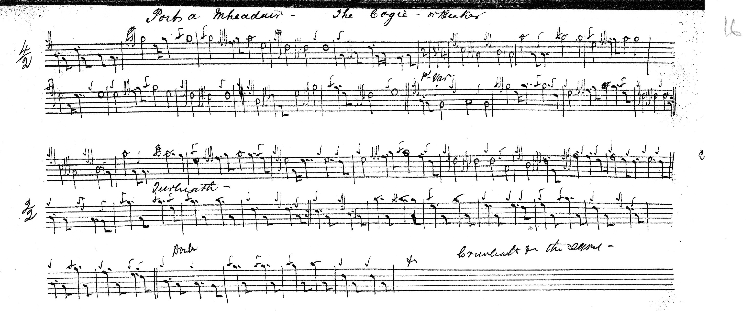

This shows the throw up to high G in bar two played off a low A rather than low G as in the other scores; also we see prolongation of what are treated as passing notes by other editors to accommodate McLennan’s preferred 4/2 setting. The musical gain is not entirely clear.

C. S. Thomason’s setting does not add to the expressive possibilities of the tune and is not reproduced here.

David Glen’s score presents a useful summary of the 19th century’s conclusions about this tune:
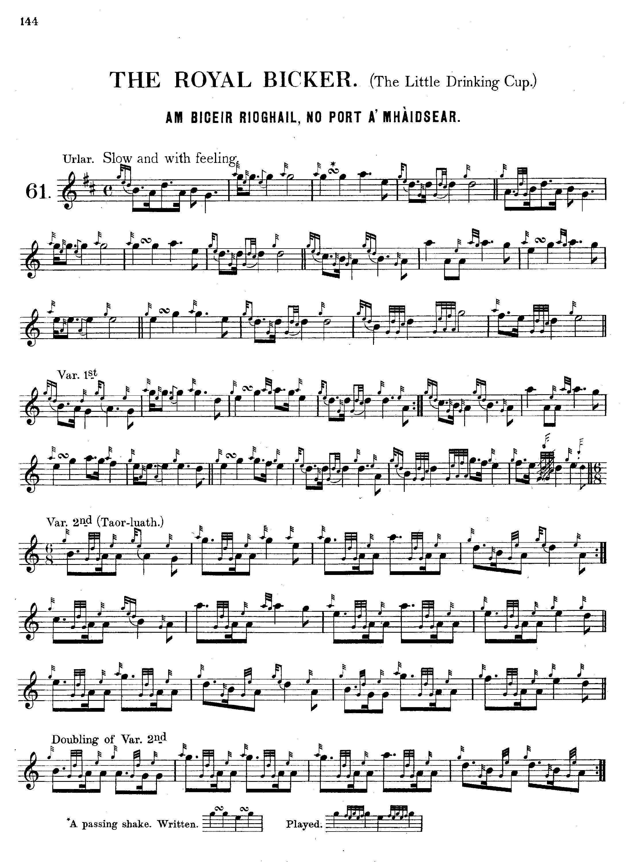
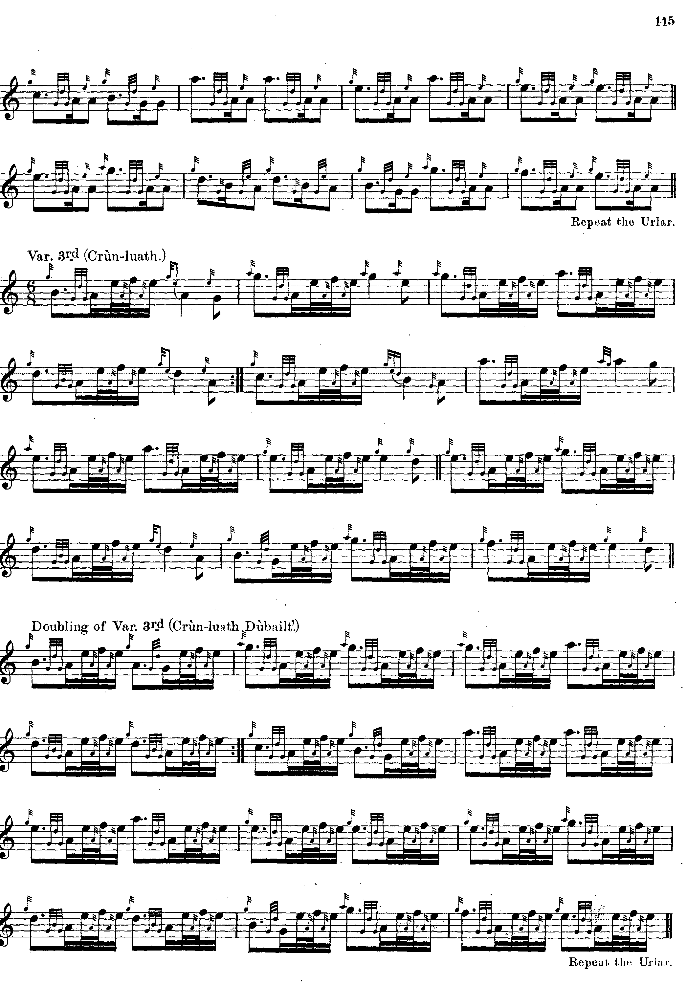

Commentary:

In his notes to Glen’s Ancient Piobaireachd, historian and journalist Henry Whyte, “Fionn”, says:

The Royal Bicker
Am Biceir Rioghail.

This tune is also called "The Little Drinking Cup," and is said to have been composed by Lord Reay's piper, hence, doubtless, it is sometimes called "Sutherland's Gathering." To Gaelic speaking people it has the further title of "Port a' Mhàidsear," the Major's Tune. (“Notes”, p.15)

Musically the main effect here is the interplay between the two adjacent pentatonic scales GABDE and ABCEG. The most emphatic moment in the tune perhaps comes at the beginning of the second line where the C (gapped in the initial scale) is boldly asserted, the degree of emphasis varying according to whether in the opening motif in line two the C is held or whether it is slightly masked by treating it as a passing note--achieved playing the movement in a “run down” fashion as Colin Cameron seems to do, perhaps based on Angus MacKay’s treatment of this figure in the latter’s “Seaforth MS” to which we know the Cameron pipers had access. Indeed the tune fills the gaps in both of its initial scales. With the second scale the note is F, artfully introduced right at the end of the ground where it has maximum impact since it frustrates the expectations formed by the development of the piece up to that point. It is this F that is highlighted in the later variations.

* * *
Electronic text © Dr. William Donaldson, Aberdeen, Scotland, 6th June 2012

