Beloved Scotland

There are settings of this tune in the following manuscript sources:

--Angus MacKay’s MS, i, 15-17;
--Colin Cameron’s MS, ff.22-24;
--Duncan Campbell of Foss’s MS, ff.137-139;
--D. S. MacDonald’s MS, i, 1-3;
--John MacDougall Gillies’s MS, ff.43-44;

and in the following published sources:

--Frans Buisman and Andrew Wright, eds., The MacArthur—MacGregor Manuscript of Piobaireachd (1820), p.141;
--C. S. Thomason’s Ceol Mor, p. 221;
--David Glen’s Collection of Ancient Piobaireachd, pp.146-8.

All the later authentic scores seem to follow Angus MacKay; and MacKay, with one or two little changes in the grace noting, follows the time values of his source, the MacGregor/MacArthur MS, exactly. Indeed, his title “Albain Bheadarach’s mise ga’d Fhàgail dubh. Beloved Scotland, I leave thee Gloomy”, is also headed “No 13 In the H.S. of London’s MSS.” Angus points the taorluath “down”, and the crunluath “up” as in the MacArthur/MacGregor.

Colin Cameron simply follows MacKay, a reminder of how little textual variety there is with this tune: it all seems to stem from the MacArthur/MacGregor and not to exist independently elsewhere in the tradition, which is curious, seeing what a lovely piece it is, unless, as we may guess, it is a late tune, composed during the later 18th or perhaps early 19th centuries when the Clearances were at their height.

Duncan Campbell of Foss follows MacKay in the ground, but then gives his taorluath movement as even quavers which is the way that many may want to play this piece. He, too, cuts his crunluath variations “up”. His score is as follows:

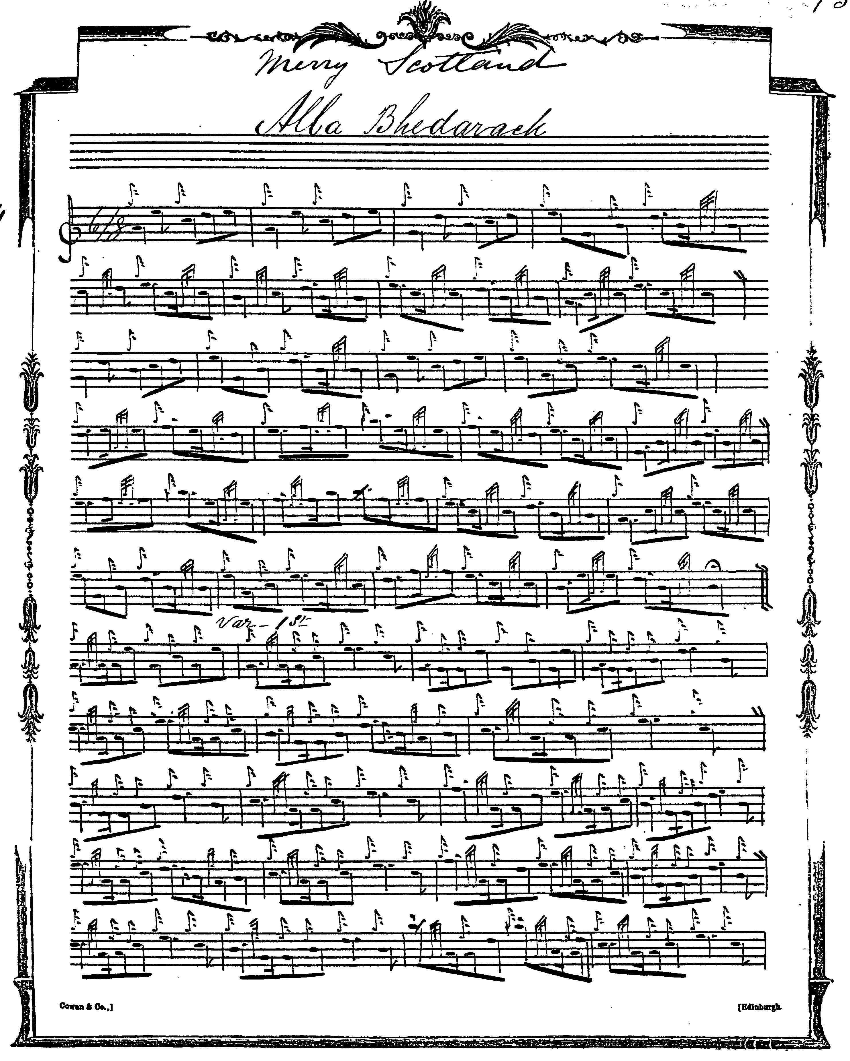

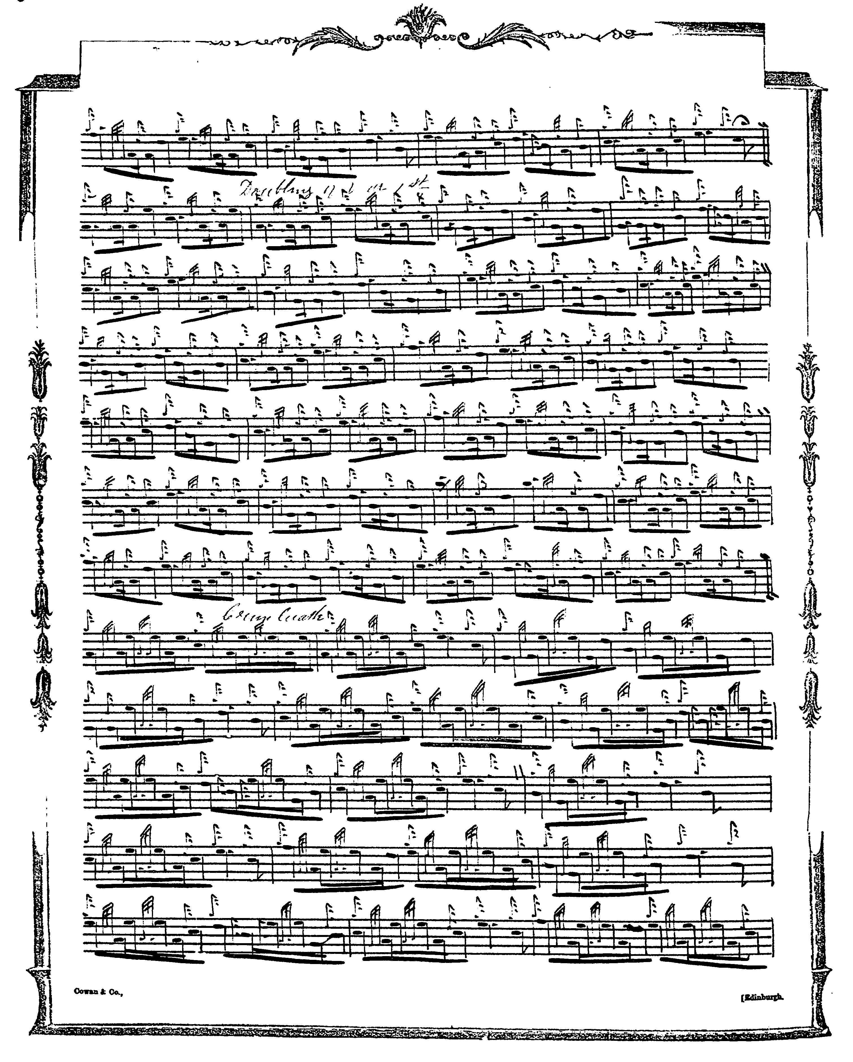

and so on.

Duncan Campbell has missed out the 7th bar in the first line of his taorluath singling, but it can easily be made good from other parts. There is an interesting fermata placed on the final passing note at end of the taorluath singling, suggesting that it is ever so briefly “held” before accelerating into the doubling.

D. S. MacDonald follows MacKay (except he does not indicate a repeat of the ground at the end of the taorluath doubling, as MacKay does). This score is not reproduced here.

John MacDougall Gillies times the tune as follows:

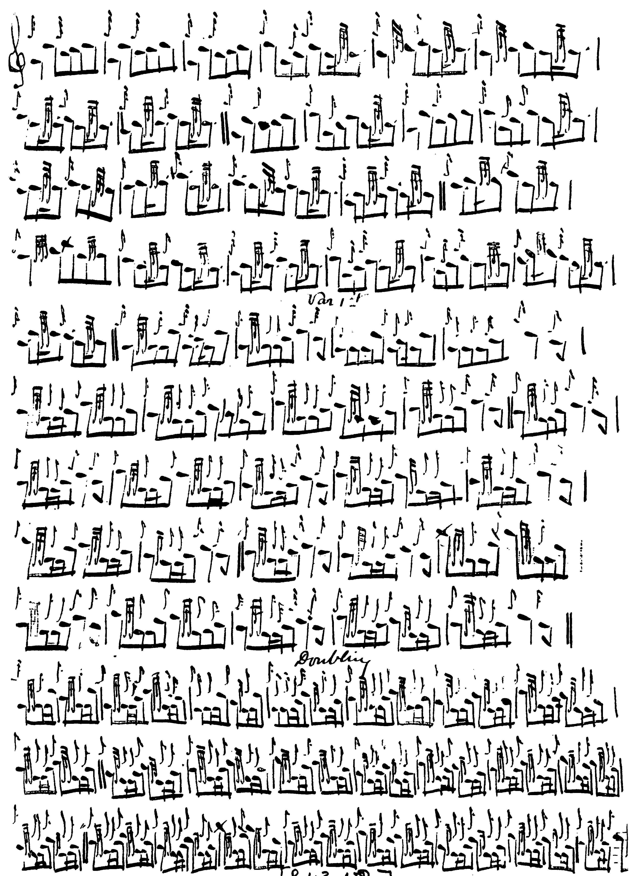

and so on.
C. S. Thomason’s score is based on the one in MacKay’s MS, and he follows its timings carefully. Thomason’s score is not reproduced here.

David Glen adds one or two slurs to the ground (although otherwise his ground is the same as MacKay’s) and varies MacKay’s pointing in the taorluath singling. Since such movements should be played “round” anyway, to avoid the jerky effect described by Lt. John McLennan as “Raoichden an Asail” (“The Braying of the Ass”—quoted in W. Donaldson, Highland Pipe and Scottish Society, p.303), the differences in playing would probably be slight:

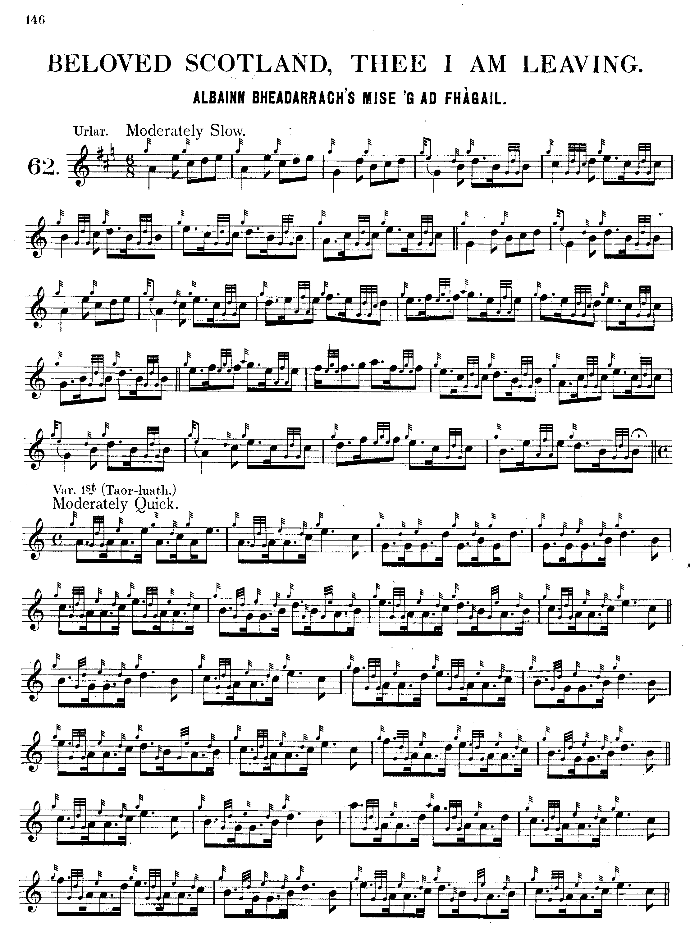

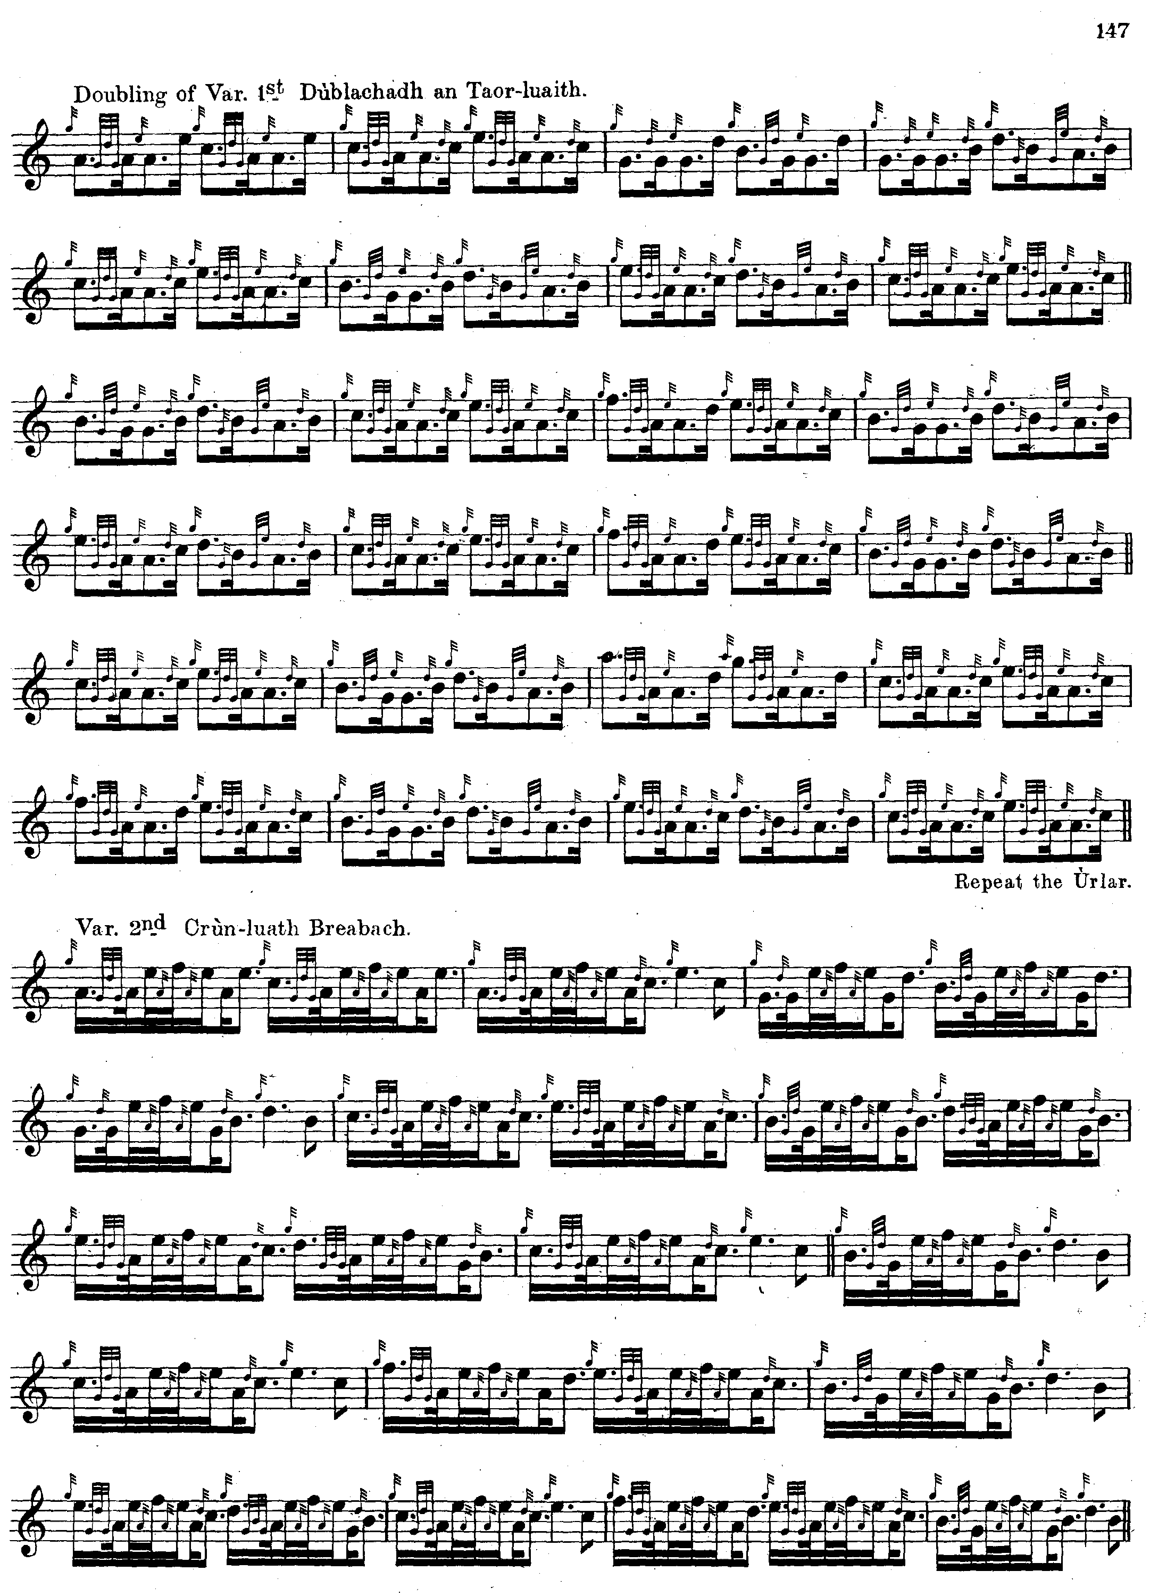

and so on.

Commentary:

Nothing is known with any certainty about the historical background or date of composition of this lovely tune. In his notes to David Glen’s Ancient Piobaireachd, Fionn gets in an uncharacteristic tangle. He says: “Beloved Scotland, thee I am leaving Albainn bheadarrach, ’s mise ’gad fhàgail. This fine Pibroch is said to have been the favourite March of Sir Donald MacDonald XX. of Slate when marching to the Battle of Sheriffmuir. This Chief was known as “Dòmhnull a’ Chogaidh", Donald of the Wars, from the part he took in Killiecrankie and other engagements.
He died in 1718”. (“Historic, Biographic, and Legendary Notes to the Tunes”, p.15). The ultimate source for this may be a note in Donald MacDonald’s MS as follows: “Alba Bheadarach, or Cheerful Scotland. This fine short Piobaireachd was the favourite march of Donald Gorm of Slate, Isle of Skye, when going to the battle of Sheriffmuir. The air is supposed to be very old, but when composed is unknown.” But what MacDonald is referring to here is not the “Beloved Scotland” which now goes under that title, but a quite different tune, published as “Cheerful Scotland” by Thomason (p.89) and by Angus MacKay in his published book as “The Battle of Sheriffmuir” (pp.63-5).

The lists compiled by Iain MacInnes in his M.Litt. thesis “The Highland Bagpipe: the Impact of the Highland Societies of London and Scotland” (Edinburgh University, 1989), show that the tune was not offered in competition during the first half century of the Highland Societies’ events. This may be another indication of its relatively recent composition.

* * *

Electronic text © Dr. William Donaldson, Aberdeen, Scotland, October 2003.

