Beinn a’ Ghriain

This is one of the tunes for which there seems to be a single ultimate source, namely the MacArthur/MacGregor MS. Angus MacKay acknowledges this as the source of the setting in his MS and all the later settings are close to MacKay. This suggests that the tune was not widely distributed in tradition, and, as a result, shows relatively little variety in style and approach. Since it occupies a similar tonal territory to one of the great favourites, “I got a Kiss of the King’s Hand” (see below), this is perhaps not very surprising.

There are settings of this tune in the following manuscript sources:
---MacArthur/MacGregor, ff.11-14;
---Angus MacKay, i, ff.7-10;
---Duncan Campbell of Foss, ff.124-127;
---D. S. MacDonald, ii, 81;
---David Glen, ff.75-78;
---Robert Meldrum, ff.225-227;

and in the following published sources:
--The MacArthur-MacGregor Manuscript of Piobaireachd (1820), p.132;
--C. S. Thomason’s Ceol Mor, p.288.

The MacArthur/MacGregor treats the tune as follows:

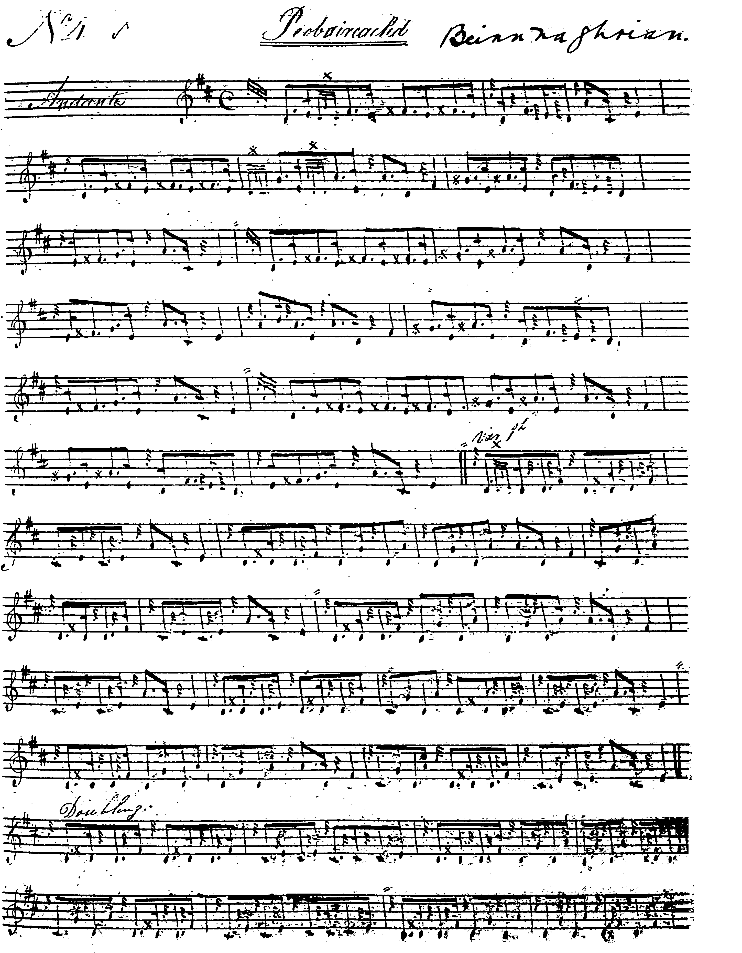
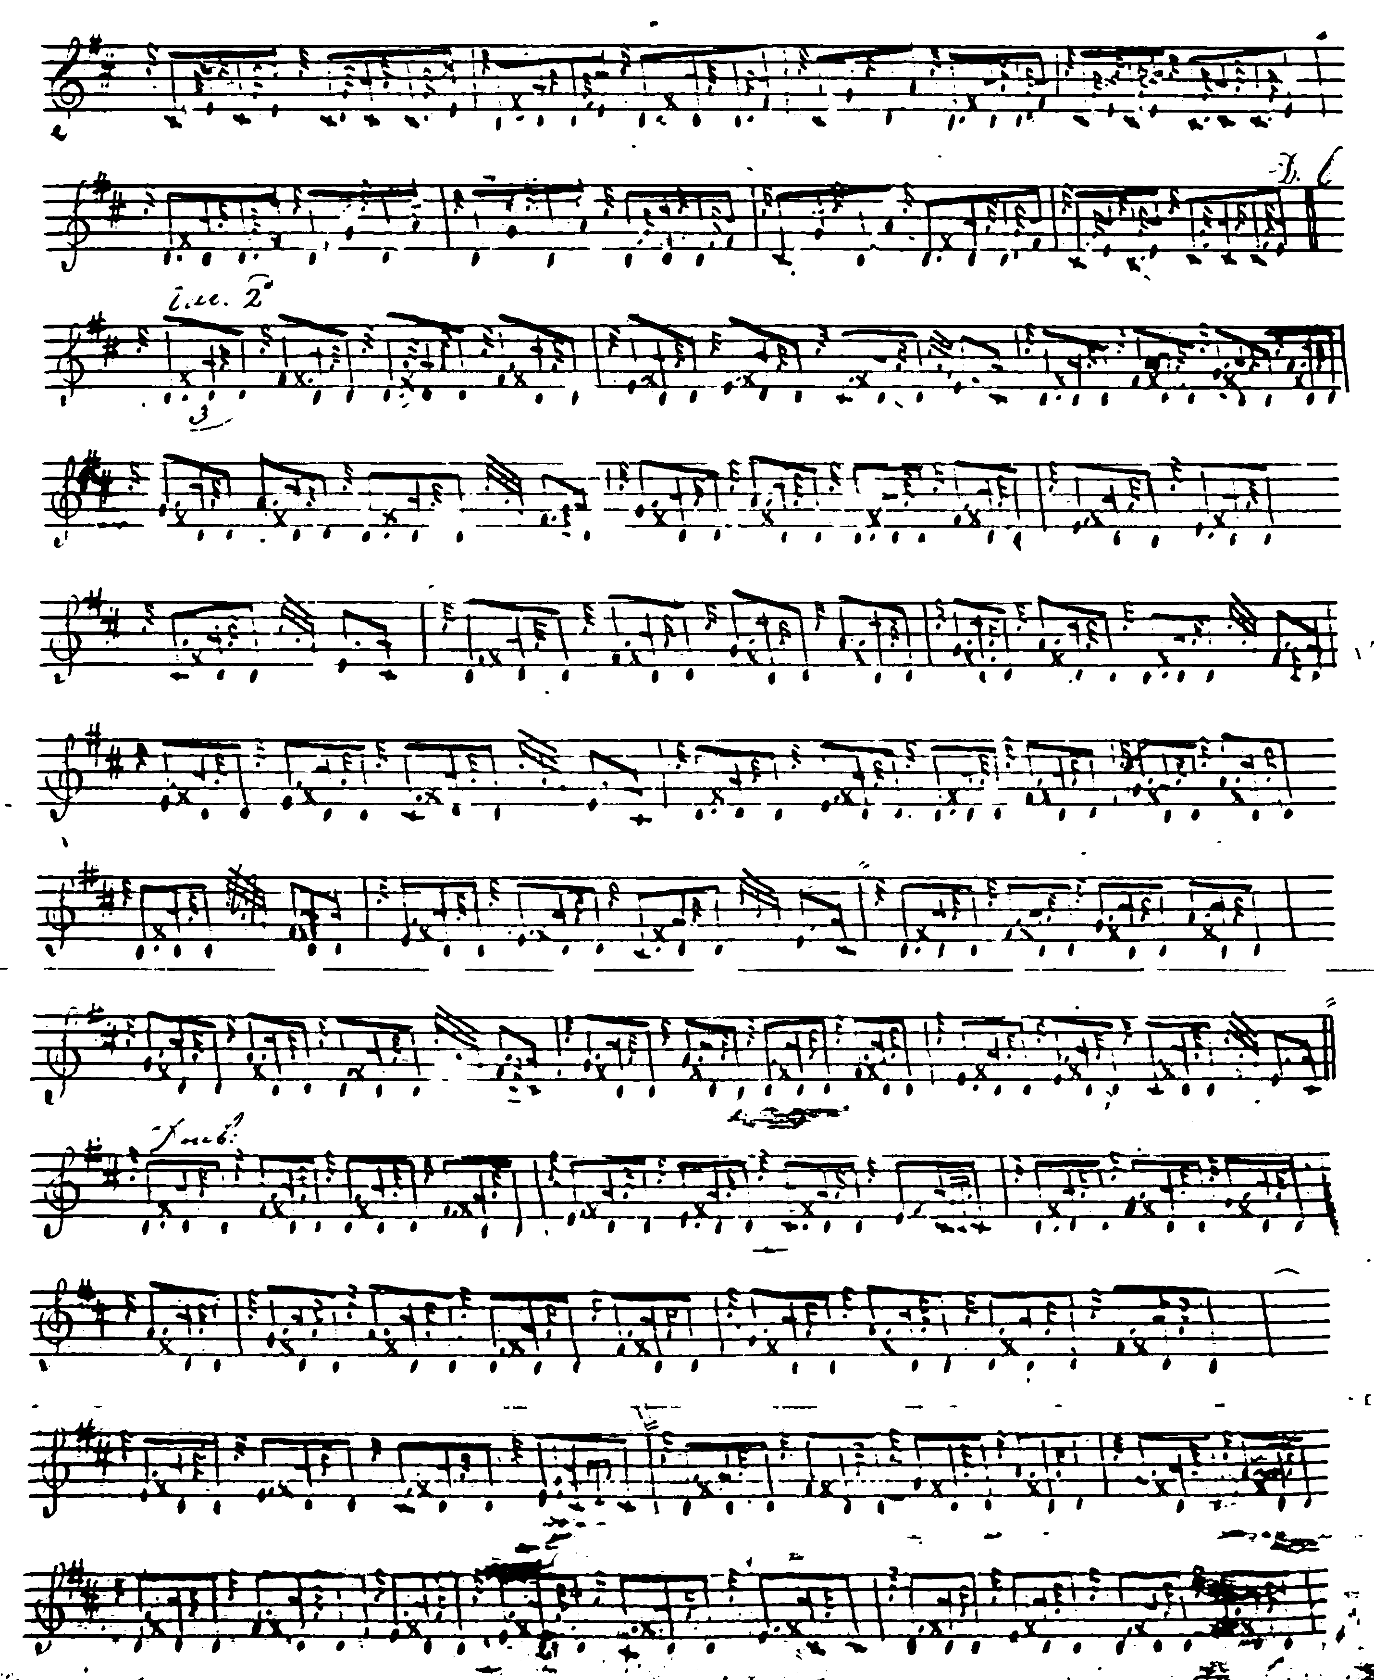

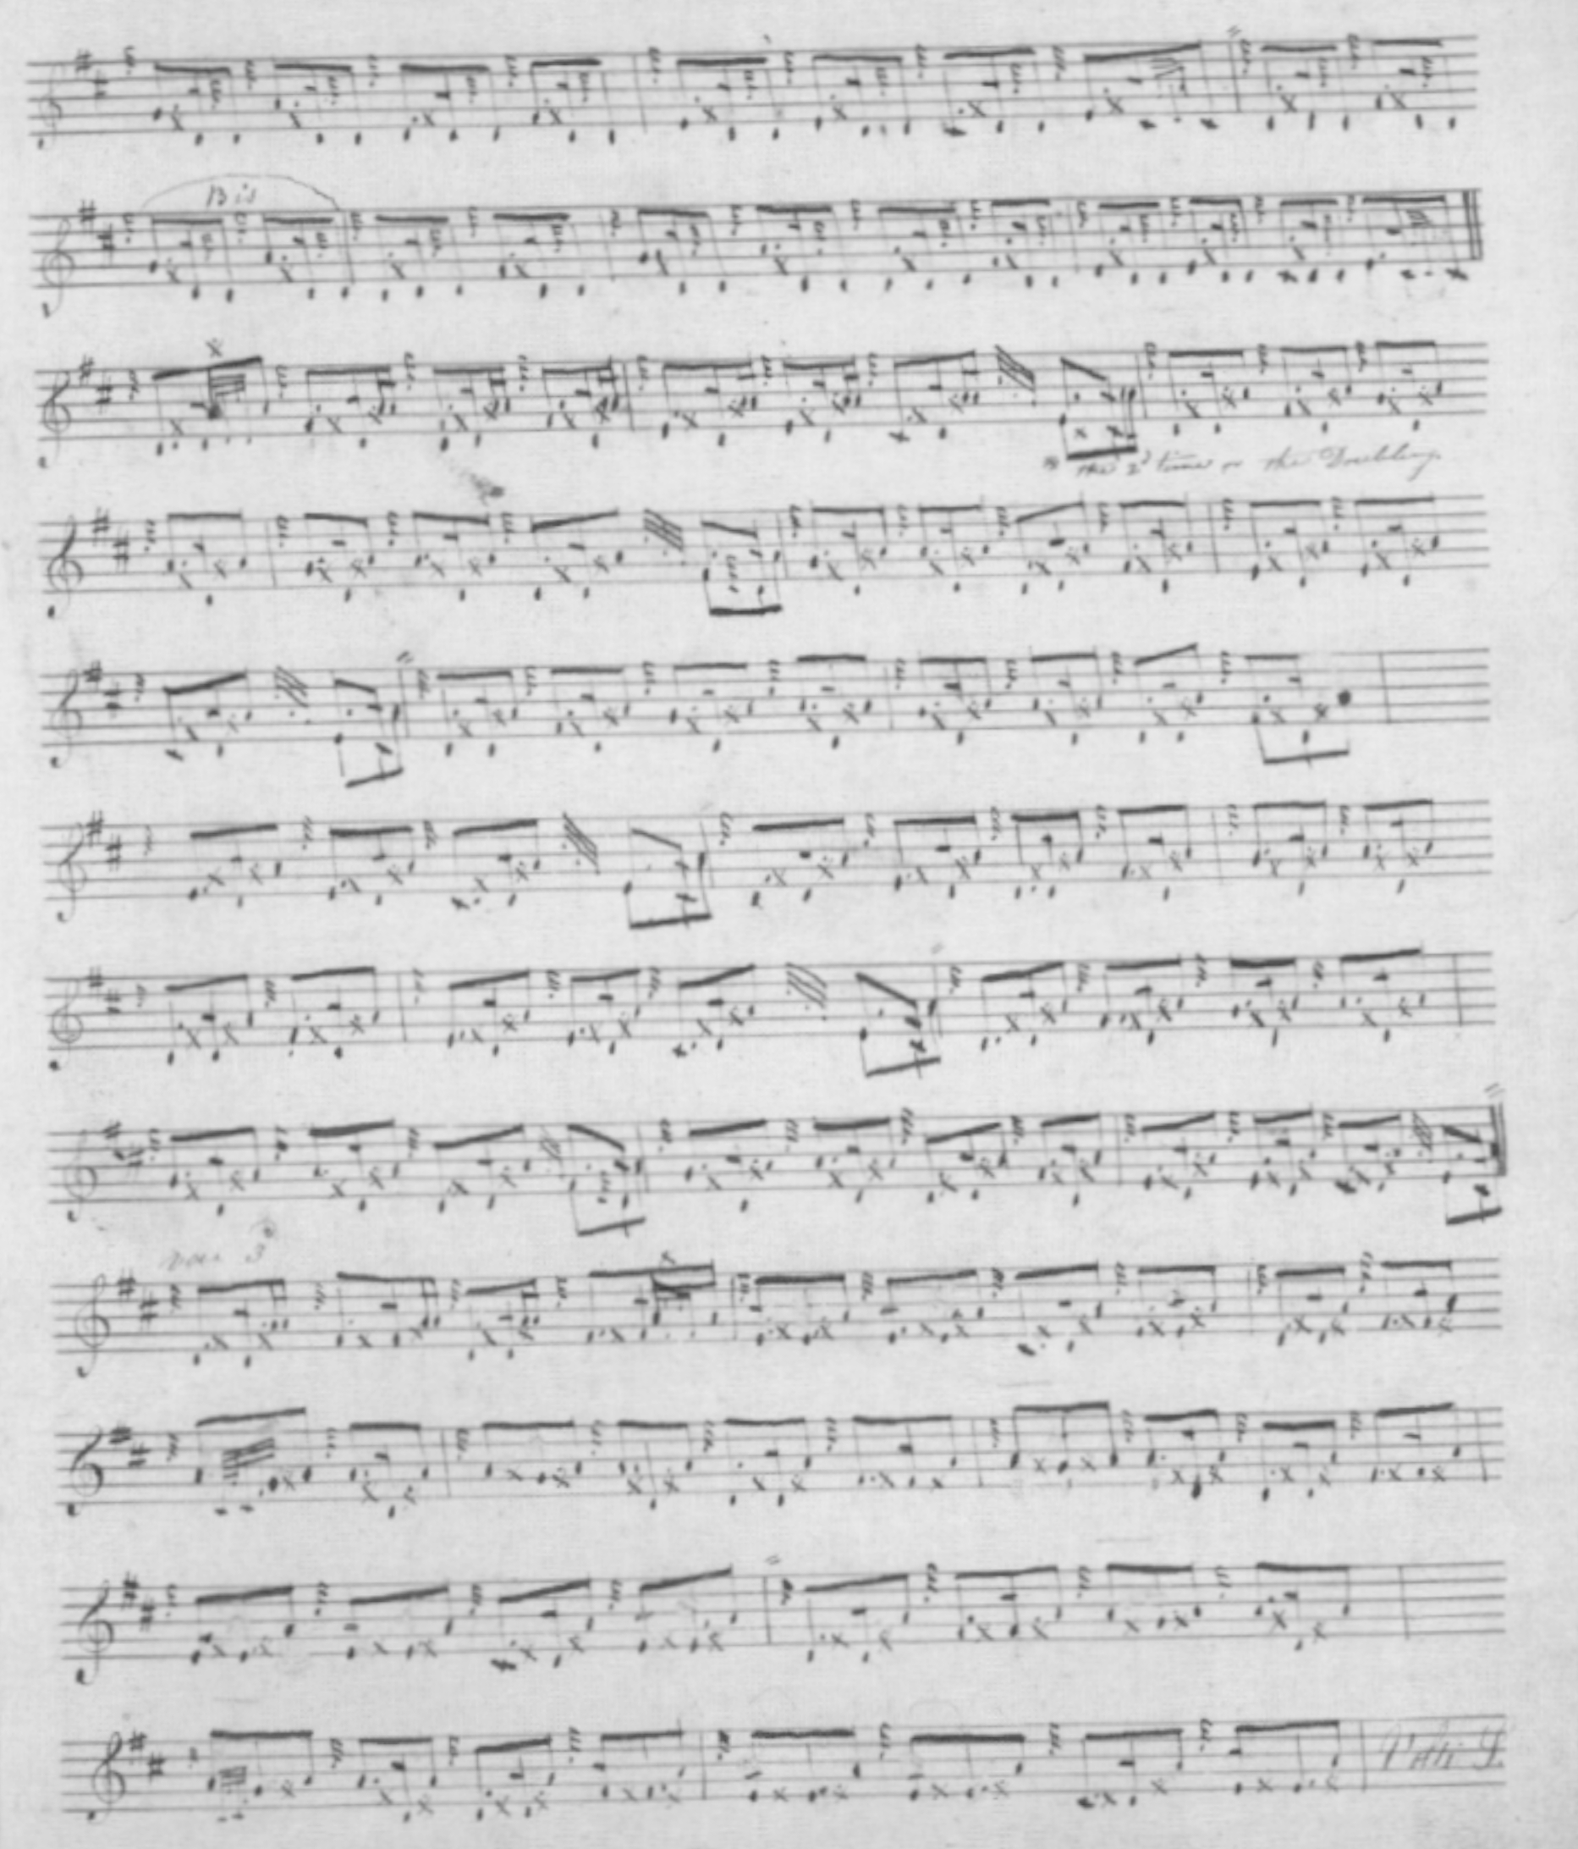
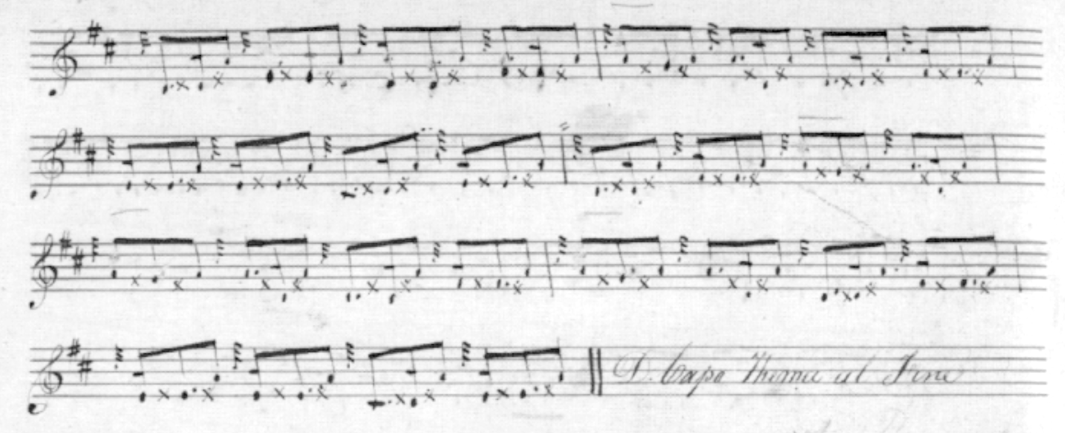

The reader will note the repeat of the ground at the end of the first variation doubling and again at the end of the tune (but not, interestingly, at the end of the taorluath doubling), and the characteristic MacArthur crunluath a mach movements on D which are played off an initial E rather than B.

Angus MacKay follows the MacArthur-MacGregor version fairly closely but he repeats his ground after the taorluath doubling rather than after the first variation doubling; he also repeats the ground at the end of the tune. MacKay’s score is not reproduced here.

Duncan Campbell of Foss adds little to Angus MacKay, except that he drops the instruction to repeat the ground at the end of the taorluath doubling; his score is not reproduced here.

D. S. MacDonald’s score is written in outline only, i.e. there are no gracenotes indicated; it follows MacKay’s time values throughout and is not reproduced here.

David Glen’s stylish setting has some interesting features: although he sets the First Variation singling and doubling as even quavers---as many of the scores do—there are various very lightly inserted dots and cuts, suggesting that he may have contemplated pushing the accent around a bit here to avoid the awkward see-saw effect (which Lt. John McLennan described as “Raoichden an Asail—The braying of the ass”) which can follow if these quavers are actually played as written. The intention seems to be somewhat thus:

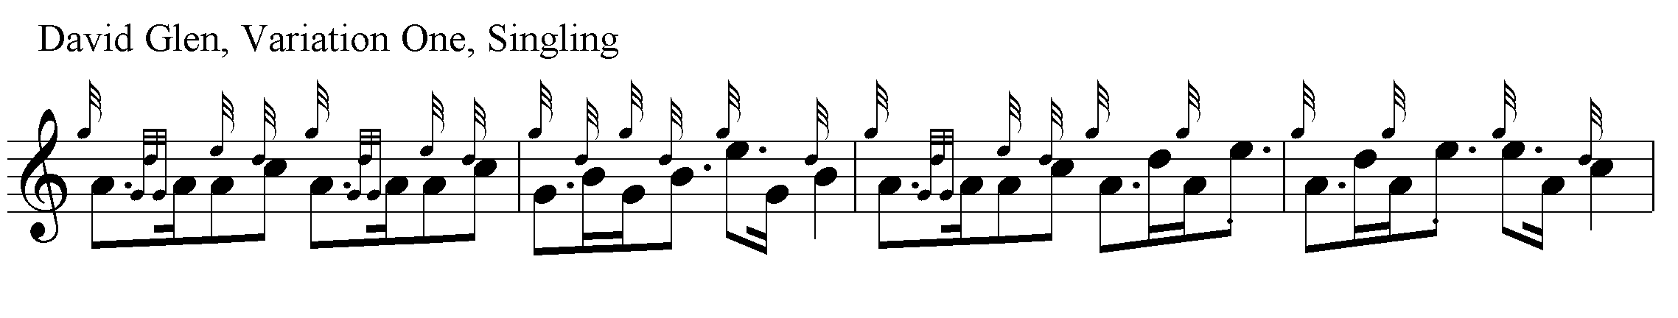

There may be a good case for playing these movements “up” throughout, to give a brisker feel, and avoid the squareness and heaviness that can descend like hill fog on this tune if approached over-cautiously.

David Glen sets the tune as follows:

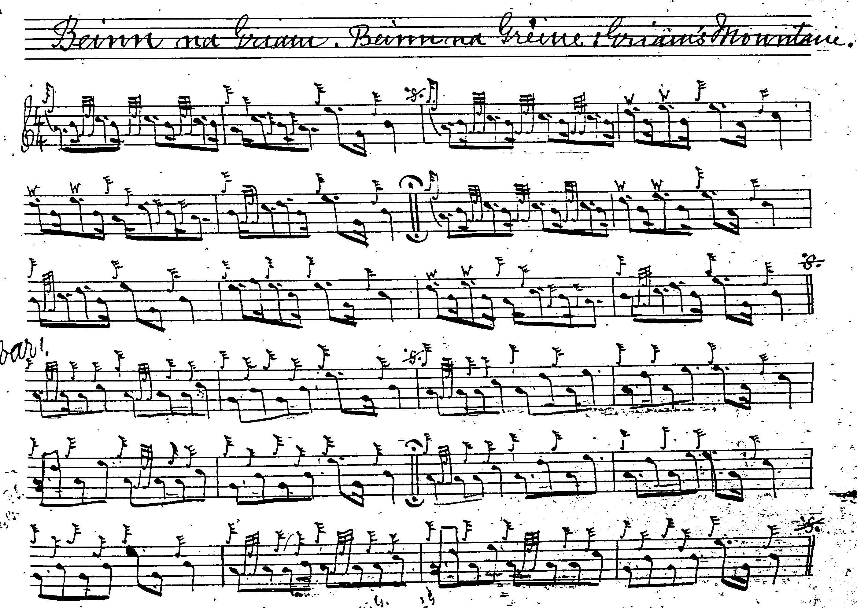
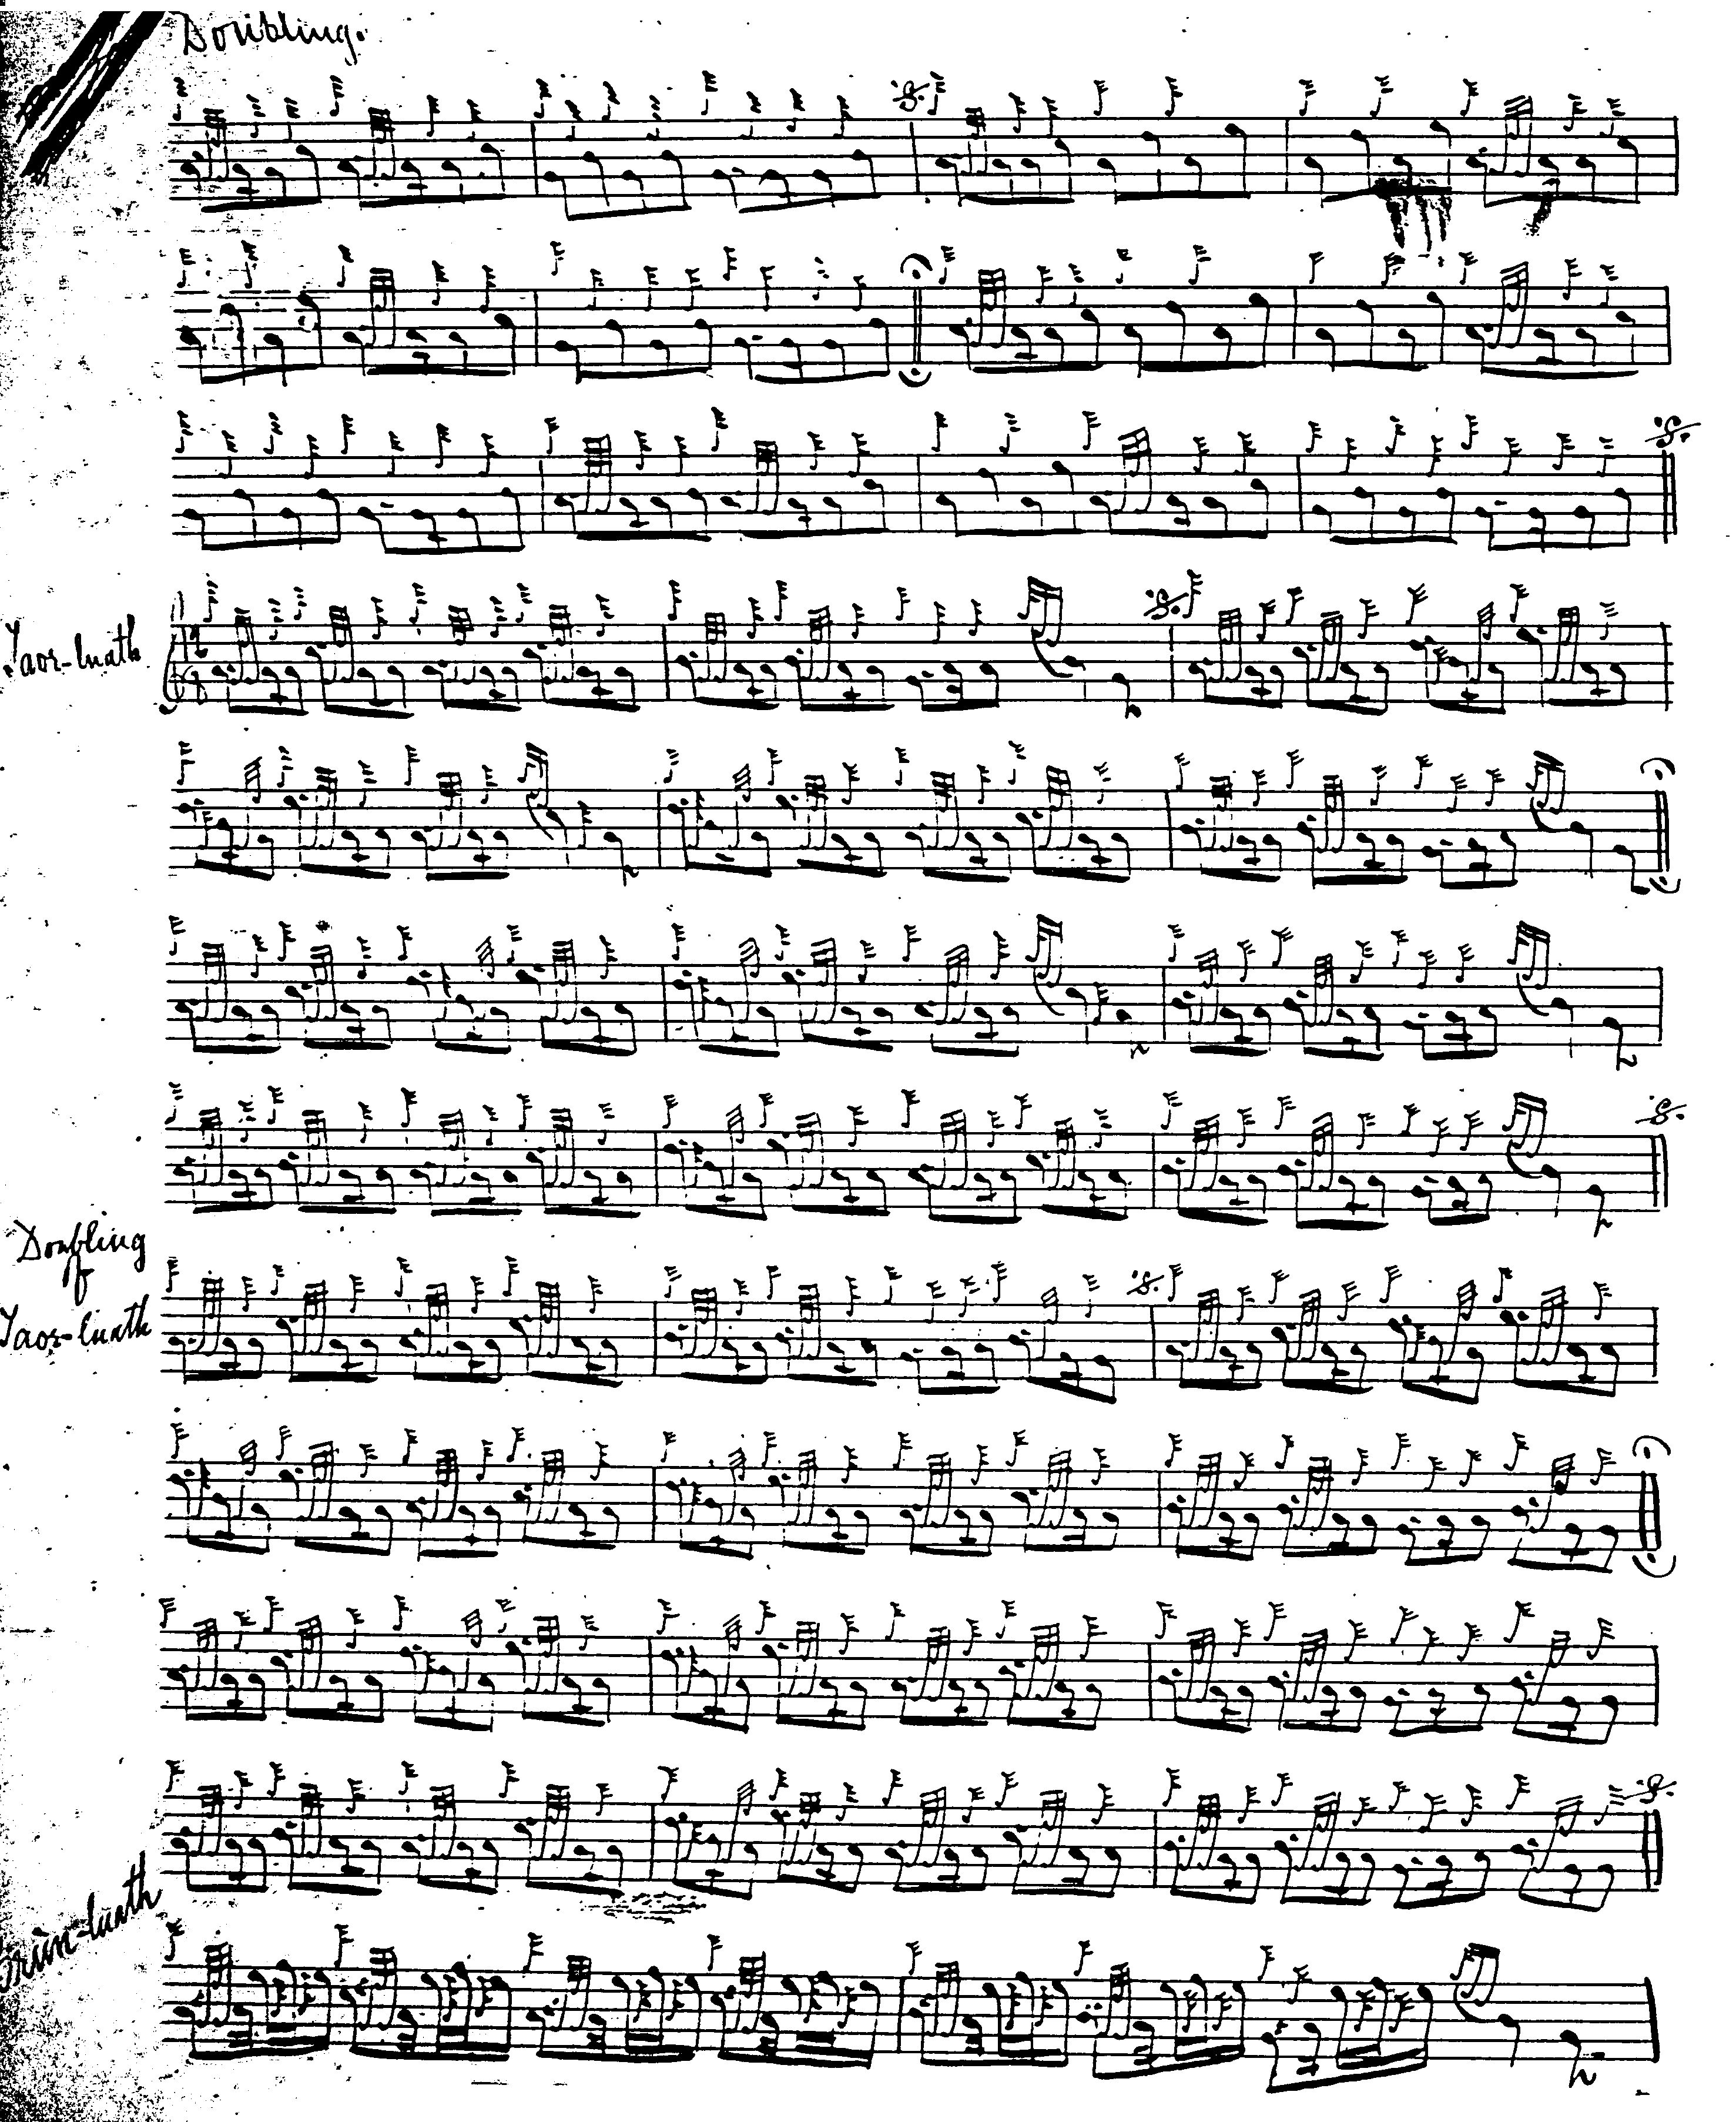
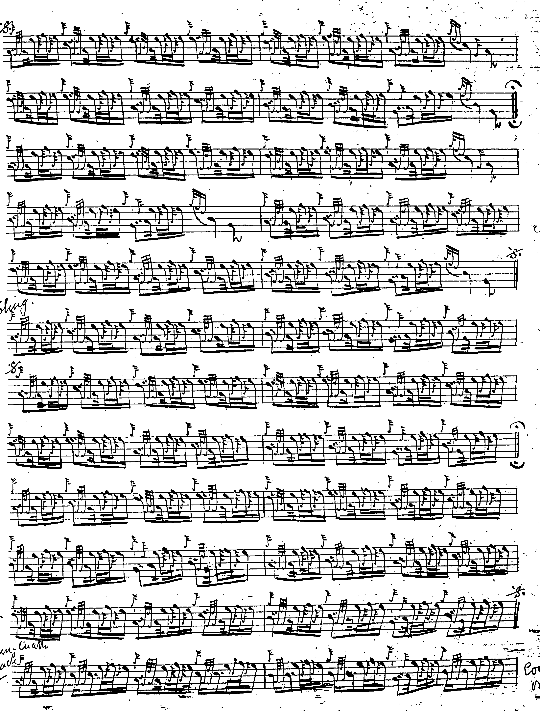
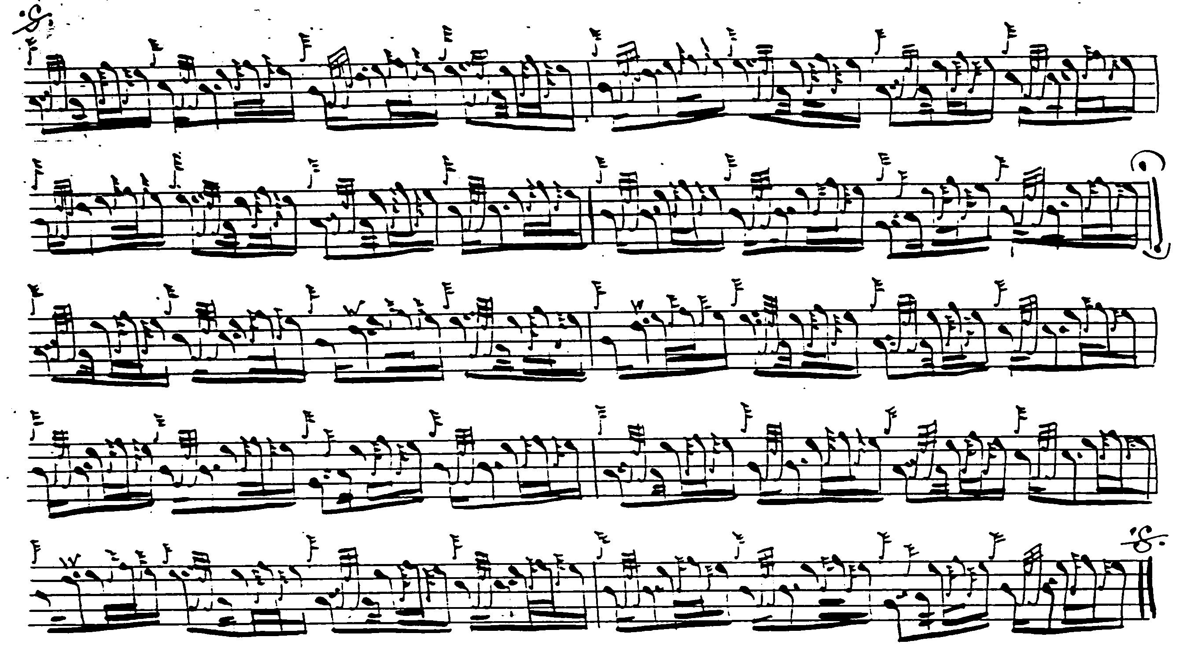

The tune is included towards the end of Robert Meldrum’s MS, (begun in 1929), suggesting it is a late addition, especially as Meldrum reflects the note values of the Piobaireachd Society’s score which was published in 1932. It is not reproduced here.

C. S. Thomason follows MacKay, his single source for this tune, including directing that the ground be repeated after the taorluath doubling; he gives crunluath singling and doubling only, omitting the crunluath a mach. His score is not reproduced here.

Archibald Campbell, editing the Piobaireachd Society Collection (second series), claimed that his setting was a combination of Angus MacKay’s MS and the MacArthur/MacGregor. The former was in 6/8 time the latter in 4/4. Campbell opted for 4/4 throughout and lengthened various passing notes in the cadences, making the tune squarer and more laborious, for which there was little justification in his sources. Rather unusually, he indicated that he had done this; usually such changes were made silently. He does not specify a crunluath a mach here but one is given in both MacArthur/MacGregor and MacKay, although not in all the idiomatic sources.

Commentary:

Context:
There has been an attempt to link this tune to a battle in east Sutherland in the summer of 1601 on the skirts of the twin peaks Beinn Griam Mor and Beinn Griam Beag: and there is a long and interesting note on this in A. J. Haddow, The History and Structure of Ceol Mor (privately printed, 1982, reprinted 2004), pp.68-71.

Style:

This is a heavy bottom-handed tune with a long line and covering a fairly narrow tonal range. Therefore, it is important not to hang around on anything that it is not imperatively necessary to hang around on, as the idiomatic scores acknowledge with their cut bottom notes in the cadences and implied “up’” timings (which PS4 ignores); otherwise, the effect becomes unbearably lumpish and heavy. The tempo must be kept going too, for the same reason; this is a brisk tune: MM, say, = 50 in the ground. Conventional wisdom in competition suggests that players should avoid including similar tunes in their active repertoire, i.e., a piper who has “The King’s Taxes”, might avoid “The Groat” because of the risk of straying between them under pressure. Likewise, if playing “The King’s Hand” it might be better to leave “Beinn a Ghriain” alone. Also, if a chanter is obtrusively flat or sharp on low G, as so many are nowadays, one might think carefully before including this tune in one’s list.

Scales:

“Beinn a Ghriain” is based on a hexachordal scale GABCDE, with much emphasis on contrasting double tonic motifs, ACAC/GBGB; the tone row is as follows:

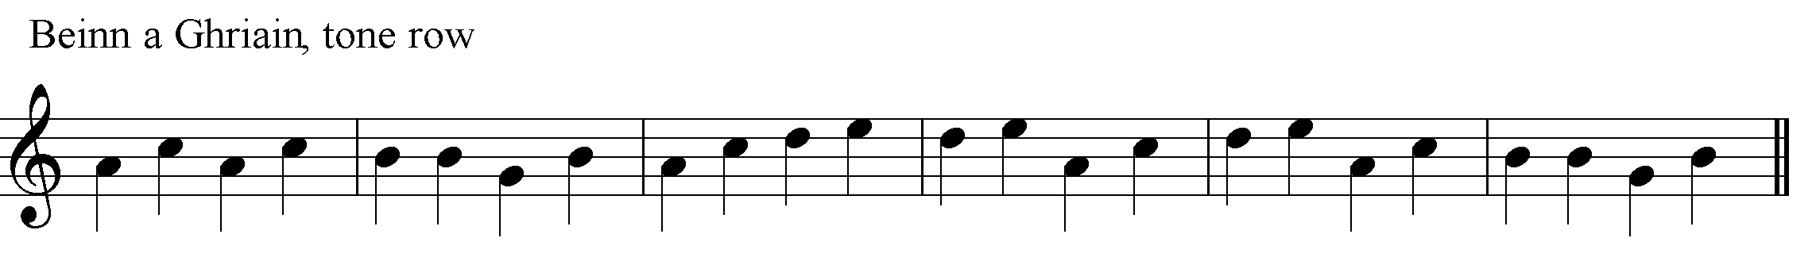

“I got a Kiss of the King’s Hand” uses a slightly more expansive scale, GABCEF, in this case hexatonic, i.e., gapped, the gap falling at D, a note emphasised strongly in “Beinn a Ghriain”, and making little play of the G (which also features prominently in “Beinn a Ghriain”), indeed the low G is little more than a passing note in “The King’s Hand”, the basic scale being pentatonic ABCEF. So that while the two tunes appear to occupy a similar tonal space at first sight, even down to sharing an opening motif as noted above, the way their scales are handled give them a very different “feel”:

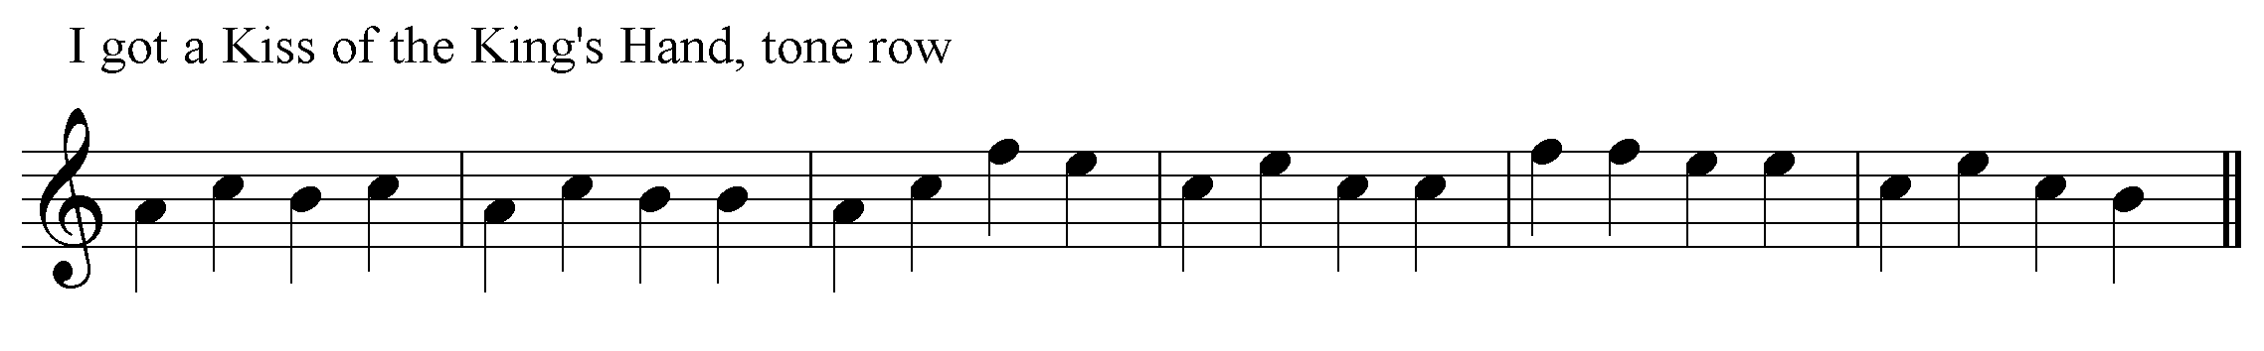

* * *

Electronic text © Dr. William Donaldson, Aberdeen, Scotland, September 2004

