Battle of the Bridge of Perth
There are settings of this tune in the following MS sources:
--Colin Mór Campbell’s, “Nether Lorn Canntaireachd”, ii, 129-32 (with the title “Duke of Perth’s March”);
--Angus MacKay’s MS, i, 210-2 (and also in the so-called “Kintarbert MS”, ff.111-12);
--Duncan Campbell of Foss’s MS, ff.108-111 (with the title “The Battle of the Inch of Perth”);
--Uilleam Ross’s MS, ff.36-7;
--D. S. MacDonald’s MS, i, 147-8;
--Robert Meldrum’s MS, ff.67-9;

and in the following published sources:
--C. S. Thomason’s Ceol Mor, p.359;
--David Glen’s Ancient Piobaireachd, pp.64-5.

Angus MacKay gives the earliest staff notated setting, thus:
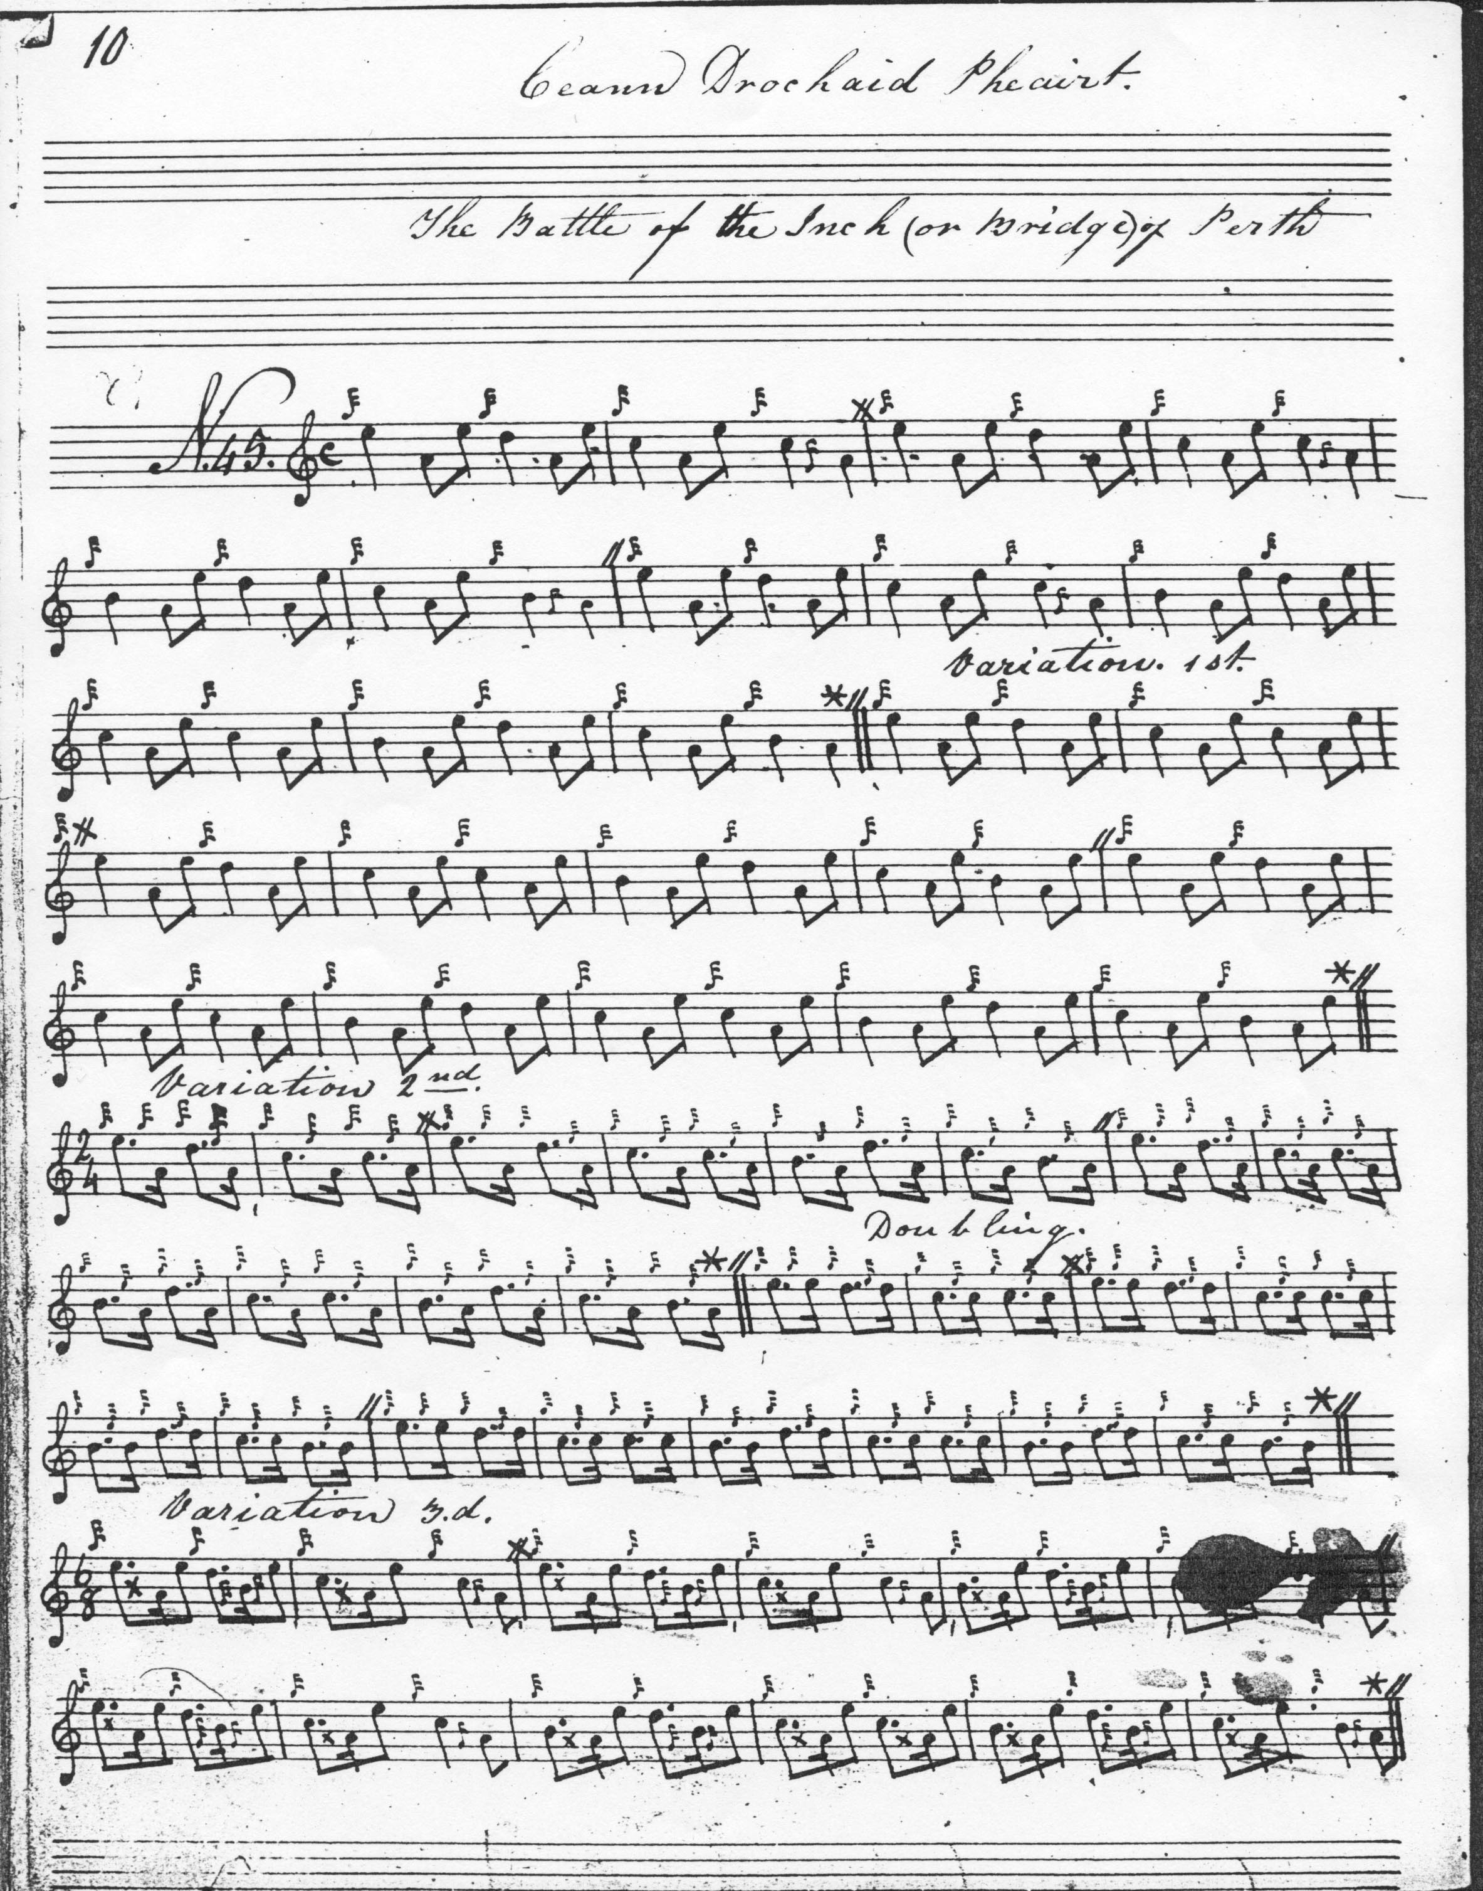
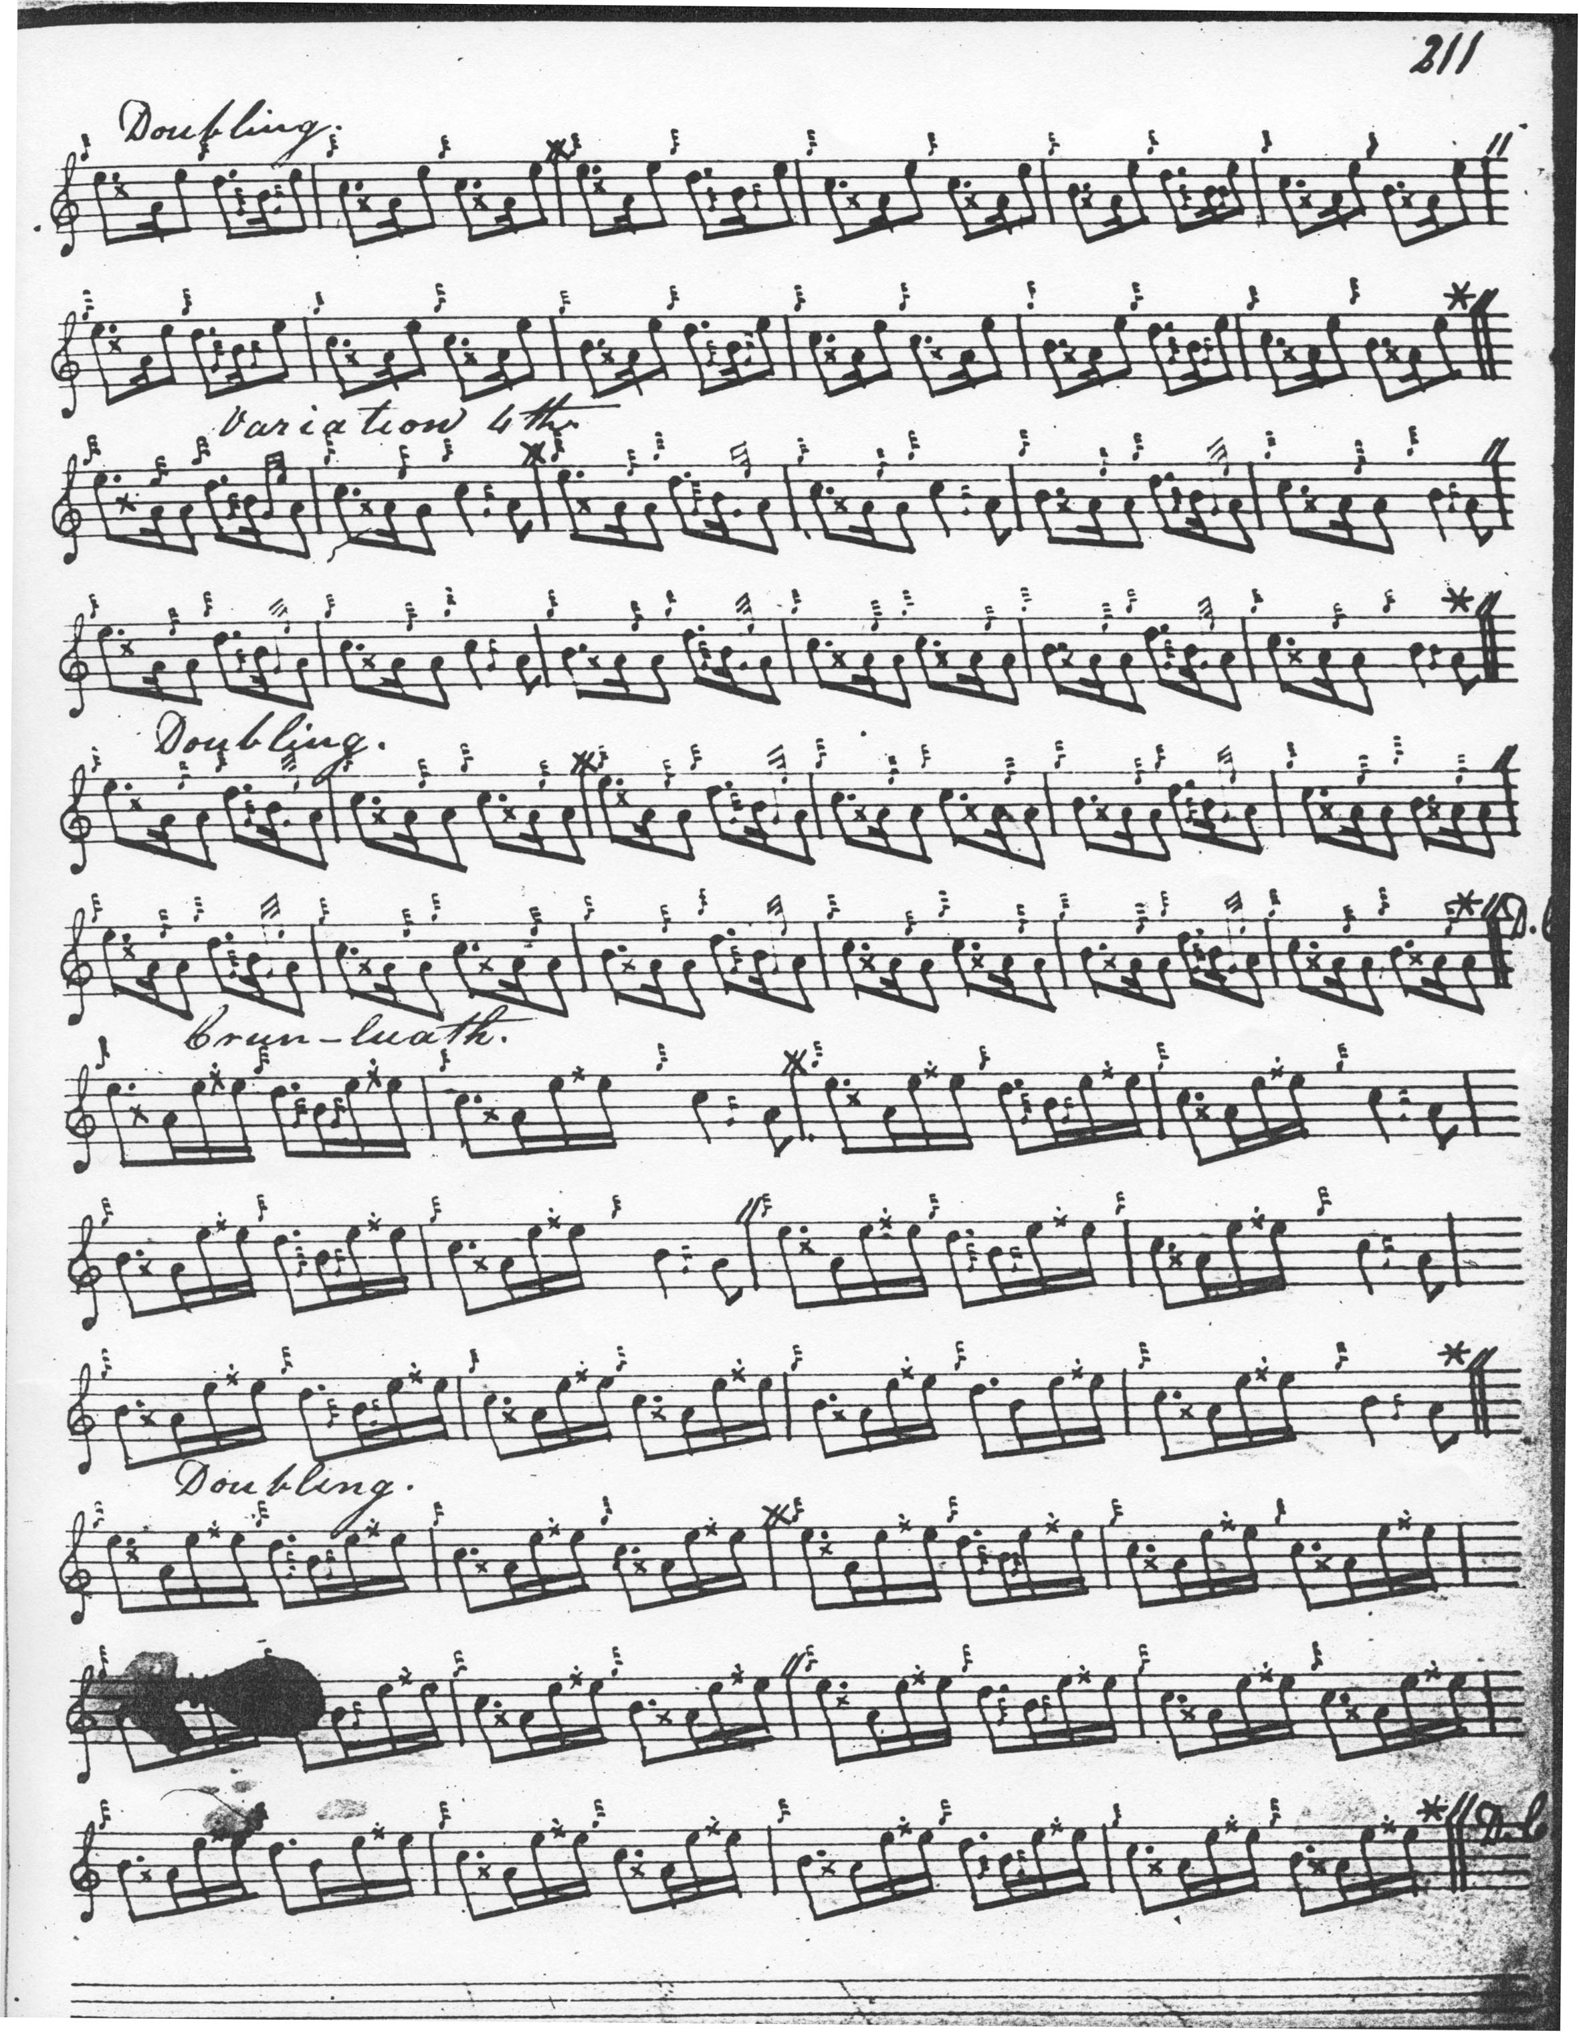
MacKay develops the tune as follows: ground and doubling of ground; siubhal singling and doubling; leumluath singling and doubling; taorluath duinte singling and doubling; crunluath singling and doubling, repeating the ground after the taorluath and crunluath doublings in his normal manner. There is no cadencing in the Ground, or in the later variations. Comparing this with Colin Campbell’s setting in the “Nether Lorn” MS below, we see that Campbell has a thumb variation and no leumluath, and a slightly different tone row. Here once again we see the kind of choices historically available to the performer before each tune was narrowed down to a single fixed printed score.
The setting of Duncan Campbell of Foss adds little to the expressive possibilities of the tune, and is not reproduced here.
Uilleam Ross’s setting is a partial one, not proceeding beyond the taorluath duinte. It omits MacKay’s leumluath singling and doubling, but adds nothing otherwise to MacKay’s interpretation of the tune, and is not reproduced here.
D. S. MacDonald “historicises” the title, calling the piece “The Battle of the North Inch of Perth Blar Innis tuath Pheart 1396 A.D.” The score is based on MacKay’s manuscript, of course, since it was MacDonald’s aim to prepare a published version of the latter. But it was very much an edited transcript as we see by his introduction of pleasing little cadential figures, which are absent in his source, at the ends of phrases in the leumluath, taorluath and crunluath singlings:
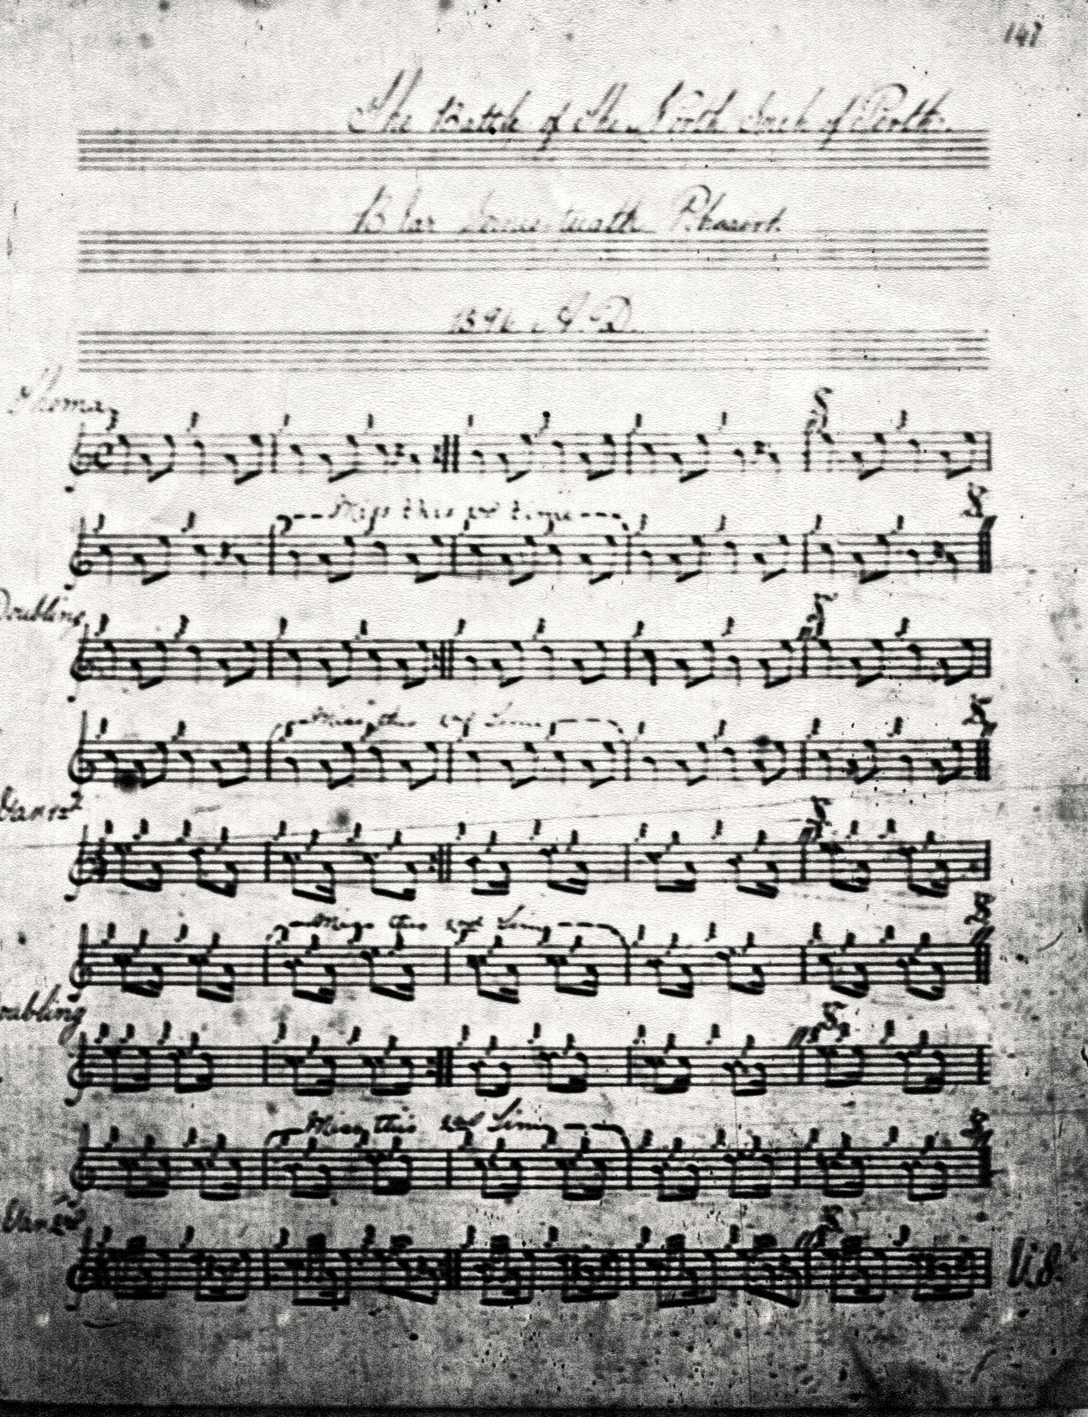

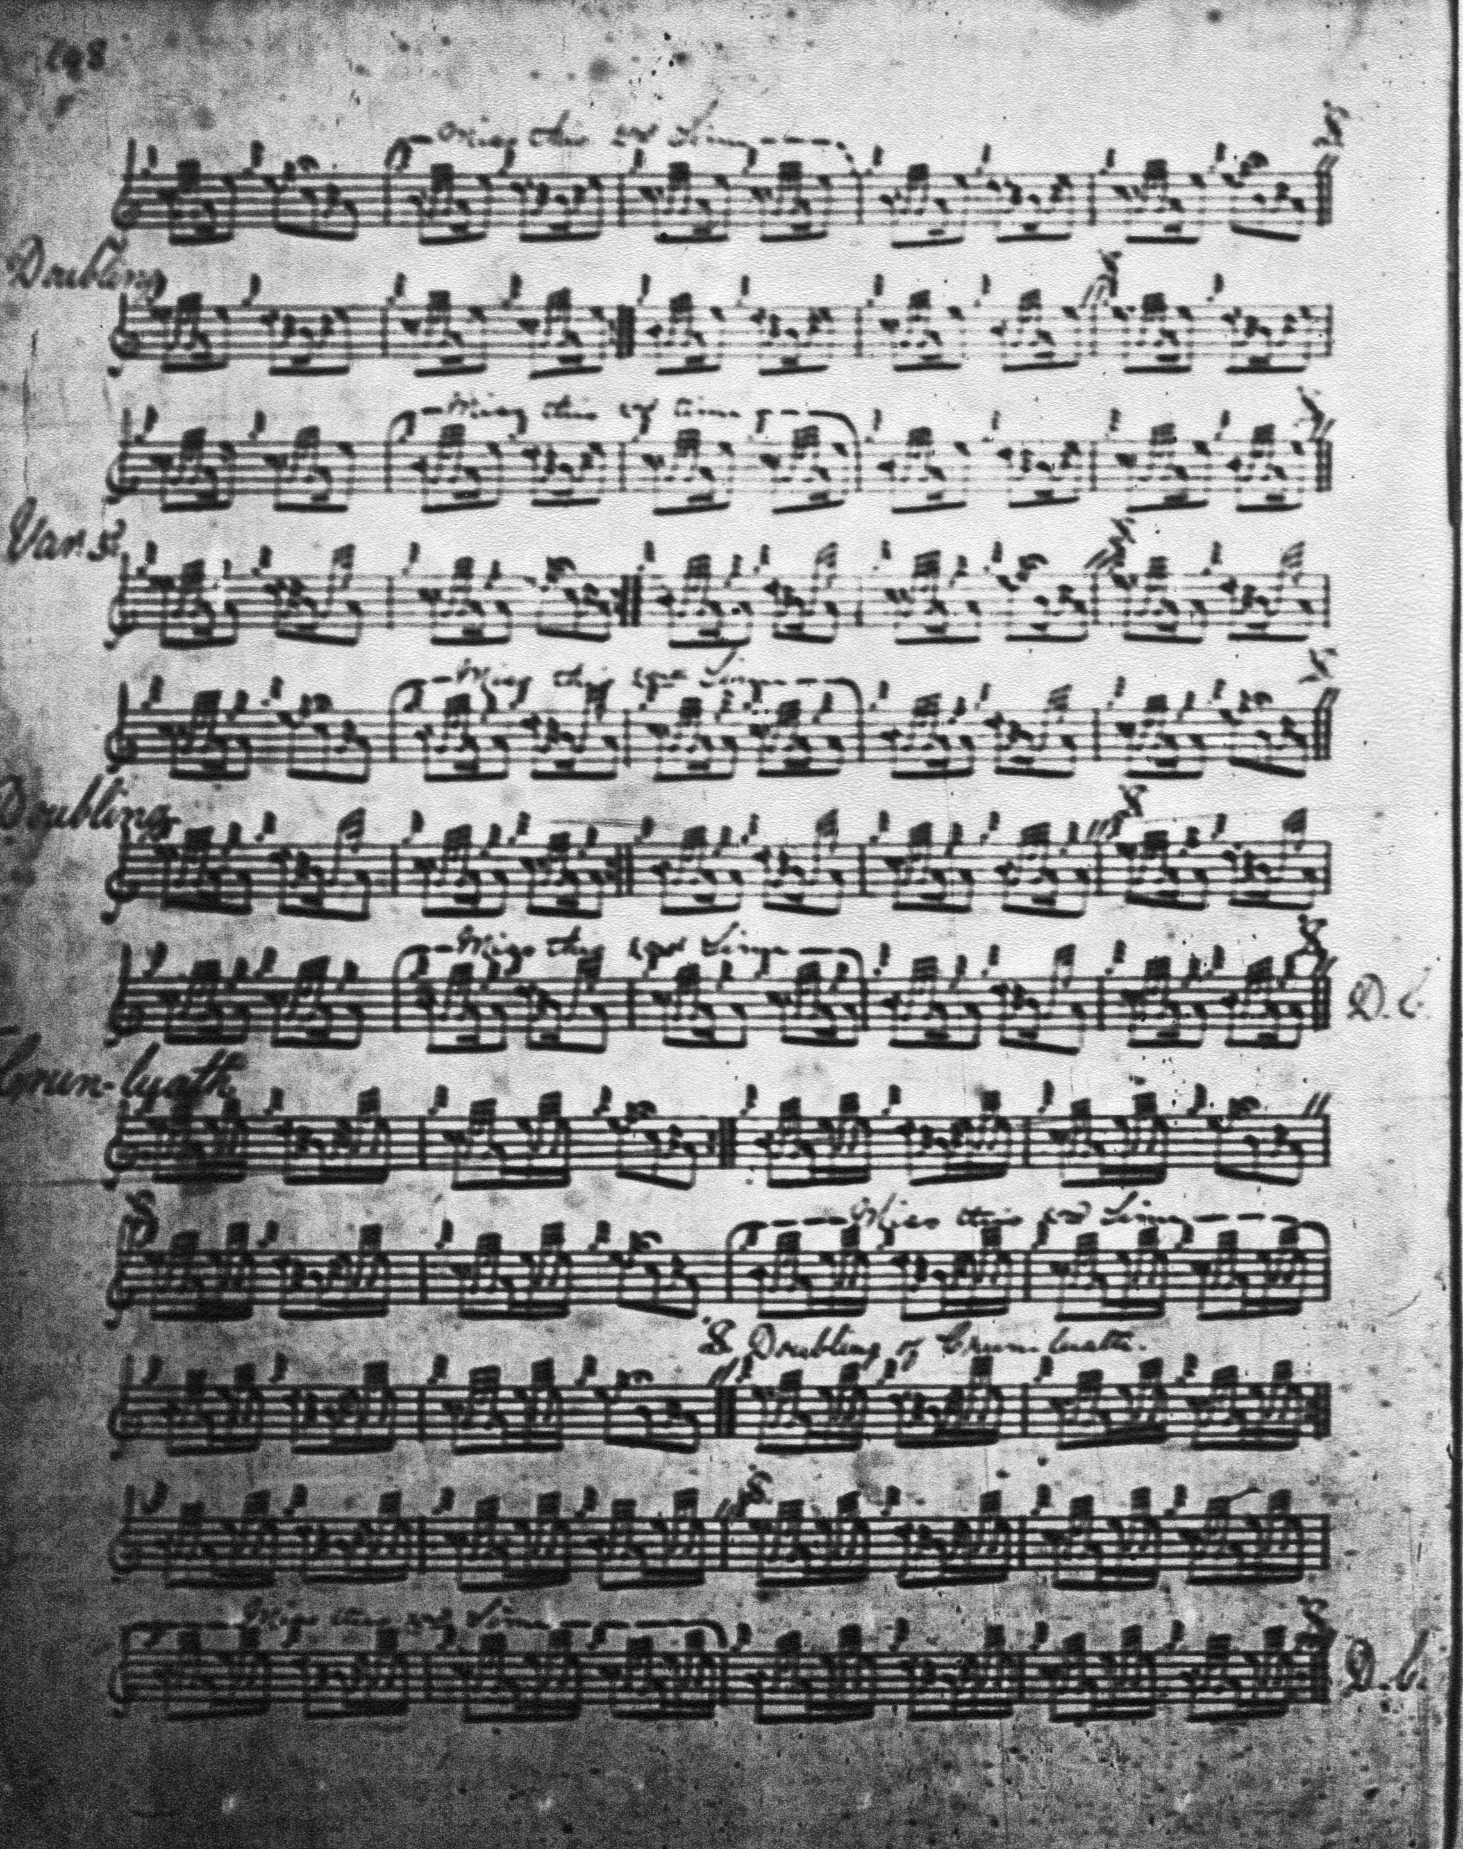

Robert Meldrum, the latest of the manuscripts considered here, indicates that a crunluath a mach should be played, probably reflecting the Piobaireachd Society’s blanket insertion of this movement wherever it could possibly be played in order to make tunes a stiffer test in competition, but otherwise he adds nothing to MacKay, and his score is not reproduced here.
Colin Campbell sets the tune like this:

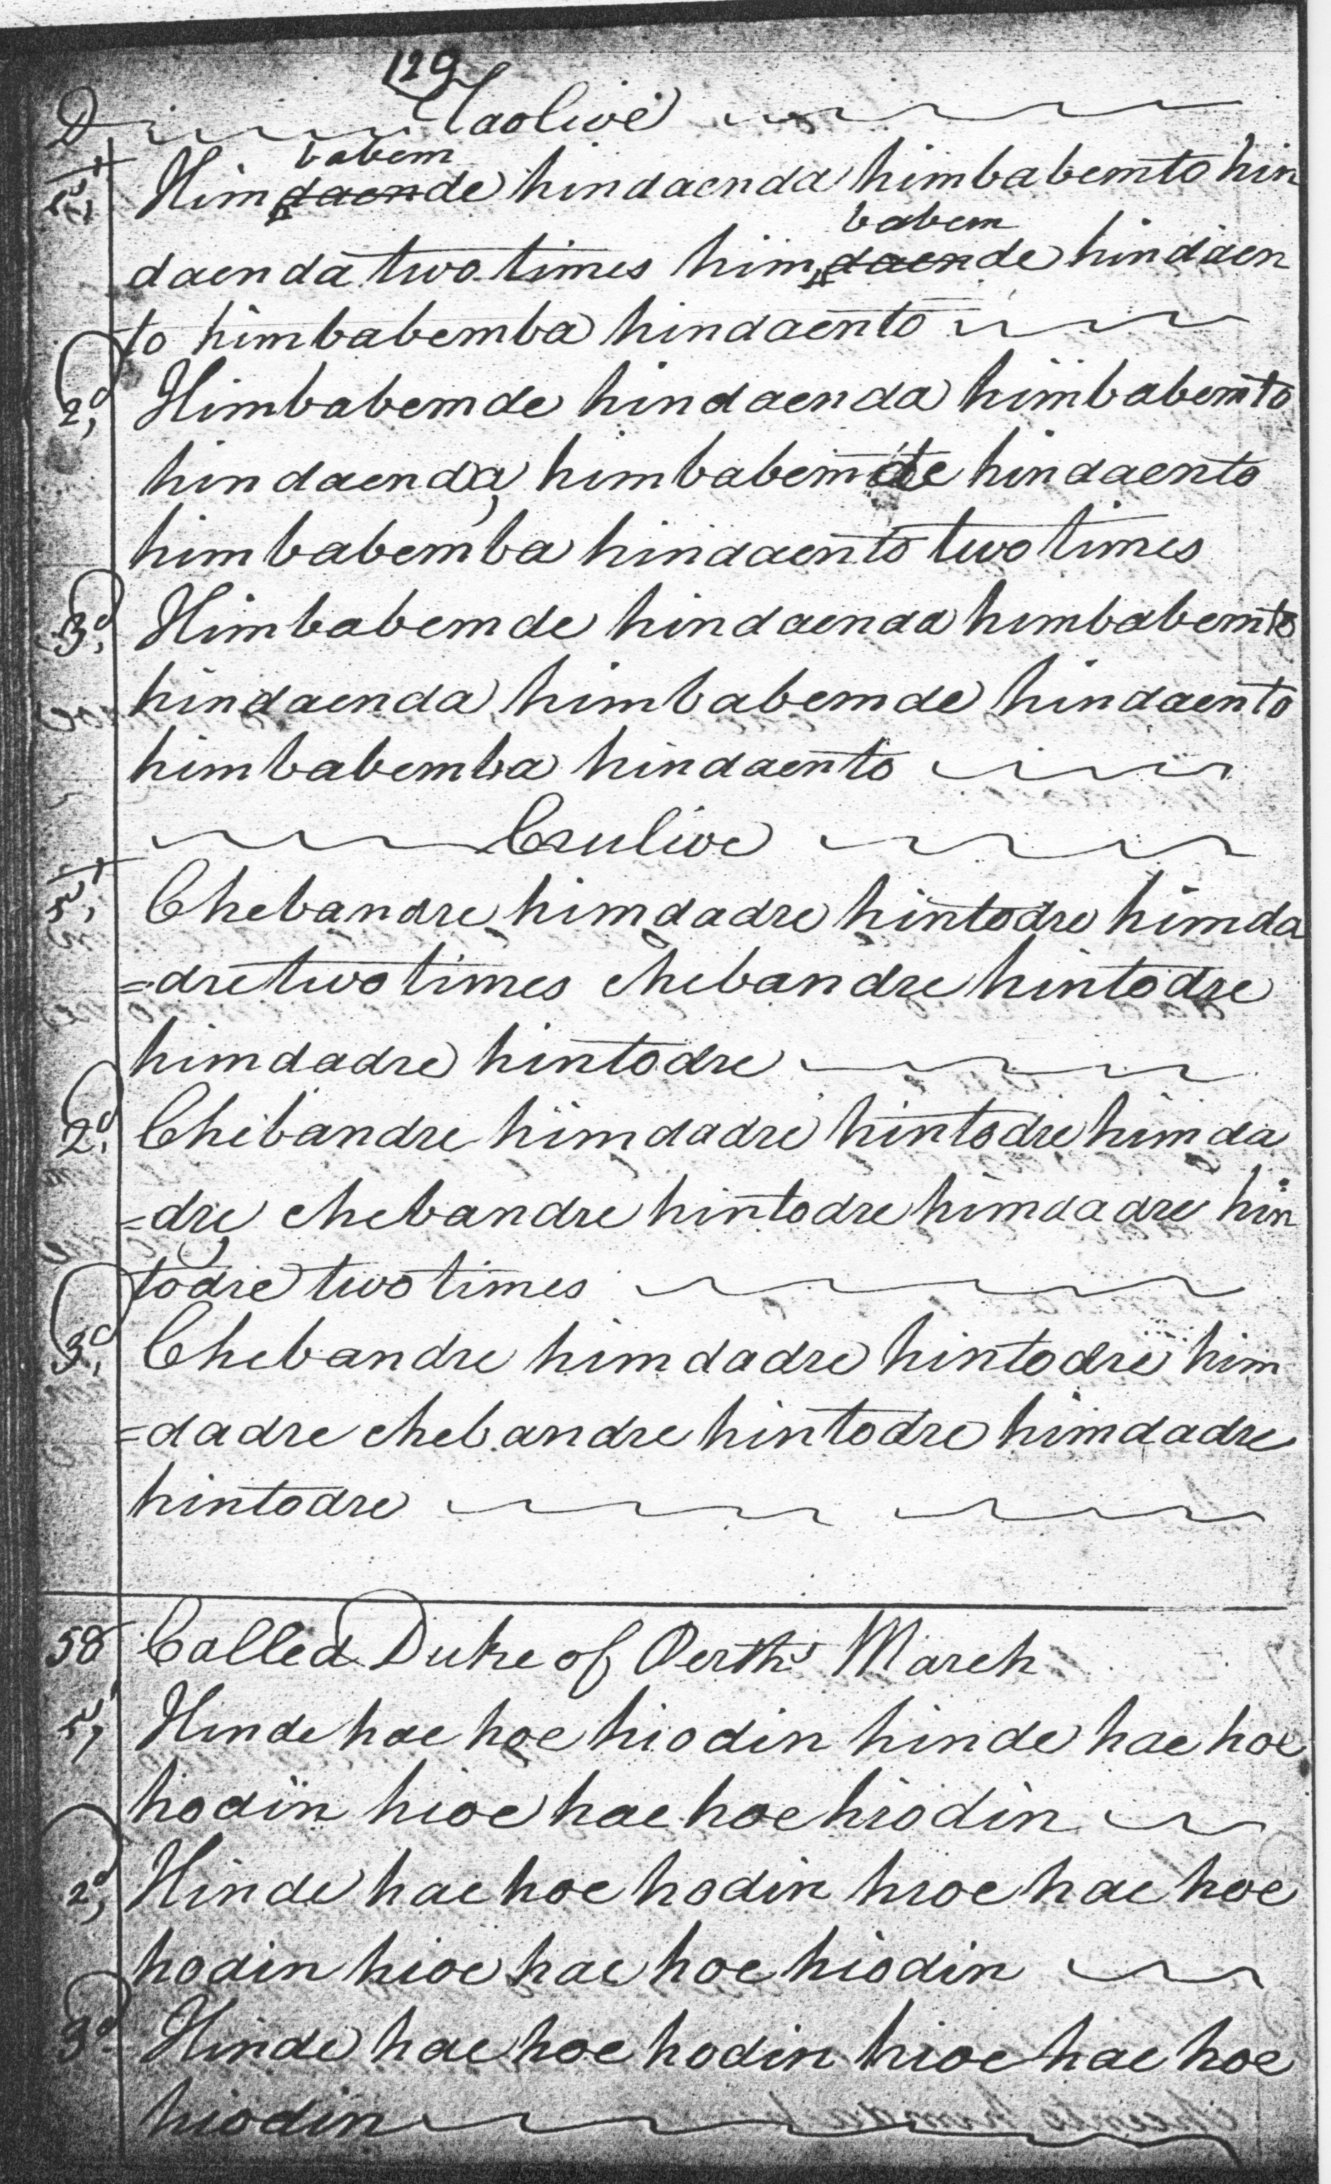
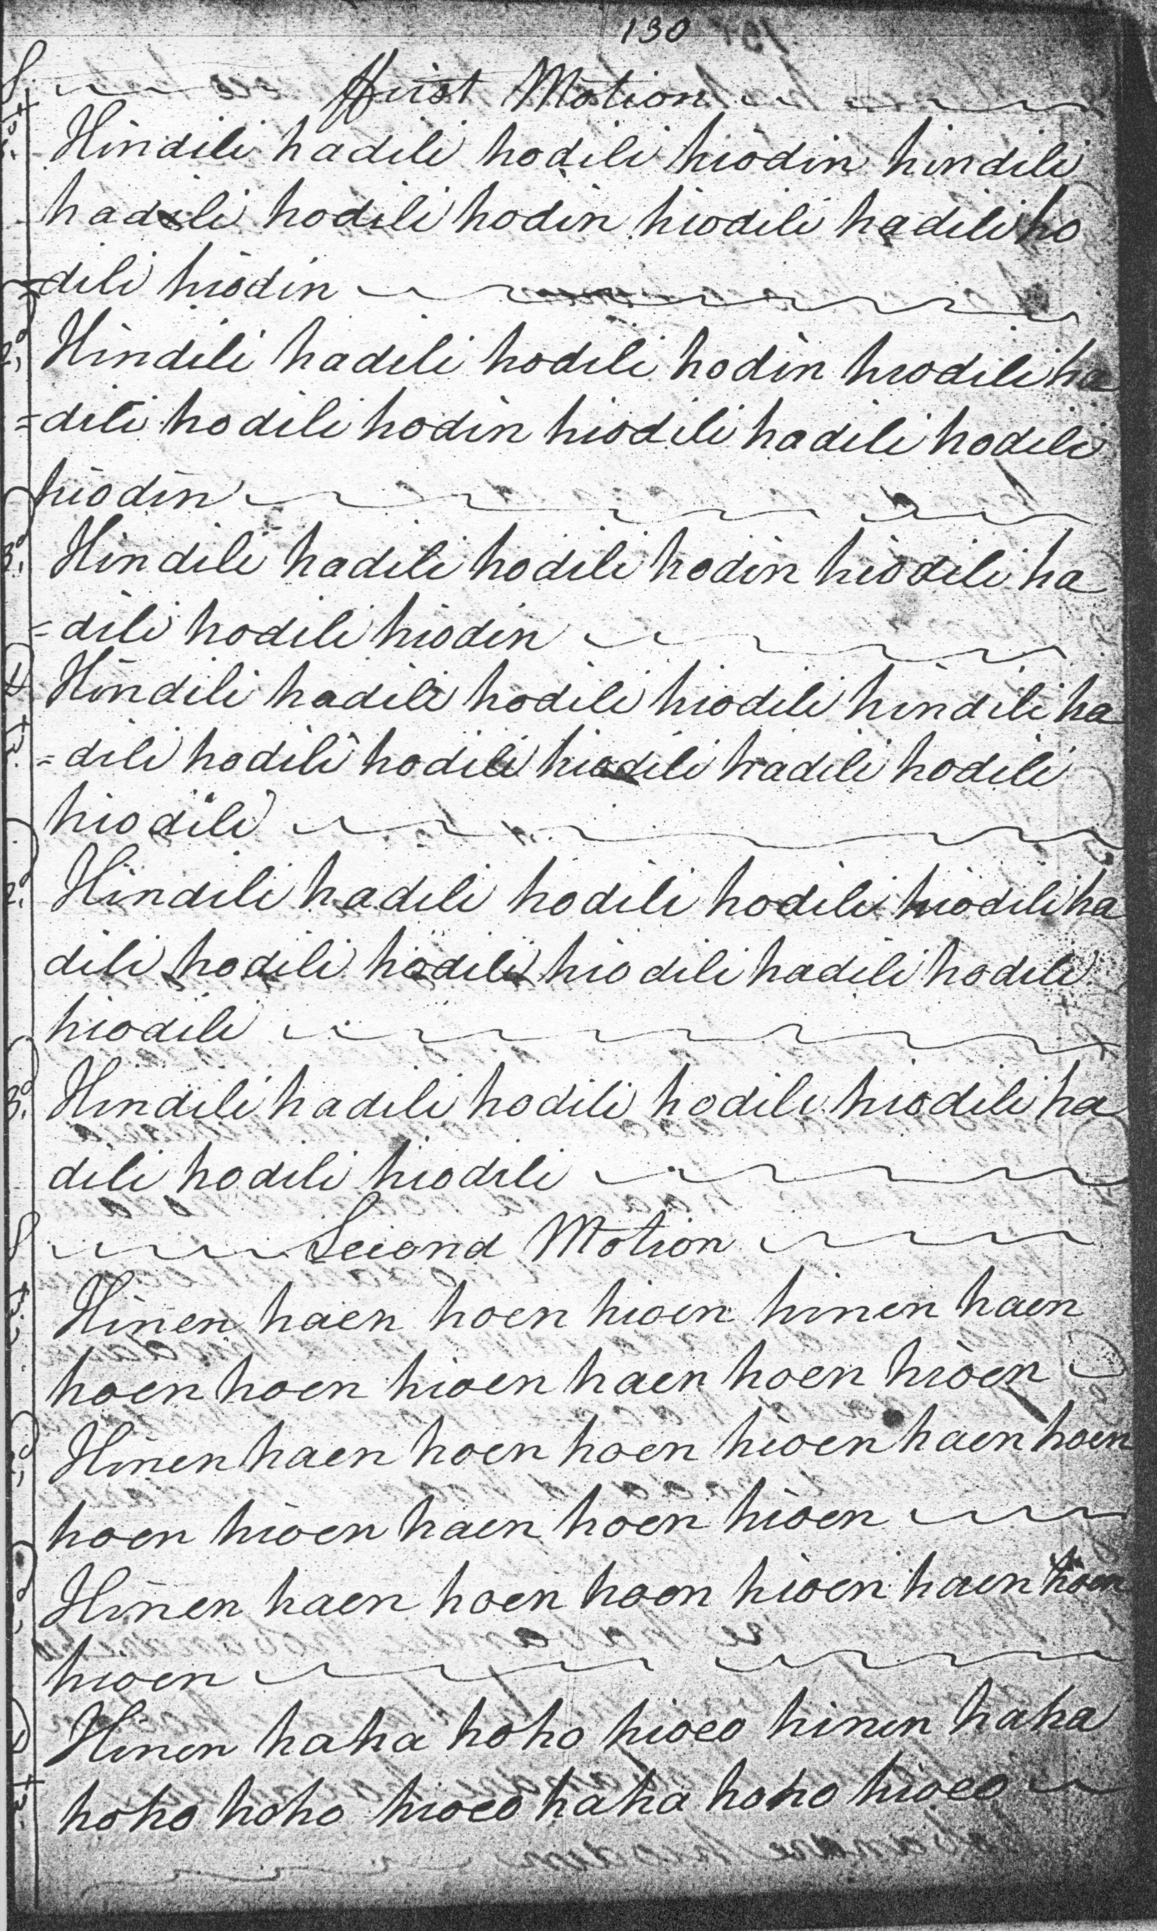
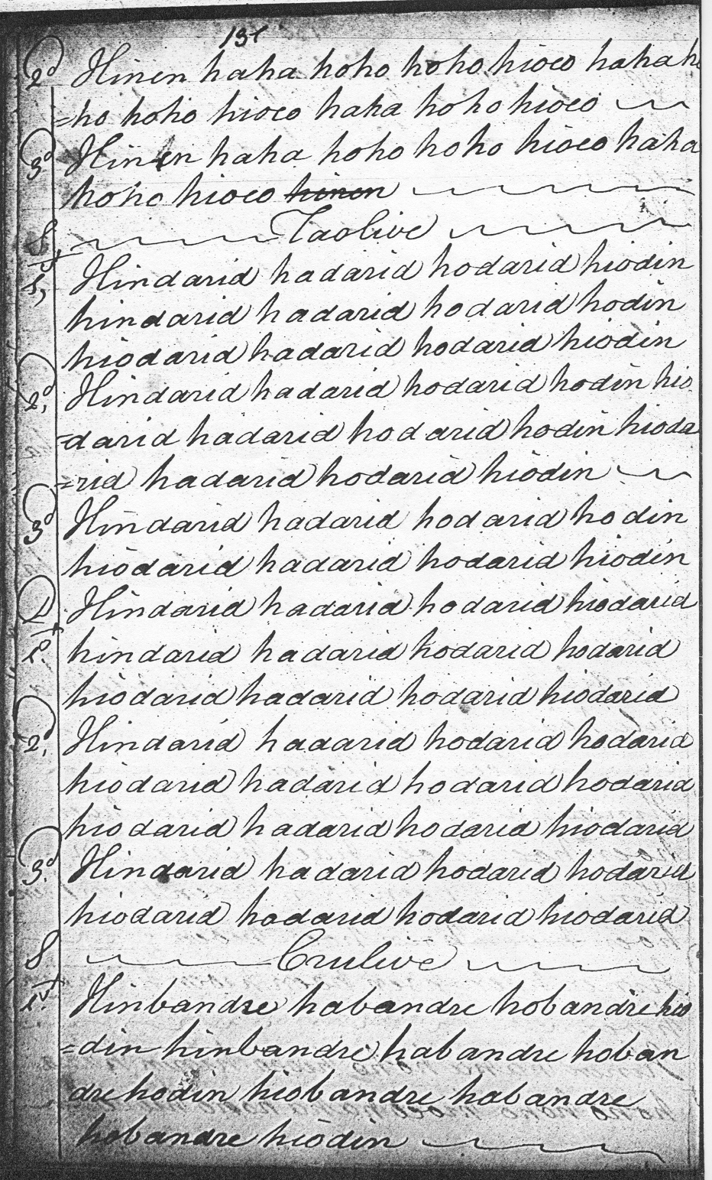
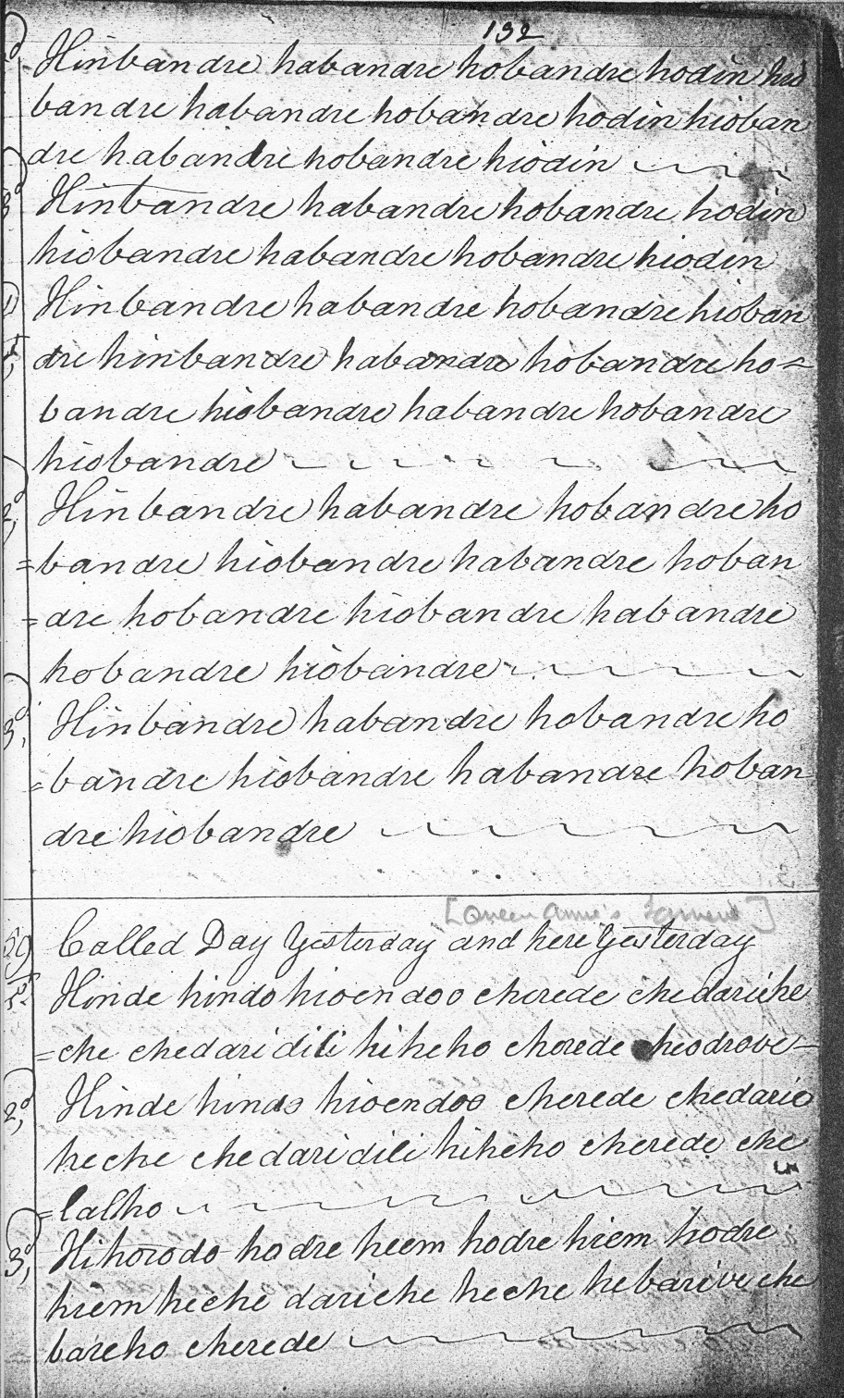

Colin Campbell develops the tune in a perfectly clear and regular manner. He has a ground and thumb variation, a siubhal singling and doubling, taorluath duinte singling and doubling, and crunluath duinte, singling and doubling. Campbell’s A phrase is based on a four rather than a three-note tone-row, A-B-C-D. The ground is in 2/4 while MacKay’s 4/4 timing is realised by inter-spacing the themal notes of the ground with rising A/E quavers, but these are essentially two variants of the same tune. In the oral tradition in which the tune had its roots, this kind of variety was both possible and expected.

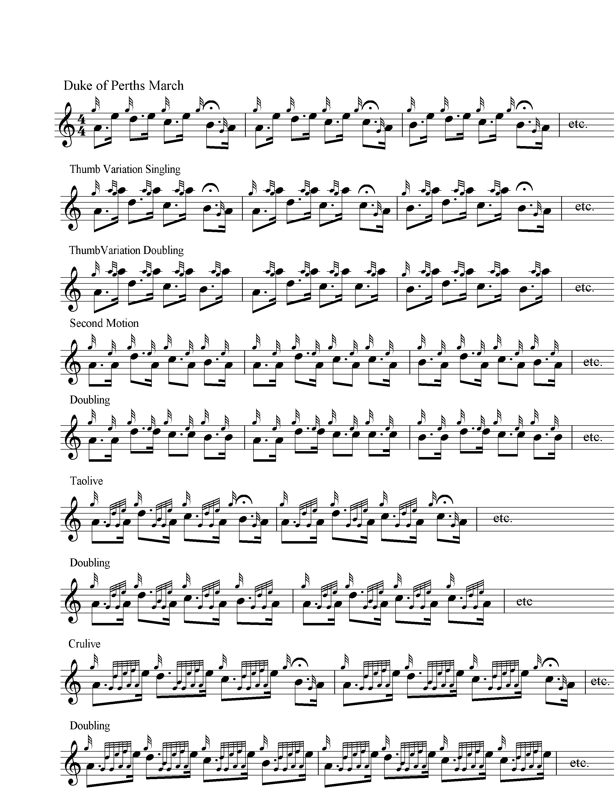

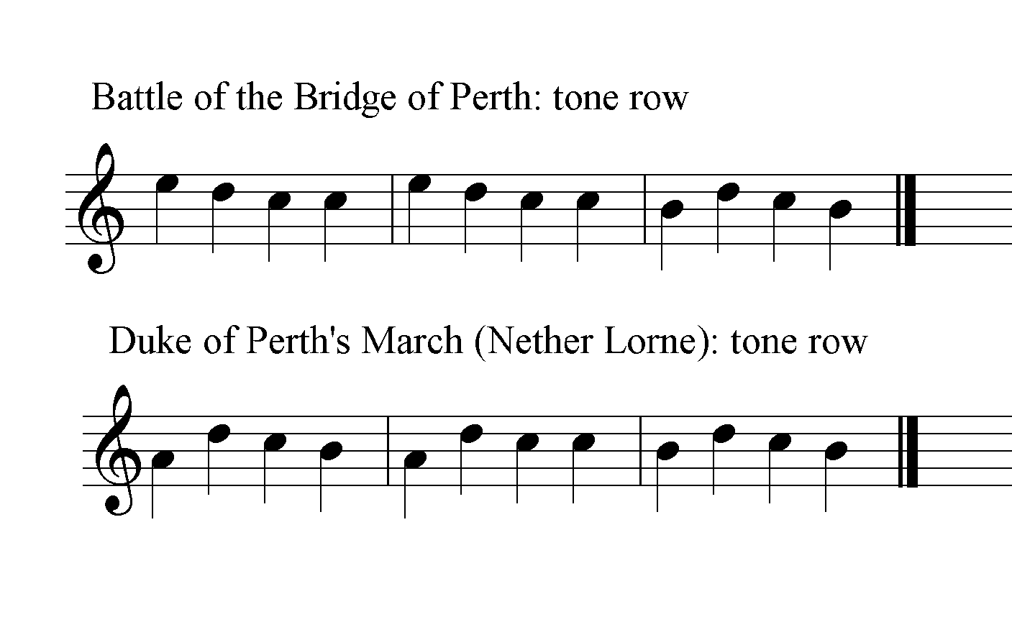

Commentary:
Angus MacKay’s version of this tune is based on two little overlapping three-note scales at an interval’s distance from each other, C-D-E and B-C-D, and the stepwise, mainly descending phrase contours they support possess considerable energy if played up to time. Colin Campbell’s tone row differs by a single note, but the balance and contrast between two arching contours have a pleasing effect.
“The Battle of the Bridge of Perth” is one of the tunes cited in support of claims for the great antiquity of piobaireached, on the presumption that it celebrates the famous clan battle on the North Inch of Perth which took place in 1396, and has been transmitted, unchanged, ever since. But but both ideas rest on very dubious grounds.
There are two stories connected with this tune, depending which title is preferred. The background of “The North Inch of Perth” can be found in numerous sources, including highly coloured accounts in Sir Walter Scott’s Tales of a Grandfather (1828) and The Fair Maid of Perth (1828). But here is W. F. Skene in Celtic Scotland, on the curious judicial combat on the North Insh of Perth which a number of commentators have connected, rather arbitrarily perhaps, with this tune. He cites, inter alia, Maurice Buchannan, in the Book of Pluscarden, who says that in 1391,
so great a contention had arisen among the wild Scots (silvestres Scottos), that their whole country was disturbed by it, and, on that account, the king finding himself unable to restore peace, arranged, in a council of the magnates of the kingdom, that their two principal captains, with their best and most valiant friends, amounting on each side to thirty men, should fight in an enclosed field after the manner of judicial combatants (more duellancium), with swords only, cross bows having each three arrows only, and this before the king on a certain day on the North Inch of Perth; and this, by the intervention of the earl of Crawford and other nobles, was agreed upon and carried out, when all on both sides were slain except seven, five on the one side and two on the other escaping alive, of which two one escaped by flying to the river and escaping across it, and the other being taken was pardoned with the consent of the other party, though some say that he was hung. In the beginning of the conflict one of the number of one party disappeared and could not be found, on which one of the spectators, who happened to belong to the same clan (parental) and was hostile to the other party, agreed to supply his place for forty shillings, fought most valiantly, and escaped with his life. William Forbes Skene, Celtic Scotland: A History of Ancient Alban, (1886), iii, 311-312.

The other possibility, if one accepts Colin Campbell’s title, is that the tune commemorates one of the eighteenth-century Jacobite Dukes of Perth, either James, the 2rd Duke, who commanded the cavalry at Sheriffmuir in 1715, or, more likely, James the 3rd Duke (1713-1746), a major figure in Jacobite annals who was Lt. General of the Highland Army during the ’45, fought at Prestonpans, laid siege to Stirling Castle, and was present at Culloden. A contemporary portrait shows an elegant figure:

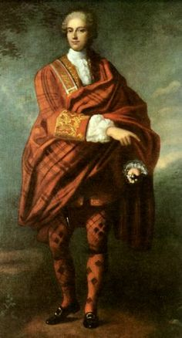

A colleague, Murray of Broughton, described him as
six foot high, of slender make, fair complexion and weakly constitution […] and fired with an extraordinary love for his country’. He had an unparalleled affection for the exiled family of Stuart…He never attained to the perfect knowledge of the English language, and what prevented this in a great measure was his over-fondness to speak broad Scots…He was Roman Catholic, but far from being bigoted…In short, never was man possessed of more shining qualities, nor attended with a worse fortune.
(R. F. Bell, ed., Memorials of John Murray of Broughton, Scottish History Society, Vol.xxvii, 1898, pp.188-9).

One can see the force of the famous Jacobite prayer:
O hold me not, my mother earth,
But raise me with the Duke of Perth,
With many another loyal lad,
Once more to wear the white cockade.
(Robert Forbes, Lyon in Mourning, Scottish History Society, Vol.xxii, iii, 284).

His health was severely undermined by the campaign and the privations that followed and he died and was buried at sea from the French privateer carrying him back into exile.
There is a quite distinct tune published with the title “The Duke of Perth’s March”, in Angus MacKay’s Ancient Piobaireachd (1838), attributed to Finlay Dubh Macrae and with a historical note which seems to confuse the 2nd with the 3rd Dukes.
“The North Inch of Perth” was the piece that Bob Nicol played when he first competed at the Northern Meeting in 1922 as a boy of sixteen. Shortly afterwards, an old man with a white beard came up and said “I liked your tune”, and, assuming the man Bob was conversing with to be his father, added “He’s going to be some player that laddie of yours”. The speaker was the legendary Sandy Cameron.
* * *
Electronic text © Dr. William Donaldson, Cambridge, Massachusetts, 31st May 2016

