The Battle of Balladruishaig

There are settings of this tune in the following manuscript sources:

**Angus MacKay**’s MS, i,18-19; and in the so-called “Kintarbert” MS, ff.91-2;

**Duncan Campbell of Foss**’s MS, ff.106-8;

**Uilleam Ross**’s MS, ff.71-2;

**D. S. MacDonald**’s MS i,145-6;

**John MacDougall Gillies**’s MS, f.29;

**David Glen**’s MS, ff.67-9;

and in the following published source:

**C. S. Thomason**, *Ceol Mor,* p.289.

In his main manuscript **Angus MacKay**sets the tune as follows:

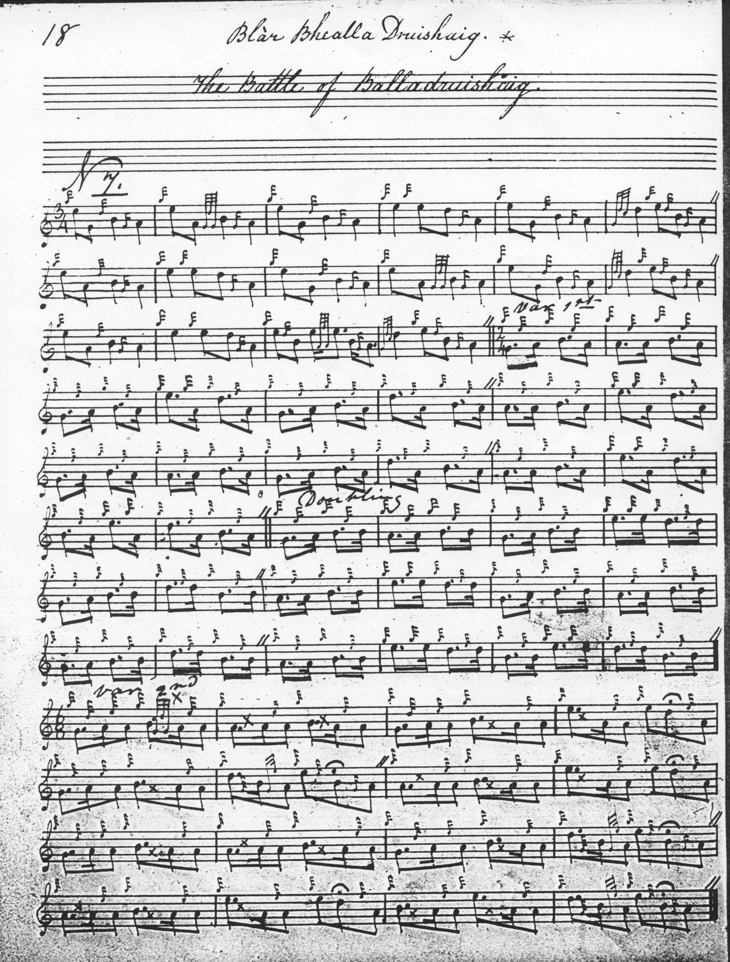

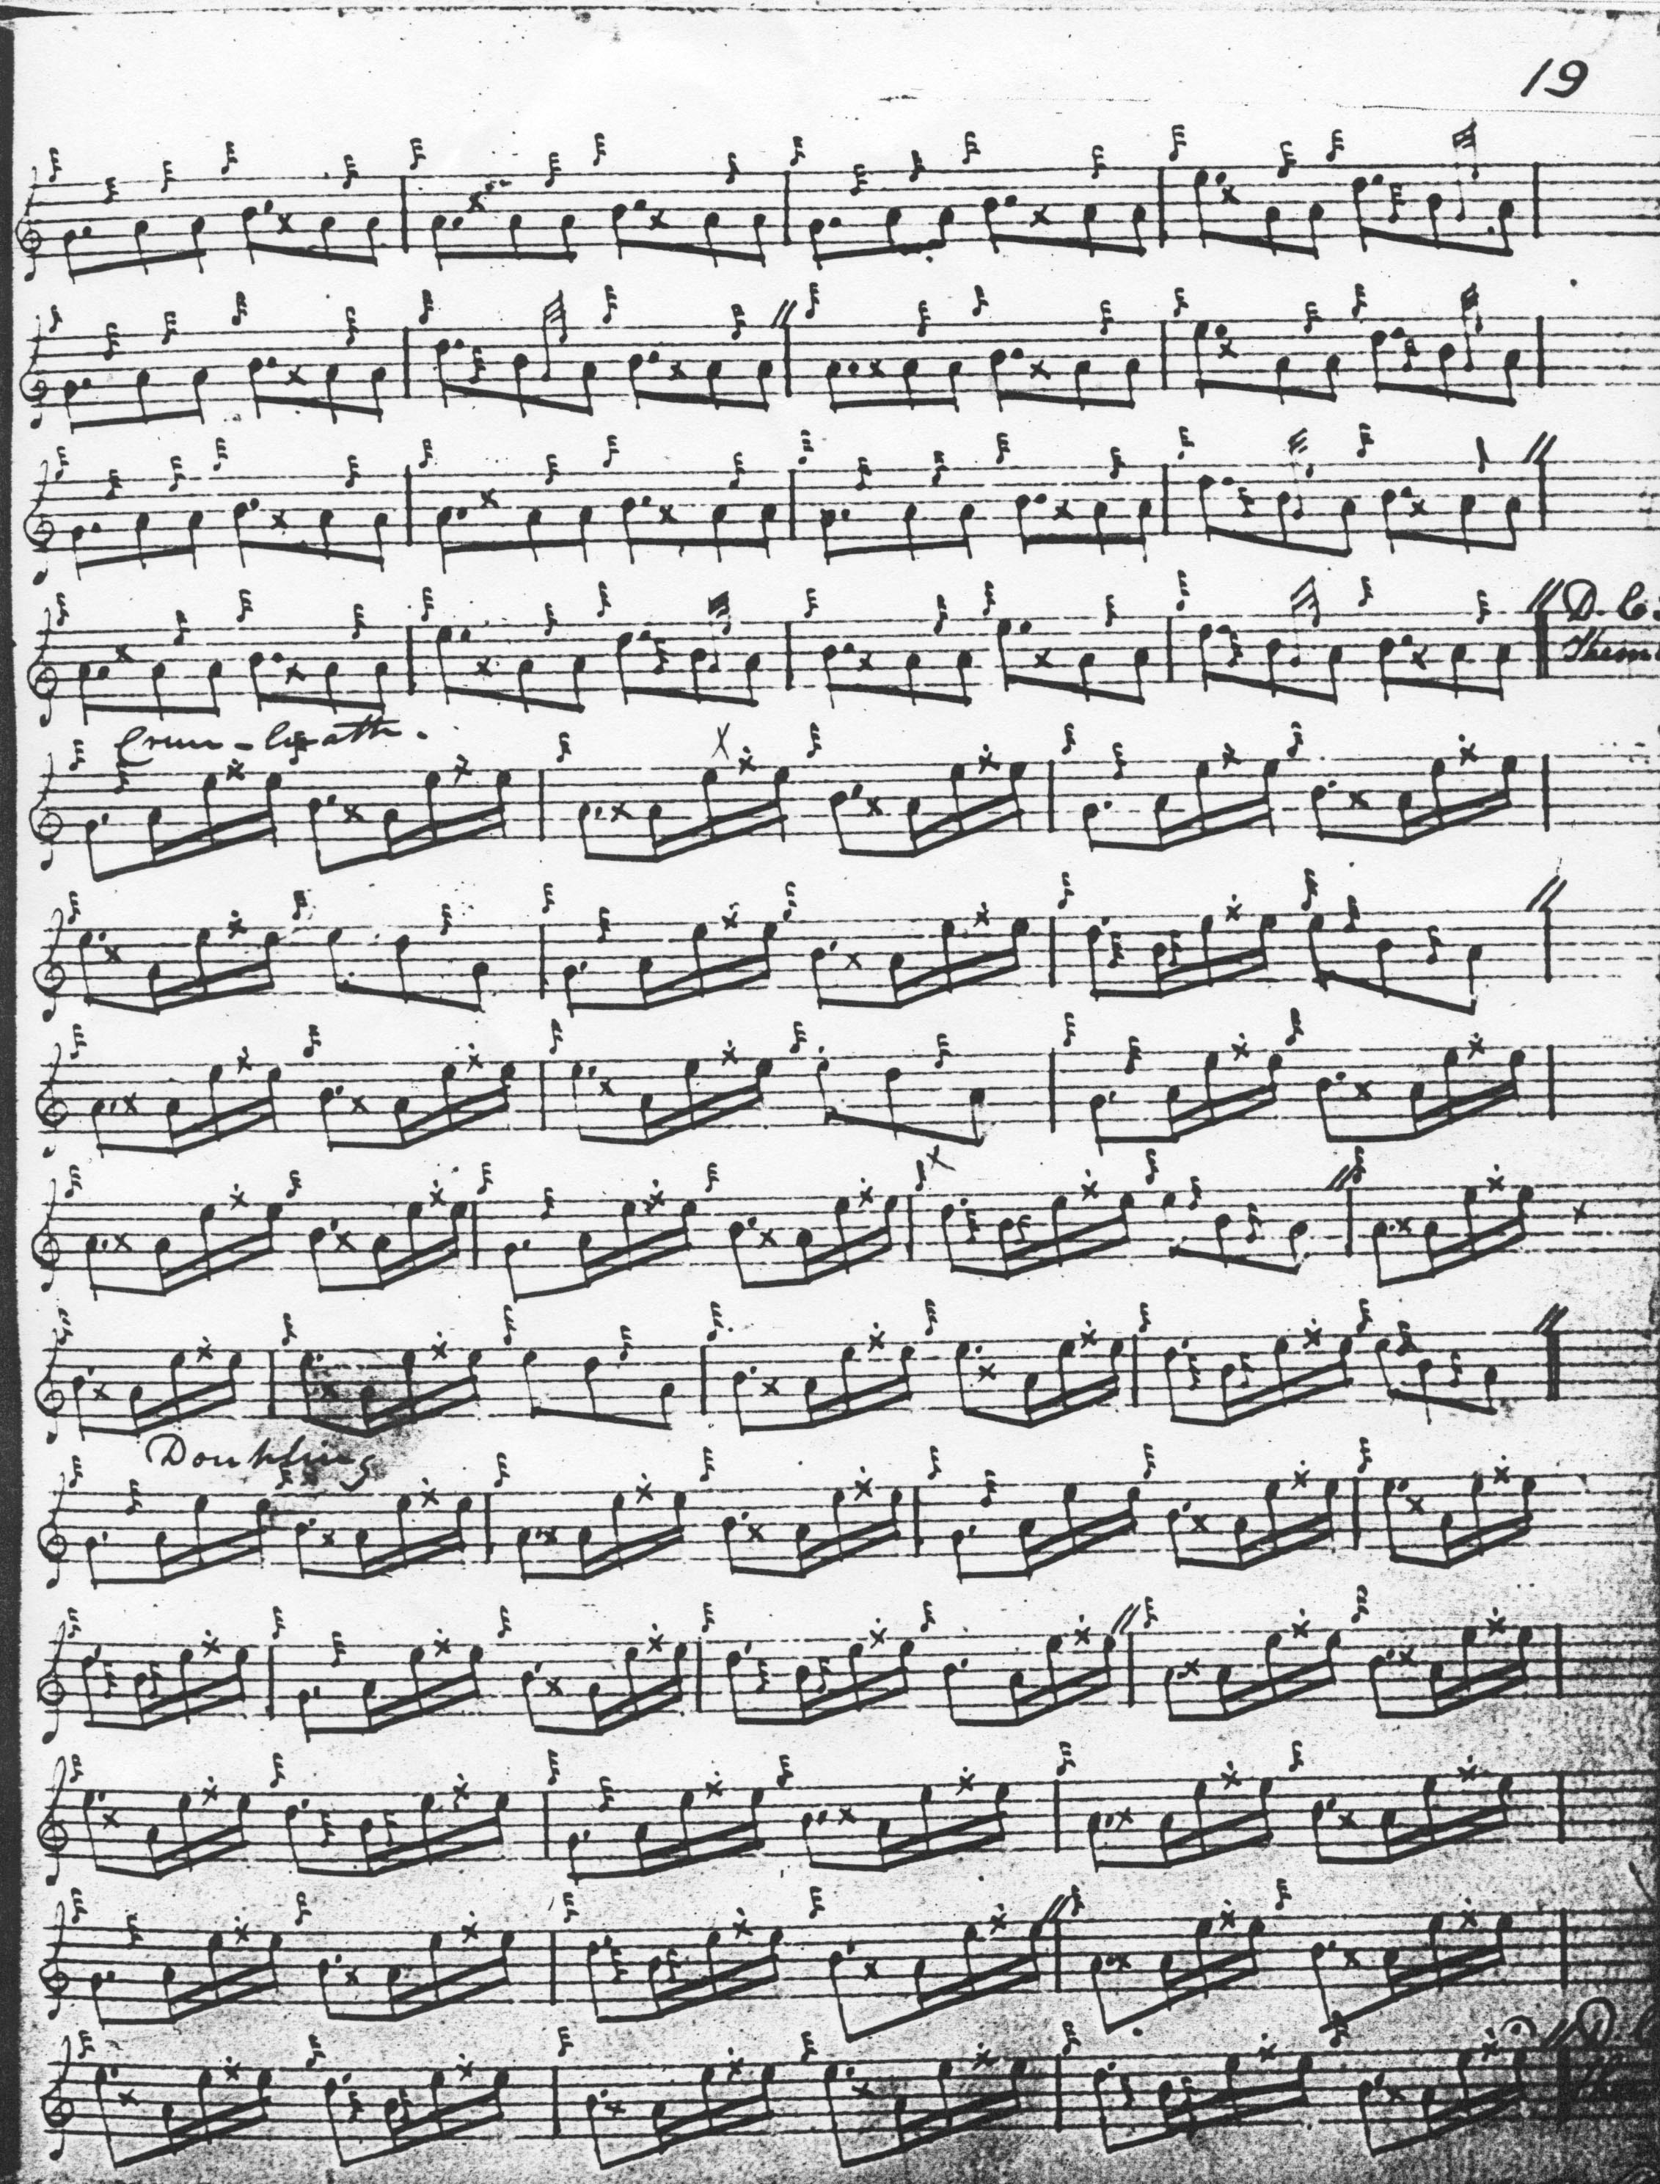

Structurally MacKay’s setting is very straightforward: ground, siubhal singling and doubling, duinte taorluath singling and doubling and duinte crunluath singling and doubling. MacKay repeats the ground between the taorluath and crunluath variations and again at the end of the tune in both his scores, for there are two MacKay settings, the second in the so-called “Kintarbert MS”, where the even quavers of the ground are pointed, as follows:

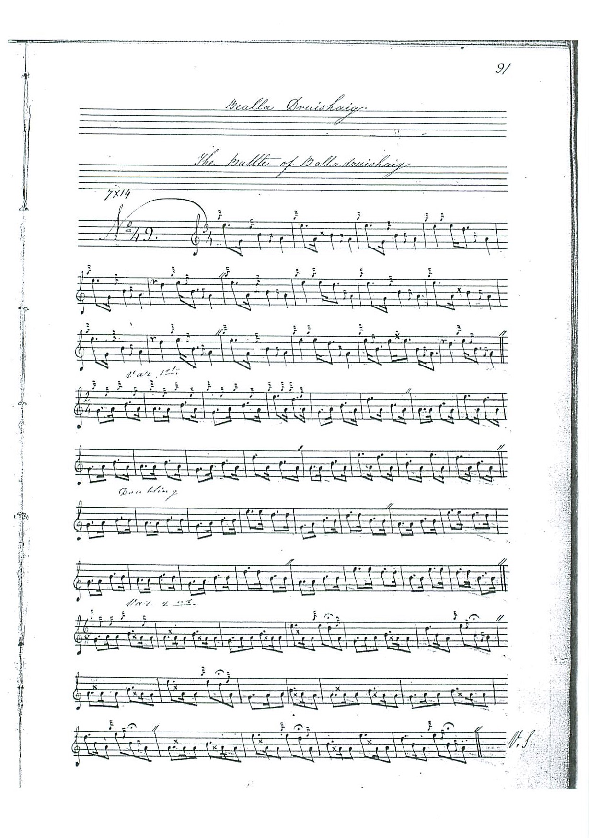

and so on.

MacKay is the single early source for this tune, suggesting that it was not of very wide distribution, and that it may existed mainly in scribal rather than performance tradition. All the Victorian piper-editors time the piece as MacKay does in the “Kintarbert”, although there are a number of features which gave **David Glen** pause for thought, as we see here:

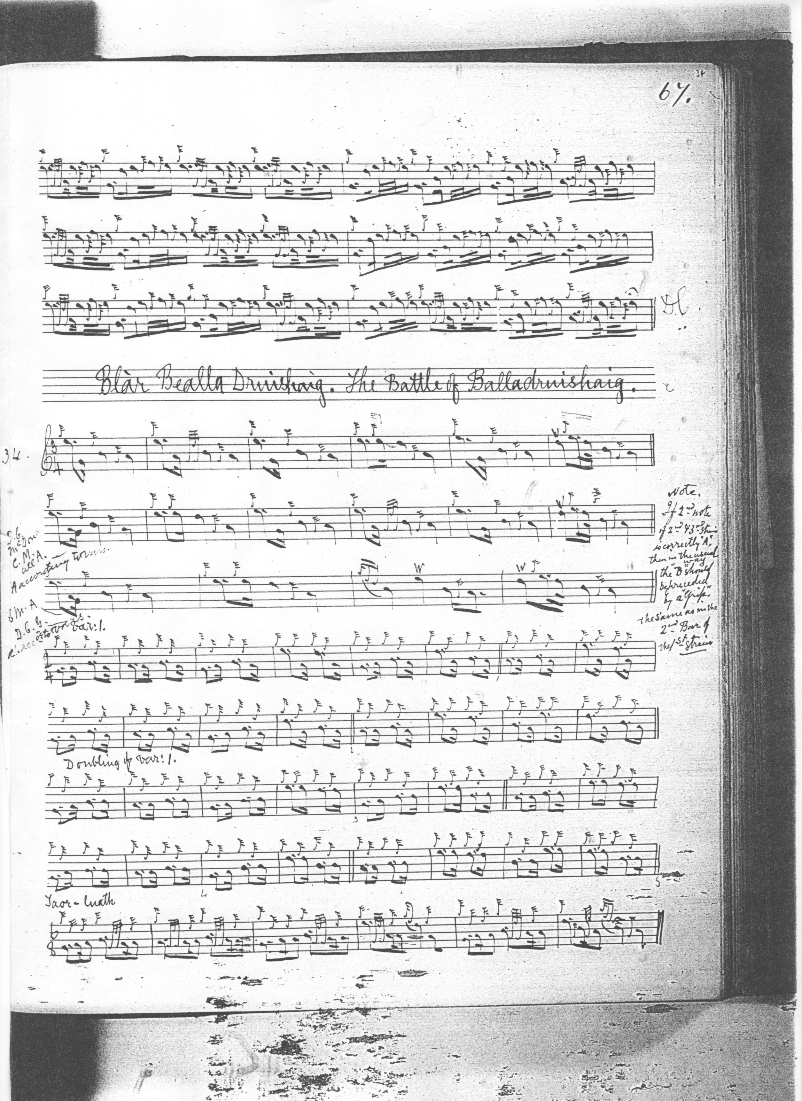

Glen queries the consistency of MacKay’s use or ornament in the bottom-hand figures and his placing of the themal notes low A and G at the phrase beginnings. However although he sets the rest of the tune is in 2/4, Glen leaves intact MacKay’s choice of 3/4 time for the ground. All the later editors approach the ground in the same way, but this creates significant problems of expression, obvious to anyone who has heard this tune attempted to be played as written. If the second two notes in most bars of the ground are timed as crotchets, it gives the melody a very ponderous feel, a thumping return to the tonic in bar after bar, which can hardly be the intention. Musical context may supply an answer. The tune seems similar in flavor to “Weighing from Land”, and if set in 2/4 might give a considerably enhanced sense of rhythmical pulse and forward movement. Perhaps along the following lines:

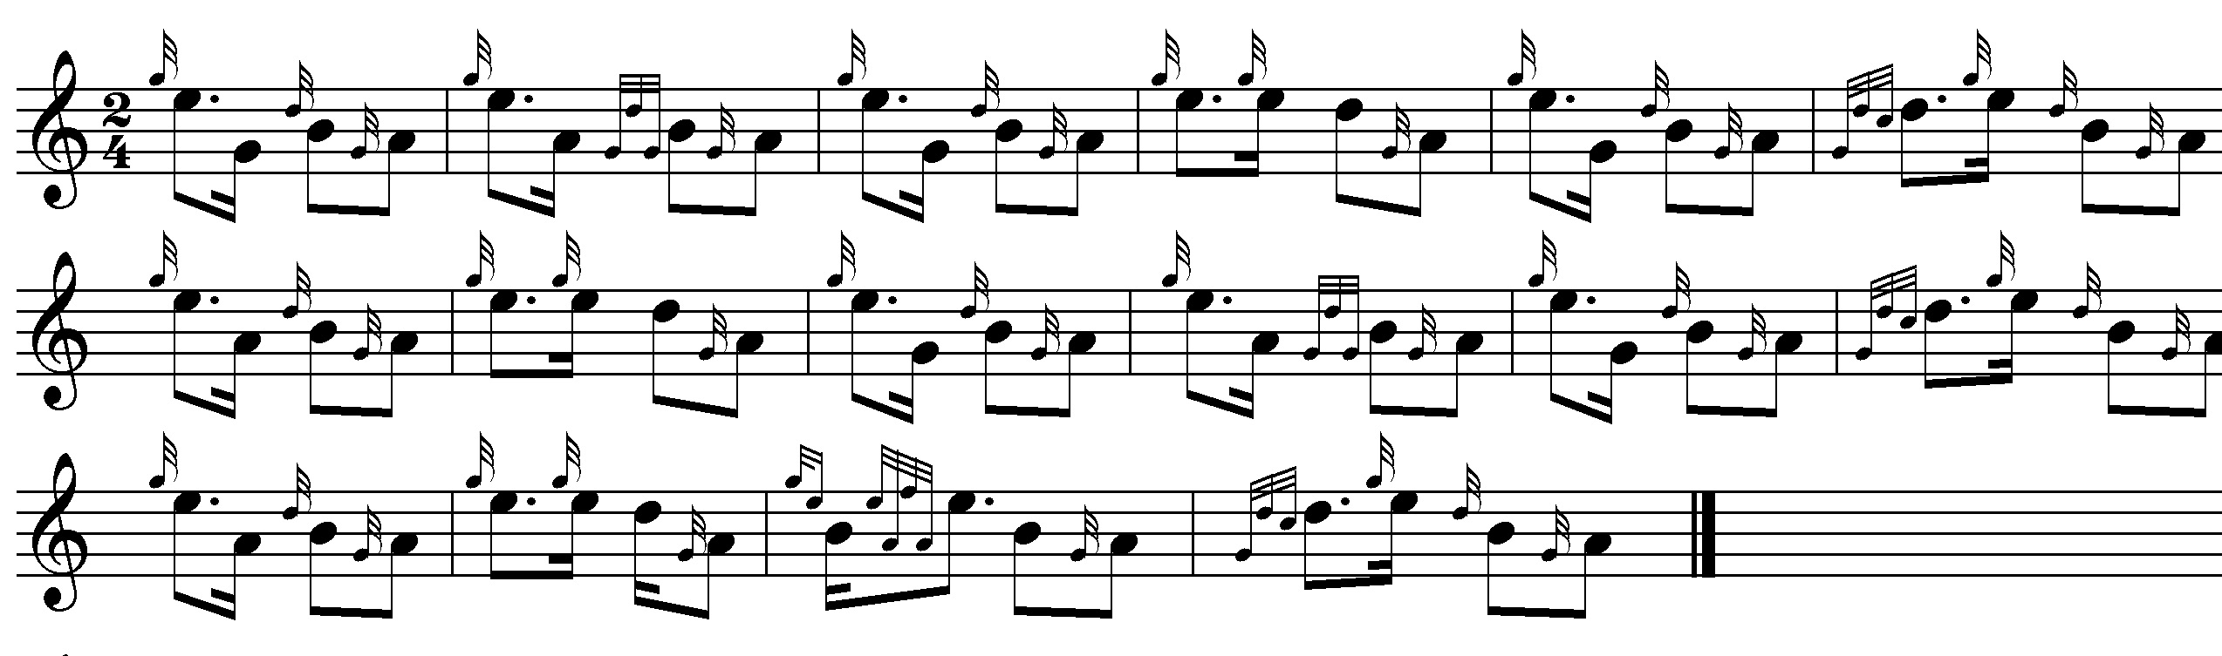

**Duncan Campbell of Foss** follows MacKay fairly closely, but indicates pointing for MacKay’s even quavers in the ground; otherwise he adds nothing of stylistic significance to MacKay’s two scores and his version is not reproduced here.

**Uilleam Ross** points the ground in a similar manner to Duncan Campbell, but his setting adds little to MacKay’s and is not reproduced here.

**D. S. MacDonald** merely replicates MacKay’s score and is not reproduced here.

**John MacDougall Gillies** follows Duncan Campbell’s pointing; his score adds noting of musical significance to it, and is not reproduced here.

**C. S. Thomason** follows MacKay, giving the MacKay MS as his sole source; his score is not reproduced here.

*Commentary:*

In “The Battle of Balladruishaig” the musical tension springs from the pull between two overlapping gapped scales, low G, A, B, D, E, and low A, B, D, and E forming a typical double-tonic sequence. It is a tune full of unobtrusive subtlety, including when we come to the variations the end note of each line returning not to the tonic but to the second interval of the scale, giving a flowing, “circular” feel, another reason for suggesting the more fluent approach to timing the ground discussed above. The tone row has similarities with “The (Grant’s) Blue Ribbon”, and the metrical pattern, as suggested above, may be similar to that of “Weighing from Land”. There is another example of a similar tune in the MacKay manuscripts where the ground is timed in 3/4 where is should perhaps be 2/4, namely “Catherine’s Salute”. Uilleam Ross has it in his published book, describing it as “very old” and he sets it in 2/4 in the ground (pp.3-4). There seems little known about the history of this tune, or the circumstances of its composition. Leading Gaelic scholar Professor Colm O’Boyle of Aberdeen University, an authority on the harp tradition and the terms of art in Highland music, suggests that the title may be a mis-spelling of  “**Ballardruishaig**, which might represent 'the town [*baile*in Gaelic] of Ardrishaig', in Argyllshire?” (private communication 14 July 2020).

*

Electronic text © Dr. William Donaldson, Cambridge, Massachusetts, 17 July 2020