All the Old Men Paid Rent but Rory
There is a manuscript setting of this tune in
--Colin Campbell’s “Nether Lorne Canntaireachd”, ii, 149-52.

This is the sole source: the tune is not recorded in any other pre-twentieth-century MS or printed collection.

Colin Campbell sets the tune like this:

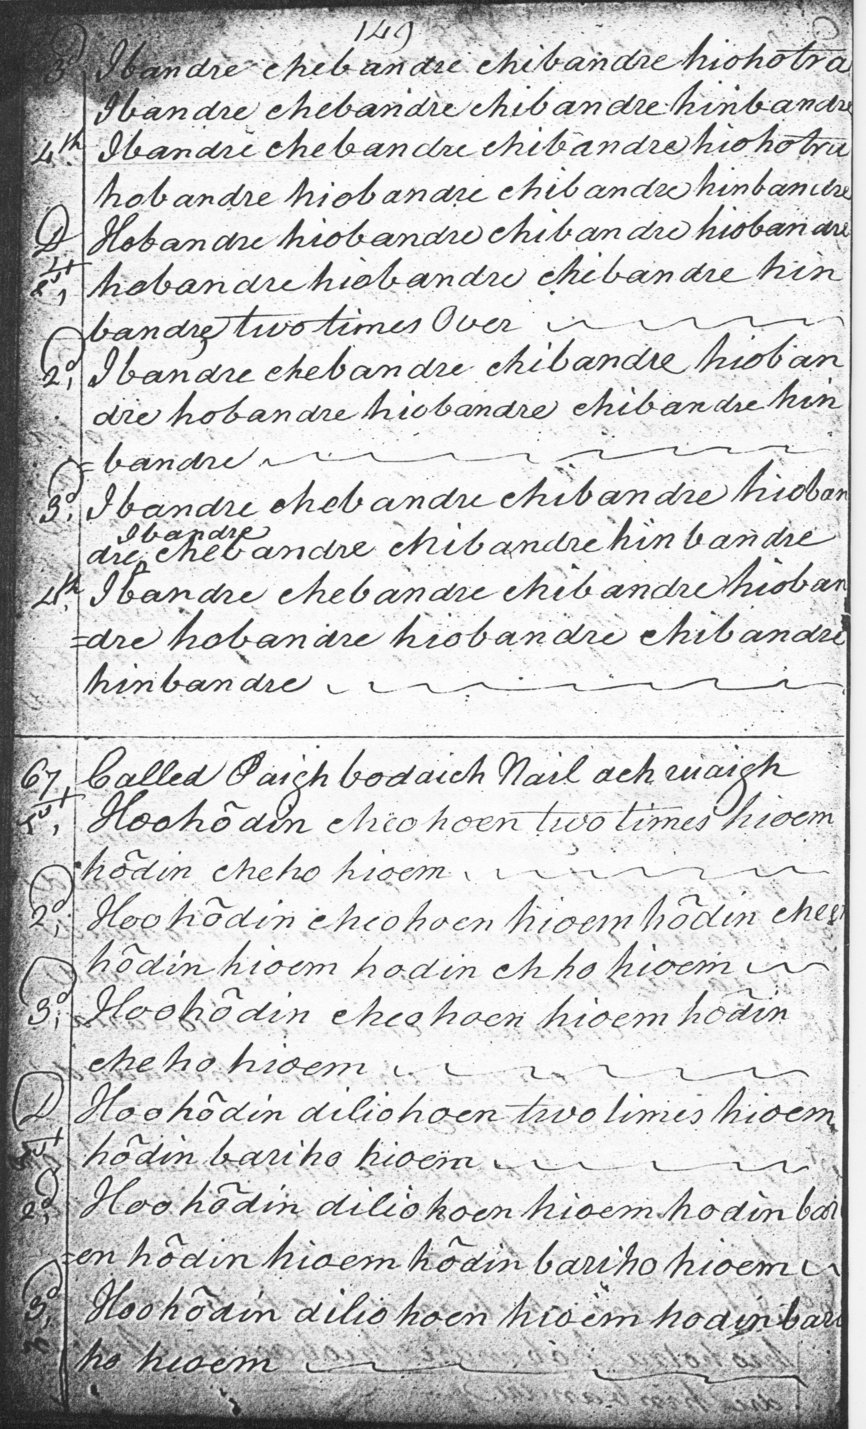
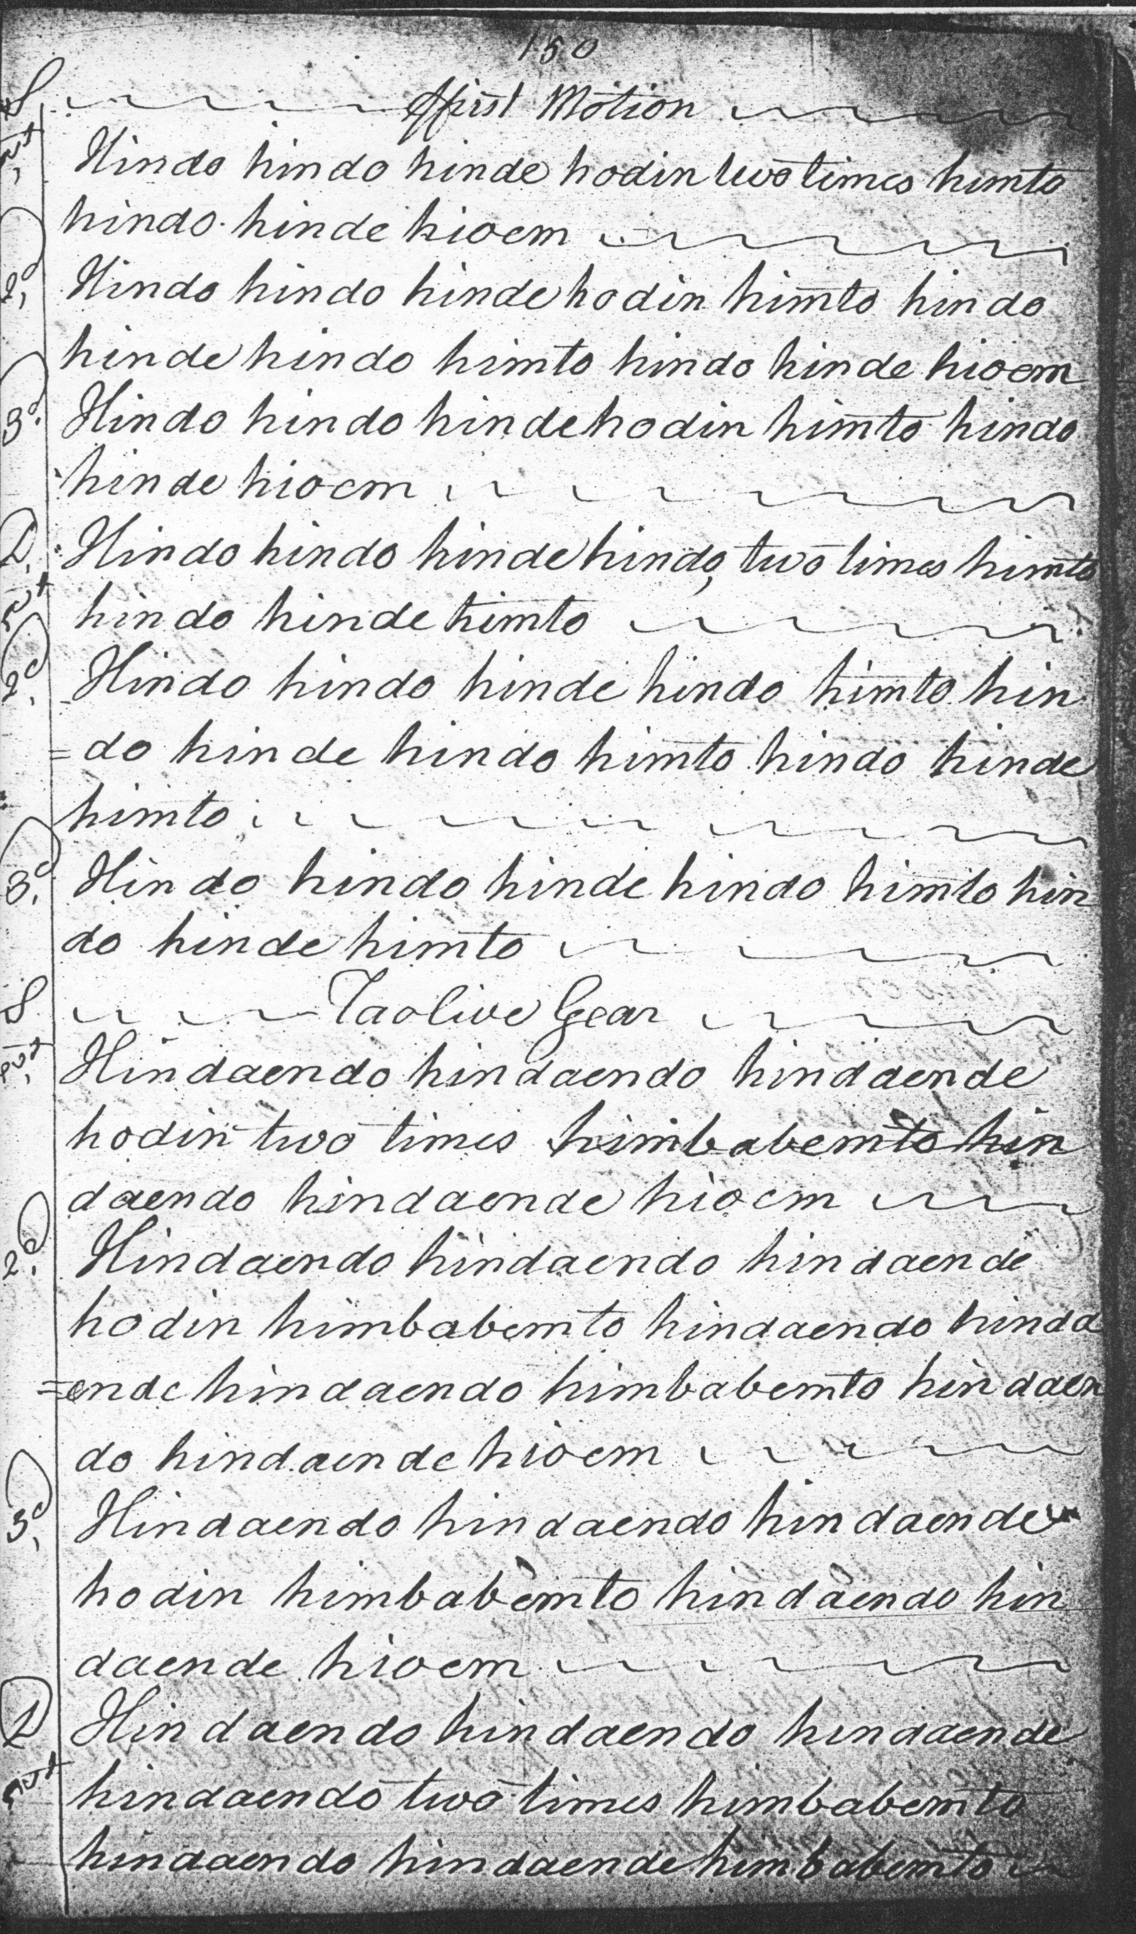
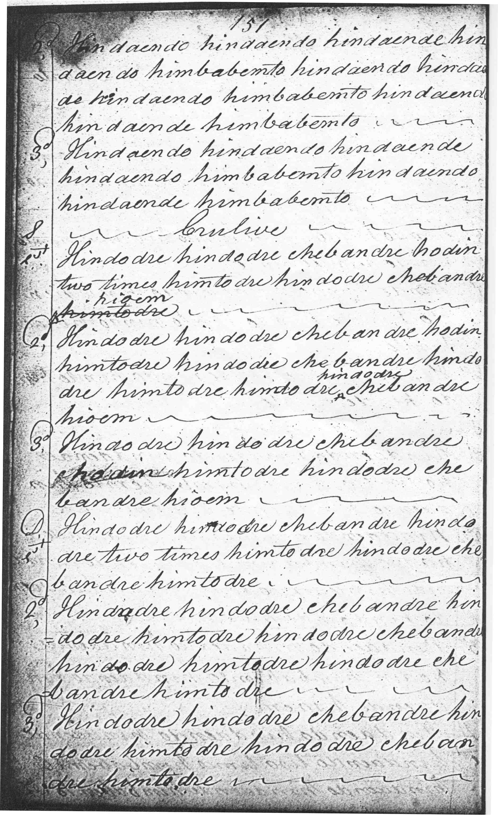
As the reader will have noted, the superscription “hindodre” in line two of the crunluath singling seems obviously redundant.

This bold and beautifully symmetrical tune illustrates the interesting problems arising from canntaireachd scores; in this specific instance there are no enormous difficulties of interpretation, the main point at issue turning on the inclusion and placing of cadence notes, characteristically unspecified in scores in this medium.

In this case, omission seems the best policy—to play the piece as written and not to interrupt its powerfully rhythmical onward flow—to produce an effect perhaps somewhat along the following lines:
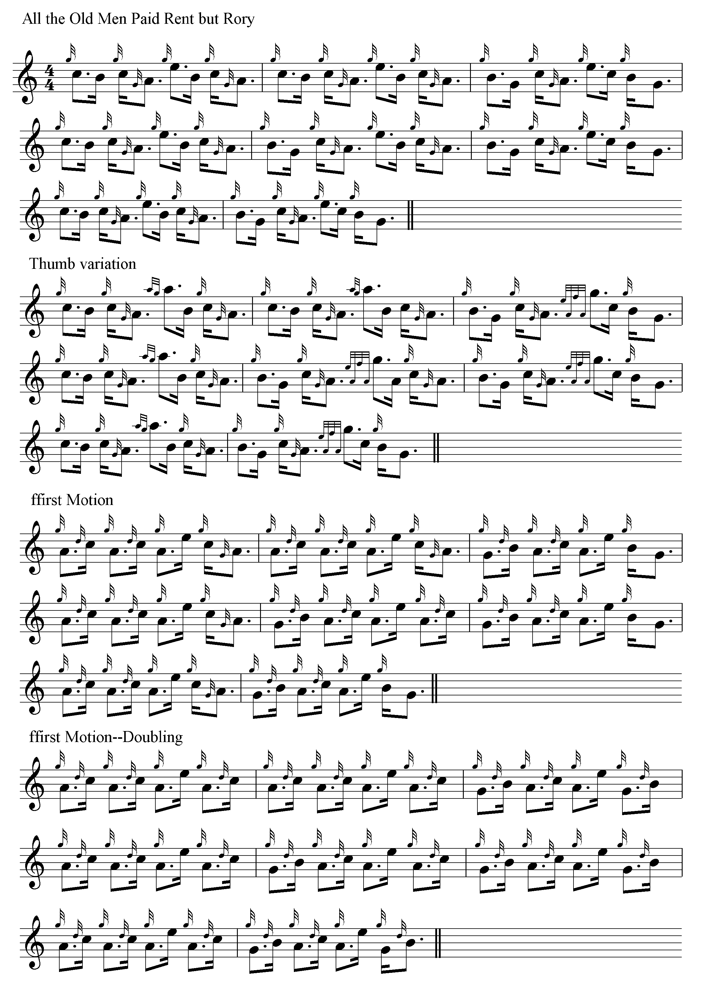
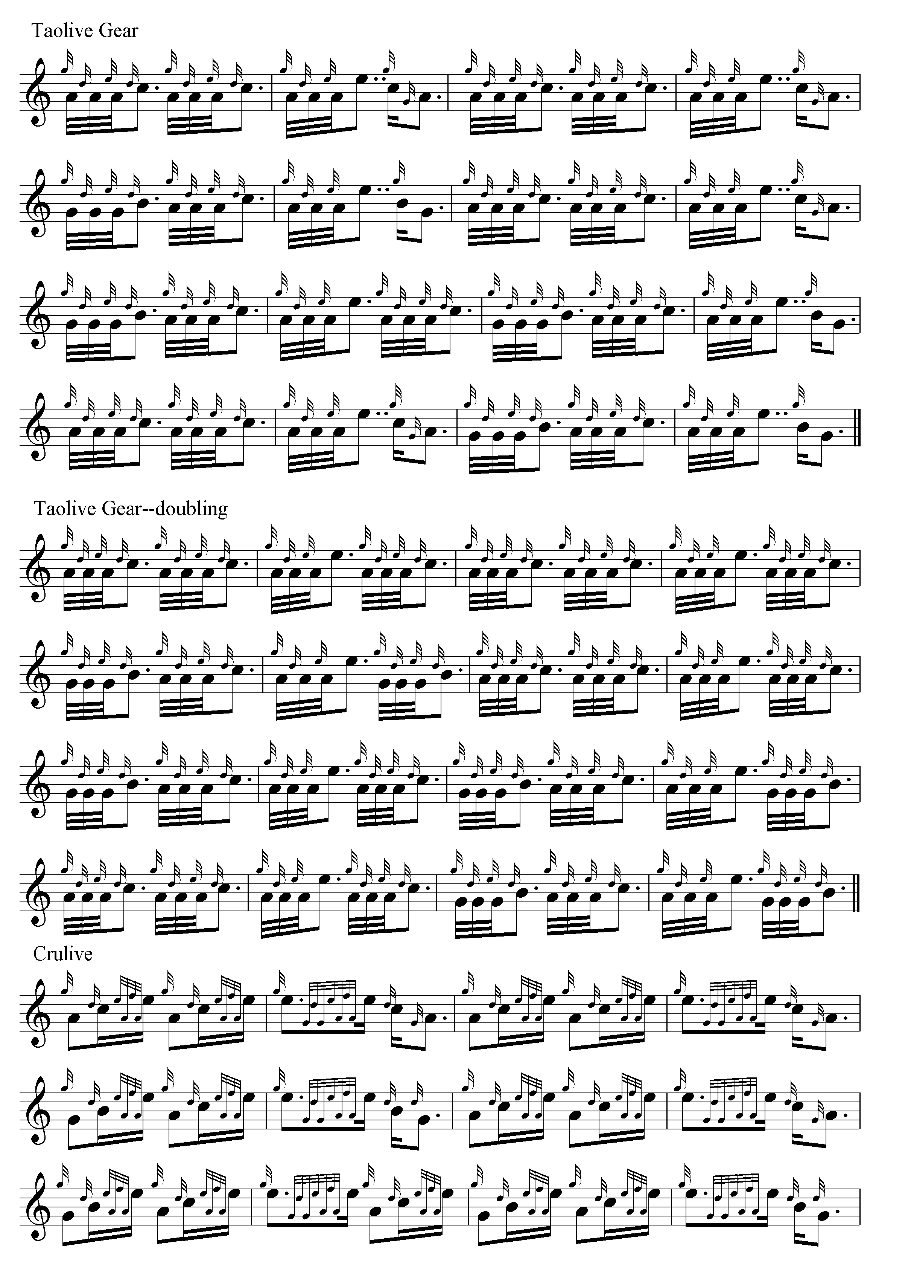
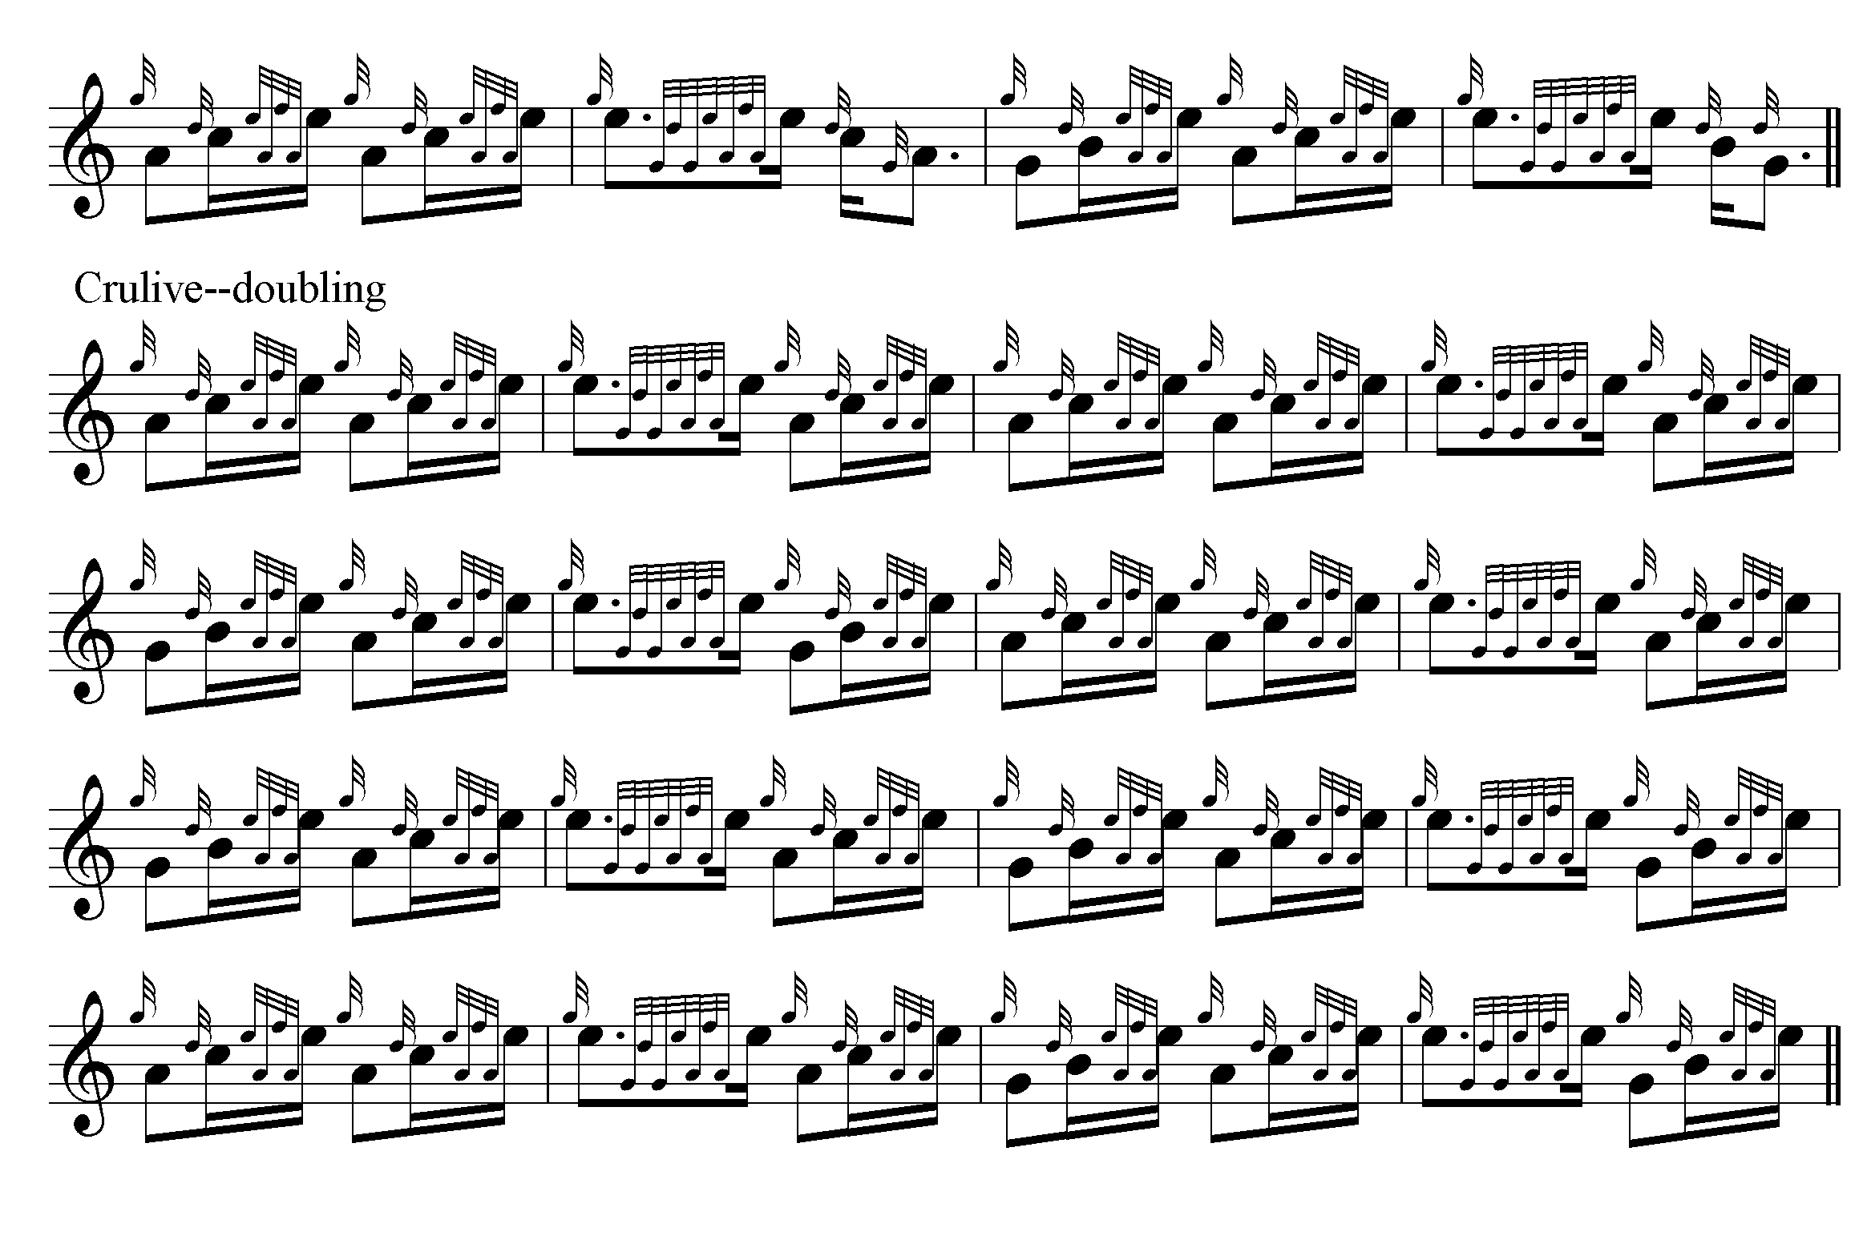

Commentary:

The curious name of this piece has prompted some speculation, but nothing is known with certainty about its occasion, or how widely distributed it may once have been. However, it is one of the really attractive smaller fosgailte tunes. Its strength lies in the balanced interplay of its descending figures C-A and B-G, and the sweetly satisfying route it picks through its pentatonic scale, low G, A, B, C, E.

* * *

Electronic text © Dr. William Donaldson, Cambridge, Massachusetts, 8 May 2013

