Airds Lament

This tune is preserved in a single manuscript source:
--Colin Mór Campbell’s Nether Lorn Canntaireachd, ii, 103-7.

Colin Mór sets the tune like this:

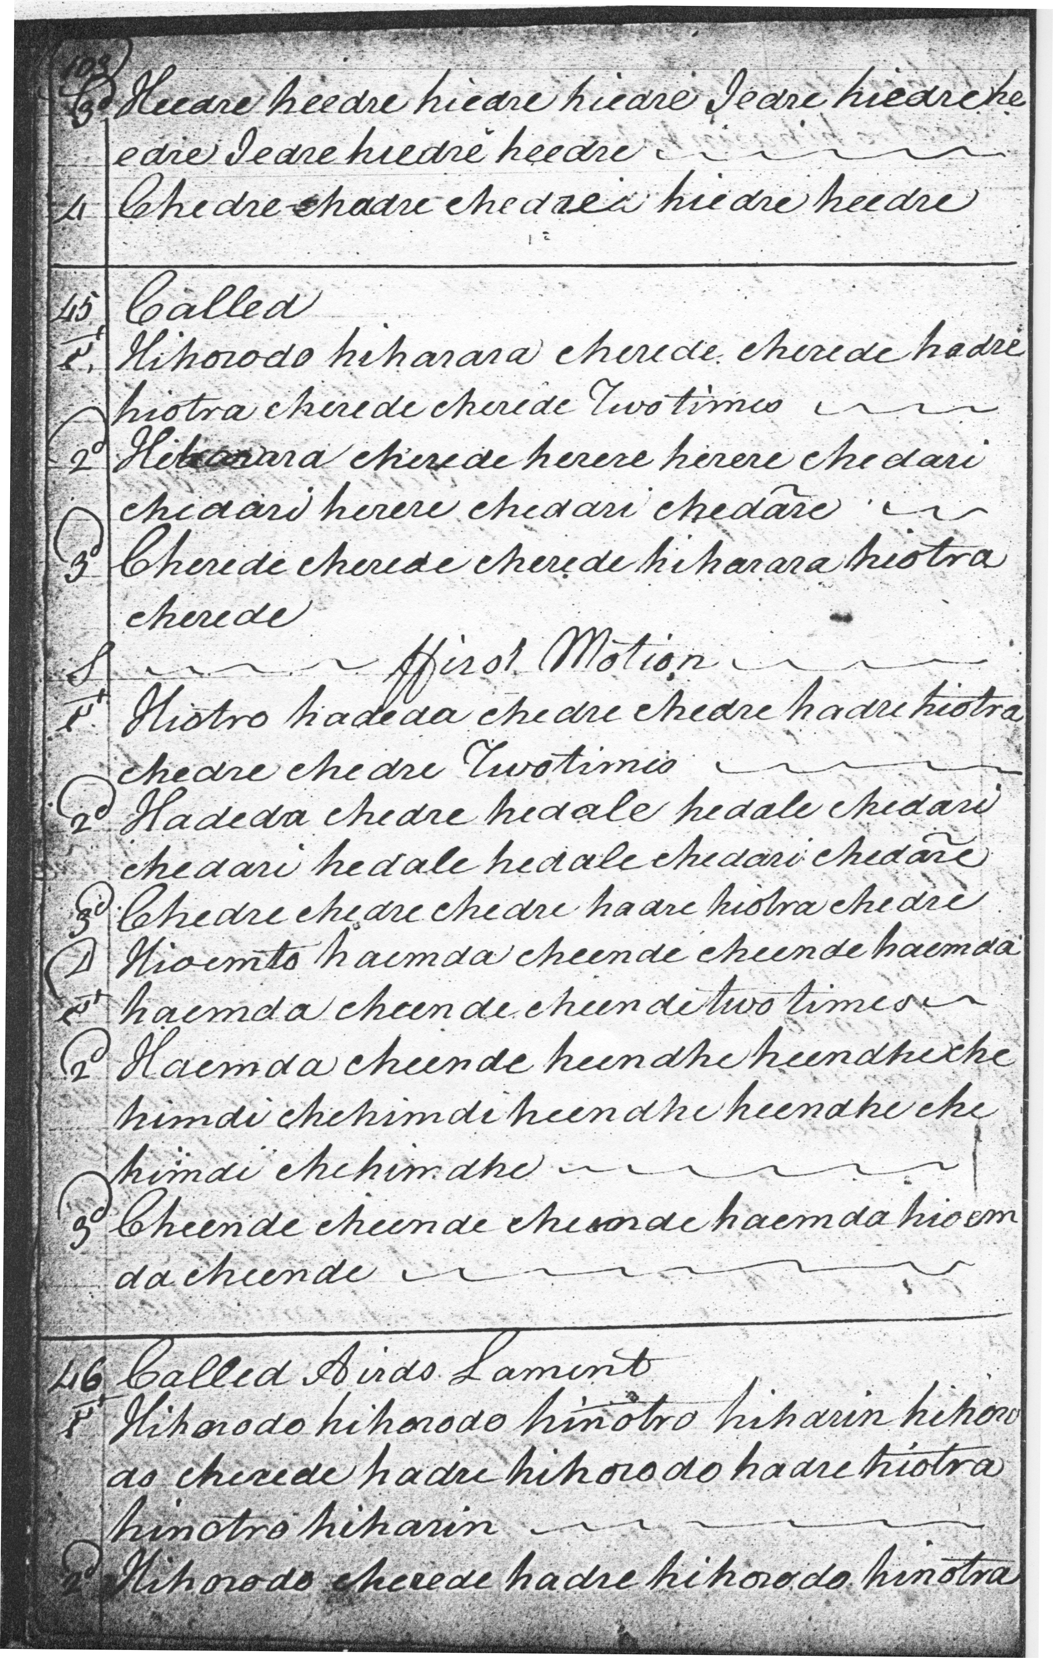
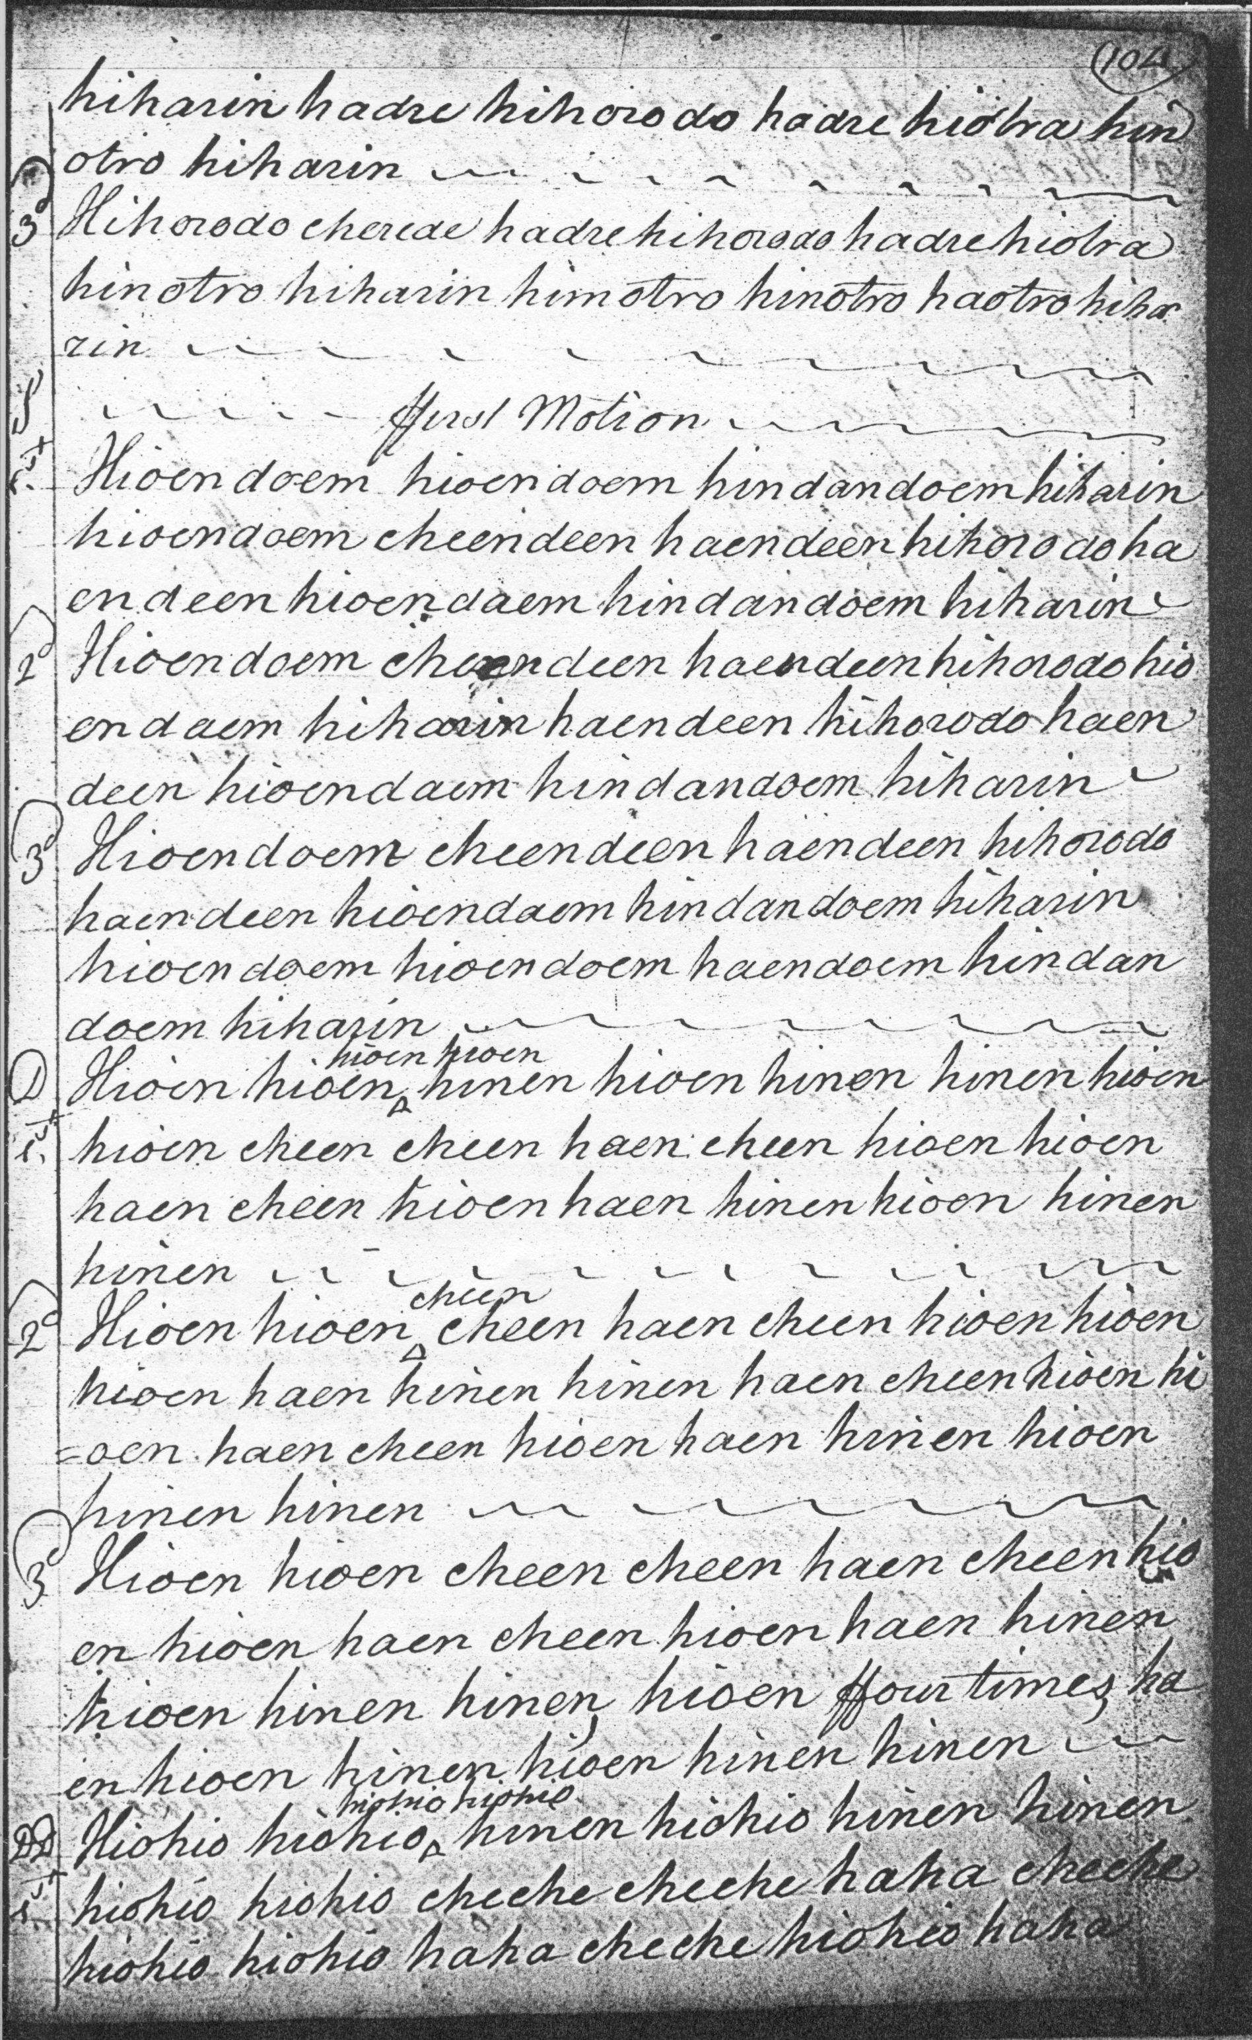
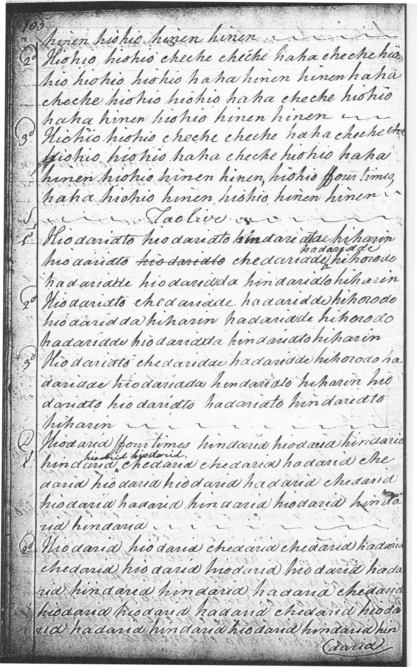
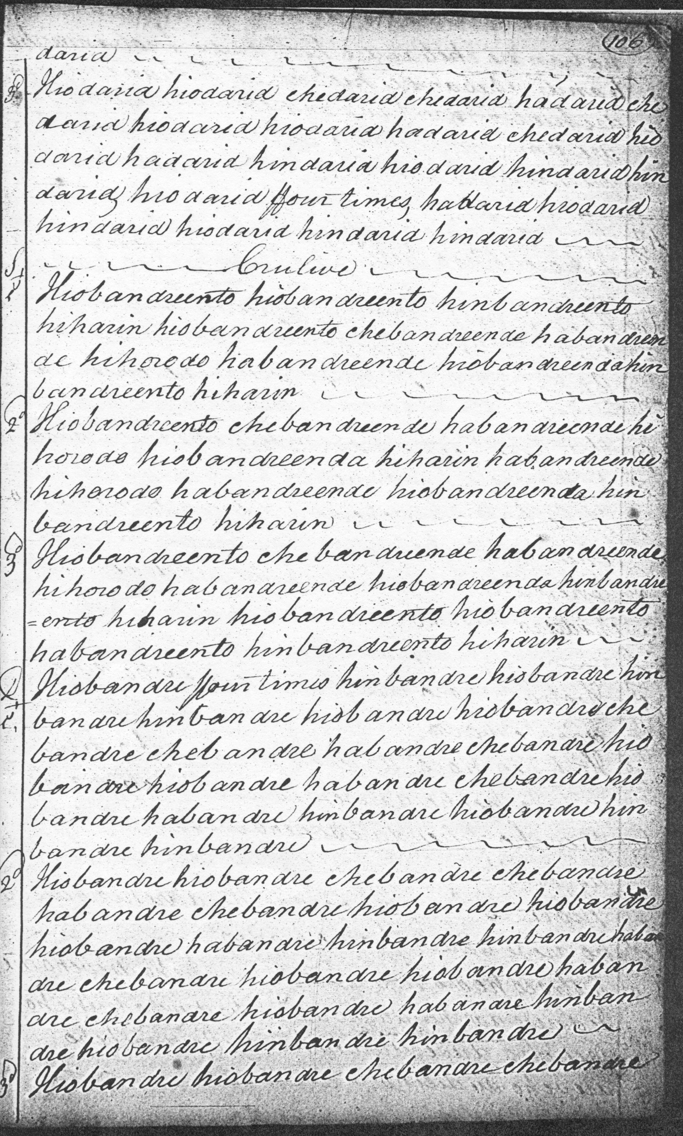
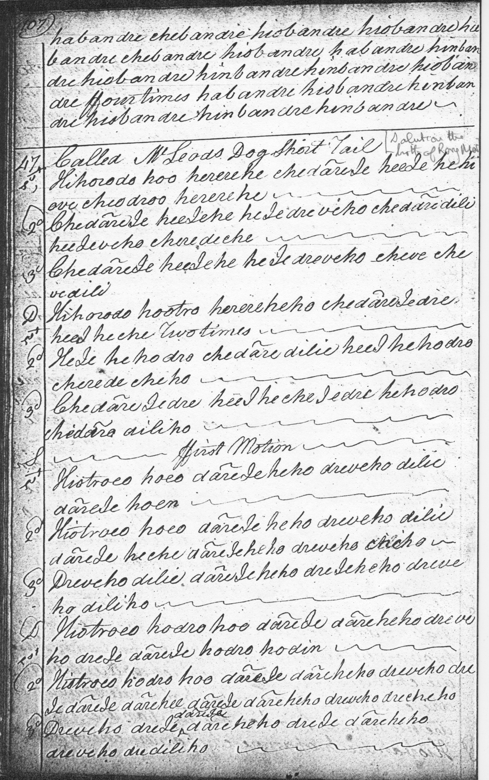

The tune is structured as follows:
--ground;
--siubhal
singling
doubling
trebling
--taorluath
singling
doubling
--crunluath
singling
doubling

The ground is in three lines, 6-6-6 based on a pleasing and inventive tone row, and possessing an additional quirky little two-bar coda. Each of the subsequent variations, however, appears to show some kind of irregularity. In the ffirst Motion, there seems to be a superfluous half bar in line three, and I have suggested omitting the second half of bar five, i.e. repeating the vocable hinen twice rather than the stipulated four times.
There seems a half bar too many in line three of the Taolive singling: in bar six the latter half of the bar seems to have a vocable, hindaridto, too many. And there’s a half bar too many-- hindarid hiodarid--towards the end of line three in the doubling. There is a superfluous half bar hinbandre hinto in a similar position in line three of the Crulive singling, and also in the doubling: the final couple of bars probably should read habandre hiobandre hinbandre hinbandre. Unless…Colin Campbell actually meant to give an additional wry twist to the little ritornello which ends each part. The tune might be realised somewhat thus in staff notation:

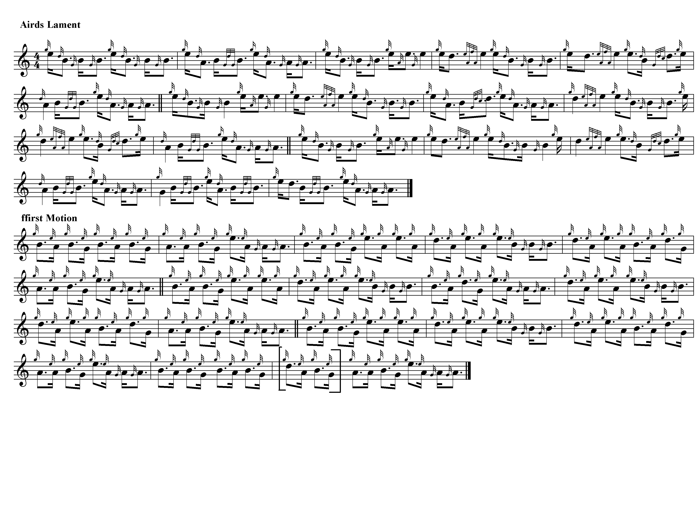

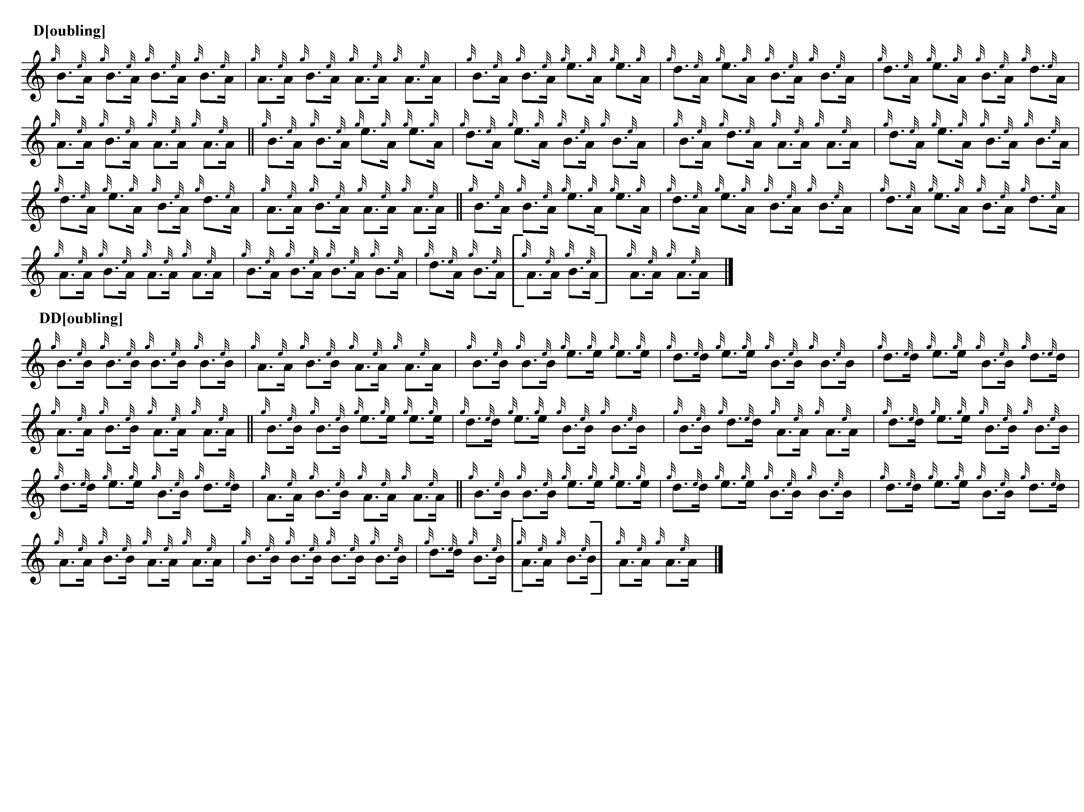

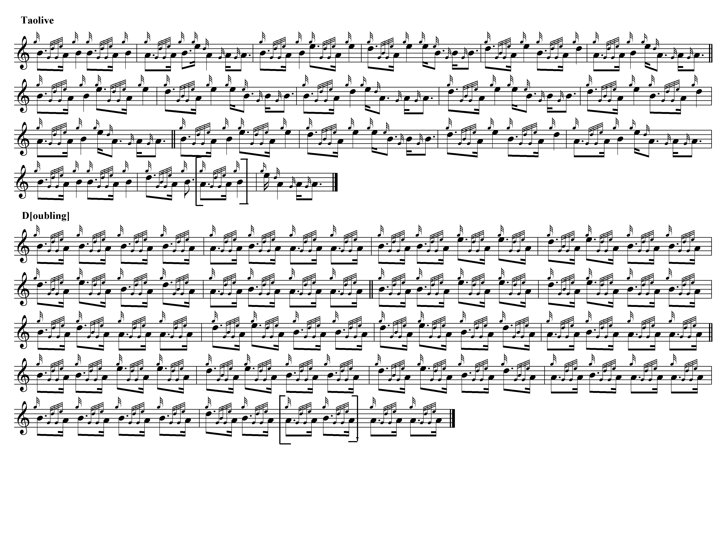

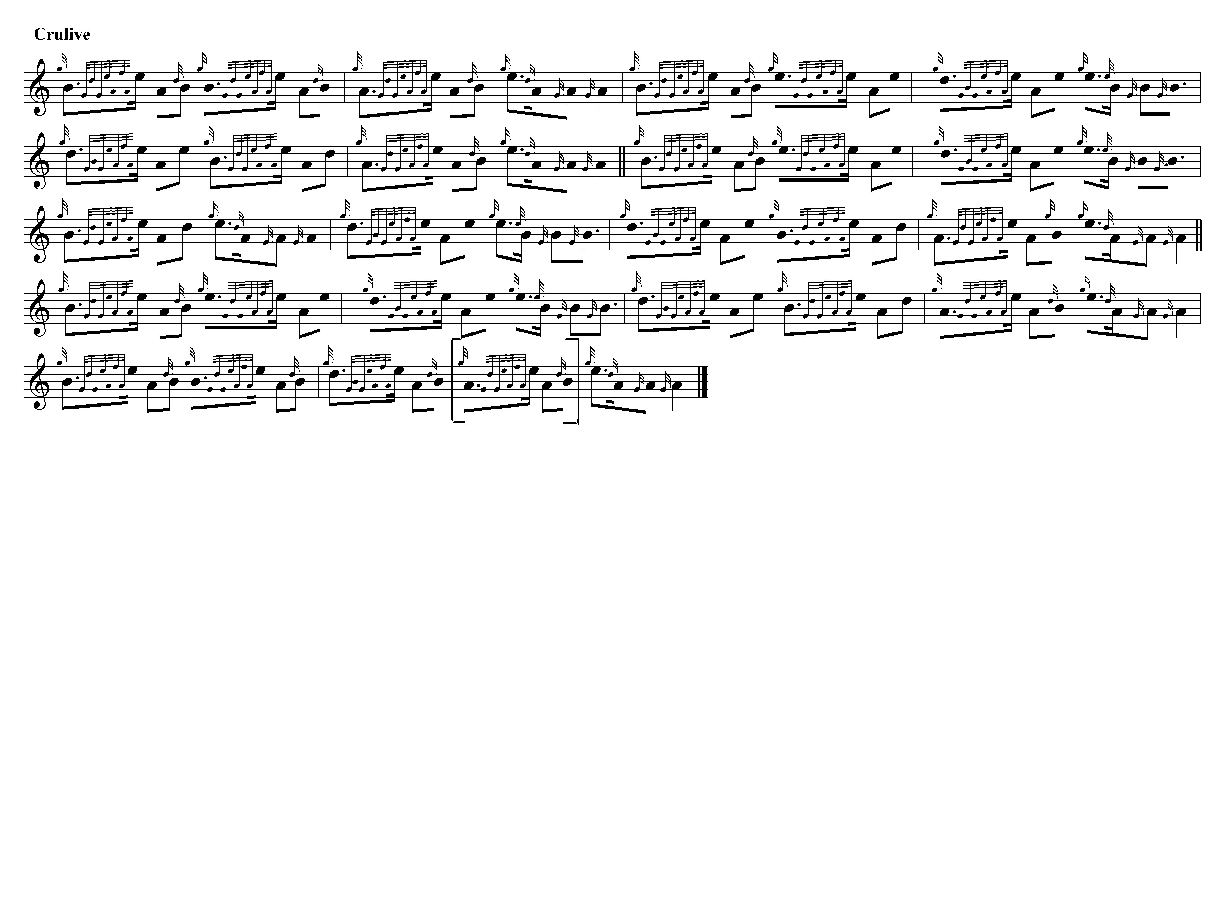
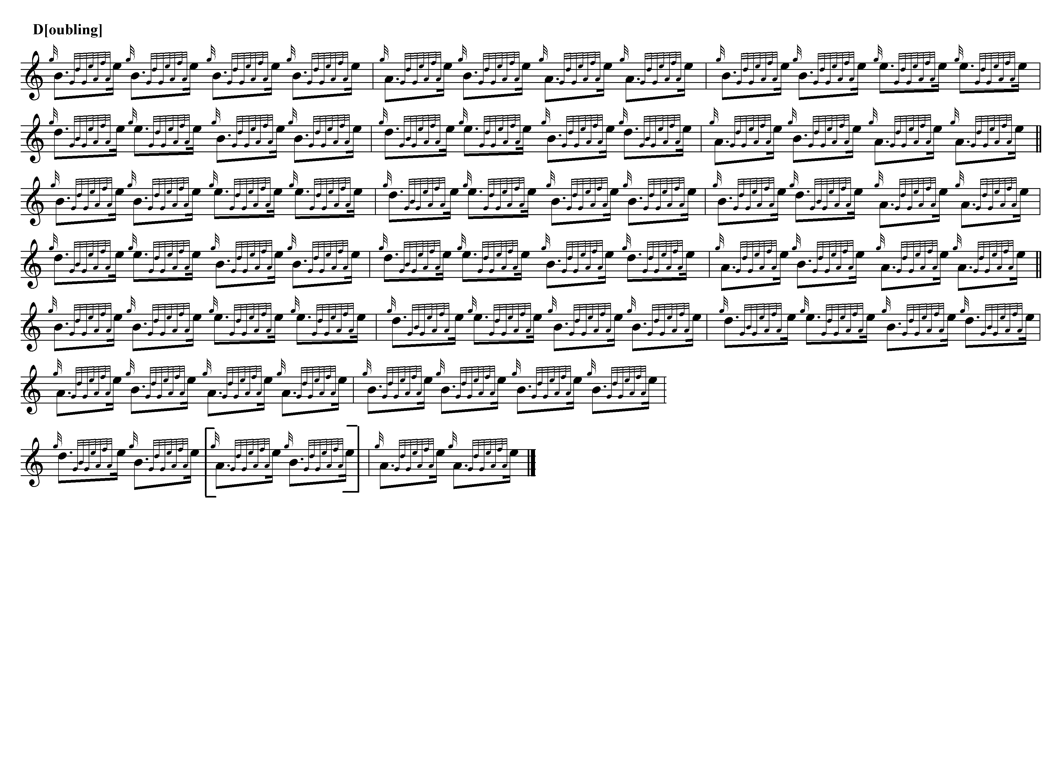

Commentary

It has been suggested that the subject of this tune may have been George Campbell of Airds, scion of a family of minor Campbell lairds in Argyllshire and who died in 1685 (Bridget MacKenzie, Piping Traditions of Argyll. College of Piping: Glasgow, 2004, pp.125-6). But the style might seem to indicate a later laird, possibly John William Campbell, 5th of Airds (1737-1788). It seems to follow the melodic “house style” of a number of tunes in the Nether Lorn Manuscript—it is recorded in no other source--which may imply a date of composition nearer the end of the eighteenth century. The Airds lies near the head of Loch Creran, a short sail up the Firth of Lorn from Colin Campbell’s base at Ardmaddy. Neil MacLean, piper to Major Campbell of Airds, controversially won the prize pipe at Falkirk in 1783. The complicated, and not altogether creditable, circumstances surrounding his win are discussed in my book The Highland Pipe and Scottish Society 1750-1950 (pp.69-75).

* * *

Electronic text © Dr William Donaldson, Cambridge, Massachusetts, 3rd December 2022

