The Aged Warrior's Sorrow / The Sword's Lament

There are settings of this tune in the following manuscript sources:

**Hannay-MacAuslan** MS, f.37;

**Angus MacKay**'s MS, i, 70 (with the title “The Sword's Lament”).

And in the following published sources:

**Donald MacDonald**, *Ancient Martial Music of Caledonia,* pp.71-2 (with the title “The Sword's Lament or the Aged Warriors Sorrow for not Being able to Wield his Sword as formerly”); also in Roderick D. Cannon and Keith Sanger, eds., *Donald MacDonald’s Collection of Piobaireachd* vol.1 (Piobaireachd Society: n.p. 2006), 92-3;

**C. S. Thomason**, *Ceol Mor,* p.29* (with the title “The Aged Warrior's Lament” (marked “a, Ed,” i.e. Donald MacDonald with editorial intervention by Thomason himself);

**David Glen**, *Edinburgh Collection of Bagpipe Music,* IV, 22 (“The Old Sword's Lament, or The Aged Warrior's Sorrow; *on being no longer able to wield his sword.”)*

The **Hannay-MacAuslan MS** sets the tune like this:

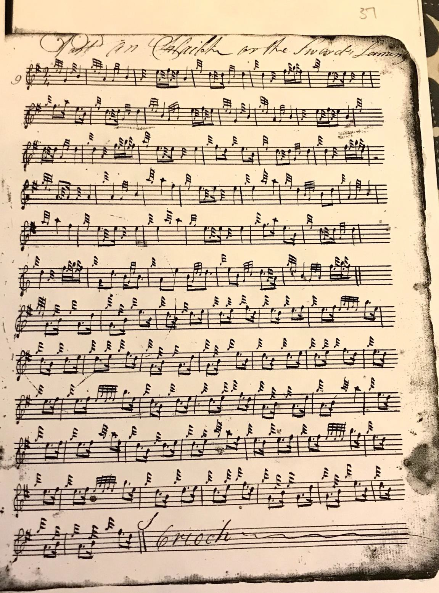

A number of stylistic points emerge here; we note the uncertain barring, which seems to stem in turn from ambiguity about note values especially in the opening thee bars of the tune, Then there is the interesting use of little “releasing notes” before the throws on E and F (a device which can be useful in helping clarify otherwise ambiguous sequences involving series of throws on the left hand in some other tunes). The timing of the double-echo beats on A, D and E is also noteworthy with their emphasis on the first note of the group, unlike the cut MacKay style. It is clear also from the gracing that each is prefixed by an appoggiatura with detectable time value.

Finally, there's the lyric brevity of the tune, a ground and single variation – none of the versions has more than this – the ground establishing the tonal framework for the melodically attractive siubhal which follows.

**Donald MacDonald** sets the tune like this:

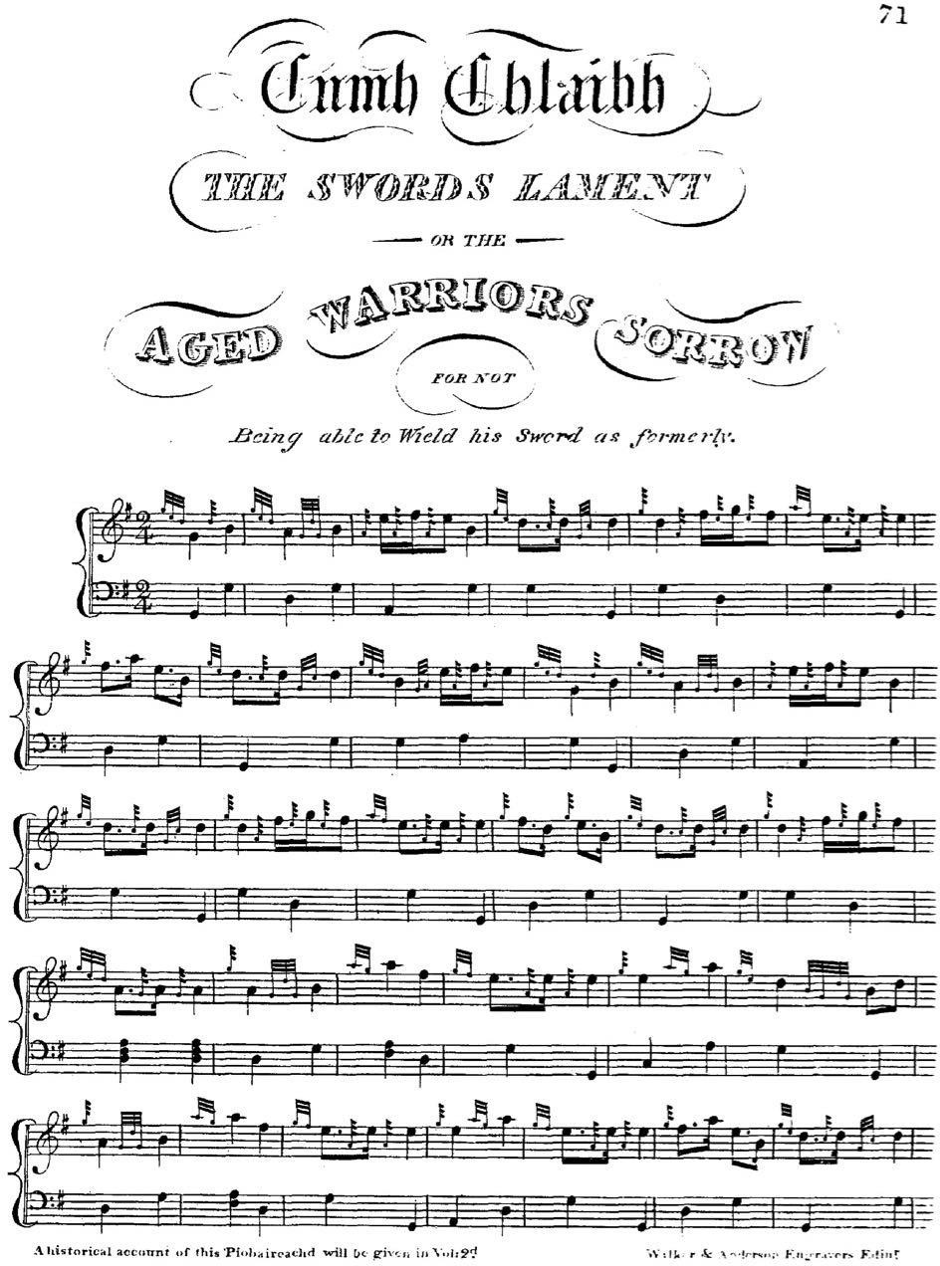

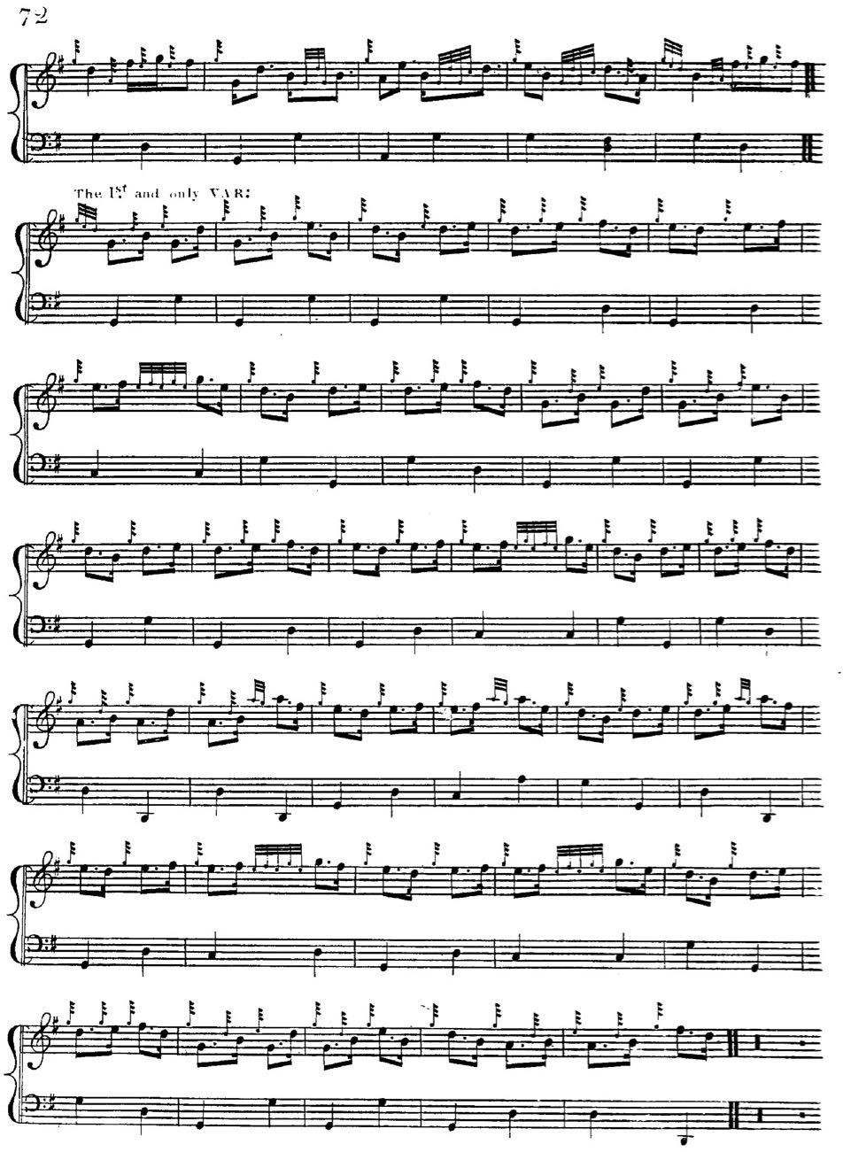

It will be seen at once that MacDonald’s published score and that in the Hannay-MacAuslan manuscript are very closely connected. Indeed, it was thought at one time that the Hannay- MacAuslan had actually been compiled by Donald MacDonald, and although this has been disputed, the MacDonald published score of this tune does read rather like a tidied up version of

the manuscript score with “hard GDG” grips to reflect the latest thinking stylistically, and the appoggiaturas before the double-echo beats transcribed more accurately but in precisely similar style. The paper on which the Hannay-MacAuslan is written is apparently watermarked “1810” so that it could well predate MacDonald’s published score, just as the hand could perhaps be an earlier version of MacDonald’s own as witnessed by the manuscript settings which are firmly ascribed to him.

**Angus MacKay** sets the tune like this:

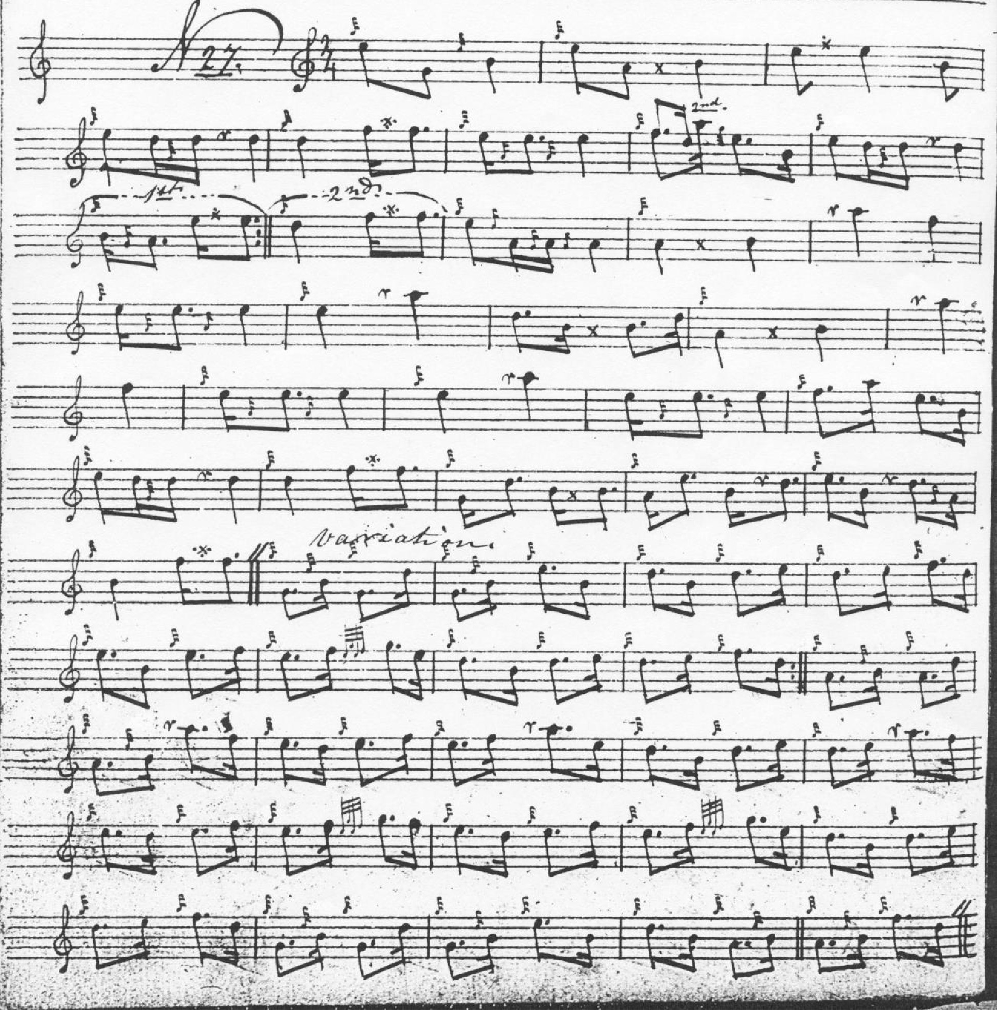

We can see here that MacKay in this instance may be working from scribal rather than performance tradition. An attempt is made to resolve the metrical difficulty of the opening bars of the ground visible in the earlier scores, but their influence still seems palpable in the timing of that B crotchet in bar two (which seems more likely to be a passing note leading on to the following throw on E), and just like Hannay-MacAuslan and MacDonald, MacKay still has nine rather than eight bars in the first line and the rest of the ground scans awkwardly as if he were working from a source which has been seen rather than heard. The remainder follows MacKay’s normal styling, dropping the appoggiaturas on left-hand double echo beats and cutting the opening note of the beat wherever it occurs and thinning out cadences throughout. Producing typically a more bare, abrupt effect, one of the costs perhaps of attempting to “standardize” the music, which was part of Angus MacKay’s goal as an editor.

**C. S. Thomason** sets the tune like this: taking Donald MacDonald’s published setting as his copy text and indicating editorial intervention by himself:

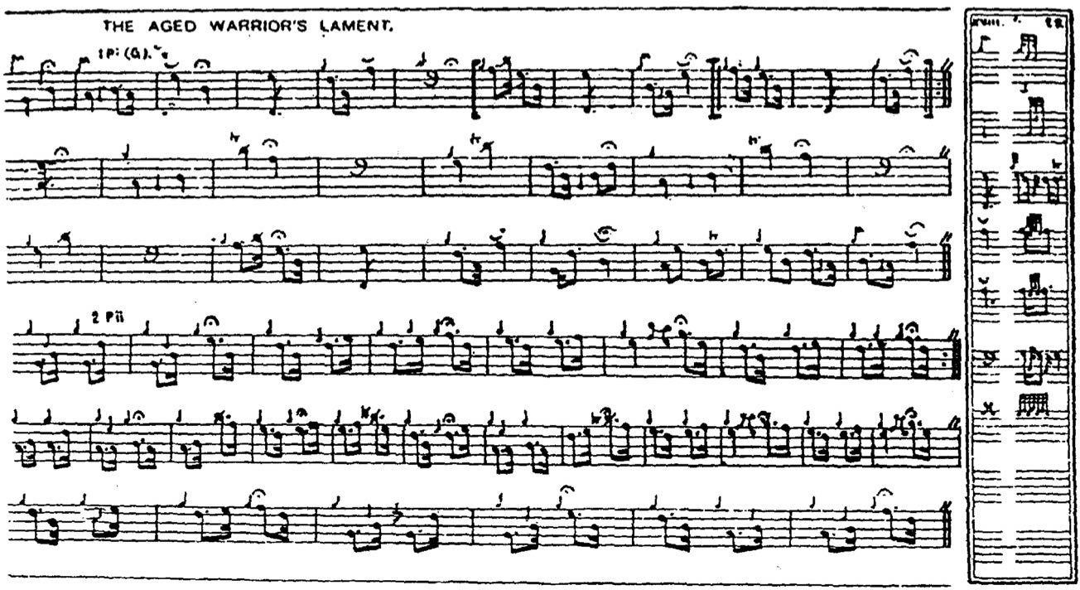

What Thomason does here is to add expression marks, a series of fermata to distinguish the phrase endings, and they shape the movement nicely.

Thomason left Donald MacDonald's structure in place and it was to fall to **David Glen** to resolve the notational difficulties in a very plausible reading which neatly restores the piece to a regular form:

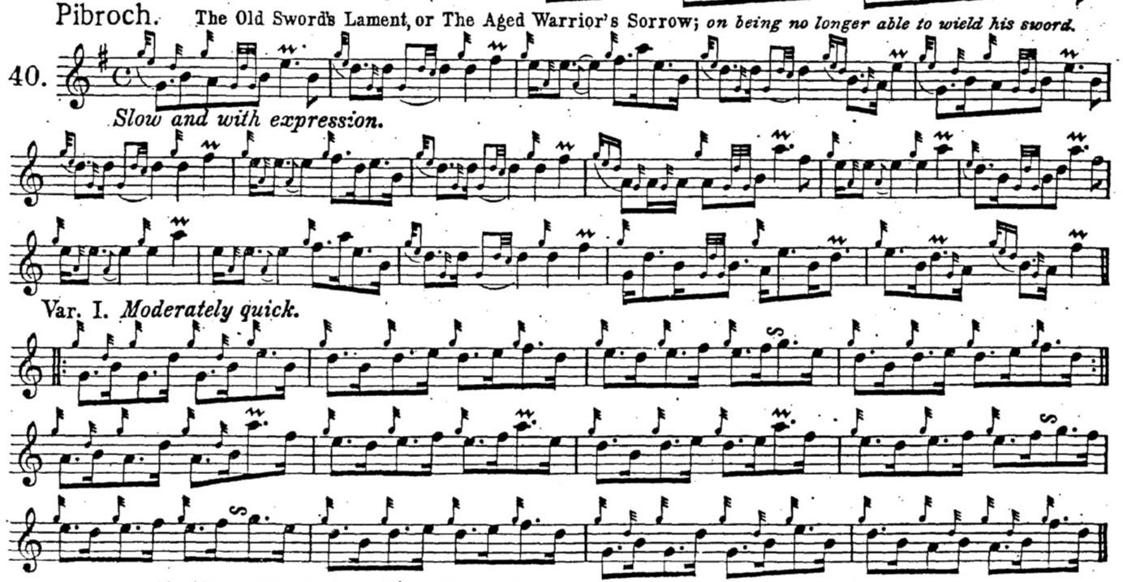

This he did in his *Edinburgh Collection* a large and fascinating anthology which ushered in the twentieth century by returning to the editorial practices of the early nineteenth, freely including light music and piobaireachd within single sets of covers. Glen takes MacDonald's problematic opening three bars and re-times them convincingly as an idiomatic single bar in common time. Guided throughout by the principle of melodic coherence, Glen drops a probably superfluous bar in the third line of MacDonald’s ground to produce a regular sixteen-bar format.

*Commentary:*

When we see a capable editorial mind like David Glen’s at work to resolve the contradictions of a cherished but sometimes enigmatic tradition, it is sad to reflect how his work was driven from print, and his shapely and musical settings should be effectively outlawed from public performance while competitive players were forced for much of the twentieth century to plod with dogged literalism through Archibald Campbell’s corrupt and inaccurate scores in the *Piobaireachd Society Collection* (second series) and the *Kilberry Book of Ceol Mor*.

*

Electronic text © Dr. William Donaldson, Cambridge, Massachusetts, 8 July 2020